**27**

# HVDC Transmission

Vijay K. Sood University of Ontario Institute of Technology, Oshawa, ON, Canada

## Abstract

High-voltage direct current (HVDC) is a mature technology and a large user of power electronics technology. from its humble beginning with mercury-arc valves in 1954 with an undersea inter-connection to the island of Gotland, it has now become a major technology transporting bulk power over long distances and inter-connecting asynchronous AC systems. This chapter presents the theoretical background of the original line-commutated convertors to the voltage source converters implemented with the latest transistor technology.

### KEYWORDS

HVDC transmission; Line-commutated converters; Voltage-source converters; DC transmission line

27.1 [Introduction](https://learning.oreilly.com/library/view/power-electronics-handbook/9780128114087/B9780128114070000301.xhtml#s0010)

27.1.1 Comparison of AC-DC Transmission

27.1.2 Evaluation of Reliability and Availability Costs

27.1.3 Applications of DC Transmission

27.1.4 Types of HVDC Systems

27.2 [Main Components of HVDC Converter Station](https://learning.oreilly.com/library/view/power-electronics-handbook/9780128114087/B9780128114070000301.xhtml#s0060)

27.2.1 Converter Unit

27.2.2 Converter Transformer

27.2.3 Filters

27.2.4 Reactive Power Source

27.2.5 DC Smoothing Reactor

27.2.6 DC Switchgear

27.2.7 DC Cables

27.3 [Analysis of Converter Bridge](https://learning.oreilly.com/library/view/power-electronics-handbook/9780128114087/B9780128114070000301.xhtml#s0120)

27.4 [Controls and Protection](https://learning.oreilly.com/library/view/power-electronics-handbook/9780128114087/B9780128114070000301.xhtml#s0125)

27.4.1 Basics of Control for a Two-Terminal DC Link

27.4.2 Control Implementation

27.4.3 Control Loops

27.4.4 Hierarchy of DC Controls

27.4.5 Monitoring of Signals

27.4.6 Protection Against Over-Currents

27.4.7 Protection Against Over-Voltages

27.5 [MTDC Operation](https://learning.oreilly.com/library/view/power-electronics-handbook/9780128114087/B9780128114070000301.xhtml#s0190)

27.5.1 Series Tap

27.5.2 Parallel Tap

27.5.3 Control of MTDC System

27.6 [Application](https://learning.oreilly.com/library/view/power-electronics-handbook/9780128114087/B9780128114070000301.xhtml#s0210)

27.6.1 HVDC Interconnection at Gurun (Malaysia)

27.7 [Modern Trends](https://learning.oreilly.com/library/view/power-electronics-handbook/9780128114087/B9780128114070000301.xhtml#s0240)

27.7.1 Converter Station Design of the 2000s

27.8 [VSC-HVDC System](https://learning.oreilly.com/library/view/power-electronics-handbook/9780128114087/B9780128114070000301.xhtml#s0295)

27.8.1 Introduction

27.8.2 VSC-HVDC System

27.8.3 Topologies of the VSC

27.8.4 PWM for VSC

27.8.5 VSC-HVDC Operation

27.8.6 Summary

27.9 [Control of VSC-HVDC System](https://learning.oreilly.com/library/view/power-electronics-handbook/9780128114087/B9780128114070000301.xhtml#s0410)

27.9.1 Introduction

27.9.2 Direct Control Method

27.9.3 Vector Control Method

27.9.4 Limitations

27.9.5 Outer Controller

27.9.6 Summary

27.10 [HVDC System Simulation Techniques](https://learning.oreilly.com/library/view/power-electronics-handbook/9780128114087/B9780128114070000301.xhtml#s0460)

27.10.1 DC Simulators and TNAs [9]

27.10.2 Digital Computer Analysis

27.11 [Concluding Remarks](https://learning.oreilly.com/library/view/power-electronics-handbook/9780128114087/B9780128114070000301.xhtml#s0475)

[Acknowledgments](https://learning.oreilly.com/library/view/power-electronics-handbook/9780128114087/B9780128114070000301.xhtml#ac0010)

[References](https://learning.oreilly.com/library/view/power-electronics-handbook/9780128114087/B9780128114070000301.xhtml#bi0010)

ABBREVIATIONS

**AEP** American Electric Power

**ASVC** Advanced static var compensator

**BB** Back to back

**BC Hydro** British Columbia Hydro

**BESS** Battery energy storage system

**BPA** Bonneville Power Authority

**CCC** Capacitor-commutated converter

**CSCC** Controlled series capacitor-commutated converter

**EMTP** Electromagnetic transient program

**EPRI** Electric Power Research Institute

**FACTS** Flexible AC transmission system

**GTO** Gate turn off (thyristor)

**HVDC** High-voltage direct current

**IEE** Institute of Electrical Engineers

**IEEE** Institute of Electrical and Electronic Engineers

**IGBT** Insulated-gate bipolar transistor

**IPC** Interphase power controller

**LT** Load tap

**MP** Minnesota Power

**MSC** Mechanical switch controller

**NSP** Northern States Power Co.

**PLL** Phase-locked loop

**PSS** Power system stabilizer

**PWM** Pulse-width modulation

**SMES** Superconducting magnetic energy storage

**SSR** Subsynchronous resonance

**STATCON** Static condenser

**STATCOM** Static compensator

**SVC** Static var compensator

**TCBR** Thyristor-controlled braking resistor

**TCPAR** Thyristor-controlled phase-angle regulator

**TCSC** Thyristor-controlled switched capacitor

**TNA** Transient network analyzer

**TSC** Thyristor-switched capacitor

**TSR** Thyristor-switched reactor

**TVA** Tennessee Valley Authority

**UPFC** Unified power flow controller

**VSI** Voltage-source inverter

**WAPA** Western Area Power Authority

## Acknowledgments

The author pays tribute to the many pioneers whose vision of HVDC transmission has led to the rapid evolution of the power industry. It is not possible here to name all of them individually.

A number of photographs of equipment have been included in this chapter, and I thank the suppliers (Mr. P. Lips of Siemens and Mr. R. L. Vaughan from ABB) for their assistance in getting clearances.

I also thank my wife Vinay for her considerable assistance in the preparation of this manuscript.

## 27.1 Introduction

High-voltage direct current (HVDC) transmission [[1](https://learning.oreilly.com/library/view/power-electronics-handbook/9780128114087/B9780128114070000301.xhtml#bb0010)–[3](https://learning.oreilly.com/library/view/power-electronics-handbook/9780128114087/B9780128114070000301.xhtml#bb0020)] is a major user of power electronics technology. HVDC technology first made its mark in the early undersea cable interconnections of Gotland (1954) and Sardinia (1967) and then in long-distance transmission with the Pacific Intertie (1970) and Nelson River (1973) schemes using mercury-arc valves. A significant milestone development occurred in 1972 with the first back-to-back (BB) asynchronous interconnection at Eel River between Quebec and New Brunswick; this installation also marked the introduction of thyristor valves to the technology and replaced the earlier mercury-arc valves.

Until 2005, a total of 70,000 MW HVDC transmission capacity is installed in some 95 projects all over the world. To understand the rapid growth of DC transmission ([Table 27.1](https://learning.oreilly.com/library/view/power-electronics-handbook/9780128114087/B9780128114070000301.xhtml#t0010)) [[4](https://learning.oreilly.com/library/view/power-electronics-handbook/9780128114087/B9780128114070000301.xhtml#bb0025)] in the past 50 years, it is first necessary to compare it to conventional AC transmission.

**Table 27.1**

**Listing of HVDC installations**

|  |  |  |  |  |  |  |
| --- | --- | --- | --- | --- | --- | --- |
| **HVDC link** | **Supplier** | **Year** | **Power MW** | **DC Voltage kV** | **Length km** | **Location** |
| Gotland I[*a*](https://learning.oreilly.com/library/view/power-electronics-handbook/9780128114087/B9780128114070000301.xhtml#tf0010) | A | 1954 | 20 | ±100 | 96 | Sweden |
| English Channel | A | 1961 | 160 | ±100 | 64 | England-France |
| Volgograd-Donbass[*b*](https://learning.oreilly.com/library/view/power-electronics-handbook/9780128114087/B9780128114070000301.xhtml#tf0015) |  | 1965 | 720 | ±400 | 470 | Russia |
| Inter-Island | A | 1965 | 600 | ±250 | 609 | New Zealand |
| Konti-Skan I | A | 1965 | 250 | 250 | 180 | Denmark-Sweden |
| Sakuma | A | 1965 | 300 | 2×125 | B-B[*c*](https://learning.oreilly.com/library/view/power-electronics-handbook/9780128114087/B9780128114070000301.xhtml#tf0020) | Japan |
| Sardinia | I | 1967 | 200 | 200 | 413 | Italy |
| Vancouver I | A | 1968 | 312 | 260 | 69 | Canada |
| Pacific Intertie | JV | 1970 | 1440 | ±400 | 1362 | The United States |
| Pacific Intertie |  | 1982 | 1600 |  |  |  |
| Nelson River I[*d*](https://learning.oreilly.com/library/view/power-electronics-handbook/9780128114087/B9780128114070000301.xhtml#tf0025) | I | 1972 | 1620 | ±450 | 892 | Canada |
| Kingsnorth | I | 1975 | 640 | ±260 | 82 | England |
| Gotland | A | 1970 | 30 | ±150 | 96 | Sweden |
| Eel River | C | 1972 | 320 | 2×80 | B-B | Canada |
| Skagerrak I | A | 1976 | 250 | 250 | 240 | Norway-Denmark |
| Skagerrak II | A | 1977 | 500 | ±250 |  | Norway-Denmark |
| Skagerrak III | A | 1993 | 440 | 350 | 240 | Norway-Denmark |
| Vancouver II | C | 1977 | 370 | −280 | 77 | Canada |
| Shin Shinano | D | 1977 | 300 | 2×125 | B-B | Japan |
| Shin Shinano |  | 1992 | 600 | 3×125 | B-B | Japan |
| Square Butte | C | 1977 | 500 | ±250 | 749 | The United States |
| David A. Hamil | C | 1977 | 100 | 50 | B-B | The United States |
| Cahora Bassa | J | 1978 | 1920 | ±533 | 1360 | Mozambique-S. Africa |
| Nelson River II | J | 1978 | 900 | ±250 | 930 | Canada |
| Nelson River II | J | 1985 | 1800 | ±500 | 930 | Canada |
| CU Project | A | 1979 | 1000 | ±400 | 710 | The United States |
| Hokkaido-Honshu | E | 1979  1980  1993 | 150  300  600 | 125  250  ±250 | 168 | Japan |
| Acaray | G | 1981 | 50 | 25.6 | B-B | Paraguay |
| Vyborg  Vyborg  Vyborg | F  F  F | 1981  1982 | 355  710  1065 | 1×170(±85)  2×170  3×170 | B-B | Russia (tie with Finland) |
| Duernrohr | J | 1983 | 550 | 145 | B-B | Austria |
| Gotland II | A | 1983 | 130 | 150 | 100 | Sweden |
| Gotland III | A | 1987 | 260 | ±150 | 103 | Sweden |
| Eddy County | C | 1983 | 200 | 82 | B-B | The United States |
| Châteauguay | J | 1984 | 1000 | 2×140 | B-B | Canada |
| Oklaunion | C | 1984 | 200 | 82 | B-B | The United States |
| Itaipu | A | 1984 | 1575 | ±300 | 785 | Brazil |
| Itaipu | A | 1985 | 2383 | 785 | Brazil |  |
| Itaipu | A | 1986 | 3150 | ±600 | 785 | Brazil |
| Inga-Shaba | A | 1982 | 560 | ±500 | 1700 | DR Congo |
| Pacific Intertie upgrade | A | 1984 | 2000 | ±500 | 1362 | The United States |
| Blackwater | B | 1985 | 200 | 57 | B-B | The United States |
| Highgate | A | 1985 | 200 | ±56 | B-B | The Unite States |
| Madawaska | C | 1985 | 350 | 140 | B-B | Canada |
| Miles City | C | 1985 | 200 | ±82 | B-B | The United States |
| Broken Hill | A | 1986 | 40 | 2×17(±8.33) | B-B | Australia |
| Intermountain Power Project | A | 1986 | 1920 | ±500 | 784 | The United States |
| Cross-Channel:  Les Mandarins (Sellindge) | H  I | 1986  1986 | 1000  2000 | ±270  2×±270 | 72 | France-England  France  England |
| Des Cantons-Comerford | C | 1986 | 690 | ±450 | 172 | Canada-the United States |
| Sacoi[*e*](https://learning.oreilly.com/library/view/power-electronics-handbook/9780128114087/B9780128114070000301.xhtml#tf0030)  Sacoi[*f*](https://learning.oreilly.com/library/view/power-electronics-handbook/9780128114087/B9780128114070000301.xhtml#tf0035) | H  H | 1986  1992 | 200  300 | 200 | 415 | Corsica Island  Italy |
| Itaipu II | A | 1987 | 3150 | ±600 | 805 | Brazil |
| Sidney (Virginia Smith) | G | 1988 | 200 | 55.5 | B-B | The United States |
| Gezhouba-Shanghai | B+G | 1989  1990 | 600  1200 | 500  ±500 | 1000 | China |
| Konti-Skan II | A | 1988 | 300 | 285 | 150 | Sweden-Denmark |
| Vindhyachal | A | 1989 | 500 | 2×69.7 | B-B | India |
| Pacific Intertie Exp. | B | 1989 | 1100 | ±500 | 1362 | The United States |
| McNeill | I | 1989 | 150 | 42 | B-B | Canada |
| Fenno-Skan | A | 1989 | 500 | 400 | 200 | Finland-Sweden |
| Sileru-Barsoor | K | 1989 | 100  200  400 | +100  +200  ±200 | 196 | India |
| Rihand-Delhi | A | 1991 | 1500 | ±500 | India |  |
| Quebec-New England  Nicolet Tap | A  A | 1990  1992 | 2000[*g*](https://learning.oreilly.com/library/view/power-electronics-handbook/9780128114087/B9780128114070000301.xhtml#tf0040)  1800 | ±450 | 1500 | Canada-the United States  Canada |
| DC Hybrid Link | AB | 1992 | 992 | +270/−350 | 617 | New Zealand |
| Etzenricht | G | 1993 | 600 | 160 | B-B | Germany (tie with Czech) |
| Vienna Southeast | G | 1993 | 600 | 145 | B-B | Austria (tie with Hungary) |
| Haenam-Cheju | I | 1993 | 300 | ±180 | 100 | South Korea |
| Baltic Cable Project | AB | 1994 | 600 | 450 |  | Sweden-Germany |
| Welch-Monticello |  | 1995 | 600 |  | B-B | The United States |
| Kontek Interconnection |  | 1995 | 600 | 400 | 170 | Denmark-Germany |
| Scotland-N. Ireland |  | 1996 | 250 | 250 |  | The United Kingdom |
| Chandrapur-Ramagundum |  | 1996 | 1000 | 2×500 | B-B | India |
| Chandrapur-Padghe | AB | 1997 | 1500 | ±500 | 900 | India |
| Greece-Italy | AB | 1997 | 500 | 400 | 200, sea | Italy |
| Gajuwaka-Jeypore | AB | 1997 | 500 |  | B-B | India |
| Leyte-Luzon | AB | 1997 | 1600 | 400 | 440 | Philippines |
| Cahora Bassa | G | 1998 | 1920 | ±533 | 1456 | Mozambique-S. Africa |
| TSQ-Beijao | G | 2000 | 1800 | ±500 | 903 | China |
| Thailand-Malaysia | G | 2001 | 300 | ±300 | B-B | Thailand-Malaysia |
| Moyle | G | 2001 | 2×250 | 250 | 64 | Ireland-Scotland |
| East-South Intercon. | G | 2003 | 2000 | ±500 | 1450 | India |
| Rapid City DC tie | AB | 2003 | 2×100 | ±13 | B-B | S. Dakota, the United States |
| Three Gorges-Changzhou | AB | 2003 | 3000 | ±500 | 890 | China |
| Three Gorges-Guangdong | AB | 2004 | 3000 | ±500 | 940 | China |
| Guizhou-Guangdong | G | 2004 | 3000 | ±500 | 940 | China |
| Celilo conv. station | AB | 2004 | 2000 | ±500 | Upgrade | The United States |
| Nelson River Bipole II | G | 2004 | 1000 | 450 | Pole 1 | Canada |
| Basslink | G | 2005 | 500 | 400 | 350 | Australia-Tasmania |
| Lamar | G | 2005 | 210 | 63.6 | B-B | Colorado, the United States |
| Vizag II | AB | 2005 | 500 | ±88 | B-B | India |
| Estlink | AB | 2006 | 350 | ±150 | HVDC Light | Estonia-Finland |
| Three Gorges-Shanghai | AB | 2007 | 3000 | ±500 | 1059 | China |
| NorNed | AB | 2007 | 700 | ±450 | 560 | Norway-Netherlands |
| Valhall offshore | AB | 2009 | 950 |  | HVDC Light | Norway |
| Yunnan-Guangdong | G | 2009 | 5000 | ±800 | 1418 | China |
| Outaouais | AB | 2009 | 1250 | 175 | B-B | Canada |
| Blackwater | AB | 2009 | 200 | 57 | B-B | The United States |
| Ballia-Bhiwadi | G | 2010 | 2500 | ±500 | 800 | India |
| Storebælt | G | 2010 | 600 | 400 | 56 | Denmark |
| Trans Bay Cable project | G | 2010 | 400 | ±200 | 85 | The United States |
| Hulunbeir-Liaoning | AB | 2010 | 3000 | ±500 | 920 | China |
| Xiangjiaba-Shanghai | G | 2010 | 6400 | ±800 | 2070 | China |
| Caprivi Link | AB | 2010 | 300 | 350 | 950 | Namibia |
| Intermountain Power | AB | 2010 | 2400 | ±500 | 785 | The United States |
| Lingbao II | AB | 2010 | 750 | 168 | B-B | Chain |
| BritNed, Great Britain | G | 2011 | 1000 | ±450 | 260 | Netherlands |
| SAPEI | AB | 2011 | 1000 | ±500 | 2×450 | Italy-Sardinia |
| Fenno-Skan | AB | 2011 | 500 | 400 | 200 | Finland-Sweden |
| Valhall | AB | 2011 | 78 | 150 | 292 | Norway |
| COMETA | G | 2012 | 2×200 | ±200 | 250 | Spain |
| Jinping-Sunan | G | 2012 | 7200 | ±800 | 2059 | China |
| Mundra-Haryana | G | 2012 | 2500 | ±500 | 960 | India |
| Highgate | AB | 2012 | 200 | 57 | B-B | Canada |
| Back to back | G | 2013 | 500 | 158 | B-B | Bangladesh |
| Porto Velho | AB | 2013 | 2×400 | ? | B-B | Brazil |
| Black Sea Transmission | G | 2013 | 2×350 | 96 | B-B | Georgia |
| Hudson Transmission | G | 2013 | 660 | 180 | B-B | The United States |
| East-West Interconnector | AB | 2013 | 500 | ±200 | 2×75 | The United Kingdom-Ireland |
| Jinping-Sunan | AB | 2013 | 7200 | ±800 | 2090 | China |
| Nuozhadu-Guangdong | G | 2013 | 5000 | ±800 | 1451 | China |
| Rio Madeira | AB | 2013 | 2×400 | ±600 | B-B | Brazil |
| Xiluodu-Guangdong | G | 2013 | 6400 | ±500 | 1286 | China |
| INELFE | G | 2014 | 2×1000 | ±320 | 65 | France-Spain |
| Mackinac | AB | 2014 | 200 | ±71 | B-B | The United States |
| Inga-Kolwezi | AB | 2014 | 560 | ±500 | 1700 | Congo |
| Skagerrak | AB | 2014 | 700 | 500 | 140 | Norway-Denmark |
| Eel River | AB | 2014 | 350 | 80 | B-B | Canada |
| EstLink 2 | G | 2014 | 670 | 450 | 171 | Finland-Estonia |
| Railroad DC Tie | AB | 2014 | 300 | ±21 | B-B | Mexico |
| Oklaunion | AB | 2014 | 220 | ±31 | B-B | The United States |
| Inter-Island Connector Pole 3 | G | 2014 | 700 | ±350 | 649 | New Zealand |
| Western HVDC Link | G | 2015 | 2200 | ±600 | 420 | The United Kingdom |
| Troll A 3&4 | AB | 2015 | 100 | ±60 | 70 | Norway |
| DolWin1 | AB | 2015 | 800 | ±320 | 2×75 | Germany |
| ÅL-link | AB | 2015 | 100 | ±80 | 158 | Finland |
| BorWin1 | AB | 2015 | 400 | ±150 | 2×75 | Germany |
| LitPol Link | AB | 2015 | 500 | ±60 | B-B | Poland-South Lithuania |
| Madawaska | AB | 2016 | 350 | 130 | B-B | Canada |
| Pacific Intertie | AB | 2016 | 1440 | ±400 | 1360 | The United States |
| NordBalt | AB | 2016 | 700 | ±320 | 400 | Sweden-Lithuania |
| DolWin2 | AB | 2016 | 916 | ±320 | 2×45 | Germany (North Sea) |
| North-East Agra | AB | 2016 | 6000 | ±800 | 1728 | India |
| Québec-New England | AB | 2016 | 2000 | ±450 | 1480 | Canada-the United States |

*A*, ASEA; *B*, Brown Boveri; *C*, General Electric; *D*, Toshiba; *E*, Hitachi; *F*, Russian; *G*, Siemens; *H*, CGEE Alstom; *I*, GEC (formerly English Electric); *J*, HVDC W.G. (AEG, BBC, and Siemens); *K*, (Independent); *AB*, ASEA Brown Boveri (ABB); *JV*, Joint Venture (GE and ASEA).

[a](https://learning.oreilly.com/library/view/power-electronics-handbook/9780128114087/B9780128114070000301.xhtml#xtf0010) Retired from service.

[b](https://learning.oreilly.com/library/view/power-electronics-handbook/9780128114087/B9780128114070000301.xhtml#xtf0015) Two VGs replaced with thyristors in 1977.

[c](https://learning.oreilly.com/library/view/power-electronics-handbook/9780128114087/B9780128114070000301.xhtml#xtf0020) Back-to-back HVDC system.

[d](https://learning.oreilly.com/library/view/power-electronics-handbook/9780128114087/B9780128114070000301.xhtml#xtf0025) Two VGs in pole 1 replaced with thyristors by GEC in 1991.

[e](https://learning.oreilly.com/library/view/power-electronics-handbook/9780128114087/B9780128114070000301.xhtml#xtf0030) 50 MW thyristor tap.

[f](https://learning.oreilly.com/library/view/power-electronics-handbook/9780128114087/B9780128114070000301.xhtml#xtf0035) Uprated with thyristor valves.

[g](https://learning.oreilly.com/library/view/power-electronics-handbook/9780128114087/B9780128114070000301.xhtml#xtf0040) Multiterminal system. Largest terminal is rated 2250 MW.

### 27.1.1 COMPARISON OF AC-DC TRANSMISSION

Making a planning selection between either AC or DC transmission is based on an evaluation of transmission costs, technical considerations, and reliability/availability offered by the two power transmission alternatives.

#### **27.1.1.1 Evaluation of Transmission Costs**

The cost of a transmission line comprises the capital investment required for the actual infrastructure (i.e., right of way (RoW), towers, conductors, insulators, and terminal equipment) and costs incurred for operational requirements (i.e., losses). Assuming similar insulation requirements for peak voltage levels for both AC and DC lines, a DC line can carry as much power with two conductors (having positive/negative polarities with respect to ground) as an AC line with three conductors of the same size. Therefore, for a given power level, a DC line requires a smaller RoW, simpler and cheaper towers, and reduced conductor and insulator costs. As an example, [Fig. 27.1](https://learning.oreilly.com/library/view/power-electronics-handbook/9780128114087/B9780128114070000301.xhtml#f0010) shows the comparative case of AC and DC systems carrying 2000 MW.

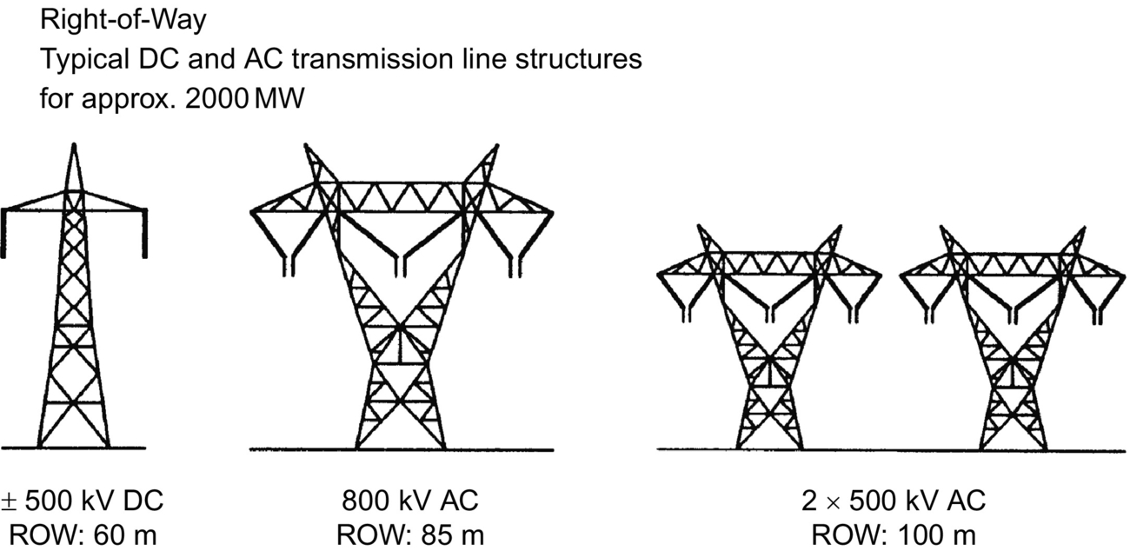

**FIG. 27.1** Comparison of RoW for AC and DC transmission systems.

With the DC option, since there are only two conductors (with the same current capacity of three AC conductors), the power transmission losses are also reduced to about two-thirds of the comparable AC system. The absence of skin effect with DC is also beneficial in reducing power losses marginally, and the dielectric losses in the case of power cables are also very much less for DC transmission.

Corona effects tend to be less significant on DC than for AC conductors. The other factors that influence line costs are the costs of compensation and terminal equipment. DC lines do not require reactive power compensation, but the terminal equipment costs are increased due to the presence of converters and filters.

[Fig. 27.2](https://learning.oreilly.com/library/view/power-electronics-handbook/9780128114087/B9780128114070000301.xhtml#f0015) shows the variation of infrastructure costs with distance for AC and DC transmission. AC tends to be more economical than DC for distances less than the “break-even distance” but is more expensive for longer distances. This is due to a combination of the terminal equipment costs and line costs for the two types of transmission. The break-even distances can vary from about 500 to 800 km in overhead lines depending on the per unit line costs. With a cable system, this break-even distance approaches 50 km.

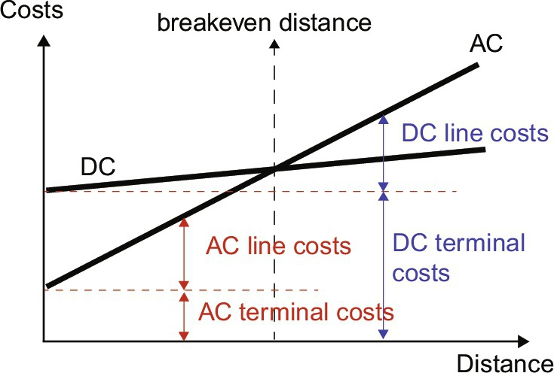

**FIG. 27.2** Comparison of AC-DC transmission system costs.

#### **27.1.1.2 Evaluation of Technical Considerations**

Due to its fast controllability, a DC transmission system has full control over transmitted power, an ability to enhance transient and dynamic stability in associated AC networks and can limit fault currents in the DC lines. Furthermore, DC transmission overcomes some of the following problems associated with AC transmission:

• Stability limits

The power transfer in an AC line is dependent on the angular difference between the voltage phasors at the two line ends. For a given power transfer level, this angle increases with distance. The maximum power transfer is limited by the considerations of steady state and transient stability. The power-carrying capability of an AC line is inversely proportional to transmission distance, whereas the power-carrying ability of DC lines is unaffected by the distance of transmission.

• Voltage control

Voltage control in AC lines is complicated by line-charging requirements and voltage drops. The voltage profile in an AC line is relatively flat only for a fixed level of power transfer, corresponding to its surge impedance loading (SIL). The voltage profile varies with the line loading. For constant voltage at the line ends, the midpoint voltage is reduced for line loadings higher than SIL and increased for loadings less than SIL.

The maintenance of constant voltage at the two ends requires reactive power control as the line loading is increased. The reactive power requirements increase with line length.

Although DC converter stations require reactive power related to the power transmitted, the DC line itself does not require any reactive power.

The steady-state charging currents in AC cables pose serious problems and make the break-even distance for cable transmission around 50 km.

• Line compensation

Line compensation is necessary for long-distance AC transmission to overcome the problems of line charging and stability limitations. The increase in power transfer and voltage control is possible through the use of shunt inductors, series capacitors, static var compensators (SVCs), and, lately, the new-generation static compensators (STATCOMs).

In the case of DC lines, such compensation is not needed.

• Problems of AC interconnection

The interconnection of two power systems through AC ties requires the automatic generation controllers of both systems to be coordinated using tie line power and frequency signals. Even with coordinated control of interconnected systems, the operation of AC ties can be problematic due to (i) the presence of large power oscillations that can lead to frequent tripping, (ii) increase in fault level, and (iii) transmission of disturbances from one system to the other.

The fast controllability of power flow in DC lines eliminates all of the above problems. Furthermore, the asynchronous interconnection of two power systems can only be achieved with the use of DC links.

• Ground impedance

In AC transmission, the existence of ground (zero sequence) current cannot be permitted in steady state due to the high magnitude of ground impedance that will not only affect efficient power transfer but also result in telephonic interference.

The ground impedance is negligible for DC currents, and a DC link can operate using one conductor with ground return (monopolar operation). The ground return is objectionable only when buried metallic structures (such as pipelines) are present and are subject to corrosion with DC current flow. It is to be noted that even while operating in the monopolar mode, the AC network feeding the DC converter station operates with balanced voltages and currents. Hence, single-pole operation of DC transmission systems is possible for extended periods, while in AC transmission, single-phase operation or any unbalanced operation is not feasible for more than a second.

• Problems of DC transmission

The application of DC transmission is limited by factors such as

(1) high cost of conversion equipment,

(2) inability to use transformers to alter voltage levels,

(3) generation of harmonics,

(4) requirement of reactive power,

(5) complexity of controls.

Over the years, there have been significant advances in DC technology, which have tried to overcome the disadvantages listed above, except for item (2). These are the following:

(1) Increase in the ratings of a thyristor cell that makes up a valve

(2) Modular construction of thyristor valves

(3) Twelve-pulse operation of converters

(4) Use of forced commutation

(5) Application of digital electronics and fiber optics in the control of converters.

Some of the above advances have resulted in improving the reliability and reduction of conversion costs in DC systems.

### 27.1.2 EVALUATION OF RELIABILITY AND AVAILABILITY COSTS

Statistics on the reliability of HVDC links are maintained by CIGRE and IEEE working groups. The reliability of DC links has been very good and is comparable with AC systems. The availability of DC links is quoted in the upper 90%.

### 27.1.3 APPLICATIONS OF DC TRANSMISSION

Due to their costs and special nature, most applications of DC transmission generally fall into one of the following four categories:

• Underground or underwater cables

In the case of long cable connections over the break-even distance of about 40–50 km, DC cable transmission system has a marked advantage over AC cable connections. Examples of this type of applications were the Gotland (1954) and Sardinia (1967) schemes.

The recent development of voltage-source converters (VSC) and the use of rugged polymer DC cables, with the so-called “HVDC Light” option, are being increasingly considered. An example of this type of application is the 180-MW Directlink connection (2000) in Australia.

• Long-distance bulk power transmission

Bulk power transmission over long distances is an application ideally suited for DC transmission and is more economical than AC transmission whenever the break-even distance is exceeded. Examples of this type of application abound from the earlier Pacific Intertie to the recent links in China and India.

The break-even distance is being effectively decreased with the reduced costs of new compact converter stations possible due to the recent advances in power electronics (discussed in a later section).

• Asynchronous interconnection of AC systems

In terms of an asynchronous interconnection between two AC systems, the DC option reigns supreme. There are many instances of BB connections where two AC networks have been tied together for the overall advantage to both AC systems. With recent advances in control techniques, these interconnections are being increasingly made at weak AC systems. The growth of BB interconnections is best illustrated with the example of N. America where the four main independent power systems are interconnected with 12 BB links.

In the future, it is anticipated that this BB connection will also be made with VSCs offering the possibility of full four-quadrant operation and the total control of active/reactive power coupled with the minimal generation of harmonics.

• Stabilization of power flows in integrated power system

In large interconnected systems, power flow in AC ties (particularly under disturbance conditions) can be uncontrolled and lead to overloading and stability problems, thus endangering system security. Strategically placed DC lines can overcome this problem due to the fast controllability of DC power and provide much needed damping and timely overload capability. The planning of DC transmission in such applications requires detailed study to evaluate the benefits. Examples are the IPP link in the United States and the Chandrapur-Padghe link in India.

Presently, the number of DC lines in a power grid is very small compared with the number of AC lines. This indicates that DC transmission is justified only for specific applications. Although advances in technology and introduction of multiterminal DC (MTDC) systems are expected to increase the scope of application of DC transmission, it is not anticipated that the AC grid will be replaced by a DC power grid in the future. There are two major reasons for this. First, the control and protection of MTDC systems is complex, and the inability of voltage transformation in DC networks imposes economic penalties. Second, the advances in power electronics technology have resulted in the improvement of the performance of AC transmissions using FACTS devices, for instance, through introduction of static var systems, static phase shifters, etc.

### 27.1.4 TYPES OF HVDC SYSTEMS

Three types of DC links are considered.

#### **27.1.4.1 Monopolar Link**

A monopolar link ([Fig. 27.3A](https://learning.oreilly.com/library/view/power-electronics-handbook/9780128114087/B9780128114070000301.xhtml#f0020)) has one conductor and uses either ground or sea return. A metallic return can also be used where concerns for harmonic interference and/or corrosion exist. In applications with DC cables (i.e., HVDC Light), a cable return is used. Since the corona effects in a DC line are substantially less with negative polarity of the conductor as compared with the positive polarity, a monopolar link is normally operated with negative polarity.

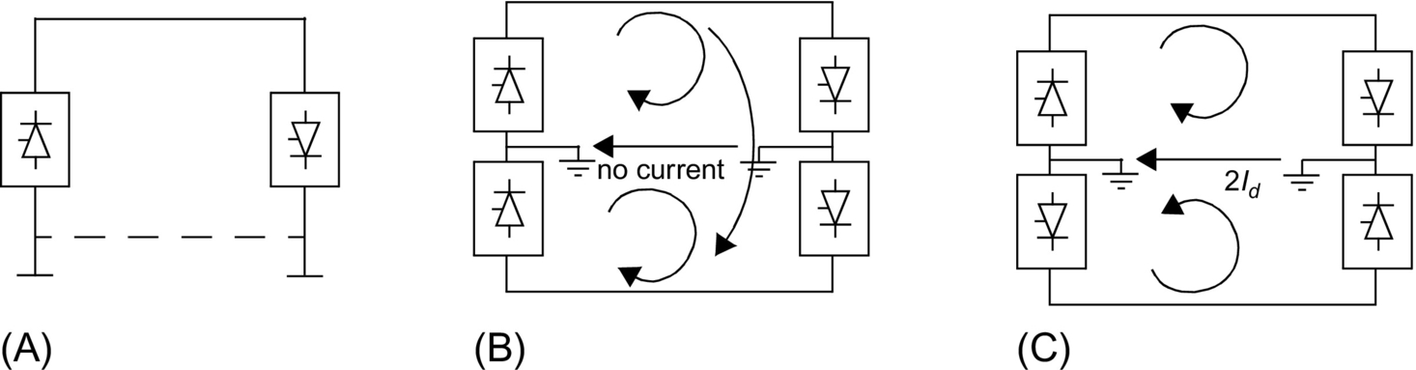

**FIG. 27.3** Types of HVDC links: (A) monopolar link, (B) bipolar link, and (C) homopolar DC link.

#### **27.1.4.2 Bipolar Link**

A bipolar link ([Fig. 27.3B](https://learning.oreilly.com/library/view/power-electronics-handbook/9780128114087/B9780128114070000301.xhtml#f0020)) has two conductors, one positive and the other with negative polarity. Each terminal has two sets of converters of equal rating, in series on the DC side. The junction between the two sets of converters is grounded at one or both ends by the use of a short electrode line. Since both poles operate with equal currents under normal operation, there is zero-ground current flowing under these conditions. Monopolar operation can also be used in the early stages of the development of a bipolar link. Alternatively, under faulty converter conditions, one DC line may be temporarily used as a metallic return with the use of suitable switching.

#### **27.1.4.3 Homopolar Link**

In this type of link ([Fig. 27.3C](https://learning.oreilly.com/library/view/power-electronics-handbook/9780128114087/B9780128114070000301.xhtml#f0020)), two conductors having the same polarity (usually negative) can be operated with ground or metallic return.

Due to the undesirability of operating a DC link with ground return, bipolar links are mostly used. A homopolar link has the advantage of reduced insulation costs, but the disadvantages of earth return outweigh the advantages.

## 27.2 Main Components of HVDC Converter Station

The major components of an HVDC transmission system are the converter stations at the ends of the transmission system. In a typical two-terminal transmission system, both a rectifier and an inverter are required. The role of the two stations can be reversed as controls are usually available for both functions at the terminals. The major components of a typical 12-pulse bipolar HVDC converter station ([Fig. 27.4](https://learning.oreilly.com/library/view/power-electronics-handbook/9780128114087/B9780128114070000301.xhtml#f0025)) are discussed below.

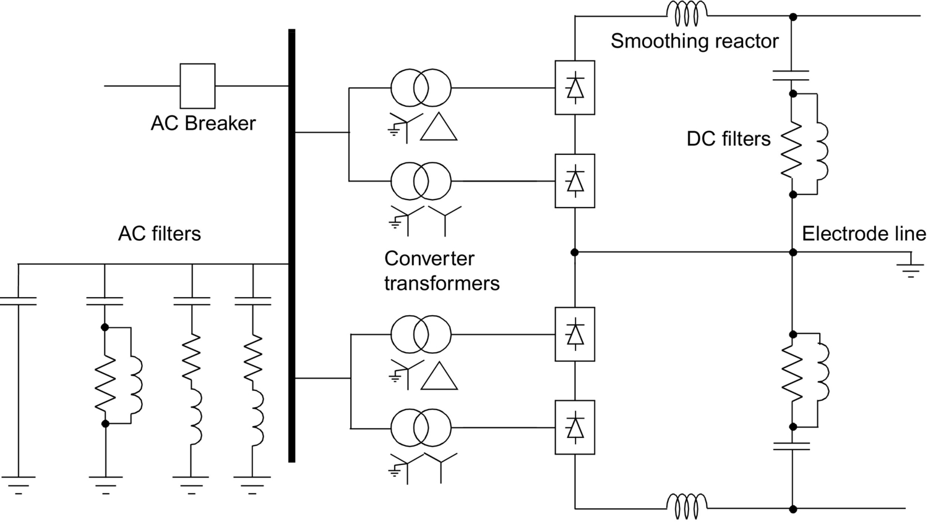

**FIG. 27.4** Typical HVDC converter station equipment.

### 27.2.1 CONVERTER UNIT

This usually consists of two three-phase converter bridges connected in series to form a 12-pulse converter unit. The design of valves is based on a modular concept where each module contains a limited number of series-connected thyristor levels. The valves can be packaged as either a single-valve, double-valve, or quadruple-valve arrangement. The converter is fed by converter transformers connected in star/star and star/delta arrangements to form a 12-pulse pair.

The valves may be cooled by air, oil, water, or Freon. However, the cooling using deionized water is more modern and considered efficient and reliable. The ratings of a valve group are limited more by the permissible short-circuit currents than by the steady-state load requirements.

Valve firing signals are generated in the converter control at ground potential and are transmitted to each thyristor in the valve through a fiber-optic light guide system. The light signal received at the thyristor level is converted to an electric signal using gate drive amplifiers with pulse transformers. Recent trends in the industry indicate that direct optical firing of the valves with LTT thyristors is also feasible.

The valves are protected using snubber circuits, protective firing, and gapless surge arrestors.

#### **27.2.1.1 Thyristor Valves**

Many individual thyristors are connected in series to build up an HVDC valve. To distribute the off-state valve voltage uniformly across each thyristor level and protect the valve from di/dt and dv/dt stresses, special snubber circuits are used across each thyristor level ([Fig. 27.5](https://learning.oreilly.com/library/view/power-electronics-handbook/9780128114087/B9780128114070000301.xhtml#f0030)).

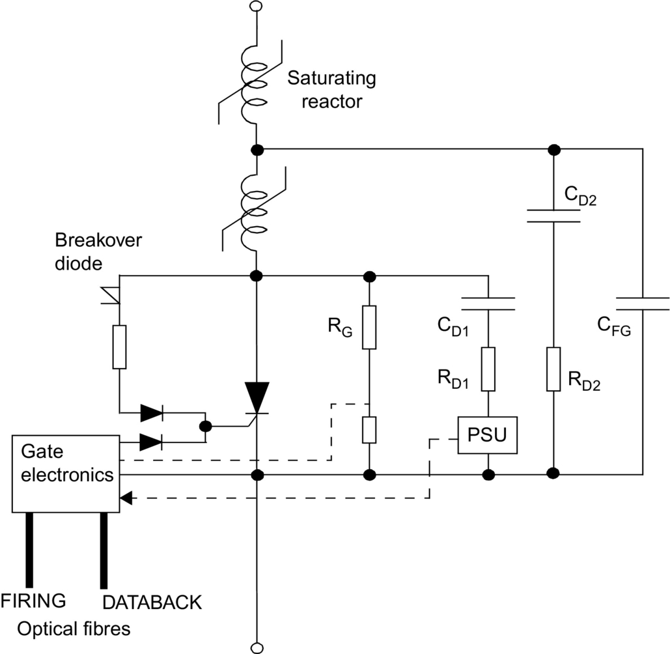

**FIG. 27.5** Electric circuit of the thyristor level [[2](https://learning.oreilly.com/library/view/power-electronics-handbook/9780128114087/B9780128114070000301.xhtml#bb0015)].

The snubber circuit is composed of the following components:

• A saturating reactor is used to protect the valve from *di*/*dt* stresses during turn-on. The saturating reactor offers a high inductance at low current and a low inductance at high currents.

• A DC grading resistor RG distributes the direct voltage across the different thyristor levels. It is also used as a voltage divider to measure the thyristor level voltage.

• RC snubber circuits are used to damp out voltage oscillations from power frequency to a few kHz.

• A capacitive grading circuit CFG is used to protect the thyristor level from voltage oscillations at a much higher frequency.

A thyristor is triggered on by a firing pulse sent via a fiber-optic cable from the valve base electronics (VBE) unit at earth potential. The fiber-optic signal is amplified by a gate electronic unit (GEU) that receives its power from the RC snubber circuit during the valve's off period.

The GEU can also effect the protective firing of the thyristor independent of the central control unit. This is achieved by a breakover diode (BOD) via a current-limiting resistor that triggers the thyristor when the forward voltage threatens to exceed the rated voltage for the thyristor. This may arise in a case when some thyristors may block forward voltage, while others may not.

It is normal to include some extra redundant thyristor levels to allow the valve to remain in service after the failure of some thyristors. A metal oxide surge arrestor is also used across each valve for overvoltage protection.

The thyristors produce considerable heat loss, typically 24–40 W/cm2 (or over 1 MW for a typical quadruple valve), and so, an efficient cooling system is essential.

### 27.2.2 CONVERTER TRANSFORMER

The converter transformer ([Fig. 27.6](https://learning.oreilly.com/library/view/power-electronics-handbook/9780128114087/B9780128114070000301.xhtml#f0035)) can have different configurations: (i) three phase, two winding; (ii) single phase, three winding; and (iii) single phase, two winding. The valve-side windings are connected in star and delta with neutral point ungrounded. On the AC side, the transformers are connected in parallel with the neutral grounded. The leakage impedance of the transformer (typical value between 15% and 18%) is chosen to limit the short-circuit currents through any valve.

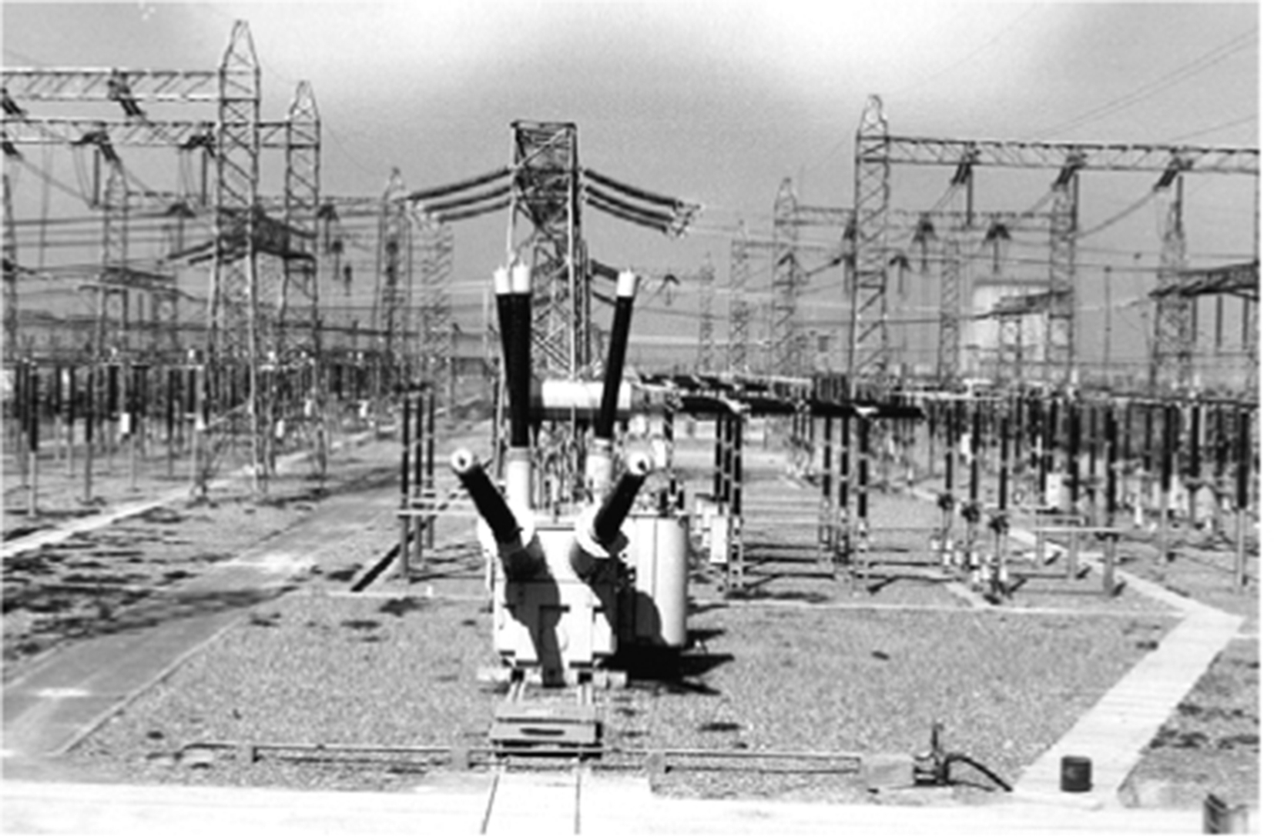

**FIG. 27.6** Spare converter for multilevel convertertransformer in the switchyard of an HVDC station.

The converter transformers are designed to withstand DC voltage stresses and increased eddy current losses due to harmonic currents. One problem that can arise is due to the DC magnetization of the core due to unsymmetrical firing of valves.

### 27.2.3 FILTERS

Due to the generation of characteristic and noncharacteristic harmonics by the converter, it is necessary to provide suitable filters on the AC-DC sides of the converter to improve the power quality and meet telephonic and other requirements. Generally, three types of filters are used for this purpose:

#### **27.2.3.1 AC Filters**

AC filters ([Fig. 27.7](https://learning.oreilly.com/library/view/power-electronics-handbook/9780128114087/B9780128114070000301.xhtml#f0040)) are passive circuits used to provide low impedance, shunt paths for AC harmonic currents. Both tuned and damped filter arrangements are used. In a typical 12-pulse station, filters at eleventh and thirteenth harmonics are required as tuned filters. Damped filters (normally tuned to the twenty-third harmonic) are required for the higher harmonics. In recent years, C-type filters have also been used since they provide more economic designs. Double- or even triple-tuned filters exist to reduce the cost of the filter (see application example system).

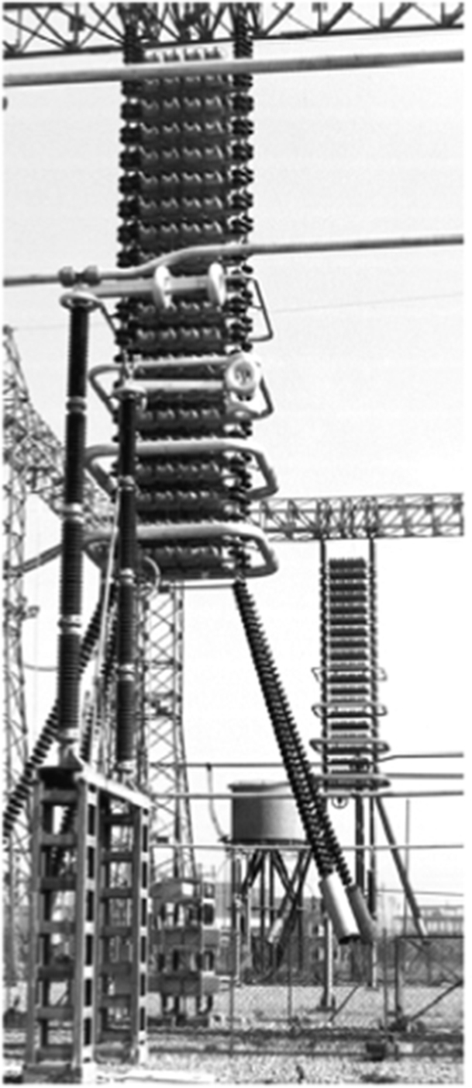

**FIG. 27.7** Installation of an AC filter in the switchyard.

The availability of cost-effective active AC filters will change the scenario in the future.

#### **27.2.3.2 DC Filters**

These are similar to AC filters and are used for the filtering of DC harmonics. Usually, a damped filter at the twenty-fourth harmonic is utilized. Modern practice is to use active DC filters (see also the application example system presented later). Active DC filters are increasingly being used for efficiency and space-saving purposes.

#### **27.2.3.3 High Frequency (RF/PLC) Filters**

These are connected between the converter transformer and the station AC bus to suppress any high-frequency currents. Sometimes, such filters are provided on the high-voltage DC bus connected between the DC filter and DC line and also on the neutral side.

### 27.2.4 REACTIVE POWER SOURCE

Converter stations consume reactive power that is dependent on the active power loading (typically about 50%–60% of the active power). Part of this reactive power requirement is provided by the AC filters. In addition, shunt (switched) capacitors and static var systems are also used.

### 27.2.5 DC SMOOTHING REACTOR

A sufficiently large series reactor is used on the DC side of the converter to smooth the DC current and for the converter protection from line surges. The reactor ([Fig. 27.8](https://learning.oreilly.com/library/view/power-electronics-handbook/9780128114087/B9780128114070000301.xhtml#f0045)) is usually designed as a linear reactor and may be connected on the line side, on the neutral side, or at an intermediate location. Typical values of the smoothing reactor are in the 240–600 mH range for long-distance transmission and about 24 mH for a BB connection.

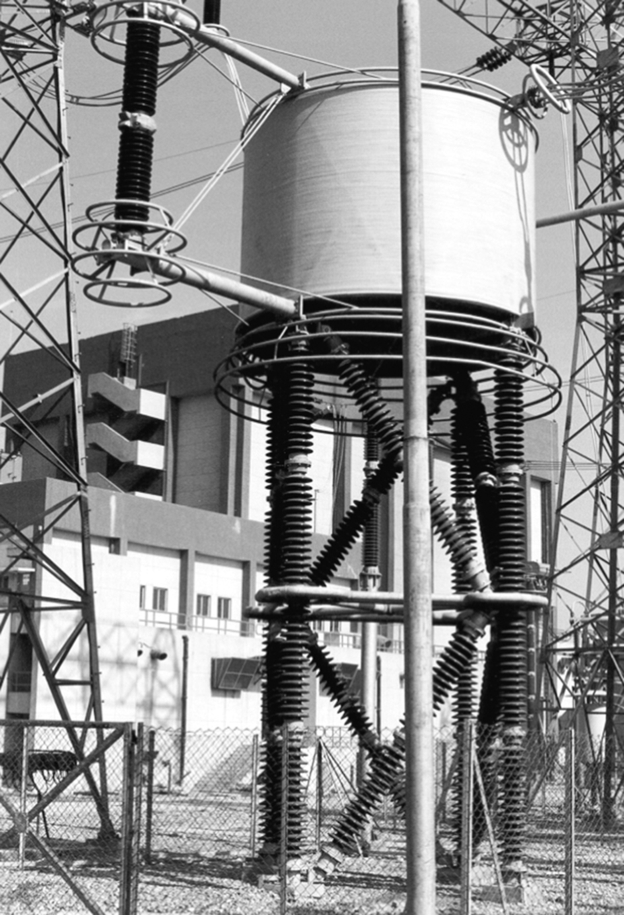

**FIG. 27.8** Installation of an air-cooled smoothing reactor.

### 27.2.6 DC SWITCHGEAR

This is usually modified AC equipment and used to interrupt only small DC currents (i.e., employed as disconnecting switches). DC breakers or metallic return transfer breakers (MRTB) are used, if required, for the interruption of rated load currents.

In addition to the equipment described above, AC switchgear and associated equipment for protection and measurement are also part of the converter station.

### 27.2.7 DC CABLES

Contrary to the use of AC cables for transmission, DC cables do not have a requirement for continuous charging current. Hence, the length limit of about 50 km does not apply. Moreover, DC voltage gives less aging and hence a longer lifetime for the cable. The new design of HVDC Light cables from ABB is based on extruded polymeric insulating material instead of classic paper-oil insulation that has a tendency to leak. Due to their rugged mechanical design, flexibility, and low weight, polymer cables can be installed underground cheaply with a plowing technique or, in submarine applications, can be laid in very deep waters and on rough sea bottoms. Since DC cables are operated in bipolar mode, one cable with positive polarity and one cable with negative polarity, very limited magnetic fields result from the transmission. HVDC Light cables have successfully achieved operation at a stress of 20 kV/mm.

## 27.3 Analysis of Converter Bridge

To consider the theoretical analysis of a conventional six-pulse bridge ([Fig. 27.9](https://learning.oreilly.com/library/view/power-electronics-handbook/9780128114087/B9780128114070000301.xhtml#f0050)), the following assumptions are made:

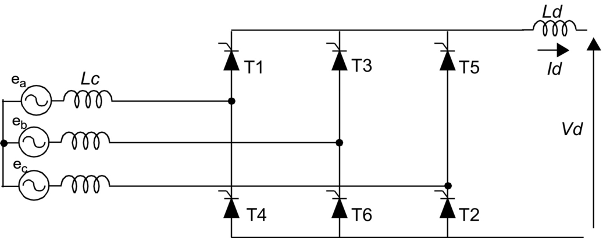

**FIG. 27.9** Six-pulse bridge circuit.

– DC current *Id* is considered constant.

– Valves are ideal switches.

– AC system is strong (infinite).

Due to the leakage impedance of the converter transformer, commutation from one valve to the next is not instantaneous. An overlap period is necessary, and depending on the leakage, either two, three, or four valves may conduct at any time. In the general case, with a typical value of converter transformer leakage impedance of about 13%–18%, either two or three valves conduct at any one time.

The analysis of the bridge gives the following DC output voltages:

For a rectifier:

 **(27.1)**

where 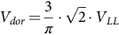 and 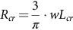.

For an inverter:

There are two options possible depending on choice of the delay angle or extinction angle as the control variable:

 **(27.2)**

**** **(27.3)**

where

*Vdr* and *Vdi*—DC voltage at the rectifier and inverter, respectively

*Vdor* and *Vdoi*—open-circuit DC voltage at the rectifier and inverter, respectively

*Rcr* and *Rci*—equivalent commutation resistance at the rectifier and inverter, respectively

*Lcr* and *Lci*—leakage inductance of converter transformer at rectifier and inverter, respectively

*Id*—DC current

*α*—delay angle

*β*—advance angle at the inverter (*β*=*π*−*α*)

*γ*—extinction angle at the inverter (*γ*=*π*−*α*−*μ*)

## 27.4 Controls and Protection

In a typical two-terminal DC link connecting two AC systems ([Fig. 27.10](https://learning.oreilly.com/library/view/power-electronics-handbook/9780128114087/B9780128114070000301.xhtml#f0055)), the primary functions of the DC controls are to

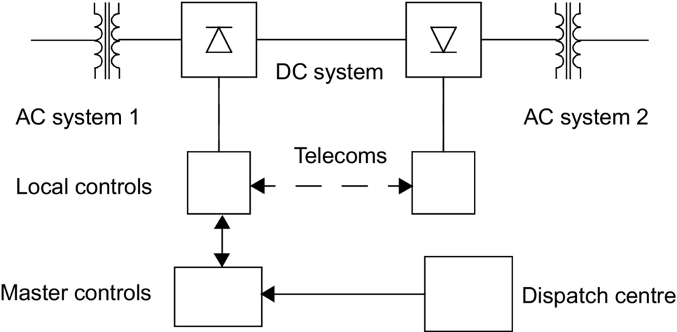

**FIG. 27.10** Typical HVDC system linking two AC systems.

• control power flow between the terminals,

• protect the equipment against the current/voltage stresses caused by faults,

• stabilize the attached AC systems against any operational mode of the DC link.

The DC terminals each have their own local controllers. A centralized dispatch center will communicate a power order to one of the terminals that will act as a master controller and has the responsibility to coordinate the control functions of the DC link. Besides the primary functions, it is desirable that the DC controls have the following features:

• Limit the maximum DC current

Due to a limited thermal inertia of the thyristor valves to sustain overcurrents, the maximum DC current is usually limited to less than 1.2 pu for a limited period of time.

• Maintain a maximum DC voltage for transmission

This reduces the transmission losses and permits optimization of the valve rating and insulation.

• Minimize reactive power consumption

This implies that the converters must operate at a low firing angle. A typical converter will consume reactive power between 50% and 60% of its MW rating. This amount of reactive power supply can cost about 15% of the station cost and comprise about 10% of the power loss.

The desired features of the DC controls are indicated below:

1. Limit maximum DC current—Since the thermal inertia of the converter valves is quite low, it is desirable to limit the DC current to prevent failure in the valves.

2. Maintain maximum DC voltage for transmission purposes to minimize losses in the DC line and converter valves.

3. Keep the AC reactive power demand low at either converter terminal. This implies that the operating angles at the converters must be kept low. Additional benefits of doing this are to reduce the snubber losses in the valves and reduce the generation of harmonics.

4. Prevent commutation failures at the inverter station and hence improve the stability of power transmission.

5. Other features, that is, the control of frequency in an isolated AC system or enhanced power system stability.

In addition to the above desired features, the DC controls will have to cope with the steady-state and dynamic requirements of the DC link, as shown in [Table **27.2**](https://learning.oreilly.com/library/view/power-electronics-handbook/9780128114087/B9780128114070000301.xhtml#t0015).

**Table 27.2**

**Requirements of the DC link**

|  |  |
| --- | --- |
| **Steady-state requirements** | **Dynamic requirements** |
| Limit the generation of noncharacteristic harmonics | Step changes in DC current or power flow |
| Maintain the accuracy of the controlled variable, that is, DC current and/or constant extinction angle | Start-up and fault-induced transients |
| Cope with the normal variations in the AC system impedances due to topology changes | Reversal of power flow |
|  | Variation in frequency of attached AC system |

### 27.4.1 BASICS OF CONTROL FOR A TWO-TERMINAL DC LINK

From converter theory, the relationship between the DC voltage *Vd* and DC current *Id* is given by Eqs. [(27.1)](https://learning.oreilly.com/library/view/power-electronics-handbook/9780128114087/B9780128114070000301.xhtml#fo0010)–[(27.3)](https://learning.oreilly.com/library/view/power-electronics-handbook/9780128114087/B9780128114070000301.xhtml#fo0020). These three characteristics represent straight lines on the *Vd*-*Id* plane. Notice that Eq. [(27.2)](https://learning.oreilly.com/library/view/power-electronics-handbook/9780128114087/B9780128114070000301.xhtml#fo0015), that is, beta characteristic, has a positive slope, while the Eq. [(27.3)](https://learning.oreilly.com/library/view/power-electronics-handbook/9780128114087/B9780128114070000301.xhtml#fo0020), that is, gamma characteristic, has a negative slope. The choice of the control strategy for a typical two-terminal DC link is made according to conditions in [Table **27.3**](https://learning.oreilly.com/library/view/power-electronics-handbook/9780128114087/B9780128114070000301.xhtml#t0020).

**Table 27.3**

**Choice of control strategy for two-terminal DC link**

|  |  |  |  |
| --- | --- | --- | --- |
| **Condition No.** | **Desirable features** | **Reason** | **Control implementation** |
| 1 | Limit the maximum DC current, *Id* | For the protection of valves | Use constant current control at the rectifier |
| 2 | Employ the maximum DC voltage, *Vd* | For reducing power transmission losses | Use constant voltage control at the inverter |
| 3 | Reduce the incidence of commutation failures | For stability purposes | Use minimum extinction angle control at inverter |
| 4 | Reduce reactive power consumption at the converters | For voltage regulation and economic reasons | Use minimum firing angles |

Condition [(27.1)](https://learning.oreilly.com/library/view/power-electronics-handbook/9780128114087/B9780128114070000301.xhtml#fo0010) implies the use of the rectifier in constant current control mode. And condition [(27.3)](https://learning.oreilly.com/library/view/power-electronics-handbook/9780128114087/B9780128114070000301.xhtml#fo0020) implies the use of the inverter in constant extinction angle (CEA) control mode. Other control modes may be used to enhance the power transmission during contingency conditions depending upon applications. This control strategy is illustrated in [Fig. 27.11](https://learning.oreilly.com/library/view/power-electronics-handbook/9780128114087/B9780128114070000301.xhtml#f0060).

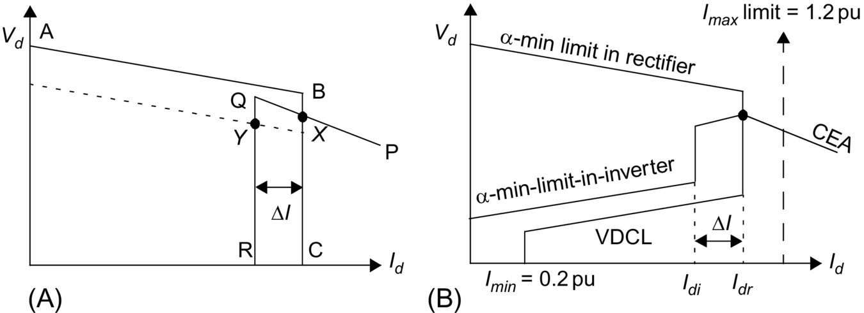

**FIG. 27.11** Static *Vd*-*Id* characteristic for a two-terminal link: (A) unmodified and (B) modified.

The rectifier characteristic is composed of two control modes: alpha-min (line AB) and constant current (line BC). The alpha-min mode of control at the rectifier is imposed by the natural characteristics of the rectifier AC system and the ability of the valves to operate at alpha equal to zero, that is, in the limit, the rectifier acts as a diode rectifier. However, since a minimum positive voltage is desired before firing of the valves to ensure conduction, an alpha-min limit of about 2–5 degrees is typically imposed.

The inverter characteristic is composed of two modes: gamma-min (line PQ) and constant current (line QR). The operating point for the DC link is defined by the crossover point X of the two characteristics. In addition, a constant current characteristic is also used at the inverter. However, the current demanded by the inverter *Idi* is usually less than the current demanded by the rectifier *Idr* by the current margin Δ*I* that is typically about 0.1 pu; its magnitude is selected to be large enough so that the rectifier and inverter constant current modes do not interact due to any current harmonics that may be superimposed on the DC current. This control strategy is termed the current margin method.

The advantage of this control strategy becomes evident if there is a voltage decrease at the rectifier AC bus. The operating point then moves to point Y. This way, the current transmitted will be reduced to 0.9 pu of its previous value, and voltage control will shift to the rectifier. However, the power transmission will be largely maintained near to 90% of its original value.

The control strategy usually employs the following other modifications to improve the behavior during system disturbances:

At the rectifier:

1. Voltage-dependent current limit, VDCL

This modification is made to limit the DC current as a function of either the DC voltage or, in some cases, the AC voltage. This modification assists the DC link to recover from faults. Variants of this type of VDCL do exist. In one variant, the modification is a simple fixed value instead of a sloped line.

2. Id-min limit

This limitation (typically 0.2–0.3 pu) is to ensure a minimum DC current to avoid the possibility of DC current extinction caused by the valve current dropping below the hold-on current of the thyristors, an eventuality that could arise transiently due to harmonics superimposed on the low value of DC current. The resultant current chopping would cause high overvoltages to appear on the valves. The magnitude of *Id*-min is affected by the size of the smoothing reactor employed.

At the inverter:

1. Alpha-min limit at inverter

The inverter is usually not permitted to operate inadvertently in the rectifier region, that is, a power reversal occurring due to, say, an inadvertent current margin sign change. To ensure this, an alpha-min limit in inverter mode of about 100–110 degrees is imposed.

2. Current error region

When the inverter operates into a weak AC system, the slope of the CEA control mode characteristic is quite steep and may cause multiple crossover points with the rectifier characteristic. To avoid this possibility, the inverter CEA characteristic is usually modified into either a constant beta characteristic or a constant voltage characteristic within the current error region.

### 27.4.2 CONTROL IMPLEMENTATION

#### **27.4.2.1 Historical Background**

The *equidistant pulse firing control* systems used in modern HVDC control systems were developed in the mid-1960s [[5](https://learning.oreilly.com/library/view/power-electronics-handbook/9780128114087/B9780128114070000301.xhtml#bb0030),[6](https://learning.oreilly.com/library/view/power-electronics-handbook/9780128114087/B9780128114070000301.xhtml#bb0035)]; although improvements have occurred in their implementation since then, such as the use of microprocessor-based equipment, their fundamental philosophy has not changed much. The control techniques described in Refs. [[5](https://learning.oreilly.com/library/view/power-electronics-handbook/9780128114087/B9780128114070000301.xhtml#bb0030),[6](https://learning.oreilly.com/library/view/power-electronics-handbook/9780128114087/B9780128114070000301.xhtml#bb0035)] are of the *pulse frequency control* (PFC) type as opposed to the now-out-of-favor *pulse phase control* (PPC) type. All these controls use an independent *voltage-controlled oscillator* (VCO) to decouple the direct coupling between the firing pulses and the commutation voltage, *Vcom*. This decoupling was necessary to eliminate the possibility of harmonic instability detected in the converter operation when the AC system capacity became nearer to the power transmission capacity of the HVDC link, that is, with the use of weak AC systems. Another advantage of the equidistant firing pulse controls was the elimination of noncharacteristic harmonics during steady-state operation. This was a prevalent feature during the use of the earlier *individual phase control* (IPC) system where the firing pulses were directly coupled to the commutation voltage, *Vcom*.

#### **27.4.2.2 Firing Angle Control**

To control the firing angle of a converter, it is necessary to synchronize the firing pulses emanating from the ring counter to the AC commutation voltage that has a frequency of 60 Hz in steady state. However, it was noted quite early on (the early 1960s) that the commutation voltage (system) frequency is not a constant, neither in frequency nor amplitude, during a perturbed state. However, it is the frequency that is of primary concern for the synchronization of firing pulses. For strong AC systems, the frequency is relatively constant and distortion free to be acceptable for most converter type applications. But as converter connections to weak AC systems became required more often than not, it was necessary to devise a scheme for synchronization purposes that would be *decoupled* from the commutation voltage frequency for durations when there were perturbations occurring on the AC system. The most obvious method is to utilize an *independent oscillator* at 60 Hz, which can be *synchronously locked* to the AC commutation voltage frequency. This oscillator would then provide the (phase) reference for the generation of firing pulses to the ring counter during the perturbation periods and would use the steady-state periods for locking in step with the system frequency. The advantage of this independent oscillator would be to provide an ideal (immunized and clean) sinusoid for synchronizing and timing purposes. There are two possibilities for this independent oscillator:

• Fixed-frequency operation

• Variable frequency operation

Use of a fixed-frequency oscillator (although feasible and called the pulse phase control oscillator) is not recommended, since it is known that the system frequency does drift, between say 55 and 65 Hz, due to the rotating machines used to generate electricity. Therefore, it is preferable to use a variable frequency oscillator (called the pulse frequency control oscillator) with a locking range of between 50 and 70 Hz and the center frequency of 60 Hz. This oscillator would then need to track the variations in the system frequency, and a control loop of some sort would be used for this tracking feature; this control loop would have its own gain and time parameters for steady-state accuracy and dynamic performance requirements.

The control loop for frequency tracking purposes would also need to consider the mode of operation for the DC link. The method widely adopted for DC-link operation is the so-called current margin method.

### 27.4.3 CONTROL LOOPS

Control loops are required to track the following variables:

(a) The ordered current *Ior* at the rectifier and the inverter

(b) The ordered extinction angle (*γo*) at the inverter

#### **27.4.3.1 Current Control Loops**

In conventional HVDC systems, a PI regulator is used ([Fig. 27.12](https://learning.oreilly.com/library/view/power-electronics-handbook/9780128114087/B9780128114070000301.xhtml#f0065)) for the rectifier current controller. The rectifier plant system is inherently nonlinear and has a relationship given in Eq. [(27.1)](https://learning.oreilly.com/library/view/power-electronics-handbook/9780128114087/B9780128114070000301.xhtml#fo0010). For constant *Id* and for small changes in *α*, we have

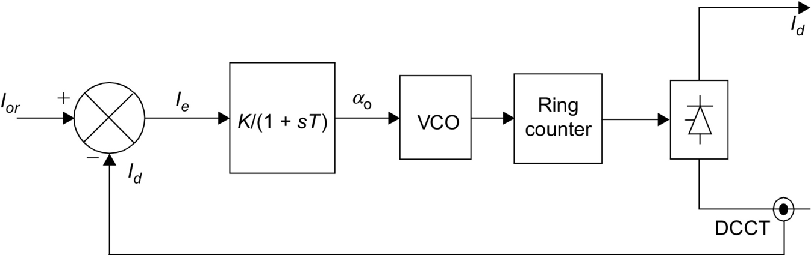

**FIG. 27.12** Control loop for the rectifier.

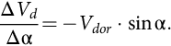 **(27.4)**

It is obvious from Eq. [(27.4)](https://learning.oreilly.com/library/view/power-electronics-handbook/9780128114087/B9780128114070000301.xhtml#fo0025) that the maximum gain (Δ*Vd*/Δ*α*) occurs when *α*=90 degrees. Thus, the control loop must be stabilized for this operation point, resulting in slower dynamic properties at normal operation with *α* within the range 12–18 degrees. Attempts have been made to linearize this gain and have met with some limited success. However, in practical terms, it is not always possible to have the DC link operating with the rectifier at 90 degrees due to harmonic generation and other protection elements coming into operation also. Therefore, optimizing the gains of the PI regulator can be quite arduous and take a long time. For this reason, the controllers are often pretested in a physical simulator environment to obtain approximate settings. Final (often very limited) adjustments are then made on-site.

Other problems with the use of a PI regulator are listed below:

• It is mostly used with fixed gains, although some possibility for gain scheduling exists.

• It is difficult to select optimal gains, and even then, they are optimal over a limited range only.

• Since the plant system is varying continually, the PI controller is not optimal.

A similar current control loop is used at the inverter ([Fig. 27.13](https://learning.oreilly.com/library/view/power-electronics-handbook/9780128114087/B9780128114070000301.xhtml#f0070)). Since the inverter also has a gamma controller, the selection between these two controllers is made via a MINIMUM SELECT block. Moreover, in order to bias the inverter current controller off, a current margin signal ΔI is subtracted from the current reference Ior received from the rectifier via a communication link.

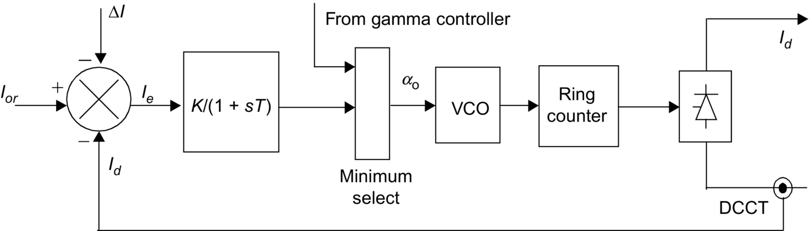

**FIG. 27.13** Current controller at the inverter.

##### **Telecommunication requirements**

As was discussed above, the rectifier and inverter current orders must be coordinated to maintain a current margin of about 10% between the two terminals at all times; otherwise, there is a risk of loss of margin, and the DC voltage could run down. Although, it is possible to use slow voice communication between the two terminals and maintain this margin, the advantage of fast control action possible with converters may be lost for protection purposes. For maintaining the margin during dynamic conditions, it is prudent to raise the current order at the rectifier first followed by the inverter; in terms of reducing the current order, it is necessary to reduce at the inverter first and then at the rectifier.

#### **27.4.3.2 Gamma Control Loop**

At the inverter end, there are two known methods for the gamma control loop. The two variants are different only due to the method of determining the extinction angle:

– Predictive method for the indication of extinction angle (gamma)

– Direct method for actual measurement of extinction angle (gamma)

In either case, a delay of one cycle occurs from the indication of actual gamma and the reaction of the controller to this measurement. Since the avoidance of a commutation failure often takes precedence at the inverter, it is normal to use the minimum value of gamma measured for the 6 or 12 inverter valves for the converter(s).

1. *Predictive method of measuring gamma*

The predictive measurement tries to maintain the commutation *voltage-time area after commutation* larger than a specified minimum value. Since the gamma prediction is only approximative, the method is corrected by a slow feedback loop that calculates the error between the predicted value and actual value of gamma (one cycle later) and feeds it back.

The predictor calculates continuously, by a triangular approximation, the total available voltage-time area that remains after commutation is finished. Since an estimate of the overlap angle μ is necessary, it is derived from a well-known fact in converter theory that the overlap commutation voltage-time area is directly proportional to direct current and leakage impedance (assumed constant and known) value of the converter transformer.

The prediction process is inherently of an individual phase firing character. If no further measures are taken, each valve would fire on the minimum margin condition. To counteract this undesired property, a special firing symmetrizer is used; when one valve has fired on the minimum margin angle, the following two or five valves fire equidistantly. (The choice of either two or five symmetrized valves is mainly a stability question.)

2. *Direct method of measuring gamma*

In this method, the gamma measurement is derived from a measurement of the actual valve voltage. Waveforms of the gamma measuring circuit are shown in [Fig. 27.13](https://learning.oreilly.com/library/view/power-electronics-handbook/9780128114087/B9780128114070000301.xhtml#f0070). An internal timing waveform, consisting of a ramp function of fixed slope, is generated after being initiated from the instant of anode current zero. This value corresponds to a direct voltage proportional to the last value of gamma. From the gamma values of all (either 6 or 12) valves, the smallest value is selected to produce the indication of measured gamma for use with the feedback regulator ([Fig. 27.14](https://learning.oreilly.com/library/view/power-electronics-handbook/9780128114087/B9780128114070000301.xhtml#f0075)).

This value is compared with a gamma-ref value, and a PI regulator defines the dynamic properties for the controller. Inherently, this method has an individual phase control characteristic. One version of this type of control implementation overcomes this problem by using a symmetrizer for generating equidistant firing pulses. The 12-pulse circuit generates 12 gamma measurements; the minimum gamma value is selected and then used to derive the control voltage for the firing pulse generator with symmetrical pulses ([Fig. 27.15](https://learning.oreilly.com/library/view/power-electronics-handbook/9780128114087/B9780128114070000301.xhtml#f0080)).

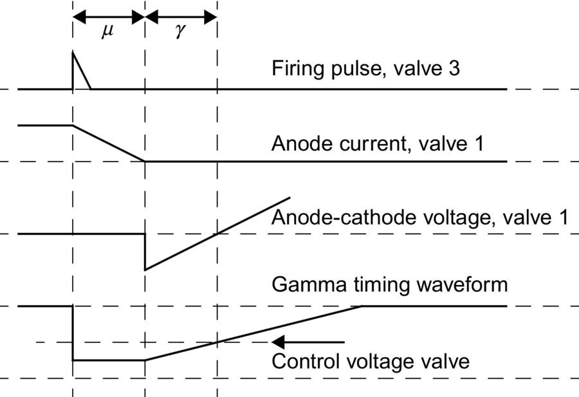

**FIG. 27.14** Waveforms for the gamma measuring circuit [[5](https://learning.oreilly.com/library/view/power-electronics-handbook/9780128114087/B9780128114070000301.xhtml#bb0030)].

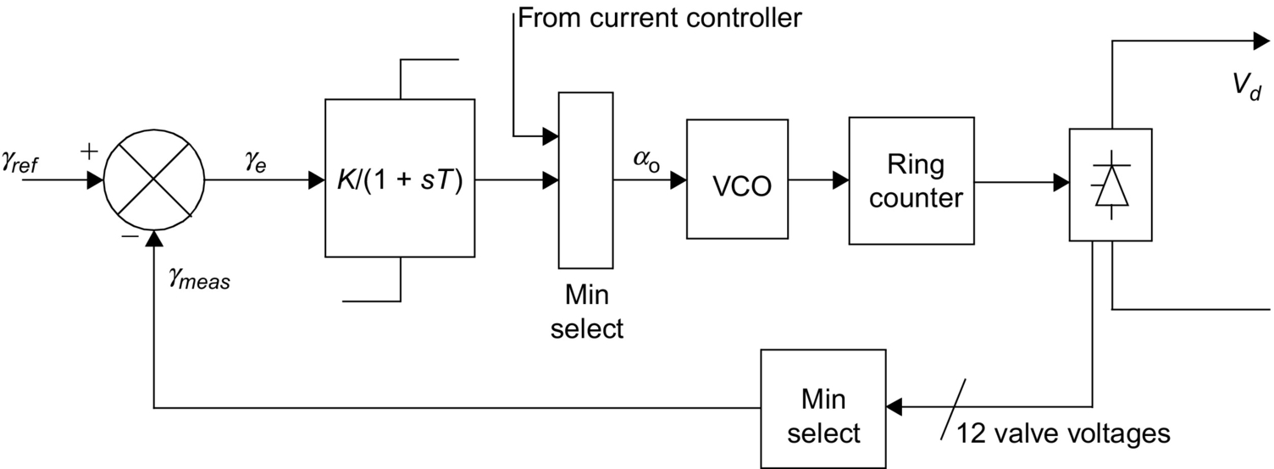

**FIG. 27.15** Gamma feedback controller.

### 27.4.4 HIERARCHY OF DC CONTROLS

Since HVDC controls are hierarchical in nature, they can be subdivided into blocks that follow the major modules of a converter station ([Fig. 27.16](https://learning.oreilly.com/library/view/power-electronics-handbook/9780128114087/B9780128114070000301.xhtml#f0085)). The main control blocks are as follows:

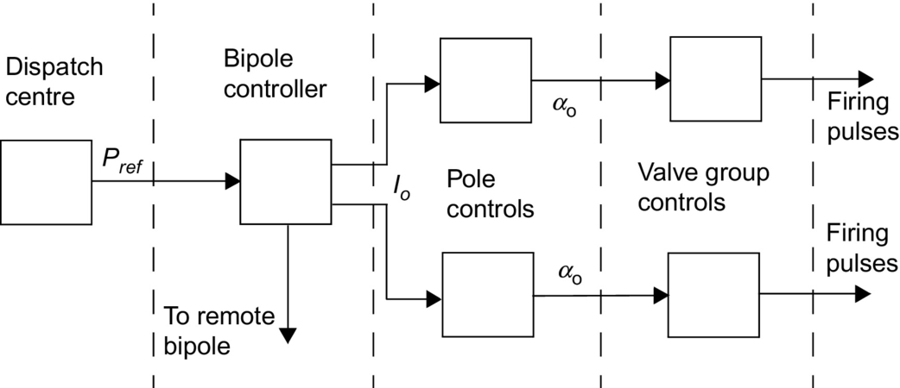

**FIG. 27.16** Hierarchy of controllers.

1. The bipole (master) controller is usually located at one end of the DC link and receives its power order from a centralized system dispatch center. The bipole controller derives a current order for the pole controller using a local measurement of either AC or DC voltage. Other inputs may also be used by the bipole controller such as frequency control for damping or modulation purposes. A communication to the remote terminal of the DC link is also necessary to coordinate the current references to the link.

2. The pole controller then derives an alpha order for the next level. This alpha order is sent to both the positive and negative poles of the bipole.

3. The valve group controllers generate the firing pulses for the converter valves. Controls also receive measurements of DC current, DC voltage, and AC current into the converter transformer. These measurements assist in the rapid alteration of firing angle for protection of the valves during perturbations. A slow loop for control of tap-changer position as a function of alpha is also available at this level.

### 27.4.5 MONITORING OF SIGNALS

As described earlier, monitoring of the following signals is necessary for the controls ([Fig. 27.17](https://learning.oreilly.com/library/view/power-electronics-handbook/9780128114087/B9780128114070000301.xhtml#f0090)) to perform their functions and assist in the protection of the converter equipment:

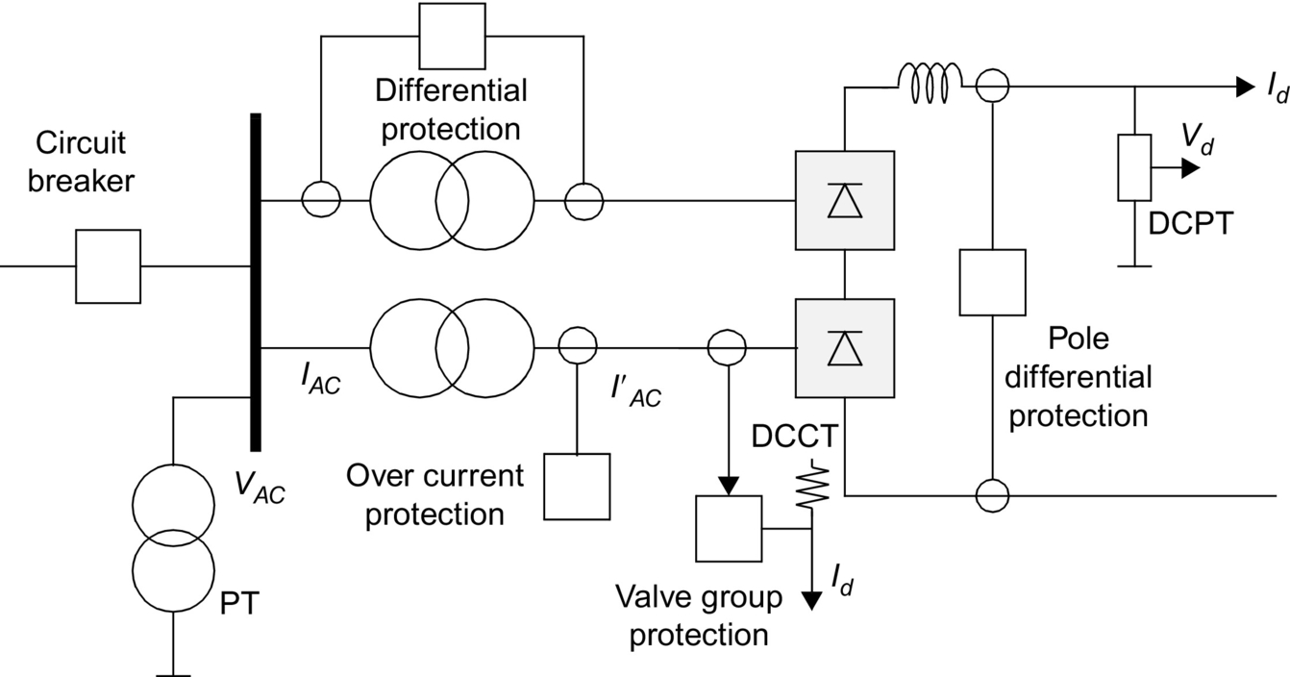

**FIG. 27.17** Monitoring points for the protection circuits.

*Vd* and *Id*—DC voltage and DC current, respectively,

*IAC* and *I′AC*—AC current on line side and converter side of the converter transformer, respectively,

*VAC*—AC voltage at the AC filter bus.

### 27.4.6 PROTECTION AGAINST OVER-CURRENTS

Faults and disturbances can be caused by malfunctioning equipment or insulation failures due to lightening and pollution. First, these faults need to be detected with the help of monitored signals. Second, the equipment must be protected by control or switching actions. Since DC controls can react within one cycle, control action is used to protect equipment against overcurrent and overvoltage stresses and minimize loss of transmission. In a converter station, the valves are the most critical (and most expensive) equipment that need to be protected rapidly due to their limited thermal inertia.

The basic types of faults that the converter station can experience are the following:

• Current extinction (CE)

CE can occur if the valve current drops below the holding current of the thyristor. This can happen at low-current operation accompanied by a transient leading to current extinction. Due to the phenomena of current chopping of an inductive current, severe overvoltages may result. The size of the smoothing reactor and the rectifier minimum current setting *Imin* helps to minimize the occurrence of CE.

• Commutation failure (CF) or misfire

In line-commutated converters, the successful commutation of a valve requires that the extinction angle *γ*-nominal be maintained more than the minimum value of the extinction angle *γ*-min. Note that *γ*-nominal=180−*α*−*μ*. The overlap angle *μ* is a function of the commutation voltage and the DC current. Hence, a decrease in commutation voltage or an increase in DC current can cause an increase in *μ*, resulting in a decrease in *γ*-nominal. If *γ*-nominal<*γ*-min, a CF may result. In this case, the outgoing valve will continue to conduct current, and when the incoming valve is fired in sequence, a short circuit of the bridge will occur.

A missing firing pulse can also lead to a misfire (at a rectifier) or a CF (at an inverter). The effects of a single misfire are similar to those of a single CF. Usually, a single CF is self-clearing, and no special control actions are necessary. However, a multiple CF can lead to the injection of AC voltages into the DC system. Control action may be necessary in this case.

The detection of a CF is based on the differential comparison of DC current and AC currents on the valve side of the converter transformer. During a CF, the two valves in an arm of the bridge are conducting. Therefore, the AC current goes to zero, while the DC current continues to flow.

The protection features employed to counteract the impact of a CF are indicated in [Table **27.4**](https://learning.oreilly.com/library/view/power-electronics-handbook/9780128114087/B9780128114070000301.xhtml#t0025).

**Table 27.4**

**Protection against overcurrents**

|  |  |  |  |
| --- | --- | --- | --- |
| **Fault type** | **Occurrence** | **Fault current level** | **Protection method** |
| Internal faults | Infrequent | 10 pu | Valve is rated to withstand this surge |
| DC line faults | Frequent | 2–3 pu | – Forced retard of firing angle  – Dynamic VDCL deployment  – Trip AC breaker CB after third attempt |
| Commutation failures (single or multiple) | Very frequent | 1.5–2.5 pu | Single CF:  – Self-clearing  Multiple CF:  – Beta angle advanced in stages  – Static VDCL deployment |

• Short circuits—internal or DC line

An internal bridge fault is rare as the valve hall is completely enclosed and is air-conditioned. However, a bushing can fail, or valve cooling water may leak resulting in a short circuit. The AC breaker may have to be tripped to protect against bridge faults.

The protection features employed to counteract the impact of short circuits are indicated in [Table **27.4**](https://learning.oreilly.com/library/view/power-electronics-handbook/9780128114087/B9780128114070000301.xhtml#t0025).

The fast-acting HVDC controls (which operate within one cycle) are used to regulate the DC current for protection of the valves against AC and DC faults.

The basic protection ([Fig. 27.18](https://learning.oreilly.com/library/view/power-electronics-handbook/9780128114087/B9780128114070000301.xhtml#f0095)) is provided by the VGP differential protection that compares the rectified current on the valve side of the converter transformer with the DC current measured on the line side of the smoothing reactor. This method is applied because of its selectivity possible due to high impedances in the smoothing reactor and converter transformer.

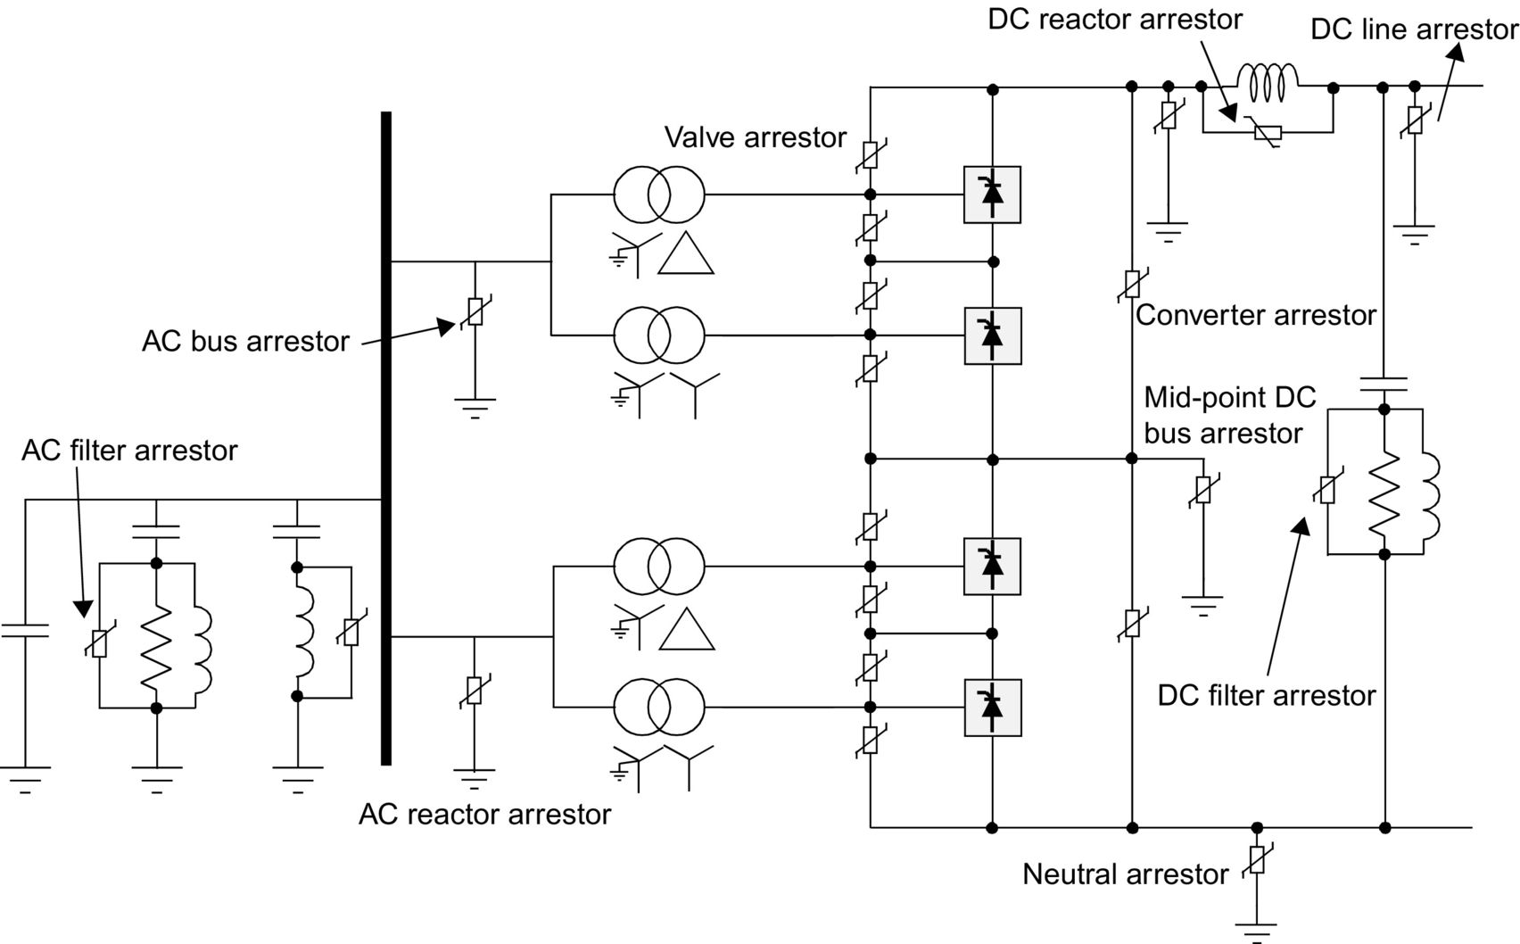

**FIG. 27.18** Typical arrangement of surge arrestors for a converter pole.

The OCP is used as a backup protection in case of malfunction in the VGP. The level of overcurrent setting is set higher than the differential protection.

The pole differential protection (PDP) is used to detect ground faults, including faults in the neutral bus.

### 27.4.7 PROTECTION AGAINST OVER-VOLTAGES

The typical arrangement of metal oxide surge arrestors for protecting equipment in a converter pole is shown in [Fig. 27.18](https://learning.oreilly.com/library/view/power-electronics-handbook/9780128114087/B9780128114070000301.xhtml#f0095). In general, overvoltages entering from the AC bus are limited by the AC bus arrestors; similarly, overvoltages entering the converter from the DC line are limited by the DC arrestor. The AC and DC filters have their respective arrestors also. Critical components such as the valves have their own arrestors placed close to these components. The protective firing of a valve is used as a backup protection for overvoltages in the forward direction. Owing to their varied duty, these arrestors are rated accordingly for the location used. For instance, the converter arrestor for the upper bridge is subjected to a higher energy dissipation than for the lower bridge.

Since the evaluation of insulation coordination is quite complex, detailed studies are often required with DC simulators to design an appropriate insulation coordination strategy.

## 27.5 MTDC Operation

Most HVDC transmission systems are two-terminal systems. A multiterminal DC system (MTDC) has more than two terminals, and there are two existing installations of this type. There are two possible ways of tapping power from an HVDC link, that is, with series or parallel taps.

### 27.5.1 SERIES TAP

A monopolar version of a three-terminal series DC link is shown in [Fig. 27.19](https://learning.oreilly.com/library/view/power-electronics-handbook/9780128114087/B9780128114070000301.xhtml#f0100). The system is grounded at only one suitable location. In a series DC system, the DC current is set by one terminal and is common to all terminals; the other terminals are operated at a constant delay angle for a rectifier and constant extinction angle for inverter operation with the help of transformer tap changers.

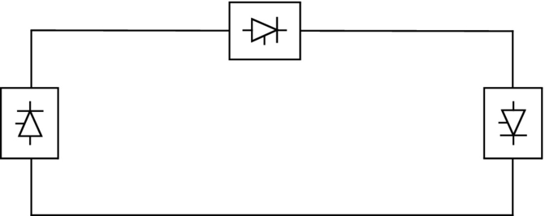

**FIG. 27.19** Series tap.

Power reversal at a station is done by reversing the DC voltage with the aid of angle control.

No practical installation of this type exists in the world at present. From an evaluation of ratings and costs for series taps, it is not practical for the series tap to exceed 20% of the rating for a major terminal in the MTDC system.

### 27.5.2 PARALLEL TAP

A monopolar version of a three-terminal parallel DC link is shown in [Fig. 27.20](https://learning.oreilly.com/library/view/power-electronics-handbook/9780128114087/B9780128114070000301.xhtml#f0105). In a parallel MTDC system, the system voltage is common to all terminals. There are two variants possible for a parallel MTDC system: radial or mesh. In a radial system, disconnection of one segment of the system will interrupt power from one or more terminals. In a mesh system, the removal of one segment will not interrupt power flow providing the remaining links are capable of carrying the required power.

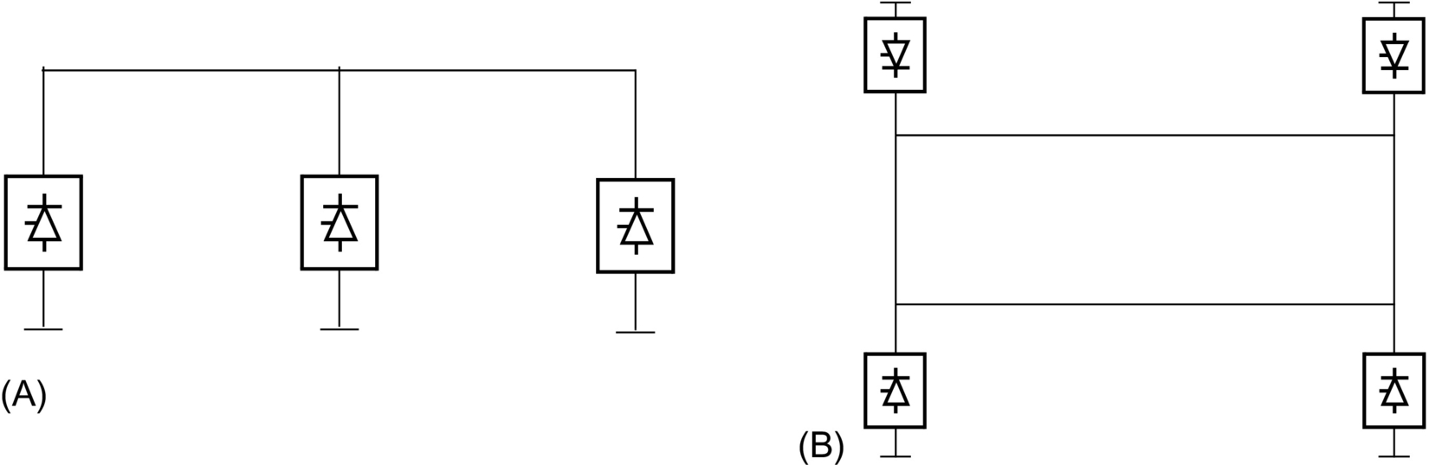

**FIG. 27.20** Parallel tap: (A) radial type and (B) mesh type.

Power reversal in a parallel system will require mechanical switching of the links as the DC voltage cannot be reversed.

From an evaluation of ratings and costs for parallel taps, it is not practical for the parallel tap to be less than 20% of the rating for a major terminal in the MTDC system.

There are two installations of parallel taps existing in the world. The first is the Sardinia-Corsica-Italy link where a 50 MW parallel tap at Corsica is used. Since the principal terminals are rated at 200 MW, a commutation failure at Corsica can result in very high overcurrents (typically 7 pu); for this reason, large smoothing reactors (2.5 H) are used in this link.

The second installation is the Quebec-New Hampshire 2000 MW link where a parallel tap is used at Nicolet. Since the rating of Nicolet is at 1800 MW, the size of the smoothing reactors was kept to a modest size.

### 27.5.3 CONTROL OF MTDC SYSTEM

Although several control methods exist for controlling MTDC systems, the most widely utilized method is the so-called current margin method that is an extension of the control method used for two-terminal DC systems.

In this method, the voltage setting terminal (VST) operates at the angle limit (minimum alpha or minimum gamma), while the remaining terminals are controlling their respective currents. The control law that is used sets the current reference at the voltage setting terminal according to

 **(27.5)**

where Δ*I* is known as the current margin.

The terminal with the lowest voltage ceiling acts as the VST.

An example of the control strategy is shown in [Fig. 27.21](https://learning.oreilly.com/library/view/power-electronics-handbook/9780128114087/B9780128114070000301.xhtml#f0110) for a three-terminal DC system with one rectifier REC and two inverters, INV1 at 40% and INV2 at 60% rating. The REC1 and INV2 terminals are maintained in current control, while INV1 is the VST operating in CEA mode.

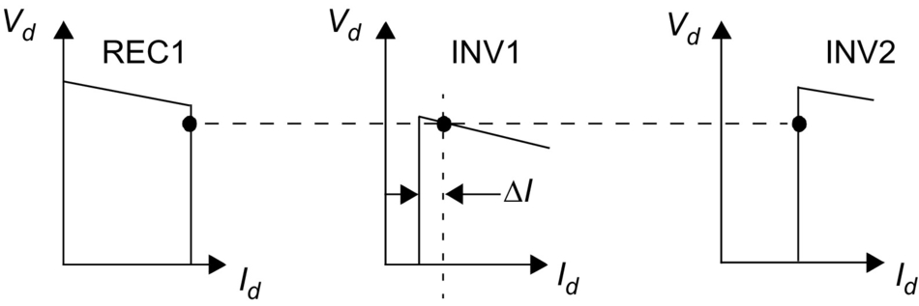

**FIG. 27.21** Current margin method of control for MTDC system.

Due to the requirement to maintain current margin for the MTDC system at all times, a centralized current controller, known as the current reference balancer (CRB) ([Fig. 27.22](https://learning.oreilly.com/library/view/power-electronics-handbook/9780128114087/B9780128114070000301.xhtml#f0115)), is required. With this technique, reliable two-way telecommunication links is required for current reference coordination purposes. The current orders, *Iref*1–*Iref*3, at the terminals must satisfy the control law according to Eqs. [(27.5)](https://learning.oreilly.com/library/view/power-electronics-handbook/9780128114087/B9780128114070000301.xhtml#fo0030) and [(27.6)](https://learning.oreilly.com/library/view/power-electronics-handbook/9780128114087/B9780128114070000301.xhtml#fo0035). The weighting factors (*K*1, *K*2, and *K*3) and limits are selected as a function of the relative ratings of the terminals.

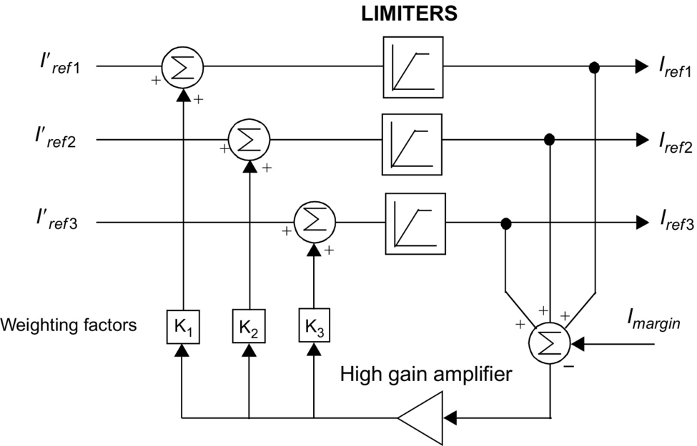

**FIG. 27.22** Current reference balancer.

## 27.6 Application

### **27.6.1 HVDC INTERCONNECTION AT GURUN (MALAYSIA)**

The 240/600 MW HVDC interconnection between Malaysia and Thailand is a major first step in implementing electric power network interconnections in the ASEAN region. It is jointly undertaken by two utilities, Tenaga Nasional Berhad (TNB) of Malaysia and Electricity Generating Authority of Thailand (EGAT). This will be the first HVDC project for both these utilities. The HVDC interconnection consists of a 110 km HVDC line (85 km owned by TNB and 25 km owned by EGAT) with the DC converter stations at Gurun on the Malaysian side and Khlong Ngae on the Thailand side. The scheme entered into commercial operation in July 2000. The interconnection provides a range of diverse benefits such as

• spinning reserve sharing,

• economic power exchange-commercial transactions,

• emergency assistance to either AC system,

• damping of AC system oscillations,

• reactive power support (voltage control),

• deferment of generation plant up.

#### **27.6.1.1 Power Transmission Capacity**

The converter station is presently constructed for monopolar operation for power transfer of 240 MW in both directions with provisions for future extensions to a bipole configuration giving a total power-transfer capability of 600 MW. The HVDC line is constructed with two pole conductors to cater for the second 240 MW pole. Full-length neutral conductors are used instead of ground electrodes because of high land costs and inherently high values of soil resistivity.

The monopole is rated for a continuous power of 240 MW (240 kV and 1000 A) at the DC terminal of the rectifier station. In addition, there is a 10 min overload capability of up to 450 MW, which may be utilized once per day when all redundant cooling equipment is in service.

The HVDC interconnection scheme is capable of continuous operation at a reduced DC voltage of 210 kV (70%) over the whole load range up to the rated DC current of 1000 A with all redundant cooling equipment in service.

#### **27.6.1.2 Performance Requirements**

A high degree of energy availability was a major design objective ([Fig. 27.23](https://learning.oreilly.com/library/view/power-electronics-handbook/9780128114087/B9780128114070000301.xhtml#f0120)). Guaranteed targets for both stations are the following:

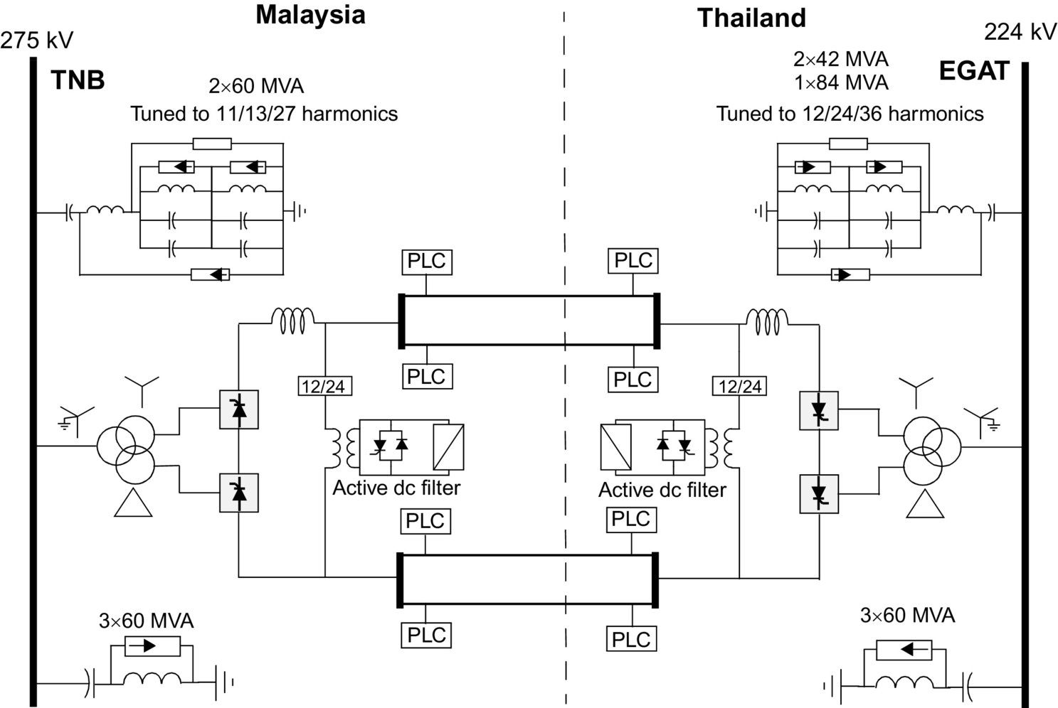

**FIG. 27.23** One-line diagram of the HVDC interconnection between Malaysia and Thailand.

• Energy availability: >99.5%

• Forced energy unavailability: <0.43%

• Forced outage rate: <5.4 outages per year

#### **27.6.1.3 Technical Information**

See [Table **27.6**](https://learning.oreilly.com/library/view/power-electronics-handbook/9780128114087/B9780128114070000301.xhtml#t0035).

#### **27.6.1.4 Major Technical Features**

The station incorporates the latest state-of-the-art technology in power electronics and control equipment. The features include the following:

• A fully decentralized control and protection system

• Active DC filter technology

• Hybrid DC current shunt measuring devices

• Triple-tuned AC filter

## 27.7 Modern Trends

### **27.7.1 CONVERTER STATION DESIGN OF THE 2000S**

The 1500 MW, ±500 kV Rihand-Delhi HVDC transmission system (commissioned in 1991) serves as an example of a typical design of the last decade. Its major design aspects were the following:

• Stations employ water-cooled valves of indoor design with the valves arranged as three quadruple valves suspended from the ceiling of the valve hall.

• Converter transformers are one-phase, three-winding units situated close to the valve hall with their bushings protruding into the valve hall.

• AC filtering is done with conventional, passive, double-tuned, and high-pass units employing internally fused capacitors and air-cored reactors; these filters are mechanically switched for reactive power control.

• DC filtering is done with conventional, passive units employing a split smoothing reactor consisting of both an oil-filled reactor and an air-cored reactor.

• DCCT measurement is based on a zero-flux principle.

• Control and protection hardware is located in a control room in the service building between the two valve halls. The controls still employed some analog parts, particularly for the protection circuits. The controls were duplicated with an automatic switchover to hot standby for reliability reasons.

This design was done in the 1980s to meet the requirements of the day for increased reliability and performance requirements, that is, availability, reduced losses, higher overload capability, etc. However, these requirements led to increased costs for the system.

The next-generation equipment is now being spearheaded by a desire to reduce costs and make HVDC as competitive as AC transmission. This is being facilitated by the major developments of the past decade that have taken place in power electronics. Therefore, the next-generation HVDC equipment will be influenced by the following.

#### **27.7.1.1 Thyristor Development**

HVDC thyristors are now available with a diameter of 150 mm at a rating of 8–9 kV and power handling capacity of 1500 kW that will lead to a dramatic decrease in the number of series-connected components for a valve with consequential cost reductions and improvement in reliability.

The development of the light-triggered thyristor (LTT) ([Figs. 27.24](https://learning.oreilly.com/library/view/power-electronics-handbook/9780128114087/B9780128114070000301.xhtml#f0125) and [27.25](https://learning.oreilly.com/library/view/power-electronics-handbook/9780128114087/B9780128114070000301.xhtml#f0130)) is likely to eliminate the electronic unit (with their high number of electronic components) for generating the firing pulses for the thyristor ([Fig. 27.26](https://learning.oreilly.com/library/view/power-electronics-handbook/9780128114087/B9780128114070000301.xhtml#f0135)). The additional functional requirements of monitoring and protection of the device are being incorporated also.

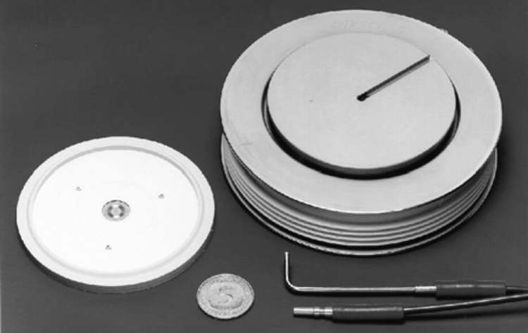

**FIG. 27.24** Silicon wafer and construction of the LTT. The light guides appear in the bottom right-hand corner.

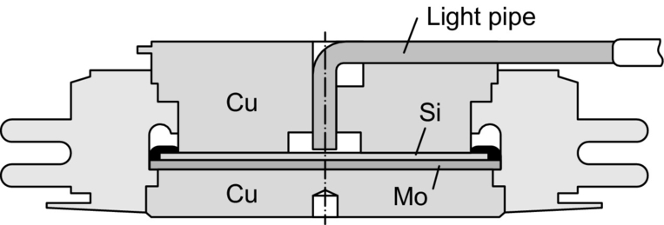

**FIG. 27.25** Cross section of the LTT with the light pipe entry.

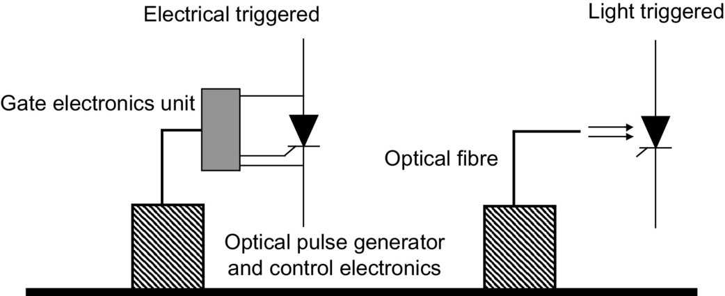

**FIG. 27.26** Conventional firing versus light-triggered firing.

Both of the above developments present the possibility of achieving compact valves that can be packaged for outdoor construction, thereby reducing the overall cost and reliability of the station.

#### **27.7.1.2 Higher DC Transmission Voltages**

For long-distance transmission, there is a tendency to use a high voltage to minimize the losses. The typical transmission voltage has been ±500 kV, although the Itaipu project in Brazil uses 600 kV. The transmission voltage has to balance against the cost of insulation. The industry is considering raising the voltage to ±800 kV.

#### **27.7.1.3 Controls**

It is now possible to operate an HVDC scheme into an extremely weak AC system, even with short-circuit capacity down to unity.

Using programmable DSPs has resulted in a compact and modular design that is low cost; furthermore, the number of control cubicles has decreased by a factor of almost 10 times in the past decade. Now, all control functions are implemented on digital platforms. The controls are fully integrated having monitoring, control, and protection features. The design incorporates self-diagnostic and supervisory characteristics. The controls are optically coupled to the control room for reliable operation. Redundancy and duplication of controls is resulting in very high reliability and availability of the equipment.

#### **27.7.1.4 Outdoor Valves**

The introduction of air-insulated, outdoor valves will reduce costly requirements for a valve hall. The use of a modular, compact design that will be preassembled in the manufacturing plant will save installation time and provide for a flexible station layout. This design has been feasible because of development of a composite insulator for DC applications that is used as a communication channel for fiber optics, cooling water, and ventilation air between the valve unit and ground.

#### **27.7.1.5 Active DC Filters**

This development, made possible due to advances in power electronics and microprocessors, has resulted in a more efficient DC filter operating over a wide spectrum of frequencies and provides a compact design ([Fig. 27.27](https://learning.oreilly.com/library/view/power-electronics-handbook/9780128114087/B9780128114070000301.xhtml#f0140)).

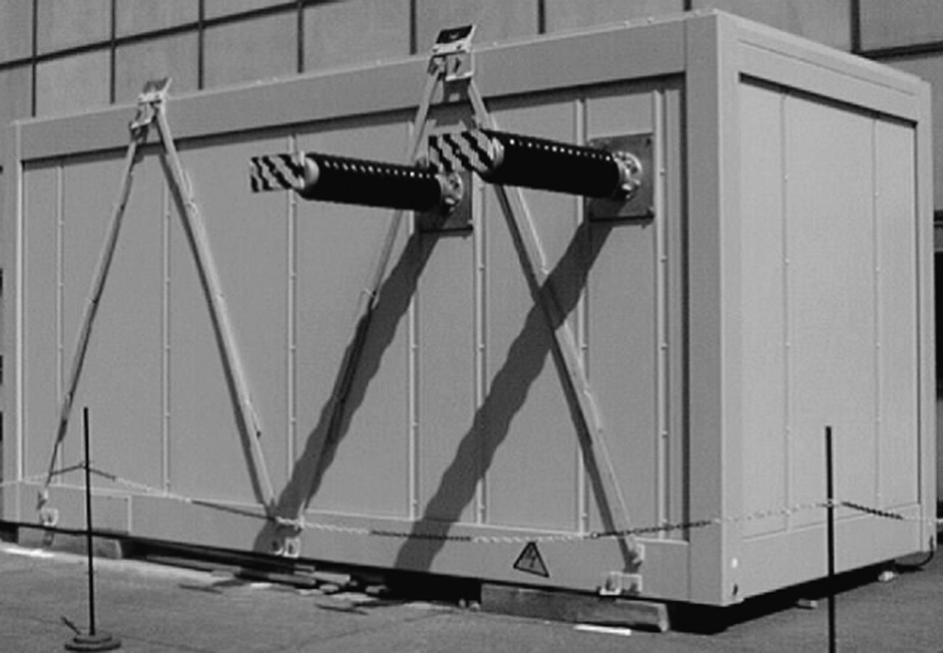

**FIG. 27.27** Compact outdoor container with an active DC filter.

#### **27.7.1.6 AC Filters**

Conventional AC filters used passive components for tuning out certain harmonic frequencies. Due to the variations in frequency and capacitance, physical aging, and thermal characteristics of these tuned filters, the quality factors for the filters were typically about 100–125, which meant that the filters could not be too sharply tuned for efficient harmonic filtering. The advent of electronically tunable inductors, based on the transductor principle, means that the *Q*-factors can now approach the natural one of the inductor. This will lead to much more enhanced filtering capacities ([Fig. 27.28](https://learning.oreilly.com/library/view/power-electronics-handbook/9780128114087/B9780128114070000301.xhtml#f0145)).

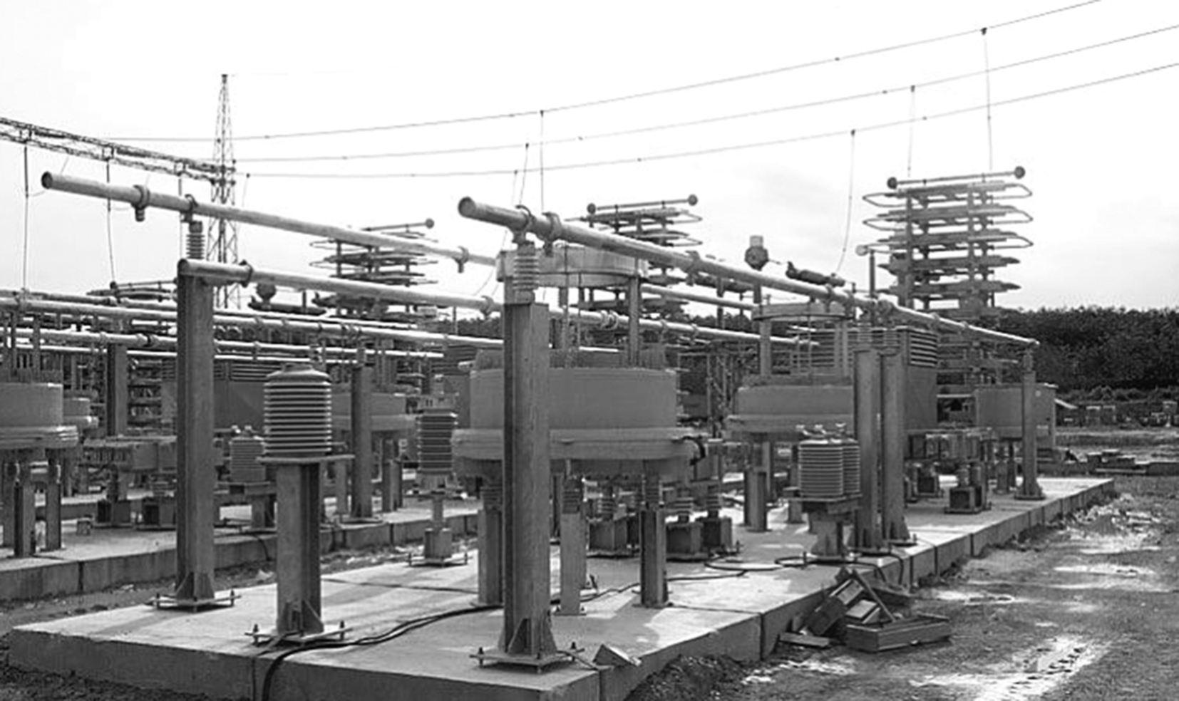

**FIG. 27.28** Installation of the triple-tuned filter at the Gurun station in Malaysia.

#### **27.7.1.7 AC-DC Current Measurements**

The new optical current transducers utilize a precision shunt at high potential. A small optical fiber link between ground and high potential is utilized resulting in a lower probability of a flashover. The optical power link transfers power to high potential for use in the electronic equipment. The optical data link transfers data to ground potential. This transducer results in high reliability, compact design, and efficient measurement ([Fig. 27.29](https://learning.oreilly.com/library/view/power-electronics-handbook/9780128114087/B9780128114070000301.xhtml#f0150)).

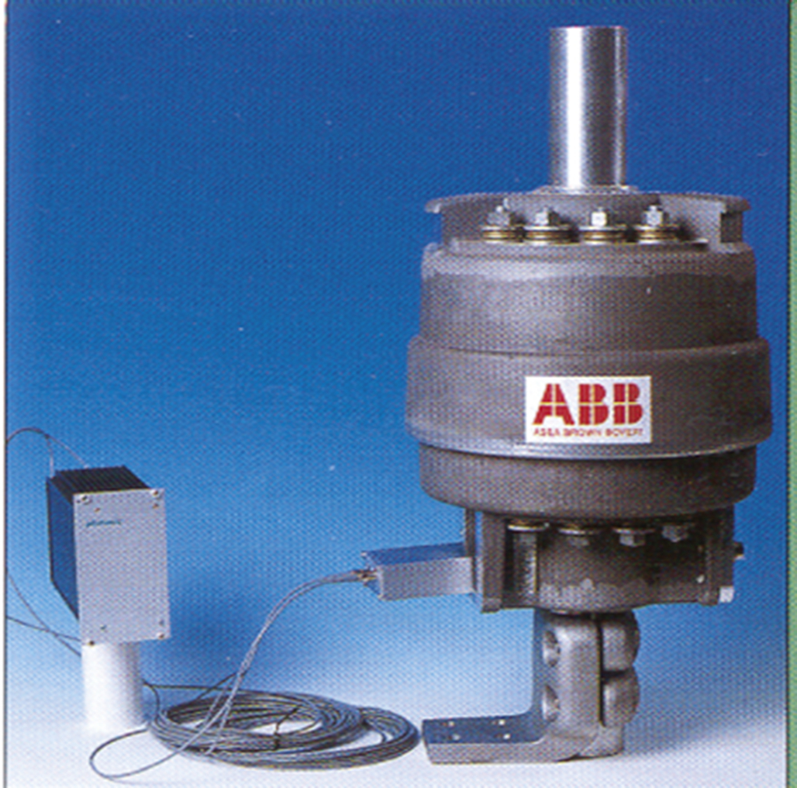

**FIG. 27.29** The optical current transducer.

#### **27.7.1.8 New Topologies**

Two new topological changes to the converter design will impact greatly on future designs:

1. Series-compensated commutation:

There are two variants to this topology: the capacitor-commutated converter (CCC) ([Fig. 27.30A](https://learning.oreilly.com/library/view/power-electronics-handbook/9780128114087/B9780128114070000301.xhtml#f0155)) and the controlled series capacitor converter (CSCC) ([Fig. 27.30B](https://learning.oreilly.com/library/view/power-electronics-handbook/9780128114087/B9780128114070000301.xhtml#f0155)). Essentially, the behavior of the two variants is very similar. The insertion of a capacitor in series with the converter transformer leakage reactance causes a major reduction in the commutation impedance of the converter resulting in a reduction in the reactive power requirement of the converter. An increase in the size of the series capacitor can even result in the converter operation at a leading power factor if so desired. However, the negative impact of a lower commutation impedance results in additional stresses on the valves and transformers and additional cost implications [[7](https://learning.oreilly.com/library/view/power-electronics-handbook/9780128114087/B9780128114070000301.xhtml#bb0040)].

The first CCC back-to-back converter station (rated at 2×550 MW) has been put into service at Garabi, on the Brazilian side of the Uruguay River. The system interconnects the electric systems of Argentina and Brazil.

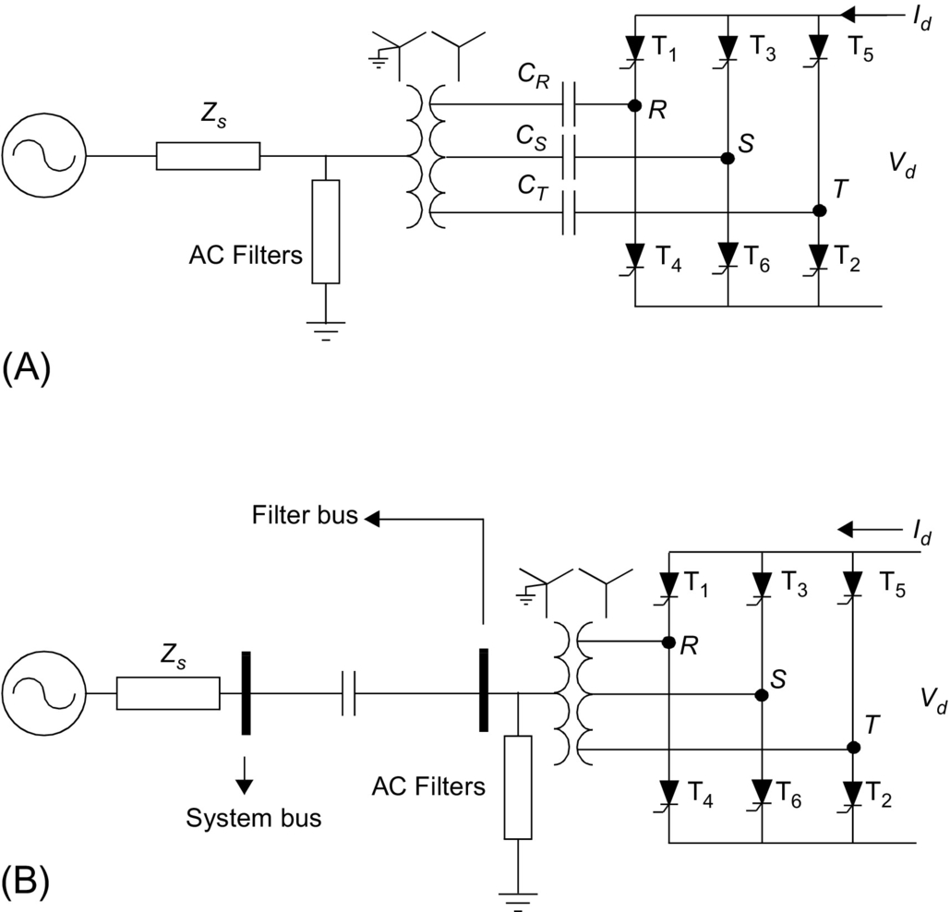

**FIG. 27.30** (A) Capacitor-commutated converter circuit and (B) controlled series capacitor converter circuit.

2. Voltage-source converters (VSC): The use of self-commutation with the new-generation switching devices (i.e., GTOs and IGBTs) has resulted in the topology of a voltage-source converter (VSC) ([Fig. 27.31](https://learning.oreilly.com/library/view/power-electronics-handbook/9780128114087/B9780128114070000301.xhtml#f0160)) as opposed to the conventional converter using line-commutated thyristors and current source converter (CSC) topology. The VSC, being self-commutated, can control active/reactive power and, with PWM techniques, control harmonic generation as well. The application of such circuits is presently limited by the switching losses and ratings of available switching devices. The ongoing advances in power electronic devices are expected to have a major impact on the future application of this type of converter in HVDC transmission. New application areas, particularly in distribution systems, are being actively investigated with this topology. [Table **27.5**](https://learning.oreilly.com/library/view/power-electronics-handbook/9780128114087/B9780128114070000301.xhtml#t0030) provides a partial list of the HVDC links in operation using this technique.

One major difficulty for the use of the VSC is the threat posed to the valves from a short circuit on the DC line. Unlike the CSC where the valves are inherently protected against short-circuit currents by the presence of the smoothing reactor, the VSC is relatively unprotected. For this reason, the VSC applications are almost always used with DC cables where the risk of a DC line short circuit is greatly reduced ([Table **27.7**](https://learning.oreilly.com/library/view/power-electronics-handbook/9780128114087/B9780128114070000301.xhtml#t0040)).

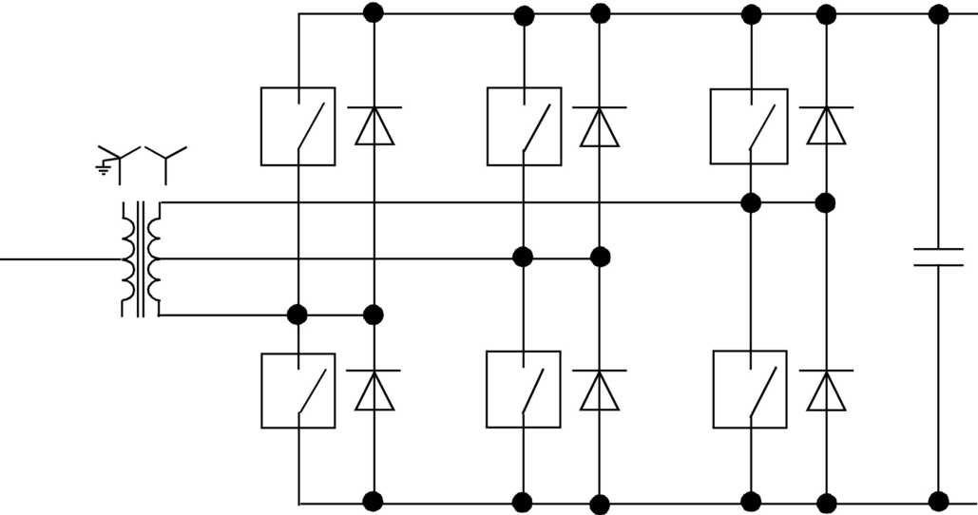

**FIG. 27.31** Voltage-source converter topology.

**Table 27.5**

**Main data 1**

|  |  |  |  |
| --- | --- | --- | --- |
| **Monopolar operation** |  | **Rectifier (Malaysia)** | **Inverter (Thailand)** |
| DC power, *Pdn* | Rated | 240 MW (stage 1) | 240 MW |
| Max. overload (10 min) | 450 MW |  |
| Minimum (10% of rated) | 24 MW |  |
| DC current, *Idn* |  | 1000 A | 1000 A |
| DC voltage, *Udn* |  | 240 kV | 293.5 kV |
| Firing angle, alpha |  | 15.0 degrees | – |
| Extinction angle, gamma |  | – | 19.6 degrees |
| Transformer sec. voltage, *Uv* |  | 122.2 kV | 122.2 kV |
| Converter reactive power, *QDC* |  | 133.3 MVAr | 150.9 MVAr |
| Reduced DC voltage operation | 210 kV (70% DC voltage) |  |  |
| AC system voltage |  | 275 kV, 50 Hz | 224 kV, 50 Hz |
| DC transmission line Distance | 110 km |  |  |

**Table 27.6**

**Main data 2**

|  |  |
| --- | --- |
| **Main equipment** | **GURUN converter station** |
| Smoothing reactor | 100 mH |
| DC filter | Active type DC filters including passive type (twelfth/twenty-fourth harmonics) |
| AC filter | 2×60 MVAr (11/13/27) |
| Reactive power compensation | 3×60 MVAr C-shunt |
| Power thyristor  Diameter  Blocking voltage  Max. DC current  Max. effective current | Type T1501 N75T-S34  100 mm  7.5 kV repetitive, 8.0 kV nonrepetitive  1550 A, 120 degrees el., *Tc*=60°C  3240 A |
| Converter transformer | Single phase, three winding  Rated power=275 kV/116 MVA |
| Transmission line  Pole conductor  Neutral conductor | Cardinal ACSR 546 mm2, twin conductors per pole  Hen ACSR 298 mm2 |

**Table 27.7**

**Applications of HVDC Light technology**

|  |  |  |  |  |  |  |
| --- | --- | --- | --- | --- | --- | --- |
| **No.** | **Project** | **Rating** | | **Distance (km)** | **Application** | **Commissioned** |
| **MVA** | **kV** |
| 1 | Hellsjon | 3 | ±10 | 10 | AC-DC conversion | Mar. 1997 |
| 2 | Gotland | 50 | ±80 | 70 | Feed from wind power generation | Jun. 1999 |
| 3 | Tjaereborg | 7 | ±10 | 4 | Feed from wind power generation | Aug. 1999 |
| 4 | Directlink | 180 | ±140 | 65 | Asynchronous interconnection | Dec. 1999 |
| 5 | Murraylink | 220 | ±140 | 180 | Asynchronous interconnection | 2002 |
| 6 | Shoreham | 330 | ±140 | 40 | Cross sound cable link | 2002 |
| 7 | Troll A 1&2 | 2×42 | ±60 | 70 | Gas production offshore platform | 2005 |
| 8 | Estlink | 350 | ±150 | 2×74 | Length of land cable, sea crossing, and nonsynchronous AC systems | 2006 |
| 9 | Caprivi Link | 300 | 350 | 950 | Interconnecting grids, energy trade | 2010 |
| 10 | Valhall | 78 | 150 | 292 | Power from shore | 2011 |
| 11 | BorWin1 | 400 | ±150 | 200 | Offshore wind connections | 2012 |
| 12 | East-West Interconnector | 500 | ±200 | 261 | AC voltage control, black start | 2012 |
| 13 | Skagerrak 4 | 700 | 500 | 244 | Interconnecting grids, grid stability | 2014 |
| 14 | Mackinac | 200 |  | ±71 | DC links in AC grids | 2014 |
| 15 | DolWin1 | 800 | ±320 | 165 | Offshore wind connection | 2015 |
| 16 | DolWin2 | 900 | ±320 | 135 | Offshore wind connection | 2015 |
| 17 | NordBalt | 700 | ±300 | 450 | Prepare for future DC grid, black start | 2015 |
| 18 | Troll A 3&4 | 2×50 | ±60 | 70 | Power from shore | 2015 |
| 19 | Åland | 100 | ±80 | 158 | Asynchronous networks | 2015 |
| 20 | Maritime Link | 500 | ±250 | 180 | Connecting remote generation | 2017 |
| 21 | Caithness-Moray | 800/1200 | ±350 | 160 | Reinforcement of AC network | 2018 |
| 22 | Johan Sverdrup | 100 | ±80 | 200 | Offshore oilfield | 2019 |
| 23 | Kriegers | Flak | 410 | ±140 | Asynchronous networks | 2019 |
| 24 | NordLink | 2×700 | ±500 | 571 | Interconnecting grids, energy trade | 2020 |
| 25 | NSL | 2(700) | ±515 | 722 | Interconnecting grids, energy trade | 2021 |

#### **27.7.1.9 Compact Station Layout**

The advances discussed above have resulted in marked improvement of the footprint requirement of the compact station [[8](https://learning.oreilly.com/library/view/power-electronics-handbook/9780128114087/B9780128114070000301.xhtml#bb0045)] of the year 2000 that has about 24% space requirement of the comparable HVDC station designed in the past decade ([Fig. 27.32](https://learning.oreilly.com/library/view/power-electronics-handbook/9780128114087/B9780128114070000301.xhtml#f0165)).

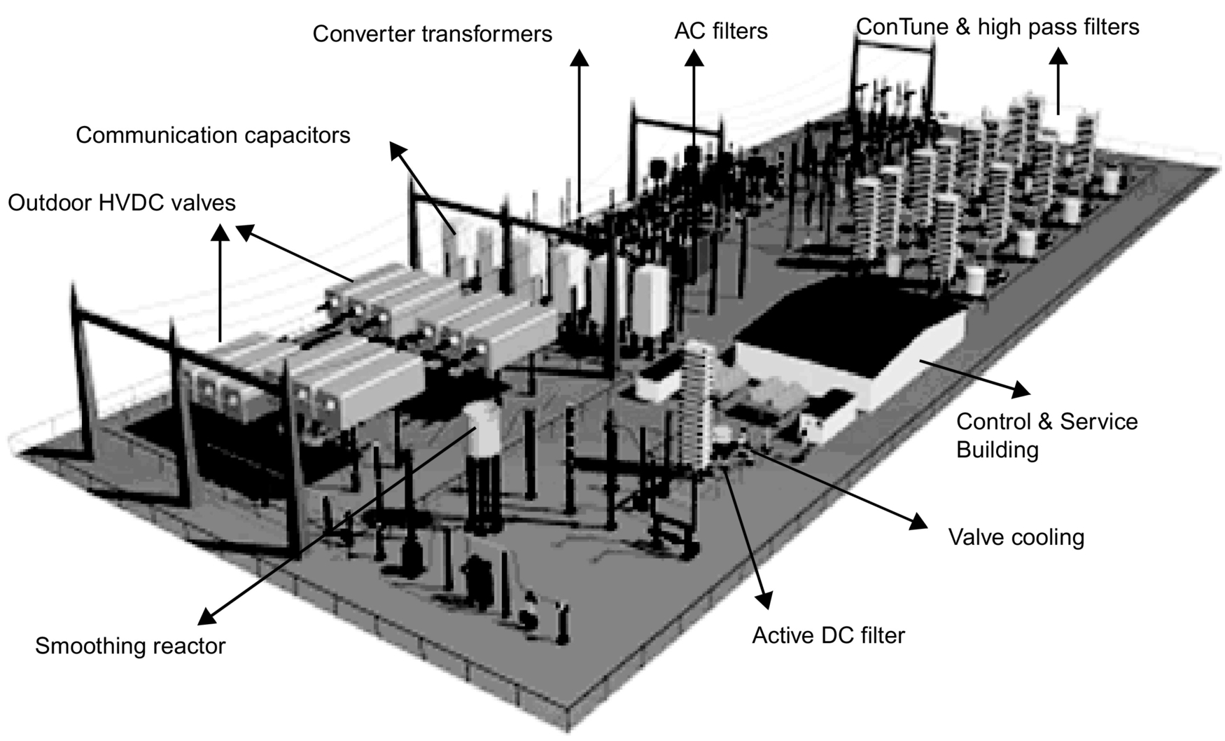

**FIG. 27.32** Layout of a compact HVDC.

## 27.8 VSC-HVDC System

### **27.8.1 INTRODUCTION**

The existing power transmission networks in most developed countries are heavily loaded that has created the risk of system instability and power quality deterioration. Furthermore, these countries have the problem of obtaining right of ways and face environmental issues for the construction of new transmission lines. The necessity for a new technology by which increased power transmission can be achieved using the existing network infrastructure is clear. As explained earlier, the VSC-HVDC transmission system can take the place of this technology to solve the problem to some extent. The VSC-HVDC system is a relatively mature technology that comprises the high-power, high-frequency semiconductor switches (i.e., IGBTs and GTOs). These devices incorporated with antiparallel diodes make one complete unit. Several units are connected in series to build a valve to get the required voltage level and to increase the redundancy in the converter. The control of these switches is done by using pulse-width modulation (PWM) techniques by which it is possible to control the magnitude and phase angle of the generated fundamental (60 Hz) voltage component. This high controllability of VSC results in a wide range of power system applications like VSC-HVDC, static synchronous compensator (STATCOM), static synchronous series compensator (SSSC), unified power flow controller (UPFC), interline power flow controller (IPFC), and active filters. In addition to bulk power transmission, strategically located VSC-HVDC system in an existing AC power system network augments the network stability and reliability during disturbances and contingencies.

### 27.8.2 VSC-HVDC SYSTEM

[Fig. 27.33](https://learning.oreilly.com/library/view/power-electronics-handbook/9780128114087/B9780128114070000301.xhtml#f0170) shows the single-line diagram of a VSC-HVDC system that interconnects two AC networks of same operating frequency for power transmission and stability improvement during contingencies. The system consists of different equipments, such as shunt-connected RLC filters, interfacing transformers, VSCs and their control systems, DC overhead or underground cables, and DC capacitors. The following subsections provide explanations regarding the function of each apparatus comprising the VSC-HVDC.

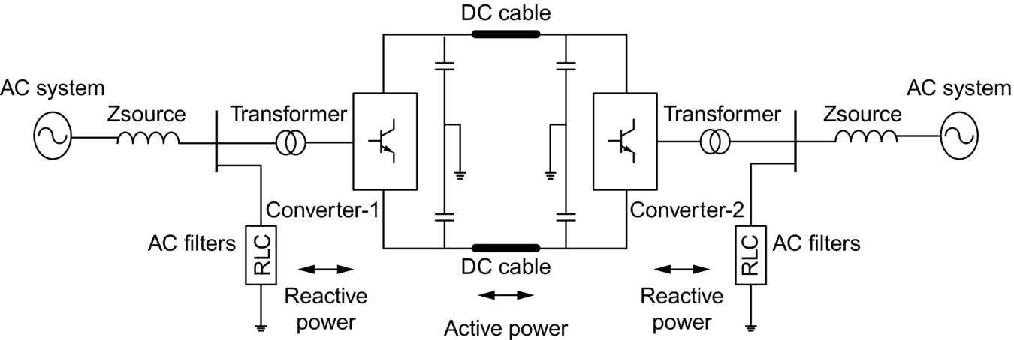

**FIG. 27.33** Single-line diagram of VSC-HVDC system.

#### **27.8.2.1 AC Shunt RLC-Filters**

Switching of high-power, high-frequency switches generates harmonics in the converter output voltages and currents. The order of harmonics generated is directly related to the PWM switching frequency of the semiconductor switches.

Single- or double-tuned low-pass and high-pass damped RLC filters are connected to suppress these harmonics. The frequency modulation index is defined as *m*f that is defined as the ratio of the switching frequency of the converter to the fundamental frequency of the AC voltage. In the case of three-phase VSC, the harmonics in the line-to-line voltages are present. The odd harmonics exist as sidebands, centered around the *m*f and its multiples where *m*f is odd. The value of *m*f is chosen such that it should be an odd integer to eliminate the even harmonics; also, if it is a multiple of 3, then most of the triplen harmonics are canceled out in the line-to-line voltage.

#### **27.8.2.2 Converter Transformer**

A converter transformer interfaces the VSC AC terminals to AC network with suitable voltage level at both sides. It provides electric isolation and operates as a filter between converter and AC networks and provides the appropriate AC voltage level to optimize the available converter valve voltage rating. Configuration and rating of the transformer can be decided from the total system power rating, converter topology, and specified requirements.

#### **27.8.2.3 Voltage Source Converter**

The VSC is the main building block of the VSC-HVDC system. The number of switches employed depends on the operating characteristic and voltage level required. The series-connected IGBT switches, connected with antiparallel diodes, make up a valve. Two valves are connected in series to make up the converter leg for one phase. VSC can operate as a rectifier or an inverter at either end depending on the current flow direction. Two converters can be connected as a back-to-back system to connect two different AC grids, DC transmission line, or overhead cables for bulk power transmission or underground cables for connection of offshore oil rigs, islands, or offshore wind farms. The six-switch converter comprises a group of six valves. Different types of PWM techniques are used to operate and control the converter switches. Typical IGBT has rating of 6.5 kV and 2.4 kA. The voltage across the IGBT switch in the ON state is typically in the range of 1–3 V that creates the ON state losses. The switching losses are the second major loss mechanism and are due to fact that, during the turn ON and turn OFF transition, current is still flowing while voltage is present across the device. In order to minimize the switching losses, the maximum switching frequency needs to be carefully considered. VSC is equipped with the RC snubbers and series R-L elements to reduce the *dv*/*dt* and *di*/*dt* stresses on the switches during ON/OFF transitions.

#### **27.8.2.4 DC Transmission**

The DC system can be in the form of a transmission line, with underground or overhead cables. The overhead cables can be used with a moderate size of towers. The extruded polymer cable is a newly developed technique in which the insulation is highly resistant to the DC voltage.

The DC transmission system adopted here is a bipolar transmission system in which the power can flow in both the overhead poles and ground is used as a return path in case of monopolar operation. In case of failure or preplanned maintenance of one pole, reduced power can still be transmitted using the other pole. Two smoothing inductors are connected on DC transmission system to reduce the ripples in the DC current.

#### **27.8.2.5 DC Capacitors**

As shown in [Fig. 27.33](https://learning.oreilly.com/library/view/power-electronics-handbook/9780128114087/B9780128114070000301.xhtml#f0170), two series-connected DC capacitors of same size are employed across the DC terminals of converter with grounded midpoint. The size of the capacitor depends on the required DC voltage level and the acceptable DC ripple.

The DC voltage should be adequate for the generation of sinusoidal voltages on AC side of the converter. For the system to operate in the linear range of the PWM, the DC voltage should be 1.634 times the value of root mean square (RMS) AC voltage.

The PWM switching of high-power high-frequency switches generates the harmonics in the DC current flowing in the transmission line. This generates the harmonics in the DC voltage that is strongly related to the converter AC voltage. By evaluation of the magnitude of ripple and the switching frequency of the semiconductor switches, the DC side capacitor ratings can be finalized.

The value of DC capacitor *CDC* used here can be small, which may result in a faster converter response. The energy stored in the capacitor is released during transients that will help to stabilize the power flow on the DC transmission system. The DC capacitor size is characterized with a time constant *τ*, which can be defined as the ratio between the energy stored in the capacitor at the rated DC voltage *VDC* and the apparent power rating of the converter SC:

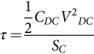 **(27.6)**

The time constant is equal to the time needed to charge the capacitor from zero to rated voltage *VDC* if the converter is supplied with a constant active power equal to SC. The time constant τ can be selected to be small to satisfy ripple and transient overvoltage requirement on the DC voltage. A relatively small time constant allows fast control of active power and reactive power.

### 27.8.3 TOPOLOGIES OF THE VSC

VSC can be divided into topologies according to the number of levels for converter output AC voltage, either two level or multilevel. These are explained in following subsections.

#### **27.8.3.1 Two-Level Voltage Source Converter**

A two-level bridge is the simplest circuit configuration that can be used to construct a three-phase VSC. It has been widely used in many applications for a range of power levels. As shown in [Fig. 27.34](https://learning.oreilly.com/library/view/power-electronics-handbook/9780128114087/B9780128114070000301.xhtml#f0175), the converter can generate DC voltage waveform of only two values, ±*VDC*/2, where *VDC* is the total DC voltage. Relatively simple power and control circuitry, small DC capacitor size, small footprint environmentally, and same semiconductor duty ratio are some of the advantages related to a two-level VSC.

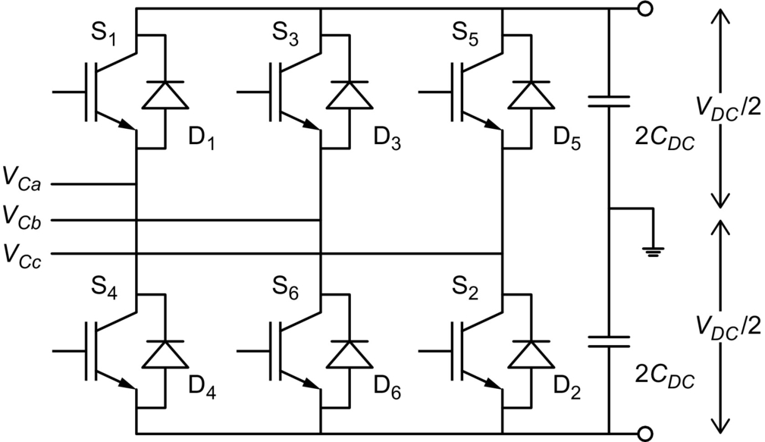

**FIG. 27.34** Two-level, six-switch, three-phase converter topology.

#### **27.8.3.2 Multi-level Voltage Source Converter VSC**

Converter topologies with more than two-level voltages are known as multilevel converters. In this type of VSC, the output AC voltage waveform has different level according to the construction of the VSC. The main requirement for multilevel converters is to synthesize a sinusoidal voltage from several voltage levels that are obtained from the DC side capacitor voltages. Multilevel VSCs are divided into different types according to their application. The multilevel VSC found various applications in power systems due to its high power density, excellent performance, and high reliability. Various multilevel topologies are explained next.

#### **27.8.3.3 Neutral Point Diode Clamped VSC**

Neutral-point diode-clamped VSC topology is shown in [Fig. 27.35](https://learning.oreilly.com/library/view/power-electronics-handbook/9780128114087/B9780128114070000301.xhtml#f0180). As shown, this topology uses clamping diodes to limit the dynamic and static overvoltages of switching devices. The clamping diodes are connected to the center point of the DC bus capacitor.

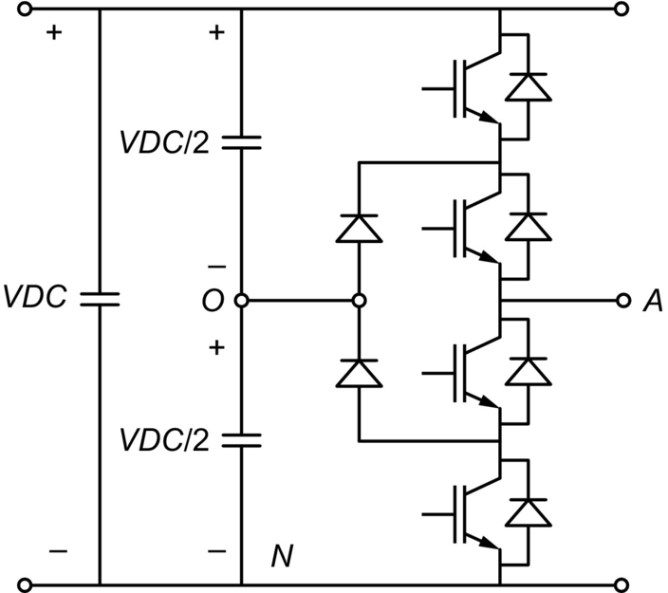

**FIG. 27.35** Three-level, NPC converter topology.

The advantages of this topology include reasonable small size of the DC capacitors, small footprint environmentally, and good quality AC output waveform. An n-level diode-clamp converter typically consists of (n-1) capacitors on the DC bus and produces n-levels of the converter output AC voltage. With a higher number of levels, harmonics generation is very low that can even avoid the need for filters in some cases. The disadvantages are related to voltage balancing across the DC capacitors, uneven loss distribution between devices, and excessive clamping diodes necessity in higher levels.

#### **27.8.3.4 Flying Capacitor VSC**

[Fig. 27.36](https://learning.oreilly.com/library/view/power-electronics-handbook/9780128114087/B9780128114070000301.xhtml#f0185) shows the three-level flying-capacitor-type VSC topology. This topology uses capacitors instead of diodes in the diode-clamped topology. For an *n*-level converter, (*n*−1) numbers of DC capacitors at DC bus and (*n*−1)×(*n*−2)/2 number of auxiliary capacitors per phase leg are required. These capacitors are known as floating capacitors.

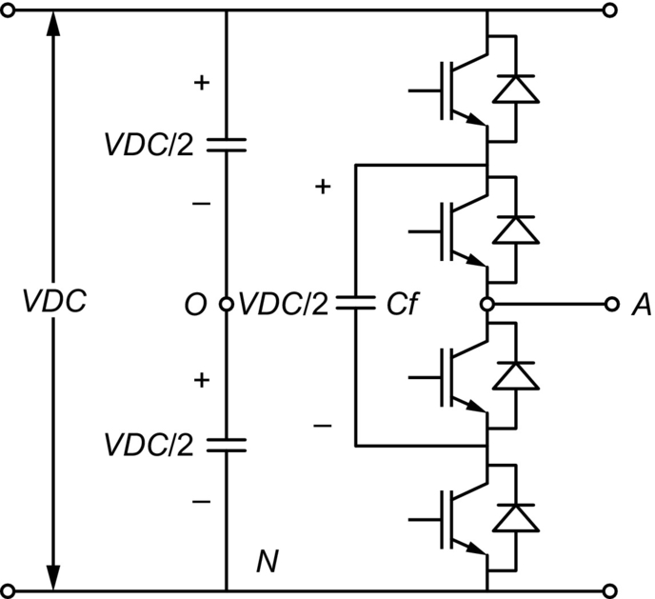

**FIG. 27.36** Three-level, flying-capacitor converter topology.

The AC waveform synthesized by this topology is better than the diode-clamped topology. The advantages of this topology are the extra ride through capabilities during power outage and severe disturbances due to large number of storage capacitors, switch combination redundancy for balancing different voltage levels, and avoidance of harmonic filters in higher-level applications. The requirement of an excessive number of storage capacitors on DC side and across the semiconductor switches in higher number of levels makes this topology very expensive. The converter control system is complex, and switching losses are higher compared with diode-clamped topology.

#### **27.8.3.5 ANPC (Actively Neutral Point Clamped) converter**

[Fig. 27.37](https://learning.oreilly.com/library/view/power-electronics-handbook/9780128114087/B9780128114070000301.xhtml#f0190) shows the three-level ANPC converter topology in which the clamping diodes are replaced by semiconductor switches. The disadvantage of uneven loss distribution across various devices in the neutral-point diode-clamped converter topology is mitigated by this newly developed topology.

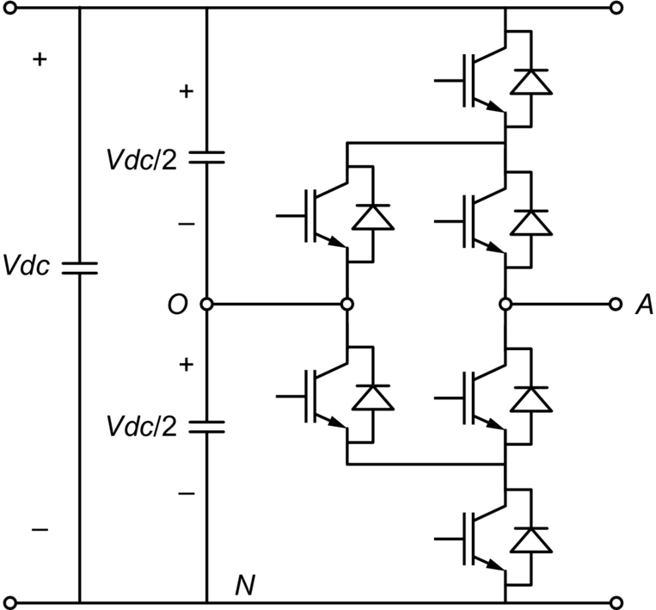

**FIG. 27.37** Three-level, actively neutral-point-clamped converter topology.

#### **27.8.3.6 Cascaded H-Bridge Converter**

This VSC topology ([Fig. 27.38](https://learning.oreilly.com/library/view/power-electronics-handbook/9780128114087/B9780128114070000301.xhtml#f0195)) is a cascaded structure that consists of full-bridge inverter units connected in series.

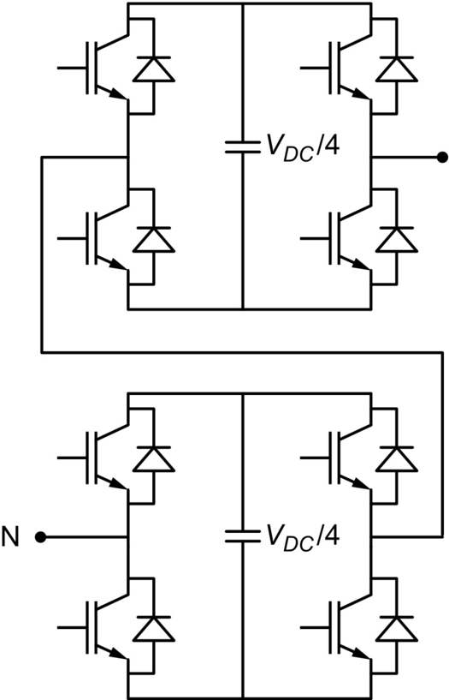

**FIG. 27.38** Five-level, cascaded H-bridge converter topology.

Each unit is fed by a separate DC capacitor, and no other circuit to balance the voltage matching of the switching devices is necessary. There is no need to add the clamping diodes or voltage-balancing capacitors in this topology that results in a relatively simple construction. Main drawback of this topology is the requirement of several independent DC power supplies.

#### **27.8.3.7 Multi-pulse Topologies**

In a six-switch converter, the commutation of current takes place six times per cycle. In the case of 12-switch converter, two six-switch converters are connected in series to form a 12-switch converter topology. By using the six-switch converter, the additional multiswitch topologies in multiples of six can be created to form the required pulse level. The 24-switch and 48-pulse converters are implemented in some research papers for application as a STATCOM in power system. The main purpose of using these topologies is to reduce the voltage and current harmonics in the system. As the number of switches increases, the harmonic distortion in the system decreases proportionally.

### 27.8.4 PWM FOR VSC

PWM is the most accepted switching technique in which the comparison between a fundamental frequency modulating waveform and a fixed carrier frequency triangular waveform generates the firing pulses for VSC. The magnitude and phase angle of the generated fundamental frequency component of the converter output AC voltage can be controlled by varying the magnitude and phase angle of the modulating waveform. In this technique, the converter output AC voltage contains harmonic frequency components in addition to fundamental frequency component located around the multiples of the triangular waveform carrier frequency.

#### **27.8.4.1 Sinusoidal PWM**

The PWM technique used for switching of the semiconductor devices of converter decides the frequency and nature of the converter output AC voltage. So to get the sinusoidal waveform as an output, sinusoidal PWM technique is used. The sinusoidal modulating waveform of 60 Hz system frequency is compared with a high-frequency triangular waveform to generate the pulse-width modulated firing pulses for converter. Two different SPWM methods can be implemented to get the required output.

(a) Bi-polar SPWM

In the case of bipolar sinusoidal PWM method, a single fundamental frequency modulating waveform per phase is compared with the high-frequency triangular waveform. The output voltage switches between −*VDC*/2 and *+VDC*/2 voltage levels where *VDC* is the total DC voltage. It is the reason why this type of switching is called a bipolar PWM switching. As shown in [Fig. 27.39](https://learning.oreilly.com/library/view/power-electronics-handbook/9780128114087/B9780128114070000301.xhtml#f0200), during comparison, when the sinusoidal waveform is greater than the triangular waveform, the PWM trigger signal is high, otherwise at lower level.

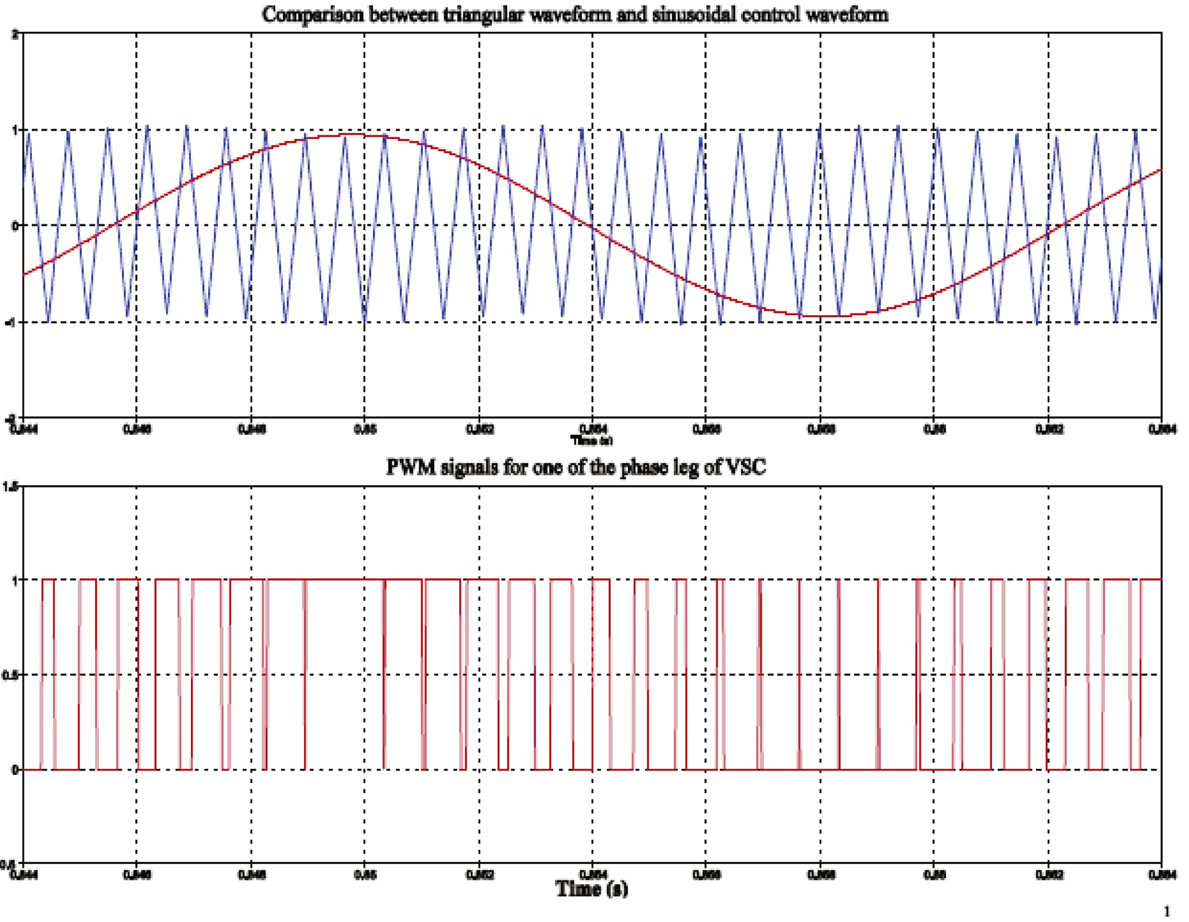

**FIG. 27.39** Comparison between sinusoidal and triangular waveform and PWM signals.

(b) Uni-polar SPWM

In the case of unipolar sinusoidal PWM technique, two same phase fundamental frequency modulating waveforms with opposite polarity are compared with the high-switching-frequency triangular waveforms. The output voltage switches between *+VDC*/2 and 0 or between 0 and −*VDC*/2. For this reason, this type of PWM scheme is called a PWM with a unipolar voltage switching.

### 27.8.5 VSC-HVDC OPERATION

The VSC-HVDC operation can be explained by considering its operating principle, four-quadrant operation in P-Q diagram, and capability to operate in either rectifier or inverter modes.

#### **27.8.5.1 Operating Principle of VSC-HVDC**

The VSC-HVDC operating principle can be explained from the SLD shown in [Fig. 27.40](https://learning.oreilly.com/library/view/power-electronics-handbook/9780128114087/B9780128114070000301.xhtml#f0205), where two AC networks are connected by a VSC-HVDC transmission system.

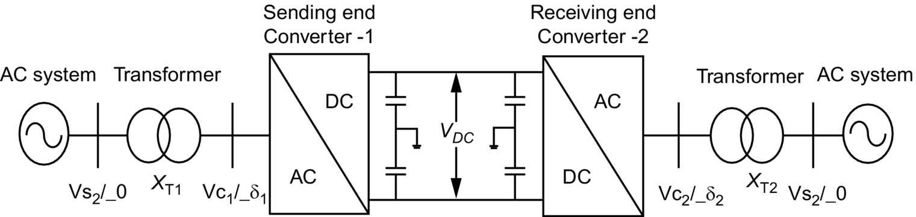

**FIG. 27.40** Single-line diagram for VSC-HVDC operating principle.

The converter transformer connecting AC network and converter can be modeled as an equivalent series resistance and reactance. The transformer resistance is very small compared with the transformer reactance, so it can be neglected in power calculations. The phase shift between both sides’ voltages due to transformer reactance is responsible for active power flow. At sending end, the voltage *VS*1 at AC bus is considered as a reference, so the converter output AC voltage *VC*1 has phase shift *δ*1 with respect to the bus voltage *VS*1. The magnitude and phase angle of converter output AC voltage *VC*1 is controlled by the VSC control system. The active and reactive power flow between the AC system and the converter depends on the magnitude of the voltages at both sides of the transformer, the transformer reactance *XT*1 and the phase angle *δ*1 between them. The active and reactive power flow between AC bus and converter AC terminals can be expressed as follows: the active power at sending end and receiving end is given by

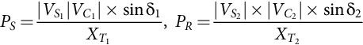 **(27.7)**

The reactive power at sending end and receiving end is given by

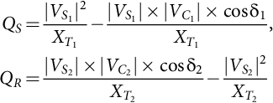 **(27.8)**

The amplitude, phase angle, and frequency of fundamental component of converter output AC voltage *VC*1 and *VC*2 can be controlled using the SPWM technique. If the voltage at the DC side of the converter is *VDC* that is assumed to be constant, then the fundamental frequency component of converter output AC voltage can be derived from the following equation:

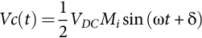 **(27.9)**

where *VDC* is the voltage on DC side, *ω* is the angular frequency, *Mi* is modulation index, and *δ* is the phase angle between the converter output AC voltage and the AC bus voltage. *Mi* can be defined as the ratio of peak value of voltage of modulating waveform (fundamental frequency sinusoidal waveform) to the peak value of voltage of carrier waveform (switching-frequency triangular waveform). From Eq. [(27.9)](https://learning.oreilly.com/library/view/power-electronics-handbook/9780128114087/B9780128114070000301.xhtml#fo0050), it is seen that the fundamental component of converter voltage depends on the variables *Mi*, angle *δ*, and frequency that are independently controlled by VSC controllers. The active and reactive power can be controlled by controlling the phase angle *δ* and the amplitude of the fundamental frequency component of converter AC output voltage *VC*, respectively.

In a VSC-HVDC, the polarity of DC voltage is constant, so the power reversal is done by current reversal in the DC link. The current in DC link flows from higher to lower DC voltage level. For stable VSC operation and flow of active power, the DC-link voltage is maintained at a desired reference value by using a feedback control loop. The power flow to and from the AC source can be controlled according to the DC-link voltage requirements. The voltage *VDC* is measured and controlled in such manner that the DC current flow can be in either direction depending on the requirement of active power flow direction.

#### **27.8.5.2 Four Quadrant Operation of VSC**

Active power flow direction for rectifier or inverter operation and reactive power flow direction for inductive or capacitive operating mode of VSC can be explained by a P-Q circle diagram shown in [Fig. 27.41](https://learning.oreilly.com/library/view/power-electronics-handbook/9780128114087/B9780128114070000301.xhtml#f0210). The diagram explains the ability of VSC to operate in all four quadrants of P-Q circle and to achieve the independent control of active and reactive power. The direction of current flow and hence active power flow decides the rectifier or inverter operation of converter.

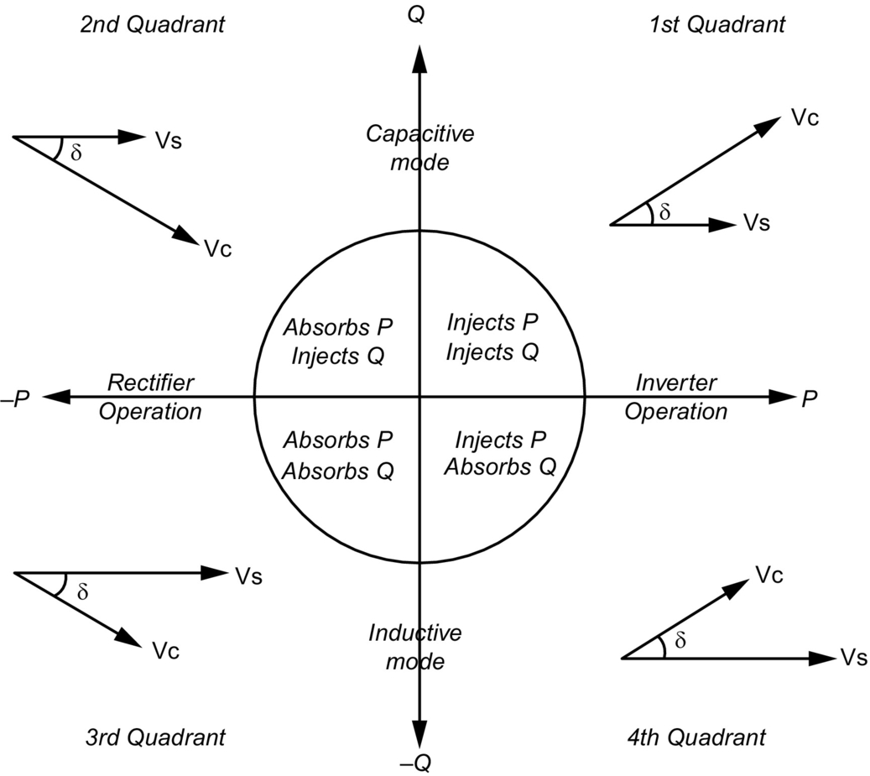

**FIG. 27.41** P-Q circle diagram for VSC operation.

In the first quadrant, both the active and reactive powers are positive, which means that the converter injects both powers to AC system that shows the capacitive mode of inverter operation. The converter output AC voltage magnitude is higher than AC bus voltage and leads AC bus voltage by an angle *δ*.

In the second quadrant, the active power is negative, and the reactive power is positive, which explains the capacitive mode of rectifier operation. In this case, the converter output AC voltage amplitude is higher than AC bus voltage, but it lags the AC bus voltage by an angle *δ.*

Both the powers in the third quadrant are negative that means the converter absorbs both powers from the AC system, which explains the inductive mode of rectifier operation. In this case, the AC bus voltage magnitude is higher than the converter output AC voltage, and it leads by an angle *δ*.

In the fourth quadrant, the active power is positive, and the reactive power is negative, which explains the inductive mode of inverter operation. Here, the converter output AC voltage leads the AC bus voltage, but its magnitude is less than the AC bus voltage.

According to the converter MVA capacity and system requirements, converter can operate in any mode (i.e., capacitive or inductive) of rectifier or inverter operation.

#### **27.8.5.3 Rectifier-Inverter Operation of VSC**

The rectifier or inverter operation of VSC can be explained by considering [Fig. 27.42](https://learning.oreilly.com/library/view/power-electronics-handbook/9780128114087/B9780128114070000301.xhtml#f0215). AC bus voltage *VS* can be taken as a reference, and *VC* is the converter AC output voltage with phase shift *δ*. The converter transformer can be represented by an equivalent resistance *RT* and reactance *XT*. Two capacitors of same rating 2*CDC* are connected in series across the DC terminals of the converter. The direction of current flow decides the operation of VSC as a rectifier or inverter.

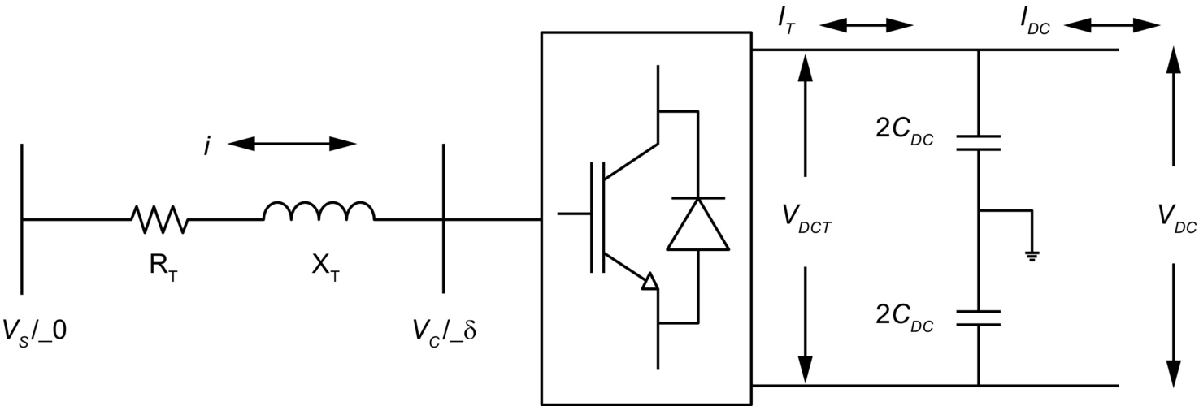

**FIG. 27.42** VSC operation as rectifier or inverter.

As shown in [Fig 27.43](https://learning.oreilly.com/library/view/power-electronics-handbook/9780128114087/B9780128114070000301.xhtml#f0220), the AC system voltage *VS* leads the converter AC output voltage *VC* by an angle *δ*. The active power flows from the AC system to the converter, so the converter operates as a rectifier. As shown in the figure, Δ*V* is the voltage drop across the transformer impedance that is controlled in order to control the angle *δ*. In the rectifier mode of operation, the current *IDC* is considered positive, and the capacitor *CDC* is discharged through the DC transmission system. The error signal demands the control circuit for more power from the AC supply. The control circuit thereby generates the appropriate PWM signals for the switching devices, and accordingly, more current flows from the AC to DC side, and the capacitor voltage recovers its predefined value.

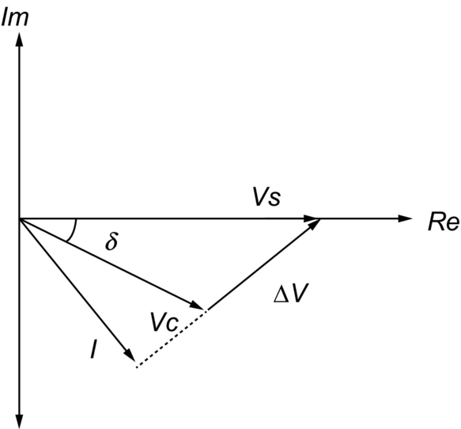

**FIG. 27.43** VSC operation as a rectifier.

As shown in [Fig. 27.44](https://learning.oreilly.com/library/view/power-electronics-handbook/9780128114087/B9780128114070000301.xhtml#f0225), the AC system voltage *VS* lags the converter AC output voltage by an angle *δ*. In this case, the active power flows from the converter to AC system, so the converter operates as an inverter. In the inverter mode of operation, *IDC* becomes negative, and the capacitor *CDC* is overcharged. The error signal demands the controls to discharge the capacitor *CDC* and return power to the AC system. The PWM can control both the active power and reactive power independently. Thus, this type of converter can be used for power factor correction also in addition to power transmission.

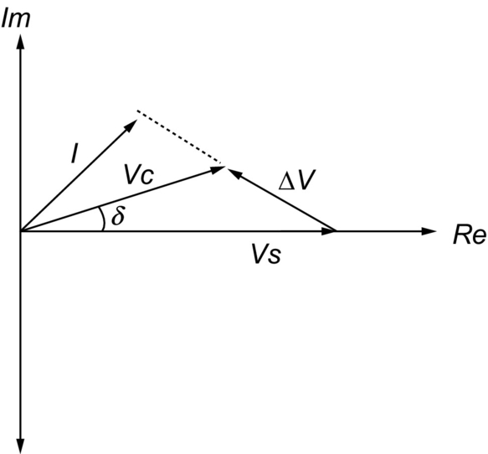

**FIG. 27.44** VSC operation as an inverter.

Depending on the control strategy, VSC can be operated as either inverter or rectifier; therefore, it is often referred to as a converter. Two such converters are often cascaded to control the power flow between two AC networks. The first converter converts AC voltage to variable DC-link voltage, and the second converter converts the DC voltage to variable AC voltage with fixed or variable frequency.

### 27.8.6 SUMMARY

In this chapter, the VSC-HVDC system construction, its principle of operation, and operational function of each component are explained in detail. The different topologies of VSC and PWM techniques are explained. The principle of operation for the VSC-HVDC is explained regarding the active and reactive power flow. P-Q circle diagrams are explained regarding the rectifier/inverter operation and capacitive or inductive mode of operation.

## 27.9 Control of VSC-HVDC System

### **27.9.1 INTRODUCTION**

VSC-HVDC transmission system has flexibility in terms of controlled quantities offering two degrees of freedom at each end to provide stable and robust control. As described in [Section **27.8.5**](https://learning.oreilly.com/library/view/power-electronics-handbook/9780128114087/B9780128114070000301.xhtml#s0385), VSC-HVDC system has advantage of independent control of active and reactive power. The direction of active power flow can be changed without changing the DC voltage polarity. The reactive power can be controlled independently at either converter station by controlling converter AC output voltage.

Although both current and voltage control schemes are possible, current control is generally preferred for its excellent dynamic characteristics and inherent overcurrent limitation capabilities. When current control is used, the rectifier input current and inverter output currents are measured and compared with reference signals; the current errors are used as inputs to the PWM modulator, which then provides the required switching signals. The requirements for the control system to operate the VSC-HVDC system are the following:

• It must be capable of controlling the desired active power in either direction.

• The reactive power of system must be controlled independently at both ends.

• The DC voltage must be maintained at desired level for power transfer.

The control modes are chosen according to the application and requirement of the given power system. The rectifier and inverter controllers take the control of any two of abovementioned four control strategies according to the system requirements and operating conditions. VSC1 controllers operate on active power and reactive power control, whereas VSC2 controllers deal with DC voltage and reactive power control ([Fig. 27.45](https://learning.oreilly.com/library/view/power-electronics-handbook/9780128114087/B9780128114070000301.xhtml#f0230)).

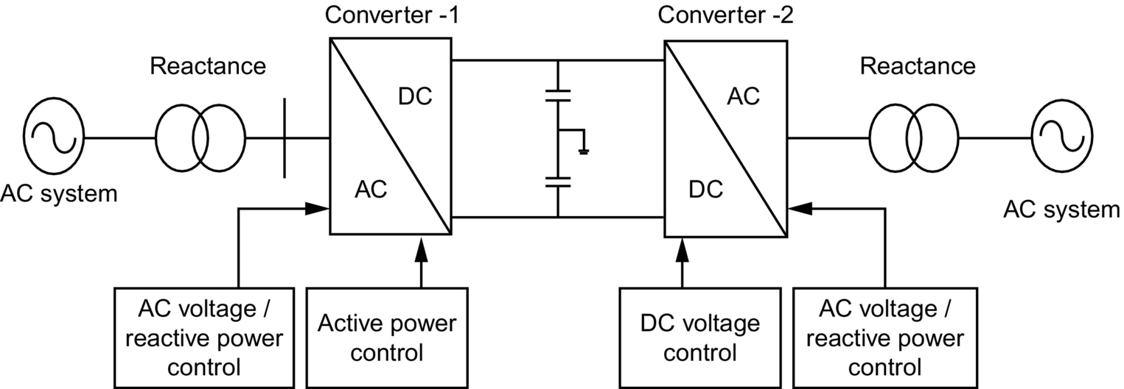

**FIG. 27.45** VSC-HVDC control system.

### 27.9.2 DIRECT CONTROL METHOD

Direct control method is a simple method for the control of VSC-HVDC. The angle *d* and modulation index *Mi* are controlled directly by using PI controllers. The measured values are compared with the reference values, and the resultant errors are fed to the PI controllers. The output of which is used as either modulation index or angle delta. The modeling of direct control system is provided in [Section **27.9.5.3**](https://learning.oreilly.com/library/view/power-electronics-handbook/9780128114087/B9780128114070000301.xhtml#s0450). Though this method is not used in practical applications, it is useful in comparative studies of operation and performance of VSC-HVDC.

### 27.9.3 VECTOR CONTROL METHOD

The P and Q controlled quantities of VSC-HVDC are coupled to each other such that any change in one quantity strongly affects the other. The vector control method removes the coupling between these quantities to ensure the independent control of each quantity. The vector control strategy consists of a cascade control system with faster inner controllers. The vector controller is accomplished by additional outer current controller that provides the reference values for inner controller. The outer controllers include active power controller, reactive power controller, AC voltage controller, DC voltage controller, or frequency controller where the implementation of particular control strategy depends on the application and operating conditions of VSC-HVDC system. It is not possible to implement all the control strategies at the same time and requires an extensive system operation and performance studies for implementation of particular control method.

For feeding the passive system at receiving end without any local voltage source, it is necessary to control the frequency and AC voltage, whereas the active power and reactive power control is required in active AC system. However, since the active power flow into the DC link must be balanced, the DC voltage controller is necessary in any case to achieve active power balance. On the DC side, the active power input to the DC link must equal the active power output from the DC link plus the losses in the DC link. Any difference would result in a change in the DC voltage.

In order to understand the vector control technique of the VSC-HVDC transmission system, the mathematical model for VSC-HVDC system needs to be derived. The vector control strategy can be derived from the mathematical modeling of the system shown in [Fig. 27.46](https://learning.oreilly.com/library/view/power-electronics-handbook/9780128114087/B9780128114070000301.xhtml#f0235).

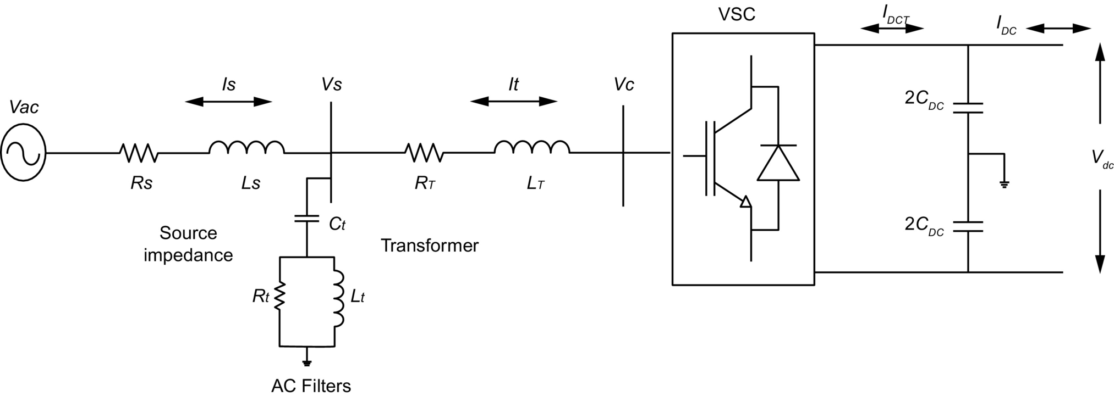

**FIG. 27.46** Vector control system of VSC-HVDC system.

The AC filters connected to the VSC-HVDC system behave as pure capacitors at fundamental frequencies. Hence, in the mathematical model presented here, the filter resistances and inductances can be neglected. From the single-line diagram ([Fig. 27.46](https://learning.oreilly.com/library/view/power-electronics-handbook/9780128114087/B9780128114070000301.xhtml#f0235)), the voltage across the transformer, the current to the filter, and the voltage across the source impedance can be obtained in three-phase instantaneous form as follows:

The voltage across the source impedance is

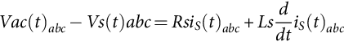 **(27.10)**

The current through the filters is

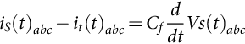 **(27.11)**

The voltage across the transformer is

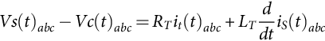 **(27.12)**

From Eqs. [(27.10)](https://learning.oreilly.com/library/view/power-electronics-handbook/9780128114087/B9780128114070000301.xhtml#fo0055)–[(27.12)](https://learning.oreilly.com/library/view/power-electronics-handbook/9780128114087/B9780128114070000301.xhtml#fo0065), the following differential equations can be derived:

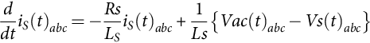 **(27.13)**

**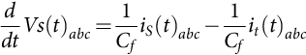** **(27.14)**

**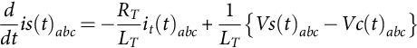** **(27.15)**

By using Clarke's transformation matrix, quantities from ABC frame can be converted to αβ reference frame as follows:

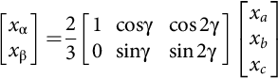 **(27.16)**

where *γ*=2π/3.

Eqs. [(27.13)](https://learning.oreilly.com/library/view/power-electronics-handbook/9780128114087/B9780128114070000301.xhtml#fo0070)–[(27.15)](https://learning.oreilly.com/library/view/power-electronics-handbook/9780128114087/B9780128114070000301.xhtml#fo0080) can be converted in to αβ frame as follows:

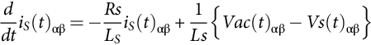 **(27.17)**

**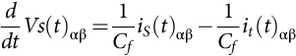** **(27.18)**

**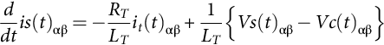** **(27.19)**

By using the transformation angle *θ* derived from a phase-locked loop (PLL), the above equations are further transferred to the synchronously rotating *dq* reference frame, using Park's transformation, as follows:

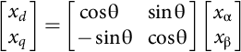 **(27.20)**

**** **(27.21)**

**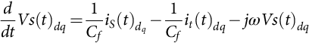** **(27.22)**

**** **(27.23)**

The AC filter voltage, the current through the transformer, and the AC side voltage of VSC can be expressed as

 **(27.24)**

**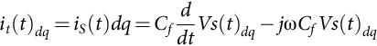** **(27.25)**

**** **(27.26)**

From Eq. [(27.26)](https://learning.oreilly.com/library/view/power-electronics-handbook/9780128114087/B9780128114070000301.xhtml#fo0135), the *dq* current component through the transformer can be given as

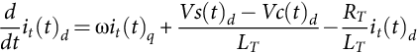 **(27.27)**

**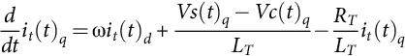** **(27.28)**

Eqs. [(27.27)](https://learning.oreilly.com/library/view/power-electronics-handbook/9780128114087/B9780128114070000301.xhtml#fo0140) and [(27.28)](https://learning.oreilly.com/library/view/power-electronics-handbook/9780128114087/B9780128114070000301.xhtml#fo0145) present the relationship between input reference current and converter output AC voltage in *dq* reference frame.

### 27.9.4 LIMITATIONS

The VSC-HVDC link with its semiconductor switches has a limited overload capacity. Large transient currents due to system disturbances can stress or damage the converter valves. Therefore, a current limit must be implemented in the control system. Moreover, since the maximum voltage amplitude out of the VSC is limited by the VSC voltage capability, the produced reference voltage from the vector controller must be appropriately limited. The current limit *Ilim* is compared with the current magnitude computed from the active and reactive reference currents. When the current limit is exceeded, both the active and reactive reference currents have to be limited. The choice of how to limit both reference currents will depend on the application. For instance, if the converter is connected to a strong system, the active component of the reference current will be given priority, when the current limit is exceeded, to produce more active power. The produced active power is estimated from the equation:

 **(27.29)**

If the converter is connected to a weak system or used to supply a bulk industrial user (or island), the VSC will give priority to the reactive component of the reference current to maintain the AC voltage when the current limit is exceeded. The remaining capacity is then available for active power production. The produced reactive and active power may be estimated from the following equations:

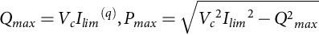 **(27.30)**

where *Ilim(q)* is the preset maximum reactive reference current.

### 27.9.5 OUTER CONTROLLER

The outer controller consists of the DC voltage controller, active power controller and reactive power controller. The proposed simulation model consists of active power and reactive power controllers at VSC1 and DC voltage and reactive power controllers at VSC2. The outer controller creates the reference values of the *dq* current components for inner current controllers. The outer controller gains are smaller when compared with the inner controller to ensure the stability of the complete system.

#### **27.9.5.1 DC Voltage Controller**

As shown in [Fig. 27.46](https://learning.oreilly.com/library/view/power-electronics-handbook/9780128114087/B9780128114070000301.xhtml#f0235), the instantaneous active and reactive powers in *dq* reference frame at the AC side of the VSC and the power *PDC* transmitted on the DC side of the VSC are expressed as

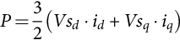 **(27.31)**

**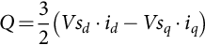** **(27.32)**

**** **(27.33)**

where *IDCT* is the current flowing in the DC terminals of the VSC.

During steady-state operation, the *dq* components of voltages are constant at the rated values. Therefore, the voltage *Vsd* is rated voltage *Vs*, and *Vsq* is zero. By considering the above assumptions, the active and reactive powers are expressed as follows:

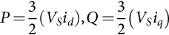 **(27.34)**

If the losses in the converter transformer and converter are neglected, the power at the AC and DC sides can be considered equal, that is,

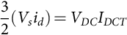 **(27.35)**

Hence,

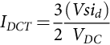 **(27.36)**

The current in the DC line of the VSC is given as

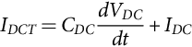 **(27.37)**

Any imbalance between the AC and DC powers leads to a change in voltage at the DC-link capacitors, which is given as

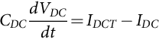 **(27.38)**

where *IDCT* is the current in the DC terminals of the VSC, *CDC* is the total DC side capacitance, *VDC* is the DC voltage across the capacitor, and *IDC* is the DC current flowing through the transmission line. The value of DC current from Eq. [(27.37)](https://learning.oreilly.com/library/view/power-electronics-handbook/9780128114087/B9780128114070000301.xhtml#fo0190) can be used in Eq. [(27.35)](https://learning.oreilly.com/library/view/power-electronics-handbook/9780128114087/B9780128114070000301.xhtml#fo0180), that is,

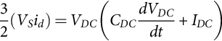 **(27.39)**

**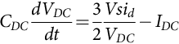** **(27.40)**

From Eq. [(27.39)](https://learning.oreilly.com/library/view/power-electronics-handbook/9780128114087/B9780128114070000301.xhtml#fo0200), the value of the reference current *id⁎* is derived as follows:

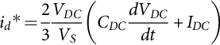 **(27.41)**

The d-component of the current derived Eq. [(27.41)](https://learning.oreilly.com/library/view/power-electronics-handbook/9780128114087/B9780128114070000301.xhtml#fo0210) gives the reference current for the inner current controller for DC voltage control.

#### **27.9.5.2 Active Power Controller**

The active current reference is obtained from Eq. [(27.34)](https://learning.oreilly.com/library/view/power-electronics-handbook/9780128114087/B9780128114070000301.xhtml#fo0175):

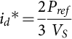 **(27.42)**

where *Pref* is the reference active power. For accurate control of the active power, a combination of a feedback loop and an open loop is used:

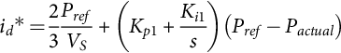 **(27.43)**

where *Kp*1 and *Ki*1 are the proportional and integral gains, respectively, of the active power controller.

#### **27.9.5.3 Reactive Power Controller**

A reactive power controller similar to the active power controller is obtained from Eq. [(27.34)](https://learning.oreilly.com/library/view/power-electronics-handbook/9780128114087/B9780128114070000301.xhtml#fo0175) as

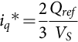 **(27.44)**

where *Qref* is reference reactive power. Again, same method is used to combine a feedback loop with an open loop:

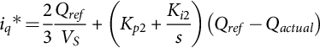 **(27.45)**

where *Kp*2 and *Ki*2 are the proportional and integral gains, respectively, of the reactive power controller.

[Fig. 27.47](https://learning.oreilly.com/library/view/power-electronics-handbook/9780128114087/B9780128114070000301.xhtml#f0240) shows active and reactive power control system for VSC1. The control block of PLL is shown from which the synchronization angle *θ* is derived and fed to the ABC to *dq* block.

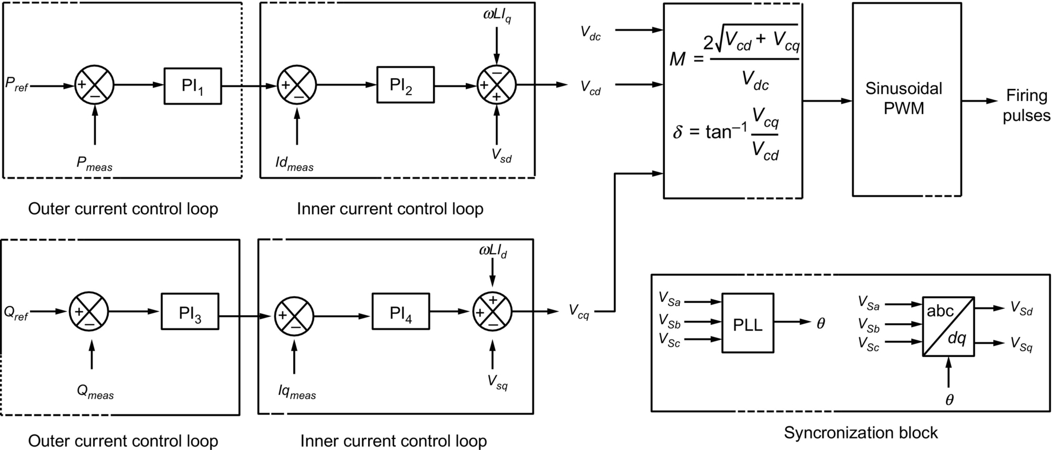

**FIG. 27.47** Active and reactive power control system.

### 27.9.6 SUMMARY

This chapter deals with the control system of VSC-HVDC transmission system. Two different control systems, direct control and vector control, are explained. The VSC-HVDC mathematical model is provided in this chapter. Block diagram of active power and reactive power control systems in vector control technique is also provided here.

## 27.10 HVDC System Simulation Techniques

Modern HVDC systems incorporate complex control and protection features. The testing and optimization of these features require powerful tools that are capable of modeling all facets of the system and have the flexibility to do the evaluation in a rapid, effective, and cost-efficient manner.

### 27.10.1 DC SIMULATORS AND TNAS [[9](https://learning.oreilly.com/library/view/power-electronics-handbook/9780128114087/B9780128114070000301.xhtml#bb0050)]

For decades, this has been achieved with the aid of physical power system simulators or transient network analyzers (TNAs) that incorporate scaled physical models of all power system elements (three-phase DC network lines/cables, sources as emf behind reactances, model circuit breakers for precisely timed AC system disturbances, transformers (system and convertor transformers with capacity to model saturation characteristics), filter capacitors, reactors, resistors, arrestors, and machines). Until the 1970s, these were built with analog components. However, with the developments in microprocessors, it is now feasible to utilize totally digital simulators operating in real time for even the most complex HVDC system studies. Most simulator operating scale are in the range 20–100 V DC and 0.2–1 A AC and at power frequency of 50 or 60 Hz. The stray capacitances and inductances are, however, not normally represented since the simulator is primarily used to assess control system behavior and temporary overvoltages of frequencies below 1000 Hz. Due to the developments of flexible AC transmission system (FACTS) application, most modern simulators now include similarly scaled models of HVDC converters, static compensators, and other thyristor-controlled equipment. The controls of these equipments are usually capable of realistic performance during transients such as the AC faults and commutation failure. The limited availability of adequate models of some of the system elements restricts the scope of the studies that can be completed entirely by means of the simulator. Due to the scaling problems, the losses in the simulator may be disproportionately high and need to be partly compensated by electronic circuits (negative resistances) to simulate appropriate damping of overvoltages and other phenomena.

### 27.10.2 DIGITAL COMPUTER ANALYSIS

The main type of program employed for studies is an electromagnetic transient program (EMTP) that solves sets of differential equations by step-by-step integration methods. The digital program must allow for modeling of both the linear and nonlinear components (single and three phase) and of the topological changes caused, for example, by valve firing or by circuit-breaker operation. Detailed modeling of the converter control system is necessary depending on the type of study.

EMTP has become an industry standard analysis tool for power systems and is widely used. The program has had a checkered history, and numerous variants have appeared. Initially, the development of the program was supported by the Bonneville Power Administration (BPA). Some of the drawbacks in the capabilities of EMTP became more pronounced as the modeling of flexible AC transmission system (FACTS) with power electronic switches and voltage-source converters became more desirable.

Some of the drawbacks of the original EMTP version were the following:

1. The use of a fixed timestep that did not take into account the relatively long periods of inaction during nonswitching events. This results in unnecessarily long simulation times and huge amounts of data to be manipulated. This is particularly problematic for simulating power electronic converters.

2. The use of a fixed timestep results in the modeled switches chopping inductive currents that causes numerical oscillations. The use of artificial RC “snubbers” helped to alleviate some of these problems. The choice of the snubber capacitor was a function of the magnitude of the current to be chopped and the timestep size.

3. The use of the trapezoidal integration method results in numerical oscillations when the network admittance matrix to be inverted becomes singular. This is the direct result of modeling switches as truly either ON or OFF without representation of their intermediate nonlinear characteristics.

4. The requirement of a one timestep delay between the main program and the TACS subroutine for control simulation.

5. The use of new voltage-source converters with multiple switchings per cycle made the problem of switching “jitter” much more evident.

6. The lack of user-friendly input and output processors.

In recent years, considerable effort has been made by the EMTP Development Coordination Group (DCG) to restructure the program. This has resulted in the latest version called the EMTP restructured version (RV) (see [www.emtp.com](http://www.emtp.com/)). The entire code of the program has been rewritten, and graphic input and output processors have been added. A sample of the graphic input file is shown in [Fig. 27.48](https://learning.oreilly.com/library/view/power-electronics-handbook/9780128114087/B9780128114070000301.xhtml#f0245).

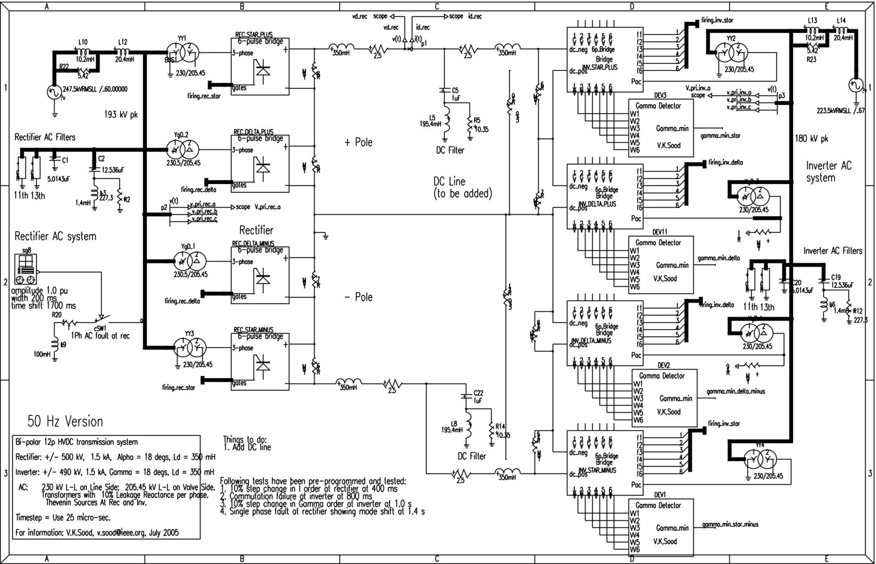

**FIG. 27.48** A sample of the graphic input file of EMTP RV.

The main advantage of digital studies is the possibility of correct representation of the damping present in the system. This feature permits more accurate evaluation of the nature and rate of decay of transient voltages following their peak levels in the initial few cycles and also a more realistic assessment of the peak current and total energy absorption of the surge arrestors. The digital program also allows modeling of stray inductances and capacitances and can be used to cover a wider frequency range of transients than the DC simulator.

The main disadvantage of the digital studies is the lack of adequate representation of commutation failure phenomena with the use of power electronic converters. However, with the increasing capacity of computers, this is likely to be overcome in the future.

The models used in the simulators and digital programs depend on the assumptions made and on the proper understanding of the component and system characteristics; therefore, they require care in their usage to avoid unrealistic results in inexperienced hands.

## 27.11 Concluding Remarks

HVDC technology is now mature, reliable, and accepted all over the world. From its modest beginning in the 1950s, the technology has advanced considerably and maintained its leading edge image. The encroaching technology of flexible AC transmission systems (FACTS) has learned and gained from the technological enhancements made initially by HVDC systems. FACTS technology may challenge some of the traditional roles for HVDC applications since the deregulation of the electric utility business will open up the market for increased interconnection of networks [[7](https://learning.oreilly.com/library/view/power-electronics-handbook/9780128114087/B9780128114070000301.xhtml#bb0040)]. HVDC transmission has unique characteristics that will provide it with new opportunities. Although the traditional applications of HVDC transmission will be maintained for bulk power transmission in places like China, India, S. America, and Africa, the increasing desire for the exploitation of renewable resources will provide both a challenge and an opportunity for innovative solutions in the following applications:

• Connection of small dispersed generators to the grid

• Alternatives to local generation

• Feeding to urban city centers

## References

[1] Kimbark E.W. *Direct Current Transmission—Volume I.* Wiley Interscience; 1971.0-471-35550-X.

[2] Arrillaga J. *High Voltage Direct Current Transmission.* second ed. The Institution of Electrical Engineers; 1998.0-85296-941-4.

[3] Padiyar K.R. *HVDC Power Transmission Systems—Technology and System Interactions.* John Wiley & Sons; 1990.0-470-21706-5.

[4] D. Melvold, HVDC Projects Listing, Prepared by IEEE DC and Flexible AC Transmission Subcommittee, 1965.

[5] Ainsworth J. The phase-locked oscillator—a new control system for controlled static converters. *IEEE Trans. Power Appar. Syst.* 1968;PAS-87(3):859–865.

[6] Ekstrom A., Liss G. A refined HVDC control system. *IEEE Trans. Power Appar. Syst.* 1970;PAS-89(5/6):723–732.

[7] Sood V.K. *HVDC and FACTS Controllers—Applications of Static Converters in Power Systems.* Kluwer Academic Publishers; 2004.1-4020-7890-0.

[8] Carlsson L., Asplund G., Bjorklund H., Stomberg H. *Recent and future trends in HVDC converter station design”.* In: IEE 2nd International Conference on Advances in Power System Control, Operation and Management, Dec. 1993, Hong Kong; 1993:221–226.

[9] C. Gagnon, V.K. Sood, J. Belanger, A. Vallee, et al., Hydro-Québec power system simulator, IEEE Canadian Rev. (19) Spring-Summer 1994, 6–9.

**28**

# Flexible AC Transmission Systems

Edson H. Watanabe Electrical Engineering Department, COPPE/Federal University of Rio de Janeiro, Rio de Janeiro, Brazil

Francisco K. deAraújo Lima Electrical Engineering Department, Federal University of Ceara, Fortaleza, Brazil

Robson F. daSilva Dias Electrical Engineering Department, Polytechnic School and COPPE/Federal University of Rio de Janeiro, Rio de Janeiro, Brazil

Maurício Aredes Electrical Engineering Department, Polytechnic School and COPPE/Federal University of Rio de Janeiro, Rio de Janeiro, Brazil

Pedro G. Barbosa Electrical Engineering Department, Federal University of Juiz de Fora, Juiz de Fora, Brazil

Silvangela L.S. Lima Barcelos Electrical Engineering Department, Federal University of Maranhão, São Luís, Brazil

Gilson Santos, Jr. Forbes Bros Ltd, Edmonton, Alberta, Canada

## Abstract

This chapter presents the basic operation principles of FACTS devices. Starting with a brief introduction on the concept and its origin, the text then focuses on the ideal behavior of each basic shunt and series of FACTS device. Guidelines on the synthesis of the first generation of these devices based on thyristors are presented, followed by the newer generations of FACTS devices based on self-commutated semiconductor switches.

### KEYWORDS

FACTS; STATCOM; SSSC; UFFC; SVC; TCR

28.1 [Introduction](https://learning.oreilly.com/library/view/power-electronics-handbook/9780128114087/B9780128114070000313.xhtml#s0010)

28.2 [Ideal Shunt Compensator](https://learning.oreilly.com/library/view/power-electronics-handbook/9780128114087/B9780128114070000313.xhtml#s0015)

28.3 [Ideal Series Compensator](https://learning.oreilly.com/library/view/power-electronics-handbook/9780128114087/B9780128114070000313.xhtml#s0020)

28.4 [Synthesis of FACTS Controllers](https://learning.oreilly.com/library/view/power-electronics-handbook/9780128114087/B9780128114070000313.xhtml#s0025)

28.4.1 Thyristor-Based FACTS Controllers

28.4.2 FACTS Controllers Based on Self-Commutated Switches

28.5 [Ancillary Services](https://learning.oreilly.com/library/view/power-electronics-handbook/9780128114087/B9780128114070000313.xhtml#s0155)

[References](https://learning.oreilly.com/library/view/power-electronics-handbook/9780128114087/B9780128114070000313.xhtml#bi0010)

[Further Reading](https://learning.oreilly.com/library/view/power-electronics-handbook/9780128114087/B9780128114070000313.xhtml#fr0010)

## 28.1 Introduction

In 1988, Hingorani [[1](https://learning.oreilly.com/library/view/power-electronics-handbook/9780128114087/B9780128114070000313.xhtml#bb0010)] published a paper entitled “Power Electronics in Electric Utilities: Role of Power Electronics in Future Power Systems,” proposing the extensive use of power electronics for the control of ac systems, which resulted in the flexible ac transmission system or the FACTS concepts [[2](https://learning.oreilly.com/library/view/power-electronics-handbook/9780128114087/B9780128114070000313.xhtml#bb0015)]. The basic idea was to obtain ac systems with a high level of control flexibility, as in high-voltage direct current (HVDC) systems [[3](https://learning.oreilly.com/library/view/power-electronics-handbook/9780128114087/B9780128114070000313.xhtml#bb0020)] based on the use of the thyristor and the self-commutated (controllable turn-on and turn-off) silicon (Si) semiconductor devices, such as gate turn-off thyristors (GTOs), insulated gate bipolar transistors (IGBTs), and integrated gate-controlled thyristors (IGCTs) [[4](https://learning.oreilly.com/library/view/power-electronics-handbook/9780128114087/B9780128114070000313.xhtml#bb0025),[5](https://learning.oreilly.com/library/view/power-electronics-handbook/9780128114087/B9780128114070000313.xhtml#bb0030)], or silicon carbide (SiC)-based devices [[6](https://learning.oreilly.com/library/view/power-electronics-handbook/9780128114087/B9780128114070000313.xhtml#bb0035)], which were not yet developed at that time.

The switching characteristics of thyristors—controlled turn-on and natural turn-off—are appropriate for using in line-commutated converters, such as in conventional HVDC transmission systems with a current source in the dc side. In this application, the technology for series connection of thyristors is very important due to the high-voltage characteristics of the transmission voltage. This is a well-known technology. Maximum breakdown voltage and current conduction capabilities are around 8 kV and 4 kA, respectively. These are some features that make thyristors important for very high-power applications, although they present some serious drawbacks, such as the lack of controlled turn-off capability and low switching speeds.

Self-commutated switches are adequate for use in converters where turn-off capability is necessary. The device with highest ratings in this group was, for a long time, the GTO with maximum switching capability of 6 kV and 6 kA. At present, there are IGBTs with ratings in the range of 6.5 kV to 3 kA and IGCTs with switching capability of about 6 kV and 4 kA. The GTOs and IGCTs are devices that normally need small inductor for limiting the rate of change of turn-on current (*di/dt*). Normally, GTOs also need a snubber circuit for limiting the rate of change of voltage (*dv/dt*).

The GTOs, IGCTs, and IGBTs are the most used options for self-commutated high-power converters. Because the switching time of these devices is in the microsecond range (or below), their series connection is more complicated than in the case of thyristors. However, there are examples of series connections of various GTOs or IGCTs, and in the case of IGBTs, the number of series connected devices can go as high as 32 [[7](https://learning.oreilly.com/library/view/power-electronics-handbook/9780128114087/B9780128114070000313.xhtml#bb0040)]. It is worth to note that GTOs are not used in new projects anymore.

Because of the commutation nature of the thyristors, the converters used in HVDC systems are of the current source type [[8](https://learning.oreilly.com/library/view/power-electronics-handbook/9780128114087/B9780128114070000313.xhtml#bb0045)]. On the other hand, the force-commutated converters using the self-commutated devices are basically of the voltage source type. More details about current source and voltage source converters can be found in many power electronics books, for example, Refs. [[3](https://learning.oreilly.com/library/view/power-electronics-handbook/9780128114087/B9780128114070000313.xhtml#bb0020),[8](https://learning.oreilly.com/library/view/power-electronics-handbook/9780128114087/B9780128114070000313.xhtml#bb0045)].

## 28.2 Ideal Shunt Compensator

A simple and lossless ac system is composed of two ideal generators, and a short transmission line, as shown in [Fig. 28.1](https://learning.oreilly.com/library/view/power-electronics-handbook/9780128114087/B9780128114070000313.xhtml#f0010), is considered as basis to the discussion of the operating principles of a shunt compensator [[9](https://learning.oreilly.com/library/view/power-electronics-handbook/9780128114087/B9780128114070000313.xhtml#bb0050)]. The transmission line is modeled by an inductive reactance *XL*. In the circuit, a continuously controlled voltage source is connected in the middle of the transmission line. It is assumed that the voltage phasors *VS* and *VR* have the same magnitude, *V*, and are phase-shifted by *δ*. The subscript “*S*” stands for “source” and “*R*” stands for “receptor.” [Fig. 28.2](https://learning.oreilly.com/library/view/power-electronics-handbook/9780128114087/B9780128114070000313.xhtml#f0015) shows the phasor diagram of the system given in [Fig. 28.1](https://learning.oreilly.com/library/view/power-electronics-handbook/9780128114087/B9780128114070000313.xhtml#f0010) in which the compensation voltage phasor *VM* has also the same magnitude as *VS* and *VR*, and its phase is exactly (−*δ*/2) with respect to *VS* and (+*δ*/2) with respect to *VR*.

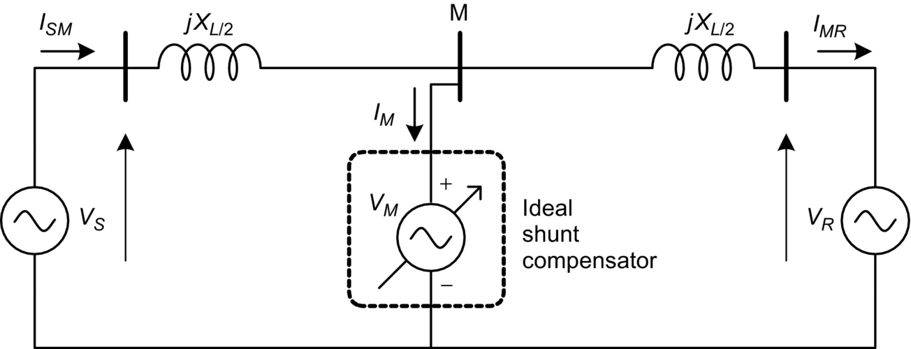

**FIG. 28.1** Ideal shunt compensator connected in the middle of a transmission line.

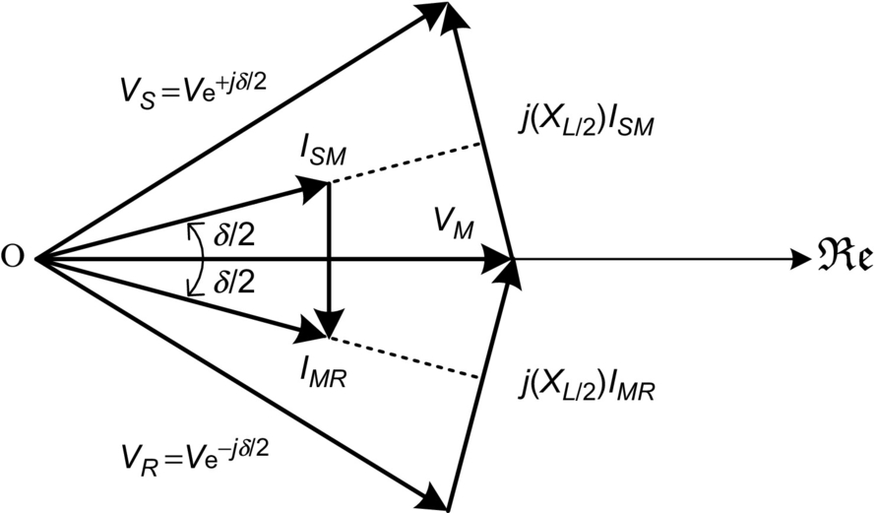

**FIG. 28.2** Phasor diagram of the system with shunt reactive power compensation.

In this situation, the current *ISM* flows from the source and the current *IMR* flows into the receptor. The phasor *IM* is the resulting current flowing through the ideal shunt compensator; [Fig. 28.2](https://learning.oreilly.com/library/view/power-electronics-handbook/9780128114087/B9780128114070000313.xhtml#f0015) shows that this current *IM*, in this case, is orthogonal to the voltage *VM*, which means that the ideal shunt compensator voltage source does not have to generate or absorb active power and have only reactive power in its terminals.

From [Fig. 28.2](https://learning.oreilly.com/library/view/power-electronics-handbook/9780128114087/B9780128114070000313.xhtml#f0015) and knowing that no active power flows to or from the ideal shunt compensator, it is possible to calculate the power transferred from *VS* to *VR* that is given by

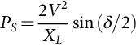 **(28.1)**

where *PS* is the active power flowing from the source.

If the ideal shunt compensator were not present, the transferred power would be given by

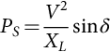 **(28.2)**

Since 2 sin(*δ*/2) is always greater than sin *δ* for *δ* in the range of [0, 2π], the ideal shunt compensator does improve the power transfer capability of the transmission line. This voltage source is in fact operating as an ideal reactive power shunt compensator.

If the phase angle between *VM* and *VS* is different from *δ*/2 (as shown in [Fig. 28.3](https://learning.oreilly.com/library/view/power-electronics-handbook/9780128114087/B9780128114070000313.xhtml#f0020)), the power flowing through *VM* has both active and reactive components.

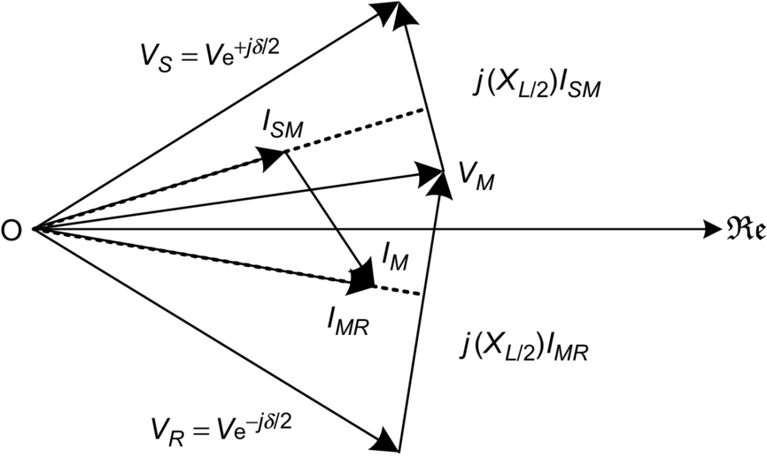

**FIG. 28.3** Phasor diagram of the system with shunt reactive and active power compensation.

With the characteristics of the ideal shunt compensator, presented above, it is possible to synthesize power electronic-based devices to operate as active or reactive power compensators. This is discussed in the following sections. It will be seen that the requirements of the device synthesis with actual semiconductor switches for the situations of reactive or active power compensation are different because of the need of energy storage element or energy source if active power is to be drained or generated by the shunt compensator.

## 28.3 Ideal Series Compensator

Similar to the previous section, the ideal series compensator is modeled by a voltage source for which the phasor is *VC* connected in the middle of a lossless transmission line as shown in [Fig. 28.4](https://learning.oreilly.com/library/view/power-electronics-handbook/9780128114087/B9780128114070000313.xhtml#f0025)

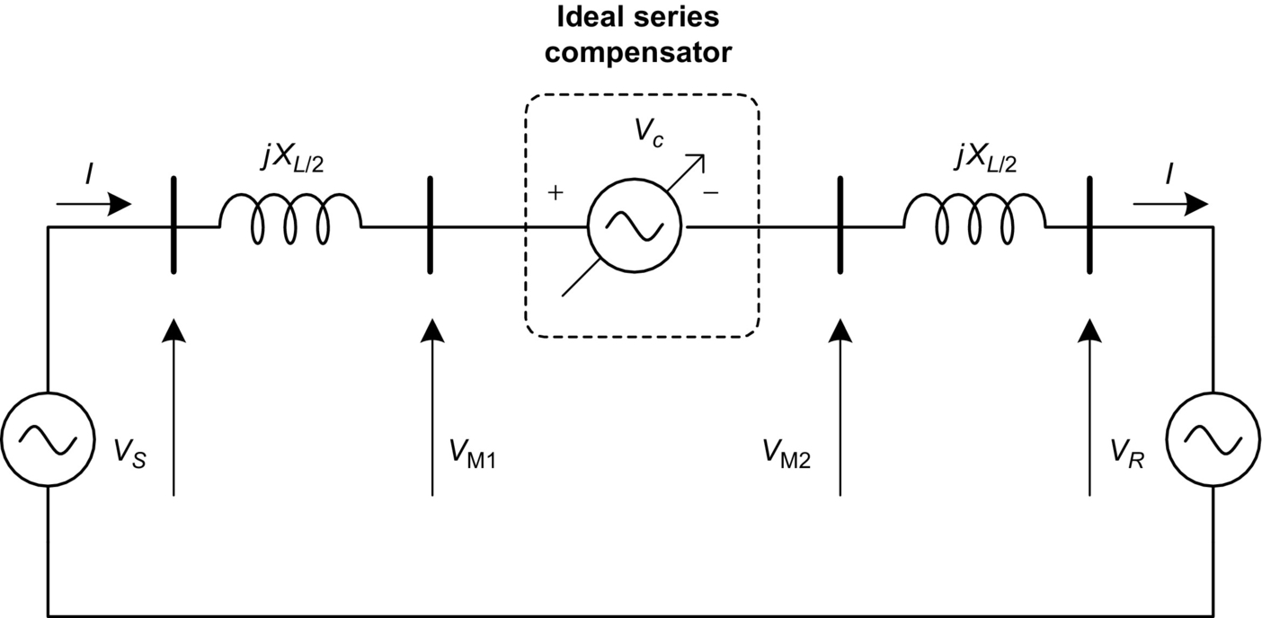

**FIG. 28.4** Ideal series compensator connected in the middle of a transmission line.

The current flowing through the transmission line is given by

 **(28.3)**

where .

If the ideal series compensator voltage is generated in such a way that its phasor *VC* is in quadrature with line current *I*, this series compensator neither supplies nor absorbs active power. As discussed earlier, power at the series source is only reactive, and the voltage source may, in this particular case, be replaced by capacitive or inductive equivalent impedance. Then, the equivalent impedance is given by

 **(28.4)**

where

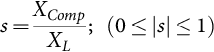 **(28.5)**

is the compensation factor and *XComp* is the series equivalent compensation reactance, negative if capacitive and positive if inductive. In this case, the compensation voltage is given by

 **(28.6)**

and the transmitted power is equal to

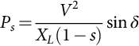 **(28.7)**

Eq. [(28.7)](https://learning.oreilly.com/library/view/power-electronics-handbook/9780128114087/B9780128114070000313.xhtml#fo0040) shows that the transmitted power can be considerably increased by series compensation, choosing a proper compensation factor *s*. The reactive power at the series source is given by

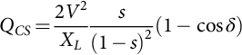 **(28.8)**

The left-hand side of [Fig. 28.5A](https://learning.oreilly.com/library/view/power-electronics-handbook/9780128114087/B9780128114070000313.xhtml#f0030) shows the phasor diagram of the system shown in [Fig. 28.4](https://learning.oreilly.com/library/view/power-electronics-handbook/9780128114087/B9780128114070000313.xhtml#f0025) without the ideal series compensator. On the right-hand side of the [Fig. 28.5A](https://learning.oreilly.com/library/view/power-electronics-handbook/9780128114087/B9780128114070000313.xhtml#f0030), the voltage phasor *VL* on the line reactance *XL* and the compensator voltage phasor *VC* are shown for a given compensation level, assuming that this voltage *VC* corresponds to a capacitive compensation. In this case, the line current phasor leads voltage phasor *VC* by 90 degrees, and the total voltage drop in the line  is larger than the original voltage drop *VL*. The current flowing in the line is larger after compensation than before. This situation shows the case where the series compensator is used to increase power flow.

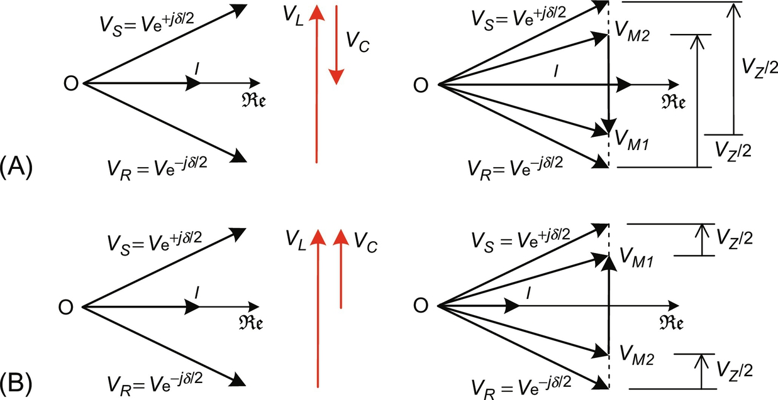

**FIG. 28.5** Phasor diagram of the series reactive compensator: (A) capacitive and (B) inductive mode.

The left-hand side of the [Fig. 28.5B](https://learning.oreilly.com/library/view/power-electronics-handbook/9780128114087/B9780128114070000313.xhtml#f0030) shows the same noncompensated situation as in the previous case. On the right-hand side, the case of an equivalent inductive compensation is shown. In this case, the compensation voltage *V****C*** is in phase with the line drop voltage *VL*, producing an equivalent total voltage drop *VZ* smaller than in the original case. As a result, the current phasor *I* flowing in the line is smaller than before compensation. This kind of compensation might be interesting in the case that the power flowing through the line has to be decreased. In either capacitive or inductive compensation modes, no active power is absorbed or generated by the ideal series compensator.

[Fig. 28.6](https://learning.oreilly.com/library/view/power-electronics-handbook/9780128114087/B9780128114070000313.xhtml#f0035) shows an ac system with an ideal generic series compensation voltage source *VC* for the general case where it may not be in quadrature with the line current. In this case, the compensator can fully control the phase difference between the two systems, thus controlling the active and reactive power exchanged between them. However, in this case, the compensation voltage source *VC* may have to absorb or generate active power (*PC*) and control the reactive power (*QC*).

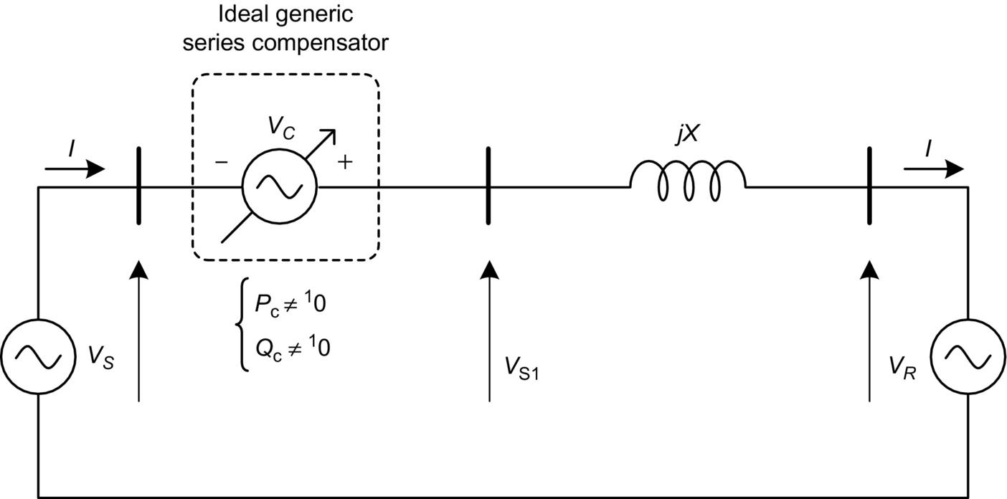

**FIG. 28.6** Ideal generic series compensator.

[Fig. 28.7](https://learning.oreilly.com/library/view/power-electronics-handbook/9780128114087/B9780128114070000313.xhtml#f0040) shows the phasor diagram of this ideal generic series compensator. This figure also shows a dashed-line circle with the locus of all possible positions that the compensation voltage *VC* could take, assuming that the magnitude shown for this voltage is its maximum. Naturally, if the sum of the compensation voltage and the source voltage *VS* is on the circle, the magnitude of *VS1* may be smaller or larger than the magnitude of *VS*.

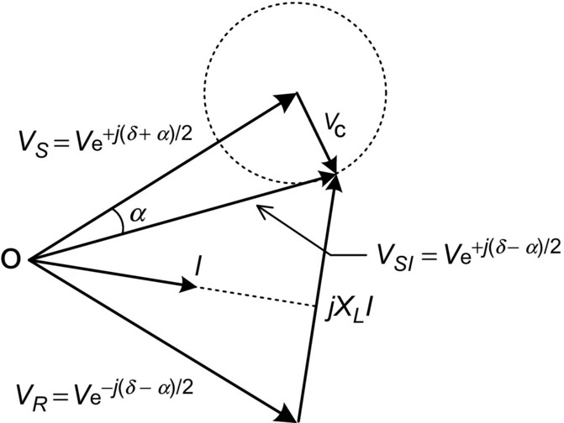

**FIG. 28.7** Phasor diagram of the ac system compensated with an ideal generic series compensator.

The compensation voltage *V*C can be added to the *V*S in a way that the resultant voltage *V*S1 has the same magnitude of *V*S but with a phase shifted by an angle *α*. In this case, the series compensator can be called as a phase-shifter compensator, and the power flowing through the transmission line (see [Fig. 28.6](https://learning.oreilly.com/library/view/power-electronics-handbook/9780128114087/B9780128114070000313.xhtml#f0035)) is expressed below:

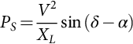 **(28.9)**

Eq. [(28.9)](https://learning.oreilly.com/library/view/power-electronics-handbook/9780128114087/B9780128114070000313.xhtml#fo0050) shows that transmitted power increases as the phase difference () reaches 90 degrees. However, its maximum value is the same as in the case of no compensation. The difference is that with this compensator, the system power angle, and angle difference between the two voltage sources at the terminals of the line can be controlled faster than the conventional way, that is, by controlling the synchronous generator.

In [Fig. 28.7](https://learning.oreilly.com/library/view/power-electronics-handbook/9780128114087/B9780128114070000313.xhtml#f0040), voltage *VC* may have any phase angle with respect to line current. Therefore, it may have to supply or absorb active power and control reactive power. As in the case of the shunt device, this feature must also be taken into account in the synthesis of the actual devices. As a first approximation, when the goal is to control active power flowing through the medium- or short-length transmission lines, compensator location seems to be a question of convenience.

[Fig. 28.8](https://learning.oreilly.com/library/view/power-electronics-handbook/9780128114087/B9780128114070000313.xhtml#f0045) summarizes the active power transfer characteristics in a transmission line as a function of the power angle, *δ*, as shown in [Figs. 28.1](https://learning.oreilly.com/library/view/power-electronics-handbook/9780128114087/B9780128114070000313.xhtml#f0010) and [28.2](https://learning.oreilly.com/library/view/power-electronics-handbook/9780128114087/B9780128114070000313.xhtml#f0015), for the cases of the line without compensation, line with series or shunt reactive power compensation, and line with phase-shift compensation (generic series compensation). These characteristics are drawn on the assumption that the source voltages *VS* and *VR* (see [Fig. 28.2](https://learning.oreilly.com/library/view/power-electronics-handbook/9780128114087/B9780128114070000313.xhtml#f0015)) have the same magnitude. A 50% series compensation (*s*=0.5) as defined in Eq. [(28.4)](https://learning.oreilly.com/library/view/power-electronics-handbook/9780128114087/B9780128114070000313.xhtml#fo0025) presents a significant increase in the line power transfer capability.

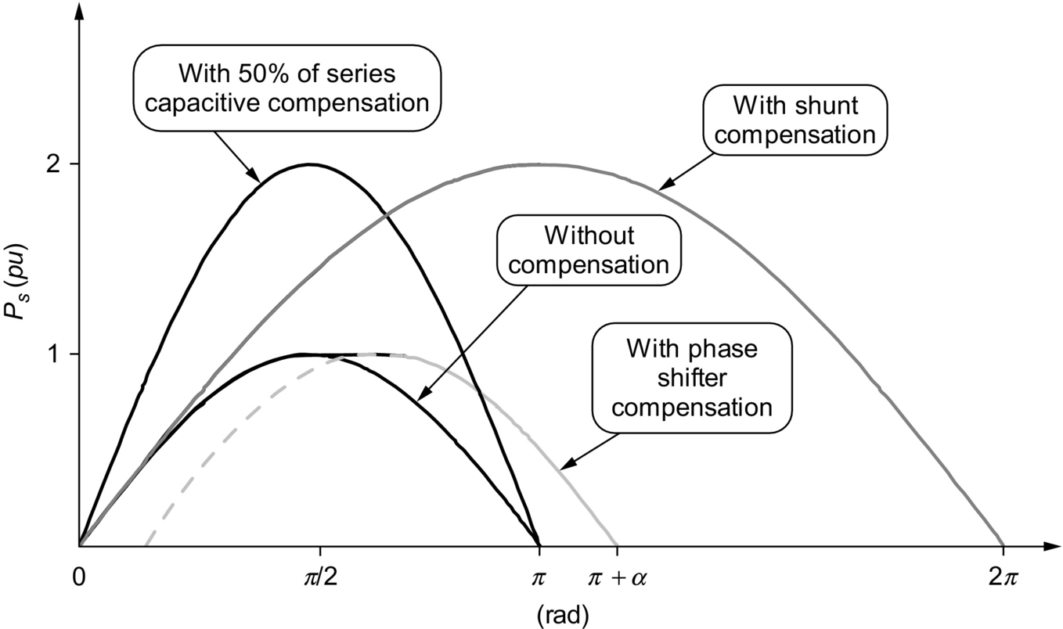

**FIG. 28.8** Power transfer characteristics for the case of shunt, series, phase shift, and no compensation.

As shown in [Fig. 28.8](https://learning.oreilly.com/library/view/power-electronics-handbook/9780128114087/B9780128114070000313.xhtml#f0045), in general, series compensation is the best choice for increasing power transfer capability. The phase-shifter compensator is important to connect two systems with excessive or uncontrollable phase difference. It does not increase power transfer capability significantly; however, it may allow the adjustment of large or highly variable phase differences. The shunt compensator does not increase power transfer capability in a significant way in its normal operating region, where the angle *δ* is naturally below 90 degrees and in general around or less than 30 degrees. The great importance of the shunt compensator is the increase in the stability margin, as explained in [Fig. 28.9](https://learning.oreilly.com/library/view/power-electronics-handbook/9780128114087/B9780128114070000313.xhtml#f0050).

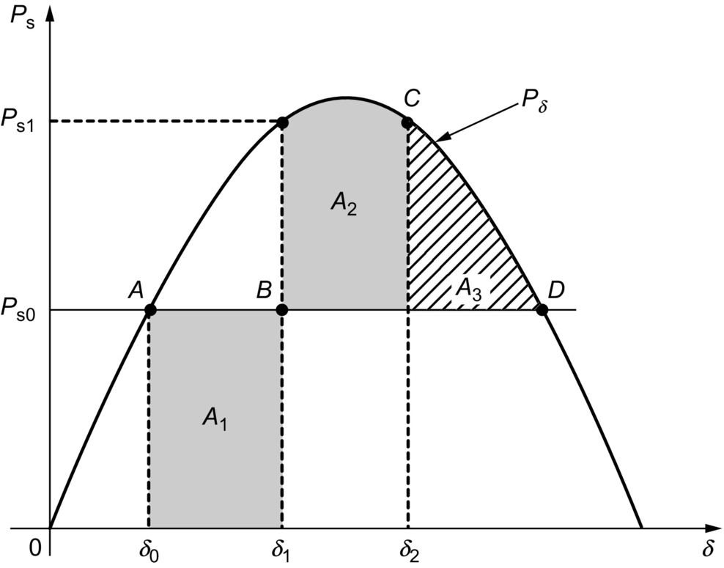

**FIG. 28.9** Stability margin characteristics—stable situation.

[Fig. 28.9](https://learning.oreilly.com/library/view/power-electronics-handbook/9780128114087/B9780128114070000313.xhtml#f0050) shows the power transfer characteristics  of a transmission line, which is first assumed to be transmitting power *PS*0 at phase angle *δ*0. If a problem happens in the line (e.g., a fault), the turbine that drives the generator cannot change its mechanical power input immediately even if there is no power transmission for a short time. This situation accelerates the generator, increasing its frequency and leading to an increase of the phase angle *δ* to *δ*1. If the line restarts operation at the instant corresponding to this phase angle *δ*1, the transmitted power will be *PS*1, which is larger than *PS*0 and decelerates the turbine or generator. The area *A*1 corresponds to the energy that accelerated the turbine. As the frequency gets higher than the rated frequency at (*PS*1, *δ*1), the phase angle will increase up to *δ*2, where the area *A*2 is equal to the area *A*1. If the area given by the *A*2 plus *A*3 is larger than *A*1, the system is said to be dynamically stable. On the contrary, if it is not possible to have an area *A*2 equal to *A*1, the system is said to be unstable. An unstable situation is shown in [Fig. 28.10](https://learning.oreilly.com/library/view/power-electronics-handbook/9780128114087/B9780128114070000313.xhtml#f0055) in which the system is the same as in [Fig. 28.9](https://learning.oreilly.com/library/view/power-electronics-handbook/9780128114087/B9780128114070000313.xhtml#f0050) but assuming a longer interval with no power transmission. In this case, the turbine or generator accelerates more than that in [Fig. 28.9](https://learning.oreilly.com/library/view/power-electronics-handbook/9780128114087/B9780128114070000313.xhtml#f0050), and the phase angle *δ* increases above its critical value *δ*c, which is slightly less than 90degrees reaching *δ*1. Therefore, the area below the *Pxδ* curve to decelerate the system is not enough leading to an unstable system because *A*2 is smaller than *A*1 and the frequency does not return to its original value.

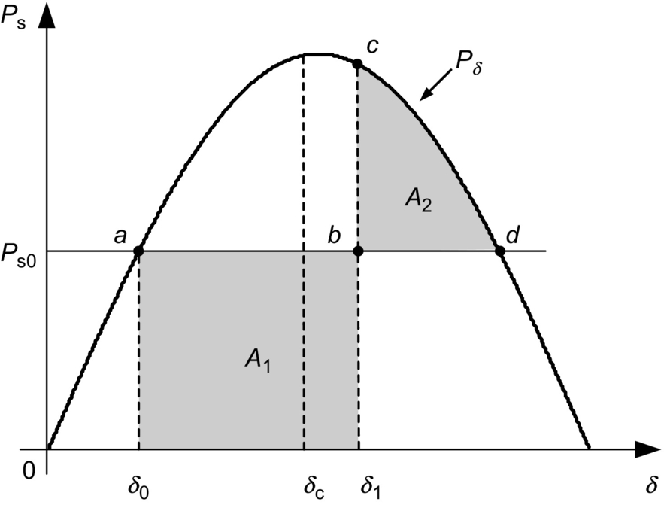

**FIG. 28.10** Stability margin characteristics—unstable situation.

Looking at [Fig. 28.8](https://learning.oreilly.com/library/view/power-electronics-handbook/9780128114087/B9780128114070000313.xhtml#f0045), it is possible to see that depending on the operating point, all three compensation methods increase the stability margin as the area under the curve of transmitted power *Pδ* versus phase angle *δ* is increased. The ideal shunt compensator is the one that most increases this area, and thus, it is said to be the best option to increase the stability margin.

## 28.4 Synthesis of FACTS Controllers

It has been stated that the synthesis of the compensators presented in [Sections 28.2](https://learning.oreilly.com/library/view/power-electronics-handbook/9780128114087/B9780128114070000313.xhtml#s0015) and [28.3](https://learning.oreilly.com/library/view/power-electronics-handbook/9780128114087/B9780128114070000313.xhtml#s0020) can be achieved with thyristors or self-commutated switches. Each type of switches (thyristor or self-commutated) leads to controllers with different operating principles and synthesis concepts, and hence, they should be discussed separately. Terms and definitions for most of the FACTS controllers are given in Ref. [[10](https://learning.oreilly.com/library/view/power-electronics-handbook/9780128114087/B9780128114070000313.xhtml#bb0055)].

Thyristor-based FACTS controllers use line or natural commutation together with large passive energy storage elements (capacitors or reactors). On the other hand, controllers based on self-commutating switches use gate-controlled commutation. In general, it is said that the first generation of FACTS devices is based on conventional line-commutated thyristors, and the subsequent generations are based on gate-controlled devices or self-commutated switches. The most important FACTS controllers based on thyristors and self-commutating controllers are presented in the following sections.

### 28.4.1 THYRISTOR-BASED FACTS CONTROLLERS

#### **28.4.1.1 Thyristor-Controlled Reactor**

The most used thyristor-based FACTS controller is the thyristor-controlled reactor (TCR) as shown in [Fig. 28.11A](https://learning.oreilly.com/library/view/power-electronics-handbook/9780128114087/B9780128114070000313.xhtml#f0060). This is a shunt compensator that produces an equivalent continuous variable inductive reactance by using phase-angle control. [Fig. 28.11B](https://learning.oreilly.com/library/view/power-electronics-handbook/9780128114087/B9780128114070000313.xhtml#f0060) shows the voltage and current waveforms of the TCR. The current is controlled by the firing angle *α*; the magnitude of the fundamental current component can be larger or smaller depending on the angle *α*, which can vary from 90 to 180 degrees measured from the zero crossing of the voltage. At , the reactor is fully inserted in the circuit, and for , the reactor is completely out of the circuit. [Fig. 28.12](https://learning.oreilly.com/library/view/power-electronics-handbook/9780128114087/B9780128114070000313.xhtml#f0065) shows the equivalent admittance of the TCR as function of the firing angle *α*. Naturally, this admittance is always inductive.

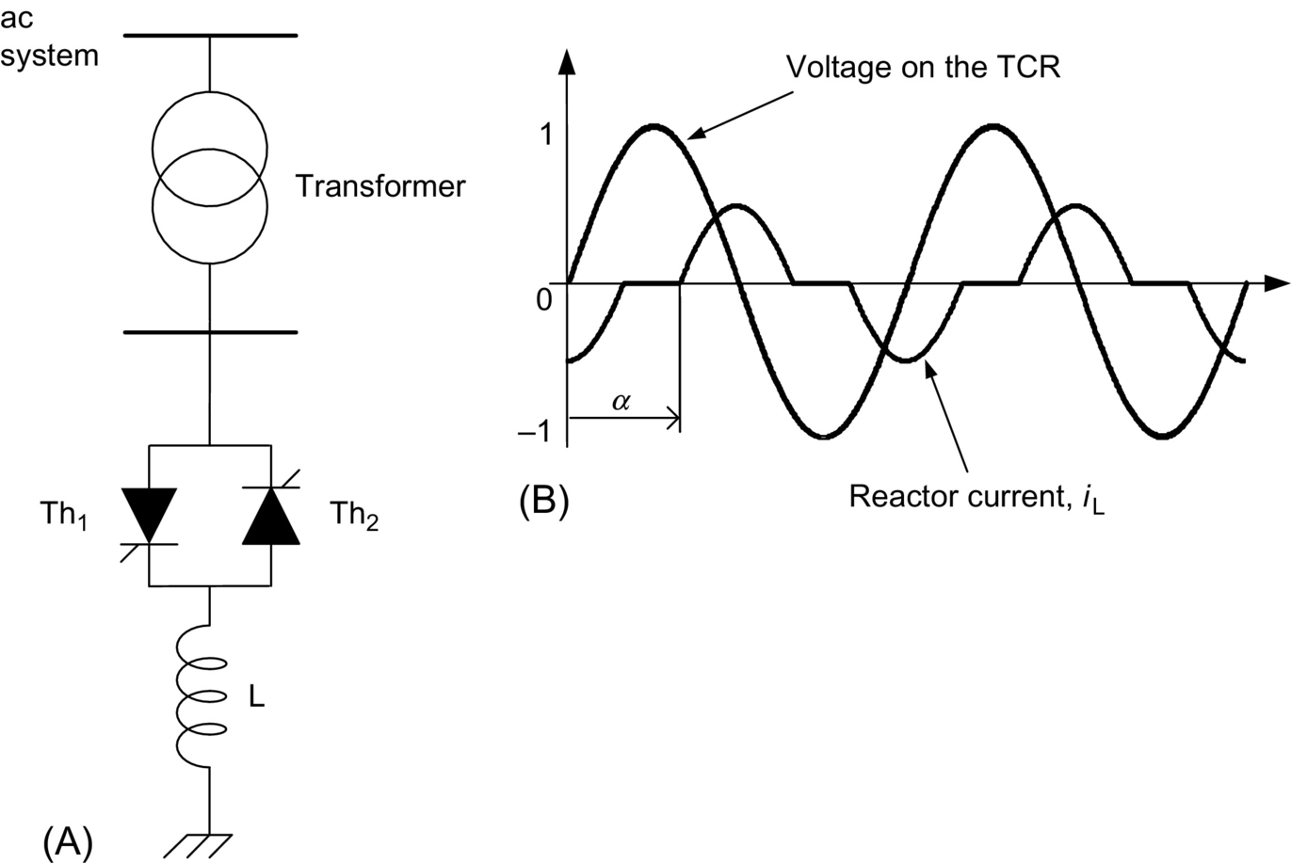

**FIG. 28.11** (A) TCR and (B) its voltage and current waveforms.

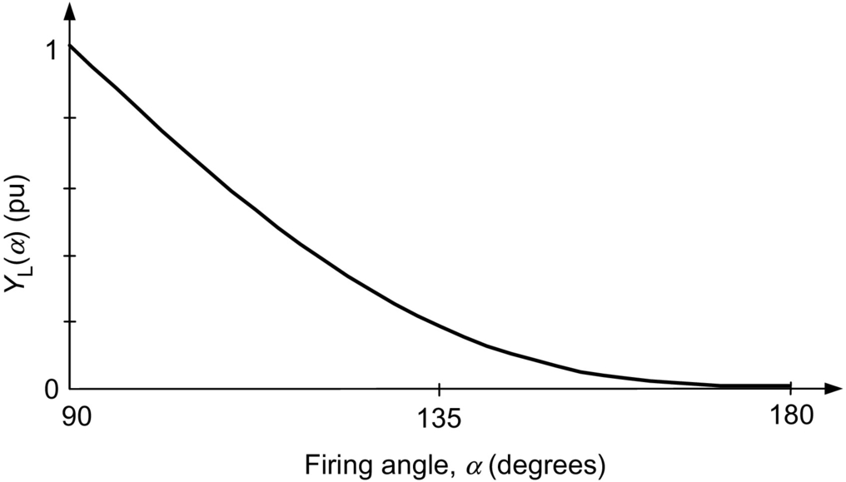

**FIG. 28.12** Equivalent admittance of a TCR as a function of the firing angle *α*.

#### **28.4.1.2 Thyristor-Switched Capacitor**

[Fig. 28.13](https://learning.oreilly.com/library/view/power-electronics-handbook/9780128114087/B9780128114070000313.xhtml#f0070) shows the thyristor-switched capacitor (TSC). The word “controlled” used in the case of the reactor is substituted by “switched” because the thyristor is turned on only when zero-voltage switching (ZVS) condition is possible. This means that the voltage across the thyristor terminals has to be zero at the turn-on instant. In practical cases, it may be slightly positive because thyristors need positive anode-cathode voltages to be triggered (positive anode-cathode voltage during turn-on); however, if this voltage is too high, it can produce a large current spike that can damage the thyristors. Therefore, due to this switching characteristic, the thyristors can only connect the capacitor to the grid or disconnect it. Consequently, only steplike control is possible, and a continuous control is not possible. The capacitor connection to or disconnection from the grid is normally performed at very low frequencies, and the harmonics, when they appear, are not a serious concern.

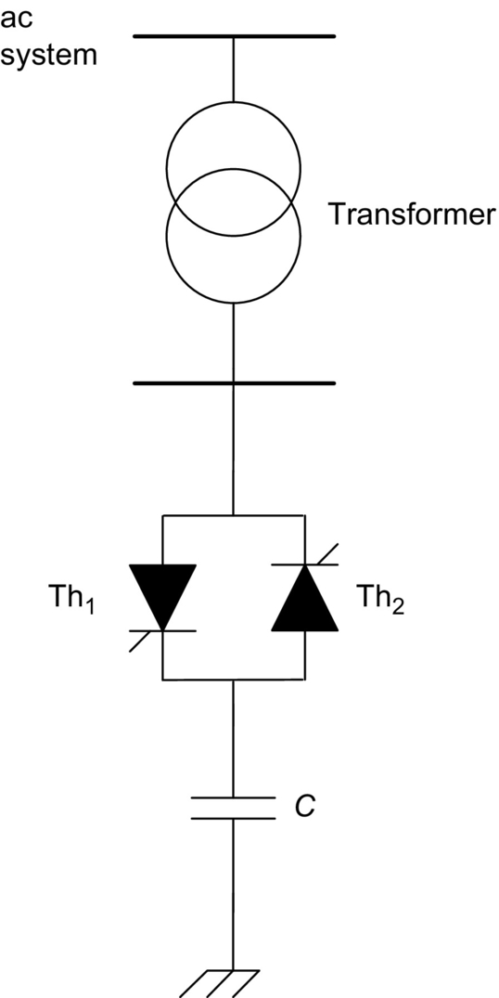

**FIG. 28.13** Thyristor-switched capacitor (TSC).

#### **28.4.1.3 Static Var Compensator**

The use of the TCR shown in [Fig. 28.11](https://learning.oreilly.com/library/view/power-electronics-handbook/9780128114087/B9780128114070000313.xhtml#f0060) or the TSC shown in [Fig. 28.13](https://learning.oreilly.com/library/view/power-electronics-handbook/9780128114087/B9780128114070000313.xhtml#f0070) allows only continuous inductive compensation or discontinuous capacitive compensation. However, in most applications, it is desirable to have continuous capacitive or inductive compensation. The static var compensator (SVC) is generally designed to operate in both inductive and capacitive continuous compensation [[11](https://learning.oreilly.com/library/view/power-electronics-handbook/9780128114087/B9780128114070000313.xhtml#bb0060),[12](https://learning.oreilly.com/library/view/power-electronics-handbook/9780128114087/B9780128114070000313.xhtml#bb0065)]. It may be used for reactive power compensation for either voltage regulation or power factor correction. The basic three-phase SVC scheme is comprised of a three-phase TCR parallel connected to a capacitor bank. The TCR serves as the controller basis for the conventional SVC.

[Fig. 28.14](https://learning.oreilly.com/library/view/power-electronics-handbook/9780128114087/B9780128114070000313.xhtml#f0075) shows a single-line diagram of an SVC, where the TCRs are Δ connected and the capacitors are Y connected. The circuit does not show the filters that are normally needed due to the switching-generated harmonics. In some cases, the capacitor bank can be a fixed capacitor parallel connected to a TSC in order to get more flexibility in terms of control range.

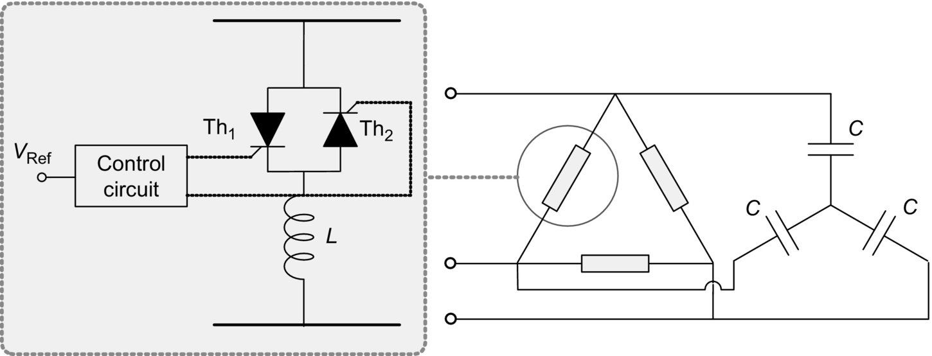

**FIG. 28.14** Six-pulse SVC.

The capacitance of the SVC is calculated in such a way as to generate the maximum capacitive reactive power that it has to control. This condition is achieved when the thyristors are turned off (). On the other hand, the maximum reactive power of the TCR inductor has to be greater than the reactive power of the capacitor bank. In this way, the SVC can control the reactive power from capacitive to inductive. The maximum inductive reactive power is given for the case when the thyristors are turned on at minimum firing angle (). The SVC can control reactive power from maximum capacitive for  to maximum inductive for . Thus, the SVC represents an adjustable fundamental frequency susceptance to the ac network, controlled by the firing angle of the TCR thyristors ().

The SVC is well known, and many examples of successful applications can be found around the world.

Due to the once-per-cycle thyristor firing with phase-angle control, current with low-order harmonic components appears and Y-Δ transformers and passive filters may be needed to eliminate part of them. Three sets of TCRs connected in the Δ side of Y-Δ transformers form a conventional six-pulse TCR. To minimize harmonic generation, it is common to have two sets of transformers connected in Y-Δ and Δ-Δ with the TCR connected in the Δ side forming a 12-pulse TCR.

#### **28.4.1.4 Thyristor-Switched Series Capacitor**

[Fig. 28.15](https://learning.oreilly.com/library/view/power-electronics-handbook/9780128114087/B9780128114070000313.xhtml#f0080) shows the thyristor-switched series capacitor (TSSC). In this controller, the thyristors should be kept untriggered so as to connect the capacitors in series with the transmission line. If the thyristors are turned on, the capacitor is bypassed. Thyristors must be turned on at a zero-voltage condition (ZVS), as it occurs in the case of the TSC, to avoid current spikes in the switches. An example of an application based on this concept is presented in Ref. [[13](https://learning.oreilly.com/library/view/power-electronics-handbook/9780128114087/B9780128114070000313.xhtml#bb0070)].

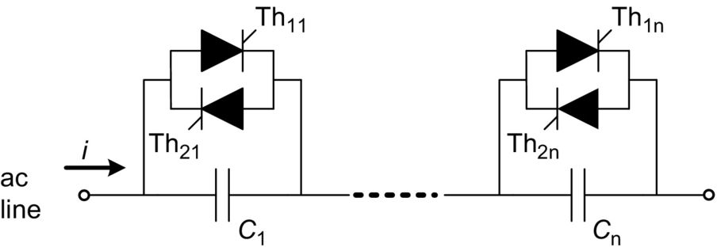

**FIG. 28.15** Thyristor-switched series capacitors (TSSC).

This compensation system has the advantage of being very simple. However, it does not allow continuous control. If the connection or disconnection of the capacitors is to be made at sporadic switching, it can be said that no harmonic problem occurs. Depending on the frequency the thyristors are switched, harmonic or subharmonics may appear. In this arrangement, it is interesting to choose a number of capacitors in such a way that many different combinations can be achieved. For example, if the total number of capacitors is three, they could have impedance proportional to 1, 2, and 3. Therefore, by combining these values, it is possible to obtain equivalent capacitive impedance proportional to 1, 2, 3, 4, 5, and 6.

#### **28.4.1.5 Thyristor-Controlled Series Capacitor**

[Fig. 28.16](https://learning.oreilly.com/library/view/power-electronics-handbook/9780128114087/B9780128114070000313.xhtml#f0085) shows the thyristor-controlled series capacitor (TCSC). In this figure, the transmission line and the voltage sources at its ends are represented by a current source because this is the actual behavior of most of the transmission system. This compensator is also based on the TCR that was first developed for shunt connection. When the TCR is used connected in series with the line, it has to be always connected in parallel with a capacitor because it is not possible to control the current if the equivalent of the transmission line and the sources is a current source. This circuit is similar to the conventional SVC with the difference that the TCSC is connected in series with the line. In this compensator, the equivalent value of the series connected reactor can be continuously controlled by adjusting the firing angle of the thyristors. As a consequence, this device presents a continuously controllable series capacitor. Various practical systems based on this concept are under operation around the world [[13](https://learning.oreilly.com/library/view/power-electronics-handbook/9780128114087/B9780128114070000313.xhtml#bb0070)–[15](https://learning.oreilly.com/library/view/power-electronics-handbook/9780128114087/B9780128114070000313.xhtml#bb0080)]. This device has been used for power flow control and power oscillation damping.

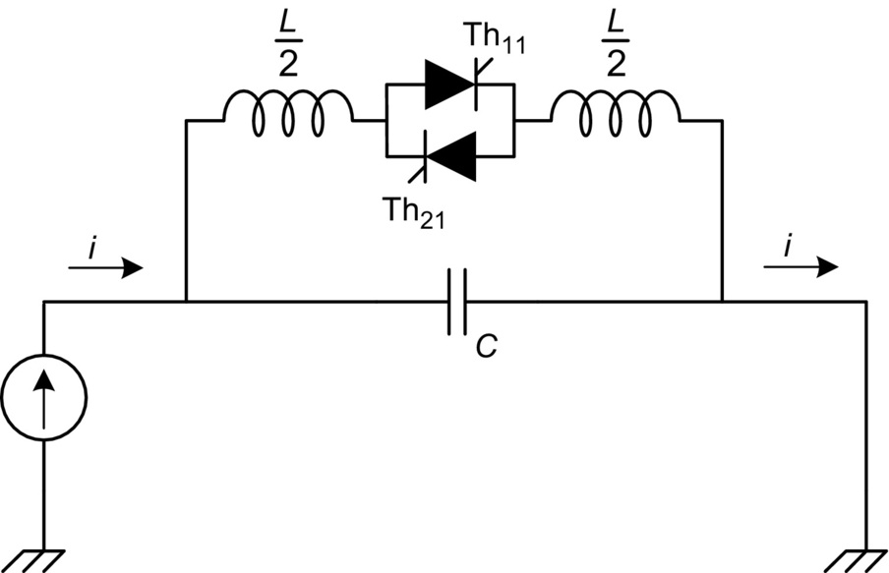

**FIG. 28.16** Thyristor-controlled series capacitors (TCSC).

[Fig. 28.17](https://learning.oreilly.com/library/view/power-electronics-handbook/9780128114087/B9780128114070000313.xhtml#f0090) presents the current and voltage waveforms in the TCSC, showing that although there is a large amount of harmonics in the capacitor and reactor currents, capacitor voltage is almost sinusoidal. In actual applications, these harmonics are not a serious concern, and they are filtered by the capacitor itself and by the transmission line impedance.

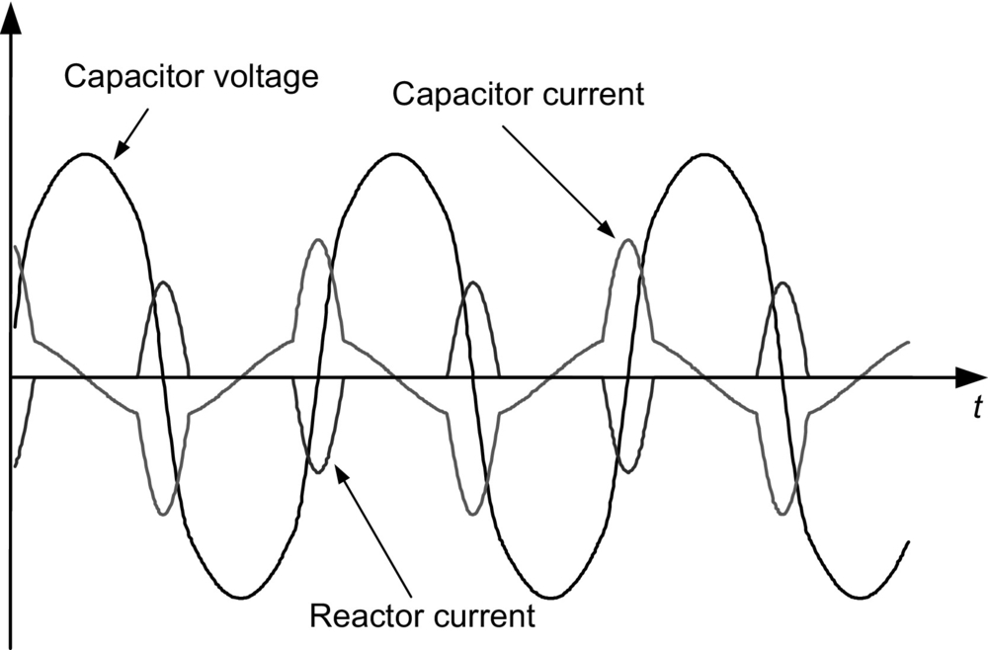

**FIG. 28.17** TCSC voltage and current waveforms.

[Fig. 28.18](https://learning.oreilly.com/library/view/power-electronics-handbook/9780128114087/B9780128114070000313.xhtml#f0095) shows the equivalent impedance of the TCSC as a function of the firing angle *α*. This figure shows that this controller has both capacitive and inductive characteristic regions divided by a resonant region. In the example shown in this figure, the resonance happens for *α* around 145 degrees. In normal operation, the TCSC is controlled in the capacitive compensation region where its impedance varies from its minimum value *Z*min for firing angle  and its maximum safe value *Z*max for *α* around 150 degrees. Operation with *α* close to the resonance region is not safe. This device can operate also in the inductive region, but in this case, normally, it is used only when  to decrease power transfer capability of the transmission line.

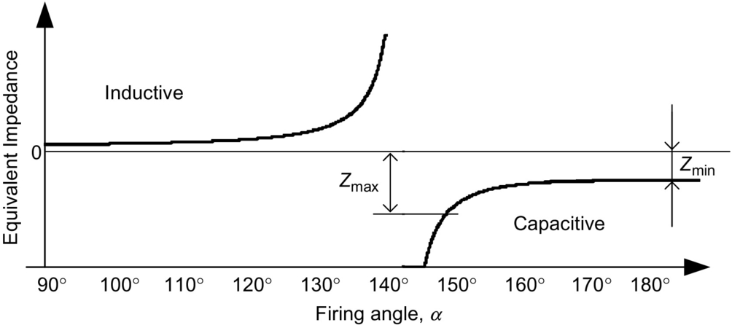

**FIG. 28.18** TCSC equivalent reactance.

#### **28.4.1.6 Thyristor-Controlled Phase Angle Regulator**

The thyristor-controlled phase-angle regulator (TCPAR), shown in [Fig. 28.19](https://learning.oreilly.com/library/view/power-electronics-handbook/9780128114087/B9780128114070000313.xhtml#f0100) as an example, may improve considerably the controllability of a utility of power transmission system. In this figure, only the control of phase “a” is detailed. The series voltage generated in phase “a” comes from three secondary windings of a transformer whose primary side is connected between phases “b” and “c.” Each of the three secondary windings can be connected in series with the line through the thyristors' switching. The thyristors are connected in antiparallel, forming bidirectional naturally commutated switches. By turning on a set of thyristors, a voltage whose magnitude can be controlled by phase control is connected in series with the transmission line. The number of secondary windings is chosen as to decrease harmonic content of the series compensation voltage ([Fig. 28.17](https://learning.oreilly.com/library/view/power-electronics-handbook/9780128114087/B9780128114070000313.xhtml#f0090)).

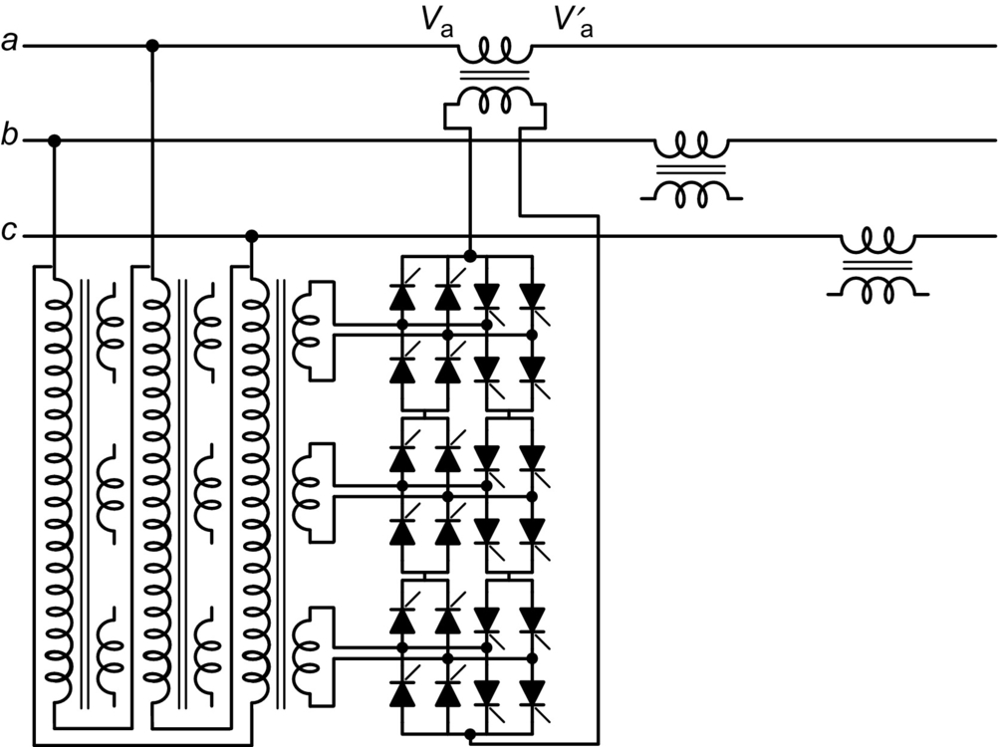

**FIG. 28.19** Thyristor-controlled phase-angle regulator (TCPAR).

The TCPAR in [Fig. 28.19](https://learning.oreilly.com/library/view/power-electronics-handbook/9780128114087/B9780128114070000313.xhtml#f0100) has some peculiarities that should be pointed out. One of them is that active power can only flow from the shunt to the series windings. The compensation voltage phasor, as shown in [Fig. 28.20](https://learning.oreilly.com/library/view/power-electronics-handbook/9780128114087/B9780128114070000313.xhtml#f0105), has a limited range of variation; in the case of phase “a,” its locus is along a line orthogonal to *Va* because the injected voltage is in phase with the voltage . As a consequence, it is not possible for the TCPAR to generate a compensating voltage phasor whose locus is a circle, as shown in [Fig. 28.7](https://learning.oreilly.com/library/view/power-electronics-handbook/9780128114087/B9780128114070000313.xhtml#f0040), for the case of an ideal generic series compensator.

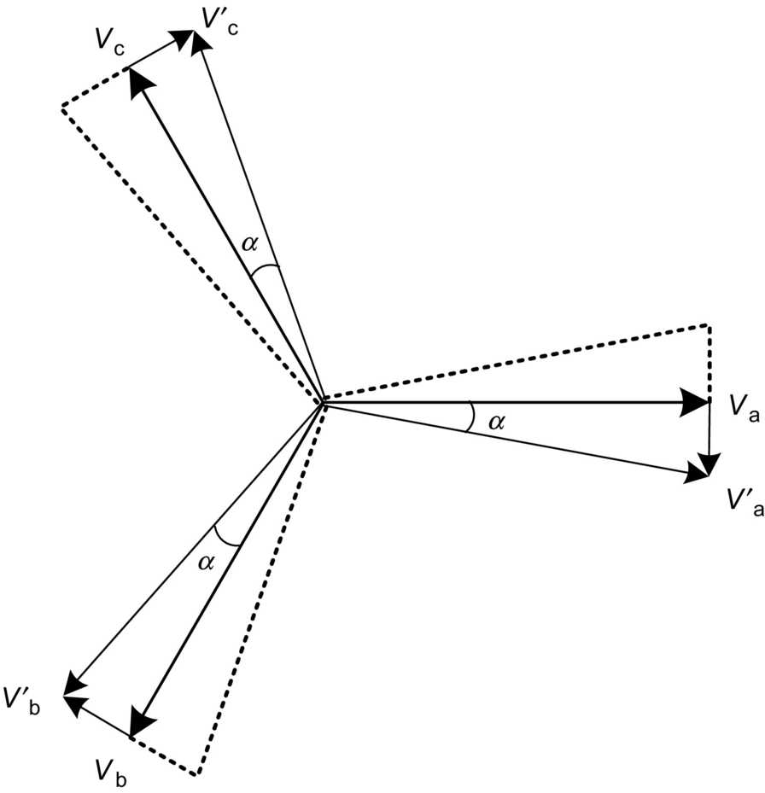

**FIG. 28.20** Phasor diagram of the TCPAR in [Fig. 28.19](https://learning.oreilly.com/library/view/power-electronics-handbook/9780128114087/B9780128114070000313.xhtml#f0100).

Other configuration of phase shifters can be found in the literature, for example [[16](https://learning.oreilly.com/library/view/power-electronics-handbook/9780128114087/B9780128114070000313.xhtml#bb0085),[17](https://learning.oreilly.com/library/view/power-electronics-handbook/9780128114087/B9780128114070000313.xhtml#bb0090)].

### 28.4.2 FACTS CONTROLLERS BASED ON SELF-COMMUTATED SWITCHES

There are various different types of FACTS controllers based on self-commutated switches, and the names used here are in accordance with the names published in Ref. [[10](https://learning.oreilly.com/library/view/power-electronics-handbook/9780128114087/B9780128114070000313.xhtml#bb0055)]. Some of them are newer controllers and are not in that reference. In this case, the name used is the same as it appears in the literature. In Ref. [[2](https://learning.oreilly.com/library/view/power-electronics-handbook/9780128114087/B9780128114070000313.xhtml#bb0015)], it is possible to find most of the details of FACTS controllers.

The development of high-power self-commutated devices has led to the development of high-power voltage source converters (VSC), such as the six-pulse two-level VSC shown in [Fig. 28.21A](https://learning.oreilly.com/library/view/power-electronics-handbook/9780128114087/B9780128114070000313.xhtml#f0110) [[4](https://learning.oreilly.com/library/view/power-electronics-handbook/9780128114087/B9780128114070000313.xhtml#bb0025)] or the three-level neutral point clamped VSC shown in [Fig. 28.21B](https://learning.oreilly.com/library/view/power-electronics-handbook/9780128114087/B9780128114070000313.xhtml#f0110) [[18](https://learning.oreilly.com/library/view/power-electronics-handbook/9780128114087/B9780128114070000313.xhtml#bb0095)]. In the figures, the generic switches could be IGBTs, IGCTs, or other self-commutating switches or even the recently developed SiC switches, with an antiparallel connected diode. This set of self-commutated switch and antiparallel diode operates with a unidirectional voltage-blocking capability and a bidirectional current flow. In contrast, the current source converters (CSC) used in HVDC transmission systems use switches (thyristors) operating with unidirectional current flow and bidirectional voltage-blocking capabilities.

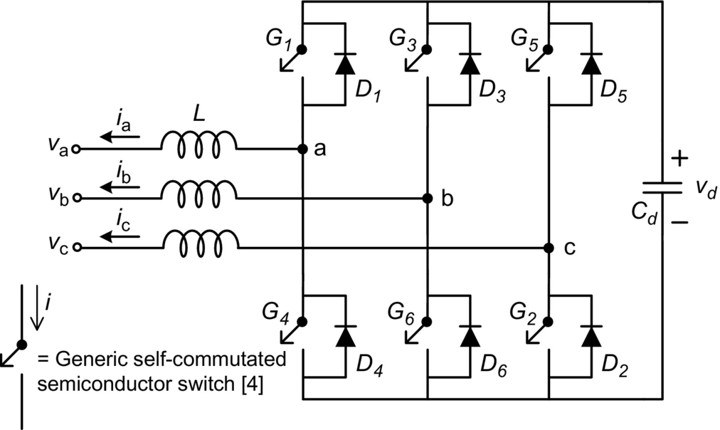

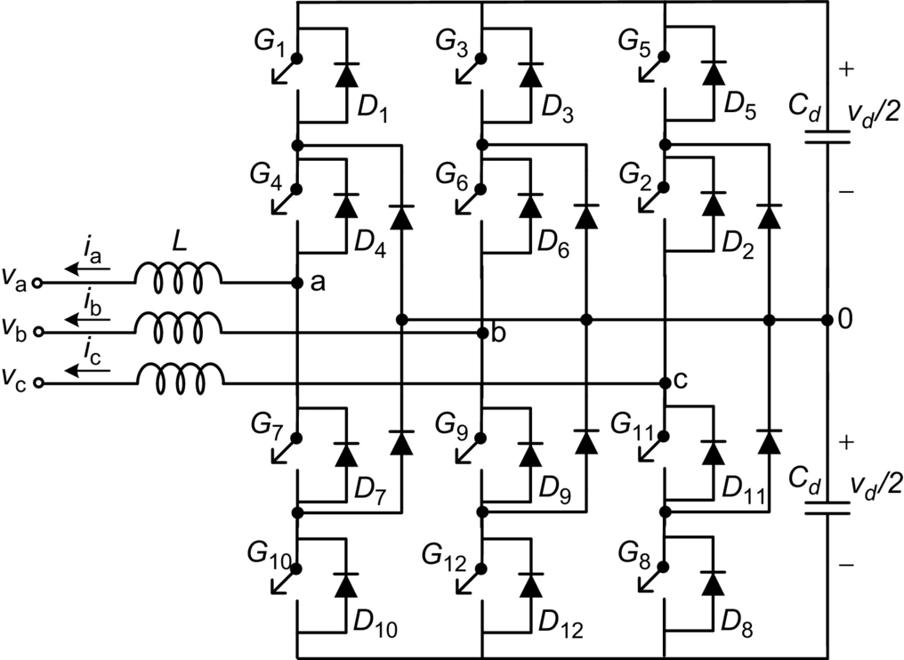

**FIG. 28.21** (A) Basic six-pulse VSC two-level var compensator and (B) basic three-level var compensator.

In a conventional VSC, for industrial applications, a voltage source is connected at the converter dc side. However, in the case that only reactive power has to be controlled, the dc voltage source may be replaced by a capacitor. If active power has to be absorbed or generated by the compensator, an energy storage system has to be connected at the dc side of the VSC.

In practical applications, small reactors (L) are necessary to connect the VSC to the ac network. This is necessary to avoid current peaks during switching transients. In most cases, these reactors are the leakage inductance of the coupling transformers.

#### **28.4.2.1 Static Synchronous Compensator (STATCOM)**

The first high-rating STATCOM started operation in 1991 [[19](https://learning.oreilly.com/library/view/power-electronics-handbook/9780128114087/B9780128114070000313.xhtml#bb0100)] in Japan and uses three single-phase VSCs to form one three-phase, six-pulse, 10 MVA converter. To guarantee low losses, the switching frequency is equal to the line frequency, and a total of eight sets of three-phase converters are used to form a 48-pulse converter. All the converters have a common dc capacitor in their dc side. In the ac side, the converters are connected in series through a zigzag transformer to eliminate low-frequency voltage harmonics. The device with compensation capability of 80 MVA was developed to increase the transient stability margin of the system, and it has allowed a 20% increase of the transmitted power above the previous stability limit. Since it was developed for improving transient stability margin, it normally operates in standby mode without reactive compensation and, consequently, low losses. During transient situation, this STATCOM operates for a short time until the system is stable.

The development of the first high-power (±100 Mvar) STATCOM in the United States was reported in Ref. [[20](https://learning.oreilly.com/library/view/power-electronics-handbook/9780128114087/B9780128114070000313.xhtml#bb0105)]. It is based on eight sets of three-phase bridge converters, similar to that shown in [Fig. 28.21A](https://learning.oreilly.com/library/view/power-electronics-handbook/9780128114087/B9780128114070000313.xhtml#f0110); it was developed for reactive power control, so it can operate continuously with acceptable losses. The switching frequency is equal to line frequency, and the number of pulses is 48; therefore, the output voltage waveform is almost sinusoidal, and harmonic filters are not used in both cases referred in Refs. [[19](https://learning.oreilly.com/library/view/power-electronics-handbook/9780128114087/B9780128114070000313.xhtml#bb0100),[20](https://learning.oreilly.com/library/view/power-electronics-handbook/9780128114087/B9780128114070000313.xhtml#bb0105)].

##### **Basic switching control techniques**

In FACTS applications, the power ratings of the converters are in the range of some MW to hundreds of MW, and the switching frequency is lower than the switching frequency used in industrial application converters to avoid excessive switching losses. However, there are various switching control types. The most known so far are as follows:

• Multipulse converters switched at line frequency, as in Refs. [[19](https://learning.oreilly.com/library/view/power-electronics-handbook/9780128114087/B9780128114070000313.xhtml#bb0100),[20](https://learning.oreilly.com/library/view/power-electronics-handbook/9780128114087/B9780128114070000313.xhtml#bb0105)]

• Pulse-width modulation (PWM) with harmonic elimination technique [[21](https://learning.oreilly.com/library/view/power-electronics-handbook/9780128114087/B9780128114070000313.xhtml#bb0110)]

• Sinusoidal PWM [[7](https://learning.oreilly.com/library/view/power-electronics-handbook/9780128114087/B9780128114070000313.xhtml#bb0040)]

• Cascade converters [[22](https://learning.oreilly.com/library/view/power-electronics-handbook/9780128114087/B9780128114070000313.xhtml#bb0115)], including the multilevel modular converter (MMC) [[23](https://learning.oreilly.com/library/view/power-electronics-handbook/9780128114087/B9780128114070000313.xhtml#bb0120)]

##### **Multipulse converters switched at line frequency**

The multipulse converter was the first choice for STATCOM application because it presents low losses and low harmonic content [[19](https://learning.oreilly.com/library/view/power-electronics-handbook/9780128114087/B9780128114070000313.xhtml#bb0100),[20](https://learning.oreilly.com/library/view/power-electronics-handbook/9780128114087/B9780128114070000313.xhtml#bb0105)]. [Fig. 28.22](https://learning.oreilly.com/library/view/power-electronics-handbook/9780128114087/B9780128114070000313.xhtml#f0115) shows a 24-pulse converter based on three-phase, two-level six-pulse converters. In this case, the zigzag transformers are connected in such a way as to produce phase differences of 15, 30, 45, and 60 degrees. With this arrangement, the resulting output voltage and its harmonic spectrum are as shown in [Fig. 28.23](https://learning.oreilly.com/library/view/power-electronics-handbook/9780128114087/B9780128114070000313.xhtml#f0120). The first two harmonic components are the twenty-third- and twenty-fifth-order harmonics. [Fig. 28.24](https://learning.oreilly.com/library/view/power-electronics-handbook/9780128114087/B9780128114070000313.xhtml#f0125) shows the voltage waveform for a 48-pulse converter and its respective harmonic spectrum. In this case, the first two harmonic components are the forty-seventh- and forty-ninth-order harmonics. The total harmonic distortions (THD) for the 24-pulse and 48-pulse converters are 7% and 3.3%, respectively. These converters can also be built by using three-level converters. However, one drawback of the multipulse converter is the complexity, weight, and cost of the transformers, which have to operate with high harmonic content in their voltage and various different turns ratio.

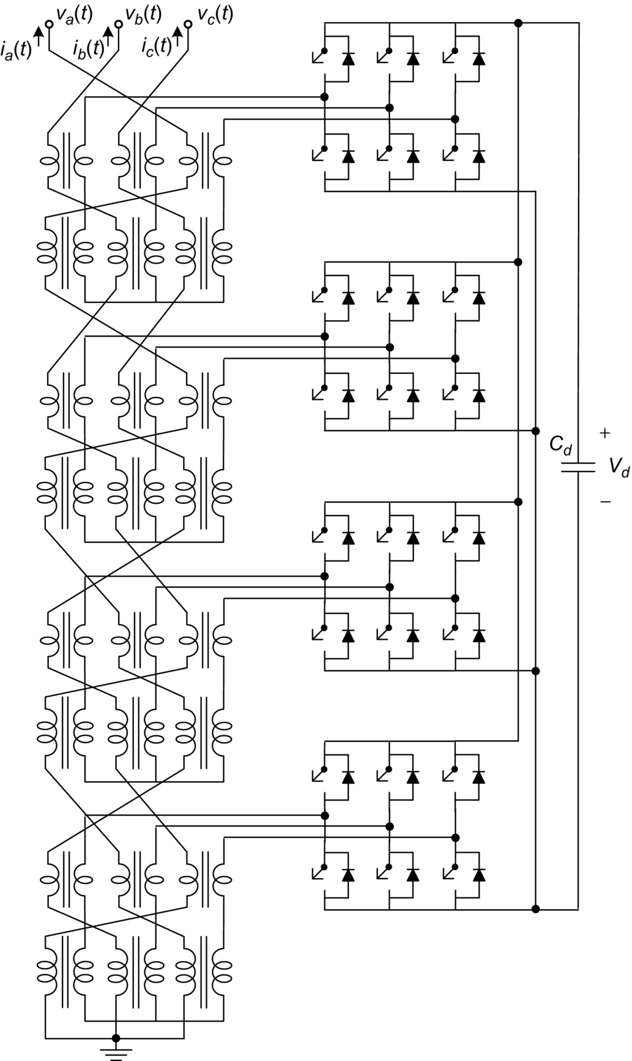

**FIG. 28.22** Six-pulse 2-level VSC-based 24-pulse static var compensator (STATCOM).

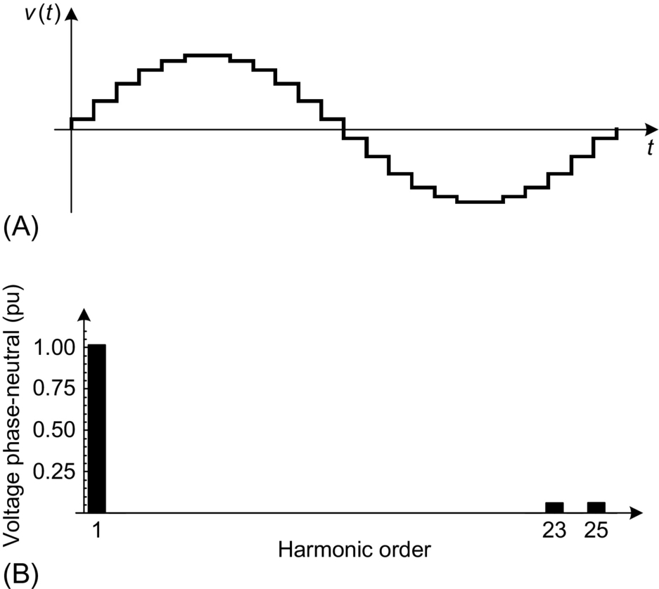

**FIG. 28.23** (A) 24-pulse converter voltage waveform and (B) its harmonic spectrum.

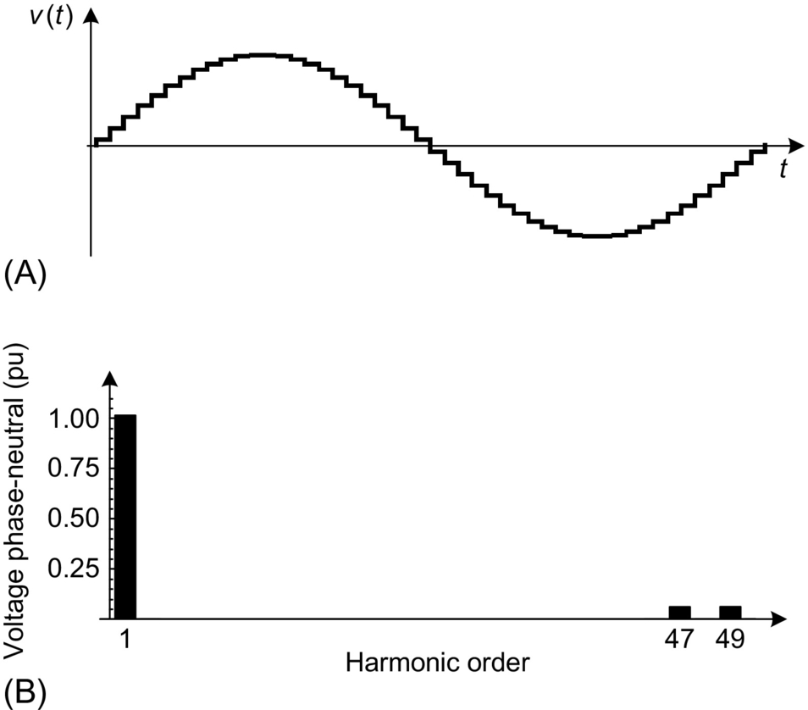

**FIG. 28.24** (A) 48-pulse converter voltage waveform and (B) its harmonic spectrum.

##### **PWM with harmonic elimination technique**

One way to avoid the complexity of the multipulse converters is to use PWM with harmonic elimination technique [[21](https://learning.oreilly.com/library/view/power-electronics-handbook/9780128114087/B9780128114070000313.xhtml#bb0110)]. With this approach, it is possible to use relatively low switching frequency and, consequently, have low switching losses. The PWM modulation is obtained by off-line calculation of the switches at “on” and “off” instants in order to eliminate the low-frequency harmonics. [Fig. 28.25A](https://learning.oreilly.com/library/view/power-electronics-handbook/9780128114087/B9780128114070000313.xhtml#f0130) shows an example of voltage waveform with “on” and “off” instants calculated in such a way as to eliminate the fifth-, seventh-, eleventh-, and thirteenth-order harmonics. This voltage corresponds to the voltage between one phase of the converter and the negative terminal of the dc side. [Fig. 28.25B](https://learning.oreilly.com/library/view/power-electronics-handbook/9780128114087/B9780128114070000313.xhtml#f0130) shows the control angle as a function of the modulation index *ma*. [Fig. 28.26](https://learning.oreilly.com/library/view/power-electronics-handbook/9780128114087/B9780128114070000313.xhtml#f0135) shows the harmonic spectrum for the phase-to-phase voltage waveform corresponding to that shown in [Fig. 28.25A](https://learning.oreilly.com/library/view/power-electronics-handbook/9780128114087/B9780128114070000313.xhtml#f0130). Here, it is considered that the rms value of the fundamental component of the voltage in [Fig. 28.25](https://learning.oreilly.com/library/view/power-electronics-handbook/9780128114087/B9780128114070000313.xhtml#f0130) is equal to unity. In [Fig. 28.26](https://learning.oreilly.com/library/view/power-electronics-handbook/9780128114087/B9780128114070000313.xhtml#f0135), the magnitude of the fundamental component is equal to  pu. The higher-order harmonics in the voltage waveform can be eliminated by a relatively small passive filter, so the voltage and the current at the converter terminals are practically harmonic-free; therefore, the transformer that connects a PWM-controlled STATCOM to the grid may be a conventional transformer designed for sinusoidal operation.

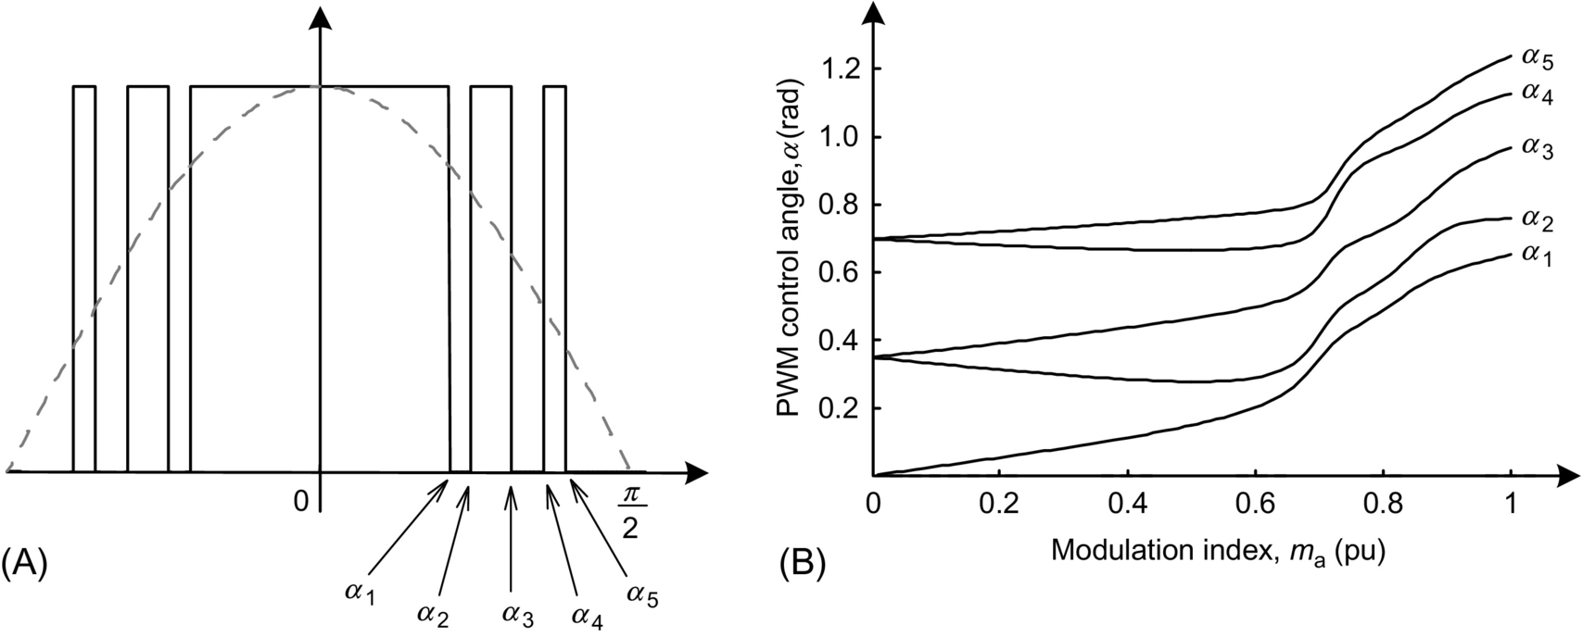

**FIG. 28.25** (A) Example of one-phase voltage with the harmonic elimination technique and (B) the control angle as function of the modulation index.

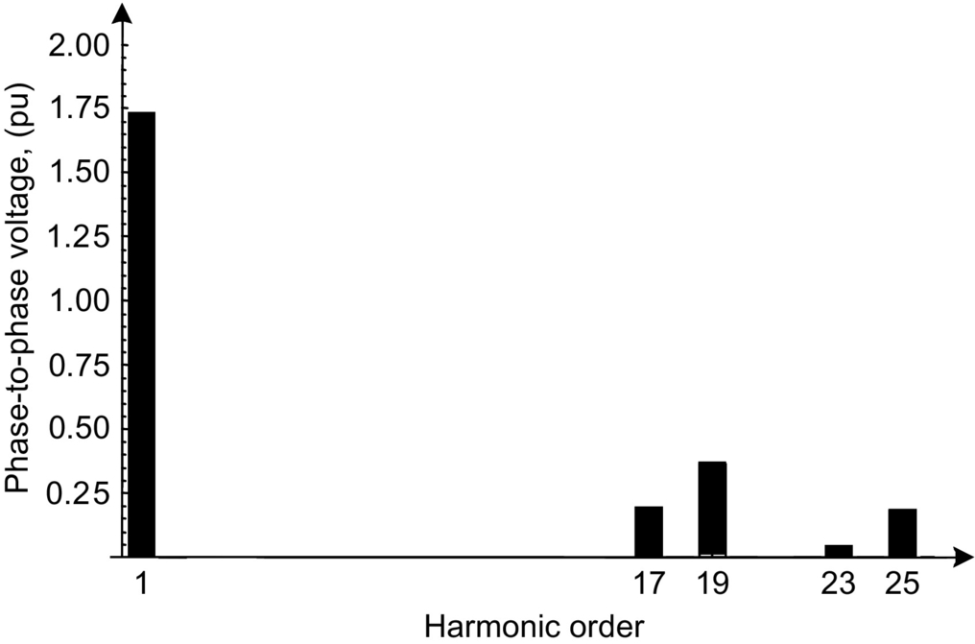

**FIG. 28.26** Line voltage harmonic spectrum for the voltage waveform in [Fig. 28.25A](https://learning.oreilly.com/library/view/power-electronics-handbook/9780128114087/B9780128114070000313.xhtml#f0130).

##### **Sinusoidal PWM**

The sinusoidal PWM control technique is possibly the simplest to implement and can be synthesized by comparing a sinusoidal reference voltage with a triangular carrier [[4](https://learning.oreilly.com/library/view/power-electronics-handbook/9780128114087/B9780128114070000313.xhtml#bb0025)]. This switching control method needs a relatively high switching frequency, which is in the range of 1–2 kHz and consequently produces higher switching losses than multipulse STATCOM. The harmonic content at low frequencies is negligible; however, there is a relatively high harmonic content at the switching frequency, which is eliminated by a passive filter.

##### **Cascade converter**

The basic cascade converter [[22](https://learning.oreilly.com/library/view/power-electronics-handbook/9780128114087/B9780128114070000313.xhtml#bb0115)] topology is shown in [Fig. 28.27](https://learning.oreilly.com/library/view/power-electronics-handbook/9780128114087/B9780128114070000313.xhtml#f0140). Only two single-phase full-bridge converters are shown, the first and the *n*th. However, in actual application, several of them are connected in series and switched at line frequency. The resulting voltage waveform can be similar to the multipulse converter waveform with the advantage that there is no need of transformers to sum up the converter output voltage. Due to the line frequency switching, the switching losses are very low. The resulting voltage waveform can be almost sinusoidal depending on the number of series converters, and the transformer used to connect them to the grid can be a conventional sinusoidal waveform transformer, if necessary. The need to have one dc capacitor for each single-phase converter has two consequences: the number of capacitors is equal to the number of single-phase converters, and the capacitance of each capacitor has to be much higher than three-phase converters. This is because the instantaneous power in each single-phase converter has a large oscillating component at double of the line frequency, and it would force a large voltage ripple in the capacitors if they were small.

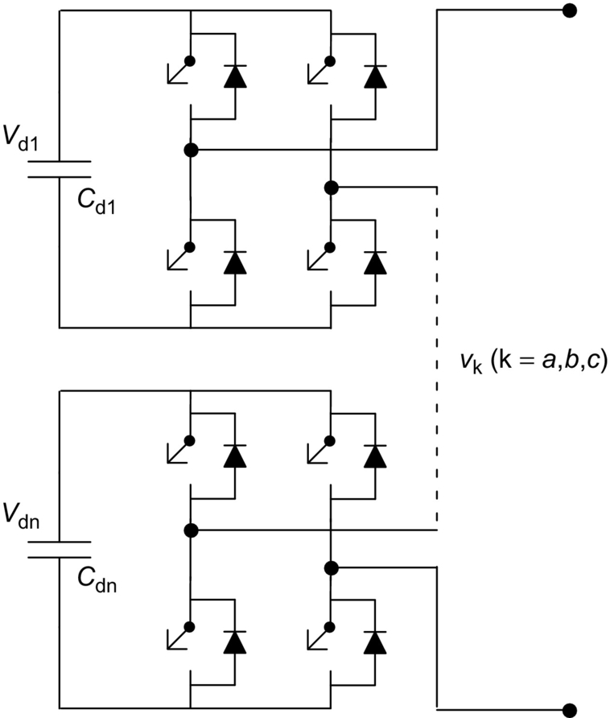

**FIG. 28.27** Cascade converter basic topology.

###### **Multilevel modular converter**

The MMC is an emerging topology for high-power and high-voltage VSC application [[23](https://learning.oreilly.com/library/view/power-electronics-handbook/9780128114087/B9780128114070000313.xhtml#bb0120)]; it is suitable for either HVDC transmission or FACTS applications [[24](https://learning.oreilly.com/library/view/power-electronics-handbook/9780128114087/B9780128114070000313.xhtml#bb0125),[25](https://learning.oreilly.com/library/view/power-electronics-handbook/9780128114087/B9780128114070000313.xhtml#bb0130)]. For very high-power applications, an MMC is also an alternative, and potentially preferable, to a multilevel converter [[26](https://learning.oreilly.com/library/view/power-electronics-handbook/9780128114087/B9780128114070000313.xhtml#bb0135)]. The MMC is being presented as the preferred potential candidate for VSC-HVDC system applications [[27](https://learning.oreilly.com/library/view/power-electronics-handbook/9780128114087/B9780128114070000313.xhtml#bb0140)]. Features like modularity and capability of a multimodule VSC to handle high power or high voltage indicate that a MMC may also be an option to high-power STATCOM and other FACTS compensator such as SSSC, UPFC, or IPFC.

[Fig. 28.28](https://learning.oreilly.com/library/view/power-electronics-handbook/9780128114087/B9780128114070000313.xhtml#f0145) shows the basic topology of a three-phase MMC. Each leg is comprised of *n* submodules, which are composed of two self-commutated switches and a storage capacitor. Depending on the application, a full-bridge submodule might be necessary instead of the half bridge shown in this figure. A semi-full-bridge submodule topology is an alternative option for blocking short-circuit current in the dc link of the converter [[28](https://learning.oreilly.com/library/view/power-electronics-handbook/9780128114087/B9780128114070000313.xhtml#bb0145)]. The submodule can be seen as a voltage source with two possible stages 0 or *VC* where *VC* is the voltage over the submodule capacitor. Thus, each arm can be understood as a controllable voltage with *n* possible voltage steps, and the higher the number of submodules, the more approximated sine waveform can be achieved at the ac side. The main advantages of the MMC are low switching losses, low *dv/dt* over individual switch, modularity, reconfigurable design, and increased energy storage [[26](https://learning.oreilly.com/library/view/power-electronics-handbook/9780128114087/B9780128114070000313.xhtml#bb0135)]. Beyond that, the MMC can also be directly connected to the power system, that is, without any power transformer [[29](https://learning.oreilly.com/library/view/power-electronics-handbook/9780128114087/B9780128114070000313.xhtml#bb0150)], which can reduce the overall substation footprint and cost, resulting in a compact-area HVDC substation.

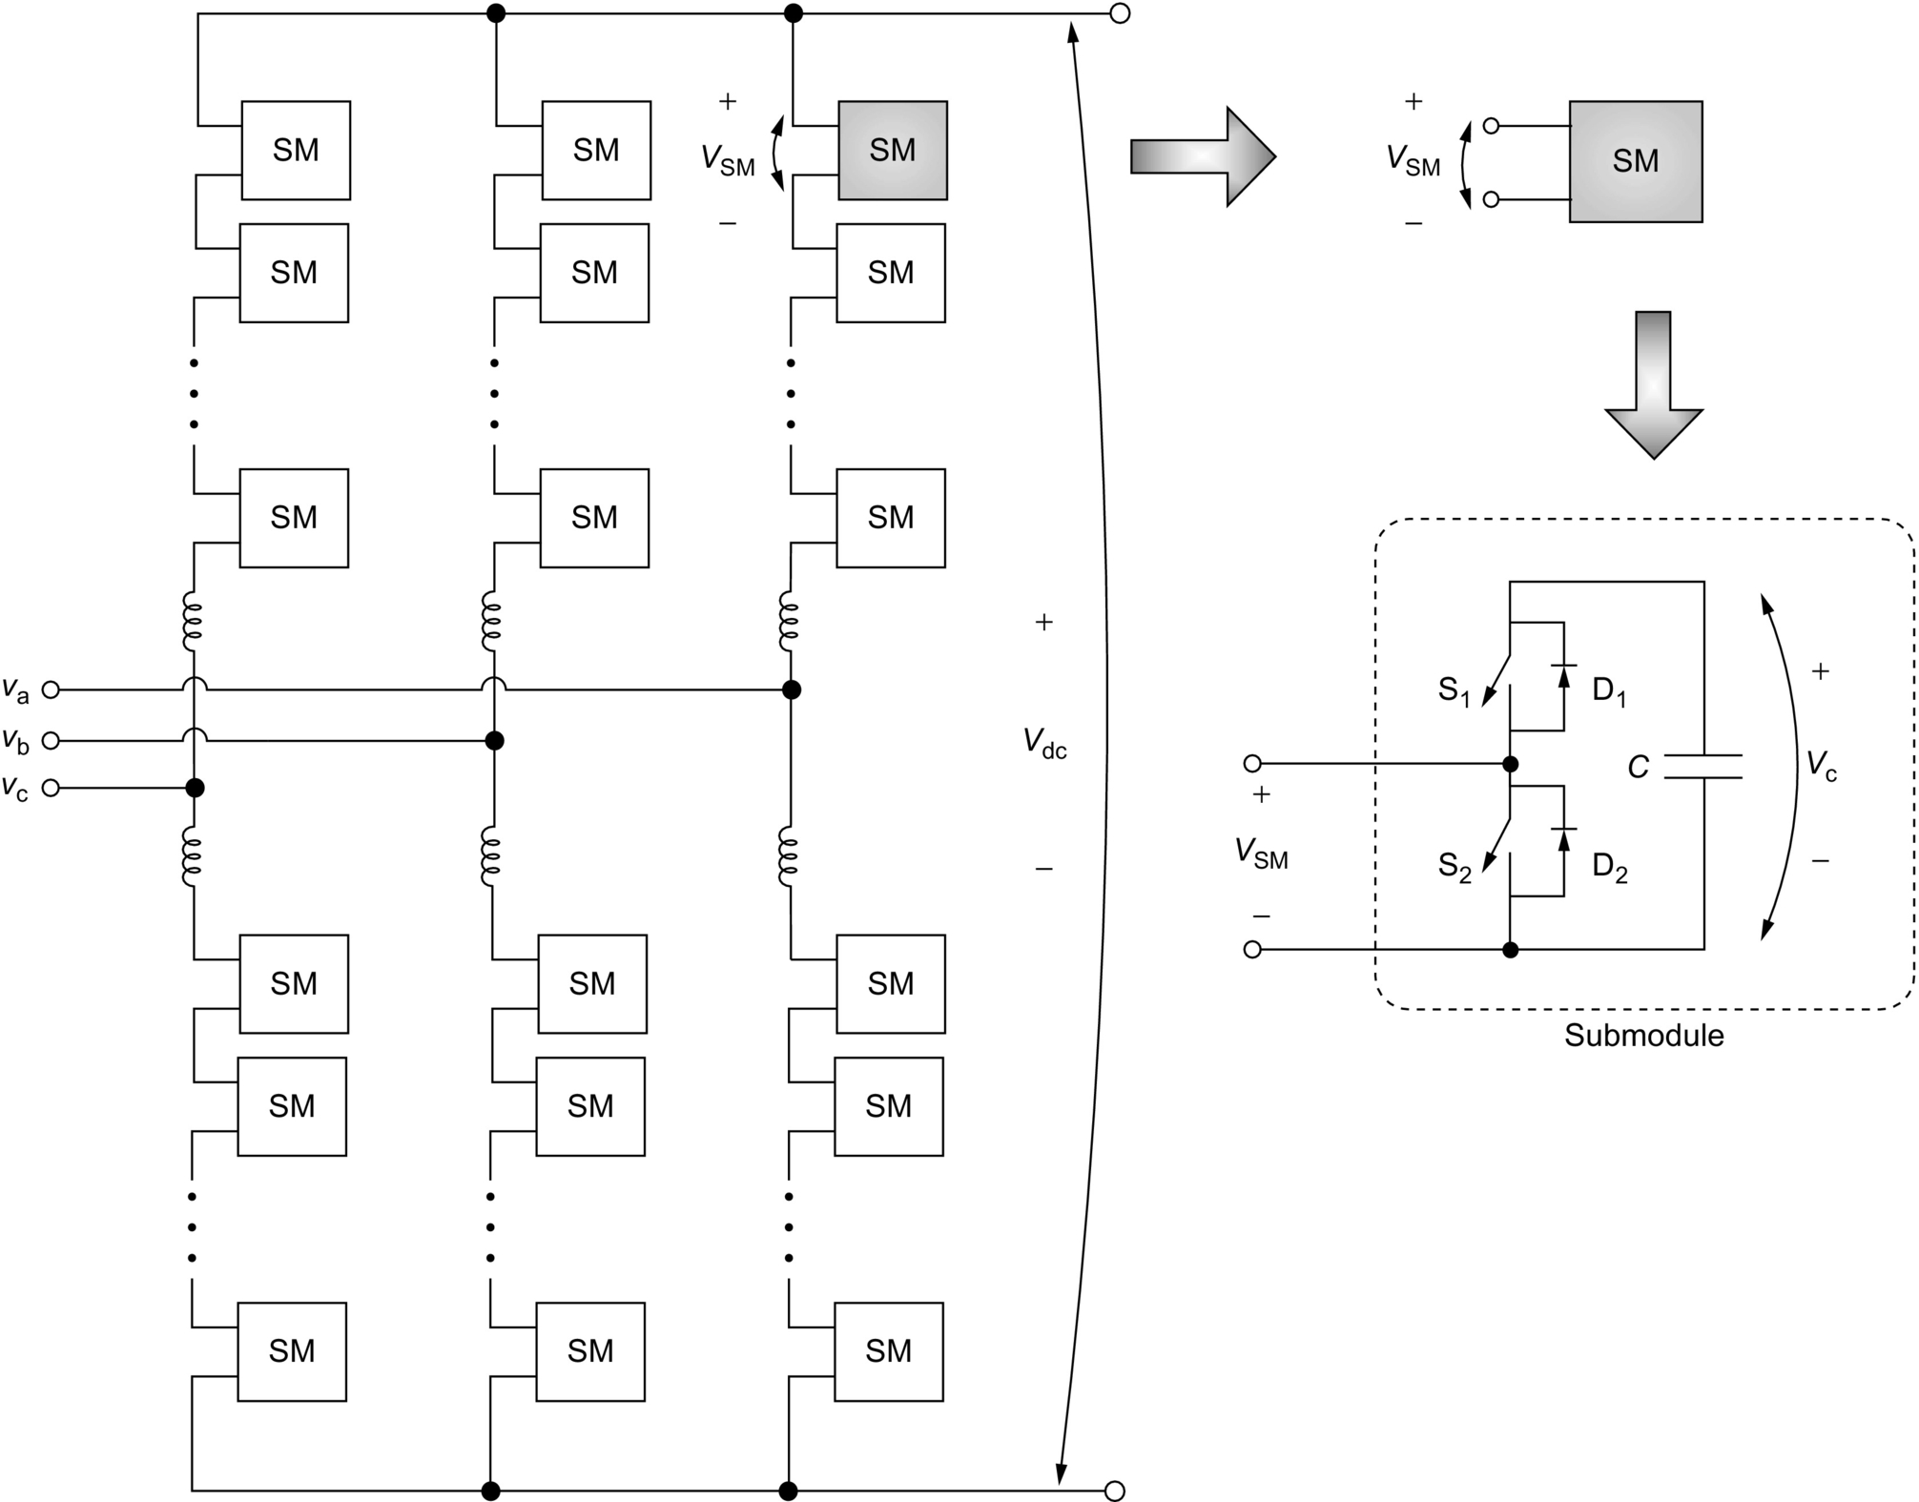

**FIG. 28.28** Modular multilevel converter topology.

##### **STATCOM control techniques**

The control of reactive power in the STATCOM is done by controlling its terminal voltage. [Fig. 28.29](https://learning.oreilly.com/library/view/power-electronics-handbook/9780128114087/B9780128114070000313.xhtml#f0150) shows a simplified circuit in which the ac grid is represented by a voltage source *VS* behind an impedance *jXL* and the STATCOM is represented by its fundamental voltage component *VI*. [Fig. 28.30A](https://learning.oreilly.com/library/view/power-electronics-handbook/9780128114087/B9780128114070000313.xhtml#f0155) shows the case when the ac grid phasor voltage *VS* is in phase with the STATCOM voltage *VI* and both have the same magnitude. In this case, the line current *IL* is zero. [Fig. 28.30B](https://learning.oreilly.com/library/view/power-electronics-handbook/9780128114087/B9780128114070000313.xhtml#f0155) shows the case when *VS* is little larger than *VI*. In this case, the line current *IL*, which lags the impedance voltage *VL* by 90 degrees, is also lagging the ac grid phasor voltage *VS*, and therefore, the STATCOM produces an inductive reactive power. On the other hand, [Fig. 28.30C](https://learning.oreilly.com/library/view/power-electronics-handbook/9780128114087/B9780128114070000313.xhtml#f0155) shows the case when *VS* is little smaller than *VI*. Hence, the line current *IL*, which lags the voltage *VL* by 90 degrees, leads the voltage *VS*, and therefore, the STATCOM produces a capacitive reactive power. In summary, the STATCOM reactive power can be controlled if the magnitude of its *VI* voltage is controlled, assuming that it is in phase with *VS*:

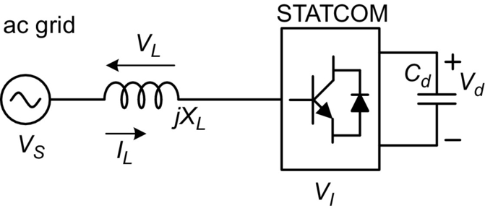

**FIG. 28.29** Simplified circuit for the ac grid and the STATCOM.

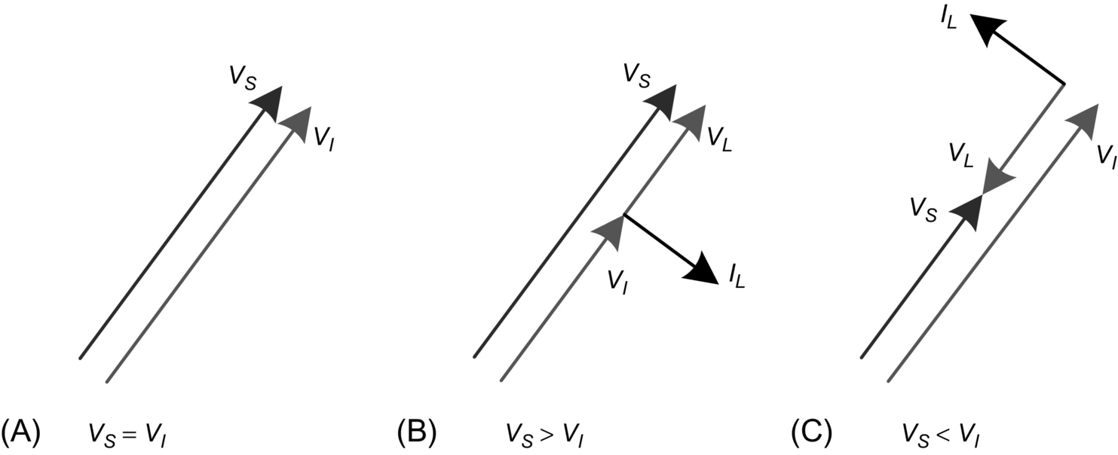

**FIG. 28.30** Reactive power control in a STATCOM.

• If |*VS*| is equal to |*VI*|, there is no reactive power and no active power in the STATCOM.

• If |*VS*| is larger than |*VI*|, the STATCOM reactive power is inductive.

• If |*VS*| is smaller than |*VI*|, the STATCOM reactive power is capacitive.

Therefore, the reactive power control in a STATCOM is a problem of how to control the magnitude of its voltage *VI*. There are two basic principles: (*i*) in the case of multipulse converters, the output voltage magnitude can only be controlled by controlling the dc-side voltage that is the dc capacitor voltage, and (*ii*) in the case of PWM control, the dc capacitor voltage can be kept constant, and the voltage can be controlled by PWM controller.

[Fig. 28.31A](https://learning.oreilly.com/library/view/power-electronics-handbook/9780128114087/B9780128114070000313.xhtml#f0160) shows the phasor diagram for the case when a phase difference *δ* between *VS* and *VI* is positive. The resulting line current is in such a way that produces an active power flowing into the converter, charging the dc capacitor. [Fig. 28.31B](https://learning.oreilly.com/library/view/power-electronics-handbook/9780128114087/B9780128114070000313.xhtml#f0160) shows the phasor diagram for a negative phase angle *δ*. In this case, the dc capacitor is discharged. Therefore, by controlling the phase angle *δ*, it is possible to control the dc capacitor voltage.

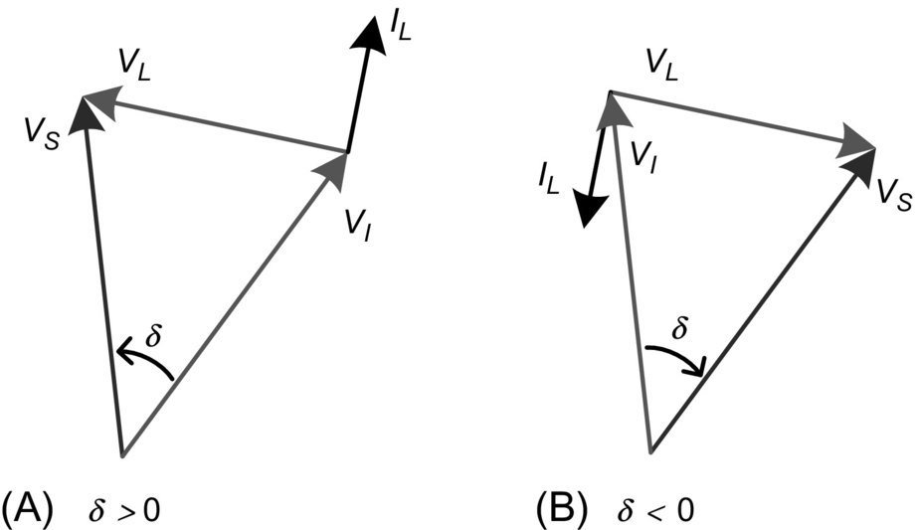

**FIG. 28.31** Active power control in a STATCOM.

In general, STATCOM based on multipulse converter without PWM has to control its voltage by charging or discharging the dc capacitor, and this voltage has to be variable. On the other hand, STATCOM based on a PWM-controlled converter has to control dc-side capacitor voltage only to maintain it constant. In both cases, the principle shown in [Fig. 28.31](https://learning.oreilly.com/library/view/power-electronics-handbook/9780128114087/B9780128114070000313.xhtml#f0160) is valid.

The STATCOM control technique presented previously illustrates the basic scalar control concepts. However, this compensator can be also controlled by a vector technique [[30](https://learning.oreilly.com/library/view/power-electronics-handbook/9780128114087/B9780128114070000313.xhtml#bb0155)].

[Fig. 28.32](https://learning.oreilly.com/library/view/power-electronics-handbook/9780128114087/B9780128114070000313.xhtml#f0165) shows a basic control structure for the STATCOM. In this diagram, the vector control technique is implemented in dq synchronous reference frame. This technique is called voltage-oriented control (VOC), in which the grid voltage vector is aligned with the d-axis through the phase-locked loop (PLL) block. This means that the q-axis component of the grid voltage, in steady state, is zero.

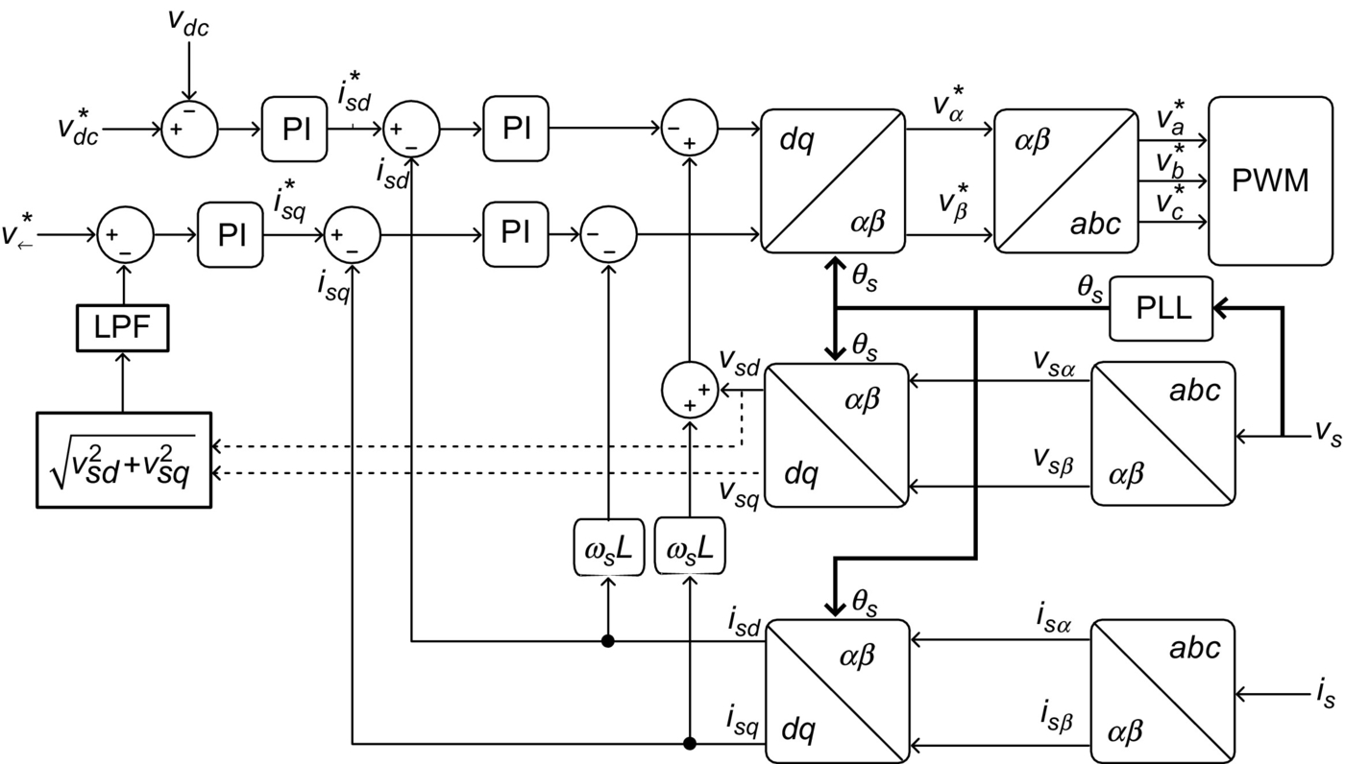

**FIG. 28.32** Block diagram of STATCOM based on voltage-oriented control (VOC).

The dc-link and grid voltages are controlled through the d- and q-axes, respectively. For the dc voltage control, the voltage across the capacitor is sensed by Hall effect sensor and compared with its reference value. For the grid voltage control, the voltage at the PCC is sensed by Hall effect sensor too, and these signals are transformed to *dq* components in synchronous reference frame. The next step is to compute the aggregate value for this quantity. The aggregate value is an instantaneous quantity, and it results from the square root of the sum of the squared instantaneous values of currents or voltages. This means that the aggregate value is a constant if and only if the voltages (or currents) in all phases are perfectly sinusoidal and balanced [[31](https://learning.oreilly.com/library/view/power-electronics-handbook/9780128114087/B9780128114070000313.xhtml#bb0160),[32](https://learning.oreilly.com/library/view/power-electronics-handbook/9780128114087/B9780128114070000313.xhtml#bb0165)]. The LPF block is a low-pass filter to eliminate any oscillating components in the signal of the aggregate value. Error signals are generated and are input in proportional-integral (PI) controllers, for both cases, as shown in [Fig. 28.32](https://learning.oreilly.com/library/view/power-electronics-handbook/9780128114087/B9780128114070000313.xhtml#f0165), and the current references are generated. From these, reference currents are in *dq* synchronous reference frame. In the inner control loop, the current references are compared with measured values of these same variables. Thus, error signals resulting from this operation excite PI controllers that generate voltage references in the controllers’ outputs. Nevertheless, these values must be compensated to avoid coupling between *d*- and *q*-axes [[33](https://learning.oreilly.com/library/view/power-electronics-handbook/9780128114087/B9780128114070000313.xhtml#bb0170)–[35](https://learning.oreilly.com/library/view/power-electronics-handbook/9780128114087/B9780128114070000313.xhtml#bb0180)].

Another detail, for this diagram, is that there is an intermediate transformation block from abc to αβ instead of the direct transformation abc-dq, because dc values can be present in αβ component signals caused by the acquisition and/or signal conditioning systems or even by the modulation system, in some cases. Thus, they can be eliminated through the installation of high-pass filters (not present in the figure) just after those intermediate blocks, which would not be possible in the case of direct transformation from abc to dq.

Another way to control the STATCOM is by using the instantaneous power theory [[36](https://learning.oreilly.com/library/view/power-electronics-handbook/9780128114087/B9780128114070000313.xhtml#bb0185),[37](https://learning.oreilly.com/library/view/power-electronics-handbook/9780128114087/B9780128114070000313.xhtml#bb0190)], where only the imaginary power is controlled.

##### **STATCOM DC side capacitor**

Theoretically, the dc-side capacitor of a STATCOM based on three-phase converters operating in a balanced system and controlling only the reactive power could have a capacitance equal to zero farad, once the three-phase instantaneous reactive power does not contribute to the energy transfer between the dc and ac side [[38](https://learning.oreilly.com/library/view/power-electronics-handbook/9780128114087/B9780128114070000313.xhtml#bb0195)]. However, in actual STATCOM, a finite capacitor has to be used with the objective of keeping constant or controlled dc voltage as it tends to vary due to the converter switching. One parameter commonly used in synchronous machine is the inertia constant *H* defined by

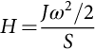 **(28.10)**

where *J* and ω are the rotor moment of inertia and angular speed and *S* is the machine apparent power. A similar parameter for the STATCOM, *HST,* can be defined by

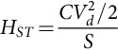 **(28.11)**

where *C* and *Vd* are the dc capacitance and its voltage, respectively, and *S* is the STATCOM apparent power.

In both cases, the constants *H* and *HST* are values in time units corresponding to the relation of the amount of energy stored in the rotor inertia, or in the capacitor, and the machine, or STATCOM, apparent power, respectively. In the case of synchronous machines, the value of *H* is in the range of few seconds (generally, in the range of 1–3 s), and in the case of the STATCOM, *HST* value is in the range of milliseconds or below (0.5–50 ms) if only reactive power is to be controlled. These numbers show that the STATCOM based on three-phase converters and designed only for reactive power control (which is the general case) has almost no stored energy in its dc capacitor. On the other hand, STATCOM based on single-phase converters without a common dc link may have larger capacitors as in the case of cascade converters due to the power oscillations at double of the line frequency.

There are STATCOM (in some cases with different names) that are designed for operation with unbalanced loads. In this case, the dc capacitor has to be also much larger than in the case of balanced systems to avoid large voltage ripple on the dc voltage due to power oscillations at twice the line frequency, which appears naturally in unbalanced systems [[33](https://learning.oreilly.com/library/view/power-electronics-handbook/9780128114087/B9780128114070000313.xhtml#bb0170),[39](https://learning.oreilly.com/library/view/power-electronics-handbook/9780128114087/B9780128114070000313.xhtml#bb0200)] or unbalanced voltages [[34](https://learning.oreilly.com/library/view/power-electronics-handbook/9780128114087/B9780128114070000313.xhtml#bb0175)] or system with flicker problem [[35](https://learning.oreilly.com/library/view/power-electronics-handbook/9780128114087/B9780128114070000313.xhtml#bb0180),[40](https://learning.oreilly.com/library/view/power-electronics-handbook/9780128114087/B9780128114070000313.xhtml#bb0205)]. In this case, the STATCOM compensates reactive power and the instantaneous oscillating active power due to the negative sequence current components. In fact, this is an extension of the shunt active power filter application where the goal is the current harmonic compensation, which includes negative sequence currents even at the fundamental frequency. If subharmonics are present, the device is able to filter them out as well.

##### **STATCOM with energy storage**

In general, the STATCOM is designed for reactive power compensation, and it does not need large energy storage elements. However, there are some applications where it may be interesting to have some energy stored in the dc side, for example, to compensate for active power for a short time. In these applications, the dc-side capacitor has to be substituted by a voltage source energy storage device like a battery [[41](https://learning.oreilly.com/library/view/power-electronics-handbook/9780128114087/B9780128114070000313.xhtml#bb0210)] or a double-layer capacitor (super capacitor). Another possibility is to store energy in superconducting magnetic energy storage (SMES) systems [[42](https://learning.oreilly.com/library/view/power-electronics-handbook/9780128114087/B9780128114070000313.xhtml#bb0215),[43](https://learning.oreilly.com/library/view/power-electronics-handbook/9780128114087/B9780128114070000313.xhtml#bb0220)]. A natural solution for the use of the superconducting reactor would be the connection to the ac grid through a current source converter (CSC) instead of the voltage source converter. However, this has not been the case found in the literature. [Fig. 28.33](https://learning.oreilly.com/library/view/power-electronics-handbook/9780128114087/B9780128114070000313.xhtml#f0170) shows a block diagram of a typical STATCOM/SMES system, where the SMES is connected to the dc side of the STATCOM through a dc-dc converter, which converts the direct current in the superconductor magnet to dc voltage in the STATCOM dc side and vice versa. This STATCOM can control reactive power continuously and active power for a short time, normally up to few seconds, depending on the amount of energy stored in the superconducting magnet.

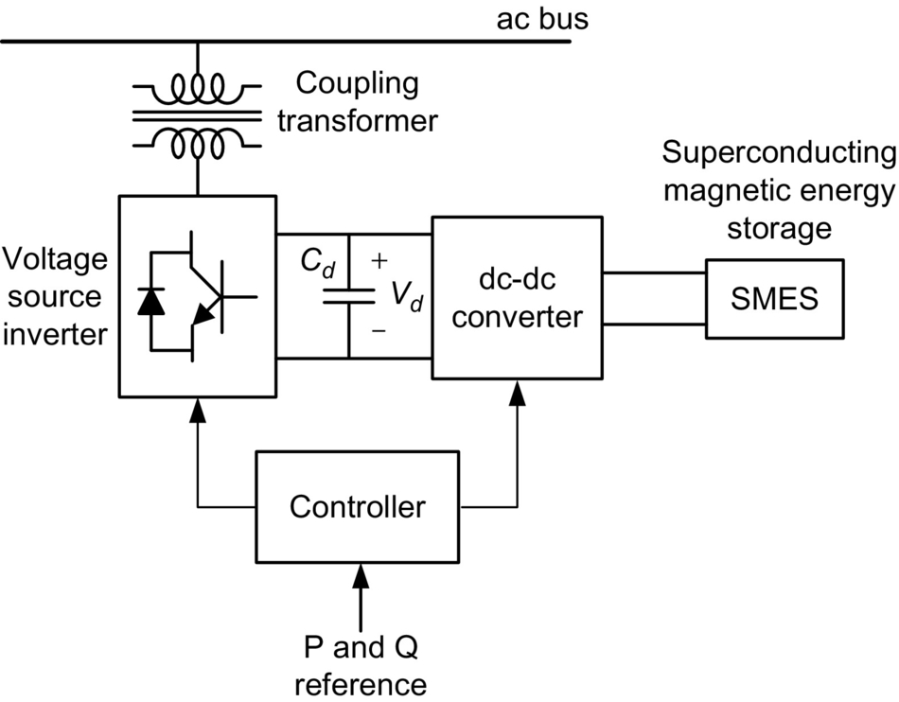

**FIG. 28.33** STATCOM with SMES.

##### **Comparison between SVC and STATCOM**

[Fig. 28.34A](https://learning.oreilly.com/library/view/power-electronics-handbook/9780128114087/B9780128114070000313.xhtml#f0175) shows the steady-state volt-ampere characteristics for the SVC shown in [Fig. 28.14](https://learning.oreilly.com/library/view/power-electronics-handbook/9780128114087/B9780128114070000313.xhtml#f0075), whereas [Fig. 28.34B](https://learning.oreilly.com/library/view/power-electronics-handbook/9780128114087/B9780128114070000313.xhtml#f0175) shows the same characteristics for a STATCOM. For operation at rated voltage, both devices can present similar characteristics in terms of control range. However, current compensation capability of SVC for lower voltages becomes smaller, whereas in the STATCOM, it does not change significantly for voltages lower than rated value (but approximately above 0.2 pu). This is explained by the fact that the SVC is based on impedance control, whereas the STATCOM is based on current controlled voltage source control. Therefore, in the SVC, the current decreases with a corresponding voltage decrease, whereas in the STATCOM, the current capability of the converters depends only on the switching device used, so the maximum current can be kept unchanged even for a low voltage condition. This is an important characteristic, especially in applications where the voltage may drop (as in most cases), where the STATCOM presents a better performance.

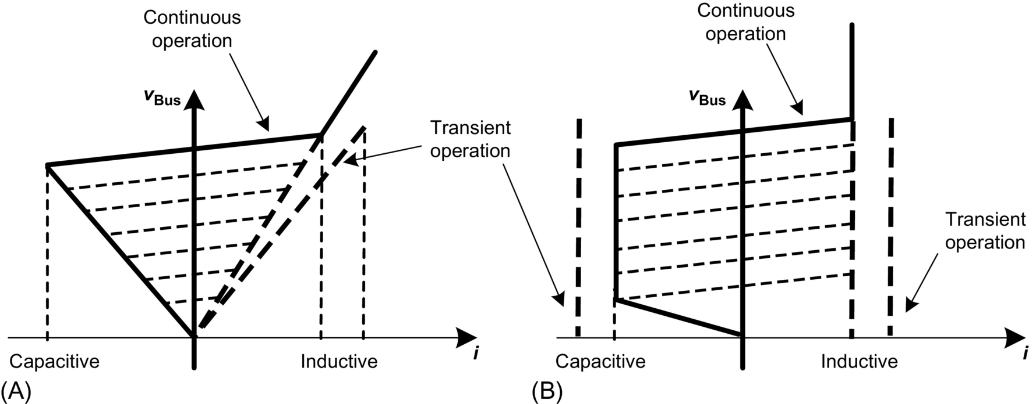

**FIG. 28.34** Comparison between volt-ampere characteristics of (A) SVC and (B) STATCOM.

#### **28.4.2.2 Adjustable Speed Synchronous Condenser (ASSC)**

The adjustable speed synchronous condenser is not exactly a FACTS compensator, as it contains an electric machine. However, it may be an interesting shunt device to compensate reactive power continuously and relatively large amounts of active power for a short time. The basic topology of this compensator is shown in [Fig. 28.35](https://learning.oreilly.com/library/view/power-electronics-handbook/9780128114087/B9780128114070000313.xhtml#f0180). It is based on a double-fed machine with a conventional three-phase winding in the stator and a three-phase winding in the rotor. The latter is supplied by a three-phase converter connected back-to-back to a second converter, which is connected to the grid.

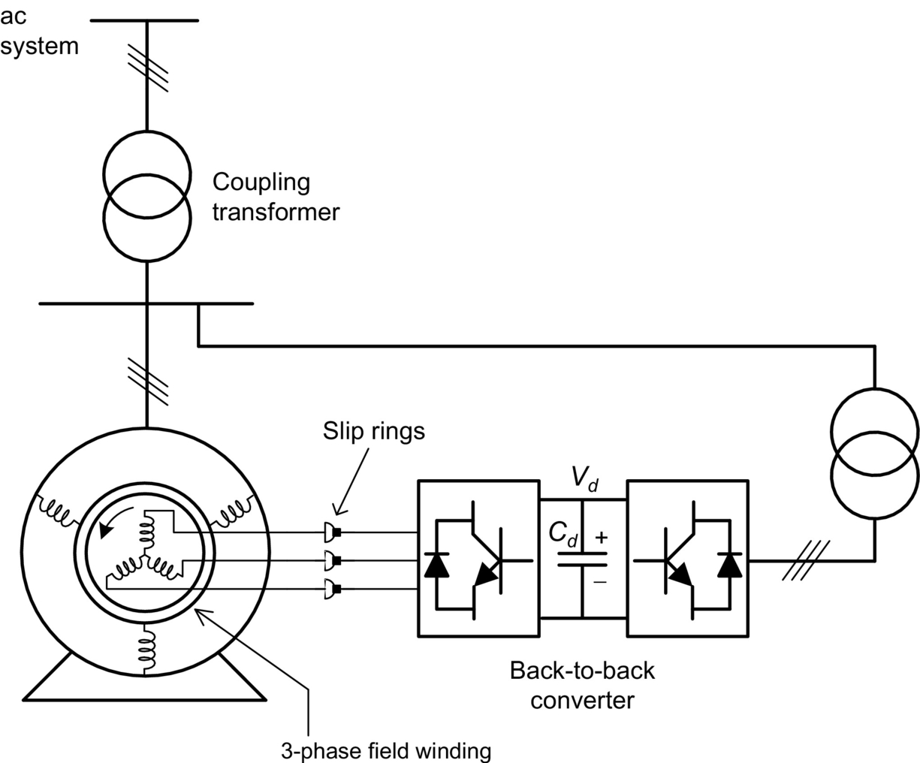

**FIG. 28.35** Adjustable speed synchronous condenser (ASSC).

This configuration allows the generation of a rotating magnetic flux in the rotor, which depends on the rotor converter frequency. When the machine is rotating at synchronous speed, the rotor converter operates at zero frequency and the magnetic flux in the rotor is stationary with respect to the rotor itself. In this case, the compensator operates as a conventional synchronous condenser.

However, when the rotor speed is lower or higher than the synchronous speed (normally during transients), the rotor converter generates a field current with the necessary frequency to keep the stator and rotor fluxes synchronized—if the synchronous frequency is 60 Hz and the rotor is running, for instance, at 58 Hz, the rotor converter has to supply voltage or current at 2 Hz so as to synchronize the fluxes. Naturally, it would be more interesting to use field-oriented control [[44](https://learning.oreilly.com/library/view/power-electronics-handbook/9780128114087/B9780128114070000313.xhtml#bb0225)] instead of scalar control to get a better performance.

This hybrid compensator may supply energy to the ac system, if rotor speed is decreased. This machine is designed to have relatively large rotor inertia so as to present a large inertia constant (which may be in the range of more than 10 s). It is also called adjustable speed rotary condenser [[45](https://learning.oreilly.com/library/view/power-electronics-handbook/9780128114087/B9780128114070000313.xhtml#bb0230)]. Operation at speeds higher than the synchronous speed is also possible, if it is necessary to absorb energy from the grid.

One of the advantages of this device is that a compensator with power in the range of 400 MVA may be synthesized with power electronics converter rated at a small fraction of this power and with a large capability to supply both active (for a few seconds) and reactive power (continuously) [[45](https://learning.oreilly.com/library/view/power-electronics-handbook/9780128114087/B9780128114070000313.xhtml#bb0230)].

#### **28.4.2.3 Static Synchronous Series Compensator**

In contrast to the STATCOM, which is a shunt FACTS compensator, it is possible to build a converter-based compensator for series compensation. [Fig. 28.36](https://learning.oreilly.com/library/view/power-electronics-handbook/9780128114087/B9780128114070000313.xhtml#f0185) shows the basic diagram of a static synchronous series compensator (SSSC) based on voltage source converter (VSC) with a capacitor in its dc side and connected in series with the transmission line through a transformer [[46](https://learning.oreilly.com/library/view/power-electronics-handbook/9780128114087/B9780128114070000313.xhtml#bb0235)]. The inputs to the SSSC controller shown in this figure are the line current and voltage and the active and reactive power references *p*SE⁎ and *q*SE⁎, respectively. In general, only reactive power is compensated, and in this case, the active power reference *p*SE⁎ is zero and *q*SE⁎ is chosen so as to control power flow. Naturally, in the case of power flow control, it is necessary to have another control loop for this purpose and this is not shown in the figure.

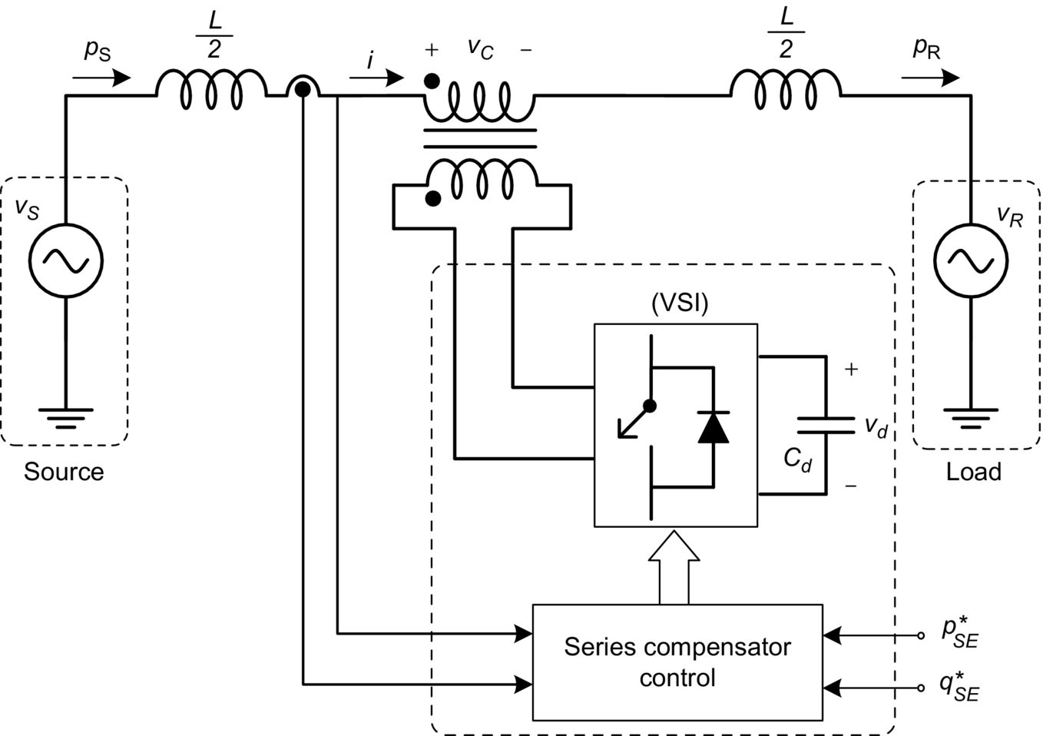

**FIG. 28.36** Static synchronous series compensator (SSSC).

One should note that if current is flowing in the transmission line, the SSSC controls reactive power by generating voltage *vC* in quadrature with the line current. The device then shows capacitive or inductive equivalent impedance by increasing or decreasing the power flow, respectively. The compensation characteristic is as shown in [Fig. 28.8](https://learning.oreilly.com/library/view/power-electronics-handbook/9780128114087/B9780128114070000313.xhtml#f0045), for the case of series compensation where the transmitted power is always positive for . That is, with reactive power control, it is only possible to transmit in one direction. However, if instead of controlling *q*SE⁎, voltage *vC* is controlled, it is possible to have power flow reversion. [Fig. 28.37](https://learning.oreilly.com/library/view/power-electronics-handbook/9780128114087/B9780128114070000313.xhtml#f0190) shows the power flow characteristics of a transmission line with an SSSC using constant voltage control. The voltage is in quadrature with the current, and its magnitude is kept constant. The figure shows that it is possible to have power flow reversion for small values of *δ* with a constant compensation voltage *vC*.

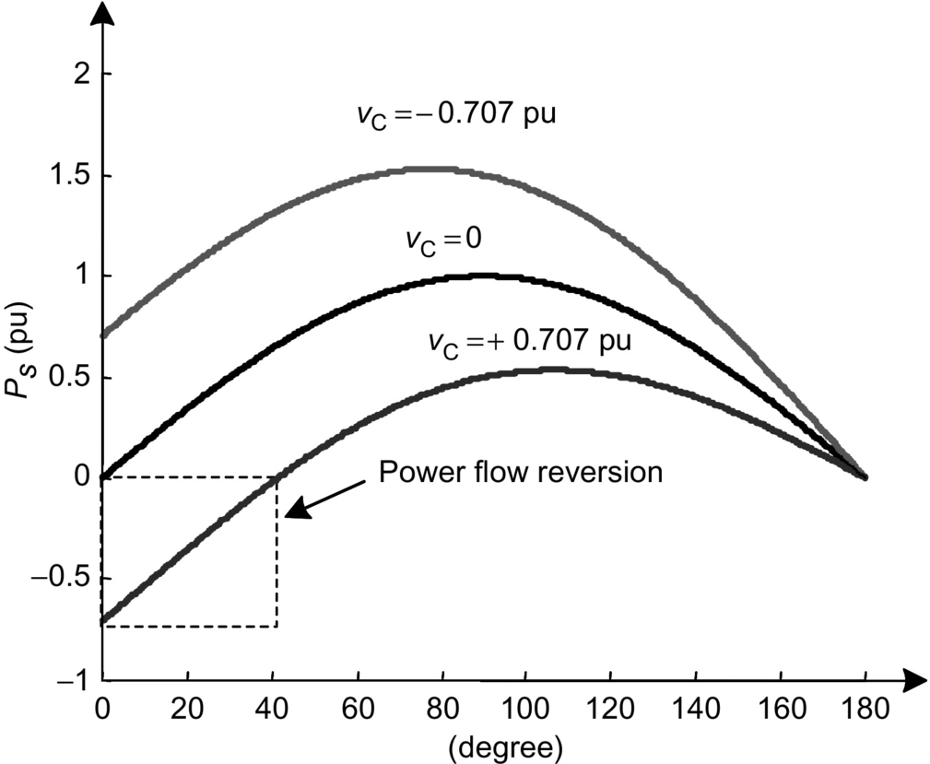

**FIG. 28.37** Power flow characteristics for voltage-controlled SSSC.

It should be noted that the discussion presented with respect to the converters topologies and controllers for the case of the STATCOM is also valid for the case of the SSSC. The SSSC can be used for power flow control and for power oscillation damping as well.

#### **28.4.2.4 Gate-Controlled Series Capacitor**

[Fig. 28.16](https://learning.oreilly.com/library/view/power-electronics-handbook/9780128114087/B9780128114070000313.xhtml#f0085) shows the TCSC, which is basically a TCR in parallel with a capacitor and both connected in series with a transmission line. The combination is effective in continuously controlling the equivalent capacitive reactance presented to the system, mainly for power flow control and power oscillation damping purposes. It was also pointed out that the device has the disadvantage of a resonant condition due to the parallel association of capacitor and TCR (see [Fig. 28.18](https://learning.oreilly.com/library/view/power-electronics-handbook/9780128114087/B9780128114070000313.xhtml#f0095)).

In [[47](https://learning.oreilly.com/library/view/power-electronics-handbook/9780128114087/B9780128114070000313.xhtml#bb0240)], the continuously regulated series capacitor using GTO thyristors to directly control capacitor voltage is presented. [Fig. 28.38](https://learning.oreilly.com/library/view/power-electronics-handbook/9780128114087/B9780128114070000313.xhtml#f0195) shows this new device that is called gate-controlled series capacitor (GCSC) [[48](https://learning.oreilly.com/library/view/power-electronics-handbook/9780128114087/B9780128114070000313.xhtml#bb0245)], hereafter renamed as the gate-controlled series capacitor (GCSC) because it may also be built using other self-commutated switches such as IGBTs or IGCTs.

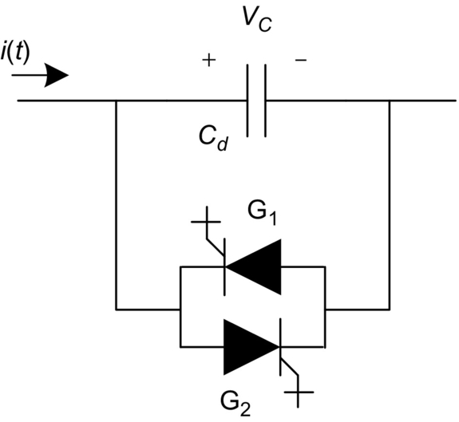

**FIG. 28.38** Gate-controlled series capacitor.

The GCSC circuit consists of a capacitor and a pair of self-commutated switches in antiparallel connection. As the switches operate under ac voltage, they must be able to block both direct and reverse voltages and allow current control in both directions.

[Fig. 28.39](https://learning.oreilly.com/library/view/power-electronics-handbook/9780128114087/B9780128114070000313.xhtml#f0200) shows the voltage and current waveforms for the GCSC, where the current in the transmission line is assumed to be sinusoidal. If the switches are kept turned on, the capacitor is bypassed and does not present any compensation effect. If they are kept off, the capacitor is fully inserted in the line. On the other hand, if the switches are conducting and are turned off at a given blocking angle *γ* counted from the zero crossings of the line current, the capacitor voltage *vC* appears as a result of the integration of the line current passing through it. The next time the capacitor voltage crosses zero, the switches are turned on again, to be turned off at the next turn-off angle *γ*. With this switching control sequence, it must be clear that the switches always switch at zero voltage. This is an interesting feature for the series connection of the switches under high-voltage operation [[49](https://learning.oreilly.com/library/view/power-electronics-handbook/9780128114087/B9780128114070000313.xhtml#bb0250)].

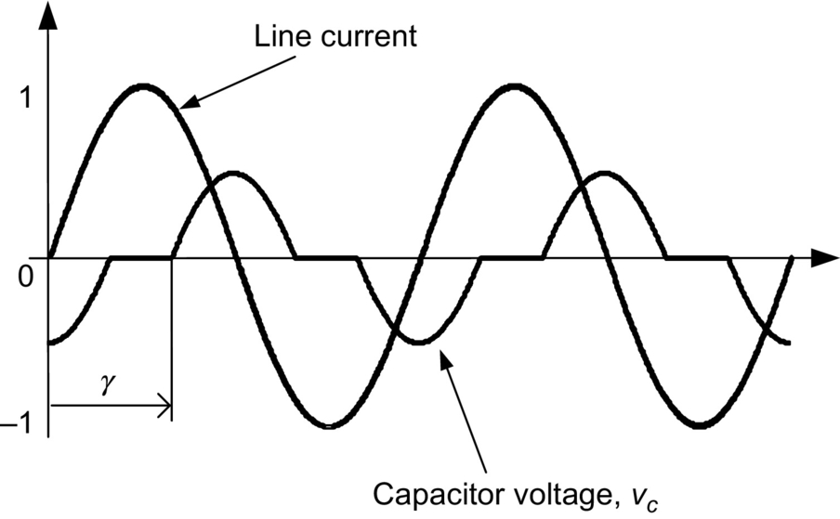

**FIG. 28.39** GCSC voltage and current waveforms.

The GCSC has some advantages when compared with the TCSC—the blocking angle can be continuously varied, which in turn varies the fundamental component of the voltage *vC*. Also, it can be smaller than the TCSC [[50](https://learning.oreilly.com/library/view/power-electronics-handbook/9780128114087/B9780128114070000313.xhtml#bb0255)]. Moreover, the dynamic response of the GCSC is generally better than that of the TCSC [[51](https://learning.oreilly.com/library/view/power-electronics-handbook/9780128114087/B9780128114070000313.xhtml#bb0260)].

The impedance of the GCSC at the fundamental frequency, as a function of the blocking angle *γ*, is shown in [Fig. 28.40](https://learning.oreilly.com/library/view/power-electronics-handbook/9780128114087/B9780128114070000313.xhtml#f0205). A blocking angle of 90 degrees means the capacitor is fully inserted in the circuit, whereas a value of 180 degrees corresponds to a situation where the capacitor is bypassed and no compensation occurs.

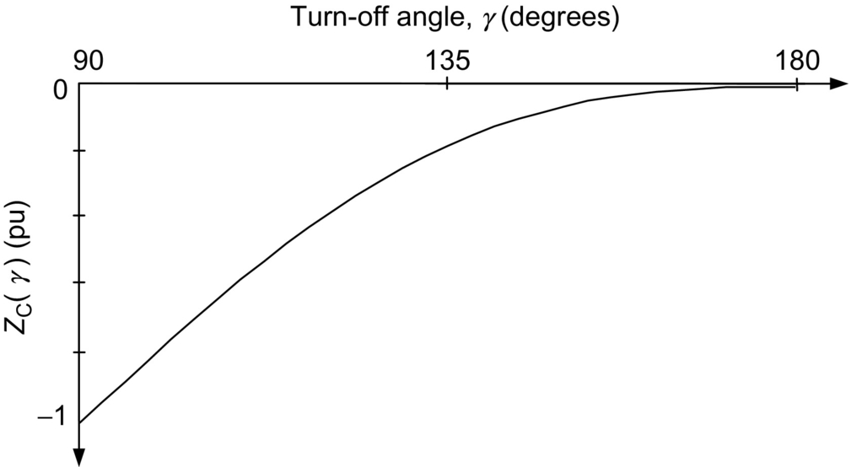

**FIG. 28.40** GCSC equivalent fundamental impedance.

#### **28.4.2.5 Unified Power Flow Controller**

The unified power flow controller (UPFC) is a more complete transmission line compensator [[52](https://learning.oreilly.com/library/view/power-electronics-handbook/9780128114087/B9780128114070000313.xhtml#bb0265)], shown as a simplified block diagram in [Fig. 28.41](https://learning.oreilly.com/library/view/power-electronics-handbook/9780128114087/B9780128114070000313.xhtml#f0210). This device can be understood as a STATCOM and an SSSC with a common dc link. The energy storing capacity of the DC capacitor is generally small, and so the shunt converter has to drain (or inject) active power from the grid in exactly the same amount as the active power being injected (or drained) by the series converter. If this is not followed, the dc-link voltage may increase or decrease with respect to the rated voltage, depending on the net power being absorbed or delivered by both converters. On the other hand, the reactive power in the shunt or series converter can be controlled independently, giving a great flexibility to the power flow control.

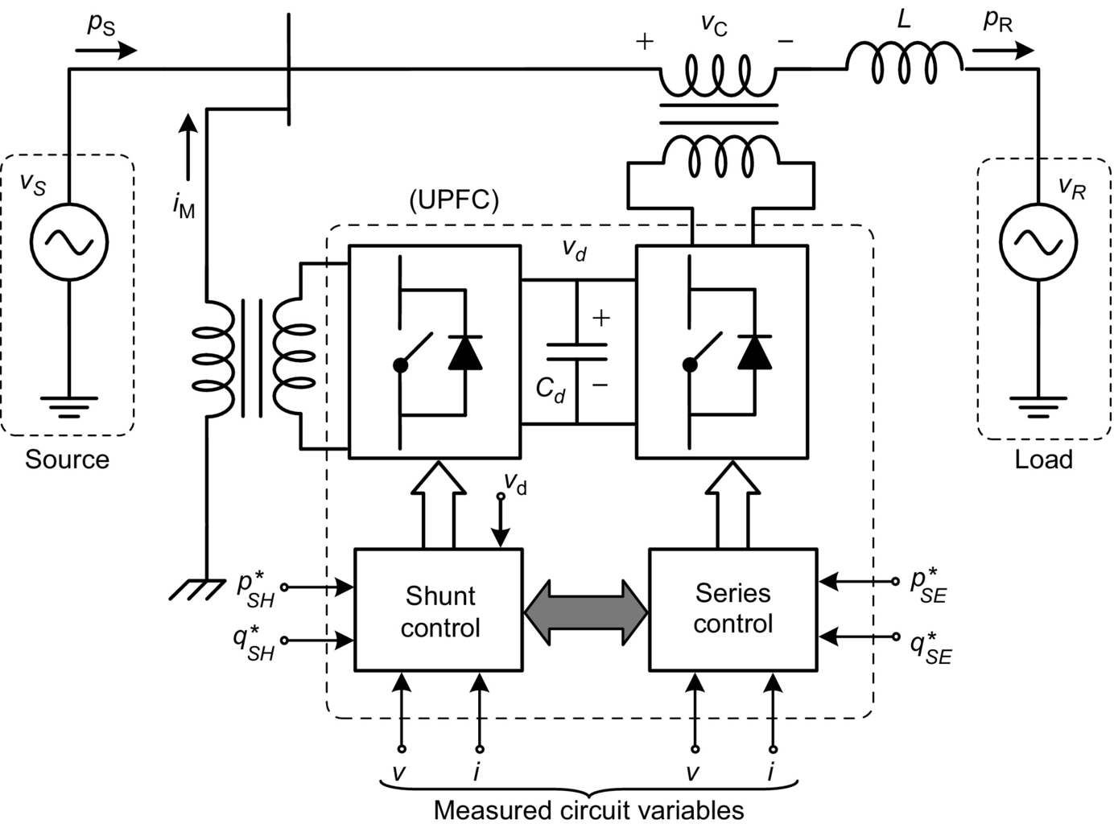

**FIG. 28.41** UPFC block diagram.

The phasor diagram in [Fig. 28.42](https://learning.oreilly.com/library/view/power-electronics-handbook/9780128114087/B9780128114070000313.xhtml#f0215) shows that the UPFC can be controlled in such a way as to produce any voltage phasor in series with the transmission line that fits inside the dashed-line circle on top of the phase voltage phasors. The maximum radius of the circle is limited by the voltage limitation of the series converter. The fact that the locus of *vc* is a circle is one of the greatest advantages of the UPFC when compared with the thyristor-based phase shifter. If the UPFC presents capacitive or inductive reactive power in parallel with the system, the magnitude of voltage *V*S is increased or decreased, respectively. This extra characteristic increases the locus of the series voltage *vc.* Of course, this effect is only possible if an inductive impedance is present in series with the voltage source *V*S, which is normally the case.

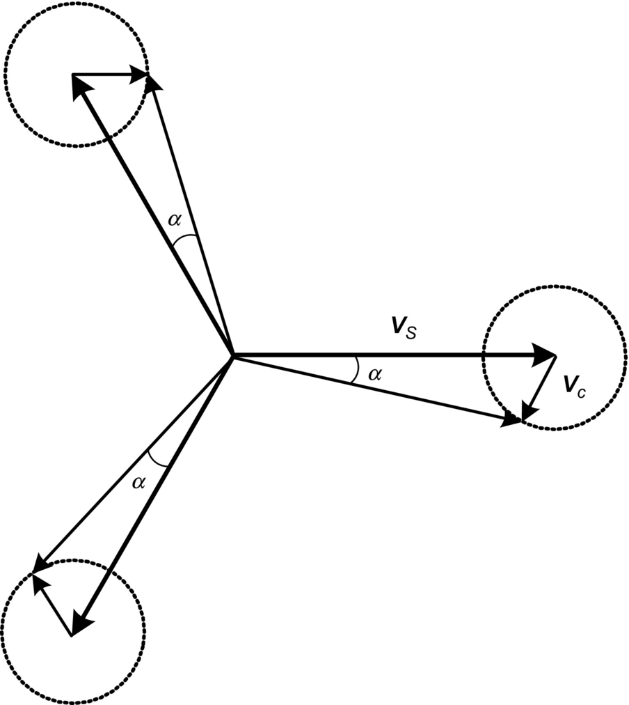

**FIG. 28.42** Phasor diagram for a system with a UPFC.

The shunt compensator of the UPFC is normally used with two objectives. The first is to control the reactive power in the point of connection, therefore controlling the voltage at this point. The second is to control active power in such a way as to control the dc-link voltage. The control technique to be used can be similar to the one used in STATCOM. The series compensator can be controlled in the same way as the SSSC, with the difference that in this case, it may control active and reactive power. Naturally, the active power control in the series compensator would change the capacitor voltage that should be controlled by the shunt compensator.

The UPFC can also be used to regulate directly the voltage in distribution feeder or transmission line. In the case that the UPFC is based on single-phase converter units (UPFC-1ɸ) [[53](https://learning.oreilly.com/library/view/power-electronics-handbook/9780128114087/B9780128114070000313.xhtml#bb0270),[54](https://learning.oreilly.com/library/view/power-electronics-handbook/9780128114087/B9780128114070000313.xhtml#bb0275)], it can control unbalanced voltage. This application is named as direct voltage control (DVC) [[55](https://learning.oreilly.com/library/view/power-electronics-handbook/9780128114087/B9780128114070000313.xhtml#bb0280)], and it is a promising solution for power quality issues in distribution grid with high penetration of intermittent generation sources, such as wind or solar power. Since this grid has a resistive characteristic, the indirect voltage control, based on shunt reactive compensator, could be ineffective [[56](https://learning.oreilly.com/library/view/power-electronics-handbook/9780128114087/B9780128114070000313.xhtml#bb0285)]. Moreover, the use of single-phase converters permits the direct voltage control even under unbalanced operation, and each phase voltage can be controlled independently to balance the grid voltage.

[Fig. 28.43](https://learning.oreilly.com/library/view/power-electronics-handbook/9780128114087/B9780128114070000313.xhtml#f0220) shows the basic line diagram of the UPFC based on single-phase back-to-back VSC unit for phase *a*. In each phase, one converter (VSC 1a) is shunt connected to the grid through a transformer (*Tsh*), and the other converter (VSC 2a) is directly connected in series at the point that voltage should be controlled (PCC). In [Fig. 28.43](https://learning.oreilly.com/library/view/power-electronics-handbook/9780128114087/B9780128114070000313.xhtml#f0220), each VSC is connected in series with the secondary windings of the grid transformer (*Tgrid*), avoiding a coupling transformer. The series converter of each UPFC 1ϕ is controlled to synthesize a compensation voltage (*Vcomp*) to keep the PCC voltage regulated at a reference value, that is,

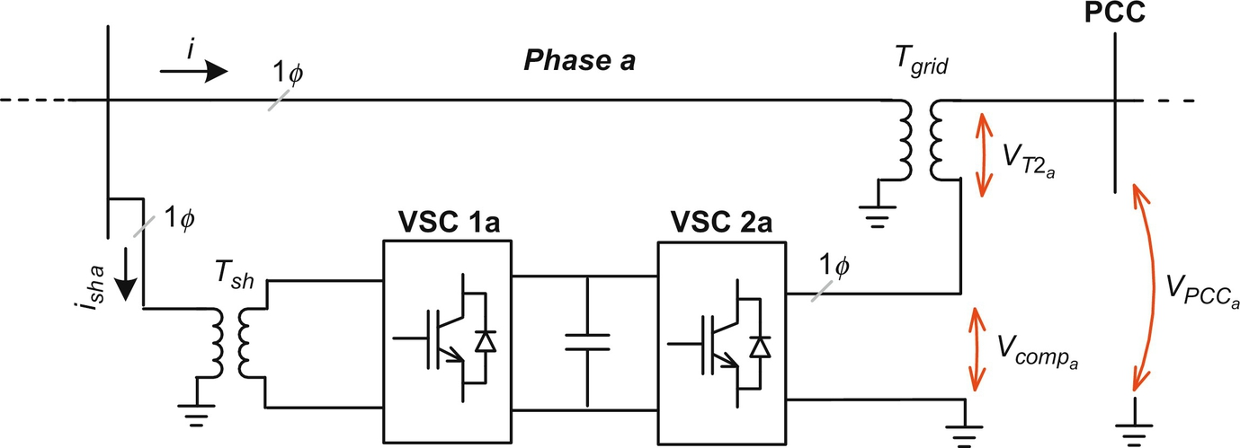

**FIG. 28.43** Direct voltage control using UPFC 1ϕ units.

 **(28.12)**

where  (*j=a, b, c*) is the phasor of voltage phase “*j*” in secondary wind of the transformer and  is the phasor of the compensation voltage synthetized by the series VSC connected to phase “*j*.” The compensation voltage can be represented as

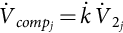 **(28.13)**

where  is the complex compensation factor, which means that both the magnitude and the phase of the compensation voltage can be controlled independently in each phase. This feature is suitable for grids with unbalanced voltage issues. If only the magnitude of the voltage in each phase should be compensated, the compensation factor is a real number, which means that the compensation voltage, , is in phase to the secondary phase voltage of the grid transformer, , and a simple control strategy can be applied as shown in [Fig. 28.44](https://learning.oreilly.com/library/view/power-electronics-handbook/9780128114087/B9780128114070000313.xhtml#f0225). This figure shows the control block diagram of the series VSC for direct voltage magnitude compensation for one phase. The rms value of the PCC phase voltage () is compared with the reference value (*Vrms ref*); the output error is processed by a PI controller, generating the compensation voltage magnitude. This signal is multiplied by a sinusoidal signal, sin(*θPLL*), in phase with secondary phase voltage of the grid transformer, , obtained from the synchronizing circuit (phase locked loop (PLL)).

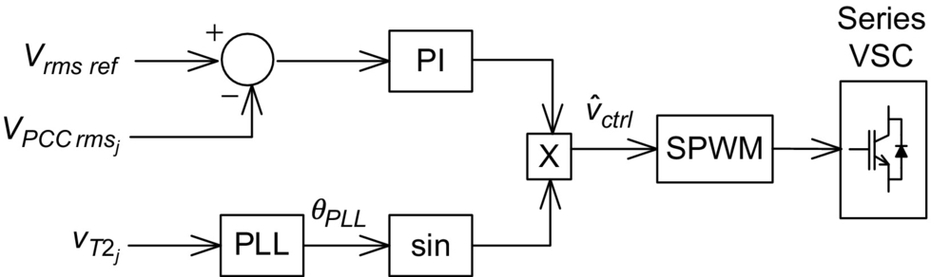

**FIG. 28.44** Voltage control block diagram for the series VSC (magnitude compensation only).

#### **28.4.2.6 Interline Power Flow Controller**

The interline power flow controller (IPFC) [[53](https://learning.oreilly.com/library/view/power-electronics-handbook/9780128114087/B9780128114070000313.xhtml#bb0270)] is a UPFC-derived device with the objective of controlling power flow between two lines instead of one line as in the UPFC. [Fig. 28.45](https://learning.oreilly.com/library/view/power-electronics-handbook/9780128114087/B9780128114070000313.xhtml#f0230) shows a basic block diagram of an IPFC with two converters to control the power flow in lines 1 and 2. The minimum number of converters connected back-to-back is two, but there may be more. Each converter should be connected in series with a different transmission line and should control power flow in this line with the following conditions:

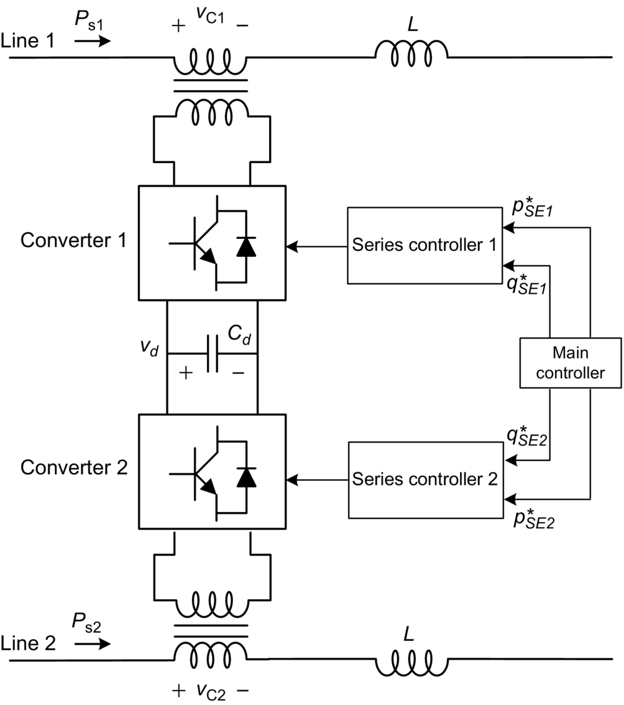

**FIG. 28.45** Block diagram of IPFC with two converters.

• The reactive power control can be totally independent in each converter.

• The active power flowing into or out of each converter has to be coordinated in such a way that the dc-link voltage is kept controlled.

The dc-link voltage control can be achieved in a similar way as in the case of the UPFC. In this case, one of the series converters can control the compensation voltage freely, and it may produce active power flowing into or from the dc link, which would charge or discharge the dc-link capacitor. Therefore, the other converter has to be controlled to regulate this dc voltage. If there are *n* converters with *n* greater than two, () converters can absorb or generate active power, whereas one converter has to control the dc-link voltage. Anyway, all *n* converters can control reactive power freely. For instance, this concept allows the control of the power flow in *n* lines, and it is possible to transfer active power from one line to another to balance power flow in *n* parallel transmission lines.

#### **28.4.2.7 Convertible Static Converter**

Following the IPFC, a more generic concept is the convertible static converter (CSC) [[57](https://learning.oreilly.com/library/view/power-electronics-handbook/9780128114087/B9780128114070000313.xhtml#bb0290),[58](https://learning.oreilly.com/library/view/power-electronics-handbook/9780128114087/B9780128114070000313.xhtml#bb0295)], which is based on the connection of a voltage source converter in various different topologies. Considering one simple case of two transmission lines and two converters with apparent power each equals to *S*, it is possible to have the following topologies:

• Two converters connected in shunt operating as a STATCOM rated at 2*S* apparent power

• Two converters connected in series with one transmission line forming an SSSC with 2*S* apparent power

• One converter connected in shunt and the other in series forming a UPFC

• One converter connected in series with one line and the other connected in series with the other line forming an IPFC

Other topologies are possible depending on how the converters are connected in the system. The basic control of each converter depends on how it is being used if, as a STATCOM, SSSC, UPFC, or IPFC.

## 28.5 Ancillary Services

Ancillary services are essential for grid reliability, including these services that can facilitate wind farms obtaining connection permits in some countries. Thus, taking advantage of the current scenario with high penetration of wind turbines in the distribution and transmission systems in several regions throughout the world, more and more, these services are being incorporated into the modern wind farms. These services include voltage and reactive power support, frequency-active power control, and fault ride through capability. This is all possible thanks to the ability of modern wind turbines to make use of FACTS controller features. Nowadays, most of wind farms are based on doubly fed induction generator (DFIG) or permanent magnet synchronous generator (PMSG). However, solar photovoltaic power plants can also contribute to these services, since they are connected to the grid via power inverters [[59](https://learning.oreilly.com/library/view/power-electronics-handbook/9780128114087/B9780128114070000313.xhtml#bb0300)]. So, photovoltaic and wind turbine power plants can contribute to increase the reliability of distribution and transmission systems, as indicated in [Fig. 28.46](https://learning.oreilly.com/library/view/power-electronics-handbook/9780128114087/B9780128114070000313.xhtml#f0235).

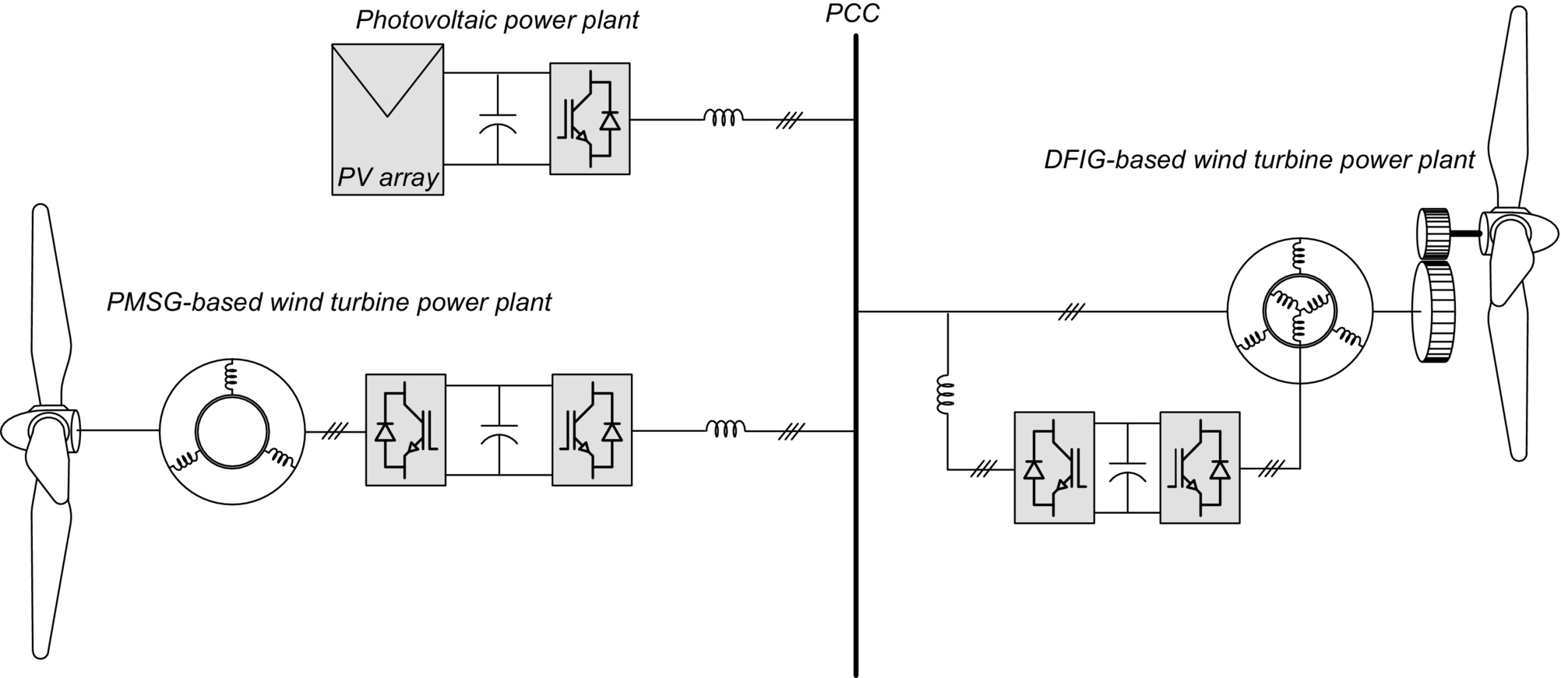

**FIG. 28.46** Photovoltaic and wind turbine power plants connected to the grid.

Modern grid codes define a range of technical requirements that generation power plants must fulfill. For example, it is very common in the voltage support through reactive current injection during fault operation and the voltage support of the power system in normal operation through the reactive power control. Advanced control designs associated with power electronics converters are responsible to provide these ancillary services [[59](https://learning.oreilly.com/library/view/power-electronics-handbook/9780128114087/B9780128114070000313.xhtml#bb0300),[60](https://learning.oreilly.com/library/view/power-electronics-handbook/9780128114087/B9780128114070000313.xhtml#bb0305)].

Wind turbines connected to the grid through a static power converter can provide an adequate inertial response to the system. The idea behind that is that the converter control system ensures a resistant torque to the wind turbine shaft during a frequency disturbance to extract energy. Thus, the behavior of synchronous generator with large inertia can be emulated [[61](https://learning.oreilly.com/library/view/power-electronics-handbook/9780128114087/B9780128114070000313.xhtml#bb0310)–[65](https://learning.oreilly.com/library/view/power-electronics-handbook/9780128114087/B9780128114070000313.xhtml#bb0330)].

Generally, a photovoltaic power plant has no energy storage; therefore, it cannot emulate an inertia, so it cannot contribute by itself to increasing the inertia of the system. Unless it uses other components like a flywheel or a battery to allow this service [[61](https://learning.oreilly.com/library/view/power-electronics-handbook/9780128114087/B9780128114070000313.xhtml#bb0310)].

## References

[1] Hingorani N.G. Power electronics in electric utilities: role of power electronics in future power systems. *Proc. IEEE.* 1988;76(4):481–482.

[2] Hingorani N.G., Gyugyi L. *Understanding Facts—Concepts and Technology of Flexible AC Transmission Systems.* New York: IEEE Press; 1999.

[3] Kimbark E.W. *Direct Current Transmission.* New York: Wiley-Interscience; 1971.

[4] Mohan N., Undeland T.M., Robins W.P. *Power Electronics—Converters, Applications and Design.* New York: John Wiley & Sons, Inc.; 2003.

[5] Rashid M.H. *Power Electronics, Circuits, Devices, and Applications.* third ed. Prentice Hall; 2003.

[6] Rabkowski J., Peftitsis D., Nee H.P. Silicon carbide power transistors: a new era in power electronics is initiated. *IEEE Ind. Electron. Mag.* 2012;6(2):17–26. doi:10.1109/MIE.2012.2193291.

[7] Bose B.K. *Power Electronics and Motor Drives: Advances and Trends.* Elsevier Inc; 2006.

[8] Yazdani A., Iravani R. *Voltage-Sourced Converters in Power Systems.* Wiley-IEEE Press; 2010.

[9] Gyugyi L. *Emerging Practices in Technology: Solid-State Synchronous Voltage Sources for Dynamic Compensation and Real Time Control AC Transmission Lines.* IEEE Standards Press; 1993.

[10] Edris A.A., Adapa R., Baker M.H., Bhomann L., Clark K., Habashi K., Gyugyi L., Lemay J., Mehraban A.S., Myers A.K., Reeve J., Sener F., Togerson D.R., Wood R.R. Proposed terms and definitions for flexible AC transmission systems (FACTS). *IEEE Trans. Power Del.* 2002;12(4):1848–1853.

[11] Wei-Nan C., Wu C.-J. Developing static reactive power compensators in a power system simulator for power education. *IEEE Trans. Power Syst.* 1995;10(4):1734–1741.

[12] Hasegawa T., Aoshima Y., Sato T. *Development of 60 MVA SVC (static var compensator) using large capacity 8 kV and 3.5 kA thyristors.* In: IEEE Power Converter Conference—PCC-Nagaoka; 1997:725–730.

[13] Deri A.J.F., Ware B.J., Byron R.A., Mehraban A.S., Chamia M., Halvarsson P., Ängquist L. *Improving transmission system performance using controlled series capacitors.* In: Cigré Joint Session 14/37/38-07, Paris, France; 1992.

[14] Christl N., Hedin R., Sadek K., Lützelberger P., Krause P.E., McKenna S.M., Montoya A.H., Torgerson D. *Advanced series compensation (ASC) with thyristor controlled impedance.* In: Cigré Joint Session 14/37/38-05, Paris, France; 1992.

[15] Gama C. *Brazilian north–south interconnection control application and operating experience with a TCSC.* In: IEEE—PES Summer Meeting; 1103–1108. 1999;vol. 2.

[16] Xing K., Kusic G.L. Damping sub-synchronous resonance by phase shifters. *IEEE Trans. Energy Conver.* 1989;4(3):344–350.

[17] Nyati S., Eitzmann M., Kappenman J., VanHouse D., Mohan N., Edris A. Design issues for a single core transformer thyristor controlled phase-angel regulator. *IEEE Trans. Power Del.* 1995;10(4):2013–2019.

[18] Holmes D.G., Lipo T.A. *Pulse Width Modulation for Power Converters: Principles and Practice.* Wiley-IEEE Press; 2003.

[19] Mori S., Matsuno K., Takeda M., Seto M. Development of a large static var generator using self-commutated inverters for improving power system stability. *IEEE Trans. Power Del.* 1993;8(1):371–377.

[20] Schauder C., Gernhardt M., Stacey E., Lemak T., Gyugyi L., Cease T.W., Edris A. Development of a /spl plusmn/100 Mvar static condenser for voltage control of transmission system. *IEEE Trans. Power Del.* 1995;10(3):1486–1496.

[21] Reed G., Paserba J., Croasdaile T., Takeda M., Hamasaki Y., Aritsuka T., Morishima N., Jochi S., et al. *The VELCO STATCOM based transmission system project.* In: IEEE Power Engineering Society Winter Meeting, 2001; 1109–1114. 2001;vol. 3.

[22] Qian C., Crow M.L. *A cascade converter-based STATCOM with energy storage.* In: IEEE PES Winter Meeting; 544–549. 2002;vol. 1.

[23] Lesnicar A., Marquardt R. *An innovative modular multilevel converter topology suitable for a wide power range.* In: IEEE Power Tech Conference Proceedings, Bologna, 23–26 June; 6. 2003;vol. 3.

[24] Dorn J., Huang H., Retzmann D. *Novel voltage-sourced converters for HVDC and FACTS applications.* In: Cigré Symposium, Osaka, Japan; 2008.

[25] Huang H. *Multilevel voltage-sourced converters for HVDC and FACTS applications.* In: Cigré SC B4 Colloquium, Bergen and Ullensvang, Norway; 2009.

[26] Soto D., Green T. A comparison of high-power converter topologies for the implementation of FACTS controllers. *IEEE Trans. Ind. Electron.* 2002;49(5):1072–1080.

[27] Kuang J., Ooi B. Series connected voltage-source converter modules for force-commutated SVC and DC-transmission. *IEEE Trans. Power Del.* 1994;9(2):977–983.

[28] Ferreira, J.R.B.L., Direct Current Transmission Based on Modular Multilevel Converter, PhD. Thesis, (in Portuguese), Federal University of Rio de Janeiro, Rio de Janeiro, 2014.

[29] Allebrod S., Hamerski R., Marquardt R. *New transformerless, scalable modular multilevel converters for HVDC-transmission.* In: IEEE Power Electronics Specialists Conference, 2008, PESC 2008; 2008:174–179.

[30] Schauder C., Mehta H. Vector analysis and control of advanced static var compensators. *IEE Proc. Gener. Transm. Distrib.* 1993;140(4):299–306.

[31] Buchholz, F., Das Begriffsystem Rechtleistung. Wirkleistung, totale Blindleistung. Selbstverlag München, 1950.

[32] Depenbrock M. The FBD-method, a generally applicable tool for analyzing power relations. *IEEE Trans. Power Syst.* 1993;8(2):381–387.

[33] Takeda M., et al. *Development of an SVG series for voltage control over three-phase unbalance caused by railway load.* In: Proc. International Power Electronics Conference—IPEC-Yokohama’95, Yokohama, Japan; 1995:603–608.

[34] Hochgraf C., Lasseter R.H. STATCOM controls for operation with unbalanced voltages. *IEEE Trans. Power Del.* 1998;13(2):538–544.

[35] Reed G.F., Greaf J.E., Matsumoto T., Yonehata Y., Takeda M., Aritsuka T., Hamasaki Y., Ojima F., Sidell A.P., Chervus R.E., Nebecker C.K. *Application of a 5 MVA, 4.16 kV D-STATCOM system for voltage flicker compensation at Seattle iron and metals.* In: IEEE Power Engineering Society Summer Meeting 2000; 1605–1611. 2000;vol. 3.

[36] Akagi H., Kanazawa Y., Nabae A. Instantaneous reactive power compensators comprising switching devices without energy storage components. *IEEE Trans. Ind. Appl.* 1984;IA-20(3):625–630.

[37] Watanabe E.H., Stephan R.M., Aredes M. New concepts of instantaneous active and reactive power for three phase system and generic loads. *IEEE Trans. Power Del.* 1993;8(2):697–703.

[38] Akagi H., Watanabe E.H., Aredes M. *Instantaneous Power Theory and Application to Power Conditioning.* Wiley-IEEE Press; 2007.

[39] Ichikawa F., et al. *Operating experience of a 50 MVA self-commutated SVC at the Shin–Shimano Substation.* In: Proc. International Power Electronics Conference—IPEC-Yokohama’95, Yokohama, Japan; 1995:597–602.

[40] Schauder C. *STATCOM for compensation of large electric arc furnace installations.* In: IEEE Power Engineering Society Summer Meeting 1999; 1109–1112. 1999;vol. 2.

[41] Shen C., Yang Z., Crow M.L., Atcitty S. *Control of STATCOM with energy storage device.* In: IEEE Power Engineering Society Winter Meeting 2000; 2722–2728. 2000;vol. 4.

[42] Arsoy A.B., Liu Y., Ribeiro P.F., Wang F. STATCOM-SMES. *IEEE Ind. Appl. Mag.* 2003;9(2):21–28.

[43] Molina M.G., Mercado P.E., Watanabe E.H. *Dynamic performance of a static synchronous compensator with superconducting magnetic energy storage.* In: IEEE Power Electronics Specialist Conference—PESC’2005; 2005:224–230.

[44] Leonhard W. *Control of Electrical Drives.* third ed. Springer; 2001.

[45] Akagi H. The state-of-the-art of power electronics in Japan. *IEEE Trans. Power Electron.* 1998;13(2):345–356.

[46] Gyugyi L., Schauder C.D., Kalyan K.S. Static synchronous series compensator: a solid-state approach to the series compensation of transmission lines. *IEEE Trans. Power Del.* 1997;12(1):406–417.

[47] Karady G.G., Ortmeyer T.H., Pilvelait B.R., Maratukulam D. Continuous regulated series capacitor. *IEEE Trans. Power Del.* 1993;8(3):1348–1354.

[48] de Souza L.F.W., Watanabe E.H., Aredes M. GTO controlled series capacitors: multi-module and multi-pulse arrangements. *IEEE Trans. Power Del.* 2000;15(2):725–731.

[49] Watanabe E.H., Aredes M., de Souza L.F.W., Bellar M.D. Series connection of power switches for very high-power applications and zero voltage switching. *IEEE Trans. Power Electron.* 2000;15(1):44–50.

[50] de Souza L.F.W., Watanabe E.H., Alves J.E.R., Pilotto L.A.S. *Thyristor and gate controlled series capacitors: comparison of components rating.* In: IEEE Power Engineering Society General Meeting, Toronto, Canada; 2003:2542–2547.

[51] Banerjee S., Chatterjee J.K., Triphathy S.C. Application of magnetic energy storage unit as continuous VAR controller. *IEEE Trans. Energy Conver.* 1990;5(1):39–45.

[52] Gyugyi L. Unified power-flow control concept for flexible AC transmission systems. *IEE Proc. C.* 1992;139(4):323–331.

[53] S.L. Silva Lima, UPFC for Voltage Control. PhD. Thesis, (in Portuguese), Federal University of Rio de Janeiro, Rio de Janeiro, 2013.

[54] Silva Lima S.L., Dias R.F.S., Watanabe E.H. Direct voltage control in grids with intermittent sources using UPFC. *Power Electron. Mag. SOBRAEP.* 2014;19(3):260–267.

[55] da Costa W.S.J.P., Kruschel W., Zacharias P. *Power electronics for voltage control in distribution networks.* In: 16th Kassel Symposium on Energy Systems Technology; 2011:1–15.

[56] Geibel D., Degner T., Engel B., da Costa J.P., Kruschel W., Reimann T., Blo T., Sahan B., Zacharias P. *Active intelligent distribution networks coordinated voltage regulation methods for networks with high share of decentralised generation.* In: 2012 CIRED Workshop, Lisbon; 2012:1–4.

[57] Edris A.A., Zelinger S., Gyugyi L., Kovalsky L.J. Squeezing more power from the grid. *IEEE Power Eng. Rev.* 2002;22(6):4–6.

[58] Uzunovic E., Fardanesh B., Hopkins L., Shperling B., Zelingher S., Schuff A. *NYPA convertible static compensator (CSC) application phase I: STATCOM.* In: IEEE—PES Transmission and Distribution Conference and Exposition; 1139–1143. 2001;2.

[59] Margaris I.D., Hansen A.D., Sørensen P., Hatziargyriou N.D. Illustration of modern wind turbine ancillary services. *Energies.* 2010;3(6):1290–1302.

[60] Zertek A., Verbic G., Pantos M. A novel strategy for variable-speed wind turbines' participation in primary frequency control. *IEEE Trans. Sustain. Energy.* 2012;3(4):791–799. doi:10.1109/TSTE.2012.2199773.

[61] Revel G., Leon A.E., Alonso D.M., Moiola J.L. Dynamics and stability analysis of a power system with a PMSG-based wind farm performing ancillary services. *IEEE Trans. Circ. Syst. I: Reg. Papers.* 2014;61(7):2182–2193. doi:10.1109/TCSI.2014.2298281.

[62] Ela E., et al. *Effective ancillary services market designs on high wind power penetration systems.* In: 2012 IEEE Power and Energy Society General Meeting; 2012.

[63] MacDowell J., Dutta S., Richwine M., Achilles S., Miller N. Serving the future: advanced wind generation technology supports ancillary services. *IEEE Power Energy Mag.* 2015;13(6):22–30. doi:10.1109/MPE.2015.2461331.

[64] Baccino F., Conte F., Grillo S., Massucco S., Silvestro F. An optimal model-based control technique to improve wind farm participation to frequency regulation. *IEEE Trans. Sustain. Energy.* 2015;6(3):993–1003. doi:10.1109/TSTE.2014.2327243.

[65] Ruttledge L., Flynn D. Emulated inertial response from wind turbines: gain scheduling and resource coordination. *IEEE Trans. Power Syst.* 2016;31(5):3747–3755. doi:10.1109/TPWRS.2015.2493058.

## Further Reading

[66] Gyugyi L., Schauder C.D., Kalyan K.S. The interline power flow controller concept: a new approach to power flow management in transmission systems. *IEEE Trans. Power Del.* 1999;14(3):1115–1123.

[67] Andersen B.R., Xu L., Horton P.J., Cartwright P. Topologies for VSC transmission. *Power Eng. J.* 2002;16(3):142–150.

[68] Flourentzou N., Agelidis V.G., Demetriades G.D. VSC-based HVDC power transmission systems: an overview. *IEEE Trans. Power Electron.* 2009;24(3):592–602.

[69] Bahrman M.P., Johnson B.K. The ABCs of HVDC transmission technologies. *IEEE Power Energy Mag.* 2007;5(2):32–44.

[70] Baroudi J.A., Dinavahi V., Knight A.M. A review of power converter topologies for wind generators. *Renew. Energy.* 2007;32(14):2369–2385.

**SECTION V**

Motor Drive

**29**

# Drive Types and Specifications

Yahya Shakweh AEC, London, United Kingdom

## Abstract

In every industry, there are industrial processes of some form, which require adjustments for either normal operation or optimum performance. Such adjustments are usually accomplished with a variable speed drive system. They are an important part of automation. They help to optimize the process, reduce investment costs, energy consumption, and energy cost.

### KEYWORDS

Variable speed drive; Electric motor; Transformer; Converters; Inverters; Rectifier

29.1 [An Overview](https://learning.oreilly.com/library/view/power-electronics-handbook/9780128114087/B9780128114070000337.xhtml#s0010)

29.1.1 Introduction

29.1.2 Historical Review

29.1.3 Advantages of VSD

29.1.4 Disadvantages of VSD

29.2 [Drives Requirements and Specifications](https://learning.oreilly.com/library/view/power-electronics-handbook/9780128114087/B9780128114070000337.xhtml#s0070)

29.2.1 General Market Requirements

29.2.2 Drive Specifications

29.3 [Drive Classifications and Characteristics](https://learning.oreilly.com/library/view/power-electronics-handbook/9780128114087/B9780128114070000337.xhtml#s0105)

29.3.1 Classification by Applications

29.3.2 Classification by Type of Power Device

29.3.3 Classification by the Type of Converter

29.4 [Load Profiles and Characteristics](https://learning.oreilly.com/library/view/power-electronics-handbook/9780128114087/B9780128114070000337.xhtml#s0175)

29.4.1 Load Profile Types

29.4.2 Motor Drive Duty

29.5 [VSD Topologies](https://learning.oreilly.com/library/view/power-electronics-handbook/9780128114087/B9780128114070000337.xhtml#s0215)

29.5.1 DC Motor Drives

29.5.2 Induction Motor Drive

29.5.3 Synchronous Motor Drives

29.5.4 Special Motors

29.6 [PWM-VSI DRIVE](https://learning.oreilly.com/library/view/power-electronics-handbook/9780128114087/B9780128114070000337.xhtml#s0280)

29.6.1 Drive Comparison

29.6.2 Medium Voltage PWM-VSI

29.6.3 Control Strategies

29.6.4 Communication in VSDs

29.6.5 PWM Techniques

29.6.6 Impact of PWM Waveform

29.6.7 Techniques Used to Reduce the Effect of PMP Voltage Waveform

29.6.8 Supply Front-End for PWM-VSI Drives

29.7 [Applications](https://learning.oreilly.com/library/view/power-electronics-handbook/9780128114087/B9780128114070000337.xhtml#s0405)

29.7.1 VSD Applications

29.7.2 Applications by Industry

29.7.3 Examples of Modern VSD Systems

29.8 [Summary](https://learning.oreilly.com/library/view/power-electronics-handbook/9780128114087/B9780128114070000337.xhtml#s0465)

[References](https://learning.oreilly.com/library/view/power-electronics-handbook/9780128114087/B9780128114070000337.xhtml#bi0010)

[Further Reading](https://learning.oreilly.com/library/view/power-electronics-handbook/9780128114087/B9780128114070000337.xhtml#fr0010)

## 29.1 An Overview

### **29.1.1 INTRODUCTION**

In every industry, there are industrial processes of some form, which require adjustments for either normal operation or optimum performance. Such adjustments are usually accomplished with a variable speed drive (VSD) system. They are an important part of automation. They help to optimize the process, reduce investment costs, energy consumption, and energy cost.

There are three basic types of VSD systems: electric drives, hydraulic drives, and finally mechanical drives. This chapter focuses mainly on electric drives.

A typical electric VSD system consists of three basic components: the electric motor, the power converter, and the control system, as illustrated in [Fig. 29.1](https://learning.oreilly.com/library/view/power-electronics-handbook/9780128114087/B9780128114070000337.xhtml#f0010). The electric motor is connected directly or indirectly (through gears) to the load. The power converter controls the power flow from an AC supply (often via a supply transformer) to the motor by appropriate control of power semiconductor switches (part of the power converter).

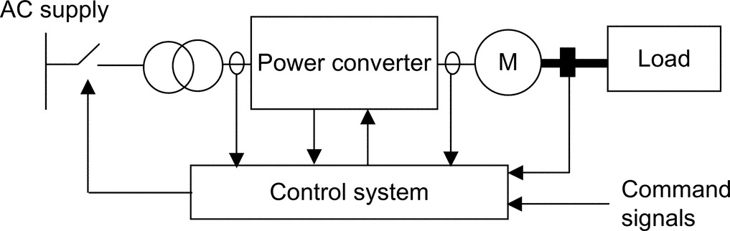

**FIGURE 29.1** VSD schematic diagram.

With recent advances of power semiconductor and converter topologies, electric VSDs are witnessing a revolution in applications including computer peripheral drives, machine tools and robotic drives, test benches, fan pumps and compressors, paper mill drives, automation, traction and ship propulsion, and cement mill and rolling mill drives.

For a proper control system, the VSD system variables, both mechanical and electric, are required for control and protection. Signals are usually derived from sensors, whose outputs are very much dependent on the control strategy employed and the functionality required.

This chapter introduces electric VSDs and briefly describes their benefits. It examines their classifications from different perspectives. Their specification requirement to meet applications of different industries is briefly outlined. Various VSD topologies have been carefully examined and compared with each other. A selection of modern VSD applications are examined and briefly commented upon.

### 29.1.2 HISTORICAL REVIEW

In order to appreciate electric VSDs, significant dates in the evolution of electric drives are summarized in [Table 29.1](https://learning.oreilly.com/library/view/power-electronics-handbook/9780128114087/B9780128114070000337.xhtml#t0010) [[1](https://learning.oreilly.com/library/view/power-electronics-handbook/9780128114087/B9780128114070000337.xhtml#bb0010)].

**Table 29.1**

**Historical review**

|  |  |
| --- | --- |
| **Year** | **Key advancement** |
| 1886 | The birth of the electric variable speed drive system represented by Ward-Leonard system |
| 1889 | The invention of squirrel cage induction motor |
| 1890 | The slip-ring induction motor drive—speed control via rotor resistance control |
| 1904 | Kramer drives—introduce a DC link between the slip rings and the AC supply |
| 1911 | Variable speed system based on induction motor with a commutator on the rotor |
| 1923 | Ignitron made controlled rectification possible |
| 1928 | The invention of thyratron and grid-controlled mercury-arc rectifiers |
| 1930 | DC-to-AC power inversion |
| 1931 | AC-to-AC power conversion by cycloconverters |
| 1950 | Silicon-based power switches |
| 1960 | Thyristors (SCRs) became available, and variable speed drives began |
| 1961 | Back-to-back reversing DC drive introduced |
| 1960s | Power semiconductor voltage and current ratings grew and performance characteristics improved |
| 1970 | The concept of packaging industrial drives was introduced |
| 1972 | First integrated motors with DC converter |
| 1973 | Isolated thyristors packages |
| 1970s | The principle of vector control (field-oriented control) evolved |
| 1983 | Plastic molding made their first significant impact on VSDs |
| 1985 | Direct torque control as a concept |
| 1990 | Integrated power modules |
| 1992 | A new packaging trend emerged |
| 1996 | Universal drives (a general purpose open-loop vector drive, a closed-loop flux vector drive, and a servo drive) |
| 1998 | Complete AC/AC integral converter up to 15 kW |
| 1998 | Medium-voltage pulse-width-modulated voltage-source inverter drives—became a commercial product |

The increased popularity of electric VSD systems, witnessed in recent years, may be explained by the many advantages a VSD can offer. Such advantages include operation at speeds significantly different from the synchronous speed, energy saving, reduced mechanical shock, improved process performance, improved efficiency, reduced mechanical wear, increased plant life, reduced total ownership costs, reduced system fault levels, and reduced AC disturbances in certain applications. Furthermore, modern electric drives are equipped with many features, including serial communication, remote control, diagnostics, and trip history. In the low-voltage low-power arena, packaged electric drives are becoming a commodity product. The disadvantages of such a system are also recognized. They include the need for extra space to accommodate the equipment, cooling, capital cost, noise, and power system harmonic effects. The following is a brief review of some of the benefits and drawbacks of VSDs.

### 29.1.3 ADVANTAGES OF VSD

The author suggests that VSDs benefit most industrial processes with some form of drive. The challenge has often been how to quantify these benefits. The energy saving potential of VSD can be easily quantified, particularly for fan and pump drive applications.

#### **29.1.3.1 Energy Saving**

Electric VSD provides savings in two ways: (a) directly by consuming less energy and (b) indirectly by improving the product quality. The latter is often more difficult to quantify.

Direct energy saving is possible only with centrifugal loads such as centrifugal pumps and fans. Such loads are often run at fixed speeds. Traditionally, an automatic valve, or some other mechanical means, is used to vary fluid flow rates in pumps. However, if a VSD is used, then the motor speeds can be controlled electronically to obtain a desired flow rate and can result in significant energy savings.

On the basis of the laws of affinity for centrifugal loads,

• the volume of flow is directly proportional to speed,

• pressure is proportional to the square of the speed,

• input power is proportional to the cube of the speed.

The affinity law states that the power consumption is proportional to the cube of the motor speed. This implies that if the speed is halved, then the power consumption is reduced to one-eighth. So, energy savings occur as the requirement for volume decreases. If, for example, a cooling system calls for operation at 50% airflow volume, it requires only 12.5% of the power needed to run the system at 100% volume. Because power requirements decrease faster than the reduction in volume, there is a potential for significant energy reduction at lower volume.

Generally, centrifugal pumps and fans are sized to handle peak volume requirements that typically occur for short periods. As a result, centrifugal pumps and fans mostly operate at reduced volumes.

Opening or closing of a damper allows the airflow of fans to be controlled. Restricting the airflow causes the motor to work hard even with a low throughput.

With a VSD, the speed of the fan can be reduced, thus giving the opportunity to reduce energy consumption. Adjusting the speed of the motor regulates the airflow. The control can be achieved by monitoring humidity, temperature, flow, etc. The lower the required throughput, the greater the energy saved.

It has been estimated that the payback period of a 50 kW fan or pump VSD equipment operating 2000 h/year is 1.9 years for operation at 75% speed and 1.23 years for 50% speed. It has been assumed that the cost of the VSD is £5.5 k and the cost of power is £0.05/kW.

#### **29.1.3.2 Improved Process Control**

Using VSDs to improve process control results in more efficient operating systems. The throughput rates of most industrial processes are functions of many variables. For example, throughput in continuous metal annealing depends on, among other factors, the material characteristics, the cross-sectional area of the material being processed, and the temperature of one or more heat zones. If constant speed motors are used to run conveyors on the line, it must either run without material during the time required to change the temperature in a heat zone or produce scrap during this period. Both choices waste energy or material.

With VSDs, however, the time needed to change speed is significantly less than the time it takes to change heat-zone temperature. By adjusting the material flow continuously to match the heat-zone conditions, a production line can operate continuously. The results are less energy use and less scrap metal.

#### **29.1.3.3 Reduced Mechanical Stress (Soft Starts)**

Starting a motor on line power increases stress on the mechanical system, for example, belts and chains. Direct on-line start-up of an induction motor is always associated with high inrush current with poor power factor.

VSD can improve the operating conditions for a system by giving a smooth, controlled start and by saving some energy during starting and running. Smoother start-up operation will prolong life and reduce maintenance, but it is difficult to do more than make an estimate of the cost advantages of these. The benefits of soft start, inherent in VSD, are that it eliminates the uncontrolled inrush of current that occurs when stationary motor is connected to full line voltage, and also the inevitable suddenly applied high start-up torque. Benefits are that the power wasted by current inrush is eliminated and that the life of the motor and the driven machine are prolonged by the gentle, progressive application of torque.

#### **29.1.3.4 Improved Electrical System Power Factors**

When a diode supply bridge is used for rectification, electric VSDs operate at near-unity power factor over the whole speed range (the supply delivers mostly real power). When a fully controlled thyristor supply bridge is used (as in DC, cyclo, and current source drives), the power factor starts at around 0.9 at full speed and proportionately worsens as speed declines due to front-end thyristors (typically 0.45 at 50% speed and 0.2 at 25% speed).

Modern pulse-width modulated (PWM) drives convert the three phases AC line voltage to a fixed-level DC voltage. They do this regardless of inverter output speed and power. The PWM inverters, therefore, provide a constant power factor regardless of the power factor of the load machine and the controller installation configuration, for example, by adding a reactor or output filter between the VSD and the motor.

### 29.1.4 DISADVANTAGES OF VSD

The cost of VSD is generally space, cooling, and capital cost. Some of the drawbacks are the following:

• Acoustic noise

• Motor derating

• Supply harmonics

The PWM voltage-source inverter (VSI) drives, equipped with fast-switching devices, add other possible problems such as (a) premature motor insulation failures, (b) bearing/earth current, and (c) electromagnetic compatibility (EMC).

#### **29.1.4.1 Acoustic Noise**

In some installations, placing a VSD on a motor increases the motor's acoustic noise level. The noise occurs when the drive's nonsinusoidal (current and voltage) waveforms produce vibration in the motor's laminations. The nonsinusoidal current and voltage waveforms produced by the VSD are the result of the transistor switching frequency and modulation in the DC-to-AC inverter. The switching frequency, fixed or variable, determines the audible motor noise. In general, the higher the carrier frequency, the closer the output waveform is to a pure sine wave. One method of reducing audible motor noise is full-spectrum switching (random switching frequency). The VSD manufacturers accomplish full-spectrum switching by an algorithm within the VSD controller. The motor performance is optimized by evaluating motor characteristics, including motor current, voltage, and the desired output frequency. The resulting frequency band, though audible to humans, produces a family of tones across a wide frequency band. So, the perceived motor noise is considerably less than it would be with a single switching frequency.

Motor noise may not present a problem. Relevant factors include motor locations and the amount of noise produced by other equipment. Traditionally, motor noise level is reduced by adding an LC filter between the VSD and the motor, that is, reducing the high-frequency component of the motor voltage waveform. Modern PWM inverter drives run at very high switching frequency and with random switching frequency thus reducing the noise level too. Various methods have been proposed to reduce the magnetically generated noise, which is radiated from inverter-fed induction motors.

#### **29.1.4.2 Motor Heating**

Most motor manufacturers design their products according to NEMA standards to operate on utility-supplied power. Designers base their motors' heating characteristics and cooling methods on power supplied at fixed voltage and frequency.

For many drive applications, particularly those requiring relatively low power, inverters with a high switching speed can produce variable voltage and variable frequency with little significant harmonic content. With these, either standard or high-efficiency induction motors can be used with little or no motor derating. However, the inverters used in larger drives have limits on switching rate that cause their output voltages to contain substantial harmonics of orders 5, 7, 11, 13, and so on. These, in turn, cause harmonic currents and additional heating (copper and iron losses) in the stator and rotor windings. These harmonic currents are limited mainly by the leakage inductance. For simple six-step inverters, the additional power losses, particularly those in the rotor, may require derating of the motor by 10%–15%.

Existing constant speed drives often have an oversized induction motor. These can usually be converted to variable speed operation using the original induction motor. Most of the subsequent operation will be at lower load and lower loss than that for which the motor was designed.

Modern PWM-VSI drives produce a voltage wave with negligible lower-order harmonics. The wave consists of pulses formed by switching at relatively high frequency between the positive and negative sides of the DC link voltage supply. With larger motors that operate from AC supplies up to 6600 V, the rapid rate of change of the voltage applied to the winding may cause deterioration and failure in the insulation on the entry turns of standard motors.

On self-ventilated (fan-cooled) motors, reducing the motor shaft speed decreases the available cooling airflow. Operating a motor at full torque and reduced speed results in inadequate airflow. This consequently results in increased motor insulation temperature. This potentially can be damaging and can reduce the life of the motor's insulation or cause the motor to fail. One potential solution is to add a constant speed, separately driven cooling fan to the motor. This approach ensures adequate stator cooling over the whole speed range. However, the rotor will run hotter than designed as internal airflow remains a function of speed. As there are no windings in the rotor, insulation failure is not an issue, but bearings may run hotter and require more frequent lubrication.

Fan-cooled motors with centrifugal loads present less of a problem. Pumps and fans, for example, do not require full torque at reduced speeds. So, in these cases, there is less thermal stress on motors at reduced speeds. Centrifugal load does not cause the motor to exceed thermal limits defined by the insulation system.

#### **29.1.4.3 Supply Harmonics**

Current and voltage harmonics in the AC supply are created by VSD (as a nonlinear load) connected on the power distribution system. Such harmonics pollute the electric plant, which could cause problems if harmonic level increases beyond a certain level. The effect of harmonics can be overheating of transformers, cables, motors, generators, and capacitors connected to the same power supply with the devices generating the harmonics.

The IEEE 519 recommends practices and requirements for harmonic control in electric power systems. The philosophy of such regulations is to limit the harmonics injection from customers so that they will not cause unacceptable voltage distortion levels for normal system characteristics and to limit the overall total harmonic distortion of the system voltage supplied by the utility.

In order to reduce supply harmonics that are generated by VSDs equipped with a 6-pulse diode bridge rectifier, VSD equipment manufacturers adopt various techniques. [Table 29.2](https://learning.oreilly.com/library/view/power-electronics-handbook/9780128114087/B9780128114070000337.xhtml#t0015) summarizes the most common methods and their advantages and disadvantages [[2](https://learning.oreilly.com/library/view/power-electronics-handbook/9780128114087/B9780128114070000337.xhtml#bb0015)].

**Table 29.2**

**Techniques used to reduce supply harmonics**

|  |  |  |
| --- | --- | --- |
| **Topology** | **Advantage** | **Disadvantage** |
| 6-Pulse bridge with a choke | • Least expensive—low cost  • Known technology  • Simple to apply | • Bulky  • Too large a value can reduce available torque  • Only applies to the drive  • Least effective method of filtering |
| 12-Pulse bridge | • Eliminates the 5, 7, 17, and 19 harmonics  • Known technology  • Simple to apply | • Bulky and expensive  • Only applies to the drive  • A lot of 12-pulse drives on one site will shift the problem to the eleventh and thirteenth harmonics |
| 6-Pulse, fully controlled active front end | • Comprehensive filtering for the drive  • Cancels all low-order harmonics | • Very expensive  • Not widely available  • New technology |
| Harmonic filters | • Filters the installation  • Reduces the harmonics at the point of common coupling  • Least expensive filter to install | • Needs a site survey  • Only sized to the existing load |
| Active filter | • Intelligent filter  • Extremely efficient  • Can be used globally or locally  • More than one device can be installed on the same supply | • Very expensive |

Ref. [[2](https://learning.oreilly.com/library/view/power-electronics-handbook/9780128114087/B9780128114070000337.xhtml#bb0015)] quantifies the cost of these options as a percentage of the cost of a basic system with 6-pulse diode bridge. For low-power VSDs, the cost of a drive with a line reactor is estimated to be 120% of that without. A VSD with a 12-pulse diode bridge with a polygon transformer is 200% while for a double-wound transformer is 210%. The most expensive solution is that with active front end, estimated at 250%.

For 6-pulse converter,  (5, 7, 11, 13, 17, 19, etc) order harmonics are generated. To minimize the effects on the supply network, recommendations are laid down by IEEE 519 as to the acceptable harmonic limits. For higher drive powers, therefore, either harmonic filtering or use of a higher converter pulse number is necessary. It is generally true that the use of a higher pulse number is the cheaper alternative. Ref. [[2](https://learning.oreilly.com/library/view/power-electronics-handbook/9780128114087/B9780128114070000337.xhtml#bb0015)] also quantifies the harmonic levels generated by each of the above method; refer to [Table 29.3](https://learning.oreilly.com/library/view/power-electronics-handbook/9780128114087/B9780128114070000337.xhtml#t0020) for a direct comparison.

**Table 29.3**

**Supply harmonics for different supply bridge configurations**

|  |  |  |  |  |  |  |
| --- | --- | --- | --- | --- | --- | --- |
| **Harmonic order number** | **Fifth (%)** | **Seventh (%)** | **Eleventh (%)** | **Thirteenth (%)** | **Seventeenth (%)** | **Nineteenth (%)** |
| 6-Pulse | 54 | 36 | 10 | 6.7 | 7 | 5 |
| 6-Pulse with inductor | 30 | 12 | 9 | 6 | 4 | 4 |
| 12-Pulse with polygon transformer | 11 | 6 | 6 | 5 | 2 | 1 |
| 12-Pulse with double-wound transformer | 4 | 3 | 8 | 5 | 1 | 1 |
| 24-Pulse 250% cost | 4 | 3 | 1 | 1 | 1 | 1 |
| Active front end | 3 | 3 | 3 | 0 | 2 | 2 |

## 29.2 Drives Requirements and Specifications

### **29.2.1 GENERAL MARKET REQUIREMENTS**

Some of the most common requirements of VSDs are high reliability, low initial and running costs, high efficiency across speed range, compactness, satisfactory steady-state and dynamic performance, compliance with applicable national and international standards (e.g., EMC, shock, and vibration), durability, high availability, ease of maintenance, and repairs.

The order and priority of such requirements may vary from one application to another and from one industry to another. For example, for low-performance drives such as fans and pumps, the initial cost and efficiencies are paramount, as the main reason for employing VSDs is energy saving. However, in other industries such as marine, the compactness of the equipment (high volumetric power densities) is a priority requirement due to shortage in space. In such environments, direct raw water cooling is the preferred choice as water is plentiful, and forced water cooling results in a more compact drive solution.

In critical VSD applications, such as military marine propulsion, reliability, availability, and physical size are very critical requirements. Cost is relatively less critical. However, achieving these requirements adds to the cost of the basic drive unit. Series and parallel redundancy of components enable the VSD equipment to continue operation even with failed components. These are usually repaired during regular maintenance. In other critical applications (such as hot mill strips or subsea drives), the cost of drive failures could be many times more expensive than the drive itself. For example, accessing a drive down on the seabed, many kilometers below the seawater level, could be very difficult.

This section identifies the VSD requirements in various drive applications in different industries.

#### **29.2.1.1 The Mining Industry**

The majority of early-generation large mine winders are DC drives. Modern plants and retrofits generally employ cycloconverters with AC motors. However, small mine winders (below 1 MW) tend to remain DC.

The main requirements are the following:

• High reliability and availability

• Fully regenerative

• Small number requiring single-quadrant operation

• High range of speeds

• High starting torque required

• High torque required continuously during slow-speed running

• Low-torque ripple required

• Low supply harmonics

• Low audible noise emissions

• Flameproof packaging

#### **29.2.1.2 The Marine Industry**

The requirements of this industry are the following:

• Initial purchase price

• Reliability

• Ease of maintenance, that is, minimum component count and simple design

• Size and weight of equipment

• Transformerless, water-cooled VSD equipment is always preferred

Other desirable features include the following:

• A requirement for the integration of power management functions

• High volumetric power density (the smallest possible)

• Remote diagnostics, to allow faultfinding by experts onshore in critical situations

Drive powers are commonly in the range of 0.75–5.8 MW for thrusters and 6–24 MW for propulsion. The evolution in the commercial market is toward powers from 1 to 10 MW for propulsion. Higher powers are required for naval applications. The package drive efficiency must be equal to or better than 96%. Noise and harmonics problems are to be considered when using PWM inverters. The supply side harmonics produced must be capable of being filtered. Above 1 MW, power converters are usually equipped with a 12-pulse supply bridge, given today's technology.

Two-quadrant operation is required in general; hence, a diode supply bridge is adequate. Occasional requirement for crash stops forces the use of dynamic brake chopper. DC bus can be advantageous for supply to wharf loading equipment, but the drive power ranges are such that commercially available products already adequately serve this application.

The use of standard AC machines is desirable; however, if motors matched to the inverter prove to be cheaper, their use could be preferred. Low-noise emission (acoustic and electromagnetic) is very important. There is no requirement for high torque at low speed. Programming and expanded input and output capabilities are required to avoid the need for additional programmable logic control (PLC).

#### **29.2.1.3 The Process Industries**

The main requirements of this market are the following:

• Initial purchase price (long-term cost of ownership does not generally influence purchasing decision)

• Efficiency in continuous processes

• Reliability

• Ease of maintenance

• Bypass facility

The industry preference is for air-cooled drives. It is perceived that air-cooled drives are less costly than their water-cooled equivalents. Customers often have the belief that water and electricity does not mix well and are wary of problems with leaks. The exception is the offshore industry where equipment size is paramount, and therefore, water cooling is standard. In general, there is no perceived requirement for space saving in majority of process plants. The desirable features often requested by customers are ease of maintenance and good diagnostic facilities.

The market requirement is for cost-effective, stand-alone drives at various power levels from a fraction of a kW up to 30 MW. The use of standard AC machines is desirable. However, if nonstandard but simpler and cheaper machines can be offered, an advantage could be gained:

• Two-quadrant operation for fans, pumps, and compressors.

• Four-quadrant operation for some test benches.

• Control must allow additional functions such as temperature protection, motor bearing temperature, and flow and pressure control.

• There is no requirement, in general, for field weakening.

• The harmonics produced by the drive, imposed on the power system, should not require a harmonic filter. Harmonics must be minimized.

In the low-voltage (LV) arena, the PWM-VSI is dominating the market. In the medium-voltage (MV) arena, there are a number of viable drive solutions—load-commutated inverters (LCIs) and cycloconverters. However, there is a developing market for MV PWM-VSI drives.

#### **29.2.1.4 The Metal Industries**

The requirements of this industry are the following:

• Reliability—high availability.

• Efficiency of the equipment—long-term costs of ownership.

• Low maintenance costs—this has been a key factor in the move from DC to AC.

• Power supply system distortion—more onerous regulations from the supply authorities.

• Initial purchase cost—very competitive market and large drive costs have a big impact on total project costs.

• Confidence in the supplier and their solution.

The following is a list of desirable features:

• Programmable system drives with powerful programming tools.

• Preference for air-cooled stacks but water-cooled is acceptable if a water-to-air heat exchanger is used.

• Powerful maintenance and diagnostic tools.

• Low EMC noise signature.

• Ability to interface to existing automation system via network, fieldbus, or serial link.

• Physical size of equipment is often not an important consideration.

• Fire protection systems integral to drive equipment.

The main market concerns are (a) EMC regulations, (b) effects on motor insulation of higher voltage levels, and (c) cooling with “dirty” mill water is not acceptable. The maintenance of deionized water circuits is a big issue.

### 29.2.2 DRIVE SPECIFICATIONS

Failure to properly specify an electric VSD can result in a conflict between the equipment's supplier and the end user. Often, the cost can be delayed project completion and/or the loss of revenue.

In order to avoid such a problem, requirement specifications should reflect the operating and environmental conditions ([Table 29.4](https://learning.oreilly.com/library/view/power-electronics-handbook/9780128114087/B9780128114070000337.xhtml#t0025)). The equipment supplier and the customer need to work as partners and cooperate from the beginning of the project until successful commissioning and hand over. It is advisable that the end user procures the complete drive system, including system engineering, commissioning, and engineering support, from one competent supplier.

**Table 29.4**

**Typical example of VSD specifications**

|  |  |
| --- | --- |
| **Variable** | **Specification** |
| Application | Dynamometer application for a test bench |
| Motor type | Induction motor |
| Duty cycle | Continuous at full rating. 150% overload for 1 min every 60 min |
| Power rating | 100 kW |
| Supply voltage | 690 V±5% |
| Supply frequency | 50±0.05 Hz |
| Speed range | 1000:1 |
| Accuracy | 0.1% |
| Min/max speed | 0/1500 rpm |
| Torque dynamic response | <10 ms from 100% positive torque to 100% negative torque |
| Power factor | >96% lagging at all speeds |
| Efficiency | >98% at full load |
| Performance | Fully regenerative |
| Full torque at zero speed |
| Ambient temperature | 0–40°C |
| Supply harmonics | G5/3, IEEE519 |
| Life expectancy | >5 years |
| MTBF | >50,000 h |
| MTTR | <2 h |
| IP rating | IP45 |
| IEEE 519 | IEEE recommended practices and requirements for harmonic control in electric power systems |
| IEC 60146 | Semiconductor converters. Specifications of basic requirements |
| IEC 61800 | Adjustable speed electric power drives systems |

It is one of the first priorities to identify applicable national and international standards on issues related to EMC, harmonics, safety, noise, and smoke emissions during faults, dust, and vibration. Overspecifying the requirements could often result in a more expensive solution than necessary. Underspecifying the requirements result in poor performance and disappointment.

As far as the end user is concerned, they need to specify the drive interfaces—the AC input voltage, shaft mechanical power, and shaft speed. The torque and current are calculated from these. Frequency and power factor depend on the choice of motor.

For a high-power drive, it is always recommended to carry out a “harmonic survey.” Such a survey will reveal the existing level of harmonics and quantify the impact of the new drive on the harmonic levels.

## 29.3 Drive Classifications and Characteristics

[Table 29.5](https://learning.oreilly.com/library/view/power-electronics-handbook/9780128114087/B9780128114070000337.xhtml#t0030) illustrates the most commonly used classifications of electric VSDs. In this section, particular emphases will be given to classification by applications and by converter types.

**Table 29.5**

**Classifications of electric VSD**

|  |  |  |  |  |  |
| --- | --- | --- | --- | --- | --- |
| **By application** | **By devices** | **By converter** | **By motors** | **By industry** | **By rating** |
| • Appliances | • Thyristor | • AC/DC (chopper) | • DC | • Power generation | • Fraction kW power <1 kW |
| • Low performance (2Q) | • Transistor | • AC/AC direct (cyclo- and matrix converter) | • Induction motor (squirrel cage and wound rotor) | • Metal | • Low power (1<*P*<5 kW) |
| • High performance (4Q) | • Gate turn-off thyristor (GTO) |  |  |  |  |
| • Integrated gate-commutated thyristor (IGCT) | • AC/AC via a DC link voltage source | • Synchronous motor | • Petrochemical | • Medium power<500 kW |  |
| • Servo | • Insulated-gate bipolar transistor (IGBT) | • AC/AC via a DC link current source | • *Special motors*: SRM, BDCM, stepper, actuators, linear motor | • Process industry | • High power 1–50 MW |
| • MOSFET |  |  |  | • Mining  • Marine |  |

Other classifications, not listed in [Table 29.5](https://learning.oreilly.com/library/view/power-electronics-handbook/9780128114087/B9780128114070000337.xhtml#t0030), include the following:

• Working voltage: low voltage <690 V or medium voltage (MV) 2.4–11 kV

• Current type: unipolar or bipolar drive

• Mechanical coupling: direct (via a gearbox) or indirect mechanical coupling

• Packaging: integral motors as opposed to separate motor inverter

• Movement: rotary movement, vertical, or linear

• Drive configuration: stand-alone system and DC link bus

• Speed: high speed and low speed

• Regeneration mode: regenerative or nonregenerative

• Cooling method: direct and indirect air and direct water (raw water and deionized water)

[Section 29.2](https://learning.oreilly.com/library/view/power-electronics-handbook/9780128114087/B9780128114070000337.xhtml#s0070) deals with the subject of drives requirement and specification from applications point of view, while [Section 29.5](https://learning.oreilly.com/library/view/power-electronics-handbook/9780128114087/B9780128114070000337.xhtml#s0215) deals with drive topologies from the point of view of motor classifications.

### 29.3.1 CLASSIFICATION BY APPLICATIONS

Under this classification, there are four main groups:

• Appliances (white goods)

• General purpose drives

• System drives

• Servo drives

[Table 29.6](https://learning.oreilly.com/library/view/power-electronics-handbook/9780128114087/B9780128114070000337.xhtml#t0035) describes the main features of these groups and lists typical applications.

**Table 29.6**

**Classification of electric VSD by application**

|  |  |  |  |  |
| --- | --- | --- | --- | --- |
| **Type of drive** | **Appliances** | **General purpose** | **System** | **Servo** |
| Performance | Low | Low | High | Very high |
| Power rating | Very low | Whole range | Whole range | Low |
| Motor | Universal and induction motor. Recently, PM and SRM are being used | DC motor, induction motor, and synchronous motor | DC motors, induction motors, and synchronous motors | DC motors, brushless DC motors, induction motor, stepper motors, and actuators |
| Converter | Simple, low cost | AC and DC drives with open-loop controller | PWM drives with DC bus, cycloconverter, good quality control with closed-loop control, and needs encoder or an observer | DC drive, AC drive, and special motor drives. Tendency toward brushless DC motors |
| Typical industry | Home | Process | Metal | Automation |
| Feature | Mass production, low cost, price-sensitive, and very low power | Nonregenerative, cost-sensitive, low or no overload, low start-up, low performance, and stand-alone | Accuracy with encoders ⋘0.1% in steady state and dynamic, good precision and linearity of I/O and control, flexible with operation capability, and setup and configuration communication and feedback | Closed loop, PM motor, >1000 Hz torque response, precise and rapid response, and frequent full speed reversal high precision and linearity of I/Os |
| Applications | Home appliances, for example, washing machines, dishwasher, temple dryers, and freezers | Fans, pumps, compressors, mixers, and simple elevator | Test benches, winders, sectional process line, elevator, cranes, and hoists | Positioning, pick and place, robotics, coordinate control, and machine tools |

### 29.3.2 CLASSIFICATION BY TYPE OF POWER DEVICE

The silicon-controlled rectifier (SCR), also known as the thyristor, is the oldest controllable solid-state power device and still the most widely used power device for MV—AC voltages between 2.4 and 11 kV—high-power drive applications. Such devices are available at high voltages and currents, but the maximum switching frequency is limited and requires a complex commutation circuit for VSI drive. The SCRs are therefore most popular in applications where natural commutation is possible (e.g., cycloconverters and LCI current source converters).

The gate turn-off thyristor (GTO) has made PWM-VSI drives viable in LV drive applications. The traction industry was one of the first to benefit from such a device on a large scale. Complex gate drive and limited switching performance, combined with the need for a snubber circuit, limited this device to high-performance applications where the SCR-based drives could not give the required performance.

The main power devices available in the market can be divided into two groups as shown in [Table 29.7](https://learning.oreilly.com/library/view/power-electronics-handbook/9780128114087/B9780128114070000337.xhtml#t0040).

**Table 29.7**

**Power devices used in the VSD converters**

|  |  |
| --- | --- |
| **Group 1: thyristors** | **Group 2: transistors** |
| This group covers devices having a four-layer, three-junction monolithic structure. They are characterized by low conduction losses and high surge and current-carrying capabilities. They operate as an on/off switch. The most popular types of devices listed under this group | Switches listed under this group are basically three-layer two-junction structure devices, which operate in switching and linear modes. They are best recognized for ruggedness of their turn-off capabilities |
| • Silicon-controlled rectifier (SCR)  • Gate turn-off thyristor (GTO)  • MOSFET-controlled thyristor (MCT)  • Field-controlled thyristor (FCT)  • Emitter-switched thyristor (EST)  • MOS turn-Off thyristor (MTO)  • Integrated gate-commutated thyristor (IGCT) | • Bipolar junction transistor (BJT)  • Darlington transistor  • MOSFET  • Injection-enhanced gate transistor (IEGT)  • Carrier stored trench-gate bipolar transistor (CSTBT)  • Insulated-gate bipolar transistor (IGBT) |

Bipolar-/MOSFET-type transistors have witnessed significant popularity in the late 1980s; however, they have been replaced by the IGBT that combines the characteristics of both devices—the current handling capability of the bipolar transistor and the ease of drive of the MOSFET.

Traction inverters are designed for DC link voltages between 650 V DC and 3 kV DC with ratings up to 3 MW. The first generation of widely used traction inverter equipment was GTO-based, while the latest generation is almost exclusively IGBT-based. Conversion to IGBT has enabled a 30%–50% reduction in cost, weight, and volume of the equipment.

Early attempts to use GTOs in MV applications failed because of their high cost, snubber requirements, and associated snubber energy loss, which is proportional to the square of the supply voltage. Energy-recovery circuitry enables recovery of most of the snubber energy but adds to the cost and complexity of the converter. With high-voltage IGBT and IGCT, MV PWM-VSI has become commercially available with supply voltage up to 6.6 kV and power rating in excess of 19 MW.

### 29.3.3 CLASSIFICATION BY THE TYPE OF CONVERTER

The power converter is capable of changing both its output voltage magnitude and frequency. However, in many applications, these two functions are combined into a single converter by the use of the appropriate switching function, for example, PWM. By appropriate control of the stator frequency of AC machines, the speed of rotation of the magnetic field in the machine's air gap and thus output speed of the mechanical drive shaft can be adjusted. As the magnetic flux density in the machine must be kept constant under normal operation, the ratio of motor voltage over stator frequency must be kept constant.

The input power of the majority of VSD systems is obtained from sources with constant frequency (e.g., AC supply grid or AC generator). In order to achieve a variable-frequency output energy, an AC/AC converter is needed. Some converters achieve direct power conversion from AC/AC without an intermediate step (e.g., cycloconverters and matrix converters). Other converters require DC link (as current source or voltage source).

In all AC VSDs, the direction of shaft rotation is reversed by simply changing the phase rotation of the inverter through the sequence of driving the switches.

#### **29.3.3.1 DC Static Converter**

This drive employs the simplest static converter. It is easily configured to be a regenerative drive with a wide speed range. [Table 29.8](https://learning.oreilly.com/library/view/power-electronics-handbook/9780128114087/B9780128114070000337.xhtml#t0045) summarizes its key features.

**Table 29.8**

**Converter topologies**

|  |  |  |
| --- | --- | --- |
| **Converter** | **Schematic** | **Features** |
| (a) Controlled rectifier | t29-01-9780128114070 | • DC motor  • Fully controlled SCR converter  • Controlled DC voltage  • Simple converter topology  • Power factor is a function of speed |
| (b) Cyclo | t29-02-9780128114070 | • Induction motor and synchronous motor  • Direct AC/AC power conversion  • 3×6-pulse SCR-based fully controlled converters—APT for fully regenerative  • Natural commutation  • Low supply harmonics, 18-pulse  • Power factor is a function of speed |
| (c) Matrix | t29-03-9780128114070 | • Squirrel-cage induction motor  • Synchronous motor  • Direct AC/AC power conversion  • Forced commutated, reverse conducting switches  • Four-quadrant operation inherent PWM in/PWM out  • Controlled power factor |
| (d) LCI | t29-04-9780128114070 | • Synchronous motor  • Simple converter arrangement  • Power factor is a function of speed  • Load-commutated SCRs  • Synchronous motor requires excitation  • Suffer from torque pulsation at low speeds |
| (e) FCI | t29-05-9780128114070 | • Squirrel-cage induction motor  • Similar to LCI  • Requires output capacitors for commutation  • Requires a diverter commutation circuit for commutation at low speeds  • Torque pulsation and resonance |
| (f) VSI | t29-06-9780128114070 | • Synchronous and squirrel-cage induction motors  • 6-pulse diode front end  • Good power factor across speed range  • DC link voltage source  • PWM output voltage |
| (g) Kramer | t29-07-9780128114070 | • Wound-rotor induction motor with slip rings  • Small energy recovery converter  • Any type of converter may be used between slip ring and AC input |

High torque is available throughout the speed range with excellent dynamic performance. Unfortunately, the motor requires regular maintenance, and the top speed often is a limiting factor. Commutator voltage is limited to around 1000 V, and this limits the maximum power available. The continuous stall torque rating is very limited due to the motor's commutator.

#### **29.3.3.2 Direct AC/AC Converters**

##### **Cyclo-converter**

A typical cycloconverter comprises the equivalent of three antiparallel 6-pulse bridges (for regenerative converter) whose output may be operated in all four quadrants with natural commutation. The main features of cycloconverters are listed in [Table 29.8](https://learning.oreilly.com/library/view/power-electronics-handbook/9780128114087/B9780128114070000337.xhtml#t0045). This type of drive is best suited for high-performance high-power >2 MW drives where the maximum motor frequency is <33% of the mains frequency.

##### **Matrix-converter**

The force-commutated cycloconverter (better known as a matrix converter) represents possibly the most advanced state of the art at present, enabling a good input and output current waveform and eliminating the DC link components with very little limitation in input-to-output frequency ratio. This type of converter is still at its early stages of development. The main advantage of this drive is the ability to convert AC fixed-frequency supply input to AC output without DC bus. It is ideal for integrated motor drives with relatively low power ratings. Major drawbacks include (a) the increased level of silicon employed (bidirectional switches), (b) its output voltage is always less than its input voltage, and (c) complexity of commutation and protection.

Matrix converters provide direct AC/AC power conversion without an intermediate DC link and the associated reactive components. They have substantial benefits for integrated drives as outlined below:

• Reduced volume due to the absence of DC link components.

• Ability to operate at the higher thermal limit imposed by the power devices.

• Reduced harmonic input current compared with diode bridge.

• Ability to regenerate into the supply without dumping heat in dynamic braking resistors.

• Matrix converters have not been commercially exploited because of voltage ratio limitation, device count, and difficulties with current commutation control and circuit protection.

#### **29.3.3.3 Current Source Inverter**

The output of this inverter is rectangular blocks of current from the motor bridge supplied from a supply converter whose output is kept at constant current by a DC link reactor and current servo. This type of inverter is typically based on fast thyristors.

##### **Load commutated inverter**

Natural commutations of thyristors are usually achieved with synchronous machines at speeds >10%. Natural commutation is induced as a result of the presence of the motor's electromotive force (EMF); this is called load commutation hence the drives' other name of LCI. At low speeds, the motor voltage is too low to give motor bridge commutations. This is achieved by using the supply converter. Induction-motor LCI drives can be supplied by adding a large capacitor on the motor terminals.

The LCI drive covers a wider speed range (up to 10,000 rpm) with power rating up to 100 MW. It gives full load torque throughout the speed range with moderate dynamic performance. Its simple converter design combined with a maintenance-free motor design (both induction and synchronous) has increased the popularity of these drives. It is still a popular solution for high-power drives (e.g., conveyors, pumps, fans, compressors, and marine propulsion).

The LCI drive has limited performance at low speeds. It also suffers from torque pulsation at 6 and 12 times the motor's frequency and beat frequencies. Critical speeds can excite mechanical resonance. Its AC power factor varies with speed. Torque pulsations can be reduced in 12-pulse systems if required.

##### **Forced commutated inverter**

Externally commutated current source converters with an induction motor are also a viable solution. To compensate for the inductive component in the motor current, a bank of capacitors are usually used at the motor terminals. The capacitor current is proportional to the motor voltage and frequency. Load commutation at high speed where the compensation current is high enough. Forced commutation at lower speed where the capacitive current is too low for compensation. Forced commutation is achieved using various techniques. The one shown above is based on DC link diverter that consists of a GTO, loading equipment in parallel with the diverting/compensating capacitor. Modern drives employ forced commutated devices, such as reverse-blocking GTOs and IGCTs.

#### **29.3.3.4 Slip Power Recovery (Kramer)**

In this type of converter, which is described in [Table 29.8](https://learning.oreilly.com/library/view/power-electronics-handbook/9780128114087/B9780128114070000337.xhtml#t0045), the rotor current of a slip-ring wound-rotor induction motor is rectified and the power then reconverted to AC at fixed frequency and fed back into the supply network. For traditional designs, the low-frequency slip-ring currents are rectified with a diode bridge, and the DC power is then inverted into AC power at mains frequency.

The traditional designs had poor AC mains dip immunity, high torque pulsation, and high levels of low-frequency AC supply harmonics. The latest generation of this type of drive is called the rotor drive and uses PWM-VSI inverters for the rotor and AC supply bridges.

This keeps sine-wave currents in the AC rotor circuits, and the drive has many advantages over traditional circuits including the following:

• No torque pulsation

• Low AC harmonics

• Very high immunity to AC supply dips

• Very cost-effective if a limited speed range is required but still requires a separate starter

• Inherent ability to run at rated speed without electronic circuits

• Converter cost reduced by 2:1 if it uses the ± speed ability to give a speed range

#### **29.3.3.5 PWM-VSI Converter**

The availability of power electronic switches with turn-off capability; for example, FETs, BJTs, IGBTs, and GTOs have currently favored drives with voltage-fed PWM converters on induction.

The PWM-VSI drives offer the highest possible performance of all VSDs; refer to [Table 29.9](https://learning.oreilly.com/library/view/power-electronics-handbook/9780128114087/B9780128114070000337.xhtml#t0050). Recent improvements in switching technology and the use of microcontrollers have greatly advanced this type of drive. The inverters are now able to operate with an infinite speed range. The supply power factor is always near unity. Additional hardware is easily added if there is a requirement to regenerate power back into the mains supply. Motor ripple current is related to the switching frequency, and in large drives, the motor may be derated by <3%.

**Table 29.9**

**Drive features**

|  |  |  |  |  |  |  |
| --- | --- | --- | --- | --- | --- | --- |
| **Type** | **DC drive** | | | **AC drive** | | |
| **DC** | **Cyclo** | **CSI (FCI)** | **CSI (LCI)** | **Kramer** | **PWM-VSI** |
| Motor type | • DC motor | • Induction and synchronous motors | • Induction motor | • Synchronous motor | • Slip-ring wound-rotor induction motor | • Induction or synchronous |
| Power | • Up to 10 MW | • 2–30 MW | • 1–10 MW | • 1–100 MW | • 0.5–50 MW | • 0.5–2 MW |
| • Speed range  • Accuracy  • Maximum speed | • 1000:1  • 0.01%  • Limited by motor capability | • 1000:1  • ±0.01%  • 1000 rpm | • 10:1  • ±1%  • 6000 rpm | • 10:1  • ±0.01%  • 10,000 rpm | • 0.8:1.2  • 0.1%  • <1200 rpm | • 1000:1  • 0.01%  • 10,000 rpm |
| Performance | • High torque over speed range  • High dynamic performance | • High torque over speed range  • High dynamic performance | • Poor dynamic response  • Low starting torque | • High torque over speed range  • Reasonable dynamic performance | • High torque over speed range  • High dynamic performance | • High torque over speed range  • High dynamic performance |
| Advantages | • Simple regenerative | • High stall torque (induction)  • Inherently regenerative  • Robust motors  • Low maintenance motor  • High overload capacity | • Standard robust maintenance-free motor  • Minimal derating | • Simple  • Inherently regenerative  • Maintenance-free motor | • Regenerative (new)  • Robust  • Slip ring wound rotor  • High overload capacity | • Good power factor  • Tolerant to supply dips  • Standard robust maintenance-free motor  • Minimal derating |
| Disadvantages | • Stall torque rating  • Motor maintenance  • Custom motor design | • Motor custom design  • Low AC supply power factor | • Complex  • Poor dynamic performance  • Torque pulsation and resonance | • Motor custom design  • Torque pulsation | • Complex  • Motor custom design | • Complex  • Expensive  • Regeneration at extra cost |
| Applications | • Mill drives (ball and sag)  • Marine propulsion  • Mine winders  • Process lines  • Conveyors | • Mill drives (ball and sag)  • Marine propulsion  • Mine winders  • Conveyors | • Pumps, fans, and compressors  • Soft starter | • Pumps, fans, and compressors  • Soft starter  • Marine propulsion  • Conveyors  • Mill drives | • Pumps, fans, and compressors  • Power generation  • Mills (ball and sag) | • Process lines  • Paper machines  • Traction |

#### **29.3.3.6 Comparison**

[Table 29.9](https://learning.oreilly.com/library/view/power-electronics-handbook/9780128114087/B9780128114070000337.xhtml#t0050) summarizes the main features of all types of converter drives discussed above and assesses their merits and drawbacks. It also illustrates typical applications.

## 29.4 Load Profiles and Characteristics

The way the drive performs is very much dependent on the load characteristics. Here are four load characteristics described.

### 29.4.1 LOAD PROFILE TYPES

In the literature, four different load profiles have been described, for example, Ref. [[3](https://learning.oreilly.com/library/view/power-electronics-handbook/9780128114087/B9780128114070000337.xhtml#bb0020)] ([Table 29.10](https://learning.oreilly.com/library/view/power-electronics-handbook/9780128114087/B9780128114070000337.xhtml#t0055)). These are the following:

**Table 29.10**

**Load characteristics**

|  |  |  |  |
| --- | --- | --- | --- |
| **Type I** | **Type II** | **Type III** | **Type IV** |
| • *T*=*f*(*n*2) | • *T*=*f*(*n*) | • *T*=constant | • *T*=*f*(1/*n*) |
| • *P*=*f*(*n*3) | • *P*=*f*(*n*2) | • *P*=*f*(*n*) | • *P*=constant |
| • Low start-up torque  • Best suited for energy saving  • Torque-speed curve is required when specifying a drive | • Information about process is needed (e.g., density, consistency, viscosity, and temperature) | • At start-up, the torque may be higher than nominal. Examples are static friction with conveyor belts. Vertical and horizontal forces need to be taken into consideration for inclined conveyors | • Mostly dominated by DC drives but modern PWM-VSI is taking over. Certain loads such as winding and reeling machinery require closed-loop controls |
| • Axial and centrifugal pumps | • Mixers | • Extrusions, draw benches | • Lift machine |
| • Axial and centrifugal ventilators | • Stirrers | • Paper and printing continuous machines | • Reciprocating rolling mill |
| • Screw and centrifugal compressors |  | • Volumetric gear pumps/pistons pumps, etc. | • Winding machines |
| • Centrifugal mixers |  | • Piston compressors | • Lathes |
| • Agitators |  | • Conveyor machines | • Winders |
|  |  | • Lift machines | • Reelers |
|  |  |  | • Wire drawers |
|  |  |  | • Web-feed printing machines |
| t29-08-9780128114070 | t29-09-9780128114070 | t29-10-9780128114070 | t29-11-9780128114070 |

1. Torque proportional to the square of the shaft speed (variable torque)

2. Torque linearly proportional to speed (linear torque)

3. Torque independent of speed (constant torque)

4. Torque inversely proportional to speed (inverse torque)

### 29.4.2 MOTOR DRIVE DUTY

#### **29.4.2.1 Duty Cycle**

The size of the driven motors is generally chosen for continuous operation at rated output, yet a considerable proportion of motor drives is used for duties other than continuous. As the output attainable under such deviating conditions may differ from the continuous rating, fairly accurate specification of the duty is an important prerequisite for proper planning. There is hardly a limit to the number of possible duty types.

In high-performance applications, such as traction and robotics, the load and speed demands vary with time. During acceleration of traction equipment, a higher start-up torque (typically twice the nominal torque) is required; this is usually followed by cruising and deceleration intervals. As the torque varies with time so does the motor current (and motor flux linkage level). The electric, magnetic, and thermal loading of the motor and the electric and thermal loading of the power electronics converter are definite constraints in a drive specification.

Table [Table 29.11](https://learning.oreilly.com/library/view/power-electronics-handbook/9780128114087/B9780128114070000337.xhtml#t0060) categorizes operating duties into eight major types (Ref. [[4](https://learning.oreilly.com/library/view/power-electronics-handbook/9780128114087/B9780128114070000337.xhtml#bb0025)]).

**Table 29.11**

**Definition of load cyclic duties—VDE0530, in accordance with IEC 34-1**

|  |  |  |
| --- | --- | --- |
| **Duty type** | **Representation** | **Description** |
| S1: Continuous running duty | t29-12-9780128114070 | Operation at constant load of sufficient duration for the thermal equilibrium to be reached. Specify by indicating “S1” and required output |
| S2: Short-time duty | t29-13-9780128114070 | Operation at constant load during a given time, less than required to reach thermal equilibrium, followed by a rest and deenergized period of sufficient duration to reestablish machine temperatures within 2°C of the coolant |
| S3: Intermittent periodic duty with a high start-up torque | t29-14-9780128114070 | A sequence of identical duty cycles, each including a period of operation at constant load and a rest and deenergized period. In this duty type, the cycle is such that the starting current does not significantly affect the temperature rise |
| S4: Intermittent periodic with a high start-up torque | t29-15-9780128114070 | A sequence of identical duty cycles, each cycle including a significant period of starting, a period of operation at constant load, and a rest and deenergized period |
| S5: Intermittent periodic duty with high start-up torque and electric braking | t29-16-9780128114070 | A sequence of identical cycles, each cycle consisting of a period of starting, a period of operation at constant load, a period of rapid electric braking, and a rest and deenergized period |
| S6: Continuous-operation periodic duty | t29-17-9780128114070 | A sequence of identical duty cycles, each cycle consisting of a period of operation at constant load and a period of operation at no load. There is no rest and deenergized period |
| S7: Continuous-operation periodic duty with high start-up torque and electric braking | t29-18-9780128114070 | A sequence of identical duty cycles, each cycle consisting of a period of starting, a period of operation at constant load, and a period of electric braking. There is no rest and deenergized period |
| S8: Continuous-operation periodic duty with related load/speed changes |  | A sequence of identical duty cycles, each cycle consisting of a period of operation at constant load corresponding to a predetermined speed of rotation, followed by one or more periods of operation at other constant loads corresponding to different speeds of rotation. There is no rest and deenergized period |

#### **29.4.2.2 Mean Output**

Variation of the required motor output during the periods of loaded operation is among the most frequent deviations from the duty types defined in Table [Table 29.11](https://learning.oreilly.com/library/view/power-electronics-handbook/9780128114087/B9780128114070000337.xhtml#t0060). In such cases, the load (defined as current or torque) is represented by the mean load. This represents the root-mean-square (RMS) value, calculated from the load versus time characteristics. The maximum torque must not exceed 80% of the breakdown torque of an induction motor.

If the ratio of the peak torque to the minimum power requirements is greater than 2:1, the error associated with using the RMS output becomes excessive, and the mean current has to be used instead. No such mean value approximation is possible with duty type S2, which therefore necessitates special inquiry.

Careful assessment of duty types S2–S8 reveals that there exist two distinct groups:

1. Duties S2, S3, and S6 permit uprating of motors relative to the output permissible in continuous running duty (S1).

2. Duties S4, S5, S7, and S8 requiring derating relative to the output permissible in continuous running duty (S1).

#### **29.4.2.3 Thermal Cycling**

The drive duty cycle also affects the reliability and the life expectancy of power devices. Repetitive load cyclic duty results in additional thermal stresses on power devices. Frequent acceleration and deceleration of drives results in repetitive junction temperature rise and falls at the cyclic duty. The life expectancy of devices is often determined by the maximum allowed number of cycles for a given power device junction temperature rise.

Although this is true for all types of power devices, it is more critical for IGBTs where wire bonds and solder layers are used.

In modern IGBT-based converter design, the maximum junction temperature rise of the IGBTs is limited to a level, which ensures a conservative number of thermal cycles over the lifetime of the drive. Typical junction temperature rise is 30°C for a repetitive cyclic duty (e.g., steel mill) and 40°C for nonrepetitive cyclic duty (e.g., fan pumps).

#### **29.4.2.4 Multiquadrant Operation**

Fully regenerative electric VSDs offer a rapid regenerative dynamic braking in both forward and reverse directions. Operation in motoring implies that torque and speed are in the same direction (QI, III). In regenerative braking, the torque is opposite to the speed direction (QII and IV), and the electric power flow in the motor is reversed. (See [Fig. 29.2](https://learning.oreilly.com/library/view/power-electronics-handbook/9780128114087/B9780128114070000337.xhtml#f0015).)

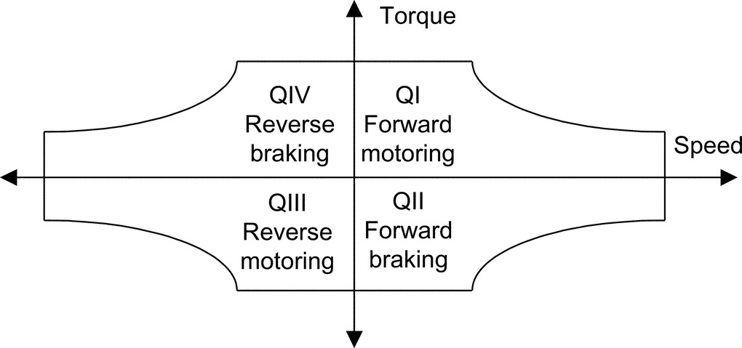

**FIGURE 29.2** Operating regions of electric VSD.

Positive power flow of electric energy means that electric power is drawn from the power supply via the power electronics converter by the motor, while negative power flow refers to electric power delivered by the motor in the generator mode to the power electronics converter. This could be regenerated back to the supply or dissipated as a heat in the dynamic brake dissipative mechanism.

For regenerative drive, the power electronics converter has to be designed to be able to handle bidirectional power flow. In low and medium power converter (say <500 kW) with slow dynamic braking demands, the generated power during the braking period is interchanged with the strong filter capacitor of power electronics converter, or DC (dynamic) braking is used.

#### **29.4.2.5 Dynamic Braking Energy**

There exist two types of energy stored in VSD, which need to be dealt with during dynamic braking:

• *Inertia or kinetic energy loads*: Typically moving (rotating or linear) machines. These would decelerate naturally to rest. Braking can speed up the process cycle for the sake of productivity.

• *Mass or potential energy loads*: Typically hoists or lifts—which would run on or even accelerate. Braking must apply full power to maintain constant speed while the load is lowered.

The drive losses, mechanical resistance, and the transmission efficiency, work in favor of deceleration, reducing the braking power demand. The energy regenerated by potential energy loads depends on maximum power and both the overrun time and the decelerating time.

The braking time and the duty cycle time are decided by the requirements of the process system, but note particularly the effect of varying the braking duty cycle time and the deceleration time.

For DC injection braking, the kinetic energy of the motor-load system is converted to heat in the motor rotor. For fast and frequent generator braking, the power electronics converter has to handle the generated power either by a controlled dynamic brake chopper (with braking resistor) or through bidirectional power flow. The power losses in the converter can assist in dynamic braking.

For a fast speed response, modern VSDs may develop a maximum transient torque up to the base speed and maximum transient power up to a maximum speed, provided that both the motor and the power electronics converter can handle these powers. For a 200 kW dynamometer drive application, a rapid change of torque from full positive torque to full negative torque is required in <10 ms.

## 29.5 VSD Topologies

In this section, drive topologies are classified according to the motor they employ. Various publications dealt with this subject, for example, Refs. [[3](https://learning.oreilly.com/library/view/power-electronics-handbook/9780128114087/B9780128114070000337.xhtml#bb0020),[5](https://learning.oreilly.com/library/view/power-electronics-handbook/9780128114087/B9780128114070000337.xhtml#bb0030)]. The most common motors are illustrated in [Fig. 29.3](https://learning.oreilly.com/library/view/power-electronics-handbook/9780128114087/B9780128114070000337.xhtml#f0020).

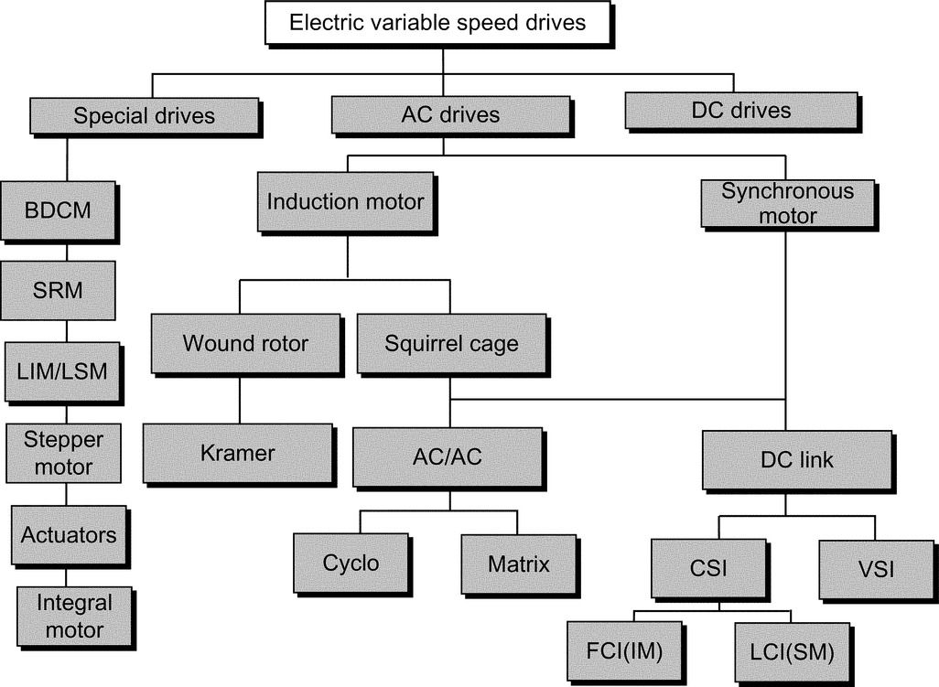

**FIGURE 29.3** Classification of electric VSD.

### 29.5.1 DC MOTOR DRIVES

Until recently, the DC motor drive was the most commonly used type of electric VSD, with only very few exceptions, and is the least expensive. The mechanical commutator is an electromechanical DC-to-AC bidirectional power flow power converter, as the currents in the rotor armature coils are AC while the brush current is DC. The DC drive is well-known, well proved, and widely applied; yet, its popularity is in relative decline due to the emergence of the more robust, lower cost squirrel-cage induction motor drive.

Unfortunately, the mechanical commutator though not bad in terms of losses and power density has serious commutation current and speed limits and thus limits the power per unit to 1–2 MW at 1000 rpm and may not be accepted at all in chemically aggressive or explosion-prone environments. The application of the DC drive has been restricted to hazardous areas due to the very limited availability of flameproof DC machines. Commutator and brush maintenance is difficult in such environments. Furthermore, continuous sparking at the brushes is virtually inevitable at full load output.

Due to the inherent ease of speed control of the separately excited DC machine, DC drives found popularity in early electric drive applications, by varying the applied armature voltage. This variable armature voltage is simply generated by phase-controlled rectification, and this technique has now almost entirely replaced the Ward-Leonard systems previously used.

The AC/DC converter offers a variable DC voltage, which is capable of four-quadrant operation (positive and negative DC voltage and DC current output). Permanent magnet-excited brushed motors have been used in numerous applications for some time, particularly in nonregenerative drive applications.

Motor output torque is approximately proportional to armature current, and motor speed is approximately proportional to converter output voltage. Speed control by sensing armature voltage is therefore feasible giving an accuracy of around 5%.

Provided the motor excitation is kept constant, the DC drive power factor is proportional to motor speed. Since most pumps, compressors, and fans demand a torque proportional to the square of speed, constant excitation systems are used and so the above relationship applies.

A typical power factor, at maximum rated speed for a DC drive, is 0.85. This relationship applies to many other types of electric drives.

If a slow dynamic response is satisfactory, regeneration to the mains supply is achieved either by reversing the motor field or armature connection. Alternatively, regeneration with faster response is achieved by connecting another thyristor bridge in antiparallel with the main bridge. In this case, fast response is possible with changeover time of <15 ms between full torque motoring to full torque regenerating. The 6-pulse drive configuration is acceptable for powers up to 1 MW. This limitation arises not from any semiconductor device limitation but is due to AC line current harmonics the converter generates.

A force-commutated or “chopper” converter for DC motors uses the principle of variable mark-space control using a thyristor or transistor solid-state switch. With a diode front-end converter, a fixed, smoother DC supply is derived from the mains by uncontrolled rectification and rapidly applied, removed, and reapplied to the machine for adjustable intervals, thus applying a variable mean DC voltage to the DC motor; refer to [Fig. 29.4B](https://learning.oreilly.com/library/view/power-electronics-handbook/9780128114087/B9780128114070000337.xhtml#f0025).

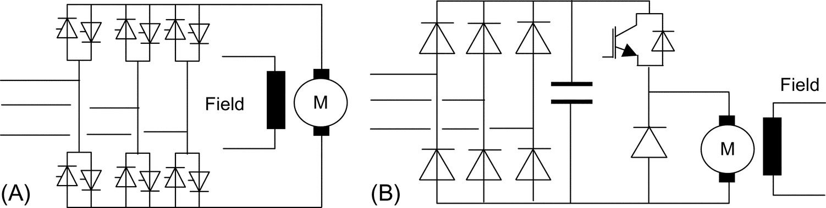

**FIGURE 29.4** DC drive: (A) with fully controlled antiparallel supply bridge and (B) diode rectifier with DC chopper.

This type of DC drive has the advantage of high (near unity) power factor at all motor speeds and much reduced harmonic spectrum.

### 29.5.2 INDUCTION MOTOR DRIVE

#### **29.5.2.1 Squirrel Cage Induction Motor**

Squirrel-cage induction motors are simpler in structure than DC motors and are most commonly used in the VSD industry. They are robust and reliable. They require little maintenance and are available at very competitive prices. They can be designed with totally enclosed motors to operate in dirty and explosive environments. Their initial cost is substantially less than that of commutator motors, and their efficiency is comparable. All these features make them attractive for use in industrial drives.

The three-stator windings develop a rotating magnetic flux rotating at synchronous speed. This speed depends on the motor pole number and supply frequency: the rotating flux intersects the rotor windings and induces an EMF in the rotor winding, which in turn results in circulating current. The rotor currents produce a second magnetic flux, which interacts with the stator flux to produce torque to accelerate the machine. As the rotor accelerates, the induced rotor voltage falls in magnitude and frequency until an equilibrium speed is reached. At this point, the induced rotor current is sufficient to produce the torque demanded by the load. The rotor speed is slightly lower than the synchronous speed by the slip frequency, typically 3%.

In order to ensure constant excitation of the machine, and to maximize torque production up to the base speed, the ratio of stator voltage to frequency needs to be kept approximately constant.

Induction motor drive has three distinct operating regions:

(a) *Constant torque*: The inverter voltage is controlled up to a maximum value limited by the supply voltage. As the motor speed and the voltage are increased in proportion, constant *V*/*F*, the rated flux linkage is maintained up to the base speed. Values of torque up to the maximum value can be produced at speeds up to about this base value. The maximum available torque is proportional to the square of the flux linkage. Typically, the induction motor is designed to provide a continuous torque rating of about 40%–50% of its maximum torque.

(b) *Constant power*: For higher speed, the frequency of the inverter can be increased, but the supply voltage has to be kept constant at the maximum value available in the supply. This causes the stator flux linkage to decrease in inverse proportion to the frequency. Constant power can be achieved up to the speed at which the peak torque available from the motor is just sufficient to reach the constant power curve. A constant power speed range of 2–2.5 can usually be achieved. Within this range, the motor frequency is increased until at maximum speed.

(c) *Machine limit (pullout torque)*: Once the machine limit has been reached, the torque falls off in proportion to the square of motor frequency. Operation at the higher end of this speed range may not be feasible as the motor power factor worsens. This in turn results in a higher stator current than the rated value. The motor heating may be excessive unless the duty factor is low.

Induction motors are used in applications requiring fast and precise control of torque, speed, and shaft position.

The control method widely used in this type of application is known as vector control, a transient response at least equivalent to that of a commutator motor can be achieved.

The voltage, current, and flux linkage variables in this circuit are space vectors from which the instantaneous values of the phase quantities can be obtained by projecting the space vector on three radial axes displaced 120 degrees from each other. The real and imaginary components of the space vectors are separated, resulting in separate direct and quadrature axis equivalent circuits but with equal parameters in the two axes.

Changes in the rotor flux linkage can be made to occur only relatively slowly because of the large value of the magnetizing inductance of the induction motor. Vector control is based on keeping the magnitude of the instantaneous magnetizing current space vector constant so that the rotor flux linkage remains constant. The motor is supplied from an inverter that provides an instantaneously controlled set of phase currents that combine to form the space vector, which is controlled to have constant magnitude to maintain constant rotor flux linkage. The second component is a space vector, which is in space quadrature with the instantaneous magnetizing current space vector. This component is instantaneously controlled to be proportional to the demand torque.

To the extent that the inverter can supply instantaneous stator currents meeting these two requirements, the motor is capable of responding without time delay to a demand for torque. This feature, combined with the relatively low inertia of the induction motor rotor, makes this drive attractive for high-performance control systems.

Vector control requires a means of measuring or estimating the instantaneous magnitude and angle of the space vector of the rotor flux linkage. Direct measurement is generally not feasible. Rapid advances are being made in devising control configurations that use measured electric terminal values for estimation.

#### **29.5.2.2 Slip-Ring (Wound-rotor) Induction Motor Drive**

Wound-rotor induction motors with three rotor slip rings have been used in adjustable speed drives for many years. In an induction motor, torque is equal to the power crossing the air gap divided by the synchronous mechanical speed. In early slip-ring induction motor drives, power was transferred through the motor to be dissipated in external resistances, connected to the slip-ring terminals of the rotor. This resulted in an inefficient drive over most of the speed ranges. More modern slip-ring drives use an inverter to recover the power from the rotor circuit, feeding it back to the supply system.

The speed of slip-ring induction motor can be controlled by the following:

• Stator frequency control as with a cage rotor machine.

• Rotor frequency control.

• Rotor resistance control.

• Slip energy recovery (Kramer system). For capital cost reasons, the last two are commonly used.

Addition of rotor resistance especially for starting large induction motors is well-known. The basic effect produced by adding rotor resistance is to alter the speed at which maximum motor torque is developed. Unfortunately, power dissipation as heat in the rotor resistance bank takes place; earlier means to overcome this shortcoming were to convert the rotor power to DC and feed a DC motor on the same shaft. The rotor slip energy, when running at reduced speed, is therefore reconverted to mechanical power. This is the “Kramer” system. The disadvantages of this approach were the extra maintenance and capital costs.

The static Kramer system overcomes these shortcomings by replacing the DC machine with a line-commutated inverter that returns the slip energy directly to the AC line, either directly (on lower power systems) or via a transformer. A key advantage of the Kramer drive system is that the slip-energy recovery equipment (DC machines or static inverter) needs only be rated for a fraction of the maximum motor rating. This is true when a small speed range is required and provided that a separate means is provided of starting the motor. This is because the motor rotor current is proportional to torque and the rotor voltage inversely proportional to speed.

Naturally, if the slip-energy recovery network can be rated to withstand full rotor voltage (developed at standstill), a controlled speed range of zero to maximum could be achieved. However, this is generally only feasible on smaller motors (below 2000 kW) where the rotor voltage is sufficiently low for an economic inverter package. Secondly, if a full speed range is needed, the slip-energy recovery network has to be rated at full motor power, so static Kramer drives become uneconomic for wide speed ranges. The overall system power factor would be very low for a wide speed range system.

For the above reasons, Kramer drives are very suitable for high-power drives (>200 kW) where a small speed range is required. Pump and fan drives present therefore good economic applications. Kramer drives have also been used for low-speed-range endurance dynos using the recovery system to control torque of induction generator. As with all line-commutated converters and inverters, current harmonics are produced, and these can be reduced to acceptable values. However, as the slip-energy recovery network is only power-rated in direct proportion to the speed reduction required (assuming constant load torque), the magnitudes of the harmonic currents generated are proportionally less than with drives where the solid-state converters have to handle the whole drive power. Harmonics of the rotor rectifiers are transmitted through the rotor and appear as noninteger harmonics in the main supply.

The main disadvantages of the slip-ring induction motor drive are (a) the increased cost of the motor in comparison with a squirrel cage, (b) the need for slip-ring maintenance, (c) difficulty in operating in hazardous environments, (d) the need for switchable start-up resistors, and (e) the poor power factor compared with other types of drive.

### 29.5.3 SYNCHRONOUS MOTOR DRIVES

To understand the way the synchronous machine operates, let us assume that the induction motor were to rotate at the synchronous speed by an external means. Under this condition, the frequency and magnitude of the rotor currents would become zero. If an external DC power supply were connected to the rotor winding, then the rotor would become polarized in a similar way to a permanent magnet. The rotor would pull into step with the air-gap-rotating magnetic field, generated by the stator but lagging it by a small constant angle referred to as the load angle. The load angle is proportional to the torque applied to the shaft, and the rotor keeps rotating at synchronous speed, provided that the DC supply is maintained to the rotor field winding. The magnetic flux produced by the rotor winding intersects the stator windings and generates a back EMF, which makes the synchronous motor significantly different from the induction motor.

As with the induction motor drive, the requirement is to keep the ratio *V*/*F* constant (i.e., varies both the stator frequency and applied voltages in proportion to the desired motor speed).

The supply bridge converter is phase-controlled generating an adjustable DC current in the DC link choke. To generate maximum torque from the synchronous motor, this current is switched into the motor stator windings at the correct phase position with respect to rotor angular position as detected by the position sensor by the inverter bridge. When running above about 10% speed, the back EMF generated by the synchronous motor is sufficient to commutate the current into the next arm of the inverter bridge. So, as this type of inverter is machine (motor)-commutated, the inverter configuration is merely that of a conventional DC drive. The complexity, expense, and limited power capability of the force-commutated circuitry is therefore avoided.

The motor back EMF is insufficient for thyristor commutation at low speeds. The technique here, therefore, is to rapidly phase back the supply converter bridge to reduce the DC link current to zero and after a short delay (to ensure that all thyristors in the machine bridge are turned off) reapply DC current when the correct thyristor trigger pattern has been reestablished. As the motor speed and thus back EMF increase to a value sufficient for machine commutation, changeover to continuous DC link current operation is effected.

During the starting mode, the correct inverter bridge firing instant is determined by rotor position sensor, which is mounted on the motor shaft whose angular position is detected by opto or magnetic probes. When in the machine-commutated mode, sensing of stator voltage is used. To develop maximum torque in the low speed or pulsed mode, angular rotor position sensing is necessary. However, if less than full load torque availability at low speed can be tolerated, the inverter system can be set to produce a low fixed frequency in the pulsed mode. This frequency is then increased, as motor rotation is detected (either in steps or on a preset ramp rate) until sufficient back EMF is generated to facilitate changeover to the voltage-sensing mode.

As previously stated, the key advantage of this type of drive is that all thyristor devices are line- or machine-commutated. Expensive and complex forced commutation circuitry is avoided, and fast turn-off thyristors are unnecessary. Inverter systems of this type can therefore be built at very high powers, up to 100 MW. Also, as a result of avoiding force commutation, converter efficiency is high.

The thyristors in the machine inverter bridge must be triggered at such an angle to give sufficient time for commutation from one device to the next. This results in the synchronous motor operating at a high leading power factor of around 0.85. However, as far as the mains supply is concerned, the total drive has the characteristics of a DC drive where power factor is proportional to speed.

Another important characteristic of this type of drive is that it is inherently reversible and regenerative. For regenerative operation, the inverter bridge is triggered in the fully advanced position, so in effect, it becomes a plain diode bridge. A DC output voltage, approximately proportional to motor speed, is therefore generated at the DC side of the supply converter bridge. This converter bridge is now triggered in the regenerative mode thus returning power to the supply system. Reversing operation is achieved by altering the sequence in which the thyristors in the inverter bridge are triggered.

This type of drive is widely applied over a wide power range as it embodies an efficient brushless motor and relatively simple and efficient converter. At lower powers, say below 30 kW, permanent-magnet synchronous motors are more common.

Unlike the induction motor, the synchronous type requires two types of converter: the first for main power conversion while the second is low power for field excitation. The field converter feeds the rotor exciter winding through slip rings and brushes, or alternatively, a brushless exciter can be used. A coordinated control of the two converters provides for active power and reactive power control and for efficient wide speed range control in high-power applications.

For high-power applications, synchronous motors are preferred because of the ability to control reactive power flow through appropriate control of excitation. Synchronous motors tend to have wider speed range and higher efficiency. However, synchronous motors are generally more expensive than induction motors.

With modern high-power PWM-VSI drives, synchronous motor can be driven for same inverter with vector control methods.

### 29.5.4 SPECIAL MOTORS

Motors under this category employ power electronics converters for normal operation. Generally, this type of motor has a large number of phases in order to limit torque pulsation and self-start from any rotor initial position. This is a new breed of motors, which can be fed through a unipolar or bipolar current. Also they have singly salient or doubly salient magnetic structures with or without permanent magnets on the rotor.

#### **29.5.4.1 Brushless DC Motor Drive**

This type of machine has a similar construction to a standard synchronous machine, but the rotor magnetic field is produced by permanent magnet material. A position sensor is used to ensure synchronism between the rotor position and the stator magnetomotive force (MMF) via drive signals to the inverter. The use of new magnet materials characterized by high coercive force levels has reduced magnet sizes and largely overcome the demagnetization problem. The absence of the field copper losses improves the machine efficiency.

As the permanent magnet is the source for excitation, the brushless DC motor (BDCM) can be viewed as a constant flux motor. A limited amount of flux weakening can be achieved by increasing the load angle of the stator current. Achieving a useful constant power range is not usually practical with this type of motor. A large demagnetizing component of stator current would be required to produce a significant reduction in magnet flux, and this would increase the stator loss substantially.

The required base torque determines the motor size, and the losses are essentially independent of the number of stator turns. At speeds up to the base speed of the constant power range, the efficiency of the motor is essentially the same as for one designed for rated voltage at base speed. For operation above base speed, the stator current from the inverter is reduced in inverse proportion to the speed. This mode of operation in the high-speed range reduces the dominant stator winding losses relative to a machine in which the flux is reduced and the current kept constant. The losses in the inverter are, however, increased due to its higher current rating. For an electric road vehicle that must carry its energy store, the net energy saving may be sufficiently valuable to overcome the additional cost of the larger inverter. A further advantage of this approach is that, if the DC supply to the inverter is lost, the open-circuit voltage applied to the inverter switches will be within their normal ratings.

The BDCM has higher volumetric power density compared with other types of motors (induction or synchronous). They are particularly suited for the high values of acceleration required in drives (e.g., machine tools). They are often operated with high acceleration for a short time followed by a longer period of low torque. At such low values of load factor, the cooling capability is frequently not a limitation. The major interest is in obtaining the maximum acceleration from the motor. The short-term stator current of a BDCM is limited to the value required for magnet protection. These values of acceleration are significantly higher than that can be achieved with either induction or DC motors of similar maximum torque rating.

#### **29.5.4.2 Switched Reluctance Motor Drive**

This motor can be regarded as a special case of a salient synchronous machine in which the field MMF is zero and the torque is produced by reluctance or saliency action only. The rotor has no winding. The switched reluctance motor (SRM) drive needs an inverter whose frequency is locked to the shaft speed, but since the torque is linearly proportional to the square of the stator current, the use of unidirectional current involves little sacrifice in performance.

Generally, the use of position sensors in the SRM and BDCM is something of a disadvantage in both cases. The SRM does not require permanent magnets, which can cost and may involve demagnetization risks and limit top speeds due to centrifugal forces. The SRM hence has a simpler construction and is more robust. However, the need to magnetize the motor from the AC side adds to inverter costs and may increase peak current levels significantly, hence raising stator copper losses.

Switched-reluctance synchronous motors have a cylindrical stator with three AC windings and a solid rotor (without any winding) with a moderate orthogonal axis magnetic saliency up to 4 (6) to 1. High magnetic saliency is obtained with multiple flux barriers. The conventional SRMs are to some extent (up to 100 kW) used in low-dynamics VSDs with open-loop speed control, as the speed does not decrease with load. Consequently, the control is simpler than with induction motors.

The main drawback of the conventional SRD is the low motor power factor and the relatively poor torque density, which leads to a higher kVA rating of the power converter (~20%). The main advantage of the synchronous reluctance motor over the induction motor of similar rating is the higher efficiency. Compared with the squirrel-cage induction motor, the rotor loss is small or negligible in synchronous reluctance machines. If the saliency ratio is sufficient to produce a power factor equal to that of the induction motor, the stator winding loss will be the same. Also, the stator iron losses will be similar for the two motors.

The reluctance motor is capable of operation in the constant power mode of operation. As for all AC drives, when the supply voltage limit is reached above the base speed, the flux linkage is reduced in inverse proportion to the shaft speed, and the torque is inversely proportional to speed squared.

#### **29.5.4.3 Linear Motors**

There are applications in which linear motion, as opposed to rotational, is required. A linear machine has the same operating principles as those applied to all other rotating machines. The PWM-VSI converters and motor control principles discussed in this chapter are also applicable to this type of motor.

There are two types of linear motors:

• LIM—linear induction motor

• LSM—linear synchronous motor with permanent magnetic excitation

The LSM type has the following advantages over the LIM:

• Better power factor

• More responsive control

• Higher efficiency

The disadvantages of LSM are the following:

• Very accurate position feedback is required.

• The use of PM—expensive and heavy.

Transport, material handling, and extrusion processes are a few examples in which linear motors have successfully been employed.

#### **29.5.4.4 Stepper Motors**

Stepper motors are either built in a similar manner to BDCM, with permanent magnets embedded in or bonded to the rotor or a rotor with no magnets. The latter type is made of a ferrite magnetic material, and its circumference is cut to form a number of slots, forming teeth lengthwise to the rotor axis.

Torque production can be based on (a) magnetic reluctance (as in SRM), (b) magnetic attraction (as in BDCM), or (c) both magnetic reluctance and attraction.

Stepper drives do not offer dynamic speed control, and the main action is to accelerate at full torque to full speed, maintain the speed, and decelerate at full torque. In comparison with the reluctance-type stepper motor, the permanent magnet type offers greater torque for a given speed, particularly at start and low speeds.

Most drives incorporate controllers with connections for a communications link for supervisory control by PLC, hard-wiring connectors for analog/digital inputs and outputs, and some are equipped with software for communications with a computer or handheld keypad. [Table 29.12](https://learning.oreilly.com/library/view/power-electronics-handbook/9780128114087/B9780128114070000337.xhtml#t0065) lists typical options.

**Table 29.12**

**Control features for servo and stepper motor drives (Ref. [**[**6**](https://learning.oreilly.com/library/view/power-electronics-handbook/9780128114087/B9780128114070000337.xhtml#bb0035)**])**

|  |  |  |
| --- | --- | --- |
| **Control features** | **Servo drive** | **Stepper drive** |
| Acceleration/deceleration time | Adjustable | Accelerate at maximum torque, time is dependent on maximum torque and inertia |
| Maximum speed | Part of the motor specification | Part of the motor specification |
| Speed control | Permit a range of speed settings | Not necessarily available |
| Torque control | Many offer speed and torque control | Always operate at maximum torque |
| Auto-tuning | A feature of some servo drive | Not applicable |
| Reversing | Commonly available by digital control signal | Commonly available by digital control signal |
| Zero speed clamp | Applies full torque to hold the position constant | Applies full torque to hold the position constant |
| Dynamic braking | Controlled deceleration, may require dissipative brake resistor | Usually standard |
| Regenerative braking | Dedicated circuit for controlled braking | Not applicable |
| Travel limits | Definition of travel limits in the forward and reverse directions | Standard |
| Jog or inch | Digital command to “jog” one step (with defined distance) | Optional feature |
| Closed-loop configuration | Most drives accept external signals for closed-loop control | Most drives accept external signals for closed-loop control |
| Programming functions | Many drives incorporate programming functions as in PLCs, reset all functions to default states, return to a home position, enable or disable repetition or a preset sequence, select a particular set of control inputs, increased or decreased speed, change the torque boost, etc. | |

Unlike above motor drives, the stepper motor can achieve precise position control without the need for any external feedback.

#### **29.5.4.5 Actuators**

Actuators are widely used in industry, primarily for positioning tasks. Their designs are based on all sorts of force-producing principles. Ref. [[7](https://learning.oreilly.com/library/view/power-electronics-handbook/9780128114087/B9780128114070000337.xhtml#bb0040)] describes several types of direct drive electric actuators, including (a) the DC actuator (moving coil type), (b) induction actuators, (c) synchronous actuators (moving magnet DC type), (d) reluctance actuators, and (e) inductor actuators (polarized reluctance type).

Electric actuators are used increasingly in control systems and automated electromechanical equipment. Typical specification factors include range of motion, type of motion (linear or rotary and stepwise or continuous), resolution needs, speed of response, environmental conditions, supply conditions, allowable electromagnetic noise emission level, need for integrated position and velocity sensors, maintenance needs, eligibility, cost, peak, and continuous torque.

The main demands of industry for high-performance systems are the following:

(a) A convenient supply and low power consumption

(b) Reliability and robustness

(c) Low initial cost and maintenance

(d) Fast response

(e) Linear “torque-excitation” characteristics

#### **29.5.4.6 Integrated Motors**

The integral motor consists of a standard AC motor with an integrated frequency inverter and EMC filter. It is robust and specified for reliable operation and often designed to handle rough working conditions, including ambient temperature −25°C to −40°C and dusty, corrosive, and humid environments (enclosure IP55). This type of drive uses a standard induction motor with the AC/AC converter integrated in the motor frame often as a separate converter box mounted directly above the motor frame in place of the terminal box. The power popularity of this type of drive is limited to 0.5–7.5 kW.

This type of motor offers the following advantages:

• Save space by eliminating the need for a separate controller

• Reduce installed costs because cabling between motor and converter is eliminated

• Eliminate motor problems caused by high voltage transient due to output cable capacitance

• Minimize EMC due to high *dV*/*dt*

The integrated drive includes most features including start, stop, forward, reverse, speed and torque controls, and controlled acceleration and deceleration.

## 29.6 PWM-VSI DRIVE

In recent years, the popularity of PWM-VSI has increased beyond recognition. Its dynamic performance and controllability is better than the DC drive. Its power range has extended to areas dominated for years by traditional solutions such as the cycloconverter and LCI drives.

### 29.6.1 DRIVE COMPARISON

[Table 29.13](https://learning.oreilly.com/library/view/power-electronics-handbook/9780128114087/B9780128114070000337.xhtml#t0070) shows a direct comparison between the cycloconverter, LCI, and PWM-VSI drives. The DC drive and the slip-power recovery converter type are not listed because AC drives have already replaced DC drives in most applications due to low maintenance and better reliability of AC motors. Slip recovery is only suitable for applications with a limited speed range and requires a slip-ring wound rotor.

**Table 29.13**

**Drive comparison**

|  |  |  |  |  |
| --- | --- | --- | --- | --- |
| **Control features** | **Cyclo** | **LCI** | **PWM-VSI** | **Matrix** |
| Speed | Limited | Wide | Wide | Wide |
| Dynamic response | Excellent | Good | Excellent | Excellent |
| Torque pulsation | Low | High | Very low | Very good |
| Power factor at low speed | Poor | Poor | Very good | Very good |
| Stability | Good | Moderate | Very good | Very good |
| Motor | Custom | Custom | Standard | Standard[a](https://learning.oreilly.com/library/view/power-electronics-handbook/9780128114087/B9780128114070000337.xhtml#tf0010) |
| Regeneration | Inherent | Inherent | Needs extra hardware | Inherent |
| Volumetric power density | Moderate | Good | Very good | Excellent |

[a](https://learning.oreilly.com/library/view/power-electronics-handbook/9780128114087/B9780128114070000337.xhtml#xtf0010) The AC output voltage of the matrix converter is always less than the input voltage—derating is expected, or a larger frame size is required.

In comparison with the cycloconverter and LCI current-source converter drives, the PWM-VSI drive offers the following advantages:

• Excellent dynamic response

• Smooth torque/speed control over full speed range (0–200 Hz)

• High volumetric power density

• Ride through of dips in supply voltage

• Use of standard motors (squirrel-cage induction motor or synchronous motor)

• Improved AC supply power factor over full speed range

• Reduced cabling and transformer size and cost in comparison with cycloconverters

• No significant torque pulsation

• Lower noise level

• Low maintenance

### 29.6.2 MEDIUM VOLTAGE PWM-VSI

The maximum power rating of LV VSD is limited by practical current ratings of power components such as motor, cable, and transformer (typically 1500 A), giving a limit of about 2 MVA at 600 V. At this rating, motor manufacturers always prefer an MV machine design—significant saving and improved thermal performance of power components can be achieved by operating at medium voltages instead of low voltages. Many VSD applications will benefit from the availability of economic MV alternatives.

When adequately rated high blocking voltage devices are available, a simple two-level inverter or alternatively three-level neutral-point clamp (NPC) has always been the choice to meet required output voltages. These topologies offer a simple and cost-effective solution.

Series connection of power devices is the traditional solution for high-power high-voltage thyristor-based drives. This approach is perceived to be complex with fast-switching IGBTs because of simultaneous switching and correct static and dynamic voltage sharing of series devices.

The “multilevel” inverter drive is seen to offer a better solution for high-power, high-voltage inverter drive. The output waveform is high quality, even at very high modulation frequencies, which inherently results in lower harmonic content in the output voltage waveform (less losses, less torque pulsation, and lower insulation voltage stresses).

Ref. [[8](https://learning.oreilly.com/library/view/power-electronics-handbook/9780128114087/B9780128114070000337.xhtml#bb0045)] and [Fig. 29.5](https://learning.oreilly.com/library/view/power-electronics-handbook/9780128114087/B9780128114070000337.xhtml#f0030) categorize MV converter topologies as follows:

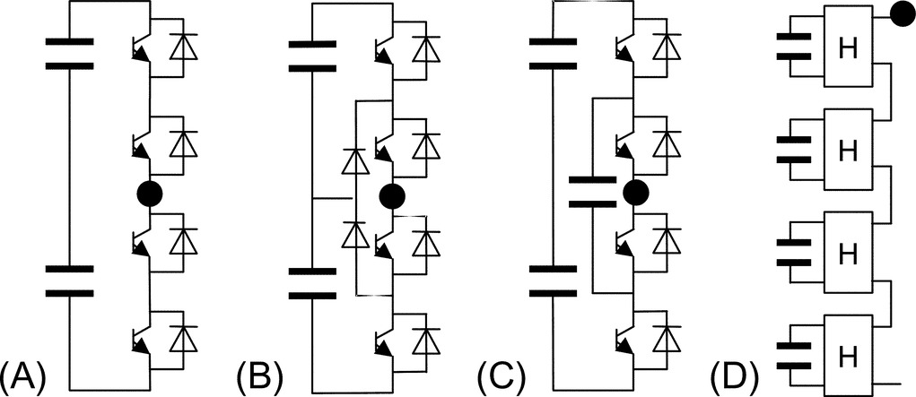

**FIGURE 29.5** MV stack topologies.

(A) Series-connected two level (SC2L)

(B) Three-level neutral-point clamp (3LNPC)

(C) Multilevel: diode-clamped multilevel (DCML) and capacitor-clamped multilevel (CCML)

(D) Isolated series H-bridge (ISHB) ([Table 29.14](https://learning.oreilly.com/library/view/power-electronics-handbook/9780128114087/B9780128114070000337.xhtml#t0075))

**Table 29.14**

**Comparison between different MV converter stack topologies**

|  |  |  |
| --- | --- | --- |
| **Topologies** | **Advantages** | **Disadvantages** |
| Two-level with series devices (SC2L) | • Simple and proved technology  • Same converter design over supply voltage range  • Standard fully developed PWM control  • Provision for series redundancy of power switches per inverter phase arm (*n*+1) | • Static and dynamic voltage sharing of series devices  • High *dV/dt* due to synchronous commutation of series devices  • High switching frequency harmonic content in inverter output voltage |
| Three-level NPC (3LNPC) | • Well proved  • Reduced harmonic content  • Better utilization of switches  • Reduced *dV/dt* (half the SC2L equivalent) | • Series redundancy is difficult to achieve  • More complex PWM control is needed than two level  • Requires extra clamping diodes  • Requires split DC link  • Requires midpoint voltage balance control  • Even number of power devices per arm is always needed  • Switches require snubbers |
| Diode-clamped multilevel (DCML) | • Reduced harmonic contents  • Reduced *dV/dt* | • Series redundancy is very difficult to achieve  • Very complex PWM control is needed  • Requires many steering diodes  • Requires split DC link  • Requires voltage balance control of split DC link capacitors  • Uneven current stresses on power devices  • Requires snubbers |
| Capacitor-clamped multilevel (CCML) | • This configuration has all the advantages of a multilevel converter plus simpler arrangement, modular building block  • Less components  • Snubberless operation is possible  • Easier capacitor voltage balance than 3LNPC | • Possible parasitic resonance between decoupling capacitors  • Complex to provide series redundancy  • More complex PWM control strategy than for two level  • Voltage redistribution of capacitors during supply voltage surges  • Too many capacitors (bulky stack design and poor capacitor utilization at high ratings)  • Complex converter arrangement (for low stray inductance)  • Inverter rating is limited by the load current flowing through the capacitors |
| Series-connected isolated H-bridges (ISHB) | • Modular design of the converter power modules  • The basic building block is based on a DC supply bridge, decoupling capacitor, and an H-bridge arrangement  • In the AC supply, the combined diode bridge rectifiers act like a multipulse bridge (18p for four level and 24p for five level), reducing harmonic injection into the AC supply.  • Its output has very low harmonic contents in spite of the low switching frequency | • Employs a special (bulky and expensive) transformer  • Complex to achieve series redundancy  • Different supply transformer designs are required for applications operating at different AC line voltages  • Power pulsation for poor power factor loading  • Poor utilization of capacitors  • Not suitable for common DC bus applications  • Dynamic braking is difficult |

### 29.6.3 CONTROL STRATEGIES

Several control techniques can be found in the VSD industry; refer to [Fig. 29.6](https://learning.oreilly.com/library/view/power-electronics-handbook/9780128114087/B9780128114070000337.xhtml#f0035). These are the following:

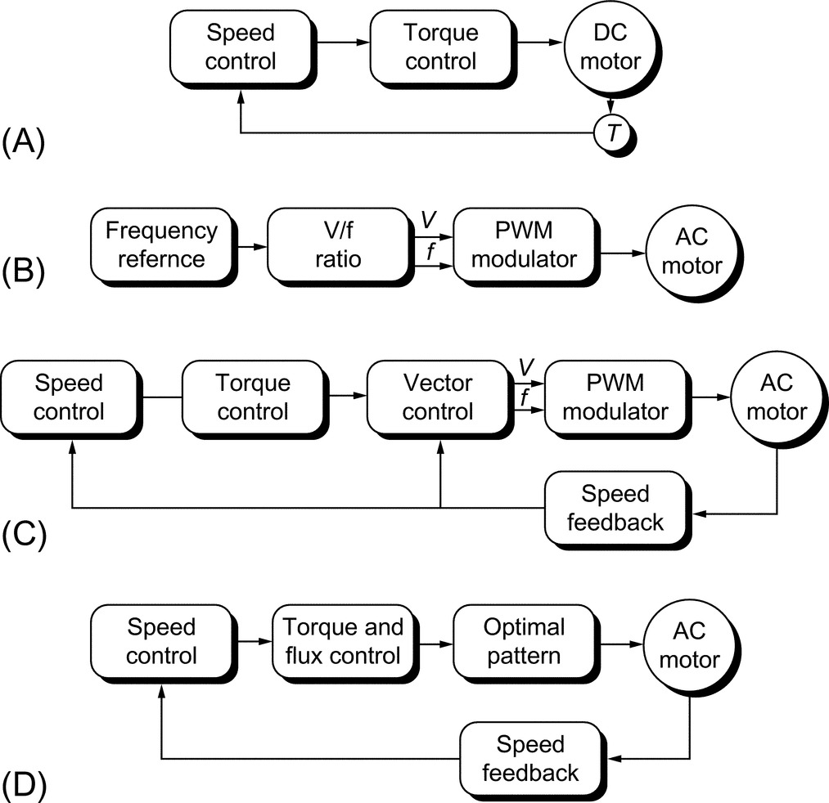

**FIGURE 29.6** Electric drive control techniques. (A) DC drive, (B) frequency control (PWM scalar control), (C) flux vector control (field-oriented control), and (D) direct torque control.

• Open-loop inverter with fixed V/Hz control

• Open-loop inverter with flux vector control

• Closed-loop inverter with flux vector control (induction motor)

[Table 29.15](https://learning.oreilly.com/library/view/power-electronics-handbook/9780128114087/B9780128114070000337.xhtml#t0080) summarizes the main features, advantages, and disadvantages of each technique.

**Table 29.15**

**Comparison between various control methods used in VSD**

|  |  |  |  |  |
| --- | --- | --- | --- | --- |
| **Drive type** | **DC drive** | | **AC drive** | |
| Control method | • Field oriented | • Frequency control | • Flux vector control | • Direct torque control |
| Features | • Field orientation via mechanical commutator  • Controlling variables are armature current and field current  • Torque control is direct  • Typical response 10–20 ms | • Voltage and frequency control  • Simulation of variable speed drive using modulator  • Flux provided with a constant *V*/*F* ratio  • Open-loop drive  • Load dictate torque level  • Typical torque dynamic response 100 ms | • Field-oriented control—similar to DC drive  • Motor electric characteristics are modeled (observer)  • Closed-loop drive  • Torque controlled indirectly  • Typical torque dynamic response 10–20 ms | • Use advance control theory  • Controlled variables are magnetizing flux and motor control  • Typical torque dynamic response is <5 ms |
| Advantages | • Accurate and fast torque control  • High dynamic speed response  • Simple to control | • Low cost  • No feedback devices are required  • Simple | • Good torque response  • Accurate speed control  • Full torque at zero speed  • Performance approaching DC drive | • Simple  • No feedback requirements  • No need for an observer |
| Disadvantages | • Reduced motor reliability  • Regular maintenance  • Motor costly to purchase  • Needs encoder for feedback | • Field orientation not used  • Motor status ignored  • Torque is not controllable  • Delaying modulator used | • Feedback is needed  • Costly  • Modulator is needed |  |

### 29.6.4 COMMUNICATION IN VSDS

The use of a high-speed advanced digital communication (fieldbus) to build industrial automation system for real-time control or simply for data logging has become well established in modern industries. Digital communication resulted in replacing wiring looms with a digital serial network; this resulted in a lower cost installation and a more reliable solution. Over the last few years, many industrial fieldbuses emerged, and end users, system integrators, and original equipment manufacturers (OEMs) chose the optimum system for their applications.

A fieldbus is a digital communication system that allows a control system to exchange data with remote sensors, actuators, and drives using a single communication link. The major benefits seen are (a) reduced installation and cabling cost and better overall immunity of the system. Both factors result in a more reliable operation and reduced maintenance costs.

There exist two main types of network:

(a) Centralized network—requires a network master controller, typically a PLC. The master device is entirely responsible for controlling communications over the network, while the slave devices tend to be “dumb” devices with no local intelligence.

(b) Decentralized network—which requires some local intelligence at each node but no overall master device. This is ideal for real-time application environment, as all nodes are effectively running in parallel.

Most modern VSDs are equipped with hardware and software, which enable local and remote communication with plant automated system via a fieldbus system. The most popular fieldbuses are Profibus, Interbus, Ctnet, Sercos, Worldfib, and DeviceNet.

### 29.6.5 PWM TECHNIQUES

Different PWM techniques have been employed in PWM-VSD converters. [Fig. 29.7](https://learning.oreilly.com/library/view/power-electronics-handbook/9780128114087/B9780128114070000337.xhtml#f0040) identifies the most commonly used techniques.

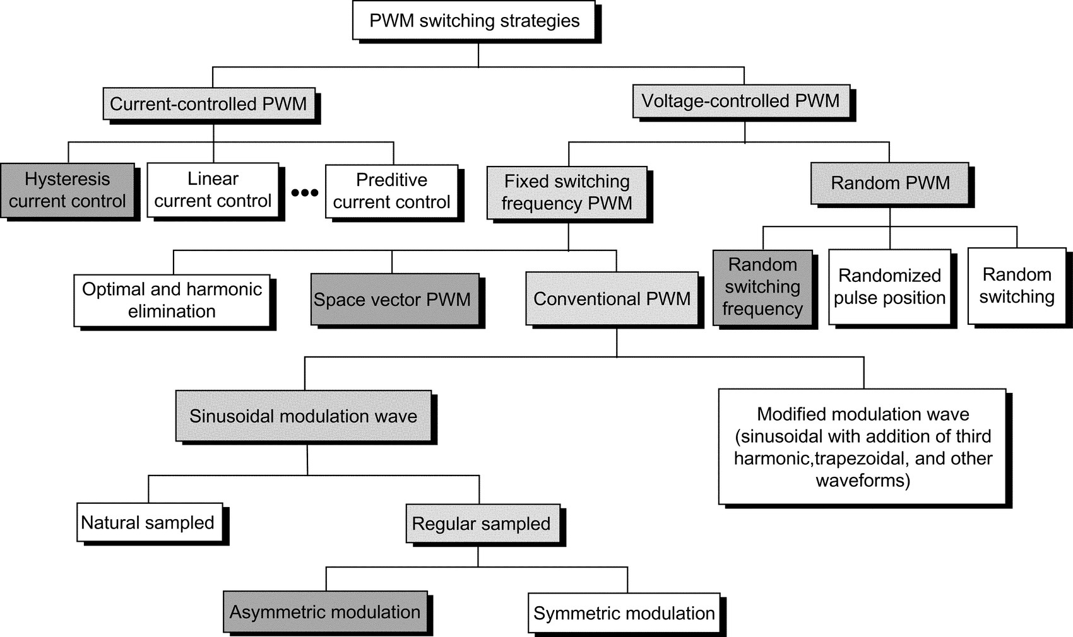

**FIGURE 29.7** Classifications of PWM techniques.

### 29.6.6 IMPACT OF PWM WAVEFORM

#### **29.6.6.1 PWM Voltage Waveform**

Fast switching of IGBTs (typically <1 μs) results in high *dV/dt*, typically 3–5 kV/μs, and possible voltage overshoot at turn-off that can last for a few microseconds. The fast rate of rise/fall of voltage combined with high peak voltage at the turn-off results in a premature failure of motors and EMC. Refs. [[9](https://learning.oreilly.com/library/view/power-electronics-handbook/9780128114087/B9780128114070000337.xhtml#bb0050)–[11](https://learning.oreilly.com/library/view/power-electronics-handbook/9780128114087/B9780128114070000337.xhtml#bb0060)] deal with the effect of PWM waveforms of VSD.

The following is a brief summary of the effect of the unfiltered waveforms.

#### **29.6.6.2 Effect on Motor**

• Premature insulation failure due to partial discharge as a result of peak voltage, high *dV/dt*, and high frequency.

• Motor shaft voltage that forces current into the shaft bearing, leading to early bearing failure.

• Motor stray capacitance (between windings and earthed frame) leads to earth-current flow caused by high *dV/dt*.

• High *dV/dt* creates nonuniform distribution of voltage across the winding, with high voltage drop across the first few turns and consequential failures.

• In a large motor, voltage differential on the frame is likely to develop in spite of protective earthing of the motor. More than one earthing point is needed.

#### **29.6.6.3 Effect on Cables**

• Voltage-doubling effect at the rising/falling edges of voltage waveform due to wave propagation in long cables [[9](https://learning.oreilly.com/library/view/power-electronics-handbook/9780128114087/B9780128114070000337.xhtml#bb0050)].

• Earth-current flows in cable stray capacitance due to *dV/dt*.

• Restriction on cable type used and earthing methods employed.

• Cable type (armored, screen, and multicore).

• Likelihood of cross talk with other surrounding cables running in parallel.

• For PWM drives, the cost of cabling is likely to be significant due to special requirements of cables and termination methods employed.

#### **29.6.6.4 Effect on EMC/Insulation/Earthing**

• Inductive and capacitive couplings between live components and earth result in common-mode and differential-mode noise. This could lead to malfunctioning of nearby sensitive equipment.

• The voltage to earth applied on drive components pulsates at the switching frequency, adding voltage stresses (worst at low speeds and low modulation index). This poses additional insulation requirements on main power components (motor, cable, output filter, and transformer).

• A fourth wire may be required between the motor frame and the converter virtual earth so that a low impedance path is provided for the motor earth current.

• Strict rules must be observed when cabling and earthing.

#### **29.6.6.5 Motor Insulation**

High peak voltages can be experienced at the motor terminals especially when long cable is employed (10–100 m depending on the size of motor). This is usually caused by voltage-doubling phenomena of a transmission line with unequal line and load impedance. Motor line voltage can reach twice the DC link voltage with long cables.

Fast voltage rise times of 5000 V/μs can be measured at the motor terminals. Under this condition, the motor insulation becomes stressed and can lead to a premature breakdown of a standard motor insulation. When motor fails due to insulation stress caused by high peak voltage and fast voltage rise times, failure occurs in the first turn as phase-to-phase short or phase-to-stator short. The highest voltage is normally seen by the first turn of the winding.

Standard motor capabilities, established by the National Electrical Manufacturers Association (NEMA) and expressed in the MG-I standard (part 30), indicate that standard NEMA type B motors can withstand 1000 V peak at a minimum rise time of 2 μs (500 V/μs). Ref. [[10](https://learning.oreilly.com/library/view/power-electronics-handbook/9780128114087/B9780128114070000337.xhtml#bb0055)] describes the effect of PWM inverter waveform on motor insulation in more detail.

##### **Partial discharge**

The phenomena that starts deterioration of the motor insulation is called partial discharge (PD). When electric stresses in insulation voids exceed the breakdown voltage of the air, a partial discharge occurs. Successive PDs destroy the insulation slowly.

##### **Voltage strength between phase to phase and phase to frame**

Both NEMA and IEC are proposing (a) maximum 1000 V at rise time <2 μs and (b) a maximum rate of rise of 500 V/μs. It is believed that low-voltage standard motors can withstand a lot larger voltage stresses than specified by NEMA and IEC, possibly up to 1300 V, almost regardless of the rise time.

##### **Voltage strength between turn to turn**

In low-voltage AC motors, the conductor insulation is designed for 245 V RMS (350 V peak). The insulation strength is however higher depending on the impregnation method.

#### **29.6.6.6 Bearing Current**

Bearing current and shaft voltages under 50/60 Hz sine-wave operation has been recognized since 1924. The bearing impedance characteristics largely determine the resulting bearing current that will flow for a given shaft voltage [[11](https://learning.oreilly.com/library/view/power-electronics-handbook/9780128114087/B9780128114070000337.xhtml#bb0060)].

The rotating machines have three basic sources of shaft voltage. These are the following:

• Electromagnetic induction from the stator winding to the rotor shaft (due to small asymmetries of the magnetic field in the air gap that is inherent in a practical machine design). The design limit is <1 V RMS.

• Electrostatic coupled from internal sources: such as voltage in motors where rotor charge accumulation may occur (belt-driven coupling and ionized air passing over rotor fan blades).

• Electrostatic coupled from external sources such as PWM inverter. The presence of high *dV/dt* across the stator neutral to frame ground causes a portion of the voltage to ground due to capacitor divider action. The presence of PWM-related voltage components is undesirable and leads to a premature bearing failure.

• The fundamental cause of the shaft voltage is magnetic asymmetry between the stator and the rotor or possibly a phase shift of the motor voltage waveform. System ground may also contribute to this condition through unbalance system voltage.

• NEMA-500 recommends the consideration of insulated bearing for motor frame of certain sizes.

#### **29.6.6.7 Electromagnetic Compatibility**

The main sources of electromagnetic emission of PWM-VSI drives are described in [[12](https://learning.oreilly.com/library/view/power-electronics-handbook/9780128114087/B9780128114070000337.xhtml#bb0065)] as follows:

*AC/DC converter*: Supply harmonics caused by supply bridge rectifier (from 100 Hz to 2.5 kHz): as already explained, the input bridge circuit with an SCR or diode bridge is a source of supply harmonics in the input current.

*DC/AC inverter*: Harmonics caused by the switching of the inverter bridge (from 3 kHz to 20 MHz): the inverter bridge uses fast-switching devices to create PWM voltage output. The inverter is a source of a wide band of frequencies, typically extending from the basic switching frequency (usually several kilohertz) to the radio high-frequency bands at 20 MHz. The radio frequency current spreads out into both the supply and motor connections. An EMC filter is often used to limit the spread of high-frequency harmonics into the supply.

*Control electronics*: The control circuit employs a microprocessor with clock frequency of several megahertz, typically 20 MHz. The clock wave produces frequencies, which are multiple of 20 MHz up to 300 MHz ([Table 29.16](https://learning.oreilly.com/library/view/power-electronics-handbook/9780128114087/B9780128114070000337.xhtml#t0085)).

**Table 29.16**

**An overview of techniques used as a counter measure to EMI**

|  |  |  |  |
| --- | --- | --- | --- |
| **Effect** | **Frequency range (*f*)** | **Counter measure** | |
| **At source** | **At load** |
| Mains | ≤100 Hz | • Avoid circulating currents | • Balanced signal circuits  • Avoid earth loops in signal paths  • Screening (electric field only) |
| Mains harmonics | 100<*f*≤2.5 kHz | • Line and/or DC link reactor on rectifiers.  • Higher pulse number rectifier (e.g., 12, 18, or 24)  • Low impedance supply  • Harmonic filters | • Balanced signal circuits  • Avoid earth loops in signal paths  • Filtering |
| Intermediate | 2.5<*f*≤150 kHz | • Filters | • Filtering  • Screening  • Balanced signal circuits |
| Low frequency | 150 kHz<*f*≤30 MHz | • Filters—one per apparatus  • Cable screening | • Filtering  • Screening |
| High frequency | 30 MHz<*f*≤1 GHz | • Screening  • Internal filtering | • Screening |

### 29.6.7 TECHNIQUES USED TO REDUCE THE EFFECT OF PMP VOLTAGE WAVEFORM

#### **29.6.7.1 Output Line Reactor**

A reactor increases the rise time, but the benefit of its connection may be negated as follows:

• Beneficial connection if cable length is short enough for reflections to be superimposed within rise time, that is, if rise time is increased beyond critical value of cable length.

• Harmful connection if cable length is too long; the reactor may have negligible effect on peak voltage (theoretically, its presence is insignificant in this case) or ringing period, but it will increase the duration of each overshoot, thus increasing the probability of partial discharge.

Adding a series line reactor between the motor and inverter is not as simple as illustrated above because the reactor adds or adjusts other resonant modes where the reactor rings with lumped capacitance. These resonant modes are pure transmission line modes and can double voltage. Some line inductance helps short-circuit protection. If earth current is limited by other means, then the coupled reactors may be helpful.

#### **29.6.7.2 Sine-Wave Filter**

This mechanism filters the PWM carrier frequency; thus, the converter output voltages are sinusoidal. This type of filter is best suited for low-performance drives and/or retrofit applications (old or standard motors). Ref. [[13](https://learning.oreilly.com/library/view/power-electronics-handbook/9780128114087/B9780128114070000337.xhtml#bb0070)] and [Table 29.17](https://learning.oreilly.com/library/view/power-electronics-handbook/9780128114087/B9780128114070000337.xhtml#t0090) illustrate the filtering options for high-power VSDs.

**Table 29.17**

**Filtering options for PWM-VSI drives (Ref. [**[**13**](https://learning.oreilly.com/library/view/power-electronics-handbook/9780128114087/B9780128114070000337.xhtml#bb0070)**])**

|  |  |  |  |
| --- | --- | --- | --- |
| **Option** | **No filter** | ***dV/dt* filter** | **Sine-wave filter** |
| Motor *dV*/*dt* | High | Acceptable | Low |
| Motor insulation | Must be increased | Normal | Normal |
| EMC ground noise | Very high | Low | Very low |
| PWM carrier at motor | 100% | 100% | Very low |
| Motor audible noise | Higher | Decreased a little | Minimum |
| Motor derating | Approx. 13% | Approx. 3% | 0% |
| Torque response | Fast | Fast | Suits most applications |
| Motor cost | Typically +10% cost | Normally no extra cost | No extra cost |
| Conclusions | Impractical | Suitable only for high dynamic torque response | Best choice for most drives |

Employing a filter at the inverter output has some practical consequences:

• Cost and weight of filter

• Filter power losses and voltage drop

• A small derating of power switches due to circulating current between filter *L*, *C*, and DC link capacitor

• Reduced torque response due to time delay in the filter, sine-wave type

• Potential oscillations that have to be electronically dampened

• Potential induction motor self-excitation

#### **29.6.7.3 PWM (*dV/dt*) Filter**

This reduces the *dV/dt* seen by the motor to a level, which does not compromise the motor or EMC. It is ideal for high-performance drives with custom-built motors.

#### **29.6.7.4 RC Filter at Motor Terminals**

A simple RC network is used at the motor terminal; the capacitor would represent a short circuit for the high-frequency components (sharp *dV/dt*). Wave reflection will not happen if the resistor value is similar to the cable characteristic impedance. Resistor losses are generally small, as current flow will only occur at the rising and falling edges of the PWM waveform.

#### **29.6.7.5 Common Mode Reactor**

The presence of capacitive current due to the high *dV/dt* can be improved by employing a common-mode reactor. It is well established that such a choke is not effective to reduce the RMS and mean values of the leakage current but only effective to reduce the peak value. The presence of such a choke in the circuit increases the inductance and resistance of the zero sequence impedance.

### 29.6.8 SUPPLY FRONT-END FOR PWM-VSI DRIVES

There are many types of PWM voltage-source drive depending on the supply front-end type and regenerative technique employed ([Table 29.18](https://learning.oreilly.com/library/view/power-electronics-handbook/9780128114087/B9780128114070000337.xhtml#t0095)):

**Table 29.18**

**Types of supply front-end bridges of PWM-VSI drives**

|  |  |  |  |  |  |
| --- | --- | --- | --- | --- | --- |
| **Type** | **Power device** | **Motor speed reversal** | **Regenerative capability** | **Regenerative with AC supply loss** | **Comment** |
| I | Diode | Yes | No | No | • Good power factor across speed range  • Needs precharge circuit  • The lack of protection |
| II | Diode | Yes | Dissipative | Yes | • Ditto |
| III | SCR | Yes | No | No | • Power factor is function of speed  • Fully controlled DC link  • Phase back when (a) supply voltage rises, (b) fault on DC bus side  • Needs gate drivers for SCRs |
| IV | SCR | Yes | Dissipative | Yes | • Ditto |
| V | SCR | Yes | Regenerative into supply | No | • Ditto |
| VI | Forced commutated devices (e.g., IGBT/IGCT) | Yes | Regenerative into supply | No | • Can operate with controlled power factor (unity, lagging, leading)  • High-frequency harmonics  • DC link voltage higher than the crest of the supply voltage  • Fully controlled DC link, even during a supply dip  • Output voltage equals to input voltage  • Requires a precharge circuit |

(i) PWM-VSI with a diode supply front end

(ii) As above but with a dynamic brake chopper

(iii) Fully controlled thyristor front end

(iv) As above but with a dynamic brake chopper

(v) Fully controlled antiparallel thyristor supply bridge

(vi) PWM supply front end

The use of a higher pulse number than 6-pulse would necessitate the use of a supply transformer. This is always considered to be an unnecessary “evil” because of additional cost, losses, and the need for extra space to accommodate this component. For MV applications, this is considered to be a necessity for isolation and protection.

#### **29.6.8.1 Regenerative Braking**

Several techniques are usually used for regenerative braking.

A simple diode front-end supply bridge will operate in two quadrants (positive and negative speeds). There is no regenerative power capability as any regeneration of power would result in an increase in the DC link voltage, and the drive will trip on overvoltage.

If a small amount of regeneration is required, during stopping, or speed reversal, then a dynamic brake chopper may be used. This is a simple chopper with a dynamic brake resistor. The size of the resistor is very much dependent on the regenerative brake energy, its magnitude, and repetition rate.

Full power regeneration is possible by employing a fully controlled antiparallel thyristor front end. This is similar to that used on DC drives or cycloconverters.

A more modern approach is to use pulse converter front end (fully controlled bridge). This is a four-quadrant converter with the ability to control the power factor and the DC link. Such an option necessitates the use of a precharge circuit for the DC link and smoothing inductance on the AC side.

For fully regenerative drives, the supply needs to be receptive.

By using a PWM rectifier as a primary converter in this composite structure, both the problems of regeneration and line current distortion are successfully solved—with the penalty of having a much more complicated converter structure and control system.

With the modern PWM-VSI VSD controller, the supply bridge can be fully controlled. Such an option offers the following benefits:

• Fully regenerative drive

• Unity power factor all time

• Sine-wave input voltage and current

• Can operate with controlled power factor (e.g., leading power factor)

• Can operate as an active filter while supplying power to the load. Possible elimination of low-order supply harmonics (fifth and seventh)

• Output voltage equals the input voltage

## 29.7 Applications

### **29.7.1 VSD APPLICATIONS**

[Table 29.19](https://learning.oreilly.com/library/view/power-electronics-handbook/9780128114087/B9780128114070000337.xhtml#t0100) summarizes main industries and applications.

**Table 29.19**

**Application analysis of VSDs**

|  |  |  |  |
| --- | --- | --- | --- |
| **Industry** | **Current drive topology** | **Preferences** | **Applications** |
| Power generation | Direct on line (DOL) | • 6.6–11 kV | Boiler feed pump, start-up converter, coal mills |
| Soft start |
| CSI3 |
| Petrochemical | LCI | • Air-cooled, stand-alone | Petrochemical and derivatives, gas liquefaction, pipelines and storage, oil on/offshore and pipelines |
| DOL | • Induction motors up to 10 MW |
| CSI3 | • Synchronous above 10 MW |
| Mining | Cycloconverters | • Low maintenance | Mine winders, conveyor belts, coal mills, ventilation fans, underground machinery |
| • Reliability |
| • Low power supply distortion |
| Stand-alone and process industries |  | • Low cost | Water and sewage pumps, wind mills, material handling (extruders), test benches, paper and plastic machines |
| • Efficiency |
| • Ease of repair and maintenance |
| Metals | Mill drives—cycloconverters | • Air-cooled | Hot mills, medium section mills, finishing section mills, cold mills |
| • High dynamic performance |
| • Low maintenance motor |
| Marine | LCI cycloconverters | • Small size | Warships, drilling vessels (mono hulls), chemical tankers, shuttle tankers, cruise liners, icebreakers, semisubmersibles, fishing vessels, cable layers, floating exploration rigs, ferries, research vessels, container vessels |
| • Low maintenance |
| • Water-cooled |

Present solution of drives and electric drive application examples from various industries have been described in this section.

### 29.7.2 APPLICATIONS BY INDUSTRY

#### **29.7.2.1 Deep Mining**

Ref. [[14](https://learning.oreilly.com/library/view/power-electronics-handbook/9780128114087/B9780128114070000337.xhtml#bb0075)] lists various high-power MV VSI inverter drive applications for the mining industry. In deep mine conveyor belt applications, a PWM-VSI drive offers significant advantages over other conventional alternatives. The following benefits have been identified for deep mine conveyor belts applications:

• Improved drive starting and stopping

• Improved reliability

• Matching belt speed to production

• Easier belt inspection

• Reduced belt wear and increased belt life

• Lower specification belt material may be used

• Low speed running to reduce coal removal by windage

• Manpower saving—less coal spillage

• Unity power factor with low harmonic content

• Reduced AC supplies disturbances

For hoist applications, the PWM-VSI drives can also be used to replace DC and cycloconverter drives for mine hoist applications. The benefits are the following:

• Improved drive control, with 100% continuous stall torque available with induction motors

• Reduced AC supplies disturbances

• Very unlikely to need reactive MVAR correction even at high ratings

• Improved immunity to AC supplies dips

The use of electrically coupled mine hoist systems has many advantages especially for deep mines and set to become an essential feature of many new mine shaft systems. The circuit is shown in [Fig. 29.8](https://learning.oreilly.com/library/view/power-electronics-handbook/9780128114087/B9780128114070000337.xhtml#f0045).

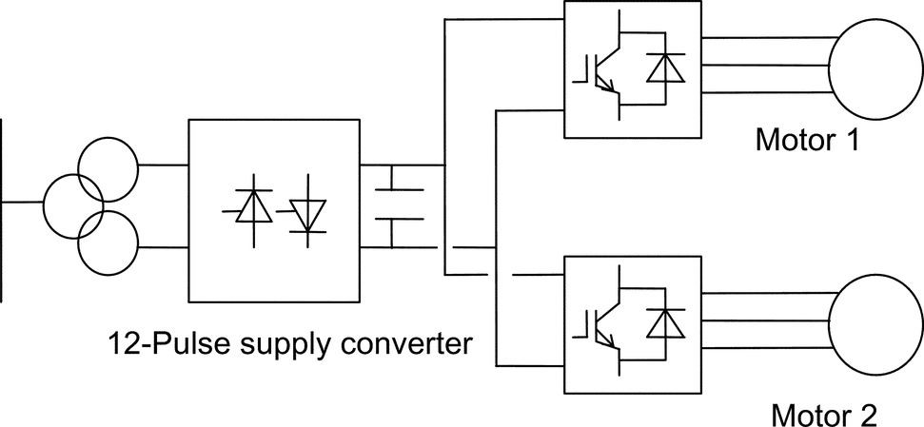

**FIGURE 29.8** PWM-VSI electrically coupled mine hoist drive.

The power flows naturally from motor 1 to motor 2 such that at the point of balance, the AC supply current is virtually zero and at near-unity power factor.

This technology is the natural successor to the DC electrically coupled winders and totally solves the poor AC power factor that would result if twin drive cyclo motors were used.

#### **29.7.2.2 Industrial Processes**

In this industry, there are a number of viable drive solutions available for the major market power ranges, from LCIs to FCI. However, there is a developing market for MV variable speed drives. The PWM-VSI using new high-power IGBTs or IGCTs appears to be the best solution for the future. Benefits include better power factor, no limit on frequency, and higher voltages.

PWM-VSI converter cost is likely to be higher than equivalent other well-established technologies (e.g., LCI). Hence, the flexibility in choice of motors and improved control must be exploited. The advantage of offering an MV solution may prove significant. Possible means of reducing motor costs are the following:

1. Higher frequencies are achievable, allowing the use of high-speed motors and gearboxes.

2. Higher pole number machines can be used, giving a cost saving.

3. Better power factor over the speed range giving power supply saving.

4. Induction motors with rotors adapted for use with VSDs can be used with resultant cost savings over standard DOL, fixed speed motors.

5. Higher voltages and smaller conductors.

6. However, at low powers, the relative cost of the machines is less significant versus the cost of the converters. Hence, the viability of this technology in this market requires close examination.

The cycloconverter drive with a synchronous motor is used when four-quadrant operation is required. Particularly for high power rating with high torque at low speed and at standstill but with a rather low maximum speed are drive requirements. Gearless cement mill drives were the first applications of cycloconverters. The mill tube is driven from low-speed wraparound motor with a high number of poles.

#### **29.7.2.3 Metal Industry**

The majority of installed hot mill drives are cycloconverters. A few LCI drives have been used, but applications are limited for such technology on mill main drives. Most early-generation plants are equipped with DC drives. The trend is to replace DC with AC.

Direct current drive applications were universally used in the first generation of rolling mills. The market for new mills requiring this technology is declining as the steel industry moves to AC as a preference. On early-generation mills where motors are retained, DC drives are likely to be required. Customers in their inquiries, some requesting AC alternatives, are still requesting DC drive solutions.

DC drives are probably still the most economic for the power range of 750–1500 kW. The number of manufacturers however, producing DC motors, is declining, particularly in the case of large DC motor manufacture. The lower price of DC solutions is offset by the advantage of the use of AC motors in AC solutions, making AC the more popular choice.

Current-source inverter LCI can be applied to roughing stands of rod and bar mills. Technical limitations include the risk of torque pulsation and a minimum drive output frequency of 8 Hz.

Cycloconverter is the solution most often used. However, it is relatively expensive compared with alternative technology. Major cost penalties arise from supply transformers, cabling, and bridge configuration. In some cases, active power supply compensation equipment may be required, taking the costs even higher. Cycloconverter solutions will still be cost-effective for medium-to-high power, low-speed, low-frequency (say below 21 Hz maximum operating frequency) applications. This would include hot reversing mills, with direct drive, for the primary rolling processes, albeit a declining application area, and possibly for direct-drive, low-speed, high-torque roller-table applications. Technical limitations include limited output frequency (typically 29 Hz for 12-pulse at 60 Hz supplies), which can necessitate the use of two-pole motors to reach application speeds.

The high-power PWM-VSI using new power devices (IGBT/IGCT) appears to be the best solution for the future. Benefits include better power factor, no limit on frequency, and higher voltages. Potentially, either the two-level or the multilevel solution will meet the market requirements.

In some applications, like coilers/uncoilers, the system is composed of several drives, which have different power cycles; when some drives are furnishing power, others are braking. A common DC bus system will allow that the energy fed from drives operating in the regenerative braking mode will be utilized by other drives connected to the same DC bus but operating in the motoring mode. The supply bridge, that is, rectifier, feeding the DC bus system will only be rated for the total system power.

The benefits of the DC bus systems include the following:

• Good operating power factor

• Low harmonics (lowest when using 12-pulse or 18-pulse front ends)

• Possibility of energy transfer on the common DC link solutions (reducing front-end converter and transformer sizes with attendant energy saving, possibility of using kinetic energy to allow controlled stopping)

#### **29.7.2.4 Marine and Offshore**

Drive powers are commonly in the range of 0.75–5.8 W for thrusters and 6–24 MW for propulsion. The evolution in the commercial market is toward powers from 1 to 10 MW for propulsion. Higher powers are required for naval applications with package drive efficiency better than 96%.

The PWM inverters at these powers would allow the use of induction machines, rather than the more expensive synchronous alternatives required for LCI drive. This could give savings in the price of the motor.

Current source inverter (CSI) drive LCI is used for all applications except for icebreakers where cycloconverter drives are used. The PWM (voltage source) inverter using new force-commutated drive appears to be the best solution for the future. Benefits include better power factor, no limit on frequency, and higher voltages. Many icebreakers and some other ships are equipped with diesel-generator-fed cycloconverter synchronous motors with power ratings up to about 20 MW per unit.

### 29.7.3 EXAMPLES OF MODERN VSD SYSTEMS

#### **29.7.3.1 Integrated Power System for All Electric Ship**

This is a full-scale main propulsion drive for the US Navy [[15](https://learning.oreilly.com/library/view/power-electronics-handbook/9780128114087/B9780128114070000337.xhtml#bb0080)]. It consists of a main propulsion 19 MW induction motor drive system. The power converter consists of three 6-pulse rectifier stages, three 6 kV DC links, and 15 IGBT-based H-bridges feeding a 15-phase induction motor ([Fig. 29.9](https://learning.oreilly.com/library/view/power-electronics-handbook/9780128114087/B9780128114070000337.xhtml#f0050)).

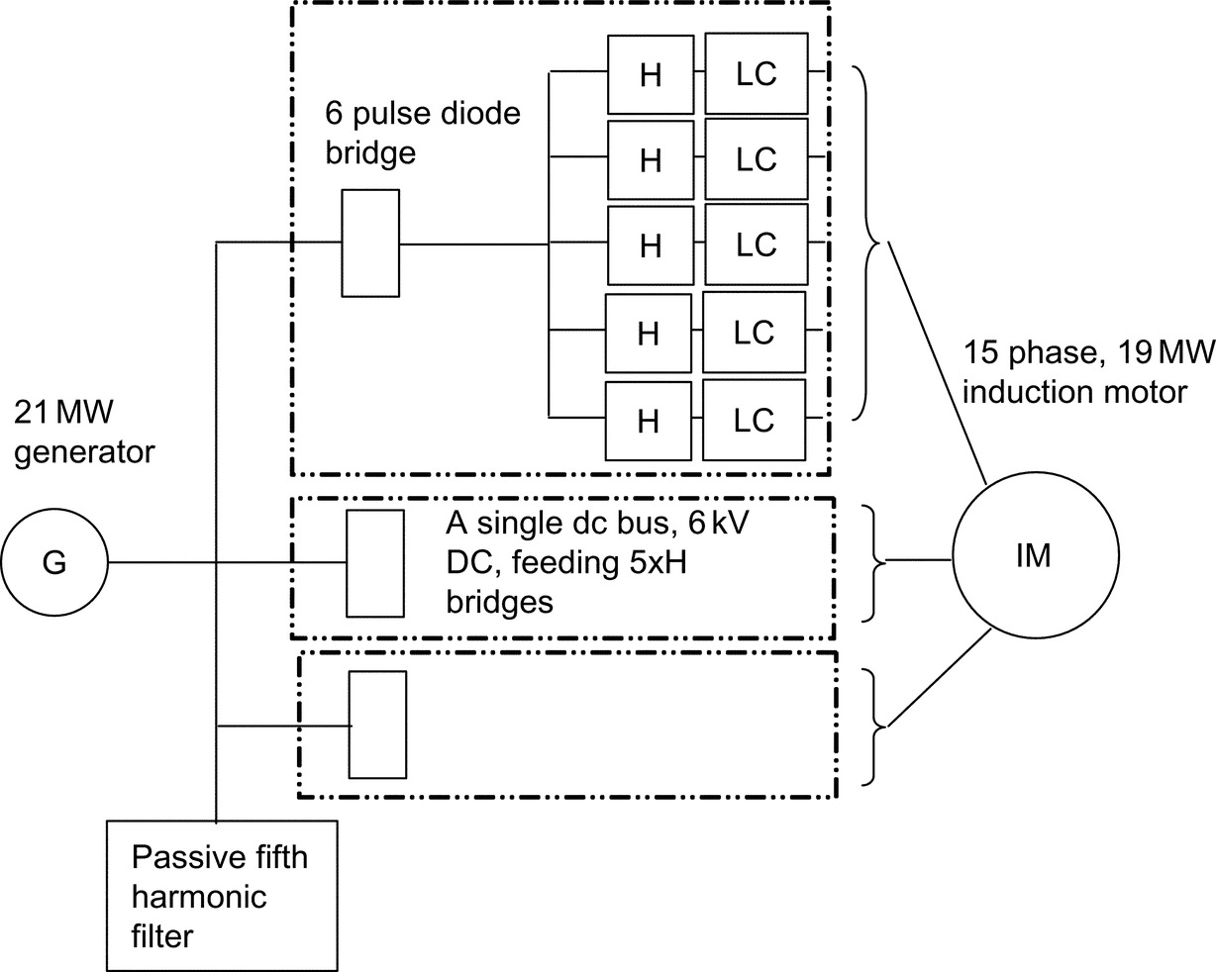

**FIGURE 29.9** Schematic diagram of the IPS drive system [[15](https://learning.oreilly.com/library/view/power-electronics-handbook/9780128114087/B9780128114070000337.xhtml#bb0080)].

This drive demonstrates the potential of modern power electronics over more traditional solutions such as cycloconverter and LCI. The volumetric power density of the new converter is reported to be 905 kW/m3, compared with 455 kW/m3 for cyclo and 313 kW/m3 for LCI.

#### **29.7.3.2 Subsea Separation and Injection System**

This is a full-scale pilot plant developed to increase recovery and improve the economics of offshore oil and gas fields. The system comprises several VSD units, typically 500 kW oil pump, 1 MW multiphase booster and 1–2.5 MW water injection drive unit, and such a system is called “SUBSIS” [[16](https://learning.oreilly.com/library/view/power-electronics-handbook/9780128114087/B9780128114070000337.xhtml#bb0085)]. The main task for such a system is to separate the bulk water from the well stream and treat it either for discharge into the sea or reinjection into the reservoir.

This system employs subsea-based rotating machinery for pumping, boosting, and compression. The subsea electric power distribution system (SEPDIS) is an innovative and cost-effective subsea processing ([Fig. 29.10](https://learning.oreilly.com/library/view/power-electronics-handbook/9780128114087/B9780128114070000337.xhtml#f0055)). The pump motors are mounted in a pressurized vessel and positioned on the seabed. Ref. [[16](https://learning.oreilly.com/library/view/power-electronics-handbook/9780128114087/B9780128114070000337.xhtml#bb0085)] identifies the benefits of subsea drives as follows:

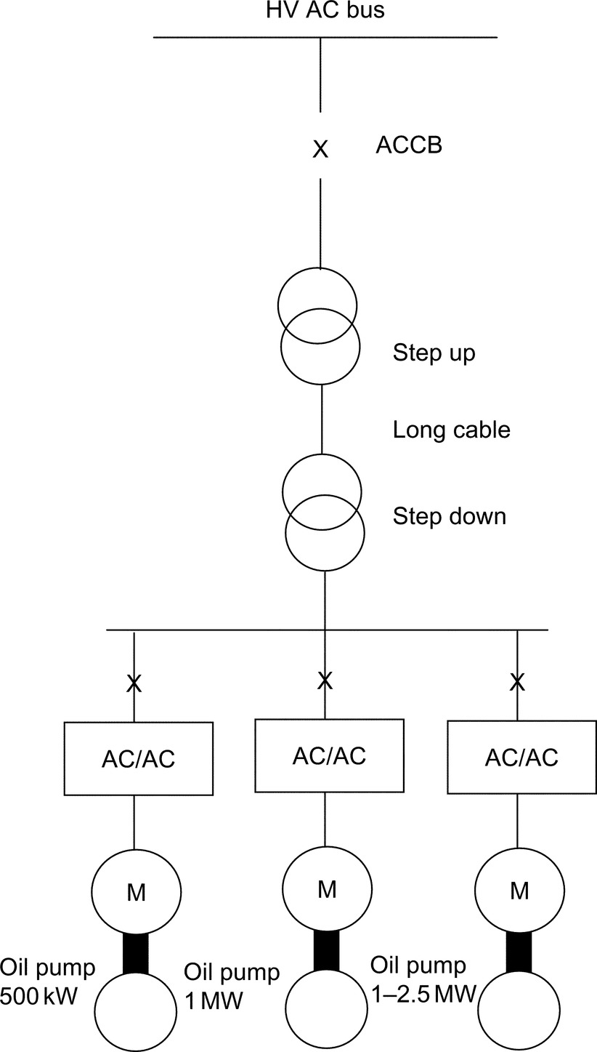

**FIGURE 29.10** Schematic diagram of SEPDIS.

• 3%–6% increase in oil and gas recovery

• Improved pipeline transportation conditions by removing water from the well stream

• Reduced environmental impact due to lower energy consumption and reduction in chemicals used to inhibit corrosion

• Reduced size and cost of new platforms

• Cost-effective development of marginal fuels through reuse of existing infrastructure

#### **29.7.3.3 Shaft-Generator for Marine Application**

During cruising at sea, up to 3.5 MW of electric power is extracted from the ship's main diesel engine/propeller shaft (90,000 hp per ship) via a salient pole shaft generator, which is fitted to the main propeller shaft. The converter output voltage (set at 60 Hz) is stepped up to 6.6 kV [[17](https://learning.oreilly.com/library/view/power-electronics-handbook/9780128114087/B9780128114070000337.xhtml#bb0090)].

The converter is based on 24-pulse converter (LCI) technology, which is traditionally used as main ship propulsion. The shaft generator output frequency varied between 14 and 25.7 Hz; six-phase generator and the output stage are configured as 24-pulse, via a step-up transformer. At the output, a passive LC filter is employed, with a synchronous condenser started by a pony motor.

This type of application is likely to significantly benefit from the higher volumetric power density of the PWM-VSI with fully controlled front-end. Such a system will eliminate the need for a passive filter at the output stage and use a standard three-phase generator.

The same technology is also applicable to high-speed generators and windmill energy. The ability of the active front end to sustain fixed DC link voltage over a relatively wide shaft speed range results in a very good control of the output voltage, irrespective of the shaft speed.

In wind power plants, the optimal efficiency of the wind turbine depends on the speed when the wind conditions change. It is, therefore, advantageous to vary the speed of the generator and link it via a frequency converter to the AC system.

For high-speed generators, driven by diesel engine or gas turbine, the fully controlled converters enable direct power conversion from AC high frequency (hundreds of Hz) to fixed power frequency (50/60) Hz fixed output voltage. The magnitude of the output voltage is kept constant irrespective of speed variation of the generator ([Fig. 29.11](https://learning.oreilly.com/library/view/power-electronics-handbook/9780128114087/B9780128114070000337.xhtml#f0060)).

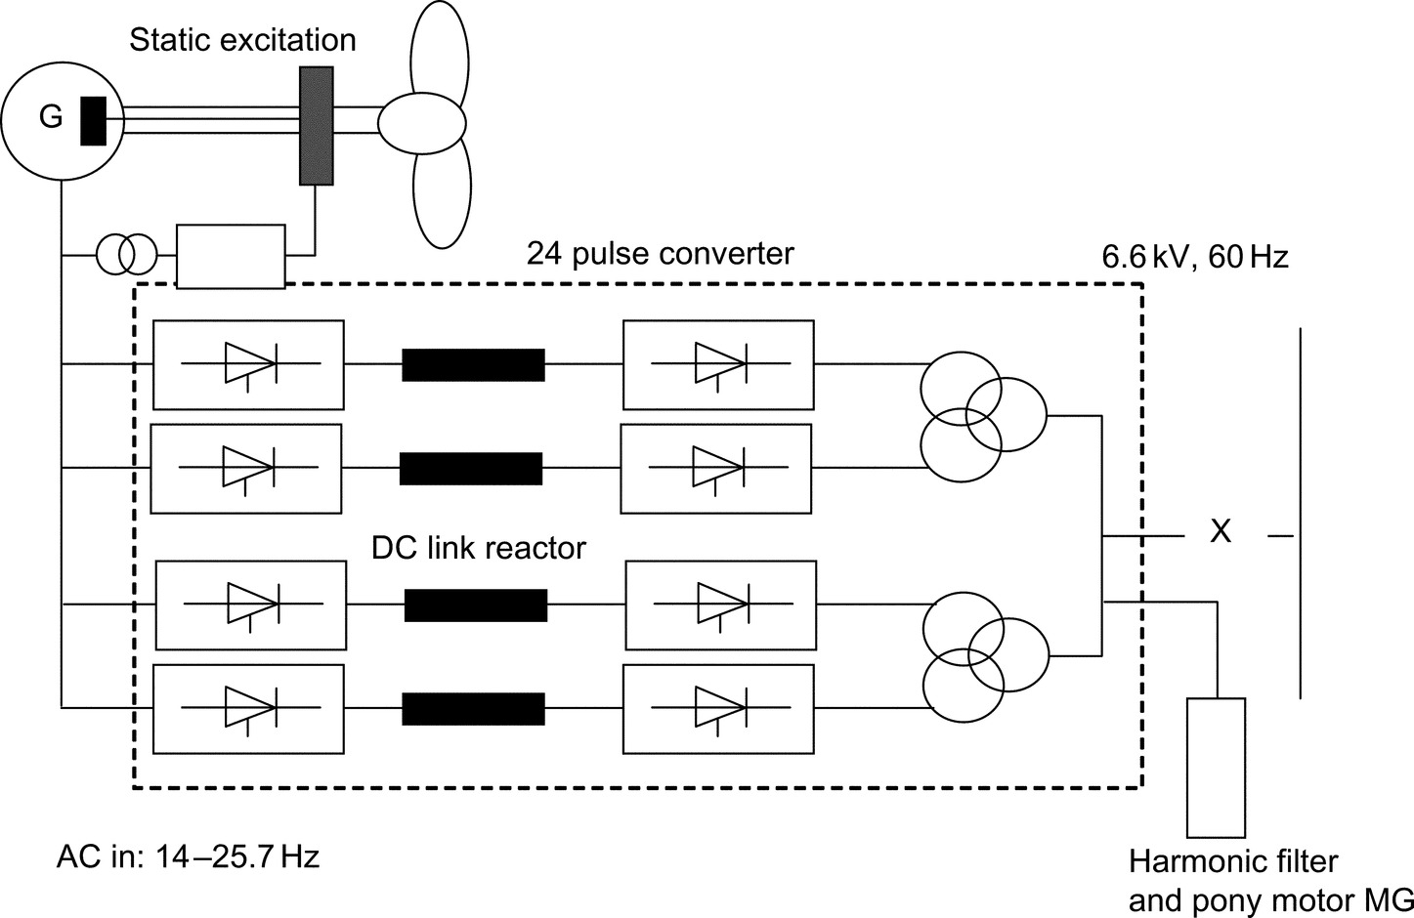

**FIGURE 29.11** Schematic diagram of shaft generator.

#### **29.7.3.4 Linear Motor Drive for Roller Coaster**

This drive involves a fully regenerative PWM-VSI. The supply front end is made of antiparallel thyristor front end, while the machine bridge is based on PWM IGBT VSI. “Superman” has been developed for Six Flags California at Magic Mountain. The inverter output frequency is 0–230 Hz and 525 V AC RMS. The power rating is 1.8 MW. The duty cycle is 1.8 MW for 7 s, followed by 16 s at zero power, and 1.3 MW for 5 s and a stop period of 32 s. This ride involves acceleration at 4.5 g, speed and free fall (6.5 s of weightlessness, during which a height of 415 ft is achieved [[18](https://learning.oreilly.com/library/view/power-electronics-handbook/9780128114087/B9780128114070000337.xhtml#bb0095)]).

The same concept employed in this application could be used for aeroplane launcher on aircraft carriers, instead of the conventional catapult.

## 29.8 Summary

The benefits of VSD are there to be quantified, and energy saving has been the prime reason for employing a VSD in stand-alone drive applications. Other benefits such as improved process control or increase life expectancy are often difficult to quantify in real terms.

There is a large selection of VSD systems to meet a wide range of applications. In the low and medium power, the induction motor and PWM-VSI are supreme. At higher power ratings, MV PWM-VSIs are gaining popularity, but LCI and cycloconverter drives would remain key technologies with very high power applications.

Modern drives are becoming more available at competitive prices with good reliability record. However, there are concerns with regard to the impact of fast switching on the motor and the environment.

To ensure successful implementation of a VSD system, both the supplier and end users need to work in partnership. Ideally, one competent supplier should supply the full drive package, with some after-sale service support. Understanding the nature of the load plays an important role in specifying the power rating of VSD correctly to meet performance requirements and required life expectancy.

New areas of VSD applications are emerging as the power electronics advances and become more reliable at affordable prices. Packaged drives up to several hundred kWs are becoming a commodity product, and end users do not need to involve a third party during specification, installation, and commissioning. Integrated motors are likely to increase their popularity, possibly with new types of power converters, for example, matrix.

## References

[1] Dury W. Electrical variable speed drives mature consumable or radical infant. *Power Eng. J.* 1999;13(2):65–78 IEE, London.

[2] Guide to Harmonics with AC drives. ABB Technical Guide No. 6.

[3] Bose B.K. *Power Electronics and Variable Frequency Drives: Technology and Applications.* Piscataway, NJ: IEEE Press; 1997.

[4] Siemens, Complete Guide Series to Variable Speed Drives, Knowledge of Motor Duty—Key to Proper Planning of Drives, 3.6.

[5] Hobbs P.J. *Electrical variable speed drives saves energy.* In: Conference on Development in Variable Speed Drives for Fluid Machinery, ImechE; 1981 C101/81.

[6] A.W. Richmond, Apprentice Engineers' Handbook No. 2, Servos and Steppers, Drives and Controls Publication, Kamtech Publishing Ltd, Croydon, Surrey.

[7] Shakweh Y. *Aspects of Limited Motion Actuators and Sub-kW Unipolar Drives.* (Ph.D. thesis) London University; 1989.

[8] Shakweh Y., Lewis E. *Assessment of MV converter stack topologies.* In: Power Electronics Specialist Conference; 1999.

[9] von Jouanne A., et al. Application issues for PWM adjustable speed AC motor drives. *IEEE Ind. Appl. Mag.* 1998;10–18.

[10] Manz L. Motor insulation system quality for IGBT drives. *IEEE Ind. Appl. Mag.* 1997;3:51–55.

[11] Chen S., Lipo T.A. Circulating type motor bearing current in inverter drives. *IEEE Ind. Appl. Mag.* 1998;32–38.

[12] C. Hargis, Electro-Magnetic Compatibility—A Basic Guide for Power Engineers, Control Techniques Technical Publications, Powys.

[13] Shakweh Y., Aufleger P. *Multi-megawatts, medium voltage, PWM voltage source sine-wave converter for industrial drive applications.* In: Power Electronics & Variable Speed Drives Conference (PEVD'98), UK, London, 21–23 September; 1998.

[14] Shakweh Y., Lewis E.A., Gent A. *High-power drives for mining applications.* In: Minmech 98, South Africa, September; 1998.

[15] Crane A., McCoy T.J. *EMC design for a 19 MW PWM motor drive.* In: IEEE Industry Applications Society Annual Meeting'99, Vol. 3; 1999:1590–1995.

[16] R. Stromquist, S. Gustafson, SUBSIS—World's First Separation and Injection System, ABB Review, 6/1998.

[17] B. Clegg, et al., The Application of Drives and Generator Technology to a Modern Container Ship, IEE, PEVD98, London, UK.

[18] Elliott N.J. *Novel application of a linear synchronous motor drive.* In: IEE Colloquium on “Update on New Power Electronics Techniques”, IEE, London, May 23; 1997.

## Further Reading

[1] Shakweh Y. Power devices for MV PWM VSI converters. *Power Eng. J.* 1999 IEE, UK.

[2] Richmond A.W. *A Practical Engineer's handbook, Industrial Electric Drives, Drives & Controls Publications.* Croydon, Surrey, UK: Kamtech Publishing Ltd; 2015.

[3] Direct Torque Control, ABB Technical Guide No. 1.

**30**

# Motor Drives

Muhammed F. Rahman The University of New South Wales, Sydney, NSW, Australia

Dean Patterson University of Nebraska, Lincoln, LE, United States

Adrian Cheok Imagineering Institute, Nusajaya, Malaysia

Robert Betz University of Newcastle, Callaghan, NSW, Australia

## Abstract

The widespread proliferation of power electronics and ancillary control circuits into motor control systems in the past several decades have led to a situation where motor drives, which process about two-thirds of the world's electric power into mechanical power, are on the threshold of processing all of this power via power electronics. The days of driving motors directly from the fixed ac or dc mains via mechanical adjustments are truly over. [Table 30.1](https://learning.oreilly.com/library/view/power-electronics-handbook/9780128114087/B9780128114070000349_1.xhtml#t0010) indicates application areas where various types of power electronic converter-driven motor drives are routinely used.

**Table 30.1**

**Typical motor, converter, and application guides**

|  |  |  |  |
| --- | --- | --- | --- |
| **Motor** | **Type of converter** | **Type of control** | **Applications** |
| Brushed dc motor | Thyristor ac-dc converter | Phase control, with inner current loop | Process rolling mills, winders, locomotives, large cranes, extruders, and elevators |
|  | GTO/IGBT/MOSFET chopper | Pulse-width modulator (PWM) control with inner current loop | Drives for transportation, machine tools, and office equipment |
| Induction motor (cage) | Back-back thyristor | Phase control | Pumps and compressors |
|  | IGBT/GTO inverter/cycloconverter | PWM *V-f* control | General-purpose industrial drive such as for cranes, pumps, fans, elevators, material transport and handling, extruders, and subway trains |
|  | IGBT/GTO | Vector control | High-performance ac drives in transportation, motion control, and automation |
| Induction motor (slip ring) | Thyristor ac-dc converter | Phase control with dc-link current loop | Large pumps, fans, and cement kilns |
| Synchronous motor (excited) | Thyristor ac-dc converter | DC-link current loop | Large pumps, fans, blowers, compressors, and rolling mills |
| Synchronous motor (PM) | IGBT/MOSFET inverter | PWM current control | High-performance ac servo drives for office equipment, machine tools, automotive traction drives and motion control |

### KEYWORDS:

DC motor drives; Induction motor drives; Synchronous motor drives; Switched reluctance motor drives; Stepping motor drives; Torque control; Inverter; Vector control; Synchronous reluctance motor drives

30.1 [Introduction](https://learning.oreilly.com/library/view/power-electronics-handbook/9780128114087/B9780128114070000349_1.xhtml#s0010)

30.2 [DC Motor Drives](https://learning.oreilly.com/library/view/power-electronics-handbook/9780128114087/B9780128114070000349_1.xhtml#s0015)

30.2.1 Introduction

30.2.2 DC Motor Representation and Characteristics

30.2.3 Converters for DC Drives

30.2.4 Drive System Integration

30.2.5 Converter-DC Drive System Considerations

30.3 [Induction Motor Drives](https://learning.oreilly.com/library/view/power-electronics-handbook/9780128114087/B9780128114070000349_1.xhtml#s0055)

30.3.1 Introduction

30.3.2 Steady-State Representation

30.3.3 Characteristics and Methods of Control

30.3.4 Vector Controls

30.4 [Synchronous Motor Drives](https://learning.oreilly.com/library/view/power-electronics-handbook/9780128114087/B9780128114070000349_1.xhtml#s0125)

30.4.1 Introduction

30.4.2 Steady-State Equivalent-Circuit Representation of the Motor

30.4.3 Performance with Voltage-Source Inverter Drive

30.4.4 Characteristics Under Current-Source Inverter (CSI) Drive

30.4.5 Brushless DC Operation of the CSI-Driven Motor

30.4.6 Operating Modes

30.4.7 Vector Control

30.5 [Permanent-Magnet Synchronous Motor Drives](https://learning.oreilly.com/library/view/power-electronics-handbook/9780128114087/B9780128114070000349_1.xhtml#s0185)

30.5.1 Introduction

30.5.2 The Surface-Magnet Synchronous Motor with Trapezoidal Back Emf Waveform

30.5.3 The PM Synchronous Motor with Sinewave Back Emf Waveforms

30.6 [Permanent-Magnet Brushless DC Motor Drives](https://learning.oreilly.com/library/view/power-electronics-handbook/9780128114087/B9780128114070000349_2.xhtml#s0240)

30.6.1 Machine Background

30.6.2 Electronic Commutation

30.6.3 Current/Torque Control

30.6.4 The Signal Processing for Producing Switch Drive Signals from Hall Effect Sensors and Current Sensors

30.6.5 Summary

30.7 [Servo Drives](https://learning.oreilly.com/library/view/power-electronics-handbook/9780128114087/B9780128114070000349_2.xhtml#s0355)

30.7.1 Introduction

30.7.2 Servo Drive Performance Criteria

30.7.3 Servo Motors, Shaft Sensors, and Coupling

30.7.4 The Inner Current/Torque Loop

30.7.5 Sensors for Servo Drives

30.7.6 Servo Control-Loop Design Issues

30.8 [Stepper Motor Drives](https://learning.oreilly.com/library/view/power-electronics-handbook/9780128114087/B9780128114070000349_2.xhtml#s0415)

30.8.1 Introduction

30.8.2 Motor Types and Characteristics

30.8.3 Mechanism of Torque Production

30.8.4 Single- and Multi-Step Responses

30.8.5 Drive Circuits

30.8.6 Micro Stepping

30.8.7 Open-Loop Acceleration–Deceleration Profiles

30.9 [Switched-Reluctance Motor Drives](https://learning.oreilly.com/library/view/power-electronics-handbook/9780128114087/B9780128114070000349_2.xhtml#s0500)

30.9.1 Introduction

30.9.2 Advantages and Disadvantages of Switched-Reluctance Motors

30.9.3 Switched-Reluctance Motor Variable-Speed Drive Applications

30.9.4 SR Motor and Drive Design Options

30.9.5 Operating Theory of the Switched-Reluctance Motor: Linear Model

30.9.6 Operating Theory of the SR Motor (II): Magnetic Saturation and Nonlinear Model

30.9.7 Control Parameters of the SR Motor

30.9.8 Position Sensing

30.10 [Synchronous Reluctance Motor Drives](https://learning.oreilly.com/library/view/power-electronics-handbook/9780128114087/B9780128114070000349_2.xhtml#s0600)

30.10.1 Introduction

30.10.2 Basic Principles

30.10.3 Machine Structure

30.10.4 Basic Mathematical Modeling

30.10.5 Control Strategies and Important Parameters

30.10.6 Practical Considerations

30.10.7 A Syncrel Drive System

30.10.8 Conclusion

[Further Reading](https://learning.oreilly.com/library/view/power-electronics-handbook/9780128114087/B9780128114070000349_2.xhtml#fr0010)

## 30.1 Introduction

The widespread proliferation of power electronics and ancillary control circuits into motor control systems in the past several decades have led to a situation where motor drives, which process about two-thirds of the world's electric power into mechanical power, are on the threshold of processing all of this power via power electronics. The days of driving motors directly from the fixed ac or dc mains via mechanical adjustments are truly over. [Table 30.1](https://learning.oreilly.com/library/view/power-electronics-handbook/9780128114087/B9780128114070000349_1.xhtml#t0010) indicates application areas where various types of power electronic converter-driven motor drives are routinely used.

The widespread incorporation of power, control, and signal electronics in motor drives has meant that processes can now be driven much more efficiently with a much greater degree of flexibility than previously possible. Of course, certain processes are more favorable to certain types of motors, because of the more favorable match between their characteristics. Historically, this situation was brought about by the demands of the industry. Increasingly, however, power electronic devices and control hardware are easily tailoring the rigid characteristics of the motor (when driven from a fixed dc or ac supply source) to the requirements of the load. Development of novel forms of machines and control techniques therefore has not abated, as recent trends would indicate.

It should be expected that just as power electronics equipment has tremendous variety, depending on the power level of the application, motors also come in many different types, depending on the requirements of application and power level. Often, the choice of a motor and its power electronic drive circuit for application is forced by these realities, and the application engineer therefore needs to have a good understanding of the application, the available motor types, and the suitable power electronic converter and its control techniques. [Table 30.1](https://learning.oreilly.com/library/view/power-electronics-handbook/9780128114087/B9780128114070000349_1.xhtml#t0010) gives a rough guide of combinations of suitable motors and power electronic converters for a few typical applications.

For many years, the brushed dc motor had been the natural choice for applications requiring high dynamic performance. Drives of up to several hundred kilowatts have used this type of motor. In contrast, the induction motor was considered for low-performance, adjustable-speed applications at low and medium power levels. At very high power levels, the slip-ring induction motor or the synchronous motor drive was the natural choice. These boundaries are increasingly becoming blurred, especially at the lower power levels, especially for AC motor drives.

Another factor for motor drives was the consideration for servo performance. The ever-increasing demand for greater productivity or throughput and higher quality of most of the industrial products that we use in our everyday lives means that all aspects of dynamic response and accuracy of motor drives have to be increased. Issues of energy efficiency and harmonic proliferation into the supply grid are also increasingly affecting the choices for motor-drive circuitry.

A typical motor-drive system is expected to have some of the system blocks indicated in [Fig. 30.1](https://learning.oreilly.com/library/view/power-electronics-handbook/9780128114087/B9780128114070000349_1.xhtml#f0010). The load may be a conveyor system, a traction system, the rolls of a mill drive, the cutting tool of a numerically controlled machine tool, the compressor of an air conditioner, a ship propulsion system, a control valve for a boiler, a robotic arm, and so on. The power electronic converter block may use diodes, metal oxide semiconductor field-effect transistors (MOSFETS), gate turnoff thyristors (GTOs), insulated gate bipolar transistors (IGBTs), or thyristors. The controllers may consist of several control loops, for regulating voltage, current, torque, flux, speed, position, tension, or other desirable conditions of the load. Each of these may have their limiting features purposely placed in order to protect the motor, the converter, or the load. The input commands and the limiting values to these controllers would normally come from the supervisory control systems that produce the required references for a drive. This supervisory control system is normally more concerned with the overall operation of the process rather than the drive.

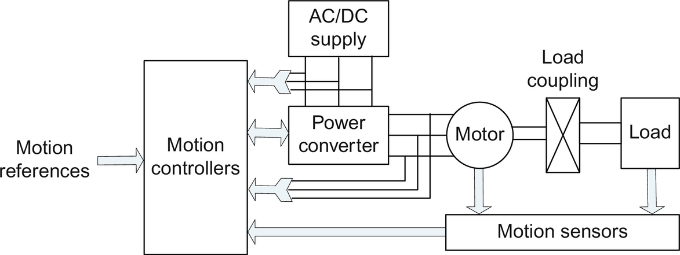

**FIG. 30.1** Block diagram of a typical motor-drive system.

Consequently, a vast array of choices and technologies exist for a motor-drive application. Against this background, this chapter gives a brief description of the dominant forms of motor drives in current usage. The interested reader is expected to consult further reading material listed at the end of this chapter for more detailed coverage.

## 30.2 DC Motor Drives

### **30.2.1 INTRODUCTION**

Direct-current motors are extensively used in variable-speed drives and position-control systems where good dynamic response and steady-state performance are required. Examples are in robotic drives, printers, machine tools, process rolling mills, paper and textile industries, and many others. Control of a dc motor, especially of the separately excited type, is very straightforward, mainly because of the incorporation of the commutator within the motor. The commutator brush allows the motor-developed torque to be proportional to the armature current if the field current is held constant. Classical control theories are then easily applied to the design of the torque and other motion loops of a drive system.

The mechanical commutator limits the maximum applicable voltage to about 1500 V and the maximum power capacity to a few hundred kilowatts. Series or parallel combinations of more than one motor are used, when dc motors are applied in applications that handle larger loads. The maximum armature current and its rate of change are also limited by the commutator.

### 30.2.2 DC MOTOR REPRESENTATION AND CHARACTERISTICS

The dc motor has two separate sources of fluxes that interact to develop torque. These are the field and the armature circuits. Because of the commutator action, the developed torque is given by

 **(30.1)**

where *if* and *ia* are the field and the armature currents, respectively, and *K* is a constant relating motor dimensions and parameters of the magnetic circuits.

The dynamic and the steady-state responses of the motor and load are given by



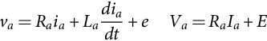 **(30.2)**

**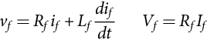** **(30.3)**

**** **(30.4)**

**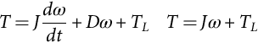** **(30.5)**

where *J*,*D* and *TL* are the moment of inertia, damping factor, and load torque, respectively, referred to the motor, and the subscripts *a* and *f* refer to the armature and field circuits, respectively. *R*, *L*, *I*, and *E* refer to resistance, inductance, current, and back emf of the motor in associated circuits referred by the subscripts.

Small servo-type dc motors normally have permanent-magnet (PM) excitation for the field, whereas larger size motors tend to have separate field supply, *Vf*, for excitation. The separately excited dc motors represented in [Fig. 30.2A](https://learning.oreilly.com/library/view/power-electronics-handbook/9780128114087/B9780128114070000349_1.xhtml#f0015) have fixed field excitation, and these motors are very easy to control via the armature current control, which are easily designed using classical linear control theory. Thyristor ac-dc converters with phase-angle control are popular for the larger size motors, whereas the duty-cycle-controlled pulse-width-modulated switching dc-dc converters are popular for servo-motor drives. The series-excited dc motor has its field circuit in series with the armature circuit as shown in [Fig. 30.2B](https://learning.oreilly.com/library/view/power-electronics-handbook/9780128114087/B9780128114070000349_1.xhtml#f0015). Such a connection gives high torque at a low speed and low torque at a high speed—a pseudo constant-power-like characteristic that may match traction-type loads well.

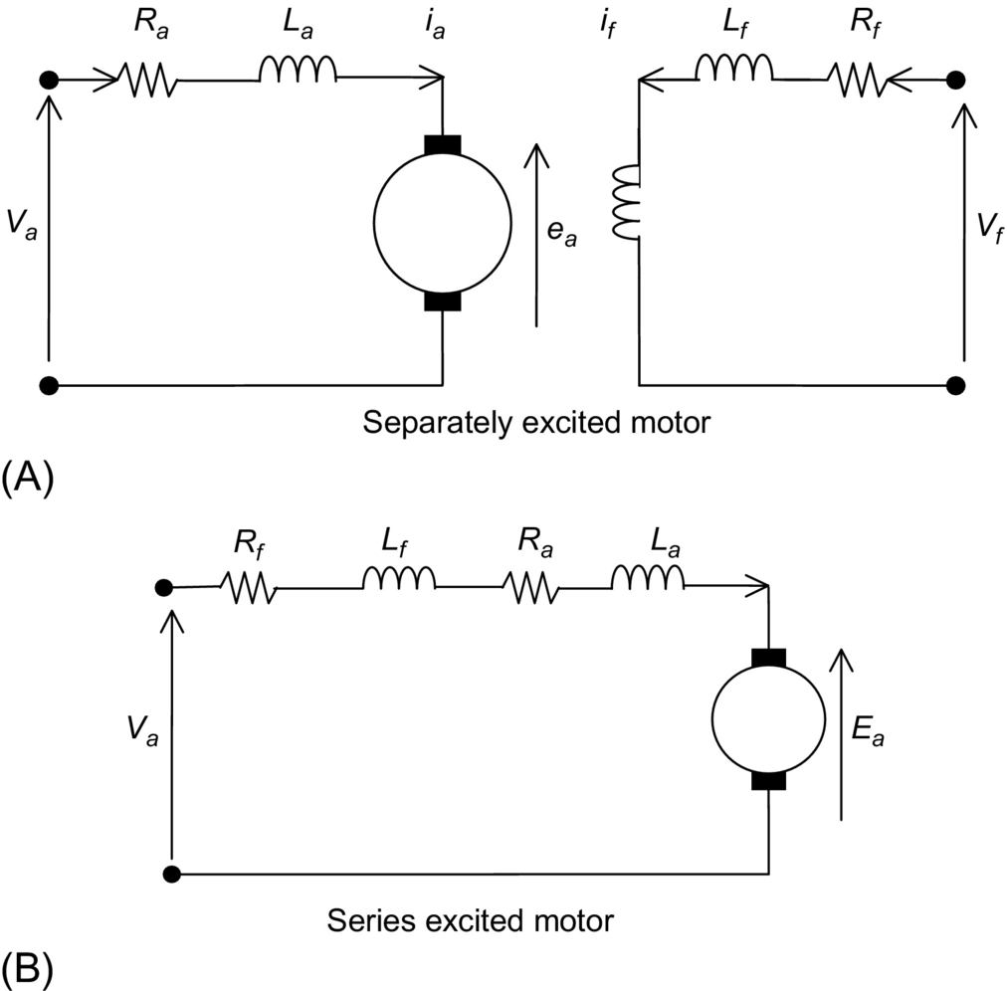

**FIG. 30.2** Representation of the separately excited and series-excited motor circuits: (A) separately excited dc motor circuit and (B) series-excited dc motor circuit.

Torque-speed characteristics of the separately excited and series-excited dc motors are indicated in [Fig. 30.3A and B](https://learning.oreilly.com/library/view/power-electronics-handbook/9780128114087/B9780128114070000349_1.xhtml#f0020), respectively. The speed of the separately excited dc motor drops with load, the net drop being about 5%–10% of the base speed at full load. The voltage drop across the armature resistance and the armature reaction are responsible for this. Operation of the motor above the base speed at which the armature voltage reaches for the rated field excitation is by means of field weakening, whereby the field current is reduced in order to increase speed beyond the base speed. The armature voltage is now maintained at the rated value actively, by overriding the field control if required. Note that the range of field control is limited because of the magnetic nonlinearity of the field circuit and the problem of good commutation at weak field. Usually, the top speed is limited to about three times the base speed. Note also that field weakening results in reduced torque production per ampere of armature current. Depending on the type of load, the armature current, and speed change as dictated by Eqs. [(30.1)](https://learning.oreilly.com/library/view/power-electronics-handbook/9780128114087/B9780128114070000349_1.xhtml#fo0010)–[(30.5)](https://learning.oreilly.com/library/view/power-electronics-handbook/9780128114087/B9780128114070000349_1.xhtml#fo0035).

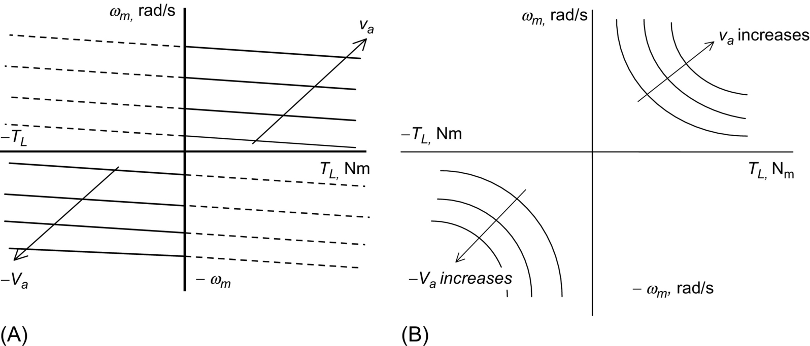

**FIG. 30.3** Torque-speed characteristics of the (A) separately excited and (B) series-excited motors.

For the separately excited dc motor, assuming that the field excitation is held constant, the transfer characteristic between the shaft speed and the applied voltage to the armature can be expressed as indicated in the block diagram of [Fig. 30.4](https://learning.oreilly.com/library/view/power-electronics-handbook/9780128114087/B9780128114070000349_1.xhtml#f0025). If we ignore the load torque *TL*, the transfer characteristic is given by

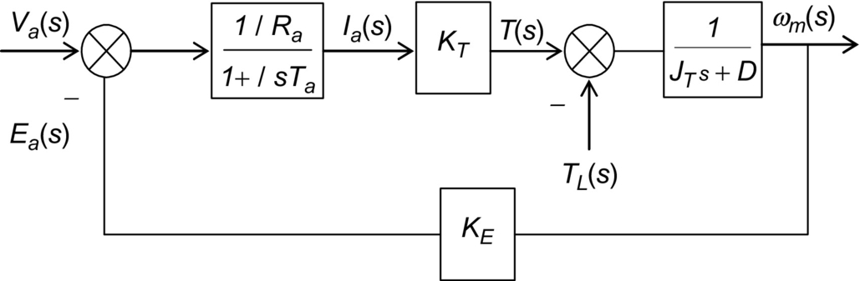

**FIG. 30.4** Transfer characteristic block diagram of a separately excited motor.

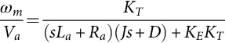 **(30.6)**

the characteristic roots of which are given by

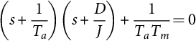 **(30.7)**

If we compare this with a standard second-order system, the undamped natural frequency and damping factor are given by

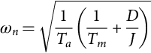 **(30.8)**

and

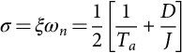 **(30.9)**

where *Tm*=mechanical time constant=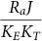 in which  in SI units and *Ta*=electric time constant=.

The speed response of the motor around an operating speed to the application of load torque on the shaft is given by

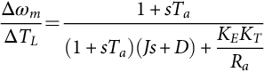 **(30.10)**

### 30.2.3 CONVERTERS FOR DC DRIVES

Depending on the application requirements, the power converter for a dc motor may be chosen from a number of topologies. For example, a half-controlled thyristor converter or a single-quadrant pulse-width-modulated (PWM) switching converter may be adequate for a drive that does not require controlled deceleration with regenerative braking. On the other hand, a full four-quadrant thyristor or transistor converter for the armature circuit and a two-quadrant converter for the field circuit may be required for a high-performance drive with a wide speed range.

The frequency at which the power converter is switched, for example, 100 Hz for a single-phase thyristor bridge converter supplied from a 50 Hz ac source (or 300 Hz for a three-phase thyristor bridge converter), 20 kHz for a PWM MOSFET H-bridge converter, and so on, has a profound effect on the dynamics achievable with a motor drive. Low-power switching devices tend to have faster switching capability than high-power devices. This is convenient for low-power motors since these are normally required to be operated with high dynamic response and accuracy.

#### **30.2.3.1 Thyristor Converter Drive**

Consider the dc drive of [Fig. 30.5](https://learning.oreilly.com/library/view/power-electronics-handbook/9780128114087/B9780128114070000349_1.xhtml#f0030) for which the armature supply voltage *va* to the motor is given by

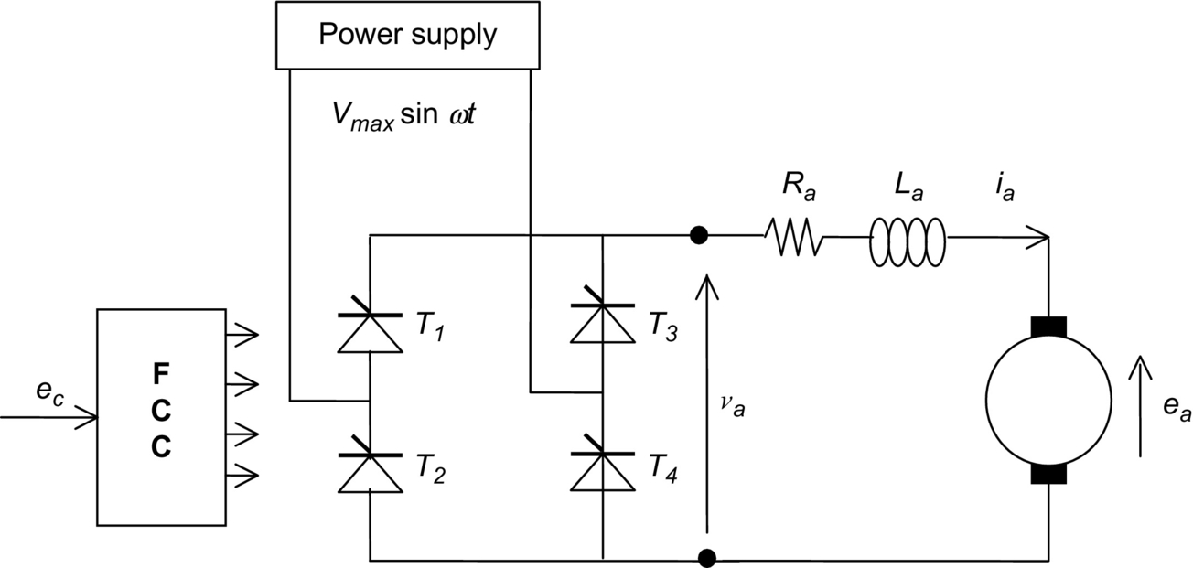

**FIG. 30.5** A two-quadrant single-phase thyristor bridge converter drive.

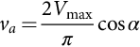 **(30.11)**

where *Vmax* is the peak value of the line-line ac supply voltage to the converter and *α* is the firing angle. The dc output voltage *va* is controllable via the firing angle *α*, which in turn, is controlled by the control voltage *ec* as the input to the firing control circuit (FCC). The FCC is synchronized with the mains ac supply and drives individual thyristors in the ac-dc converter according to the desired firing angle. Depending on the load and the speed of operation, the conduction of the current may become discontinuous as indicated in [Fig. 30.6A](https://learning.oreilly.com/library/view/power-electronics-handbook/9780128114087/B9780128114070000349_1.xhtml#f0035). When this happens, the converter output voltage does not change with the control voltage as proportionately as with the continuous conduction. The motor speed now drops much more with the load as indicated by [Fig. 30.6B](https://learning.oreilly.com/library/view/power-electronics-handbook/9780128114087/B9780128114070000349_1.xhtml#f0035). The consequent loss of gain of the converter may have to be avoided or compensated if good control over speed is desired.

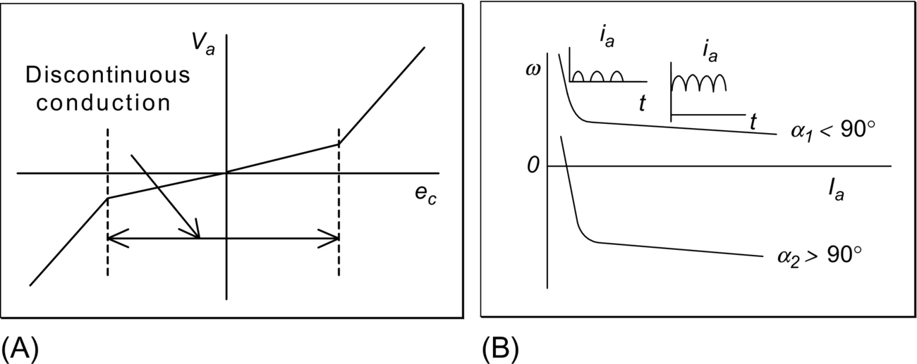

**FIG. 30.6** Converter output voltage and motor torque-speed characteristic with discontinuous conduction.

The output voltage of the simple, two-pulse ac-dc converter of [Fig. 30.5](https://learning.oreilly.com/library/view/power-electronics-handbook/9780128114087/B9780128114070000349_1.xhtml#f0030) is rich in ripples of frequency *nf*, where *n* is an even integer starting with two and *f* is the frequency of the ac supply. Such low-frequency ripple may derate the motor considerably. Converters with higher pulse number, such as the 6- or 12-pulse converters deliver much smoother output voltage and may be desirable for more demanding applications.

A high-performance dc drive for a rolling mill drive may consist of such converter circuits connected for bidirectional operation of the drive, as indicated in [Fig. 30.7](https://learning.oreilly.com/library/view/power-electronics-handbook/9780128114087/B9780128114070000349_1.xhtml#f0040). The interfacing of the FCC to other motion-control loops, such as speed and position controllers, for the desired motion is also indicated

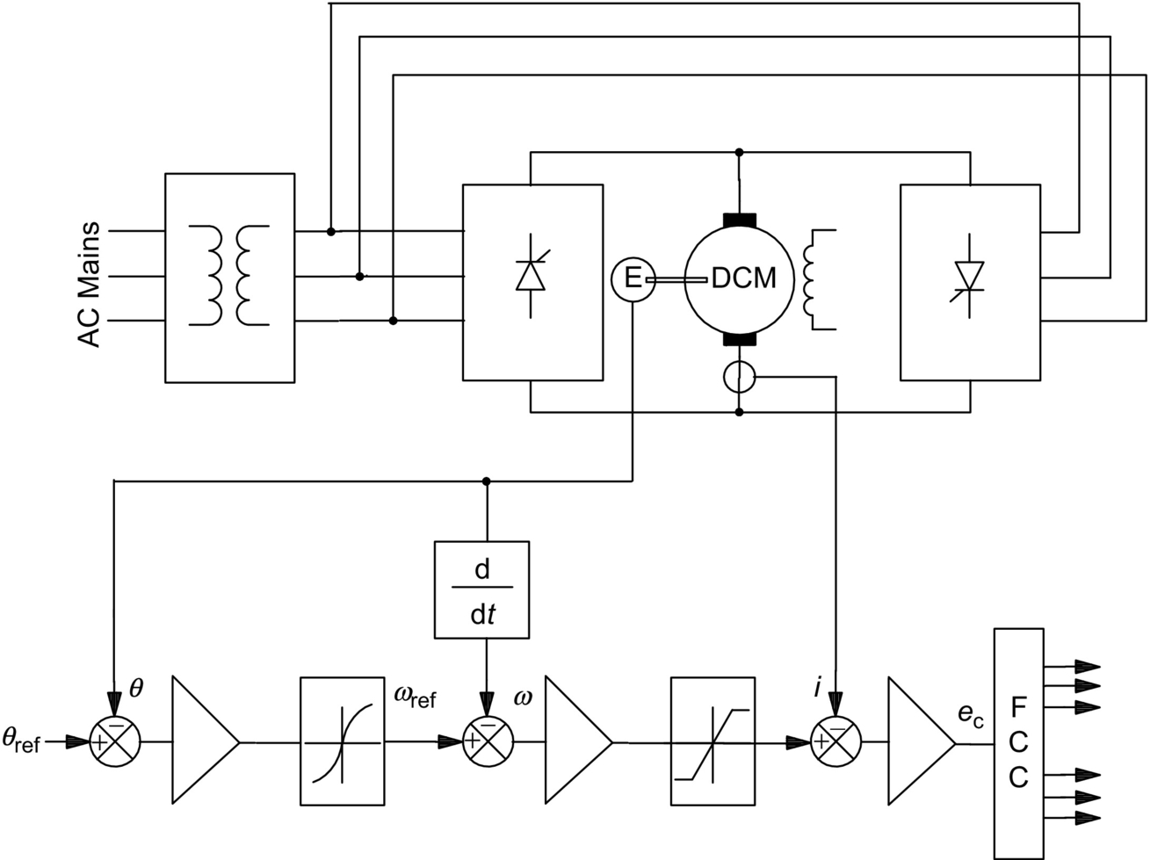

**FIG. 30.7** Bidirectional speed- and position-control system with a back-to-back (dual) thyristor converter.

Two fully controlled bridge ac-dc converter circuits are used back-to-back from the same ac supply. One is for forward, and the other is for reverse driving of the motor. Since each is a two-quadrant converter, either may be used for regenerative braking of the motor. For this mode of operation, the braking converter, which operates in the inversion mode, sinks the motor current aided by the back emf of the motor. The energy of the overhauling decelerating motor now returns to the ac source.

It may be noted that the braking converter may be used to maintain the braking current at the maximum allowable level right down to zero speed. A complete acceleration-deceleration cycle of such a drive is indicated in [Fig. 30.8](https://learning.oreilly.com/library/view/power-electronics-handbook/9780128114087/B9780128114070000349_1.xhtml#f0045). During braking, the firing angle is maintained at an appropriate value at all times so that the controlled and predictable deceleration takes place at all times.

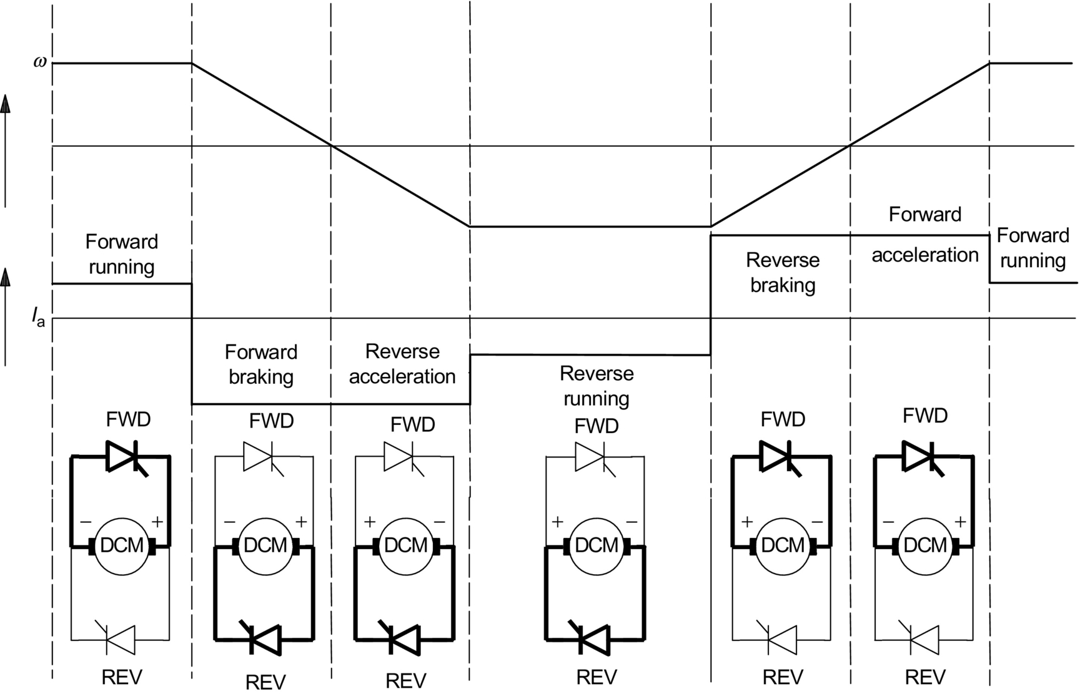

**FIG. 30.8** Converter conduction and operating duty of a bidirectional drive.

The innermost control loop indicated in [Fig. 30.7](https://learning.oreilly.com/library/view/power-electronics-handbook/9780128114087/B9780128114070000349_1.xhtml#f0040) is for torque, which translates to an armature current loop for a dc drive. Speed- and position-control loops are usually designed as hierarchical control loops. Operation of each loop is sufficiently decoupled from each other so that each stage can be designed in isolation and operated with its special limiting features.

#### **30.2.3.2 PWM Switching Converter Drive**

Pulse-width-modulated switching converters have traditionally been referred to as choppers in many traction and forklift-type drives. These are essentially PWM dc-dc converters operating from rectified dc or battery mains. These converters can also operate in one, two, or four quadrants, offering a few choices to meet application requirements. Servo-drive systems normally use the full four-quadrant converter of [Fig. 30.9](https://learning.oreilly.com/library/view/power-electronics-handbook/9780128114087/B9780128114070000349_1.xhtml#f0050) that allows the bidirectional driving and regenerative braking capabilities.

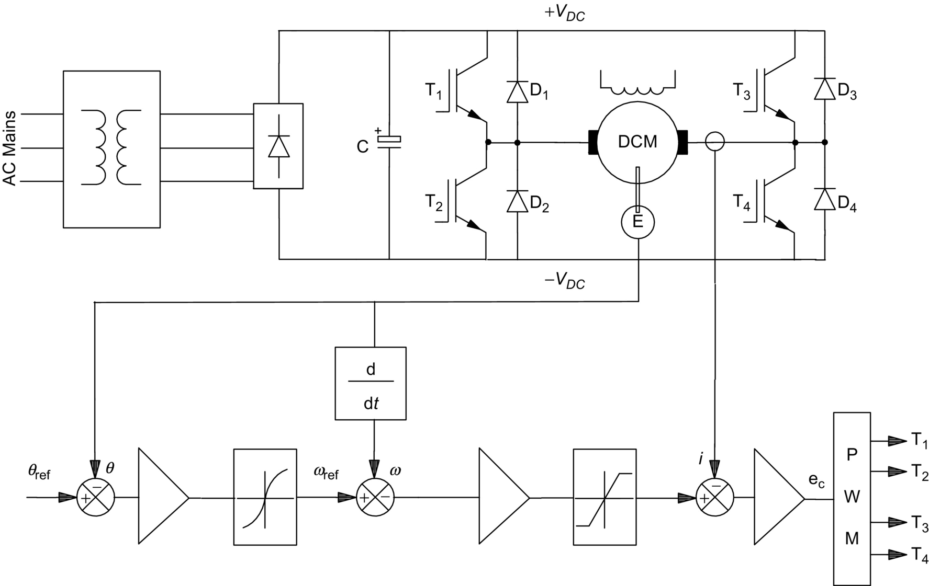

**FIG. 30.9** Bidirectional speed- and position-control system with a PWM transistor bridge drive.

For forward driving, the transistors T1 and T4 and diode D2 are used as a buck converter that supplies a variable voltage, *va*, to the armature given by

 **(30.12)**

where *VDC* is the dc supply voltage to the converter and *δ* is the duty cycle of the transistor T1.

The duty cycle *δ* is defined as the duration of the ON-time of the modulating (switching transistor) as a fraction of the switching period. The switching frequency is normally dictated by the application and the type of switching devices selected for the application.

During regenerative braking in the forward direction, transistors T2 and diode D4 are used as a boost converter that regulates the braking current through the motor by automatically adjusting the duty cycle of T2. The energy of the overhauling motor now returns to the dc supply through the diode D1, aided by the motor back emf and the dc supply. Again, note that the braking converter, comprising T2 and D1, may be used to maintain the regenerative braking current at the maximum allowable level right down to zero speed.

[Fig. 30.10](https://learning.oreilly.com/library/view/power-electronics-handbook/9780128114087/B9780128114070000349_1.xhtml#f0055) shows a typical acceleration-deceleration cycle of such a drive under the action of the control loops indicated in [Fig. 30.9](https://learning.oreilly.com/library/view/power-electronics-handbook/9780128114087/B9780128114070000349_1.xhtml#f0050).

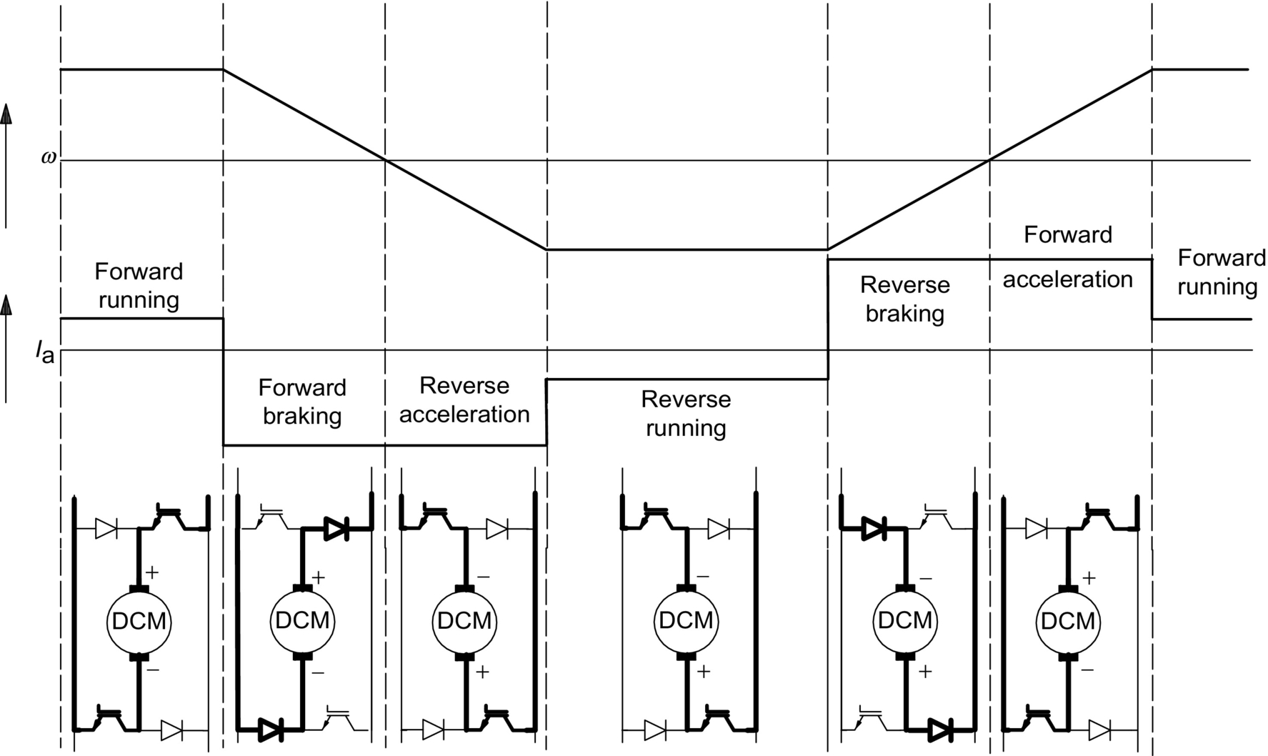

**FIG. 30.10** Converter conduction and operating duty with a PWM bridge transistor drive.

Four-quadrant PWM converter drives such as that in [Fig. 30.10](https://learning.oreilly.com/library/view/power-electronics-handbook/9780128114087/B9780128114070000349_1.xhtml#f0055) are widely used for motion-control equipment in the automation industry. Because of the significant development of power switching devices, switching frequencies of 10–20 kHz are easily attainable. At such frequencies, virtually, no derating of the motor is necessary.

In order to satisfy the requirements of a drive application, simpler versions of the drive circuits indicated in [Figs. 30.7](https://learning.oreilly.com/library/view/power-electronics-handbook/9780128114087/B9780128114070000349_1.xhtml#f0040) and [30.9](https://learning.oreilly.com/library/view/power-electronics-handbook/9780128114087/B9780128114070000349_1.xhtml#f0050) may be used. For instance, for a unidirectional drive, half of the converter circuits indicated earlier may be used. Further simplification of the drive circuit is possible, if regenerative braking is not required.

### 30.2.4 DRIVE SYSTEM INTEGRATION

A complete drive system has a torque controller (armature current controller for a dc drive) as its innermost loop, followed by a speed controller as indicated in [Fig. 30.11](https://learning.oreilly.com/library/view/power-electronics-handbook/9780128114087/B9780128114070000349_1.xhtml#f0060).

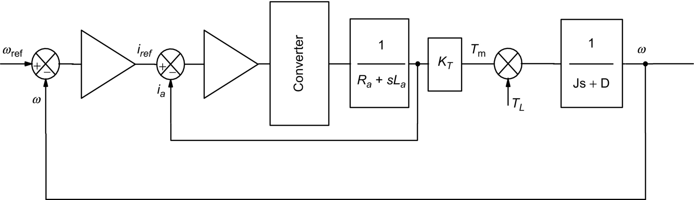

**FIG. 30.11** Structure of a closed-loop speed-control system with a dc drive.

The inner current loop is often regulated with a proportional-plus-integral (PI)-type controller of high gain. The rest of the inner loop consists of the converter, the motor armature, which is essentially an R-L circuit with the armature back emf as disturbance and the current sensor. The current sensor is typically an isolated circuit, such as a Hall sensor or a direct-current transformer (DCT). A well-designed torque (armature current) loop behaves essentially as a first-order lag system. Together with the mechanical inertia load, this loop can be indicated as the middle Bode plot of [Fig. 30.12](https://learning.oreilly.com/library/view/power-electronics-handbook/9780128114087/B9780128114070000349_1.xhtml#f0065), in which 1/*T*1 represents the current-controlled system bandwidth. (Note that the damping factor *D* and the load torque *TL* indicated in [Fig. 30.11](https://learning.oreilly.com/library/view/power-electronics-handbook/9780128114087/B9780128114070000349_1.xhtml#f0060) have been neglected in this description for simplicity.) The current loop is normally designed by analyzing the block diagram of [Fig. 30.11](https://learning.oreilly.com/library/view/power-electronics-handbook/9780128114087/B9780128114070000349_1.xhtml#f0060), the converter and the PI controller for the current loop using Bode analysis or other control system design tools.

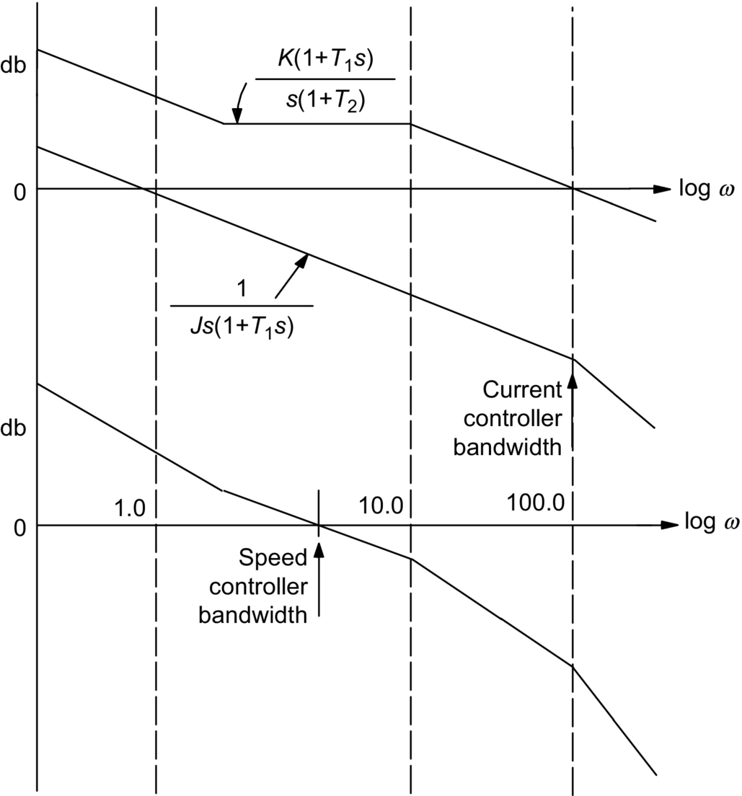

**FIG. 30.12** Typical current and speed-control-loop designs for the system of [Fig. 30.11](https://learning.oreilly.com/library/view/power-electronics-handbook/9780128114087/B9780128114070000349_1.xhtml#f0060).

The next step is usually the design of the speed controller. The 0 db intercept of  is normally too low. Again, if a PI controller is selected for the speed loop, its Bode plot is superimposed on the current-controlled system as indicated in [Fig. 30.12](https://learning.oreilly.com/library/view/power-electronics-handbook/9780128114087/B9780128114070000349_1.xhtml#f0065) to obtain the desired speed-control bandwidth.

### 30.2.5 CONVERTER-DC DRIVE SYSTEM CONSIDERATIONS

Several operational factors need to be considered in applying a dc drive. Some of the important ones are as follows:

1. The armature current may be rich in harmonics. This is particularly true for thyristor converters. The feedback of these current ripples into the FCC may cause overloading of individual switches and tripping. Adequate filtering is necessary to avoid such problems.

2. Since the converter is switched at regular intervals while the current controller operates continuously, current overshoot may occur because of the delay in the FCC. The current controller gains must be limited to limit this overshoot.

3. The switching frequency of the converter should be selected according to the desired motor-current ripple, supply input current harmonics, and the dynamic performance of the drive.

4. Ripple in the speed-sensor output limits the performance of the speed controller. Analog tachogenerator output is particularly noisy and defines the upper limit of the speed-control bandwidth. Digital speed sensors, such as encoders and resolvers, alleviate this limit significantly.

## 30.3 Induction Motor Drives

### **30.3.1 INTRODUCTION**

The ac induction motor is by far the most widely used motor in the industry. Traditionally, it has been used in constant and variable-speed drive applications that do not cater for fast dynamic processes. Because of the recent development of several new control technologies, such as vector and direct torque controls, this situation is changing rapidly. The underlying reason for this is the fact that the cage induction motor is much cheaper and more rugged than its competitor, the dc motor, in such applications. This section starts with the induction motor drives that are based on the steady-state equivalent circuit of the motor, followed by vector-controlled drives that are based on its dynamic model.

### 30.3.2 STEADY-STATE REPRESENTATION

The traditional methods of variable-speed drives are based on the equivalent circuit representation of the motor referred to the stator, as shown in [Fig. 30.13](https://learning.oreilly.com/library/view/power-electronics-handbook/9780128114087/B9780128114070000349_1.xhtml#f0070).

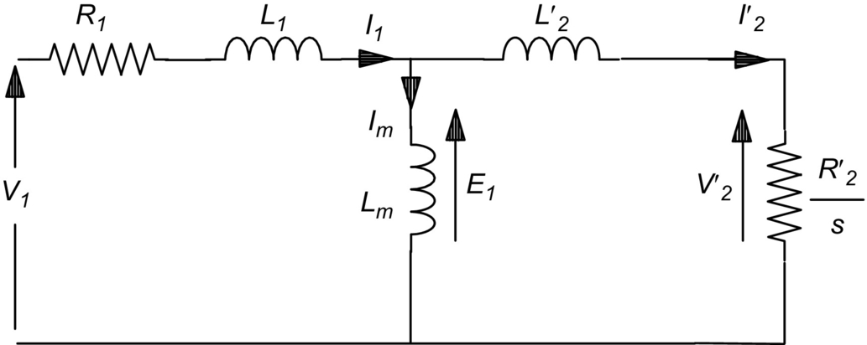

**FIG. 30.13** Steady-state equivalent circuit of an induction motor.

From this representation, the following power relationships in terms of motor parameters and the rotor slip can be found:

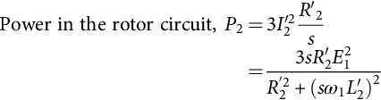 **(30.13)**

**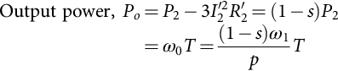** **(30.14)**

where

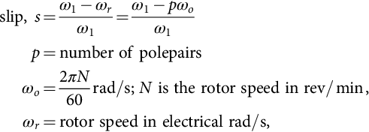 **(30.15)**

and



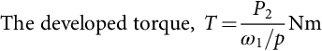 **(30.16)**

The slip frequency, *sf*1, is the frequency of the rotor current and the air-gap voltage *E*1 is given by

 **(30.17)**

where *λm* is the stator flux linkage due to the air-gap flux. If the stator impedance is negligible compared with *E*1, which is true when *f*1 is near the rated frequency *fo*,

 **(30.18)**

and

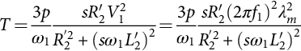 **(30.19)**

### 30.3.3 CHARACTERISTICS AND METHODS OF CONTROL

The above analysis suggests several speed-control methods. The following are the widely used methods:

1. Stator voltage control

2. Slip power control

3. Variable-voltage, variable-frequency (*V-f*) control

4. Variable-current, variable-frequency (*I-f*) control

These methods are sometimes called *scalar controls* to distinguish them from *vector controls*, which are described in [Section 30.3.4](https://learning.oreilly.com/library/view/power-electronics-handbook/9780128114087/B9780128114070000349_1.xhtml#s0105). The torque-speed characteristics of the motor differ significantly under different types of control, as will be evident in the following sections.

#### **30.3.3.1 Stator Voltage Control**

In this method of control, back-to-back thyristors are used to supply the motor with variable ac voltage, as indicated in the converter circuit diagram of [Fig. 30.14A](https://learning.oreilly.com/library/view/power-electronics-handbook/9780128114087/B9780128114070000349_1.xhtml#f0075).

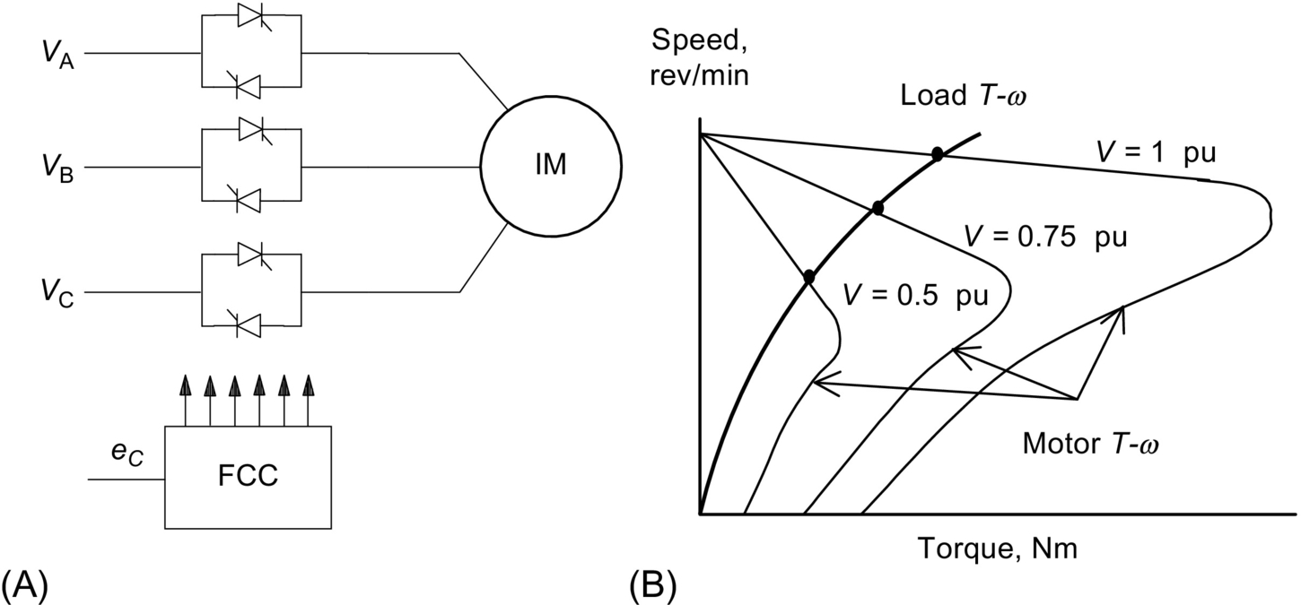

**FIG. 30.14** (A) Stator voltage controller and (B) motor and load torque-speed characteristics under voltage control.

The analysis of [Section 30.3.1](https://learning.oreilly.com/library/view/power-electronics-handbook/9780128114087/B9780128114070000349_1.xhtml#s0060) implies that the developed torque varies inversely as the square of the input root-mean-square (RMS) voltage to the motor, as indicated in [Fig. 30.14B](https://learning.oreilly.com/library/view/power-electronics-handbook/9780128114087/B9780128114070000349_1.xhtml#f0075). This makes such a drive suitable for fan- and impeller-type loads for which the torque demand rises faster with speed. For other type of loads, the suitable speed range is very limited. Motors with high rotor resistance may offer an extended speed range. It should be noted that this type of drive with back-to-back thyristors with the firing-angle control suffers from poor power and harmonic distortion factors when operated at a low speed.

If unbalanced operation is acceptable, the thyristors in one or two supply lines to the motor may be bypassed. This offers the possibility of dynamic braking or plugging, desirable in some applications.

#### **30.3.3.2 Slip Power Control**

Variable-speed, three-phase, wound-rotor (or slip-ring) induction motor drives with slip power control may take several forms. In a passive scheme, the rotor power is rectified and dissipated in a liquid resistor or in a multitapped resistor that may be adjustable and forced cooled. In a more popular scheme, which is widely used in medium- to large-capacity pumping installations, the rectified rotor power is returned to the ac mains by a thyristor converter operating in a naturally commutated inversion mode. This static Scherbius scheme is indicated in [Fig. 30.15](https://learning.oreilly.com/library/view/power-electronics-handbook/9780128114087/B9780128114070000349_1.xhtml#f0080). In this scheme, the rotor terminals are connected to a three-phase diode bridge that rectifies the rotor voltage. This rotor output is then inverted into mains frequency ac by a fully controlled thyristor converter operating from the same mains as the motor stator.

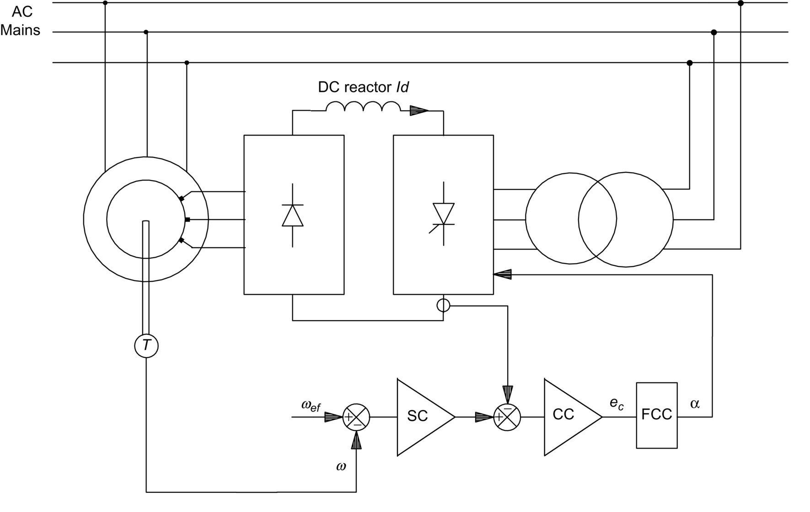

**FIG. 30.15** The static Scherbius drive scheme of slip power control.

The converter in the rotor circuit handles only the rotor slip power, so that the cost of the power converter circuit can be much less than that of an equivalent inverter drive, albeit at the cost of the more expensive motor. The dc-link current, smoothed by a reactor, may be regulated by controlling the firing angle of the converter in order to maintain the developed torque at the level required by the load. The current controller (CC) and speed controller (SC) are also indicated in [Fig. 30.15](https://learning.oreilly.com/library/view/power-electronics-handbook/9780128114087/B9780128114070000349_1.xhtml#f0080). The current controller output determines the converter firing angle *α* from the firing control circuit (FCC).

From the equivalent circuit of [Fig. 30.13](https://learning.oreilly.com/library/view/power-electronics-handbook/9780128114087/B9780128114070000349_1.xhtml#f0070) and ignoring the stator impedance, the RMS voltage per phase in the rotor circuit is given by

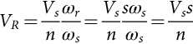 **(30.20)**

where *ωs* and *ωr* are the angular frequencies of the voltages in the stator and rotor circuits, respectively, and *n* is the ratio of the equivalent stator to rotor turns. The dc-link voltage at the rectifier terminals of the rotor, *v*d is given by

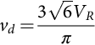

Assuming that the transformer interposed between the inverter output and the ac supply has the same turns ratio *n* as the effective stator-to-rotor turns of the motor,

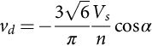 **(30.21)**

The negative sign arises because the thyristor converter develops negative dc voltage in the inverter mode of operation. The dc-link inductor is mainly to ensure continuous current through the converter so that the expression [(30.21)](https://learning.oreilly.com/library/view/power-electronics-handbook/9780128114087/B9780128114070000349_1.xhtml#fo0130) holds for all conditions of operation. Combining the preceding three equations gives



and the rotor speed

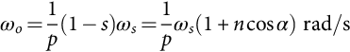 **(30.22)**

Thus, the motor speed can be controlled by adjusting the firing angle *α*. By varying *α* between 180*°* and 90*°*, the speed of the motor can be varied from zero to full speed, respectively. For a motor with low rotor resistance and with the assumptions taken earlier, it can be shown that the developed torque of the motor is given by

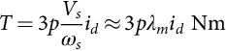 **(30.23)**

where *id* is the dc-link current. Thus, the inner torque-control loop of a variable-speed drive using the Scherbius scheme normally employs a dc-link current loop as the innermost torque loop. [Fig. 30.16](https://learning.oreilly.com/library/view/power-electronics-handbook/9780128114087/B9780128114070000349_1.xhtml#f0085) shows the transient responses of the dc-link, rotor, and stator currents of such a drive when the motor is accelerated between two speeds.



**FIG. 30.16** Transient responses of a slip power-controlled drive under acceleration.

The drive is normally started with a short-time-rated liquid resistor, and the thyristor speed controller is started when the drive reaches a certain speed.

By replacing the diode rectifier of [Fig. 30.16](https://learning.oreilly.com/library/view/power-electronics-handbook/9780128114087/B9780128114070000349_1.xhtml#f0085) with another thyristor bridge, power can be made to flow to and from the rotor circuit, allowing the motor to operate at higher than synchronous speed, as is used for grid-connected generator operation in wind power conversion. For very large drives, a cycloconverter may also be used in the rotor circuit with direct conversion of frequency between the ac supply and the rotor and driving the motor above and below synchronous speed.

#### **30.3.3.3 Variable-Voltage, Variable-Frequency (V–f) Control**

##### **SPWM inverter drive**

When an induction motor is driven from an ideal ac voltage source, its normal operating speed is less than 5% below the synchronous speed, which is determined by the ac source frequency and the number of motor poles. With a sinusoidally modulated (SPWM) inverter, indicated in [Fig. 30.17](https://learning.oreilly.com/library/view/power-electronics-handbook/9780128114087/B9780128114070000349_1.xhtml#f0090), the supply frequency to the motor can be easily adjusted for variable speed. Eq. [(30.18)](https://learning.oreilly.com/library/view/power-electronics-handbook/9780128114087/B9780128114070000349_1.xhtml#fo0110) implies that, if rated air-gap flux is to be maintained at its rated value at all speeds, the supply voltage *V*1 to the motor should be varied in proportion to the frequency *f*1, when the voltage drop across the stator resistance can considered to be negligible. The block diagram of [Fig. 30.18A](https://learning.oreilly.com/library/view/power-electronics-handbook/9780128114087/B9780128114070000349_1.xhtml#f0095) shows how the frequency *f*1 and the output voltage *V*1 of the SPWM inverter are proportionately adjusted with the speed reference. The speed reference signal is normally passed through a filter that only allows a gradual change in the frequency *f*1. This type of control is widely referred to as the *V-f* inverter drive. Control of the stator input voltage *V*1 as a function of the frequency *f*1 is readily arranged within the inverter by modulating the switches . At a low speed, however, where the input voltage *V*1 is low, most of the input voltage may drop across the stator impedance, leading to a reduction in air-gap flux and loss of torque.

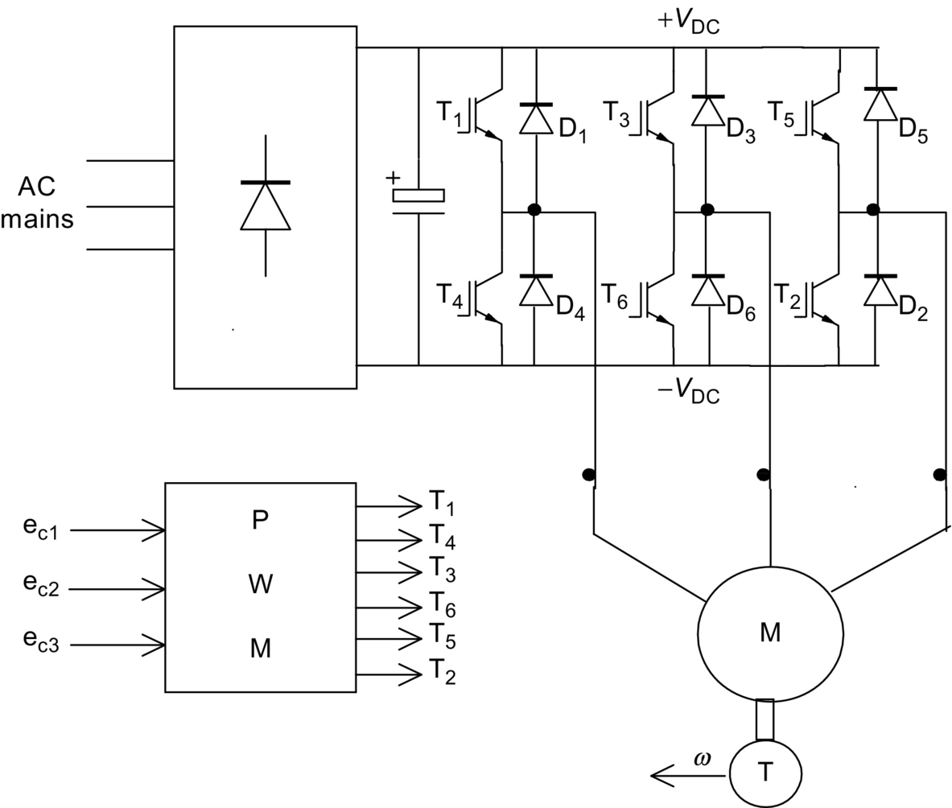

**FIG. 30.17** *V-f* drive with SPWM inverter.

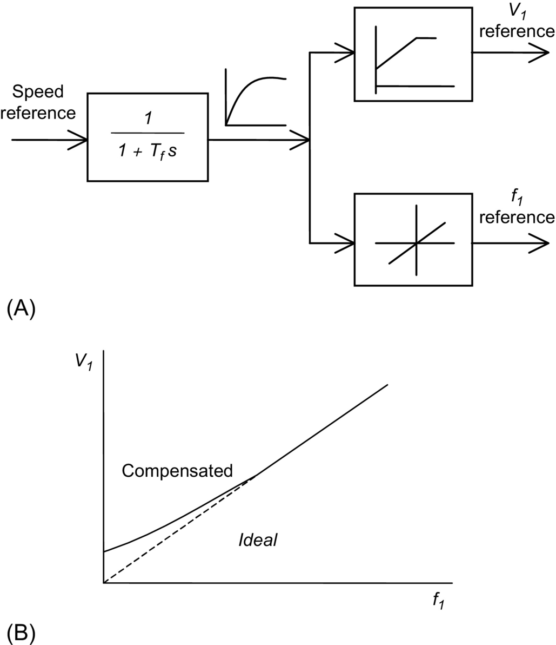

**FIG. 30.18** (A) Input reference filter and voltage and frequency reference generation for the *V-f* inverter drive and (B) voltage compensation at a low speed.

Compensation for the stator resistance drop, as indicated in [Fig. 30.18B](https://learning.oreilly.com/library/view/power-electronics-handbook/9780128114087/B9780128114070000349_1.xhtml#f0095), is often employed. However, if the motor becomes lightly loaded at a low speed, the air-gap flux may exceed the rated value, causing the motor to overheat.

From the equivalent circuit of [Fig. 30.13](https://learning.oreilly.com/library/view/power-electronics-handbook/9780128114087/B9780128114070000349_1.xhtml#f0070) and neglecting the rotor leakage inductance, the developed torque *T* and the rotor current *I*′2 are given by

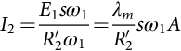 **(30.24)**

and

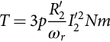 **(30.25)**

where s *ω*1 is the slip frequency, which is also the frequency of the voltages and currents in the rotor. Eq. [(30.24)](https://learning.oreilly.com/library/view/power-electronics-handbook/9780128114087/B9780128114070000349_1.xhtml#fo0150) implies that by limiting the slip *s*, the rotor current can be limited, which in turn limits the developed torque Eq. [(30.25)](https://learning.oreilly.com/library/view/power-electronics-handbook/9780128114087/B9780128114070000349_1.xhtml#fo0155). Consequently, a slip-limited drive is also a torque-limited drive. Note that this is true only in the steady state. A speed-control system with such a slip limiter is shown in [Fig. 30.19](https://learning.oreilly.com/library/view/power-electronics-handbook/9780128114087/B9780128114070000349_1.xhtml#f0100). In this scheme, the motor speed is sensed and added to a limited speed error (or limited slip speed) to obtain the frequency (or speed reference for the *V-f* drive).

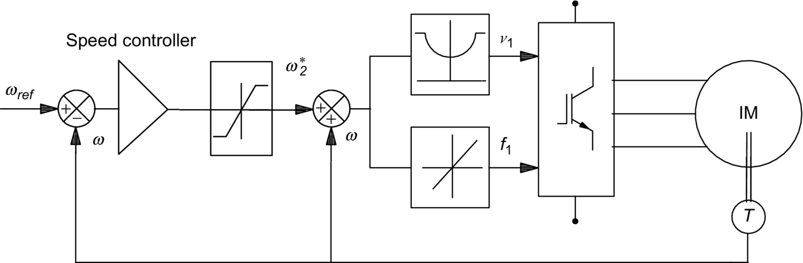

**FIG. 30.19** Closed-loop speed controller with an inner slip loop.

Many applications of the *V-f* controller, however, are open-loop schemes, in which any demanded variation in *V*1 is passed through a ramp limiter (or filter) so that sudden changes in the slip speed *ωr* are precluded, thereby allowing the motor to follow the change in the supply frequency without exceeding the rotor current and torque limits.

From the foregoing analyses, it is obvious that the *V-f* inverter drive essentially operates in all four quadrants, with rotor speed dropping slightly with the load and developing full torque at the same slip speed at all speeds. This assumes that the stator input voltage is properly compensated, so that the motor is operated with constant (or rated) air-gap flux at all speed. The motor can be operated above the base speed by keeping the input voltage *V*1 constant, while increasing the stator frequency above base frequency in order to run the motor at speeds higher than the base speed. The air-gap flux and hence the maximum developed torque now fall with speed, leading to constant-power-type characteristic. [Fig. 30.20](https://learning.oreilly.com/library/view/power-electronics-handbook/9780128114087/B9780128114070000349_1.xhtml#f0105) depicts the  characteristics of such a voltage- and frequency-controlled drive for various operating frequencies. In this figure, the  characteristic for base speed has been drawn in full, indicating the maximum developed torque *Tmax* and the rated torque. Below base speed, the  ratio is maintained to keep the air-gap flux constant. Above base speed, *V*1 is kept constant, while *f*1 increases with speed, thus weakening the air-gap flux. Forward driving in quadrant 1 takes place with the inverter output voltage sequence of , whereas reverse driving in quadrant 3 takes place with the sequence . Regenerative braking while forward driving takes place by adjusting the input frequency *f*1 in such a way that the motor operates in quadrant 2 (quadrant 4 for reverse braking) with the desired braking characteristic.

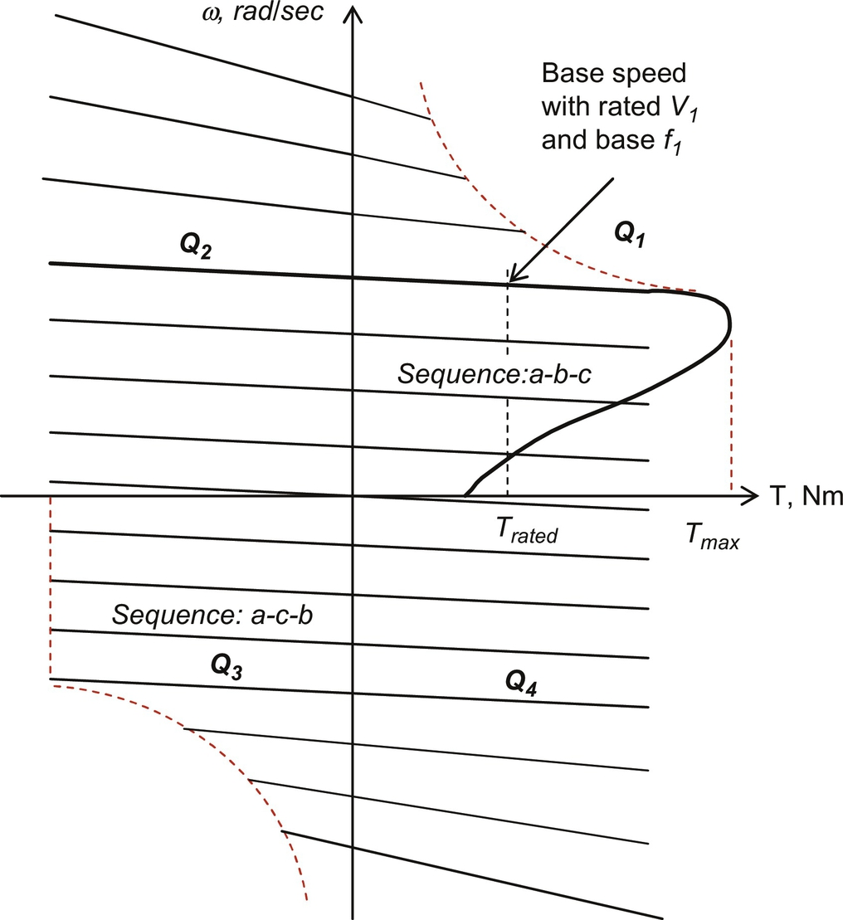

**FIG. 30.20** Typical  characteristics of *V-f* drive with the input frequency *f*1 and voltage *V*1 below and above base speed.

Note that the characteristics in [Fig. 30.20](https://learning.oreilly.com/library/view/power-electronics-handbook/9780128114087/B9780128114070000349_1.xhtml#f0105) are based on the steady-state equivalent circuit model of the motor. Such a drive suffers from the poor torque response during transient operation because of time-dependent interactions between the stator and rotor fluxes. [Fig. 30.21](https://learning.oreilly.com/library/view/power-electronics-handbook/9780128114087/B9780128114070000349_1.xhtml#f0110) indicates the machine air-gap flux during acceleration with *V-f* control obtained from a dynamic model. Clearly, the air-gap flux does not remain constant during the dynamic operation.

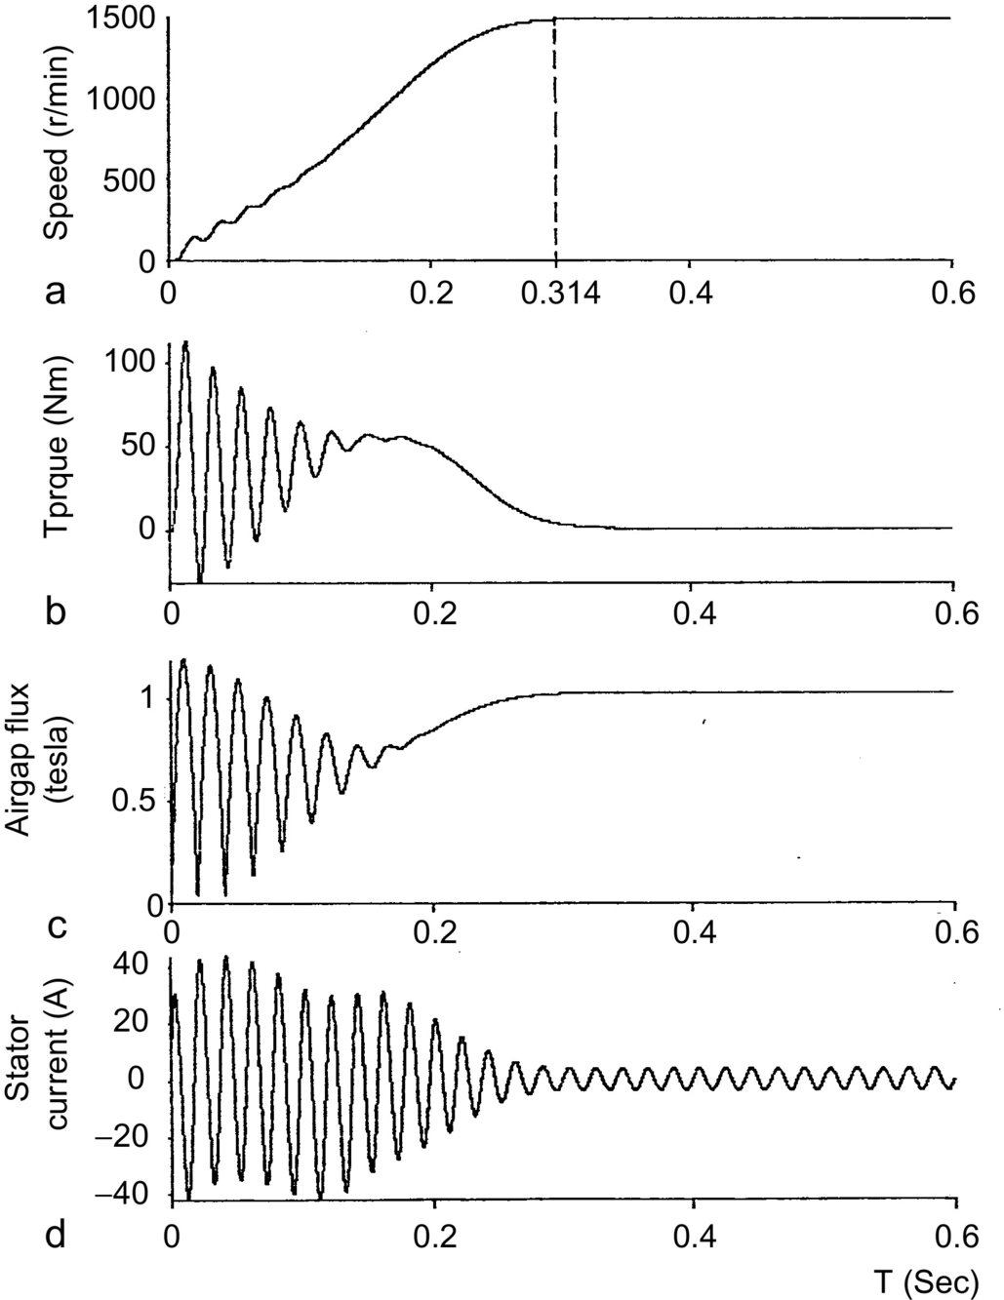

**FIG. 30.21** Transient response of torque, speed, current, and air-gap flux during acceleration from standstill using a *V-f* inverter drive.

##### **Cycloconverter drive**

For large-capacity induction motor drives, the variable-frequency supply at variable voltage is effectively obtained from a cycloconverter in which a back-to-back thyristor converter pairs are used, one for each phase of the motor, as indicated in [Fig. 30.22](https://learning.oreilly.com/library/view/power-electronics-handbook/9780128114087/B9780128114070000349_1.xhtml#f0115). Each thyristor block in this figure represents a fully controlled thyristor ac-dc converter. The maximum output frequency of such a converter can be as high as about 40% of the supply frequency. In view of the large number of thyristor switches required, cycloconverter drives are suitable for large-capacity but low-speed applications.

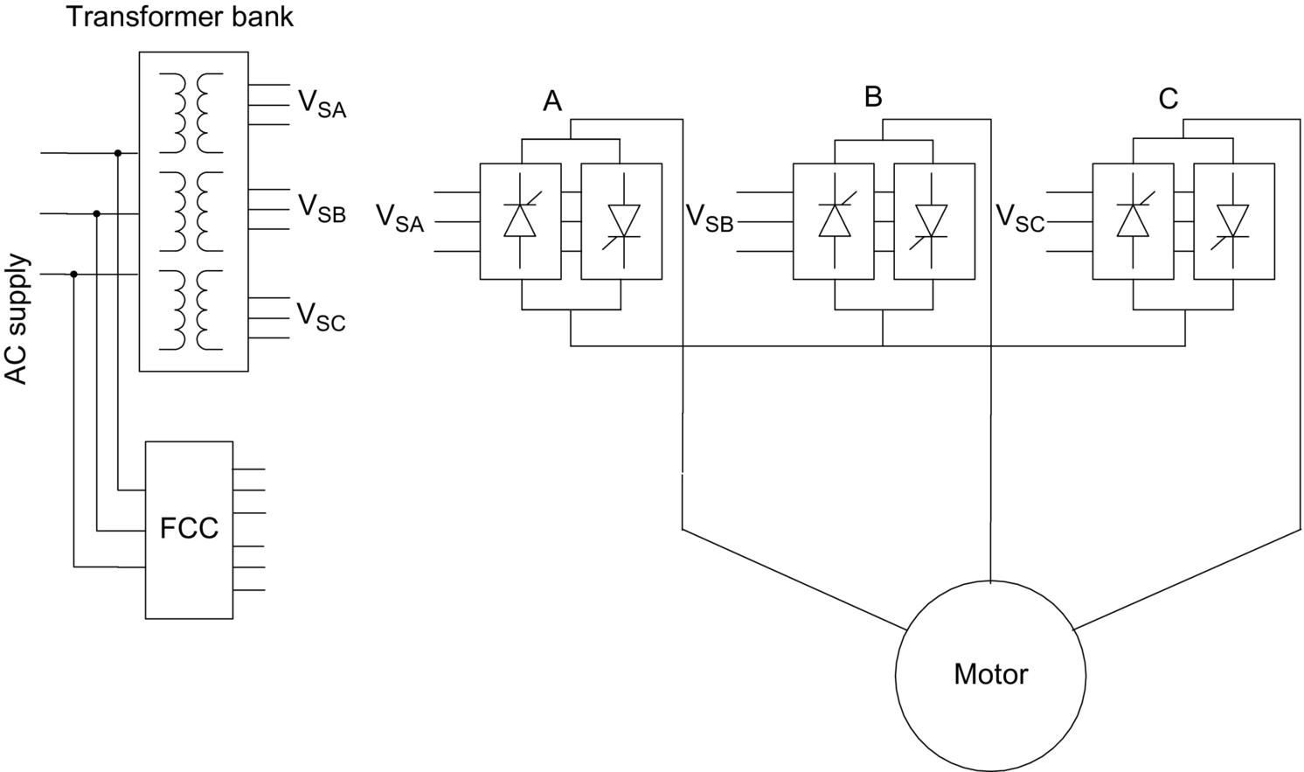

**FIG. 30.22** *V-f* drive with cycloconverter drive.

#### **30.3.3.4 Variable Current–Variable Frequency (*I–f*) Control**

In this scheme, medium- to large-capacity induction motors are driven from a variable but stiff current supply that may be obtained from a thyristor converter and a dc-link inductor as indicated in [Fig. 30.23](https://learning.oreilly.com/library/view/power-electronics-handbook/9780128114087/B9780128114070000349_1.xhtml#f0120). The frequency of the current supply to the motor is adjusted by a thyristor converter with auxiliary diodes and capacitors. The diodes in each inverter leg and the capacitors across them are needed for turning off the thyristors when current is to be commutated from one to the next in sequence. The motor-current waveforms are normally six-step, or quasi-square, as indicated in [Fig. 30.24](https://learning.oreilly.com/library/view/power-electronics-handbook/9780128114087/B9780128114070000349_1.xhtml#f0125). The switching states of the inverter thyristors are also indicated in this figure. The motor voltage waveforms are determined by the load. These waveforms are more nearly sinusoidal than the current waveforms.

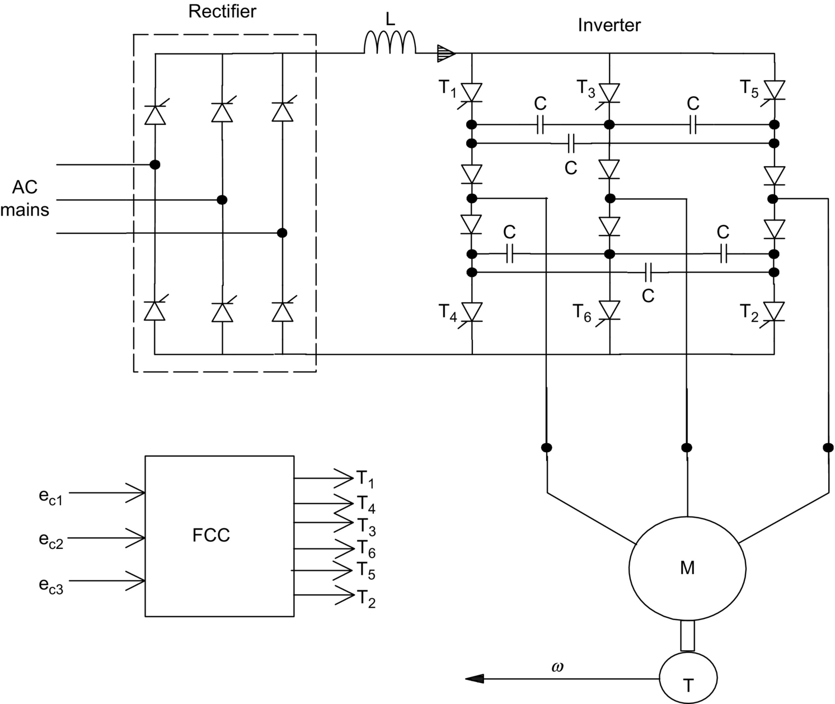

**FIG. 30.23** DC-link current-source thyristor inverter drive.

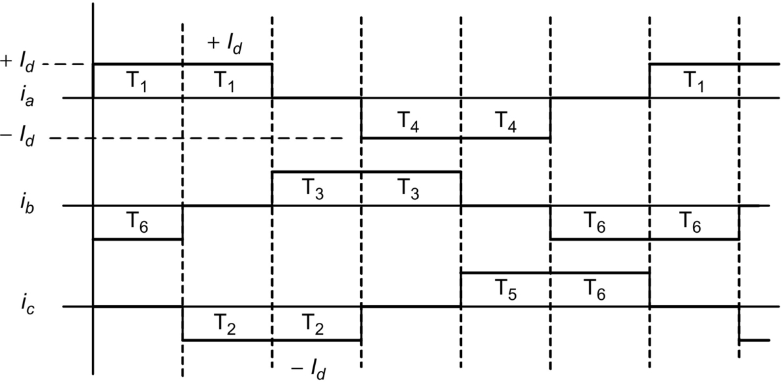

**FIG. 30.24** Motor-current waveforms and the thyristor switching states for a current-source drive.

The thyristor converter supplying the quasi-square current waveforms to the motor has firing-angle control, in order to regulate the dc-link current to the inverter. The dynamics of the dc-link current control is such that this current may be considered to be constant during the time the inverter switches commutate the dc-link current from one switch to the next. Such a current-source drive offers four-quadrant operation, with independent control of the dc-link current and output frequency. One drawback is that the motor voltage waveforms have voltage spikes due to commutation.

From the analysis of [Section 30.3.2](https://learning.oreilly.com/library/view/power-electronics-handbook/9780128114087/B9780128114070000349_1.xhtml#s0065), if the higher order harmonics of the current waveforms in [Fig. 30.24](https://learning.oreilly.com/library/view/power-electronics-handbook/9780128114087/B9780128114070000349_1.xhtml#f0125) are neglected and it is assumed that the motor voltage and current waveforms are sinusoidal, the magnetizing current *Im* in [Fig. 30.13](https://learning.oreilly.com/library/view/power-electronics-handbook/9780128114087/B9780128114070000349_1.xhtml#f0070) can be kept constant (for constant air-gap flux operation) if the RMS value of the stator supply current *I*1 is defined according to Eq. [(30.26)](https://learning.oreilly.com/library/view/power-electronics-handbook/9780128114087/B9780128114070000349_1.xhtml#fo0160). This relationship is also shown in graphic form in [Fig. 30.25](https://learning.oreilly.com/library/view/power-electronics-handbook/9780128114087/B9780128114070000349_1.xhtml#f0130).

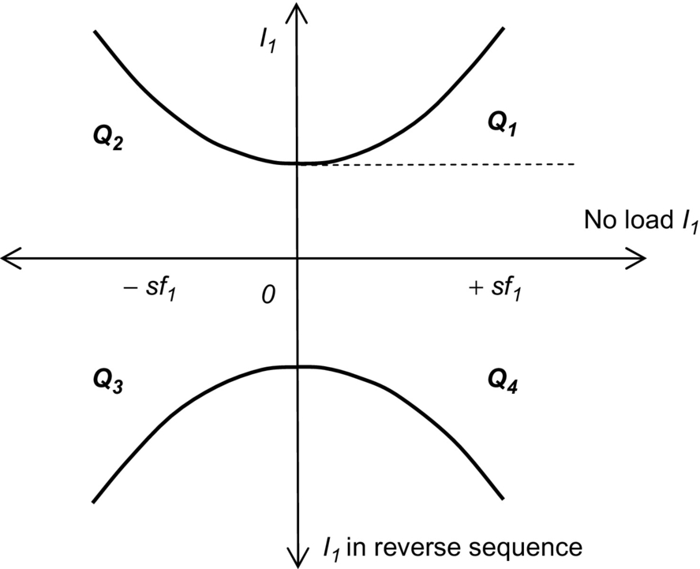

**FIG. 30.25** Stator current versus rotor (slip) frequency for constant air-gap flux operation.

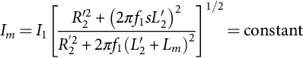 **(30.26)**

The control scheme for variable-speed operation with a current-source drive is indicated in the block diagram of [Fig. 30.26](https://learning.oreilly.com/library/view/power-electronics-handbook/9780128114087/B9780128114070000349_1.xhtml#f0135). The speed reference defines the stator current reference according to Eq. [(30.26)](https://learning.oreilly.com/library/view/power-electronics-handbook/9780128114087/B9780128114070000349_1.xhtml#fo0160), and the frequency reference is obtained by adding the rotor frequency to the actual speed of the motor. The inverter drive may consist of the thyristor current source and the inverter of [Fig. 30.23](https://learning.oreilly.com/library/view/power-electronics-handbook/9780128114087/B9780128114070000349_1.xhtml#f0120) or a diode rectifier supplied SPWM transistor inverter of [Fig. 30.17](https://learning.oreilly.com/library/view/power-electronics-handbook/9780128114087/B9780128114070000349_1.xhtml#f0090) with independent current regulators, one for each phase.

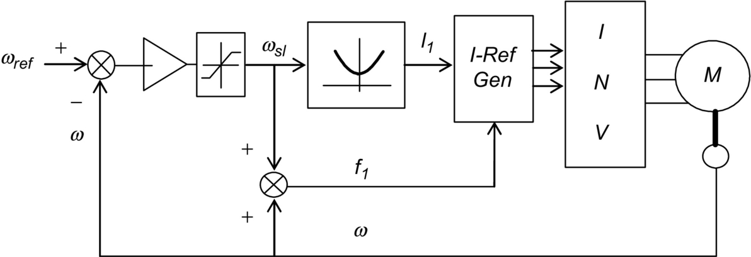

**FIG. 30.26** Variable-current/variable-frequency inverter drive scheme.

The dynamic performance of such current-controlled induction motor drives is not very satisfactory, just as for the voltage-source inverters. Furthermore, the current-source inverter drive cannot normally be operated open loop, like the *V-f* inverter drive. For high dynamic performance, vector-controlled drives are becoming popular.

### 30.3.4 VECTOR CONTROLS

The foregoing scalar control methods are only suitable for adjustable-speed applications in which the load speed or position is not controlled like in a servo system. Instantaneous frequency control with a view to control motor speed or position cannot be defined, and therefore, instantaneous torque control cannot be addressed by scalar control methods. Vector control technique allows a squirrel-cage induction motor to be driven with high dynamic performance, comparable with that of a dc motor. In vector control, machine dynamic model rather than steady-state model (on which scalar controllers are based on) is used to design the controller. For this, the controller needs to know the rotor speed (in the indirect method) or the air-gap flux vector (in the direct method) accurately, using sensors. The latter method is not practical because of the requirement of attaching air-gap flux sensors. The indirect method, which is being widely accepted in recent years, requires the controller to be matched with the motor being driven. This is because the controller also needs to know some rotor parameter(s), which may vary according to the conditions of operation, continuously.

#### **30.3.4.1 Basic Principles**

The methods of vector control are based on the dynamic equivalent circuit of the induction motor. There are at least three fluxes (rotor, air gap, and stator) and three currents or mmfs (stator, rotor, and magnetizing) in an induction motor. For high dynamic response, interactions among current, fluxes, and speed, must be taken into account in determining appropriate control strategies. These interactions are understood only via the dynamic model of the motor.

All fluxes rotate at synchronous speed. The three-phase currents create mmfs (stator and rotor) that also rotate at synchronous speed. Vector control aligns axes of an mmf and a flux orthogonally at all times. It is easier to align the stator current mmf orthogonally to the rotor flux.

Any three-phase sinusoidal set of quantities in the stator can be transformed to an orthogonal reference frame by

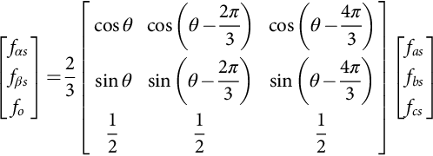 **(30.27)**

where *θ* is the angle of the orthogonal set  with respect to any arbitrary reference. If the  axes are stationary and the *α*-axis is aligned with the stator *α*-axis, then  at all times. Thus,

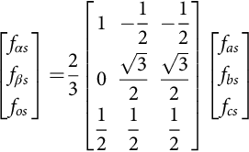 **(30.28)**

If the orthogonal set of reference rotates at the synchronous speed *ω*1, its angular position at any instant is given by

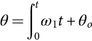 **(30.29)**

The orthogonal set is then referred to as  axes. The three-phase rotor variables, transformed to the synchronously rotating frame, are

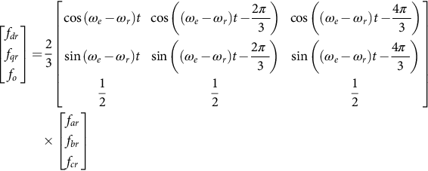 **(30.30)**

It should be noted that the difference  is the relative speed between the synchronously rotating reference frame and the frame attached to the rotor. This difference is also the slip frequency, *ωsl*, which is the frequency of the rotor variables. By applying these transformations, voltage equations of the motor in the synchronously rotating frame reduce to

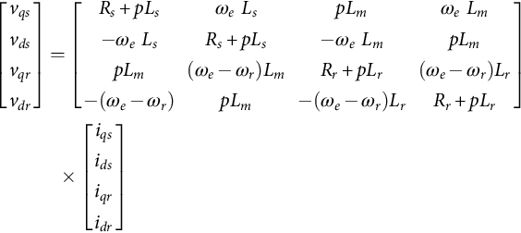 **(30.31)**

where the speed of the reference frame, *ωe*, is equal to *ω*1 and 

Subscripts *l* and *m* stand for leakage and magnetizing, respectively, and *p* represents the differential operator *d/dt*, not the number of pole pairs. The equivalent circuits of the motor in this reference frame are indicated in [Fig. 30.27A and B](https://learning.oreilly.com/library/view/power-electronics-handbook/9780128114087/B9780128114070000349_1.xhtml#f0140).

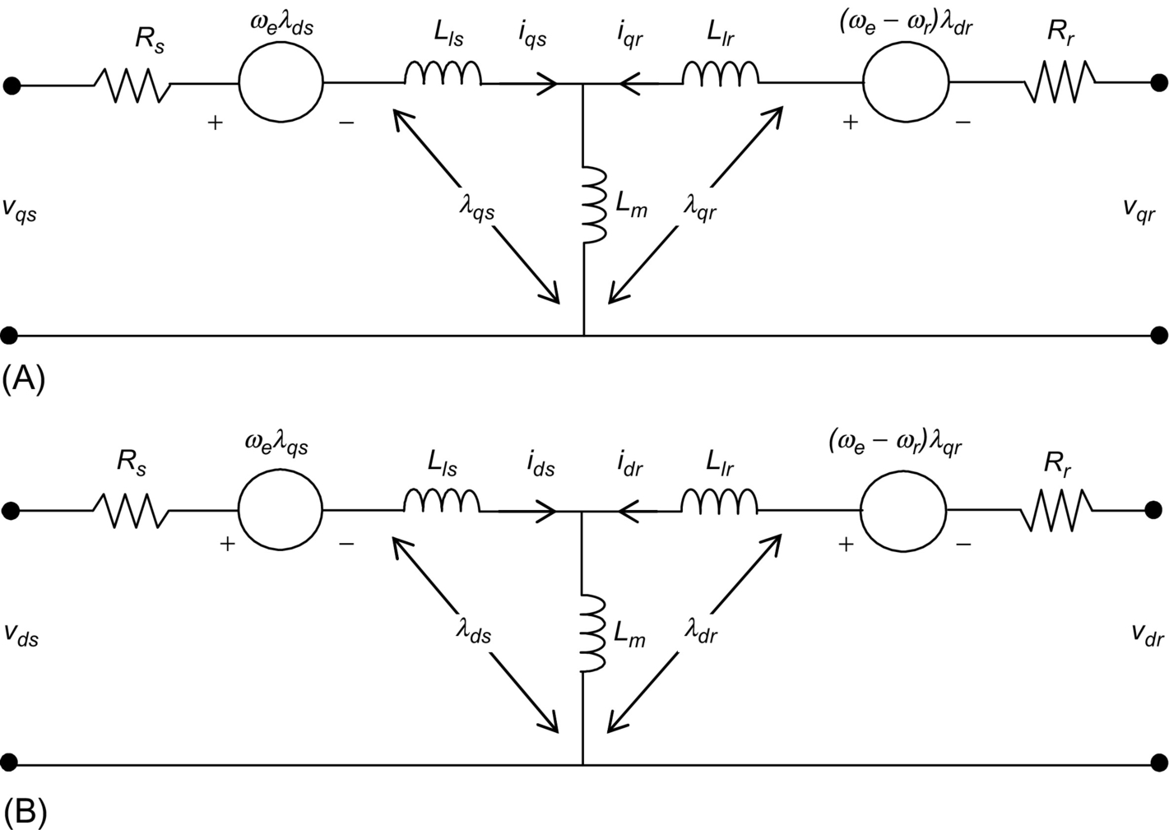

**FIG. 30.27** Motor dynamic equivalent circuits in the synchronously rotating: (A) *q*- and (B) *d*-axes.

The stator flux linkage equations are

 **(30.32)**

**** **(30.33)**

**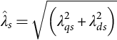** **(30.34)**

The rotor flux linkages are given by

 **(30.35)**

**** **(30.36)**

**** **(30.37)**

The air-gap flux linkages are given by

 **(30.38)**

**** **(30.39)**

**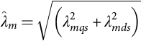** **(30.40)**

The torque developed by the motor is given by

 **(30.41)**

where *p* is the number of pole pairs.

From Eq. [(30.31)](https://learning.oreilly.com/library/view/power-electronics-handbook/9780128114087/B9780128114070000349_1.xhtml#fo0185), the rotor voltage equations are

 **(30.42)**

**** **(30.43)**

Using Eqs. [(30.35)](https://learning.oreilly.com/library/view/power-electronics-handbook/9780128114087/B9780128114070000349_1.xhtml#fo0205) and [(30.36)](https://learning.oreilly.com/library/view/power-electronics-handbook/9780128114087/B9780128114070000349_1.xhtml#fo0210),

 **(30.44)**

**** **(30.45)**

Also from Eqs. [(30.35)](https://learning.oreilly.com/library/view/power-electronics-handbook/9780128114087/B9780128114070000349_1.xhtml#fo0205) and [(30.36)](https://learning.oreilly.com/library/view/power-electronics-handbook/9780128114087/B9780128114070000349_1.xhtml#fo0210),

 **(30.46)**

**** **(30.47)**

The rotor currents *iqr* and *idr* can be eliminated from Eqs. [(30.44)](https://learning.oreilly.com/library/view/power-electronics-handbook/9780128114087/B9780128114070000349_1.xhtml#fo0250) and [(30.45)](https://learning.oreilly.com/library/view/power-electronics-handbook/9780128114087/B9780128114070000349_1.xhtml#fo0255) by using Eqs. [(30.46)](https://learning.oreilly.com/library/view/power-electronics-handbook/9780128114087/B9780128114070000349_1.xhtml#fo0260) and [(30.47)](https://learning.oreilly.com/library/view/power-electronics-handbook/9780128114087/B9780128114070000349_1.xhtml#fo0265). Thus,

 **(30.48)**

**** **(30.49)**

The elimination of transients in rotor flux and the coupling between the two axes occurs when

 **(30.50)**

The rotor flux should also remain constant so that

 **(30.51)**

From Eq. [(30.48)](https://learning.oreilly.com/library/view/power-electronics-handbook/9780128114087/B9780128114070000349_1.xhtml#fo0270) to Eq. [(30.51)](https://learning.oreilly.com/library/view/power-electronics-handbook/9780128114087/B9780128114070000349_1.xhtml#fo0285),

 **(30.52)**

**** **(30.53)**

Substituting the expressions for *iqr* and *idr* into Eqs. [(30.35)](https://learning.oreilly.com/library/view/power-electronics-handbook/9780128114087/B9780128114070000349_1.xhtml#fo0205) and [(30.36)](https://learning.oreilly.com/library/view/power-electronics-handbook/9780128114087/B9780128114070000349_1.xhtml#fo0210),

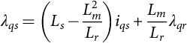 **(30.54)**

**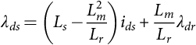** **(30.55)**

Substituting *λqs* and *λds* from Eqs. [(30.54)](https://learning.oreilly.com/library/view/power-electronics-handbook/9780128114087/B9780128114070000349_1.xhtml#fo0300) and [(30.55)](https://learning.oreilly.com/library/view/power-electronics-handbook/9780128114087/B9780128114070000349_1.xhtml#fo0305) into the torque equation of Eq. [(30.41)](https://learning.oreilly.com/library/view/power-electronics-handbook/9780128114087/B9780128114070000349_1.xhtml#fo0235),

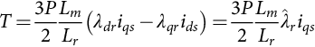 **(30.56)**

It is clear from Eq. [(30.53)](https://learning.oreilly.com/library/view/power-electronics-handbook/9780128114087/B9780128114070000349_1.xhtml#fo0295) that the rotor flux  is determined by *ids*, subject to a time delay *Tr*, which is the rotor time constant (*Lr*/*Rr*). The current *iqs*, according to Eq. [(30.56)](https://learning.oreilly.com/library/view/power-electronics-handbook/9780128114087/B9780128114070000349_1.xhtml#fo0310), controls the developed torque *T* without delay. Currents *ids* and *iqs* are orthogonal to each other and are called the flux- and torque-producing currents, respectively. This correspondence between the flux- and torque-producing currents is subject to maintaining the conditions in Eqs. [(30.50)](https://learning.oreilly.com/library/view/power-electronics-handbook/9780128114087/B9780128114070000349_1.xhtml#fo0280) and [(30.51)](https://learning.oreilly.com/library/view/power-electronics-handbook/9780128114087/B9780128114070000349_1.xhtml#fo0285). Normally, *ids* would remain fixed for operation up to the base speed. Thereafter, it is reduced in order to weaken the rotor flux so that the motor may be driven with a constant-power-like characteristic.

Based on how the rotor flux is detected and regulated, two methods of control are available. One is the more popular indirect rotor-flux-oriented control (IFOC) method, and the other is the direct vector control method; both are described hereafter.

#### **30.3.4.2 Indirect Rotor Flux Oriented (IFOC) Vector Control**

In the indirect scheme, the relationship between the slip frequency and current *iqs* given by Eq. [(30.52)](https://learning.oreilly.com/library/view/power-electronics-handbook/9780128114087/B9780128114070000349_1.xhtml#fo0290) is used to relate the compensated speed error  to *iqs*. The *iqs*, in turn, is used to develop to the demanded torque *T*⁎ according to the Eq. [(30.56)](https://learning.oreilly.com/library/view/power-electronics-handbook/9780128114087/B9780128114070000349_1.xhtml#fo0310). The rotor flux is maintained at the base value for operation below speed, and it may be reduced to a lower value for field weakening above base speed. The orthogonal relationship between the torque-producing stator current *iqs* and the flux-producing stator current *ids* is maintained at all times by generating the stator current references in the synchronously rotating *dq* reference frame, using sine and cosine functions of angle *θ*1. This angle is obtained as indicated in [Fig. 30.28](https://learning.oreilly.com/library/view/power-electronics-handbook/9780128114087/B9780128114070000349_1.xhtml#f0145).

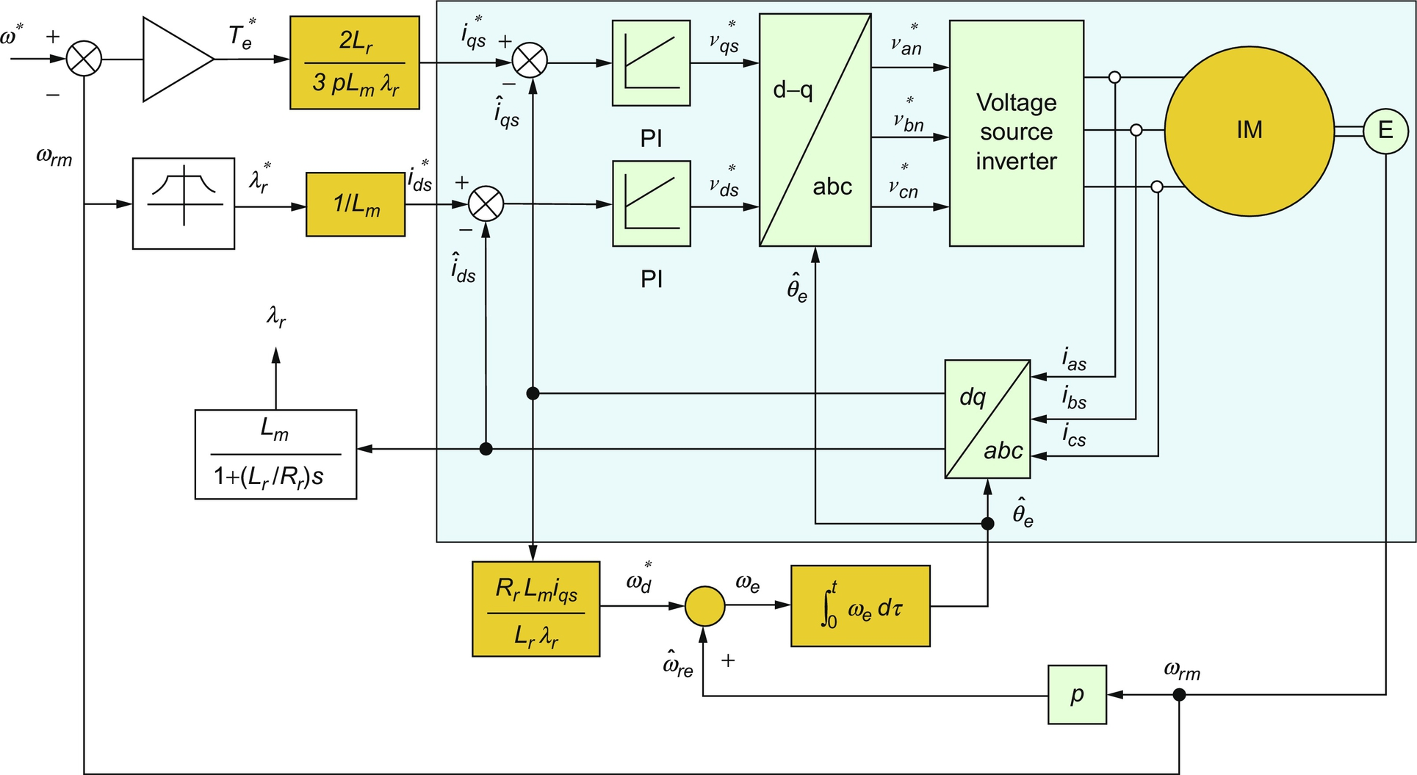

**FIG. 30.28** Indirect rotor flux oriented vector control scheme.

The compensated speed error produces the current reference  according to Eq. [(30.56)](https://learning.oreilly.com/library/view/power-electronics-handbook/9780128114087/B9780128114070000349_1.xhtml#fo0310). The current reference  also gives the slip speed *ωsl*, according to Eq. [(30.53)](https://learning.oreilly.com/library/view/power-electronics-handbook/9780128114087/B9780128114070000349_1.xhtml#fo0295). The slip speed *ωsl* is added to the rotor speed *ω*, to obtain the stator frequency *ω*1. This frequency is integrated with respect to time to produce the required angle *θ*1 of the stator mmf relative to the rotor flux vector. This angle is used to transform the stator currents to the *dq* reference frame. Two independent current controllers are used to regulate the *iq* and *id* currents to their reference values. The compensated *iq* and *id* errors are then inverse transformed into the stator  reference frame for obtaining switching signals for the inverter via PWM or hysteresis comparators.

It is clear that this scheme uses a feedforward scheme, or a machine model, in which the current reference for *iqs* is also determined by the rotor time constant *Tr*. This is also indicated in [Fig. 30.28](https://learning.oreilly.com/library/view/power-electronics-handbook/9780128114087/B9780128114070000349_1.xhtml#f0145). The rotor time constant *Tr* cannot be expected to remain constant for all conditions of operation. Its considerable variation with operating conditions means that the slip speed *ωsl*, which directly affects the developed torque and the rotor flux vector position, may vary widely. Many rotor time-constant identification schemes have been developed in recent years to overcome the problem.

The mandatory requirement for a rotor-speed sensor is also a significant drawback, because its presence reduces the reliability of the IFOC drive. Consequently, sensorless schemes of identifying the rotor flux position have also drawn considerable interest in recent years.

[Fig. 30.29](https://learning.oreilly.com/library/view/power-electronics-handbook/9780128114087/B9780128114070000349_1.xhtml#f0150) shows the transient response of an induction motor under the IFOC drive scheme of [Fig. 30.28](https://learning.oreilly.com/library/view/power-electronics-handbook/9780128114087/B9780128114070000349_1.xhtml#f0145). In this case, the drive accelerates a large inertia load from standstill to the base speed of 1500 rev/min. It is clear that the overcurrent transients of [Fig. 30.21](https://learning.oreilly.com/library/view/power-electronics-handbook/9780128114087/B9780128114070000349_1.xhtml#f0110) are eliminated, while the motor accelerates under a constant torque (implied by the constant rate at which the speed increases) and settles at the final speed with little over- or undershoot in speed. Clearly, rotor and air-gap fluxes remain constant at all times.

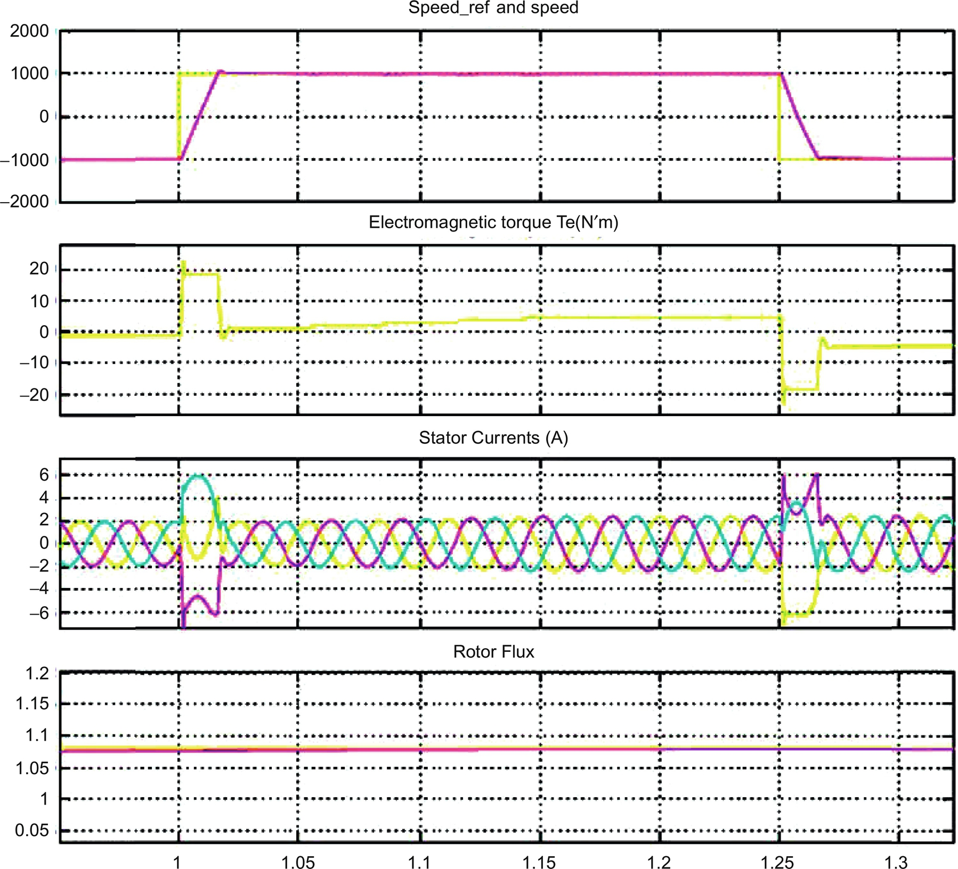

**FIG. 30.29** Speed and current responses of an induction motor drive under the IFOC scheme of [Fig. 30.28](https://learning.oreilly.com/library/view/power-electronics-handbook/9780128114087/B9780128114070000349_1.xhtml#f0145).

#### **30.3.4.3 Direct Vector Control with Airgap Flux Sensing**

In the direct scheme, use is made of the air-gap flux linkages in the stator *d*- and *q*-axes, which are then compensated for the respective leakage fluxes in order to determine the rotor flux linkages in the stator reference frame. The air-gap flux linkages are measured by installing quadrature flux sensors in the air gap, as indicated in [Fig. 30.30](https://learning.oreilly.com/library/view/power-electronics-handbook/9780128114087/B9780128114070000349_1.xhtml#f0155).

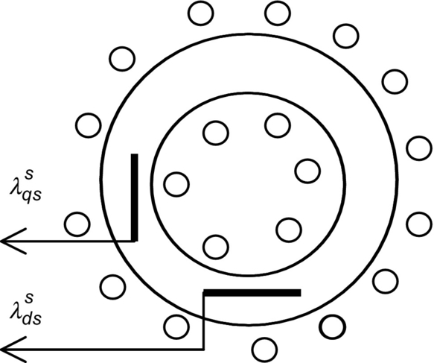

**FIG. 30.30** Quadrature sensors for air-gap flux for direct vector control.

By returning to Eqs. [(30.32)](https://learning.oreilly.com/library/view/power-electronics-handbook/9780128114087/B9780128114070000349_1.xhtml#fo0190)–[(30.40)](https://learning.oreilly.com/library/view/power-electronics-handbook/9780128114087/B9780128114070000349_1.xhtml#fo0230) in the stator reference frame and using some simplifications, it can be shown that

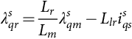 **(30.57)**

**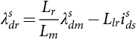** **(30.58)**

where the superscript *s* stands for the stator reference frame. Since the rotor flux rotates at a synchronous speed with respect to the stator reference frame, the angle *θ*1 used for the coordinate transformations in [Fig. 30.27](https://learning.oreilly.com/library/view/power-electronics-handbook/9780128114087/B9780128114070000349_1.xhtml#f0140) can be obtained from

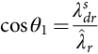 **(30.59)**

**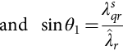** **(30.60)**

where 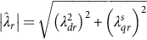.

The control of torque via *iqs* and the rotor flux via *ids*, subject to satisfying conditions [(30.50)](https://learning.oreilly.com/library/view/power-electronics-handbook/9780128114087/B9780128114070000349_1.xhtml#fo0280) and [(30.51)](https://learning.oreilly.com/library/view/power-electronics-handbook/9780128114087/B9780128114070000349_1.xhtml#fo0285), remain as indicated in [Fig. 30.28](https://learning.oreilly.com/library/view/power-electronics-handbook/9780128114087/B9780128114070000349_1.xhtml#f0145), according to the basic principle of vector control.

The requirement of air-gap flux sensors is rather restrictive. Such fittings also reduce reliability. Even though this method of control offers better low-speed performance than the IFOC, this restriction has practically precluded the adoption of this scheme. In an alternative method, the *d*- and *q*-axes stator flux linkages of the motor may be computed from integrating the stator input voltages.

## 30.4 Synchronous Motor Drives

### **30.4.1 INTRODUCTION**

Variable-speed synchronous motors have been widely used in very large-capacity () pumping and centrifuge-type applications using naturally commutated current-source thyristor converters. At the low-power end, the current-source SPWM inverter-driven synchronous motors have become very popular in recent years in the form of permanent-magnet brushless dc and ac synchronous motor drives in servo-type applications. There are certain features of three-phase synchronous motors that have allowed them, especially the lower capacity motors, to be controlled with high dynamic performance using cheaper control hardware than is required for the induction motor of similar capacity. Since the average speed of the synchronous motor is precisely related to the supply frequency, which can be precisely controlled, multimotor drives with a fixed speed ratio among them are also good candidates for synchronous motor drives. This section begins with the performance of the variable-speed nonsalient-pole and salient-pole synchronous motor drive using the steady-state equivalent circuit followed by the dynamics of the vector-controlled synchronous motor drive.

### 30.4.2 STEADY-STATE EQUIVALENT-CIRCUIT REPRESENTATION OF THE MOTOR

Some of the operating characteristics of variable-frequency voltage- and current-source-driven synchronous motors can be readily obtained from their steady-state equivalent representation, as was the case with the scalar controls of induction motor drives. Assuming balanced, sinusoidal distribution of stator and rotor mmfs and a uniform air-gap (nonsalient-pole motor), the per-phase equivalent circuit of [Fig. 30.31](https://learning.oreilly.com/library/view/power-electronics-handbook/9780128114087/B9780128114070000349_1.xhtml#f0160) represents the motor at a constant speed.

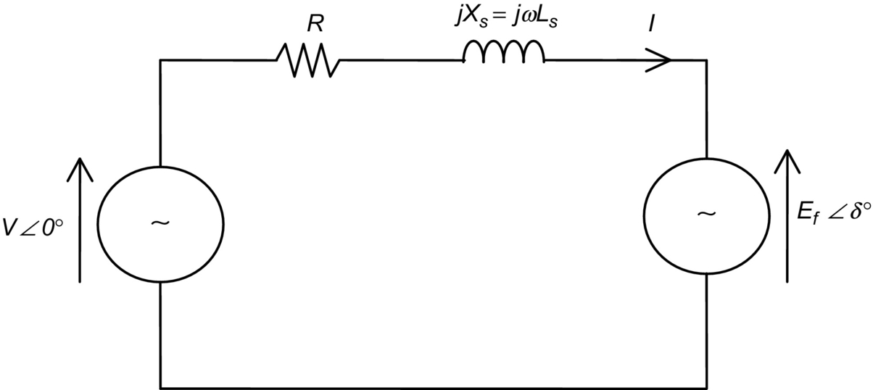

**FIG. 30.31** Equivalent circuit of a nonsalient-pole motor.

The representation in [Fig. 30.31](https://learning.oreilly.com/library/view/power-electronics-handbook/9780128114087/B9780128114070000349_1.xhtml#f0160) is in terms of the RMS voltage *V* applied to the motor phase winding that consists of the phase resistance *R*, the synchronous reactance *Xs* (in Ω/phase), and the per-phase induced voltage *Ef*. The back emf *Ef* develops in the stator phase winding as a result of rotor excitation supplied from an external dc source via slip rings or by permanent magnets in the rotor. The phasor *Ef* has an arbitrary phase angle *δ* with respect to the input voltage *V*. This is the load angle of the motor.

Unlike the induction motor, a synchronous motor may derive part or all of its excitation from the rotor via rotor excitation. For small synchronous motors that are used in the brushless dc and ac servo applications, this excitation is derived from permanent magnets in the rotor. This is readily and economically obtained with the modern permanent magnets, thus dispensing with the slip-ring-brush assembly. The *i*2*R* losses in the rotor windings with the external excitation are also eliminated. These magnets also allow considerable reduction in space requirement for the rotor excitation. For large synchronous motors, this excitation is supplied more economically from an external dc source via slip rings or via an exciter.

The phasor diagrams of [Fig. 30.32](https://learning.oreilly.com/library/view/power-electronics-handbook/9780128114087/B9780128114070000349_1.xhtml#f0165) may be used to analyze characteristics of the nonsalient-pole synchronous motor drive. Since the rotor magnetic field may be such that the motor may develop a back emf that is smaller or larger than the ac supply voltage to the stator windings, the motor may accordingly be underexcited or overexcited, respectively. The overexcited motor will normally operate at a leading power factor, as is the case in [Fig. 30.32B](https://learning.oreilly.com/library/view/power-electronics-handbook/9780128114087/B9780128114070000349_1.xhtml#f0165). This is desirable in high-power applications.

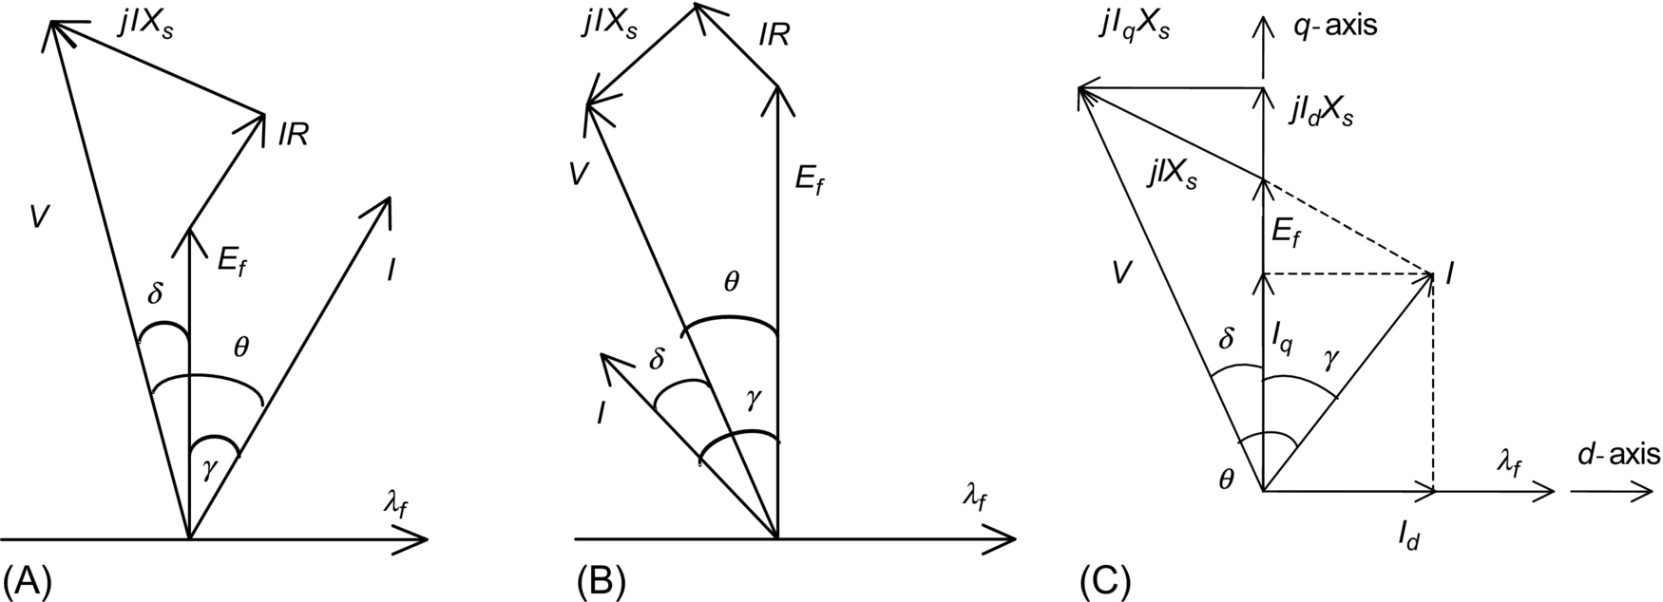

**FIG. 30.32** Phasor diagrams of synchronous motors: (A) underexcited nonsalient-pole motor, (B) overexcited nonsalient-pole motor, and (C) underexcited salient-pole motor.

In the phasor diagrams of [Fig. 30.32C](https://learning.oreilly.com/library/view/power-electronics-handbook/9780128114087/B9780128114070000349_1.xhtml#f0165), the stator current *I* has been resolved into two components *Id* and *Iq*, which are current phasors responsible for developing mmfs in the rotor *d*- and *q*-axes. These representations are in the stator reference frame, and hence are sinusoidal quantities at the frequency of the stator supply.

If the voltage drop across the stator resistance is neglected, which may be acceptable when the stator frequency is near the base frequency or higher, the developed torque *T* of the motor can be found from the phasor relationships of [Fig. 30.32](https://learning.oreilly.com/library/view/power-electronics-handbook/9780128114087/B9780128114070000349_1.xhtml#f0165). Thus

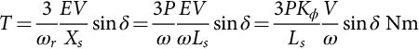 **(30.61)**

for the nonsalient-pole motor (also for the sine wave PM ac motor with rotor magnets at the surface of the rotor) and

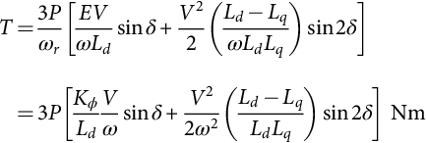 **(30.62)**

for the salient-pole motor (also for the interior-magnet motor in which the rotor magnets are buried inside the rotor). Here, the flux constant of the motor, *Kϕ*, is the ratio of the RMS value of the phase voltage *Ef* induced in the stator only due to the rotor excitation and speed. Note that for a given rotor excitation, the ratio  remains constant at all speed.

### 30.4.3 PERFORMANCE WITH VOLTAGE-SOURCE INVERTER DRIVE

Eqs. [(30.61)](https://learning.oreilly.com/library/view/power-electronics-handbook/9780128114087/B9780128114070000349_1.xhtml#fo0335) and [(30.62)](https://learning.oreilly.com/library/view/power-electronics-handbook/9780128114087/B9780128114070000349_1.xhtml#fo0340) imply that if the motor is driven from a voltage-source supply and if the input voltage to frequency ratio, *V-f*, is kept constant, the motor will develop the same maximum torque at all speeds. For the nonsalient-pole motor, this maximum torque will occur for a load angle . For the salient-pole motor, this will occur for a load angle, which is also influenced by the relative values of *Ld* and *Lq*.

At a low speed, where the supply voltage *V* is small, the voltage drop in the stator resistance may become significant compared with *Ef*. This may lead to a significant drop in the maximum available torque, as given by the torque Eqs. [(30.63)](https://learning.oreilly.com/library/view/power-electronics-handbook/9780128114087/B9780128114070000349_1.xhtml#fo0345) and [(30.64)](https://learning.oreilly.com/library/view/power-electronics-handbook/9780128114087/B9780128114070000349_1.xhtml#fo0350), which are derived from the phasor diagrams of [Fig. 30.32](https://learning.oreilly.com/library/view/power-electronics-handbook/9780128114087/B9780128114070000349_1.xhtml#f0165). The stator per-phase resistance *R* is now included in the analysis. The developed torque is then given by

 **(30.63)**

for the nonsalient-pole motor and

 **(30.64)**

for the salient-pole motor where the subscript *o* refers to the base quantities and *λ* refers to the per unit input frequency *f*1/*f*0.

Eqs. [(30.63)](https://learning.oreilly.com/library/view/power-electronics-handbook/9780128114087/B9780128114070000349_1.xhtml#fo0345) and [(30.64)](https://learning.oreilly.com/library/view/power-electronics-handbook/9780128114087/B9780128114070000349_1.xhtml#fo0350) indicate that the maximum torque that the motor can develop diminishes at a low speed because of the voltage drop across the stator resistance *R*. This drop in maximum available torque at a low speed can be avoided by boosting the input voltage at a low speed, as indicated in [Fig. 30.33A](https://learning.oreilly.com/library/view/power-electronics-handbook/9780128114087/B9780128114070000349_1.xhtml#f0170). This voltage boosting is similar to the *IR* compensation applied to a variable-frequency induction motor drive.



**FIG. 30.33** (A) *V-f* controller for an open-loop inverter drive and (B)  characteristics with a limited maximum *δ* for constant-power operation.

[Fig. 30.33](https://learning.oreilly.com/library/view/power-electronics-handbook/9780128114087/B9780128114070000349_1.xhtml#f0170) indicates an open-loop *V-f* inverter drive scheme, similar to the scheme for an induction motor drive in which the RMS stator input voltage is made proportional to frequency. The speed reference is passed through a first-order filter, as shown in [Fig. 30.33A](https://learning.oreilly.com/library/view/power-electronics-handbook/9780128114087/B9780128114070000349_1.xhtml#f0170), so that a large and abrupt change in the input frequency command to the inverter is avoided. The filtered speed reference is translated into a proportional frequency reference *f*1. The voltage reference *V*1 is also proportional to frequency reference but with a zero frequency bias. The variable RMS input voltage *V*1 to the motor may be obtained from an inverter by SPWM methods or from a cycloconverter with phase-angle control.

The available input voltage *V*1 is normally limited by the available dc-link voltage to the inverter or the ac supply voltage to a cycloconverter. This limit is normally arranged to occur at base speed. Above this speed, the stator flux drops leading to field weakening and constant-power-like operation, as indicated in [Fig. 30.33B](https://learning.oreilly.com/library/view/power-electronics-handbook/9780128114087/B9780128114070000349_1.xhtml#f0170). In some control scheme, the maximum load angle *δ* is not allowed to exceed a certain limiting value *δmax*. By selecting *δmax*, constant-power operation at various power levels is possible.

### 30.4.4 CHARACTERISTICS UNDER CURRENT-SOURCE INVERTER (CSI) DRIVE

A CSI-driven synchronous motor drive generally gives higher dynamic response. It also gives better reliability because of the automatic current-limiting feature. In a variable-speed application, the synchronous motor is normally driven from a stiff current source. A rotor-position sensor is used to place the phase current phasor *I* of each phase at a suitable angle with respect to the back-emf phasor (*Ef*) of the same phase. The rotor-position sensor is thus mandatory.

Two converter schemes have generally been used. In one scheme, as indicated in [Fig. 30.34](https://learning.oreilly.com/library/view/power-electronics-handbook/9780128114087/B9780128114070000349_1.xhtml#f0175), a large dc-link reactor (inductor) makes the current source to the inverter stiff. The scheme is suitable for large synchronous motors for which thyristor switches are used in the inverter. A current loop may also be established by sensing the dc-link current and by using a closed-loop current controller that continuously regulates the firing angle of the controllable rectifier in order to supply the inverter with the desired dc-link current. It can be shown that the motor-developed torque is proportional to the level of the dc-link current.



**FIG. 30.34** Schematic of a current-source inverter (CSI)-driven synchronous motor.

The inverter drives the motor with quasi-square-wave current waveforms as indicated in [Fig. 30.35](https://learning.oreilly.com/library/view/power-electronics-handbook/9780128114087/B9780128114070000349_1.xhtml#f0180). The current waveforms are switched according to the measured rotor-position information, such that the current waveform in each phase has a fixed angular displacement, *γ*, with respect to the induced emf of the corresponding phase. Because of this, the drive is sometimes referred to as self-controlled. The angular displacement of these current waveforms (or their fundamental components) with the respective back-emf waveforms is indicated in [Fig. 30.35](https://learning.oreilly.com/library/view/power-electronics-handbook/9780128114087/B9780128114070000349_1.xhtml#f0180). Because of the large dc-link inductor, the phase currents may be considered to remain essentially constant between the switching intervals. The quasi-square current waveforms contain many harmonics, and are responsible for large torque pulsations that may become troublesome at a low speed.

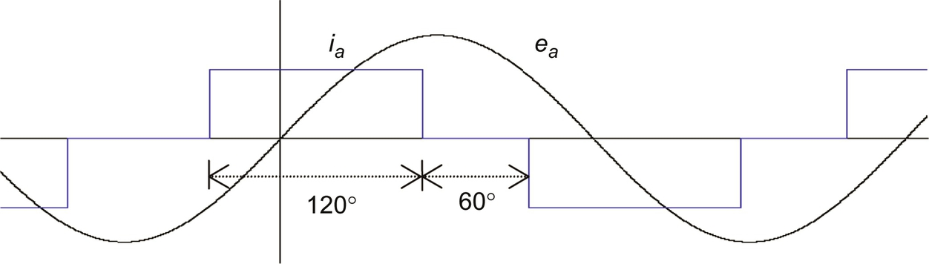



**FIG. 30.35** Current waveforms in the dc-link current-source-driven motor.

In the foregoing scheme, the motor can be reversed easily by reversing the sequence of switching of the inverter. It can also be braked regeneratively by increasing the firing angle of the input rectifier beyond 90*°* while maintaining the dc-link current at the desired braking level until braking is no longer required. The rectifier now returns the energy of the overhauling load to the ac mains regeneratively.

In another scheme, which is preferred for lower capacity drives for which higher dynamic response is frequently sought, phase currents are regulated within the inverter. The inverter typically employs gate turnoff switches, such as the IGBT, and pulse-width modulation techniques, as indicated in [Fig. 30.36](https://learning.oreilly.com/library/view/power-electronics-handbook/9780128114087/B9780128114070000349_1.xhtml#f0185). Motor currents are sensed and used to close independent current controllers for each phase. Normally, two current controllers suffice for a balanced star-connected motor. Three-phase sinusoidal ac currents are supplied to the motor, the amplitude and phase angle of which can be independently controlled as required. The references for the current controllers are obtained from a three-phase current reference generator that is addressed by the feedback of the rotor position. The rotor position is continuously measured by a high-resolution encoder. In this way, the current references and hence the actual stator currents are synchronized to the rotor.



**FIG. 30.36** Control scheme of the PWM current-source drive.

### 30.4.5 BRUSHLESS DC OPERATION OF THE CSI-DRIVEN MOTOR

The torque characteristic of the CSI drive scheme of the foregoing section can be easily analyzed using the phasor diagrams shown earlier, if the harmonics in the motor-current waveform are neglected or if the motor-current waveforms are indeed sinusoidal as in the second scheme described earlier. In the following analysis, it is assumed that the supply current waveforms are sinusoidal. It is also assumed that the phase angle of these current sources with respect to the induced voltage in each phase can be arbitrarily chosen.

The phase back-emf and the current waveforms and the phasor diagram of the nonsalient-pole motor are shown in [Fig. 30.37](https://learning.oreilly.com/library/view/power-electronics-handbook/9780128114087/B9780128114070000349_1.xhtml#f0190). The phase angle *γ* between the *Ef* and *I* phasors and the RMS value (or amplitude) of *I* are determined according to the desired torque and power factor considerations. The developed torque is found from the phasor diagram to be



**FIG. 30.37** Phasor relationships of CSI-driven motor: (A) back-emf and current waveforms and (B) the phasor diagram.

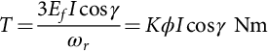 **(30.65)**

If the angle  is chosen, the familiar dc-motor-like torque characteristic is obtained. It should be noted from the foregoing that the developed torque at any speed is independent of *R* since a high-gain (stiff) current-source drive is used. Note also that the ratio *Ef*/*ω* at any operating speed is proportional to the amplitude of the stator flux linkage, *λf*, due to rotor excitation. For fixed rotor excitation, this ratio is a constant.

Eq. [(30.65)](https://learning.oreilly.com/library/view/power-electronics-handbook/9780128114087/B9780128114070000349_1.xhtml#fo0355) indicates that the developed torque of a nonsalient-pole synchronous motor can be controlled by controlling the amplitude of the rotor field (field control), or more conveniently, by controlling the amplitude of the stator phase current. The highest torque per ampere characteristic is achieved when . Note that the operation with a fixed *γ* angle is key to this dc-motor-like torque characteristic.

#### **30.4.5.1 Operation with Field Weakening**

If the stator impedance drop is neglected, the maximum *Ef* is largely determined by the dc-link voltage and  implies that speed *ω* can be increased by decreasing *λf*. Consequently, the operation above base speed is normally achieved with field weakening. In this speed range, because of the limited dc-link voltage, the rotor field must be weakened; otherwise, the amplitude of the phase-induced emf will exceed the dc-link voltage, and current control will not be effective. Field weakening is a means of keeping this voltage at the rated level for speeds higher than the base speed.

The flux linkage due to the rotor excitation, *λf*, can be adjusted when a variable rotor supply is available. This may also be achieved by demagnetizing the rotor mmf by using the mmf produced by the stator currents. For motors with permanent-magnet excitation, the latter is the only means of weakening the *λf*. Referring to the phasor diagram of [Fig. 30.38](https://learning.oreilly.com/library/view/power-electronics-handbook/9780128114087/B9780128114070000349_1.xhtml#f0195), if *I* is made to lead *Ef*, the *d*-axis component of *I*, that is, *Id*, will lead *Ef* by 90*°*. The mmf due to *Id* then opposes the rotor *d*-axis mmf. The net rotor flux linkage along the *q*-axis is then given by



**FIG. 30.38** Field weakening using stator mmf.

 **(30.66)**

where *Id* is negative when *I* leads *Ef*. If the air gap is small, the *d*-axis component of the armature current may reduce the rotor flux to the required extent.

### 30.4.6 OPERATING MODES

A synchronous motor may be driven with a view to achieving various operating characteristics, such as power factor compensation, maximum torque per ampere characteristic, and field weakening. The power factor at which a synchronous motor operates is an important issue, especially for a large drive. A large angle *θ* between the input voltage and current phasors of the motor results in a poor overall power factor. The operation of the synchronous motor with stator current waveforms with a certain phase angle with respect to the respective phase back-emf waveforms allows interesting power-factor compensation possibilities. Consider the following three cases.

#### **30.4.6.1 Case 1: Operation with *I* Lagging *Ef***

In this case, the motor is underexcited and *I* lags *Ef*, by an angle *γ*, as indicated in [Fig. 30.39](https://learning.oreilly.com/library/view/power-electronics-handbook/9780128114087/B9780128114070000349_1.xhtml#f0200). The overall power factor in this case is lagging, since *I* lags *V* by an angle *θ*. The power-factor angle *θ* is larger than *γ*. Note that *Id* now magnetizes the rotor field.

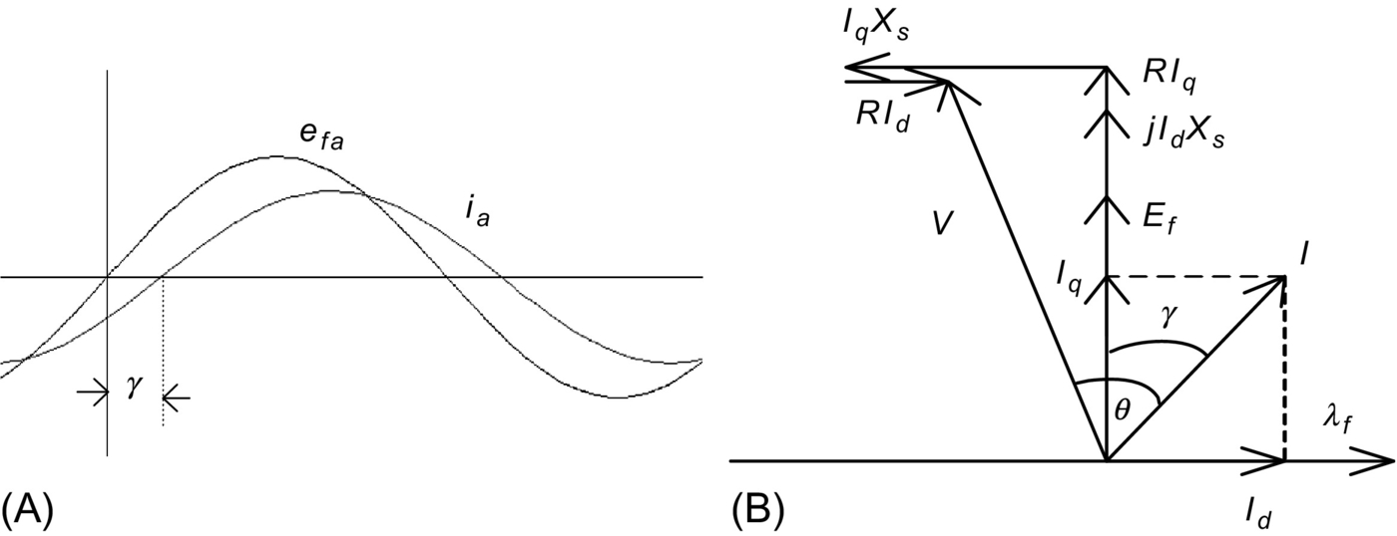

**FIG. 30.39** (A) Phase back-emf and current waveforms and (B) the phasor diagram with *I* lagging *Ef*.

#### **30.4.6.2 Case 2: *I* is in phase with *Ef*; Maximum Torque per Ampere Operation (si109_e)**

If  is used, the motor input current *ia* is in phase with the back emf *ea*, as indicated in the waveforms of [Fig. 30.40A](https://learning.oreilly.com/library/view/power-electronics-handbook/9780128114087/B9780128114070000349_1.xhtml#f0205). From Eq. [(30.65)](https://learning.oreilly.com/library/view/power-electronics-handbook/9780128114087/B9780128114070000349_1.xhtml#fo0355), the developed torque is given by



**FIG. 30.40** (A) Phase back-emf and current waveforms and (B) phasor diagram for *I* in phase with *Ef*.

 **(30.67)**

Thus, for a fixed rotor excitation, the developed torque is the highest that can be achieved per ampere of stator current *I*. In other words, if  is chosen, the drive operates with its maximum torque per ampere characteristic. From the phasor diagram of [Fig. 30.40B](https://learning.oreilly.com/library/view/power-electronics-handbook/9780128114087/B9780128114070000349_1.xhtml#f0205), it is clear that the input current *I* phasor now lags the voltage *V* phasor at the motor terminals (see the phasor diagram in the figure). Note that the level of *Ef* that is determined by the level of excitation also determines the angle *θ* to some extent. Clearly, when maximum-torque-per-ampere characteristic is required, a power factor less than unity has to be accepted.

#### **30.4.6.3 Case 3: Operation with *I* Leading *Ef***

If *I* is chosen to lead *Ef*, the overall power factor can be higher, including unity, as is indicated in [Fig. 30.41](https://learning.oreilly.com/library/view/power-electronics-handbook/9780128114087/B9780128114070000349_1.xhtml#f0210). Note that the motor now operates with less than maximum torque per ampere characteristic. Note also that the *d*-axis component of *I* now tends to demagnetize the rotor and that the operation with field weakening is implied.



**FIG. 30.41** Back-emf and current waveforms and phasor diagram for *I* leading *Ef*.

With a CSI-driven motor, the amplitude and the angle of the phase current relative to the back emf can be selected according to one of the desirable operating characteristics mentioned above. Additionally, other operational limits such as the inverter/motor-current limit, the maximum stator voltage limit, and the maximum power limit can also be addressed. The amplitude of the stator current *I* clearly determines the developed torque of the motor. Consequently, the error of the speed controller is used to determine the amplitude of *I*. The overall control system with an inner torque loop can be described by [Fig. 30.42](https://learning.oreilly.com/library/view/power-electronics-handbook/9780128114087/B9780128114070000349_1.xhtml#f0215).

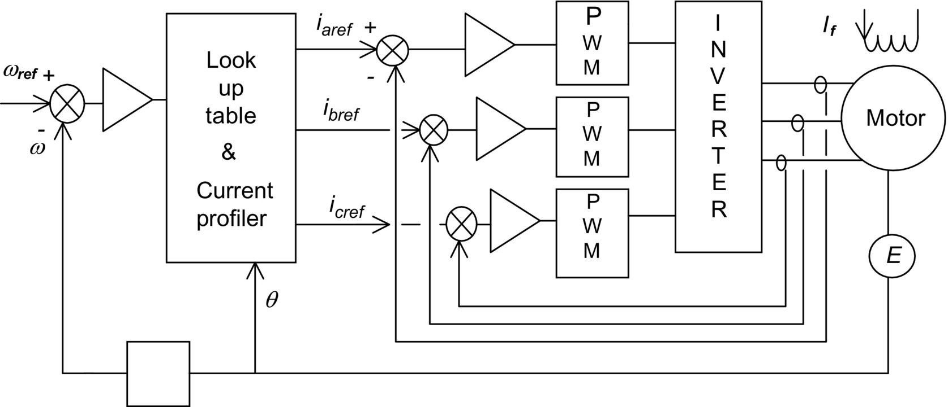

**FIG. 30.42** Structure of a speed-control system with a CSI-driven synchronous motor.

### 30.4.7 VECTOR CONTROL

Controls described in foregoing sections were based on the steady-state equivalent circuit of the motor. Even though the torque Eq. [(30.65)](https://learning.oreilly.com/library/view/power-electronics-handbook/9780128114087/B9780128114070000349_1.xhtml#fo0355) for a current-source drive evokes vector-control-like relationships, they do not address the dynamics of the current controls as is possible in an orthogonal reference frame. Using an orthogonal set of reference attached to the rotor, a simple set of decoupled, dc-motor-like torque-control relationships is readily obtained. Following the transformation technique used in [Section 30.3.4](https://learning.oreilly.com/library/view/power-electronics-handbook/9780128114087/B9780128114070000349_1.xhtml#s0105), the stator voltage equations of a synchronous motor with fixed rotor excitation in the rotor reference frame are

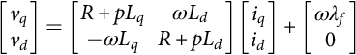 **(30.68)**

**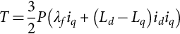** **(30.69)**

where all the quantities in lower case represent instantaneous quantities in the rotor *dq*-frame. The *λf* is the flux linkage per phase due to the rotor excitation, *ω* is the electric angular velocity in radians per second, and *P* is the number of pole pairs. Here, *p* is the time derivative operator *d/dt*. Assuming the magnetic linearity, the stator flux linkages are

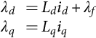 **(30.70)**

Note that the Eq. [(30.68)](https://learning.oreilly.com/library/view/power-electronics-handbook/9780128114087/B9780128114070000349_1.xhtml#fo0370) can be written down directly from Eq. [(30.31)](https://learning.oreilly.com/library/view/power-electronics-handbook/9780128114087/B9780128114070000349_1.xhtml#fo0185), taking into account the fixed rotor excitation so that the third and fourth rows and columns of Eq. [(30.31)](https://learning.oreilly.com/library/view/power-electronics-handbook/9780128114087/B9780128114070000349_1.xhtml#fo0185) may be dropped. Since the reference frame now rotates at the speed of the rotor, . The induced back emf due to the fixed rotor excitation occurs in the rotor *q*-axis and is included in Eq. [(30.68)](https://learning.oreilly.com/library/view/power-electronics-handbook/9780128114087/B9780128114070000349_1.xhtml#fo0370), as a separate term. Similarly, the torque expression of Eq. [(30.69)](https://learning.oreilly.com/library/view/power-electronics-handbook/9780128114087/B9780128114070000349_1.xhtml#fo0375) may also be written down from Eq. [(30.41)](https://learning.oreilly.com/library/view/power-electronics-handbook/9780128114087/B9780128114070000349_1.xhtml#fo0235), using the flux linkages of Eq. [(30.70)](https://learning.oreilly.com/library/view/power-electronics-handbook/9780128114087/B9780128114070000349_1.xhtml#fo0380).

Eqs. [(30.67)](https://learning.oreilly.com/library/view/power-electronics-handbook/9780128114087/B9780128114070000349_1.xhtml#fo0365)–[(30.69)](https://learning.oreilly.com/library/view/power-electronics-handbook/9780128114087/B9780128114070000349_1.xhtml#fo0375) are for a salient-pole motor for which . For a nonsalient-pole motor, *Ld* is equal to *Lq*, and the developed torque is proportional to *iq* only. In either case, the inner torque loop consist of two separate current loops: one for *id* and the other for *iq*, as indicated in [Fig. 30.43](https://learning.oreilly.com/library/view/power-electronics-handbook/9780128114087/B9780128114070000349_1.xhtml#f0220). The *iq* current loop generally derives its reference signal from the output of the speed controller and constitutes the inner torque loop. The reference for the *id* current loop is normally specified by the extent of field weakening for which a negative *id* reference is used. Otherwise, the *d*-axis current is maintained at zero. Note that for large synchronous motors with variable external excitation, field weakening is normally applied through adjustment of the rotor excitation, using a spillover signal from the output of the speed controller.

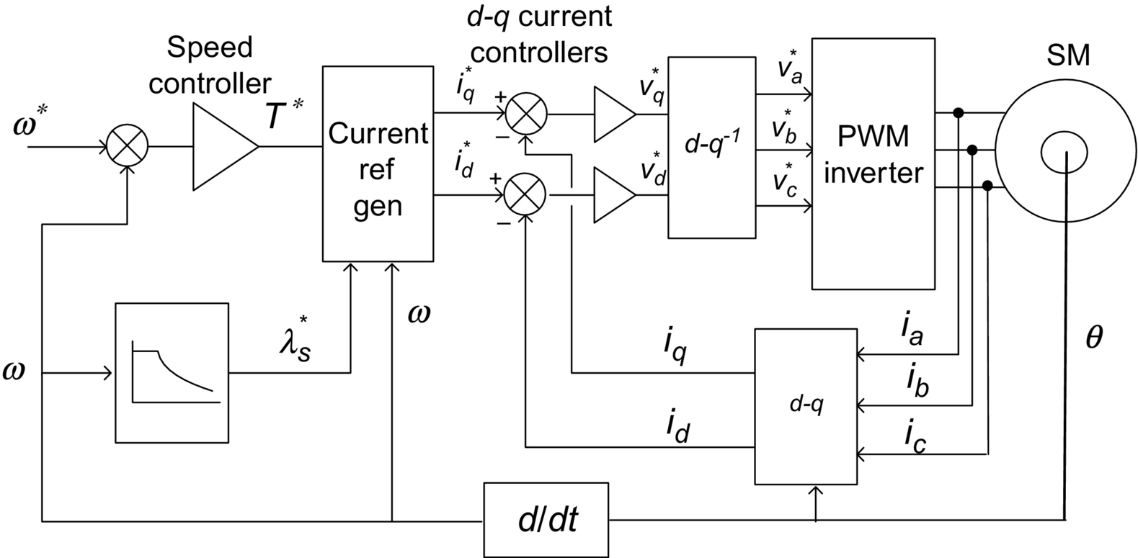

**FIG. 30.43** Inner torque loop of a vector-controlled synchronous motor drive.

From Eq. [(30.68)](https://learning.oreilly.com/library/view/power-electronics-handbook/9780128114087/B9780128114070000349_1.xhtml#fo0370), it is clear that the couplings of *q*- and *d*-axis voltages exist through the *d*- and *q*-axis currents, respectively, and the back emf. During dynamic operation, such coupling effects become undesirable. The coupling effects of *d*- and *q*-axis currents and the back emf into *q*- and *d*-axis voltages, respectively, can be removed by the feedforward terms shown in the shaded part of the block the diagram of [Fig. 30.44](https://learning.oreilly.com/library/view/power-electronics-handbook/9780128114087/B9780128114070000349_1.xhtml#f0225), which also shows the two current-control loops. The two outputs  and  from the decoupled current controllers are transformed to the stator reference frame before being subjected to pulse-width modulators or hysteresis comparators. Note that the current references  and  are obtained with due regard for the desired operating and limiting conditions as described in [Section 30.4.5](https://learning.oreilly.com/library/view/power-electronics-handbook/9780128114087/B9780128114070000349_1.xhtml#s0150).



**FIG. 30.44** The *d*- and *q*-axis decoupling compensation.



**FIG. 30.45** Schematic of the cross section of a surface-magnet synchronous motor.

Under this type of control, which is exercised in the rotor reference frame, the *d*- and *q*-axis currents are separately regulated. The purpose of the *q*-axis current controller is primarily to control the developed torque, especially for the nonsalient-pole motor. For this motor, the *d*-axis current is normally maintained at zero, when the motor is operated below the base speed. The *d*-axis current may be used to weaken the air-gap flux so that the motor operates with a constant-power-like characteristic. It should be noted that the field weakening may also be carried out more directly by adjusting the rotor excitation current by using a spillover signal from the speed controller, when the base speed is exceeded.

The dynamic response of the drive under the vector control scheme indicated in [Fig. 30.44](https://learning.oreilly.com/library/view/power-electronics-handbook/9780128114087/B9780128114070000349_1.xhtml#f0225) is the highest possible with a CSI drive. It should also be noted that the *dq* currents in the rotor reference frame vary only the mechanical dynamics of the rotor. In fact, they are dc quantities when the motor runs at a constant speed. Consequently, the following error (or lag) associated with tracking a sinusoidally time-varying current reference, which is the case when current control is exercised in the stator  reference frame, can be reduced easily by using an integral-type current controllers.

## 30.5 Permanent-Magnet Synchronous Motor Drives

### **30.5.1 INTRODUCTION**

Since the introduction of samarium cobalt and neodymium-iron-boron magnetic materials in the 1970s and 1980s, respectively, synchronous motors with permanent-magnet excitation in the rotor have been displacing the dc motor in many high-performance applications. The trend is more noticeable in applications requiring high-performance motors of up to a few kilowatts. In low- to medium-power applications, the superior dynamics, smaller size, and higher efficiency of motors with PM excitation in the rotor, compared with all other motors, are well-known.

The arrangement just mentioned is very similar to a conventional synchronous motor. This is particularly so when the stator windings and the rotor mmf are sinusoidally distributed. Several rotor configurations of the PM synchronous motor have been developed, of which the important ones are indicated in [Figs. 30.45](https://learning.oreilly.com/library/view/power-electronics-handbook/9780128114087/B9780128114070000349_1.xhtml#f0230)–[30.47](https://learning.oreilly.com/library/view/power-electronics-handbook/9780128114087/B9780128114070000349_1.xhtml#f0240).



**FIG. 30.46** Schematic of the rotor cross section of an interior-magnet motor.



**FIG. 30.47** Schematic of the rotor cross section of a circumferential-magnet motor.

### 30.5.2 THE SURFACE-MAGNET SYNCHRONOUS MOTOR WITH TRAPEZOIDAL BACK EMF WAVEFORM

The surface-magnet motor comes with the rotor magnets glued onto the surface of the rotor. An additional stainless steel (i.e., nonmagnetic) cylindrical shell may be used to cover the rotor in order to keep the magnets in place against centrifugal force in high-speed applications. Since the relative permeability of the magnetic material is very close to unity, the effective air gap is uniform and large. Because the air gap includes the magnet thickness, it is long. Consequently, the synchronous inductances along the rotor *d*- and *q*-axes, as indicated in [Fig. 30.45](https://learning.oreilly.com/library/view/power-electronics-handbook/9780128114087/B9780128114070000349_1.xhtml#f0230), are equal and small (i.e., ). The armature reaction in this type of motor is small.

The three-phase winding in the stator has uniformly distributed windings. The span of the magnets are selected in such a way that the back emf induced in the stator windings are trapezoidal with nearly 120° of constant amplitude in each half cycle. Such a motor, often called a brushless dc (BLDC) motor because of its similarity to the inside-out conventional brushed PM DC motor, develops a trapezoidal back-emf waveform as indicated in [Fig. 30.48](https://learning.oreilly.com/library/view/power-electronics-handbook/9780128114087/B9780128114070000349_1.xhtml#f0245), when it is driven at a constant speed. The back-emf waveforms have flattops for nearly 120*°* in each half cycle followed by 60*°* of transition from positive to negative polarity of voltage and vice versa. These motors are very suitable for variable-speed applications such as spindle drives in machine-tool and disk drives.



**FIG. 30.48** Back emf of a trapezoidal waveform motor.

#### **30.5.2.1 Control of the Trapezoidal-wave Motor**

Neglecting higher-order harmonic terms, the back emf in the motor phases may be as indicated in [Fig. 30.49](https://learning.oreilly.com/library/view/power-electronics-handbook/9780128114087/B9780128114070000349_1.xhtml#f0250). Each back emf has a constant amplitude (or flattop) for 120*°* (electric) followed by 60*°* of transition in each half cycle. The developed torque at any instant is given by



**FIG. 30.49** Back-emf and current waveforms and on-states of transistor switches in the trapezoidal waveform motor.

 **(30.71)**

It is readily seen that the ideal current waveform in each phase needs to be a quasi-square waveform of 120*°* of conduction angle in each half cycle. The conduction of current in each phase winding coincides with the flat part of the back-emf waveforms, which guarantees that the developed torque, that is, , is constant or ripple-free at all times. With such quasi-square current waveforms, a simple set of six optocouplers or Hall-effect sensors would be required to drive the six inverter switches indicated in [Fig. 30.36](https://learning.oreilly.com/library/view/power-electronics-handbook/9780128114087/B9780128114070000349_1.xhtml#f0185). The output current waveforms for the three-phase inverter and the switching devices that conduct during the six switching intervals per cycle are also indicated in [Fig. 30.49](https://learning.oreilly.com/library/view/power-electronics-handbook/9780128114087/B9780128114070000349_1.xhtml#f0250). Since only six discrete outputs per electric cycle are required from the rotor-position sensors, the requirement of a high-resolution position sensor is dispensed with. Continuous current control for each phase of the motor, by hysteresis or PWM control, to regulate the amplitude of the motor current in each phase is normally employed. The operation of the BLDC motor drive is further described in detail in [Section 30.6](https://learning.oreilly.com/library/view/power-electronics-handbook/9780128114087/B9780128114070000349_2.xhtml#s0240).

Even though careful electromagnetic design is employed in order to have perfect trapezoidal back-emf waveforms as indicated in [Fig. 30.49](https://learning.oreilly.com/library/view/power-electronics-handbook/9780128114087/B9780128114070000349_1.xhtml#f0250), the back-emf waveforms in a practical brushless dc motor exhibit some harmonics, as indicated in [Fig. 30.48](https://learning.oreilly.com/library/view/power-electronics-handbook/9780128114087/B9780128114070000349_1.xhtml#f0245). If ripples in the back-emf waveforms are significant, then torque ripples will also exist when the motor is driven with quasi-square phase current waveforms. These ripples may become troublesome when the motor is operated at a low speed, when the motor load inertia may not filter out the torque ripples adequately.

A second source of torque ripple in the permanent-magnet brushless dc (PM BLDC) motor is from the commutation of current in the inverter. Since the actual phase currents cannot have the abrupt rise and fall times as indicated in [Fig. 30.49](https://learning.oreilly.com/library/view/power-electronics-handbook/9780128114087/B9780128114070000349_1.xhtml#f0250), torque spikes, one for each switching, may exist.

Even though the PM BLDC motor does not have sinusoidal back emf and inductance variations with rotor angle, the analysis of [Section 30.4](https://learning.oreilly.com/library/view/power-electronics-handbook/9780128114087/B9780128114070000349_1.xhtml#s0125) in terms of the fundamental quantities will often suffice. The switching of the inverter using the six rotor-position sensors guarantees that the current waveform in each phase always remains in synchronism with the back emf of the respective phase. Since the quasi-square phase current waveform in each phase coincides with the flat part of the back-emf waveform of the same phase, the angle *γ* is clearly zero for such operation. Thus, considering fundamental quantities, the motor back emf and the torque characteristics can be expressed by

 **(30.72)**

**** **(30.73)**

where *KE* and *KT* are equal in consistent units. Note that *E* and *I* are now RMS values of the fundamental components of these quantities.

#### **30.5.2.2 Sensorless Operation of the PM BLDC Motor**

In spindle and other variable-speed drive applications, where the lowest speed of operation is not less than a few hundred revolutions per minute, it is possible to obtain the switching signals for the inverter from the motor back emf, thus dispensing with rotor-position sensors. The method consists of integrating the back-emf waveforms, which are the same as the applied phase voltage if the other voltage drops are neglected, and comparing the integrated outputs with a fixed reference. These comparator outputs determine the switching signals for inverter. It may be noted that the amplitude of the back-emf waveforms is proportional to the operating speed, so that the frequency of the comparator outputs increases automatically with speed. In other words, the angle *γ* and the current waveform relative to the back-emf waveform in each phase remains the same regardless of the operating speed. Integrated circuits are available from several suppliers that perform this task of sensorless BLDC operation satisfactorily, covering a reasonable speed range.

### 30.5.3 THE PM SYNCHRONOUS MOTOR WITH SINEWAVE BACK EMF WAVEFORMS

The PM sine-wave motor, which may also have magnets on the rotor surface or buried inside the rotor (as in the interior-magnet motor of [Fig. 30.46](https://learning.oreilly.com/library/view/power-electronics-handbook/9780128114087/B9780128114070000349_1.xhtml#f0235)), typically has sinusoidally distributed windings. The air-gap flux distribution produced by the rotor magnets is also sinusoidal, arranged through magnet and rotor flux barrier shaping. Consequently, the back-emf waveform of each phase when running at a constant speed is also a sinusoidal waveform, as indicated in [Fig. 30.50](https://learning.oreilly.com/library/view/power-electronics-handbook/9780128114087/B9780128114070000349_1.xhtml#f0255), when the motor is driven at a constant speed.



**FIG. 30.50** Back-emf waveforms of a sine-wave PM motor. .

It should be noted, however, that with magnets mounted on the rotor surface, the effective air gap is large and uniform so that . Because of the large equivalent air gap, these inductances are also small, and consequently, the armature reaction is small. As a result, this motor essentially operates with fixed excitation, and there is hardly any scope for altering the operating power factor or the rotor mmf, once the motor and its drive voltage and current ratings have been selected.

The interior permanent-magnet synchronous motor (IPMSM), which comes with magnets buried inside the rotor as indicated in [Figs. 30.46](https://learning.oreilly.com/library/view/power-electronics-handbook/9780128114087/B9780128114070000349_1.xhtml#f0235), has an easier magnetization path along the rotor *q*-axis, so that . The small air gap implies that the inductances *Ld* and *Lq* may not be small and hence may allow considerable scope for field weakening.

If the sine-wave motor is supplied from an PWM inverter, the analyses and vector diagrams of PM sine-wave motor are similar to those in [Section 30.4](https://learning.oreilly.com/library/view/power-electronics-handbook/9780128114087/B9780128114070000349_1.xhtml#s0125) for the nonsalient-pole and salient-pole synchronous motor drives. The surface-magnet motor is more akin to the nonsalient-pole motor, since , whereas the interior-magnet motor is more akin to the salient-pole motor because of the *d*- and *q*-axis inductances being unequal. Thus, the equations in [Section 30.4](https://learning.oreilly.com/library/view/power-electronics-handbook/9780128114087/B9780128114070000349_1.xhtml#s0125) will apply equally well for this motor, both in the steady state and dynamically and for both voltage- and current-source supply.

#### **30.5.3.1 Control of the PM Sinewave Motor**

The sinusoidal back-emf waveforms imply that the three-phase motor must be supplied with a sinusoidal three-phase current if a dc-motor-like (or vector-control-like) torque characteristic is desired, as was found in [Section 30.4](https://learning.oreilly.com/library/view/power-electronics-handbook/9780128114087/B9780128114070000349_1.xhtml#s0125). For such operation, the phase currents must also be synchronized with the respective phase back-emf waveforms, in other words, with the rotor *dq*- reference frame. This implies the operation with a specified *γ* angle. Two implementations are possible.

In one scheme, the stator currents are regulated in the stator reference frame, and the stator current references are produced with reference to the rotor position, as indicated in [Fig. 30.51](https://learning.oreilly.com/library/view/power-electronics-handbook/9780128114087/B9780128114070000349_1.xhtml#f0260). The rotor position *θ* is continuously sensed and used to produce three sinusoidal current references of unit amplitude. The phase angle *γ* of the references relative to the respective back-emf waveforms is usually derived from the speed controller, which defines the field-weakening regime of the drive. The operating power factor of the drive may also be addressed using the *γ* angle control, as explained in [Section 30.4.5](https://learning.oreilly.com/library/view/power-electronics-handbook/9780128114087/B9780128114070000349_1.xhtml#s0150). The amplitudes of these references are then multiplied by the error of the speed controller in order to produce the desired torque reference. In this way, both the RMS value *I* of the phase current and its angle *γ* with respect to *Ef* can be adjusted independently (which is equivalent to independent *dq*-axis current control). Three PWM current controllers are indicated, but two suffice for a balanced motor. Other types of current controllers, such as hysteresis controllers, may also be used.



**FIG. 30.51** Speed-controlled drive with the inner torque loop via current control in the stator reference frame.

In the second scheme, the motor currents are first transformed into the rotor *dq*-reference frame using continuous rotor-position feedback, and the measured rotor *d*- and *q*-axis currents are then regulated in the rotor reference frame, as indicated in [Fig. 30.52](https://learning.oreilly.com/library/view/power-electronics-handbook/9780128114087/B9780128114070000349_1.xhtml#f0265). The main advantage of regulating the stator currents in the rotor reference frame, compared with the stator reference frame as in the first scheme, is that current references now vary more slowly and hence suffer from lower tracking error. At constant speed, the stator current references are in fact dc quantities as opposed to ac quantities, and hence, the inevitable tracking errors of the former scheme are easily removed by an integral-type controller. The other advantage is that the current references may now include feedforward decoupling so as to remove the cross coupling of the *d*- and *q*-axis variables as shown in the motor representation of [Fig. 30.52](https://learning.oreilly.com/library/view/power-electronics-handbook/9780128114087/B9780128114070000349_1.xhtml#f0265). The latter scheme is currently preferred, since it allows more direct control of the currents in the rotor reference frame.



**FIG. 30.52** Block diagram of a current-controlled drive.

It should be noted that continuous transformations to and from rotor *dq*-axes are required; hence, the rotor-position sensor is a mandatory requirement. Rotor-position sensors of 10- to 12-bit accuracy are normally required. This is generally viewed as a weakness for this type of drive.

The general torque relationship of a sine-wave motor supplied from a current-source SPWM inverter is given by Eq. [(30.69)](https://learning.oreilly.com/library/view/power-electronics-handbook/9780128114087/B9780128114070000349_1.xhtml#fo0375) that is rewritten here:

 **(30.74)**

Precise control of the developed torque control requires that both *id* and *iq* be actively controlled in order to regulate it to the level determined by the error of the speed controller. For the surface-magnet synchronous motor, the large effective air gap means that , so that *id* should be maintained at zero level. This implies that the *id* current reference in [Fig. 30.52](https://learning.oreilly.com/library/view/power-electronics-handbook/9780128114087/B9780128114070000349_1.xhtml#f0265) should be kept zero. For the interior-magnet motor, , so that *id* and *iq* have to be controlled simultaneously to develop the desired torque. A few modes of operation are possible.

#### **30.5.3.2 Operating Modes**

##### **Operation with maximum torque per ampere (MTPA) characteristic**

In this mode of control, the developed torque *T* per ampere of stator current is the highest for a given rotor excitation. The combination of *id* and *iq* that develops the maximum torque per ampere of stator current is indicated in [Fig. 30.53](https://learning.oreilly.com/library/view/power-electronics-handbook/9780128114087/B9780128114070000349_1.xhtml#f0270). The reference signal for the inner torque loop normally determines the *iq* reference, while the *id* reference is given by



**FIG. 30.53**  Trajectories for the maximum torque per ampere characteristic and for maximum voltage and current limits of an interior PM motor.

 **(30.75)**

It should be noted that with , this mode of operation is achieved for the surface-magnet motor.

##### **Operation with voltage and current limits**

The maximum current limit of the motor/inverter, *Ismax*, is normally imposed by setting appropriate limits on *id* and *iq* such that

 **(30.76)**

Eq. [(30.75)](https://learning.oreilly.com/library/view/power-electronics-handbook/9780128114087/B9780128114070000349_1.xhtml#fo0405) defines a circle around the origin of the  plane.

The available dc-link voltage to the inverter places an upper limit of the motor phase voltage, *Vsmax*, given by

 **(30.77)**

**** **(30.78)**

where the stator voltages *vd* and *vq* are expressed in the rotor reference frame, as in Eq. [(30.68)](https://learning.oreilly.com/library/view/power-electronics-handbook/9780128114087/B9780128114070000349_1.xhtml#fo0370). Eq. [(30.78)](https://learning.oreilly.com/library/view/power-electronics-handbook/9780128114087/B9780128114070000349_1.xhtml#fo0420) is obtained from the voltage equation of Eq. [(30.68)](https://learning.oreilly.com/library/view/power-electronics-handbook/9780128114087/B9780128114070000349_1.xhtml#fo0370) when the phase resistance *R* is neglected. Eq. [(30.78)](https://learning.oreilly.com/library/view/power-electronics-handbook/9780128114087/B9780128114070000349_1.xhtml#fo0420) defines elliptical trajectories that contract as speed increases. All the three modes of operation are included in [Fig. 30.53](https://learning.oreilly.com/library/view/power-electronics-handbook/9780128114087/B9780128114070000349_1.xhtml#f0270).

##### **Operation with field weakening**

This mode of operation is normally required for operating the motor above the base speed. A constant-power characteristic is normally desired over the full field-weakening range. For a given rotor excitation of *λf* and developed power of *P*0, the developed torque *T* and the net rotor flux linkage required for constant-power operation can be determined. From this, the limiting values for *id* and *iq*, which further constrain the allowable  trajectory is also indicated in [Fig. 30.53](https://learning.oreilly.com/library/view/power-electronics-handbook/9780128114087/B9780128114070000349_1.xhtml#f0270), can be determined.

The operating modes described in the preceding section are normally included in a trajectory controller that generates the references for *id* and *iq* continuously, as indicated in [Fig. 30.54](https://learning.oreilly.com/library/view/power-electronics-handbook/9780128114087/B9780128114070000349_1.xhtml#f0275).



**FIG. 30.54** *id* and *iq* Trajectory generation satisfying the desired operating modes.

## 30.6 Permanent-Magnet Brushless DC Motor Drives

### **30.6.1 MACHINE BACKGROUND**

Anyone studying electric machines would be aware that the classical synchronous machine offers the possibility of the very highest efficiencies. These machines have the current-carrying conductors in the stationary part; therefore, there is no need to transfer high power through a brush system. The field is provided on the rotating part either by an electromagnet, which does require some very low-power brushes, or, at best, by a permanent magnet with no power requirements at all.

This is clearly better than the traditional dc machine with high-power brushes and rotating conductors, with those conductors having a very poor path for heat to get away under overload conditions. You might ask, “why did we use so many of them?” It was of course because the dc machine offered the ability to control the speed fully and easily, which the synchronous machine, when running from the mains at a fixed frequency, was definitely not capable of. Thus, for example, all electric trains and trams built up to the 1980s, many of them still in service, use brushed dc motors. Low-cost, high-energy-density, and rare-earth PM materials available since 1984 changed this scene fundamentally.

The induction machine, the work horse of industry, is quite efficient, but because of the need to carry magnetizing current in the stator and load current and the existence of slip, it cannot be as good as the synchronous machine. It also innately has a very limited speed range.

All this changed with the advent of inexpensive, reliable power electronics. Quite suddenly, power electronics engineers had the ability to vary both the frequency and the amplitude of an ac supply and thus to provide the holy grail of variable-speed ac motors. This was first applied to induction machines, with the simplest form of open-loop control. The complexity of control for synchronous machines added substantially to the cost and was not so appealing. Today, the thought of putting a digital signal processor (DSP) or a microcontroller in a small motor controller is no longer as daunting as it was 10 years ago, so the distinction between the complexity of a controller for induction machines and synchronous machines has almost disappeared.

While power electronics radically changed our attitudes to electric machine design and operation, there was a second very important development that arrived on the scene at almost the same time: the appearance of very powerful rare-earth permanent-magnet materials.

The first rare-earth magnet material was samarium cobalt, used in very special applications such as space and defense, but it was then and still is very expensive. Neodymium-iron-boron (Nd-Fe-B) came next with even higher energy product. Energy product is a measure used to quantify the effectiveness of magnets. Nd-Fe-B began expensively but has continued to drop in price at a spectacular rate and recently became cheaper than ferrites in term of dollars per unit of energy product.

Thus, all the machines discussed here are permanent-magnet (PM) machines, in general using Nd-Fe-B magnets.

#### **30.6.1.1 Clarifying Torque Versus Speed Control**

As is well understood, given a fixed magnetic flux level, the magnitude of the current in a motor determines the magnitude of the torque out of the machine. In a general application if a torque is set, the speed is determined by the load. This is what happens when driving an automobile. The throttle or accelerator varies the torque. The speed can be very slow or very high for the same foot position, depending on the road conditions and vehicle motion history, even if the vehicle is in the same gear. This principle of torque control rather than speed control is fundamental to the operation of electric machines. When speed control is required in PMBDCMs, it is usual to implement torque control, with an extra outside control loop, like a cruise control in an automobile, to use the torque control to deliver speed control. So from here on, the discussion will describe torque control for the variable-speed motor.

#### **30.6.1.2 Permanent-Magnet AC Machines**

There are two quite different types of permanent-magnet ac machines, actually looking very similar in their physical realization but dramatically different in their electric characteristics and in the way in which they are controlled.

##### **Permanent-magnet synchronous machines**

These are simple extensions of the classical synchronous machine, where all of the voltages and currents are designed to be sinusoidal functions of time, as they are in the synchronous machine when used as a supply generator. These machines are known as permanent-magnet synchronous machines (PMSMs) or brushless ac machines and are discussed elsewhere in this book. While the application of sinusoidal waveforms everywhere is comforting to many and does result in less acoustic noise, less “stray losses,” etc., there is in general a requirement to know the exact rotor angular position at every instant of time, with an accuracy in the order of one degree. This knowledge is then used to shape the current waveforms to be sure that they are in phase with the back emf of the windings. While much research is going on to run these machines without position sensors, the reality in the workplace today is that you need to include a relatively expensive shaft position encoder with your PMSM, if you wish to control it electronically.

##### **Permanent-magnet brushless DC machines**

A very much simpler possibility has emerged, which also gives the benefits of smooth torque and rapid controllability. This results in smaller minimum machine size, yielding maximum machine power density.

For this variant, the current waveforms and the back-emf waveforms are trapezoidal rather than sinusoidal. In this case, the machine is known as a permanent-magnet brushless dc machine (PMBDCM), with waveforms as shown in [Fig. 30.55](https://learning.oreilly.com/library/view/power-electronics-handbook/9780128114087/B9780128114070000349_2.xhtml#f0280).

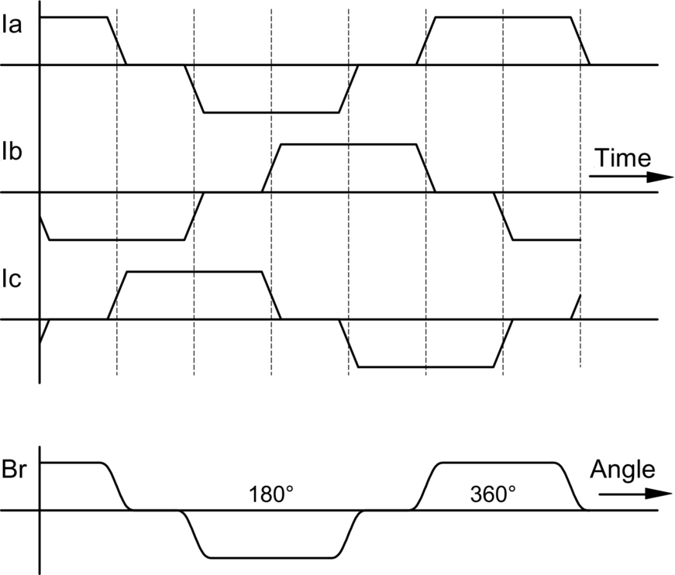

**FIG. 30.55** Phase currents as functions of time and the flux density on the surface of the rotor as a function of angular position for a typical PMBDCM.

#### **30.6.1.3 Brief Tutorial on Electric Machine Operation**

The operation of electric machines can be explained in a variety of ways. Two possible and different methods are by the following:

1. Using an understanding of the interaction of magnetic fields and the tendency of magnetic fields to align. This tendency to align is what provides the force that makes a compass needle swing around, until it aligns with the earth's magnetic field.

2. Using the physical principle that “a current-carrying conductor in a magnetic field has a force exerted on it.” This force is commonly known as the Lorentz force.

The difference between the two explanations is that the first method gives better “physical pictures.” However, when one gets a little more serious, wanting to put in numbers, the force equations, while not greatly more difficult, are a little more challenging as they involve vector cross products.

With the second method, once the principle is accepted, there is a particularly simple scalar version of the force equation that very rapidly and simply gives numeric answers. The directions of the force, current, and motion are all orthogonal, that is, at right angles and a formal exposition would again use a vector cross product. However, provided the rules learned in high school science are applied, the scalar version,  can be used, where *F* is the force in newtons, *B* is the flux density in tesla, *L* is the length of the conductor in meters, and *I* is the current in amperes.

Let us try both the methods, on the simple machine of [Fig. 30.56](https://learning.oreilly.com/library/view/power-electronics-handbook/9780128114087/B9780128114070000349_2.xhtml#f0285).

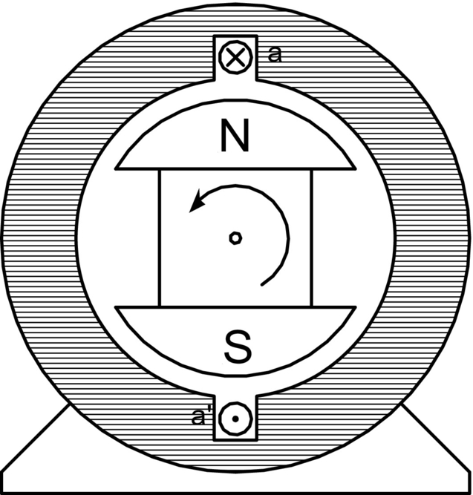

**FIG. 30.56** A simple motor with a single coil in the stator and a permanent-magnet rotor.

The rotor is a magnet with a north and a south pole, and there is a coil of wire in the slots in the stator. Current is shown going into the conductor called a at the top of the stator and coming out of the conductor called **a**′ at the bottom. To simulate a real machine more closely, one should imagine putting a one-turn “coil” of wire into the slot, with a connection made at the back of the machine to connect the top wire to the bottom, so that by applying a positive voltage to the top wire and a negative voltage to the end of the coil (the bottom wire), current will flow in at the top and out at the bottom as discussed previously.

*Method 1*. If the current is put into the top and comes out of the bottom as marked, then according to the right-hand rule (if you forget, then look at the Institution of Electrical and Electronic Engineers (IEEE) logo), magnetic flux will be forced to go through the center of the coil from right to the left, creating a north pole on the left. The flux will then double back through the iron frame of the motor to arrive back at the south pole on the right.

[Fig. 30.57](https://learning.oreilly.com/library/view/power-electronics-handbook/9780128114087/B9780128114070000349_2.xhtml#f0290) shows a computer-generated magnetic field plot. This was produced using finite element analysis and modeling the stator as electric steel, the volume in the center as air and injecting current into the coil.

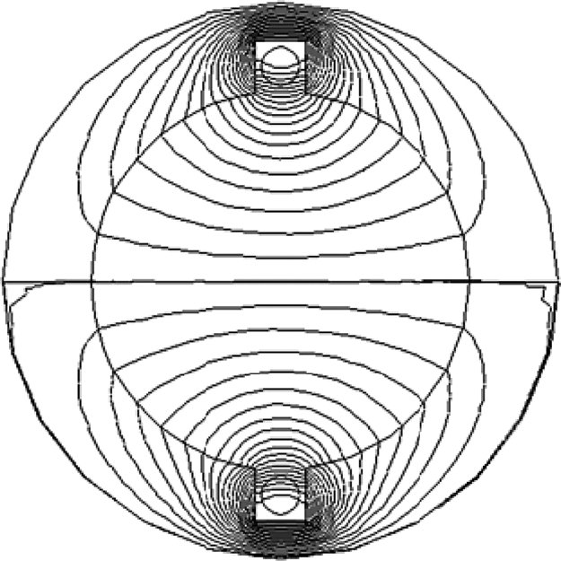

**FIG. 30.57** A computer generated magnetic field for current in the windings and a stator made of electric steel.

If the permanent-magnet rotor is then put inside the stator of [Fig. 30.57](https://learning.oreilly.com/library/view/power-electronics-handbook/9780128114087/B9780128114070000349_2.xhtml#f0290), the rotor will align by rotating 90*°* counterclockwise.

*Method 2*. In this case, looking at [Fig. 30.58](https://learning.oreilly.com/library/view/power-electronics-handbook/9780128114087/B9780128114070000349_2.xhtml#f0295), the conductor **a** will be immersed in a quite dense field produced by the magnets, with the flux lines going up the page in the rotor, across the air gap into the steel of the stator, heading down the stator to jump back across the lower air gap to return to the south pole. If a current is directed into the upper conductor and out of the bottom as before, it will produce force. Applying the direction rules associated with the Lorentz force, the force on the conductor will be to the right at the top and to the left at the bottom. Invoking Newton's third law, that action and reaction are equal and opposite, it is clear that if the wire is fixed, as it is, then there will be a force on the rotor to the left at the top and to the right at the bottom; thus, the rotor will move counterclockwise as before.

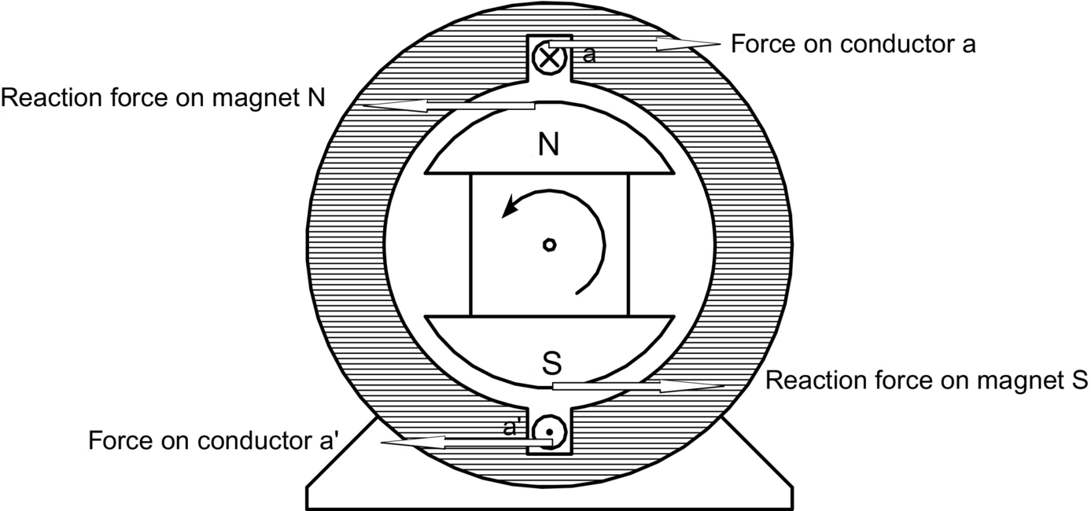

**FIG. 30.58** Lorentz forces on conductor and rotor of a simple machine.

### 30.6.2 ELECTRONIC COMMUTATION

If the rotor of [Fig. 30.58](https://learning.oreilly.com/library/view/power-electronics-handbook/9780128114087/B9780128114070000349_2.xhtml#f0295) moves, then to keep it rotating in the same direction, sooner or later, the current in the conductors must be reversed. The time at which that needs to be done is when the rotor has moved to an almost aligned position, so it is not really a matter of time but a matter of rotor position. Since the rotor is a permanent magnet, it is a very simple matter to determine at least where the physical pole edges are using simple, reliable, and inexpensive Hall-effect (HE) sensors. These are small semiconductor devices that respond to magnetic flux density. (There are many ways to sense the position of the rotor; however, the remainder of this exposition will stay with the HE sensor for simplicity.)

A very simple motor, relying on the inertia of the rotor for continuous rotation, could have a control circuit that sensed when the rotor magnet was horizontal and then reversed the current in **aa**′ of [Fig. 30.58](https://learning.oreilly.com/library/view/power-electronics-handbook/9780128114087/B9780128114070000349_2.xhtml#f0295).

The traditional “H-” bridge switching circuit shown in [Fig. 30.59](https://learning.oreilly.com/library/view/power-electronics-handbook/9780128114087/B9780128114070000349_2.xhtml#f0300) does that very effectively. Switch drive logic must ensure that either S1 and S4 are on, or S2 and S3 are on and never S1 and S2 simultaneously or S3 and S4 simultaneously. This simultaneous operation would provide a short circuit. When this happens due to errors in the switch drive signal it is called “shoot through.” There are generally important parts of the switch drive signal logic, discussed later, which try to make this impossible in normal operation.

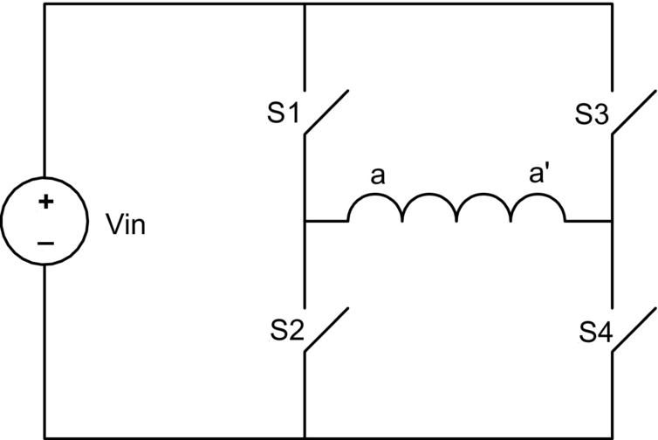

**FIG. 30.59** An “H-” bridge circuit that can reverse the current through aa′, as drawn with mechanical switches.

In real motors, the permanent-magnet rotor field does not change instantaneously from north to south as the rotor rotates, so there would be reasonably large angles over which the torque could not be effectively produced. Also, more coils are put in so that the space of the machine frame is used more efficiently.

The use of three “phases,” as in [Fig. 30.60](https://learning.oreilly.com/library/view/power-electronics-handbook/9780128114087/B9780128114070000349_2.xhtml#f0305), is very common. There are many things that balance naturally in a three-phase system, and it is the simplest system with which it is possible to develop constant and unidirectional torque at all times and positions.

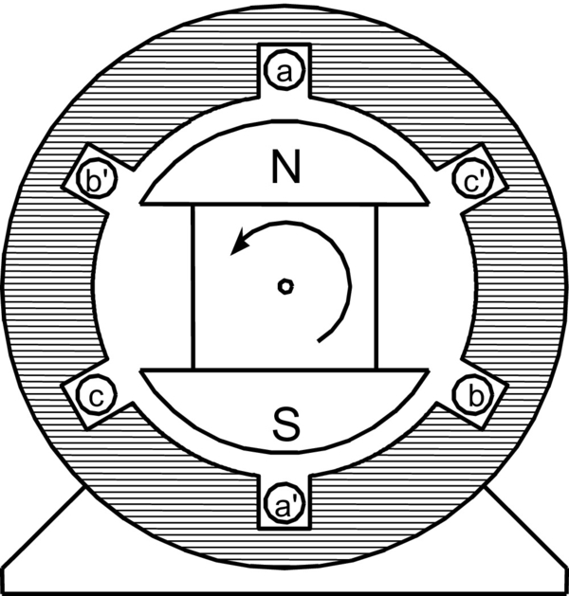

**FIG. 30.60** The physical layout of a three-phase PMBDCM.

A very common method has developed, known as “six-step switching.” In this system, three phases are used. They are connected in star, and there is a space between each of the magnet poles on the rotor, and the two phases are activated at any one time, the third “resting” as the space between the magnet poles passes over it.

While the motor in [Fig. 30.60](https://learning.oreilly.com/library/view/power-electronics-handbook/9780128114087/B9780128114070000349_2.xhtml#f0305) looks just like a three-phase synchronous machine, its operation is rather different.

As stated above, the windings are invariably star connected, as shown in [Fig. 30.61](https://learning.oreilly.com/library/view/power-electronics-handbook/9780128114087/B9780128114070000349_2.xhtml#f0310).

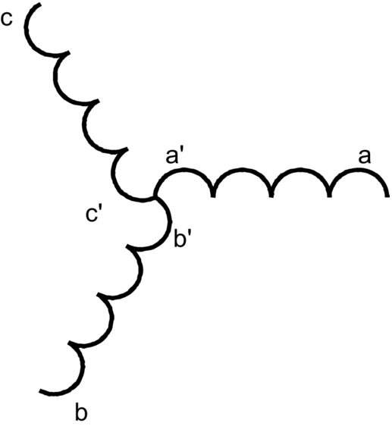

**FIG. 30.61** The schematic connection of the windings shown in [Fig. 30.60](https://learning.oreilly.com/library/view/power-electronics-handbook/9780128114087/B9780128114070000349_2.xhtml#f0305).

#### **30.6.2.1 Six Step Switching Explained**

Consider the coil **aa**′, as shown in [Fig. 30.60](https://learning.oreilly.com/library/view/power-electronics-handbook/9780128114087/B9780128114070000349_2.xhtml#f0305) and also diagrammatically in [Fig. 30.61](https://learning.oreilly.com/library/view/power-electronics-handbook/9780128114087/B9780128114070000349_2.xhtml#f0310). Current driven into the **a** terminal, coming out of the **a**′ terminal, will produce, as discussed before, flux from left to right, as shown here.



Obviously if the current direction in **aa**′ is reversed, the flux will be



Similarly if current is driven into **b** and out of **b**′, flux will result



And if it is reversed,

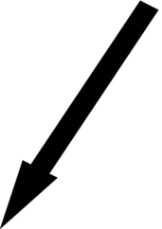

Finally, if current is driven into **c** and out of **c**′, flux will result

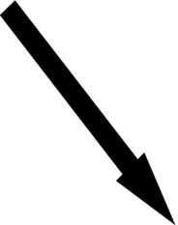

And if it is reversed,



The permanent-magnet rotor would tend to align with the flux arrow shown in each of the states above, as discussed under machine operation, Method 1.

Now, if the motor is wired in star as shown in [Fig. 30.61](https://learning.oreilly.com/library/view/power-electronics-handbook/9780128114087/B9780128114070000349_2.xhtml#f0310) and a steady current is driven into **a** and out of **b**, the first and the fourth cases above occur at the same time. They add to produce a resultant,

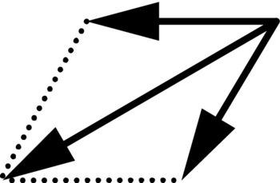

and the rotor will tend to align with this resultant.

The Hall-effect sensors are positioned so that just as the rotor gets to within 60*°* of being aligned, another arrangement of the windings is energized, and the field jumps forward another 60*°*, so the rotor is 120*°* away from being aligned. The rotor is always an average of 90*°* away from its desired position!

If a controller has input power from positive and negative of a dc supply and outputs to the terminals **a**, **b**, and **c** only, then the sequence of connections shown in [Table 30.2](https://learning.oreilly.com/library/view/power-electronics-handbook/9780128114087/B9780128114070000349_2.xhtml#t0015) will produce the resultant flux directions as shown, providing continuous rotation.

**Table 30.2**

**The sequence of connections that results in counterclockwise continuous rotation of the rotor of the PMBDCM of** [**Fig. 30.60**](https://learning.oreilly.com/library/view/power-electronics-handbook/9780128114087/B9780128114070000349_2.xhtml#f0305)

|  |  |  |  |  |
| --- | --- | --- | --- | --- |
| **When rotor gets to this position, connections are made as at right** | **Terminal a** | **Terminal b** | **Terminal c** | **Flux directions** |
| t30-01-9780128114070 | Current in | Current out | Zero | t30-02-9780128114070 |
| t30-03-9780128114070 | Zero | Current out | Current in | t30-04-9780128114070 |
| t30-05-9780128114070 | Current out | Zero | Current in | t30-06-9780128114070 |
| t30-07-9780128114070 | Current out | Current in | Zero | t30-08-9780128114070 |
| t30-09-9780128114070 | Zero | Current in | Current out | t30-10-9780128114070 |
| t30-11-9780128114070 | Current in | Zero | Current out | t30-12-9780128114070 |

The switching of [Table 30.2](https://learning.oreilly.com/library/view/power-electronics-handbook/9780128114087/B9780128114070000349_2.xhtml#t0015) is simply achieved by a variant of the “H” bridge, as shown in [Fig. 30.62](https://learning.oreilly.com/library/view/power-electronics-handbook/9780128114087/B9780128114070000349_2.xhtml#f0315). This process of switching current into different windings is called commutation and is the equivalent of the sliding brush contacts in a traditional brushed dc machine.



**FIG. 30.62** The switching circuit used for commutation of a PMBDCM.

### 30.6.3 CURRENT/TORQUE CONTROL

You may have noted that the discussion has been about current in the windings rather than the voltage across them. In very simple small brushless DC machines, like the one in the muffin fan in your computer power supply, voltages are connected directly to the windings. For these small motors, the resistance of the windings is relatively high, and this helps limit the actual current that flows and swamps inductive effects.

There is an extra difficulty that must be addressed with high-performance, high-efficiency, well-made machines, and it adds another layer to the control of the motor. Such machines can easily be designed with very low resistance windings. It is not uncommon to have windings for a 200 V machine at the 20 kw level with the winding resistances less than 0.1Ω.

When starting or at a low speed, the current in a winding is limited only by the very low resistance, and for the machine above by Ohm's law,  would result in more than 2000 A.

The most common requirement for a steady current in the windings is to provide a steady torque. There is always a back emf generated in the windings whenever the motor is rotating, which is proportional to speed and subtracts from the applied voltage. Thus, currents cannot be determined just by terminal voltage. The winding does however have inductance. Whenever the copper conductors are put in coils in an iron structure, particularly if there are low reluctance magnetic paths with only small air gaps, the creation of quite large inductances cannot be avoided. These are used to very good effect.

The nature of inductance is that when a voltage is applied to an inductor, instantaneous current does not result; rather, the current begins to increase and ramps up in a quite controlled fashion. If the voltage across the inductor is reversed, the current does not immediately reverse; rather, it ramps down, will go through zero, and reverses if the reversed voltage is left there long enough. However, if the voltage is alternated by switching rapidly, as can be done with power electronics, the current can be controlled to ramp-up and ramp-down either side of a desired current, staying within any determined tolerance of that desired current.

[Figure 30.63](https://learning.oreilly.com/library/view/power-electronics-handbook/9780128114087/B9780128114070000349_2.xhtml#f0320) looks very much like the simple “H-” bridge commutation circuit but is performing a very different function. It is controlling the current amplitude to stay within a desired band. If S1 and S4 are turned on then the current will begin to increase from left to right in the winding. The current sensor in the circuit detects when the current reaches a value of half the hysteresis band of the comparator above the desired current level and initiates turnoff of S1 and S4 and turn-on of S2 and S3. (If they were all turned off at once, the inductive nature of the circuit would produce very high voltages that would cause arcing in mechanical switches or breakdown and failure of semiconductor switches; see later.) The current then begins to reduce. It reduces a small amount, down to half the hysteresis band of the comparator below the desired current level and then the switches reverse again. Thus, a desired current level is achieved, with an arbitrarily small triangular ripple superimposed, as shown in [Fig. 30.64](https://learning.oreilly.com/library/view/power-electronics-handbook/9780128114087/B9780128114070000349_2.xhtml#f0325).



**FIG. 30.63** Hysteresis band current control using pulse-width modulation (PWM).

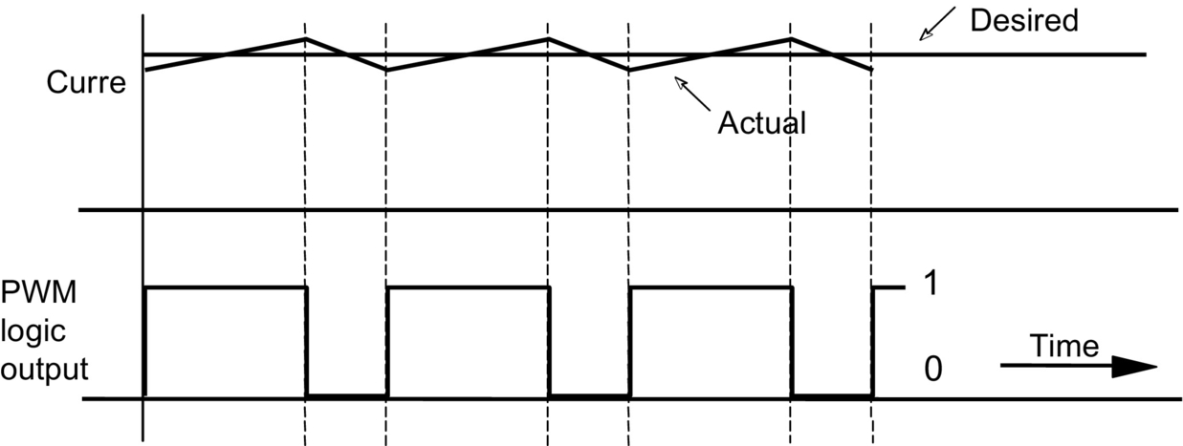

**FIG. 30.64** Hysteresis band current control and PWM waveforms.

The general process of controlling by switching a voltage fully on or fully off at a high speed is called pulse-width modulation (PWM), and the specific method of current control achieved above with PWM is called hysteresis band current control (HBCC).

Of course, to keep this current ripple small, the switching may need to be very fast, but with the modern semiconductor switches, there is no great problem up to 100 kHz for small machines and typically above 15 kHz for acoustic noise reasons, for machines rated up to several hundred kilowatts.

A perceived “drawback” of HBCC is that the switching frequency is determined by the circuit inductance, the width of hysteresis band, the back emf, and the applied voltage, ranging very widely in normal operation. It is not difficult, but it is a little more complicated, to use a fixed frequency, and a linear analog of the current error to modify the pulse width of the PWM signal.

#### **30.6.3.1 Switching Losses**

There is a practical limit to how often semiconductor switches can be operated. At every change of state, if the switch is carrying current as it is opened, then as the voltage rises across the switch and the current through it falls, there is a short pulse of power dissipated in the switch. Similarly, as the switch is closed, the voltage will take some time to fall and the current will take some time to rise, again producing a pulse of power dissipation. This loss is called switching loss. Fairly obviously, it will represent a power loss proportional to the switching frequency, and so the switching frequency is generally set as low as it can be without impinging on the effective operation of the circuit. “Effective operation” might well include criteria for acoustic noise and levels of vibration.

#### **30.6.3.2 High Efficiency Method of Managing the Switching in the H Bridge**

A very common way to control the current with the smallest number of switching transitions is to combine HBCC with, for example, alternating only S1 and S2 in [Fig. 30.65](https://learning.oreilly.com/library/view/power-electronics-handbook/9780128114087/B9780128114070000349_2.xhtml#f0330) leaving S4 on all the time, on the understanding that there will be a back emf in the winding and the current can still be increased or decreased as desired.



**FIG. 30.65** H-bridge switching with one switch steadily on and a back emf.

Thus, when the motor is rotating and the back emf is somewhere between zero and the rail voltage, alternating two switches rather than four will still allow current control in the coil, using, for example, HBCC, exactly as before.

This is a very common control scheme and will need some extra logic to reverse the direction of rotation of the motor, either by turning S4 off and S3 on continuously or by swapping the control signals to the left and right “legs.” For full-servo operation, normal H-bridge switching can be used, and the logic is slightly different, but not significantly more complicated. However, following the discussion above, the switching losses will be higher.

#### **30.6.3.3 Combining Commutation and PWM Current Control**

The real breakthrough is that one set of six switches can be used for both PWM and commutation. That is the clever part and also the confusing part when one first tries to understand what is going on.

Thus, in a controller, there are two control loops. The first is an inner current loop switching at, for example, 15 kHz to control carefully and exactly the current in two of the coils. Then, at a much lower rate, for example, at 50 times/s at 3000 rpm, the two coils doing the work are changed according to [Table 30.2](https://learning.oreilly.com/library/view/power-electronics-handbook/9780128114087/B9780128114070000349_2.xhtml#t0015), controlled by an outer commutation loop, using information from the Hall-effect shaft position sensors.

A complete controller is shown in the block diagram form in [Fig. 30.66](https://learning.oreilly.com/library/view/power-electronics-handbook/9780128114087/B9780128114070000349_2.xhtml#f0335). Various aspects of this block diagram will now be examined and explained in detail.



**FIG. 30.66** A complete controller showing the two feedback paths, one for the position sensors and one for the current sensors.

##### **Hardware details—semiconductor switches**

The three most likely semiconductor switches for a six-step controller are the bipolar junction transistor (BJT), the metal oxide silicon field-effect transistor (MOSFET), and the insulated gate bipolar transistor (IGBT). Older controllers used BJTs; however, contemporary controllers tend to use MOSFETs for lower voltages and powers and IGBTs for higher voltages and powers. Both of these devices are controlled by a gate signal and will turn-on when the voltage of the gate above the source or emitter is greater than a threshold, which is typically about 5 V. Use of about 10 V is common. The devices are thus off when the gate voltage below the threshold. Systems typically use zero volts for the off state. The controller of [Fig. 30.66](https://learning.oreilly.com/library/view/power-electronics-handbook/9780128114087/B9780128114070000349_2.xhtml#f0335) shows MOSFETs used for the six switches.

The trick is that the voltage at terminal **a**, also S1's source, is either ground or the positive potential of the battery, depending on which switches are on. Driving S2, S4, and S6 is easy since the MOSFET sources are all at the potential of the negative rail, and the lower gate drive signals are referred to this rail.

There is a range of dedicated integrated circuits that can drive the switches S1, S3, and S5 and that use a “charge pump” principle to generate the drive signal and the drive power internally, all related to the MOSFET source potential. Various approaches to this technical challenge of providing a floating gate drive are commonly discussed under the generic heading of “high-side drives.”

For the most sophisticated drives, transformer coupling is used to provide a tiny power supply especially for the isolated gate drive and send the control signals either through an optocoupler or a separate transformer coupling. The high-side drive problems here are exactly the same as those encountered in the traditional buck converter or in drives for induction motors and PMSMs.

##### **Dead time and flyback diodes**

Two issues have been mentioned above that must be addressed when using high-speed electronic switches in inductive circuits.

The first, in [Section 30.6.2](https://learning.oreilly.com/library/view/power-electronics-handbook/9780128114087/B9780128114070000349_2.xhtml#s0275) “Electronic Commutation,” was that care should be taken to ensure that the upper and lower switches in the same “leg,” (e.g., S1 and S2) are never turned on at the same time. If the controller attempts to turn one off and the other on at the same instant and switch turnoff is slower than turn-on (as it is with BJTs and IGBTs), then a short circuit will result for a brief time. The bus capacitor is usually very large to provide ripple current (see later) and usually of very high quality being fabricated especially for power electronic applications and can easily provide thousands of amperes for a few microseconds, which is enough to destroy the semiconductor switches.

The second issue, discussed in [Section 30.6.3](https://learning.oreilly.com/library/view/power-electronics-handbook/9780128114087/B9780128114070000349_2.xhtml#s0285) “Current/Torque control,” is that one cannot turn off both switches in a leg at the same time, even for a few nanoseconds, since the voltages resulting from attempting to interrupt current in an inductor will cause avalanche breakdown and failure of the semiconductors. This sounds like quite a dilemma.

There is actually a very simple and effective solution. At any transition, the control circuitry ensures that the active switches are all turned off before any switch is turned on, usually for a few microseconds. This is known as “dead time,” and its provision is an essential part of most of the dedicated integrated circuits in use. Then, a “flyback”/“freewheel” diode is put in antiparallel with each semiconductor switch, and this provides the current path during dead time. These diodes are shown in [Fig. 30.66](https://learning.oreilly.com/library/view/power-electronics-handbook/9780128114087/B9780128114070000349_2.xhtml#f0335).

The diode has a little more loss than the switch, since the diode forward drop is more than the switch drop. This is significant in a low-voltage controller. However, as stated above, for a low-voltage controller, MOSFETs are the device of choice. They have a lesser known property, that when gated on, they can carry current in both directions. Intriguingly, the “on” state resistance is lower in reverse than in the forward direction! Thus, for low-voltage controllers, when the switch forward drop represents a significant contribution to losses, the MOSFET is turned on after dead time for both the current directions. Thus, the higher loss in the diode is only for a few microseconds.

It is not difficult to produce from the PWM signal an “I up” logic signal that is used to cause the current to increase and an “I down” logic signal used to decrease it, with the timing as shown in [Fig. 30.67](https://learning.oreilly.com/library/view/power-electronics-handbook/9780128114087/B9780128114070000349_2.xhtml#f0340). The function can be executed in sequential logic, or with the simple analog timing circuits.



**FIG. 30.67** Dead time introduced into the PWM logic signal, for switch drive.

A. Semiconductor Detail

In MOSFETs and most IGBTs, there is a diode already within the device; it is unavoidable and results from the fabrication processes. In modern power semiconductors, this intrinsic diode is optimized to be a good switching diode. The serious designer, however, will check the specifications for reverse recovery of this diode, since in highly optimized controller designs, reverse recovery losses in the intrinsic diode can be significant and are very difficult to control. In low-voltage controllers, you can put a Schottky diode in parallel with the intrinsic body diode. The Schottky diode, with its lower forward voltage drop, will tend to take the current and has no reverse recovery problems, but the current must commutate to it from the semiconductor die, and the inductance of the connections is critical.

B. The Smoothing Capacitor on the Input to the Controller

This is a substantial capacitor, often very expensive, (it is shown in [Fig. 30.66](https://learning.oreilly.com/library/view/power-electronics-handbook/9780128114087/B9780128114070000349_2.xhtml#f0335) as C in), and its design is quite challenging. The issue of smoothing is quite serious. If there are high frequencies or sudden current changes in the leads from the dc supply to the controller, they will radiate electromagnetic energy. Good design will limit the length of conductors in which the current is changing rapidly. Thus, a very large capacitor is placed physically as close to the positive bus of the switches as possible, aiming to have a steady current in the longer conductors from the dc supply, up to the capacitor. When the motor is running at, say, half speed and providing large torques, a very high level of ripple current is carried by this capacitor. Kirchhoff's current law (KCL) must be applied at node A, as shown in [Fig. 30.68](https://learning.oreilly.com/library/view/power-electronics-handbook/9780128114087/B9780128114070000349_2.xhtml#f0345). Good capacitors have a ripple current maximum buried away in their specification sheet. It turns out that in general, the size of the capacitor in a given design has very little to do with how much voltage ripple you can tolerate at the bus but rather is determined by the ability to carry the ripple current without the capacitor heating up and failing. It has been known that the small electrolytics in prototype controllers mysteriously explode. On searching, it is found that they are in parallel with the main capacitor and quite close to it, so they carry a lot of ripple current, then heat up and explode!



**FIG. 30.68** Kirchhoff's current law at node A.

### 30.6.4 THE SIGNAL PROCESSING FOR PRODUCING SWITCH DRIVE SIGNALS FROM HALL EFFECT SENSORS AND CURRENT SENSORS

#### **30.6.4.1 Operation of the Hall Sensors**

The flux density directly under a magnet pole can be anywhere from 500 to 800 mT with Nd-Fe-B magnets. Hall-effect (HE) sensors with a digital output, called Hall-effect switches, change state at very close to zero flux density. Thus, they will change state when the north and south poles are equidistant from them, so that, for example, in [Fig. 30.69](https://learning.oreilly.com/library/view/power-electronics-handbook/9780128114087/B9780128114070000349_2.xhtml#f0350), the switch HE1 is just changing state with the rotor as shown.



**FIG. 30.69** Possible Hall-effect switch positions in a three-phase machine.

In practice, a motor designer needs to consider what magnetomotive force comes from the current in the windings that might result in flux that would trip the HE sensor at a slightly different time. If you follow all the above logic about six-step switching, you will see that you only need the magnet poles to have a span of a bit more than 120*°*. Using 180*°* magnet poles can add considerably to the cost and have an impact on such things as cogging torque. Actual designs often add extra “sense” magnets to cover 180*°* just at the circumferential strip where the HE switches are located, adding minimally to the magnet mass and ensuring good and accurate triggering.

However, if the switches operate as above, then [Table 30.3](https://learning.oreilly.com/library/view/power-electronics-handbook/9780128114087/B9780128114070000349_2.xhtml#t0020) will result for the HE switches located as shown in [Fig. 30.69](https://learning.oreilly.com/library/view/power-electronics-handbook/9780128114087/B9780128114070000349_2.xhtml#f0350).

**Table 30.3**

**Hall-effect switch outputs for rotor positions as shown, HE switches placed as in** [**Fig. 30.69**](https://learning.oreilly.com/library/view/power-electronics-handbook/9780128114087/B9780128114070000349_2.xhtml#f0350)

|  |  |  |  |
| --- | --- | --- | --- |
| **When the center of the rotor north pole is in this sector** | **HE1 outputs** | **HE2 outputs** | **HE3 outputs** |
| t30-13-9780128114070 | 1 | 0 | 0 |
| t30-14-9780128114070 | 1 | 1 | 0 |
| t30-15-9780128114070 | 1 | 1 | 1 |
| t30-16-9780128114070 | 0 | 1 | 1 |
| t30-17-9780128114070 | 0 | 0 | 1 |
| t30-18-9780128114070 | 0 | 0 | 0 |

#### **30.6.4.2 Sensing the Current in the Motor Windings**

[Fig. 30.66](https://learning.oreilly.com/library/view/power-electronics-handbook/9780128114087/B9780128114070000349_2.xhtml#f0335) shows two current sensors. In the most sophisticated systems, there are two current sensors, one in each of the two motor phases. The current sensing is done at the winding and isolated either with a HE sensor in a soft ferromagnetic magnetic core surrounding the conductor (commercial items are available) or by using a resistive shunt sensor and some accurate analog signal isolation/coupling through transformers or optocouplers. The isolation is necessary since the potential at points **a**, **b**, and **c** is either the dc bus voltage or zero, depending on which switches are on, so that any current measure such as the small voltage across a shunt is superimposed on these very large voltage changes. This is a very similar problem to that for the high-side gate drives discussed earlier. The current in the third winding is determined by the algebraic application of KCL, given the other two readings.

Simple controllers sometimes avoid the complexities of isolated current measurement and instead measure the current in the return negative supply, for example, from the bottom of the three lower switches to the bottom of the supply smoothing capacitor. This arrangement senses current when an upper and a lower switch is on, but not when the current is being carried in flyback diodes or by two lower switches. While it is inexpensive, it does not provide fully accurate control. The system works because the current should be decreasing when a measure is not available, heading toward zero, so switch or system failure due to overcurrent should not occur.

#### **30.6.4.3 Management of Current Sensing**

The controller must select the right current to increase or decrease, dependent on rotor position. The following convention is adopted. Positive current provides torque in the counterclockwise direction and therefore goes into winding **a**, **b**, or **c**.

All systems are capable of regeneration, which implies that negative torque can be commanded (without reversing the direction of rotation) to make the machine operate as a generator, developing retarding torque.

Thus, for the above sequence of sector determinations, referring back to [Table 30.2](https://learning.oreilly.com/library/view/power-electronics-handbook/9780128114087/B9780128114070000349_2.xhtml#t0015), the output of current sensors should be directed to the current controller as shown in [Table 30.4](https://learning.oreilly.com/library/view/power-electronics-handbook/9780128114087/B9780128114070000349_2.xhtml#t0025).

**Table 30.4**

**Current sensors to use as input to the current controller, for each of the six rotor-position sectors**

|  |  |
| --- | --- |
| **Hall-effect switch outputs (HE1, HE2, and HE3)** | **Monitor current as read by** |
| 100 | Negative of (sensor a si9_e sensor b) |
| 110 | Negative of (sensor a si9_e sensor b) |
| 111 | Sensor b |
| 011 | Sensor b |
| 001 | Sensor a |
| 000 | Sensor a |

The addition and negation required can be carried out with the standard operational amplifier circuitry. The three required analog measures are then fed to a three to one analog multiplexer, gated from the HE switch signals suitably processed in combinational logic. The resulting single analog output is fed to the current comparator.

#### **30.6.4.4 Distribution of Control Signals to the Switches**

Given that the dead time is introduced elsewhere in sequential logic, or with timing circuits, it is a simple matter to develop the combinational logic for directing, or steering, the switching signals to the right switches. A typical scheme for a specific controller is shown in [Table 30.5](https://learning.oreilly.com/library/view/power-electronics-handbook/9780128114087/B9780128114070000349_2.xhtml#t0030).

**Table 30.5**

**Distribution of control signals to the switches using “high-efficiency method of managing the switching in the H bridge”**

|  |  |  |  |  |  |  |
| --- | --- | --- | --- | --- | --- | --- |
| **HE states (1,2,3)** | **S1** | **S2** | **S3** | **S4** | **S5** | **S6** |
| 100 | I up | I down | 0 | 1 | 0 | 0 |
| 011 | 0 | 0 | 0 | 1 | I up | I down |
| 001 | 0 | 1 | 0 | 0 | I up | I down |
| 000 | 0 | 1 | I up | I down | 0 | 0 |
| 100 | 0 | 0 | I up | I down | 0 | 1 |
| 110 | I up | I down | 0 | 0 | 0 | 1 |

It is usual also to include some shutdown logic from dedicated protection circuits, for example, sensing overcurrent, overbus voltage, undervoltage for gate drive, and overtemperature both in the motor and in the controller power stage. For simplicity, this is not shown in the table.

### 30.6.5 SUMMARY

#### **30.6.5.1 What is Discussed in the Above**

The physical principles of the operation of a PMBDCM have been discussed that lead to the development of the necessary parts of a power electronic controller. One specific type of current control, hysteresis band current control was explained in detail, and one specific type of switch logic pattern was developed. The exposition has included many of the issues that can cause difficulties for controller designers if they are not careful.

#### **30.6.5.2 What is Not Discussed in the Above**

Many PMBDCMs have more than one pair of poles. The arguments above can all be extended to higher pole count machines, by taking any mention of degrees to be electrical degrees rather than mechanical degrees. The controller discussed in detail only manages one direction of rotation. It is an excellent exercise and straightforward, but not trivial, to repeat the above steps, preparing the tables for clockwise rotation of the simple machine discussed above. Then, following the discussion in the first part of [Section 30.6.3](https://learning.oreilly.com/library/view/power-electronics-handbook/9780128114087/B9780128114070000349_2.xhtml#s0285) “Current/Torque Control”, about H-bridge switching, prepare the logic tables again for full bidirectional control, using the I up and I down logic signals exactly as above but applying them to both “legs” determined by the rotor position. Only one form of current sensing was discussed in detail. There are many simpler schemes in use that do not have quite the flexibility and accuracy of the above but that can suit certain applications. Similarly, there are other forms of current control such as the constant-frequency linear method briefly discussed. Shaft position sensors take many forms. Adherence to the HE sensor was for simplicity and to reinforce the magnetic field aspects of the machine operation.

## 30.7 Servo Drives

### **30.7.1 INTRODUCTION**

Servo drives are motor drives that operate with high dynamic response. Historically, servo drives have implied motion-control systems in which sophisticated motor design, drive, and control techniques have been employed to obtain very much shorter positioning times than is possible with conventional drive systems. Examples are in machine-tool drives, robotic actuators, and computer disk drives. The power range for these drives has typically been in the range of a few kilowatts or less. This range has steadily increased in recent years as a result of advances in magnetic materials, machine design, power and signal electronic devices, and sensors.

Apart from the fast positioning times, “high dynamic response” also means that the drive operates with the following:

1. Very smooth torque up to a very low speed

2. Very high reliability and little maintenance

3. Immunity from load disturbances

The last of the foregoing items is brought about by robust and intelligent control algorithms; the first two items are brought about by innovative and often costly motor and controller designs. As a result of these, the cost of a servo-motor drive is usually much higher than the equivalent power-rated industrial drives.

The distinctions just mentioned may be easily recognized by noting, for example, that the drives that bring material to a mill may not require high performance, but the drives that take part in shaping, milling, or reducing the material should have high dynamic response in order to increase throughput and meet the accuracy requirements of the final product.

### 30.7.2 SERVO DRIVE PERFORMANCE CRITERIA

The performance of a servo drive can be expressed in terms of a number or factors such as servo bandwidth, accuracy, percentage regulation, and stiffness. While servo bandwidth indicates the ability of the drive to track a moving or cyclic reference, the percentage regulation and stiffness stipulate the drive's static holding performance for speed or position, in the face of disturbances from the load and in the supply conditions. The servo bandwidth, specified as a frequency in hertz or radian per second, is often found from the system frequency response plot, such as the Bode diagram.

The percentage regulation of a speed-controlled system often refers to the percentage change in speed from no load to full load. In a type-zero system, this figure will have a finite value. Many systems are type zero, albeit with a high gain so that the regulation is acceptably low. For such systems, the regulation is often necessary for operational reasons. In some applications, zero percentage error is required, which calls for type 1 or integral-type control system.

The servo stiffness is similar to the percentage error mentioned earlier, but it applies mainly for the position servo. It specifies the deflection of the load from its reference position, when full load torque is applied. It is usually the slope of the deflection versus the applied load torque in rad/Nm around the reference position.

### 30.7.3 SERVO MOTORS, SHAFT SENSORS, AND COUPLING

Servo drives use motors that allow the desired goals of high dynamic response to be achieved. The important parameters/attributes of a servo motor are as follows:

1. High torque-to-inertia ratio

2. High torque-to-volume ratio

3. Low inductance of the motor windings

4. Low cogging torque at a low speed

5. Efficient heat dissipation

6. Low coefficient of shaft compliance

7. Direct-coupled, high-resolution, shaft-mounted sensors for position and speed

High torque-to-inertia ratio allows fast acceleration or deceleration of the drive when motion references are changed. This is often achieved through innovative low-inertia rotor design and low inductance in the stator winding. One example of a dc servo motor is the pancake-printed armature dc motor with no iron in the rotor, as indicated in [Fig. 30.70](https://learning.oreilly.com/library/view/power-electronics-handbook/9780128114087/B9780128114070000349_2.xhtml#f0355). The rotor is sandwiched between axially mounted stator poles. The commutator is also on the printed armature. Another example is the disk rotor stepping motor, also without iron in the rotor, as indicated in [Fig. 30.71](https://learning.oreilly.com/library/view/power-electronics-handbook/9780128114087/B9780128114070000349_2.xhtml#f0360).

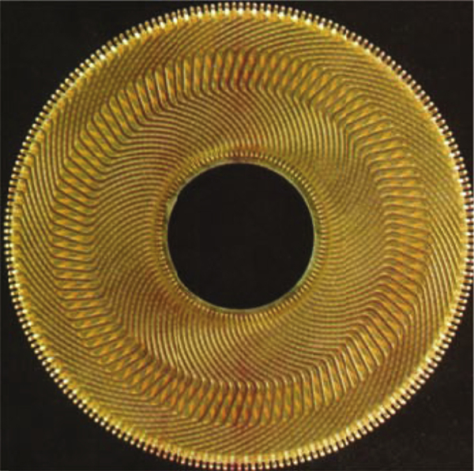

**FIG. 30.70** Pancake armature of a dc servo motor. Courtesy—printed Motors Ltd., the United Kingdom.

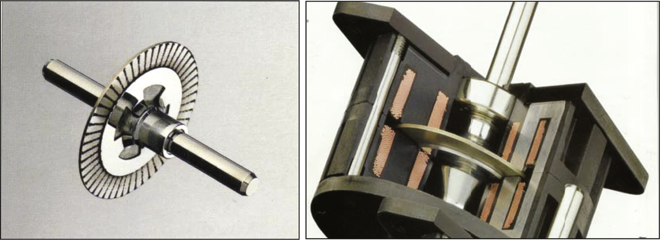

**FIG. 30.71** A disk rotor stepping motor with ironless rotor for low inertia and inductance. Courtesy—Escap Motors.

The PM ac synchronous motors with modern high-energy-density magnets in the rotor, as described in [Section 30.6](https://learning.oreilly.com/library/view/power-electronics-handbook/9780128114087/B9780128114070000349_2.xhtml#s0240), are also examples where the motor designer strives to minimize the rotor inertia. Modern permanent magnets allow the required air-gap flux to be developed with a much reduced volume of the magnets, consequently reducing the diameter of the rotor. It is well-known that the moment of inertia of a motor increases as the fourth power of its outer radius!

Another benefit of the modern permanent-magnet material is that the motor volume is also reduced. Servo motors often have to be located in a very confined space, and this reduction in volume is an important attribute.

The ironless designs mentioned earlier bring other benefits in the form of reduced inductance and cogging torque. Brushed pancake ironless motors are available with armature inductance as low as 100μH.

From [Section 30.2.2](https://learning.oreilly.com/library/view/power-electronics-handbook/9780128114087/B9780128114070000349_1.xhtml#s0025), the mechanical and electric time constants of a brushed dc motor are given by

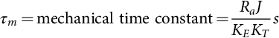

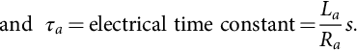

It is well-known that for the highest load acceleration, the load inertia referred to the motor should be equal to the rotor inertia. Thus, in a matched system, the total inertia the motor accelerates is twice its own inertia. In other words, the motor inertia should also be minimized.

For a good servo motor, the ratio between the mechanical and the electric time constants is often of the order of five or more. This allows the speed and the current-control loops to be decoupled and noninteracting. The electric time constant of a motor determines how quickly the motor current may be changed and hence how quickly the torque can be changed. As also mentioned in [Section 30.2](https://learning.oreilly.com/library/view/power-electronics-handbook/9780128114087/B9780128114070000349_1.xhtml#s0015), drives with a reasonable dynamic performance should have an inner torque loop. This torque loop is built around current loops, for the armature, for the brushed dc motor, or for the *d*- and *q*-axis currents for the induction and synchronous motor drives. Having a low inductance in the winding allows these currents to be followed dynamically changing current or the torque references with higher accuracy and bandwidth.

The cogging torque, if appreciable, causes the rotor to have preferential positions. As a result, the position accuracy of the motor may suffer. Another problem is the ripple in speed as the motor is operated at a low speed. At a high speed, these ripples due to cogging torque may be filtered out by the motor inertia; however, the extra loss due to cogging remains. The ironless or toothless rotor obviously produce very small cogging torque because of the absence of preferential paths for the air-gap flux to establish through the rotor iron of the brushed dc motor. The surface-magnet synchronous motor also has this feature. The interior-magnet motor normally has skewed stator slots to avoid the production of cogging torque.

Servo motors often operate with frequent start-and-stop duty, with the fastest allowable acceleration and deceleration during which the motor current is allowed to reach about 2–3 times the continuously rated current. The increased *I*2*R* loss in such duty must be dissipated. This calls for adequate cooling measures to be incorporated in the motor housing. With such operation, it is sometimes possible to excite the mechanical resonance due to shaft compliance. This is avoided through proper arrangement of the shaft position/speed sensor and the coupling between the motor and the sensor. A belt-driven speed sensor may be acceptable for an industrial drive; however, for servo applications, a rigid, direct-coupled sensor mounted as close as possible to the motor armature is preferable. Additionally, the speed sensor is also required to have negligible noise. Speed signal from analog tachogenerators, which were used for speed sensing until recently, invariably needed to be filtered to remove the cyclic ripple/noise that existed. Such filtering often limits the maximum speed-control bandwidth of a drive.

### 30.7.4 THE INNER CURRENT/TORQUE LOOP

The inner current loops in a servo-motor drive play a more important role than just limiting the current in case of overload. These loops operate continuously to regulate the motor-developed torque so as to meet the load demand, and for meeting the speed trajectory specified by the motion controller. Motor drives of high dynamic response currently employ PWM current sources. These sources use MOSFET or IGBT switching devices that allow the modulator to be operated with a switching frequency between 10 and 25 kHz. At these frequencies, the inherent switching delay, which is equivalent to half of the PWM switching period, is made rather small for the bandwidth of the torque-control loop. The bandwidth of the current-control loops closely represents the bandwidth of the torque control. This is because the motor-developed torque generally is proportional to these currents. Servo drives up to a few kilowatts presently have torque-/current-control-loop bandwidths in excess of 1 kHz.

For higher power, fast-response drives, such as those used in the metal-processing industries, thyristor converters have been used for many years. The switching frequencies of these converters are rather low, being some multiple of the mains frequency, according to the converter chosen. Fortunately, the larger mechanical time constant of the larger power motor and the nature of the applications have allowed the 300 Hz (360 Hz in the United States) switch frequency of the three-phase thyristor bridge converter to be used satisfactorily in many applications requiring high dynamic response. The growing availability of faster and higher power IGBT devices is continually enhancing the dynamic performance of larger drives.

Fast-response, inner torque-control loops have in recent years been extended to ac induction and synchronous motors. These motors were hitherto considered only for industrial drives. The vector methods described in [Sections 30.3](https://learning.oreilly.com/library/view/power-electronics-handbook/9780128114087/B9780128114070000349_1.xhtml#s0050) and [30.4](https://learning.oreilly.com/library/view/power-electronics-handbook/9780128114087/B9780128114070000349_1.xhtml#s0125), which employ inner quadrature axis current controllers in the synchronous (for the induction motor) or the rotor (for the synchronous motor) reference frame, have transformed the prospects of ac motor drives in servo applications.

Because of the fast dynamic response requirement of servo drives, the servo motor is nearly always driven with the maximum torque per ampere (MTPA) characteristic. Field weakening is normally not used. In other words, field control either directly for a brushed dc motor or a synchronous motor or indirectly through armature reaction (i.e., through *id* current control) for induction, or PM ac synchronous motors is not used for field weakening. It is nevertheless used for regulating the field at the desired level. Field weakening are mainly used for drives where the operation at higher than base speed with constant-power characteristic is desirable.

### 30.7.5 SENSORS FOR SERVO DRIVES

Servo drives require high-bandwidth current sensors for the inner torque loop and high-accuracy, noise-free speed and position sensors for the outer loops. The current sensor is often a Hall device with an amplifier, which can have bandwidths as high as 100 kHz. The inner current loop both limits and continuously regulates the motor current in all operating modes of the drive, including acceleration and deceleration. About 2–3 times, the continuous rated current of the motor is tolerated during acceleration and deceleration. This entails limiting the speed controller output to the level corresponding to the current sensor output for the limiting values of motor currents.

The current-sensor output has to be filtered to adequately remove the switching frequency noise. Otherwise, certain switching devices in converter may be overloaded. This task is more important for the thyristor converters for dc drives for which the switching frequency is rather low. This filtering of the current-sensor output limits the bandwidth of the current-control system, that is, the inner torque-control loop.

Performance of servo-motor drives depends critically on the noise and accuracy of the speed and position sensors. Synchro resolvers with 12-bit or higher digital accuracy were used in many servo-drive systems until recently. The advent of cheaper incremental and absolute optical encoders has altered this situation completely. These digital sensors are actually position sensors. The speed information is derived from positions measured by discrete differentiation. Such differentiation is not feasible with analog position sensors, because of the noise.

Analog tachogenerators are also avoided for speed servo systems. This is because of the tachogenerator ripples inherent in the sensor.

Modern discrete position sensors provide for virtually noise-free speed and position sensing. This allows very fast dynamic response to be achieved if the switching frequency of the converter allows it.

### 30.7.6 SERVO CONTROL-LOOP DESIGN ISSUES

#### **30.7.6.1 Typical Controllers**

##### **Proportional controller**

A proportional controller provides for a straight gain to amplify the error signal. It has no discriminatory properties. With the input and feed-resistance values indicated in [Fig. 30.72](https://learning.oreilly.com/library/view/power-electronics-handbook/9780128114087/B9780128114070000349_2.xhtml#f0365), the total gain of the controller is ().

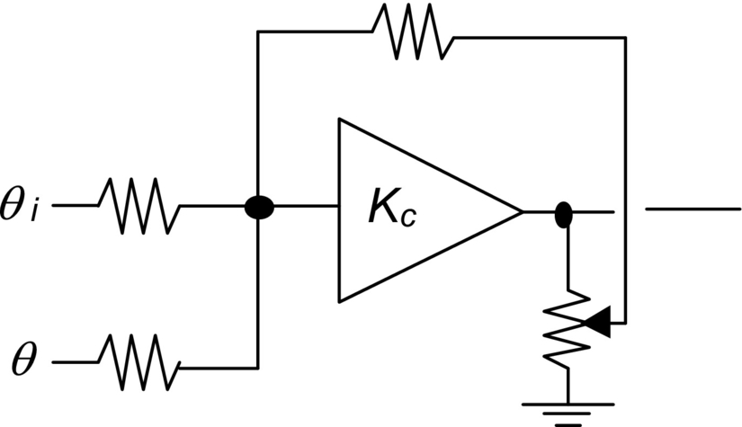

**FIG. 30.72** Proportional controller.

 **(30.79)**

##### **Transient velocity feedback controller**

It is well-known that a following error will exist in the preceding system when a moving or ramp reference is tracked. If a rate feedback, such as the speed feedback in a position-control system, is used to damp the system, this error is further increased. To overcome this following error due to velocity feedback, transient velocity feedback can be used as indicated in [Fig. 30.73](https://learning.oreilly.com/library/view/power-electronics-handbook/9780128114087/B9780128114070000349_2.xhtml#f0370).

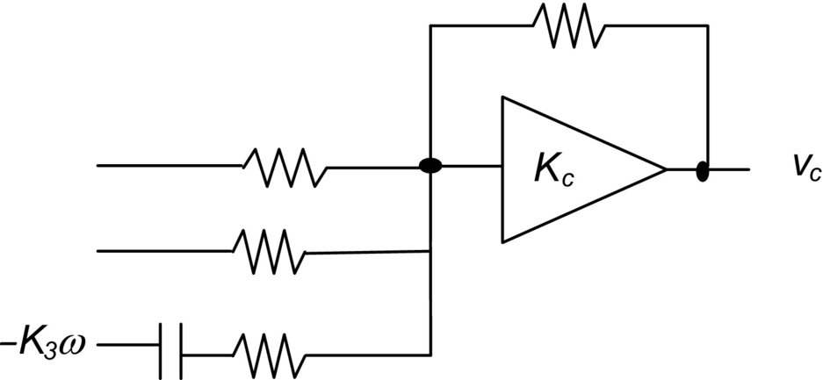

**FIG. 30.73** Transient velocity feedback controller.

The speed (velocity) signal is passed through an RC circuit at the input of the amplifier circuit. An input current occurs only when the speed signal changes. In the steady state, the capacitor is fully charged, so that no following error in the steady state due to the velocity feedback can exist.

In the steady state when the velocities are equal, the output may lag or lead depending on the relative values of *R*1 and *R*2. It can be shown that in the absence of frictional load torque, as is often the case in servo applications, no following error is introduced if .

##### **Integral controller**

In the transient-velocity and error-rate feedback schemes, the following error will exist if viscous friction and load torque are present. If such loads are present, the system gain has to be infinity to have a zero error. Very large gains will make any physical systems unstable, unless bandwidth limitations exist. One way to employ infinite gain in the steady state is to use an integrator. This amplifies the steady-state error until it is eliminated.

Normally, a proportional plus integral (PI) action is used. A derivative term is normally not used in the control system of a drive system, since the drive feedback signals are very noisy. Instead, derivative signals are obtained through sensors such as tachogenerators. The structure of a PI controller is indicated in [Fig. 30.74](https://learning.oreilly.com/library/view/power-electronics-handbook/9780128114087/B9780128114070000349_2.xhtml#f0375).

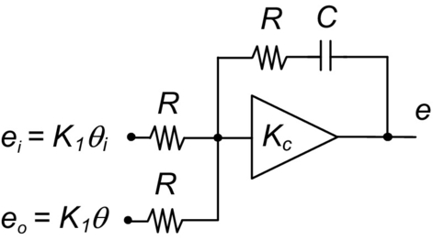

**FIG. 30.74** Integral controller.

It can be shown that there will be no steady-state error even in the presence of frictional or other load torque.

Many types of more complex controllers are available, such as the variable structure controller. Drives with fuzzy controllers have also been in the marketplace for some years.

The controller circuits just described are usually implemented in analog circuits using operational amplifiers. Digital implementations are also being gradually introduced using the embedded microcontrollers and digital signal processors.

#### **30.7.6.2 Simplified Drive Representations and Control**

Consider the block diagram of [Fig. 30.75](https://learning.oreilly.com/library/view/power-electronics-handbook/9780128114087/B9780128114070000349_2.xhtml#f0380) in which the individual elements (blocks) are represented in terms of their transfer functions in terms of the Laplace operators.

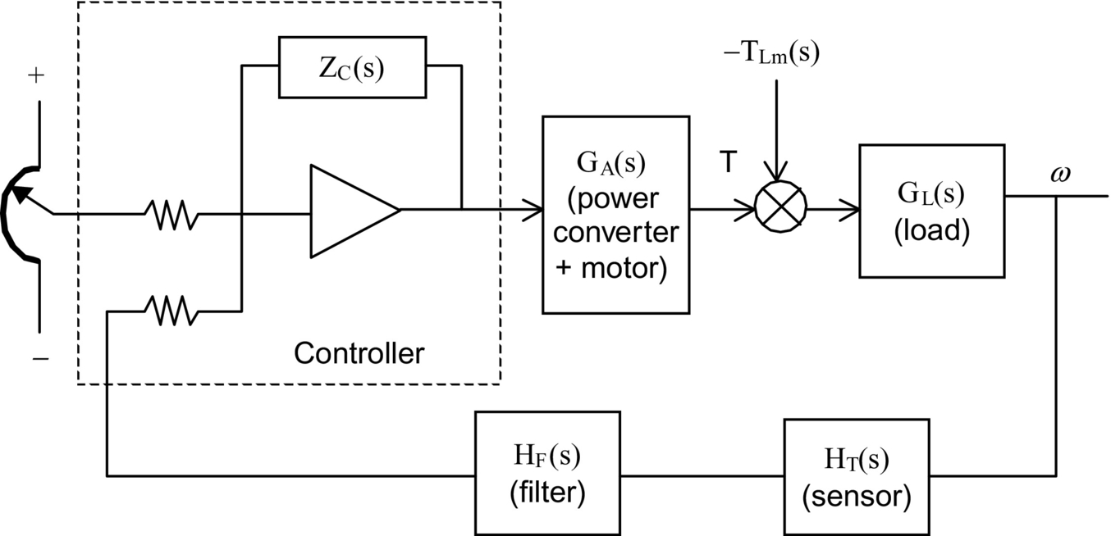

**FIG. 30.75** Block diagram of a speed-control system.

Here, *GA*(*s*), *GC*(*s*), *GL*(*s*), *HT*(*s*), and *HF*(*s*) represent the transfer functions of the power converter plus the motor, the controller, the load, the sensor (of speed in this example), and the filter following the sensor, respectively. The reference input for speed and the feedback signal are connected to a summing junction of an operational amplifier through resistors *Ri* and *Rf*, respectively.

The preceding system can be simplified to that shown in [Fig. 30.76](https://learning.oreilly.com/library/view/power-electronics-handbook/9780128114087/B9780128114070000349_2.xhtml#f0385) and further to that in [Fig. 30.77](https://learning.oreilly.com/library/view/power-electronics-handbook/9780128114087/B9780128114070000349_2.xhtml#f0390).

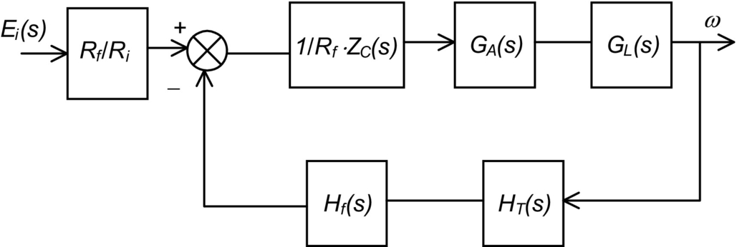

**FIG. 30.76** Simplified representation of [Fig. 30.75](https://learning.oreilly.com/library/view/power-electronics-handbook/9780128114087/B9780128114070000349_2.xhtml#f0380).

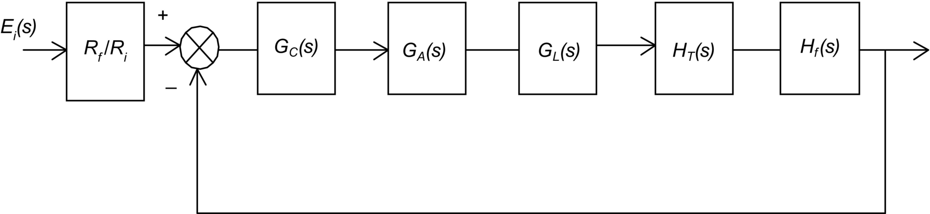

**FIG. 30.77** Further simplified representation of [Fig. 30.75](https://learning.oreilly.com/library/view/power-electronics-handbook/9780128114087/B9780128114070000349_2.xhtml#f0380).

In general, if the individual control blocks are approximated as first-order systems and are mutually decoupled, meaning that each block operates in a frequency band that is far outside the frequency bands of all other blocks, then the foregoing systems can be represented by a transfer function of the form

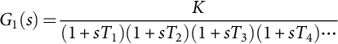 **(30.80)**

When *T*3 and *T*4 are much smaller time constants than *T*1 and *T*2, the preceding may be approximated by

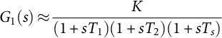 **(30.81)**

where . A dc-motor speed-control system with current and speed sensors falls in this category. For such a system, there exist two dominant time constants (poles).

For such a system, a proportional plus integral controller is of the form

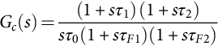 **(30.82)**

One optimization criterion (Kessler's) stipulates that , , and . With this stipulation, the transfer function of the complete system is given by

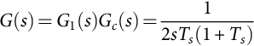 **(30.83)**

**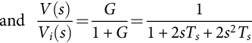** **(30.84)**

Note that the two filter time constants *τF*1 and *τF*2 are included in *Gc*(*s*) for the sake of its realizability. These can be relegated to frequencies far higher than the range of interest and can be ignored for further analysis of the system. For an unit step input of *Vi*, the output *V* is given by

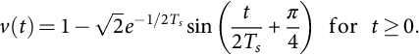 **(30.85)**

A typical output is indicated in [Fig. 30.78](https://learning.oreilly.com/library/view/power-electronics-handbook/9780128114087/B9780128114070000349_2.xhtml#f0395).

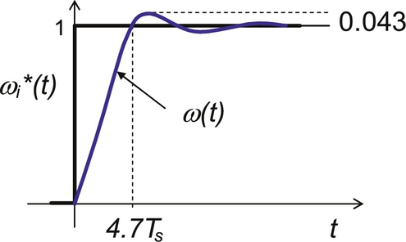

**FIG. 30.78** Response of the optimized system of [Fig. 30.75](https://learning.oreilly.com/library/view/power-electronics-handbook/9780128114087/B9780128114070000349_2.xhtml#f0380).

If the transfer function *G*1(*s*) has one dominant time constant *T*1(*s*), as for the field current control of a dc motor, a suitable controller is the form

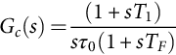 **(30.86)**

In some cases, the transfer function *G*1(*s*) is of the form

 **(30.87)**

where *Ts* is the sum of a number of short-time constants, associated with sensors, switching frequency, and so on. The current controller of the dc motor with back emf has such a characteristic. A suitable PI controller for this system is

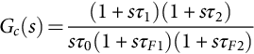 **(30.88)**

For this system, Kessler's optimization criterion stipulates that



The transfer function of the complete system is then

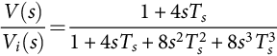 **(30.89)**

The peak overshoot of this system to a unit step unit is usually unacceptable, as indicated by the response of [Fig. 30.79](https://learning.oreilly.com/library/view/power-electronics-handbook/9780128114087/B9780128114070000349_2.xhtml#f0400). This overshoot is usually reduced by inserting a first-order filter in the reference circuit. The filter network and the responses are given in [Fig. 30.80](https://learning.oreilly.com/library/view/power-electronics-handbook/9780128114087/B9780128114070000349_2.xhtml#f0405).

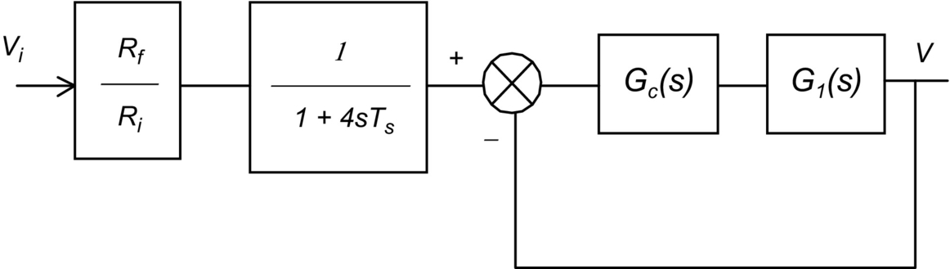

**FIG. 30.79** Block diagram representation of a drive with one dominant time constant.

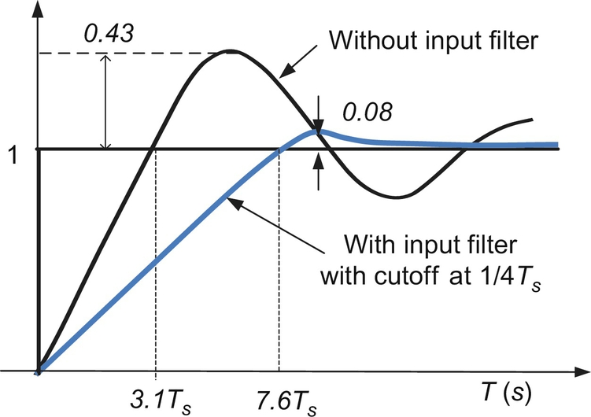

**FIG. 30.80** Optimized response of the system of [Fig. 30.79](https://learning.oreilly.com/library/view/power-electronics-handbook/9780128114087/B9780128114070000349_2.xhtml#f0400).

## 30.8 Stepper Motor Drives

### **30.8.1 INTRODUCTION**

A stepper motor is a positioning device that increments its shaft position in direct proportion to the number of current pulses supplied to its windings. A digital positioning system without any position or speed feedback is thus easily implemented at a much lower cost than with the other types of motors, simply by delivering a counted number of switching signals to the motor. Typically, a 200 steps-per-revolution stepper motor with 5% stepping accuracy will be equivalent to a dc motor with a 12-bit (or 4000 counts/rev) encoder plus the closed-loop speed and position controllers for obtaining similar positioning resolution. This advantage, however, is obtained at a cost of increased complexity of the drive circuits. A disadvantage of the motor is perhaps its inability to reach an absolute position, since the final position reached is only relative to its arbitrary initial position. Nevertheless, the true digital nature of this motor makes it a very suitable candidate for digital positioning systems in many manufacturing, automation, and indexing systems.

The working principle of stepper motors is based on the tendency of the rotor to align with the position where the stator flux becomes maximum (i.e., seeking of the minimum-reluctance position, also called the detent position). The rotor and the stator are both toothed structures, and the stator normally has more than two windings to step the rotor in the desired direction when they are energized in certain combinations with current. Some motors additionally have permanent magnets embedded in the rotor that accentuate an already existing, zero-excitation detent torque. These motors hold their positions even when the stator excitations are removed completely, a feature desirable for some applications.

In addition to the point-to-point stepping action, these motors can also be operated at high slewing speed, simply by increasing the pulsing rate of phase currents. Since the motor is inherently a synchronous actuator, the pulsing rate has to be increased and decreased properly, so that the rotor may follow it. At the end of a complete run, the motor always stops at the desired incremental position or angle without any accumulated error. The only error that may be encountered is mainly due to the machining accuracy of the teeth in the stator and rotor. This error is of the order of about 5% of one step position/angle, and it is nonaccumulative.

### 30.8.2 MOTOR TYPES AND CHARACTERISTICS

#### **30.8.2.1 Single-Stack Variable-reluctance Stepper Motor**

Single-stack motors are normally of the variable-reluctance type with no excitation in the rotor. The cross section of a three-phase motor with two stator poles/phase and four rotor poles is indicated in [Fig. 30.81](https://learning.oreilly.com/library/view/power-electronics-handbook/9780128114087/B9780128114070000349_2.xhtml#f0410). The motor can be stepped clock or anticlockwise by energizing the phase winding in the ABCA or ACBA sequence, respectively. The step angle, that is, the angle moved by the rotor for each change in excitation sequence, of the motor is given by

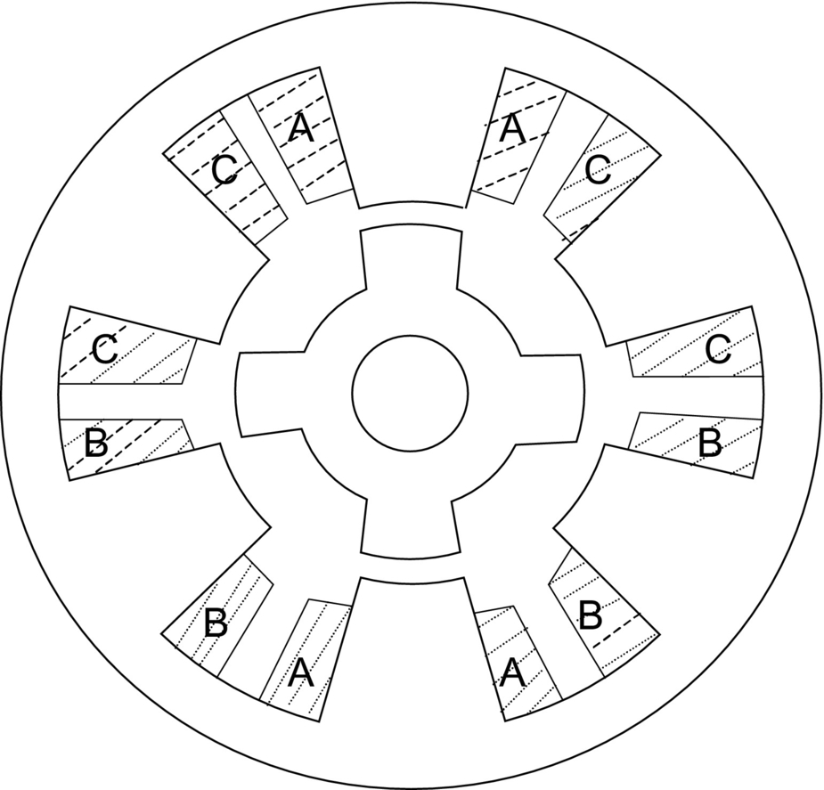

**FIG. 30.81** Cross section of a single-stack variable-reluctance stepper motor.

 **(30.90)**

where *N* is the number of phases in the stator and *P* is the number of poles in the stator. Single-stack motors typically have larger step angles than other types because of limitations of space for the windings. The step angle of these motor tend to be larger than the multistack and hybrid stepper motors.

For each excited winding, the motor develops a torque angle () characteristic as indicated in [Fig. 30.82](https://learning.oreilly.com/library/view/power-electronics-handbook/9780128114087/B9780128114070000349_2.xhtml#f0415). Note that there are two equilibrium positions of the rotor, namely, *X* and *Y*, where the motor develops zero torque.

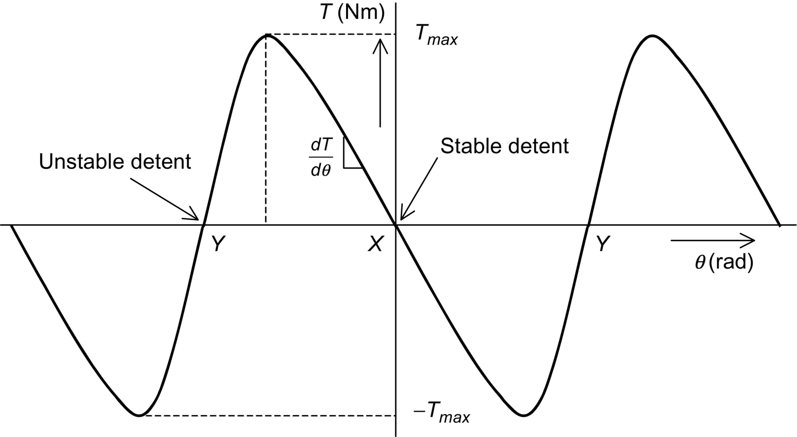

**FIG. 30.82** Static torque characteristic of a stepper motor.

The position *X* is referred to as the stable detent position, around which the rotor develops a restoring torque when displaced. The restoring torque increases as the rotor is moved from its detent position, becoming a maximum *Tmax* on either side of this position. The slope of the  characteristic around this detent position and the maximum torque, both of which depend on the level of excitation, indicate how far the rotor will be displaced under load torque. This means that the level of excitation also affects the position holding accuracy of the motor.

The motor may also be excited in the sequence: AB-BC-CA or AB-CA-BC for forward and reverse stepping, respectively. The two-phases-on scheme develops more torque around the detent positions at the expense of twice the resistive losses.

Yet, another excitation scheme is AB-B-BC-C-CA-A-AB for forward stepping and AB-A-AC-C-BC-B-AB for reverse stepping. In this scheme, the step size is halved as opposed to the full-step size of the previous sequences. Two different levels of torque are produced for alternate detent positions. However, the reduced step size and the more damped nature of each step may outweigh this disadvantage.

#### **30.8.2.2 Multi Stack Variable-Reluctance Stepping Motor**

In a multistack variable-reluctance motor, the stator windings are stacked along the shaft. Each stack section now has the same number of poles in the stator and the rotor. Normally, each stator stack is staggered with respect to its neighbor by *one/Nth* of a pole pitch, where *N* is the number of stator/rotor phases or sections. The cutout view of [Fig. 30.83](https://learning.oreilly.com/library/view/power-electronics-handbook/9780128114087/B9780128114070000349_2.xhtml#f0420) shows some internal details of a six-phase multistack motor, in which each stack has a phase winding between two rings, each with 32 stator and rotor poles. The step size of this motor is



**FIG. 30.83** Cutout view of a six-phase, multistack, and variable-reluctance stepper motor. Courtesy: Pratt Hydraulics, the United Kingdom.

 **(30.91)**

The excitation sequence of this motor is similar to the ones mentioned in [Section 30.8.2.1](https://learning.oreilly.com/library/view/power-electronics-handbook/9780128114087/B9780128114070000349_2.xhtml#s0430), except that more excitation sequences are available. When a stator winding is energized, the rotor poles of that section tend to align with those defined by the stator excitation. The stator and rotor teeth in the other sections are not aligned. By changing the combination of excited phases to the next in sequence, the rotor is made to move by one step angle.

#### **30.8.2.3 Hybrid Stepping Motor**

A hybrid stepper motor has an axially oriented permanent magnet sandwiched between two sections of the stator and rotor, as indicated in [Fig. 30.84](https://learning.oreilly.com/library/view/power-electronics-handbook/9780128114087/B9780128114070000349_2.xhtml#f0425). The magnetic flux distributes radially through the two stator and rotor sections, both of which are toothed, and axially through the back iron of the stator and the shaft. The stator has two-phase windings, each of which creates alternate polarities of magnetic poles in both sections of the stator. Stator windings are excited with bipolar currents, as opposed to the unipolar currents in the variable-reluctance motors of the two preceding sections. The magnetic flux produced by the stator windings not only is circumferential in each stator and rotor section but also crosses the air gap radially. It does not, however, pass through the rotor magnet. The two rotor sections are offset by half its tooth pitch.



**FIG. 30.84** Axial cross section of the hybrid motor.

The rotor magnet causes to the stator and rotor teeth to settle at the minimum reluctance position with a modest amount of detent torque to keep the rotor in position, when the stator windings are not energized. The rotor magnetic flux distributes outward through stator poles 3 and 7 in section *X* and inward through poles 1 and 5 in section *Y*, as shown in [Fig. 30.85A and B](https://learning.oreilly.com/library/view/power-electronics-handbook/9780128114087/B9780128114070000349_2.xhtml#f0430). When the stator windings A and B (indicated as dark and faint shaded, respectively) are energized with positive and negative currents, respectively, the resulting stator flux also distributes through these same poles, so that the rotor then develops a much higher detent torque () characteristic. The motor can be stepped forward or backward by energizing windings in sequence  or  respectively, where the over bar indicates the polarity of currents in phases *A* and *B*.



**FIG. 30.85** Cross section of the hybrid motor: (A) section *X* and (B) section *Y*.

The stepping angle of a hybrid stepper motor is given by

 **(30.92)**

where *P* is the number of rotor poles.

#### **30.8.2.4 Permanent-Magnet Stepping Motor**

Permanent-magnet stepper motors have alternate polarities of permanent magnets on the rotor surface, while the rotor iron, if it is used, has no teeth. In one type of construction, the rotor has no iron, and the stator consists of two windings that set up alternate poles when energized, just as in the case of the hybrid motor. The rotor consists of permanent magnets, alternately polarized, attached to the surface of a nonmagnetic disk, as shown in [Fig. 30.86](https://learning.oreilly.com/library/view/power-electronics-handbook/9780128114087/B9780128114070000349_2.xhtml#f0435). The stator and rotor fluxes cross the air gap, one on either side of the disk, axially.



**FIG. 30.86** Rotor of a PM stepper motor. Courtesy: Escap Motors.

### 30.8.3 MECHANISM OF TORQUE PRODUCTION

#### **30.8.3.1 Variable-Reluctance Motor**

If it is assumed that the current in the excited winding remains constant, the production of static torque of a variable-reluctance motor around a detent position is given by

 **(30.93)**

This torque expression may also be expressed as in Eq. [(30.94)](https://learning.oreilly.com/library/view/power-electronics-handbook/9780128114087/B9780128114070000349_2.xhtml#fo0515), when it is further assumed that the inductance of the excited winding at any given position remains constant for all currents:

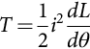 **(30.94)**

The developed torque is due to the variation of inductance (or reluctance) with position. Note that the direction of current has no bearing on the developed torque. When the stator and rotor poles are perfectly aligned, as indicated in [Fig. 30.87A](https://learning.oreilly.com/library/view/power-electronics-handbook/9780128114087/B9780128114070000349_2.xhtml#f0440), the inductance *L* changes little with a small change in *θ*. The developed torque is thus very small around this position, corresponding to the position *X* in [Fig. 30.82](https://learning.oreilly.com/library/view/power-electronics-handbook/9780128114087/B9780128114070000349_2.xhtml#f0415). When the stator and rotor teeth are unaligned, as in [Fig. 30.87B](https://learning.oreilly.com/library/view/power-electronics-handbook/9780128114087/B9780128114070000349_2.xhtml#f0440), *L* changes more significantly with *θ*, and the restoring torque becomes much larger. As *θ* increases, *dL*/*dθ* goes through a maximum, producing *Tmax*. It should be noted that around a stable detent, *L* reduces as *θ* increases, so that the slope of the  characteristic is negative at the origin. Beyond the position where *Tmax* is developed, *L* increases as a result of the next set of rotor teeth coming under the stator teeth. This explains the drop in *Tmax* and the positive slope of the  characteristic in the region between where *Tmax* is developed and *Y* in [Fig. 30.82](https://learning.oreilly.com/library/view/power-electronics-handbook/9780128114087/B9780128114070000349_2.xhtml#f0415).

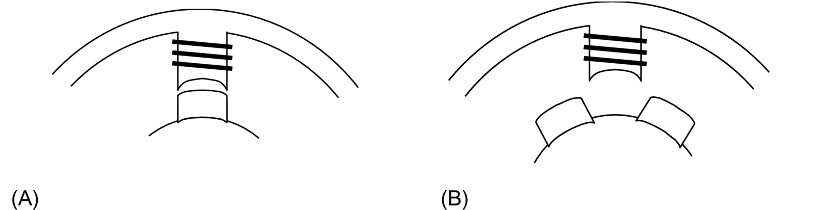

**FIG. 30.87** Stator and rotor teeth alignment: (A) aligned position, , and (B) unaligned position, .

If stepper motors are operated in magnetically linear region where *L* remains constant with the current for a given angular position, the developed torque per unit volume is small. Because of this, steppers motors are normally driven far into saturation. Eq. [(30.94)](https://learning.oreilly.com/library/view/power-electronics-handbook/9780128114087/B9780128114070000349_2.xhtml#fo0515) then does not represent the torque characteristic adequately.

For a saturated stepper motor, the calculation of the  characteristic for any given current involves complex computation of stored energy, or coenergy, for each position of the rotor. This requires the magnetization characteristics of the motor for different levels of stator currents and rotor positions to be known. Reference [[33]](https://learning.oreilly.com/library/view/power-electronics-handbook/9780128114087/B9780128114070000349_2.xhtml#bb0215) may be consulted for further reading on this.

#### **30.8.3.2 Hybrid and PM Motors**

In hybrid stepper motors, most of the developed torque is contributed by the variable-reluctance principle explained earlier. The rest is developed by the rotor magnet in striving to find the minimum-reluctance position. It should be noted that the alternate polarities of the magnetic poles created by each winding may be reversed by the direction of its current. Consequently, the polarity of the winding currents also determines the direction in which the developed torque increases positively around a detent position.

### 30.8.4 SINGLE- AND MULTI-STEP RESPONSES

When the rotor is at a detent position and phase currents are changed to a new value, the detent position is moved, and the rotor proceeds toward it and settles down at the new detent position. The movement of the rotor is influenced by the shape of the  characteristic and the load friction. The rotor stepping is normally quite underdamped. The final positioning error is also determined largely by the load torque. For instance, if the  characteristic is assumed to be a sinusoidal function of *θ*, the error in stepping is given by Eq. [(30.95)](https://learning.oreilly.com/library/view/power-electronics-handbook/9780128114087/B9780128114070000349_2.xhtml#fo0520), where *Tmax* is the peak of the  characteristic and *TL* is the load friction torque.

 **(30.95)**

However, this error does not accumulate as further stepping is performed. If the phase currents are switched in succession, the rotor makes multiple steps. Typical single- and multistep responses are as indicated in [Fig. 30.88](https://learning.oreilly.com/library/view/power-electronics-handbook/9780128114087/B9780128114070000349_2.xhtml#f0445)



**FIG. 30.88** Typical step responses of a stepper motor: (A) single-step response and (B) multistep response.

The maximum rate at which the rotor can be moved depends on several factors. The rise and fall times of the winding currents, which are largely determined by the electric parameters of the windings and the type of drive circuits used, and the combined inertia and friction parameters of the motor and load are important factors.

The discrete signals to step the motor in the forward or reverse direction are translated into current-switching signals for the drive circuits. This translator is a simple logical operation that is embedded in most of the integrated circuits available for driving stepper motors.

In many applications, the stepper motor is operated at far higher speeds than that it can start/stop from. The performance of a stepper motor at a high speed is normally given in terms of its pullout torque-speed () characteristic. This characteristic indicates the maximum average torque; the motor may develop while stepping continuously at a given rate. This torque is also largely determined by the parameters of the motor and its drive circuits. [Fig. 30.89](https://learning.oreilly.com/library/view/power-electronics-handbook/9780128114087/B9780128114070000349_2.xhtml#f0450) indicates the typical shape of the pullout  characteristic of a stepper motor drive.



**FIG. 30.89** Typical pullout torque characteristic of a stepper motor.

At a low speed, the pullout torque is roughly equal to the average value of the positive half cycle of the  waveforms of [Fig. 30.82](https://learning.oreilly.com/library/view/power-electronics-handbook/9780128114087/B9780128114070000349_2.xhtml#f0415). At a high speed, the finite but fixed rise and fall times of the currents and the back emf of the winding reduces the extent to which the windings are energized during each switching period. Consequently, the pullout torque of the motors falls as the stepping rate (speed) increases.

For operation at a high speed, the stepping rate is gradually increased and decreased from one speed to another. Without careful acceleration and deceleration to and from a high speed, the motor will not be able to follow the stepping commands and will lose its synchronism with the stepping pulses or winding excitations. The acceleration and deceleration rates of a stepper motor are also determined largely by the pullout torque characteristic.

Stepper motors are known to suffer from mechanically induced resonance and consequent misstepping when its switching rate falls within certain bands, which are largely determined by the way the developed torque varies with time, as the motor steps. Careful selection of stepping rate is normally employed to overcome the problem. Some shaft-mounted external damping measures may also be used when the stepping rate needs to be continuously varied, such as in the case of machine-tool profile following.

### 30.8.5 DRIVE CIRCUITS

Two types of drive circuits are in general use for stepper motors. The unipolar drive is suitable for variable-reluctance stepper motors, for which the developed torque is determined by the level of current, not its polarity. For hybrid and permanent-magnet motors, the direction of current is also important, so that the bipolar drive circuits are more suitable.

#### **30.8.5.1 Unipolar Drive Circuits**

In its simplest form, the unipolar drive circuits, one for each winding, are as indicated in [Fig. 30.90](https://learning.oreilly.com/library/view/power-electronics-handbook/9780128114087/B9780128114070000349_2.xhtml#f0455). The transistor (MOSFET) is turned on to energize the winding, with a current that is limited either by the winding resistance or by hysteresis or PWM current controllers. The freewheeling diode allows the winding current a circulating path when the transistor is turned off.





**FIG. 30.90** Three commonly used unipolar drive circuits: (A) the basic unipolar drive, (B) unipolar drive with PWM current limiting and zener diode turnoff, and (C) unipolar drive with regenerative turnoff.

The drive circuit of [Fig. 30.90A](https://learning.oreilly.com/library/view/power-electronics-handbook/9780128114087/B9780128114070000349_2.xhtml#f0455) is a basic one. A better drive circuit is shown in [Fig. 30.90B](https://learning.oreilly.com/library/view/power-electronics-handbook/9780128114087/B9780128114070000349_2.xhtml#f0455), which includes a zener diode in the freewheeling path. A pulse-width modulator is also included in the gate driving circuit. The pulse-width modulator allows a higher dc supply voltage (typically 5–10 times the voltage for the resistance-limited drive) to be used, thereby reducing the rise time of current at switch on by 5–10 times. The zener diode allows a fast fall time for the current when the transistor is turned off by dissipating the trapped energy of the winding at switch-off faster. Yet another scheme is shown in [Fig. 30.90C](https://learning.oreilly.com/library/view/power-electronics-handbook/9780128114087/B9780128114070000349_2.xhtml#f0455) that allows the trapped energy of the winding at switch-off to be returned to the dc source when the transistor is turned off, rather than being dissipated in the winding or the freewheeling circuits. This circuit is by far the most efficient and at the same time gives the fastest possible rise and fall times for the winding currents.

#### **30.8.5.2 Bipolar Drive Circuits**

The bipolar drive allows the motor windings to be driven with bidirectional currents. The four-transistor bridge drive circuit of [Fig. 30.91](https://learning.oreilly.com/library/view/power-electronics-handbook/9780128114087/B9780128114070000349_2.xhtml#f0460), one for each winding, is the most popular. The circuit can cater to the required rise and fall times of the winding by properly selecting the dc supply voltage *Vdc*, the pulse-width modulator, and the current controller gains.



**FIG. 30.91** Bipolar drive circuit (gate-drive circuits omitted).

Some hybrid and PM motors come with four windings, two for each phase. These may be connected in series or parallel, depending on the torque characteristics desired. In any case, only two drive circuits of the type indicated in [Fig. 30.91](https://learning.oreilly.com/library/view/power-electronics-handbook/9780128114087/B9780128114070000349_2.xhtml#f0460) are required.

#### **30.8.5.3 Drive Circuits for Bifilar Wound Motors**

Hybrid stepping motors may also come with bifilar windings, which allow the simpler unipolar drive circuits to be used. These motors have two tightly coupled windings for each phase. [Fig. 30.92](https://learning.oreilly.com/library/view/power-electronics-handbook/9780128114087/B9780128114070000349_2.xhtml#f0465) illustrates two bifilar windings on stator pole and their unipolar drives. The two windings on each pole have opposite sense, so that the magnetic polarity is reversed by simply switching the other winding. Since only unidirectional current is involved, the unipolar drive circuits of [Fig. 30.90A or B](https://learning.oreilly.com/library/view/power-electronics-handbook/9780128114087/B9780128114070000349_2.xhtml#f0455) may be used at a considerable savings in terms of the drive circuits. This benefit is, however, derived at the cost of extra winding space, and hence larger volume, for the same torque.



**FIG. 30.92** Drive circuits for one phase of a bifilar-wound motor: (A) bifilar pole windings and (B) drive circuits.

### 30.8.6 MICRO STEPPING

The drive sequences mentioned in [Section 30.8.2](https://learning.oreilly.com/library/view/power-electronics-handbook/9780128114087/B9780128114070000349_2.xhtml#s0425) normally switch-rated current through the motor windings. These produce regular step angles. The half-stepping operation also uses rated motor currents. Halving of the step angle is arranged mainly through the selection of the windings switched.

In microstepping, the regular step angle of the motor is subdivided further by a factor, typically from 10 to 100, by energizing the windings partially, with combinations of currents ranging from zero to full rated value in more than one windings simultaneously. This does not lead to any sacrifice of the developed torque, since the phase currents are so selected that the peak of total torque contributed by two partially energized windings is not lower than the peak detent torque *Tmax* obtained in regular stepping.

The idea behind microstepping is readily understood when it is considered that by increasing the current in phase *A* of a two-phase hybrid in 10 equal steps to full value and decreasing the current in phase *B* in a similar manner, the motor step size may be divided by a factor of 10. If the closed-loop current controllers are added to the two drive circuits of [Fig. 30.91](https://learning.oreilly.com/library/view/power-electronics-handbook/9780128114087/B9780128114070000349_2.xhtml#f0460) and distinct current references are obtained from a reference generator, a complete microstepping drive is realized.

In microstepping, the two current references must have values such that the motor does the following:

1. Develops the same *Tmax* for every combination of winding currents

2. Develops the same torque slope, that is, *dt*/*dθ* at every microstepping detent position

3. Dissipates no more than the rated power loss (*I*2*R*) for every combination of winding currents

The preceding conditions are necessary if the motor is to retain its static accuracy, maximum torque, and power dissipation characteristics.

The static torque characteristics ([Fig. 30.92](https://learning.oreilly.com/library/view/power-electronics-handbook/9780128114087/B9780128114070000349_2.xhtml#f0465)) of stepper motors are close to, but not exactly, sinusoidal functions of angle *θ*. The required current references for all windings of a stepper motor, including the variable-reluctance motor of three or more phases, can easily be calculated from the data of the  characteristics of the motor for each phase for various currents and rotor positions. A typical set of  data for a three-phase variable-reluctance motor is shown in [Fig. 30.93](https://learning.oreilly.com/library/view/power-electronics-handbook/9780128114087/B9780128114070000349_2.xhtml#f0470). The application of the three conditions mentioned earlier leads to a unique set of current references for each phase of the motor for each microstep. [Fig. 30.94](https://learning.oreilly.com/library/view/power-electronics-handbook/9780128114087/B9780128114070000349_2.xhtml#f0475) shows the current references for this motor for microstepping.



**FIG. 30.93**  characteristics of a three-phase variable-reluctance motor.



**FIG. 30.94** Microstepping current references for the VR motor of [Fig. 30.93](https://learning.oreilly.com/library/view/power-electronics-handbook/9780128114087/B9780128114070000349_2.xhtml#f0470). Stepping rate: 28,800 steps/s, A (maximum).

In multi stepping operation, these microstepping current references have to be issued to the current controllers for each phase, at a rate determined by the commanded stepping rate.

Care has to be taken in designing the phase-current controllers so that the actual winding currents match the current references in both single- and multistepping operation up to the maximum stepping rate desired. Since the current references are time-varying, high-bandwidth current controllers are normally required to cover the desired speed range.

### 30.8.7 OPEN-LOOP ACCELERATION–DECELERATION PROFILES

As mentioned in [Section 30.8.4](https://learning.oreilly.com/library/view/power-electronics-handbook/9780128114087/B9780128114070000349_2.xhtml#s0465), many applications require the stepper motors to be driven far above the stepping rates to and from which the motor can start and stop abruptly without losing or gaining any step. This calls for carefully designed acceleration-deceleration profiles that the stepping pulse rate must not exceed.

The number of steps the motor is to be stepped and its direction are normally under the control of the motion controller. Once this reference is known, a digital timer/counter circuit can be used in the controller to progressively adjust the time between the stepping pulses such that a prescribed acceleration-deceleration profile, as indicated in [Fig. 30.95](https://learning.oreilly.com/library/view/power-electronics-handbook/9780128114087/B9780128114070000349_2.xhtml#f0480), is followed. The timer/counter and the pulsing sequence controller (the translator) need to be managed in real time to execute the motion-control task at hand.



**FIG. 30.95** Typical acceleration-deceleration profiles.

The fastest acceleration-deceleration profile, a stepper motor is capable of is largely determined by its pullout () characteristic, which in turn is determined by the motor winding parameters and the drive circuit. An optimized stepping profile to and from the top speed may have a number of segments as indicated in [Fig. 30.95](https://learning.oreilly.com/library/view/power-electronics-handbook/9780128114087/B9780128114070000349_2.xhtml#f0480). These profiles are easily computed from the pullout () characteristic by integrating the dynamic torque balance equation of the drive. For a large positioning angle, the entire profile, including some constant speed running at the top speed, may be used. For short-positioning angles, only part of the profile may be traversed. In general, a single-segment acceleration-deceleration profile is used in commercial stepper motor controllers, so as to avoid a great deal of real-time number crunching by the profile controller.

The overall stepper motor controller thus consists of the blocks depicted in [Fig. 30.96](https://learning.oreilly.com/library/view/power-electronics-handbook/9780128114087/B9780128114070000349_2.xhtml#f0485).



**FIG. 30.96** Structure of an open-loop motion controller for a stepper motor.

## 30.9 Switched-Reluctance Motor Drives

### **30.9.1 INTRODUCTION**

The switched-reluctance (SR) motor is a doubly salient electric machine with salient-poles on both the stator and rotor. The machine is operated by switching current pulses to each stator winding on and off in a continuous switching sequence. The rotor poles have no excitation. [Fig. 30.97](https://learning.oreilly.com/library/view/power-electronics-handbook/9780128114087/B9780128114070000349_2.xhtml#f0490) shows the physical topology of a typical SR motor. The diagram illustrates a motor with eight salient stator poles (numbered A1–D2) and six salient rotor poles (numbered 1–6). Although many combinations of the number of stator and rotor poles are possible, this particular type has found widespread use.



**FIG. 30.97** Four-phase SR motor topology.

The phase windings on the stator of the SR motor consist of concentrated windings wrapped around the stator poles. In the conventional arrangement, each stator pole winding is connected with that of the diametrically opposite pole to form a stator phase. In [Fig. 30.97](https://learning.oreilly.com/library/view/power-electronics-handbook/9780128114087/B9780128114070000349_2.xhtml#f0490), the connected stator pole pairs are indicated by the same prefix letter.

The general principle of operation of the SR motor is the same as all types of reluctance machines, that is, the stator and the rotor poles seek the minimum-reluctance position, so that the stator excited flux becomes maximum. Hence, when current flows in an SR motor stator phase and produces a magnetic field, the nearest rotor pole will tend to position itself with the direction of the developed magnetic field. This position, which is termed the *aligned position*, is reached when the rotor pole center axis is aligned with the stator pole center axis (assuming symmetrical poles). The aligned position also corresponds to the position of minimum reluctance and hence the position of maximum inductance.

It should be noted that the *unaligned* position is defined as the position when the *interpole axis*, or the axis of the center of the interpolar space in the rotor, is aligned with a stator pole axis. This position corresponds to the position of minimum inductance. These rotor axis positions are illustrated in [Fig. 30.98](https://learning.oreilly.com/library/view/power-electronics-handbook/9780128114087/B9780128114070000349_2.xhtml#f0495).



**FIG. 30.98** Rotor pole axis positions.

To achieve continuous rotation, the stator phase currents are switched on and off in each phase in a sequence according to the position of the rotor. Consider the motor schematic illustrated in [Fig. 30.97](https://learning.oreilly.com/library/view/power-electronics-handbook/9780128114087/B9780128114070000349_2.xhtml#f0490). If coils A1 and A2 of phase A are excited and produce a magnetic field in a vertical direction, then poles 1 and 4 on the rotor will align themselves with the stator poles of phase A. If the coils of phase A now have their current switched off and coils B1 and B2 of phase B are now excited, then in a similar fashion, the rotor will move so that the poles 2 and 5 are aligned with stator poles B1 and B2. Exciting phases A, B, C, and D in sequence will produce rotor rotation in the counterclockwise direction.

From the preceding discussion, one may see that the switching on and off of excitation current to the motor phases is related to the rotor pole positions. This means that some form of position sensor is essential for the effective operation of the SR motor.

### 30.9.2 ADVANTAGES AND DISADVANTAGES OF SWITCHED-RELUCTANCE MOTORS

The SR motor has a number of inherent advantages that makes it suitable for use in certain variable-speed drive applications. Nevertheless, the motor also has some inherent disadvantages that must be considered before choosing the motor for a particular application. In [Table 30.6](https://learning.oreilly.com/library/view/power-electronics-handbook/9780128114087/B9780128114070000349_2.xhtml#t0035), the main advantages and disadvantages of the SR motor drive are summarized.

**Table 30.6**

**Advantages and disadvantages of SR drives**

|  |  |
| --- | --- |
| **Advantages** | **Disadvantages** |
| Low-cost motor | Need for position measurement |
| Robust motor construction | Higher torque ripple than other machine types |
| Absence of brushes | Higher noise than other machine types |
| No motor short-circuit fault | Nonlinear and complex characteristics |
| No shoot-through faults |  |
| Ability to operate with faulted phase |  |
| High torque-to-inertia ratio |  |
| Unidirectional currents |  |
| High efficiency |  |

### 30.9.3 SWITCHED-RELUCTANCE MOTOR VARIABLE-SPEED DRIVE APPLICATIONS

The main application for SR motors is in variable-speed drive systems. One application area has been general-purpose industrial drives where speed, acceleration, and torque control are desired. SR-motor-based industrial drives provide the advantages of a very wide range of operating speeds and high efficiency and robustness. Other applications of the SR drive include automotive applications, where the SR motor has advantages of robustness and fault tolerance. The SR motor in this application can also be easily controlled for acceleration, steady speed, and regenerative braking.

The SR motor is also well suited to aerospace applications where the ability to operate under faulted conditions and its suitability for operation under harsh environments are critical. Additionally, the very high-speed capability and high power density also make these motors well suited in the aerospace field. There are also many domestic appliances where cost is of primary concern. In these products, the SR motor can provide a low-cost solution for a brushless fully controllable motor drive. In addition, the motor can be used in battery-powered applications, where the motor-high efficiency and ability to use a dc supply are important.

### 30.9.4 SR MOTOR AND DRIVE DESIGN OPTIONS

The main components of the drive system are shown in [Fig. 30.99](https://learning.oreilly.com/library/view/power-electronics-handbook/9780128114087/B9780128114070000349_2.xhtml#f0500). It is important to design the motor and drive together in an integrated manner. The main criteria that need to be considered in designing the components of the SR drive system will be discussed later. It will be seen that certain design choices, which may be advantageous for one component of the drive system, may bring about disadvantages in another component. This highlights the need for a careful, integrated system approach to be taken when designing the drive system.



**FIG. 30.99** Main components of an SR drive.

#### **30.9.4.1 Number of Motor Phases**

There are many possibilities in choosing the number of stator phases and rotor poles in SR motors. The simplest SR motor may consist of only one phase; however, to operate the motor in four quadrants (motoring or generating in both forward and reverse directions), at least three phases are required. The most common configuration to date has been the four-phase SR motor, which has eight rotor poles and six stator poles, as was shown in [Fig. 30.97](https://learning.oreilly.com/library/view/power-electronics-handbook/9780128114087/B9780128114070000349_2.xhtml#f0490).

#### **30.9.4.2 Maximum Speed**

The SR motor is capable of operating at very high speeds because of its robust rotor construction, and in most applications, the maximum speed is limited by the inverter switching speed and not limited by the motor itself. The maximum speed of the SR motor is itself normally greater than 15,000 rpm for a standard SR motor.

However, to determine the maximum drive speed, the controller and motor must be considered together. This is because the power-electronic device switching speed is directly proportional to the commutation frequency, which is in turn proportional to the motor speed. The maximum switching frequency of the power devices must therefore be taken into account in the SR drive design.

#### **30.9.4.3 Number of Power Devices**

In general, the number of switches per phase in SR motor drives will vary according to the inverter topology. A wide range of different SR drive circuits are available for SR drives, and these are detailed below. Circuits with only one switch per phase are possible; however, these have various disadvantages such as control restrictions, a need for extra windings, or higher switch voltages. However, with two switches per phase, the motor is fully controllable in four quadrants and has completely independent motor phase control. Therefore, the maximum number of power switches required for the motor operation is normally 2*q*, where *q* is the number of phases.

#### **30.9.4.4 Inverter Topology Types for SR Motors**

As was mentioned, the torque produced in the SR motor is independent of the direction of current flow in each motor phase. This means the inverter is only required to supply unidirectional currents into the stator windings. The three major circuit topology types that have been used for each winding of SR motor drives are shown in [Fig. 30.100](https://learning.oreilly.com/library/view/power-electronics-handbook/9780128114087/B9780128114070000349_2.xhtml#f0505). As indicated in this figure, these are commonly termed the *bifilar*-, *split-dc-supply*-, and *two-switch*-type inverter circuits.



**FIG. 30.100** Major SR inverter topology types: (A) bifilar type, (B) split-dc-supply type, and (C) two-switch type.

In the circuits shown in [Fig. 30.100](https://learning.oreilly.com/library/view/power-electronics-handbook/9780128114087/B9780128114070000349_2.xhtml#f0505), only one or two switching components per phase are required. Other circuit topology types that use shared components between the motor phases have limitations in control flexibility.

##### **Bifilar type inverter circuit**

In [Fig. 30.100A](https://learning.oreilly.com/library/view/power-electronics-handbook/9780128114087/B9780128114070000349_2.xhtml#f0505), a drive circuit for a bifilar-wound SR motor is shown. The bifilar windings are closely coupled, with one winding being connected to a switching device, while the other is connected to a freewheeling diode. Current is increased in the winding when the switching device closes. At turnoff, the current transfers to the secondary winding through transformer action, and the inductive energy flows back into the supply via the freewheeling diode. If perfect coupling is assumed, then the voltage across the switching device will rise to twice the dc supply voltage during turnoff. However, in practice, this would be higher. This is because there will be some uncoupled inductance in the primary that will cause high induced voltages when the current in the winding collapses to zero. Thus, snubbing circuits would almost certainly be required to protect the switching components from overvoltage.

The advantage of the bifilar circuit is that it requires only one switching device per phase. However, with the advent of modern power electronic devices, which have both low cost and low losses, this advantage quickly disappears.

##### **Split DC supply inverter circuit**

The split-dc-supply-type inverter circuit is in [Fig. 30.100B](https://learning.oreilly.com/library/view/power-electronics-handbook/9780128114087/B9780128114070000349_2.xhtml#f0505). As in the bifilar circuit, this configuration also uses only one switching device and one diode per phase. However, a center-tapped dc source is required. When the switching device is turned on, current increases in the phase winding because of the positive capacitor voltage being applied. At turnoff, the current is forced to flow through the diode and thus decays to zero more quickly because of the connection to the negative voltage. It is usual for the dc center tap to be implemented using a split capacitor in the dc-link. The voltages across each capacitor must remain balanced, which means that there can be no significant power-flow difference between the two capacitors.

Upon examination of the circuit, it can be seen that because of the split capacitor bank, only half the available dc voltage can be switched across the phase winding. Thus, for the same voltage across the motor phases that is supplied by the bifilar circuit described earlier, the dc supply voltage must be doubled with respect to the bifilar circuit supply. This means that the voltage rating of the devices would effectively be the same as in the bifilar circuit.

This is inherently inefficient. The configuration also has the need for balanced split capacitive components. In addition, it will be seen that the *soft-chopping* form of control described in [Section 30.9.7](https://learning.oreilly.com/library/view/power-electronics-handbook/9780128114087/B9780128114070000349_2.xhtml#s0580) is not available in this drive.

##### **Two-switch inverter circuit**

The two-switch-inverter-type circuit, which is shown in [Fig. 30.100C](https://learning.oreilly.com/library/view/power-electronics-handbook/9780128114087/B9780128114070000349_2.xhtml#f0505), uses two switching devices and two diodes per phase. Unlike the previous two circuits, three modes of operation are possible:

Mode 1—positive-phase voltage

A positive-phase voltage can be applied by turning both switching devices on. This will cause the current to increase in the phase winding.

Mode 2—zero-phase voltage

A zero-voltage loop can be imposed on the motor phases when one of the two switches is turned off while current is flowing through the phase winding. This results in current flow through a freewheeling loop consisting of one switching device and one diode, with no energy being supplied by or returned to the dc supply. The current will decay slowly because of the small resistance of the semiconductors and connections, which leads to small conduction losses. This mode of operation is used in soft-chopping control, as described in [Section 30.9.7](https://learning.oreilly.com/library/view/power-electronics-handbook/9780128114087/B9780128114070000349_2.xhtml#s0580).

Mode 3—negative-phase voltage

When both switches in a motor phase leg are turned off, the third mode of operation occurs. In this mode, the motor phase current will transfer to both of the freewheeling diodes and return energy to the supply. When both of the diodes in the phase circuit are conducting, a negative voltage with amplitude equal to the dc supply voltage level is imposed on the phase windings.

In this circuit, the switching devices and diodes must be able to block the dc supply voltage amplitude when they are turned off, in addition to any switching transient voltages. However, because the circuit contains two devices in series, the blocking voltage is essentially half the value seen in the previous two circuit types for the same applied motor phase voltage amplitude. Another advantage of the two-switch inverter circuit is that it offers greater control flexibility with its three modes of voltage control.

A disadvantage of this inverter type, as compared with the bifilar and split dc supply types, is that it contains twice as many switching components per phase. However, with the current wide availability and economy of power semiconductors, in most applications, the advantages of the two-switch circuit outweigh the cost of an extra switching device per phase.

### 30.9.5 OPERATING THEORY OF THE SWITCHED-RELUCTANCE MOTOR: LINEAR MODEL

If a linear magnetic circuit is assumed, the flux linkage is proportional to phase current for any rotor position *θ*. This is demonstrated in [Fig. 30.101](https://learning.oreilly.com/library/view/power-electronics-handbook/9780128114087/B9780128114070000349_2.xhtml#f0510), where the magnetization curves for the linear SR motor for various rotor positions and currents are shown. In this linear case, the inductance *L* at any position *θ*, which is the slope of these curves, is *constant* and independent of current.



**FIG. 30.101** Magnetization characteristics of linear SR motor.

As the motor rotates, each stator phase undergoes a cyclic variation of inductance. As can be seen in [Fig. 30.101](https://learning.oreilly.com/library/view/power-electronics-handbook/9780128114087/B9780128114070000349_2.xhtml#f0510), in the fully aligned position (when a rotor pole axis is directly aligned with the stator pole axis) the reluctance of the magnetic circuit through the stator and rotor poles will be at a minimum, and thus the inductance of the stator winding will be at a maximum. The opposite will occur in the fully unaligned position (when the rotor interpole axis is aligned with the stator pole). Thus, the inductance becomes a function of position only and is not related to the current level. If it is also assumed that mutual inductance between the phases is zero, then a typical inductance variation *L*(*θ*) with respect to the rotor position similar to that shown in [Fig. 30.102](https://learning.oreilly.com/library/view/power-electronics-handbook/9780128114087/B9780128114070000349_2.xhtml#f0515) arises. Although this is an idealized inductance variation, it is helpful in the understanding of key operating principles of the machine. One should note that in the idealized inductance variation, there are sharp corners, which can only arise if flux fringing is completely ignored.



**FIG. 30.102** Typical linear inductance variations and corresponding torque variations for constant phase current.

Four distinct regions can be identified in the plot of the linear inductance variation shown in [Fig. 30.102](https://learning.oreilly.com/library/view/power-electronics-handbook/9780128114087/B9780128114070000349_2.xhtml#f0515). These distinct regions correspond to a range of rotor pole positions relative to the stator pole positions as described below:

Region A

This region begins at rotor angle *θ*1, where the first edge of the rotor, with respect to the direction of rotation, just meets the first edge of the stator pole. The inductance will then rise in a linear fashion until the poles of the stator and rotor are completely overlapped at angle *θ*2. At this point, the magnetic reluctance is at a minimum, and the phase inductance is at a maximum. These rotor positions are illustrated in [Fig. 30.103A and B](https://learning.oreilly.com/library/view/power-electronics-handbook/9780128114087/B9780128114070000349_2.xhtml#f0520), for example, four-phase motor with rotor pole 1 approaching the stator pole of phase A.



**FIG. 30.103** Rotor pole 1 positions: (A) meeting edge of stator pole A, (B) overlapped by stator pole A, (C) edge of rotor pole leaving overlap region, and (D) rotor pole completely leaving overlap region. (Note that air-gap space is exaggerated for clarity.)

Region B

This region spans from rotor positions *θ*2 to *θ*3. In this region, the inductance remains constant because the rotor pole is completely overlapped by the stator pole (i.e., the overlap area of the poles remains constant). At rotor angle *θ*3, the edge of the rotor pole leaves the stator pole overlap region, and thus, the area of overlap will again begin to decrease. The position at which this occurs is illustrated in [Fig. 30.103C](https://learning.oreilly.com/library/view/power-electronics-handbook/9780128114087/B9780128114070000349_2.xhtml#f0520).

Region C

When the rotor moves past *θ*3, the rotor pole leading edge begins to leave the pole overlap region, and region C begins. At this point, the inductance begins to linearly decrease, until at *θ*4, the rotor pole has completely left the stator pole face overlap region. At this point, the inductance is at its minimum once more. The rotor position at which the rotor pole has completely left the overlap is indicated in [Fig. 30.103D](https://learning.oreilly.com/library/view/power-electronics-handbook/9780128114087/B9780128114070000349_2.xhtml#f0520).

Region D

In this region, the rotor and stator have no overlap, and thus, the inductance remains constant at the minimum level, until region A is reached once again.

It was mentioned earlier that when a stator phase is excited, the rotor poles will tend to move toward the maximum-inductance region. Thus, a motoring torque is produced when a stator phase is provided with a current pulse during the angles when the inductance is rising (assuming motoring rotation is in the direction of increasing *θ* in [Fig. 30.102](https://learning.oreilly.com/library/view/power-electronics-handbook/9780128114087/B9780128114070000349_2.xhtml#f0515)). This means that if positive torque is desired, excitation should be arranged such that the current flows between the appropriate rotor angles when the inductance is rising.

Conversely, if current flows during the decreasing inductance region, a negative torque would result. This is because the rotor will be attracted to the stator pole in such a way that it rotates in the opposite direction to the motoring rotation, or in other words, the rotor experiences a torque opposite to the direction of rotation.

It should be noted that this reluctance-machine torque always acts to decrease the reluctance. The direction of current flowing into the stator winding is irrelevant. This signifies that unidirectional current excitation is possible in the SR motor drive.

The variation of torque with rotor angle for a constant phase winding current is as shown in [Fig. 30.102](https://learning.oreilly.com/library/view/power-electronics-handbook/9780128114087/B9780128114070000349_2.xhtml#f0515). It can be seen that the torque is constant in the increasing and decreasing inductance regions and is zero when the inductance remains constant.

The preceding physical explanation of the developed torque is also given by the familiar torque Eq. [(30.96)](https://learning.oreilly.com/library/view/power-electronics-handbook/9780128114087/B9780128114070000349_2.xhtml#fo0525) for a variable-reluctance machine.

 **(30.96)**

From Eq. [(30.96)](https://learning.oreilly.com/library/view/power-electronics-handbook/9780128114087/B9780128114070000349_2.xhtml#fo0525), it is evident that the magnitude of the instantaneous torque developed in the SR motor is proportional to both *i*2 and *dL*/*dθ*. If the inductance is increasing with respect to the angle, and current flows in the phase winding, then the torque will be positive and the machine will operate in motoring mode. Hence, from Eq. [(30.96)](https://learning.oreilly.com/library/view/power-electronics-handbook/9780128114087/B9780128114070000349_2.xhtml#fo0525), it can be seen that when the motor phase is excited during a rising inductance region, part of the energy from the supply is converted to mechanical energy to produce the torque, and another part is stored in the magnetic field. If the supply is turned off during this region, then any stored magnetic energy is partly converted to mechanical energy and partly returned to the supply.

However, a negative or braking torque will be developed by the motor if the inductance is decreasing with respect to the rotor angle and current flows in the phase winding. In this case, energy flows back to the supply from both the stored magnetic energy and the mechanical load, which acts as a generator.

It can also be seen from Eq. [(30.96)](https://learning.oreilly.com/library/view/power-electronics-handbook/9780128114087/B9780128114070000349_2.xhtml#fo0525) that the sign (or direction) of the torque is independent of the direction of the current and is only dependent on the sign of *dL*/*dθ*. This explains the torque waveforms that were seen in [Fig. 30.102](https://learning.oreilly.com/library/view/power-electronics-handbook/9780128114087/B9780128114070000349_2.xhtml#f0515), where for constant current (and constant *dL*/*dθ* magnitude), the magnitude of the torque was constant in the rising or decreasing inductance regions. However, it was seen that the torque changes from positive to negative according to the sign of *dL*/*dθ*.

Hence, the ideal waveform for the production of motoring torque would be a square-wave pulse of current (with magnitude equal to the maximum possible supply current) flowing only during the increasing inductance period ([Fig. 30.104](https://learning.oreilly.com/library/view/power-electronics-handbook/9780128114087/B9780128114070000349_2.xhtml#f0525)). This current waveform is illustrated in [Fig. 30.104B](https://learning.oreilly.com/library/view/power-electronics-handbook/9780128114087/B9780128114070000349_2.xhtml#f0525). However, in practice, this type of current waveform is difficult to produce in a motor phase. This is because the motor phase current is supplied from a finite dc voltage source, and thus, inductance of the stator phase winding would delay the rise and fall of current at the pulse edges. Instead, a more practical current waveform is normally used as is illustrated in [Fig. 30.104C](https://learning.oreilly.com/library/view/power-electronics-handbook/9780128114087/B9780128114070000349_2.xhtml#f0525). It can be seen that in this waveform, the ideal square waveform is closely approximated by the use of hysteresis current control. At higher speeds, hysteresis current control can no longer be used and a current waveform similar to that shown in [Fig. 30.104B](https://learning.oreilly.com/library/view/power-electronics-handbook/9780128114087/B9780128114070000349_2.xhtml#f0525) is seen in the phase winding. These two types of practical current waveforms, which approximate the ideal square pulse waveform *(a) at low to medium speeds* and *(b) at high speeds*, will be discussed next.



**FIG. 30.104** (A) Linear phase inductance variation, (B) ideal square-wave phase current, (C) chopping-mode phase current, (D) chopping-mode phase voltage, and (E) flux linkage waveform corresponding to chopping-mode current.

#### **30.9.5.1 Low to Medium-Speed Approximation to Square-pulse Current Waveform**

At low to medium motor speeds, the ideal square-pulse current waveform is approximated in the practical motor drive using hysteresis current control, as is shown in [Fig. 30.104C](https://learning.oreilly.com/library/view/power-electronics-handbook/9780128114087/B9780128114070000349_2.xhtml#f0525). The hysteresis method of controlling the current is termed the *chopping-mode control* method in SR motor drives. During the time of conduction (between the turn-on and turnoff angles), the current is maintained within the hysteresis band by the switching off and on of the phase voltage by the inverter when the phase current reaches the maximum and minimum hysteresis band. An example of the voltage waveform used for the hysteresis current control is shown [Fig. 30.104D](https://learning.oreilly.com/library/view/power-electronics-handbook/9780128114087/B9780128114070000349_2.xhtml#f0525), where a constant inverter dc supply voltage of magnitude *Vs* is used. It can be seen that the switching frequency of the voltage waveform decreases as the angle increases. This is due to the fact that the phase inductance is linearly increasing with angle, which has the effect of increasing the current rise and fall time within the hysteresis band.

In the chopping-mode control method, the *turn-on region* is defined as the angle between the *turn-on angle θon* and the *turnoff angle θoff* and is chosen to occur during the rising inductance region for motoring torque. In the practical chopping current waveform, the current turn-on angle *θon* is placed somewhat before the rising-inductance region. This is to ensure that the current can quickly rise to the maximum level in the minimum-inductance region before the rising-inductance, or torque-producing, region. Similarly, the turnoff angle *θoff* is placed a little before the maximum-inductance region so that the current has time to decay before the negative-torque, or decreasing-inductance, region. The angle at which the current decays to zero after turnoff is labeled as *θq* in [Fig. 30.104C](https://learning.oreilly.com/library/view/power-electronics-handbook/9780128114087/B9780128114070000349_2.xhtml#f0525).

#### **30.9.5.2 High-Speed Approximation to Square-Pulse Current Waveform**

The chopping-mode of operation cannot be used at higher speeds, as at these speeds, the hysteresis band current level will not be reached. This is because at high speeds, the back emf of the motor becomes equal to or larger than the voltage supply in the rising-inductance region ([Fig. 30.105](https://learning.oreilly.com/library/view/power-electronics-handbook/9780128114087/B9780128114070000349_2.xhtml#f0530)), which limits the increase of the motor phase current. In addition, the rise time of the current will correspond to an ever-increasing angle as the speed is increased. Eventually, at high speeds, the rise-time angle will be so large that the turnoff angle *θoff* will be reached before the hysteresis current level has been exceeded. Thus, at high speeds, the current is switched on and off only once per cycle. In SR motor-drive control, this is called the *single-pulse mode* of operation. An example of the single-pulse mode current is illustrated in [Fig. 30.105B](https://learning.oreilly.com/library/view/power-electronics-handbook/9780128114087/B9780128114070000349_2.xhtml#f0530).



**FIG. 30.105** (A) Linear phase inductance variation, (B) single-pulse mode phase current, (C) single-pulse mode phase voltage, and (D) flux linkage waveform corresponding to single-pulse mode current.

In the single-pulse mode of operation, the inverter power switches turn-on at rotor angle *θon*, which places the dc voltage supply *Vs* across the phase winding, as is shown for the example single-pulse voltage waveform in [Fig. 30.105C](https://learning.oreilly.com/library/view/power-electronics-handbook/9780128114087/B9780128114070000349_2.xhtml#f0530).

As for the chopping-mode case, in order to maximize torque, *θon* must usually be located prior to the rising-inductance region. This is so that, while the inductance is low, the current has a chance to rise rapidly to a substantial value before the torque-producing region begins and the motor back emf increases. At rotor angle *θoff*, the power switches are turned off, and the phase will have a negative voltage (typically ) thrown across it. The current will then decay until it becomes zero at rotor angle *θq*.

### 30.9.6 OPERATING THEORY OF THE SR MOTOR (II): MAGNETIC SATURATION AND NONLINEAR MODEL

In the linear model described earlier, it was assumed that the inductance of a phase winding is independent of current. However, in a real SR motor, significant saturation of the magnetic circuit normally occurs as the phase current increases, and thus, the phase inductance is related to both the phase current level and position. Because of the magnetic saturation effect, the actual phase inductances at a given rotor position can be reduced significantly compared with the inductance given by linear magnetization characteristics. In addition, the effect of magnetic saturation becomes larger as the motor current level increases.

The effects of saturation in an SR motor can be observed in a plot of its magnetization curves. This shows the relationship of flux linkage versus current, at rotor positions varying between the fully aligned and unaligned angles. A typical set of SR motor magnetization curves is shown in [Fig. 30.106](https://learning.oreilly.com/library/view/power-electronics-handbook/9780128114087/B9780128114070000349_2.xhtml#f0535), where it can be seen that there is a nonlinear relationship between the flux linkage and current for each curve.



**FIG. 30.106** Measured four-phase SR motor magnetization characteristics (each curve represents a constant rotor position).

Due to the magnetic saturation effect discussed earlier, the instantaneous torque Eq. [(30.96)](https://learning.oreilly.com/library/view/power-electronics-handbook/9780128114087/B9780128114070000349_2.xhtml#fo0525), which was derived assuming linear conditions, will not be generally valid for calculating the torque in SR motors. Therefore, for accurate calculations, the torque must take into account the dependence of phase inductance with current and position.

If one considers the phase-inductance saturation, the expression for instantaneous torque production of an SR motor phase can be written as

 **(30.97)**

where the coenergy *W*′ is defined as

 **(30.98)**

### 30.9.7 CONTROL PARAMETERS OF THE SR MOTOR

A variety of performance characteristics can be obtained in the SR motor by controlling various parameters. These parameters include the chopping-mode control hysteresis level at low to medium speeds and the turn-on and turnoff angles *θon* and *θoff* at all motor speeds. By controlling these parameters, it is possible to produce any desired characteristic such as constant torque, constant power, or some other particular characteristic in between.

As discussed in [Section 30.9.5](https://learning.oreilly.com/library/view/power-electronics-handbook/9780128114087/B9780128114070000349_2.xhtml#s0560), two distinct modes of operation apply in the SR motor depending on the nature of the current waveform. These modes are the chopping-mode control, which can be used at low to medium motor speeds, and single-pulse mode of control, which is used at high speeds. Both of these modes of operation will be further detailed hereafter, with an explanation of the corresponding inverter switching operation.

#### **30.9.7.1 Chopping-Mode Control**

In the chopping-mode control region, the turn-on and turnoff angles are controlled together with the current level. As described in [Section 30.9.5](https://learning.oreilly.com/library/view/power-electronics-handbook/9780128114087/B9780128114070000349_2.xhtml#s0560), the turn-on angle and turnoff angle are controlled, so that the current flows during the rising-inductance, or positive torque-producing, region. This normally means that the turn-on angle is placed shortly before the place where the rising-inductance angle begins and the turnoff angle is placed shortly before this region ends.

In the chopping mode, the current level is controlled to remain below the maximum allowable level. This involves switching the voltage across the phase on and off in such a manner that the current is maintained between some chosen upper and lower hysteresis current levels. An example of this form of current chopping control was shown in [Fig. 30.104C](https://learning.oreilly.com/library/view/power-electronics-handbook/9780128114087/B9780128114070000349_2.xhtml#f0525).

The actual torque production of the motor in the chopping mode is set by the control turn-on and turnoff angles and the current hysteresis level. Within the chopping-mode of operation, two current hysteresis control schemes can be used. These are termed *soft* and *hard* chopping. Soft chopping can only be used in some circuit configurations, such as that shown in [Fig. 30.107](https://learning.oreilly.com/library/view/power-electronics-handbook/9780128114087/B9780128114070000349_2.xhtml#f0540). For soft-chopping control, one switching device remains on during the entire conduction period, while the other is switched on and off to maintain the desired current level. This can be seen in [Fig. 30.107A and B](https://learning.oreilly.com/library/view/power-electronics-handbook/9780128114087/B9780128114070000349_2.xhtml#f0540), where the two conduction modes during chopping are shown. When both switches are on, the phase winding receives the full positive supply, whereas when only one switching device is on, the phase experiences a zero-voltage freewheeling loop that will decrease the current.



**FIG. 30.107** Soft-chopping mode conduction paths: (A) both devices on: positive voltage applied to motor phase and (B) T1 turned off: zero voltage freewheeling loop applied to motor phase.

In the hard-chopping scheme, both devices are switched simultaneously and have the same switching state at all times. If both switching devices are turned on, the phase winding sees the full positive supply. To decrease the current, the full negative supply is applied by turning both devices off as shown in [Fig. 30.108](https://learning.oreilly.com/library/view/power-electronics-handbook/9780128114087/B9780128114070000349_2.xhtml#f0545). In circuit configurations with fewer than two switches per phase, only hard chopping can be used.



**FIG. 30.108** Hard-chopping mode conduction paths: (A) both devices on: positive voltage applied to motor phase and (B) T1 and T2 turned off: negative voltage applied to motor phase.

Soft chopping is more advantageous than hard chopping. This is because of a smaller dc ripple current in the supply, which can substantially minimize the ripple-current rating of the dc-link capacitor and lower the hysteresis loss in the motor. It has also been found that the soft chopping lowers acoustic noise and electromagnetic radiation.

#### **30.9.7.2 Single-Pulse Mode Control**

At higher speeds, the back emf of the SR motor eventually becomes greater than or equal to the supply voltage during the rising-inductance region. This means that even if a phase is excited, the current in the motor phase will not increase in the rising-inductance region. Therefore, at higher speeds, the turn-on angle must be placed before the beginning of the increasing inductance region, so that the phase current will have an adequate time to increase before the back emf becomes high.

In addition, the time available for the current to rise after turn-on becomes less and less as the speed of the motor increases. This is due to the fact that the available conduction time is lower for constant switching angles as the speed of rotation increases. This can be seen by considering that speed is the time rate of change of angle. Thus, as the speed increases, there will be a point when the current level never rises to the chopping level. At this point, the single-pulse mode of operation will come into effect and the current will decrease or remain constant throughout the increasing-inductance zone. An example of a single-pulse mode current waveform was seen in [Fig. 30.105B](https://learning.oreilly.com/library/view/power-electronics-handbook/9780128114087/B9780128114070000349_2.xhtml#f0530).

As the current is not commutated in the single-pulse mode, the control in this mode consists only of controlling the on and off angles. The turn-on angle *θon* can be placed at some point in advance of the rising-inductance region where the phase inductance is low, so that the current can increase at a faster rate before the increasing-inductance region. The angle can be advanced up until maximum allowable current occurs at the peak of the waveform (this may even mean switching on in the previous decreasing-inductance zone). The actual control turn-on and turnoff angles for the single-pulse mode, for a given load torque and speed, can be determined by simulating the motor equations.

The speed at which a changeover between single-pulse and chopping-mode occurs is called the *base speed*. Base speed is defined as the highest speed at which the chopping mode can be maintained at the rated voltage and with fixed on and off angles. Below the base speed, the current increases during the rising-inductance region, unless it is maintained at the maximum or a lower level by chopping.

Therefore, it can be seen that at lower speeds that are below the base speed, the motor is controlled using chopping-mode control, whereas at speeds above the base speed, the single-pulse mode of control is used. In both the control modes, the control turn-on and turnoff angles are chosen so that the motor provides the required load torque.

### 30.9.8 POSITION SENSING

It can be seen from the preceding discussion that to control the SR motor satisfactorily, the motor phases are excited at the rotor angles determined by the control method. It is therefore essential to have knowledge of the rotor position. Furthermore, the rotor-angle information must be accurate and have high resolution to allow implementation of the more sophisticated nonlinear control schemes that can minimize torque ripple and optimize the motor performance.

This means that the performance of an SR drive depends on the accurate position sensing. The efficiency of the drive and its torque output can be greatly decreased by the inaccurate position sensing, and the corresponding inaccurate excitation angles. It has been demonstrated that at high motor speeds, an error of only 1*°* may decrease the torque production by almost 8% of the maximum torque output.

Traditionally, the rotor-position information has been measured using some form of mechanical angle transducer or encoder. The position-sensing requirements are in fact similar to those for brushless PM motors. However, although position sensing is required for the motor operation, the position-measurement sensors are often undesirable. The disadvantages of the electromechanical sensors include the following:

(a) The position sensors have a tendency to be unreliable because of environmental factors such as dust, high temperature, humidity, and vibration.

(b) The cost of the sensors rises with the position resolution. Hence, if high-performance control is required, an expensive high-resolution encoder needs to be employed.

(c) There is an additional manufacturing expense and inconvenience due to the sensor installation on the motor shaft. In addition, consideration must be given to maintenance of the motor because of the mechanical mounting of the sensors, which also adds to the design time and cost.

(d) Mechanical position sensors entail extra electric connections to the motor. This increases the quantity of electric wiring between the motor and the motor drive. This wire normally needs to be shielded from electromagnetic noise and thus further adds to the expense of the drive system.

(e) The allocation of space for the mounting of the position sensor may be a problem for small applications (such as for motors used in consumer products).

Hence, to overcome the problems induced by rotor-position transducers, researchers have developed a number of methods to eliminate the electromechanical sensor for deriving position information. This is achieved by indirectly determining the rotor position. Such methods are commonly termed *sensorless* rotor-position estimation methods. The term sensorless seems to imply that there are no sensors at all. However, there must be some form of sensor used to measure the rotor position. In fact, the term sensorless position estimation in reality implies that there are no additional sensors required to determine position apart from those that measure the motor electric parameters to control the motor. These are normally current- or voltage-measuring circuits.

Hence, all sensorless position estimation methods for the SR motor use some form of processing on electric waveforms of the motor windings. In essence, the major difference between sensorless position detection, and the electromechanical sensors mentioned above, is that there is no mechanical connection of the sensor to the motor shaft. Therefore, sensorless position detection involves electric measurements only.

## 30.10 Synchronous Reluctance Motor Drives

### **30.10.1 INTRODUCTION**

In recent years, there has been a revival of interest in reluctance machines. Two main machines have been the focus of this interest: the switched-reluctance machine (SRM) and the synchronous reluctance machine (Syncrel). The SRM is a machine that does not have sine-wave spatial distributed windings, but instead has concentrated coils and a doubly salient rotor and stator structure. The operation of this machine is highly nonlinear in character, and normal ac machine modeling techniques cannot be applied in a straightforward manner to describe its operation. The SRM drive has been considered in detail in an earlier section.

The Syncrel, on the other hand, has conventional three-phase sinusoidally distributed windings on the stator. The word “synchronous” in the machine's name emphasizes the fact that the stator windings generate a spatial sinusoidally distributed magnetomotive force (mmf) in the air gap between the stator and the rotor and under steady-state conditions the rotor rotates in synchronism with this field. Therefore, the stator winding configuration of this machine is virtually exactly the same as that of the induction machine or the conventional synchronous machine. The major difference between the Syncrel and conventional synchronous and induction machines is in the rotor structure. In both the induction machine and the synchronous machine, there is a source of flux in the rotor itself. In the case of the induction machine, this flux is produced by currents resulting from an induction mechanism, and for the synchronous machine, there is a field winding wound on the rotor that is fed with the dc current to produce flux. The permanent-magnet synchronous machine replaces the wound field on the rotor with a permanent magnet. The Syncrel, on the other hand, does not have any source of flux on the rotor, but instead, the rotor is designed to distort the flux density distribution produced by the sinusoidally distributed mmf.

Sinusoidally wound reluctance machines were traditionally used in the fiber-spinning industry because of their synchronous nature. This made it simple to keep a large number of machines running at the same speed using just the frequency of the supply to the machines. These machines were direct-on-line-start machines. This was facilitated by the presence of an induction machine starting cage on the rotor. This cage was also essential to damp out oscillations in the rotor speed when running at synchronous speed. It should be pointed out that these machines are not considered to be Syncrels—*a Syncrel does not have an induction machine cage on the rotor*. A Syncrel is absolutely dependent on an intelligent inverter drive in order to start the machine and to stabilize it when running. The lack of a requirement for a starting cage means that the rotor design can be optimized for best torque and power performance.

The revival of interest in the Syncrel in the early 1980s was motivated by the development of low-cost microprocessors and reliable power electronics, coupled with the perception that the Syncrel may be more efficient and simpler to control in variable-speed applications compared with the induction machine. The control simplicity is achieved in practice, mainly because one does not have to locate the flux vector in order to implement vector control. The potential for improved efficiency and torque density compared with the induction machine is very much dependent on the rotor design. The Syncrel has the advantage over the switched-reluctance machine; in that it produces relatively smooth torque naturally, and it uses a conventional three-phase inverter. Therefore, inverter technology developed for the induction machine can be applied directly.

### 30.10.2 BASIC PRINCIPLES

Reluctance machines are one of the oldest electric machine structures, since they are based on the basic physical fact that a magnet attracts a piece of iron. In fact, Syncrel structures were being published in the early 1920s [1]. The essential idea behind the operation of all reluctance machines is that the windings of the machine produce magnetic poles that are used to attract the reluctance rotor. If the magnetic poles are moved around the periphery of the machine at the rate at which the rotor is moving, then sustained torque and rotation can be achieved.

A conceptual diagram of a Syncrel is shown in [Fig. 30.109](https://learning.oreilly.com/library/view/power-electronics-handbook/9780128114087/B9780128114070000349_2.xhtml#f0550). In this figure, the rotor is represented as a simple “dumbbell”-type rotor. The axes of the three-phase sinusoidally distributed windings are indicated by the dashed lines. If these windings are being fed with currents, then a spatial sinusoidally distributed, mmf results. Because this mmf is sinusoidally distributed, it can be represented by a “space vector” (similar to sinusoidal time-varying quantities being represented by a time phasor). In [Fig. 30.109](https://learning.oreilly.com/library/view/power-electronics-handbook/9780128114087/B9780128114070000349_2.xhtml#f0550), this resultant space vector is indicated by *F*, *Fd*, and *Fq* are the components of this vector that lie along the high-permeance and low-permeance axes of the machine, respectively.



**FIG. 30.109** Conceptual diagram of a synchronous reluctance machine.

If one considers the situation shown in [Fig. 30.109](https://learning.oreilly.com/library/view/power-electronics-handbook/9780128114087/B9780128114070000349_2.xhtml#f0550), then the rotor would tend to rotate in the direction indicated. This rotation would continue until the high-permeance *dr* axis (i.e., the least-reluctance axis) of the machine aligns with the mmf vector. When this alignment occurs, the flux produced by the stator mmf vector would be maximized. If the vector *F* also rotates as the rotor rotates, then as mentioned previously, the angle between *F* and *dr* will remain constant and the rotor will continue to chase the *F* vector, continuous rotation being the result.

One can ask even more fundamental questions such as “why does the rotor rotate to the position that maximizes the flux density?” This is essentially asking why a magnet attracts a piece of iron. To completely answer this question, one has to delve into the field of quantum physics, which is beyond the scope of this presentation. A less complicated explanation is based on the fact that the stator flux density tends to align the domains in the ferromagnetic rotor material, which produces an effect similar to having a current-carrying winding wrapped around the rotor. This effective current then interacts with the stator flux density to produce a force that has a component that is oriented radially around the periphery of the machine. It is this component that produces the torque on the rotor that causes the alignment with the stator mmf vector.

It was mentioned previously that in order to have a continuous motion, the mmf vector *F* must rotate at the same angular velocity as the rotor, so that the angle between the mmf vector and the *dr* axis of the rotor is kept at a constant value. The rotation of the mmf vector is achieved by feeding the three-phase windings of the machine with time-varying currents. It can be shown that if these form a balanced 120*°* temporally phase-shifted set of sinusoidal currents, then the resultant mmf vector will rotate at a constant velocity related to the frequency of the input current waveforms and the number of pole pairs in the machine.

In order to get a more precise figure for the torque produced by a Syncrel, one has to develop techniques of modeling the machine. Because the Syncrel is a reluctance machine, the coenergy technique for developing the torque expressions can be used [2,3]. The coenergy technique is a very accurate way of determining the torque as it explicitly takes into account, the saturation nonlinearities in the iron of the machine. However, the technique does not lend itself to mathematical analysis and is not a good way of understanding the basic dynamic properties of the machine. The coenergy approach will not be pursued any further in this presentation.

### 30.10.3 MACHINE STRUCTURE

The essential difference between the Syncrel and, say, the induction machine is the design of the rotor. Most experimental Syncrel systems that have been built use the stator of an induction machine, including the same windings. The rotor designs can take on a number of different forms, from the very simple and basic dumbbell-shaped rotor (such as that sketched in [Fig. 30.109](https://learning.oreilly.com/library/view/power-electronics-handbook/9780128114087/B9780128114070000349_2.xhtml#f0550)) to more complex designs. Unfortunately, the designs that are simple to manufacture (such as the dumbbell design) do not give good performance; therefore, one is forced into more complex designs. The design of the rotor in a Syncrel is the key to whether it is economic to manufacture and has competitive performance with similar machines.

The design of Syncrel rotors fall into four main categories of increasing manufacturing complexity and performance: dumbbell or higher pole-number equivalent designs, flux-barrier designs, radially laminated flux-barrier designs, and axially laminated designs. The first two of these design methodologies are old and lead to designs with poor to modest performance. Therefore, they will not be considered any further. The latter two, however, lead to machine designs with performance comparable with that of the induction machine.

[Figs. 30.110](https://learning.oreilly.com/library/view/power-electronics-handbook/9780128114087/B9780128114070000349_2.xhtml#f0555) and [30.111](https://learning.oreilly.com/library/view/power-electronics-handbook/9780128114087/B9780128114070000349_2.xhtml#f0560) show the cross section of a four-pole machine with a radial lamination flux barrier designed rotor and an axially laminated rotor. The radial lamination design allows the rotor to be built using similar techniques to standard radial laminations for other machines. The flux barriers can be punched for mass production, or wire-eroded for low production numbers. These laminations are simply stacked onto the shaft to form the rotor. The punched areas can be filled with plastic or epoxy materials for extra strength, if required. The iron bridges at the outside of the rotor are designed to saturate under normal flux levels and therefore do not adversely affect the performance of the machine. They are there to provide mechanical strength.



**FIG. 30.110** Cross section of a radially laminated Syncrel.



**FIG. 30.111** Cross section of an axially laminated Syncrel.

The axially laminated rotor is constructed with laminations running the length of the rotor (i.e., into the page on [Fig. 30.111](https://learning.oreilly.com/library/view/power-electronics-handbook/9780128114087/B9780128114070000349_2.xhtml#f0560)). In between the laminations, a nonmagnetic packing material is used. This can be aluminum or bronze, for example, but a nonconductive material such as slot insulation is better since eddy currents can be induced in conductive materials. The ratio of the steel laminations to nonmagnetic material is usually about 1:1. The axial laminations are all stacked on top of each other, and a nonmagnetic pole piece is bolted on top of the stack to hold the laminations to the shaft. The strength of these bolts is usually the main limitation on the mechanical strength and hence the speed of rotation of this rotor. If more or thicker bolts are used to increase strength, the magnetic properties of the rotor are compromised because of the amount of lamination that has to be cut out to make room for them.

Radial- and axial-laminated rotors are usually limited to four-pole or higher machines because of the difficulty of accommodating the shaft in two-pole designs. An axially laminated two-pole rotor has been built with the shafts effectively bonded onto the end of the rotor. Another design was constructed of a block of alternating steel and bronze laminations, the whole structure being brazed together and the resultant stack then being machined into a round rotor and shafts (this rotor was used for high-speed generator applications).

Of the two rotor designs, the radially laminated one has the best potential for economic production. The axially laminated rotor in general gives the best performance, but the mass production difficulties with folding and assembling the laminations make its adoption by industry unlikely. On the other hand, improved designs for radially laminated rotors mean that they can now produce performance very close to that of the axial-laminated designs, and the ease of manufacture would indicate that these rotors are the future of Syncrel rotors.

### 30.10.4 BASIC MATHEMATICAL MODELING

In order to give a more quantitative understanding of the machine, a basic mathematical dynamic model of the machine will be introduced.[1](https://learning.oreilly.com/library/view/power-electronics-handbook/9780128114087/B9780128114070000349_2.xhtml#fn0010) This model will assume that the iron material in the machine does not saturate. This means that the flux density and flux linkage of the windings in the machine are linear functions of the currents in the machine.

To derive the electric dynamic model of a machine, one usually uses Faraday's flux linkage expressions. In the case of the Syncrel, the self and mutual flux linkage between the phases is obviously a function of the angular position of the rotor; therefore, one needs to have expressions for these inductances in terms of rotor position. The fundamental assumption used to make this mathematically tractable is that the inductances vary as a sinusoidal function of the rotor position.[2](https://learning.oreilly.com/library/view/power-electronics-handbook/9780128114087/B9780128114070000349_2.xhtml#fn0015) The other major part of the modeling process is the conversion from a three-phase model to a two-phase model. This is a process that is carried out for most sinusoidally wound machines, since it allows a variety of machines to be represented by very similar models.

A further complication in this process is that the two-phase model is derived in a “rotating reference frame,” as opposed to a stationary reference frame. Developing the equations in a rotating reference frame has the advantage that the normal sinusoidal currents feeding the machine are transformed into dc currents in the steady state, and the angular dependence of the machine's inductances disappear.

One way of heuristically understanding the effect of the rotating frame transformation is to imagine that we are observing the machine's behavior from the vantage point of the rotor. Because the sinusoidal flux density waveform is rotating around the machine in synchronism with the rotor, it appears from the rotor that the flux density is not changing with time—that is, it is a flux density created by dc currents flowing in a single sinusoidally distributed winding. This single sinusoidal winding is effectively rotating with the rotor. It should be noted that the transformation process of the fluxes, currents, voltages, and machine parameters to the two-phase rotating frame is an invertible process; therefore, one can apply the inverse transformation to ascertain what is happening in the original three-phase machine.

The models derived using the three-phase to two-phase transformations are known as *dq* models, the *d* and *q* referring to the two axes of the machine in the two-phase model (both stationary and rotating frame *dq* axes are shown in [Fig. 30.109](https://learning.oreilly.com/library/view/power-electronics-handbook/9780128114087/B9780128114070000349_2.xhtml#f0550)). The linear[3](https://learning.oreilly.com/library/view/power-electronics-handbook/9780128114087/B9780128114070000349_2.xhtml#fn0020) *dq* equations for the Syncrel can be derived as [4]

 **(30.99)**

**** **(30.100)**

where

*vdid* = the *d*-axis voltage and current,

*vqiq* = the *q*-axis voltage and current,

*Ld*,*Lq* = the *d*- and *q*-axis inductances, respectively,

*ω* = the electric angular velocity of the rotor.

Thus far, we have concentrated on the electric dynamics of the machine. The other very important aspect is the torque produced by the machine. It is possible to derive the torque of the Syncrel using the principle of virtual work based on coenergy as

 **(30.101)**

The 3/2 factor is to account for the fact that the two-phase machine produces two-thirds the torque of the three-phase machine.[4](https://learning.oreilly.com/library/view/power-electronics-handbook/9780128114087/B9780128114070000349_2.xhtml#fn0025)

The only other remaining equation is the mechanical equation for the system

 **(30.102)**

where

*J*  the rotational inertia of the rotor/load,

*D*  the friction coefficient for the load,

*TF*  the fixed load torque of the load,

*ωr*  the rotor mechanical angular velocity ().

**Remark**

Eq. [(30.101)](https://learning.oreilly.com/library/view/power-electronics-handbook/9780128114087/B9780128114070000349_2.xhtml#fo0550) shows that the machine must be designed so that  is as large as possible. This will maximize the torque that is produced by the machine for given d- and q-axis currents. To lower *Lq*, one must design the q-axis so that it has as much air obstructing the flow of flux as possible, and the d-axis must be designed so that it has as much iron as possible. In practice, these quantities cannot be varied independently.

[Fig. 30.112](https://learning.oreilly.com/library/view/power-electronics-handbook/9780128114087/B9780128114070000349_2.xhtml#f0565) shows the equivalent circuit for the Syncrel corresponding to Eqs. [(30.99)](https://learning.oreilly.com/library/view/power-electronics-handbook/9780128114087/B9780128114070000349_2.xhtml#fo0540) and [(30.100)](https://learning.oreilly.com/library/view/power-electronics-handbook/9780128114087/B9780128114070000349_2.xhtml#fo0545). One can see that the dynamic equations for the Syncrel are intrinsically simple. In contrast, the induction machine electric equations consist of a set of four complex coupled differential equations.



**FIG. 30.112** Two-phase equivalent circuit of the Syncrel in a rotating frame.

### 30.10.5 CONTROL STRATEGIES AND IMPORTANT PARAMETERS

The *dq* model captured in Eqs. [(30.99)](https://learning.oreilly.com/library/view/power-electronics-handbook/9780128114087/B9780128114070000349_2.xhtml#fo0540)–[(30.101)](https://learning.oreilly.com/library/view/power-electronics-handbook/9780128114087/B9780128114070000349_2.xhtml#fo0550) can be used to explain a number of control strategies for the Syncrel. It is beyond the scope of this section to present the derivation of these. The interested reader should consult references [4–6] cited at the end of this chapter.

One of the most common control strategies for any electric machine is to maximize the torque per ampere of input current. The following discussion should be considered in conjunction with [Fig. 30.113](https://learning.oreilly.com/library/view/power-electronics-handbook/9780128114087/B9780128114070000349_2.xhtml#f0570), which shows the relationship of the various vectors in the machine to the *drqr*- and *dsqs*-axes.



**FIG. 30.113** Space phasor diagram of a Syncrel.

It turns out that one of the critical parameters for the control of the Syncrel is the angle of the resultant current vector in the machine in relation to the *d*-axis of the machine. It is possible to write the torque expression for the Syncrel in terms of this as

 **(30.103)**

It is obvious that this expression is maximized for a given value of *i* if . Therefore, one should control the currents so that *δ* stays at this angle, if maximum torque per ampere is desired.

Another control objective for the Syncrel is to maximize the power factor for the machine. This is important to minimize the kVA for the inverter. It can be shown that the current angle to maximize the power factor is [4]

 **(30.104)**

where  (the inductance ratio).

**Remark**

Eq. [(30.104)](https://learning.oreilly.com/library/view/power-electronics-handbook/9780128114087/B9780128114070000349_2.xhtml#fo0565) indicates that *ξ* is the important parameter in relation to power factor. In order to obtain a power factor of 0.8, one requires an inductance ratio of approximately 10.

Finally, we shall consider another control objective—to maximize the rate of change of torque with a fixed-current-angle control strategy. In effect, this means that one is maximizing the rate of change of the currents in the machine for a given voltage applied to it. The analysis of this requirement results in [4]

 **(30.105)**

**Remark**

As with the maximum-power-factor case, *ξ* is the most important parameter in relation to the rate of change of torque. Because this control effectively optimizes the current into the machine for a given voltage and angular velocity, this angle also corresponds to that required to maximize the field-weakening range of the machine.

Other control strategies for the machine can be devised, as well as the current angles required to obtain the maximum power from the machine during field-weakening operation.

**Remark**

If one carries out a thorough analysis of all the control properties of the Syncrel, then it emerges that all performance measures for the machine are enhanced by a large value of the *ξ* ratio.

### 30.10.6 PRACTICAL CONSIDERATIONS

The control strategies discussed in the previous section were all derived assuming that the machine does not exhibit saturation and there are no iron losses. The *q*-axis of the machine does not have any saturation, as the flux path on this axis is dominated by air. However, the *d*-axis of the machine does exhibit substantial saturation under operational flux levels, and this effect must be accounted for to optimize the drive performance.

The effect that saturation has on the ideal current angles is to increase them. This increase is most pronounced for the maximum torque per ampere control strategy, since this strategy results in a larger component of current in the *d*-axis, and consequently more saturation. Maximum power factor and maximum rate of change of torque are not affected as much. In order to get the correct current angle for maximum torque per ampere, a lookup table of the saturation characteristic of the machine must be stored in the controller, which is consulted in order to calculate the desired current angle [7].

It has been found that iron losses in the stator and the rotor also affect the optimal current angles. However, usually saturation effects dominate, and the effects of iron losses can be ignored.

### 30.10.7 A SYNCREL DRIVE SYSTEM

The basic structure of a variable-speed drive system based on using the Syncrel is shown in [Fig. 30.114](https://learning.oreilly.com/library/view/power-electronics-handbook/9780128114087/B9780128114070000349_2.xhtml#f0575). Many components of this drive are very similar to those found in an induction machine drive system. One notable exception is the *Ld* lookup table block and the current reference generator. The *Ld* lookup stores the current versus *d*-axis inductance table for the machine, thereby allowing the inductance to be determined for various current levels. This table is also used to generate the incremental *d*-axis inductance. The inductance values generated from this table are used in the state feedback block and the torque estimator.



**FIG. 30.114** Block diagram of a Syncrel drive system.

The state feedback block effectively generates an offset voltage to the PWM generator so that the voltage it produces is at least enough to counter the back emf. This technique effectively eliminates the back-emf disturbance from the current-control loops.

The current reference generator takes the desired torque as an input and generates the required *d*- and *q*-axis currents at the output. This block uses a lookup-table technique together with an inverse of the torque equation to generate these currents and takes into account the saturation characteristics of the machine.

The three-to-two-phase block converts the currents from a three-phase stationary frame to a two-phase rotating frame. This is a standard block in induction machine drives, and as with induction machine drives, this means that the Syncrel control algorithm is implemented in a rotating reference frame. The conversion from this frame back to the stationary frame occurs implicitly in the space vector PWM generator.

The Syncrel control algorithm is essentially a simplified vector controller, and consequently, the computational requirements are not high. This means that a Syncrel controller can be implemented on a modest microprocessor. As far as input and output hardware is concerned, the requirements are basically the same as those for an induction machine system—that is, sample two of the phase currents, the link voltage, and the rotor position.

### 30.10.8 CONCLUSION

The Syncrel-based drive system offers simplicity in control, excellent performance for variable-speed and position-control applications, good torque and power density, and efficiency that is more than competitive with that of the induction machine drive systems. To date, very few commercial drive systems are available using Syncrels, this being mainly due to the slow emergence of easy-to-manufacture rotors that give good performance and the conservatism of the motor-drive industry. One commercial application that has emerged is ac-servo applications, where the Syncrel offers low torque ripple (with appropriate rotor design) together with a small moment of inertia. Other applications under consideration are in the area of drives for electric vehicles and generators for flywheel energy storage systems. It remains to be seen whether the Syncrel can ever challenge the supremacy of the vector-controlled induction machine in mainstream industrial applications.

The interested reader who wishes to pursue Syncrel drives in more detail can find a good coverage of the control and motor design issues in [8].

## Further Reading

DC Motor Drives

[1] Dubey G.K. *Power Semiconductor Controlled Drives.* Englewood Cliffs, NJ, USA: Prentice Hall; 1989.

[2] Leonhard W. *Control of Electric Drives.* Berlin Heidelberg, Germany: Springer-Verlag; 1996.

[3] Subrahmanyam V. *Electric Drives: Concepts and Applications.* New York and London: McGraw Hill; 1994.

[4] El-Sharkawi M.A. *Fundamentals of Electric Drives.* Boston, MA, USA: Thompson Learning; 2000.

[5] Sul S.-K. *Control of Electric Machine Drive Systems.* New Jersey, USA: Wiley & IEEE Press; 2011.

[6] Mohan N. *Electric Drives, and Integrative Approach.* Minneapolis, USA: MNPERE; 2003.

Induction Motor Drives

[7] Leonhard W. *Control of Electric Drives.* Berlin Hedelberg, Germany: Springer-Verlag; 1996.

[8] Bose B.K. *Power Electronics and AC Drives.* Englewood Cliffs, NJ, USA: Prentice Hall; 1987.

[9] Murphy J.M.D., Turnbull G.G. *Power Electronic Control of AC Motors.* Oxford, England, USA: Pergamon Press; 1988.

[10] Novotny D.W., Lipo T.A. *Vector Control and Dynamics of Drives.* Oxford, UK: Oxford Science Publications; 1996.

[11] Vas P. *Electrical Machines and Drives: A Space Vector Theory Approach.* Oxford, UK/New York, USA: Clarendon Press; 1992.

[12] Dubey G.K. *Power Semiconductor Controlled Drives.* Englewood Cliffs, NJ, USA: Prentice Hall; 1989.

[13] Sul S.-K. *Control of Electric Machine Drive Systems.* New Jersey, USA: Wiley & IEEE Press; 2011.

[14] Donker R.D., Pulle D.W.J., Veltman A. *Advanced Electrical Drives.* Berlin Heidelberg, Germany: Springer; 2011.

Synchronous Motor Drives

[15] Leonhard W. *Control of Electrical Drives.* Berlin Heidelberg, Germany: Springer-Verlag; 1996.

[16] Murphy J.M.D., Turnbull G.G. *Power Electronic Control of AC Drives.* Oxford, England, USA: Pergamon Press; 1988.

[17] Slemon G.R. *Electric Machines and Drives.* New York, USA: Addison-Wesley; 1992.

[18] Novotny W.W., Lipo T.A. *Vector Control and Dynamics of AC Drives.* Oxford, UK: Oxford Science Publications; 1996.

[19] Sul S.-K. *Control of Electric Machine Drive Systems.* New Jersey, USA: Wiley & IEEE Press; 2011.

[20] Donker R.D., Pulle D.W.J., Veltman A. *Advanced Electrical Drives.* Berlin Heidelberg, Germany: Springer; 2011.

Permanent-magnet Synchronous Motor Drives

[21] Miller T.J.E. *Brushless Permanent Magnet and Reluctance Motor Drives.* Oxford, UK: Oxford Science Publications; 1989.

[22] “Performance and Design of Permanent Magnet AC Motor Drives”, Tutorial course, IEEE Industry Application Society, 1989.

[23] Crowder R.M. *Electric Drives and Their Controls.* Oxford, UK: Oxford Science Publications; 1995.

[24] Zhong L., Rahman M.F., Lim K.W. Modelling and Experimental Studies of an Instantaneous Torque and Field Weakening Control Scheme for and Interior Permanent Magnet Synchronous Motor Drive. *Journal on Mathematics and Computers in Simulation.* 1998;46:289–300.

[25] Schiferl R.F., et al. Power Capability of Salient-pole Permanent-Magnet Synchronous Motors in Variable Speed drive Applications. *IEEE Transactions on Industrial Applications.* 1990;26:115–123.

Permanent-magnet Brushless DC (BLDC) Motor Drives

[26] Miller T.J.E. *Brushless Permanent-magnet and Reluctance Motor Drives.* Oxford, UK: Oxford University Press; 1989 For “square-wave brushless dc motors”.

[27] Kenjo T., Nagamori S. *Permanent-magnet and Brushless DC Motors.* Oxford, UK: Oxford University Press; 1985 For “small machines used particularly in consumer electronics”.

[28] Hanselman D.C. *Brushless Permanent-magnet Motor Design.* USA: Mc Graw Hill; 1994 For “the possible range of controllers in the last chapter”.

[29] Application notes from the various integrated circuit companies, particularly those that specialize in motor control.

Servo Drives

[30] Younkin G.W. *Industrial Servo Control Systems: Fundamentals and Applications.* New York, USA: Marcel Dekker; 1996.

[31] Kuo B.C., Tal J. *Incremental Motion Control 1: DC motors and systems.* Champaign, USA: SRL Publishing; 1978.

[32] Shetty D., Kolk R. *Mechatronics Systems Design.* Boston, MA, USA: PWS Publishing; 1997.

[33] Fransua, Magureanu R. *Electric machines and Drive Systems.* Oxford: Technical Press; 1984.

Stepper Motor Drives

[34] Ertan H.B., Hughes A., Lawrenson P.J. Efficient numerical method for predicting the torque-displacement curve of saturated VR stepping motors. *Proc. IEE.* 1980;133(Part B).

[35] Kenjo T., Sugawara A. *Stepping Motors and Their Microprocessor Controls.* Oxford, UK: Oxford University Press; 1994.

[36] Acarnley P.P. Stepping Motors: A Guide to Modern Theory and Practice. London, UK: Peter Peregrinus; *IEE Control Engineering Series.* 1982;Vol. 19.

[37] Application Notes AN235, “Stepper Motor Driving,” Discrete Semiconductor Handbook. SGS Thompson Microelectronics, 1995.

[38] Rahman M.F., Chang C.S., Poo A.N. Approaches to ministepping step motor controllers and their accuracy considerations. *IEEE Transactions on Industrial Electronics.* 1985;32(3).

[39] Proceedings of Symposium on Incremental Motion Controls Systems and Devices. 1972–1992. University of Illinois, Urbana-Champaign, IL.

Switched-reluctance Motor Drives

[40] J. R. Hendershot, “Application of SR drives”, “IEEE Industry Application Society Tutorial on Switched Reluctance Drives”, 60–90, 1990.

[41] Lawrenson P.J. Switched reluctance motor drives. *Electronics and Power.* 1983;144–147.

[42] Richter E. *Switched reluctance machines for high performance operations in a harsh environment—a review paper.* In: Int. Conf. Electrical machines (ICEM ‘90), Part 1, 18–24 August 1990; 1990.

[43] Lawrenson P.J. Switched Reluctance Drives—A Fast Growing Technology. *Electric Drives and Controls.* 1985.

[44] Miller T.J.E. *Switched Reluctance Motors and Their Control.* Oxford: Clarendon; 1993.

[45] MacMinn S.R. *Control of the Switched Reluctance Machine.* In: Switched reluctance drives tutorial, IEEE Industry Applications Society Conference, 25th Industry Application Society Annual Meeting, Seattle, 12 October 1990; 1990:36–59.

[46] Cheok A.D., Ertugrul N. High robustness of an sr motor angle estimation algorithm using fuzzy predictive filters and heuristic knowledge based rules. *IEEE Trans. Ind. Electr.* 1999;46(5):904–916.

Synchronous Reluctance Motor Drives

[47] Kostko J. Polyphase reaction synchronous motors. *J. Amer. Inst. Elec. Eng.* 1923;42:1162–1168.

[48] O'Kelly D., Simmons S. *Introduction to Generalised Electrical Machine Theory.* London, UK: McGraw Hill; 1968.

[49] Staton D., Soong W., Miller T.J. Unified theory of torque production in switched reluctance motors. *IEEE Trans. on Industry Applications.* 1995;IA-31:329–337.

[50] Betz R.E. Theoretical aspects of control of synchronous reluctance machines. *IEE Proc. B.* 1992;139:355–364.

[51] Chiba T. Fukao. A closed-loop operation of super high speed reluctance motor for quick torque response. *IEEE Trans. on Industry Applications.* 1992;IA-28:600–606.

[52] Jovanovic M.G., Betz R.E. *Theoretical aspects of the control of synchronous reluctance machine including saturation ad iron losses.* In: Proceedings of IEEE-IAS Annual Meeting, Houston, October, 1992; 1992.

[53] Jovanovic M.G. *Sensorless Control of Synchronous Reluctance Machines.* Australia: University of Newcastle; 1997 PhD thesis.

[54] Boldea I. *Reluctance Synchronous Machines and Drives.* Gloucestershire, UK: Clarendon Press; 1996.

[1](https://learning.oreilly.com/library/view/power-electronics-handbook/9780128114087/B9780128114070000349_2.xhtml#xfn0010) Note that the model is not derived but instead just stated. The structure of the model will be heuristically explained.

[2](https://learning.oreilly.com/library/view/power-electronics-handbook/9780128114087/B9780128114070000349_2.xhtml#xfn0015) The sinusoidal variation of inductance with rotor position turns out to be very accurate because of the fact that the stator windings are sinusoidally wound. This forces the flux linkage to behave in a sinusoidal fashion.

[3](https://learning.oreilly.com/library/view/power-electronics-handbook/9780128114087/B9780128114070000349_2.xhtml#xfn0020) Linear refers to the fact that the equations are derived assuming that the iron circuit behaves linearly in relation to applied mmf and the flux produced.

[4](https://learning.oreilly.com/library/view/power-electronics-handbook/9780128114087/B9780128114070000349_2.xhtml#xfn0025) The 3/2 conversion factor is required if the transformations are power-variant transformations, as opposed to the power-invariant transformations. The power-variant transformations are the most common ones used because the single-phase machine parameters can be used directly in the resultant models, and the two-phase voltages and currents are identical in magnitude to their three-phase counterparts.

**31**

# Fundamentals of Power Electronics Controlled Electric Propulsion

Shailendra Jain Maulana Azad NIT, Bhopal, India

Lalit Kumar NIT, Raipur, India

## Abstract

In recent years, growing concern about environmental protection, stringent emission regulation, and rapid depletion of fossils fuels enforced to look forward for sustainable alternatives of road transportation system. Electrification of vehicular technology (EVT), partial or complete, is emerged as a promising and sustainable alternative for road transportation system. EVT has engaged auto manufacturers and researchers to primarily focus on fuel economy, driving range, performance, and costs. These parameters are influenced by the design and performance of electric propulsion system (EPS). EPS involves integration of electric, mechanical, chemical, and electronics engineering in a one platform that is a major challenge and needs to be taken care properly. Power electronic converters (PECs) and switches are playing significant role in compatible integration and proper coordination among different components of EPS. Thus, in this chapter, different configurations of electrified vehicles are presented along with their current status, technical challenges, futures issues, and market penetration. To present the study in synthesis, important constituents of EPS are discussed briefly, and comparative analyses are made in terms of present trends, ongoing technological advancements, and future challenges. The importance of power electronic converters has been emphasized, and detailed study on the role of power electronic converters in different segments of electrified vehicles has been discussed.

### KEYWORDS

Electric vehicular technology; Electric propulsion system; Electric vehicle; Hybrid electric vehicle; Power electronic converter; dc/dc converter; dc/ac converter; Electric motor; Energy storage system

31.1 [Introduction](https://learning.oreilly.com/library/view/power-electronics-handbook/9780128114087/B9780128114070000350.xhtml#s0010)

31.1.1 Motivations for Vehicular Electrification

31.1.2 Advancement of Electric Vehicular Technology

31.1.3 Hybridization of Energy System for EVT

31.1.4 Power Electronics for EVT

31.2 [Electric Vehicular Technology](https://learning.oreilly.com/library/view/power-electronics-handbook/9780128114087/B9780128114070000350.xhtml#s0035)

31.3 [Classification of Electric Vehicular Technology](https://learning.oreilly.com/library/view/power-electronics-handbook/9780128114087/B9780128114070000350.xhtml#s0040)

31.3.1 ICE Vehicles

31.3.2 Battery Electric Vehicles

31.3.3 Hybrid Electric Vehicles

31.3.4 Plug-in Hybrid Electrical Vehicles

31.3.5 Fuel Cell Vehicles

31.4 [Electrical Propulsion System](https://learning.oreilly.com/library/view/power-electronics-handbook/9780128114087/B9780128114070000350.xhtml#s0090)

31.4.1 Energy Storage System

31.4.2 Electric Motor

31.4.3 Power Electronics Converters for EVT

31.5 [Electronic Control Unit](https://learning.oreilly.com/library/view/power-electronics-handbook/9780128114087/B9780128114070000350.xhtml#s0220)

31.6 [Power Management and Control Algorithm](https://learning.oreilly.com/library/view/power-electronics-handbook/9780128114087/B9780128114070000350.xhtml#s0225)

31.7 [Summary](https://learning.oreilly.com/library/view/power-electronics-handbook/9780128114087/B9780128114070000350.xhtml#s0230)

[References](https://learning.oreilly.com/library/view/power-electronics-handbook/9780128114087/B9780128114070000350.xhtml#bi0010)

[Further Reading](https://learning.oreilly.com/library/view/power-electronics-handbook/9780128114087/B9780128114070000350.xhtml#fr0010)

## 31.1 Introduction

After the energy-generating industries, transportation system is utilizing a big part of world's energy resources. Thus, it is responsible for a comparable share of environment pollutants caused by the combustion of fossil fuel (viz. petrol, diesel, and ethanol) [[1](https://learning.oreilly.com/library/view/power-electronics-handbook/9780128114087/B9780128114070000350.xhtml#bb0010)]. A global transformation of transportation system for environment protection, energy conservation, energy-efficient system, and low-carbon emission will require significant improvement in the process of onboard energy production and its efficient consumption [[2](https://learning.oreilly.com/library/view/power-electronics-handbook/9780128114087/B9780128114070000350.xhtml#bb0015)–[4](https://learning.oreilly.com/library/view/power-electronics-handbook/9780128114087/B9780128114070000350.xhtml#bb0025)]. This technological transformation requires systematic development of fuel- and energy-efficient technologies in transportation sector.

### 31.1.1 MOTIVATIONS FOR VEHICULAR ELECTRIFICATION

Conventional transportation system employs internal combustion engine (ICE)-based propulsion system, which uses petroleum products for propulsion. It is estimated that, at the present consumption rate, the current global petroleum resources will be used up within the next 50 years [[4](https://learning.oreilly.com/library/view/power-electronics-handbook/9780128114087/B9780128114070000350.xhtml#bb0025)]. It has also raised growing concerns about environmental pollution and subsequent climate changes. For example, in the United States of America (USA), conventional transportation system accounts for 30% of total greenhouse gases (GHG) emission, causing significant global warming [[3](https://learning.oreilly.com/library/view/power-electronics-handbook/9780128114087/B9780128114070000350.xhtml#bb0020)]. Moreover, it is projected that world population will increase from the existing 6 billion to around 10 billion in the next 50 years while the number of vehicles in operation is set to increase from 700 million to 2.5 billion [[4](https://learning.oreilly.com/library/view/power-electronics-handbook/9780128114087/B9780128114070000350.xhtml#bb0025)].

With the projected growth of small cars and its CO2 emissions, the importance of addressing fuel efficiency in road transport is significantly important on global environment, energy, and climate change agendas. Road transportation system is responsible for approximate 20% of global CO2 emissions from fossil-fuel combustion, and in most countries, CO2 emissions from transportation are growing at a faster rate than total CO2 emissions [[2](https://learning.oreilly.com/library/view/power-electronics-handbook/9780128114087/B9780128114070000350.xhtml#bb0015),[3](https://learning.oreilly.com/library/view/power-electronics-handbook/9780128114087/B9780128114070000350.xhtml#bb0020)]. Projections for road transport growth and car ownership for the next few decades as shown in [Fig. 31.1](https://learning.oreilly.com/library/view/power-electronics-handbook/9780128114087/B9780128114070000350.xhtml#f0010) show that road transport will continue to dominate, despite the rapid growth in shipping and aviation sectors.

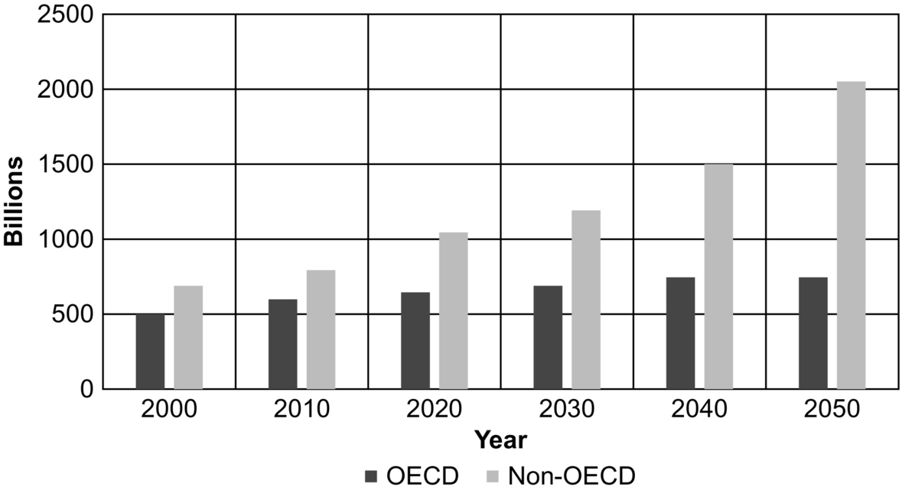

**FIG. 31.1** Global growth in light-duty vehicles. Data from Mobility 2030: “Meeting the Challenges of Sustainability,” World Business Council forSustainable Development (WBCSD) July 2004a and 2004b.

Significant fuel economy improvements and reduction in tailpipe emission in road transportation sector are required to stabilize and reduce greenhouse gas and CO2 emissions. The United Nations Intergovernmental Panel on Climate Change (IPCC) states that an ambitious 50%–80% reduction in global CO2 emissions is required by 2050 (as compared with 2000 levels) in order to limit temperature rise to 2–2.4°C and stabilize atmospheric CO2 concentration at 450 ppm, thus avoiding severe climate change [[2](https://learning.oreilly.com/library/view/power-electronics-handbook/9780128114087/B9780128114070000350.xhtml#bb0015),[3](https://learning.oreilly.com/library/view/power-electronics-handbook/9780128114087/B9780128114070000350.xhtml#bb0020)]. Doubling the fuel efficiency of road vehicles is one of the most cost-effective and accessible measures toward achieving global stabilization of CO2 emissions. However, the targets for both reduction of global CO2 emission and improvement in fuel efficiency require that all countries should adopt cleaner technology on a large scale. Given this scenario, meeting the worldwide energy demand for the present and future transportation systems with the least impact on the environment is an important challenge in terms of technological and societal development.

In order to meet this challenge, novel concepts and innovations are being infused to make transportation systems more and more energy-efficient, reliable, and safe with zero or reduced emissions at an affordable cost. These novel concepts and innovations can be seen in terms of use of low-carbon fuel such as bioethanol or biodiesel, substitution of the petroleum energy by electric energy to drive vehicles, and hydrogen-based power generation. [[4](https://learning.oreilly.com/library/view/power-electronics-handbook/9780128114087/B9780128114070000350.xhtml#bb0025)]. Majority of these innovations are solely relying on electrification of conventional vehicular technology and are grouped under the genre of electric vehicular technology (EVT). In EVT, ICE-based propulsion systems are being replaced by electric propulsion system (EPS), either partially or fully, to minimize fuel consumption and tailpipe emission. Vehicles that employ EVT can be broadly classified as follows [[5](https://learning.oreilly.com/library/view/power-electronics-handbook/9780128114087/B9780128114070000350.xhtml#bb0030)–[15](https://learning.oreilly.com/library/view/power-electronics-handbook/9780128114087/B9780128114070000350.xhtml#bb0080)]:

▪ Battery electric vehicles (BEVs)

▪ Hybrid electric vehicles (HEVs)

▪ Plug-in hybrid electric vehicles (PHEVs)

▪ Fuel-cell vehicles (FCVs)

BEVs are mainly the combination of energy storage system (ESS) and electric propulsion unit that together constitute the power to propel the wheels. Limited operating range and comparatively poor performance and limitation of storage system are the major concerns with BEVs. HEVs are the combination of BEVs and ICE vehicles to bring the advantages of both the vehicles together. Hybrid technologies can be used for almost all kinds of energy sources and engines. The additional electric and mechanical components make the HEVs more complex, bulkier, and costlier. PHEVs are the integration of EVs and HEVs to extend the degree of electrification and electric driving range of the vehicles to achieve the higher efficiency and reduced emission. However, infrastructures for charging stations are major concern. FCVs use hydrogen as fuel to produce electricity; therefore, they are basically emission-free.

### 31.1.2 ADVANCEMENT OF ELECTRIC VEHICULAR TECHNOLOGY

In the last decade, EVT is accelerated globally as competitor and sustainable alternatives of conventional ICE-based vehicles. Efforts and substantial resources are directed to meet market expectations for high-performance, energy-efficient, durable, safe, and affordable electrified vehicles [[5](https://learning.oreilly.com/library/view/power-electronics-handbook/9780128114087/B9780128114070000350.xhtml#bb0030)]. The technological development and growth of EVT has taken on an accelerated pace on their road map to overcome the abovementioned issues associated with each of the electrified vehicles. Therefore, the dream of having commercially viable EVs/HEVs/FCVs/PHEVs is becoming a reality. EVs/HEVs are gradually commercializing and capturing the significant market space; PHEVs are ready to be commercialized, whereas FCVs are under development and yet to be commercialized [[5](https://learning.oreilly.com/library/view/power-electronics-handbook/9780128114087/B9780128114070000350.xhtml#bb0030)–[13](https://learning.oreilly.com/library/view/power-electronics-handbook/9780128114087/B9780128114070000350.xhtml#bb0070)]. The vision of vehicular electrification also includes generating electricity more and more from carbon-free and renewable energy sources such as wind, solar, hydro, fuel cell, and using them in transportation [[12](https://learning.oreilly.com/library/view/power-electronics-handbook/9780128114087/B9780128114070000350.xhtml#bb0065)]. The next generation of electrified vehicles will therefore be integrated with electric power systems through EVs and PHEVs that will enable to implement grid-to-vehicle (G2V) and vehicle-to-grid (V2G) concept and will reduce environmental footprint significantly [[12](https://learning.oreilly.com/library/view/power-electronics-handbook/9780128114087/B9780128114070000350.xhtml#bb0065)–[14](https://learning.oreilly.com/library/view/power-electronics-handbook/9780128114087/B9780128114070000350.xhtml#bb0075)]. The world-wise sales of BEVs, HEVs, and PHEVS are presented in [Fig. 31.2](https://learning.oreilly.com/library/view/power-electronics-handbook/9780128114087/B9780128114070000350.xhtml#f0015).

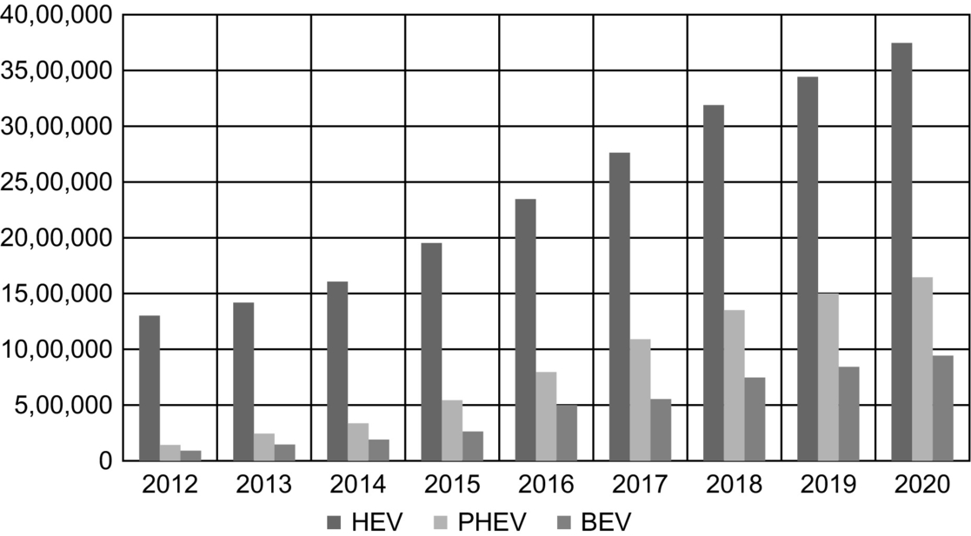

**FIG. 31.2** Electrified vehicles sales worldwide. Data from <https://www.navigantresearch.com/research/transportation-forecast-light-duty-vehicle/> (accessed 09.08.15).

In the last decade, successive development in vehicular electrification brought back the electrified vehicles specially HEVs in competition with ICE vehicles in terms of dynamic behavior, driving range, and practicability with added advantage of higher efficiency, reduced emission, and globally emerged as sustainable alternative of conventional ICE-based vehicles [[5](https://learning.oreilly.com/library/view/power-electronics-handbook/9780128114087/B9780128114070000350.xhtml#bb0030)–[10](https://learning.oreilly.com/library/view/power-electronics-handbook/9780128114087/B9780128114070000350.xhtml#bb0055)]. Therefore, at present, major attention has been focused on technological advancement and modernization of HEVs. Moreover, automobile industries are shifting toward more fuel-efficient, improved performance, higher degree of reliability, durability, safety, and added comforts. Thus, significant efforts and resources are being spent by leading car manufacturers and government to meet these market expectations at an affordable cost [[16](https://learning.oreilly.com/library/view/power-electronics-handbook/9780128114087/B9780128114070000350.xhtml#bb0085)].

### 31.1.3 HYBRIDIZATION OF ENERGY SYSTEM FOR EVT

In an EVT, the onboard energy sources are limited and acting as bottleneck of the technology [[17](https://learning.oreilly.com/library/view/power-electronics-handbook/9780128114087/B9780128114070000350.xhtml#bb0090)]. However, it is essential that the power requirement of vehicle load should be met on board. It is impractical and very expensive to size a single-source energy system to offer continuous power with a capacity many times higher than the average power demand, just to meet momentary peaks in power needs. Therefore, adopting multiple energy sources on board that are specialized for the various segments within a vehicular power demand bandwidth becomes a viable solution [[17](https://learning.oreilly.com/library/view/power-electronics-handbook/9780128114087/B9780128114070000350.xhtml#bb0090)]. The combination of storage system with high-energy-density specifications and storage system with high-power-density specifications provides sustainable solutions [[18](https://learning.oreilly.com/library/view/power-electronics-handbook/9780128114087/B9780128114070000350.xhtml#bb0095)]. The task of a power and energy management system then is to properly coordinate the dynamics of the energy systems without compromising the vehicle's targeted performance [[19](https://learning.oreilly.com/library/view/power-electronics-handbook/9780128114087/B9780128114070000350.xhtml#bb0100)].

In EPS, none of the available energy sources are capable enough to meet power and energy requirement of the vehicle for all driving profile [[18](https://learning.oreilly.com/library/view/power-electronics-handbook/9780128114087/B9780128114070000350.xhtml#bb0095)]. In recent years, it has been observed that to fix the onboard energy demand of electrified vehicles, there is need to mix the energy sources. This encapsulates the idea that the solution to problem of meeting onboard energy demand is hybridization of diverse energy sources such as fossil fuel, solar, hydrogen, and portable source of electric energy like battery, ultracapacitor, and fuel cell.

As an alternative to onboard single-source energy system, hybridization of energy sources is considered as durable and sustainable energy system. HES is gaining more and more popularity in vehicular electrification due to their ability to provide high-power and high-energy-density systems. A well-designed HES offers features like reliability, durability, cleanliness, and efficient power processing operation compared with single-source energy system [[17](https://learning.oreilly.com/library/view/power-electronics-handbook/9780128114087/B9780128114070000350.xhtml#bb0090)–[20](https://learning.oreilly.com/library/view/power-electronics-handbook/9780128114087/B9780128114070000350.xhtml#bb0105)]. It provides optimum solution between availability and utilization of energy sources and offers good power-handling capability in steady-state operation and superior dynamic response during transient conditions.

### 31.1.4 POWER ELECTRONICS FOR EVT

The integration of different components from different branches is a major challenge and is a growing concern in the road map of vehicular electrification. PECs and switches are playing a very significant role in incorporating different components and provide compatibility for proper coordination among them to meet vehicle's requirement in all driving profiles [[21](https://learning.oreilly.com/library/view/power-electronics-handbook/9780128114087/B9780128114070000350.xhtml#bb0110)–[25](https://learning.oreilly.com/library/view/power-electronics-handbook/9780128114087/B9780128114070000350.xhtml#bb0130)]. Advancement in power electronic devices is an enabling technology for the next generation of vehicles that offers smarter, efficient, cleaner, precise, environmentally friendly, and more flexible drive. The reasons for rapid acceleration in growth of vehicular power electronics as discussed in [[23](https://learning.oreilly.com/library/view/power-electronics-handbook/9780128114087/B9780128114070000350.xhtml#bb0120)] are as follows:

▪ The new vehicle architecture integrated with power electronics makes the switching and fusing functions through single component with higher degree of reliability.

▪ Integrated of sensing technique with power electronic devices enables easy fault detections and diagnosis and makes system capable for fault-tolerant operation.

▪ PECs make on demand power conversion as per auxiliary load profile and for propulsion motor resembling the functions of adjustable speed drives.

▪ Voltage conversion for different voltage level especially in dual-voltage architecture and dc/ac and ac/dc conversion can be done using power electronics.

▪ Power electronics devices are used in the development of electronically controlled actuators and variable valves with high degree of precision and accuracy.

▪ Power electronics with modern digital signal controller provides very fast and high-power motion control of propulsion system by enabling high-power actuation and dynamics.

Power semiconductor devices constitute the heart of modern power electronic apparatus, and today's power electronic evolution has been possible primarily due to evolution in power electronic devices [[21](https://learning.oreilly.com/library/view/power-electronics-handbook/9780128114087/B9780128114070000350.xhtml#bb0110)]. In the past few years, power device technology has made remarkable progress and grown in power rating and performance by an evolutionary process.

For EVT, there is a need of highly reliable, flexible, and fault-tolerant EPS. Suitable integration of ESS, power electronic converters (PECs), electric motors (EM), and electronic control unit (ECU) makes the EPS to compete against the conventional ICE-based vehicle [[25](https://learning.oreilly.com/library/view/power-electronics-handbook/9780128114087/B9780128114070000350.xhtml#bb0130)]. The responsibility of integration of these components is well taken care by power electronic devices. A PEC, consisting of a matrix of power semiconductor switches and one or several passive components, helps to convert and control electric power from one form to another form at different voltage and current profile between ESSs and EMs according to the driving profile of the vehicle. PECs act as an interfacing medium for the hybridization of different energy sources like battery, ultracapacitor and fuel cell to match the onboard power and energy requirement. For vehicle acceleration, PECs take power from onboard energy system and supply power to the electric motor as per the demanded vehicle operation. On the other hand, PECs can also be used to utilize recovered energy during deceleration and regenerative braking to charge ESS. The electronic controllers composed of sensors, digital signal processors, and interfacing circuitry are used to generate the control signals for PECs [[26](https://learning.oreilly.com/library/view/power-electronics-handbook/9780128114087/B9780128114070000350.xhtml#bb0135)].

Power electronics is an enabling technology for efficient electric power processing, which plays crucial role in shifting paradigm from conventional ICE vehicles to electrified vehicles [[22](https://learning.oreilly.com/library/view/power-electronics-handbook/9780128114087/B9780128114070000350.xhtml#bb0115),[25](https://learning.oreilly.com/library/view/power-electronics-handbook/9780128114087/B9780128114070000350.xhtml#bb0130)]. The demand of electric power in vehicular application is growing rapidly as the mechanical components are being replaced by the electric and electronic components. It is expected that the power demand in electrified vehicle could reach 2–3 times of the current demand [[23](https://learning.oreilly.com/library/view/power-electronics-handbook/9780128114087/B9780128114070000350.xhtml#bb0120)]. In order to accomplish the growing power demands of electrified vehicles in desired manner, integration of power electronic components with electric and mechanical loads of the vehicle becomes crucial [[24](https://learning.oreilly.com/library/view/power-electronics-handbook/9780128114087/B9780128114070000350.xhtml#bb0125)]. The integration of PEC not only improves the overall performance and fuel economy but also reduces the emission as well as weight and size of the EPS.

## 31.2 Electric Vehicular Technology

The development process of the electrified vehicles is interesting, as the first battery-operated electric vehicle is invented in 1834 [[8](https://learning.oreilly.com/library/view/power-electronics-handbook/9780128114087/B9780128114070000350.xhtml#bb0045)]. Due to the lack of technology, primarily for electrochemical storage units, the interest in EVs gradually diminished and ceased to receive any attention after 1920. In the early 1970s, circumstances changed in favor of the electrified vehicle concept due to the dramatic increase in petroleum prices, global awareness about environmental pollution, and stringent emission regulation [[8](https://learning.oreilly.com/library/view/power-electronics-handbook/9780128114087/B9780128114070000350.xhtml#bb0045)]. The research on EVT is motivated by the argument that electric vehicles represent an economical and technically sustainable option for future transportation systems. Environmental impacts, escalating prices of petroleum fuels, emission restrictions, and the depletion of natural resources provide compelling impetus toward the development of more eco-friendly solutions. It represents one of the greatest challenges of today, a challenge that calls for sustainable advancements and development of EVT.

EVT, essentially, has two major components:

(1) Vehicle architecture and configuration

(2) Electric propulsion system that includes

▪ energy storage system (ESS),

▪ power electronic converter (PEC),

▪ electric motor (EM),

▪ electronic control unit (ECU).

There are plenty of review papers and literature that deal individually with topological architecture and configuration [[4](https://learning.oreilly.com/library/view/power-electronics-handbook/9780128114087/B9780128114070000350.xhtml#bb0025)–[15](https://learning.oreilly.com/library/view/power-electronics-handbook/9780128114087/B9780128114070000350.xhtml#bb0080),[27](https://learning.oreilly.com/library/view/power-electronics-handbook/9780128114087/B9780128114070000350.xhtml#bb0140)–[29](https://learning.oreilly.com/library/view/power-electronics-handbook/9780128114087/B9780128114070000350.xhtml#bb0150)], energy source and storage systems [[17](https://learning.oreilly.com/library/view/power-electronics-handbook/9780128114087/B9780128114070000350.xhtml#bb0090)–[20](https://learning.oreilly.com/library/view/power-electronics-handbook/9780128114087/B9780128114070000350.xhtml#bb0105),[30](https://learning.oreilly.com/library/view/power-electronics-handbook/9780128114087/B9780128114070000350.xhtml#bb0155)–[47](https://learning.oreilly.com/library/view/power-electronics-handbook/9780128114087/B9780128114070000350.xhtml#bb0240)], electric machines [[21](https://learning.oreilly.com/library/view/power-electronics-handbook/9780128114087/B9780128114070000350.xhtml#bb0110),[48](https://learning.oreilly.com/library/view/power-electronics-handbook/9780128114087/B9780128114070000350.xhtml#bb0245)–[62](https://learning.oreilly.com/library/view/power-electronics-handbook/9780128114087/B9780128114070000350.xhtml#bb0315)], power electronic converters [[21](https://learning.oreilly.com/library/view/power-electronics-handbook/9780128114087/B9780128114070000350.xhtml#bb0110)–[25](https://learning.oreilly.com/library/view/power-electronics-handbook/9780128114087/B9780128114070000350.xhtml#bb0130),[63](https://learning.oreilly.com/library/view/power-electronics-handbook/9780128114087/B9780128114070000350.xhtml#bb0320)–[75](https://learning.oreilly.com/library/view/power-electronics-handbook/9780128114087/B9780128114070000350.xhtml#bb0380)], and power-flow management and control strategy [[76](https://learning.oreilly.com/library/view/power-electronics-handbook/9780128114087/B9780128114070000350.xhtml#bb0385),[77](https://learning.oreilly.com/library/view/power-electronics-handbook/9780128114087/B9780128114070000350.xhtml#bb0390)]. This section discusses the architecture of HEVs that includes series, parallel, series-parallel, and complex HEV.

## 31.3 Classification of Electric Vehicular Technology [[6](https://learning.oreilly.com/library/view/power-electronics-handbook/9780128114087/B9780128114070000350.xhtml#bb0035)]

The vehicular technology can be classified as ICE-based vehicles and EPS-based vehicles or electrified vehicles. Electrified vehicles that are driven by EPS either fully or partially further are classified as EVs, HEVs, PHEVs, and FCVs. In EVT, each vehicle has its own capability and limitation in terms of energy density, power density, emission rate, performance, fuel efficiency, size, weight, cost, and safety [[4](https://learning.oreilly.com/library/view/power-electronics-handbook/9780128114087/B9780128114070000350.xhtml#bb0025)–[10](https://learning.oreilly.com/library/view/power-electronics-handbook/9780128114087/B9780128114070000350.xhtml#bb0055)]. These factors are heavily governed by the particular vehicle architecture and propulsion system configuration. Out of the several class of electrified vehicle mentioned above, HEV is the only option that has potential to compete the ICE vehicles in terms of performance. The major advantages of HEV are extended electric range of operation, good fuel economy, higher efficiency, and sufficient onboard power and better dynamic response. Different characteristic such as size versus distance characteristic is depicted in [Fig. 31.3](https://learning.oreilly.com/library/view/power-electronics-handbook/9780128114087/B9780128114070000350.xhtml#f0020), whereas driving distance of some popular BEVs, HEVs, and PHEVs commercialized so far is given in [Table 31.1](https://learning.oreilly.com/library/view/power-electronics-handbook/9780128114087/B9780128114070000350.xhtml#t9000) along with their associated benefits.

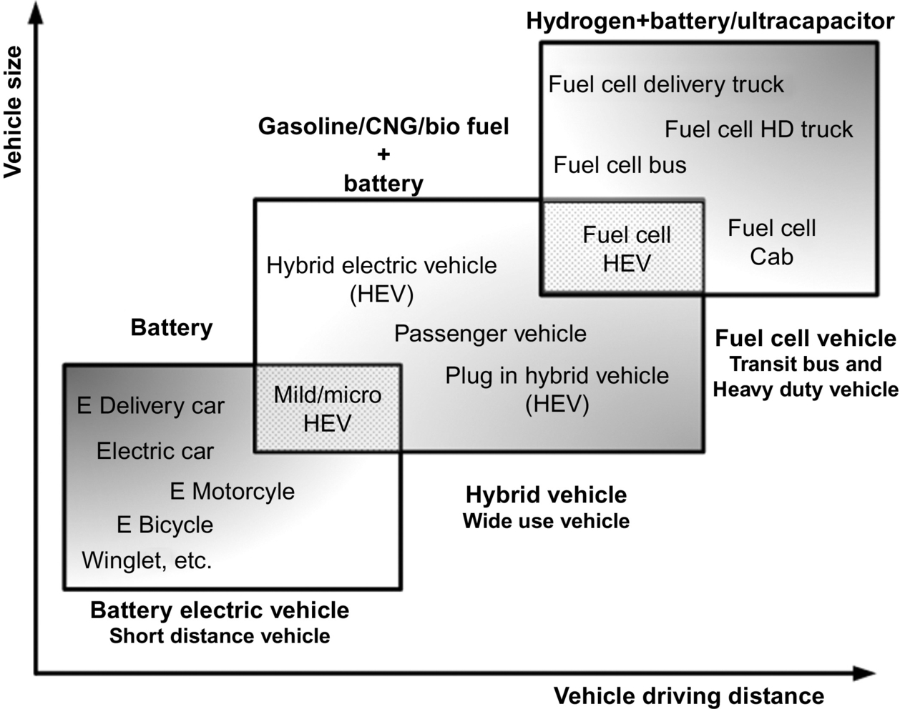

**FIG. 31.3** Classification of EVs/HEVs/PHEVs/FCVs based on size versus distance. Based on [www.toyota-global.com](http://www.toyota-global.com/).

**Table 31.1**

**Characteristic of different electrified vehicles**

|  |  |  |  |  |  |  |  |
| --- | --- | --- | --- | --- | --- | --- | --- |
| **S.No** | **Car Model** | **Range (miles)** | **Top Speed (mph)** | **Charge Time (hrs)** | **Battery (kWh)** | **Rated output (HP)** | **Acceleration (0-60 mph)** |
| **Battery Electric Vehicle** | | | | | | | |
| 1 | Smart Fortwo Electric | 70-80 | 81 | 2.5 | 17.6 | 80 | 11.4 s |
| 2 | Ford Focus Electric | 115 | 84 | 5.5 (240V) | 33.5 | 143 | 9.9 s |
| 3 | Nissan Leaf | 107 | 93 | 9.5 | 30 | 107 | 9.9 s |
| 4 | BMW i3 | 114 | 93 | 4 | 33 | 170 | 7 s |
| 5 | Kia Soul EV | 132 | 90 | 4-5 | 27 | 109 | 10.8 s |
| **Hybrid Electric Vehicle** | | | | | | | |
| 6 | Toyota Prius Plus | 640  25 on battery | 103 | 2 | 8.8 | 121 | 10.5 s |
| 7 | BMW i8 | 310  23 on battery | 155 | 2-3 | 7.1 | 357 | 4.2 s |
| 8 | Chevy Volt 2nd Generation | 420  53 on battery | 100 | 13 (120V) | 18.4 | 84 (Engine)  74 (Motor) | 9.2 s |
| 9 | Honda Accord Hybrid | 758  On battery NA | 112 | NA | 1.3 | 212 | 6.9 s |
| 10 | Volkswagon Jetta Hybrid | 571.2  On battery NA | 185 | NA | 1.1 | 170 | 7 s |

⁎ NA – Not Available

### 31.3.1 ICE VEHICLES

A conventional ICE burns a high-energy-density petroleum fuel (gasoline/diesel) in its combustion chamber and produces power that can be utilized to propel the vehicle by means of mechanical transmission. An ICE-based power train is shown in [Fig. 31.4](https://learning.oreilly.com/library/view/power-electronics-handbook/9780128114087/B9780128114070000350.xhtml#f0030). It consists of a fuel tank that provides onboard high-density-energy source, the internal combustion engine, and a mechanical transmission to transport the power from engine to wheel. The ICE vehicles score in driving distance because of the high energy density of liquid hydrocarbon fuels and dominate in recharging times as a refilling station takes minutes, compared with hours of battery charging time in electrified vehicles [[6](https://learning.oreilly.com/library/view/power-electronics-handbook/9780128114087/B9780128114070000350.xhtml#bb0035),[29](https://learning.oreilly.com/library/view/power-electronics-handbook/9780128114087/B9780128114070000350.xhtml#bb0150)]. The main drawbacks of the conventional ICE vehicles are poor efficiency to convert the fuels into useful power and excessive tailpipe emission, which produces harmful impact on the environment. It has been proved that the maximum fuel conversion efficiency of conventional ICE-based vehicles is 25%–30% at best [[6](https://learning.oreilly.com/library/view/power-electronics-handbook/9780128114087/B9780128114070000350.xhtml#bb0035),[7](https://learning.oreilly.com/library/view/power-electronics-handbook/9780128114087/B9780128114070000350.xhtml#bb0040)]. The main reason of inefficiency of ICE vehicles is the mismatch of engine power characteristic with the real load characteristic of the vehicles as shown in [Fig. 31.5](https://learning.oreilly.com/library/view/power-electronics-handbook/9780128114087/B9780128114070000350.xhtml#f0035), poor efficiency of mechanical transmission and waste of kinetic energy during braking [[29](https://learning.oreilly.com/library/view/power-electronics-handbook/9780128114087/B9780128114070000350.xhtml#bb0150)]. Although internal combustion engines have been used for more than a century, significant improvements in fuel economy, energy efficiency, and emission reduction have been achieved, and still, great research for optimization is going on.

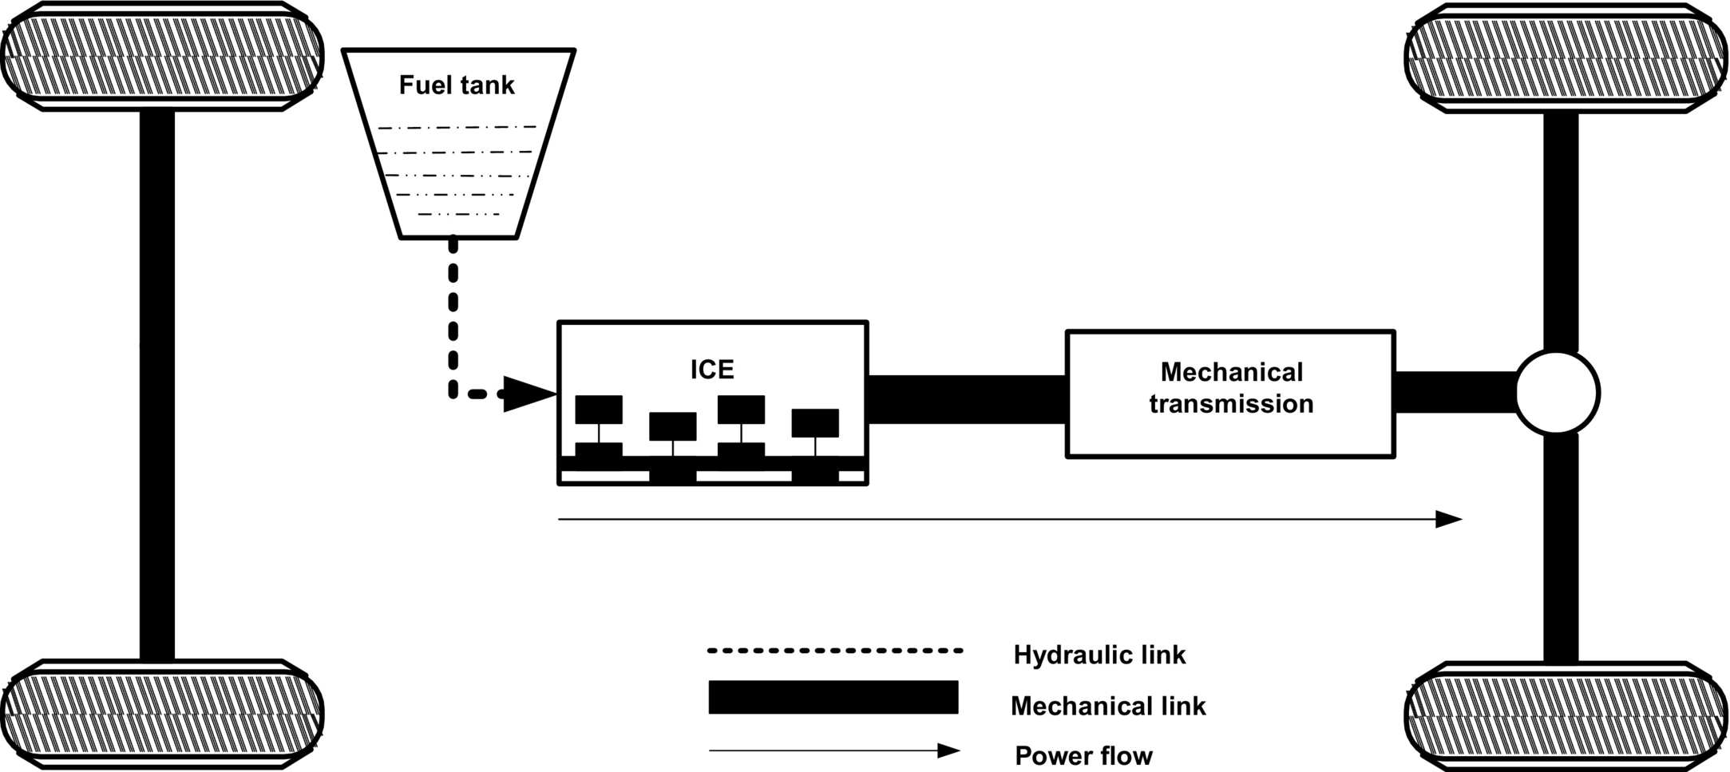

**FIG. 31.4** Configuration of ICE-based vehicles [[6](https://learning.oreilly.com/library/view/power-electronics-handbook/9780128114087/B9780128114070000350.xhtml#bb0035)].

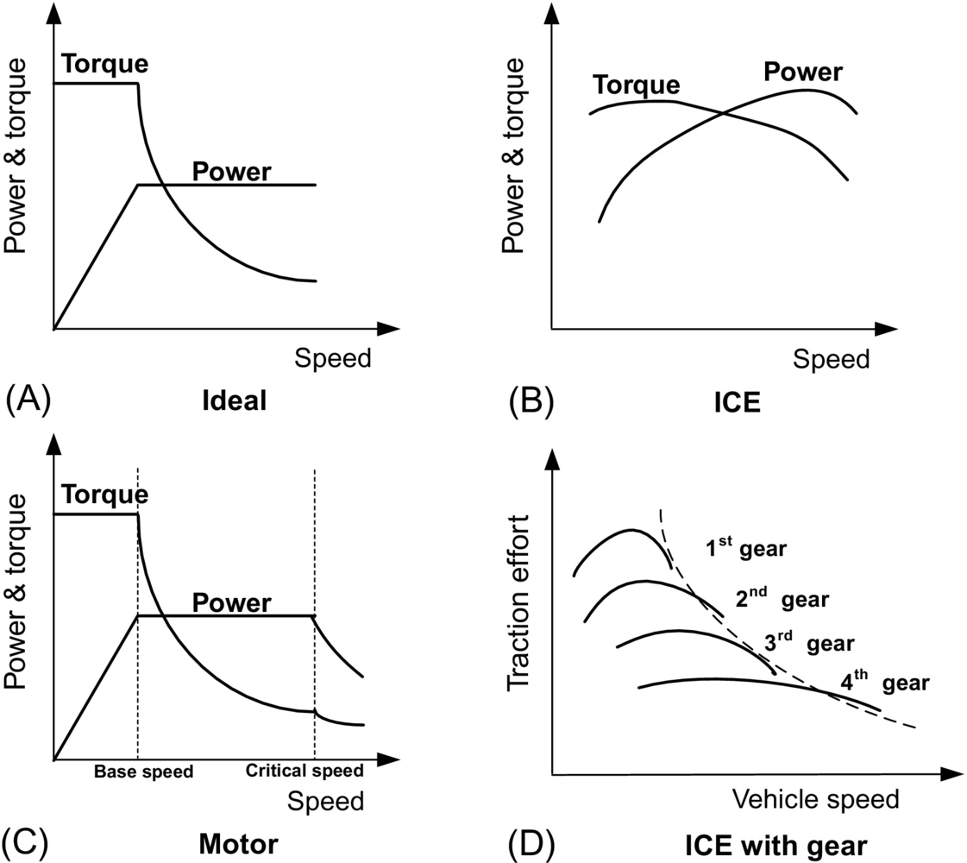

**FIG. 31.5** (A) Ideal torque-speed characteristic for vehicles, (B) torque-speed characteristic of ICE, (C) torque-speed characteristic of electric motor, and (D) torque-speed characteristic of ICE with gear arrangement [[29](https://learning.oreilly.com/library/view/power-electronics-handbook/9780128114087/B9780128114070000350.xhtml#bb0150)].

### 31.3.2 BATTERY ELECTRIC VEHICLES

New environmental concerns over the amount of pollutants released into the atmosphere by internal combustion engines (ICE), unstable petroleum prices in international market, and various emission regulations such as the California Air Resources Board (CARB) have mandated the concept of zero-emission vehicle (ZEV). This becomes a powerful motivation for the use of battery electric vehicles.

The concept of electric vehicles is based on electric drives that consist of the electric motor, power modulator, and onboard energy source and a controller. A simplified architecture of a BEV is shown in [Fig. 31.6](https://learning.oreilly.com/library/view/power-electronics-handbook/9780128114087/B9780128114070000350.xhtml#f0040). A BEV has various advantages such as zero emission, high efficiency, independence of petroleum fuels, less noise, safe, and smooth operation. Moreover, while the maximum efficiency of the ICE vehicle can be 30%–35%, electric propulsion system drawing the power from battery can operate with a peak efficiency of 90% [[4](https://learning.oreilly.com/library/view/power-electronics-handbook/9780128114087/B9780128114070000350.xhtml#bb0025)–[8](https://learning.oreilly.com/library/view/power-electronics-handbook/9780128114087/B9780128114070000350.xhtml#bb0045)]. Also, electric vehicles have the capability to recover the waste energy through regenerative braking.

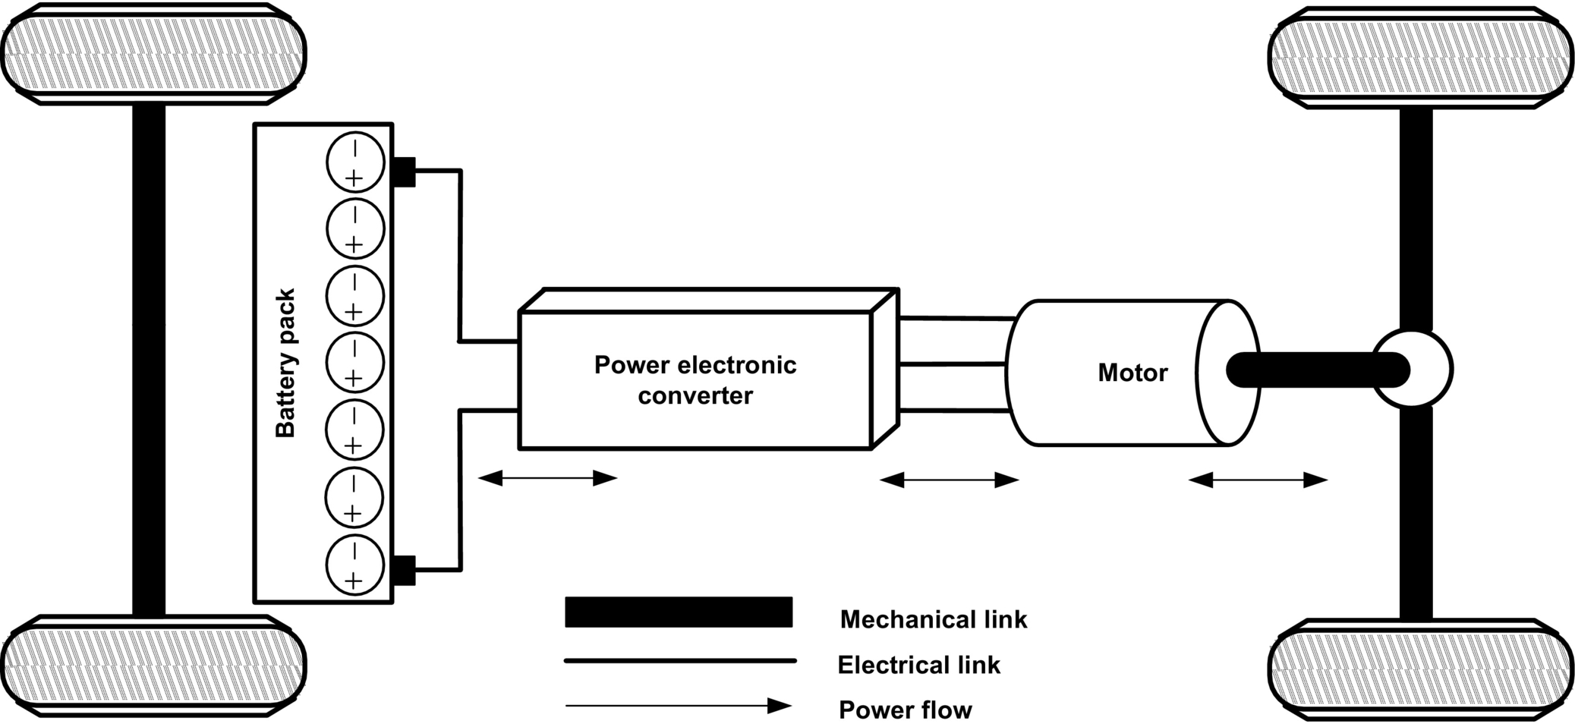

**FIG. 31.6** Topological structure of BEVs [[6](https://learning.oreilly.com/library/view/power-electronics-handbook/9780128114087/B9780128114070000350.xhtml#bb0035)].

Apart from significantly large battery charging time, lower flexibility, and dynamic performance, an important limitation of BEV is its limited operating range per cycle of battery charge. For BEVs to compete against ICE vehicles, advanced energy sources and intelligent energy management system would play key roles.

### 31.3.3 HYBRID ELECTRIC VEHICLES

A hybrid electric vehicle (HEV) is powered by the existing ICE technology and a suitable electric drive system. According to technical committee 69 (electric road vehicles) of the International Electrotechnical Commission, “a hybrid electric vehicle (HEV) is a vehicle in which at least one of the ESSs or converter can deliver electric energy.” Conceptually, HEV uses two energy sources, namely, a fuel (like gasoline, diesel, and hydrogen) and stored energy (as in battery, ultracapacitor, and flywheel), to propel the wheel. The concept of HEV is to combine the EV and ICE vehicle so that better fuel utilization, good dynamic performance, and reduced tailpipe emission can be achieved, and their respective limitations can be overcome [[6](https://learning.oreilly.com/library/view/power-electronics-handbook/9780128114087/B9780128114070000350.xhtml#bb0035)–[9](https://learning.oreilly.com/library/view/power-electronics-handbook/9780128114087/B9780128114070000350.xhtml#bb0050)].

The major advantages of HEV are extended electric range of operation, good fuel economy, higher efficiency, and sufficient onboard power to meet the vehicles' demand in all driving profile. Combining automobile technology with electric technology adds complexity in controls and makes the system heavier and costly. Management and control of power flow from more than one energy sources to the load is a major concern and has to be treated in an optimized way so that better utilization of energy at predicted cost is achieved [[6](https://learning.oreilly.com/library/view/power-electronics-handbook/9780128114087/B9780128114070000350.xhtml#bb0035),[10](https://learning.oreilly.com/library/view/power-electronics-handbook/9780128114087/B9780128114070000350.xhtml#bb0055)]. [Fig. 31.7](https://learning.oreilly.com/library/view/power-electronics-handbook/9780128114087/B9780128114070000350.xhtml#f0045) shows the conceptual power-flow diagram of HEV.

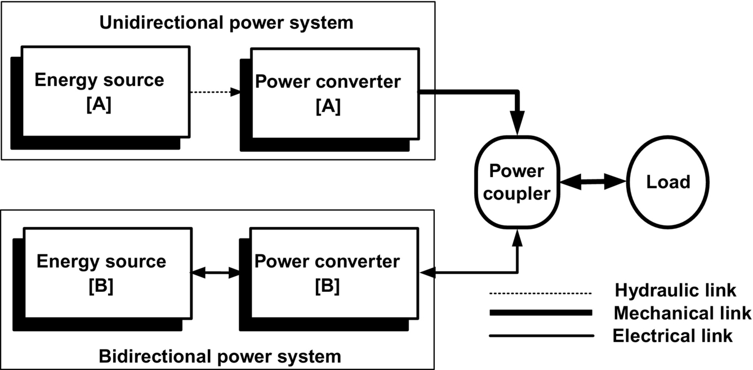

**FIG. 31.7** Power flow in HEVs [[78](https://learning.oreilly.com/library/view/power-electronics-handbook/9780128114087/B9780128114070000350.xhtml#bb0395)].

To meet the desired load demand and to optimize the utilization of energy source(s), there are following possible operating modes to combine the two energy sources as illustrated in [Fig. 31.7](https://learning.oreilly.com/library/view/power-electronics-handbook/9780128114087/B9780128114070000350.xhtml#f0045):

Mode I—Energy source A alone supplies power to the load.

Mode II—Energy source B alone supplies power to the load.

Mode III—Both energy sources A and B supply power to the load simultaneously.

Mode IV—Energy source B draws power from energy source A.

Mode V—Energy source B draws power from load at the time of braking (regenerative braking).

Mode VI—Energy source A supplies power to energy source B and the load simultaneously.

Mode VII—Energy source B draws power from energy source A and load simultaneously.

Mode VIII—Energy source A supplies power to energy source B, and energy source B supplies to the load.

Mode IX—Energy source A supplies power to load, and load supplies power to energy source B.

Energy source A could be gasoline/diesel/fuel cell, and power converter A is unidirectional in nature and converts chemical energy into mechanical energy. Energy source B could be a battery and/or ultracapacitor, and power converter B is bidirectional in nature and delivers electric output. Topological configuration of HEVs is based on energy utilization scheme of energy sources. In the automobile industry, development trends are toward mounting sophisticated electric systems and replacing various mechanical and hydraulic systems to provide more comfort and to increase safety [[8](https://learning.oreilly.com/library/view/power-electronics-handbook/9780128114087/B9780128114070000350.xhtml#bb0045)].

HEVs are traditionally classified into four categories: series hybrids, parallel hybrids, series-parallel hybrids, and complex hybrids, where the entire configuration brings together the electric and mechanical power through various components.

#### **31.3.3.1 Series Hybrid Electric Vehicles**

A series hybrid is an HEV that has two energy sources empowering an electric motor that propels the vehicle. SHEVs are the simplest form of HEVs in which an ICE is mechanically coupled with an electric generator that, in turn, is connected to the electric motor and electrochemical battery pack through a power electronic converter as shown in [Fig. 31.8](https://learning.oreilly.com/library/view/power-electronics-handbook/9780128114087/B9780128114070000350.xhtml#f0050). With the help of generator, mechanical power of ICE is transformed into electric power. The transformed electric power can be used to charge the battery or can evade the battery to supply the electric motor to propel the vehicle, or both can happen simultaneously by means of power electronic converter [[5](https://learning.oreilly.com/library/view/power-electronics-handbook/9780128114087/B9780128114070000350.xhtml#bb0030),[10](https://learning.oreilly.com/library/view/power-electronics-handbook/9780128114087/B9780128114070000350.xhtml#bb0055)]. The power flow from fuel tank to power electronic converter is unidirectional and from battery to electric motor is bidirectional.

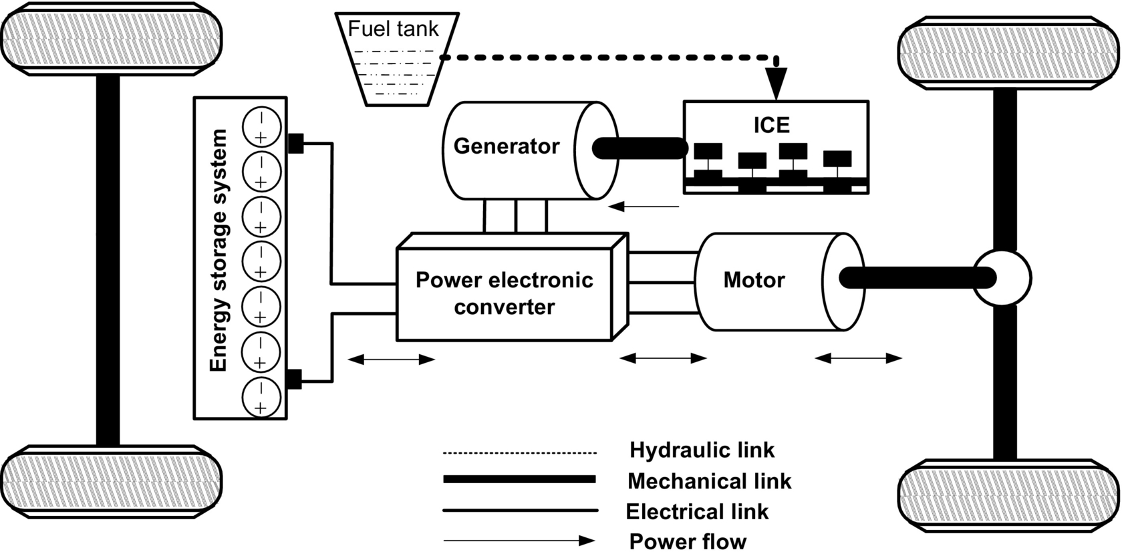

**FIG. 31.8** Architecture of an SHEV [[6](https://learning.oreilly.com/library/view/power-electronics-handbook/9780128114087/B9780128114070000350.xhtml#bb0035)].

Basically, it is ICE-based EVs where there is no mechanical link between ICE and wheel. The start/stop of ICE is controlled by the battery state of charge (SOC). When the battery reaches at a preset minimum SOC, the ICE starts in order to charge the battery. The ICE stops when the battery has reached a desirable maximum SOC. The control algorithm for the optimal operation of engine, having high efficiency and low fuel consumption, is selected such that the battery SOC should be maintained at around 65%–75% of full charge [[9](https://learning.oreilly.com/library/view/power-electronics-handbook/9780128114087/B9780128114070000350.xhtml#bb0050)]. However, power transportation from energy sources to the wheel takes two stages of power conversion (mechanical to electric and electric to mechanical) and leads to increased energy losses and reduction in overall efficiency of the vehicle. All possible combinations (modes I–IX) of two energy sources are applicable for the SHEVs, but practically, only modes I–VI have been used so as to extend the life of battery [[6](https://learning.oreilly.com/library/view/power-electronics-handbook/9780128114087/B9780128114070000350.xhtml#bb0035)]. The mechanical decoupling between the engine and wheels increases the degree of flexibility and reduces the complexity. Since the electric motor has the desired torque-speed characteristic, multigear mechanical transmission system can be eliminated. Simplified construction, control strategy, and reduced costs are the salient features for such a system. However, addition of generator and size of propulsion unit are two major concerns. The SHEVs are best suited for city driving where frequent “starts” and “stops” occur over a part of distance being traveled [[5](https://learning.oreilly.com/library/view/power-electronics-handbook/9780128114087/B9780128114070000350.xhtml#bb0030)].

#### **31.3.3.2 Parallel Architecture**

In a parallel hybrid configuration, ICE and electric motor are connected in parallel to deliver power to the wheel as shown in [Fig. 31.9](https://learning.oreilly.com/library/view/power-electronics-handbook/9780128114087/B9780128114070000350.xhtml#f0055). The powers from electric motor and ICE are pooled together with the help of mechanical coupling. However, the mechanical coupling adds to the complexity in control algorithm for the vehicle. The vehicle can be driven with the ICE, the electric motor, or both simultaneously, and therefore, it is possible to feed the desired amount of power at any given period of time [[5](https://learning.oreilly.com/library/view/power-electronics-handbook/9780128114087/B9780128114070000350.xhtml#bb0030)–[10](https://learning.oreilly.com/library/view/power-electronics-handbook/9780128114087/B9780128114070000350.xhtml#bb0055)]. In parallel HEV, except modes VII, VIII, and IX, all other modes (I–VI) can be used for better utilization of energy sources and reliable operation [[6](https://learning.oreilly.com/library/view/power-electronics-handbook/9780128114087/B9780128114070000350.xhtml#bb0035)]. In this configuration, efforts are made to operate the electric motor alone at lower speed and ICE alone at higher speeds. Thus, at higher speed, ICE is operated at most efficient point, and hence, higher efficiency and better fuel consumption along with reduced tailpipe emission can be achieved. In case of acceleration or hill climbing, both the power sources are activated to fulfill the desired power demand. When ICE is working alone or in case of regenerative braking, the electric motor can operate as a generator to charge the battery.

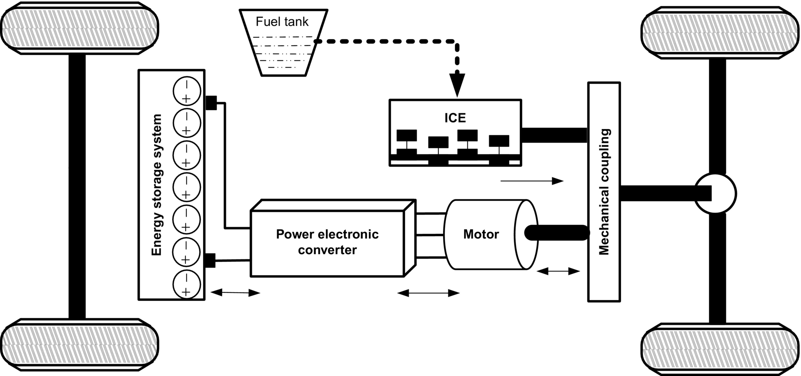

**FIG. 31.9** Architecture of parallel HEV [[6](https://learning.oreilly.com/library/view/power-electronics-handbook/9780128114087/B9780128114070000350.xhtml#bb0035)].

As compared with series HEV, elimination of generator leads to single-stage power conversion that increases the efficiency and reduces the weight and cost of the vehicle. The parallel coupling of the power sources leaves space for further research and improvement of vehicle's performance. The major research efforts on parallel HEVs are focused on the implementation of continuously variable transmission (CVT) instead of a fixed-step transmission that gives the freedom to operate the ICE at its most efficient point at demanded torque [[9](https://learning.oreilly.com/library/view/power-electronics-handbook/9780128114087/B9780128114070000350.xhtml#bb0050)].

#### **31.3.3.3 Series Parallel Architecture**

Series-parallel HEV is an integration of the series and parallel hybrids as shown in [Fig. 31.10](https://learning.oreilly.com/library/view/power-electronics-handbook/9780128114087/B9780128114070000350.xhtml#f0060). The configuration introduces an additional mechanical link (unlike the series hybrid) and an additional generator (unlike the parallel hybrid) to facilitate the advantages of both configurations [[4](https://learning.oreilly.com/library/view/power-electronics-handbook/9780128114087/B9780128114070000350.xhtml#bb0025)–[10](https://learning.oreilly.com/library/view/power-electronics-handbook/9780128114087/B9780128114070000350.xhtml#bb0055)]. Among various possibilities in series-parallel hybrids, the general classification includes electric-intensive and engine-intensive. In electric-intensive configuration, electric motor is more dominating than the ICE. In engine-intensive configuration, ICE is more dominating than electric motor [[10](https://learning.oreilly.com/library/view/power-electronics-handbook/9780128114087/B9780128114070000350.xhtml#bb0055)]. Accordingly, the dominating components are designed. The operating modes (start, normal driving, acceleration, deceleration, braking, and battery charging) of electric-intensive and ICE-intensive are almost the same except for the normal driving mode. In normal driving mode, efforts are made to operate the engine at its most efficient point. Therefore, in ICE-intensive configuration, the engine propels the wheels solely, and in electric-intensive configuration, the ICE can assist the electric motor to propel the wheels. Although the series-parallel hybrid vehicle incorporates the advantages of both the series and parallel hybrid, the use of additional electric and mechanical components (generator and planetary gear arrangement) adds to the complexity, weight, and costs.

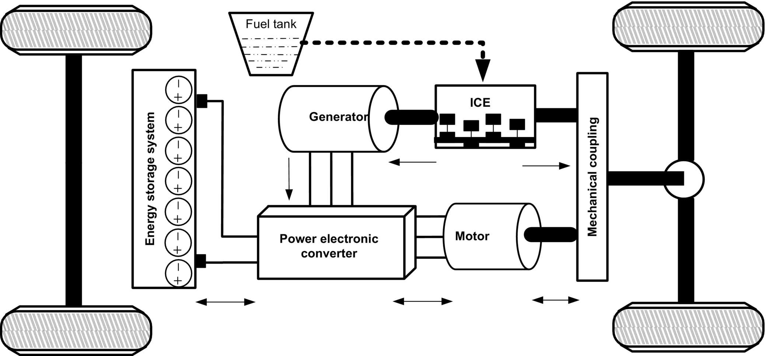

**FIG. 31.10** Architecture of series-parallel HEVs [[6](https://learning.oreilly.com/library/view/power-electronics-handbook/9780128114087/B9780128114070000350.xhtml#bb0035)].

#### **31.3.3.4 Complex Hybrid System**

All the configurations discussed previously are implemented for single-axle propulsion, for either the front or the rear wheel. A new hybrid scheme known as complex hybrid configuration is designed for dual-axle propulsion. In such an architecture, illustrated in [Fig. 31.11](https://learning.oreilly.com/library/view/power-electronics-handbook/9780128114087/B9780128114070000350.xhtml#f0065), both the front and rear wheels propel the vehicle. In this configuration, the front-wheel and rear-wheel axles are decoupled from each other, and there is no mechanical link between them; hence, both the axles are driven independently [[10](https://learning.oreilly.com/library/view/power-electronics-handbook/9780128114087/B9780128114070000350.xhtml#bb0055)]. In complex hybrid vehicle, the electric generator offers bidirectional power flow, whereas in case of series-parallel, it offers unidirectional power flow. However, both the configurations involve ICE, electric generator, and motor to propel the vehicle. The capability of complex hybrid system, to drive the wheels by either electric propulsion or hybrid propulsion or combination of both, offers additional flexibility and reliability. The front wheels are propelled by hybrid propulsion system, and rear wheels are propelled by electric propulsion system or vice versa. The operating modes for both the scheme are almost common, except when front wheels are propelled by hybrid system, all the wheels are driven; however, when front wheels are propelled by electric system, only front wheels are driven at starting [[8](https://learning.oreilly.com/library/view/power-electronics-handbook/9780128114087/B9780128114070000350.xhtml#bb0045)–[10](https://learning.oreilly.com/library/view/power-electronics-handbook/9780128114087/B9780128114070000350.xhtml#bb0055)]. A planetary gear arrangement is used to coupled ICE, front electric motor, and front axle altogether. Independent control of front and rear wheels provides smooth vehicle operation and flexibility in casing. This, however, increases complexity and costs. Also, regenerative braking in all four wheels can significantly improve efficiency of the system and hence fuel economy.

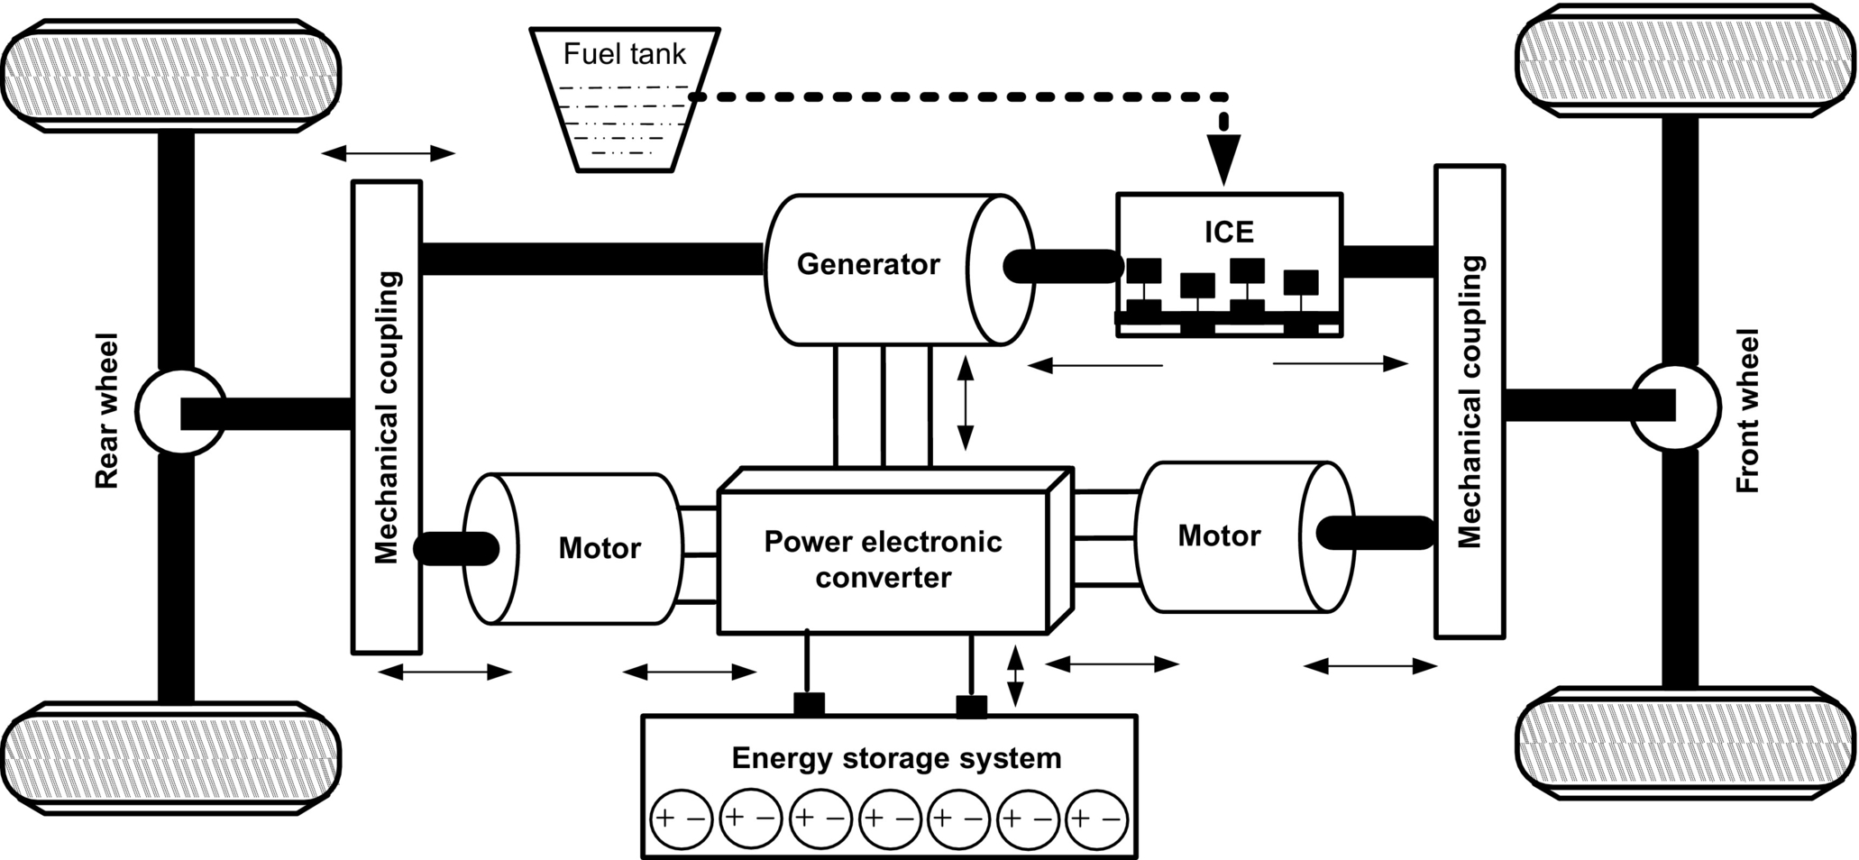

**FIG. 31.11** Operating modes of complex HEVs [[6](https://learning.oreilly.com/library/view/power-electronics-handbook/9780128114087/B9780128114070000350.xhtml#bb0035)].

### 31.3.4 PLUG-IN HYBRID ELECTRICAL VEHICLES

Plug-in hybrid electric vehicle is a transitional technology between BEVs and HEVs. The IEEE (board of directors, 2007) defines a PHEV as “any hybrid electric vehicle that contains at least (i) a battery storage system of 4 kWh or more, used to power the motion of the vehicle; (ii) a means of recharging that battery system from an external source of electricity; and (iii) an ability to drive at least 10 mi in all-electric mode, and consume no gasoline” [[15](https://learning.oreilly.com/library/view/power-electronics-handbook/9780128114087/B9780128114070000350.xhtml#bb0080)]. Conceptually, a PHEV is a HEV with large battery pack that can be recharged from the external source (utility grid or renewable source of energy) to extend the all-electric range (AER) of the vehicles as shown in [Fig. 31.12](https://learning.oreilly.com/library/view/power-electronics-handbook/9780128114087/B9780128114070000350.xhtml#f0070).

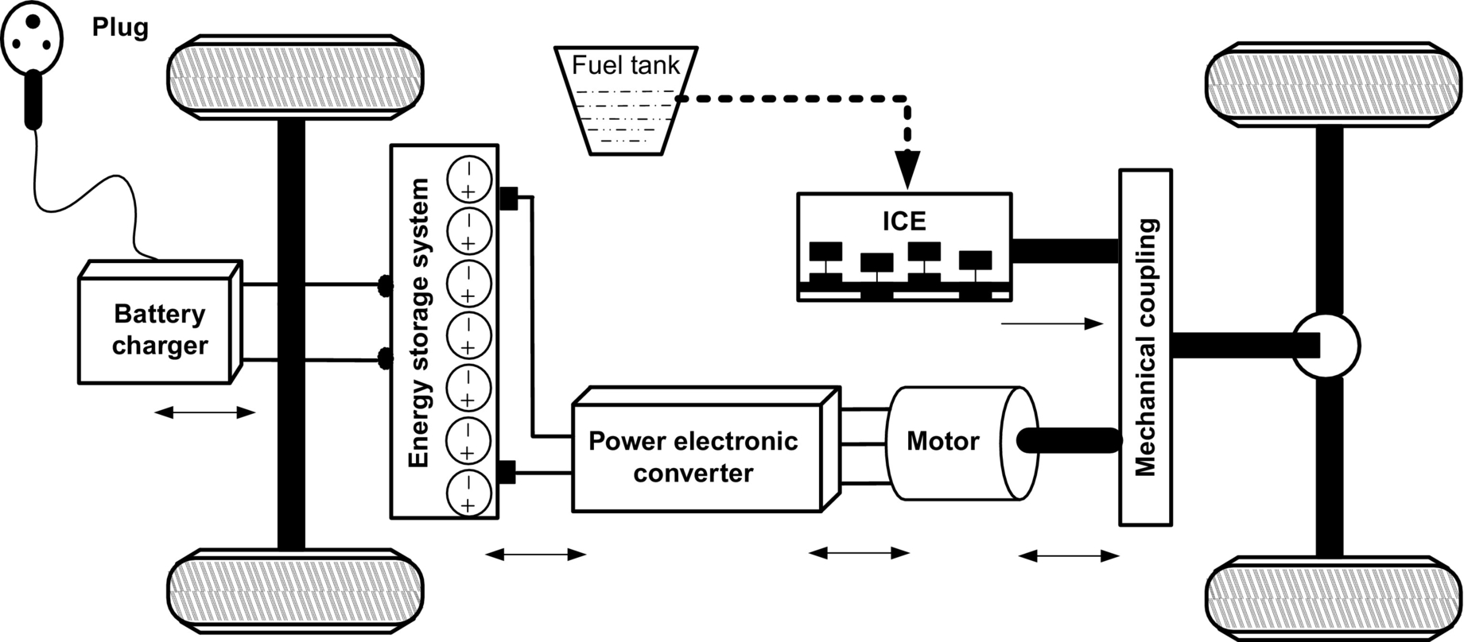

**FIG. 31.12** Schematic diagram of PHEVs [[6](https://learning.oreilly.com/library/view/power-electronics-handbook/9780128114087/B9780128114070000350.xhtml#bb0035)].

In this vehicle, fuel tank and battery pack both can be recharged by external sources and are entirely different from hybrid vehicles that do not utilize any electric energy from the external sources or grid. When the battery pack is fully charged by external source, PHEV operates as EV with extended AER (30–60 km) and then switches to hybrid mode when battery reaches its predefined SOC or vehicle demands extra power for acceleration [[13](https://learning.oreilly.com/library/view/power-electronics-handbook/9780128114087/B9780128114070000350.xhtml#bb0070),[14](https://learning.oreilly.com/library/view/power-electronics-handbook/9780128114087/B9780128114070000350.xhtml#bb0075)]. Moreover, not only PHEV has the capability to charge the battery pack from the grid, but also it will be able to supply the power to the grid, and hence, the vehicle-to-grid (V2G) concept is evolved [[15](https://learning.oreilly.com/library/view/power-electronics-handbook/9780128114087/B9780128114070000350.xhtml#bb0080)]. The emerging technology of V2G must be bidirectional in nature so that grid can transfer power to the vehicle in charging mode, and vehicle delivers power to the grid in discharging mode at peak hours. All vehicles with V2G capability must meet the IEEE Standard 1547 for connecting to the utility.

### 31.3.5 FUEL CELL VEHICLES

In recent times, fuel-cell vehicle (FCV) is an upcoming technology, which involves automobile, electric, and chemical engineering. A fuel cell is a chemical engine that produces electricity from hydrogen, emitting only water as a by-product. The electricity produced is used for driving electric motor coupled with wheel of the vehicles. Fuel-cell technology offers the advantages of portable power supply. Unlike ICE, a fuel cell directly converts chemical energy into electric energy without internal combustion and pollution. In contrast to a battery, the fuel cell generates electric energy rather than storing it and continues to supply energy as long as fuel is fed [[9](https://learning.oreilly.com/library/view/power-electronics-handbook/9780128114087/B9780128114070000350.xhtml#bb0050)].

Fuel-cell vehicles (FCVs) can be fueled with pure hydrogen gas stored on board in high-pressure tanks. They can also be fueled with hydrogen-rich fuels including methanol, natural gas, or even gasoline; these fuels must first be converted into hydrogen gas by an onboard device called a “reformer.” This will add cost, complexity, and weight to the vehicle but will make the fuel distribution easier [[28](https://learning.oreilly.com/library/view/power-electronics-handbook/9780128114087/B9780128114070000350.xhtml#bb0145)]. FCVs fueled with pure hydrogen emit no pollutants, only water and heat, while those using hydrogen-rich fuels and a reformer produce only small amounts of air pollutants. In addition, FCVs can be twice as efficient as similarly sized conventional vehicles and may also incorporate other advanced technologies to increase efficiency [[9](https://learning.oreilly.com/library/view/power-electronics-handbook/9780128114087/B9780128114070000350.xhtml#bb0050)]. A conventional FCV system is shown in [Fig. 31.13](https://learning.oreilly.com/library/view/power-electronics-handbook/9780128114087/B9780128114070000350.xhtml#f0075), where hydrogen-enriched fuel is first refined by the reformer to acquire pure hydrogen gas. This hydrogen gas is fed to fuel-cell stack where it directly meets oxygen of the atmosphere and undergoes a chemical reaction; consequently, electricity is produced. The output power of fuel-cell stack is processed by *PEC* to meet the power requirement of the EPS.

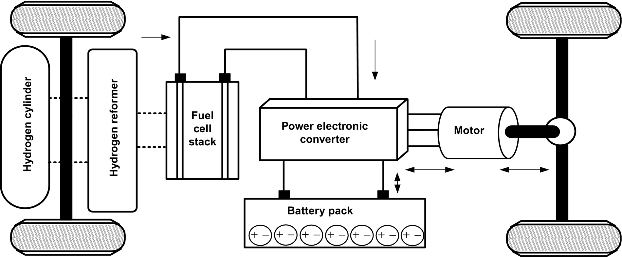

**FIG. 31.13** Schematic diagram of FCVs [[6](https://learning.oreilly.com/library/view/power-electronics-handbook/9780128114087/B9780128114070000350.xhtml#bb0035)].

Since the power flow from the fuel cell to propulsion unit is unidirectional, to recover the braking energy by means of regenerative braking, storage medium such as battery and ultracapacitor can be included in the system. The storage unit stores energy and supplies to propulsion system at the time of acceleration to assist the fuel cell [[27](https://learning.oreilly.com/library/view/power-electronics-handbook/9780128114087/B9780128114070000350.xhtml#bb0140)]. The integration of ICE and battery pack with fuel-cell system gives the concept of hybrid FCVs where all the configuration and advantages of HEVs can be utilized. With suitable power electronics arrangement, FCVs can also be operated as plug-in fuel-cell vehicles (PFCVs) where battery pack can be charged from grid or discharged to supply the grid [[34](https://learning.oreilly.com/library/view/power-electronics-handbook/9780128114087/B9780128114070000350.xhtml#bb0175)]. Higher efficiency, reliability, and quieter operation with negligible emissions are some of the important features, which continue to attract the attention of researchers. As efforts are being directed to further improve the fuel-cell technology along with significant cost reduction, it has high potential to energize future automobile [[8](https://learning.oreilly.com/library/view/power-electronics-handbook/9780128114087/B9780128114070000350.xhtml#bb0045),[9](https://learning.oreilly.com/library/view/power-electronics-handbook/9780128114087/B9780128114070000350.xhtml#bb0050)]. A fuel-cell system integrated with vehicular propulsion system must have the ability to compete against the ICE vehicles on cost, weight, onboard energy density, start-up, and transient response with the attainment of benefits such as zero emission and higher efficiency of the battery-operated vehicles.

Different types of electrified vehicles have their own capabilities and limitations in terms of emission rate, performance, fuel efficiency, durability, size, weight, cost, safety, and comfort. Among different types of electrified vehicles, HEV is the only one that currently has the potential to compete the ICE vehicle in terms of performance and all driving profiles and offers advantages like extended electric range of operation, good fuel economy, higher efficiency, sufficient onboard power, and better dynamic response [[5](https://learning.oreilly.com/library/view/power-electronics-handbook/9780128114087/B9780128114070000350.xhtml#bb0030)–[10](https://learning.oreilly.com/library/view/power-electronics-handbook/9780128114087/B9780128114070000350.xhtml#bb0055)]. However, integration of automobile technology with electric technology adds complexity in controls and makes the HEV system comparatively bulky and costly. At present, HEV technology is rated as a promising technology that is growing rapidly and capturing significant market space at a fast growth rate [[7](https://learning.oreilly.com/library/view/power-electronics-handbook/9780128114087/B9780128114070000350.xhtml#bb0040)–[9](https://learning.oreilly.com/library/view/power-electronics-handbook/9780128114087/B9780128114070000350.xhtml#bb0050)]. Plug-in HEVs are currently at the commercialization stage. To be commercially viable, they require good energy policies and infrastructure for charging stations in the near future [[13](https://learning.oreilly.com/library/view/power-electronics-handbook/9780128114087/B9780128114070000350.xhtml#bb0070)–[15](https://learning.oreilly.com/library/view/power-electronics-handbook/9780128114087/B9780128114070000350.xhtml#bb0080)]. The efficiency analysis from well to wheels, the concept of V2G and G2V, and the impact of charging station on the grid are the major issues that are being researched for successful commercialization. On the other hand, fuel-cell vehicles, powered by hydrogen, are considered as the future of EVT [[27](https://learning.oreilly.com/library/view/power-electronics-handbook/9780128114087/B9780128114070000350.xhtml#bb0140),[28](https://learning.oreilly.com/library/view/power-electronics-handbook/9780128114087/B9780128114070000350.xhtml#bb0145)]. The different characteristics and issues of ICEV and EVT presented in [[8](https://learning.oreilly.com/library/view/power-electronics-handbook/9780128114087/B9780128114070000350.xhtml#bb0045)] are revised and summarized in [Table 31.2](https://learning.oreilly.com/library/view/power-electronics-handbook/9780128114087/B9780128114070000350.xhtml#t0010).

**Table 31.2**

**Different characteristics of ICEV/EV/HEV/PHEV/FCV [**[**4**](https://learning.oreilly.com/library/view/power-electronics-handbook/9780128114087/B9780128114070000350.xhtml#bb0025)**]**

|  |  |  |  |  |  |  |
| --- | --- | --- | --- | --- | --- | --- |
| **Characteristic** | **Propulsion system** | **Energy storage** | **Energy source infrastructure** | **Advantages** | **Drawbacks** | **Important issues** |
| ICE vehicles | ▪ ICE based drives | ▪ Fuel tank | ▪ Petroleum products with refueling station | ▪ Matured technology  ▪ Fully commercialized  ▪ Better performance  ▪ Simple operation  ▪ Reliable and durable | ▪ Less efficient  ▪ Poor fuel economy  ▪ Harmful emission  ▪ Comparatively  ▪ Bulky | ▪ Fuel economy  ▪ Harmful Emission  ▪ Highly dependency on petroleum products |
| EVs | ▪ EPS based drive | ▪ Battery  ▪ Ultra capacitor  ▪ Flywheel | ▪ Electrical energy with charging facilities | ▪ Energy efficient  ▪ Quite and Zero emission  ▪ Independency from petroleum products  ▪ Smooth operation  ▪ Commercialized | ▪ Limited driving range  ▪ Higher recharging time  ▪ Poor dynamic response | ▪ Size and weight of battery Pack  ▪ Vehicle performance  ▪ Infrastructure for charging station |
| Hybrid EVs | ▪ EPS and ICE based drive | ▪ Fuel tank  ▪ Battery  ▪ Ultra capacitor  ▪ Flywheel | ▪ Electrical power  ▪ Petroleum products with refueling station | ▪ Higher fuel economy  ▪ Very low emission  ▪ Long electric driving range  ▪ Reliable and durable  ▪ Commercialized | ▪ Costly and Bulky  ▪ Complex system  ▪ Complexity in control algorithm  ▪ Large component count | ▪ Power management of multi input source  ▪ Size and weight of battery Pack and ICE  ▪ Integration of components |
| Plug In HEVs | ▪ EPS and ICE based drive | ▪ Fuel tank  ▪ Battery  ▪ Ultra capacitor  ▪ Flywheel | ▪ Electrical power with charging station  ▪ Petroleum products with refueling station | ▪ Lower emission  ▪ Higher fuel efficient  ▪ Extended electric driving range  ▪ V2G or G2V capability  ▪ Partially commercialized | ▪ Higher complexity  ▪ Impact on grid  ▪ Higher initial cost  ▪ Sophisticated electronic circuitry  ▪ Battery technology | ▪ Size and weight of battery pack and ICE  ▪ Charging station infrastructure  ▪ Power flow control  ▪ Impact on grid |
| FCVs | ▪ EPS based drive | ▪ Fuel cell stack  ▪ Battery  ▪ Ultra capacitor | ▪ Hydrogen cylinder or Hydrogen enriched fuel  ▪ Hydrogen refueling station | ▪ Ultra low emission  ▪ Highly efficient  ▪ Independency from petroleum products  ▪ Competent driving range  ▪ Reliable and durable | ▪ High cost  ▪ Slow transient response  ▪ Not commercialized yet  ▪ Sophisticated ECU | ▪ Cost of fuel cell  ▪ Cycle life and reliability  ▪ Infrastructure for Hydrogen conditioning, storage and refilling system |

## 31.4 Electrical Propulsion System

The sustainability of EVT is relying on maturity, which depends on technological advancement and development of its components such as ESS, PEC, electric motor, and ECU [[29](https://learning.oreilly.com/library/view/power-electronics-handbook/9780128114087/B9780128114070000350.xhtml#bb0150),[78](https://learning.oreilly.com/library/view/power-electronics-handbook/9780128114087/B9780128114070000350.xhtml#bb0395)]. The ESS replaces the fuel tank and fulfills the energy requirement of the electric vehicular system. Basically, ESS provides electric energy that has been processed and utilized by the other components of EPS. The electric motors transform the electric energy into mechanical energy or vice versa, as and when required. It converts electric energy of the ESS into mechanical energy to meet the power demands of the vehicle. The reversible process can also be achieved by regenerative braking, or electric energy can also be generated by electric motor to charge the ESS. The power electronic converters (PECs) are used to modulate power with suitable voltage and current between ESSs and electric motors. For vehicle acceleration, PECs supply required power to the electric motor to achieve the demanded operation. On the other hand, PECs can also be used to utilize the recovered energy of regenerative braking for the charging of ESS. The electronic controllers are composed of sensors, digital processors, and interfacing circuitry to generate the control signals for PECs and other electric and mechanical components.

In order to achieve the vision of sustainable EVT, electric propulsion system should address some important issues such as driving profile, weight and volume of vehicle, reliability and flexibility, packaging and installation, cooling system and maintenance, and all at affordable costs [[16](https://learning.oreilly.com/library/view/power-electronics-handbook/9780128114087/B9780128114070000350.xhtml#bb0085),[79](https://learning.oreilly.com/library/view/power-electronics-handbook/9780128114087/B9780128114070000350.xhtml#bb0400)]. At present, the major challenges of EPS manufactures are to design and implement electric machines and power electronic converters that give better performance and can be more easily integrated for next-generation vehicles.

A functional block diagram of electric propulsion system, including the possible types of motors, computer-aided design methodologies, power converter devices/topologies, control hardware, software, and strategies, is shown in [Fig. 31.14](https://learning.oreilly.com/library/view/power-electronics-handbook/9780128114087/B9780128114070000350.xhtml#f0080).

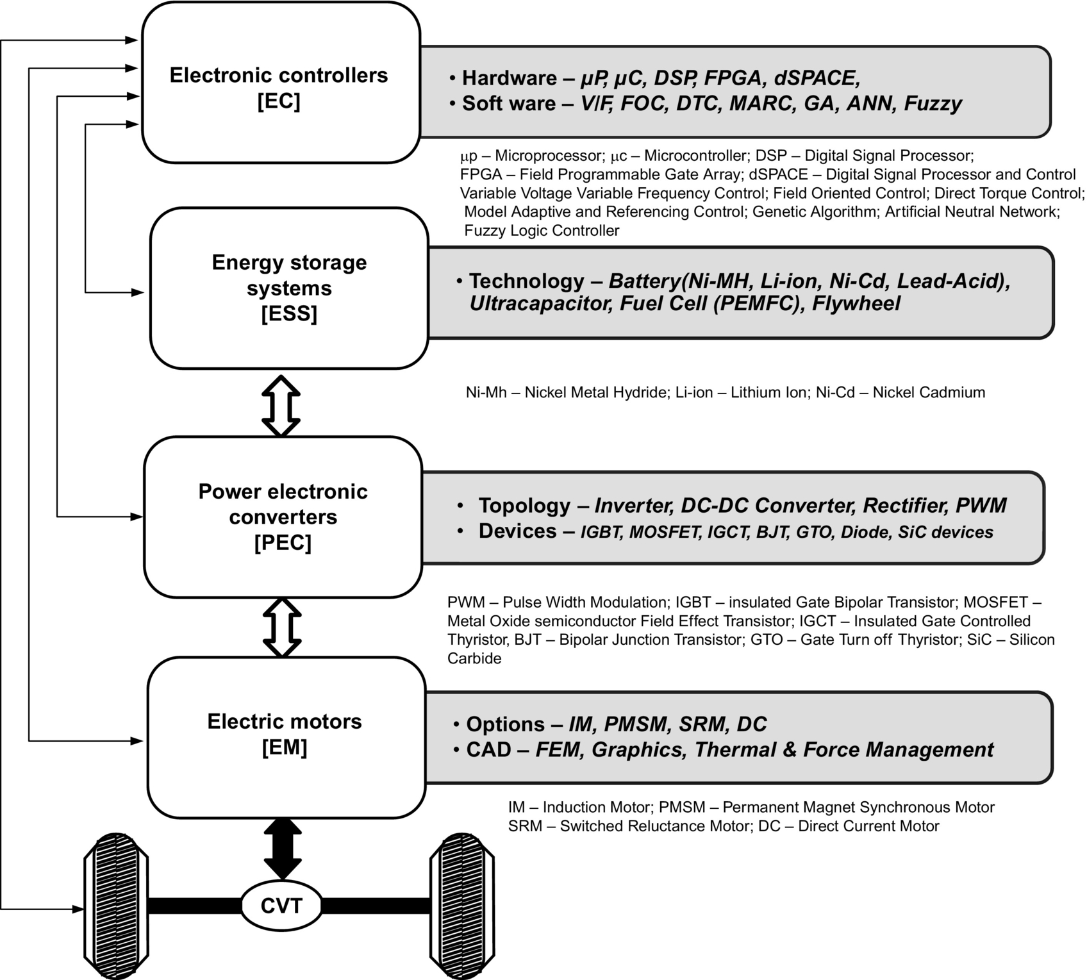

**FIG. 31.14** Functional block diagram of electric propulsion system [[4](https://learning.oreilly.com/library/view/power-electronics-handbook/9780128114087/B9780128114070000350.xhtml#bb0025)]. Modified from C.C. Chan, Y.S. Wong, Electric vehicles charge forward, IEEE Power Energy Mag. 2(6) (2004) 24–33.

### 31.4.1 ENERGY STORAGE SYSTEM

The strength of ESS is an important factor and plays vital role in vehicular electrification [[17](https://learning.oreilly.com/library/view/power-electronics-handbook/9780128114087/B9780128114070000350.xhtml#bb0090)–[20](https://learning.oreilly.com/library/view/power-electronics-handbook/9780128114087/B9780128114070000350.xhtml#bb0105)]. Basically, ESS constitutes the source (fuel cell) and onboard energy storage devices that include battery, ultracapacitor, and flywheel. Battery and fuel cell both produce onboard electric energy by means of electrochemical energy conversion; however, a battery stores energy, whereas a fuel cell generates energy. Ultracapacitor relies on electrostatic principle to store energy, and therefore, it has capability to store high specific power rather than energy [[18](https://learning.oreilly.com/library/view/power-electronics-handbook/9780128114087/B9780128114070000350.xhtml#bb0095)]. Use of flywheel is considered an optional technology for vehicle electrification due to weight and size considerations. The efficiency, fuel economy, and all-electric range (AER) of EVs/HEVs/PHEVs/FCVs are highly dependent on the onboard ESS of the vehicles. The ESS units must be sized so that they store sufficient energy (in kilowatt hours) and provide adequate peak power (in kilowatts) for the vehicle to have a specified acceleration performance and capability to meet appropriate driving cycles [[8](https://learning.oreilly.com/library/view/power-electronics-handbook/9780128114087/B9780128114070000350.xhtml#bb0045)]. The major factors that affect the design of ESSs for vehicular application include energy density, power densities, life cycle, size, safety, maintenance, and recyclability at projected cost. The basic characteristics of specific power (W/Kg) versus specific energy (Wh/kg) of fuel cell, battery, ultracapacitor, and flywheel in comparison with petroleum-fuel-based ICE are shown in [Fig. 31.15](https://learning.oreilly.com/library/view/power-electronics-handbook/9780128114087/B9780128114070000350.xhtml#f0085).

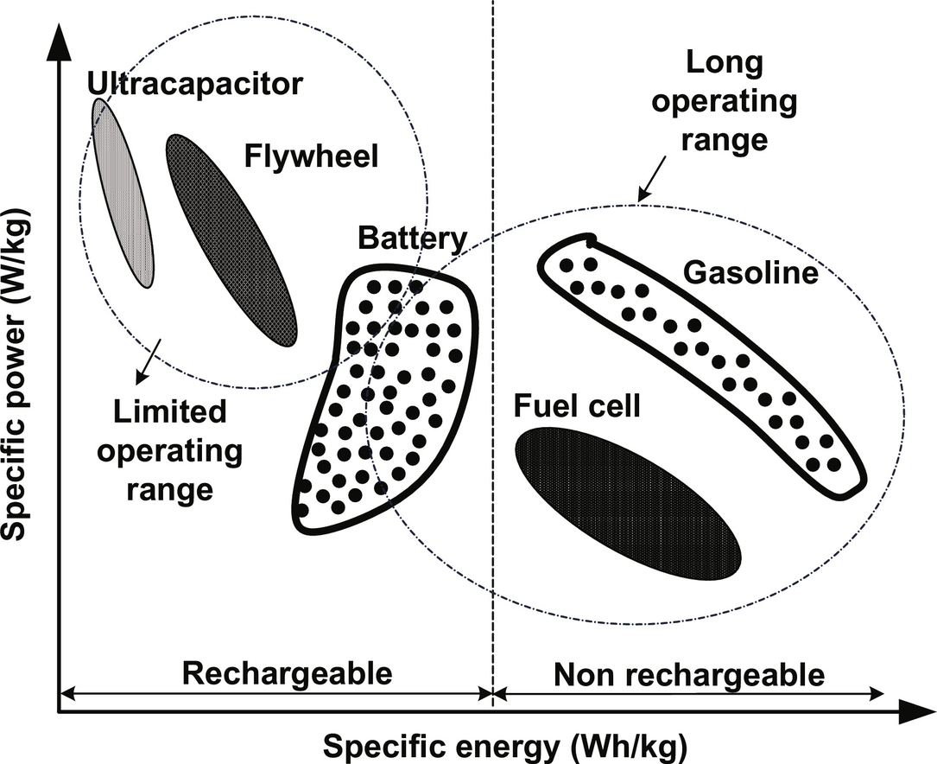

**FIG. 31.15** Specific power versus specific energy characteristic for different ESS [[8](https://learning.oreilly.com/library/view/power-electronics-handbook/9780128114087/B9780128114070000350.xhtml#bb0045)]. Reproduced with permission from C.C. Chan, The state of the art of electric, hybrid, and fuel cell vehicles, Proc. IEEE 95(4) (2007) 704–718.

#### **31.4.1.1 Battery**

Battery converts chemical energy into electric energy and vice versa at the time of charging and discharging, respectively. The electrochemical battery is a combination of independent cells that possess all the electrochemical properties. Each cell is capable to store or deliver a significant amount of energy individually or in combination based on their connections [[30](https://learning.oreilly.com/library/view/power-electronics-handbook/9780128114087/B9780128114070000350.xhtml#bb0155)]. High energy density, modularity, flexibility, and affordability are the factors that guide the battery technology on the road map of vehicle electrification [[17](https://learning.oreilly.com/library/view/power-electronics-handbook/9780128114087/B9780128114070000350.xhtml#bb0090)]. In EVT, battery stores major onboard energy and contains high energy and power density to meet complete driving cycles of vehicle operation. The basic characteristics of battery for different vehicles are different. High-energy-density batteries are required for EVs, whereas high-power-density battery is required for HEVs and FCVs. For PHEVs, intermediate battery technology is required so that it can match the energy density of an EV battery and the power density of an HEV battery. However, batteries that fulfill the demand of PHEVs are yet to be designed specifically. A suitable battery type for EVT is the lithium-based battery such as lithium ion and lithium polymer and lead-acid and nickel-based battery such as Ni-Cd and Ni-MH [[18](https://learning.oreilly.com/library/view/power-electronics-handbook/9780128114087/B9780128114070000350.xhtml#bb0095),[30](https://learning.oreilly.com/library/view/power-electronics-handbook/9780128114087/B9780128114070000350.xhtml#bb0155)–[33](https://learning.oreilly.com/library/view/power-electronics-handbook/9780128114087/B9780128114070000350.xhtml#bb0170)].

Among these, lead-acid batteries are used for short-term use because of their low energy density. On the other hand, lithium- and nickel-based batteries are preferred for medium- and long-term use, respectively. However, Ni-Cd and Ni-MH battery technologies are matured, and their potential is fully explored. Therefore, significant improvement and cost reduction in these batteries in the coming years are least expected. The inherent advantages like high energy density, low weight, and low cost of lithium-based batteries invite attraction from automakers. In addition, the potential of lithium-based batteries is still not fully explored, and maturity level is yet to be achieved. Therefore, lithium-based batteries are considered as future's battery technology to power the electrified vehicles. The dominating characteristics and comparison of different battery technologies available in [[4](https://learning.oreilly.com/library/view/power-electronics-handbook/9780128114087/B9780128114070000350.xhtml#bb0025)] are given in [Tables 31.3](https://learning.oreilly.com/library/view/power-electronics-handbook/9780128114087/B9780128114070000350.xhtml#t0015) and [31.4](https://learning.oreilly.com/library/view/power-electronics-handbook/9780128114087/B9780128114070000350.xhtml#t0020), respectively.

**Table 31.3**

**Characteristics of different battery technology [**[**4**](https://learning.oreilly.com/library/view/power-electronics-handbook/9780128114087/B9780128114070000350.xhtml#bb0025)**]**

|  |  |  |  |  |  |
| --- | --- | --- | --- | --- | --- |
| **Battery/parameters** | **Lithium-based** | | **Nickel-based** | | **Lead acid** |
|  | **Ion** | **Polymer** | **Ni-MH** | **Ni-Cd** |
| Nominal cell voltage | 3.6 | 3.0 | 1.2 | 1.2 | 2.0 |
| Specific energy (Wh/kg) | 35 | 100–200 | 60 | 40–60 | 35 |
| Energy density (Wh/L) | 70 | 150–350 | 220 | 60–100 | 70 |
| Specific power (W/kg) | ~200 | >200 | 130 | 140–220 | ~200 |
| Power density (W/L) | ~400 | >350 | 475 | 220–350 | ~400 |
| Self-discharge (%/M) | 4–8 | ~1 | 30 | 10–20 | 4–8 |
| Cycle life | 500–1000 | 200–1000 | 300–500 | 300–700 | 250–500 |
| Operating temp (°C) | From −20 to 60 | From 0 to 60 | From −20 to 60 | From −40 to 60 | From −20 to 60 |

**Table 31.4**

**Comparison of different battery technologies [**[**4**](https://learning.oreilly.com/library/view/power-electronics-handbook/9780128114087/B9780128114070000350.xhtml#bb0025)**]**

|  |
| --- |
| **t31-01-9780128114070** |

Source: c. pilot “worldwide rechargeable battery 2007–11/report/pdf.”

#### **31.4.1.2 Ultracapacitor**

Ultracapacitor is an electrochemical device that works on electrostatic principle to store energy; therefore, it can be charged/discharged hundreds or thousands of time without degrading the performance [[34](https://learning.oreilly.com/library/view/power-electronics-handbook/9780128114087/B9780128114070000350.xhtml#bb0175)–[36](https://learning.oreilly.com/library/view/power-electronics-handbook/9780128114087/B9780128114070000350.xhtml#bb0185)]. Basically, in ultracapacitor, porous carbon electrodes, which offer high surface area (1000 m2gm−1), are impregnated with electrolyte and small charge separation (10 Å) created by the dielectric separator between the electrodes as shown in [Fig. 31.16](https://learning.oreilly.com/library/view/power-electronics-handbook/9780128114087/B9780128114070000350.xhtml#f0090). Appropriate modification in material selection and fabrication brought the ultracapacitor far away from conventional capacitor with very high capacitive (1000–5000 F) density [[34](https://learning.oreilly.com/library/view/power-electronics-handbook/9780128114087/B9780128114070000350.xhtml#bb0175)]. Ultracapacitor stores energy higher than traditional capacitor but lower than battery, and hence, it can be used for applications, reserved for battery and capacitor.

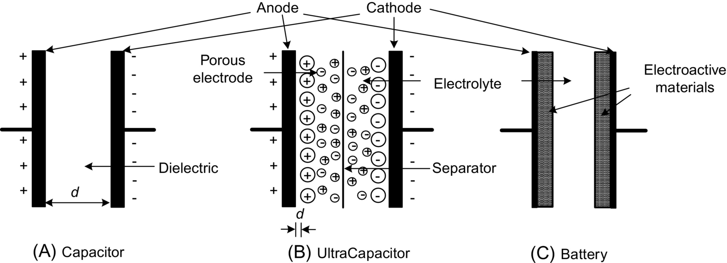

**FIG. 31.16** Construction overview of (A) capacitor, (B) ultracapacitor, and (C) battery [[78](https://learning.oreilly.com/library/view/power-electronics-handbook/9780128114087/B9780128114070000350.xhtml#bb0395)]. Reproduced with permission from L. Kumar, S. Jain, Electric propulsion system for electric vehicular technology: a review, Renew. Sust. Energ. Rev. 29 (2014) 924–940.

The detailed comparison is given in [Table 31.5](https://learning.oreilly.com/library/view/power-electronics-handbook/9780128114087/B9780128114070000350.xhtml#t0025). It offers high power density, long cycle life, and efficient operation. Since the rates of charge and discharge are determined by its physical properties, an ultracapacitor can release energy much faster (with more power) than a battery that relies on slow chemical reactions [[34](https://learning.oreilly.com/library/view/power-electronics-handbook/9780128114087/B9780128114070000350.xhtml#bb0175)–[36](https://learning.oreilly.com/library/view/power-electronics-handbook/9780128114087/B9780128114070000350.xhtml#bb0185)]. Ultracapacitors have been used for ICE-based vehicle tanks and submarines starting due to its ability of burst power delivery. In EVT, ultracapacitors can be used as primary energy devices for power delivery during starting, acceleration, and hill climbing and for recovery of braking energy during regenerative braking. The combination of ultracapacitor with a battery improves the energy performance of the former with greater energy storage capability of the latter [[18](https://learning.oreilly.com/library/view/power-electronics-handbook/9780128114087/B9780128114070000350.xhtml#bb0095)]. It can downsize and extend the life of a battery, reducing maintenance and replacement costs. In future, it is expected that ultracapacitor can become a major dominating technology in vehicle electrification; however, desired energy density at reasonable weight and cost is a major concern.

**Table 31.5**

**Different characteristics of battery, capacitor, and ultracapacitor [**[**78**](https://learning.oreilly.com/library/view/power-electronics-handbook/9780128114087/B9780128114070000350.xhtml#bb0395)**]**

|  |  |  |  |
| --- | --- | --- | --- |
| **Characteristics** | **Battery** | **Ultracapacitor** | **Conventional capacitor** |
| Charging time | 1–5 h | 0.3–30 s | 10−3–10−6 s |
| Discharging time | 0.3–3 h | 0.3–30 s | 10−3–10−6 s |
| Energy densities (Wh/kg) | 10–100 | 1–10 | <0.1 |
| Power densities (W/kg) | <1000 | <10,000 | <100,000 |
| Cycle life | 1000–2000 | >500,000 | >500,000 |
| Efficiency (%) | 70–85 | 85–97 | >95 |

The application of ultracapacitor in vehicle electrification is under development, and significant improvement has to be done for achieving maturity and commercialization in mass scale.

#### **31.4.1.3 Fuel Cell**

Recent technical advancements in fuel-cell technology have constructed the road map for its application in EVT as onboard energy source [[40](https://learning.oreilly.com/library/view/power-electronics-handbook/9780128114087/B9780128114070000350.xhtml#bb0205)]. Significant advantages of a fuel cell are eco-friendly, simplicity, continuous power supply, durability, and silent operation along with strict confirmation to emission norms of vehicular systems. In fact, a fuel cell combines the best features of ICE (they can operate as long as fuel is supplied) and batteries (they can produce electricity directly from fuel, without combustion), thereby reducing emissions and noise and increasing the efficiency [[41](https://learning.oreilly.com/library/view/power-electronics-handbook/9780128114087/B9780128114070000350.xhtml#bb0210)]. A fuel cell is an electrochemical device that uses hydrogen (H2) as fuel and oxygen (O2) from air to produce electricity with water and heat as by-products as shown in [Fig. 31.17](https://learning.oreilly.com/library/view/power-electronics-handbook/9780128114087/B9780128114070000350.xhtml#f0095). To speed up the rate of these reactions, a catalyst such as platinum is used.

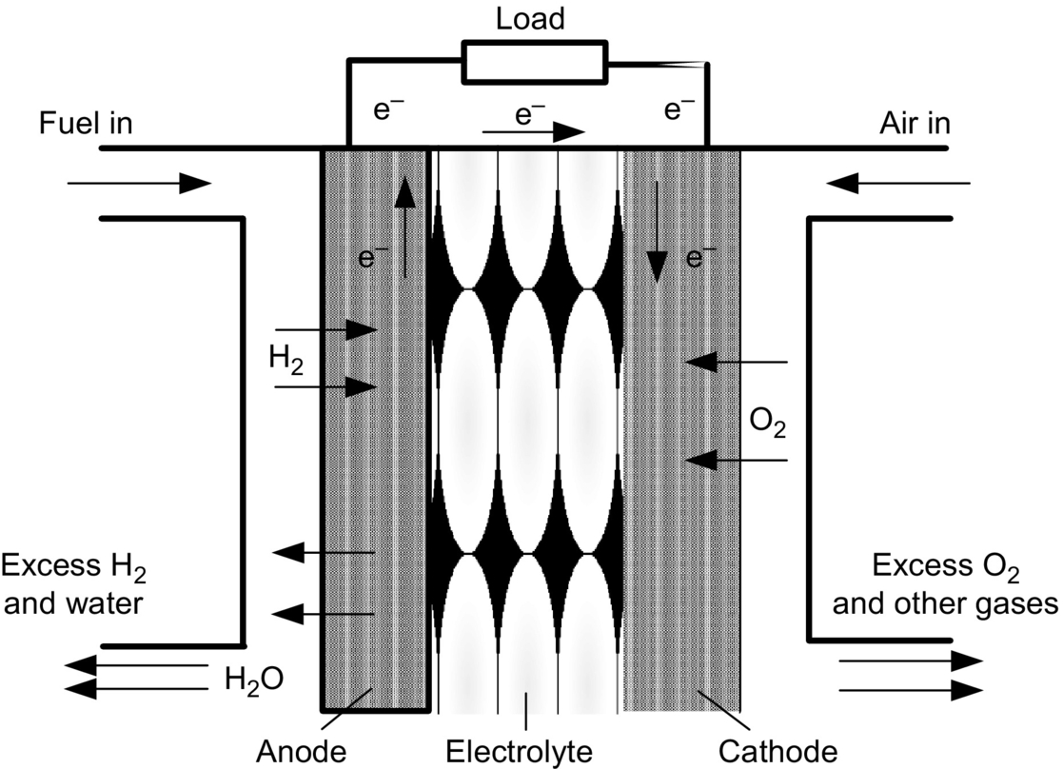

**FIG. 31.17** Fuel-cell construction and operation [[78](https://learning.oreilly.com/library/view/power-electronics-handbook/9780128114087/B9780128114070000350.xhtml#bb0395)].

In a fuel cell, chemical energy of hydrogen is directly converted into electric power, thus eliminating the intermediate steps of converting fossil fuel to heat and then electric power that enhances efficiency comparatively. The specific energy of a fuel cell is as good as gasoline; however, its specific power is much lesser; therefore, the starting performances of fuel-cell vehicles are very poor. Consequently, to improve the power density and starting performance, battery or ultracapacitor can be used in conjunction with the fuel cell for vehicular application [[41](https://learning.oreilly.com/library/view/power-electronics-handbook/9780128114087/B9780128114070000350.xhtml#bb0210),[42](https://learning.oreilly.com/library/view/power-electronics-handbook/9780128114087/B9780128114070000350.xhtml#bb0215)]. Therefore, it can be said that fuel cells and ultracapacitors are made for each other to lead perfect ESS for automotive. The types of fuel cell and their detailed comparison are presented in [[43](https://learning.oreilly.com/library/view/power-electronics-handbook/9780128114087/B9780128114070000350.xhtml#bb0220)–[45](https://learning.oreilly.com/library/view/power-electronics-handbook/9780128114087/B9780128114070000350.xhtml#bb0230)]. Among different fuel-cell technologies presented in [[43](https://learning.oreilly.com/library/view/power-electronics-handbook/9780128114087/B9780128114070000350.xhtml#bb0220)–[45](https://learning.oreilly.com/library/view/power-electronics-handbook/9780128114087/B9780128114070000350.xhtml#bb0230)], a PEM fuel cell is promising and is being used as energy source in fuel-cell vehicles. It offers easy start at low temperature, comparatively high power density, simple structure, small size, maintenance-free operation, and ability to operate in hostile environment [[44](https://learning.oreilly.com/library/view/power-electronics-handbook/9780128114087/B9780128114070000350.xhtml#bb0225)].

#### **31.4.1.4 Flywheel**

A flywheel that stores and delivers mechanical energy in the form of rotational kinetic energy has been researched for many decades, but due to heavy weight and high cost, its implementation in vehicular system has been limited. Recent advancement in frictionless magnetic bearing, carbon-fiber composite materials, manufacturing technique, and sophisticated power electronic controllers has accelerated the development of flywheel energy storage system (FESS) [[37](https://learning.oreilly.com/library/view/power-electronics-handbook/9780128114087/B9780128114070000350.xhtml#bb0190)]. The numerous features of advanced FESS such as higher power density, reliability, efficiency, and higher speed at reduced size made it a potential candidate for ESS in EVT [[37](https://learning.oreilly.com/library/view/power-electronics-handbook/9780128114087/B9780128114070000350.xhtml#bb0190)–[39](https://learning.oreilly.com/library/view/power-electronics-handbook/9780128114087/B9780128114070000350.xhtml#bb0200)]. The flywheel rim rotates in an evacuated containment that reduces frictional losses and ensures safety in case of failure.

A flywheel stores energy linear to its mass but square proportional to velocity from supply and delivers it to the load as per the requirements. The stored mechanical energy can be converted to electric energy or vice versa by means of integrated motor/generator set and PEC. Flywheel gets charged by speeding up as it accumulates mechanical energy and discharges by slowing down as it supplies mechanical energy to the EPS. The energy of regenerative braking can be recovered by charging the flywheel, which is further used for battery charging. Modern flywheels can store more energy and power than existing metal hydride or lead-acid batteries of similar weight and volume [[38](https://learning.oreilly.com/library/view/power-electronics-handbook/9780128114087/B9780128114070000350.xhtml#bb0195),[39](https://learning.oreilly.com/library/view/power-electronics-handbook/9780128114087/B9780128114070000350.xhtml#bb0200)]. Unlike battery and ultracapacitor, flywheels are independent of in-depth discharge that improves its life cycle. It spins at a very high speed; therefore, safety, tensile strength of the material, and location of the placement of flywheel in EVT are prime concerns and need to be dealt with properly.

#### **31.4.1.5 Hybrid Energy System**

It can be concluded that not only the power and energy densities but also the voltage and current characteristics of different energy systems are different. Therefore, exclusive employment of one of the aforementioned energy sources cannot meet the energy and power demands of vehicle operation for all driving profiles. Compared to ultracapacitors and flywheel, a battery and a fuel cell have much higher specific energy but much lesser specific power as depicted in [Table 31.6](https://learning.oreilly.com/library/view/power-electronics-handbook/9780128114087/B9780128114070000350.xhtml#t0030). Employment of such energy systems alone results higher cost, weight, and volume [[46](https://learning.oreilly.com/library/view/power-electronics-handbook/9780128114087/B9780128114070000350.xhtml#bb0235)]. However, when these different energy systems are combined, an energy system with high power and high energy density can be obtained. Such kind of energy system is termed as hybrid energy system (HES), where batteries and a fuel cell supply the energy demand and the ultracapacitors and flywheel supply the power demand [[46](https://learning.oreilly.com/library/view/power-electronics-handbook/9780128114087/B9780128114070000350.xhtml#bb0235),[47](https://learning.oreilly.com/library/view/power-electronics-handbook/9780128114087/B9780128114070000350.xhtml#bb0240)]. The combination of energy system can be chosen on the basis of vehicle design, operating profiles, and application. The prime concerns of hybrid energy system formation are their suitable integration, life expectancy, maintenance, cost, durability, and reliability.

**Table 31.6**

**Comparison of different energy source and storage systems [**[**78**](https://learning.oreilly.com/library/view/power-electronics-handbook/9780128114087/B9780128114070000350.xhtml#bb0395)**]**

|  |  |  |  |  |
| --- | --- | --- | --- | --- |
| **Characteristics** | **Battery** | **Ultracapacitor** | **Fuel cell** | **Flywheel** |
| Mechanism | Chemical | Electrostatic | Chemical | Mechanical |
| Technology | Proved | Promising | Promising | Proved |
| Energy density | High | Low | Very high | Low |
| Power density | Low | Very high | Moderate | High |
| Charging time | Hours | Seconds | — | Minutes |
| Discharging time | Hours | Seconds | — | Minutes |
| Life | 3–5 years | >10 years | 10–20 k Hr | >20 years |
| Efficiency (%) | 75–85 | 85–95 | 40–60 | 80–90 |
| Issues | Disposal | Less | Very less | Very less |

### 31.4.2 ELECTRIC MOTOR

In EVT, the electric motor needs to go through frequent starts and stops, high rate of acceleration, and deceleration, such as low-speed hill climbing and high-speed cruising along with different environmental and hostile conditions. Industrial motors, on the other hand, are usually operated at rated speed under common circumstances [[16](https://learning.oreilly.com/library/view/power-electronics-handbook/9780128114087/B9780128114070000350.xhtml#bb0085)]. Thus, the electric motors used in EVT cannot be compared with motors being used for industrial processes. The electric motors used for EPS should be able to satisfy some basic characteristic for efficient operation. These characteristics are high torque for starting and low-speed hill climbing operation; high power density for acceleration and high-speed cruising for highway; high efficiency over wide torque and speed range; suitability for regenerative braking; overload capability during certain period of time; and controllability, high reliability, and robustness at affordable costs [[48](https://learning.oreilly.com/library/view/power-electronics-handbook/9780128114087/B9780128114070000350.xhtml#bb0245)–[50](https://learning.oreilly.com/library/view/power-electronics-handbook/9780128114087/B9780128114070000350.xhtml#bb0255)]. In addition, fault-tolerant capability, minimum torque ripple, temperature management, and low acoustic noise are other important issues for design consideration [[21](https://learning.oreilly.com/library/view/power-electronics-handbook/9780128114087/B9780128114070000350.xhtml#bb0110)–[24](https://learning.oreilly.com/library/view/power-electronics-handbook/9780128114087/B9780128114070000350.xhtml#bb0125),[63](https://learning.oreilly.com/library/view/power-electronics-handbook/9780128114087/B9780128114070000350.xhtml#bb0320),[64](https://learning.oreilly.com/library/view/power-electronics-handbook/9780128114087/B9780128114070000350.xhtml#bb0325)]. Suitability of electric motor in propulsion application should be strongly approved by torque-speed characteristic as discussed in [[56](https://learning.oreilly.com/library/view/power-electronics-handbook/9780128114087/B9780128114070000350.xhtml#bb0285)] and illustrated in [Fig. 31.18A](https://learning.oreilly.com/library/view/power-electronics-handbook/9780128114087/B9780128114070000350.xhtml#f0100). Moreover, the standard torque-speed characteristic of EPS is shown in [Fig. 31.18B](https://learning.oreilly.com/library/view/power-electronics-handbook/9780128114087/B9780128114070000350.xhtml#f0100).

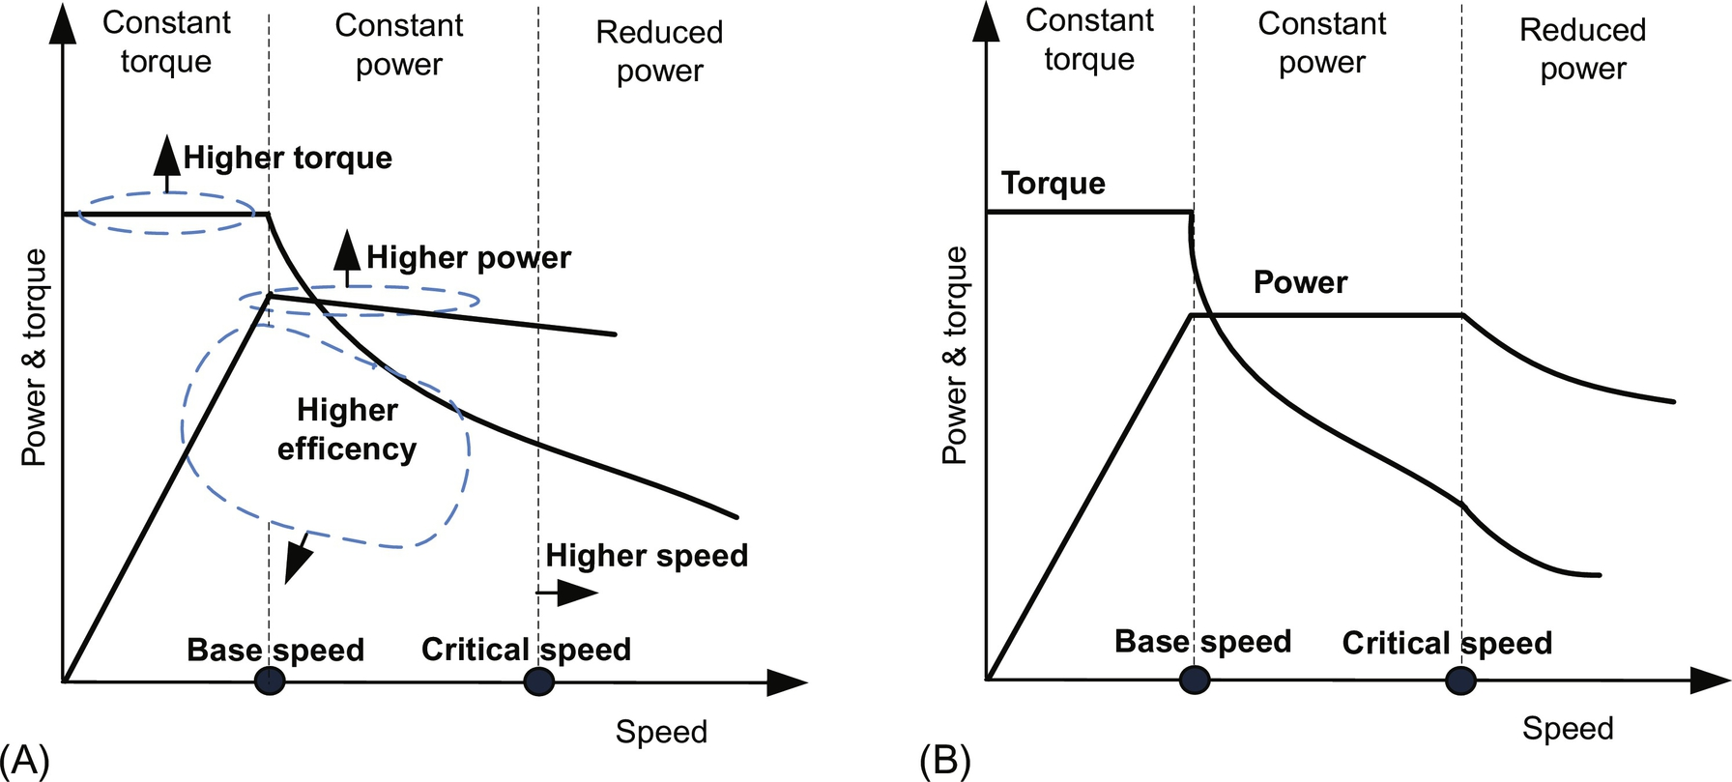

**FIG. 31.18** Desired torque-speed characteristic of (A) vehicle propulsion system and (B) electric motors [[56](https://learning.oreilly.com/library/view/power-electronics-handbook/9780128114087/B9780128114070000350.xhtml#bb0285)].

The choice of electric motor is the key factor in overall EPS design. A brief classification of the family of electric motor for EPS is summarized in [Fig. 31.19](https://learning.oreilly.com/library/view/power-electronics-handbook/9780128114087/B9780128114070000350.xhtml#f0105). The commonly used electric motors for EPS include dc motor, induction motor, permanent-magnet (PM) motor, and switched reluctance (SR) motor [[50](https://learning.oreilly.com/library/view/power-electronics-handbook/9780128114087/B9780128114070000350.xhtml#bb0255)–[53](https://learning.oreilly.com/library/view/power-electronics-handbook/9780128114087/B9780128114070000350.xhtml#bb0270)]. Existing literature indicates that squirrel-cage rotor induction motors and PM motors are best suitable options. Also, SR motors are gaining more popularity and becoming reliable alternative for the future, while use of dc motors is declining gradually.

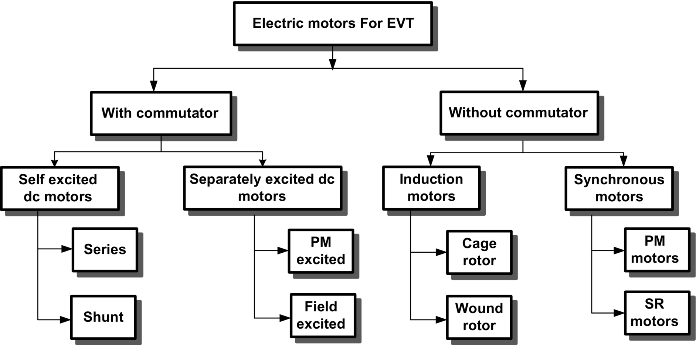

**FIG. 31.19** Classification of electric motor for EPS.

#### **31.4.2.1 DC Motors**

Traditionally, a dc motor has been used prominently for EPS due to its high starting torque and simple speed control. The torque-speed characteristics of dc motor exhibit good compliance for propulsion application; however, the inherent disadvantage of bulky construction, low efficiency, and the presence of mechanical commutators and brushes that aggravate maintenance requirements limit its use in light, high-speed, and maintenance-free vehicle application in hostile conditions [[48](https://learning.oreilly.com/library/view/power-electronics-handbook/9780128114087/B9780128114070000350.xhtml#bb0245)–[51](https://learning.oreilly.com/library/view/power-electronics-handbook/9780128114087/B9780128114070000350.xhtml#bb0260)]. Nevertheless, due to simple speed control and technical maturity, dc motors are prominent for low-power EPS. Technological advancements in power electronic converters and switches have helped to replace dc machines with commutatorless motors such as induction motors, PM motors, and SR motors. The commutatorless motors offer some tremendous advantages such as high power density, higher efficiency, and more reliable and maintenance-free operation with wide speed range over the dc motors.

#### **31.4.2.2 Induction Motor**

Induction motor (IM)-based propulsion systems are mature and are being extensively accepted as dominating candidate for EPS among various commutatorless motors. The numerous attractive features of IM are simplicity, high reliability, robustness, wide speed range, low maintenance, low torque ripple/noise, low cost, established power electronic converters, and ability to operate in hostile environment [[48](https://learning.oreilly.com/library/view/power-electronics-handbook/9780128114087/B9780128114070000350.xhtml#bb0245)–[53](https://learning.oreilly.com/library/view/power-electronics-handbook/9780128114087/B9780128114070000350.xhtml#bb0270)]. The behavior and performance characteristics of dc series motors can also be achieved with induction motor by employing well-matured field-oriented control (FOC) that provides decoupling of torque control from flux control [[56](https://learning.oreilly.com/library/view/power-electronics-handbook/9780128114087/B9780128114070000350.xhtml#bb0285)]. The dynamic performance of IM can be further improved by applying either vector control or direct torque control (DTC) technique [[57](https://learning.oreilly.com/library/view/power-electronics-handbook/9780128114087/B9780128114070000350.xhtml#bb0290)]. High-speed operation with extended constant power range of up to 4–5 times the base speed can be achieved by flux weakening, which is one of the desirable requirements for vehicle operation [[56](https://learning.oreilly.com/library/view/power-electronics-handbook/9780128114087/B9780128114070000350.xhtml#bb0285)], although the high-speed operation and constant power range are limited by its pullout torque.

Apart from the various advantages, there are several disadvantages such as high losses, poor power factor, low efficiency, and low inverter usage. Moreover, its weight and volume are greater for the same power rating as compared with PM motors. These drawbacks of induction motor have been acting as speed bump in the race track. These limitations have been taken into account by the researchers. Efforts are being made to resolve these issues either at design level or by proposing new control schemes and/or converter topologies.

#### **31.4.2.3 Permanent Magnet Motor**

Among the available commutatorless motors, only permanent-magnet brushless motors have the capability to compete against the induction motors in EPS [[48](https://learning.oreilly.com/library/view/power-electronics-handbook/9780128114087/B9780128114070000350.xhtml#bb0245)]. In recent times, PM motors are widely accepted by the leading vehicle manufacturers for designing the existing and upcoming EPS. Generally, PM motors are classified based on supply voltage and current as brushless dc and brushless ac. To maximize the torque density while keeping torque pulsation low, it is preferred to operate a PM machine in BLDC mode for trapezoidal back EMF waveform and in BLAC mode for sinusoidal back EMF waveform [[58](https://learning.oreilly.com/library/view/power-electronics-handbook/9780128114087/B9780128114070000350.xhtml#bb0295)]. PM motors possess some inherent advantages: PMs excite the field that offers high power density and reduced weight and volume of the motor for a given power rating; due to reduced rotor losses, it offers highly efficient operation; compact packaging provides higher degree of reliability and maintenance-free operation; effective dissipation of heat into atmosphere enables efficient cooling [[48](https://learning.oreilly.com/library/view/power-electronics-handbook/9780128114087/B9780128114070000350.xhtml#bb0245)–[53](https://learning.oreilly.com/library/view/power-electronics-handbook/9780128114087/B9780128114070000350.xhtml#bb0270)]. Despite their numerous advantages, PM motors have some limitations such as short constant power region due to limited field weakening capability. In addition, control and management of back EMF at high speed increase size and ratings of PECs, and fault-tolerant capability is an issue. The extended speed range up to 3–4 times the base speed and enhanced efficiency of PM motors can be achieved by applying suitable control algorithms of power converters above the base speed [[59](https://learning.oreilly.com/library/view/power-electronics-handbook/9780128114087/B9780128114070000350.xhtml#bb0300)]. Important design considerations for PM motors associated with fixed excitation for EPS include torque density, flux weakening capability, overload capability, stator iron losses, rotor eddy-current losses, and demagnetization withstanding capability.

The basic configurations of PM motors are classified based on the location of PMs. In conventional PM motors, PMs either are mounted on rotor surface or buried within the rotor. Surface-mounted PM (SPM) motors are widely used design and uses less magnet, whereas interior PM (IPM) motors use more magnets and offer higher air-gap flux density with higher degree of ruggedness [[60](https://learning.oreilly.com/library/view/power-electronics-handbook/9780128114087/B9780128114070000350.xhtml#bb0305)]. Therefore, the interior PM motors are exceedingly being preferred for extended speed range and constant power operation over surface PM motors. In conventional PM motors, a compromise has to be made between low-speed torque capability and high-speed power capability. In order to overcome this problem, the concept of hybrid PM motor and field excitation technique has been adopted [[49](https://learning.oreilly.com/library/view/power-electronics-handbook/9780128114087/B9780128114070000350.xhtml#bb0250)]. Conceptually, hybrid PM motor is either a combination of PM motor and reluctance motor or an inclusion of additional field winding that limits air-gap field. Thus, the hybrid PM motors enhance the overall operational efficiency and offer wide speed, constant power operation with more complex structures. Availability, cost, and supply issues with rare-earth PMs may affect their wide applications in EPS.

#### **31.4.2.4 Switched Reluctance Motor**

SR motor is gaining more and more attention for EPS in vehicular application. An SR motor offers tremendous potential for vehicular application especially for HEVs and FCVs [[61](https://learning.oreilly.com/library/view/power-electronics-handbook/9780128114087/B9780128114070000350.xhtml#bb0310),[62](https://learning.oreilly.com/library/view/power-electronics-handbook/9780128114087/B9780128114070000350.xhtml#bb0315)]. The remarkable features of SR motors are the following: rotor without magnet and windings offers simple and robust construction that is desirable for very-high-speed and high-temperature operation; excellent torque-speed characteristics; fault-tolerant capability; and constant power region that can be extended up to 3–7 times, smooth and hazard-free operation [[48](https://learning.oreilly.com/library/view/power-electronics-handbook/9780128114087/B9780128114070000350.xhtml#bb0245)–[53](https://learning.oreilly.com/library/view/power-electronics-handbook/9780128114087/B9780128114070000350.xhtml#bb0270)]. Limitations of SR motors include high acoustic noise, vibrations, high torque ripple, complex control mechanism, and requirement of special converter topology. Although the cost of SR motors is relatively high, their mass production is expected to render them as cost-effective as induction motors. All the advantages are prominent for vehicular application, whereas the disadvantages are needed to be taken care properly to have feasible SR motor-based EPS.

Comparison of different motors based on desirable characteristic for EPS is shown in [Table 31.7](https://learning.oreilly.com/library/view/power-electronics-handbook/9780128114087/B9780128114070000350.xhtml#t0035). The suitability of particular motor at particular characteristic is rated in the scale of 1–5 relatively. The point 5 indicates the higher attributes, whereas point 1 shows the poor attributes. This comparison is indicative and measured relatively on the basis of existing literature; however, it may vary with several factors like the design consideration of motor's type, placement of motor (in wheel or out of wheel), material used for magnet, core and laminations, relevant power electronics converter, and their control algorithms [[21](https://learning.oreilly.com/library/view/power-electronics-handbook/9780128114087/B9780128114070000350.xhtml#bb0110)]. The main purpose of [Table 31.7](https://learning.oreilly.com/library/view/power-electronics-handbook/9780128114087/B9780128114070000350.xhtml#t0035) is to bring out the motor technology with higher attributes to vehicular application.

**Table 31.7**

**Comparative analysis of different electric motors used in EPS [**[**78**](https://learning.oreilly.com/library/view/power-electronics-handbook/9780128114087/B9780128114070000350.xhtml#bb0395)**]**

|  |  |  |  |  |
| --- | --- | --- | --- | --- |
| **Characteristic** | **dc** | **IM** | **PMSM** | **SRM** |
| Controllability | 5 | 5 | 4 | 3 |
| Size and weight | 3 | 4 | 4.5 | 4 |
| Robustness | 3.5 | 5 | 4 | 4.5 |
| Reliability | 3 | 5 | 4 | 4.5 |
| Power density | 3 | 4 | 5 | 3.5 |
| Efficiency | 3 | 4 | 5 | 4.5 |
| Speed range | 2.5 | 4 | 5 | 5 |
| Life time | 3.5 | 5 | 4 | 4.5 |
| Torque density | 3 | 3.5 | 5 | 4 |
| Technical maturity | 5 | 4.5 | 4 | 3.5 |
| Cost | 3.5 | 5 | 3 | 4 |
| Overload capability | 3 | 4 | 4.5 | 4 |
| Torque ripple/noise | 3.5 | 4.5 | 4 | 3 |
| Manufacturability | 3 | 5 | 3 | 4 |
| Improvability | 2.5 | 3 | 4.5 | 5 |

### 31.4.3 POWER ELECTRONICS CONVERTERS FOR EVT

For sustainable EVT, there is a need of highly reliable, flexible, and fault-tolerant electric power processing system on board to deliver high quality of power, as per vehicle demands [[24](https://learning.oreilly.com/library/view/power-electronics-handbook/9780128114087/B9780128114070000350.xhtml#bb0125)]. At present, this responsibility has been taken care by the available PEC that includes dc/dc converters, rectifiers (dc/ac), inverters (ac/dc), and battery charger that is composed of ac/dc and dc/dc converters.

Individually or combination of these converters can be taken to serve the purpose of onboard power processing; however, operation of each PEC is entirely different from the other. Conceptually, PECs perform some of the critical tasks like ON/OFF switching of various actuators, valves, and equipments; power conditioning and voltage/current modulation to create compatibility among the sources; traction motors; and auxiliary loads like air conditioner, head lamp, power steering, power window, etc. [[63](https://learning.oreilly.com/library/view/power-electronics-handbook/9780128114087/B9780128114070000350.xhtml#bb0320)]. PECs not only serve the purpose of converting electric power from one form to another (dc/dc and dc/ac) but also help to step up or step down the system voltage level on board.

These PECs are composed of power electronic devices that play significant role and are evolving rapidly. The selection of PEC devices for EV propulsion is generally based on the requirements of the voltage rating, current rating, switching frequency, power loss, and dynamic characteristic of the system [[63](https://learning.oreilly.com/library/view/power-electronics-handbook/9780128114087/B9780128114070000350.xhtml#bb0320)]. The voltage rating depends on the battery nominal voltage, maximum voltage during charging, and regenerative braking. The current rating depends on the motor peak power rating and number of devices connected in parallel. Furthermore, the switching frequency should be high enough to reduce the noise, filter size, and EMI problem with good dynamic characteristics. The device protection, packaging, reliability, and cost should also be considered while choosing particular device. Among the available power devices, the GTO, BJT, MOSFET, IGBT, and MCT are particularly suitable for EV propulsion [[38](https://learning.oreilly.com/library/view/power-electronics-handbook/9780128114087/B9780128114070000350.xhtml#bb0195)]. Some of their operating characteristics as presented in [[74](https://learning.oreilly.com/library/view/power-electronics-handbook/9780128114087/B9780128114070000350.xhtml#bb0375)] are given in [Table 31.8](https://learning.oreilly.com/library/view/power-electronics-handbook/9780128114087/B9780128114070000350.xhtml#t0040). At present, the most attractive and suitable device for EVT is IGBT, which possesses high-speed characteristics of a MOSFET with the high-conductivity characteristic of a BJT. In the near future, the wideband gap (WBG) devices like SiC and GaN will be the most favorable candidate for EPS because they provide high-temperature operation, high-power-handling capability, superior dynamic characteristic, low switching losses, and high reliability [[74](https://learning.oreilly.com/library/view/power-electronics-handbook/9780128114087/B9780128114070000350.xhtml#bb0375)].

**Table 31.8**

**Power semiconductor devices for EPS [**[**74**](https://learning.oreilly.com/library/view/power-electronics-handbook/9780128114087/B9780128114070000350.xhtml#bb0375)**]**

|  |  |  |  |  |  |
| --- | --- | --- | --- | --- | --- |
| **Component** | **Semiconductor devices** | **Voltage rating (volt)** | **Current rating (amp)** | **Power rating (kW)** | **Switching frequency (kHz)** |
| Inverter/rectifier for EPS | IGBTs/diodes | 600–1200 | 100–600 | 20–100 | 5–30 |
| dc/dc converter for EPS | IGBTs/diodes | 600–1200 | 100–600 | 20–100 | 5–30 |
| Inverter/rectifier for auxiliary loads | IGBTs/MOS-FET/diodes | 600–900 | 15–60 | 2–4 | 5–50 |
| dc/dc converter for low-power loads | MOSFET/diodes | 400–600 | 10–40 | 1–2 | 50–200 |

In the last decade, significant advancement in converter topologies dealing with battery charger, voltage-source inverter for motor drives, and bidirectional dc/dc converter for ESS integration has been made. Regardless of this topological advancement, still conventional PEC topologies are being used in modern electrified vehicles. Therefore, PECs for EVT can be broadly classified as shown in [Fig. 31.20](https://learning.oreilly.com/library/view/power-electronics-handbook/9780128114087/B9780128114070000350.xhtml#f0110). The classification of the PECs is done based on their basic operation rather than topological advancement.

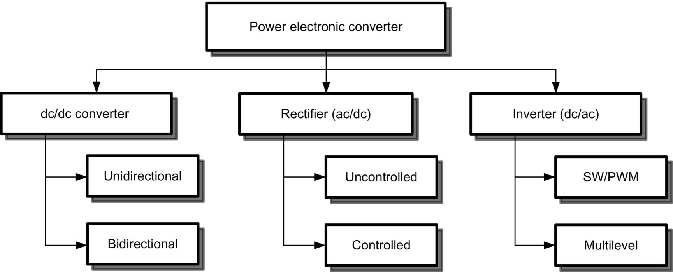

**FIG. 31.20** Classification of power electronic converters.

The current trends and future status of EM, PEC, and EPS based on essential characteristics of vehicle application are summarized in [Table 31.9](https://learning.oreilly.com/library/view/power-electronics-handbook/9780128114087/B9780128114070000350.xhtml#t0045).

**Table 31.9**

**Present and future status of EM, PEC, and EPS [**[**16**](https://learning.oreilly.com/library/view/power-electronics-handbook/9780128114087/B9780128114070000350.xhtml#bb0085)**]**

|  |  |  |  |  |  |  |  |  |  |  |  |  |
| --- | --- | --- | --- | --- | --- | --- | --- | --- | --- | --- | --- | --- |
| **Characteristic** | **Electric motors** | | | | **Power electronic converter** | | | | **Electric propulsion system** | | | |
|  | **2010** | **2013** | **2015** | **2020** | **2010** | **2013** | **2015** | **2020** | **2010** | **2013** | **2015** | **2020** |
| Power density (kW/L) | 3.7 | 4.8 | 5 | 5.7 | 8.7 | 10.2 | 12 | 13.4 | 1.06 | 1.15 | 1.2 | 1.4 |
| Specific power (kW/kg) | 1.2 | 1.3 | 1.3 | 1.6 | 10.8 | 11.5 | 12 | 14.1 | 2.6 | 3.1 | 3.5 | 4.0 |
| Efficiency (%) | 90 | 91 | 92 | 93 | 91 | 92 | 94 | 97 | 90 | 91 | 93 | 95 |
| Cost ($/kW) | 11.1 | 9.5 | 7 | 4.7 | 7.9 | 6.5 | 5 | 3.3 | 19 | 16 | 12 | 8 |

#### **31.4.3.1 PEC Configuration for EPS**

PECs are controlling, managing, and optimizing the power flow among energy sources and vehicle loads, and hence, they are considered as the heart of EPS, whereas EPS is the heart of EVT. The architecture of modern EPS for EVT with interconnection among electric power system, ESS, propulsion system, and control and protection system is shown in [Fig. 31.21](https://learning.oreilly.com/library/view/power-electronics-handbook/9780128114087/B9780128114070000350.xhtml#f0115). The main elements for the power processing and conversion comprise an ac/dc charger, a bidirectional dc/dc converter, a dc/ac inverter, and a digital controller.

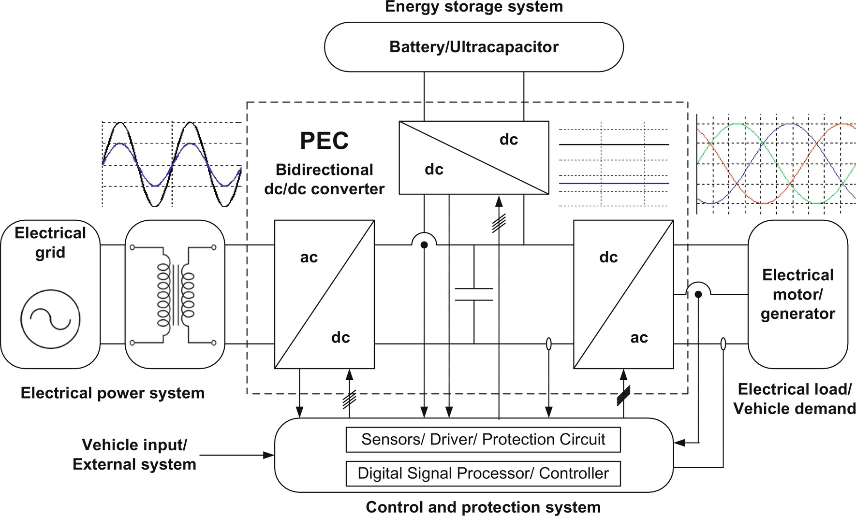

**FIG. 31.21** Architecture of PECs in modern vehicular application.

Charging from utility grid inevitably needs a battery charger with power factor correction (PFC). The bidirectional dc/dc converter with a proper charging-discharging profile is required to transfer energy between the ESS and the propulsion system [[73](https://learning.oreilly.com/library/view/power-electronics-handbook/9780128114087/B9780128114070000350.xhtml#bb0370)]. The plug-in charger is usually composed of ac/dc rectifier and dc/dc converter. The bidirectional dc/dc converter is placed between the add-on battery and the high-voltage bus of the HEV. The digital controller is in charge of the control and monitoring of the ac/dc charger, bidirectional dc/dc converter, dc/ac inverter for propulsion, battery state of charge (SOC), and communication with external systems. Three voltage sources, that is, ac outlet voltage *Vac*, battery voltage *Vbatt*, and input to the propulsion inverter *Vo*, are shown in [Fig. 31.21](https://learning.oreilly.com/library/view/power-electronics-handbook/9780128114087/B9780128114070000350.xhtml#f0115)**.** These voltages are might be different from input/output voltage magnitude in each converter stage. This variation in voltage magnitude governs the operating modes and switching strategy of the converters under the supervision of digital controller.

The PECs contributing weight and volume of EPS are inverter, onboard charger, and bidirectional dc/dc converter. The main attention is being focused on bidirectional dc/dc converter for power-flow optimization [[70](https://learning.oreilly.com/library/view/power-electronics-handbook/9780128114087/B9780128114070000350.xhtml#bb0355)]. Apart from dc/dc converter, innovative efforts are also directed toward inverters that drive the traction motors and supply the auxiliary loads of electrified vehicle in desired manner. The selection of inverter should be done based on the topology, power rating, type of motors, and the packaging methods [[71](https://learning.oreilly.com/library/view/power-electronics-handbook/9780128114087/B9780128114070000350.xhtml#bb0360)]. Despite of significant topological advancement in multilevel inverters, as of now, the conventional two-level voltage-source PWM inverter is the most popular topology used in almost all the commercial electrified vehicles.

In EPS, two popular configurations are used to interface the ESS with propulsion inverter motor: (i) A high-voltage ESS is directly connected to propulsion inverter motor; (ii) a bidirectional dc/dc converter is placed between low-voltage ESS and propulsion inverter-motor drive [[24](https://learning.oreilly.com/library/view/power-electronics-handbook/9780128114087/B9780128114070000350.xhtml#bb0125)]. In the first configuration, battery voltage level should match with propulsion inverter dc-link voltage level as shown in [Fig. 31.22](https://learning.oreilly.com/library/view/power-electronics-handbook/9780128114087/B9780128114070000350.xhtml#f0120). This imposes certain constraints over the design and optimization of battery, inverter, and motor [[24](https://learning.oreilly.com/library/view/power-electronics-handbook/9780128114087/B9780128114070000350.xhtml#bb0125)]. In the second configuration, a bidirectional dc/dc converter is placed between low-voltage ESS and high-voltage dc link of propulsion inverter motor as shown in [Fig. 31.23](https://learning.oreilly.com/library/view/power-electronics-handbook/9780128114087/B9780128114070000350.xhtml#f0125). Inclusion of dc/dc converter increases overall component count but offers several advantages over the first configuration. It boosts voltage level of ESS to match the rated voltage of propulsion inverter dc link. It provides regulated bidirectional power flow between ESS and motor drive, which assists rapid acceleration and recovers energy to charge the battery during deceleration and regenerative braking. It not only offers significant reduction in weight, size, and cost of ESS but also gives space and flexibility in inverter control and motor design [[24](https://learning.oreilly.com/library/view/power-electronics-handbook/9780128114087/B9780128114070000350.xhtml#bb0125)]. Another most important aspect of the inclusion of dc/dc converter is to recover the energy during regenerative braking that can be further utilized to recharge the battery or storage unit.

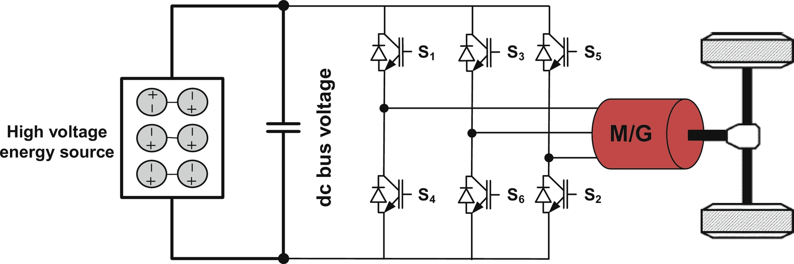

**FIG. 31.22** Conventional battery-fed EPS.

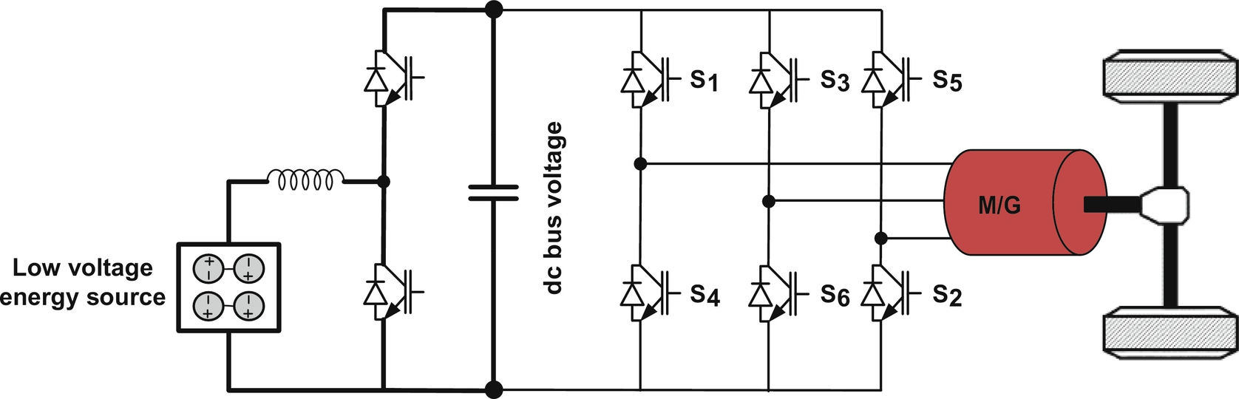

**FIG. 31.23** Conventional bidirectional dc/dc converter-fed EPS.

Addition of bidirectional dc/dc converter imposes certain disadvantages such as multistage power conversion, increased cost, power losses, integration, and control complexity. It also raises concern about size and cost of power switches and passive components. In addition, the reliability issues due to the integration of additional components must be taken into account properly. However, the role of bidirectional dc/dc converter is very significant especially in terms of better utilization of onboard energy sources, power management, dynamic performance, flexibility, system optimization, and reduction of weight and cost [[64](https://learning.oreilly.com/library/view/power-electronics-handbook/9780128114087/B9780128114070000350.xhtml#bb0325)].

#### **31.4.3.2 PEC Configurations for Electrified Vehicle**

PEC integration for EPS that completely replaces ICE-based propulsion system is shown in [Fig. 31.24](https://learning.oreilly.com/library/view/power-electronics-handbook/9780128114087/B9780128114070000350.xhtml#f0130). In conventional configuration of EVs propulsion system, a battery bank is directly connected to propulsion inverter that converts dc voltage into three-phase variable ac voltage. This configuration is applicable to the system where battery bank is sufficiently large to match with the voltage of propulsion inverter-motor drives as discussed in previous section. In the second configuration of BEV propulsion system, a bidirectional dc/dc converter is connected in between battery bank and propulsion motor as shown in [Fig. 31.24A](https://learning.oreilly.com/library/view/power-electronics-handbook/9780128114087/B9780128114070000350.xhtml#f0130). Inclusion of bidirectional dc/dc converter increases flexibility and control in power flow and management from battery bank to propulsion inverter. It offers better utilization of battery bank and extends life of battery with controlled charging and discharging. It also helps to recover energy during regenerative braking. A battery charger is connected to battery bank to charge the battery from ac outlet. BEVs practically replace the ICE and the various mechanical systems with electric system.

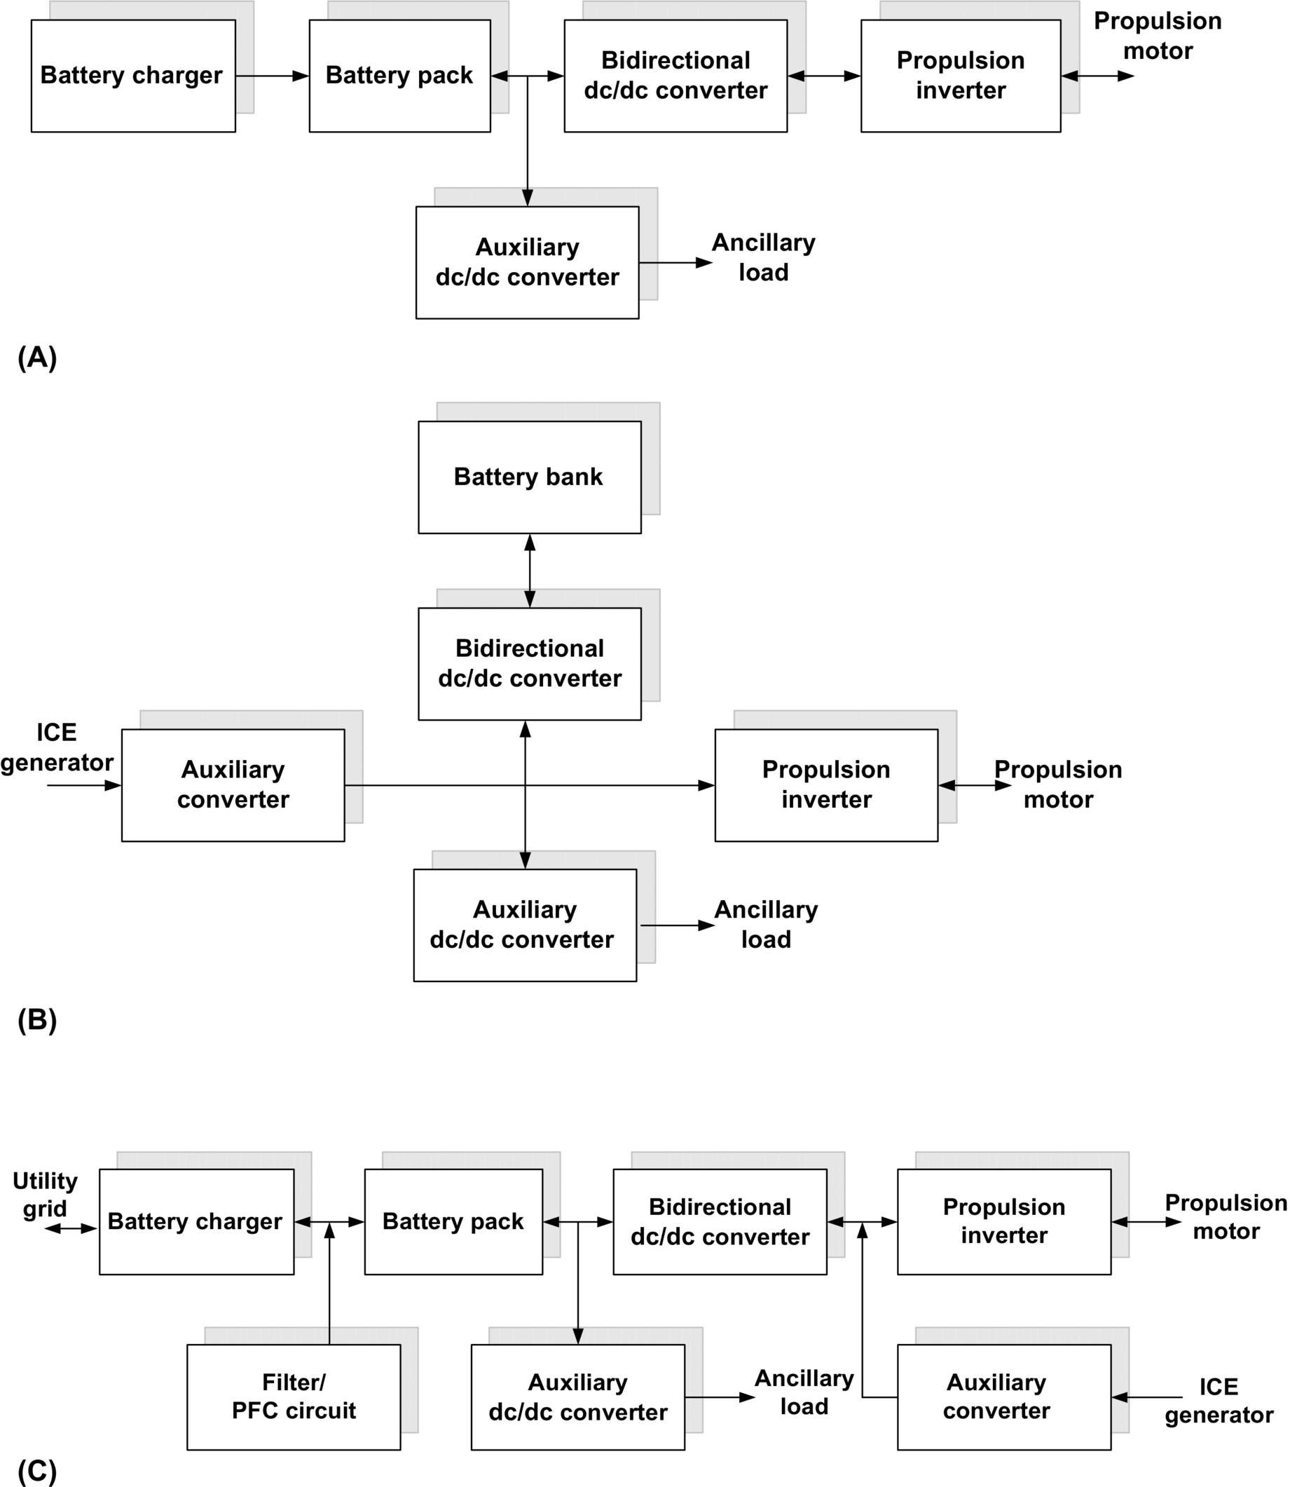

**FIG. 31.24** Schematic diagrams of PECs for BEV, HEV, and plug-in HEV. (A) PEC configuration for BEVs, (B) PEC configuration for HEVs, and (C) PEC configuration for PHEVs.

It is well-established fact that the traditional rechargeable batteries are the main source of energy though they are heavy and expensive to replace and hence acting as a bottleneck of the BEV technology. In addition to traditional batteries like lead-acid, nickel-metal hydride (Ni-MH), and nickel-cadmium (Ni-Cd), there are advanced technologies like lithium-polymer (Li-polymer) and lithium-ion (Li-ion) batteries. Despite the popularity of these advanced batteries in portable electronic applications, they fail to keep same reputation for use in BEVs [[22](https://learning.oreilly.com/library/view/power-electronics-handbook/9780128114087/B9780128114070000350.xhtml#bb0115)]. Consequently, the vehicle manufacturers are cutting down the production of BEV and shifting toward development on HEVs and FCVs.

The PEC for HEVs as shown in [Fig. 31.24B](https://learning.oreilly.com/library/view/power-electronics-handbook/9780128114087/B9780128114070000350.xhtml#f0130) consists of an ac/dc converter for converting the alternator ac output voltage into dc voltage for charging the batteries, an inverter for dc/ac conversion to power the propulsion motor, and a bidirectional dc/dc converter for charging the battery and maintaining bidirectional power flow. In addition to this, a low-voltage dc/dc converter is also connected to the battery bank to supply power to low-voltage ancillary loads of the vehicles. Furthermore, an electric air-conditioning unit, pump, and compressor units need an inverter and associated control systems [[22](https://learning.oreilly.com/library/view/power-electronics-handbook/9780128114087/B9780128114070000350.xhtml#bb0115)].

The PEC configuration of plug-in HEV shown in [Fig. 31.24C](https://learning.oreilly.com/library/view/power-electronics-handbook/9780128114087/B9780128114070000350.xhtml#f0130) is similar to HEV with the charger facility to charge the battery bank from utility grid. The high-energy battery bank must be able to store enough electric energy from external charging and from regenerative braking and must be able to supply the stored electric energy to a propulsion inverter-motor system [[23](https://learning.oreilly.com/library/view/power-electronics-handbook/9780128114087/B9780128114070000350.xhtml#bb0120)]. ac outlet charging should inevitably need a battery charger that is composed of a PFC-integrated ac-dc converter with a proper voltage-current profile for high-energy battery bank. A bidirectional dc-dc converter and charge-discharge profile is also necessary so as to transfer energy between the battery and the propulsion motor system as per requirement [[23](https://learning.oreilly.com/library/view/power-electronics-handbook/9780128114087/B9780128114070000350.xhtml#bb0120)].

The main task of the fuel-cell propulsion system is converting the fuel-cell stack power output into a usable power for different electric and mechanical loads. Furthermore, the objective is to realize the full potential of the onboard fuel-cell stack by implementing efficient PEC in cost-effective manner. The primary power conversion would be used for three-phase ac output with variable voltage and variable frequency for the propulsion motor of the vehicle [[80](https://learning.oreilly.com/library/view/power-electronics-handbook/9780128114087/B9780128114070000350.xhtml#bb0405)]. It is important to note that a high-peak-to-average power ratio is generally demanded from the PEC. If there is no ESS, the fuel-cell stack also needs to maintain the above critical power ratio to a maximum that increases size and volume of fuel-cell stack. Secondary power conversion is required for 12 or 42 V auxiliaries and for other loads such as air conditioning, pump, and power steering [[80](https://learning.oreilly.com/library/view/power-electronics-handbook/9780128114087/B9780128114070000350.xhtml#bb0405)].

The different configuration of fuel-cell-based propulsion system for passenger car is shown in [Fig. 31.25](https://learning.oreilly.com/library/view/power-electronics-handbook/9780128114087/B9780128114070000350.xhtml#f0135). The output voltage of the fuel-cell stack is first conditioned and processed to be compatible with the ESS voltage and propulsion motor using a dc/dc converter. The type of dc/dc converter depends on the voltage level of a fuel cell and ESS. A propulsion inverter is used to convert the dc voltage into modulating ac voltage at variable frequency to drive the propulsion motor under different torque and speed. The electronic controller unit (ECU) sends control signals to regulate the power output of the fuel cell, the dc/dc converter, and the dc/ac inverter based on the feedback signals of speed and torque and driver commands [[80](https://learning.oreilly.com/library/view/power-electronics-handbook/9780128114087/B9780128114070000350.xhtml#bb0405)].

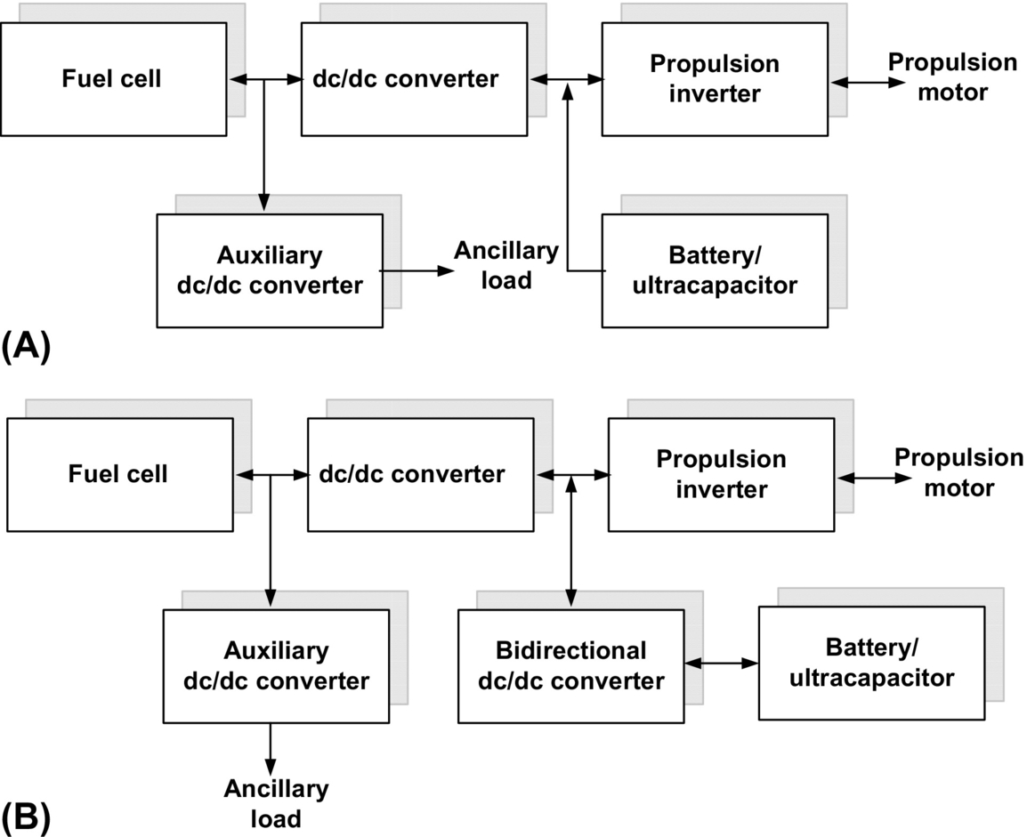

**FIG. 31.25** PEC configuration for fuel-cell vehicles. (A) Parallel connected battery/ultracapacitor and (B) interfacing of battery and ultracapacitor through dc/dc converter.

To begin with fuel-cell vehicle, a simplest configuration of a fuel cell is directly connected to propulsion motor through dc/ac converter. This configuration is applicable to the system only if the fuel-cell stack can produce a voltage level that is suitable for the propulsion inverter motor. However, this configuration is not preferred in general; hence, a unidirectional dc/dc boost converter is connected in between the fuel-cell stack and propulsion inverter as shown in [Fig. 31.25A](https://learning.oreilly.com/library/view/power-electronics-handbook/9780128114087/B9780128114070000350.xhtml#f0135). The purpose of the dc/dc converter is to condition the fuel-cell power and raise the voltage level to match with the dc-link voltage. Typically, dc-link voltage in the range of 300–400 V is favorable for power levels up to about 100 kW [[23](https://learning.oreilly.com/library/view/power-electronics-handbook/9780128114087/B9780128114070000350.xhtml#bb0120)]. A diode is connected in series with the output of the fuel-cell stack to prevent it from overload, getting short-circuited at output terminal, and to prevent current flowing back into fuel-cell stack [[22](https://learning.oreilly.com/library/view/power-electronics-handbook/9780128114087/B9780128114070000350.xhtml#bb0115)]. Further, an additional low-voltage dc/dc buck converter is connected to supply the power to ancillary loads. Unlike the ICE-driven alternator, a fuel cell can produce power on board for different ancillary electric loads of vehicles that can eliminate the need of an alternator.

[Fig. 31.25B](https://learning.oreilly.com/library/view/power-electronics-handbook/9780128114087/B9780128114070000350.xhtml#f0135) shows the modification to system shown in [Fig. 31.25A](https://learning.oreilly.com/library/view/power-electronics-handbook/9780128114087/B9780128114070000350.xhtml#f0135), with a low-voltage ESS connected through bidirectional dc-dc converter that performs the crucial task of power management and control. Generally, fuel cells are very efficient over particular load range but exhibit poor efficiency under light load condition and poor dynamic response during transient [[24](https://learning.oreilly.com/library/view/power-electronics-handbook/9780128114087/B9780128114070000350.xhtml#bb0125)]. Therefore, integration of battery and ultracapacitor with a fuel cell makes it sustainable HES onboard for vehicular application. The ESS provides an input power to the propulsion inverter during warm-up time of the fuel cell. Once the fuel cell starts providing the required power, the ESS is disconnected, and the system can completely run on the fuel cell. The ESS system also provides power during transient conditions, to support the fuel cell, which improves the dynamic response and load leveling of overall system [[80](https://learning.oreilly.com/library/view/power-electronics-handbook/9780128114087/B9780128114070000350.xhtml#bb0405)].

The fuel-cell propulsion system wins over ICE propulsion system on higher fuel conversion efficiency and fuel flexibility, emits practically no toxic pollutants, and reduces CO2 emission drastically. However, a fuel-cell system designed for vehicular propulsion system should have weight, volume, power density, start-up, and a transient response similar to present-day ICE-based propulsion system [[23](https://learning.oreilly.com/library/view/power-electronics-handbook/9780128114087/B9780128114070000350.xhtml#bb0120)].

#### **31.4.3.3 PEC Configurations for ESS and HES**

ESS whether battery and/or ultracapacitor is employed to reduce the cost and improve the performance of electrified vehicles [[18](https://learning.oreilly.com/library/view/power-electronics-handbook/9780128114087/B9780128114070000350.xhtml#bb0095)]. The voltage level, *V-I* characteristics, and dynamic response of the ESS are normally different from the primary energy sources (ICE or fuel cell). Thus, a PEC needs to be incorporated to manage and control the power flow in overall vehicle system, which is a key component for achieving better fuel efficiency and dynamic performance [[68](https://learning.oreilly.com/library/view/power-electronics-handbook/9780128114087/B9780128114070000350.xhtml#bb0345),[69](https://learning.oreilly.com/library/view/power-electronics-handbook/9780128114087/B9780128114070000350.xhtml#bb0350)]. For HES, storage element is an essential requirement to act as an energy buffer during transients in the system, to improve the dynamics of the overall system. Also, the storage element compensates the mismatch in power, between the source and load. Therefore, the choice of source combinations, such as battery/ultracapacitor or fuel cell/battery, fuel cell/ultracapacitor, and fuel cell/battery/ultracapacitor, is primarily governed by characteristics of the primary source and operating condition of the load [[40](https://learning.oreilly.com/library/view/power-electronics-handbook/9780128114087/B9780128114070000350.xhtml#bb0205),[41](https://learning.oreilly.com/library/view/power-electronics-handbook/9780128114087/B9780128114070000350.xhtml#bb0210)].

In a fuel cell, the amount of power delivered depends on hydrogen pressure and slow chemical reaction results in poor dynamic response. Therefore, it should be combined with battery or ultracapacitor to achieve sustainable HES [[40](https://learning.oreilly.com/library/view/power-electronics-handbook/9780128114087/B9780128114070000350.xhtml#bb0205)]. For example, a fuel cell and an ultracapacitor are combined together to constitute a portable HES that can meet different energy and power requirements as necessitated by different driving profiles of vehicle [[41](https://learning.oreilly.com/library/view/power-electronics-handbook/9780128114087/B9780128114070000350.xhtml#bb0210)]. During acceleration, bulk amount of power has to be released to develop sufficient thrust. This responsibility can be well taken care by ultracapacitor as it can deliver power quickly. Similarly, a fuel cell can support to extend all-electric driving range of the vehicles, by supplying constant power, which in turn enhances durability and life span of the fuel-cell membrane [[44](https://learning.oreilly.com/library/view/power-electronics-handbook/9780128114087/B9780128114070000350.xhtml#bb0225)].

In HEV, it is desired for the energy system to have high power density and high energy density to cater the sudden changes in the load demand [[9](https://learning.oreilly.com/library/view/power-electronics-handbook/9780128114087/B9780128114070000350.xhtml#bb0050)]. Moreover, applications that require instantaneous power input and output delivery typically find batteries suffering from frequent charge and discharge cycle, which have an adverse effect on battery life. For such systems, it is crucial to have an additional storage system that is much better and robust in handling surge current. Here, the basic idea of HES is to combine battery and ultracapacitor to achieve a better performance than the latter system. Thus, an ideal source for EVT would be the combination of both the storage sources [[18](https://learning.oreilly.com/library/view/power-electronics-handbook/9780128114087/B9780128114070000350.xhtml#bb0095)]. Also, the hybridization of battery and ultracapacitor offers much better utilization of energy recovered during regenerative braking.

HES demands suitable PEC to incorporate different energy sources and manages power flow among different sources and vehicle loads [[18](https://learning.oreilly.com/library/view/power-electronics-handbook/9780128114087/B9780128114070000350.xhtml#bb0095)]. Therefore, investigation on PEC for HES is crucial task in EPS design for achieving optimal balance among efficiency, performance, durability, and reliability of system [[63](https://learning.oreilly.com/library/view/power-electronics-handbook/9780128114087/B9780128114070000350.xhtml#bb0320)]. In HES, a dc/dc converter is the key constituent that provides compatible interfacing and integration of energy sources [[64](https://learning.oreilly.com/library/view/power-electronics-handbook/9780128114087/B9780128114070000350.xhtml#bb0325)]. Beside output voltage regulation, a well-designed dc/dc converter can also control and manage power flow through different components. Therefore, selection and design considerations of dc/dc converters are important aspect in ESS. Apart from dc/dc converter, multiple-input dc/dc converter and multiphase interleaved converters are also employed for better energy diversification and utilization of the onboard HES [[66](https://learning.oreilly.com/library/view/power-electronics-handbook/9780128114087/B9780128114070000350.xhtml#bb0335),[67](https://learning.oreilly.com/library/view/power-electronics-handbook/9780128114087/B9780128114070000350.xhtml#bb0340)]. Several topologies for HES configuration for EVT have been proposed in [[68](https://learning.oreilly.com/library/view/power-electronics-handbook/9780128114087/B9780128114070000350.xhtml#bb0345)–[70](https://learning.oreilly.com/library/view/power-electronics-handbook/9780128114087/B9780128114070000350.xhtml#bb0355)] to improve fuel efficiency and dynamic performance that range from simple to complex circuits. On the basis of the use of dc/dc converter, HES can be classified into two categories: passive configuration and active configuration.

##### **Passive configuration**

Passive configuration [[33](https://learning.oreilly.com/library/view/power-electronics-handbook/9780128114087/B9780128114070000350.xhtml#bb0170)] is the simplest method of combining battery and ultracapacitor (UC) bank together as shown in [Fig. 31.26A](https://learning.oreilly.com/library/view/power-electronics-handbook/9780128114087/B9780128114070000350.xhtml#f0140), where battery and ultracapacitor are connected together in parallel without any dc/dc converters. In this method, since the two sources are connected in parallel, battery voltage, ultracapacitor voltage, and dc-link voltage should be maintained at the same level, and ultracapacitor essentially acts as filter. This configuration is easy to implement and eliminates need of expensive PEC and peripheral circuitry. However, major problem with this configuration is inefficient utilization of stored energy in ultracapacitor and battery.

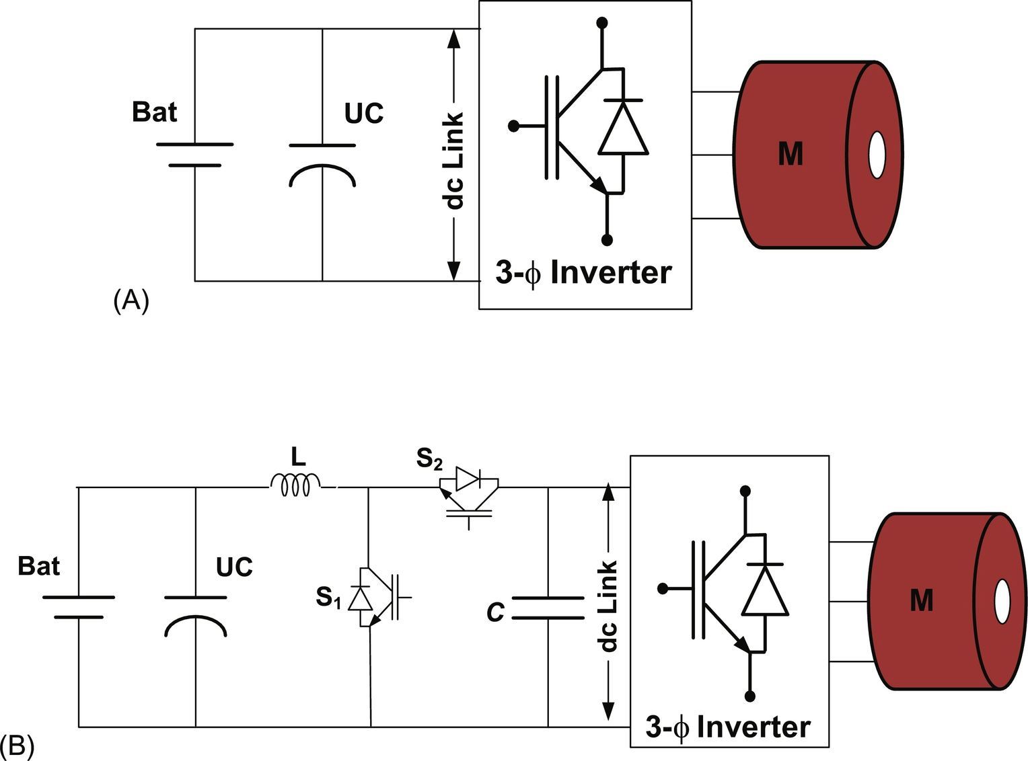

**FIG. 31.26** Passive configurations of battery and ultracapacitor parallel with dc/dc converter. (A) Direct interfacing of battery and ultracapacitor and (B) interfacing of battery and ultracapacitor through dc/dc converter.

To improve power flow and its proper utilization, a bidirectional dc/dc converter interfaces the parallel-connected ultracapacitor and battery with the dc link as shown in [Fig. 31.26B](https://learning.oreilly.com/library/view/power-electronics-handbook/9780128114087/B9780128114070000350.xhtml#f0140). Despite wide voltage variation across ultracapacitor terminals, the dc-link voltage remains constant due to the regulation of the dc/dc converter. However, in this configuration, the battery voltage is always the same with the ultracapacitor voltage due to the lack of interfacing control between the battery and the ultracapacitor [[18](https://learning.oreilly.com/library/view/power-electronics-handbook/9780128114087/B9780128114070000350.xhtml#bb0095)]. The battery current must charge the ultracapacitor and provide power to the load side as well.

##### **Active configuration of battery/ultra capacitor**

Conventional active methods use one or multiple full-size dc/dc converters to hybridize the battery and ultracapacitor to the dc link. In this case, full size refers to the fact that the dc/dc converter forms the sole path for the flow of energy in the device. The UC/battery configuration as shown in [Fig. 31.27A](https://learning.oreilly.com/library/view/power-electronics-handbook/9780128114087/B9780128114070000350.xhtml#f0145) proposed in [[31](https://learning.oreilly.com/library/view/power-electronics-handbook/9780128114087/B9780128114070000350.xhtml#bb0160)] is the most studied and researched HES. By using a bidirectional dc/dc converter to interface the ultracapacitor, the voltage of ultracapacitor can be used in a wide range. However, the bidirectional converter needs to be of a larger size in order to handle the power of the ultracapacitor. The battery is connected directly to the dc link; as a result, the dc-link voltage cannot be varied. By swapping the positions of the battery and ultracapacitor in the ultracapacitor/battery configuration, we get the battery/ultracapacitor configuration as discussed in [[68](https://learning.oreilly.com/library/view/power-electronics-handbook/9780128114087/B9780128114070000350.xhtml#bb0345)] and shown in [Fig. 31.27B](https://learning.oreilly.com/library/view/power-electronics-handbook/9780128114087/B9780128114070000350.xhtml#f0145). In this configuration, the voltage of the battery can be maintained lower or higher than the ultracapacitor voltage. The ultracapacitor is connected in parallel with the dc link directly working as a low-pass filter. The control strategy applied to this configuration allows the dc-link voltage to vary within a range such that the ultracapacitor energy can be utilized more efficiently. However, in standard practice to achieve efficient HES, it is preferred that fast-response components are connected with high-power-density system whereas slow response devices are connected to high-energy-density system.

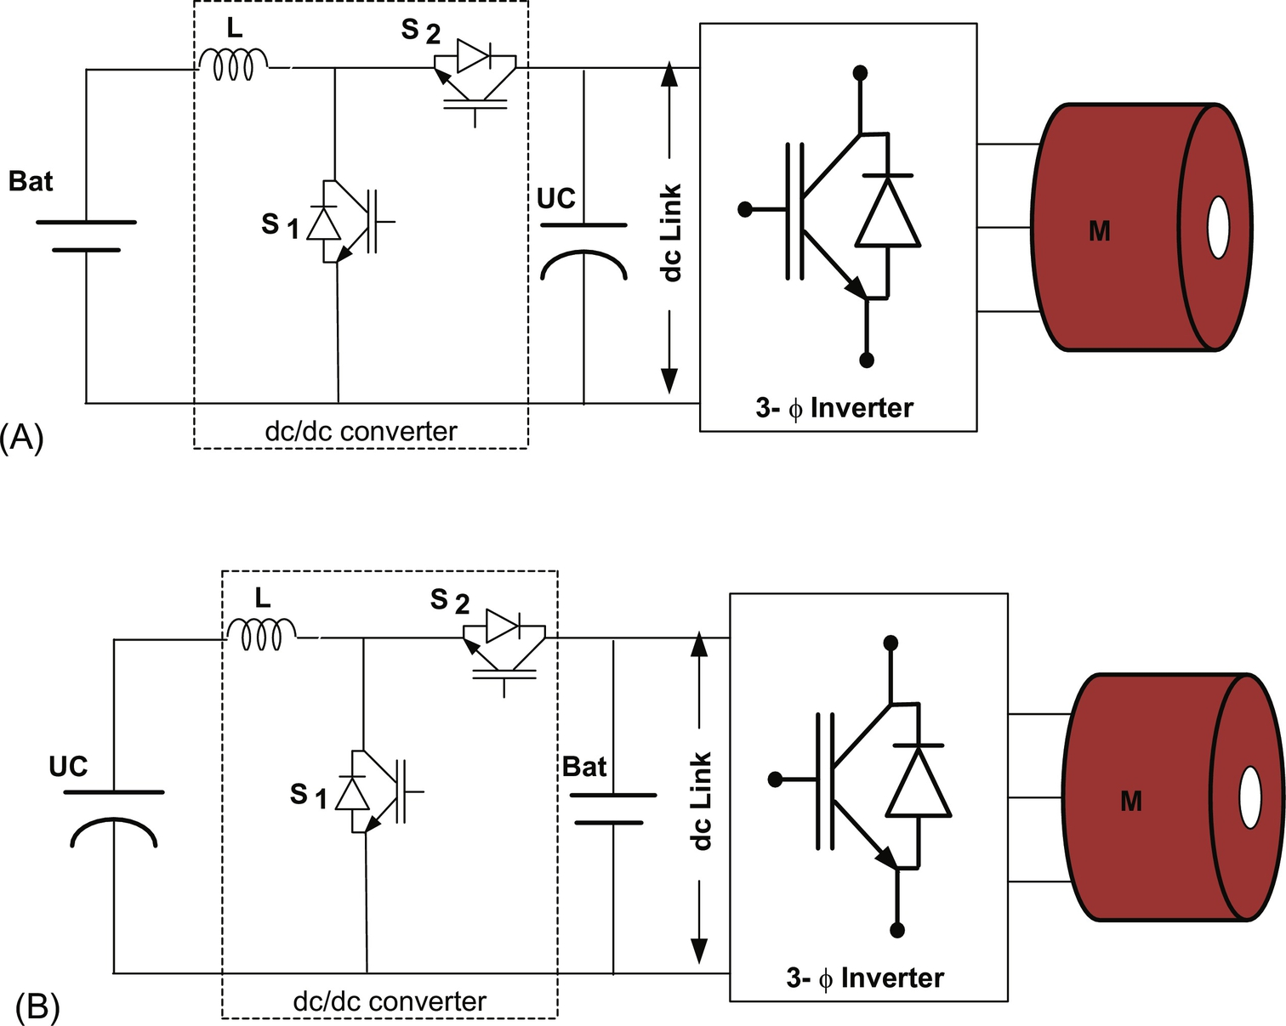

**FIG. 31.27** Active configuration of battery and ultracapacitor. (A) Battery is connected through dc/dc converter. (B) Ultracapacitor is connected through dc/dc converter.

##### **Cascaded configuration**

To make a better working range of the ultracapacitor of the battery/ultracapacitor configuration, another bidirectional dc/dc converter is added between the ultracapacitor bank and the dc link, as shown in [Fig. 31.28](https://learning.oreilly.com/library/view/power-electronics-handbook/9780128114087/B9780128114070000350.xhtml#f0150). This forms a cascaded configuration where two dc/dc converters are connected in series. In this configuration, a smaller size battery can be used with lower voltage level, which can be boosted up to a higher voltage level, to reduce the cost. In addition, the battery current can more efficiently be controlled compared with the passive configuration. Due to the existence of the boost converter, the battery current is smoothened, and the stress on the battery is reduced [[18](https://learning.oreilly.com/library/view/power-electronics-handbook/9780128114087/B9780128114070000350.xhtml#bb0095)]. The battery supplies average power to the load, whereas the ultracapacitor delivers instantaneous power charge and gets charged quickly by recovering energy during regeneration. The drawback of this topology is that the battery can be charged neither by braking energy nor by the ultracapacitor due to the unidirectional boost converter [[18](https://learning.oreilly.com/library/view/power-electronics-handbook/9780128114087/B9780128114070000350.xhtml#bb0095)]. However, the possibility of battery charging can be explored by replacing unidirectional dc/dc converter with a bidirectional dc/dc converter.

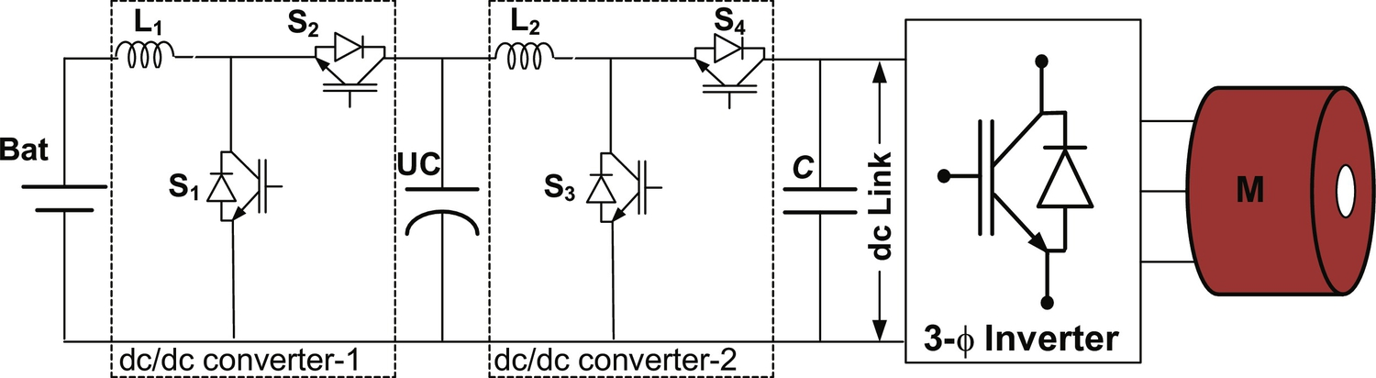

**FIG. 31.28** Cascaded configuration of battery and ultracapacitor.

##### **Parallel configuration**

Instead of cascaded connection of the two converters, parallel configurations of battery/ultracapacitor are also used as shown in [Fig. 31.29](https://learning.oreilly.com/library/view/power-electronics-handbook/9780128114087/B9780128114070000350.xhtml#f0155) proposed in [[66](https://learning.oreilly.com/library/view/power-electronics-handbook/9780128114087/B9780128114070000350.xhtml#bb0335)]. The battery bank and the ultracapacitor are connected to the dc link in parallel through bidirectional dc/dc converter. In this configuration, both the battery and the ultracapacitor present a lower voltage level than the dc-link voltage. The voltage of the ultracapacitor can vary in a wide range so that capacitor is fully used. The voltages of the battery and the ultracapacitor will be boosted up when the propulsion system demands power and bucked down under recharging conditions. Power-flow directions in/out of the battery and the ultracapacitor can separately be controlled, allowing flexibility for power management [[18](https://learning.oreilly.com/library/view/power-electronics-handbook/9780128114087/B9780128114070000350.xhtml#bb0095)]. However, if two full-sized dc/dc converters are integrated in parallel, the cost, size, and complexity of control increase.

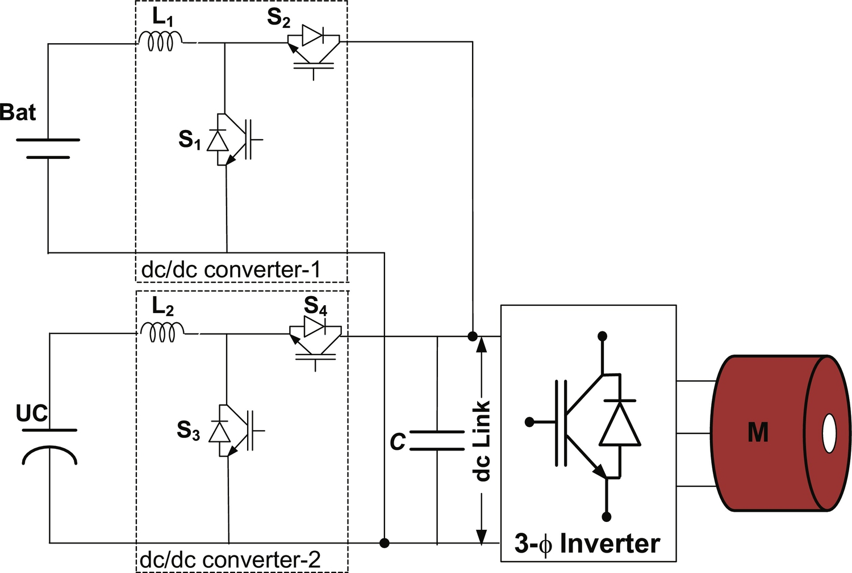

**FIG. 31.29** Parallel configuration of battery and ultracapacitor.

##### **Multiple input configuration**

As discussed in previous section, multiple-converter configuration is expensive because it requires two full-size bidirectional converters to interface both battery and ultracapacitor. Therefore, multiple-input converter (MIC) topologies [[81](https://learning.oreilly.com/library/view/power-electronics-handbook/9780128114087/B9780128114070000350.xhtml#bb0410)–[84](https://learning.oreilly.com/library/view/power-electronics-handbook/9780128114087/B9780128114070000350.xhtml#bb0425)] are proposed in order to reduce the cost of the overall system. The configurations of the MIC are shown in [Figs. 31.30](https://learning.oreilly.com/library/view/power-electronics-handbook/9780128114087/B9780128114070000350.xhtml#f0160) and [31.31](https://learning.oreilly.com/library/view/power-electronics-handbook/9780128114087/B9780128114070000350.xhtml#f0165). MIC is a converter that can combine different energy sources with a single stage of power conversion. It offers simplicity, flexibility, and compact design and reduces the cost and control complexity of the system [[82](https://learning.oreilly.com/library/view/power-electronics-handbook/9780128114087/B9780128114070000350.xhtml#bb0415)–[84](https://learning.oreilly.com/library/view/power-electronics-handbook/9780128114087/B9780128114070000350.xhtml#bb0425)]. In the multiple-input bidirectional converter shown in [Fig. 31.30](https://learning.oreilly.com/library/view/power-electronics-handbook/9780128114087/B9780128114070000350.xhtml#f0160), both the battery and the ultracapacitor are connected to one common inductor by parallel switches [[81](https://learning.oreilly.com/library/view/power-electronics-handbook/9780128114087/B9780128114070000350.xhtml#bb0410)]. Each switch is paired with a diode, which is designed to avoid short circuit between the battery and the ultracapacitor. In parallel-connected switch, the higher-voltage-source cell will be dominating, which needs time multiplexing switching. The second approach is to form a pulsating voltage-source cell (PVSC) of the sources and connect these PVSC in series as shown in [Fig. 31.31](https://learning.oreilly.com/library/view/power-electronics-handbook/9780128114087/B9780128114070000350.xhtml#f0165) and proposed in [[82](https://learning.oreilly.com/library/view/power-electronics-handbook/9780128114087/B9780128114070000350.xhtml#bb0415)]. In series configuration of MIC, voltage magnitude of battery and ultracapacitor can be asymmetrical, and each of the sources can deliver power individually and simultaneously. Both input voltages are less than the dc-link voltage; thus, the converter works in boost mode when input sources supply energy to drive load and in buck mode for recovering regenerative braking energy to recharge the battery and the ultracapacitor [[81](https://learning.oreilly.com/library/view/power-electronics-handbook/9780128114087/B9780128114070000350.xhtml#bb0095)]. Only one inductor is needed, even if more inputs are added into the system. However, the controlling strategy and power-flow management of the system are relatively complex.

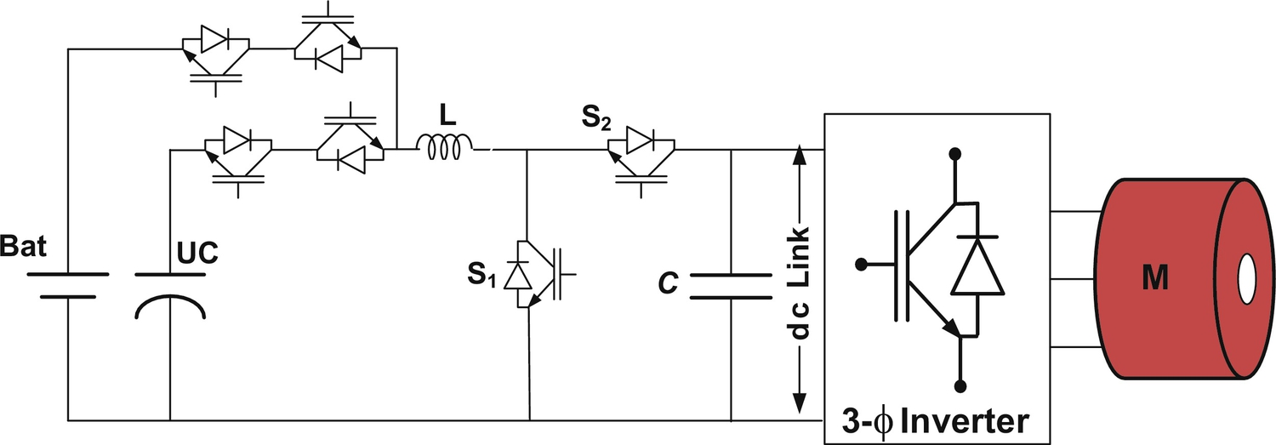

**FIG. 31.30** Parallel configuration of multiple-input converters.

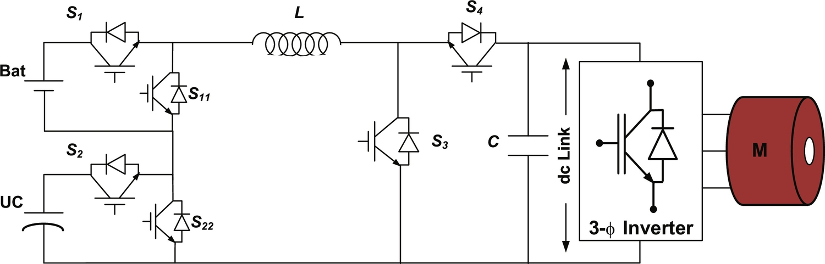

**FIG. 31.31** Series configuration of multiple-input converter.

As discussed in parallel configuration, in HES, each energy source is connected together through separate single-input dc/dc converter (SIC), and their outputs are connected in parallel to a common dc bus as shown in [Fig. 31.32](https://learning.oreilly.com/library/view/power-electronics-handbook/9780128114087/B9780128114070000350.xhtml#f0170). In conventional configuration paralleling, the whole system including energy sources offers good solution to obtain high degree of availability [[76](https://learning.oreilly.com/library/view/power-electronics-handbook/9780128114087/B9780128114070000350.xhtml#bb0385),[83](https://learning.oreilly.com/library/view/power-electronics-handbook/9780128114087/B9780128114070000350.xhtml#bb0420),[84](https://learning.oreilly.com/library/view/power-electronics-handbook/9780128114087/B9780128114070000350.xhtml#bb0425)]. However, such configurations are costly, bulky, and relatively complex in design and reduce overall efficiency and flexibility and increase control complexity of the system. If costs and availability are being considered, then the single-input converters can be successfully replaced by a single multiple-input converter as shown in [Fig. 31.33](https://learning.oreilly.com/library/view/power-electronics-handbook/9780128114087/B9780128114070000350.xhtml#f0175).

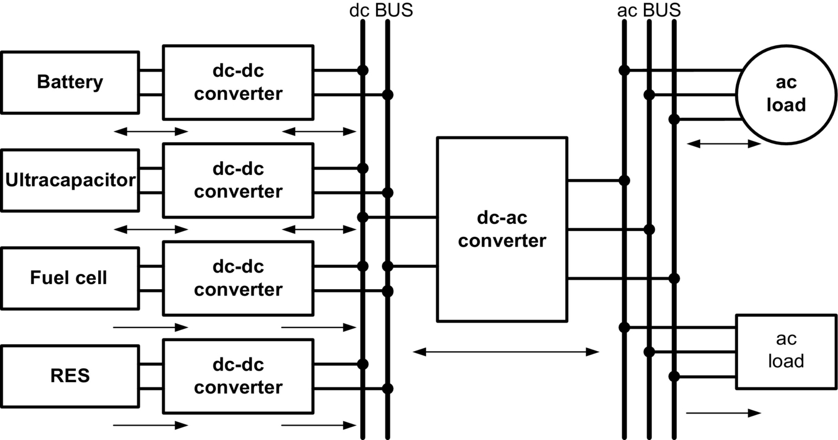

**FIG. 31.32** Conventional hybrid energy system configuration with single-input dc/dc converter [[83](https://learning.oreilly.com/library/view/power-electronics-handbook/9780128114087/B9780128114070000350.xhtml#bb0420)].

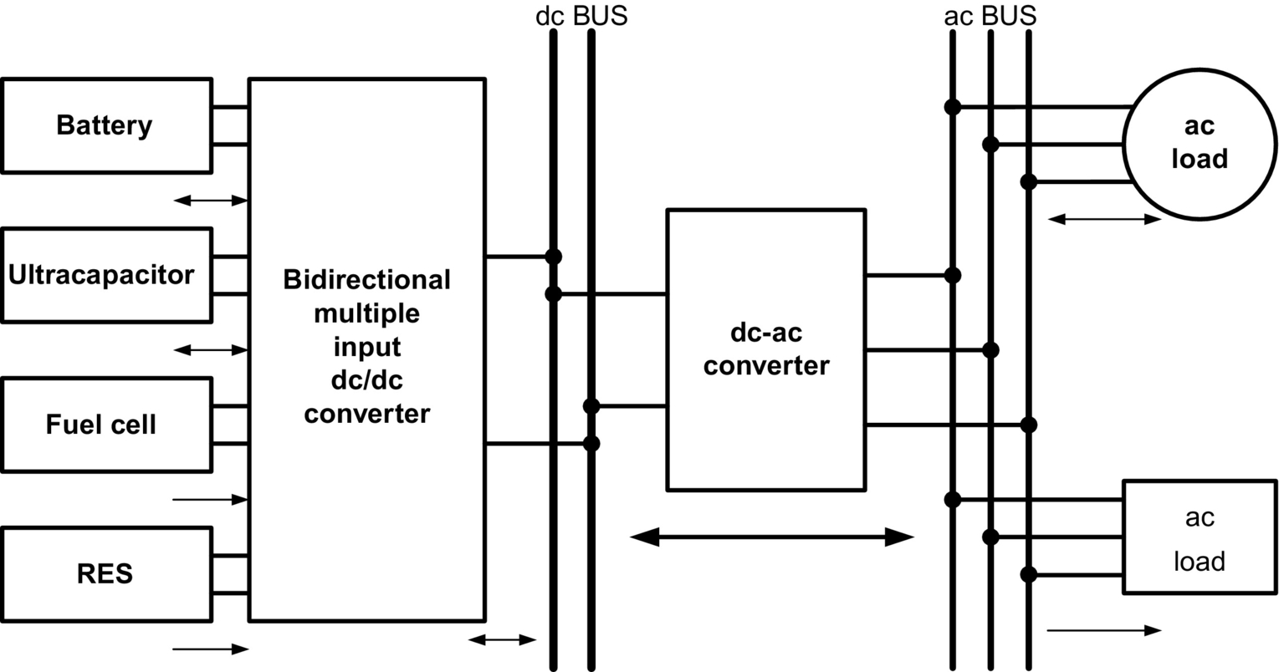

**FIG. 31.33** Hybrid energy system configuration based on multiple-input dc/dc converter [[83](https://learning.oreilly.com/library/view/power-electronics-handbook/9780128114087/B9780128114070000350.xhtml#bb0420)].

The conventional structure of interfacing multiple energy sources in multiple power stages can be successfully replaced by a single MIC that integrates multiple energy sources with a single stage of power conversion. In this structure, the system voltage is regulated, and the power flow among the energy sources, storage devices, and load can be controlled optimally and centrally. It eliminates the need for redundant power stages of the conventional structure and thus achieves reduced parts count [[83](https://learning.oreilly.com/library/view/power-electronics-handbook/9780128114087/B9780128114070000350.xhtml#bb0420)]. MICs have advantages of easy power management, efficient thermal management, better utilization of available input sources, and centralized control compared with a conventional structure. The overall system efficiency is increased due to the reduction of the conversion stages, redundant passive elements, power switches, and hence their associated losses. The disadvantage of the MIC configuration is that the output stage of a MIC can act as a single point of failure. However, a MIC with modular component can compensate for this drawback by reducing the mean downtime (MDT) of the system [[67](https://learning.oreilly.com/library/view/power-electronics-handbook/9780128114087/B9780128114070000350.xhtml#bb0340)].

In HEV, as shown in [Fig. 31.34](https://learning.oreilly.com/library/view/power-electronics-handbook/9780128114087/B9780128114070000350.xhtml#f0180), where the combination of battery and ultracapacitor is preferred, battery supplies constant power, whereas additional power demand by the load during start-up and acceleration is delivered by the ultracapacitor while maintaining dc-link voltage constant. The amount of power drawn from the battery relies on the state of charge (SOC) of the battery; thus, for change in power drawn from the battery, power delivered by the ultracapacitors should also be changed. Thus, effective power sharing can be achieved by MICs depending on the control strategies and operating mode. This modulation of power between battery and ultracapacitor is not possible in conventional structure because both the sources have to supply constant power to regulate the output dc-link voltage.

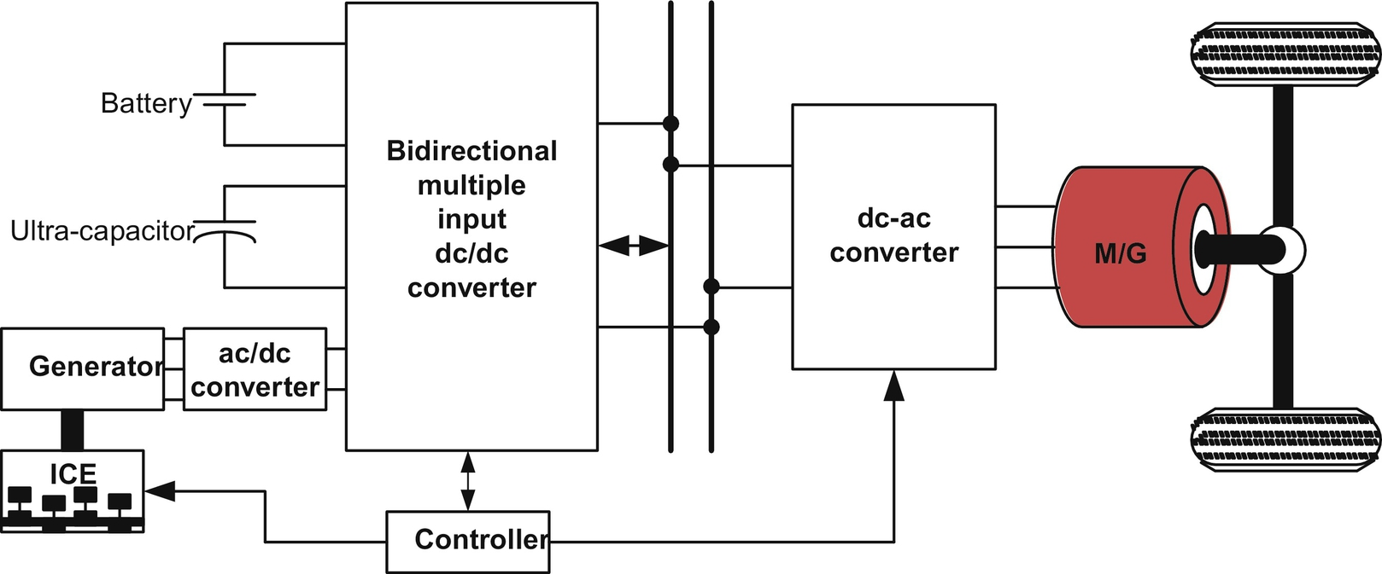

**FIG. 31.34** Multiple-input converter-based hybrid electric vehicle.

MIC structure has an explicit advantage over the conventional structure in terms of total component count and conversion stages used due to mutual sharing of system components. As a result, compact design and improved system efficiency can be achieved. Comparison of these two structures given in [Table 31.10](https://learning.oreilly.com/library/view/power-electronics-handbook/9780128114087/B9780128114070000350.xhtml#t0050) shows that the MIC structure is promising alternatives in vehicular application to interface multiple sources on board.

**Table 31.10**

**Comparison of SIC and MIC structure [**[**83**](https://learning.oreilly.com/library/view/power-electronics-handbook/9780128114087/B9780128114070000350.xhtml#bb0420)**]**

|  |  |  |
| --- | --- | --- |
| **Characteristics** | **SIC structure** | **MIC structure** |
| Common dc bus | Yes | No |
| Conversion step | Multiple | Single |
| Control scheme | Individual control | Centralized control |
| Power-flow management | Complicated and slow | Simple and fast |
| Transformer (isolated) | Multiple | Single multiwinding |
| Implementation effort | High | Low |
| Component count | High | Low |
| Flexibility | Low | High |
| Cost and volume | High | Low |

#### **31.4.3.4 PEC Configurations for Battery Charger**

PEC configuration for battery chargers plays a critical role in the sustainable development of BEVs/PHEVs. The challenge of transforming BEVs/PHEVs from concept to reality is to make it safe, convenient, and affordable for consumers to charge batteries [[63](https://learning.oreilly.com/library/view/power-electronics-handbook/9780128114087/B9780128114070000350.xhtml#bb0320)]. In order to improve convenience and increase charging efficiency, a number of charging schemes have been proposed as house charging, solar charging station, park and charge (PAC), move and charge (MAC), and regenerative charging as shown in [Fig. 31.35](https://learning.oreilly.com/library/view/power-electronics-handbook/9780128114087/B9780128114070000350.xhtml#f0185). A battery charger composed of several PECs should be reliable and efficient with high power delivery capacity at low cost and weight. Its operation depends on power electronics component, switching strategies, and control algorithms. A BEV/PHEV charger must ensure the operation at unity power factor or close to unity power factor to draw maximum amount of real power from utility grid with less distortion in current to minimize the power quality impact on grid. The battery charger should be designed according to IEEE-1547, SAE-J2894, and similar standards such that the amount of harmonic and dc current injected into the utility grid must be controlled within the preset limit.

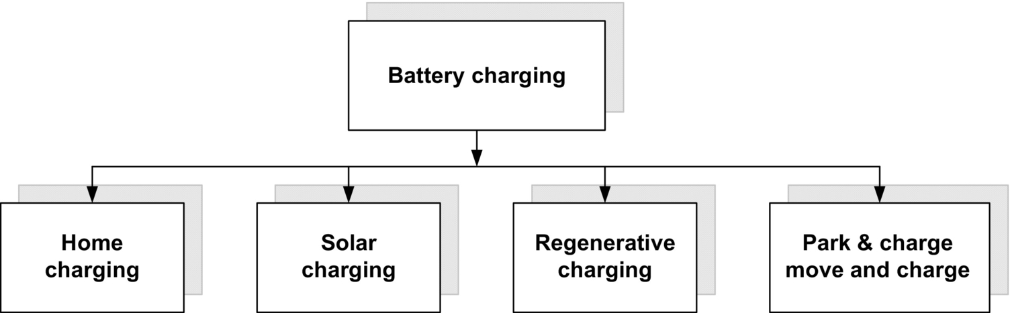

**FIG. 31.35** Multiple options for charging of BEVs/PHEVs.

A variety of PEC configurations and control methods have been developed as BEVs/PHEVs battery chargers, which includes single-stage and multistage power conversion. Single-stage conversion (ac/dc) configuration suffers with large low-frequency ripple in the output current, and hence, its application is limited to lead-acid batteries only. Conversely, multistage conversion configuration (ac-dc and dc-dc) inherently offers low-voltage ripple and relatively high power rating and hence is suitably adopted for lithium-ion and Ni-MH batteries, which are being used in PHEVs [[43](https://learning.oreilly.com/library/view/power-electronics-handbook/9780128114087/B9780128114070000350.xhtml#bb0220)]. A simplified universal two-stage battery charger for BEVs/PHEVs is shown in [Fig. 31.36](https://learning.oreilly.com/library/view/power-electronics-handbook/9780128114087/B9780128114070000350.xhtml#f0190). The input voltage is first filtered out and fed to the PFC integrated ac/dc converter. The rectified voltage is fed to a regulated intermediate dc-link bus. The dc/dc converter then converts dc-link voltage to a regulated output voltage for battery charging. The galvanic isolation is achieved at dc/dc conversion stage by using isolated dc/dc converter.

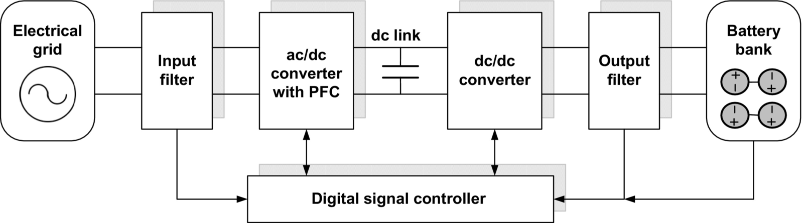

**FIG. 31.36** Simplified diagram of universal battery charger.

The availability of infrastructure for charging facility will help to reduce the size and capacity of onboard ESS, and consequently, cost and size will be reduced. Charging stations are classified as three types, on the basis of power-handling capacity, charging time, and location of charger installation. Type-I charging is the slowest method of charging, designed for home or business sites with readily available power outlet, and no additional infrastructure is required. It uses standard 120/230 V, 15 A single-phase charger outlet with standard J1772 connector [[85](https://learning.oreilly.com/library/view/power-electronics-handbook/9780128114087/B9780128114070000350.xhtml#bb0430)]. In type-II charging, dedicated infrastructure and charging equipments are required, which be installed either on board or off-board to avoid redundancy in PEC. It charges battery with 240 V, 80 A single-phase or three-phase and offers fast charging compared with type-I charging. The BEVs/PHEVs owners are likely to prefer type-II charging technology due to its faster charging time and standardized vehicle-to-charger connection. Type-III charging is a commercialized fast charging method and offers the possibility of charging in less than 1.0 h. It can be installed in highway and city refueling points, analogous to conventional fuel stations. It typically operates with 480 V and requires an off-board charger to provide regulated power conversion. The SAE J1772 standard prescribes that type-I and type-II charging infrastructures should be installed on board, whereas type-III chargers should be mounted off-board. It is expected to use type-I and type-II charging stations to enable fast charging in public and private places with less impact on utility [[86](https://learning.oreilly.com/library/view/power-electronics-handbook/9780128114087/B9780128114070000350.xhtml#bb0435)]. However, type-III charging can increase peak demand and has the potential to quickly overload local distribution system and equipment at peak times. The charging characteristics and infrastructure aspects for different type of charging methods are presented in [[72](https://learning.oreilly.com/library/view/power-electronics-handbook/9780128114087/B9780128114070000350.xhtml#bb0365)] and are given in [Table 31.11](https://learning.oreilly.com/library/view/power-electronics-handbook/9780128114087/B9780128114070000350.xhtml#t0055).

**Table 31.11**

**Charging types and power level [**[**72**](https://learning.oreilly.com/library/view/power-electronics-handbook/9780128114087/B9780128114070000350.xhtml#bb0365)**]**

|  |  |  |  |  |  |
| --- | --- | --- | --- | --- | --- |
| **Charging type** | **Charger location** | **Charger interface** | **Power rating (kW)** | **Charging time (h)** | **Vehicle technology** |
| Type-I | Onboard  One-phase | Home outlet | 1.4 (12 A)  1.9 (20 A) | 4–11  11–36 | BEV (5–15 kWh)  PHEV (16–50 kWh) |
| Type-II | Onboard  One-phase | Dedicated public or private outlet | 8 (32 A)  19.2 (80 A) | 1–4  2–6 | BEV (5–15 kWh)  PHEV (16–30 kWh) |
| Type-III | Off-board  Three-phase | Dedicated commercial outlet | 50  100 | 0.4–1  0.2–0.5 | BEV (20–50 kWh) |

Battery chargers for BEVs/PHEVs can be classified as follows:

I. On-board and off-board charger

II. Unidirectional and bidirectional charger

III. Integrated charger

IV. Inductive charger

##### **On-board and off-board charger**

The onboard charger should be installed in the vehicle and designed for the slow charging rate, that is, it takes longer time to charge relatively. Due to limitation in available space in vehicle and payload, the onboard charger for BEVs/PHEVs should be light and compact in design. The advantage of onboard charger is that the battery can be charged at anyplace where there is electric outlet is available. An off-board battery charger is less constrained by size and weight and keeps redundancy in power electronic converters, which adds flexibility in the system. The onboard and off-board charger are usually implemented either with unidirectional or bidirectional power flow. Initially, the unidirectional charging should be the first step because it reduces power electronic component requirement, simplifies interconnection issues and control complexity, and reduces battery degradation [[85](https://learning.oreilly.com/library/view/power-electronics-handbook/9780128114087/B9780128114070000350.xhtml#bb0430)]. These chargers typically use a diode bridge rectifier in conjunction with a power factor correction (PFC) and dc-dc converters [[85](https://learning.oreilly.com/library/view/power-electronics-handbook/9780128114087/B9780128114070000350.xhtml#bb0430)].

##### **Unidirectional and bidirectional charger**

The classification of conventional unidirectional and bidirectional charger topology is shown in [Fig. 31.37](https://learning.oreilly.com/library/view/power-electronics-handbook/9780128114087/B9780128114070000350.xhtml#f0195). The classification is made on the basis of operation of particular PEC topologies. A unidirectional PEC topology for a type-I battery charging system [[87](https://learning.oreilly.com/library/view/power-electronics-handbook/9780128114087/B9780128114070000350.xhtml#bb0440)] is shown in [Fig. 31.38](https://learning.oreilly.com/library/view/power-electronics-handbook/9780128114087/B9780128114070000350.xhtml#f0200). Simple control and operation of unidirectional chargers make it relatively unproblematic for a utility grid to manage heavily loaded distribution network to charge multiple BEVs at a time [[88](https://learning.oreilly.com/library/view/power-electronics-handbook/9780128114087/B9780128114070000350.xhtml#bb0445)]. Battery charger with active front-end converter can control the supply current phase angle to deliver reactive power without discharging the battery. In unidirectional charging, it needs to optimize charging strategy to maximize the benefits and to minimize the impact on distribution system [[87](https://learning.oreilly.com/library/view/power-electronics-handbook/9780128114087/B9780128114070000350.xhtml#bb0440),[88](https://learning.oreilly.com/library/view/power-electronics-handbook/9780128114087/B9780128114070000350.xhtml#bb0445)]. For high penetration of BEVs/PHEVs and active control of charging current, unidirectional chargers can meet practically all the objectives of the utility grid.

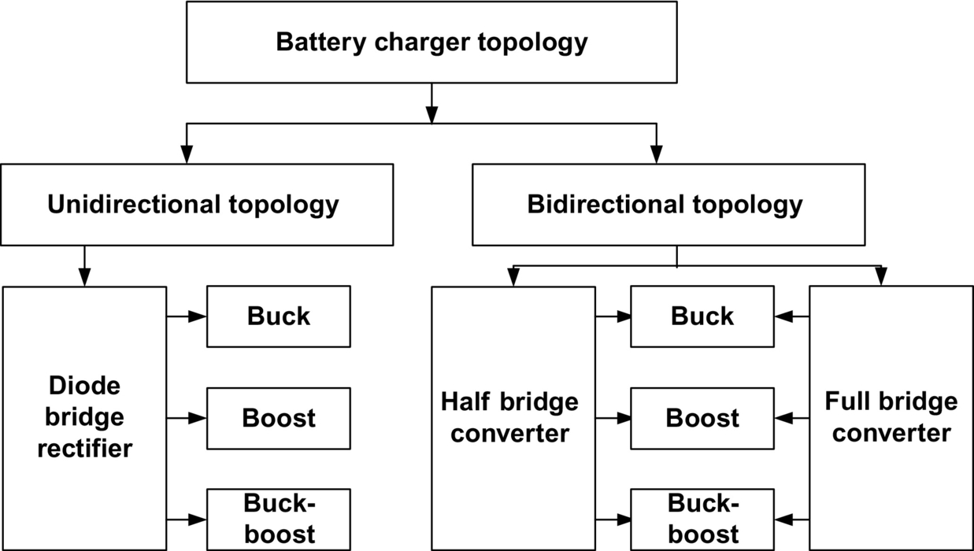

**FIG. 31.37** Classification of conventional battery charger topology.

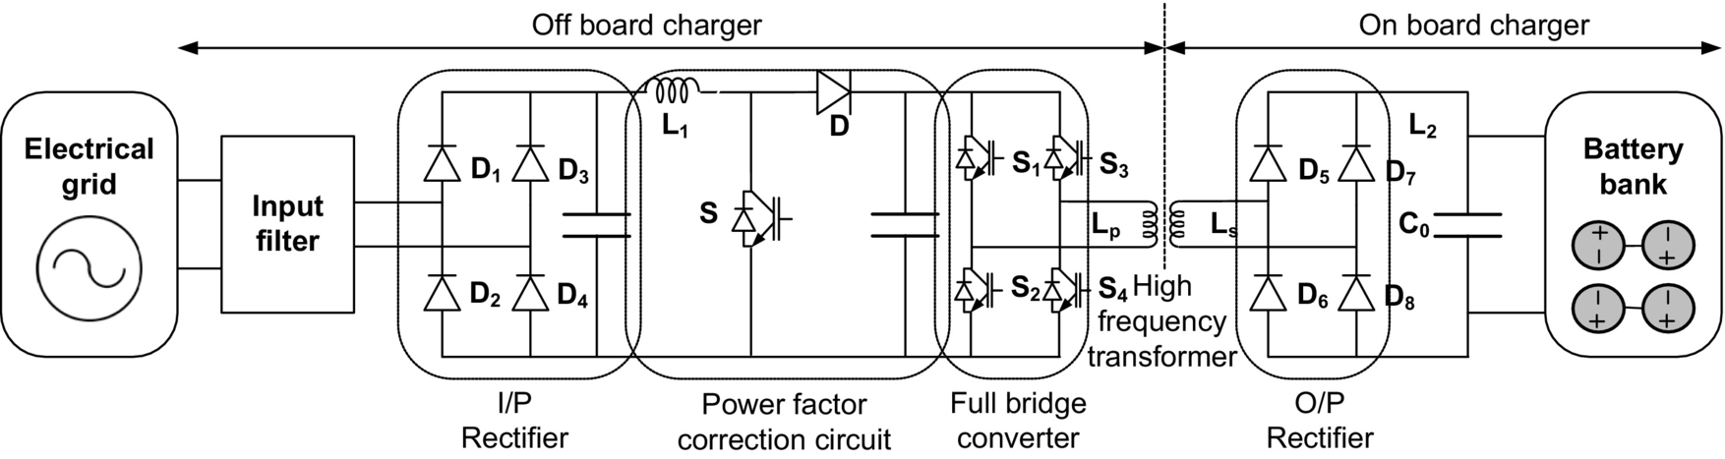

**FIG. 31.38** Battery charger configuration for unidirectional power flow.

The conventional boost converter topology with PFC as battery charger is shown in [Fig. 31.39](https://learning.oreilly.com/library/view/power-electronics-handbook/9780128114087/B9780128114070000350.xhtml#f0205) that is very popular configuration for unidirectional battery charging. A dedicated diode bridge rectifier is used to rectify the ac input voltage to dc that is further converted to dc followed by boost section. In this topology, the output ripple current, which is a difference between diode current and dc output current, is very high [[89](https://learning.oreilly.com/library/view/power-electronics-handbook/9780128114087/B9780128114070000350.xhtml#bb0450)]. To reduce the current ripple, the interleaved boost converter is presented as shown in [Fig. 31.40](https://learning.oreilly.com/library/view/power-electronics-handbook/9780128114087/B9780128114070000350.xhtml#f0210). It consists of two boost converters in parallel operating 180 degrees out of phase [[88](https://learning.oreilly.com/library/view/power-electronics-handbook/9780128114087/B9780128114070000350.xhtml#bb0445),[90](https://learning.oreilly.com/library/view/power-electronics-handbook/9780128114087/B9780128114070000350.xhtml#bb0455)]. The input current is the sum of the two input inductor currents that are out of phase and consequently cancel out each other, reducing the current ripple and stress across dc-link capacitor. The advantages of interleaved boost converter are parallel-connected switches that increase flexibility, switching out of 180 phase which increases the effective switch frequency and causes the reduction in filter size with lesser ripple content.

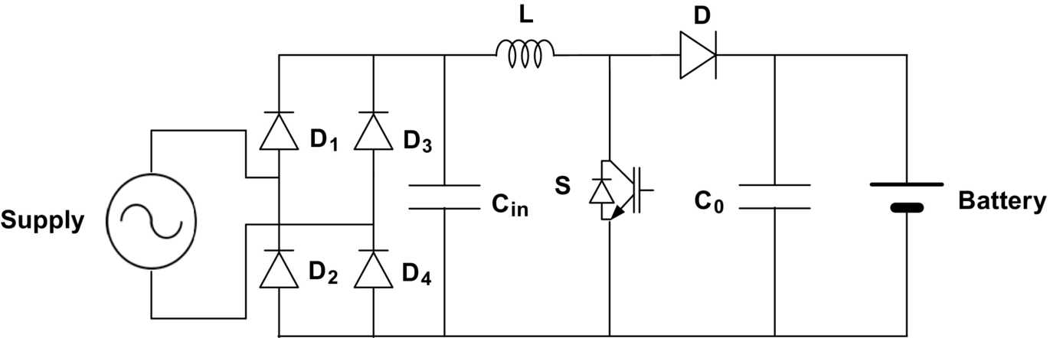

**FIG. 31.39** Conventional single-switch PFC boost converter for battery charging.

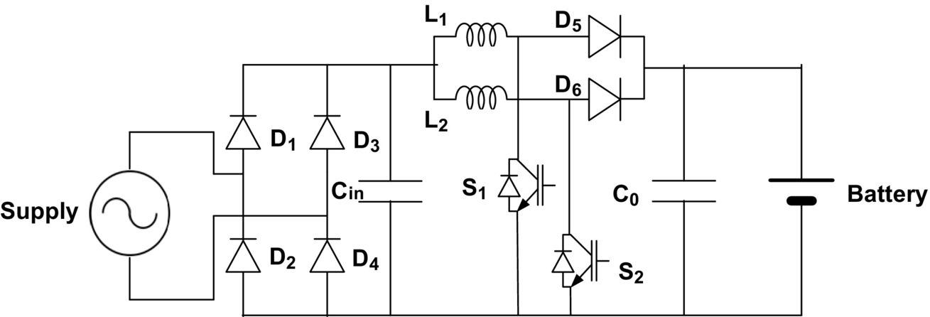

**FIG. 31.40** Interleaved dc/dc boost converter for battery charging.

A bidirectional charging system supports grid-to-vehicle (G2V) and vehicle-to-grid (V2G) operation by injecting power to the grid and power stabilization with adequate power conversion [[73](https://learning.oreilly.com/library/view/power-electronics-handbook/9780128114087/B9780128114070000350.xhtml#bb0370),[91](https://learning.oreilly.com/library/view/power-electronics-handbook/9780128114087/B9780128114070000350.xhtml#bb0460),[92](https://learning.oreilly.com/library/view/power-electronics-handbook/9780128114087/B9780128114070000350.xhtml#bb0465)]. A conventional bidirectional charger process supplies power in two stages. In the first stage, an active grid connected bidirectional ac/dc converter integrated with EMI filter and PFC is connected that enforces power factor to be close to unity. In the second stage a dc/dc converter is connected to regulate charging voltage and current [[72](https://learning.oreilly.com/library/view/power-electronics-handbook/9780128114087/B9780128114070000350.xhtml#bb0365)]. In charging mode, charger should draw sinusoidal current with defined phase angle to control active and reactive power. In discharging mode, the charger should feed back power to the grid with sinusoidal current [[91](https://learning.oreilly.com/library/view/power-electronics-handbook/9780128114087/B9780128114070000350.xhtml#bb0460)]. In ac/dc and dc/dc conversion, isolated and nonisolated converter topologies are used. An isolated bidirectional dual active bridge battery charger system is shown in [Fig. 31.41](https://learning.oreilly.com/library/view/power-electronics-handbook/9780128114087/B9780128114070000350.xhtml#f0215) that offers high power density and fast control; however, the large number of component's count can add to cost [[25](https://learning.oreilly.com/library/view/power-electronics-handbook/9780128114087/B9780128114070000350.xhtml#bb0130)].

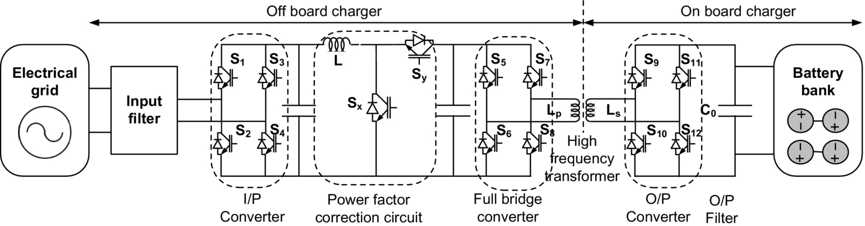

**FIG. 31.41** Battery charger for EV/PHEV with bidirectional power flow.

The development of charger infrastructure with bidirectional power flow is growing rapidly; however, it imposes some serious challenges and issues such as reduction in battery life due to frequent charging and discharging, increased cost of charger, upgradation of existing distributed network, metering, and pricing [[92](https://learning.oreilly.com/library/view/power-electronics-handbook/9780128114087/B9780128114070000350.xhtml#bb0465)]. Successful implementation of battery charger with bidirectional power flow needs to solve the abovementioned issues. Also, it requires extensive safety measures and anti-islanding protection [[92](https://learning.oreilly.com/library/view/power-electronics-handbook/9780128114087/B9780128114070000350.xhtml#bb0465)]. A unidirectional charger can be used for types I, II, and III charging; however, bidirectional chargers that are expected only for type-II charging system due to output power limit and cost target that are low and relatively high degree of freedom and flexibility in operation.

##### **Integrated charger**

At present, the onboard chargers face constraints on weight, volume cost, and space over specific power capacity of the battery. To overcome the abovementioned problems, charger configuration with integrated propulsion inverter-motor drive has been proposed [[93](https://learning.oreilly.com/library/view/power-electronics-handbook/9780128114087/B9780128114070000350.xhtml#bb0470),[94](https://learning.oreilly.com/library/view/power-electronics-handbook/9780128114087/B9780128114070000350.xhtml#bb0475)]. The concept of integrated charger is feasible only if the vehicle is at rest. In an integrated charger, the propulsion inverter serves as a bidirectional ac/dc converter, and motor windings are used as filter inductors. Low cost, high-power-density bidirectional power flow, and fast charging with unity power factor are the advantages of the system. However, extra component requirement and control complexity are some of the challenges in its successful implementation. The schematic of a typical single-motor- and single-converter-based integrated charger system is shown in [Fig. 31.42](https://learning.oreilly.com/library/view/power-electronics-handbook/9780128114087/B9780128114070000350.xhtml#f0220).

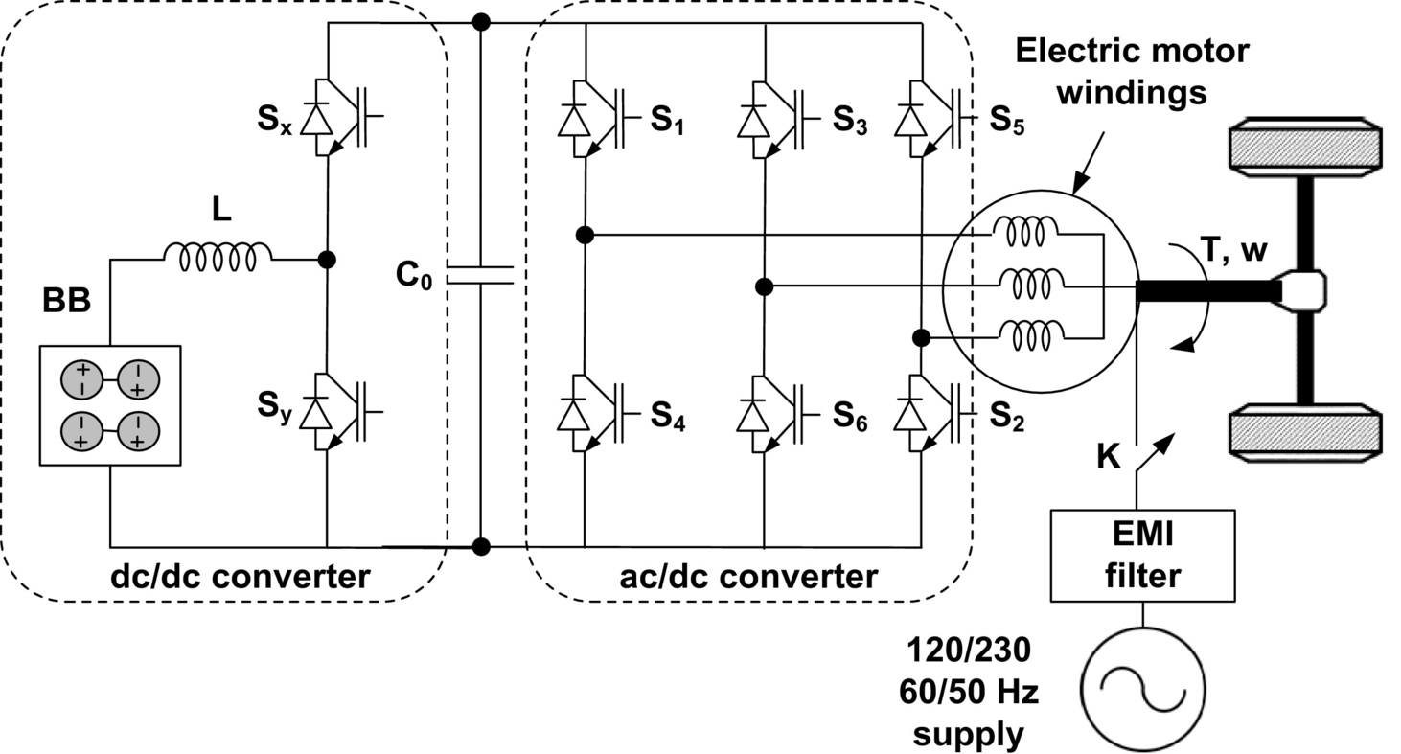

**FIG. 31.42** Typical structure of integrated BEV charger.

The classification of integrated charger topologies is done on the basis of the number of total converter and motor used such as one motor with a converter topology, one-motor and two-converter topology, and two-motor and two-converter topology [[93](https://learning.oreilly.com/library/view/power-electronics-handbook/9780128114087/B9780128114070000350.xhtml#bb0470)–[97](https://learning.oreilly.com/library/view/power-electronics-handbook/9780128114087/B9780128114070000350.xhtml#bb0490)]. A two-motor and two-converter integrated charger system is shown in [Fig. 31.43](https://learning.oreilly.com/library/view/power-electronics-handbook/9780128114087/B9780128114070000350.xhtml#f0225) as discussed in [[95](https://learning.oreilly.com/library/view/power-electronics-handbook/9780128114087/B9780128114070000350.xhtml#bb0480)]. In this system, main converter is used to drive the main motor, and auxiliary converter is used to drive the auxiliary motor during propulsion. During charging, two converters operated as ac/dc converter, and three-phase windings of the two motors act as filter inductor with neutral point connected to the grid [[95](https://learning.oreilly.com/library/view/power-electronics-handbook/9780128114087/B9780128114070000350.xhtml#bb0480),[96](https://learning.oreilly.com/library/view/power-electronics-handbook/9780128114087/B9780128114070000350.xhtml#bb0485)]. The main converter recovers energy from main motor during regenerative braking for battery charging while maintaining the driving force for propulsion. The auxiliary converter coupled with auxiliary motor serves the purpose of starting of ICE and battery charging. This configuration of integrated charger is more popular for PHEVs. The inherent disadvantages of this integrated charger are the large number of extra components (twelve power switches, three contactors, and two motors) and control complexity.

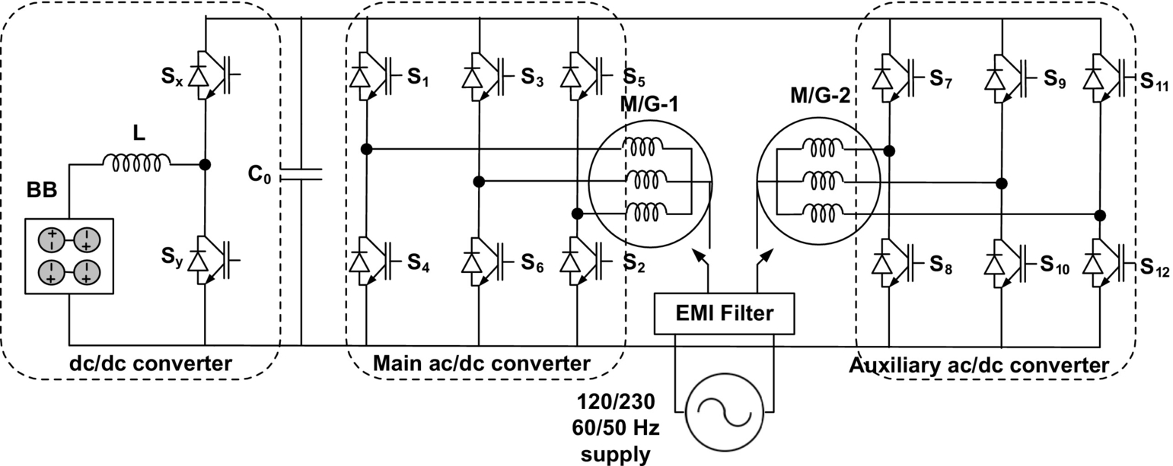

**FIG. 31.43** Dual-motor dual-inverter integrated charger configuration.

A dual-inverter, single-motor integrated charger topology is shown in [Fig. 31.44](https://learning.oreilly.com/library/view/power-electronics-handbook/9780128114087/B9780128114070000350.xhtml#f0230), where one motor with a double set of stator windings comprises two motor halves [[97](https://learning.oreilly.com/library/view/power-electronics-handbook/9780128114087/B9780128114070000350.xhtml#bb0490)]. The working principle of this configuration is similar to two-motor and two-inverter configuration. However, in this configuration, elimination of one motor leads to reduction in cost and weight but still requires three contactors, 12 power switches, and a specially designed dual winding motor.

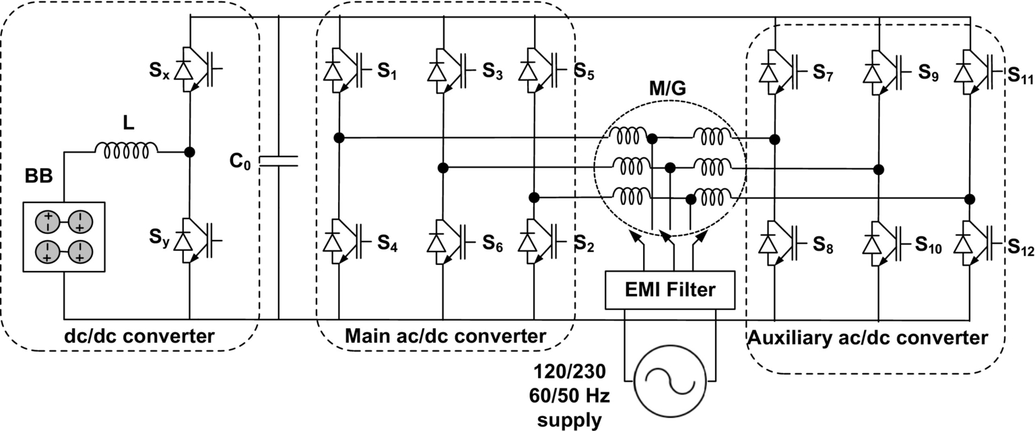

**FIG. 31.44** Dual-inverter single-motor integrated charger configuration.

##### **Inductive charging**

In conductive charging systems, battery bank is directly connected to the power outlet through charger connecting cable [[98](https://learning.oreilly.com/library/view/power-electronics-handbook/9780128114087/B9780128114070000350.xhtml#bb0495)]. The standard charging port like domestic power outlets (type I and type II) or commercialized charging station (type II and type III) can be used for battery charging. However, in conductive charging, vehicles need to be parked and plugged into charging outlet.

As an alternative, inductive power charging concept has been introduced and mostly known as inductive power transfer (IPT). In IPT, the energy from power outlet is transferred to the onboard battery magnetically. The basic scheme of the IPT is illustrated in [Fig. 31.45](https://learning.oreilly.com/library/view/power-electronics-handbook/9780128114087/B9780128114070000350.xhtml#f0235). The working principle of IPT is based on the magnetic coupling between two coils of a very-high-frequency transformer. The first coil of the transformer is mounted on the charger side, and the second coil is installed on the vehicle. Single-phase or three-phase ac supply of frequency 50–60 Hz is first rectified to dc, and then, this rectified dc is inverted to very-high-frequency ac within the charging station. This high-frequency power is transferred to the onboard battery through magnetically coupled primary and secondary coil. This high-frequency ac power received through vehicle side coil is converted to dc to charge the battery on board. The clear advantages of IPT are elimination of charger connectors, user convenience, and galvanic isolation. Also, it is possible to build charging strips on road, which enables charging while driving as shown in [Fig. 31.46](https://learning.oreilly.com/library/view/power-electronics-handbook/9780128114087/B9780128114070000350.xhtml#f0240). Relatively low power density and reduced efficiency, high control complexity, and manufacturing cost are some of the major disadvantages of this method [[99](https://learning.oreilly.com/library/view/power-electronics-handbook/9780128114087/B9780128114070000350.xhtml#bb0500)–[101](https://learning.oreilly.com/library/view/power-electronics-handbook/9780128114087/B9780128114070000350.xhtml#bb0510)].

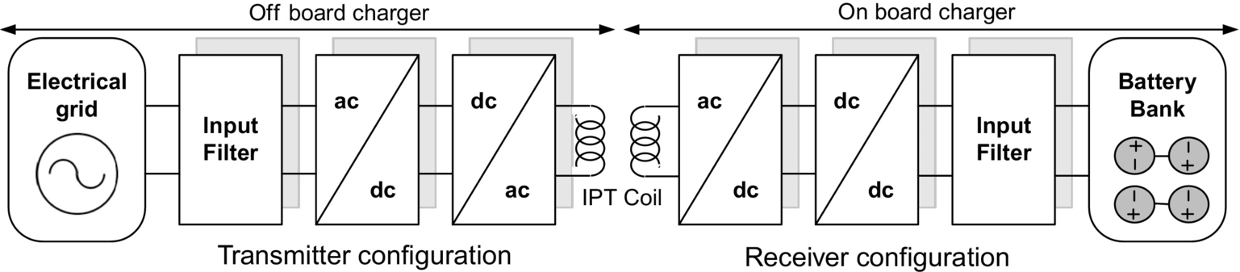

**FIG. 31.45** Contactless, inductive, and wireless charging System.

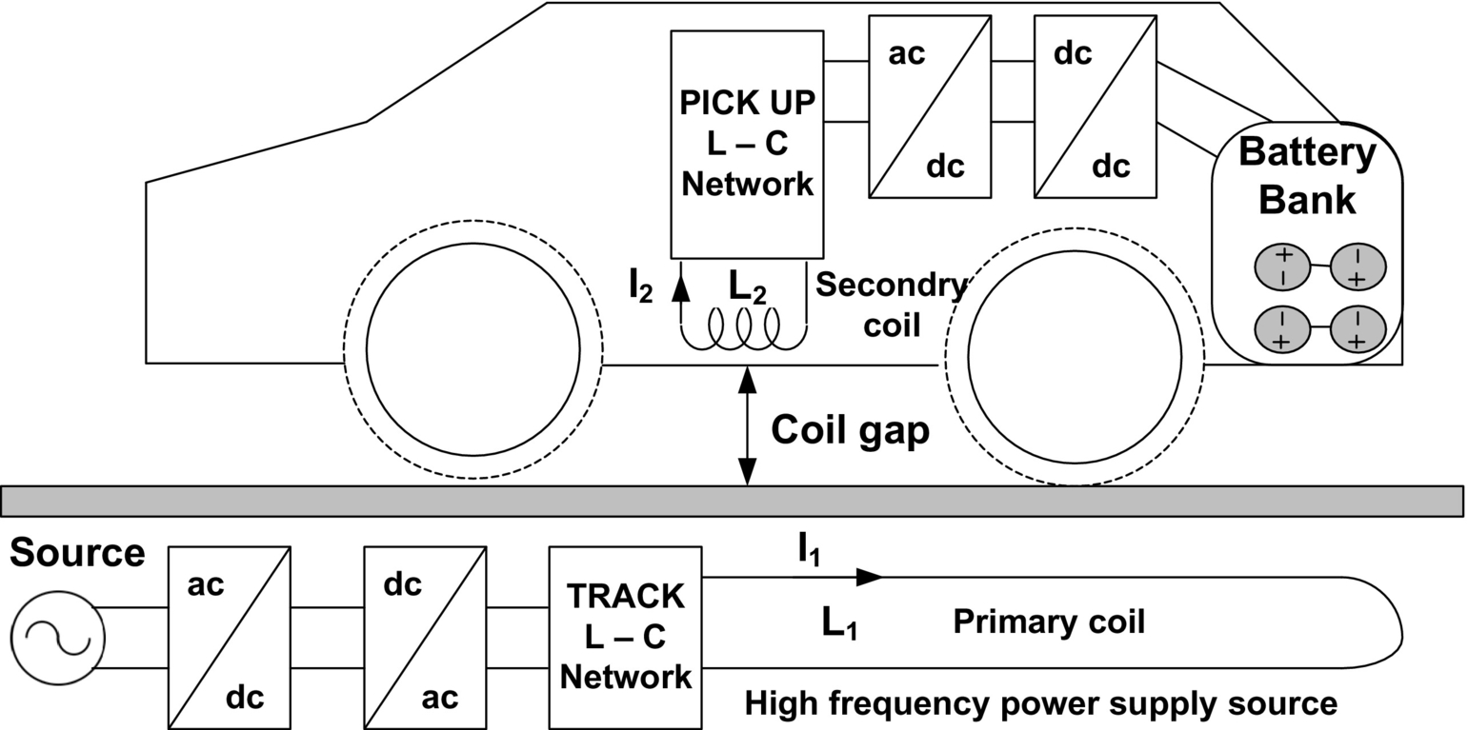

**FIG. 31.46** Inductive coupling road bed BEV battery charger.

## 31.5 Electronic Control Unit

The electronic control units (ECU) are designed to provide supervisory control of electric vehicular system [[102](https://learning.oreilly.com/library/view/power-electronics-handbook/9780128114087/B9780128114070000350.xhtml#bb0515)]. It is a combination of dedicated system control software and electronic circuitry that includes interfacing hardware, sensing circuitry, driver and isolator circuitry, and communication buses. Basically, ECU is the integration of sophisticated electronic circuitry; dedicated digital controllers like microprocessors, microcontrollers, digital signal processors (DSP), and/or field programming gate array (FPGA); and modeling and simulation tools with autocode generation systems like MATLAB/Simulink, ADVISOR, PSAT, PSIM, SABER, SIMPLORER, and VTB, along with embedded software [[26](https://learning.oreilly.com/library/view/power-electronics-handbook/9780128114087/B9780128114070000350.xhtml#bb0135),[102](https://learning.oreilly.com/library/view/power-electronics-handbook/9780128114087/B9780128114070000350.xhtml#bb0515),[103](https://learning.oreilly.com/library/view/power-electronics-handbook/9780128114087/B9780128114070000350.xhtml#bb0520)].

ECU provides the flexible multi-input/multi-output channels for communication among various components of the vehicular system. The controller synchronizes or coordinates with the components of EPS such as ESSS, PEC, electric motors along with ICE, transmission system, pilot commands, and operating modes of the vehicle. The ECU controls and maps the status of electric motor, ICE, and vehicle behavior based on a selection of system inputs. Standard pilot commands, such as braking and acceleration, are supplied as system input to the ECU from appropriate sensors and CAN buses. Based on system input and CAN bus information, certain mappings of different system components are performed to monitor their current status to select the vehicle's mode of operation [[104](https://learning.oreilly.com/library/view/power-electronics-handbook/9780128114087/B9780128114070000350.xhtml#bb0525),[105](https://learning.oreilly.com/library/view/power-electronics-handbook/9780128114087/B9780128114070000350.xhtml#bb0530)]. The entire information is processed in digital controllers through programming, which performs the required calculation and converted into desired power and/or torque and/or speed commands for each wheel individually or simultaneously. The output of ECU that is driving signals for various components of the vehicle is communicated through CAN transmitter over different sections of vehicles. Not only the ECU is able to implement a variety of advanced vehicle control and dynamic algorithms, but also it monitors overall vehicle behaviors and observes the performance. The ECU is placed near to motor drives and engine; therefore, it should be designed such that it can bear temperature ranging from 80°C to 140°C and extreme vibrations that are a major challenge. A self-explanatory architecture of the ECU is shown in [Fig. 31.47](https://learning.oreilly.com/library/view/power-electronics-handbook/9780128114087/B9780128114070000350.xhtml#f0245).

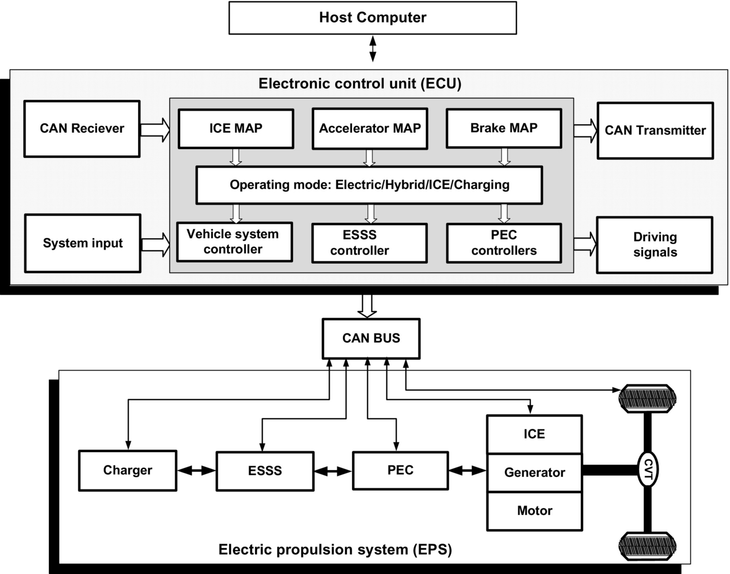

**FIG. 31.47** Architecture of electronic controller in electrified vehicles [[104](https://learning.oreilly.com/library/view/power-electronics-handbook/9780128114087/B9780128114070000350.xhtml#bb0525)].

## 31.6 Power Management and Control Algorithm

In EVT, the control and management of power flow from multiple energy sources to power electronic converters and from converters to different vehicle loads is a major challenge. The technological advancement transforms the early ON/OFF control system to modern adaptive predictive control era that improves the overall performance of control system [[106](https://learning.oreilly.com/library/view/power-electronics-handbook/9780128114087/B9780128114070000350.xhtml#bb0535),[107](https://learning.oreilly.com/library/view/power-electronics-handbook/9780128114087/B9780128114070000350.xhtml#bb0540)]. Dedicated efforts are being given for the development of appropriate control and energy management strategy that is very essential, specifically in HEV operation.

A control strategy is defined as an algorithm, which is a set of instructions or laws regulating the overall operation and power flow of the vehicular system. The algorithm can be considered as a black box that performs desired calculation on the basis of given information. Input information mainly contains measured data of vehicle's operating condition such as acceleration, braking, torque demand, traffic information, and driving profile. The output of the algorithms is a decision that commands the driver circuits to turn ON or OFF the vehicle's components or to modify their operating region toward optimization [[106](https://learning.oreilly.com/library/view/power-electronics-handbook/9780128114087/B9780128114070000350.xhtml#bb0535)]. A properly developed control algorithm and management strategy should satisfy certain objectives such as vehicle power demand, monitoring of battery's state of charge, fuel economy, reduced emission, efficiency optimization, and smooth coordination between electric and mechanical components. Therefore, it becomes prime concern to adopt systematic process for power-flow control and optimization while designing the controllers and control algorithms.

Controllers are mainly classified into two groups based on their mathematical modeling strategy: (1) rule-based systems and (2) optimization-based systems [[107](https://learning.oreilly.com/library/view/power-electronics-handbook/9780128114087/B9780128114070000350.xhtml#bb0540)]. The detailed classification of both the controllers is given in [Fig. 31.48](https://learning.oreilly.com/library/view/power-electronics-handbook/9780128114087/B9780128114070000350.xhtml#f0250). Basically, rule-based controllers are designed to obtain maximum fuel economy and efficiency and reduced emission for predefined driving profiles. Rule-based controllers are tuned based on sets of rules or criteria written on the basis of vehicle information. In this controller, state diagram and flow charts are commonly used for performance optimization of each component individually rather than cumulative. On the other hand, optimization-based controllers are designed to develop optimal control strategy for propulsion system by reducing the cost function. The cost function is derived based on the past and future information of driving profile, component parameters, and expected performance of the vehicles.

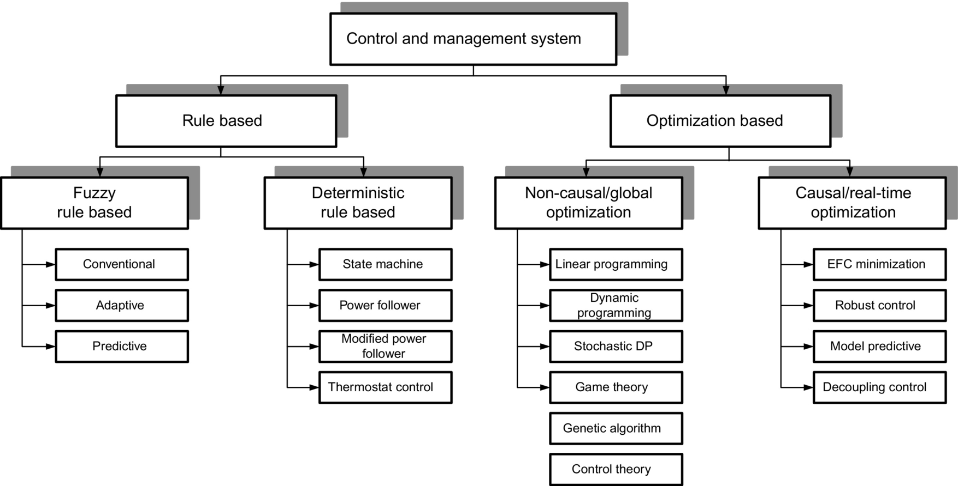

**FIG. 31.48** Classification of control algorithms and power management techniques for EPS [[107](https://learning.oreilly.com/library/view/power-electronics-handbook/9780128114087/B9780128114070000350.xhtml#bb0540)].

This controller is tuned for overall vehicular system optimization rather than component level. Both the controllers have their own pros and cons that are summarized in [Table 31.12](https://learning.oreilly.com/library/view/power-electronics-handbook/9780128114087/B9780128114070000350.xhtml#t0060) and need to be addressed properly before implementing the algorithms. The global control strategy with real-time optimization has been the best proposed solution for HEV/PHEV so far [[106](https://learning.oreilly.com/library/view/power-electronics-handbook/9780128114087/B9780128114070000350.xhtml#bb0535)].

**Table 31.12**

**Comparison between rule-based and optimization-based controllers**

|  |  |  |
| --- | --- | --- |
|  | **Rule-based** | **Optimization-based** |
| Implementation | Simple | Complex |
| Speed | Fast | Slow |
| Sensitivity | Low | High |
| Optimality | Approximate | Exact |
| Information needed | Less | More |

## 31.7 Summary

Contemporary and futuristic global scenario of environmental, economical, and technological factors has accelerated the interest toward partial and/or complete electrification of vehicular technology. In this chapter, topological configuration of different vehicles has been presented with emphasis on EPS and its components to understand the fundamentals of EVT. The comprehensive review of the electrified vehicle architecture and EPS shows that EVT is a promising technology for sustainable future transportation system. At present, HEVs are dominating vehicle configurations, emerging rapidly and capturing the significant market space at very fast growth rate. Suitable energy policy and infrastructures for charging station will accelerate the commercialization of plug-in HEV very soon in the near future, and it will sustain for long time. FCVs are under development stage, and it will take time for their successful commercialization. FCV can be seen as the future of transportation system in long run.

The comprehensive review of EPS indicates that the recent modification in EPS due to technological advancement of its members, like ESS, PEC, EM, and ECU, makes EVT capable enough to compete against conventional ICE-based vehicular technology. Among all the components, PECs play crucial role as it bears the responsibility of compatible integration proper coordination among all the electric, mechanical, and electronic components on board. Also, the PEC controls and manages power flow from different energy sources and vehicle loads at appropriate voltage level and hence behaves as a heart of EPS in vehicle architecture. The integration and packaging of different components of EPS along with power electronic components are the challenging issues that need to be addressed properly so that weight, volume, and cost can be reduced significantly. For successive advancement of EPS, technical breakthroughs are necessary from device level to system level, so that improved performance, higher efficiency, longer driving distance, and higher degree of reliability can be achieved from electrified vehicles.

## References

[1] Streimikiene D., Baležentis T., Baležentien L. Comparative assessment of road transport technologies. *Renew. Sustain. Energy Rev.* 2013;20:611–618.

[2] Mobility 2030: “Meeting the Challenges of Sustainability”, World Business Council for Sustainable Development (WBCSD) July 2004a and 2004b.

[3] International Energy Agency, Global EV outlook: Understanding the electric vehicle landscape to 2020. [Online]. Available: <https://www.iea.org/publications/freepublications/publication/GlobalEVOutlook_2013.pdf>, 2013.

[4] Chan C.C., Wong Y.S. Electric vehicles charge forward. *IEEE Power Energy Mag.* 2004;2(6):24–33.

[5] Emadi A. Transportation 2.0. *IEEE Power Energy Mag.* 2011;9(4):18–29.

[6] Kumar Lalit, Jain S. *Development of Power Electronic Interface for Electric Propulsion System.* PhD Dissertation Bhopal, India: MANIT; 2016.

[7] Williamson S.S., Emadi A. Comparative assessment of hybrid electric and fuel cell vehicles based on comprehensive well-to-wheels efficiency analysis. *IEEE Trans. Veh. Technol.* 2005;54(3):856–862.

[8] Chan C.C. The state of the art of electric, hybrid, and fuel cell vehicles. *Proc. IEEE.* 2007;95(4):704–718.

[9] Emadi A., Rajashekara K., Williamson S.S., Lukic S.M. Topological overview of hybrid electric and fuel cell vehicular power system architectures and configurations. *IEEE Trans. Veh. Technol.* 2005;54(3):763–770.

[10] Chau K.T., Wong Y.S. Overview of power management in hybrid electric vehicle. *Energy Convers. Manag.* 2002;43:1953–1968 Elsevier.

[11] Ghorbani R., Bibeau E., Filizadeh S. On conversion of hybrid electric vehicles to plug-in. *IEEE Trans. Veh. Technol.* 2010;59(4):2016–2020.

[12] Tuttle D.P., Baldick R. The evolution of plug-in electric vehicle-grid interactions. *IEEE Trans. Smart Grid.* 2012;3(1):500–505.

[13] Srinivasaraghavan S., Khaligh A. Time management. *IEEE Power Energy Mag.* 2011;9(4):46–53.

[14] F. Nemry, G. Leduc, A. Muñoz, Plug-in Hybrid and Battery-Electric Vehicles: State of the Research and Development and Comparative Analysis of Energy and Cost Efficiency, JRC Technical Notes, European Communities, 2009.

[15] Kramer B., Chakraborty S., Kroposki B. *A review of plug-in vehicles and vehicle-to-grid capability.* In: Industrial Electronics, 2008. IECON 2008. 34th Annual Conference of IEEE, 10–13 Nov; 2008:2278–2283.

[16] APEEM Annual Progress Report, <http://www1.eere.energy.gov/vehiclesandfuels/pdfs> (accessed 12.07.10).

[17] Chau K.T., Wong Y.S., Chan C.C. An overview of energy sources for electric vehicle. *Energy Convers. Manage.* 1999;40:1953–1968 Elsevier.

[18] Khaligh A., Li Z. Battery, ultracapacitor, fuel cell, and hybrid energy storage systems for electric, hybrid electric, fuel cell, and plug-in hybrid electric vehicles: state of the art. *IEEE Trans. Veh. Technol.* 2010;59(6):2806–2814.

[19] Tie S.F., Tan C.W. A review of energy sources and energy management system in electric vehicles. *Renew. Sust. Energ. Rev.* 2013;20:82–102.

[20] Sun L., Chan C.C., Liang R., Wang Q. *State-of-art of energy system for new energy vehicles.* In: Vehicle Power and Propulsion Conference, 2008. VPPC ′08. IEEE, 3–5 Sept; 2008:1–8.

[21] Bose B.K. Power electronics and motor drives recent progress and perspective. *IEEE Trans. Ind. Electron.* 2009;56(2):581–588.

[22] Emadi A., Lee Y.J., Rajashekara K. Power electronics and motor drives in electric, hybrid electric, and plug-in hybrid electric vehicles. *IEEE Trans. Ind. Electron.* 2008;55(6):2237–2245.

[23] Emadi A., Williamson S.S., Khaligh A. Power electronics intensive solutions for advanced electric, hybrid electric, and fuel cell vehicular power systems. *IEEE Trans. Power Electron.* 2006;21(3):567–577.

[24] Lai J.-S., Nelson D.J. Energy management power converters in hybrid electric and fuel cell vehicles. *Proc. IEEE.* 2007;95(4):766–777.

[25] Kumar L., Kumar Gupta K., Jain S. *Power electronic interface for vehicular electrification.* In: IEEE International Symposium on Industrial Electronics; 2013.

[26] Akin B., Choi S., Toliyat H.A. DSP applications in electric and hybrid electric vehicles [in the spotlight]. *IEEE Trans. Sig. Process.* 2012;29(3):136 133.

[27] Thounthong P., Chunkag V., Sethakul P., Davat B., Hinaje M. Comparative study of fuel-cell vehicle hybridization with battery or supercapacitor storage device. *IEEE Trans. Veh. Technol.* 2009;58(8):3892–3904.

[28] Bernard J., Delprat S., Buchi F.N., Guerra T.M. Fuel-cell hybrid powertrain: toward minimization of hydrogen consumption. *IEEE Trans. Veh. Technol.* 2009;58(7):3168–3176.

[29] Chan C.C., Chau K.T. *Modern Electric Vehicle Technology.* New York: Oxford University Press; 2001.

[30] Whittingham M.S. History, evolution, and future status of energy storage. *Proc. IEEE.* 2012;100(Special Centennial Issue):1518–1534.

[31] Ortuzar M., Moreno J., Dixon J. Ultra capacitor-based auxiliary energy system for an electric vehicle: Implementation and evaluation. *IEEE Trans. Ind. Electron.* 2007;54(4):2147–2156.

[32] Lukic S. Charging ahead. *IEEE Ind. Electron. Mag.* 2008;2(4):22–31.

[33] Lukic S.M., Wirasingha S.G., Rodriguez F., Cao J., Emadi A. *Power management of an ultra-capacitor/battery hybrid energy storage system in an HEV.* In: Proceedings of the IEEE Vehicular Power Propulsion Conference, Windsor, UK; 2006:1–6.

[34] Burke A.F. Batteries and ultracapacitors for electric, hybrid, and fuel cell vehicles. *Proc. IEEE.* 2007;95(4):806–820.

[35] Bakhoum E. New mega-farad ultracapacitors. *IEEE Trans. Ultra. Ferroelect. Freq. Control.* 2009;56(1):14–21.

[36] Zorpette G. Super charged [ultracapacitors]. *IEEE Spectr.* 2005;42(1):32–37.

[37] Hebner R., Beno J., Walls A. Flywheel batteries come around again. *IEEE Spectr.* 2002;39(4):46–51.

[38] Briat O., Vinassa J.M., Lajnef W., Azzopardi S., Woirgard E. Principle, design and experimental validation of a flywheel-battery hybrid source for heavy-duty electric vehicles. *IET Electr. Power Appl.* 2007;1(5):665–674.

[39] Sebastián R., Peña Alzola R. Flywheel energy storage systems: review and simulation for an isolated wind power system. *Renew. Sust. Energ. Rev.* 2012;16:6803–6813.

[40] Mock P., Schmid S.A. Fuel cells for automotive powertrains—A techno-economic assessment. *J. Power Sources.* 2009;190(1):133–140.

[41] Riezenman M.J. Fuel cells for the long haul, batteries for the spurts [electric vehicles]. *IEEE Spectr.* 2001;38(1):95–97.

[42] Bauman J., Kazerani M. A comparative study of fuel-cell-battery, fuel-cell-ultracapacitor, and fuel-cell-battery-ultracapacitor vehicles. *IEEE Trans. Veh. Technol.* 2008;57(2):760–769.

[43] Sorensen B. *Hydrogen and Fuel Cells: Emerging Technologies and Applications.* Oxford, UK: Academic Press, Elsevier; 2011 ISBN: 10:0-12-655281-2.

[44] Mekhilef S., Saidur R., Safari A. Comparative study of different fuel cell technologies. *Renew. Sust. Energ. Rev.* 2012;16:981–989.

[45] Kirubakaran A., Jain S., Nema R.K. A review on fuel cell technologies and power electronic interface. *Renew. Sust. Energ. Rev.* 2009;13:2430–2440.

[46] Doucette R.T., McCulloch M.D. A comparison of high-speed flywheels, batteries, and ultracapacitors on the bases of cost and fuel economy as the energy storage system in a fuel cell based hybrid electric vehicle. *J. Power Sources.* 2011;196(3):1163–1170.

[47] Miller J.M., Bohn T., Dougherty T.J., Deshpande U. *Why hybridization of energy storage is essential for future hybrid, plug-in, and battery electric vehicles.* In: Proceedings of the IEEE Energy Conversion Congress Exposition (ECCE), San Jose, CA; 2009:2614–2620.

[48] Zhu Z.Q., Howe D. Electrical machines and drives for electric, hybrid, and fuel cell vehicles. *Proc. IEEE.* 2007;95(4):746–765.

[49] Zeraoulia M., Benbouzid M.E.H., Diallo D. Electric motor drive selection issues for HEV propulsion systems: a comparative study. *IEEE Trans. Veh. Technol.* 2006;55(6):1756–1764.

[50] Nanda G., Kar N.C. *A survey and comparison of characteristics of motor drives used in electric vehicles.* In: Canadian Conference on Electrical and Computer Engineering, 2006. CCECE ′06; 2006:811–814.

[51] Hashemnia N., Asaei B. *Comparative study of using different electric motors in the electric vehicles.* In: 18th International Conference on Electrical Machines, 2008. ICEM 2008; 2008:1–5.

[52] West J.G.W. *DC, induction, reluctance and PM motors for electric vehicles.* In: IEE Colloquium on Motors and Drives for Battery Powered Propulsion; 1993 pp. 1/1–111.

[53] De Santiago J., Bernhoff H., Ekergård B., Eriksson S., Ferhatovic S., Waters R., Leijon M. Electrical motor drivelines in commercial all-electric vehicles: a review. *IEEE Trans. Veh. Technol.* 2012;61(2):475–484.

[54] Zhu Z.Q., Chan C.C. *Electrical machine topologies and technologies for electric, hybrid, and fuel cell vehicles.* In: IEEE Vehicle Power and Propulsion Conference, 2008. VPPC ′08; 2008:1–6.

[55] R. Fessler, ORNL/TM-2011/73, Final Report on Assessment of Motor Technologies for Traction Drives of Hybrid and Electric Vehicles, published 10 March 2011.

[56] Ehsani M., Gao Y., Miller J.M. Hybrid electric vehicles: architecture and motor drives. *Proc. IEEE.* 2007;95(4):719–728.

[57] Wang T., et al. Design characteristics of the induction motor used for hybrid electric vehicle. *IEEE Trans. Magn.* 2005;41(1):505–508.

[58] Chau K.T., Chan C.C., Liu C. Overview of permanent-magnet brushless drives for electric and hybrid electric vehicles. *IEEE Trans. Ind. Electron.* 2008;55(6):2246–2257.

[59] Rahman M.A. *Recent status on IPM traction drives for plug-in and hybrid electric vehicles.* In: IEEE Power and Energy Society General Meeting; 2010:1–6.

[60] Pellegrino G., Vagati A., Guglielmi P., Boazzo B. Performance comparison between surface-mounted and interior pm motor drives for electric vehicle application. *IEEE Trans. Ind. Electron.* 2012;59(2):803–811.

[61] Rahman K.M., Fahimi B., Suresh G., Rajarathnam A.V., Ehsani M. Advantages of switched reluctance motor applications to EV and HEV: design and control issues. *IEEE Trans. Ind. Electron.* 2000;36(1):111–121.

[62] Bilgin B., Emadi A., Krishnamurthy M. Design considerations for switched reluctance machines with a higher number of rotor poles. *IEEE Trans. Ind. Electron.* 2012;59(10):3745–3756.

[63] Chan C.C., Chau K.T. An overview of power electronics in electric vehicles. *IEEE Trans. Ind. Electron.* 1997;44(1):3–13.

[64] Bellur D.M., Kazimierczuk M.K. *DC-DC converters for electric vehicle applications.* In: Electrical Insulation Conference and Electrical Manufacturing Expo; 2007:286–293.

[65] Lee Y.-J., Khaligh A., Emadi A. Advanced integrated bidirectional AC/DC and DC/DC converter for plug-in hybrid electric vehicles. *IEEE Trans. Veh. Technol.* 2009;58(8):3970–3980.

[66] Solero L., Lidozzi A., Pomilio J.A. Design of multiple-input power converter for hybrid vehicles. *IEEE Trans. Power Electron.* 2005;20(5):1007–1016.

[67] Yalamanchili K.P., Ferdowsi M. *Review of multiple input DCDC converters for electric and hybrid vehicles.* In: Proceedings of the IEEE Vehicle Power and Propulsion Conference; 2005:160–163.

[68] Gao L., Dougal R.A., Liu S. Power enhancement of an actively controlled battery/ultracapacitor hybrid. *IEEE Trans. Power Electron.* 2005;20(1):236–243.

[69] Cao J., Emadi A. A new battery/ultracapacitor hybrid energy storage system for electric, hybrid, and plug-in hybrid electric vehicles. *IEEE Trans. Power Electron.* 2012;27(1):122–132.

[70] Lu S., Corzine K.A., Ferdowsi M. A new battery/ultracapacitor energy storage system design and its motor drive integration for hybrid electric vehicles. *IEEE Trans. Veh. Technol.* 2007;56(4):1516–1523.

[71] Jahns T.M., Blasko V. Recent advances in power electronics technology for industrial and traction machine drives. *Proc. IEEE.* 2001;89(6):963–975.

[72] Yilmaz M., Krein P.T. Review of battery charger topologies, charging power levels, and infrastructure for plug-in electric and hybrid vehicles. *IEEE Trans. Power Electron.* 2013;28(5):2151–2169.

[73] Lee Y.-J., Khaligh A., Emadi A. Advanced integrated bidirectional AC/DC and DC/DC converter for plug-in hybrid electric vehicles. *IEEE Trans. Veh. Technol.* 2009;58(8):3970–3980.

[74] Shen Z.J., Omura I. Power semiconductor devices for hybrid, electric, and fuel cell vehicles. *Proc. IEEE.* 2007;95(4):778–789.

[75] Zhang H., Tolbert L.M., Ozpineci B. Impact of SiC Devices on hybrid electric and plug-in hybrid electric vehicles. *IEE J. Ind. Appl.* 2011;47(2):912–921.

[76] Musavi F., Edington M., Eberle W., Dunford W.G. Evaluation and efficiency comparison of front end AC-DC plug-in hybrid charger topologies. *IEEE Trans. Smart Grid.* 2012;3(1):413–421.

[77] SAE Electric Vehicle Inductive Coupling Recommended Practice, SAE 5-1773, 1995.

[78] Kumar L., Jain S. Electric propulsion system for electric vehicular technology: a review. *Renew. Sust. Energ. Rev.* 2014;29:924–940.

[79] <https://www1.eere.energy.gov/vehiclesandfuels/pdfs/program/2013_apeem_report.pdf> (accessed 27.07.13).

[80] Lesster L.E. Fuel cell power electronics: managing a variable-voltage dc source in a fixed-voltage ac world. *Fuel Cells Bull.* 2000;3(25):5–9.

[81] Khaligh A., Cao J., Lee Y.-J. A multiple-input DC-DC converter topology. *IEEE Trans. Power Electron.* 2009;24(3):862–868.

[82] Kumar L., Jain S. Multiple-input DC/DC converter topology for hybrid energy system. *IET Power Electron.* 2013;6(8):1483–1501.

[83] Tao H., Kotsopoulos A., Duarte J., Hendrix M.A.M. Family of multiport bidirectional dc-dc converters. *IEE Proc. Electric Power Appl.* 2006;153(3):451–458.

[84] Jiang W., Fahimi B. Multiport power electronic interface—concept, modeling, and design. *IEEE Trans. Power Electron.* 2011;26(7):1890–1900.

[85] Singh B., Singh B.N., Chandra A., Al-Haddad K., Pandey A., Kothari D.P. A review of three-phase improved power quality ac-dc converters. *IEEE Trans. Ind. Electron.* 2004;51(3):641–660.

[86] Toepher C.B. Charge! EVs power up for the long haul. *IEEE Spectr.* 1998;35(11):41–47.

[87] Choe G.Y., Kim J.S., Lee B.K., Won C.Y., Lee T.W. *A bidirectional battery charger for electric vehicles using photovoltaic PCS systems.* In: Proceedings of the IEEE Vehicular Power Propulsion Conference; 2010:1–6.

[88] Fasugba M.A., Krein P.T. *Gaining vehicle-to-grid benefits with unidirectional electric and plug-in hybrid vehicle chargers.* In: Proceedings of the IEEE Vehicular Power and Propulsion Conference; 2011:1–6.

[89] Singh B., Singh B.N., Chandra A., Al-Haddad K., Pandey A., Kothari D.P. A review of single-phase improved power quality AC-DC converters. *IEEE Trans. Ind. Electron.* 2003;50(5):962–981.

[90] Aggeler D., Canales F., Zelaya - De La Parra H., Coccia A., Butcher N., Apeldoorn O. *Ultra-fast dc-charge infrastructures for EV-mobility and future smart grids.* In: Proceedings of the IEEE Power Energy Society Innovative Smart Grid Technologies Conference Europe; 2010:1–8.

[91] Du Y., Lukic S., Jacobson B., Huang A. *Review of high power isolated bi-directional DC-DC converters for PHEV/EV DC charging infrastructure.* In: Proceedings of the IEEE Energy Conversion Congress and Exposition; 2011:553–560.

[92] Peterson S.B., Whitacre J.F., Apt J. The economics of using plug-in hybrid electric vehicle battery packs for grid storage. *J. Power Sources.* 2010;195(8):2377–2384.

[93] W.E. Rippel, Integrated traction inverter and battery charger apparatus, U.S. Patent 4,920,475, 1990.

[94] Haghbin S., Khan K., Lundmark S., Alaküla M., Carlson O., Leksell M., Wallmark O. *Integrated chargers for EV's and PHEV's: Examples and new solutions.* In: Proceedings of the International Conference on Electrical Machines; 2010:1–6.

[95] Woo D.G., Choe G.Y., Kim J.S., Lee B.K., Hur J., Kang G.B. *Comparison of integrated battery chargers for plug-in electric vehicles: Topology and control.* In: Proceedings of the Electric Machines and Drives Conference; 2011:1294–1299.

[96] Tang L., Su G.J. *A low-cost, digitally-controlled charger for plug-in hybrid electric vehicles.* In: Proceedings of the IEEE Energy Conversion Congress Expo; 2009:3923–3929.

[97] W. E. Rippel, A. G. Cocconi, Integrated motor drive and recharge system, U.S. Patent 5099186, 1992.

[98] SAE Electric Vehicle and Plug-in Hybrid Electric Vehicle Conductive Charge Coupler, SAE Standard J1772.

[99] Covic G.A., Boys J.T., Lu H.G. A three-phase inductively coupled power transfer system. In: *1ST IEEE Conference on Industrial Electronics and Applications, Singapore.* 2006:1–6.

[100] Huh J.J., Lee S.W., Lee W.Y., Cho G.H., Rim C.T. Narrowwidth inductive power transfer system for online electrical vehicles. *IEEE Trans. Power Electron.* 2011;26(12):3666–3679.

[101] Li H.L., Hu A.P., Covic G.A. A direct ac-ac converter for inductive power-transfer systems. *IEEE Trans. Power Electron.* 2012;27(2):661–668.

[102] Çağatay Bayindir K., Ali Gözüküçük M., Teke A. A comprehensive overview of hybrid electric vehicle: powertrain configurations, powertrain control techniques and electronic control units. *Energy Convers. Manag.* 2011;52(2):1305–1313 Elsevier.

[103] Gao D.W., Mi C., Emadi A. Modeling and simulation of electric and hybrid vehicles. *Proc. IEEE.* 2007;95(4):729–745.

[104] [www.proteanelectric.com](http://www.proteanelectric.com/) (accessed 09.03.13).

[105] [www.delphi.com](http://www.delphi.com/) (accessed 21.05.12).

[106] Wirasingha S.G., Emadi A. Classification and review of control strategies for plug-in hybrid electric vehicles. *IEEE Trans. Veh. Technol.* 2011;60(1):111–122.

[107] Salmasi F.R. Control strategies for hybrid electric vehicles: evolution, classification, comparison, and future trends. *IEEE Trans. Veh. Technol.* 2007;56(5):2393–2404.

## Further Reading

[108] Ehsani M., Rahman K.M., Toliyat H.A. Propulsion system design of electric and hybrid vehicles. *IEEE Trans. Ind. Electron.* 1997;44(1):19–27.

32

Automotive Applications of Power Electronics

David J. Perreault Massachusetts Institute of Technology, Cambridge, MA, United States

Khurram K. Afridi University of Colorado, Boulder, CO, United States

Iftikhar A. Khan Sarhad University of Science and Information Technology, Peshawar, Pakistan

Abstract

The modern automobile has an extensive electric system consisting of a large number of electric, electromechanical, and electronic loads that are central to vehicle operation, passenger safety, and comfort. Power electronics is playing an increasingly important role in automotive electric systems—conditioning the power generated by the alternator, processing it appropriately for the vehicle electric loads, and controlling the operation of these loads. Furthermore, power electronics is an enabling technology for a wide range of future loads with new features and functions.

KEYWORDS

Lundell alternator; ABS; HID lamps; MOSFET; Electric vehicle

32.1 Introduction

32.2 The Present Automotive Electrical Power System

32.3 System Environment

32.3.1 Static Voltage Ranges

32.3.2 Transients and Electromagnetic Immunity

32.3.3 Electromagnetic Interference

32.3.4 Environmental Considerations

32.4 Functions Enabled by Power Electronics

32.4.1 High Intensity Discharge Lamps

32.4.2 Pulse-Width Modulated Incandescent Lighting

32.4.3 Piezoelectric Ultrasonic Actuators

32.4.4 Electromechanical Engine Valves

32.4.5 Electric Air Conditioner

32.4.6 Electric and Electrohydraulic Power Steering Systems

32.4.7 Motor Speed Control

32.5 Multiplexed Load Control

32.6 Electromechanical Power Conversion

32.6.1 The Lundell Alternator

32.6.2 Advanced Lundell Alternator Design Techniques

32.6.3 Alternative Machines and Power Electronics

32.7 Dual/High Voltage Automotive Electrical Systems

32.7.1 Trends Driving System

32.7.2 Voltage Specifications

32.7.3 Dual-Voltage Architectures

32.8 Electric and Hybrid Electric Vehicles

32.9 Summary

References

32.1 Introduction

The modern automobile has an extensive electric system consisting of a large number of electric, electromechanical, and electronic loads that are central to vehicle operation, passenger safety, and comfort. Power electronics is playing an increasingly important role in automotive electric systems—conditioning the power generated by the alternator, processing it appropriately for the vehicle electric loads, and controlling the operation of these loads. Furthermore, power electronics is an enabling technology for a wide range of future loads with new features and functions. Such loads include electromagnetic engine valves, active suspension, controlled lighting, and electric propulsion.

This chapter discusses the application and design of power electronics in automobiles. Section 32.2 provides an overview of the architecture of the present automotive electric power system. The next section, Section 32.3, describes the environmental factors, such as voltage ranges, EMI/EMC requirements, and temperature, which strongly influence the design of automotive power electronics. Section 32.4 discusses a number of electric functions that are enabled by power electronics, while Section 32.5 addresses load control via multiplexed remote switching architectures that can be implemented with power electronic switching. Section 32.6 considers the application of power electronics in automotive electromechanical energy conversion, including power generation. Section 32.7 describes the potential evolution of automotive electric systems toward high- and dual-voltage systems and provides an overview of the likely requirements of power electronics in such systems. Finally, the application of power electronics in electric and hybrid electric vehicles (HEVs) is addressed in Section 32.8.

32.2 The Present Automotive Electrical Power System

Present-day automobiles can have over 200 individual electric loads, with average power requirements in excess of 800 W. These include such functions as the headlamps, tail lamps, cabin lamps, starter, fuel pump, wiper, blower fan, fuel injector, transmission shift solenoids, horn, cigar lighter, seat heaters, engine control unit, cruise control, radio, and spark ignition. To power these loads, present-day internal-combustion-engine (ICE) automobiles use an electric power system similar to the one shown in Fig. 32.1. Power is generated by an engine-driven three-phase wound-field synchronous machine—a Lundell (claw-pole) alternator [1,2]. The ac voltage of this machine is rectified and the dc output regulated to about 14 V by an electronic regulator that controls the field current of the machine. The alternator provides power to the loads and charges a 12 V lead-acid battery. The battery provides the high power needed by such loads as the starter and supplies power when the engine is not running or when the demand for electric power exceeds the output power of the alternator. The battery also acts as a large capacitor and smoothes out the system voltage.

f32-01-9780128114070

FIG. 32.1 The 12 V point-to-point automotive electric power system.

Power is distributed to the loads via fuses and point-to-point wiring. The fuses, located in one or more fuse boxes, protect the wires against overheating and fire in the case of a short circuit. Most of the loads are controlled directly by manually actuated mechanical switches. These primary switches are located in areas in easy reach of either the driver or the passengers, such as the dashboard, the door panels, and the ceiling. Some of the heavy loads, such as the starter, are switched indirectly via electromechanical relays.

32.3 System Environment

The challenging electric and environmental conditions found in the modern automobile have a strong impact on the design of automotive power electronic equipment. Important factors affecting the design of electronics for this application include static and transient voltage ranges, electromagnetic interference and compatibility requirements (EMI/EMC), mechanical vibration and shock, and temperature and other environmental conditions. This section briefly describes some of the factors that most strongly affect the design of power electronics for automotive applications. For more detailed guidelines on the design of electronics for automotive applications, the reader is referred to [1,3–16] and the documents cited therein, from which much of the information presented here is drawn.

32.3.1 STATIC VOLTAGE RANGES

In most present-day automobiles, a Lundell-type alternator provides dc electric power with a lead-acid battery for energy storage and buffering. The nominal battery voltage is 12.6 V, which the alternator regulates to 14.2 V when the engine is on in order to maintain a high state of charge on the battery. In practice, the regulation voltage is adjusted for temperature to match the battery characteristics. For example, in Ref. [1], a 25°C regulation voltage of 14.5 V is specified with a −10 mV/°C adjustment. Under normal operating conditions, the bus voltage will be maintained in the range of 11–16 V [3]. Safety-critical equipment is typically expected to be operable even under battery discharge down to 9 V, and equipment operating during starting may see a bus voltage as low as 4.5–6 V under certain conditions.

In addition to the normal operating voltage range, a wider range of conditions is sometimes considered in the design of automotive electronics [3]. One possible condition is reverse-polarity battery installation, resulting in a bus voltage of approximately −12 V. Another static overvoltage condition can occur during jump starting from a 24 V system such as on a tow truck. Other static overvoltage conditions can occur due to failure of the alternator voltage regulator. This can result in a bus voltage as high as 18 V, followed by battery electrolyte boil-off, and a subsequent unregulated bus voltage as high as 130 V. Typically, it is not practical to design the electronics for operation under such an extreme fault condition, but it should be noted that such conditions can occur. Table 32.1 summarizes the range of static voltages that can be expected in the automotive electric system.

Table 32.1

Static voltage range for the automotive electric system [3]

Static voltage condition Voltage

Nominal voltage with engine on 14.2 V

Nominal voltage with engine off 12.6 V

Maximum normal operating voltage 16 V

Minimum normal operating voltage 9 V

Minimum voltage during starting 4.5 V

Jump-start voltage 24 V

Reverse-battery voltage −12 V

Maximum voltage with alternator-regulator failure followed by battery failure 130 V

32.3.2 TRANSIENTS AND ELECTROMAGNETIC IMMUNITY

Power electronic circuits designed for automotive applications must exhibit electromagnetic compatibility, that is, the conducted and radiated emissions generated by the circuit must not interfere with other equipment on board the vehicle, and the circuit must exhibit immunity to radiated and conducted disturbances. The Society of Automotive Engineers (SAE) has laid out standards and recommended practices for the electromagnetic compatibility of automotive electronics in a set of technical reports [4]. These reports are listed in Table 32.2. Here, we will focus on two of the basic requirements of automotive power electronics, immunity to power lead transients and limitation of conducted emissions.

Table 32.2

SAE J1113 electromagnetic compatibility technical reports

SAE specification Type Description

SAE J1113/1 Standard Electromagnetic compatibility measurement procedures and limits, 60 Hz–18 GHz

SAE J1113/2 Standard Conducted immunity, 30 Hz–250 kHz

SAE J1113/3 Standard Conducted immunity, direct injection of RF power, 250 kHz–500 MHz

SAE J1113/4 Standard Conducted immunity, bulk current injection method

SAE J1113/11 Standard Conducted immunity to power lead transients

SAE J1113/12 Recommended practice Electric interference by conduction and coupling—coupling clamp

SAE J1113/13 Recommended practice Immunity to electrostatic discharge

SAE J1113/21 Information report Electric disturbances by narrowband radiated electromagnetic energy—component test methods

SAE J1113/22 Standard Immunity to radiated magnetic fields from power lines

SAE J1113/23 Recommended practice Immunity to radiated electromagnetic fields, 10 kHz–200 MHz, strip-line method

SAE J1113/24 Immunity to radiated electromagnetic fields, 10 kHz–200 MHz, TEM cell method

SAE J1113/25 Standard Immunity to radiated electromagnetic fields, 10 kHz–500 MHz, triplate-line method

SAE J1113/26 Recommended practice Immunity to ac power line electric fields

SAE J1113/27 Recommended practice Immunity to radiated electromagnetic fields, reverberation method

SAE J1113/41 Standard Radiated and conducted emissions, 150 kHz–1000 MHz

SAE J1113/42 Standard Conducted transient emissions

A major consideration in the design of an automotive power electronic system is its immunity to the transients that can appear on its power leads. A number of transient sources exist in the vehicle [5], and procedures for validating immunity to these transients have been established in documents such as SAE J1113/11 [4,6] and DIN 40389 [1]. Table 32.3 illustrates the transient test pulses specified in SAE J1113/11. Each test pulse corresponds to a different type of transient. The vehicle manufacturer determines which test pulses apply to a specific device.

Table 32.3

Transient pulse waveforms specified in SAE J1113/11

Pulse Shape Maximum excursion Source impedance Duration and repetition rate

1 t32-01-9780128114070 −100 V 10 Ω Tpulse=2 ms

0.5 s<Trep<5 s

2a t32-02-9780128114070 100 V 10 Ω Tpulse=50 μs

0.5 s<Trep<5 s

2b t32-03-9780128114070 10 V 0.5–3 Ω Tpulse≥200 ms

3a t32-04-9780128114070 −150 V 50 Ω Tpulse=100 ns

Trep=100 μs

3b t32-05-9780128114070 100 V 50 Ω Tpulse=100 ns

Trep=100 μs

4 t32-06-9780128114070 −7 V 0.01 Ω Tpulse≤20 s

5 t32-07-9780128114070 84 A 0.6 Ω τ=115 ms

Tpulse~4 τ

Transients occur when inductive loads such as solenoids, motors, and clutches are turned on and off. The transients can be especially severe when the bus is disconnected from the battery, as is the case for the accessory loads when the ignition is switched off. Test pulse 1 in Table 32.3 simulates the transient generated when an inductive load is disconnected from the battery and the device under test remains in parallel with it. When the inductive load is a dc motor, it may briefly act as a generator after disconnection. This transient is simulated by test pulse 2b. Test pulse 2a models the transient when current in an inductive element in series with the device under test is interrupted. Test pulses 3a and 3b model switching spikes that appear on the bus during normal operation. Test pulse 4 models the voltage transient that occurs on starting.

Perhaps, the best-known electric disturbance is the so-called load-dump transient that occurs when the alternator load current drops sharply and the battery is unable to properly buffer the change. This can occur when the battery becomes disconnected while drawing a large amount of current. To understand why a major transient can occur under this situation, consider that the Lundell alternator has a very large leakage reactance. The high commutating reactance interacting with the diode rectifier results in a high degree of load regulation, necessitating the use of a large back emf to source-rated current at high speed [7]. Back voltages as high as 120 V may be needed to generate rated current into a 14 V output at top speed. Analytic modeling of such systems is addressed in Ref. [8]. Two effects occur when the load on the alternator suddenly steps down. First, as the machine current drops, the energy in the alternator leakage reactances is immediately delivered to the alternator output, causing a voltage spike. The peak voltage reached depends on the electric system impedance and may be limited by suppression devices. Second, once the alternator current is reduced, the voltage drops across the leakage (commutating) reactances are reduced, and a much larger fraction of the machine back emf is impressed across the dc output. The proper output voltage is only reestablished as the voltage regulator reduces the field current appropriately. With conventional regulator circuits, this takes place on the time scale of the field-winding time constant (typically 100 ms) and results in a major transient event. In systems without centralized protection, a load dump can generate a transient with a peak voltage in excess of 100 V lasting hundreds of milliseconds. Test pulse 5 in Table 32.3 (expressed as a current waveform in parallel with an output resistance) is designed to simulate such a load-dump transient; other load-dump tests are even more severe [1,3].

32.3.3 ELECTROMAGNETIC INTERFERENCE

Strict limits also exist for the amount of electromagnetic interference (EMI) that an automotive electronic component can generate. Limits for both conducted and radiated emissions are specified in SAE standards J1113/41 and J1113/42 [4,9,10]. Here, we will consider the conducted EMI specifications for power leads, since they directly impact the design of EMI filters for automotive power electronics. Meeting the conducted specifications is a major step toward achieving overall compliance.

The conducted EMI specifications in SAE J1113/41 limit the ripple that an electronic circuit can inject onto the voltage bus over the frequency range from 150 kHz to 108 MHz. The amount of ripple injected by a circuit usually depends on the bus impedance. To eliminate any variability due to this, EMI compliance testing is done using a line impedance stabilization network (LISN) between the bus and the device under test, as illustrated in Fig. 32.2. The LISN is also sometimes referred to as an artificial mains network (AN). Essentially, the LISN ensures that the equipment under test receives the proper dc voltage and current levels and also sees a controlled impedance for the ripple frequencies of interest. Fig. 32.3 shows the magnitude of the LISN output impedance for a low-impedance input source; the effective impedance is 50 Ω over most of the frequency range of interest. The 50 Ω termination impedance of the LISN is typically provided by the measurement equipment. The EMI specifications are stated in terms of the allowable voltage ripple (in dB μV) appearing across the 50-Ω LISN resistance as a function of frequency.

f32-02-9780128114070

FIG. 32.2 Conducted EMI test setup with LISN. LLISN=5 μH, CLISN=0.1 μF, and RLISN=50 Ω.

f32-03-9780128114070

FIG. 32.3 The LISN output impedance magnitude for a low-impedance input source.

There are a wide range of other technical considerations for EMI testing, including the arrangement of the equipment over a ground plane and the types and settings of the measuring devices. One characteristic to consider is that the EMI measurements are done across frequency with a spectrum analyzer having a prespecified receiver bandwidth (RBW). For frequencies between 150 kHz and 30 MHz, the receiver bandwidth is 9 kHz, resulting in spectral components within 9 kHz of one another being lumped together for purposes of the test. A full test procedure is defined in the SAE specifications, beginning with narrowband measurements and moving to wideband measurements if necessary. Fig. 32.4 illustrates the narrowband conducted EMI limits for power leads in SAE J1113/41. It is interesting to note that for the commonly used class 5 limits, the allowable ripple current into the LISN at 150 kHz is less than 100 μA!

f32-04-9780128114070

FIG. 32.4 SAE J1113/41 narrowband conducted EMI limits for power leads. The specification covers the frequency range from 150 kHz to 108 MHz.

As seen in the previous section, the transient disturbances generated by electric and electronic equipment are an important consideration in automotive applications. Because power electronic circuits typically contain switches and magnetic elements, they are potential sources for such transients, especially when powered from the switched ignition line. SAE J1113/42 specifies methods for testing and evaluating the transients generated by automotive electric components and proposes transient waveform limits for different severity levels. The equipment under test is set up in a configuration similar to that in Fig. 32.2 but with a switching device on one side or the other of the LISN, depending on the application. The equipment under test is then evaluated for transient behavior at turn-on, turnoff, and across its operating range. The voltage transients at the input of the equipment are measured and evaluated with respect to magnitude, duration, and rise and fall times. Specific limits for such transients are specified by the vehicle manufacturer, but SAE J1113/42 proposes a representative set of limits for four different transient severity levels.

Due to the tight conducted emission limits, input EMI filter design is an important consideration in automotive power electronics. Single- or multistage low-pass filters are typically used to attenuate converter ripple to acceptable levels [11–13]. When designing such filters, the parasitic behaviors of the filter components, such as capacitor equivalent series resistance and inductance and suitable filter damping, are important considerations [14]. One must also ensure that the filter design yields acceptable transients at switch on and off, and does not result in undesired dynamic interactions with the power circuit [13]. Attention to appropriate filter design, coupled with proper circuit layout, grounding, and shielding, goes a long way toward meeting electromagnetic interference specifications [14].

32.3.4 ENVIRONMENTAL CONSIDERATIONS

The automobile is a very challenging environment for electronics. Environmental factors influencing the design of automotive electronics include temperature, humidity, mechanical shock, vibration, immersion, salt spray, and exposure to sand, gravel, oil, and other chemicals. In 1978, the SAE developed a recommended practice for electronic equipment design to address these environmental considerations [3,4]. This document, SAE J1211, provides quantitative information about the automotive environment to aid the designer in developing environmental design goals for electronic equipment. Here, we briefly summarize a few of the most important factors affecting the design of power electronics for automotive applications. For more detailed guidelines, the reader is referred to [3] and the documents cited therein.

Perhaps, the most challenging environmental characteristic is the extreme range of temperatures that can occur in the automobile. Table 32.4 summarizes some of the temperature extremes listed in SAE J1211 for different locations in the automobile. Ambient temperatures as low as −40°C may be found during operation, and storage temperatures as low as −50°C may be found for components shipped in unheated aircraft. Maximum ambient temperatures vary widely depending on vehicle location, even for small differences in position. Because ambient temperature has a strong impact on the design of a power electronic system, it is important to work closely with the vehicle manufacturer to establish temperature specifications for a particular application. For equipment that is air-cooled, one must also consider that the equipment may be operated at altitudes up to 12,000 ft above sea level. This results in low ambient pressure (down to 9 psia), which can reduce the heat transfer efficiency [3]. For equipment utilizing the radiator-cooling loop, maximum coolant temperatures in the range of 105–120°C at a pressure of 1.4 bar are possible [15].

Table 32.4

Automotive temperature extremes by location [3]

Vehicle location Min temp. (°C) Max temp. (°C)

Exterior −40 85

Chassis

Isolated −40 85

Near heat source −40 121

Drivetrain high-temperature location −40 177

Interior

Floor −40 85

Rear deck −40 104

Instrument panel −40 85

Instrument panel top −40 177

Trunk −40 85

Under hood

Near radiator support structure −40 100

Intake manifold −40 121

Near alternator −40 131

Exhaust manifold −40 649

Dash panel (normal) −40 121

Dash panel (extreme) −40 141

In addition to the temperature extremes in the automobile, thermal cycling and shock are also important considerations due to their effect on component reliability. Thermal cycling refers to the cumulative effects of many transitions between temperature extremes, while thermal shock refers to rapid transitions between temperature extremes, as may happen when a component operating at high temperature is suddenly cooled by water splash. The damaging effects of thermal cycling and shock include failures caused by thermal expansion mismatches between materials. Test methods have been developed that are designed to expose such weaknesses [3,16]. The thermal environments in the automobile, including the temperature extremes, cycling, and shock, are challenging issues that must be addressed in the design of automotive power electronics.

A number of other important environmental factors exist in the automobile. Humidity levels as high as 98% at 38°C can exist in some areas of the automobile, and frost can occur in situations where the temperature drops rapidly. Salt atmosphere, spray, water splash, and immersion are also important factors for exterior, chassis, and underhood components. Failure mechanisms resulting from these factors include corrosion and circuit bridging. Dust, sand, and gravel bombardment can also be significant effects depending on equipment location. Mechanical vibration and shock are also important considerations in the design of automotive power electronic equipment. Details about the effects of these environmental factors, sample recorded data, and recommended test procedures can be found in Ref. [3].

32.4 Functions Enabled by Power Electronics

Over the past 20 years, power electronics has played a major role in the introduction of new functions such as the antilock braking system (ABS), traction control, and active suspension, as well as the electrification of existing functions such as the engine-cooling fan, in the automobile. This trend is expected to continue, as a large number of new features being considered for introduction into automobiles require power electronics. This section discusses some of the new functions that have been enabled by power electronics and some existing ones that benefit from it.

32.4.1 HIGH INTENSITY DISCHARGE LAMPS

High-intensity discharge (HID) lamps have started to appear in automobiles as low-beam headlights and fog lights. The HID lamps offer higher luminous efficacy, higher reliability, longer life, and greater styling flexibility than the traditional halogen lamps [17,18]. The luminous efficacy of an HID lamp is over three times that of a halogen lamp, and its life is about 2000 h, compared with 300–700 h for a halogen lamp. Therefore, HID lamps provide substantially higher road illumination while consuming the same amount of electric power and, in most cases, should last the life of the automobile. The HID lamps also produce a whiter light than halogen lamps since their color spectrum is closer to that of the sun.

High-intensity discharge lamps do not have a filament. Instead, light is generated by discharging an arc through a pressurized mixture of mercury, xenon, and vaporized metal halides—mercury produces most of the light, the metal halides determine the color spectrum, and xenon helps reduce the start-up time of the lamp [17,19]. Unlike halogen lamps that can be powered directly from the 12 V electric system, HID lamps require power electronic ballasts for their operation. Initially, a high-voltage pulse of 10–30 kV is needed to ignite the arc between the electrodes, and a voltage of about 85 V is needed to sustain the arc [4.3]. Fig. 32.5 shows a simplified power electronic circuit that can be used to start and drive an HID lamp. A step-up dc-dc converter is used to boost the voltage from 12 V to the voltage needed for the steady-state operation of the HID lamp. Any dc-dc converter that can step up the voltage, such as the boost or flyback converter, can be used for this application. An H-bridge is then used to create the ac voltage that drives the lamp in steady state. The circuit to initiate the arc can be as simple as a circuit that provides an inductive voltage kick, as shown in Fig. 32.5.

f32-05-9780128114070

FIG. 32.5 Simplified power electronic circuit for an HID lamp ballast.

32.4.2 PULSE-WIDTH MODULATED INCANDESCENT LIGHTING

Future automobiles may utilize a 42 V electric system in place of today's 14 V electric system (see Section 32.7). Because HID lamps are driven through a power electronic ballast, HID lighting systems operable from a 42 V bus can be easily developed. However, the high cost of HID lighting—as much as an order of magnitude more expensive than incandescent lighting—largely limits its usefulness to headlight applications. Incandescent lamps compatible with 42 V systems can also be implemented. However, because a much longer, thinner filament must be employed at the higher voltage, lamp lifetime suffers greatly. An alternative to this approach is to use pulse-width modulation to operate 12 V incandescent lamps from a 42 V bus [20].

In a pulse-width modulated (PWM) lighting system, a semiconductor switch is modulated to apply a periodic pulsed voltage to the lamp filament. Because of its resistive nature, the power delivered to the filament depends on the rms of the applied voltage waveform. The thermal mass of the system filters the power pulsations so that the filament temperature and light production are similar to that generated by a dc voltage with the same rms value. The PWM frequency is selected low enough to avoid lamp mechanical resonances and the need for EMI filtering while being high enough to limit visible flicker; PWM frequencies in the range of 90–250 Hz are typical [20].

Ideally, an 11.1% duty ratio is needed to generate 14 V rms across a lamp from a 42 V nominal voltage source. In practice, deviations from this duty ratio are needed to adjust for input voltage variations and device drops. In some proposed systems, multiple lamps are operated within a single lighting module with phase-staggered (interleaved) PWM waveforms to reduce the input rms current of the module.

Another issue with PWM lighting relates to start-up. Even with operation from a 12 V dc source, incandescent lamps have an inrush current that is 6–8 times higher than the steady-state value, because of how filament resistance changes with temperature; this inrush impacts lamp durability. The additional increase in peak inrush current due to operating from a 42 V source can be sufficient to cause destruction of the filament, even when using conventional PWM soft-start techniques (a ramping up of duty ratio). Means for limiting the peak inrush current—such as operating the controlling MOSFET in current-limiting mode during start-up—are needed to make practical use of PWM lighting control.

While PWM incandescent lighting technology is still in the early stages of development, it offers a number of promising advantages in future 42 V vehicles. These include low-cost adaptation of incandescent lighting to high-voltage systems; control of lighting intensity independent of bus voltage; ability to implement multiple intensities, flashing, dimming, etc. through PWM control; and the potential improvement of lamp durability through more precise inrush and operating control [20].

32.4.3 PIEZOELECTRIC ULTRASONIC ACTUATORS

Piezoelectric ultrasonic motors are being considered as actuators for window lifts, seat positioning, and head restraints in automobiles [21,22]. These motors work on the principle of converting piezoelectrically induced ultrasonic vibrations in an elastic body into unidirectional motion of a moving part. Unidirectional motion is achieved by allowing the vibrating body to make contact with the moving part only during a half cycle of its oscillation, and power is transferred from the vibrating body to the moving part through frictional contact. Ultrasonic motors have a number of attractive features, including high torque density, large holding torque even without input power, low speed without gears, quiet operation, no magnetic fields, and high dynamics [21,23]. These characteristics make ultrasonic motors an attractive alternative to electromagnetic motors for low-power high-torque applications.

Various types of ultrasonic motors have been developed. However, because of its compact design, the traveling-wave type is the most popular ultrasonic motor [24]. Fig. 32.6A shows the basic structure of such a motor. It consists of a metal stator and rotor, which are pushed against each other by a spring. The rotor is coated with a special lining material to increase friction and reduce wear at the contacting surfaces. A layer of piezoelectric material, such as lead zirconate titanate (PZT), is bonded to the underside of the stator. Silver electrodes are printed on both sides of the piezoceramic ring. The top electrode is segmented, and the piezoceramic is polarized as shown in Fig. 32.6B. The number of segments is twice the order of the excited vibration mode.

f32-06-9780128114070

FIG. 32.6 (A) Basic structure of a traveling-wave piezoelectric ultrasonic motor and (B) structure of the piezoceramic ring and electrode for a four-wavelength motor. Arrows indicate direction of polarization. Dashed lines indicate segments etched in the electrode for poling but electrically connected during motor operation.

When a positive voltage is applied between terminals A and C, the downward-poled segment elongates, and the upward-poled segments contract. This causes the stator to undulate, waving down at the elongated section and up at the contracted one. When the polarity of the voltage is inverted, the undulations are also inverted. Hence, when an ac voltage is applied, a flexural standing wave is created in the stator. To get a large wave amplitude, the stator is driven at the resonance frequency of the flexural mode. An ac voltage between terminals B and C similarly produces another standing wave. However, because of the spacer segments in the piezoceramic ring, the second standing wave is 90 degrees spatially out of phase from the first one. If the two standing waves are excited by ac voltages that are out of phase in time by 90 degrees, a traveling wave is generated. As the traveling wave passes through a point along the neutral plane, that point simply exhibits axial (z-axis) motion. However, off-neutral plane points also have an azimuthal (ϕ-axis) component of motion. This azimuthal motion of the surface points propels the rotor. Ultrasonic motors require a power electronic drive. A power electronic circuit suitable for driving an ultrasonic motor is shown in Fig. 32.7. The two H-bridges are controlled to generate waveforms that are 90 degrees out of phase with each other.

f32-07-9780128114070

FIG. 32.7 Drive circuit for an ultrasonic motor.

32.4.4 ELECTROMECHANICAL ENGINE VALVES

Electromagnetic actuators are finding increasing application in automotive systems. These actuators are more desirable than the other types of actuators, such as the hydraulic and pneumatic actuators, because they can be more easily controlled by a microprocessor to provide more precise control. An application of electromagnetic actuators that is of particular interest is the replacement of the camshaft and tappet valve assembly by electromechanically driven engine valves [25]. The opening and closing of the intake and exhaust valves can be controlled to achieve optimum engine performance and improved fuel economy over a wide range of conditions determined by variables such as the speed, load, altitude, and temperature. The present cam system provides a valve profile that can give optimum engine performance and improved fuel economy only under certain conditions.

Two power electronic circuits suitable for driving the solenoids for valve actuation are shown in Fig. 32.8. The circuit of Fig. 32.8A is suitable for solenoids that require unidirectional currents through their coils, while the circuit of Fig. 32.8B is suitable for solenoids that require bidirectional currents through their coils.

f32-08-9780128114070

FIG. 32.8 Power electronic circuits for driving solenoids.

32.4.5 ELECTRIC AIR CONDITIONER

It is desirable to replace some of the engine-driven functions of a vehicle with electrically driven counterparts. The benefits of driving these functions electrically include the elimination of belts and pulleys, improved design and control due to independence from engine speed, and resulting increased efficiency and improved fuel economy. Furthermore, there is the opportunity for operation of the function in the engine-off condition.

The air conditioner is an example of an engine-driven function that could benefit from electrification. The engine drives the compressor of the air conditioner. Consequently, the speed of the compressor varies over a wide range, and the compressor has to be oversized to provide the desired performance at engine idle. Also, since the compressor speed is dependent on the engine speed, excessive cooling occurs at highway speeds requiring the cool air to be blended with the hot air to keep the temperature at the desired level. Furthermore, shaft seals and rubber hoses can lead to the loss of refrigerant (CFC) and pose an environmental challenge.

In an electric air conditioner, an electric motor is used to drive the compressor [26]. The motor is usually a three-phase brushless dc motor driven by a three-phase MOSFET bridge. The speed of the compressor in an electric air conditioner is independent of the engine speed. As a result, the compressor does not have to be oversized, and excessive cooling does not occur. Also, shaft seals and hoses can be replaced with a hermetically sealed system. Another benefit of an electric air conditioner is the flexibility in its location, since it does not have to be driven by the engine.

32.4.6 ELECTRIC AND ELECTROHYDRAULIC POWER STEERING SYSTEMS

The hydraulic power steering system of a vehicle is another example of an engine-driven accessory. This system can be replaced with an electric power steering (EPS) system in which a brushless dc motor is used to provide the steering power assist [27]. The electric power steering system is more efficient than the hydraulic power steering system because, unlike the engine-driven hydraulic steering pump, which is driven by the engine all the time, the motor operates only on demand. Another system that can replace the hydraulic power steering system is the electrohydraulic power steering (EHPS) system. In this case, a brushless dc motor and inverter can be employed to drive the hydraulic steering pump. The ability of the EHPS system to drive the pump only on demand leads to energy savings of as much as 80% as compared with the conventional hydraulic system. Challenges in implementing EPS and EHPS systems include meeting the required levels of cost and reliability for this critical vehicle subsystem.

32.4.7 MOTOR SPEED CONTROL

Some of the motors used in a vehicle require variable speed control. Consider, as an example, the blower motor used to provide air flow to the passenger compartment. This motor is typically a permanent-magnet dc motor with a squirrel-cage fan. The speed of the motor is usually controlled by varying the resistance connected in series with the motor winding. This method of speed control leads to a significant power loss. A low-loss method of speed control employs semiconductor devices as shown in Fig. 32.9. In this case, the speed of the motor is controlled via PWM—that is, by switching the MOSFET on and off with different duty ratios for different speed settings. An input filter is needed to reduce the EMI generated by the switching of the MOSFET. This method of speed control is equivalent to supplying power to the motor through a variable-output dc-to-dc converter. The converter is located close to the motor, and no filter is required between the converter output and motor winding.

f32-09-9780128114070

FIG. 32.9 Low-loss circuit to control the speed of a motor.

Another low-loss method that can be used to control the speed of a motor employs a three-phase brushless dc motor. The speed in this case is controlled by controlling the MOSFETs in the dc-to-three-phase-ac converter that drives the motor.

32.5 Multiplexed Load Control

Another emerging application of power electronics in automobiles is in the area of load control. In the conventional point-to-point wiring architecture, most of the loads are controlled directly by the primary mechanical switches, as shown in Fig. 32.1. In a point-to-point wiring architecture, each load has a dedicated wire connecting it to the fuse box via the primary switch. Consequently, fairly heavy wires have to be routed all over the vehicle, as illustrated in Fig. 32.10A. The situation is made worse when multiple switches control the same load, as is the case with power windows and power door locks. The complete harness of a 1994 C-class Mercedes-Benz that uses point-to-point wiring has about 1000 wires, with a total length of 2 km, over 300 connectors, and weighs 32 kg. The process of assembling the wiring harness is difficult and time-consuming, leading to high labor costs. Retrofitting, fault tracing, and repairing are time-consuming and expensive. The bulky harness also places constraints on the vehicle body design, and the large number of connectors compromises system reliability.

f32-10-9780128114070

FIG. 32.10 Alternative control strategies illustrated for a simple automotive electric system with six loads (L1-6) and six primary switches (S1-6): (A) conventional direct switching architecture with a single fuse box (F1); (B) multiplexed remote switching architecture, with remote switches and transceivers in three distribution boxes (D1-3); and (C) multiplexed point-of-load switching with electronics integrated into the loads and the primary switches.

An alternative wiring technique is to control the loads remotely and multiplex the control signals over a communication bus, as shown in Fig. 32.10B and C. A control message is sent on the communication bus to switch a particular load on or off. This allows more flexibility in the layout of the power cables and could allow the preassembly of the harness to be more automated. Furthermore, with communication between the remote switches, it is practical to have a power management system than can turn off nonessential loads when there is a power shortage. One possibility is to group the remote switches into strategically located distribution boxes, as shown in Fig. 32.10B. A power and a communication bus connect the distribution boxes. Another possibility is to integrate the remote switches with the load, that is, point-of-load switching, as shown in Fig. 32.10C. In Fig. 32.10B, the transceivers are also built into the distribution boxes, while in Fig. 32.10C, each load and primary switch has an integrated transceiver. The point-of-load switching topology is attractive because of its simplicity but raises cost and fusing challenges.

Multiplexed remote switching architectures have been under consideration since at least the early 1970s, when Ziomek investigated their application to various electric subsystems [28]. The initial interest was dampened by cost and reliability concerns and the nonavailability of appropriate remote switches. However, advances in semiconductor technology and rapid growth in the automotive electric system revived interest in multiplexed architectures. The SAE Multiplexing Standards Committee has partitioned automotive communications into three classes: class A for low-data-rate (1–10 kbit/s) communication for the control of body functions, such as headlamps, windshield wipers, and power windows; class B for medium-data-rate (10–100 kbit/s) parametric data exchange; and class C for high-data-rate (1 Mbit/s) real-time communication between safety-critical functions, such as between ABS sensors and brake actuators [29]. Although load control is categorized as class A, the lack of any widely accepted class A communication protocols has led to the application of class B and class C communication IC's to load control. Class B has received the most attention due to the California Air Resources Board mandated requirement for onboard diagnostics (OBD II), and a large number of competing protocols, including the French vehicle area network (VAN), the ISO 9141, and the SAE J1850, have been developed [30]. Of these, the SAE J1850 is the most popular in the United States. Another popular protocol is the controller area network (CAN) developed by Bosch [31]. Although designed for class C with bit rates up to 1 Mbit/s, it is being applied for class A and class B applications due to the availability of inexpensive CAN ICs from a large number of semiconductor manufacturers.

Remote switching systems require remote power switches. An ideal remote switch must have a low on-state voltage, be easy to drive from a microcontroller, and incorporate current sensing. A low on-state voltage helps minimize the heat sinking requirements, while current sensing is needed for the circuit protection function to be incorporated into the switch. To withstand the harsh automotive environment, the switch must also be rugged. Furthermore, if PWM control is required for the load, the switch must have short turn-on and turnoff times and a high cycle life. The traditional means of remotely switching loads in an automobile is via electromechanical relays. Although relays offer the lowest voltage drop per unit cost, they require large drive current, are relatively large, are difficult to integrate with logic, and are not suitable for PWM applications [32–34]. Therefore, their use will be limited to very-high-current, non-PWM applications. The power levels of the individual loads in the automobile are too low for IGBTs and MCTs to be competitive. Bipolar transistors are also not very attractive because they are harder to drive than a MOS-gated device. Because of its fast switching speed, low voltage drop, relative immunity to thermal runaway, low drive requirements, and ease of integration with logic, the power MOSFET is the most attractive candidate for remote switching. Smart-power MOSFET devices with integrated logic interface and circuit protection have recently become available. Use of these devices for power electronic control of individual loads has become economically competitive in some subsystems and may be expected to become more so with the advent of higher-voltage electric systems.

The benefits of remote switching electric distribution systems have been demonstrated by Furuichi et al. [35]. The multiplexed architecture they implemented had 10 remote units (two power units with fuses, power drivers and signal inputs, five load control units with power drivers and signal inputs but no fuses, and three signal input units with only signal inputs). To increase system reliability, each power unit was connected to the battery via independently fused power cables. Although wiring cost decreased, the authors report an increase in overall system cost due to the additional cost of the remote units. Intel's CAN ICs with data rates of 20 kbit/s were used for the transmission and reception of control signals over an unshielded twisted-pair ring bus. Intelligent power MOSFETs were used as the remote switches, and fusing was done with minifuses. The results of their work are shown in Table 32.5. Although weight of the wiring harness was reduced by 30%, the total system weight decreased by only 12.5% due to the added weight of the remote units.

Table 32.5

Comparison of a multiplexed and the conventional system, as reported by Furuichi et al. for a compact vehicle [35]

Point-to-point Multiplexed Change (%)

Harness weight (kg) 14.0 9.8 −30

ECU weight (kg) 1.2 0.0 N/A

Remote unit weight (kg) 0.0 3.5 N/A

Total weight (kg) 15.2 13.3 −12.5

Number of wires 743 580 −21.9

Number of terminals 1195 915 −23.4

Number of splices 295 246 −16.6

Length of wire (m) 809 619 −23.5

In the multiplexed system, the function of nine electronic control units (ECUs) was integrated into the remote units.

32.6 Electromechanical Power Conversion

Power is generated in the automobile by an electric machine driven by the engine. In the early days of the automobile, the electric load was small, and a dc generator was used for this purpose. As the electric loads grew, the dc generator could not meet the growing demand of electric power and was displaced by a three-phase alternator and diode rectifier. Continuously increasing power and performance requirements are driving further evolution in automotive power generation and control and are motivating the introduction of power electronics and improved electric machines in automobiles. In addition to high-power alternators, future applications of electromechanical power conversion may include integrated starter/alternators and propulsion systems. This section describes some of the machine and power electronic technologies that are useful for meeting the increasing challenges in the automobile.

32.6.1 THE LUNDELL ALTERNATOR

The Lundell or claw-pole alternator is a three-phase wound-field synchronous machine that is almost universally used for power generation in present-day vehicles [1]. As illustrated in Fig. 32.11, the rotor is made of a pair of stamped pole pieces (claw poles) fixed around a cylindrical field coil. The field winding is driven from the stator via a pair of slip rings and brushes and causes the two pole pieces to become opposing magnetic poles. A full-bridge diode rectifier is traditionally used at the machine output, and a fan mounted on the rotor is typically used to cool the whole assembly.

f32-11-9780128114070

FIG. 32.11 Structure and circuitry of the conventional Lundell alternator.

The dc output voltage of the alternator system is regulated by controlling the field current. A switching field regulator applies a pulse-width modulated voltage across the field. The steady-state field current is determined by the field-winding resistance and the average voltage applied by the regulator. Changes in the field current occur with an L/R field-winding time constant in the order of 100 ms or more. This long field-winding time constant and a large stator leakage reactance are the characteristic of this type of alternator and tend to dominate its performance.

The alternator is driven by means of a belt and is designed to operate over a wide speed ratio of about 10:1, though much of its operating lifetime is spent within a narrower 3:1 or 4:1 range. The gearing ratio provided by the belt is a design variable for the alternator; an alternator mechanical speed range from 1800 to 18,000 rpm for a 12-pole machine is typical.

A simple electric model for the Lundell alternator is shown in Fig. 32.12. The armature of the alternator is modeled as a Y-connected set of leakage inductances Ls and back voltages vsa, vsb, and vsc. The fundamental electric frequency ω of the back emfs is one-half of the product of the number of machine poles p and the mechanical speed ωm. The magnitude of the back emfs is proportional to the electric frequency and the field current. For the sinusoidal case, the line-to-neutral voltage back-emf magnitude can be calculated as

f32-12-9780128114070

FIG. 32.12 A simple Lundell alternator model.

si1\_e (32.1)

where k is the machine constant and if is the field current. The diode bridge feeds a constant voltage Vo representing the battery and other loads. This simple model captures many of the important characteristics of the Lundell alternator while remaining analytically tractable. Other effects, such as stator resistance, mutual coupling, magnetic saturation, and waveform harmonic content, can be incorporated into this model at the expense of simplicity. The constant-voltage battery load on the alternator makes the analysis of this system different from the classic case of a diode rectifier with a current-source load. Nevertheless, with reasonable approximations, the behavior of this system can be described analytically [8]. Using the results presented in Ref. [8], alternator output power versus operating point can be calculated as

si2\_e (32.2)

where Vo is the output voltage, Vs is the back-emf magnitude, ω is the electric frequency, and Ls is the armature leakage inductance. Extensions of Eq. (32.2) that also include the effect of the stator resistance are given in Ref. [8].

As can be inferred from Eq. (32.2), alternator output power varies with speed and is maximized when the back-emf magnitude of the machine is substantially larger than the output voltage. In a typical Lundell alternator, back voltages in excess of 80 V may be necessary to source-rated current into a 14 V output at high speed. Furthermore, as can be seen from Eq. (32.2), the armature leakage reactance limits the output power capability of the alternator. These characteristics are a result of the fact that significant voltage drops occur across the leakage reactances when current is drawn from the machine. These drops increase with speed and current and cause the alternator to exhibit significant drop in output voltage with increasing current. Thus, an appropriate dc-side model for a Lundell alternator is a large open-circuit voltage (related to the back-emf magnitude) in series with a large current- and speed-dependent output impedance. This characteristic, coupled with the long field time constant, is the source of the undesirable load-dump transient characteristic of the Lundell alternator. In this transient, the large open-circuit voltage is transiently impressed across the alternator output when the load is suddenly reduced.

The efficiency of the conventional Lundell alternator is relatively poor. Typical efficiency values are in the order of 40%–60%, depending on the operating point [1,36,37]. At low and medium speeds, losses tend to be dominated by stator copper losses. Iron losses become dominant only at very high speeds [1].

32.6.2 ADVANCED LUNDELL ALTERNATOR DESIGN TECHNIQUES

The conventional diode-rectified Lundell alternator, though inefficient, has so far met vehicle electric power requirements in a cost-effective manner. However, continuing increase in electric power demand and growing interest in improved fuel economy is pushing the limits of conventional Lundell alternator technology. This section describes some established and emerging technologies that can be used to improve the performance of the Lundell alternator.

32.6.2.1 Third-harmonic Booster Diodes

One widely used approach for improving the high-speed output power capability of Lundell alternators is the introduction of third-harmonic booster diodes [1]. In this technique, the neutral point of the Y-connected stator winding is coupled to the output via a fourth diode leg, as illustrated in Fig. 32.13. While the fundamental components of the line-to-neutral back voltages are displaced by 120 degrees in phase, any third-harmonic components will be exactly in phase. As a result, third-harmonic energy can be drawn from the alternator and transferred to the output by inducing and rectifying common-mode third-harmonic currents through the three windings. The booster diodes provide a means for achieving this. At high speed, the combination of the third-harmonic voltages at the main rectifier bridge (at nodes a, b, and c in Fig. 32.13), combined with the third harmonic of the back voltages, is large enough to forward bias the booster diodes and deliver third-harmonic energy to the output. In systems with significant (e.g., 10%) third-harmonic voltage content, up to 10% additional output power can be delivered at high speed. Additional power is not achieved at low speed or in cases where the third harmonic of the back voltage is small.

f32-13-9780128114070

FIG. 32.13 Lundell alternator with booster diodes.

32.6.2.2 Lundell Alternator With Permanent Magnets

The structure of the rotor of the claw-pole alternator is such that the leakage flux is high. This reduces the output current capability of the alternator. The leakage flux can be reduced by placing permanent magnets on the pole faces or in the spaces between the adjacent poles of the rotor. This modification allows the alternator to deliver more output current. Placing the magnets in the spaces between adjacent poles is a better approach because it is simpler to implement and leads to a higher output current at engine idle [38].

32.6.2.3 Twin-rotor Lundell Alternator

The maximum power capability of the Lundell alternator is limited in part by the limit on its length-to-diameter ratio imposed by mechanical stresses on the stamped pole pieces. This prevents the Lundell alternator from being arbitrarily scaled up in size. The power capability of conventional designs is probably limited to 3 kW, which is likely to be unacceptable in the foreseeable future [39]. One way to retain the cost-effectiveness of the claw-pole alternator while achieving higher output power is to place two claw-pole rotors back-to-back on a common shaft inside a common stator [40]. This effectively increases the length of the claw-pole alternator without changing its diameter. This design allows higher power alternators to be built while retaining most of the cost benefits of the claw-pole design.

32.6.2.4 Power Electronic Control

Another approach for improving the output power and efficiency of the Lundell alternator is through the use of more sophisticated power electronics. Power electronics technology offers tremendous value in this application. For example, replacing the conventional diode rectifier with a switched-mode rectifier provides an additional degree of design and control freedom and allows substantially higher levels of power and efficiency to be attained from a given machine. One such design is shown in Fig. 32.14. It employs a simple switched-mode rectifier along with a special load-matching control technique to achieve dramatic improvement in alternator output power, efficiency, and transient performance [37]. The switched-mode rectifier provides improved control without the cost and complexity of a full active converter bridge. By controlling the duty ratio of the switched-mode rectifier based on available signals such as alternator speed, the alternator output power characteristic Eq. (32.2) can be altered and improved, particularly for speeds above idle [37]. Improvements in average power capability of a factor of two and average efficiency improvements on the order of 20% are possible with this technology. Furthermore, the switched-mode rectifier can be employed to achieve greatly improved load-dump transient control.

f32-14-9780128114070

FIG. 32.14 Lundell alternator with a switched-mode rectifier.

32.6.3 ALTERNATIVE MACHINES AND POWER ELECTRONICS

The demand for increased alternator power levels, efficiency, and performance also motivates the consideration of alternative electric machines, power electronics, and design approaches. While no alternative machine has yet displaced the Lundell alternator in production vehicles, primarily due to cost considerations, some potential candidates are reviewed in this section. These include machines that are mounted directly on the engine rather than driven from a belt. These direct-driven machines become important as power levels rise. This section also addresses the more general case of the combined starter/alternators. While the use of a single machine to do both starting and generation functions is clearly possible, a separate (transient-rated) dc machine is presently used for starting. This is because the large mismatch in starting and generating requirements has made the combined starter/alternator approach unattractive. However, as alternator power ratings increase, the mismatch is reduced, and a single starter/alternator system becomes more practical. A combined system has the potential to eliminate the need for a separate flywheel, starter, solenoid switch, and pinion-engaging drive. It also has the potential to allow regenerative braking and “light hybrid” operation and to provide idle-stop capability (i.e., the ability to turn off the engine when the vehicle is stopped and seamlessly restart when the vehicle needs to move) for reduced fuel consumption. A move to this more sophisticated approach relies upon advanced electric machines and power electronics.

32.6.3.1 Synchronous Machine with a Cylindrical Wound Rotor

The claw-pole rotor can be replaced with a cylindrical rotor to achieve better coupling between the stator and rotor. The cylindrical rotor is made from steel laminations, and the field winding is placed in the rotor slots. The cylindrical rotor is similar to the armature of a dc machine except that the connection of the field winding to the external circuit is made through slip rings instead of a commutator. The cylindrical rotor structure leads to quiet operation and increased output power and efficiency. Unlike the claw-pole alternator, the length of the machine can be increased to get higher output power at a higher efficiency. The efficiency is higher since the effect of the end windings on the machine performance is less in a machine with a long length. It is also possible to build the machine with a salient-pole rotor instead of a cylindrical rotor. However, a machine with a salient-pole rotor is likely to produce more noise than a machine with a cylindrical rotor.

A machine with a cylindrical wound rotor has similar power electronics and control options as a claw-pole machine. If generation-only operation is required, a diode bridge and field current control is sufficient to regulate the output voltage. Better performance can be achieved by using a switched-mode rectifier in conjunction with field control [37]. If motoring operation is desired (e.g., for starting) or even better performance is desired, a full-bridge (active-switch) converter can be used, as shown in Fig. 32.15. Since this is a synchronous machine, some form of rotor position sensing or estimation is typically necessary. The full-bridge converter allows maximum performance and flexibility but carries a significant cost penalty.

f32-15-9780128114070

FIG. 32.15 Model of an alternator with full-bridge converter.

32.6.3.2 Induction Machine

The stator of a three-phase induction machine is similar to that of a three-phase synchronous machine. The rotor is either a squirrel-cage or wound rotor. The machine with the squirrel-cage rotor is simpler in construction and more robust than the machine with a wound rotor in which the three-phase rotor winding is brought outside the rotor through slip rings. The rotor is cylindrical and is constructed from steel laminations. It is also possible to use a solid rotor instead of a laminated rotor. However, a solid rotor leads to higher losses as compared with a laminated rotor. The losses in a solid rotor can be reduced by cutting slots in the rotor surface, filling the stator slot openings with magnetic wedges to reduce the field ripple, and placing a copper cage on the rotor.

An induction machine requires a source that can provide the leading reactive power to magnetize the air gap. This means that a three-phase induction generator cannot supply power to a load through a three-phase diode bridge. Capacitor supply of the reactive energy is impractical because of the wide operating speed range. In the most general case (in which both motoring and generating operation can be achieved), a three-phase active bridge can be used. If only generating operation is desired, the power to the load can be supplied through a three-phase diode bridge, and the reactive power can be obtained from a small three-phase active bridge provided for this purpose. This design requires a large number of devices and complex control.

32.6.3.3 Reluctance Machines

The switched reluctance machine is a doubly salient machine. Both the stator and rotor of the machine are made from steel laminations to reduce the iron losses. Only the stator carries windings; the rotor is constructed of steel laminations with a salient shape. The structure of a three-phase switched reluctance machine with six stator poles and four rotor poles is shown in Fig. 32.16A. A winding placed on diametrically opposite stator poles forms a phase winding. When a phase of the machine is excited, a pair of rotor poles tends to align with the excited stator poles to provide a path of minimum reluctance. If the rotor is moving toward alignment with the excited pair of stator poles, then the machine develops a positive torque and acts as a motor. If the rotor is moving away from the excited pair of stator poles, then the machine develops a negative torque and acts as a generator. The advantages of the switched reluctance machine include simple construction, fault-tolerant power electronic circuit, high reliability, unidirectional phase currents, and low cost. The drawbacks of the machine include high levels of torque ripple, vibration and acoustic noise, and a relatively high-power electronic cost.

f32-16-9780128114070

FIG. 32.16 Structures of (A) switched reluctance and (B) synchronous reluctance machines. AA′ represents phase-A winding.

The synchronous reluctance machine is a singly salient machine. The stator of the machine is similar to that of a synchronous or induction machine. The rotor has a segmented structure with each segment consisting of a stack of axially laminated steel sheets sandwiched with a nonmagnetic material. The structure of a four-pole synchronous reluctance machine is shown in Fig. 32.16B. A synchronous reluctance machine has less torque ripple, lower losses, and higher power density than a comparable switched reluctance machine. Inclusion of permanent magnets in the rotor structure allows both reluctance and magnet torque to be achieved. Such interior permanent-magnet (IPM) machines can achieve very high performance and power density. When permanent magnets are included, however, careful attention must be paid to the effects of shutdown of the power electronics as an uncontrolled back-emf component will exist in this case [41].

The switched reluctance machine, like the induction machine, requires an external source to magnetize the air gap. Several circuits are available to excite the switched reluctance machine. A circuit that is suitable for the automotive application of this machine is shown in Fig. 32.17. A phase leg is needed for each stator phase of the machine. In this case, the switched reluctance machine obtains its excitation from the same bus that it generates into. Unlike the synchronous and induction machines in which the number of wires needed to connect the machines to the power converters is usually equal to the number of phases, the number of wires needed to connect the switched reluctance machine to a converter is equal to twice the number of phases. This is of no particular concern in a switched reluctance machine in which the power converter is integrated with the machine in the same housing. The synchronous reluctance machine also requires an external source to magnetize the air gap. The machine usually employs an active bridge similar to the one used with an induction machine for the desired power conversion. The machine can also employ the converters used with the switched reluctance machine. In this case, the currents through the stator windings are unidirectional. The relative complexity of the power electronics is a disadvantage of these machine types in the case where only generator operation is necessary.

f32-17-9780128114070

FIG. 32.17 Circuit for a switched reluctance machine.

32.6.3.4 Permanent Magnet and Hybrid Synchronous Machines

The permanent-magnet synchronous machine designed with high-energy rare-earth magnets operates with high efficiency, high power density, low rotor inertia, and low acoustic noise. The excitation from the permanent magnets is fixed, and therefore, the regulation of the output voltage of the machine is not as straightforward as in a synchronous machine with a wound rotor. For generator operation, machines of this type can use switched-mode rectifiers to regulate the output voltage [42,43]. The boost rectifier of Fig. 32.14 is one possible implementation of this approach. Alternatively, a diode rectifier followed by a dc/dc converter can be used to regulate the generator system output [44]. Another method proposed for this type of system involves the use of tapped windings and two three-phase SCR bridges [45]. The taps on the phase windings are connected to one bridge, while full-phase windings are connected to the other bridge. The bridge connected to the full-phase windings is used to supply power to the dc bus at low engine speeds, while the converter connected to the taps is used at high speed. The use of a tapped winding and dual bridges helps the system cope with the wide speed range of the alternator and limit the losses associated with the pulsating output currents. In the case when both motoring and generating modes are desired, a full-bridge converter can be used. Again, as this is a synchronous machine, some form of position sensing or estimation is necessary. Also, in all of these systems, the effects of failure of the power electronics must be carefully considered as there is no possibility of regulating the back voltages by field control.

Attempts to develop a simpler voltage regulation scheme for permanent-magnet synchronous machines have led to a permanent-magnet/wound-rotor hybrid synchronous machine in which the rotor consists of two parts, a part with permanent magnets and a part with a field winding [46]. The two parts are placed next to each other on a common shaft. The rotor with the field winding can employ claw-pole, salient-pole, or cylindrical structure. The field current generates a flux that is used to either aid or oppose the permanent-magnet flux and regulate the output voltage of the machine. One possible failure mode of this approach that can lead to catastrophic failure is if the field winding breaks while the machine is operating at high speed. In this case, the generated output voltage will become large and uncontrolled. Some means of mechanically disconnecting the alternator at the input or electrically disconnecting it at the output may be necessary to limit the impact of this failure mode.

32.6.3.5 Axial-airgap Machines

The principle of operation of an axial-air-gap or axial-flux machine is the same as that of a radial-air-gap machine. An axial-air-gap machine is characterized by a short axial length and large diameter. The structure of an axial-air-gap permanent-magnet machine with surface magnets is shown in Fig. 32.18 [47]. The stator of the machine can be slotless or slotted. Two different magnetic circuit configurations are possible. In the NN configuration, the magnetic polarities in one pole pitch on both sides of stator are the same so that there are two main fluxes with symmetrical distribution through the stator. In this case, the conductors can be wound into two back-to-back stator slots to make one coil. The machine has a large stator yoke dimension because the flux passes through the yoke but less copper loss because of short end windings. In the NS configuration, the magnetic polarities in one pole pitch on the opposite sides of stator are the opposite of each other so that there is only one main axial flux through the stator. In this case, the stator yoke dimension is small, but the end windings are long because the direction of current in the back-to-back stator slots is the same. The iron losses are small due to small yoke dimension, and the copper losses are high because of long end windings. Heat removal is more challenging due to small stator dimensions. The structure shown in Fig. 32.18 is that of an axial-air-gap permanent-magnet machine with surface magnets. In an axial-air-gap machine with interior permanent magnets, the magnets are embedded in the steel of the rotor.

f32-18-9780128114070

FIG. 32.18 Structure of an axial-air-gap permanent-magnet machine.

The axial-air-gap versions of other types of machines, such as the induction and switched reluctance machines, are also possible. The structure of an axial-air-gap induction machine is similar to that of an axial-air-gap permanent-magnet machine except that windings are used instead of permanent magnets.

32.7 Dual/High Voltage Automotive Electrical Systems

The electric system of a 1920s internal-combustion-engine (ICE) automobile had only a few loads: a starter, an ignition device, a horn, and some lamps [48]. The mean power consumption of these loads was less than 100 W. An engine-driven dc generator charged a 6 V lead-acid battery that provided electric power. The power was distributed via point-to-point wiring, with most loads controlled directly by manually operated primary switches located within the reach of the driver. Only the starter was switched indirectly by an electromechanical relay. After the Second World War, the automotive electric system started to grow rapidly in complexity and power consumption as additional features, including radios, multispeed windshield wipers, and power windows, were added. The introduction of higher compression engines stretched the 6 V system beyond its technological limits. The 8.5:1 compression ratio engines required 100%–200% greater ignition voltages than the 6.4:1 engines. As a result, the primary-side current of the ignition coil was doubled or tripled, and the life of the distributor contacts was reduced to an unacceptable level. To overcome this problem, the battery voltage was increased to 12 V in the mid-1950s [49,50].

Over the past four decades, the electric power requirements of automobiles have increased even more rapidly. From a mere 400 W in 1955, the power rating of a luxury vehicle's generator has increased to over 1800 W [51,52]. However, the electric system of a modern automobile is architecturally identical to the 12 V point-to-point system of the 1950s. The only changes that have taken place have been at the component level, such as the replacement of the dc generator by a three-phase alternator-rectifier, the replacement of wound-field dc motors by permanent-magnet ones, and an increased use of relays. The rapid growth in the electric system is expected to continue due to environmental regulations; consumer demand for increased functionality, safety, security, and comfort; and replacement of some mechanical actuators by electric counterparts. The average electric power requirement of a modern luxury vehicle is about 800 W. With the addition of such loads as electric power steering, engine-cooling fan, water pump, and electromechanical engine valves, the average power requirement could increase to 2.5 kW by 2005 [53]. The traditional solution of increasing the size of the alternator and the battery is not practical due to space limitations and fuel efficiency requirements. Furthermore, the peak power requirements of some of the anticipated loads—heated windshield (2.5 kW), heated catalyst (3 kW), electromechanical engine valves (2.4 kW at 3000 rpm), and active suspension (12 kW)—cannot be met economically using the present architecture. These factors have motivated the development of new dual-/high-voltage electric architectures that incorporate a higher-voltage bus in addition to the standard 14 V bus [39,54–56]. A dual-/high-voltage approach allows an efficient supply of power to many loads that benefit from operating at a higher voltage while retaining the 14 V bus for loads (such as lamps and electronics) that do not benefit from a higher voltage. High-voltage architectures that do not retain the 14 V bus are also possible but will require a substantial investment in the design and production of new high-voltage components. This section describes some of the characteristics and preliminary specifications of the new dual-/high-voltage electric system architectures. It also discusses some of the widely considered implementation approaches.

32.7.1 TRENDS DRIVING SYSTEM EVOLUTION

The conventional 12 V automotive electric power system has many defects, including a widely varying steady-state system voltage and large transients, which force the electric functions to be overdesigned. However, these limitations alone have not been a strong enough driver for automotive companies to seriously evaluate advanced alternatives. Now, a number of new factors are changing this situation. The most important of these are future load requirements that cannot be met by the present 12 V architecture.

32.7.1.1 Future Load Requirements

Table 32.6 gives a list of electric loads expected to be introduced into automobiles in the next 10 years [53]. Some of these loads (electrohydraulic power steering, electric engine fan, electric water pump, and electromechanical valves) will replace existing mechanically or hydraulically driven loads. The remaining are new loads introduced to either meet government mandates or satisfy customer needs.

Table 32.6

Electric loads expected to be introduced into automobiles in the next decade [53]

Load Peak power (W) Average power (W)

Exhaust air pump 300 10

Electrohydraulic power steering 1000 150

Electric engine fan 800 150

Heated catalytic converter 3000 90

Electric water pump 300 150

Heated windshield 2500 120

Electromechanical engine valves (six cylinders at 6000 rpm) 2400 800

Active suspension 12,000 360

Total 1830

The average electric power requirement of a present-day automobile is in the range of 500–900 W depending on whether it is an entry-level or a luxury vehicle. When the loads of Table 32.6 are introduced, the average electric power requirement will increase by 1.8 kW. Furthermore, if the air-conditioning (A/C) pump was to ever become electrically driven, the peak and average power demands would increase by an additional 3.5 and 1.5 kW, respectively. Distributing such high power at a relatively low voltage will result in unacceptably bulky wiring harnesses and large distribution losses. Since the alternator has to generate both the power consumed by the loads and the power dissipated in the distribution network, its output rating (and hence size and power consumption) will be greater than in an architecture with lower distribution losses. With the large premium attached to the size of the alternator (due to space constraints in the engine compartment), an architectural change in the distribution and generation systems is essential before many of the future loads can be introduced.

There is also an increasing disparity in the voltage requirements of future electric loads. High-pulse-power loads, such as the heated windshield and electrically heated catalytic converter, become feasible only at voltages greater than the current 14 V [57]. On the other hand, incandescent lamps and electronic control units (ECUs) will continue to require low voltages. For example, present-day ECUs have linear regulators that convert the 14 V distribution voltage to the 5 V needed by the integrated circuits. The efficiency of these regulators is equal to the ratio of output to input voltage, that is, 35%. Furthermore, the next generation of higher speed lower power consumption integrated circuits operates at 3.3 V, making the regulators more inefficient. This inefficiency also means that larger heat sinks are required to remove the heat from the ECUs.

32.7.1.2 Higher Fuel Efficiency

A secondary motivating factor for the introduction of a higher system voltage is the challenge of achieving higher fuel economy. The average fuel economy of present-day automobiles in the United States is in the vicinity of 30 mpg. There is little market incentive for automobile manufacturers to increase the fuel economy of vehicles for the US market where the price of fuel is relatively low. The price of gasoline in the United States ($1.70 per gallon) is less than the price of bottled water ($4.00 per gallon when bought by the quart). Although market forces have not been a driver for the development of fuel-efficient vehicles, a number of new incentives have emerged over the past few years. One of these is the fine imposed on the automakers by the US government if the average fuel economy of their fleet falls below the mandated standard. The mandated standard for cars has increased from 24 mpg in 1982 to its 1997 level of 27.5 mpg and will continue to increase. In Europe, the German Automotive Industry Association (VDA) plans to increase the average fleet fuel efficiency to 39.9 mpg by 2005—compared with 31.4 mpg in 1990 [58].

Another driver behind the development of fuel-efficient vehicles is the partnership for a new generation of vehicles (PNGV). This 10-year research program, launched in September 1993, is a collaboration between the US Federal Government and the big three US automakers (General Motors, Ford, and DaimlerChrysler) that aims to strengthen national competitiveness in the automotive industry and reduce dependence on foreign oil. The PNGV has set a goal to develop an 80 mpg midsize vehicle by 2004 [59]. The German Automotive Industry Association is pursuing similar targets. The VDA has undertaken a pledge to introduce a 3 L/100 km (78 mpg) vehicle by the year 2000. This is complemented by the introduction of highly fuel-efficient vehicles (in excess of 50 mpg) in both the Japanese and American markets.

With the present alternator, 800 W of electric power consumes 1.33 L of gasoline for every 100 km driven when the vehicle has an average speed of 33.7 km/h. This represents a 45% increase in fuel consumption for a 3 L/100 km vehicle. Hence, if future high-fuel-economy vehicles are going to have comfort, convenience, and safety features comparable with present-day vehicles, the efficiency of the electric generation and distribution system will have to be substantially improved. Furthermore, as discussed in Section 32.8, one widely considered means of achieving high fuel economy is the use of a hybrid vehicle architecture. In practice, this approach necessitates the introduction of a higher voltage in the vehicle.

32.7.2 VOLTAGE SPECIFICATIONS

A major issue when implementing a high- or dual-voltage system is the nominal voltage of the high-voltage bus and the operating limits of both buses. While there are many possibilities, there is a growing consensus in the automotive industry for a nominal voltage of 42 V for the high-voltage bus (corresponding to a 36 V lead-acid storage battery) [39,56,60]. This voltage is gaining acceptance because it is as high as possible while remaining within acceptable safety limits for open wiring systems (once headroom is added for transients) and it provides substantial benefits in the power semiconductors and wiring harness [61]. Furthermore, this voltage is sufficient to implement starter/alternator systems and “light” hybrid vehicle designs [62,63]. While no vehicles equipped at 42 V are in production at present, availability of 42 V components is rapidly increasing, and 42 V equipped vehicles may be expected early in this decade.

The permissible static and transient voltage ranges in an electric system are important design considerations for power electronic equipment. At present, no universally accepted specification exists for high- or dual-voltage automotive electric systems. However, the preliminary specifications proposed by the European automotive working group, Forum Bordnetz, are under wide consideration by the automotive industry [56]. These specifications, summarized in Table 32.7, impose tight static and transient limits on both the 42 and 14 V buses. The upper voltage limit on the 14 V bus is far lower than in the conventional 12 V system. The allowed upper limit on the 42 V bus is also proportionally tight. These strict limits facilitate the use of power semiconductor devices such as power MOSFETs and lower the cost of the protection circuitry needed in individual functions. However, they also require much more sophisticated means for limiting transients (such as load dump) than is found in conventional systems, which imposes a significant cost. Appropriate voltage range specifications for dual-/high-voltage electric systems are thus a subject of ongoing investigation by vehicle manufacturers and will likely continue to evolve for some time.

Table 32.7

Voltage limits for 14 and 42 V buses proposed in Ref. [56]

Voltage Description Value

V42,OV−dyn Maximum dynamic overvoltage on 42 V bus during fault conditions 55 V

V42,OV−stat Maximum static overvoltage on 42 V bus 52 V

V42,E−max Maximum operating voltage of 42 V bus while engine is running 43 V

V42,E−nom Nominal operating voltage of 42 V bus while engine is running 41.4 V

V42,E−min Minimum operating voltage of 42 V bus while engine is running 33 V

V42,OP−min Minimum operating voltage on the 42 V bus. Also, lower-limit operating voltage for all noncritical loads (i.e., loads not required for starting and safety) 33 V

V42,FS Fail-safe minimum voltage—lower limit on operating voltage for all loads critical to starting and safety on the 42 V bus 25 V

V14,OV−dyn Maximum dynamic overvoltage on 14 V bus during fault conditions 20 V

V14,OV−stat Maximum static overvoltage on 14 V bus 16 V

V14,E−max Maximum operating voltage of 14 V bus while engine is running 14.3 V

V14,E−nom Nominal operating voltage of 14 V bus while engine is running 13.8 V

V14,E−min Minimum operating voltage of 14 V bus while engine is running 12 V

V14,OP−min Minimum operating voltage of 14 V bus. Also lower-limit operating voltage for all noncritical loads 11 V

V14,FS Fail-safe minimum voltage—lower limit on operating voltage for all critical loads on the 14 V bus 9 V

32.7.3 DUAL-VOLTAGE ARCHITECTURES

Conventional automotive electric systems have a single alternator and battery. Dual-voltage electric systems have two voltage buses and typically two batteries. Single-battery configurations are possible but tend to be less cost-effective [61]. A variety of different methods for generating and supplying energy to the two buses are under investigation in the automotive community. Many of these have power electronic circuits at their core. This section describes three dual-voltage electric system architectures that have received broad attention. In all three cases, the loads are assumed to be partitioned between the two buses with the starter and many of the other high-power loads on the 42 V bus and most of the lamps and electronics on the 14 V bus.

The dc/dc converter-based implementation of Fig. 32.19 is perhaps the most widely considered dual-voltage architecture. In this implementation, an alternator and associated battery provide energy to one bus (typically the 42 V bus), while the other bus is supplied via a dc/dc converter. If a battery is used at the dc/dc converter output, the converter needs to be rated for slightly above average power. Otherwise, the converter needs to be rated a factor of two to three higher to meet peak power requirements [61]. The architecture of Fig. 32.19 has a number of advantages. The dc/dc converter provides high-bandwidth control of energy flow between the two buses, thus enabling better transient control on the 14 V bus than is available in present-day systems or in most other dual-voltage architectures. Furthermore, in systems with batteries on both buses, the dc/dc converter can be used to implement an energy management system so that generated energy is always put to best use. If the converter is bidirectional, it can even be used to recharge the high-voltage (starter) battery from the low-voltage battery, thus providing a self-jump-start capability. The major challenge presented by this architecture is the implementation of dc/dc converters having the proper functionality within the tight cost constraints dictated by the automotive industry. Some aspects of design and optimization of converters for this application are addressed in Ref. [64].

f32-19-9780128114070

FIG. 32.19 Dual-voltage architecture based on a dc/dc converter.

The dual-stator alternator architecture of Fig. 32.20 is also often considered for dual-voltage automotive electric systems [65,66]. In this case, an alternator with two armature windings is used along with two rectifiers to provide energy to the buses and their respective batteries. Control of the bus voltages is achieved via a combination of controlled rectification and field control. Typically, field control is used to regulate one output, while the other output is regulated using a controlled rectifier. Fig. 32.21 shows one possible implementation of this architecture. It should be noted that to achieve sufficient output power and power steering from the dual-wound alternator, the winding ratio between the two outputs must be carefully selected. For 42/14 V systems, a winding ratio of 2.5:1 is typical [66]. Advantages of this electric architecture include low cost. However, it does not provide the bidirectional energy control that is possible in the dc/dc converter architecture. Furthermore, there are substantial issues of cross regulation and transient control with this architecture that remain to be fully explored.

f32-20-9780128114070

FIG. 32.20 Dual-voltage architecture based on a dual-wound alternator.

f32-21-9780128114070

FIG. 32.21 Model for a dual-wound alternator system. The two output voltages are regulated through field control and phase control. For a 42/14 V system, a winding ratio between the two stator windings of 2.5:1 is typical.

In a third architecture, a single-output alternator with a dual-output rectifier is employed. This approach is shown schematically in Fig. 32.22. As with the dual-stator alternator configuration, this architecture has the potential for low cost. One widely considered implementation of the dual-rectified alternator is shown in Fig. 32.23 [65,67–69]. Despite its simplicity, this implementation approach provides less functionality than the dc/dc converter-based architecture, generates substantial low-frequency ripple that must be filtered, and has serious output power and control limitations [66]. An alternative implementation, proposed in Ref. [37] and shown in Fig. 32.24, seems to overcome these limitations and may potentially provide the same capabilities as the dc/dc converter-based architecture at lower cost. Clearly, this architecture has promise for dual-voltage electric systems but remains to be fully explored.

f32-22-9780128114070

FIG. 32.22 Dual-voltage architecture based on a dual-rectified alternator.

f32-23-9780128114070

FIG. 32.23 A dual-rectified alternator with a phase-controlled rectifier.

f32-24-9780128114070

FIG. 32.24 A dual-rectified alternator with a switched-mode rectifier.

32.8 Electric and Hybrid Electric Vehicles

Battery-powered electric vehicles were first introduced over 100 years ago and continue to incite great public interest because they do not generate tailpipe emissions. Nevertheless, the low-energy-storage density and the high cost of suitable batteries make pure electric vehicles noncompetitive with internal-combustion-engine vehicles in most applications. An alternative approach that is generating widespread attention is HEV. An HEV combines electric propulsion with another energy source, such as an internal combustion engine, allowing the traditional range and performance limitations of pure electric vehicles to be overcome [70]. Alternative energy sources, such as fuel cells, are also possible in place of an internal combustion engine.

HEVs can be classified as having either a parallel or series driveline configuration [71]. In a series HEV, all of the propulsion force is produced from electricity; the engine is only used to drive a generator to produce electricity. In a parallel hybrid, propulsive force can come from either the engine or the electric drive. In both cases, batteries or other electric storage devices are used to buffer the instantaneous difference between the power needed for propulsion and that generated by the engine. The selection of a series or parallel driveline depends heavily on the performance requirements and mission of the vehicle.

In a series HEV, all power delivered to the wheels of the vehicle must be delivered through the electric driveline. The electric driveline components, including the batteries, power electronics, and machine(s), must all be rated for the peak traction power requirements, making these components relatively large and expensive if performance (e.g., acceleration) comparable with a conventional vehicle is to be achieved. To achieve the required power levels, the electric driveline must operate at hundreds of volts, necessitating the electric subsystem to be sealed from access by the user. The engine, on the other hand, needs only be rated to deliver the average power required by the vehicle, which is much lower. In a system that does not require utility recharge of the batteries (i.e., can drive indefinitely on fuel alone), the engine size is set by the power requirements of the vehicle at maximum cruising speed. If utility recharge of the batteries and a battery-limited driving range is acceptable, engine power requirements can be reduced even further. Because the engine does not provide tractive power, it can be designed to run at a single optimized condition, thus maximizing engine efficiency and minimizing emissions. Furthermore, the need for a transmission is eliminated, and there is a great deal of flexibility in the engine placement.

In a parallel HEV, traction power is split between the engine and the electric driveline. One possible approach is to utilize a single machine mounted on the engine crankshaft to provide starting capability along with electric traction power and regeneration [72–75]. This approach can be replaced or complemented with other approaches, such as using of a power-splitting device such as a planetary gear set [70,76] or using different propulsion and generation techniques on different sets of wheels [71,77,78]. In all parallel hybrid approaches, some form of transmission is needed to limit the required speed range of the engine. A wide range of divisions between engine size and electric system size is possible in the parallel hybrid case, depending on structure. Depending on this split, the necessary electric driveline system voltage may be as low as 42 V (which is safe for an open wiring system) or as high as 300 V. Also because the electric subsystem, the internal-combustion-engine subsystem, or both may provide tractive power under different conditions, there exist a wide range of possible operating approaches for a parallel hybrid system. Consequently, the control strategy for a parallel hybrid tends to be substantially more complex than for a series hybrid.

One parallel hybrid approach that is receiving a lot of attention for near-term vehicles is a “light” or “mild” hybrid. In this case, a somewhat conventional vehicle driveline is complemented with a relatively small starter/alternator machine mounted on the crankshaft [62,63,72–75,79]. The electric drive power is typically below 10 kW average and 20 kW peak. The starter/alternator can be used to provide rapid, clean restart of the vehicle so that the engine can be turned off at idling conditions and seamlessly restarted. This so-called stop-and-go operation of the engine is valuable for fuel economy and emissions. The starter/alternator can also be used to implement regenerative braking, to provide engine torque smoothing (replacing the flywheel and allowing different engine configurations to be used) and to provide boost power for short-term acceleration. At the low-power end, such systems can be integrated directly into the open wiring configuration of a 42 V electric system, simplifying the vehicle electric architecture. System-level control remains a major challenge in realizing the full benefits of such systems. Starter-/alternator-based hybrids are expected to be a significant near-term application of power electronics and machines in automobiles.

32.9 Summary

Power electronics is playing an increasingly important role in automobiles. It is being used to enhance the output power capability and efficiency of the electric power generation components. Power electronics is also an enabling technology for a wide range of new and improved functions that enhance vehicle performance, safety, and functionality.

The design of automotive power electronic systems is strongly influenced by the challenging electric and environmental conditions found in automobiles. Important factors include the static and transient voltage ranges, electromagnetic interference and compatibility requirements, and temperature and other environmental conditions. Some of the most important design considerations for automotive power electronics were addressed in Section 32.3.

Section 32.4 described some of the vehicle functions that benefit from or are enabled by power electronics. These functions range from lighting to actuation and steering. Power electronic switches also play a central role in multiplexed electric distribution systems. This role of power electronics was addressed in Section 32.5.

The rapid increase in electric power demand in automobiles is motivating the introduction of new technologies for electric power generation and control. Lundell alternators are presently used for power generation in automobiles but are rapidly reaching their power limits. Section 32.6 reviewed the operating characteristics of the Lundell alternator. It also described several techniques for extending the power capabilities of this machine. Meeting the growing demand for electric power, alternative machine, and power electronic configurations may be necessary in the future. A number of candidate machine and power circuit configurations were reviewed in Section 32.6. Such configurations can also be applied toward the design of integrated starter/alternators and hybrid propulsion systems, as was discussed in Section 32.8.

The increasing electric and electronic content of automobiles is beginning to stretch the capabilities of the conventional 12 V electric system. Furthermore, there is a desire on the part of vehicle manufacturers to introduce new high-power loads, such as electromechanical engine valves, active suspension, and integrated starter/alternator. These are not likely to be practical within the present 12 V framework. These challenges are forcing the automotive industry to seriously consider high- and dual-voltage electric systems. The ongoing developments in this area were reviewed in Section 32.7

The increasing electric content of vehicles both underscores the need for power electronics and reflects the benefits of their introduction. It is safe to say that power electronics will continue to play an important role in the evolution of automobiles far into the future.

References

[1] Automotive Electric/Electronic Systems, second ed., Robert Bosch GmbH, Stuttgart, Germany, 1995.

[2] Denton T. Automotive Electrical and Electronic Systems. London, UK: Arnold; 1995.

[3] SAE Electronic Systems Committee, Recommended Environmental Practices for Electronic Equipment Design, SAE Recommended Practice SAE J1211, November 1978.

[4] Handbook S.A.E. Society of Automotive Engineers. PA, USA: Warrendale; 1999.

[5] Alkalay J., et al. Survey of conducted transients in the electrical system of a passenger automobile. In: IEEE Symposium on Electromagnetic Compatibility; 1989:271–278.

[6] SAE EMI Standards Committee, Immunity to Conducted Transients on Power Leads, SAE Standard SAE J1113/11, June 1995.

[7] Kassakian J.G., Schlecht M.F., Verghese G.C. Principles of Power Electronics. New York: Addison-Wesley; 1991.

[8] Caliskan V., Perreault D.J., Jahns T.M., Kassakian J.G. Analysis of three-phase rectifiers with constant-voltage loads. In: IEEE Power Electronics Specialists Conference, Charleston, SC, USA; 1999:715–720.

[9] SAE EMI Standards Committee, Limits and Methods of Measurement of Radio Disturbance Characteristics of Components and Modules for the Protection of Receivers Used On Board Vehicles, SAE Standard SAE J1113/41, July 1995.

[10] SAE EMI Test Methods and Standards Committee, Electromagnetic Compatibility—Component Test Procedure—Part 42–Conducted Transient Emissions, SAE Standard SAE J1113/42, July 1994.

[11] Phelps T.K., Tate W.S. Optimizing passive input filter design. In: Proceedings of Powercon 6; 1979 G1–1–G1-10.

[12] Nave M.J. Power Line Filter Design for Switched-Mode Power Supplies. New York: Van Nostrand Reinhold; 1991.

[13] Middlebrook R.D. Input filter considerations in design and application of switching regulators. In: IEEE Industry Applications Society Annual Meeting; 1976.

[14] Ott H.W. Noise Reduction Techniques in Electronic Systems. New York: John Wiley; 1988.

[15] Automotive Handbook, third ed., Robert Bosch GmbH, Stuttgart, Germany, 1993.

[16] Jurgen R.K., ed. Automotive Electronics Handbook. second ed. New York: McGraw Hill; 1999.

[17] Schwartz F.S., Hendrischk W., Jiao J. Intelligent automotive lighting. In: Proceedings of International Congress on Transportation Electronics, Dearborn, MI, USA; 1994:299–303.

[18] Yamamoto T., Futami T. Development of 2-lamp type HID headlighting system. In: SAE paper 900562, Proceedings of the SAE International Congress and Exposition, Detroit, MI, USA; 1990:1–6.

[19] Woerner B., Neumann R. Motor vehicle lighting systems with high intensity discharge lamps. In: Proceedings of the SAE International Congress and Exposition, Detroit, MI, USA; 1990:87–94.

[20] So L., Miller P., O'Hara M. 42 V-PWM—lighting the way in the new millennium. In: SAE paper 2000-01-3053, Future Transportation Technology Conference, Costa Mesa, CA, USA; 2000.

[21] Schoner H.P. Piezo-electric motors and their applications. Ferroelectrics. 1992;133:27–34.

[22] Wallaschek J. Piezoelectric ultrasonic motors. J. Intell. Mater. Syst. Struct. 1995;6:71–83.

[23] Sashida T., Kenjo T. An introduction to ultrasonic motors. New York: Oxford University Press; 1993.

[24] T. Sashida, Japanese Patent No. 58-148682, February 1982.

[25] Theobald M.A., Lequesne B., Henry R. Control of engine load via electromagnetic valve actuators. In: International Congress and Exposition, SAE Paper 920447, Detroit, MI, USA; 1994.

[26] Oldenkamp J.L., Erdman D.M. Automotive electrically driven air conditioner system. In: Proceedings of the IEEE Workshop on Automotive Power Electronics; 1989:71–72.

[27] Valentine R.J. Electric steering power electronics. In: IEEE Workshop on Power Electronics in Transportation, Dearborn MI, USA; 1996:105–110.

[28] Ziomek J.F. One-wire automotive electrical systems. In: SAE Paper 730132, Proceedings of the SAE International Automotive Engineering Congress, Detroit, MI, USA; 1973.

[29] Leonard M. Multiplexed buses unravel auto wiring. Electron. Des. 1991;83–90.

[30] Class B Data Communication Network Interface, SAE J1850, Rev. Aug 91, Society of Automotive Engineers, Warrendale, PA, USA, 1992.

[31] CAN Specification, Robert Bosch GmbH, Stuttgart, Germany, 1991

[32] Frank R. Replacing relays with semiconductor devices in automotive applications. In: SAE Paper 880177; 1988:47–53.

[33] Marshall A., Buss K.G. Automotive semiconductor switch technologies. In: Proceedings of IEEE Workshop on Electronic Applications in Transportation, Dearborn, MI, USA; 1990:68–72.

[34] Krieg F. Automotive relays. Automot. Eng. 1993;3:21–23.

[35] Furuichi K., Ishida K., Enomoto K., Akashi K. An implementation of class A multiplex application. In: SAE Paper 920230, SAE International Congress and Exposition, Multiplex Technology Applications to Vehicle Wire Harnesses, Detroit, MI, USA; 1992:125–133.

[36] Kuppers S., Henneberger G. Numerical procedures for the calculation and design of automotive alternators. IEEE Trans. Magn. 1997;33(2):2022–2025.

[37] Perreault D., Caliskan V. A new design for automotive alternators. In: SAE Paper 2000-01-C084, IEEE-SAE International Conference on Transportation Electronics (Convergence), Dearborn, MI, USA; 2000.

[38] Henneberger G., Kuppers S. Improvement of the output performance of claw-pole alternators by additional permanent magnets. In: Proceedings of the International Conference on Electrical Machines; 472–476. 1994;vol. 2.

[39] Miller J.M., Goel D., Kaminski D., Shoener H.-P., Jahns T.M. Making the case for a next generation automotive electrical system. In: International Congress on Transportation Electronics (Convergence), Dearborn, MI, USA; 1998:41–51.

[40] T.A. Radomski, Alternating current generator, U.S. Patent No. 4,882,515, November 21, 1989.

[41] Jahns T.M., Caliskan V. Uncontrolled generator operation of interior PM synchronous machines following high-speed inverter shutdown. IEEE Trans. Ind. Appl. 1999;35(6):1347–1357.

[42] Venkataramanan G., Milovska B., Gerez V., Nehrir H. Variable speed operation of permanent magnet alternator wind turbines using a single switch power converter. J. Solar Energy Eng. Trans. ASME. 1996;118(4):235–238.

[43] W.T. Balogh, Boost converter regulated alternator, U.S. Patent No. 5,793,625, August 11, 1998.

[44] Gutt H.-J., Muller J. New aspects for developing and optimizing modern motorcar generators. In: IEEE Industry Applications Society Annual Meeting, Denver, CO, USA; 1994.

[45] Naidu M., Boules N., Henry R. A high-efficiency, high power generation system for automobiles. In: Industry Applications Conference, 1995. Thirtieth IAS Annual Meeting, IAS '95, Conference Record of the 1995 IEEE, Orlando, FL, USA; 1995:709–716.

[46] C.D. Syverson, W.P. Curtiss, Hybrid alternator with voltage regulator, U.S. Patent No. 5,502,368, March 26, 1996.

[47] Zhang Z., Profumo F., Tenconi A. Wheels axial flux machines for electric vehicle applications. In: Proceedings of the International Conference on Electrical Machines; 7–12. 1994;vol. 2.

[48] Givens L. A technical history of the automobile. Automot. Eng. 1990;61–67.

[49] Terry S.M. 12 volts presents its case. SAE J. 1954;29–30.

[50] Hartzell H.L. It's still 12 Volts!. SAE J. 1954;63.

[51] West J.G.W. Powering up—a higher system voltage for cars. IEE Rev. 1989;35(1):29–32.

[52] Miller J.M. Multiple voltage electrical power distribution system for automotive applications. In: Intersociety Energy Conversion Engineering Conference, Washington, DC, USA; 1996.

[53] Kassakian J.G., Wolf H.C., Miller J.M., Hurton C.J. Automotive Electrical Systems circa 2005. IEEE Spectr. 1996;33(8):22–27.

[54] Hellmann J.V., Sandel R.J. Dual/high voltage electrical systems. In: Future Transportation Technology Conference and Exhibition, SAE 911652; 1991.

[55] SAE J2232, Vehicle System Voltage—Initial Recommendations, SAE Information Report J2232, June 1992.

[56] Draft Specification of a Dual Voltage Vehicle Electrical Power System 42 V/14 V, Forum Bordnetz, Working Document, Germany, March 4, 1997.

[57] Heated Windshield, PPG Industries Inc., Pittsburg, PA, USA.

[58] Automotive Industry Association Expects Production of Fuel-Efficient Cars to Begin by 2000, The Week in Germany, pp. 4, German Information Center, New York, NY, USA, 15 September 1995.

[59] Review of the Research Program of the Partnership for a New Generation of Vehicles, Second Report, National Academy Press, Washington, DC, USA, 1996.

[60] MIT Prof Drives the Shift to 42-V Cars, Electronic Engineering Times, Issue 1053, pp. 115–116, March 22, 1999.

[61] K.K. Afridi, A Methodology for the Design and Evaluation of Advanced Automotive Electrical Power Systems, PhD Thesis, Department of Electrical Engineering and Computer Science, Massachusetts Institute of Technology, Cambridge, MA, USA, February 1999.

[62] Miller J.M., Hampton K., Eriksson R. Identification of the optimum vehicle class for the application of 42 V integrated starter generator. In: SAE Paper 2000-01-C073, IEEE-SAE International Conference on Transportation Electronics (Convergence), Dearborn, MI; 2000.

[63] Lovelace E.C., Jahns T.M., Lang J.H. Impact of saturation and inverter cost on interior PM synchronous machine drive optimization. IEEE Trans. IAS. 2000;36(3).

[64] Neugebauer T.C., Perreault D.J. Computer-aided optimization of dc/dc converters for automotive applications. In: IEEE Power Electronics Specialists Conference, Galway, Ireland; 2000:689–695.

[65] J.C. Byrum, Comparative Evaluation of Dual-Voltage Automotive Alternators, S.M. Thesis, Department of Electrical Engineering and Computer Science, Massachusetts Institute of Technology, Cambridge, MA, USA, September 2000.

[66] V. Caliskan, A Dual/High-Voltage Automotive Electrical Power System with Superior Transient Performance, Ph.D. Thesis, Department of Electrical Engineering and Computer Science, Massachusetts Institute of Technology, Cambridge, MA, USA, September 2000.

[67] Smith C.R. Review of heavy duty dual voltage systems. In: International Off-Highway & Powerplant Congress and Exposition, SAE Paper 911857; 1991.

[68] Becker J., Pourkermani M., Saraie E. Dual-voltage alternators. In: International Truck and Bus Meeting and Exposition, SAE Paper 922488, Toledo, Ohio, USA; 1992.

[69] O'Dwyer J., Patterson C., Reibe T. Dual voltage alternator. In: IEE Colloquium on Machines for Automotive Applications, London, UK; 1996:4/1–4/5.

[70] Hermance D., Sasaki S. Hybrid electric vehicles take to the streets. IEEE Spectr. 1998;35(11):48–52.

[71] Burke A.F. Hybrid/electric vehicle design options and evaluations. In: Electric and Hybrid Vehicle Technology (SP-915) International Congress and Exposition, SAE Paper 920447, Detroit, MI, USA; 1992.

[72] Nakano K., Ochiai S. Development of the motor assist system for the hybrid automobile—the insight. In: IEEE-SAE International Conference on Transportation Electronics (Convergence), SAE Paper 2000-01-C079, Dearborn, MI, USA; 2000.

[73] Davis R.L., Kizer T.L., et al. Energy management in DaimlerChrysler's PNGV concept vehicle. In: IEEE-SAE International Conference on Transportation Electronics (Convergence), SAE Paper 2000-01-C063, Dearborn, MI, USA; 2000.

[74] Gale A., Brigham D. Starter/alternator design for optimized hybrid fuel economy. In: IEEE-SAE International Conference on Transportation Electronics (Convergence), SAE Paper 2000-01-C061, Dearborn, MI, USA; 2000.

[75] Miller J.M., Gale A.R., Sankaran V.A. Electric drive subsystem for a low-storage requirement hybrid electric vehicle. IEEE Trans. Veh. Technol. 1999;48(6).

[76] Abe S. Development of the hybrid vehicle and its future expectation. In: IEEE-SAE International Conference on Transportation Electronics (Convergence), SAE Paper 2000-01-C042, Dearborn, MI, USA; 2000.

[77] Shepard W.L., Claypole G.M., Kosowski M.G., York R.E. Architecture for robust efficiency: GM's ‘Precept’ PNGV vehicle. In: Future Car Congress, SAE Paper 2000-01-1582, Arlington, VA, USA; 2000.

[78] Kosowski M.G., Desai P.H. A parallel hybrid traction system for GM's precept PNGV vehicle. In: Future Car Congress, SAE Paper 2000-01-1534, Arlington, VA, USA; 2000.

[79] Miller J.M., Gale A.R., McCleer P.J., Lonardi F., Lang J.H. Starter alternator for hybrid electric vehicle: comparison of induction and variable reluctance machines and drives. In: IEEE IAS Annual Meeting, St. Louis, MO, USA; 1998.

**33**

# Fuel-Cell Systems for Transportations

Mehmet Uzunoglu Yildiz Tehnical University, Istanbul, Turkey

Mohammad S. Alam Texas A&M University-Kingsville, Kingsville, TX, United States

## Abstract

The ever-increasing problems of conventional energy shortage and air pollution have generated tremendous interest in the development alternative automotive power train. As a substitute for traditional internal combustion engine (ICE)-based vehicular systems, battery- or fuel-cell-powered electric vehicles (EVs) have become promising vehicle technologies. Among the alternatives, fuel-cell (FC)-powered electric vehicles using hydrogen as fuel are considered as the ultimate route to achieve sustainable long-term alternative propulsion systems. In particular, proton-exchange membrane FCs are widely recognized as one of the most promising technologies to meet future power requirements of vehicular applications with significant potential for widespread use in the future. The FC-based EVs can also be used as an investment tool, and it can become a major player of energy in future smart grids and smart cities. Besides, these vehicles will play a major role to realize sustainable transportation to improve the quality of life and reduce health-care costs and promote technological reform in automotive industry. In this chapter, the hydrogen-based fuel-cell-powered EVs, its infrastructure, components, current status, trends, and safety issues are presented in view of future development frameworks.

### KEYWORDS

Fuel cell; Proton-exchange membrane; Electric vehicle; Hydrogen; Storage; Hybrid system

33.1 [Introduction](https://learning.oreilly.com/library/view/power-electronics-handbook/9780128114087/B9780128114070000374.xhtml#s0010)

33.2 [Hydrogen Infrastructure and Vehicle Hydrogen Storage System](https://learning.oreilly.com/library/view/power-electronics-handbook/9780128114087/B9780128114070000374.xhtml#s0015)

33.2.1 Hydrogen Production Methods

33.2.2 Hydrogen Storage

33.2.3 Hydrogen Delivery and Fueling Station

33.3 [Fuel Cells and Types](https://learning.oreilly.com/library/view/power-electronics-handbook/9780128114087/B9780128114070000374.xhtml#s0035)

33.3.1 Alkaline Fuel Cell

33.3.2 Molten Carbonate Fuel Cell

33.3.3 Polymer Electrolyte Fuel Cell

33.3.4 Direct Methanol Fuel Cell

33.3.5 Phosphoric Acid Fuel Cell

33.3.6 Solid Oxide Fuel Cell

33.4 [Fuel Cell System Components](https://learning.oreilly.com/library/view/power-electronics-handbook/9780128114087/B9780128114070000374.xhtml#s0070)

33.5 [Fuel Cells in Automotive Applications](https://learning.oreilly.com/library/view/power-electronics-handbook/9780128114087/B9780128114070000374.xhtml#s0075)

33.5.1 Design Architectures for PEMFC Powered Hybridizations

33.5.2 Vehicular Power Control Strategy and Energy Management

33.5.3 Current Status and Future Trends of Fuel Cell Based Vehicles

33.5.4 Safety

33.6 [Conclusion](https://learning.oreilly.com/library/view/power-electronics-handbook/9780128114087/B9780128114070000374.xhtml#s0120)

[References](https://learning.oreilly.com/library/view/power-electronics-handbook/9780128114087/B9780128114070000374.xhtml#bi0010)

## 33.1 Introduction

Recently, energy-related concerns have been increasing in terms of many subtopics such as environmental sustainability, population growth, energy independence, energy security, and political imbalance between developed/developing countries. Among these hot topics, environmental sustainability is a major issue as the conventional fossil-fuel-consumption-based energy production results in significant increase in the global greenhouse gas (GHG) emissions, which in turn may cause global warming [[1](https://learning.oreilly.com/library/view/power-electronics-handbook/9780128114087/B9780128114070000374.xhtml#bb0010),[2](https://learning.oreilly.com/library/view/power-electronics-handbook/9780128114087/B9780128114070000374.xhtml#bb0015)]. Many developed/developing countries have set future targets for reduction in GHG emissions for meeting the targets provided by Kyoto Protocol, Paris Climate Conference (COP21, in Dec. 2015), and European Union 2020 perspective. Thus, due to the existing drawbacks of conventional energy sources, utilization has led to the development of new, cleaner energy-based technologies in different areas, such as transportation and power generation. Among these application areas, special emphasis has been given on the development of a new generation of environment-friendly vehicular systems because of their potential to offer reduced emissions in the transportation sector and to reduce the dependence of many countries on imported fuel [[3](https://learning.oreilly.com/library/view/power-electronics-handbook/9780128114087/B9780128114070000374.xhtml#bb0020),[4](https://learning.oreilly.com/library/view/power-electronics-handbook/9780128114087/B9780128114070000374.xhtml#bb0025)]. The automotive industry is one of the largest global industries, and there are around 1 billion vehicles in use. This sector generates a value of more than $3 trillion per year while enabling the employment of nearly 10 million people [[5](https://learning.oreilly.com/library/view/power-electronics-handbook/9780128114087/B9780128114070000374.xhtml#bb0030)]. In this regard, the transportation sector plays a crucial and growing role in the world energy use, and it is responsible for approximately 15%–20% of overall GHG emissions [[1](https://learning.oreilly.com/library/view/power-electronics-handbook/9780128114087/B9780128114070000374.xhtml#bb0010),[5](https://learning.oreilly.com/library/view/power-electronics-handbook/9780128114087/B9780128114070000374.xhtml#bb0030)]. The abovementioned factors generated renewed interest in the development of alternative vehicle technologies.

In particular, the efforts for technological improvements and innovation in transport and various electrically driven vehicles (EDVs) have been developed by important vehicular system manufacturers around the world supported by public authorities, nonprofit organizations, researchers, and many private companies promoting sustainable development [[1](https://learning.oreilly.com/library/view/power-electronics-handbook/9780128114087/B9780128114070000374.xhtml#bb0010),[4](https://learning.oreilly.com/library/view/power-electronics-handbook/9780128114087/B9780128114070000374.xhtml#bb0025),[6](https://learning.oreilly.com/library/view/power-electronics-handbook/9780128114087/B9780128114070000374.xhtml#bb0035)]. EDVs have significant potential for widespread use in the future, which may include battery-based electric vehicles (BEVs), fuel-cell-powered electric vehicles (FCEVs), hydrogen fuel-cell plug-in hybrid vehicles, or plug-in hybrid electric vehicles (PHEVs) [[1](https://learning.oreilly.com/library/view/power-electronics-handbook/9780128114087/B9780128114070000374.xhtml#bb0010)].

Many studies in the literature are dedicated to examining the economic and environmental impacts of different EDV technologies, which are based on case studies for different places. Brady and O'Mahony [[7](https://learning.oreilly.com/library/view/power-electronics-handbook/9780128114087/B9780128114070000374.xhtml#bb0040)] evaluated the possibility of vehicular system-based emission reduction for the city of Dublin under different EDV market penetration scenarios. The results proved that EDVs could be considered as long-term alternatives to conventional vehicles, with the potential for considerable emissions reduction. The electrification of vehicular systems has the potential to lower the primary energy requirement and CO2 emissions by 50% per kilometer. Browne et al. [[8](https://learning.oreilly.com/library/view/power-electronics-handbook/9780128114087/B9780128114070000374.xhtml#bb0045)] focused on the role that can be played by different fuel delivery structures and new EDVs in reducing freight traffic and its environmental impacts in towns and cities. Perujo and Cuiffo [[9](https://learning.oreilly.com/library/view/power-electronics-handbook/9780128114087/B9780128114070000374.xhtml#bb0050)] found that the vehicle-to-grid (V2G) interaction of EDVs could contribute to the efficiency of the energy distribution system that leads to better environmental results. Görbe et al. [[10](https://learning.oreilly.com/library/view/power-electronics-handbook/9780128114087/B9780128114070000374.xhtml#bb0055)] described the idea of utilizing EDV batteries as storage devices in a low-voltage grid composed of distributed small-scale renewable power plants to contribute to both grid operation and environmental impact reduction. Moriarty and Honnery [[11](https://learning.oreilly.com/library/view/power-electronics-handbook/9780128114087/B9780128114070000374.xhtml#bb0060)] explored the efforts promoting the use of EDVs to replace transportation-based fossil-fuel utilization and reduce GHG emissions, with a focus on reducing energy and emissions, and reported the midterm and long-term positive impacts of EDV penetration.

Transportation-specific policies and research & development (R&D) studies are strongly dedicated to find competitive alternative vehicular options to meet the GHG reduction targets in the long term and to enable the political effects of energy independence. Köhler et al. [[12](https://learning.oreilly.com/library/view/power-electronics-handbook/9780128114087/B9780128114070000374.xhtml#bb0065)] assessed the innovation structures for R&D in low-carbon vehicles in the European Union (EU) automobile industry, which are primarily based on conventional vehicle technologies. This study also compared BEVs with both FCEVs and hydrogen fuel-cell PHEVs. The ever-increasing energy consumption causing the depletion of fossil fuels and rising public awareness for environmental protection resulted in much of the research work to focus on alternative/renewable energy sources. Thus, it becomes a requirement to replace conventional fuels with new energy sources [[13](https://learning.oreilly.com/library/view/power-electronics-handbook/9780128114087/B9780128114070000374.xhtml#bb0070)]. As a consequence, novel renewable and clean energy power sources must be considered including vehicular systems that are primarily driven by conventional fuel types. Among the possible alternatives, as a part of the change toward the hydrogen-based energy system, hydrogen fuel-cell vehicles are given specific importance and will play a major role to realize sustainable transportation (see [Fig. 33.1](https://learning.oreilly.com/library/view/power-electronics-handbook/9780128114087/B9780128114070000374.xhtml#f0010)), improve the quality of life, reduce health-care costs, and promote technological reform in automotive industry [[14](https://learning.oreilly.com/library/view/power-electronics-handbook/9780128114087/B9780128114070000374.xhtml#bb0075)–[18](https://learning.oreilly.com/library/view/power-electronics-handbook/9780128114087/B9780128114070000374.xhtml#bb0095)].

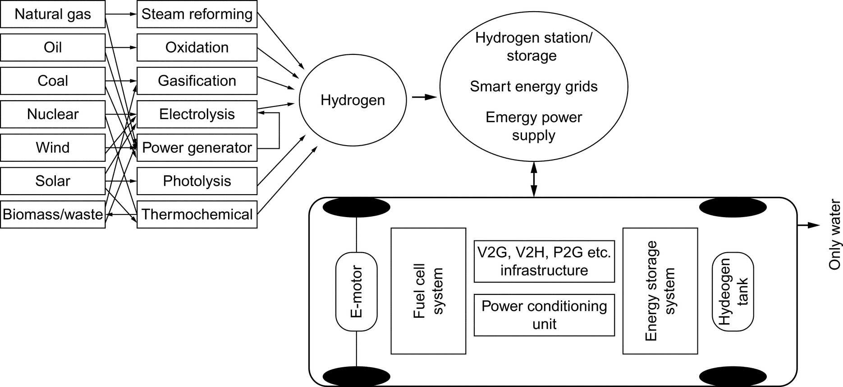

**FIG. 33.1** Hydrogen energy chain and FCEV as a part of smart grids for sustainable transportation.

An FC is an energy conversion device that converts the chemical energy of a reaction directly into electricity with byproducts of water and heat. There are several types of commercially available FCs, such as polymer electrolyte or proton-exchange membrane (PEM) FCs, solid oxide FCs, alkaline FCs, molten carbonate FCs, phosphoric acid FCs, and direct methanol FCs. Among the various types of FCs, the PEMFC technology has found widespread use, especially in vehicular applications [[14](https://learning.oreilly.com/library/view/power-electronics-handbook/9780128114087/B9780128114070000374.xhtml#bb0075)].

The PEMFC technology is still under active R&D investigation for powering systems in many applications. However, the daily operation of systems like vehicular loads and residential units with transient load changes may not be suitable for using a sole PEMFC system. This phenomenon is mainly caused by the limitation of FCs to track fast load variations due to their slow dynamics. These fast energy demand periods frequently occurring in the operation of daily utilized systems to high-voltage drops in a short time, which is defined as starvation phenomenon [[16](https://learning.oreilly.com/library/view/power-electronics-handbook/9780128114087/B9780128114070000374.xhtml#bb0085)]. In the case of fuel starvation, the FC performance degrades, and cell voltage drops. This issue may cause a significantly insecure operation for the FC stack. Thus, to utilize an FC in dynamic applications, its current or power slope must be limited to prevent the fuel-starvation problem. Therefore, hybridizing FC system with an energy storage system (ESS) decreases system cost, while sizing improves dynamic performance of overall vehicle system, promotes FC lifetime, and provides fuel economy owing to regenerative braking energy capturing and load sharing. Because of different characteristics of multiple power sources or ESS in a PEMFC-powered hybrid system, the efficiency and the fuel economy of these hybrid units mainly depend on a proper energy management strategy and well-designed power electronics architecture [[15](https://learning.oreilly.com/library/view/power-electronics-handbook/9780128114087/B9780128114070000374.xhtml#bb0080)]. However, the hybridization with ESS will cause the complexity of the vehicle and the control systems, weight increase, and extra storage cost [[5](https://learning.oreilly.com/library/view/power-electronics-handbook/9780128114087/B9780128114070000374.xhtml#bb0030)].

Since FCEV is a completely new and complex scientific area with significant capital costs and administrative challenges, it needs systematic approach involving all stakeholders (central and local governments, transportation departments, energy companies, organizations, automakers, auto parts providers, universities, R&D institutes, etc.) [[17](https://learning.oreilly.com/library/view/power-electronics-handbook/9780128114087/B9780128114070000374.xhtml#bb0090),[19](https://learning.oreilly.com/library/view/power-electronics-handbook/9780128114087/B9780128114070000374.xhtml#bb0100)]. Thus, coordination is a requirement about data collection and analysis, policy planning, infrastructure construction, safety, promotion, operation, management, maintenance, finance, etc. Besides, governments should support ambitious plans and incentivize regulations to introduce hydrogen-powered vehicles to the market. Hydrogen, which is one of the key elements of hydrogen-powered vehicles, can be produced from a variety of sources including fossil fuels such as natural gas, oil, and coal and renewable sources such as solar and wind power, biomass, waste, and nuclear energy.

Hydrogen is a future energy carrier, energy transporter, and energy transmitter. By the evaluation of environmental and economic assessments of the hydrogen supply chain, renewable sources, and conversion units such as photovoltaics (PVs), wind turbines (WTs), and FCs have been found to be promising energy sources toward building a sustainable energy economy in the next decade [[18](https://learning.oreilly.com/library/view/power-electronics-handbook/9780128114087/B9780128114070000374.xhtml#bb0095),[20](https://learning.oreilly.com/library/view/power-electronics-handbook/9780128114087/B9780128114070000374.xhtml#bb0105)]. These renewable energy sources, however, suffer from some deficiencies when used as stand-alone energy sources and grid-parallel sources. The power generated by WT and PV systems is highly dependent on weather conditions. In addition, it is difficult to store the power generated by a PV or WT system for future use. To alleviate these problems, WT and PV sources can be integrated with other alternative systems. Therefore, alternative energy conversion systems such as PV cells and wind turbines can be cooperated with fuel cells and FCEVs. Felgenhauer et al. [[19](https://learning.oreilly.com/library/view/power-electronics-handbook/9780128114087/B9780128114070000374.xhtml#bb0100)] concluded that FCEVs can be used as a part of hydrogen infrastructure may provide hydrogen to the natural gas supply (Power2Gas, P2G). Also, the V2G or vehicle-to-home (V2H) interaction of EDVs can contribute to the efficiency of the smart energy systems (as grid storage and P2G) or stand-alone applications such as emergency power sources [[21](https://learning.oreilly.com/library/view/power-electronics-handbook/9780128114087/B9780128114070000374.xhtml#bb0110)]. Thus, higher efficiency can be obtained by making the best use of their features while overcoming their limitations [[20](https://learning.oreilly.com/library/view/power-electronics-handbook/9780128114087/B9780128114070000374.xhtml#bb0105)]. In this case, when power is plentiful, FCEVs can be used both a storage and a flexible load resource [[19](https://learning.oreilly.com/library/view/power-electronics-handbook/9780128114087/B9780128114070000374.xhtml#bb0100)]. The hydrogen produced by an electrolyzer using renewable power sources is used in the FC system and acts as an energy buffer. Thus, the effects of reduction and even the absence of available power from the renewable energy system can be easily tackled. By using the electrolyzer, hydrogen can be generated and stored for later use in FCV refueling [[19](https://learning.oreilly.com/library/view/power-electronics-handbook/9780128114087/B9780128114070000374.xhtml#bb0100)].

This chapter focuses on the hydrogen-fueled FC technology, which is used in vehicle applications as an alternative energy converter (hydrogen to electric) for environment-friendly sustainable transportation. This chapter is organized as follows: First, hydrogen infrastructure, hydrogen production methods, and hydrogen storage systems are described. Second, the main types of fuel cells are described in detail. Third, fuel-cell system components and their properties are explained. Fuel-cell-powered automotive applications, their design and energy management architectures, current status and future trends, and safety issues are discussed in the final section.

## 33.2 Hydrogen Infrastructure and Vehicle Hydrogen Storage System

Hydrogen, which is the simplest and most abundant element in the universe, was discovered in the 1700s. The element is colorless, odorless, tasteless, and 14.4 times lighter than air. Hydrogen does not occur free; it is found in compounds in nature. The most well-known compound is water. Hydrogen is not found naturally; it comes from fossil fuels, renewable sources, and nuclear energy by using reformer, electrolyzer, or fuel processor.

When comparing with other energy sources, hydrogen has the highest energy content in terms of weight. For instance, 1 kg of hydrogen approximately has the energy of 2 kg natural gas or 3 kg oil. However, hydrogen has very low volumetric energy content that requires costly production, storage, and delivery of hydrogen. The capital cost of hydrogen production needs to be solved economically and environment-friendly for a successful hydrogen economy [[5](https://learning.oreilly.com/library/view/power-electronics-handbook/9780128114087/B9780128114070000374.xhtml#bb0030)]. Recent advancements in hydrogen-powered applications make hydrogen as an indispensable source of energy for the hydrogen economy.

In future energy systems, renewable energy sources will be used to generate hydrogen, and power demand might be satisfied using renewable sources and fuel cells since the hydrogen economy is a vision of the future. Therefore, alternate energy conversion systems such as PV cells and WTs can be cooperated with FCs. Here, to sustain the power demand and solve the energy storage problem when too much renewable electricity is being produced compared with the demand that exists at that moment, electric energy can be stored in the form of hydrogen. By using an electrolyzer, hydrogen can be generated and stored for future use. Since the process is providing hydrogen to the natural gas supply (Power2Gas, P2G) and combined heat power (CHP) approach, in the near future, they can be a competitive and convenient solution. It has been reported that with the growth in demand, the fuel-cell vehicle infrastructure would substantially reduce the cost [[19](https://learning.oreilly.com/library/view/power-electronics-handbook/9780128114087/B9780128114070000374.xhtml#bb0100)].

### 33.2.1 HYDROGEN PRODUCTION METHODS

Hydrogen can be produced from both renewable (hydro, wind, solar, biomass, and geothermal) and nonrenewable (coal, natural gas, and nuclear) resources [[22](https://learning.oreilly.com/library/view/power-electronics-handbook/9780128114087/B9780128114070000374.xhtml#bb0115)]. Hydrogen is mainly produced through fossil-fuel processing. In the entire world, 48% of hydrogen is produced from natural gas, 30% from oil, 18% from coal, and only 4% from renewable sources [[23](https://learning.oreilly.com/library/view/power-electronics-handbook/9780128114087/B9780128114070000374.xhtml#bb0120)].

The main hydrogen production methods are steam reforming, gasification, partial oxidation, thermochemical cycling, photolysis, and electrolysis. Steam reforming may be used with natural gas, gasification with coal and waste, partial oxidation with oil, thermochemical cycling with nuclear and solar, photolysis with solar, electrolysis with wind and solar, etc. [[23](https://learning.oreilly.com/library/view/power-electronics-handbook/9780128114087/B9780128114070000374.xhtml#bb0120),[24](https://learning.oreilly.com/library/view/power-electronics-handbook/9780128114087/B9780128114070000374.xhtml#bb0125)]. Producing hydrogen with a low cost means reforming it from fossil fuel such as natural gas, which may give rise to pollution by forming carbon dioxide. Manufacturing hydrogen is relatively more expensive [[18](https://learning.oreilly.com/library/view/power-electronics-handbook/9780128114087/B9780128114070000374.xhtml#bb0095),[25](https://learning.oreilly.com/library/view/power-electronics-handbook/9780128114087/B9780128114070000374.xhtml#bb0130)].

Hydrogen production through electrolysis of water is more promising as it avoids carbon emission. Water can be decomposed into its elementary components by passing electric current between two electrodes separated by an electrolyte. According to Faraday's law, hydrogen production rate of an electrolyzer cell is directly proportional to the electric current in the equivalent electrolyzer circuit.

Electrolysis process has been proposed especially for renewable systems. The power generated by these systems highly depends on weather conditions. For example, during cloudy periods and at night, a PV system would not generate any power. In addition, it is difficult to store the power generated by a PV system for future use. To overcome this problem, a PV system can be integrated with other alternate power sources and/or storage systems, such as electrolyzer, hydrogen infrastructure, and FC systems [[26](https://learning.oreilly.com/library/view/power-electronics-handbook/9780128114087/B9780128114070000374.xhtml#bb0135)]. When assessing recent developments in hydrogen applications, renewable energy sources have been used to generate hydrogen. Besides, energy demand/supply management can be satisfied using renewable sources and hydrogen infrastructure by including FCEVs, smart grids, and hydrogen-fueling systems. The renewable hydrogen cycle coupled with smart grids is shown in [Fig. 33.2](https://learning.oreilly.com/library/view/power-electronics-handbook/9780128114087/B9780128114070000374.xhtml#f0015).

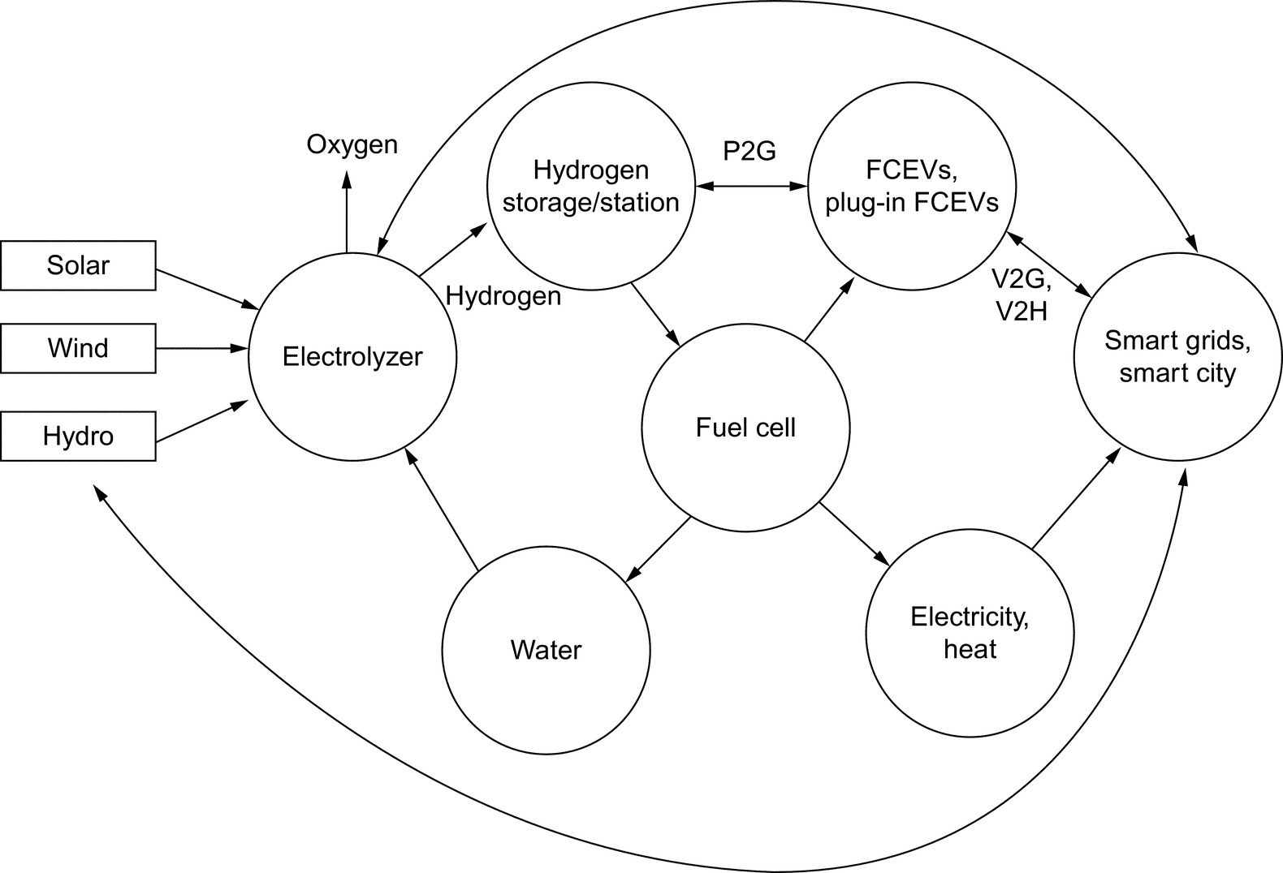

**FIG. 33.2** Renewable hydrogen cycle coupled with smart grids.

### 33.2.2 HYDROGEN STORAGE

The driving range of the FCEVs depends on its onboard hydrogen storage capability and other energy management systems. According to the improvements of the hydrogen storage tanks, FCEVs can meet to match driver expectations [[5](https://learning.oreilly.com/library/view/power-electronics-handbook/9780128114087/B9780128114070000374.xhtml#bb0030),[23](https://learning.oreilly.com/library/view/power-electronics-handbook/9780128114087/B9780128114070000374.xhtml#bb0120)]. The use of hydrogen as a vehicle fuel requires an onboard storage that offers inherent safety and both volumetric and gravimetric efficiencies. Onboard storage in vehicular systems is one of the major barriers to the acceptance of hydrogen-powered vehicles [[27](https://learning.oreilly.com/library/view/power-electronics-handbook/9780128114087/B9780128114070000374.xhtml#bb0140)]. Since onboard storage systems increase safety concerns especially for drivers and passengers during dangerous situations such as car accidents, the storage system gives a hazardous impression. The problems associated with hydrogen storage change from one storage technology to another. Thus, hydrogen storage technologies are evaluated as the first step of the current deliverable presentation. There are four technologies available today to store hydrogen aboard vehicles [[16](https://learning.oreilly.com/library/view/power-electronics-handbook/9780128114087/B9780128114070000374.xhtml#bb0085),[17](https://learning.oreilly.com/library/view/power-electronics-handbook/9780128114087/B9780128114070000374.xhtml#bb0090),[28](https://learning.oreilly.com/library/view/power-electronics-handbook/9780128114087/B9780128114070000374.xhtml#bb0145)]:

• Compressed hydrogen gas in high-pressure tanks

• Liquefied hydrogen

• Metal hydrides

• New methods currently under development

The most used technique for hydrogen storage is compression of hydrogen into different kinds of high-pressure tanks [[16](https://learning.oreilly.com/library/view/power-electronics-handbook/9780128114087/B9780128114070000374.xhtml#bb0085)]. According to the Department of Energy (DoE), compressed hydrogen technique will continue to be the most popular type of hydrogen storage for vehicular systems until 2020. Most vehicles currently in the on-road testing phase and on the road commercially are equipped with such a composite high-pressure tank. This is because of its simple structure and charge-discharge easiness. In general, vehicular pressurized hydrogen storage tanks made of very light and robust composite materials [[29](https://learning.oreilly.com/library/view/power-electronics-handbook/9780128114087/B9780128114070000374.xhtml#bb0150)]. Storage density (gravimetric ratio) of above 0.05 kg of hydrogen per 1 kg of total weight, which means a stored hydrogen ratio of 5%, is easily achievable [[16](https://learning.oreilly.com/library/view/power-electronics-handbook/9780128114087/B9780128114070000374.xhtml#bb0085)]. This ratio can reach up to 11.3% in this approach. There are two working pressures commonly used in commercialized vehicles such as 350 bar (35 MPa–5000 psi) and 700 bar (70 MPa–10000 psi) [[17](https://learning.oreilly.com/library/view/power-electronics-handbook/9780128114087/B9780128114070000374.xhtml#bb0090)]. Leading FCEV automakers have mounted the high-pressured storage tanks on their models with their own preferences. For instance, while Toyota, Honda, and Hyundai use 700 bar (10,000 psi), Nissan uses 350 bar (5,000 psi) pressurized tank [[5](https://learning.oreilly.com/library/view/power-electronics-handbook/9780128114087/B9780128114070000374.xhtml#bb0030),[21](https://learning.oreilly.com/library/view/power-electronics-handbook/9780128114087/B9780128114070000374.xhtml#bb0110)].

In another approach, the hydrogen gas is liquefied and stored under lower temperature and pressure compared with the high-pressure approach in liquefaction technique [[16](https://learning.oreilly.com/library/view/power-electronics-handbook/9780128114087/B9780128114070000374.xhtml#bb0085)]. In this method, the ratio of stored hydrogen per tank weight is around 26%. However, the usage of liquid hydrogen storage system is limited because of its properties, cost of the manufacturing material, and cost of the tank. Besides, the whole process is relatively inefficient because a lot of energy is already consumed in the first stage of hydrogen liquefaction [[30](https://learning.oreilly.com/library/view/power-electronics-handbook/9780128114087/B9780128114070000374.xhtml#bb0155)]. In this technique, nearly 26% of the stored hydrogen energy is consumed during the hydrogen liquefaction process [[28](https://learning.oreilly.com/library/view/power-electronics-handbook/9780128114087/B9780128114070000374.xhtml#bb0145)]. In addition, liquid hydrogen tanks suffer from hydrogen leaks due to the unavoidable thermal losses that lead to pressure increase in the tank. This hydrogen self-discharge of the tank may reach to 3% daily, which means a 100% self-discharge in 1 month [[31](https://learning.oreilly.com/library/view/power-electronics-handbook/9780128114087/B9780128114070000374.xhtml#bb0160)]. Hydrogen liquefaction and use of liquid hydrogen are usually practiced only where achieving high storage density is absolutely essential, such as in aerospace applications [[28](https://learning.oreilly.com/library/view/power-electronics-handbook/9780128114087/B9780128114070000374.xhtml#bb0145),[16](https://learning.oreilly.com/library/view/power-electronics-handbook/9780128114087/B9780128114070000374.xhtml#bb0085)]. Some prototype hydrogen-powered automobiles also use specially developed liquefied hydrogen tanks [[16](https://learning.oreilly.com/library/view/power-electronics-handbook/9780128114087/B9780128114070000374.xhtml#bb0085)].

Metal hydrides offer alternatives to the storage of hydrogen in gaseous and liquid form. Storing hydrogen as hydride in metals provides some advantages especially for safety in many applications. However, the tank weight provides a significant problem in this approach especially for applications like vehicular systems. The commercially available metal hydride hydrogen tanks offer a stored hydrogen ratio of 4.5% [[27](https://learning.oreilly.com/library/view/power-electronics-handbook/9780128114087/B9780128114070000374.xhtml#bb0140)]. Besides, the repetition of hydrogen storage (absorption)/release (desorption) further decreases this ratio. Moreover, heat is released during the absorption process, which must be removed in order to achieve the continuity of the reaction. Similarly, during the hydrogen desorption process, heat must be supplied to the storage tank [[16](https://learning.oreilly.com/library/view/power-electronics-handbook/9780128114087/B9780128114070000374.xhtml#bb0085)]. To overcome these limitations, some new techniques in metal hydride hydrogen storage approach are under investigation, which is expected to reach a hydrogen storage ratio of 10.5% in the near future [[31](https://learning.oreilly.com/library/view/power-electronics-handbook/9780128114087/B9780128114070000374.xhtml#bb0160)].

New hydrogen storage methods have potential for providing higher energy densities than the conventional methods. These methods contain hydrogen storage in carbon nanotubes, storage in glass microspheres, boron-based storage, or storage in polyhydride chemical complexes [[29](https://learning.oreilly.com/library/view/power-electronics-handbook/9780128114087/B9780128114070000374.xhtml#bb0150)]. Among them, the nanotube technique seems to be promising according to the recent developments in nanotechnology, which is anticipated to reach to a hydrogen storage ratio of 68% [[17](https://learning.oreilly.com/library/view/power-electronics-handbook/9780128114087/B9780128114070000374.xhtml#bb0090)]. As another novel hydrogen storage method, boron-based chemical storage materials (like borohydrides and ammonia borane) are promising compounds with their high-hydrogen capacities. However, these hydrogen storage materials create ongoing problems from the kinetic and thermodynamic limitations in practice [[32](https://learning.oreilly.com/library/view/power-electronics-handbook/9780128114087/B9780128114070000374.xhtml#bb0165)]. Besides, the current costs of these methods are extremely high that prevents the commercial utilization of these approaches [[33](https://learning.oreilly.com/library/view/power-electronics-handbook/9780128114087/B9780128114070000374.xhtml#bb0170),[34](https://learning.oreilly.com/library/view/power-electronics-handbook/9780128114087/B9780128114070000374.xhtml#bb0175)].

### 33.2.3 HYDROGEN DELIVERY AND FUELING STATION

It is expected that the FCEVs will have a significant market share in upcoming years. To that end, an effective and efficient utilization of the currently existing hydrogen infrastructure should be reconsidered for widespread penetration of FCEVs. Considering that proof-of-concept experiment with R&D studies for hydrogen generation has been already shown; construction of hydrogen generation and distribution infrastructure is a requirement for commercialization of FCEVs to achieve a sustainable process [[19](https://learning.oreilly.com/library/view/power-electronics-handbook/9780128114087/B9780128114070000374.xhtml#bb0100),[21](https://learning.oreilly.com/library/view/power-electronics-handbook/9780128114087/B9780128114070000374.xhtml#bb0110)].

Hydrogen has poor volumetric energy density, and hence, FCEVs have a limited storage capacity, which makes hydrogen generation and distribution infrastructure a must-have. In addition, to ensure acceptance by public, hydrogen-refueling stations should be constructed and mounted.

Despite the expensiveness and complexity of hydrogen storage, it has been reported that delivering hydrogen by pipeline or tanker trucks to the refueling stations is possible with some adaptive alterations to the current infrastructure [[17](https://learning.oreilly.com/library/view/power-electronics-handbook/9780128114087/B9780128114070000374.xhtml#bb0090)]. It is significantly important for both developed and developing countries to realize these studies in a timely manner in order to prevent/reduce the possible future technological dependence on other countries about this issue. Several such studies are realized worldwide, especially in countries such as Japan, the United States, Germany, China, South Korea, and Italy, where renewable sources are used with a high ratio with a vision of future hydrogen economy and hydrogen generation, and distribution infrastructure has been already established or planned [[17](https://learning.oreilly.com/library/view/power-electronics-handbook/9780128114087/B9780128114070000374.xhtml#bb0090),[19](https://learning.oreilly.com/library/view/power-electronics-handbook/9780128114087/B9780128114070000374.xhtml#bb0100)].

If hydrogen-fueled vehicles are used instead of natural gas delivery systems, using central hydrogen delivery system would be more convenient. Furthermore, decentralized and distributed hydrogen stations combined with electrolyzers and renewables will be built to meet the variable demands for hydrogen [[5](https://learning.oreilly.com/library/view/power-electronics-handbook/9780128114087/B9780128114070000374.xhtml#bb0030)].

In this regard, the fueling and P2G operations of FCEVs should be controllable under the smart grid umbrella. Besides, hydrogen storage of FCEVs in parking condition can be utilized as a backup gas unit when the gas demand increases or fuel cells of FCEVs with suitable power-conditioning unit can supply power to electric loads and appliances. Thus, FCEVs can be considered as multicarrier energy sources. Likewise, BEVs and PHEVs are also considered as both storage and a flexible load resource with a connection to smart grids (including renewables) under a suitable smart charging and discharging approach. Furthermore, smart grids have the potential of exploiting renewable sources and providing the required infrastructure for BEVs and FCEVs [[19](https://learning.oreilly.com/library/view/power-electronics-handbook/9780128114087/B9780128114070000374.xhtml#bb0100)]. Additionally, CHP of the electrolyzer can be considered as a supplementary.

In this context, Honda proposed and developed novel and efficient complementary applications of hydrogen value chain such as FCEV, compact/smart hydrogen station (SHS), high-pressure storage tank, fuel cell stack, electrolyzer, and power-conditioning units. After accomplishing their proof-of-concept experiments, commercialization by Honda has already started and currently being deployed in some regions [[21](https://learning.oreilly.com/library/view/power-electronics-handbook/9780128114087/B9780128114070000374.xhtml#bb0110)]. To this end, some governments and automakers are cooperating, aiming to support hydrogen infrastructure development by methods by partially subsidizing operation costs of infrastructure firms [[21](https://learning.oreilly.com/library/view/power-electronics-handbook/9780128114087/B9780128114070000374.xhtml#bb0110),[35](https://learning.oreilly.com/library/view/power-electronics-handbook/9780128114087/B9780128114070000374.xhtml#bb0180)]. However, the abovementioned issues cannot be evaluated independent from smart energy technologies.

## 33.3 Fuel Cells and Types

The fundamental principles of FC concept were described in 1838 by a Swedish scientist Christian Friedrich Schönbein. Sir William Grove, called the father of the FC, generated electricity by reversing the electrolysis of water in 1839, thus inventing the first FC system. In 1950, Francis Bacon from Cambridge University demonstrated the first 5 kW alkaline FC system. After the successful commercialization of alkaline FC technology, National Aeronautics and Space Administration (NASA) also started working on a weightless power system. In the 1970s, NASA developed a 12 kW alkaline fuel-cell (AFC) system for use with the space shuttle. Furthermore, researchers started R&D studies to use different types of fuel cells on applications like transportation systems. Currently, it is the most important development in the history of decentralized energy supply [[5](https://learning.oreilly.com/library/view/power-electronics-handbook/9780128114087/B9780128114070000374.xhtml#bb0030),[24](https://learning.oreilly.com/library/view/power-electronics-handbook/9780128114087/B9780128114070000374.xhtml#bb0125),[36](https://learning.oreilly.com/library/view/power-electronics-handbook/9780128114087/B9780128114070000374.xhtml#bb0185)].

FC is an electrochemical device that generates electricity through a chemical reaction. It is an energy conversion device operating at high temperatures and using chemical energy stored in fuels, such as hydrogen, hydrocarbons, and alcohols without any direct combustion processes. Since the fuel-cell device is producing electricity and heat while altering hydrogen and oxygen into water, it emerged as one of the most promising power sources offering higher energy densities and energy efficiencies without any pollution [[5](https://learning.oreilly.com/library/view/power-electronics-handbook/9780128114087/B9780128114070000374.xhtml#bb0030),[37](https://learning.oreilly.com/library/view/power-electronics-handbook/9780128114087/B9780128114070000374.xhtml#bb0190),[38](https://learning.oreilly.com/library/view/power-electronics-handbook/9780128114087/B9780128114070000374.xhtml#bb0195)].

FC is a converter, generating electric and heat energy with the electrochemical combination of hydrogen fuel and oxidant. This reaction emits only water. A fuel-cell system and chemical battery have a structural similarity. Unlike battery systems, the operation of fuel cells is restricted only by the existence of fuel, and there is no charging limitation [[13](https://learning.oreilly.com/library/view/power-electronics-handbook/9780128114087/B9780128114070000374.xhtml#bb0070)]. Since FCs convert the chemical energy directly into the electric energy, FC efficiencies are not limited by theoretical Carnot efficiencies. Thus, FC has a high conversion efficiency compared with mechanical and combustion processes [[38](https://learning.oreilly.com/library/view/power-electronics-handbook/9780128114087/B9780128114070000374.xhtml#bb0195)]. If the waste heat/exhaust can be cogenerated with the purpose of heating and cooling (can be used in residential, commercial, and industrial applications), typical values of efficiency would range up to 85% [[37](https://learning.oreilly.com/library/view/power-electronics-handbook/9780128114087/B9780128114070000374.xhtml#bb0190)].

The main advantages of the FCs are as follows [[5](https://learning.oreilly.com/library/view/power-electronics-handbook/9780128114087/B9780128114070000374.xhtml#bb0030),[37](https://learning.oreilly.com/library/view/power-electronics-handbook/9780128114087/B9780128114070000374.xhtml#bb0190),[39](https://learning.oreilly.com/library/view/power-electronics-handbook/9780128114087/B9780128114070000374.xhtml#bb0200)]:

• Potential to provide high operational efficiency and low operational maintenance

• Different fueling options

• Highly modular structure

• Offer zero or low environmental emissions and quiet operation

• No moving parts, except ancillaries (fans and pumps)

• Potential for high reliability

Barriers to more widespread adoption of the FC systems are the following [[39](https://learning.oreilly.com/library/view/power-electronics-handbook/9780128114087/B9780128114070000374.xhtml#bb0200)]:

• Cost of FCs and the hydrogen infrastructure

• The lack of manufacturing and practical operating experience

FCs are generally classified depending on the type of electrolyte they use. Six main types of FCs are available in the market as listed below:

• Alkaline fuel cells (AFC)

• Molten carbonate fuel cell (MCFC)

• Polymer electrolyte fuel cell (PEMFC)

• Direct methanol fuel cell (DMFC)

• Phosphoric acid fuel cell (PAFC)

• Solid oxide fuel cell (SOFC)

The classification with some technical characteristics is shown in [Table 33.1](https://learning.oreilly.com/library/view/power-electronics-handbook/9780128114087/B9780128114070000374.xhtml#t0010).

**Table 33.1**

**Main types of fuel cells with some technical characteristics [**[**5**](https://learning.oreilly.com/library/view/power-electronics-handbook/9780128114087/B9780128114070000374.xhtml#bb0030)**,**[**25**](https://learning.oreilly.com/library/view/power-electronics-handbook/9780128114087/B9780128114070000374.xhtml#bb0130)**,**[**37**](https://learning.oreilly.com/library/view/power-electronics-handbook/9780128114087/B9780128114070000374.xhtml#bb0190)**,**[**40**](https://learning.oreilly.com/library/view/power-electronics-handbook/9780128114087/B9780128114070000374.xhtml#bb0205)**,**[**41**](https://learning.oreilly.com/library/view/power-electronics-handbook/9780128114087/B9780128114070000374.xhtml#bb0210)**]**

|  |  |  |  |  |  |  |  |
| --- | --- | --- | --- | --- | --- | --- | --- |
| **Types of FC** | **Operating temperature [°C]** | **Fuel** | **Charge carrier** | **Electrolyte** | **Oxidant** | **Start-up time (h)** | **Efficiency (%)** |
| AFC | 50–200 | Pure H2 | OH− | Liquid solution of KOH (LiAlO2) | O2 in air | <0.1 | 50–70 |
| MCFC | 650 | H2, CO, CH4, other hydrocarbons | CO3−2 | Lithium and potassium carbonate | O2 in air | 5–10 | 40–85 with cogeneration |
| PEMFC | 50–100 | Pure H2 | H+ | Solid polymer membrane (Nafion) | O2 in air | <0.1 | 40–60 |
| DMFC | 60–200 | CH3OH | H+ | Solid polymer membrane | O2 in air | <0.1 | 35–50 |
| PAFC | 160–210 | Pure H2 | H+ | Phosphoric acid (H3PO4) | O2 in air | 1–4 | 35–85 with cogeneration |
| SOFC | 800–1000 | H2, CO, CH4, other hydrocarbons | O− | Stabilized solid oxide electrolyte (Y2O3,ZrO2) | O2 in air | 1–5 | 45–60 with cogeneration |

### 33.3.1 ALKALINE FUEL CELL

Alkaline fuel-cell system is one of the first developed fuel-cell technology with the simplest structure. It is the first type widely used on space applications [[37](https://learning.oreilly.com/library/view/power-electronics-handbook/9780128114087/B9780128114070000374.xhtml#bb0190),[41](https://learning.oreilly.com/library/view/power-electronics-handbook/9780128114087/B9780128114070000374.xhtml#bb0210)]. AFCs use a liquid solution of potassium hydroxide (KOH) as an electrolyte that conducts ions between two electrodes: anode and cathode. Because the electrolyte is alkaline, the ion conduction mechanism has differences from PEMFCs [[24](https://learning.oreilly.com/library/view/power-electronics-handbook/9780128114087/B9780128114070000374.xhtml#bb0125)]. At the basic structure of AFCs as given in [Fig. 33.3](https://learning.oreilly.com/library/view/power-electronics-handbook/9780128114087/B9780128114070000374.xhtml#f0020), at the anode side, hydrogen undergoes oxidation reaction that turns hydrogen into a positively charged ion and negatively charged electron. The negatively charged electrons travel through an external circuit that generates electricity and unifies with oxygen atoms at the cathode side [[42](https://learning.oreilly.com/library/view/power-electronics-handbook/9780128114087/B9780128114070000374.xhtml#bb0215)]. The alkaline electrolyte only lets the composed hydroxyl (OH−) go through the anode side. By this reaction, hydrogen ions and hydroxyl reunite producing water. Eventually, water, heat and the electricity will be obtained.

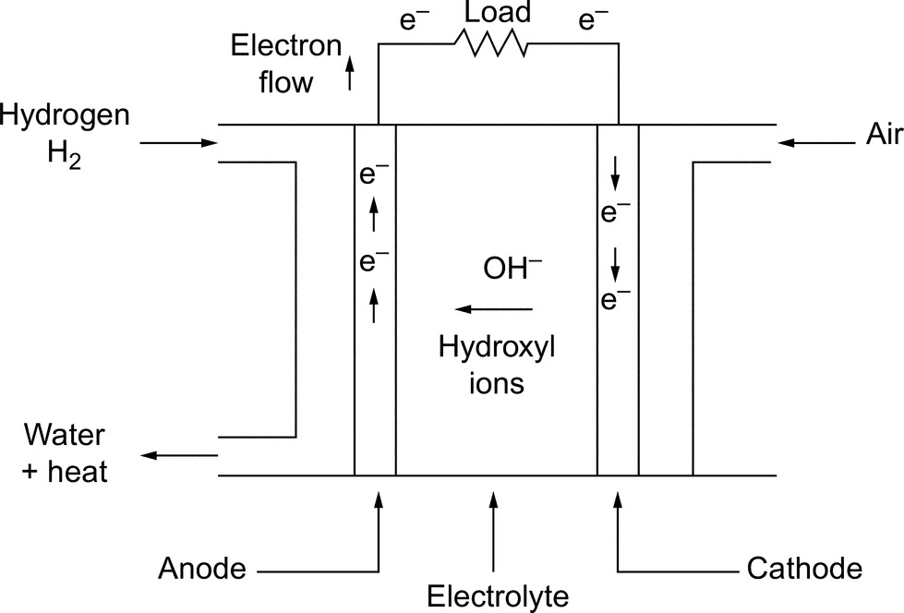

**FIG. 33.3** Basic structure of an AFC.

Some key advantages of AFC systems can be specified as [[43](https://learning.oreilly.com/library/view/power-electronics-handbook/9780128114087/B9780128114070000374.xhtml#bb0220)] the following:

• Low operation temperatures (50–200°C)

• Quick start-up range (<0.1 h)

• High efficiency (50%–70%)

• Low catalyst requirement reducing content costs

• Simple structure

• Low weight and volume

Some key disadvantages of AFC systems can be specified as [[13](https://learning.oreilly.com/library/view/power-electronics-handbook/9780128114087/B9780128114070000374.xhtml#bb0070),[43](https://learning.oreilly.com/library/view/power-electronics-handbook/9780128114087/B9780128114070000374.xhtml#bb0220)–[45](https://learning.oreilly.com/library/view/power-electronics-handbook/9780128114087/B9780128114070000374.xhtml#bb0230)] the following:

• Short operating life since they use a liquid solution of potassium hydroxide (KOH) as an electrolyte that is highly corrosive, thus eroding its parts

• Required oxygen must be provided after purification since they are very intolerant to carbon dioxide

• High cost for commercialized applications and current R&D studies are focusing on reducing costs

### 33.3.2 MOLTEN CARBONATE FUEL CELL

The main principles of MCFCs are based on SOFCs and the other types of fuel cells. In the mid-1960s, Texas Instruments developed several MCFCs for US Army that led to a widespread use of MCFCs in the field [[43](https://learning.oreilly.com/library/view/power-electronics-handbook/9780128114087/B9780128114070000374.xhtml#bb0220)].

MCFCs use lithium potassium carbonate salts as an electrolyte as shown in [Fig. 33.4](https://learning.oreilly.com/library/view/power-electronics-handbook/9780128114087/B9780128114070000374.xhtml#f0025). They operate at high temperatures (650°C); therefore, catalysts can be made of low-priced metals to reduce cost, and the heat/exhaust can be utilized [[37](https://learning.oreilly.com/library/view/power-electronics-handbook/9780128114087/B9780128114070000374.xhtml#bb0190)]. If the heat/exhaust can be utilized (with CHP), the efficiencies of MCFCs can be increased from 60% to 85%. Additionally, higher temperature makes the FC system more tolerant to poisoning (carbon monoxide) than lower temperatures. These systems can use either carbon dioxide or oxygen as a fuel. Currently, there are many molten carbonate systems available with capacities ranging from 100 kW up to 2 MW.

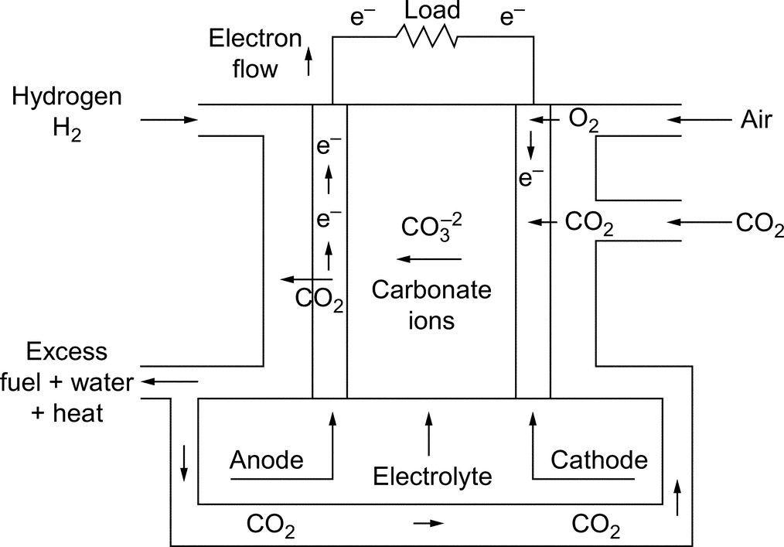

**FIG. 33.4** Basic structure of a MCFC.

MCFCs do not demand an external reformer; thus, the primary fuel used may not be hydrogen gas. The basic components of natural gas, methane, and steam are processed at a reformer in the MCFC system, and electricity will be produced. The internal reformer reduces the costs compared with the other FC technologies with external reformers.

Some key advantages of MCFC systems are specified below [[43](https://learning.oreilly.com/library/view/power-electronics-handbook/9780128114087/B9780128114070000374.xhtml#bb0220),[46](https://learning.oreilly.com/library/view/power-electronics-handbook/9780128114087/B9780128114070000374.xhtml#bb0235)]:

• Using the fuel converted in the system

• Producing so much heat/exhaust that can be cogenerated

• High efficiencies

• Relatively fast response to load changes in steady-state conditions

• Require low-cost catalysts

• Lower sensitivity to poisoning

Some key disadvantages of MCFCs include the following [[46](https://learning.oreilly.com/library/view/power-electronics-handbook/9780128114087/B9780128114070000374.xhtml#bb0235)]:

• Slow start-up range (5–10 h)

• Demand redesigning with more resistant components to corrosion

• Problems in contenting the liquid electrolyte in the structure

• Requirement of preheating before starting work

• Short operating life especially when using for high-power production systems

### 33.3.3 POLYMER ELECTROLYTE FUEL CELL

Among the various next generation power supplies, the polymer electrolytes or PEMFCs have been found to be one of the most promising energy sources due to their high efficiencies and environment-friendly operations [[47](https://learning.oreilly.com/library/view/power-electronics-handbook/9780128114087/B9780128114070000374.xhtml#bb0240)].

The basic structure of PEMFC, shown in [Fig. 33.5](https://learning.oreilly.com/library/view/power-electronics-handbook/9780128114087/B9780128114070000374.xhtml#f0030), consists of three segments: the anode (negative characteristic electrode), the cathode (positive characteristic electrode), and the electrolyte membrane sandwiched between the two that allows only positively charged ions/protons to move between the two electrodes. The anode and the cathode have a catalyst, which speeds up the reactions at the electrode. Hydrogen goes to the anode side, and oxygen from the air flow goes to the cathode side. At the anode side, hydrogen undergoes oxidation reaction that turns hydrogen into a positively charged ion and negatively charged electron. After the reaction, protons are being transferred from anode to cathode through the electrolyte membrane, while the electrons travel through an external circuit. When the ions/protons reach the second electrode cathode, they will unify again with electrons and react with oxygen to form water. Eventually, electricity, water, and heat will be generated [[39](https://learning.oreilly.com/library/view/power-electronics-handbook/9780128114087/B9780128114070000374.xhtml#bb0200)].

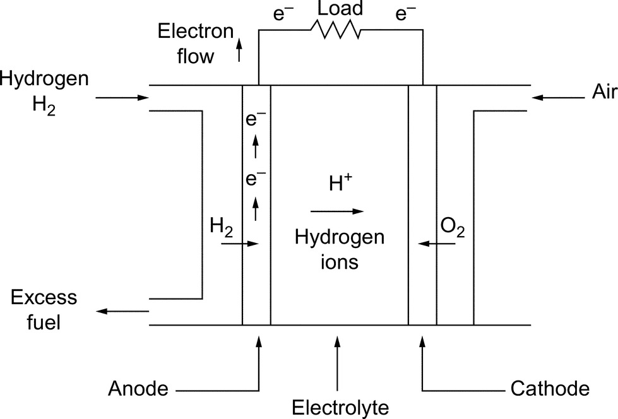

**FIG. 33.5** Basic structure of a PEMFC system.

Some key advantages of PEMFCs include the following [[16](https://learning.oreilly.com/library/view/power-electronics-handbook/9780128114087/B9780128114070000374.xhtml#bb0085)]:

• Low operation temperatures (50–100°C)

• Quick start-up range (<0.1 h)

• High efficiencies (40%–60%)

• Structure of electrolytes is more reliable, secure, and stable than other FCs

• High power density is the highest among all the available types of FCs

• High tolerance capability to differential pressures of the reactants

• Robust and simple structural design

Some key disadvantages of PEMFCs are listed below:

• Possess a structure highly depending on the purity of hydrogen

• Very poor tolerance to carbon monoxide and sulfur particles

• Gases require to be moisturized before reacting

• Comprised of a fairly expensive platinum catalyst and a solid polymer membrane

PEMFCs are a good candidate to substitute conventional technologies with their higher efficiencies and lower environmental impacts. The cost of PEMFCs is expected to down to consumer affordable levels in the near future [[13](https://learning.oreilly.com/library/view/power-electronics-handbook/9780128114087/B9780128114070000374.xhtml#bb0070)].

Many advantages of PEMFCs, including fast response time, low operating temperature, high power density, and life cycling, have made the PEMFCs attractive and promising energy devices from the transportation and mobile applications to stationary applications as a distributed generation [[5](https://learning.oreilly.com/library/view/power-electronics-handbook/9780128114087/B9780128114070000374.xhtml#bb0030),[16](https://learning.oreilly.com/library/view/power-electronics-handbook/9780128114087/B9780128114070000374.xhtml#bb0085)]. Therefore, lots of big companies such as Ballard, UTC, Nuvera, PlugPower, General Electric, Toshiba, and Sanyo produce PEMFCs commercially. Leading automaker companies such as Honda, Toyota, Daimler-Chrysler, General Motors, BMW, Nissan, Ford, Hyundai, and Renault and worldwide brand-mark companies like Samsung and IBM use this shining technology for their own commercial applications [[48](https://learning.oreilly.com/library/view/power-electronics-handbook/9780128114087/B9780128114070000374.xhtml#bb0245)].

### 33.3.4 DIRECT METHANOL FUEL CELL

FCs either use hydrogen directly or reform hydrocarbon fuels like methanol, which is the simplest organic fuel that can be most economically and efficiently produced from relatively plentiful fossil fuel [[24](https://learning.oreilly.com/library/view/power-electronics-handbook/9780128114087/B9780128114070000374.xhtml#bb0125)]. Thus, the operation of the DMFC is based on oxidation of water mixed with methanol. After the oxidation, methanol goes to the FC anode side [[37](https://learning.oreilly.com/library/view/power-electronics-handbook/9780128114087/B9780128114070000374.xhtml#bb0190)]. DMFCs use a liquid fuel methanol, which is easier to transport for public using with current infrastructure [[41](https://learning.oreilly.com/library/view/power-electronics-handbook/9780128114087/B9780128114070000374.xhtml#bb0210)]. DMFCs are often used to supply power for portable electronics and emergency power supply.

Recently, concerns about the poisonous effects of methanol have emerged; thus, companies prefer using ethanol instead of methanol [[37](https://learning.oreilly.com/library/view/power-electronics-handbook/9780128114087/B9780128114070000374.xhtml#bb0190)]. DMFCs have immature technology, low power density, slow power response, and low efficiency compared with direct hydrogen FCs [[24](https://learning.oreilly.com/library/view/power-electronics-handbook/9780128114087/B9780128114070000374.xhtml#bb0125)].

### 33.3.5 PHOSPHORIC ACID FUEL CELL

Phosphoric acid fuel cell is the first developed FC technology and first to be used commercially. They are considered as first generation of modern FC. PAFCs use liquid phosphoric acid as an electrolyte. The PAFC systems have about 40% energy production efficiency and high operating temperatures (150–220°C) [[42](https://learning.oreilly.com/library/view/power-electronics-handbook/9780128114087/B9780128114070000374.xhtml#bb0215)]. With cogeneration of heat/exhaust, the efficiency can be increased up to 85% [[43](https://learning.oreilly.com/library/view/power-electronics-handbook/9780128114087/B9780128114070000374.xhtml#bb0220)]. Currently, there are PAFCs with capacities ranging from 200 kW to 11 MW. Necessary improvements for widespread use of PAFCs will require reducing the operating cost while increasing the operating life.

These FC systems have a drawback of weight; therefore, these FCs are not preferable on transport applications. Some key advantages of PAFC systems can be specified as follows [[43](https://learning.oreilly.com/library/view/power-electronics-handbook/9780128114087/B9780128114070000374.xhtml#bb0220),[46](https://learning.oreilly.com/library/view/power-electronics-handbook/9780128114087/B9780128114070000374.xhtml#bb0235)]:

• Tolerant till 30% carbon dioxide content, hence direct usage of atmosphere air

• High efficiency (85%) with cogeneration of heat/exhaust (CHP)

• Operate trouble-free at temperatures (150–220°C)

Some key disadvantages of PAFCs include the following [[42](https://learning.oreilly.com/library/view/power-electronics-handbook/9780128114087/B9780128114070000374.xhtml#bb0215),[43](https://learning.oreilly.com/library/view/power-electronics-handbook/9780128114087/B9780128114070000374.xhtml#bb0220)]:

• Slow start-up range (1–4 h)

• Low tolerant to carbon monoxide component

• Exhausting water content can damage acidic electrolyte (corrosion)

• Massive and heavy structure

• Requirement of external reformer

• Requirement of preheating before starting to operate

### 33.3.6 SOLID OXIDE FUEL CELL

SOFCs operate at high temperatures (700–1000°C), and every single solid oxide cell produces 0.8–1 V voltages [[43](https://learning.oreilly.com/library/view/power-electronics-handbook/9780128114087/B9780128114070000374.xhtml#bb0220)]. The heat/exhaust (around 500–850°C) generated by SOFCs is attractive for cogeneration. SOFC systems are currently used in stationary applications such as backup power units. Furthermore, recent R&D studies are focusing on feasibility of SOFCs at transportation appliances [[49](https://learning.oreilly.com/library/view/power-electronics-handbook/9780128114087/B9780128114070000374.xhtml#bb0250),[50](https://learning.oreilly.com/library/view/power-electronics-handbook/9780128114087/B9780128114070000374.xhtml#bb0255)].

Solid oxide fuel cells are promising with their inherent advantages for industrial applications such as its independence from pure fuel. Therefore, hydrogen and CO, CH4, and other hydrocarbons can be used as fuel [[37](https://learning.oreilly.com/library/view/power-electronics-handbook/9780128114087/B9780128114070000374.xhtml#bb0190)] in a SOFC. Since SOFCs operate at high temperatures, these systems can use low-cost catalyst components to enhance operational performance. SOFCs use a solid electrolyte, generally a ceramic material called yttria-stabilized zirconia (YSZ). Because the electrolyte does not involve a liquid-phased reaction, a problem such as fuel flooding does not occur. Also, SOFCs can be manufactured for many configurations, although other FC types with liquid electrolyte cannot [[46](https://learning.oreilly.com/library/view/power-electronics-handbook/9780128114087/B9780128114070000374.xhtml#bb0235)].

In SOFCs, fuel is supplied to the anode side, and oxygen from the air flow goes to the cathode side as shown in [Fig. 33.6](https://learning.oreilly.com/library/view/power-electronics-handbook/9780128114087/B9780128114070000374.xhtml#f0035). At the anode side, hydrogen undergoes oxidation reaction that turns hydrogen into a positively charged ion and negatively charged electron. The separated electrons travel through an external circuit from anode to cathode to produce electricity and oxygen atoms absorb the electrons. The solid electrolyte membrane only permits the transition of negative charged oxygen ions from cathode to anode. When oxygen ions reach anode, they react with hydrogen ions to form water.

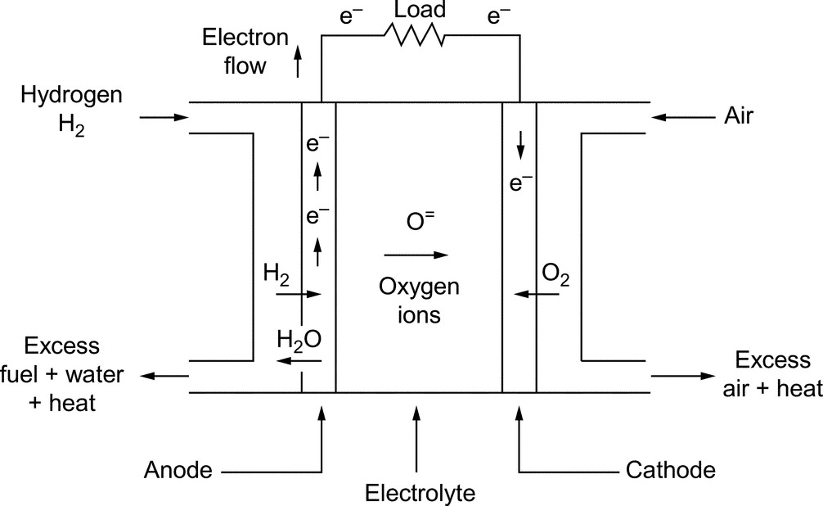

**FIG. 33.6** Basic structure of a SOFC system.

SOFCs have about 45% efficiency that can reach 85% by capturing and utilizing the heat/exhaust. Additionally, the SOFC systems have low gas emissions [[51](https://learning.oreilly.com/library/view/power-electronics-handbook/9780128114087/B9780128114070000374.xhtml#bb0260)].

Some key advantages of SOFC systems can be specified as follows [[42](https://learning.oreilly.com/library/view/power-electronics-handbook/9780128114087/B9780128114070000374.xhtml#bb0215),[45](https://learning.oreilly.com/library/view/power-electronics-handbook/9780128114087/B9780128114070000374.xhtml#bb0230),[46](https://learning.oreilly.com/library/view/power-electronics-handbook/9780128114087/B9780128114070000374.xhtml#bb0235)]:

• Producing massive amount of heat/exhaust that can be utilized

• Fast chemical reactions

• High efficiency

• The solid electrolyte is more reliable than a liquid electrolyte

• Nonrequirement of external reformer

• No corrosion problems

Some disadvantages of SOFC systems include the following:

• Slow start-up range (1–5 h)

• Requirement of R&D studies on decreasing volumetric and gravimetric parameters

• Low tolerant to sulfur element

• Requirement of long-term proof-of-concept studies

## 33.4 Fuel Cell System Components

Among the various types of fuel cells, PEMFC has drawn the most attention due to its simplicity, viability, quick start-up range, higher power density, long cycle life, and low operational temperature (80–100°C). Since PEMFCs are the best candidate for vehicular and commercial applications, in this section, PEMFC system components are discussed in detail.

In practice, FC systems need auxiliaries (blowers, pumps, fans, ejectors, motors, turbines, compressors, valves, and regulators) to support their operation [[24](https://learning.oreilly.com/library/view/power-electronics-handbook/9780128114087/B9780128114070000374.xhtml#bb0125),[52](https://learning.oreilly.com/library/view/power-electronics-handbook/9780128114087/B9780128114070000374.xhtml#bb0265)]. The main components of the FC system include the FC stack, fuel feeding, air compressors, humidifiers, power-conditioning unit with control systems, and energy storage system as shown in [Fig. 33.7](https://learning.oreilly.com/library/view/power-electronics-handbook/9780128114087/B9780128114070000374.xhtml#f0040) [[25](https://learning.oreilly.com/library/view/power-electronics-handbook/9780128114087/B9780128114070000374.xhtml#bb0130)]. All of these components work together to provide power to an electric load while regulating the proper amounts of fuel and ensuring system safety [[52](https://learning.oreilly.com/library/view/power-electronics-handbook/9780128114087/B9780128114070000374.xhtml#bb0265)].

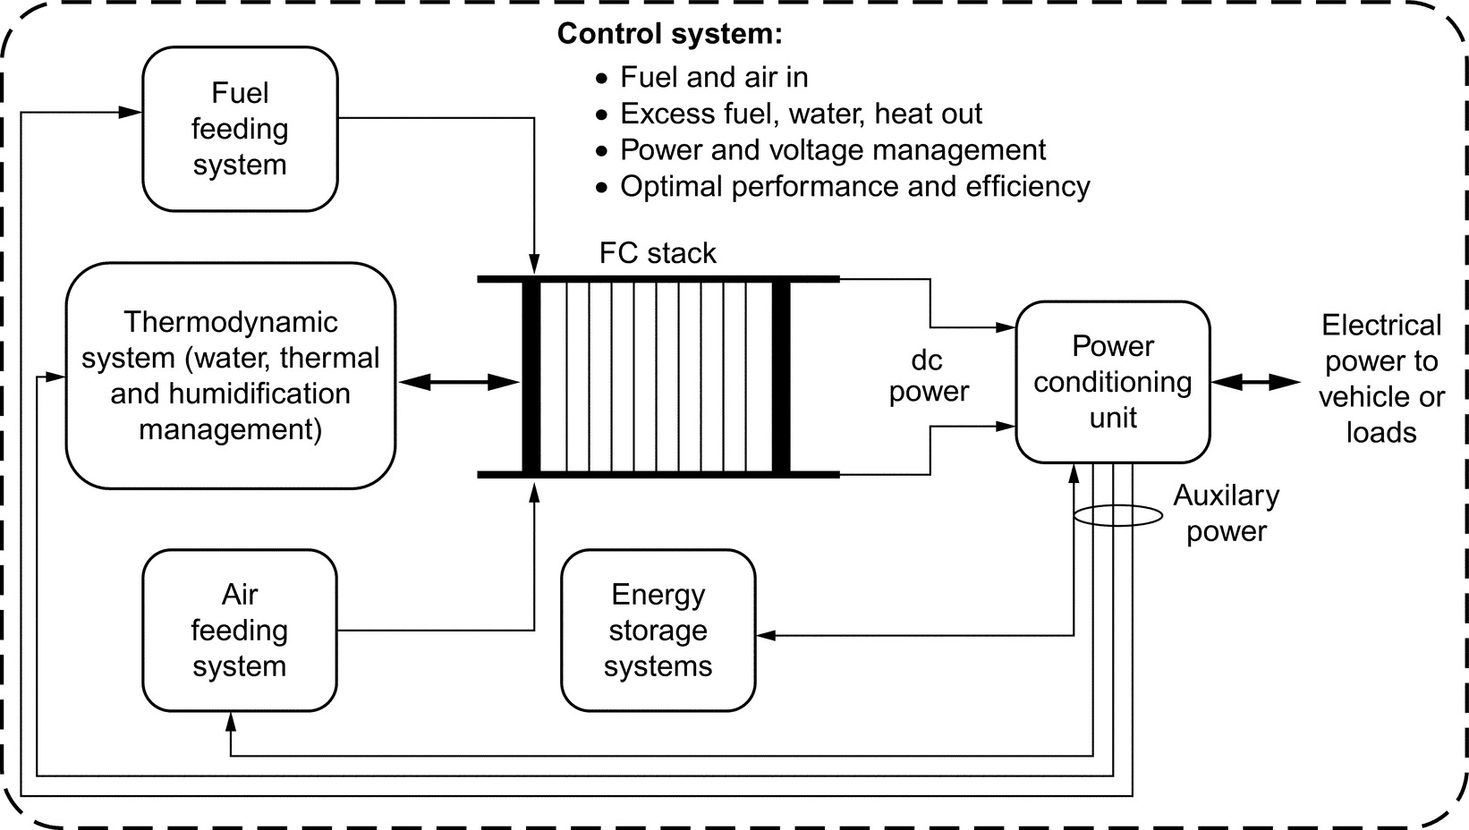

**FIG. 33.7** FC system components.

(i) *Fuel cell stack.* Although the FC stack is the main component of the fuel-cell system, for the required electric energy, all fuel-cell components must work in harmony. To that end, hydrogen fuel and air must be loaded into the stack as pressured gas. Thereafter, the excess hydrogen will be purged, and excess heat will be removed by circulating cooling water through the stacks during processing [[23](https://learning.oreilly.com/library/view/power-electronics-handbook/9780128114087/B9780128114070000374.xhtml#bb0120)]. During operation, an FC produces dc electricity and water and heat through electrochemical process.

A fuel cell stack is made by assembling cells to deliver the required amount of voltage and power. Since a single cell produces less than 1 V, this voltage ratio is insufficient for most of the applications [[21](https://learning.oreilly.com/library/view/power-electronics-handbook/9780128114087/B9780128114070000374.xhtml#bb0110),[41](https://learning.oreilly.com/library/view/power-electronics-handbook/9780128114087/B9780128114070000374.xhtml#bb0210)]. A single fuel cell consists of three metal plates called separators and two membrane electrode assembly (MEA) plates, which generates electricity. Innovative MEA design can provide effective and efficient fuel flow [[21](https://learning.oreilly.com/library/view/power-electronics-handbook/9780128114087/B9780128114070000374.xhtml#bb0110)]. The cell generates electricity in the form of direct current (dc) by reacting hydrogen and oxygen in the air at the MEA.

The ideal potential of a hydrogen/oxygen FC under standard state conditions (25°C and 1 atm) is 1.229 V with liquid water product. However, the actual FC potential is lower than the ideal potential value due to the irreversible voltage drops that occurs in the FC system. There are three types of irreversible voltage drops, namely, activation overvoltage, ohmic overvoltage, and concentration overvoltage. At low current densities, the activation overvoltage is responsible for the voltage drop of the FC. Besides, concentration overvoltage becomes more significant at high current densities. The effects of these voltage drops and the corresponding variance of FC voltage can be seen from the FC polarization curve shown in [Fig. 33.8](https://learning.oreilly.com/library/view/power-electronics-handbook/9780128114087/B9780128114070000374.xhtml#f0045) [[53](https://learning.oreilly.com/library/view/power-electronics-handbook/9780128114087/B9780128114070000374.xhtml#bb0270)]. Operating FC in this linear region is quite important for ensuring overall system efficiency.

The fuel cell stack from combined assembling cells is the most important part of a fuel-cell power system, like an engine in the conventional vehicle. The FC stack provides the current required by governing of a fuel flow rate through the anode channels, that is, the fuel flow rate varies according to the system power requirements [[5](https://learning.oreilly.com/library/view/power-electronics-handbook/9780128114087/B9780128114070000374.xhtml#bb0030)]. The auxiliaries of FC system also consume 10%–15% of the total power output of the fuel cell stack [[24](https://learning.oreilly.com/library/view/power-electronics-handbook/9780128114087/B9780128114070000374.xhtml#bb0125)]. The amount of power produced by fuel cell and its performance depends upon several factors, such as cell size, operating temperature, reactant gas stoichiometric flow rates, pressure of gases supplied to the cell, and anode and cathode humidification parameters [[41](https://learning.oreilly.com/library/view/power-electronics-handbook/9780128114087/B9780128114070000374.xhtml#bb0210),[52](https://learning.oreilly.com/library/view/power-electronics-handbook/9780128114087/B9780128114070000374.xhtml#bb0265)].

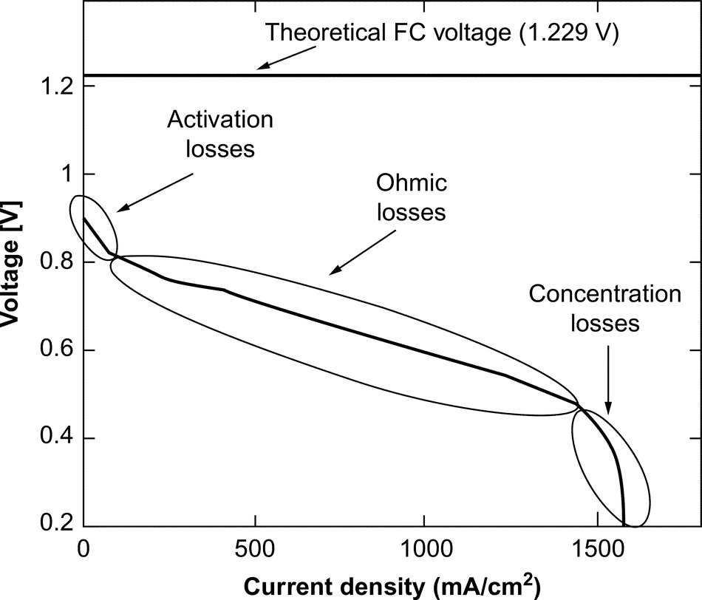

**FIG. 33.8** Typical FC polarization curve.

(ii) *Fuel- and air-feeding systems.* Automotive applications with onboard hydrogen storage tank have control systems consisting of pressure regulators, relative humidity, fuel purity grade, and fluid-dynamic conditions [[23](https://learning.oreilly.com/library/view/power-electronics-handbook/9780128114087/B9780128114070000374.xhtml#bb0120)]. As mentioned before, FCs have some limitations to track fast load variations, such as acceleration and deceleration for vehicular application, due to their relative slow dynamics, which is defined as FC starvation and flooding phenomenon. Thus, to utilize an FC in dynamic applications, both the air- and fuel-feeding control systems must be well managed and supported by a proper fuel cell energy storage system. To improve FC performance and efficiency, design and control of the air compressor are very important in order to accumulate and efficiently remove water produced from the reaction [[21](https://learning.oreilly.com/library/view/power-electronics-handbook/9780128114087/B9780128114070000374.xhtml#bb0110),[23](https://learning.oreilly.com/library/view/power-electronics-handbook/9780128114087/B9780128114070000374.xhtml#bb0120),[41](https://learning.oreilly.com/library/view/power-electronics-handbook/9780128114087/B9780128114070000374.xhtml#bb0210)]. However, some automakers like Hyundai use different design as near-ambient air pressure to provide oxygen to the FC stack [[54](https://learning.oreilly.com/library/view/power-electronics-handbook/9780128114087/B9780128114070000374.xhtml#bb0275)].

(iii) *Thermodynamic system.* In an FC system, water management, thermal management, and humidification can be increased to optimize overall system performance and improve power generation [[23](https://learning.oreilly.com/library/view/power-electronics-handbook/9780128114087/B9780128114070000374.xhtml#bb0120)]. These three components must be efficient and reliable for optimum functioning of overall system, which require proper design, control, and water balance. If these conditions cannot be achieved, problems such as membrane drying out, electrode flooding and conductivity inadequacy, and excess water accumulation in the anode side would occur [[23](https://learning.oreilly.com/library/view/power-electronics-handbook/9780128114087/B9780128114070000374.xhtml#bb0120),[25](https://learning.oreilly.com/library/view/power-electronics-handbook/9780128114087/B9780128114070000374.xhtml#bb0130)].

(iv) *Power-conditioning unit.* Another part of FC system is the power-conditioning unit (PCU). Because an FC produces dc electric energy, it must be converted from unregulated low-voltage level (voltage varies in a wide range depending on the load current) to regulated high-voltage level using a dc/dc converter and/or inverted to alternating current (ac) using dc/ac inverter for ac electric loads/drivetrains. The power-conditioning unit in such a vehicular system is mainly composed of dc/dc converters and an inverter unit. The inverter and propulsion motor are emulated using the dc load bank; therefore, only dc/dc converters are designed and built. The dc/dc converters used in FCEV topologies are the essential power-train components as they allow load sharing between main energy source and energy storage systems (ESSs) by using PCU. For example, the FC power stage is assigned for a power-tracking process to supply the determined power value from the FC system. Besides, ESS power stage can be devoted to DC link voltage control. Both power tracking and DC link voltage control processes can be implemented using a controller. Thus, this hybrid system topology provides the capability of delivering the desired power value from the FC system while keeping the bus voltage at desired intervals [[55](https://learning.oreilly.com/library/view/power-electronics-handbook/9780128114087/B9780128114070000374.xhtml#bb0280)]. The driving motor can either be ac or dc motors such as induction motors, permanent magnet brushless motors, and switched reluctance motors [[56](https://learning.oreilly.com/library/view/power-electronics-handbook/9780128114087/B9780128114070000374.xhtml#bb0285)]. The proper response of the FC system to the overall load dynamics can be achieved by generating appropriate power-switching signals to the converters [[47](https://learning.oreilly.com/library/view/power-electronics-handbook/9780128114087/B9780128114070000374.xhtml#bb0240)]. While these converters design and operate, they must be preferred with high voltage ratio, high efficiency, low electromagnetic interference (EMI), and high compactness while keeping low cost [[37](https://learning.oreilly.com/library/view/power-electronics-handbook/9780128114087/B9780128114070000374.xhtml#bb0190)].

(v) *Energy storage systems.* A stand-alone FC system integrated into an automotive powertrain is not always sufficient to satisfy the load demands of a vehicle. Although FC systems exhibit good power capability during steady-state operation, the response of fuel cells during transient and instantaneous peak power demands is relatively poor. Therefore, when utilizing a PEMFC, it is recommended to associate it with an auxiliary power source to improve the dynamic performance of the whole system. There are many types of auxiliary units for compensating the slow response characteristics of the PEMFC unit and increasing the efficiency of the overall system. Energy storage units such as batteries, ultracapacitors (UCs), and flywheels, can be classified in the auxiliary power units group for use in hybrid systems including PEMFC. Specifically, not only energy storage units compensate the slow response phenomenon of PEMFC system, but also it provides the advantage of recovering the reusable kinetic energy that occurs in vehicular applications during braking periods. Thus, the consumption of hydrogen for FC units can be significantly decreased.

In many applications, batteries are utilized as ESS. Among the various existing rechargeable batteries, lithium-ion batteries appear to occupy a prime position in various aspects. A battery is needed in an FC system to supply power during the time after a change in the flow of reactants occurs. An auxiliary power source such as a battery bank can be used to improve the FC dynamics. In addition, the use of batteries reduces the size and cost of the FC, increases the lifetime, and avoids overloading. The battery bank supplies auxiliary power during cold start of the FC and supports peak demand periods or transient events. They also compensate the tracking delays of FC system. The state of charge (SoC) is an indicator showing the emptiness or fullness of the battery. The battery current can either be negative or positive, with respect to the mode of operation, for example, charging or discharging [[57](https://learning.oreilly.com/library/view/power-electronics-handbook/9780128114087/B9780128114070000374.xhtml#bb0290)].

When the load power exceeds the maximum output of FC, battery starts to discharge through a converter located in the PCU and keeps discharging until the overloading ends. Also, if a step or ramp increase in the load demand occurs (even there is no overloading), battery bank helps the FC system until the FC power increases and matches the demanded power. The FC system has a relatively slow response in both step-up and step-down load conditions. When a step-down loading occurs, the output power of the FC slowly matches the reference power. In these conditions, the battery bank captures the differing power to successfully meet the load demands. These recaptured energies sometimes might not be sufficient to keep the battery SoC above a predefined level. Thus, another control loop is used to directly charge the battery bank from FC power plant with respect to the final SoC. The charge and discharge conditions of the battery are controlled with the aid of a dc/dc converter [[57](https://learning.oreilly.com/library/view/power-electronics-handbook/9780128114087/B9780128114070000374.xhtml#bb0290)]. In the battery discharge current control, the key point is how good the FC power matches the active power requirement of the load. Thus, the positive difference between the FC reference power and the actual FC output power is processed to force the dc/dc converter to draw the reference current from the battery. The discharge current is limited using a saturation system to avoid battery overloading.

The battery can be charged when the FC reference power is above the power demand due to its slow response. While this can be evaluated as a naturally charging condition, another charging control loop is also employed. If all these conditions conforms the respective criteria, battery can be charged. In the battery charge current control, the key point is instantaneous SoC of the battery when compared with its nominal SoC. The battery charge current should be inversely proportional to the depth of discharge [[57](https://learning.oreilly.com/library/view/power-electronics-handbook/9780128114087/B9780128114070000374.xhtml#bb0290)]. Also, the battery has some effect on meeting the reactive power demand. We can express the reactive power as the oscillating power between source and load buses. In systems including dc/ac conversion such as fuel cells, we observe that the reactive power oscillates between the reversible device (battery or UC) of the dc bus and the ac load bus. The reactive power passes through the antiparallel diodes of the inverter circuit to reach the rechargeable device and then passes to the load side through the next alternant. However, due to the reactive power losses on the contactors and the equivalent system impedance, there is always a dc power to be converted to the reactive power, which results in hydrogen consumption, stack dc voltage drop, and load bus voltage drop [[57](https://learning.oreilly.com/library/view/power-electronics-handbook/9780128114087/B9780128114070000374.xhtml#bb0290)].

Ultracapacitors are also ESS devices that offer significantly better energy densities than conventional capacitors, better power densities than conventional batteries and can be constructed in modular and/or stackable format. The charge and discharge time of an UC varies from fractions of a second to several minutes, while providing maintenance-free operation. UCs provide the lowest cost per farad and extremely high cycling capability and prove to be environmentally safe [[47](https://learning.oreilly.com/library/view/power-electronics-handbook/9780128114087/B9780128114070000374.xhtml#bb0240)]. The capacitance of UCs may vary from a few farads to several thousand farads per cell. Because of the aforementioned unique characteristics, UCs are utilized for a wide range of applications. Therefore, a UC bank can effectively serve as a cost-effective alternative to batteries, especially during short peak demand periods.

The natural structure of ultracapacitors is appropriate to meet transient and instantaneous peak power demands. The UC bank is designed to provide the difference between the load demand and the output power generated by the FC system. Without the UC bank, the FC system must supply all power demand, thus increasing the size and cost of the FC system.

The amount of energy drawn from the UC bank is directly proportional to the capacitance and the change in terminal voltage. The effective specific energy for a prescribed load can be supplied by various UC bank configurations. In practical applications, the required amount of terminal voltage and energy or the capacitance of UC storage system can be built using multiple UCs in series and parallel. The terminal voltage determines the number of capacitors, which must be connected in series to form a bank, and the total capacitance determines the number of capacitors, which must be connected in parallel in the bank. The natural structure of UC is appropriate to meet transient and instantaneous peak power demands.

As a result, while choosing an ESS, the following characteristics should be considered [[5](https://learning.oreilly.com/library/view/power-electronics-handbook/9780128114087/B9780128114070000374.xhtml#bb0030),[57](https://learning.oreilly.com/library/view/power-electronics-handbook/9780128114087/B9780128114070000374.xhtml#bb0290)]: specific energy and energy density; electric power, that is, the electric load required; volume and mass; storage capacity; reliability; durability; safety; cost; recyclability; environmental impact; response time; efficiency; self-discharge rate/charging cycles and excess discharge; sensitivity to temperature; charge-discharge rate lifetime; environmental effects; investing/operating cost; maintenance; availability; design complexity/voltage range; life cycle; and recharge rate of storage element.

## 33.5 Fuel Cells in Automotive Applications

FCs offer many advantages over the internal combustion engines (ICE) for vehicular applications because they are energy efficient, clean, and fuel flexible. Today, FCs have become smaller, more powerful, and more durable [[54](https://learning.oreilly.com/library/view/power-electronics-handbook/9780128114087/B9780128114070000374.xhtml#bb0275)]. Since FCEVs provide much better air quality, health problems, such as incidence of asthma and other chest complaints, will decrease [[25](https://learning.oreilly.com/library/view/power-electronics-handbook/9780128114087/B9780128114070000374.xhtml#bb0130)]. Hydrogen FC systems have the potential to reach 60% peak efficiency [[15](https://learning.oreilly.com/library/view/power-electronics-handbook/9780128114087/B9780128114070000374.xhtml#bb0080)]. Onboard the vehicle, conversion of hydrogen produces electricity for power train of vehicle and water. Hydrogen can be obtained from various sources with different methods [[58](https://learning.oreilly.com/library/view/power-electronics-handbook/9780128114087/B9780128114070000374.xhtml#bb0295)]. Leading automobile industries are making every effort to make hydrogen-powered vehicles affordable, environment-friendly, and safe [[25](https://learning.oreilly.com/library/view/power-electronics-handbook/9780128114087/B9780128114070000374.xhtml#bb0130),[41](https://learning.oreilly.com/library/view/power-electronics-handbook/9780128114087/B9780128114070000374.xhtml#bb0210)].

Automobiles, buses, scooters, golf cars, utility vehicles (such as forklifts and airport vehicles), locomotives, tramways, boats, airplanes, and underwater vehicles can be considered as some of the applications of PEMFC systems in transportation area [[15](https://learning.oreilly.com/library/view/power-electronics-handbook/9780128114087/B9780128114070000374.xhtml#bb0080)]. In automobile systems, almost all major automakers have demonstrated prototypes and commercially available FC vehicles and announced future plans for production and commercialization in the near future. On the other hand, buses seem to be the most likely type of road vehicles for an early market introduction of the FC technology. Also, scooters may be a significant market for FC technologies, especially in developing countries. To conclude, the transportation area seems to be the most promising sector of PEMFC technology.

The need to reduce emissions through the improvement of vehicle efficiency and the depleting fossil fuels has motivated researchers to investigate alternatives to conventional ICE-based vehicular systems. Among the alternatives, FC-powered electric vehicles using hydrogen as fuel are considered as the ultimate route to achieving sustainable long-term alternative propulsion systems [[16](https://learning.oreilly.com/library/view/power-electronics-handbook/9780128114087/B9780128114070000374.xhtml#bb0085)]. Hydrogen is an energy carrier with many important unique features. It is considered as the lightest, most efficient, and cleanest fuel. One of its unique features is that it can be converted to electricity in FCs through electrochemical processes with higher efficiencies than conversion of fossil fuels to mechanical energy in ICEs. Thus, this particular characteristic allows higher efficiency and practically null emission of polluting agents for FC-powered vehicles compared with ICE-based vehicular systems. Particularly, these efficiency and environmental friendliness advantages become more significant when renewable energy sources such as wind and solar are used for hydrogen production. In particular, passenger vehicles are mostly operated at part loads significantly below their rated power; thus, vehicle running in urban or suburban areas demands a small fraction of the rated FC power most of the time. Thus, the efficiency of the overall system becomes higher as the FC is operated most efficiently. This issue is exhibited by Villatico and Zuccari [[59](https://learning.oreilly.com/library/view/power-electronics-handbook/9780128114087/B9780128114070000374.xhtml#bb0300)] by comparing the performance of FC and ICE in real driving cycles. Moreover, FC-based vehicles have medium- and long-term potential to be the mainstream vehicle in the future because they have almost zero emission and compatible driving range to ICE-based vehicles [[1](https://learning.oreilly.com/library/view/power-electronics-handbook/9780128114087/B9780128114070000374.xhtml#bb0010),[5](https://learning.oreilly.com/library/view/power-electronics-handbook/9780128114087/B9780128114070000374.xhtml#bb0030),[55](https://learning.oreilly.com/library/view/power-electronics-handbook/9780128114087/B9780128114070000374.xhtml#bb0280)]. For real utilization of EVs, many features should be considered, such as performance, cold start, reliability, durability, cost, and fueling/charging times, availability, and infrastructure [[13](https://learning.oreilly.com/library/view/power-electronics-handbook/9780128114087/B9780128114070000374.xhtml#bb0070),[18](https://learning.oreilly.com/library/view/power-electronics-handbook/9780128114087/B9780128114070000374.xhtml#bb0095)]. Both FC and battery EVs have similar components, like driving motors, power conditioners; also, they will coexist in the future. The FCEV is a promising solution because of faster refueling, cold starting, faster warming up to operating temperature and longer driving range features compared with BEV [[24](https://learning.oreilly.com/library/view/power-electronics-handbook/9780128114087/B9780128114070000374.xhtml#bb0125),[25](https://learning.oreilly.com/library/view/power-electronics-handbook/9780128114087/B9780128114070000374.xhtml#bb0130),[60](https://learning.oreilly.com/library/view/power-electronics-handbook/9780128114087/B9780128114070000374.xhtml#bb0305)]. Generally, the FCEVs are proper for midsize and long-range vehicles, while the BEV is suitable for small-size and short-range vehicles [[5](https://learning.oreilly.com/library/view/power-electronics-handbook/9780128114087/B9780128114070000374.xhtml#bb0030)].

Among the various available FC types, PEMFC is the most likely candidate for automotive applications, thanks to its several attractive features, such as low operating temperatures, relatively low cost and quick start-up, simplicity, viability, packaging under the hood of vehicle, and high efficiency [[55](https://learning.oreilly.com/library/view/power-electronics-handbook/9780128114087/B9780128114070000374.xhtml#bb0280)]. However, the unsteady operation of a vehicle may not be appropriate for the usage of a sole FC system. Moreover, a FC system (in the power train of an automotive) needs to be equipped with the combination of ESS, driving motor, converters, and various auxiliary devices [[23](https://learning.oreilly.com/library/view/power-electronics-handbook/9780128114087/B9780128114070000374.xhtml#bb0120)]. The power demand of a vehicle motor undergoes significant variations due to acceleration, changes in road surface and traffic conditions. Thus, a sole FC system may not totally satisfy the power demand of a vehicle due to the limitation of fuel cells to track fast load variations because of their slow response dynamics. Besides, load demand fluctuations in vehicle operation may cause fuel starvation, flooding, membrane drying, and pressure imbalance across the FC membrane, which may damage the FC stack and decreases its lifetime [[61](https://learning.oreilly.com/library/view/power-electronics-handbook/9780128114087/B9780128114070000374.xhtml#bb0310)]. Moreover, an advanced energy management strategy is necessary to split the power demand of a vehicle in a suitable way for the onboard power sources in order to maximize the performance while promoting the fuel economy and endurance of hybrid system components.

### 33.5.1 DESIGN ARCHITECTURES FOR PEMFC POWERED HYBRIDIZATIONS

In general, FCEVs are configured as series vehicles [[60](https://learning.oreilly.com/library/view/power-electronics-handbook/9780128114087/B9780128114070000374.xhtml#bb0305)]. However, the architecture of a FCEV can be configured in series, series-parallel, and parallel. The selection of the hybrid power-train topology is very important for an efficient operation and better market penetration of FCEV systems. Effective and efficient power conversion technologies are strategic for the progress of FCEVs [[62](https://learning.oreilly.com/library/view/power-electronics-handbook/9780128114087/B9780128114070000374.xhtml#bb0315)]. Interfacing the load/power-train unit requirements with the different operational modes of onboard generation and storage systems call for suitable power electronic converter configuration and control. The selection of power-conditioning unit for hybrid systems including PEMFC is based on some significant factors like lower cost, space requirement, compact structure, higher efficiency, electric isolation, and ripple-free and reliable operation [[15](https://learning.oreilly.com/library/view/power-electronics-handbook/9780128114087/B9780128114070000374.xhtml#bb0080),[62](https://learning.oreilly.com/library/view/power-electronics-handbook/9780128114087/B9780128114070000374.xhtml#bb0315)].

Despite the fact that hybridization concept brings remarkable benefits, the main challenge is to find the appropriate combination of energy sources. Each energy source has unique characteristics and energy conversion efficiency. Thus, each combination is expected to show different performance, efficiency, and fuel/energy consumption. Moreover, in a hybrid topology, these energy sources can be connected to dc bus either directly or via a power converter. In case of utilizing a power converter, which allows higher flexibility in load sharing, an improved hydrogen economy may be expected. However, system efficiency may decrease due to additional conversion stage, which might worsen the equivalent fuel economy.

Considering the abovementioned factors and the load/drivetrain requirements, various topologies may be used for the operation of PEMFC hybrid systems. One of the simplest architectures for the parallel operation of PEMFC hybrid systems includes the direct integration of PEMFC system with the auxiliary power unit as shown in [Fig. 33.9](https://learning.oreilly.com/library/view/power-electronics-handbook/9780128114087/B9780128114070000374.xhtml#f0050). During low power demand, the FC system generates up to its load limit, and the excess energy between the load demand and the FC output power is used to charge the auxiliary unit. In this period, the S1 switch is closed, and S2 switch is open. During high-power-demand periods, both the FC system and the auxiliary units supply the load demand. During this period, S1 switch is kept open, and S2 switch is closed. The direct integration topology is attractive, because it does not require a high-power dc/dc converter; thus, the complexity, cost, weight, and volume of the system are significantly reduced [[15](https://learning.oreilly.com/library/view/power-electronics-handbook/9780128114087/B9780128114070000374.xhtml#bb0080)]. For example, the UC system integration can be achieved with or without power electronic converter via series and parallel connection. Because of the high specific power and power density of UC bank, it may be possible to eliminate the dc/dc converter for voltage regulation so that it can deliver higher output. This topology is proposed by Honda [[63](https://learning.oreilly.com/library/view/power-electronics-handbook/9780128114087/B9780128114070000374.xhtml#bb0320)] for a combined PEMFC-/UC-powered vehicular system. Also, the direct integration of the FC with the UC bank is possible for relatively low-voltage applications with a dc bus of less than 50 V [[64](https://learning.oreilly.com/library/view/power-electronics-handbook/9780128114087/B9780128114070000374.xhtml#bb0325)]. The UC bank and the load terminal voltages depend on the FC system terminal voltage, which prevents the power capability of the UC bank from being fully utilized*.* Therefore, the UC bank size is restricted by the terminal voltage of the FC system, as in the battery/UC hybrid system of Ref. [[65](https://learning.oreilly.com/library/view/power-electronics-handbook/9780128114087/B9780128114070000374.xhtml#bb0330)].

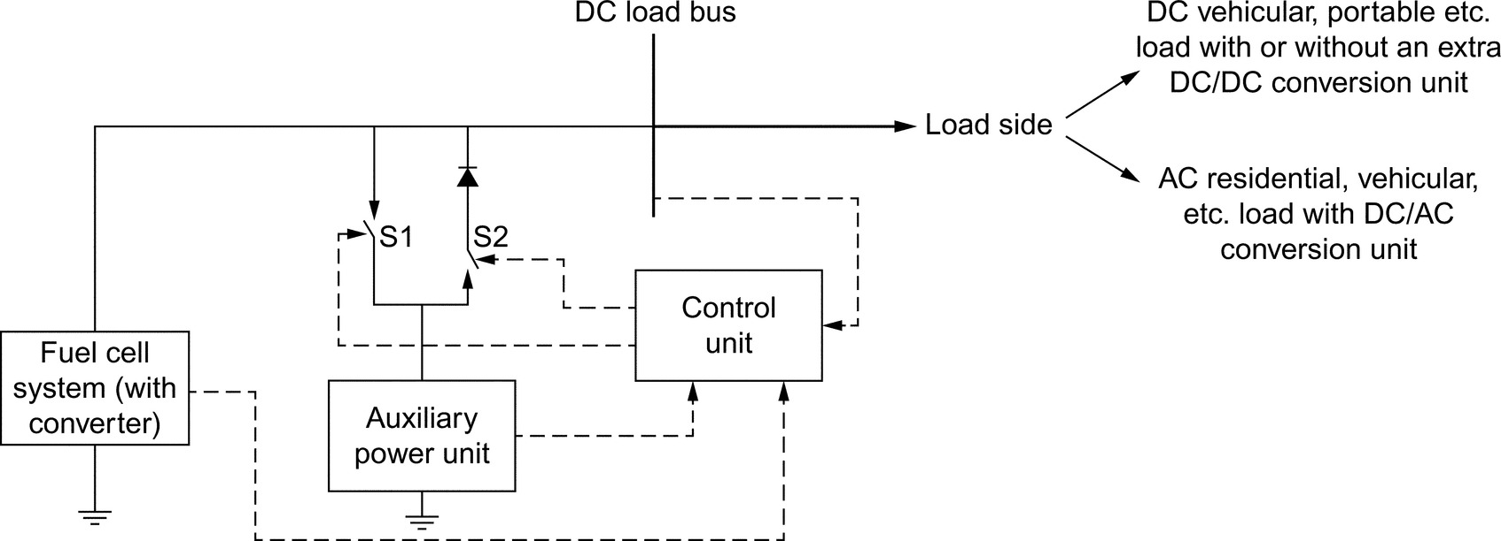

**FIG. 33.9** Direct integration topology [[15](https://learning.oreilly.com/library/view/power-electronics-handbook/9780128114087/B9780128114070000374.xhtml#bb0080)].

Different designs of a topology with only one dc/dc converter unit are shown in [Figs. 33.10](https://learning.oreilly.com/library/view/power-electronics-handbook/9780128114087/B9780128114070000374.xhtml#f0055) and [33.11](https://learning.oreilly.com/library/view/power-electronics-handbook/9780128114087/B9780128114070000374.xhtml#f0060). The topology in [Fig. 33.10](https://learning.oreilly.com/library/view/power-electronics-handbook/9780128114087/B9780128114070000374.xhtml#f0055) regulates the output power of the FC system, while the rest of the energy between the load demand and the FC output power is naturally supplied by the auxiliary unit. Besides, the topology in [Fig. 33.11](https://learning.oreilly.com/library/view/power-electronics-handbook/9780128114087/B9780128114070000374.xhtml#f0060) is based on the regulation of the auxiliary system output power or the regulation of the DC bus voltage. There are many studies in the literature using these two topologies. Some previous studies on these topologies are reviewed and summarized in Ref. [[15](https://learning.oreilly.com/library/view/power-electronics-handbook/9780128114087/B9780128114070000374.xhtml#bb0080)].

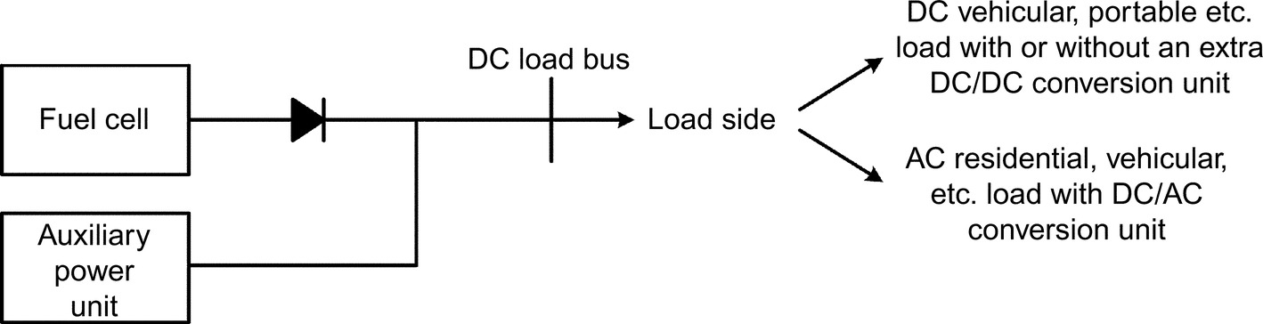

**FIG. 33.10** Single converter-based topology [[15](https://learning.oreilly.com/library/view/power-electronics-handbook/9780128114087/B9780128114070000374.xhtml#bb0080)].

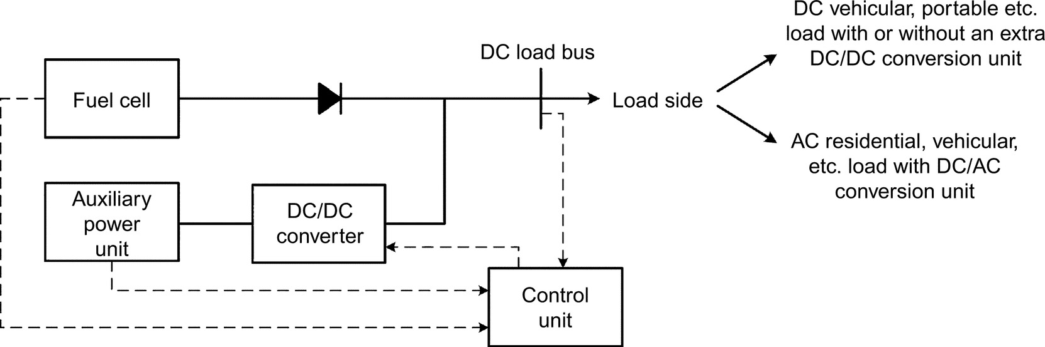

**FIG. 33.11** Single converter-based topology [[15](https://learning.oreilly.com/library/view/power-electronics-handbook/9780128114087/B9780128114070000374.xhtml#bb0080)].

The most common topology for hybrid systems is composed of multiple dc/dc converters as shown in [Fig. 33.12](https://learning.oreilly.com/library/view/power-electronics-handbook/9780128114087/B9780128114070000374.xhtml#f0065). In this kind of topology, the dc/dc converter of one of the available power sources is employed for the dc bus voltage regulation, which is called voltage-oriented-control, and the rest of the converters are controlled for power tracking by power-oriented-control methodology. Thus, the proposed power-conditioning unit provides the capability of delivering the desired power value from the hybrid power sources while keeping the bus voltage at a desired level. Additional architectures for the usage of multiple converter topologies for transportation area are available in Refs. [[53](https://learning.oreilly.com/library/view/power-electronics-handbook/9780128114087/B9780128114070000374.xhtml#bb0270),[66](https://learning.oreilly.com/library/view/power-electronics-handbook/9780128114087/B9780128114070000374.xhtml#bb0335)–[70](https://learning.oreilly.com/library/view/power-electronics-handbook/9780128114087/B9780128114070000374.xhtml#bb0355)].

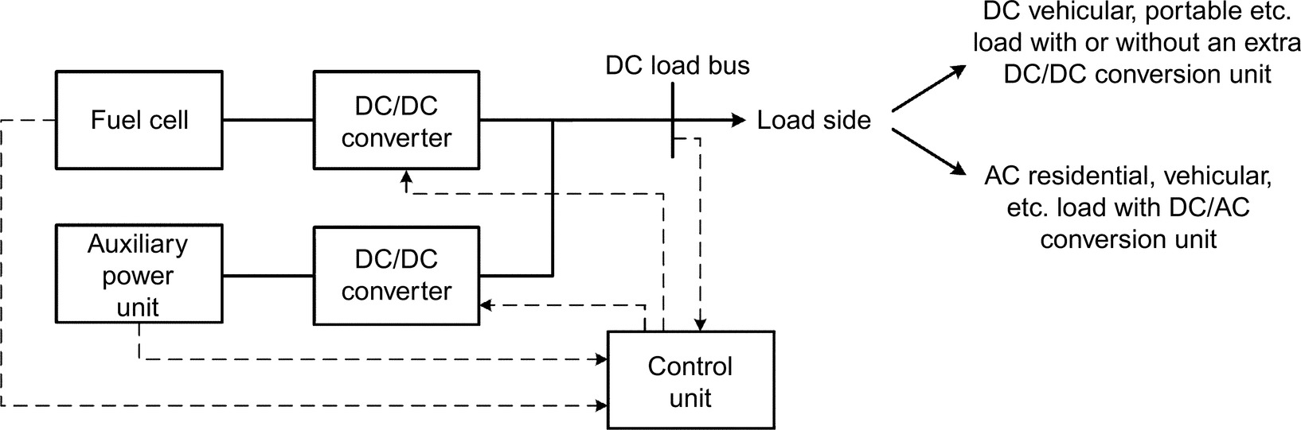

**FIG. 33.12** Multiple converter-based topology [[15](https://learning.oreilly.com/library/view/power-electronics-handbook/9780128114087/B9780128114070000374.xhtml#bb0080)].

Combining the features of multiple converter-based topology, some researchers focused on utilizing multiple-input single-output design architecture as depicted in [Fig. 33.13](https://learning.oreilly.com/library/view/power-electronics-handbook/9780128114087/B9780128114070000374.xhtml#f0070). This topology provides the advantage of reduced number of elements (multiple inputs of power sources can be connected to a dc bus via only one output capacitor) used in power electronics interface design. For example, Ferreira et al. [[71](https://learning.oreilly.com/library/view/power-electronics-handbook/9780128114087/B9780128114070000374.xhtml#bb0360)], Perez et al. [[72](https://learning.oreilly.com/library/view/power-electronics-handbook/9780128114087/B9780128114070000374.xhtml#bb0365)], and Napoli et al. [[73](https://learning.oreilly.com/library/view/power-electronics-handbook/9780128114087/B9780128114070000374.xhtml#bb0370)] utilized the multi-input converter topology for an electric vehicular system consisting of PEMFC, battery, and UC.

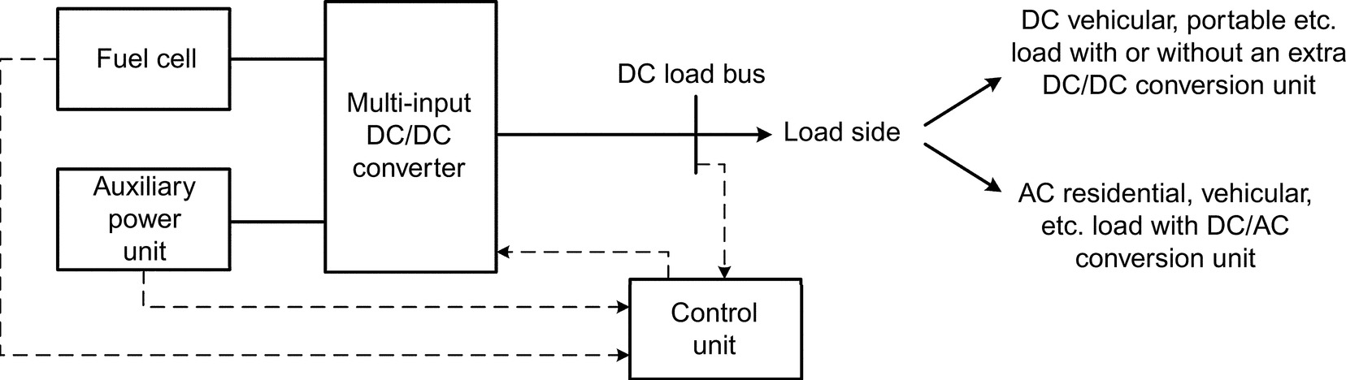

**FIG. 33.13** Multi-input converter-based topology [[15](https://learning.oreilly.com/library/view/power-electronics-handbook/9780128114087/B9780128114070000374.xhtml#bb0080)].

The design of the abovementioned single- or multi-input converters can be realized as insulated or uninsulated, unidirectional, or bidirectional according to the area of application. The basic uninsulated unidirectional and bidirectional dc/dc converter topologies are shown in [Fig. 33.14](https://learning.oreilly.com/library/view/power-electronics-handbook/9780128114087/B9780128114070000374.xhtml#f0075). The proposed multi-input and bidirectional converter-based PCU offers the following advantages:

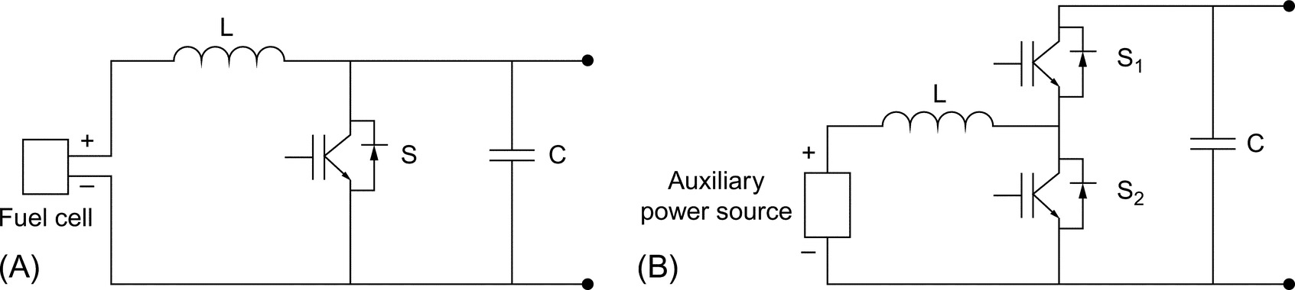

**FIG. 33.14** Structures of the basic dc/dc converter topologies: (A) boost converter topology and (B) bidirectional converter topology [[15](https://learning.oreilly.com/library/view/power-electronics-handbook/9780128114087/B9780128114070000374.xhtml#bb0080)].

• Voltage levels of the input power sources can be different.

• The input sources can deliver the requested power individually and simultaneously.

• Electrically isolation prevents damage on input sources.

• The proposed PCU can work bidirectionally, that is, the power can flow in either direction between individual input and output.

However, there are different advanced, more advantageous but complex topologies developed by power electronics researchers [[15](https://learning.oreilly.com/library/view/power-electronics-handbook/9780128114087/B9780128114070000374.xhtml#bb0080)].

### 33.5.2 VEHICULAR POWER CONTROL STRATEGY AND ENERGY MANAGEMENT

Due to the different characteristics of multiple power sources, the efficiency and the fuel economy of hybrid systems mainly depend on proper energy management strategy (EMS), which is very important for PEMFC-powered hybrid systems.

An FCEV energy control system must provide good acceleration and high recovery of braking energy. The power sharing between the FC system and energy storage system (battery or UC bank) is determined according to the load sharing and control algorithm. Main requirements of the control algorithm are satisfaction of the power demand and management of the power flow in accordance with efficient operation of the different power sources. Coupled with this, the control system should utilize the FC system and energy storage system to match the vehicle load profile by considering different features of power sources.

Since stable operation of the FC system is vital for efficiency, lifetime and cost, FC system should deliver the base load power without responding to peak power demand. Another purpose of the control system is to adopt the battery or UC bank in stabilizing the dc link voltage. This enables power transfer to/from battery or UC bank and improves the driving performance.

Hybrid systems can provide improved efficiency when a well-designed energy splitting algorithm that considers the individual characteristics of each hybrid system is applied. There are many techniques for energy management that have been investigated in the literature, such as intelligence-based strategies, optimization-based strategies, and frequency decoupling strategies [[74](https://learning.oreilly.com/library/view/power-electronics-handbook/9780128114087/B9780128114070000374.xhtml#bb0375)].

#### **33.5.2.1 Intelligence-based Energy Management**

Recently, many intelligence-based energy management strategies such as fuzzy logic, and neural networks for use in PEMFC-powered systems, have been reported in the literature [[15](https://learning.oreilly.com/library/view/power-electronics-handbook/9780128114087/B9780128114070000374.xhtml#bb0080)]. Among them, fuzzy logic controller (FLC)-based methodology plays a dominant role due to its independence of a full mathematical plant model and training procedure. Nonlinearity and difficulties in proper identification of parameters of the plant mathematical models limit the use of model-based conventional control approaches.

Fuzzy logic provides suitable structure compared with conventional control methods especially for the systems comprising nonlinear behaviors where an overall mathematical model is difficult to obtain. Moreover, there is no need for historical data, which is an important advantage over other types of intelligent controllers such as neural networks. Thus, FLC provides a suitable structure especially for systems composed of nonlinear behaviors.

In the literature, many researchers applied fuzzy logic approach for hybrid systems with PEMFC for different applications. Among them, Gao et al. [[75](https://learning.oreilly.com/library/view/power-electronics-handbook/9780128114087/B9780128114070000374.xhtml#bb0380)] provided the power distribution in a hydrogen-powered hybrid bus composed of PEMFC as the main power source and battery/UC combination as the auxiliary unit. In [[15](https://learning.oreilly.com/library/view/power-electronics-handbook/9780128114087/B9780128114070000374.xhtml#bb0080)], FLC utilized the SoC values of auxiliary units and the required power demand of the bus as inputs for determining the output power values of FC and UC systems. Erdinc et al. [[53](https://learning.oreilly.com/library/view/power-electronics-handbook/9780128114087/B9780128114070000374.xhtml#bb0270),[67](https://learning.oreilly.com/library/view/power-electronics-handbook/9780128114087/B9780128114070000374.xhtml#bb0340)] regulated the energy management in PEMFC/UC and PEMFC-/battery-/UC-powered hybrid vehicular systems using fuzzy logic. The aforementioned architectures [[53](https://learning.oreilly.com/library/view/power-electronics-handbook/9780128114087/B9780128114070000374.xhtml#bb0270),[67](https://learning.oreilly.com/library/view/power-electronics-handbook/9780128114087/B9780128114070000374.xhtml#bb0340)] utilized the SoC values of battery and/or UC units and a transient-free form of the vehicular power demand, provided by a load-sharing algorithm, based on standard drive cycles as inputs and gave the requested power value from PEMFC system as output. Li et al. [[76](https://learning.oreilly.com/library/view/power-electronics-handbook/9780128114087/B9780128114070000374.xhtml#bb0385)] proposed a FLC design for a PEMFC/Battery hybrid system with a similar structure to Erdinc et al. [[67](https://learning.oreilly.com/library/view/power-electronics-handbook/9780128114087/B9780128114070000374.xhtml#bb0340)]; however, they optimized the parameters of their FLC for an optimal energy control. As a contribution to the studies of Erdinc et al. [[53](https://learning.oreilly.com/library/view/power-electronics-handbook/9780128114087/B9780128114070000374.xhtml#bb0270),[67](https://learning.oreilly.com/library/view/power-electronics-handbook/9780128114087/B9780128114070000374.xhtml#bb0340)] and Li et al. [[76](https://learning.oreilly.com/library/view/power-electronics-handbook/9780128114087/B9780128114070000374.xhtml#bb0385)], Eren et al. [[77](https://learning.oreilly.com/library/view/power-electronics-handbook/9780128114087/B9780128114070000374.xhtml#bb0390)] inserted the control of internal dynamics of PEMFC system in the fuzzy-logic-based energy management approach in order to provide a safe and efficient operation for PEMFC. Kisacikoglu et al. [[78](https://learning.oreilly.com/library/view/power-electronics-handbook/9780128114087/B9780128114070000374.xhtml#bb0395)] directly controlled the duty cycles of the converters of PEMFC and UC as the outputs of the FLC in a PEMFC/UC hybrid vehicular system.

Another intelligent method used for the control of hybrid system is the neural network approach. Comparing neural network with one of the most popular intelligence-based technique, fuzzy logic, this quick-response capability provides a significant advantage. Fuzzy logic approach does not need a training procedure; however, the rule-based fuzzy structure makes it longer to respond compared with neural network approach. Thus, neural network control may be a competitive approach with fuzzy logic for some applications. Besides, the abovementioned features would lead the neural networks to solve complex problems precisely and flexibly and provide a suitable basis for the control of complex systems. Consequently, neural network has demonstrated remarkable success in control area [[15](https://learning.oreilly.com/library/view/power-electronics-handbook/9780128114087/B9780128114070000374.xhtml#bb0080)].

#### **33.5.2.2 Optimization Based Strategies for Energy Management**

Power management and control system is very important for improving energy efficiency, vehicle performance, and for reducing the weight, size, and cost. Various flexible control methods and intelligent techniques are used for optimization, subject to system constraints. The power management system not only optimizes the available sources but also manages the load dynamically, based on the need and priority of the demand. In these types of energy management approaches, the optimal reference power signals for onboard power sources are calculated by the minimization of a cost function. This cost function generally represents the fuel consumption or emissions especially for vehicular applications. If this optimization is performed over a fixed driving cycle, a global optimum solution can be found. Many approaches such as optimal control theory, linear programming, dynamic or stochastic programming, genetic algorithm, simulated annealing, linear and nonlinear predictive model, and game theory are utilized for solving the aforementioned global optimization problem.

There is significant number of studies dealing with the energy management of an FC-powered hybrid system utilizing an optimization-based methodology [[79](https://learning.oreilly.com/library/view/power-electronics-handbook/9780128114087/B9780128114070000374.xhtml#bb0400),[80](https://learning.oreilly.com/library/view/power-electronics-handbook/9780128114087/B9780128114070000374.xhtml#bb0405)]. For example, Rodatz et al. [[79](https://learning.oreilly.com/library/view/power-electronics-handbook/9780128114087/B9780128114070000374.xhtml#bb0400)] presented an experimentally applied equivalent fuel consumption minimization strategy aiming at minimizing the hydrogen consumption while maintaining drivability in a PEMFC/UC hybrid vehicular system. Xu et al. [[80](https://learning.oreilly.com/library/view/power-electronics-handbook/9780128114087/B9780128114070000374.xhtml#bb0405)] performed a similar optimization approach for an FC/battery hybrid bus. Similar fuel consumption minimization-based approaches were also utilized by Paladini et al. [[81](https://learning.oreilly.com/library/view/power-electronics-handbook/9780128114087/B9780128114070000374.xhtml#bb0410)] for FC/battery/UC hybridization for a vehicle in a simulated environment.

#### **33.5.2.3 Frequency Decoupling Based Energy Management Strategies**

During the daily operation of a system, load transitions may occur frequently. The load power profile is a nonstationary signal and consists of transients. The wavelet transform can be effectively used for analyzing power transients in FCEV power demand profile, because of its ability to deal with nonstationary and/or transient signals. A given signal can be decomposed into transients and desired characteristics can be extracted simultaneously in both the time and frequency domain by using the wavelet transform (WT). The WT decomposes into various components at different time intervals and frequency bands as a windowing technique. In wavelet analysis, long windows are used at low frequencies, and short windows are also used at high frequencies.

One of the most popular mother wavelets is Haar wavelet for detecting and localizing of transients. The Haar basis has the shortest filter length in the time domain in comparison to other wavelet bases. Because of the abovementioned features, the Haar wavelet transform is the most suitable functions for filtering HEV power demand load profile, which consists of transients corresponding to sharp peak power demand. The transients of the HEV power demand signal is clearly observed from the short-term frequency and component magnitude changes.

For some applications like vehicular systems, these transient changes in load demand may occur significantly, which pose dynamic stress onto the FC membrane due to pressure oscillations and possible fuel starvation, which may reduce the lifetime of the FC system. Thus, to ensure FC lifetime prolongation by preventing the FC system from load changes with high frequencies, researchers applied different frequency decoupling techniques. The basic approach for this issue is inserting a transfer function for a delay with a suitable time constant (first-order low-pass filter). Liu et al. [[82](https://learning.oreilly.com/library/view/power-electronics-handbook/9780128114087/B9780128114070000374.xhtml#bb0415)] proposed such a first-order filter for PEMFC system. Besides, some conventional filtering techniques like Butterworth high- and low-frequency filters have been utilized. These conventional filters decouple the main signal with a predefined cutoff frequency; thus, the FC system can be prevented from transient variations. However, the loss of important edge information is a significant phenomenon in conventional filtering techniques. Considering this issue, some researchers applied a wavelet-transform-based frequency decoupling strategy for PEMFC-powered systems. Wavelet transform is a signal processing method that is well known for its capability to treat transient signals. The advantage of wavelet analysis, as opposed to conventional techniques, is that wavelet transform decomposes a signal into a series of short duration waves or local basis functions (wavelets) on the time axis, which allows the analysis of local phenomena in signals consisting of many transients. Besides, wavelet transform provides a quadratic mirror filtering application and the loss of important edge information is minimized compared with conventional filtering techniques. Considering these features of wavelet transform, Uzunoglu and Alam [[83](https://learning.oreilly.com/library/view/power-electronics-handbook/9780128114087/B9780128114070000374.xhtml#bb0420)] applied a wavelet-based energy management strategy for a PEMFC/UC hybrid vehicular system. A similar wavelet-based approach was utilized by Zhang et al. [[66](https://learning.oreilly.com/library/view/power-electronics-handbook/9780128114087/B9780128114070000374.xhtml#bb0335)] for a PEMFC/battery/UC hybrid system.

With the abovementioned types of frequency decoupling strategies, the transients in the total power demand profile are captured, a safe operating condition for FC-based system can be provided and lifetime of the power sources can be extended [[15](https://learning.oreilly.com/library/view/power-electronics-handbook/9780128114087/B9780128114070000374.xhtml#bb0080)].

#### **33.5.2.4 Other Methods for Use in Energy Management**

Existing methods in the literature in addition to the before mentioned techniques include basic linear proportional-integral (PI)-based approaches, complex adaptive control, robust control, and flatness-based control. A conventional linear PI controller is a basic approach that may be useful for use in real-time implementations of PEMFC systems. Many researchers utilized PI controller especially with a main supervisory controller design. As an example, Thounthong et al. [[84](https://learning.oreilly.com/library/view/power-electronics-handbook/9780128114087/B9780128114070000374.xhtml#bb0425),[85](https://learning.oreilly.com/library/view/power-electronics-handbook/9780128114087/B9780128114070000374.xhtml#bb0430)] utilized a multiobjective PI-based linear technique for SoC sustaining and DC link voltage stabilization. Besides, Payman et al. [[86](https://learning.oreilly.com/library/view/power-electronics-handbook/9780128114087/B9780128114070000374.xhtml#bb0435)] applied PI controller for the power electronics converter duty cycle determination in order to regulate the desired values of the system parameters determined by a nonlinear flatness-based supervisory control approach.

Another common approach, adaptive control technique, involves modifying the control law used by a controller to cope with the fact that the parameters of the system being controlled are slowly time-varying or uncertain. For example, as an aircraft flies, its mass will slowly decrease as a result of fuel consumption; we need a control law that adapts itself to such changing conditions. Adaptive control does not need a priori information about the bounds on these uncertain or time-varying parameters. Besides, adaptive control is precisely concerned with control law changes. There are mainly two types of adaptive controllers: feedforward and feedback adaptive controllers. There are many types of feedback adaptive controllers such as model reference adaptive controllers (MRACs) and model identification adaptive controllers (MIACs) that are reported in the literature [[15](https://learning.oreilly.com/library/view/power-electronics-handbook/9780128114087/B9780128114070000374.xhtml#bb0080)].

Robust control methods, which explicitly deal with uncertainty, are designed to function properly so long as uncertain parameters or disturbances are within a typical limit. Robust methods aim to achieve robust performance and/or stability in the presence of bounded modeling errors. In contrast with an adaptive control policy, a robust control policy is static; rather than adapting to measurements of variations, the controller is designed to work assuming that certain variables will be unknown [[15](https://learning.oreilly.com/library/view/power-electronics-handbook/9780128114087/B9780128114070000374.xhtml#bb0080)].

### 33.5.3 CURRENT STATUS AND FUTURE TRENDS OF FUEL CELL BASED VEHICLES

Leading automakers have started to make their light-duty hydrogen FCEVs for testing and commercial applications. Available FCEVs are on the road in selected regions like California, Europe, Japan, where access to hydrogen stations are available. Some of these vehicle models include Honda FCV (2016), Toyota Mirai (2017), Mercedes-Benz B-Class F-Cell (2015), Hyundai Tuscon, and SUV (2016). All of these FCEVs uses 100 kW fuel cell stack. They also have quick refueling time of less than 10 min and driving range of around 200–300 mi [[21](https://learning.oreilly.com/library/view/power-electronics-handbook/9780128114087/B9780128114070000374.xhtml#bb0110),[54](https://learning.oreilly.com/library/view/power-electronics-handbook/9780128114087/B9780128114070000374.xhtml#bb0275),[87](https://learning.oreilly.com/library/view/power-electronics-handbook/9780128114087/B9780128114070000374.xhtml#bb0440)–[89](https://learning.oreilly.com/library/view/power-electronics-handbook/9780128114087/B9780128114070000374.xhtml#bb0450)].

The California Fuel Cell Partnership (CaFCP) plays a vital role in preparing to demonstrate and commercialize the vehicle technology of the twenty-first century. This organization is a unique collaborative of automakers, energy and FC technology companies, and government agencies. Currently CaFCP is focused on the marketization and industrialization and while emphasizing the importance for market introduction of FCEVs [[90](https://learning.oreilly.com/library/view/power-electronics-handbook/9780128114087/B9780128114070000374.xhtml#bb0455)].

Although automakers have produced FC-based commercial vehicles, actually, they started to develop FCEV prototypes many years ago. For example, Toyota has developed various types of FCEVs, after it began its fuel-cell efforts in 1992. Ballard developed and demonstrated a hydrogen-fueled transit bus in 1993. GM demonstrated an FC/battery hybrid FCEV in 1998. Nearly 200 B-Class FC-based Mercedes-Benz vehicles have been with customers in the United States and Europe since 2010 [[89](https://learning.oreilly.com/library/view/power-electronics-handbook/9780128114087/B9780128114070000374.xhtml#bb0450)]. AC Transit has the most comprehensive program to obtain real-world driving impressions and experiences and realize the earlier phase of the hydrogen FCEVs in North America [[17](https://learning.oreilly.com/library/view/power-electronics-handbook/9780128114087/B9780128114070000374.xhtml#bb0090),[90](https://learning.oreilly.com/library/view/power-electronics-handbook/9780128114087/B9780128114070000374.xhtml#bb0455)]. The new Mercedes GLC F-CELL and next generation Honda FCEVs combine fuel cell and energy storage unit (lithium-ion battery) using plug-in hybrid technology that is planned to come to the market in 2017 and 2018, respectively [[21](https://learning.oreilly.com/library/view/power-electronics-handbook/9780128114087/B9780128114070000374.xhtml#bb0110),[91](https://learning.oreilly.com/library/view/power-electronics-handbook/9780128114087/B9780128114070000374.xhtml#bb0460)].

Some governments (e.g., US and Japan) and automakers (e.g., Honda, Toyota, Daimler, Nissan, and Ford) are working together to support hydrogen infrastructure, public awareness, decrease operational costs of infrastructure firms. By cost reduction and mass production of competitive parts such as the FC stack, hydrogen, fueling stations, compact packaging, storage (battery and ultracapacitors), silicon carbide-based innovative power electronics, and electric motor technologies, these vehicles can be commercialized and introduced to the market for widespread use [[18](https://learning.oreilly.com/library/view/power-electronics-handbook/9780128114087/B9780128114070000374.xhtml#bb0095),[21](https://learning.oreilly.com/library/view/power-electronics-handbook/9780128114087/B9780128114070000374.xhtml#bb0110),[37](https://learning.oreilly.com/library/view/power-electronics-handbook/9780128114087/B9780128114070000374.xhtml#bb0190)].

It is necessary to carry out further investigation on the performance, reliability, durability, and cost reduction of FC systems. FCEV design architecture plays a significant role while considering the performance, packaging, interior-space, efficiency, real-world performance, and durability issues. FCEV systems should be environmentally safe and commercially viable. Without doubt, technologies of a stable supply of highly pure hydrogen and inexpensive cell components are a prerequisite for market penetration of FC systems. In this case, since the number of renewable energy sources is increasing rapidly, new business models and marketing strategies can be developed. For example, the production of green hydrogen from renewable sources (biomass, biowaste, electrolyzers powered by photovoltaic, and wind energy systems) and also other feasible and viable hydrogen production methods can be used to feed the FCEVs and to balance the electric and gas grids under the smart grid concept [[5](https://learning.oreilly.com/library/view/power-electronics-handbook/9780128114087/B9780128114070000374.xhtml#bb0030),[20](https://learning.oreilly.com/library/view/power-electronics-handbook/9780128114087/B9780128114070000374.xhtml#bb0105)]. Besides, as a part of sustainable energy and transportation chain, FCEVs, and their modular infrastructures like power inverter and hydrogen stations can contribute to the efficiency of the smart energy systems (as V2G, V2H, flexible load, storage, combined heat power, grid balancing, energy exchange, feed-in tariffs, and emerging application concepts). These kinds of EVs, like FCEVs, can also be used as an investment tool and as a major player of energy market in the future smart grids and smart cities.

Demonstration infrastructure should be sufficient for envisioned commercialization roadmap [[5](https://learning.oreilly.com/library/view/power-electronics-handbook/9780128114087/B9780128114070000374.xhtml#bb0030)]. Demonstration projects and proof of concept experiments will act as a seed in addressing problems associated with practical applications, data collection for standardization, durability of FCEVs and accelerate awareness of using hydrogen in our daily life [[5](https://learning.oreilly.com/library/view/power-electronics-handbook/9780128114087/B9780128114070000374.xhtml#bb0030),[17](https://learning.oreilly.com/library/view/power-electronics-handbook/9780128114087/B9780128114070000374.xhtml#bb0090),[21](https://learning.oreilly.com/library/view/power-electronics-handbook/9780128114087/B9780128114070000374.xhtml#bb0110),[92](https://learning.oreilly.com/library/view/power-electronics-handbook/9780128114087/B9780128114070000374.xhtml#bb0465)]. From the viewpoint of FCEVs market penetration, currently, there are limited commercial FCEVs, but in medium- and long-term periods, there will be huge numbers of FCEVs on the road depending on the abovementioned strategies of developed and developing countries. Thus, they can contribute significantly toward sustainable transportation and hydrogen chain.

### 33.5.4 SAFETY

Hydrogen FCs can revolutionize many sectors, since hydrogen is as safe as or even safer than other flammable fuels such as gasoline or natural gas. However, with the lack of professional design and management, hydrogen fuel cells pose several other risks that other flammable fuels do not.

Nowadays, FCEVs, hydrogen refueling stations and other values of hydrogen chain started to operate in different regions, despite pending answers to potential questions (How safe is hydrogen? What are potential hazards of hydrogen? Which improvements does it require to avoid danger?) [[5](https://learning.oreilly.com/library/view/power-electronics-handbook/9780128114087/B9780128114070000374.xhtml#bb0030)]. Hazards and associated risks for hydrogen fuel cells should be considered by all stakeholders such as designers, regulators, and users in various situations when FCEVs are inoperable, in normal operation and in collision [[5](https://learning.oreilly.com/library/view/power-electronics-handbook/9780128114087/B9780128114070000374.xhtml#bb0030),[16](https://learning.oreilly.com/library/view/power-electronics-handbook/9780128114087/B9780128114070000374.xhtml#bb0085)].

The main potential hazards can be listed as follows [[5](https://learning.oreilly.com/library/view/power-electronics-handbook/9780128114087/B9780128114070000374.xhtml#bb0030),[16](https://learning.oreilly.com/library/view/power-electronics-handbook/9780128114087/B9780128114070000374.xhtml#bb0085),[21](https://learning.oreilly.com/library/view/power-electronics-handbook/9780128114087/B9780128114070000374.xhtml#bb0110)]:

• Hydrogen burns (rather than explosion)

• Higher flammability range

• Danger posed by invisible hydrogen flames (adding chemicals like odorant for required luminosity can provide an easier detection)

• Hard detection of hydrogen leak

• Higher tendency to leak since hydrogen is the smallest molecule (professional design may prevent leaks)

• Potential of hydrogen to asphyxiate people

• Frostbite/cold burns of liquid hydrogen

• Refueling station accidents

These hazards may be prevented or the impacts can be decreased with more R&D studies, administrative supports, efforts of all stakeholders, etc. For instance, Honda improved several designs to prevent FCEVs from collision impacts such as fastening bar as an impact resistant to prevent cells, straight frame structure to protect components, and load path structure to disperse the collision load and for efficient absorption of energy [[21](https://learning.oreilly.com/library/view/power-electronics-handbook/9780128114087/B9780128114070000374.xhtml#bb0110)].

## 33.6 Conclusion

Almost all major companies have publicized ambitious plans to introduce hydrogen-powered vehicles in the market. Moreover, FCEVs are sold in selected regions with access to hydrogen stations. This vehicle type promises very clean operation and shows higher energy efficiency compared with conventional vehicles. When the FCEV technologies become mature, FCs can also be extended in many diverse areas from portable devices to silent heavy vehicles or aerospace applications. Besides, FCEVs and their infrastructure systems can also be used as a backup or integrated system for renewable energy sources.

In the near future, as a part of smart grid, FCEVs and hydrogen energy chain should be considered for sustainable development.

## References

[1] Sen G., Boynuegri A.R., Uzunoglu M., Erdinc O., Catalo J.P.S. Design and application of a power unit to use plug-in electric vehicles as an uninterruptible power supply. *Energies.* 2016;9(3):171.

[2] Tarroja B., Eichman J.D., Zhang L., Brown T.M., Samuelsen S. The effectiveness of plug-in hybrid electric vehicles and renewable power in support of holistic environmental goals: part 1—evaluation of aggregate energy and greenhouse gas performance. *J. Power Sources.* 2014;257:461–470.

[3] Offer G.J., Howey D., Contestabile M., Clague R., Brandon N.P. Comparative analysis of battery electric, hydrogen fuel cell and hybrid vehicles in a future sustainable road transport system. *Energy Policy.* 2010;38:24–29.

[4] Yagcitekin B., Uzunoglu M., Karakas A., Erdinc O. Assessment of electrically-driven vehicles in terms of emission impacts and energy requirements: a case study for Istanbul, Turkey. *J. Clean. Prod.* 2015;96(3910):487–492.

[5] Pollet B.G., Staffell I., Shang J.L. Current status of hybrid, battery and fuel cell electric vehicles: from electrochemistry to market prospects. *Electrochim. Acta.* 2012;84(1):235–249.

[6] Margaritis D., Anagnostopoulou A., Tromaras A., Boile M. Electric commercial vehicles practice perspectives and future research directions. *Res. Transport. Bus. Manag.* 2016;18:1–4.

[7] Brady J., O'Mahony M. The potential impacts of electric vehicles on climate change and urban air quality. *Transp. Res. D.* 2011;16(2):188–193.

[8] Browne M., Allen J., Leonardi J. Evaluating the use of an urban consolidation centre and electric vehicles in central London. *IATSS Res.* 2011;35(1):1–6.

[9] Perujo A., Cuiffo B. The introduction of electric vehicles in the private fleet: potential impact on the electric supply system and on the environment. A case study for the Province of Milan, Italy. *Energy Policy.* 2010;38(8):4549–4561.

[10] Görbe P., Magyar A., Hangos K.M. Reduction of power losses with smart grids fueled with renewable sources and applying EV batteries. *J. Clean. Prod.* 2012;34:125–137.

[11] Moriarty P., Honnery D. Greening passenger transport: a review. *J. Clean. Prod.* 2013;54:14–22.

[12] Köhler J., Schade W., Leduc G., Wiesenthal T., Schade B., Espinoza L.T. Leaving fossil fuels behind? An innovation system analysis of low carbon cars. *J. Clean. Prod.* 2013;48:176–186.

[13] Abd El Monem A.A., Azmy Ahmed M., Mahmoud S.A. Effect of process parameters on the dynamic behavior of polymer electrolyte membrane fuel cells for electric vehicle applications. *Ain Shams Eng. J.* 2014;5(1):75–84.

[14] Uzunoglu M., Alam M.S. Dynamic modeling, design and simulation of a PEM fuel cell/ultra-capacitor hybrid system for vehicular applications. *Energy Convers. Manag.* 2007;48(5):1544–1553.

[15] Erdinc O., Uzunoglu M. Recent trends in PEM fuel cell-powered hybrid systems: investigation of application areas, design architectures and energy management approaches. *Renew. Sust. Energ. Rev.* 2010;14(9):2874–2884.

[16] Barbir F. *PEM Fuel Cells: Theory and Practice.* London, UK: Elsevier Academic Press; 2005.

[17] Han W., Zhang G., Xiao J., Bénard P., Chahine R. Demonstrations and marketing strategies of hydrogen fuel cell vehicles in China. *Int. J. Hydrog. Energy.* 2014;39(25):13859–13872.

[18] Veziroglu A., Macario R. Fuel cell vehicles: state of the art with economic and environmental concerns. *Int. J. Hydrog. Energy.* 2011;36(1):25–43.

[19] Felgenhauer M.F., Pellow M.A., Benson S.M., Hamacher T. Evaluating co-benefits of battery and fuel cell vehicles in a community in California. *Energy.* 2016;114(1):360–368.

[20] Onar O.C., Uzunoglu M., Alam M.S. Modeling, control and simulation of an autonomous WT/PV/FC/UC hybrid power system. *J. Power Sources.* 2008;185(2):1273–1283.

[21] <http://world.honda.com/FuelCell/>.

[22] Edwards P.P., Kuznetsov V.L., David W.I.F., Brandon N.P. Hydrogen and fuel cells: towards a sustainable energy future. *Energy Policy.* 2008;36(12):4356–4362.

[23] Corbo P., Migliardini F., Veneri O. *Hydrogen Fuel Cells for Road Vehicles.* London: Springer-Verlag; 2011.

[24] Rashid M.H. *Modern Electric, Hybrid Electric, and Fuel Cell Vehicles Fundamentals, Theory, and Design.* second ed. Taylor and Francis; 2010.

[25] Dell R., Moseley Patrick T., David A., Rand J. *Towards Sustainable Road Transport.* Elsevier; 2014.

[26] Uzunoglu M., Onar O.C., Alam M.S. Modeling, control and simulation of a PV/FC/UC based hybrid power generation system for stand-alone applications. *Renew. Energy.* 2009;34(3):509–520.

[27] Elam C.C., Padro C.E.G., Sandrock G., Luzzi A., Lindblad P., Hagen E.F. Realizing the hydrogen future: the International Energy Agency's efforts to advance hydrogen energy technologies. *Int. J. Hydrogen Energy.* 2003;28(6):601–607.

[28] Momirlan M., Veziroglu T.N. Current status of hydrogen energy. *Renew. Sust. Energ. Rev.* 2002;6(1-2):141–179.

[29] Sherif S., Barbir F., Veziroglu T. *Wind energy and the hydrogen economy.* In: 41st Aerospace Sciences Meeting and Exhibit, Aerospace Sciences Meetings; 2003.

[30] Hadjipaschalis I., Poullikkas A., Efthimiou V. Overview of current and future energy storage technologies for electric power applications. *Renew. Sust. Energ. Rev.* 2009;13(6–7):1513–1522.

[31] Schell A., Peng H., Tran D., Stamos E., Lin C.C., Kim M.J. Modelling and control strategy development for fuel cell electric vehicles. *Annu. Rev. Control.* 2005;29(1):159–168.

[32] Umegaki T., Yan J.M., Zhang X.B., Shioyama H., Kuriyama N., Xu Q. Boron- and nitrogen-based chemical hydrogen storage materials. *Int. J. Hydrog. Energy.* 2009;34:2303–2311.

[33] Fraser D. *Solutions for hydrogen storage and distribution.* In: The PEI Wind-Hydrogen Symposium; 2003.

[34] Darkrim F.L., Malbrunot P., Tartaglia G.P. Review of hydrogen storage by adsorption in carbon nanotubes. *Int. J. Hydrog. Energy.* 2002;27(2):193–202.

[35] [https://www.hydrogen.energy.gov](https://www.hydrogen.energy.gov/) (accessed 23.02.17).

[36] Kirubakaran A., Jain S., Nema R.K. A review on fuel cell technologies and power electronic interface. *Renew. Sust. Energ. Rev.* 2009;13(9):2430–2440.

[37] Emadi A., Ehsani M., Miller J.M. *Vehicular Electric Power Systems, Land, Sea, Air, and Space Vehicles.* Marcel Dekker; 2004.

[38] Bocarsly A., Michael D., Mingos P. *Fuel Cells and Hydrogen Storage.* Berlin Heidelberg: Springer-Verlag; 2011.

[39] Spiegel C. *PEM Fuel Cell Modeling and Simulation Using MATLAB®.* Academic Press; 2008.

[40] Wang Y., Leung D.Y.C., Xuan J., Wang H. A review on unitized regenerative fuel cell technologies, part-A: Unitized regenerative proton exchange membrane fuel cells. *Renew. Sust. Energ. Rev.* 2016;65:961–977.

[41] <https://www.energy.gov/eere/fuel-cells/types-fuel-cells> (accessed 23.02.17).

[42] Larminie J., Dicks A. *Fuel Cell Systems Explained.* John Wiley & Sons; 2003.

[43] Andujar J.M., Segura F. Fuel cells: history and updating. A walk along two centuries. *Renew. Sust. Energ. Rev.* 2009;13(9):2309–2322.

[44] Mekhilef S., Saidur R., Safari A. Comparative study of different fuel cell technologies. *Renew. Sust. Energ. Rev.* 2012;16(1):981–989.

[45] Cai Q., Brett D.J.L., Browning D., Brandon N.P. A sizing-design methodology for hybrid fuel cell power systems and its application to an unmanned underwater vehicle. *J. Power Sources.* 2010;195(19):6559–6569.

[46] U.S. Department of Energy Office of Fossil Energy National Energy Technology Laboratory, Fuel Cell Handbook (seventh ed.), EG&G Technical Services, Inc., Under Contract No. DE-AM26-99FT40575.

[47] Uzunoglu M., Alam M.S. Dynamic modeling, design, and simulation of a combined PEM fuel cell and ultracapacitor system for stand-alone residential applications. *IEEE Trans. Energy Conver.* 2006;21(3):767–775.

[48] Wee J.H. Applications of proton exchange membrane fuel cell systems. *Renew. Sust. Energ. Rev.* 2007;11(8):1720–1738.

[49] Brett D.J.L., Aguiar P., Brandon N.P., Bull R.N., Galloway R.C., Hayes G.W., Lillie K., Mellors C., Smith C., Tilley A.R. Concept and system design for a ZEBRA battery–intermediate temperature solid oxide fuel cell hybrid vehicle. *J. Power Sources.* 2006;157(2):782–798.

[50] Guo L., Yedavalli K., Zinger D. Design and modeling of power system for a fuel cell hybrid switcher locomotive. *Energy Convers. Manag.* 2010;52(2):1406–1413.

[51] Dincer I. Technical, environmental and exergetic aspects of hydrogen energy systems. *Int. J. Hydrogen Energy.* 2002;27(3):265–285.

[52] Mi C., Masrur M.A., Gao D.W. *Hybrid Electric Vehicles: Principles and Applications with Practical Perspectives.* first ed. John Wiley & Sons; 2011.

[53] Erdinc O., Vural B., Uzunoglu M. A Wavelet-Fuzzy Logic based energy management strategy for a fuel cell/battery/ultra-capacitor hybrid vehicular power system. *J. Power Sources.* 2009;194(1):369–380.

[54] <https://www.hyundaiusa.com/tucsonfuelcell/index.aspx> (accessed 23.02.17).

[55] Vural B., Erdinc O., Uzunoglu M. Parallel combination of FC and UC for vehicular power systems using a multi-input converter-based power interface. *Energy Convers. Manag.* 2010;51(12):2613–2622.

[56] Sulaiman N., Hannan M.A., Mohamed A., Majlan E.H., Wan Daud W.R. A review on energy management system for fuel cell hybrid electric vehicle: issues and challenges. *Renew. Sust. Energ. Rev.* 2015;52:802–814.

[57] Onar O.C., Uzunoglu M., Alam M.S., El-Sharkh M.Y. *A PEM fuel cell/battery hybrid power system under various load conditions.* In: Proceedings International Hydrogen Energy Congress and Exhibition IHEC 2007 Istanbul, Turkey, 13–15 July; 2007.

[58] Wee J.H. Applications of proton exchange membrane fuel cell systems. *Renew. Sust. Energ. Rev.* 2007;11(8):1720–1738.

[59] Villatico F., Zuccari F. Efficiency comparison between FC and ice in real urban driving cycles. *Int. J. Hydrogen Energy.* 2008;33(12):3235–3242.

[60] Ettihir K., Boulon L., Agbossou K., Kelouwani S., Hammoudi M. *Design of an energy management strategy for PEM fuel cell vehicles.* In: Industrial Electronics (ISIE), 2012 IEEE International Symposium on, 28–31 May 2012; 2012.

[61] Liu Z., Yang L., Maoa Z., Zhuge W., Zhang Y., Wang L. Behavior of PEMFC in starvation. *J. Power Sources.* 2006;157(1):166–176.

[62] Prasanna U.R., Xuewei P., Rathore A.K., Rajashekara K. Propulsion system architecture and power conditioning topologies for fuel cell vehicles. *IEEE Trans. Ind. Appl.* 2015;51(1):640–650.

[63] Honda Fuel Cell Power FCX. Available: <http://world.honda.com/FuelCell/FCX/FCXPK.pdf>, December 2004. Press Information [Online].

[64] Key, T.S., Sitzlar, H.E., Geist, T.D., Fast response, load-matching hybrid fuel cell. Final Tech. Prog. Rep., EPRI PEAC Corp., Knoxville, TN NREL/SR-560-32743, 2003.

[65] Gao L., Dougal R.A., Liu S. Power enhancement of an actively controlled battery/ultracapacitor hybrid. *IEEE Trans. Power Electron.* 2005;20(1):236–243.

[66] Zhang X., Mi C.C., Masrur A., Daniszewski D. Wavelet-transform-based power management of hybrid vehicles with multiple on board energy sources including fuel cell, battery and ultracapacitor. *J. Power Sources.* 2008;185(2):1533–1543.

[67] Erdinc O., Vural B., Uzunoglu M., Ates Y. Modeling and analysis of an FC/UC hybrid vehicular power system using a Wavelet-Fuzzy Logic based load sharing and control algorithm. *Int. J. Hydrogen Energy.* 2009;34(12):5223–5233.

[68] Thounthong P., Chunkag V., Sethakul P., Davat B., Hinaje M. Comparative study of fuel-cell vehicle hybridization with battery or supercapacitor storage device. *IEEE Trans. Vehicular Technol.* 2009;58(8):3892–3903.

[69] Thounthong P., Rael S., Davat B. Energy management of fuel cell/battery/super-capacitor hybrid power source for vehicle applications. *J. Power Sources.* 2009;193(1):376–385.

[70] Feroldi D., Serra M., Riera J. Energy management strategies based on efficiency map for fuel cell hybrid vehicles. *J. Power Sources.* 2009;190(2):387–401.

[71] Ferreira A.A., Pomilio J.A., Spiazzi G., Silva L.A. Energy management fuzzy logic supervisory for electric vehicle power supplies system. *IEEE Trans. Power Electron.* 2008;23(1):107–115.

[72] Perez A.M., Gao W., Lozano J.J.F. *Fuzzy logic energy management strategy for fuel cell/ultracapacitor/battery hybrid vehicle with multiple-input DC/DC converter.* In: IEEE Vehicle Power and Propulsion Conference (VPPC '09) 7-10 Sept. 2009; 2009.

[73] Napoli A.D., Crescimbini F., Solero L., Caricchi F., Capponi F.G. *Multiple-input DC- DC power converter for power-flow management in hybrid vehicles.* In: 37th IAS Annual Meeting Conference Record of the Industry Applications Conference; 2002.

[74] Kaviani A.K., Riahy G.H., Kouhsari S.H.M. Optimal design of a reliable hydrogen-based stand-alone wind/PV generating system, considering component outages. *Renew. Energy.* 2009;34(11):2380–2390.

[75] Gao D., Jin Z., Lu Q. Energy management strategy based on fuzzy logic for a fuel cell hybrid bus. *J. Power Sources.* 2008;185(1):311–317.

[76] Li C.Y., Liu G.P. Optimal fuzzy power control and management of fuel cell/battery hybrid vehicles. *J. Power Sources.* 2009;192(2):525–533.

[77] Eren Y., Erdinc O., Gorgun H., Uzunoglu M., Vural B. A fuzzy logic based supervisory controller for an FC/UC hybrid vehicular power system. *Int. J. Hydrogen Energy.* 2009;34(20):8681–8694.

[78] Kisacikoglu M.C., Uzunoglu M., Alam M.S. Load sharing using fuzzy logic control in a fuel cell/ultra-capacitor hybrid vehicle. *Int. J. Hydrogen Energy.* 2009;34(3):1497–1507.

[79] Rodatz P., Paganelli G., Sciarretta A., Guzzella L. Optimal power management of an experimental fuel cell/supercapacitor-powered hybrid vehicle. *Control. Eng. Pract.* 2005;13(1):41–53.

[80] Xu L., Li J., Hua J., Li X., Ouyang M. Optimal vehicle control strategy of a fuel cell/battery hybrid city bus. *Int. J. Hydrogen Energy.* 2009;34(17):7323–7333.

[81] Paladini V., Donateo T., Risi A., Laforgia D. Super-capacitors fuel-cell hybrid electric vehicle optimization and control strategy development. *Energy Convers. Manag.* 2007;48(11):3001–3008.

[82] Liu G., Zhanga J., Sun Y. High frequency decoupling strategy for the PEM fuel cell hybrid system. *Int. J. Hydrogen Energy.* 2008;33(21):6253–6261.

[83] Uzunoglu M., Alam M.S. Modeling and analysis of an FC/UC hybrid vehicular power system using a novel wavelet based load sharing algorithm. *IEEE Trans. Energy Conver.* 2008;23(1):263–272.

[84] Thounthong P., Rael S., Davat B. Control algorithm of fuel cell and batteries for distributed generation system. *IEEE Trans. Energy Conver.* 2008;23(1):148–155.

[85] Thounthong P., Rael S., Davat B. Control strategy of fuel cell and supercapacitors association for a distributed generation system. *IEEE Trans. Ind. Electron.* 2007;54(6):3225–3233.

[86] Payman A., Pierfederici S., Tabar F.M. Energy control of supercapacitor/fuel cell hybrid power source. *Energy Convers. Manag.* 2008;49(6):1637–1644.

[87] <http://www.afdc.energy.gov/vehicles/fuel_cell.html> (accessed 23.02.17).

[88] <http://www.toyota-global.com/innovation/environmental_technology/fuelcell_vehicle/> (accessed 23.02.17).

[89] <https://www.mercedes-benz.com/en/mercedes-benz/innovation/crossing-the-desert-with-the-b-class-f-cell/> (accessed 23.02.17).

[90] [http://cafcp.org](http://cafcp.org/) (accessed 23.02.17).

[91] <https://www.mercedes-benz.com/en/mercedes-benz/next/e-mobility/the-fuel-cell-gets-a-plug/> (accessed 23.02.17).

[92] Kang M.J., Park H. Impact of experience on government policy toward acceptance of hydrogen fuel cell vehicles in Korea. *Energy Policy.* 2011;39(6):3465–3475.

**34**

# Wireless Charging of Electric Vehicles

Chun T. Rim GIST, Gwangju, South Korea

## Abstract

Wireless power transfer (WPT) is one of the hottest topics being actively studied, and it is being widely commercialized. In particular, there has been a rapid expansion of WPT in mobile phone chargers, stationary charging electric vehicles (EVs), and dynamic charging EVs, also called road-powered EVs (RPEVs). It is expected that WPT industry will grow persistently in the coming decades.

In this chapter, the concepts and practical applications of WPT to EVs are introduced. Inductive power transfer (IPT) for stationary and dynamic charging EVs is explained in detail. Design examples with experimental verifications are provided to help beginners of IPT to develop their own IPT products for EVs.

### KEYWORDS

Wireless power transfer; Inductive power transfer; Capacitive power transfer; Road-powered electric vehicles; Stationary charging; Dynamic charging; Online electric vehicles; Gyrator; Magnetic mirror; EMF cancel; Segmentation of power rail

34.1 [Introduction to Wireless Electric Vehicles](https://learning.oreilly.com/library/view/power-electronics-handbook/9780128114087/B9780128114070000386.xhtml#s0010)

34.1.1 The Needs for Wireless Electric Vehicles

34.1.2 What is Wireless Power Transfer?

34.1.3 Introduction to Inductive Power Transfer

34.1.4 Introduction to Capacitive Power Transfer

34.1.5 Introduction to Electric Vehicles

34.2 [Static Inductive Charging of Battery Electric Vehicles](https://learning.oreilly.com/library/view/power-electronics-handbook/9780128114087/B9780128114070000386.xhtml#s0040)

34.2.1 Overview of Static EV Chargers

34.2.2 Coil Design Issues

34.2.3 Misalignment Issues

34.3 [Dynamic Inductive Charging of Road Powered Electric Vehicles](https://learning.oreilly.com/library/view/power-electronics-handbook/9780128114087/B9780128114070000386.xhtml#s0060)

34.3.1 Overall Configuration of RPEVs

34.3.2 Design Issues of Dynamic Inductive Charging

34.3.3 Developments of On-Line Electric Vehicles

34.4 [Design Considerations of Wireless Electric Vehicles](https://learning.oreilly.com/library/view/power-electronics-handbook/9780128114087/B9780128114070000386.xhtml#s0105)

34.4.1 Compensation Circuit Design

34.4.2 Gyrator Based Circuit Analysis

34.4.3 Magnetic Mirror Based Coil Design

34.4.4 Generalized Active EMF Cancellation Methods

34.4.5 Segmentation of Power Rails

34.5 [Summary](https://learning.oreilly.com/library/view/power-electronics-handbook/9780128114087/B9780128114070000386.xhtml#s0135)

[References](https://learning.oreilly.com/library/view/power-electronics-handbook/9780128114087/B9780128114070000386.xhtml#bi0010)

## 34.1 Introduction to Wireless Electric Vehicles

In this section, a new concept of “wireless electric vehicles (WEVs),” which is coined by the author, is introduced, and wireless power transfer (WPT) technologies including inductive power transfer (IPT) and capacitive power transfer (CPT) are explained. Then, introduction to electric vehicles (EVs) is briefly provided.

### 34.1.1 THE NEEDS FOR WIRELESS ELECTRIC VEHICLES

Why most people are still not daily driving an electric vehicle?

As a customer, I feel that EVs are still very expensive and inconvenient compared with existing conventional internal combustion engine (ICE) vehicles. The structure of an EV is relatively simple and easy to have maintenance; however, it is not cheap and heavy because of its onboard batteries. Still, most EVs have much shorter driving distance for a full charge compared with ICE vehicles.

Therefore, it can be said that EVs have not been widely commercialized because of battery and charging problems, as shown in [Fig. 34.1](https://learning.oreilly.com/library/view/power-electronics-handbook/9780128114087/B9780128114070000386.xhtml#f0010).

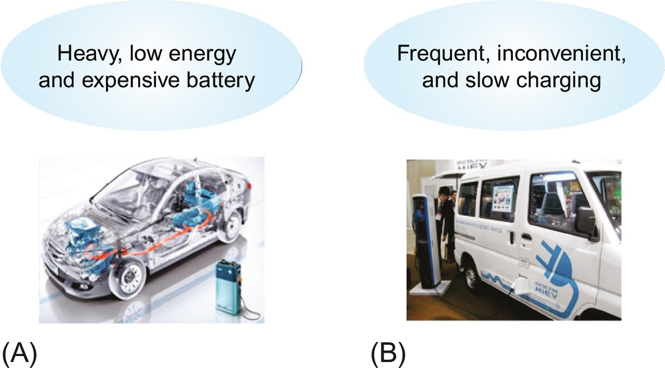

**FIG. 34.1** Major obstacles for commercialization of electric vehicles. (A) Battery problems, (B) charging problems.

Remark that battery EV (BEV) had been commercialized since the late 19th century, which is about 20 years earlier than the commercialization of ICE vehicles. The original BEVs disappeared from markets because the battery was too heavy, required long time to recharge, had a relatively short driving distance, and was expensive. Amazingly, these problems of battery still exist compared with current ICE vehicles nevertheless the drastic improvement of EV batteries. The expensive price of EVs is mainly due to battery price. The improvement of battery is very slow and does not follow the Moore's law because it is not governed by electronics but governed by chemistry.

Another major obstacle for commercialization of EVs is the charging problem. Even though innovative batteries will become available, still we have charging problems. We should have 30 C (1 C corresponds to the rated power or energy capacity of a battery for an hour) charging capacity in order to recharge an EV in 2 min in case we have such a good battery. For a 50 kWh battery example, which is common to a long-distance EV now, we should have at least 1.5 MW power rating charger and power distribution facility to support it. In practice, we should recharge an EV frequently in order to avoid the battery empty. If a cable charger is used, it is very inconvenient to plug in and plug out daily, and it is potentially dangerous to deal with the connector of a cable manually under wet conditions. Currently, a quick charger can recharge an EV battery up to 80% within 20 min, which is still too long time for customers accustomed to 2 min refueling.

Two possible solutions to the abovementioned problems are summarized in [Fig. 34.2](https://learning.oreilly.com/library/view/power-electronics-handbook/9780128114087/B9780128114070000386.xhtml#f0015).

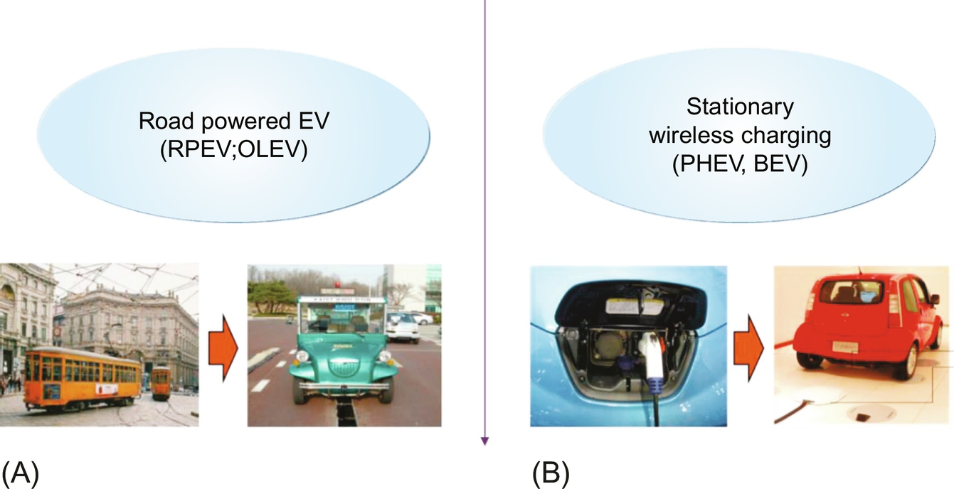

**FIG. 34.2** Two possible solutions for current electric vehicles. (A) Road powered EVs, (B) wireless charging.

The first solution is to adopt the road-powered EV (RPEV) [[1](https://learning.oreilly.com/library/view/power-electronics-handbook/9780128114087/B9780128114070000386.xhtml#bb0010),[2](https://learning.oreilly.com/library/view/power-electronics-handbook/9780128114087/B9780128114070000386.xhtml#bb0015)] or online electric vehicle (OLEV) [[3](https://learning.oreilly.com/library/view/power-electronics-handbook/9780128114087/B9780128114070000386.xhtml#bb0020)–[19](https://learning.oreilly.com/library/view/power-electronics-handbook/9780128114087/B9780128114070000386.xhtml#bb0100)], which does not rely on the battery but gets power directly from roadway power supply rails. This charging method is often referred “the dynamic wireless charging” or simply “dynamic charging” because power is delivered to an EV when it is in motion. An RPEV has a battery for temporary energy storage, but its size is a few times smaller than a BEV, which is not an obstacle for commercialization. As shown in [Fig. 34.2A](https://learning.oreilly.com/library/view/power-electronics-handbook/9780128114087/B9780128114070000386.xhtml#f0015), RPEVs have replaced conventional conductive EVs that have wearable pantographs and cumbersome power lines.

The second solution is stationary wireless charging [[20](https://learning.oreilly.com/library/view/power-electronics-handbook/9780128114087/B9780128114070000386.xhtml#bb0105)–[25](https://learning.oreilly.com/library/view/power-electronics-handbook/9780128114087/B9780128114070000386.xhtml#bb0130)], often called as “static charging,” by which the inconvenient and dangerous cable charging problems can be completely solved, as shown in [Fig. 34.2B](https://learning.oreilly.com/library/view/power-electronics-handbook/9780128114087/B9780128114070000386.xhtml#f0015). The stationary wireless charging can be applicable to both plug-in EVs (PHEVs) and BEVs. Of course, the slow charging problem cannot be directly solved by the wireless charging, and it must be mitigated by other means such as “interoperable road-powered supply rails [[26](https://learning.oreilly.com/library/view/power-electronics-handbook/9780128114087/B9780128114070000386.xhtml#bb0135)],” on which this stationary wireless charging is also made together with RPEVs.

I would like to call the stationary and dynamic charging EV solutions as wireless EVs (WEVs), which embrace WPT and wireless communications for EVs. As EVs evolve to information platforms in the future, wireless communications will be essential to every EV, which results in ubiquitously connected cars. WPT will make the WEV complete.

### 34.1.2 WHAT IS WIRELESS POWER TRANSFER?

In general, the methods of power transfer (PT) can be classified to the stationary PT and mobile PT depending on the movement of loads, as shown in [Fig. 34.3](https://learning.oreilly.com/library/view/power-electronics-handbook/9780128114087/B9780128114070000386.xhtml#f0020). WPT is nowadays the most preferable way of mobile PT that embraces inductive PT (IPT), capacitive PT (CPT), radio-frequency PT (RFPT), and optical PT (OPT), whereas the wired PT can also provide power over a flexibly long distance if properly designed. Currently, IPT is the most widely used one among WPTs, which will play a significant role in realization of the Internet of things (IoT), comprising of digital communication devices, sensors, software, and power sources.

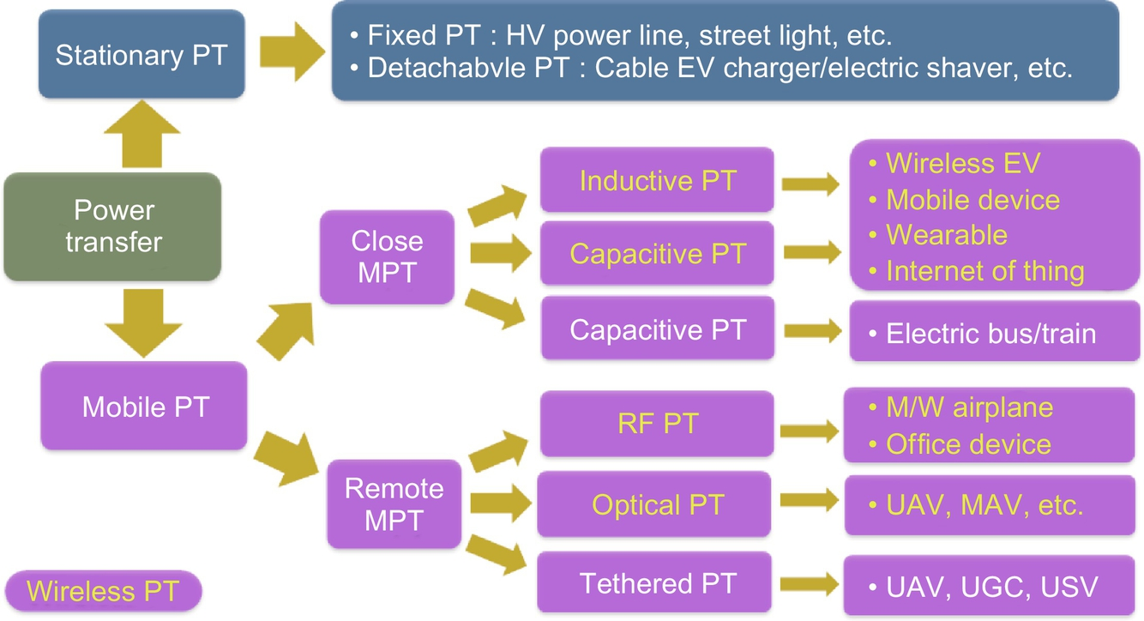

**FIG. 34.3** Classification of power transfer method.

An experiment kit, for example, WPT, is shown in [Fig. 34.4](https://learning.oreilly.com/library/view/power-electronics-handbook/9780128114087/B9780128114070000386.xhtml#f0025), where two air coils are used to transfer power “wirelessly” through “magnetic coupling” or “inductive coupling” of the coils and compensation capacitors are used to nullify the reactance of LC resonant circuits. An inverter is used to provide high-frequency AC current to a transmitter (Tx) coil, and a load transformer is used to adapt the induced voltage of a received (Rx) coil to a load voltage level.

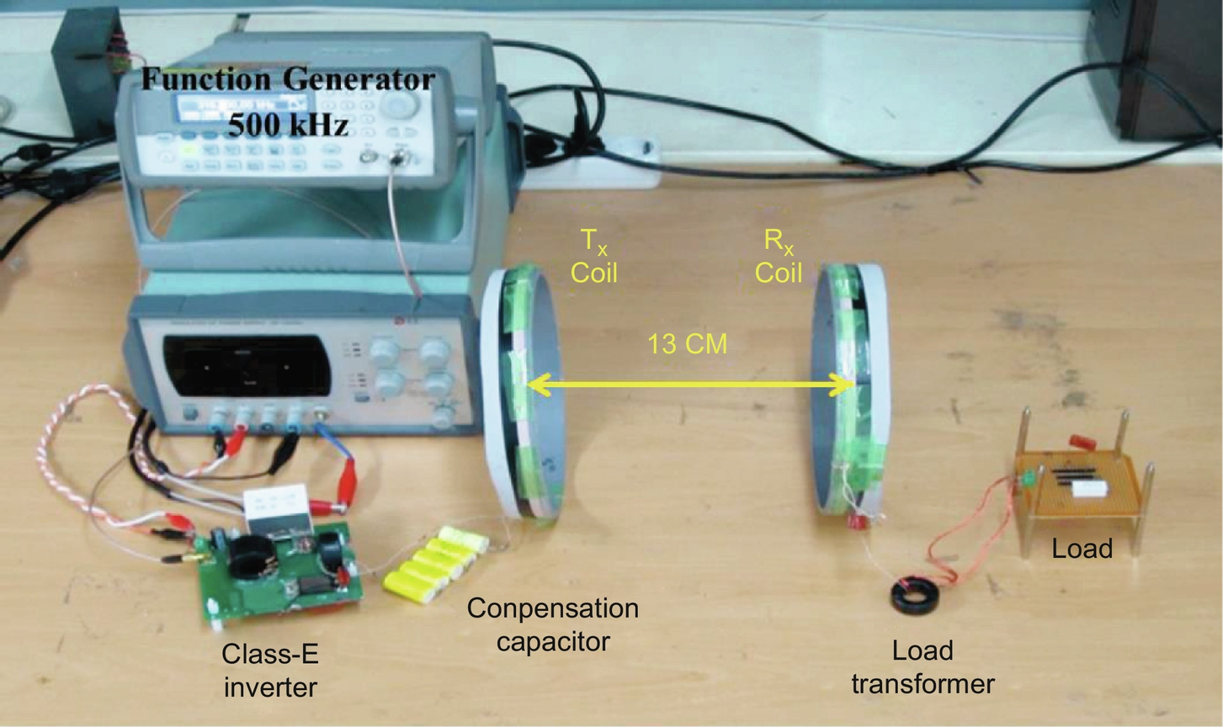

**FIG. 34.4** An example IPT of a WPT system consists of two coils operating at 500 kHz switching frequency.

What do you think about the characteristics that a WPT system should have?

First, the delivered power level for a load should be enough, and its power efficiency should be also high enough not to generate excessive heat and waste electric energy.

Second, the cost, mass, and volume of a WPT system are quite often problems compared with existing wired solutions.

Third, system resilience against resonance parameter changes, load changes, input voltage changes, proximity object movement, electromagnetic interference (EMI), and environment changes such as temperature, humidity, vibration is found to be very important in a WPT system.

Fourth, system dynamics such as response time, stability, and dynamic operating range should be met.

Fifth, accommodation, deployment, and user interfaces of a WPT system should be well considered from design phase for a successful development.

The abovementioned aspects of a WPT system are not necessarily in the order of importance, and they are strongly correlated with each other. Like other systems, the WPT system is a complex system of mechanical and electric compartments, and the design of a WPT system requires comprehensive trade-offs among the requirements. It can be said that the development of a WPT system is not a systematic science but an art of system engineering.

### 34.1.3 INTRODUCTION TO INDUCTIVE POWER TRANSFER

In general, it can be said that the IPT is governed by Ampere's law and Faraday's law among four Maxwell equations, as shown in [Fig. 34.5](https://learning.oreilly.com/library/view/power-electronics-handbook/9780128114087/B9780128114070000386.xhtml#f0030). The governing equations of IPT in the steady state for a sinusoidal magnetic field, electric field, and current density at low frequency are approximated by letting ***D***=0 as follows:

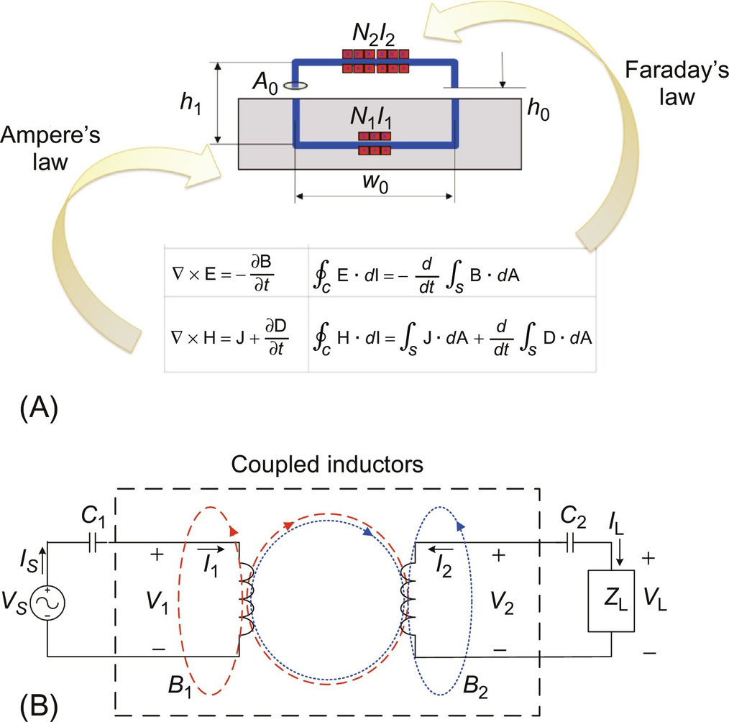

**FIG. 34.5** The fundamental principle of IPT. (A) Governing equations of IPT in general, (B) an equivalent circuit of an IPT system in phasor domain, including compensation circuits in the steady state.

 **(34.1a)**

**** **(34.1b)**

The principle of IPT power delivery can be sequentially explained as follows:

(1) Time-varying magnetic flux is generated from the Tx coil according to Ampere's law.

(2) Induced voltage is generated at the Rx coil according to Faraday's law, where magnetic flux comes from the Tx coil.

(3) Induced voltage, called back emf (counter electromotive force), is also generated at the Tx coil by the Rx coil current.

(4) Power is provided to the Tx coil and fetched from the Rx coil; thus, wireless power is delivered through the coils.

As identified from the above four steps, the IPT is essentially a transformer. A major difference from an ideal transformer, however, is relatively large leakage inductances at both the primary and secondary sides because of weakly coupled inductors. This is why we need the capacitors, as shown in [Fig. 34.5B](https://learning.oreilly.com/library/view/power-electronics-handbook/9780128114087/B9780128114070000386.xhtml#f0030), which are mostly used to compensate the reactance of corresponding leakage inductances. Depending on the source and load types, the compensating capacitors can be connected in series or parallel; [Fig. 34.5B](https://learning.oreilly.com/library/view/power-electronics-handbook/9780128114087/B9780128114070000386.xhtml#f0030) shows a series-series (S-S) compensation example.

For the circuit level analysis of IPT, an equivalent circuit for the coupled inductors in the dotted box of [Fig. 34.5B](https://learning.oreilly.com/library/view/power-electronics-handbook/9780128114087/B9780128114070000386.xhtml#f0030) is highly needed. There are three equivalent circuit models widely used for the coupled inductors in IPT, as shown in [Fig. 34.6](https://learning.oreilly.com/library/view/power-electronics-handbook/9780128114087/B9780128114070000386.xhtml#f0035). As shown in [Fig. 34.6A](https://learning.oreilly.com/library/view/power-electronics-handbook/9780128114087/B9780128114070000386.xhtml#f0035), the transformer model is convenient for designing parameters when explicit circuit variables are sought for. The mutual coupling model (M model) of [Fig. 34.6B](https://learning.oreilly.com/library/view/power-electronics-handbook/9780128114087/B9780128114070000386.xhtml#f0035) is conveniently used when each side is regarded as an inductor and a back emf voltage source, which represents mutual inductive coupling. Though the trivial galvanic isolation is not countered, the most simplified IPT model would be the “T”-shape model (T model), as shown in [Fig. 34.6C](https://learning.oreilly.com/library/view/power-electronics-handbook/9780128114087/B9780128114070000386.xhtml#f0035), which comprises three inductors only and does not apparently show any turn ratio. Note that the three models are valid not only in the steady state but also in the transient state [[27](https://learning.oreilly.com/library/view/power-electronics-handbook/9780128114087/B9780128114070000386.xhtml#bb0140)].

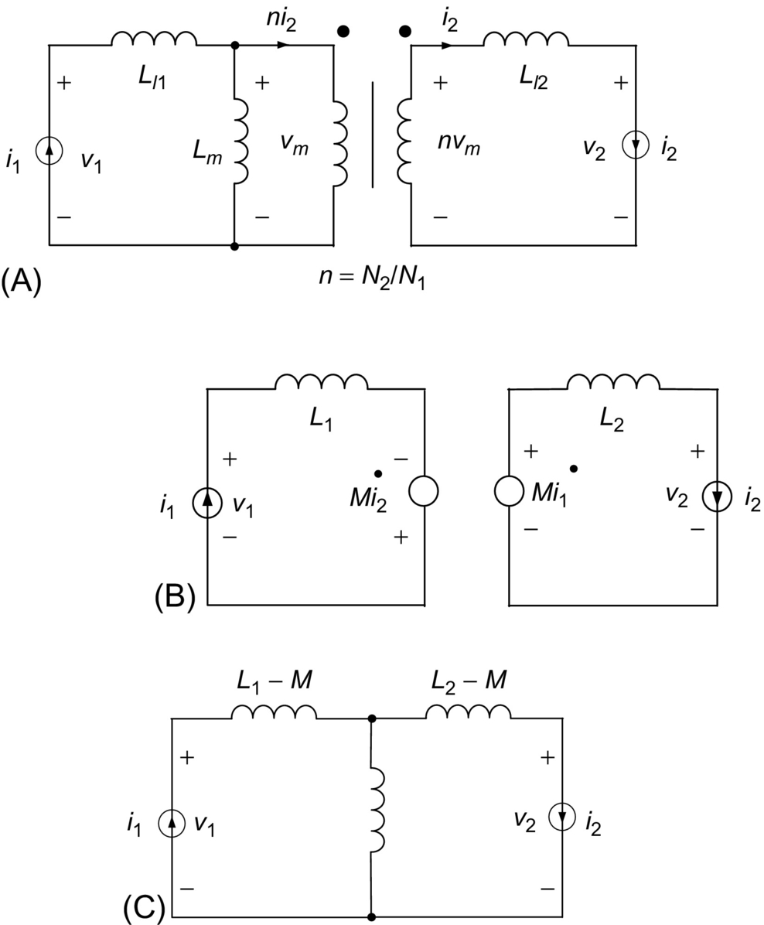

**FIG. 34.6** Equivalent circuit models for two coupled coils. (A) Transformer model, (B) M-model, (C) T-model.

The governing equations for the transformer model and M model can be related as follows:

 **(34.2a)**

**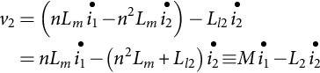** **(34.2b)**

**** **(34.2c)**

Note that the upper dot of a variable is the time derivative of the variable, and the equations are valid for in general.

The T model can be derived from the M model of (34.2) by rearranging terms as follows:

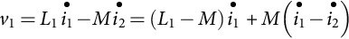 **(34.3a)**

**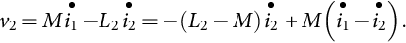** **(34.3b)**

### 34.1.4 INTRODUCTION TO CAPACITIVE POWER TRANSFER

CPT has not been widely used in WPT compared with IPT due to its low power delivery capacity and high operating frequency. However, CPT has advantages for compact and thin layer applications with low power. The configuration of a CPT system is shown in [Fig. 34.7](https://learning.oreilly.com/library/view/power-electronics-handbook/9780128114087/B9780128114070000386.xhtml#f0040), where other modules are very similar with IPT except for Tx and Rx plates and electric-field-based communication links. The application of CPT to EV is available in a few literatures [[25](https://learning.oreilly.com/library/view/power-electronics-handbook/9780128114087/B9780128114070000386.xhtml#bb0130)].

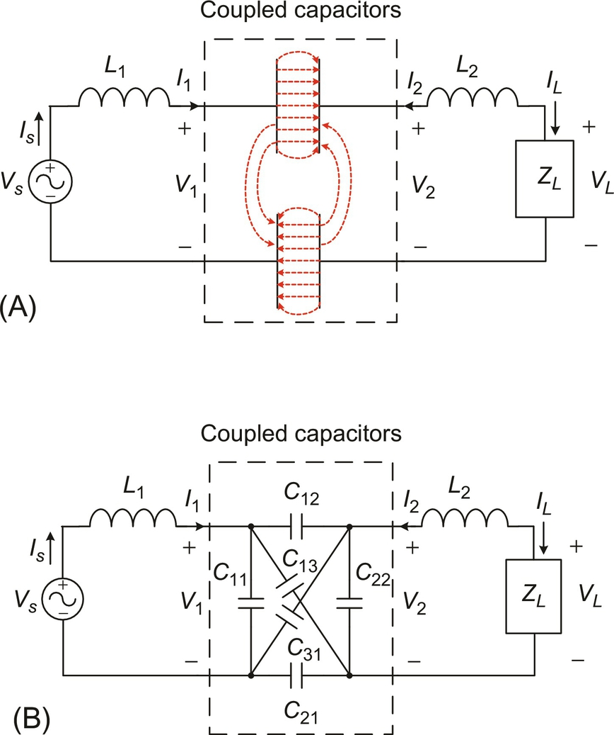

**FIG. 34.7** An equivalent CPT system in the phasor domain, including compensation circuits in the steady state. (A) Distributed capacitance model with electric field distribution, (B) lumped capacitance model with six capacitances.

### 34.1.5 INTRODUCTION TO ELECTRIC VEHICLES

Generally speaking, an EV comprises a conventional car body, and EV-specific components such as energy refuel equipment (electric chargers), onboard energy storage (batteries), power converters (inverters and rectifiers), and locomotive (electric motors and transmissions), as shown in [Fig. 34.8](https://learning.oreilly.com/library/view/power-electronics-handbook/9780128114087/B9780128114070000386.xhtml#f0045).

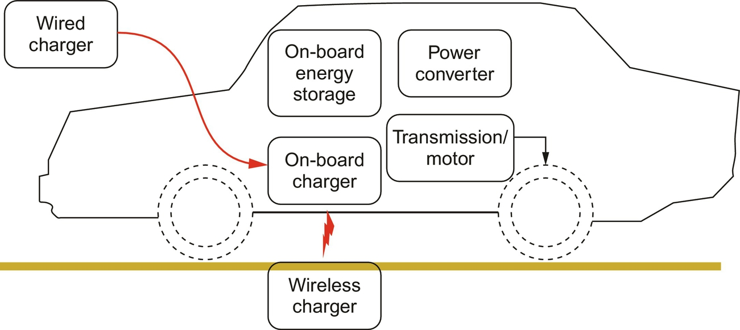

**FIG. 34.8** A general configuration of EV, charged by both wired and wireless chargers example.

It is instructive to find the analogy between EVs and ICE vehicles: electric charger versus fueling station, battery versus fuel tank, inverter versus fuel injector, and electric motor versus ICE [[28](https://learning.oreilly.com/library/view/power-electronics-handbook/9780128114087/B9780128114070000386.xhtml#bb0145)].

Depending on the energy source/refueling method, EV-specific components mentioned above, and various applications, EVs can be classified into many categories. EVs can be classified, according to energy source or energy refueling method, as wired power EVs, wireless-powered EVs (WEVs), solar- or RF-powered EVs, and battery-swap EVs. Depending on the onboard energy sources, EVs can be classified as ICE-powered EVs, called hybrid EVs (HEVs) or plug-in hybrid EVs (PHEVs), fuel-cell-powered EVs (FCEVs), and even nuclear-powered EVs though not likely to be commercialized in the near future. EVs can be also classified into applications such as ground (road and rail), aerial, sea (ship/underwater), and space EVs.

## 34.2 Static Inductive Charging of Battery Electric Vehicles

In this section, it is explained how IPT is applied to the static chargers for EVs such as BEVs and PHEVs.

### 34.2.1 OVERVIEW OF STATIC EV CHARGERS

Because automatic refueling of a vehicle is a wonderful thing for the person, boring of repeated daily cable charging of EVs, static EV chargers of this category are expected to be widely used in the near future. As identified from recently developed autonomous vehicles and self-controlled vehicles, future vehicles will be not only transportation tools but also information platforms. EVs are inherently the most electrified vehicles, which make the information platform be possible.

Among numerous static EV chargers, a few implemented examples are shown in [Figs. 34.9](https://learning.oreilly.com/library/view/power-electronics-handbook/9780128114087/B9780128114070000386.xhtml#f0050) and [34.10](https://learning.oreilly.com/library/view/power-electronics-handbook/9780128114087/B9780128114070000386.xhtml#f0055).

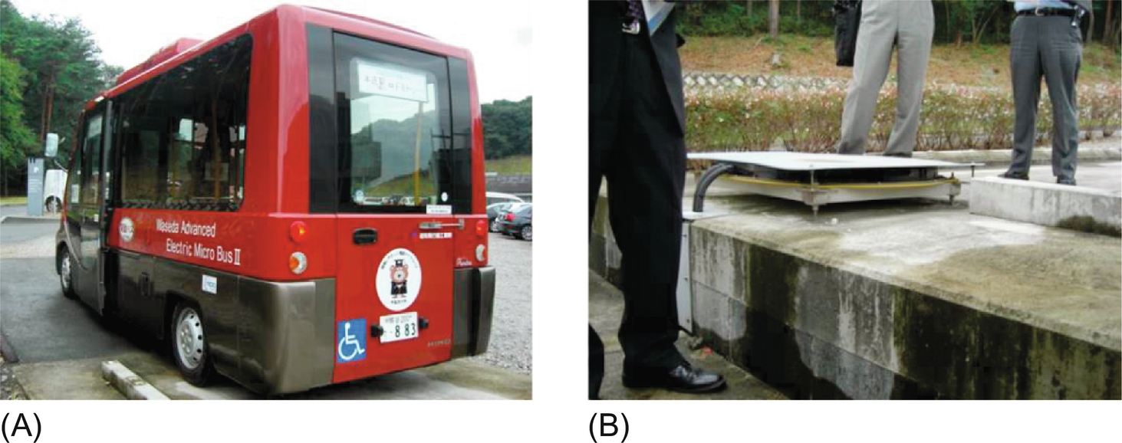

**FIG. 34.9** Static EV chargers of 30–150 kW level at bus stops, deployed in Waseda University, Japan. (A) Deployed bus, (B) deployed Tx subsystem.

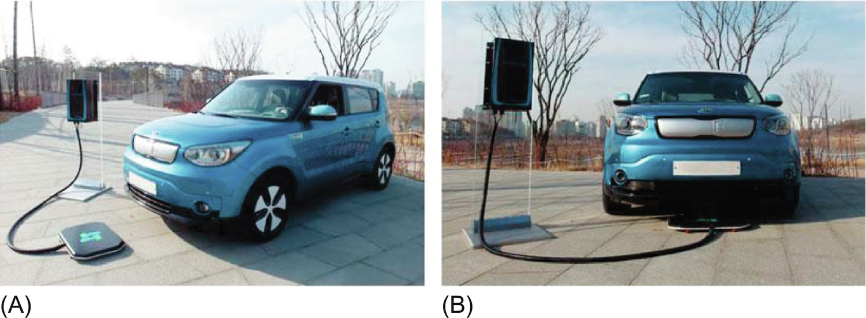

**FIG. 34.10** Static EV chargers of 3.3–6.6 kW level for passenger cars at parking area, deployed in Jeju Island, Korea. (A) Before charging, (B) being charged.

A static EV charger can be decomposed into a Tx subsystem on ground and an onboard Rx subsystem. The system requirements of a static EV charger include cost, reliability, lifetime, availability, power, efficiency, tolerances (height, longitudinal, and lateral), electromagnetic field (EMF), foreign object detection (FOD), and robustness against mechanical shock for a given source and load conditions, air gap, load change, and operating temperature. Hardware and software implementation issues such as insulation, waterproof, user interface, monitor, communications, and information are also important for the development of the system. Standardization and regulation issues are crucial for commercialization.

### 34.2.2 COIL DESIGN ISSUES

Coil design would be the most substantial part of IPT system design because the Tx coil and Rx coil determine power transfer performances such as output voltage, power level, coil-to-coil efficiency, and height/lateral tolerances. The configuration of a static charger includes Tx and Rx windings and cores, as shown in [Fig. 34.11](https://learning.oreilly.com/library/view/power-electronics-handbook/9780128114087/B9780128114070000386.xhtml#f0060). The goal of coil design is to focus magnetic field from the Tx to Rx coils so that leakage flux is minimized to lower EMF. In detail, to design the coil is to determine the ampere-turns (*N*1, *N*2, *I*1, and *I*2) and detail dimensions of coils for a given air gap, width of coil, operating frequency, power supply voltage, delivered output power, and ambient operating temperature (*hs*, *wp*, *fs*, *Vs*, *Po*, and *T*).

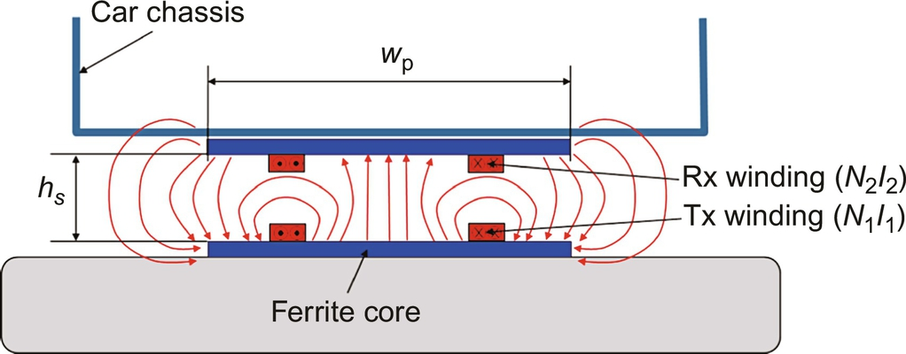

**FIG. 34.11** Configuration of Tx and Rx coils of a static EV charger when Tx coil is energized and Rx coil current is zero.

There are a few decision issues in the design of Tx and Rx coils of static EV chargers. One of them is the coil shape, as shown in [Fig. 34.12](https://learning.oreilly.com/library/view/power-electronics-handbook/9780128114087/B9780128114070000386.xhtml#f0065). The merits of the two types are listed below. The thick arrows depict lateral tolerances of two directions: the larger the arrow length, the bigger the tolerance. “S” and “N” denote magnetic polarity. There could be other shapes such as round shape, which is basically rectangular but its corners are round, and octagonal shape. Basically, the shape of the coil is largely governed by the shape of the mother body, that is, a car underbody, depending on applications.

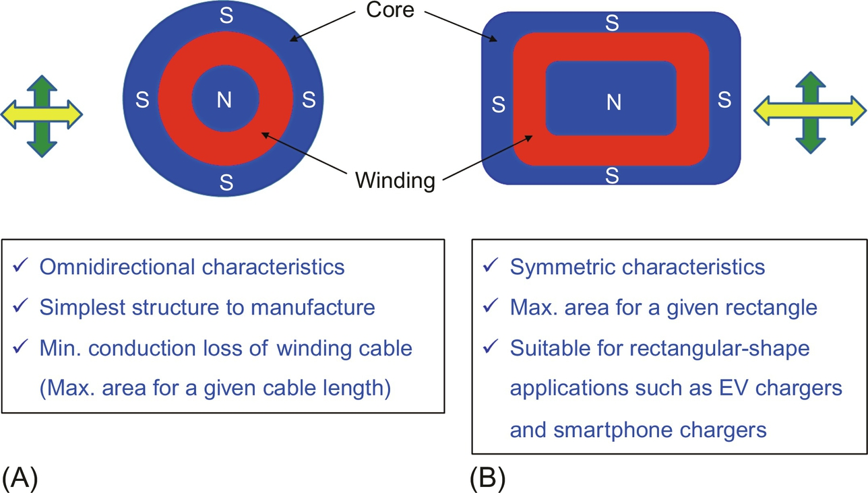

**FIG. 34.12** Shape of Tx and Rx coils (plane view). (A) Circular, (B) rectangular.

As shown in [Fig. 34.13](https://learning.oreilly.com/library/view/power-electronics-handbook/9780128114087/B9780128114070000386.xhtml#f0070), the lateral tolerance of a dual-pole coil could be better than that of a single-pole coil because the number of magnetic pole is only two for the dual-pole coil. The demerits are written in italic letters in [Fig. 34.13](https://learning.oreilly.com/library/view/power-electronics-handbook/9780128114087/B9780128114070000386.xhtml#f0070).

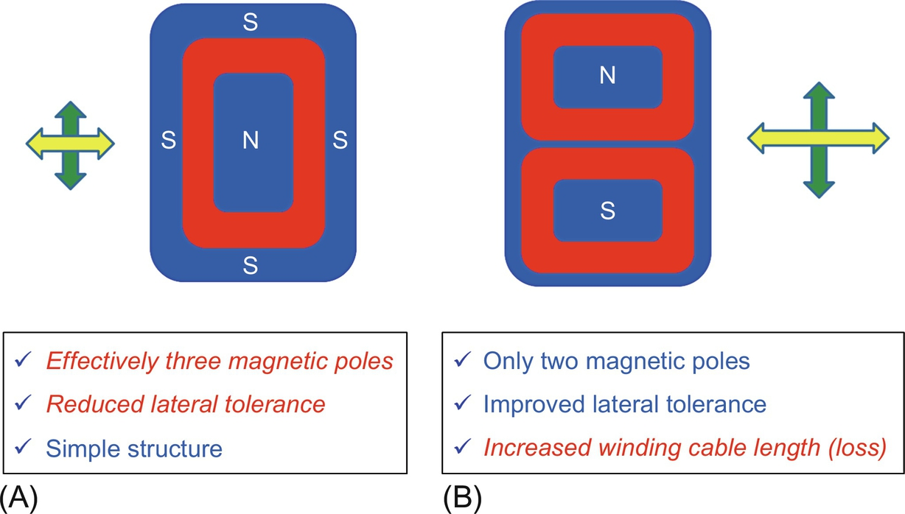

**FIG. 34.13** Number of poles in Tx and Rx coils (plane view). (A) Single pole, (B) dual pole.

You should also determine the coil type depending on magnetic field shape you want, as shown in [Fig. 34.14](https://learning.oreilly.com/library/view/power-electronics-handbook/9780128114087/B9780128114070000386.xhtml#f0075), where loop coil and dipole coil examples are selected. For a given size of the Tx and Rx coil, the dipole coil has larger lateral tolerance in side direction but has large EMF that needs more magnetic shield.

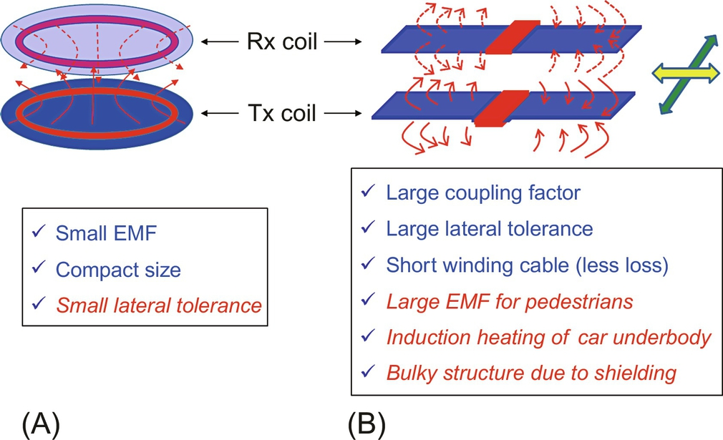

**FIG. 34.14** Magnetic field shape of Tx and Rx coils (bird's-eye view). (A) Loop coil, (B) dipole coil.

The core could be dense or sparse structures, as shown in [Fig. 34.15](https://learning.oreilly.com/library/view/power-electronics-handbook/9780128114087/B9780128114070000386.xhtml#f0080). Note that the total amount of core use could be unchanged by the average density of core if the core thickness of dense core structure is optimized. If not the case, the core use of sparse structure tends to be smaller than the dense structure.

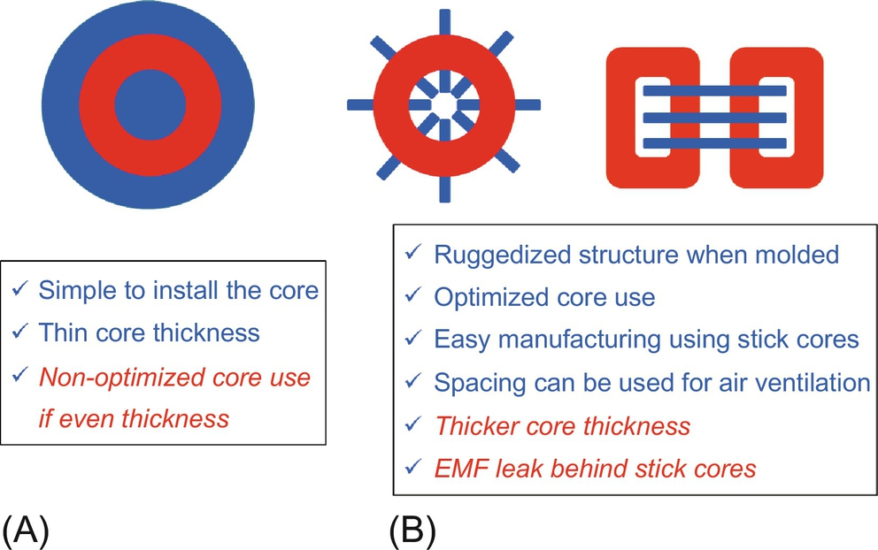

**FIG. 34.15** Core structure of Tx and Rx coils (plane view). (A) Dense core structure, (B) sparse core structures.

Another category of core structure is the use of core, as shown in [Fig. 34.16](https://learning.oreilly.com/library/view/power-electronics-handbook/9780128114087/B9780128114070000386.xhtml#f0085). Core is not necessarily always used, especially when the operating frequency is too high to use any core, as shown in [Fig. 34.16B](https://learning.oreilly.com/library/view/power-electronics-handbook/9780128114087/B9780128114070000386.xhtml#f0085). Note that the coreless coil is quite often referred as the coupled magnetic resonance system (CMRS), whereas the coil with core is called conventional inductive power transfer system (IPTS). The beginner who studies CMRS often thinks that it is quite different from IPTS due to its inherent large Q and no change of primary and secondary inductances against air-gap change. The wonderful characteristics of CMRS, however, do not come from its resonant type but come from its coreless structure, as the author announced at the Special Session of Wireless Power Transfer of the 2013 IEEE ECCE conference. As an evidence, 5 m-long-distance IPTS was built and first demonstrated that long-distance WPT is possible not only by CMRS but also by IPTS [[29](https://learning.oreilly.com/library/view/power-electronics-handbook/9780128114087/B9780128114070000386.xhtml#bb0150)]. As denoted in [Fig. 34.16](https://learning.oreilly.com/library/view/power-electronics-handbook/9780128114087/B9780128114070000386.xhtml#f0085), there are a lot of penalties for the coreless structure.

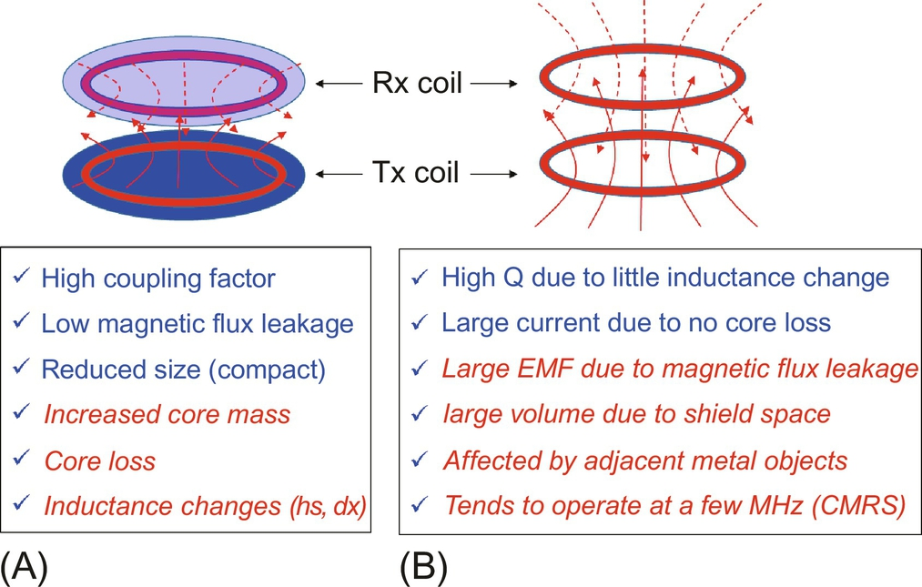

**FIG. 34.16** Core use of Tx and Rx coils (bird's-eye view). (A) With core, (B) coreless.

We have two shielding methods: core shield and metal shield, as shown in [Fig. 34.17](https://learning.oreilly.com/library/view/power-electronics-handbook/9780128114087/B9780128114070000386.xhtml#f0090). Both shields are often used to enhance magnetic shielding effect. Note again that there are not many theories available for metal shield design compared with core shield design.

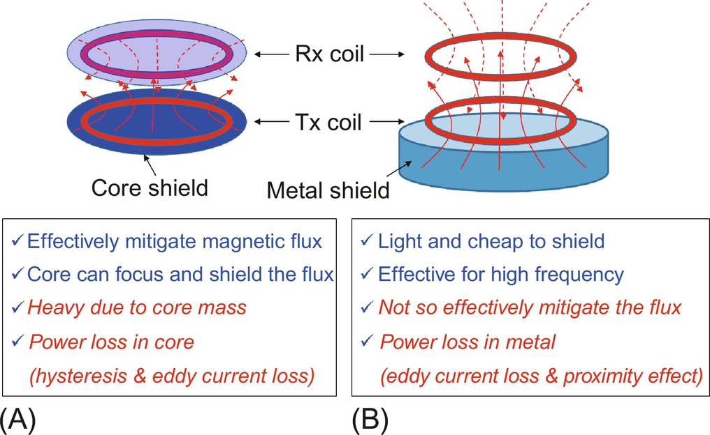

**FIG. 34.17** Magnetic field shield of Tx and Rx coils (bird's-eye view). (A) Core shield, (B) metal shield.

### 34.2.3 MISALIGNMENT ISSUES

A very important and difficult problem in IPT design is position tolerance issue arising from air-gap change and misalignments between Tx and Rx coils, as shown in [Fig. 34.18](https://learning.oreilly.com/library/view/power-electronics-handbook/9780128114087/B9780128114070000386.xhtml#f0095). As the coils are misaligned each other, induced voltage drops in general, and resonant frequencies of Tx and Rx sides usually change as well. Therefore, the position tolerance affects to not only coil design but also compensation circuit, controller, and converter designs such as power rating, zero voltage switching (ZVS) condition, and power factor.

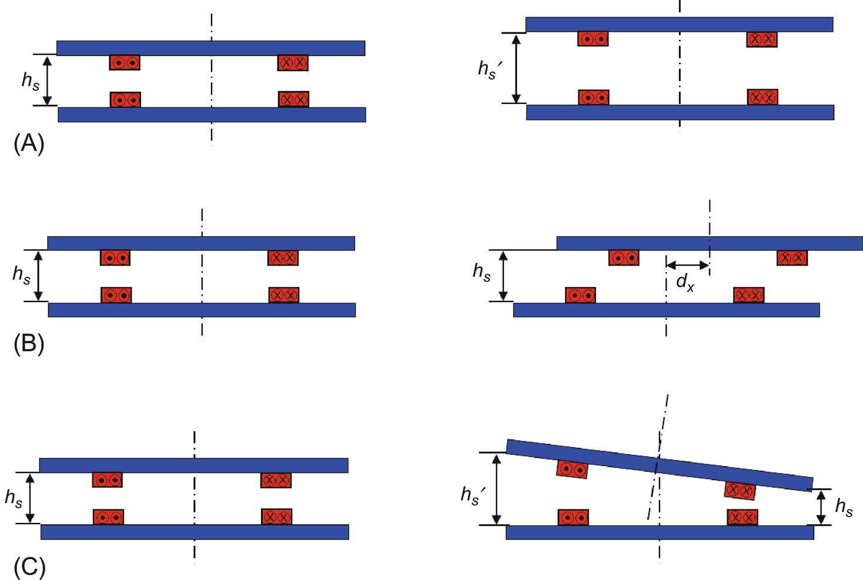

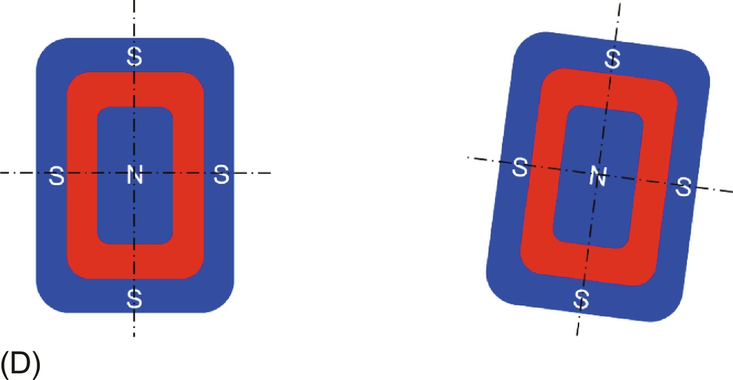

**FIG. 34.18** Position tolerance problem, arising from relative position changes of Tx and Rx coils. (A) Airgap change (side view), (B) lateral misalignment (side view), (C) tilt misalignment (side view), (D) rotation misalignment (plane view).

## 34.3 Dynamic Inductive Charging of Road Powered Electric Vehicles

In this section, the WPT system (WPTS) for RPEVs is explained. Most recently commercialized OLEVs including narrow-width power rails of I-type and ultraslim power rails of S-type are explained, where the width of power rail is important in road construction of infrastructure for RPEVs.

### 34.3.1 OVERALL CONFIGURATION OF RPEVS

The WPTS for an RPEV should be capable of delivering high power efficiently through a moderate air gap for avoiding collisions between the RPEV and ground. The WPTS is composed of two subsystems: One is the roadway subsystem for providing power, which includes a rectifier, a high-frequency inverter, a primary capacitor bank, and a power supply rail, and another is the onboard subsystem for receiving power, which includes a pickup coil, a secondary capacitor bank, a rectifier, and a regulator for battery, as shown in [Fig. 34.19](https://learning.oreilly.com/library/view/power-electronics-handbook/9780128114087/B9780128114070000386.xhtml#f0100). The roadway subsystem should be so robust and cheap that it may withstand severe road environments for a lifetime of an EV and should be economic to install over a long distance, whereas the onboard subsystem should be compact in size and light in weight so that it may be adopted into the RPEV.

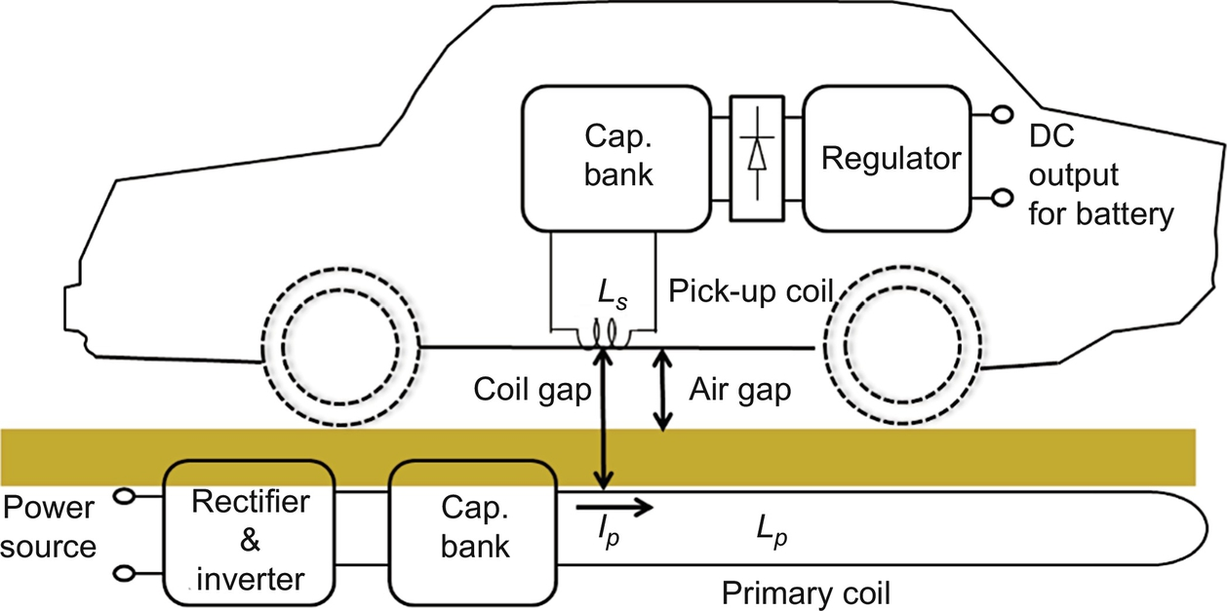

**FIG. 34.19** Overall configuration of an RPEV.

An example overall circuit diagram of an IPTS developed for OLEVs is shown in [Fig. 34.20](https://learning.oreilly.com/library/view/power-electronics-handbook/9780128114087/B9780128114070000386.xhtml#f0105), where the inverter provides constant current to the Tx power rail by a feedback control.

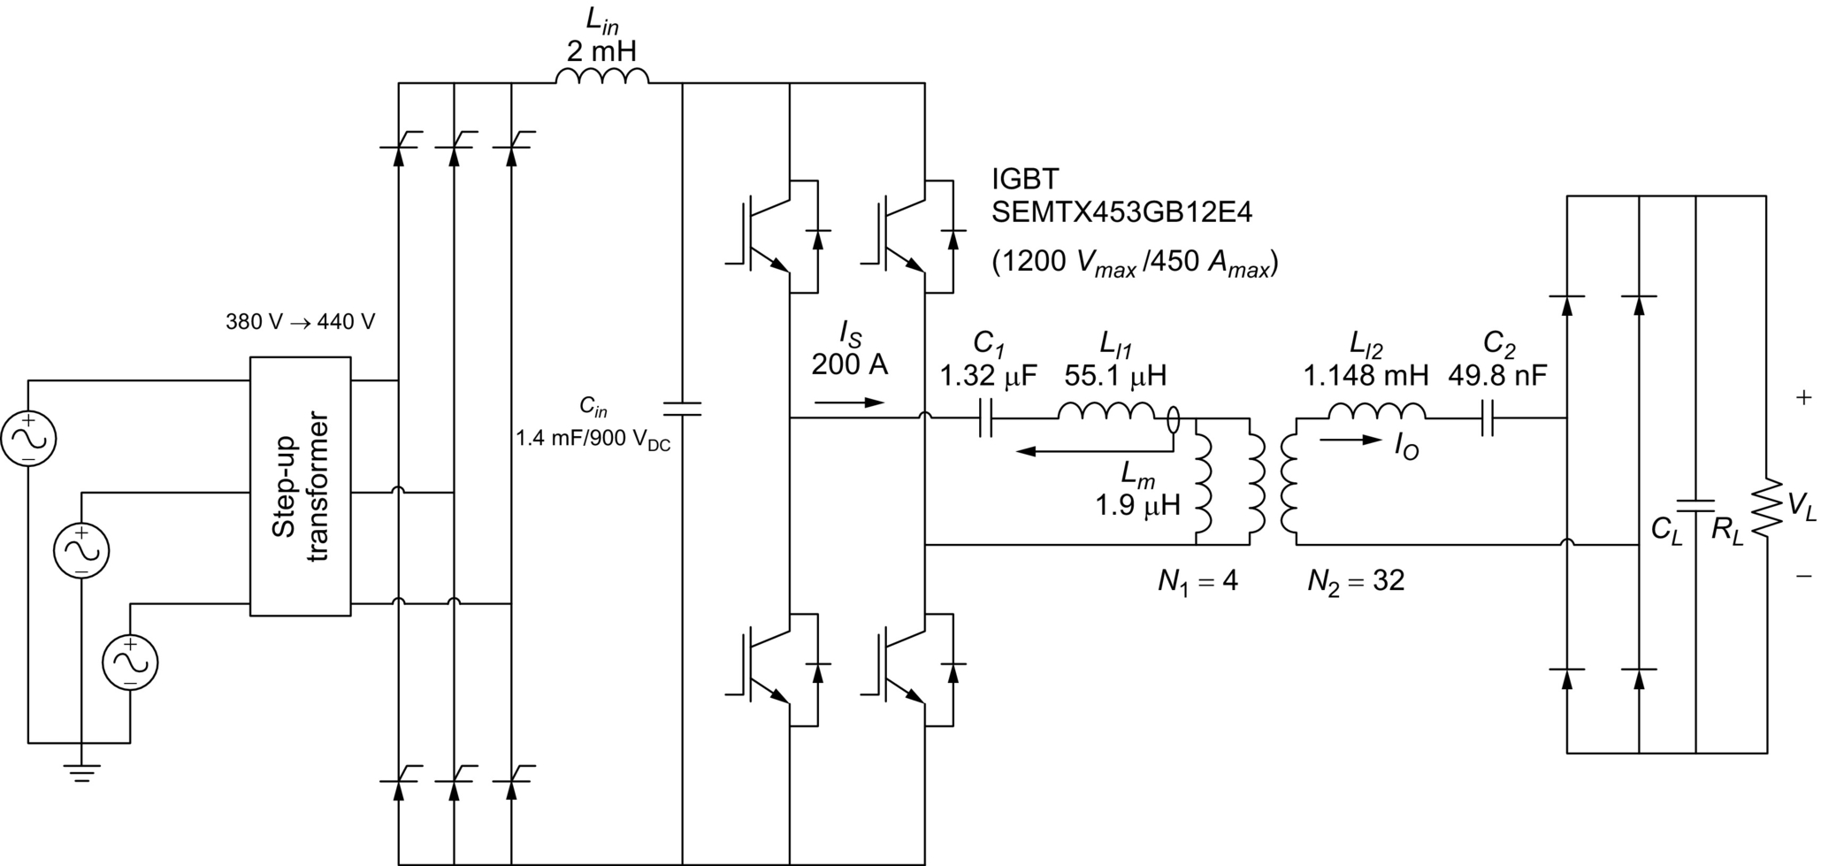

**FIG. 34.20** Overall circuit diagram of the IPTS for OLEVs (an example).

The overall system breakdown of an RPEV mission system is shown in [Fig. 34.21](https://learning.oreilly.com/library/view/power-electronics-handbook/9780128114087/B9780128114070000386.xhtml#f0110), which is drawn, reflecting the experience of developing OLEV systems by the author. The RPEV mission system includes not only the WPTS system but also the control system and EV system. The control system is unique and crucial for RPEV because it senses and identifies the EV and then appropriately turns on and off the inverters. Moreover, it monitors the health of IPTS and RPEV and provides accounting service and communication links.

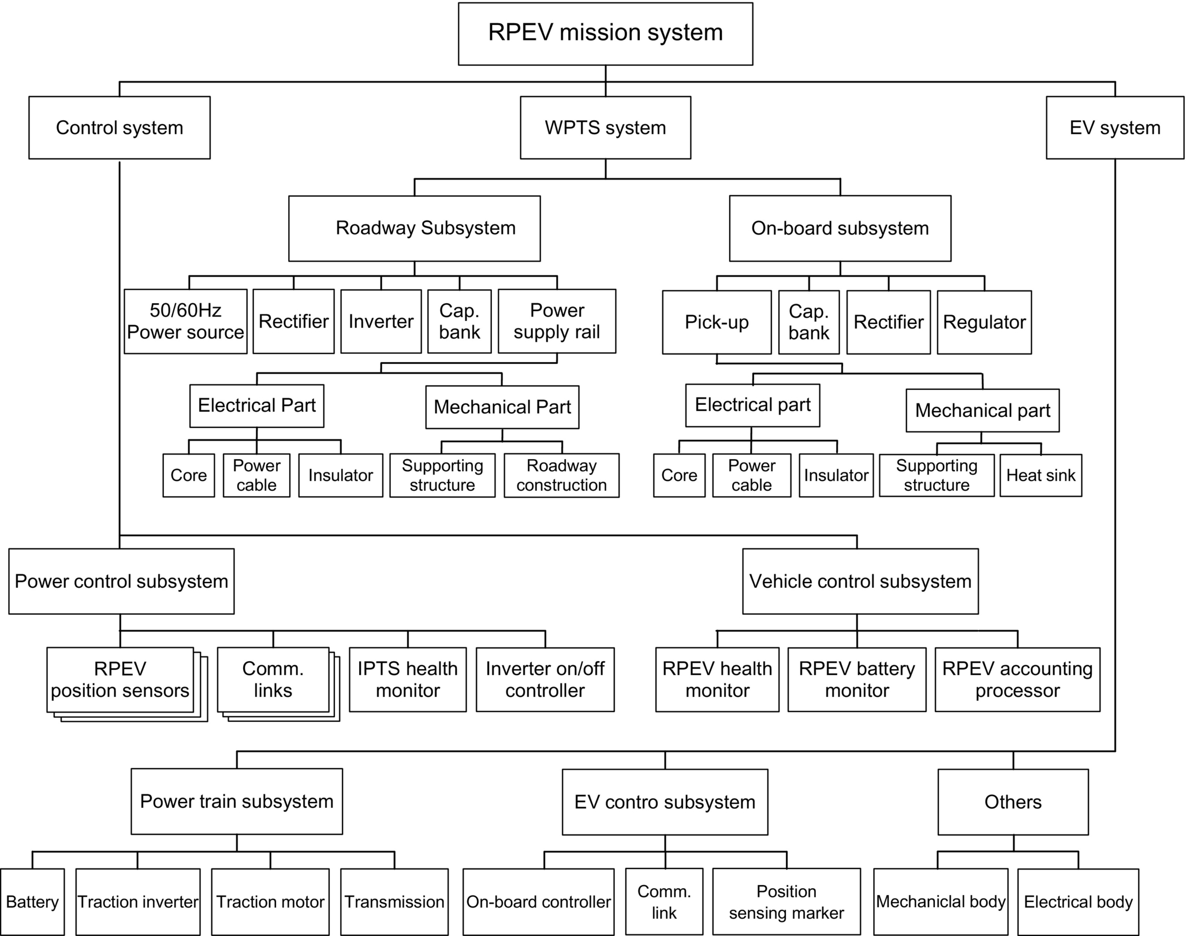

**FIG. 34.21** Overall system breakdown of an RPEV.

IPTS for RPEV is differentiated from conventional IPTS for stationary charging because additional requirements such as larger lateral tolerance, higher air gap, and lower construction cost should be considered for dynamic charging [[3](https://learning.oreilly.com/library/view/power-electronics-handbook/9780128114087/B9780128114070000386.xhtml#bb0020)–[19](https://learning.oreilly.com/library/view/power-electronics-handbook/9780128114087/B9780128114070000386.xhtml#bb0100)]. Moreover, IPTS for RPEV should survive from harsh road conditions such as extremely high and low temperatures, high humidity, and repetitive mechanical shocks for at least 10 years. Basically, the high-voltage power rail under a road should be electrically and mechanically protected well, but electricity under the conditions of a wet and fragile structure is not compatible with a road, in general. Therefore, it is quite challenging to build the roadway subsystem robustly. On the other hand, the onboard subsystem should also survive from the harsh road conditions and vibrating RPEV operating conditions, where strict technical and legislative regulations for vehicles should be met.

### 34.3.2 DESIGN ISSUES OF DYNAMIC INDUCTIVE CHARGING

The design goals of IPTS are summarized as follows:

(1) To increase magnetic coupling as much as possible so that higher induced voltage can be obtained.

(2) To increase power efficiency for a given power capacity, device ratings, and cost.

(3) To make modules as compact as possible to accommodate for a given space and weight.

(4) Not to increase or cancel out EMF.

(5) To manage resonance frequency variation and coupling factor change due to misalignment of pickup position, air-gap change, and even temperature change.

In order to meet the design goals, several important design issues of the IPTSs, which are unique for RPEVs, should be resolved as follows:

1. *Switching frequency*: The switching frequency of the inverter and rectifier of an RPEV governs overall performances. As the switching frequency *fs* increases, the coil and capacitor size decreases for the same required power, but the switching loss and core loss as well as the conduction loss of wires due to the skin effect increase. In the case of the switching frequency lower than 20 kHz, acoustic noise may be a problem [[1](https://learning.oreilly.com/library/view/power-electronics-handbook/9780128114087/B9780128114070000386.xhtml#bb0010)]. Another unique feature of RPEVs concerning frequency is the increased voltage stress in a distributed power supply rail *Vl*1 for higher switching frequency, which is proportional to the frequency and line current *Is* as follows:

 **(34.4a)**

**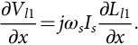** **(34.4b)**

Because of these restrictions, the switching frequency tends to be no less than 20 kHz but not far beyond 50 kHz. For OLEVs, the frequency was finally selected as 20 kHz after examining for 20 kHz, 25 kHz, and 30 kHz.

The interoperability of IPTS between RPEVs and stationary wireless EVs is an important issue that needs further study because the design of IPTSs for RPEVs is not a direct extension of that of stationary chargers. The design goals of IPTS of RPEV such as low infra cost, high power, continuity of power delivery, and low fluctuation during in-motion are not so important for stationary chargers.

2. *High power and large current*: In addition to the high operating frequency of RPEVs, high power of hundreds of kW with large current of hundreds of A makes it difficult to handle cables, converters, and devices. For example, a Litz wire of 300 A rating with 20 kV insulation capability is not commercially produced. Capacitors and IGBTs, which have high voltage and large current ratings with an operating frequency higher than 100 kHz, become scarce. Furthermore, all the inverters, rectifiers, coils, capacitors, and cables used in the IPTS of RPEV are operated outdoors, where debris and salty and wet material may damage them.

3. *Power efficiency*: In order to make RPEV competitive against internal combustion engine vehicle (ICEV), the power efficiency or energy efficiency should not be too low. The bottom line of the overall power efficiency, which is defined from the AC power source to the DC output power for battery, would be about 50%, considering grid loss and fuel cost. Fortunately, modern IPTSs have fairly good power efficiency larger than 80%. More importantly, power loss rather than power efficiency is a serious problem in designing the inverter and pickup due to over temperature.

4. *Coil design*: In order to focus magnetic field for Tx and Rx coils and to mitigate magnetic leakage flux so that large induced voltage and low EMF level can be achieved, a novel coil design is crucial for IPTS. This design is unique for the roadway subsystem in that the cost per km is critical; therefore, the roadway power supply rail should be cheap enough not to deteriorate the economic feasibility of overall RPEV solution, whereas the pickup should be neither heavy nor thick so that it can be successfully implemented on the bottom of an RPEV.

5. *Insulation*: In order to guarantee stable operation of IPTS, a few kV level insulations of the roadway subsystem and onboard subsystem should be provided. The insulation of a roadway power supply is of great importance because high voltage is induced along through the distributed power rail over a road rather than over a point and is increased by the back emf of the pickup coil abruptly displaced on the power supply rail. The insulation of the pickup coil is also an important issue when high power output is sought because the large output current of the pickup coil induces high voltage, which could be as much as 10 kV if not appropriately mitigated.

6. *Segmentation of power supply rail*: RPEV typically requires many IPTS along a road because a power supply rail cannot be infinitely deployed. It should be segmented so that each segment can be independently turned on and off. The length of a power supply rail is an important design issue because it would be too expensive if the length is very short due to an increased number of inverters and switch boxes, whereas the power loss would be too large if the length is very long due to increased resistance. Besides these issues, the amount of cable use, EMF level, and car length should be considered when determining the segmentation scheme.

7. *Roadway construction*: In order to minimize traffic obstruction, the roadway construction time of IPTS should be as short as possible. Moreover, there are numerous difficulties in roadway work because of debris and dirt. Keeping all of the electric components of IPTS clean during roadway construction for a few days or weeks is a serious problem in practice. There should be a smart way to overcome these problems.

8. *Resonant frequency variation*: The resonant frequencies of the roadway subsystem and onboard subsystem are significantly varied as the magnetic coupling between a power supply rail and a pickup changes due to air-gap change, lateral misalignment, and longitudinal movement. Moreover, the frequency changes are different from time to time for different cars and different numbers of cars on a power supply rail. There should be either the smart coil design or inverter design to cope with these frequency changes or *in situ* frequency tuning capability.

9. *Control of dynamic resonating circuits*: The resonant circuit, as shown in [Fig. 34.20](https://learning.oreilly.com/library/view/power-electronics-handbook/9780128114087/B9780128114070000386.xhtml#f0105), has finite dynamic response times and may arise high voltage and current peaks that can destroy electric devices. They should be moderately controlled so that the voltage and current level can be mitigated, where the frequency response of AC circuits can be managed with the recently developed Laplace phasor transformation [[30](https://learning.oreilly.com/library/view/power-electronics-handbook/9780128114087/B9780128114070000386.xhtml#bb0155),[31](https://learning.oreilly.com/library/view/power-electronics-handbook/9780128114087/B9780128114070000386.xhtml#bb0160)]. A resonating LC circuit has a first-order response in the dynamic phasor domain [[32](https://learning.oreilly.com/library/view/power-electronics-handbook/9780128114087/B9780128114070000386.xhtml#bb0165)]; hence, high-order IPTS with more than two resonating circuits can be managed with the general phasor transforms [[33](https://learning.oreilly.com/library/view/power-electronics-handbook/9780128114087/B9780128114070000386.xhtml#bb0170),[34](https://learning.oreilly.com/library/view/power-electronics-handbook/9780128114087/B9780128114070000386.xhtml#bb0175)].

After the two frontier projects of RPEV, the Partners for Advanced Transit and Highways (PATH) program began in 1992 to determine the technical viability of RPEV in the University of California, Berkeley. Throughout the PATH program, broad research and field tests on RPEV, as shown in [Fig. 34.22](https://learning.oreilly.com/library/view/power-electronics-handbook/9780128114087/B9780128114070000386.xhtml#f0115), including designs of IPTS, installations of an IPTS to a bus, road constructions of power supply rails, and environmental impact studies, were performed. The PATH team achieved an efficiency of 60% at an output power of 60 kW with a 7.6 cm air gap [[1](https://learning.oreilly.com/library/view/power-electronics-handbook/9780128114087/B9780128114070000386.xhtml#bb0010)].

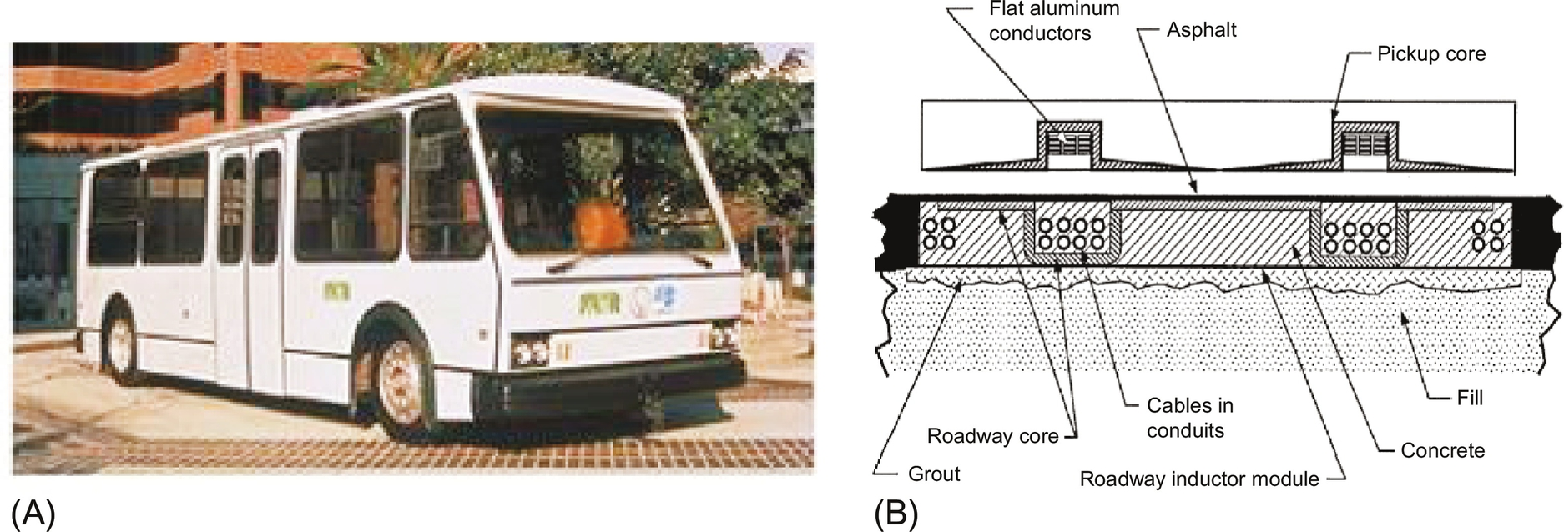

**FIG. 34.22** The first operational prototype RPEV developed by the PATH team in the 1990s. (A) Appearance of the developed RPEV bus, (B) prototype coils of the IPTS.

The PATH program, however, had not been successfully commercialized due to high-power rail construction cost of around 1 M$/km, heavy coils, and acoustic noises, as well as relatively low power efficiency and large primary current of thousand amperes owing to a low operating frequency of 400 Hz. Furthermore, the small air gap does not meet road safety regulations, and lateral displacement of less than 10 cm is not acceptable for practical use. Despite the limitations for practical applications, the PATH team's work was well documented and stimulated subsequent research and development on modern RPEVs.

### 34.3.3 DEVELOPMENTS OF ON-LINE ELECTRIC VEHICLES

#### **34.3.3.1 Overview of OLEV**

A stream of modern RPEVs is the OLEV, which has solved most of the remaining problems of the PATH team's work, as shown in [Fig. 34.23](https://learning.oreilly.com/library/view/power-electronics-handbook/9780128114087/B9780128114070000386.xhtml#f0120). The OLEV project has started since 2009 by a research team led by KAIST, including the author, Korea [[3](https://learning.oreilly.com/library/view/power-electronics-handbook/9780128114087/B9780128114070000386.xhtml#bb0020)–[19](https://learning.oreilly.com/library/view/power-electronics-handbook/9780128114087/B9780128114070000386.xhtml#bb0100)]. Innovative coil designs and roadway construction techniques and all of the systems operating at a reasonably high frequency of 20 kHz made it possible to achieve the highest power efficiency of 83% at an output power of 60 kW with a large air gap of 20 cm and a fairly good lateral tolerance of 24 cm. Moreover, the power rail construction cost of the OLEV, which is responsible for more than 80% of the total deployment cost for RPEVs, has been dramatically reduced to at least a third of that of the PATH project. The primary current has been also reasonably mitigated as low as 200 A, and the battery size has been significantly reduced to 20 kWh, which can be further reduced by increasing the length of the power supply rails.

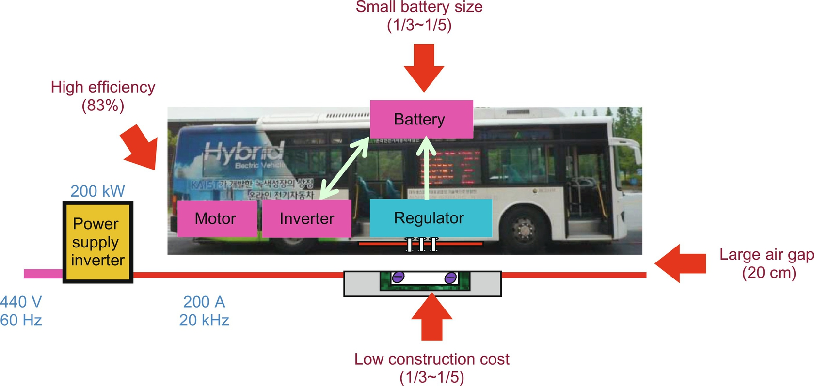

**FIG. 34.23** The development concepts of the OLEV bus developed by KAIST.

The first-generation (1G) concept demonstration car of OLEV, the second-generation (2G) OLEV buses, and the third-generation (3G) OLEV passenger car were developed and extensively tested at the test sites of KAIST since 2009, and three OLEV trains (3+G) had been successfully deployed at the Seoul Grand Park, Korea, since 2010. Two upgraded OLEV buses (3+G) were deployed at the 2012 Yeosu EXPO, Korea, and other two OLEV buses (3+G) have been in full operation at the main campus of KAIST since 2012. Recently, two OLEV buses (3+G) were firstly commercialized at a 48 km route in Gumi, Korea. The fourth-generation (4G) OLEV, showing more practical performances such as a very narrow rail width of 10 cm, a larger lateral displacement of 40 cm, lower EMF level, and lower power rail construction cost compared with the previous generation OLEV, has been also developed. The development of the fifth-generation (5G) OLEV is in progress, where an ultraslim S-type power supply coil of 4 cm rail width is proposed for power rail construction with much less cost and time [[18](https://learning.oreilly.com/library/view/power-electronics-handbook/9780128114087/B9780128114070000386.xhtml#bb0095),[19](https://learning.oreilly.com/library/view/power-electronics-handbook/9780128114087/B9780128114070000386.xhtml#bb0100)].

#### **34.3.3.2 2G OLEV**

The 2G OLEV, announced on 14 July 2009, focused on drastically improving the air gap of the 1G OLEV without mechanical moving parts and finally achieved a 17 cm air gap, which meets road regulations, 12 cm in Korea and 16 cm in Japan. At the same time, it achieved a maximum efficiency of 72% and a maximum output power of 60 kW using 10 pickups. The power supply rail, where the width is 1.4 m and the total length is 240 m, is paved with asphalt to provide the same friction force as normal roads. In order to realize the 17 cm air gap, the U-type power supply rail and the flat pickup coil of IPTS have been developed, where the name “U-type” stems from the cross section of the power supply rail, as shown in [Fig. 34.24](https://learning.oreilly.com/library/view/power-electronics-handbook/9780128114087/B9780128114070000386.xhtml#f0125). A pair of return power cables is used to mitigate the EMF from the power supply rail for the ICNIRP guidelines [[35](https://learning.oreilly.com/library/view/power-electronics-handbook/9780128114087/B9780128114070000386.xhtml#bb0180),[36](https://learning.oreilly.com/library/view/power-electronics-handbook/9780128114087/B9780128114070000386.xhtml#bb0185)]. With the U-type power supply rail and I-type pickup coil, it is found that an effective area of the magnetic path between the power supply rail and the pickup coil increases as the air gap increases due to fringe effect, as shown in [Figs. 34.24](https://learning.oreilly.com/library/view/power-electronics-handbook/9780128114087/B9780128114070000386.xhtml#f0125) and [34.25](https://learning.oreilly.com/library/view/power-electronics-handbook/9780128114087/B9780128114070000386.xhtml#f0130).

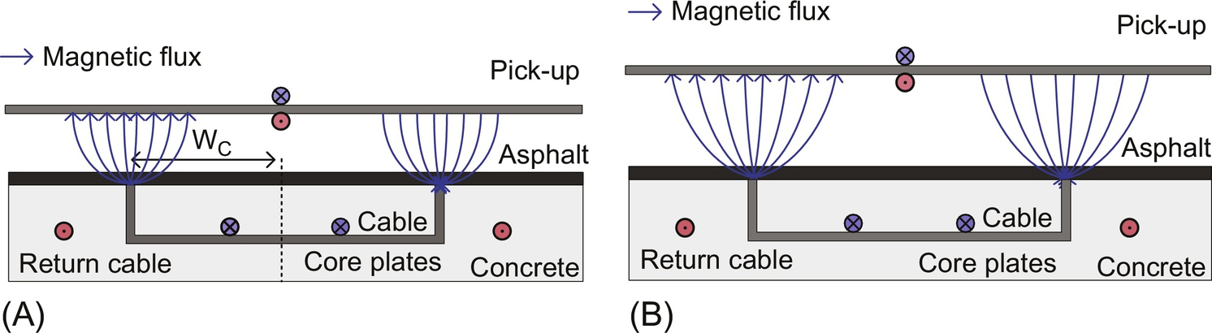

**FIG. 34.24** Cross section of the U-type power supply rail and I-type pickup coil. (A) Small air-gap, (B) large air-gap.

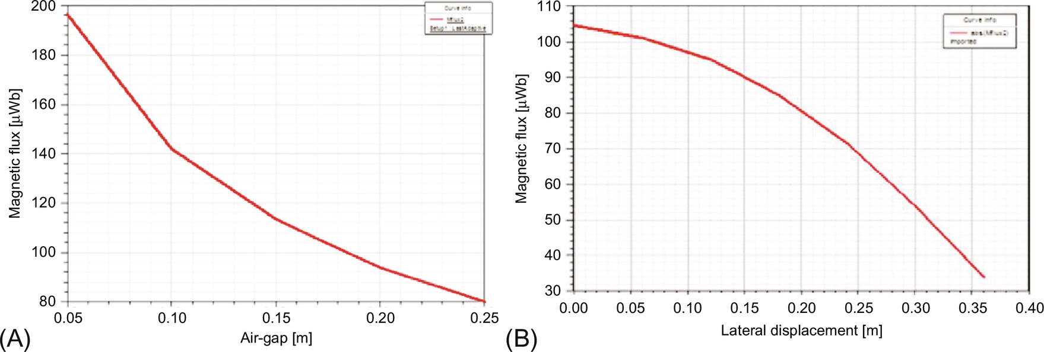

**FIG. 34.25** Magnetic flux characteristics of the 2G IPTS [[18](https://learning.oreilly.com/library/view/power-electronics-handbook/9780128114087/B9780128114070000386.xhtml#bb0095)]. (A) Along the air-gap, (B) along the lateral displacement.

The cross section of the core plates of the power rail, as shown in [Fig. 34.24](https://learning.oreilly.com/library/view/power-electronics-handbook/9780128114087/B9780128114070000386.xhtml#f0125), is significantly reduced by using the high operating frequency of 20 kHz, which is 50 times of the PATH team. The reason for selecting 20 kHz is that it is the lowest inaudible frequency, which mitigates the line voltage stress, as in (34.4). The upward magnetic flux generated from the pickup coil was appropriately shielded by an aluminum plate with a 5 cm distance.

#### **34.3.3.3 3G OLEV**

The 3G OLEV sports utility vehicle (SUV), announced on Aug. 14, 2009, adopted the W-type power supply rail and the flat pickup with overlapped double coils for higher power and increased lateral tolerance. Thus, the upward magnetic leakage flux from the pickup of 2G OLEV had been drastically mitigated by using the flat pickup core, which prohibits the magnetic flux between the power supply rail and pickup from leaking. The magnetic field shield such as an aluminum plate or additional space is no longer required.

The overall efficiency and air gap of the 3G OLEV were 71% and 17 cm, respectively, which are respectable, but slightly disappointing numbers; therefore, overall systems including a roadway rectifier and inverter, power supply rail, pickup, and onboard regulator were redesigned to achieve a maximum efficiency of 83% with a 20 cm air gap, and this new design was called the 3G+ OLEV.

The W-type power supply rail, as shown in [Fig. 34.26](https://learning.oreilly.com/library/view/power-electronics-handbook/9780128114087/B9780128114070000386.xhtml#f0135), has many cores of “W” shape, where the total magnetic resistance becomes three-quarters smaller than that of the 2G OLEV for the same air gap, and this eventually leads to the increase of the output power from 6 to 15 kW for each pickup. Moreover, the width of the power supply rail is decreased to 70 cm, which is just a half of that of the 2G OLEV, and it can reduce the deployment cost of OLEV for commercialization. The EMF at 1.75 m distance meets the ICNIRP guideline because the two power cables of opposite polarity of magnetic flux cancel each other out [[18](https://learning.oreilly.com/library/view/power-electronics-handbook/9780128114087/B9780128114070000386.xhtml#bb0095),[19](https://learning.oreilly.com/library/view/power-electronics-handbook/9780128114087/B9780128114070000386.xhtml#bb0100)].

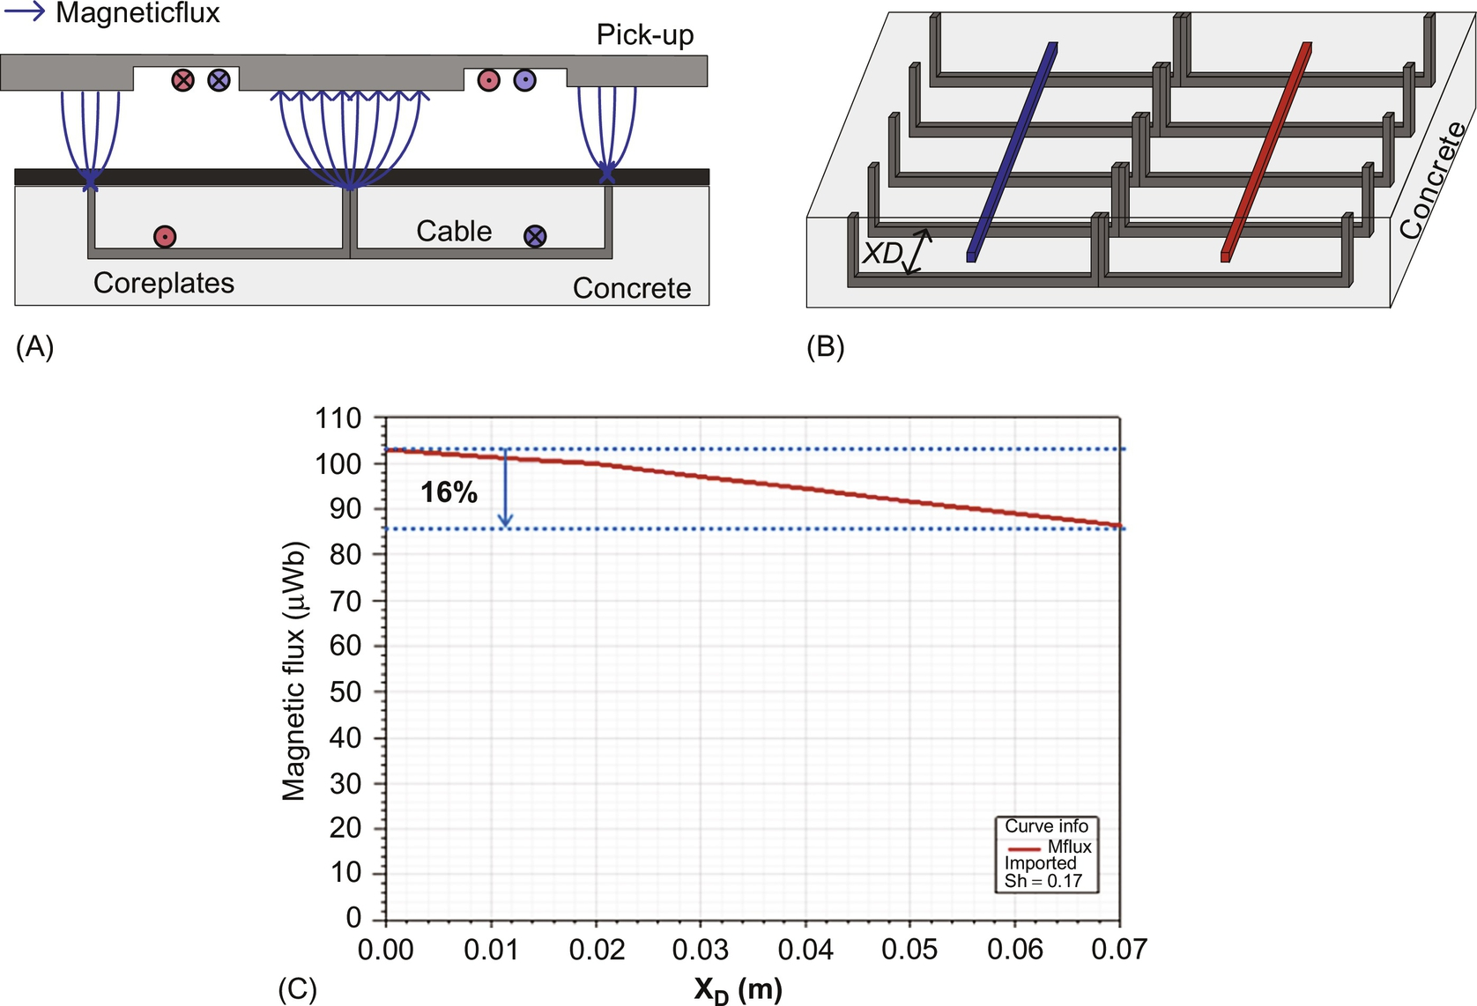

**FIG. 34.26** Views of the W-type power supply rail and flat pickup coil [[18](https://learning.oreilly.com/library/view/power-electronics-handbook/9780128114087/B9780128114070000386.xhtml#bb0095)]. (A) Cross-section view, (B) Bird's eye view of a bone structure, (C) simulated magnetic flux characteristics for different bone core-gap *XD*.

One of the problems found during the development of 2G OLEV was the inherently weak structure of the power supply rail, where the core separates the concrete into two and undergoes severe mechanical stress from heavy vehicles. As a remedy for this mechanical weakness, bone structure core of the power supply rail, as shown in [Fig. 34.26B](https://learning.oreilly.com/library/view/power-electronics-handbook/9780128114087/B9780128114070000386.xhtml#f0135), has been proposed, where the bone structure core is installed with the bone core-gap *XD*. Despite the large gap between cores, the magnetic flux does not decrease considerably, as shown in [Fig. 34.26C](https://learning.oreilly.com/library/view/power-electronics-handbook/9780128114087/B9780128114070000386.xhtml#f0135).

In addition, during power rail road construction, concretes can percolate down through the bone structure cores. Therefore, the power supply rail, which is reinforced with two iron bars and in which power cables are protected by fiber-reinforced plastic (FRP) pipes, has almost the same endurance of concrete, as shown in [Fig. 34.27](https://learning.oreilly.com/library/view/power-electronics-handbook/9780128114087/B9780128114070000386.xhtml#f0140). In practice, roadway construction of the power supply rail takes a few weeks, being affected by weather and debris, and this delay obstructs the commercialization of OLEV.

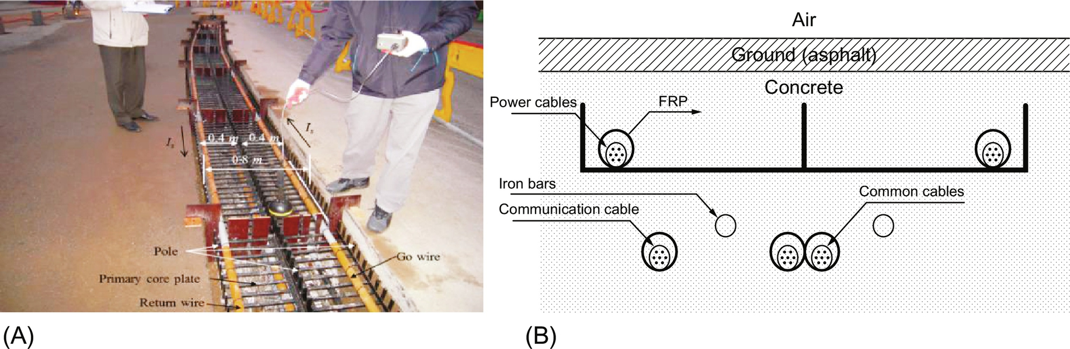

**FIG. 34.27** The W-type power supply rail of the 3G OLEV [[18](https://learning.oreilly.com/library/view/power-electronics-handbook/9780128114087/B9780128114070000386.xhtml#bb0095)]. (A) Under road construction, (B) cross-section view.

#### **34.3.3.4 4G OLEV**

As shown in [Fig. 34.28](https://learning.oreilly.com/library/view/power-electronics-handbook/9780128114087/B9780128114070000386.xhtml#f0145), the 4G OLEV, announced in 2010, has an innovative I-type structure of a power supply rail with a maximum output power of 27 kW for a double pickup coil having a 20 cm air gap and 24 cm lateral displacement. As shown in [Fig. 34.28A](https://learning.oreilly.com/library/view/power-electronics-handbook/9780128114087/B9780128114070000386.xhtml#f0145), the I-type power supply rail, where the name “I-type” stems from its front shape, has only 10 cm width, which leads to a deployment cost reduction of 20% compared with the 3G OLEV. Unlike previous generations of OLEV, a very low EMF for pedestrians, as low as 1.5 μT at a distance of 1 m from the center of the power supply rail, can be obtained because the power supply rail has alternating magnetic poles along the road, as shown in [Fig. 34.28B](https://learning.oreilly.com/library/view/power-electronics-handbook/9780128114087/B9780128114070000386.xhtml#f0145).

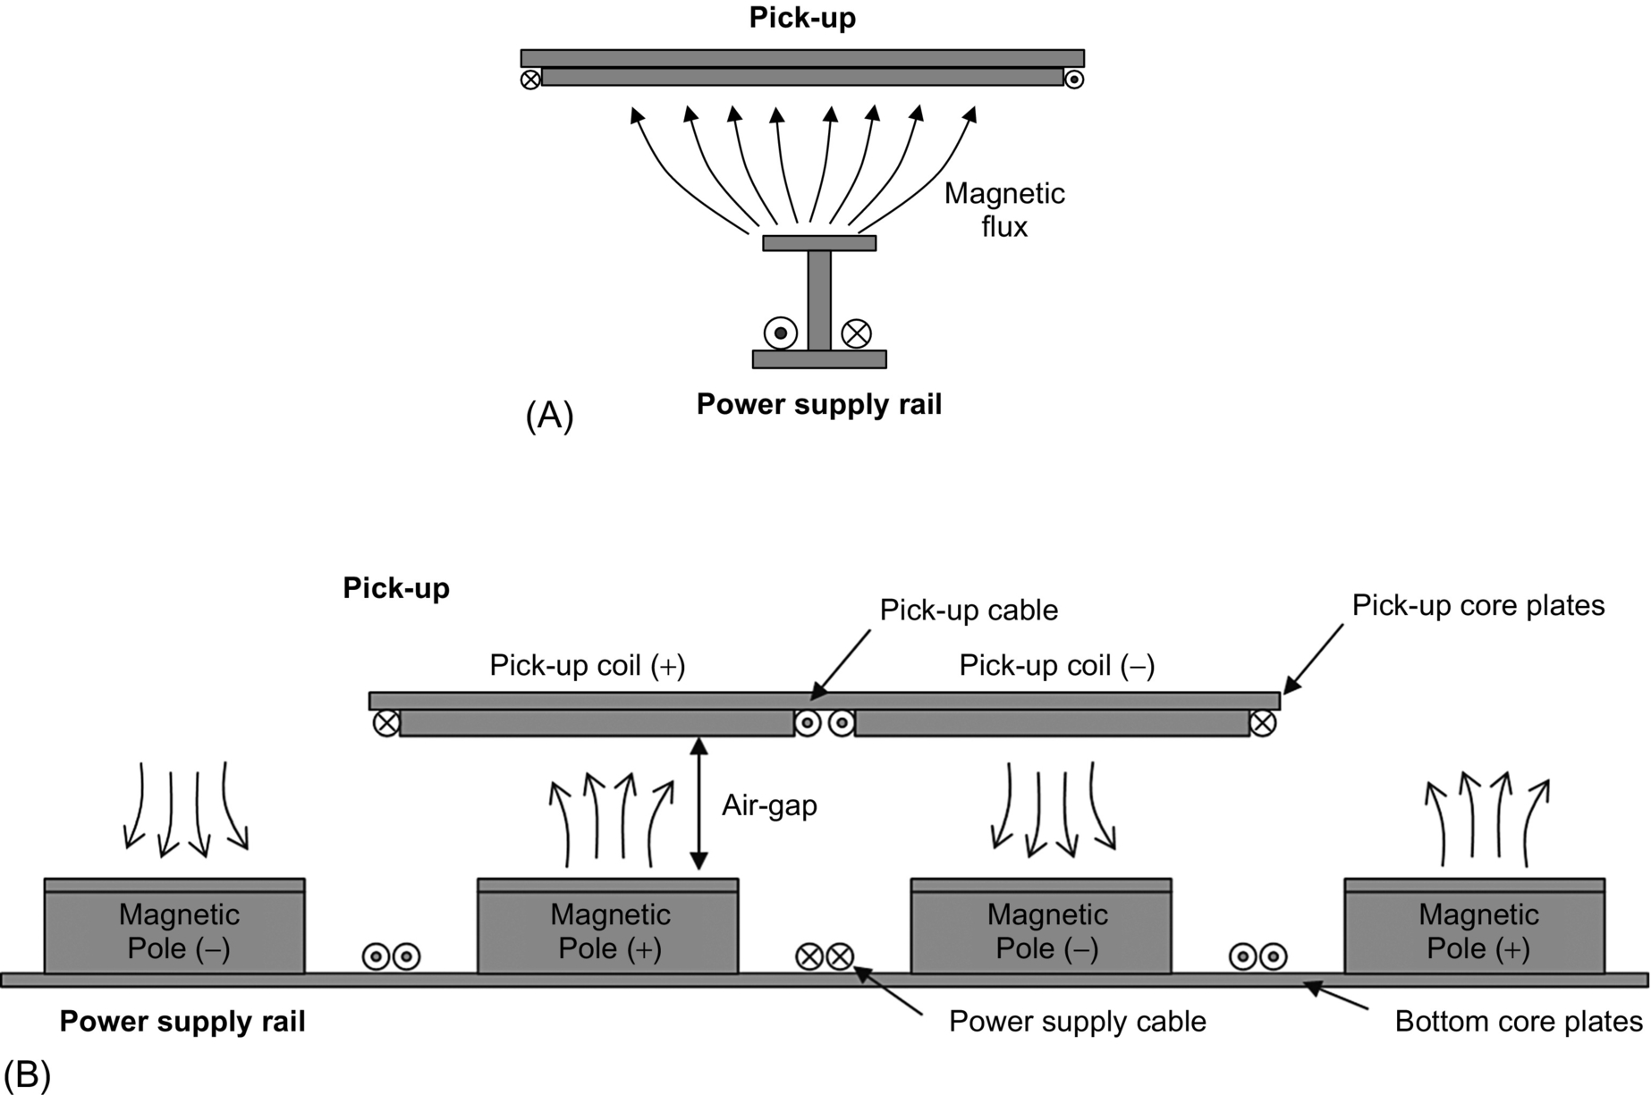

**FIG. 34.28** The I-type power supply rail and double flat pickup coil [[18](https://learning.oreilly.com/library/view/power-electronics-handbook/9780128114087/B9780128114070000386.xhtml#bb0095)]. (a) Front view, (b) side view.

As shown in [Fig. 34.29](https://learning.oreilly.com/library/view/power-electronics-handbook/9780128114087/B9780128114070000386.xhtml#f0150), the 4G OLEV adopted a module concept for the I-type power supply rail to reduce the deployment time within a few hours, which had been one of the drawbacks of the 3G OLEV. The I-type power supply module, which includes the power supply rail and capacitor banks inside, as shown in [Fig. 34.29A](https://learning.oreilly.com/library/view/power-electronics-handbook/9780128114087/B9780128114070000386.xhtml#f0150), should be robust to high humidity and external mechanical impacts at least for 10 years, for example.

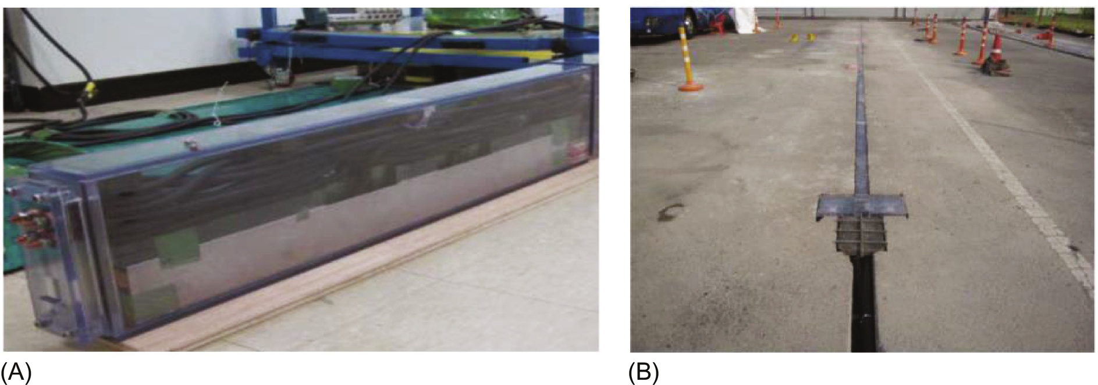

**FIG. 34.29** The I-type power supply module of the 4G OLEV [[18](https://learning.oreilly.com/library/view/power-electronics-handbook/9780128114087/B9780128114070000386.xhtml#bb0095)]. (A) A prototype module, (B) deployed modules at the 24 m test site.

#### **34.3.3.5 5G OLEV**

To further reduce the construction cost and to increase the robustness of power supply rails, the 5G OLEV of ultraslim S-type core was recently proposed, which has an S-shape when viewed from the front, as shown in [Fig. 34.30C](https://learning.oreilly.com/library/view/power-electronics-handbook/9780128114087/B9780128114070000386.xhtml#f0155).

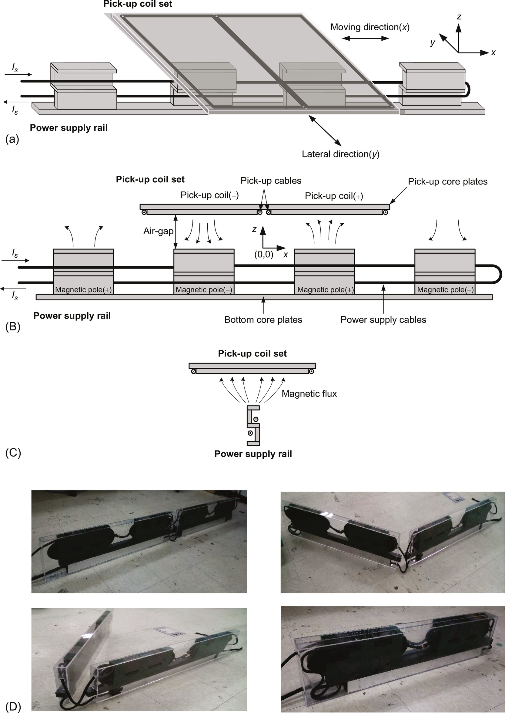

**FIG. 34.30** The concept and fabrication of ultraslim S-type power supply modules [[18](https://learning.oreilly.com/library/view/power-electronics-handbook/9780128114087/B9780128114070000386.xhtml#bb0095)]. (A) Bird's view, (B) side view, (C) front view, (D) deployment process.

The S-type power supply module has a width of only 4 cm, which has been decreased from the I-type width of 10 cm; hence, the S-type model leads to less construction cost and deployment time. Moreover, the S-type model makes it easier to fold itself, which means connecting power cables is no longer necessary after being deployed. The impact of deploying the S-type power supply modules on the surface of roads is now minimal, which fortunately does not change existing road operation conditions.

## 34.4 Design Considerations of Wireless Electric Vehicles

A few common design consideration issues applicable to both stationary and dynamic charging EVs are explained here. The issues are compensation, electric and magnetic circuit analyses, EMF cancel, and segmentation.

### 34.4.1 COMPENSATION CIRCUIT DESIGN

Due to large inductive reactances of IPT, capacitors are preferably adopted to nullify the total reactance and to resonate to a certain frequency for filtering out harmonics. One of widely used compensation circuits is two-capacitor type, called basic compensation circuit, as shown [Fig. 34.31](https://learning.oreilly.com/library/view/power-electronics-handbook/9780128114087/B9780128114070000386.xhtml#f0160). There are eight possible circuit topologies for compensation depending on current (I) or voltage (V) source types and serial (S) or parallel (P) configurations. In case the magnetic coupling factor *k* between Tx and Rx coils varies a lot, the three conditions should be met for practical applications: (1) load-independent output voltage or output current, (2) *k*-independent compensation, and (3) allowance of no magnetic coupling (*k*=0).

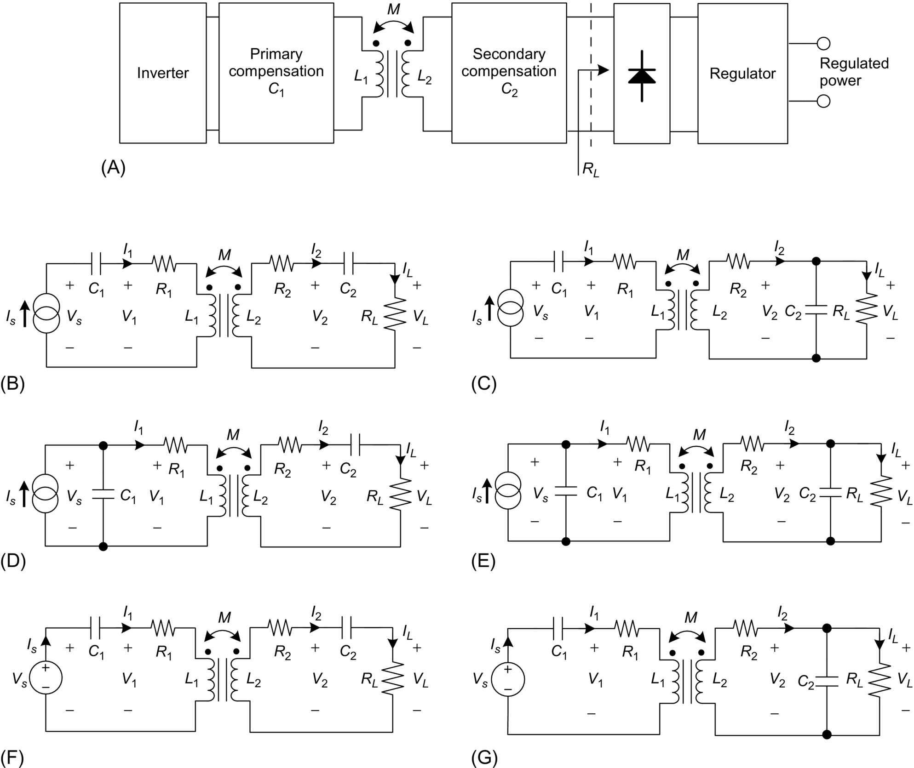

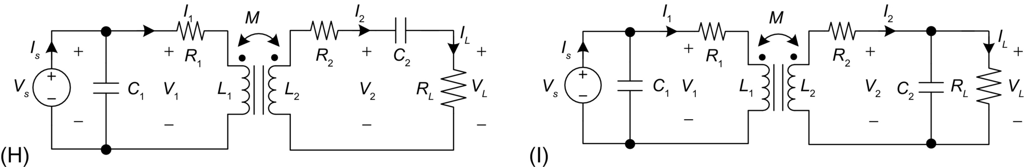

**FIG. 34.31** The eight basic compensation circuits of IPT. (A) General configuration of an IPT system, (B) current-source-type primary series-secondary series (I-SS), (C) current-source-type primary series-secondary parallel (I-SP), (D) current-source-type primary parallel-secondary series (I-PS), (E) current-source-type primary parallel-secondary parallel (I-PP), (F) voltage-source-type primary series-secondary series (V-SS), (G) voltage-source-type primary series-secondary parallel (V-SP), (H) voltage-source-type primary parallel-secondary series (V-PS), (I) voltage-source-type primary parallel-secondary parallel (V-PP).

It is identified that only I-SS and I-SP can satisfy all of the three criteria simultaneously among the eight compensation schemes [[37](https://learning.oreilly.com/library/view/power-electronics-handbook/9780128114087/B9780128114070000386.xhtml#bb0190)]. I-SS has the voltage-source-type output characteristics, which enable large load current; whereas, I-SP has the current-source-type output characteristics, which enable high load voltage. Of course, other schemes may be also used if the three conditions are not needed.

Substantial equivalence and duality between I-SS and I-SP are found in the aspect of efficiency, power transfer characteristics, and voltage and current ratings of reactive components, as shown in [Fig. 34.32](https://learning.oreilly.com/library/view/power-electronics-handbook/9780128114087/B9780128114070000386.xhtml#f0165). This means that there is no privilege between I-SS and I-SP, so we can freely choose compensation scheme according to large-current or high-voltage applications.

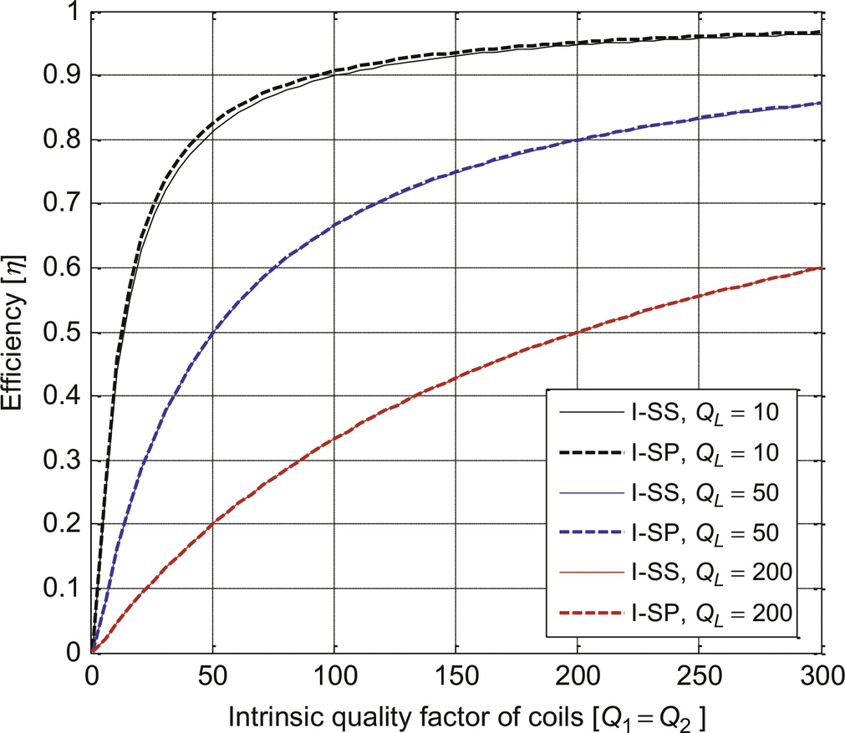

**FIG. 34.32** Efficiencies *η* versus quality factor *Q*1 for I-SS and I-SP when *ω*=*ω*2 and *k*=0.3.

One of the ways to implement the current source of IPT is to make the current of a primary coil constant by feedback, as shown in [Fig. 34.20](https://learning.oreilly.com/library/view/power-electronics-handbook/9780128114087/B9780128114070000386.xhtml#f0105). Another way of getting the current source is to use an LC filter for a given voltage source so that the Norton equivalent circuit has infinite output impedance when the source frequency is tuned to the resonance frequency, as shown in [Fig. 34.33](https://learning.oreilly.com/library/view/power-electronics-handbook/9780128114087/B9780128114070000386.xhtml#f0170). This is known to be LCC topology of IPT [[27](https://learning.oreilly.com/library/view/power-electronics-handbook/9780128114087/B9780128114070000386.xhtml#bb0140),[37](https://learning.oreilly.com/library/view/power-electronics-handbook/9780128114087/B9780128114070000386.xhtml#bb0190)], which has the current source input and voltage source output characteristics.

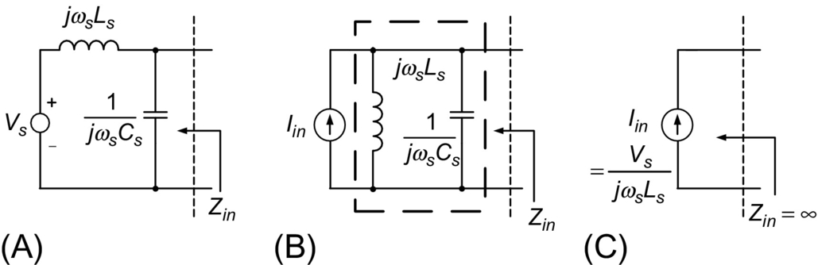

**FIG. 34.33** An LC-tuned filter with a voltage source becomes an ideal current source. (A) Original LC input filter, (B) Norton equivalent circuit, (C) final equivalent circuit for tuned case.

### 34.4.2 GYRATOR BASED CIRCUIT ANALYSIS

The electric analysis of IPT including compensation circuits is quite challenging because there are at least five energy storage circuit elements. Therefore, a powerful circuit analysis tool is recently invented, called gyrator-based circuit analysis by the author [[38](https://learning.oreilly.com/library/view/power-electronics-handbook/9780128114087/B9780128114070000386.xhtml#bb0195)]. This method drastically simplifies the analysis process and makes it possible to get analytic results without cumbersome manipulation of equations. Applying Kirchhoff's voltage law on *V*1 and *V*2 in [Fig. 34.34A](https://learning.oreilly.com/library/view/power-electronics-handbook/9780128114087/B9780128114070000386.xhtml#f0175) gives us the following equations in the steady state of sinusoidal AC circuits:

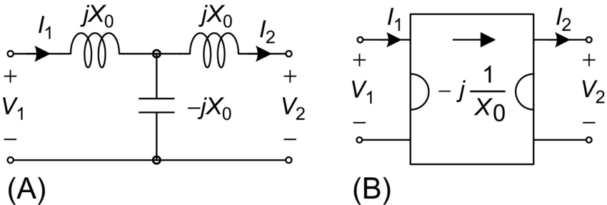

**FIG. 34.34** A T-network consists of all equal reactance and its equivalent gyrator circuit. (A) Gyratorin a T-network, (B) A Gyrator circuit model.

 **(34.5a)**

**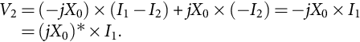** **(34.5b)**

As shown in [Fig. 34.34B](https://learning.oreilly.com/library/view/power-electronics-handbook/9780128114087/B9780128114070000386.xhtml#f0175), Eq. (34.5) describes the imaginary gyrator, first introduced in the literature [[38](https://learning.oreilly.com/library/view/power-electronics-handbook/9780128114087/B9780128114070000386.xhtml#bb0195)].

As shown in [Fig. 34.35](https://learning.oreilly.com/library/view/power-electronics-handbook/9780128114087/B9780128114070000386.xhtml#f0180), the T model of IPT can be decomposed into the imaginary gyrator and the primary and secondary inductances. This gyrator equivalent circuit is applied to the analysis of an example V-SS circuit of [Fig. 34.36](https://learning.oreilly.com/library/view/power-electronics-handbook/9780128114087/B9780128114070000386.xhtml#f0185), where the series-series resonant circuits *L*1-*C*1 and *L*2-*C*2 are tuned to the source frequency, respectively.

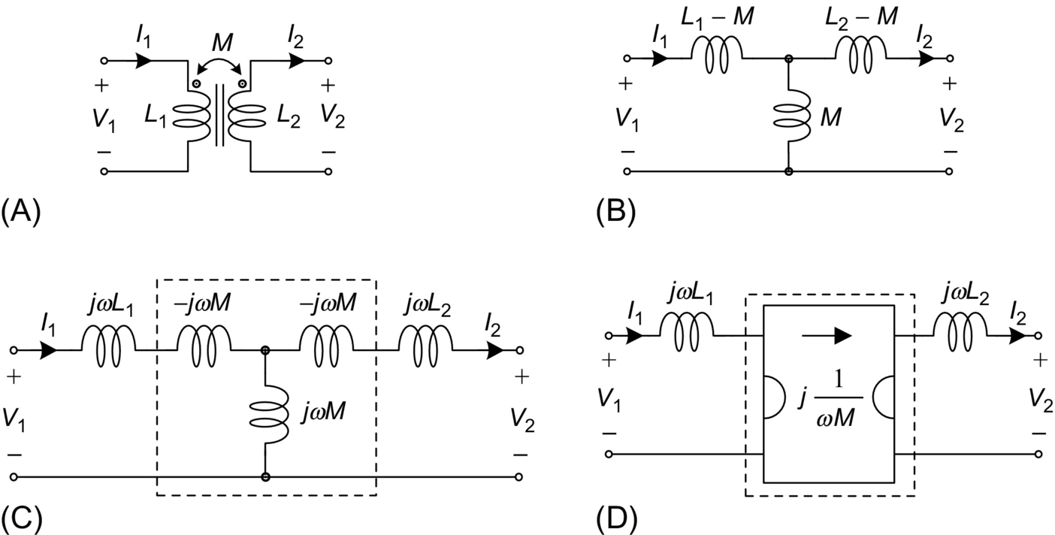

**FIG. 34.35** Representation of coupled inductors with a gyrator. (A) Circuit model of coupled inductors, (B) equivalent T-model of coupled inductors, (C) equivalent circuit of (B), (D) Representation of (C) with a gyrator model.

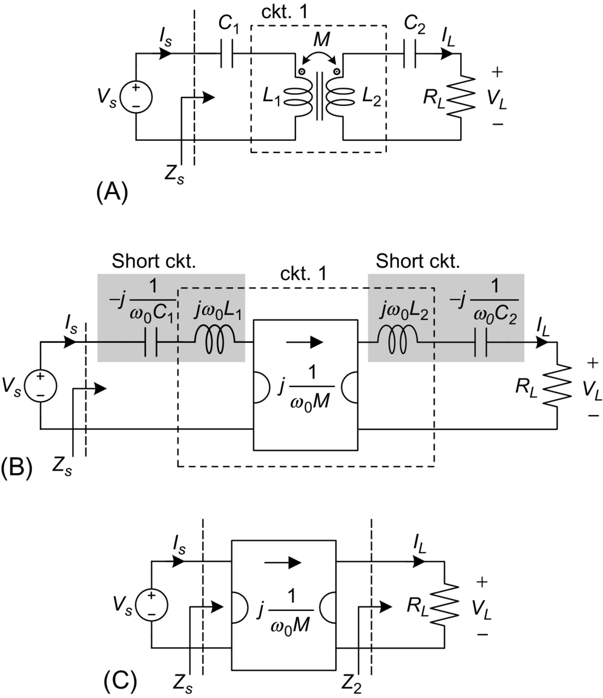

**FIG. 34.36** V-SS and the equivalent gyrator-based models. (A) V-SS circuit model, (B) equivalent V-SS circuit of (A) with a gyrator, (C) equivalent V-SS circuit of (B) with a gyrator,when primary and secondary LC's are tuned.

From the gyrator characteristics, the load current of V-SS is solely determined by the source voltage and independent of load resistance and load voltage as follows:

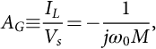 **(34.6)**

**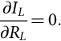** **(34.7)**

In this way, other features of the V-SS in [Fig. 34.36](https://learning.oreilly.com/library/view/power-electronics-handbook/9780128114087/B9780128114070000386.xhtml#f0185) such as input power factor, voltage and current stresses of each component, and input and output impedances can be deduced from the equivalent gyrator circuit without using high-order matrix manipulation.

### 34.4.3 MAGNETIC MIRROR BASED COIL DESIGN

In the coil design, we are quite often encountered to calculation of magnetic flux density, but you will readily see that there is nearly no available theoretical tool to finish your job. The difficulties of magnetic field calculation come from the complex interaction between current and magnetic material, which denies the application of Ampere's law that gives us the result only when appropriate current is given.

Fortunately, the magnetic flux density of an open magnetic circuit can be simply calculated by the magnetic mirror model [[15](https://learning.oreilly.com/library/view/power-electronics-handbook/9780128114087/B9780128114070000386.xhtml#bb0080)], as shown in [Fig. 34.37](https://learning.oreilly.com/library/view/power-electronics-handbook/9780128114087/B9780128114070000386.xhtml#f0190), where a reflected current at the same distance from the surface of a magnetic plate exists with a reduced amplitude as follows:

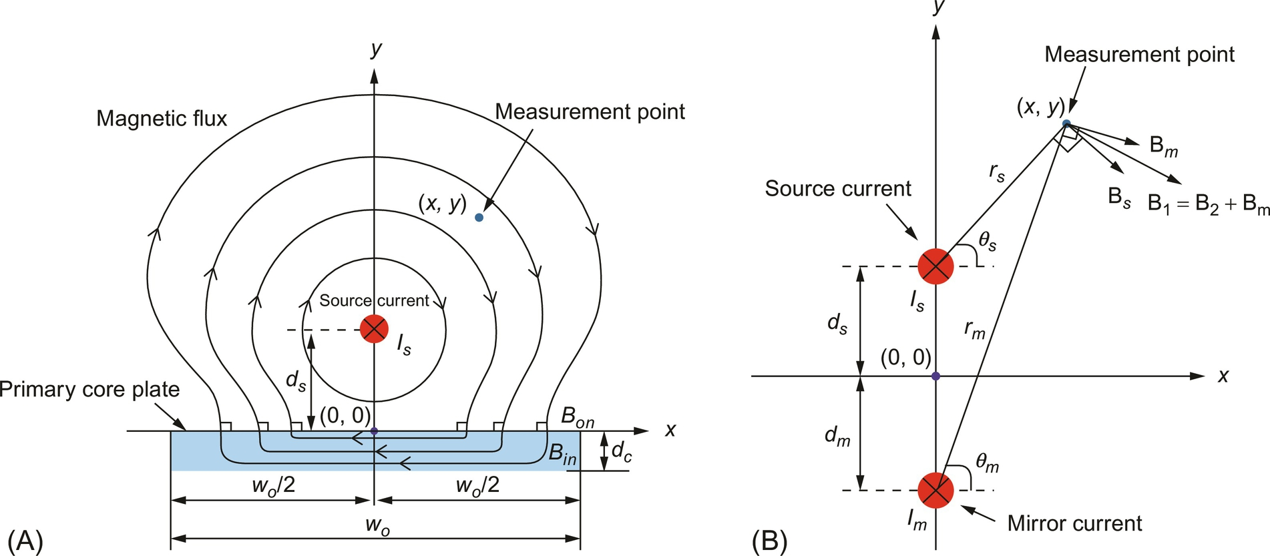

**FIG. 34.37** The magnetic mirror model. (A) Mono coil consists of a source current and a core plate with finite width and infinite permeability, (B) the magnetic mirror current of the mono coil.

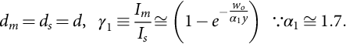 **(34.8)**

Then, the magnetic flux density of a mono coil *B*1 for a mirror current *Im* and a source current *Is* at an arbitrary measurement point (*x*, *y*) are obtained as follows:

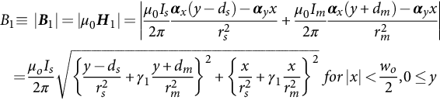 **(34.9a)**

**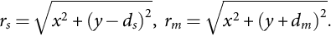** **(34.9b)**

As identified from [Fig. 34.37](https://learning.oreilly.com/library/view/power-electronics-handbook/9780128114087/B9780128114070000386.xhtml#f0190) and Eqs. [(34.8)](https://learning.oreilly.com/library/view/power-electronics-handbook/9780128114087/B9780128114070000386.xhtml#fo0075)–[(34.9)](https://learning.oreilly.com/library/view/power-electronics-handbook/9780128114087/B9780128114070000386.xhtml#fo0080), the magnetic flux density is at best doubled by the magnetic core for an open magnetic circuit. This is one of the backgrounds on no core use for some applications.

### 34.4.4 GENERALIZED ACTIVE EMF CANCELLATION METHODS

In the IPTS of OLEV, the total EMF, which is the summation of EMF generated by the power supply rail and the pickup coil, should be lower than the ICNIRP guideline for the safety of pedestrians. Among EMF cancellation methods [[35](https://learning.oreilly.com/library/view/power-electronics-handbook/9780128114087/B9780128114070000386.xhtml#bb0180),[36](https://learning.oreilly.com/library/view/power-electronics-handbook/9780128114087/B9780128114070000386.xhtml#bb0185),[39](https://learning.oreilly.com/library/view/power-electronics-handbook/9780128114087/B9780128114070000386.xhtml#bb0200)–[44](https://learning.oreilly.com/library/view/power-electronics-handbook/9780128114087/B9780128114070000386.xhtml#bb0225)], passive methods rely on the use of ferromagnetic materials, conductive materials, and selective surfaces for protecting against radio-frequency interference [[39](https://learning.oreilly.com/library/view/power-electronics-handbook/9780128114087/B9780128114070000386.xhtml#bb0200)–[41](https://learning.oreilly.com/library/view/power-electronics-handbook/9780128114087/B9780128114070000386.xhtml#bb0210)], which is found to be inadequate for OLEV. An active EMF cancellation design was applied to the RPEV of PATH team [[1](https://learning.oreilly.com/library/view/power-electronics-handbook/9780128114087/B9780128114070000386.xhtml#bb0010)], where a canceling coil mitigates the EMF without RPEV. Note that the EMF is generated from both the power supply rail and pickup coil of the IPTS, as shown in [Fig. 34.38](https://learning.oreilly.com/library/view/power-electronics-handbook/9780128114087/B9780128114070000386.xhtml#f0195); therefore, they must be canceled together without the need for accurate sensing of EMF and complicated control circuits, which is requisite for practical use.

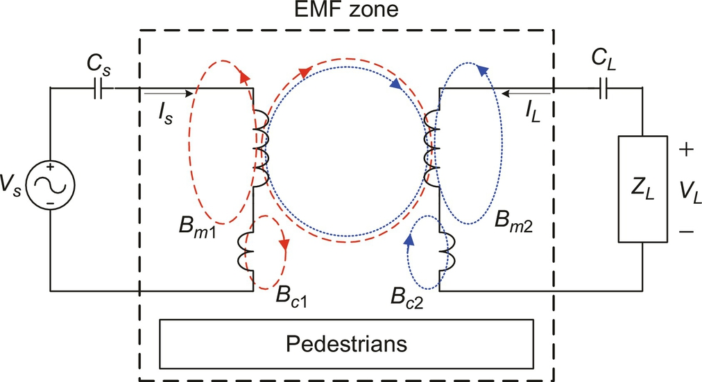

**FIG. 34.38** Independent self EMF cancellation (ISEC) method for primary and secondary sides, fetching its cancellation current from each main coil.

A generalized active EMF design principle, which can be extended to any IPTS, has been developed [[44](https://learning.oreilly.com/library/view/power-electronics-handbook/9780128114087/B9780128114070000386.xhtml#bb0225)], where there are three design methods: independent self EMF cancellation (ISEC), 3 dB dominant EMF cancellation (3DEC), and leakage-free EMF cancellation (LFEC). By adding an active EMF cancellation coil to each power supply rail and pickup coil without EMF sensing and control circuits, the EMF generated from each main coil can be independently canceled by their corresponding cancellation coils. Because the current of each cancellation coil is fetched from its corresponding main coil, the magnetic flux of a cancellation coil is in the phase of that of a main coil; hence, the EMF ***B****t* becomes independent of both phase and load conditions as follows:

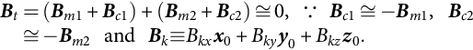 **(34.10)**

Together with ISEC, the 3DEC method is quite useful in practice for designing IPTS because it makes it possible to completely isolate the primary and secondary cancellation designs from each other.

For the full resonant IPTS that is very common in practice, the primary and secondary currents are in quadrature, that is, *B*1*x* ⊥ *B*2*x*, *B*1*y* ⊥ *B*2*y*, and *B*1*z* ⊥ *B*2*z*. Then, the total magnetic field *Bt* can be constrained to the ICNIRP guidelines so far as the dominating magnetic field *B*1 is less than 3 dB below the guideline as follows:

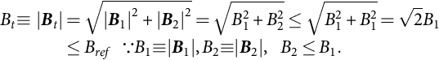 **(34.11)**

A design example for the 4G I-type IPTS based on the ISEC and 3DEC is shown in [Fig. 34.39](https://learning.oreilly.com/library/view/power-electronics-handbook/9780128114087/B9780128114070000386.xhtml#f0200), where no cancellation coil was used for the power supply rail due to the low EMF generated from itself.

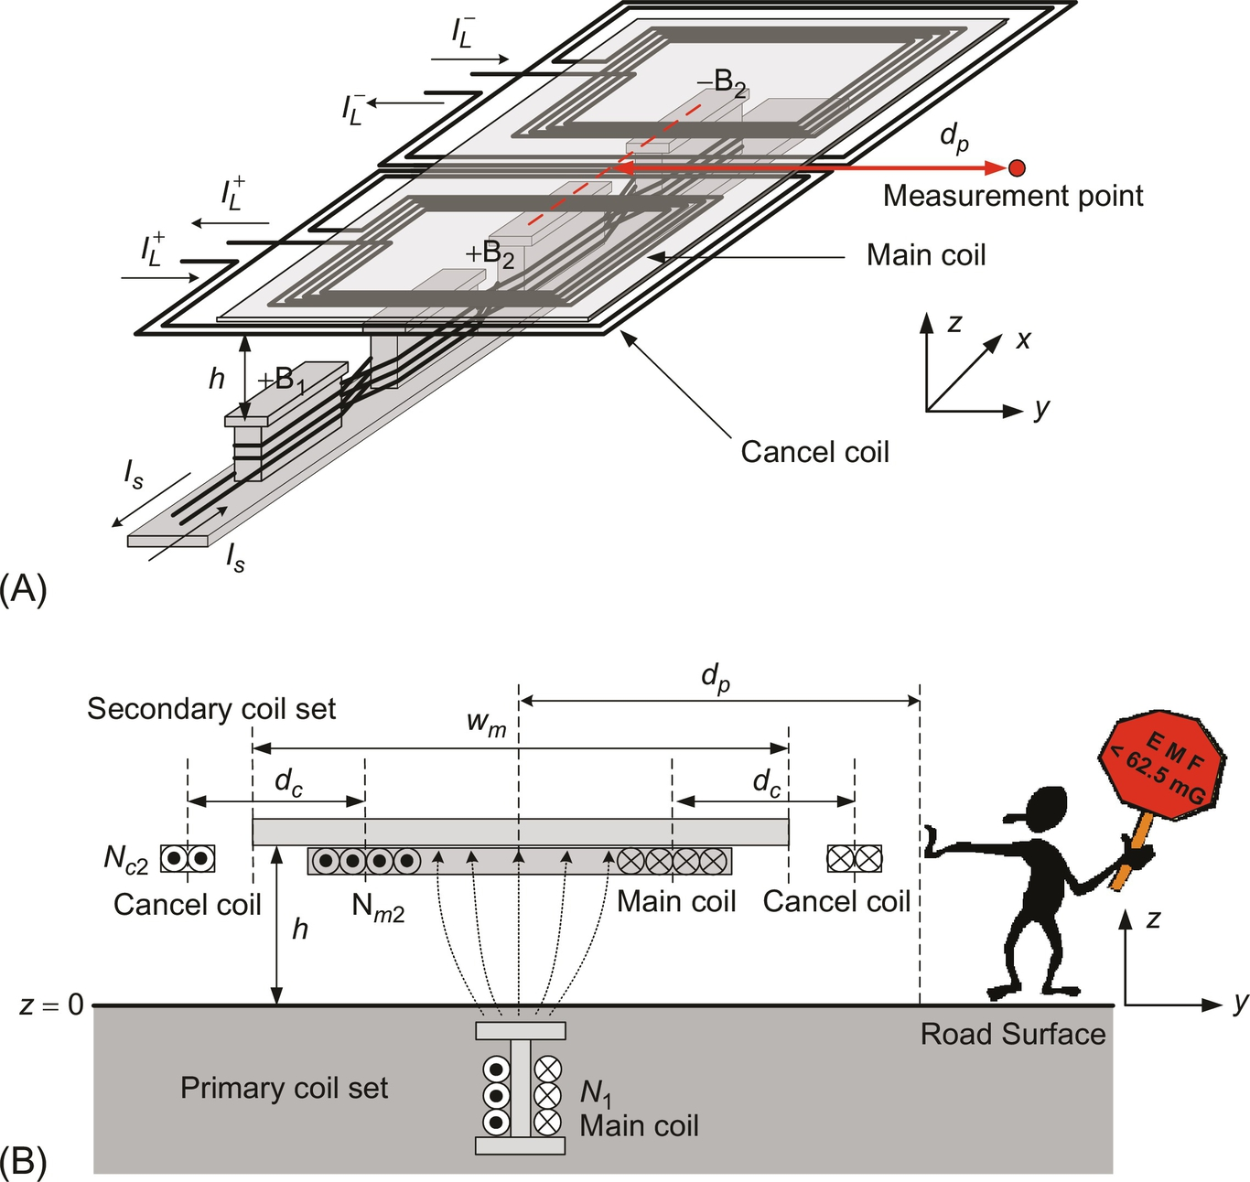

**FIG. 34.39** An active EMF cancellation design example for the I-type IPTS. (A) Bird's eye view, (B) front view.

In case the EMF cancellation coils are involved in an unwanted magnetic linkage, as shown in [Fig. 34.40](https://learning.oreilly.com/library/view/power-electronics-handbook/9780128114087/B9780128114070000386.xhtml#f0205), the induced load voltage drops; therefore, it is highly recommended to design the cancellation coils based on the LFEC method so that the magnetic linkage does not intersect them. The LFEC method can improve the load voltage as much as 21% [[44](https://learning.oreilly.com/library/view/power-electronics-handbook/9780128114087/B9780128114070000386.xhtml#bb0225)].

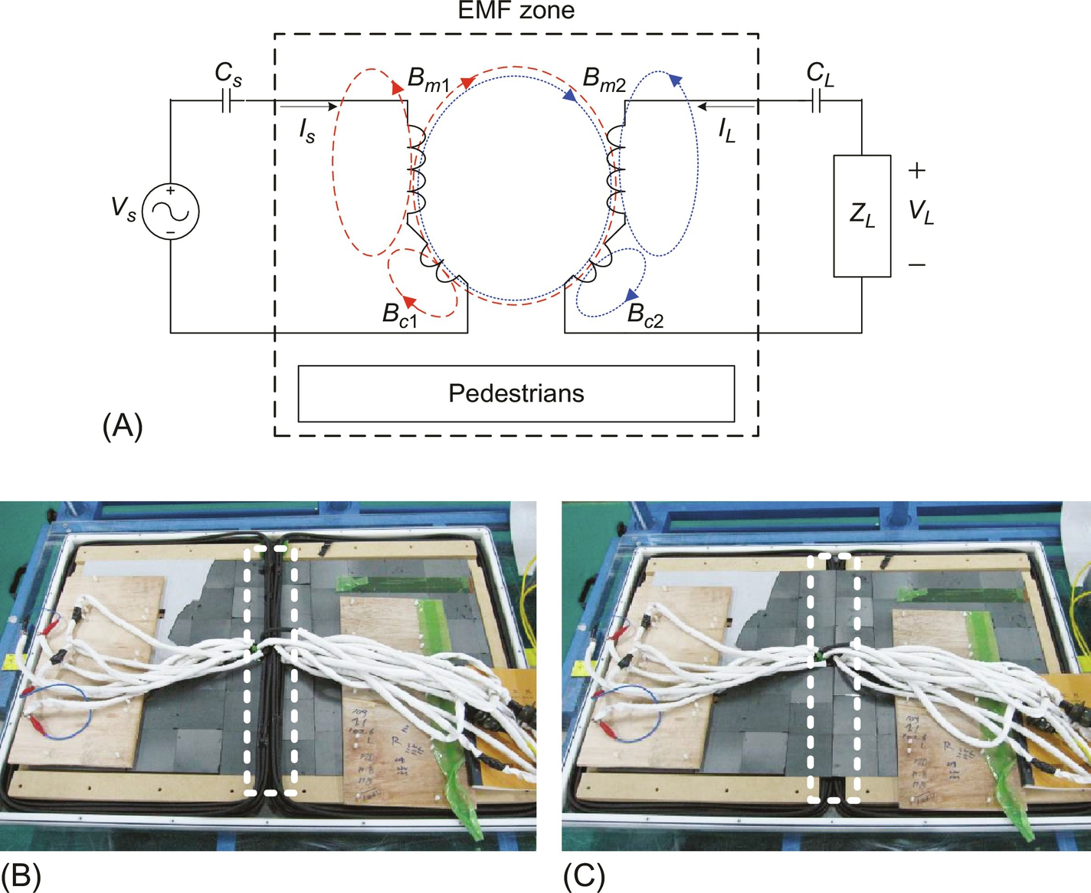

**FIG. 34.40** Leakage-free EMF cancellation (LFEC). (A) A bad design case for cancellation coils, which are strongly coupled with main magnetic linkage, (B) the application of the LFEC design to a pick-up set, (C) the case where not applied.

### 34.4.5 SEGMENTATION OF POWER RAILS

Unlike stationary charging EV, the RPEV needs its own roadway, where power supply rails should be activated when RPEVs are on the roadway, but they should be deactivated not to waste electric power and generate unwanted EMF for pedestrians; this is why the power supply rail is sometimes segmented into a few subrails. Each subrail can be activated by providing it with high-frequency current through a switch box from an inverter, as shown in [Fig. 34.41](https://learning.oreilly.com/library/view/power-electronics-handbook/9780128114087/B9780128114070000386.xhtml#f0210).

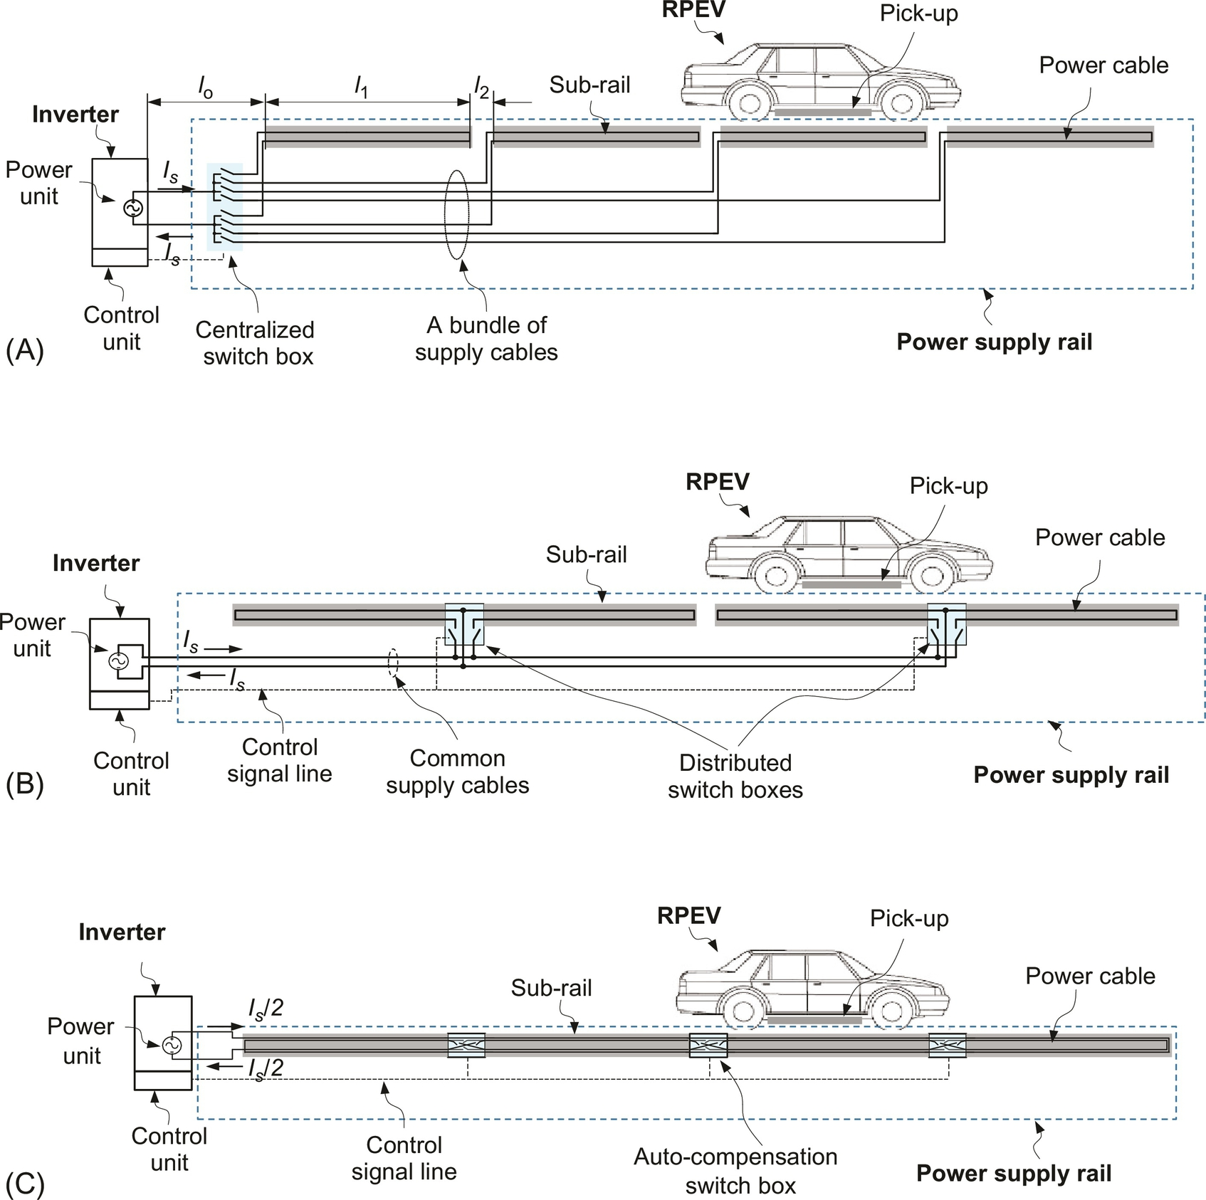

**FIG. 34.41** Segmentation of power supply rails for RPEV. (A) Centralized switching, (B) distributed switching, (C) X-segmented switching.

The first segmented power supply rail developed for OLEV, as shown in [Fig. 34.41A](https://learning.oreilly.com/library/view/power-electronics-handbook/9780128114087/B9780128114070000386.xhtml#f0210), was the centralized switching type composed of a few subrails, a bundle of supply cables, and a centralized switch box, where an inverter is connected to one of several pairs of supply cables through the switch box at a time. One of the demerits of the centralized one is that too many bundles of power cables are needed.

This is why the distributed switching power rail, as shown in [Fig. 34.41B](https://learning.oreilly.com/library/view/power-electronics-handbook/9780128114087/B9780128114070000386.xhtml#f0210), was proposed, which is composed of a few subrails, a pair of common power supply cables, and multiple switch boxes located between two subrails.

Thus, the total length of the cable could be reduced compared with the centralized one, especially for a larger number of the cables. The distributed one, however, requires the common power supply cables, which increases the power rail construction cost and conductive power loss.

A recently proposed cross segmented power supply rail (X-rail) [[16](https://learning.oreilly.com/library/view/power-electronics-handbook/9780128114087/B9780128114070000386.xhtml#bb0085)], consisting of segmented subrails, autocompensation switch boxes, control signal lines, and roadway harnesses, as shown in [Fig. 34.41C](https://learning.oreilly.com/library/view/power-electronics-handbook/9780128114087/B9780128114070000386.xhtml#f0210), has the shortest length of power cable among the segmentations developed so far, and the inverter can drive multiple RPEVs, unlike the previous segmentations that activate only one subrail at a time.

As shown in [Fig. 34.42](https://learning.oreilly.com/library/view/power-electronics-handbook/9780128114087/B9780128114070000386.xhtml#f0215), the cable cost of the X-rail is nearly halved compared with the distributed switching, and the cable length reduction effect becomes dominant as the number of segmented subrails increases.

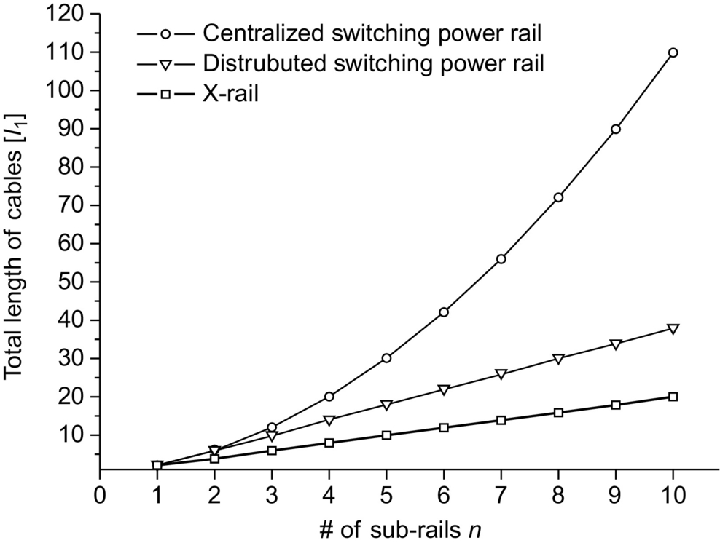

**FIG. 34.42** Comparison of the total length of power cables of the X-rail with that of the conventional switching rails.

If applicable, nonsegmented power rail would be better than the segmented one, considering increased cost and complexities. One of the possible candidates is the autotuned IPTS, where power is delivered only when EVs are on the power supply coils.

## 34.5 Summary

The concepts of WPT and its practical applications to EVs are explained throughout the chapter. IPT for stationary and dynamic charging EVs is explained. The development of IPTS for RPEV including state-of-the-art technologies is explained in detail. RPEV is becoming a viable solution for future transportation as the first commercialized online EV has demonstrated its validity.

## References

[1] California PATH Program, Road powered electric vehicle project track construction and testing program phase 3D, California PATH Research Paper, Mar. 1994.

[2] Covic G.A., Boys J.T., Kissin M., Lu H. A three-phase inductive power transfer system for roadway power vehicles. *IEEE Trans. Ind. Electron.* Dec. 2007;54(6):3370–3378.

[3] Suh N.P., Cho D.H., Rim C.T. *Design of on-line electric vehicle (OLEV.* In: Plenary Lecture at the 2010 CIRP Design Conference; 2010:3–8.

[4] Lee S.W., Huh J., Park C.B., Choi N.S., Cho G.H., Rim C.T. *On-line electric vehicle (OLEV) using inductive power transfer system.* In: IEEE Energy Conversion Congress and Exposition (ECCE); 2010:1598–1601.

[5] Huh J., Lee S.W., Park C.B., Cho G.H., Rim C.T. *High performance inductive power transfer system with narrow rail width for on-line electric vehicles.* In: IEEE Energy Conversion Congress and Exposition (ECCE); 2010 pp. 647–651.

[6] Chun T. Rim, Electric vehicle system, Patent WO 2010 076976, 2010

[7] N.P. Suh, D.H. Cho, G.H. Cho, J.G. Cho, Chun T. Rim, S.H. Jang, Ultra slim power supply and collector device for electric vehicle, Patent KR 1010406620000, 2011.

[8] S.Z. Jeon, D.H. Cho, Chun T. Rim, G.H. Jeong, Load-segmentation-based full bridge inverter and method for controlling same, Patent WO 2011 078424, 2011.

[9] S.Z. Jeon, D.H. Cho, Chun T. Rim, G.H. Jeong, Load-segmentation-based 3-level inverter and method for controlling the same, Patent WO 2011 078425, 2011.

[10] N.P. Suh, D.H. Cho, J.G. Cho, Chun T. Rim, J. Huh, J .H Kim, C.S. Choi, K.H. Lee, B.Y. Song, Y.J. Cho, C.H. Rim, Monorail type power supply device for electric vehicle including EMF cancellation apparatus, Patent WO 2011 046374, 2011.

[11] N.P. Suh, S.H. Jang, D.H. Cho, G.H. Cho, Chun T. Rim, S.W. Lee, C.B. Park, J. Huh, H.J. Kim, Space division multiplexed power supply and collector device, Patent WO 2011 152678, 2011.

[12] N.P. Suh, S.H. Jang, D.H. Cho, G.H. Cho, Chun T. Rim, J. Huh, B.H. Lee, Y.H. Kim, Cross-type segment power supply, Patent WO 2011 152677, 2011.

[13] Huh J., Lee S.W., Lee W.Y., Cho G.H., Rim C.T. Narrow-width inductive power transfer system for on-line electrical vehicles (OLEV). *IEEE Trans. Power Electron.* 2011;26(12):3666–3679.

[14] N.P. Suh, S.H. Jang, D.H. Cho, G.H. Cho, Chun T. Rim, S.W. Lee, C.B. Park, EMI cancellation device in power supply and collector device for magnetic induction power transmission, Patent WO 2011 149263, 2012.

[15] Lee W.Y., Huh J., Choi S.Y., Thai X.V., Kim J.H., Al-Ammar E.A., El-Kady M.A., Rim C.T. Finite-width magnetic mirror models of mono and dual coils for wireless electric vehicles. *IEEE Trans. Power Electron.* Mar. 2013;28(3):1413–1428.

[16] Choi S.Y., Huh J., Lee W.Y., Lee S.W., Rim C.T. New cross-segmented power supply rails for road powered electric vehicles. *IEEE Trans. Power Electron.* 2013;28(12):5832–5841.

[17] Choi S.Y., Huh J., Lee W.Y., Cho J.G., Rim C.T. Asymmetric coil sets for wireless stationary EV chargers with large lateral tolerance by dominant field analysis. *IEEE Trans. Power Electron.* 2014;29(12):6406–6420.

[18] Choi S.Y., Gu B.W., Jeong S.Y., Rim C.T. Advances in wireless power transfer systems for road powered electric vehicles. *IEEE J. Emerg. Sel. Top. Power Electron.* 2015;3(1):18–36.

[19] Mi C., Buja G., Choi S.Y., Rim C.T. Modern advances in wireless power transfer systems for roadway powered electric vehicles. *IEEE Trans. Ind. Electron.* 2016;63(10):6533–6545.

[20] Klontz K.W., Divan D.M., Novotny D.W., Lorenz R.D. Contactless power delivery system for mining applications. *IEEE Trans. Ind. Appl.* 1995;31(1):27–35.

[21] Wang C.S., Covic G.A., Stielau O.H. Power transfer capability and bifurcation phenomena of loosely coupled inductive power transfer systems. *IEEE Trans. Ind. Electron.* 2004;51(1):148–157.

[22] Wang C.S., Stielau O.H., Covic G.A. Design considerations for a contactless electric vehicle battery charger. *IEEE Trans. Ind. Electron.* 2005;52(5):1308–1314.

[23] Budhia M., Boys J.T., Covic G.A., Huang C.-Y. Development of a single-sided flux magnetic coupler for electric vehicle IPT charging systems. *IEEE Trans. Ind. Electron.* 2013;60(1):318–328.

[24] Covic G.A., Boys J.T. Modern trends in inductive power transfer for transportation applications. *IEEE J. Emerg. Sel. Top. Power Electron.* 2013;1(1):28–41.

[25] Zhang H., Lu F., Hofmann H., Liu W., Mi C. A 4-Plate compact capacitive coupler and *LCL* compensation topology for capacitive power transfer in electric vehicle charging applications. *IEEE Trans. Power Electron.* 2016;31(12):8541–8551.

[26] Thai V.X., Choi S.Y., Jeong S.Y., Rim C.T. *Coreless power supply rails compatible with both stationary and dynamic charging of electric vehicles.* In: IEEE International Future Energy Electronics Conference (IEEE IFEEC 2015), 978-1-4799-7657-7; 2015.

[27] Rim C.T., Mi C. *Wireless Power Transfer for Electric Vehicles and Mobile Devices.* USA: Wiley; 2017.

[28] Chau K.T. *Energy Systems for Electric and Hybrid Vehicles.* London: IET; 2016.

[29] Park C., Lee S., Cho G.H., Rim C.T. Innovative 5 m-off-distance inductive power transfer systems with optimum shaped dipole coils. *IEEE Trans. Power Electron.* 2015;30(2):817–827.

[30] Park C.B., Lee S.W., Rim C.T. *Static and dynamic analyses of three-phase rectifier with LC input filter by Laplace phasor transformation.* In: Energy Conversion Congress and Exposition (ECCE); Sep. 2012:1570–1577.

[31] Lee S., Choi B., Rim C.T. Dynamics characterization of the inductive power transfer system for on-line electric vehicles (OLEV) by Laplace phasor transform. *IEEE Trans. Power Electron.* 2013;28(12):5902–5909.

[32] Rim C.T., Cho G.H. Phasor transformation and its application to the dc/ac analyses of frequency phase-controlled series resonant converters (SRC). *IEEE Trans. Power Electron.* 1990;5(2):201–211.

[33] Rim C.T. Unified general phasor transformation for AC converters. *IEEE Trans. Power Electron.* 2011;26(9):2465–2745.

[34] Rim C.T. *Phasor Power Electronics.* Singapore: Springer; 2016.

[35] Guidelines for limiting exposure to time-varying electric and magnetic fields (Up to 300 GHz), ICNIRP Guidelines, 1998.

[36] Guidelines for limiting exposure to time-varying electric and magnetic fields (Up to 100 kHz), ICNIRP Guidelines, 2010.

[37] Son Y.H., Choi B.H., Lee E.S., Lim G.C., Cho G.H., Rim C.T. General unified analyses of two-capacitor inductive power transfer systems: equivalence of current-source ss and sp compensations. *IEEE Trans. Power Electron.* 2015;30(11):6030–6045.

[38] Son Y.H., Choi B.H., Cho G.H., Rim C.T. Gyrator-based analysis of resonant circuits in inductive power transfer systems. *IEEE Trans. Power Electron.* 2016;31(10):6824–6843.

[39] Bannister P.R. New theoretical expressions for predicting shielding effectiveness for the plane shield case. *IEEE Trans. Electromagn. Compat.* 1968;EMC-10(1):2–7.

[40] Yaping D., Cheng T.C., Farag A.S. Principles of power-frequency magnetic field shielding with flat sheets in a source of long conductors. *IEEE Trans. Electromagn. Compat.* 1996;38(3):450–459.

[41] Moreno P., Olsen R.G. A simple theory for optimizing finite width ELF magnetic field shields for minimum dependence on source orientation. *IEEE Trans. Electromagn. Compat.* 1997;39(4):340–348.

[42] Hiles M.L., Griffing K.L. Power frequency magnetic field management using a combination of active and passive shielding technology. *IEEE Trans. Power Delivery Electron.* 1998;171–179.

[43] Wu P., Bai F., Xue Q., Hui S.Y.R. Use of frequency selective surface for suppressing radio-frequency interference from wireless charging pads. *IEEE Trans. Ind. Electron.* 2014;61(8):3969–3977.

[44] Choi S.Y., Gu B.W., Lee S.W., Lee W.Y., Huh J., Rim C.T. Generalized active EMF cancel methods for wireless electric vehicles. *IEEE Trans. Power Electron.* 2014;29(11):5770–5783.

**SECTION VI**

Control

**35**

# Linear and Nonlinear Control of Switching Power Converters

José Fernando Silva Universidade de Lisboa, Lisboa, Portugal

Sónia F. Pinto Universidade de Lisboa, Lisboa, Portugal

## Abstract

This chapter provides tools to control switching electronic power converters. It starts by explaining techniques to obtain linear state-space converter models, illustrating them through examples. Linear models are then used to design linear feedback controllers for converter operating in the continuous or discontinuous mode.

Nonlinear state-space models and sliding-mode controllers are next used to define exactly the variables to be measured while providing the control and switching laws aiming for robust modulator and controller design.

Predictive control uses a detailed nonlinear dynamic model to forecast the converter future behavior upon application of every possible converter switching state or vector. The best vector is then applied to the converter by computing the minimum of a cost functional.

Fuzzy control needs an expert qualitative knowledge of the converter dynamics. The steps to obtain a fuzzy controller are described, and the provided example compares the fuzzy controller performance to current-mode control.

The backstepping control methodology is explained using a recursive procedure interconnecting the selection of the candidate Lyapunov function with the design of the feedback control loop, to obtain stability and robust control under conditions less restrictive than other methods.

### KEYWORDS

State-space average modeling; Linear control; Sliding mode; Predictive control; Fast predictive control; Backstepping control

35.1 [Introduction](https://learning.oreilly.com/library/view/power-electronics-handbook/9780128114087/B9780128114070000398_1.xhtml#s0010)

35.2 [Switching Power Converter Control Using State-Space Averaged Models](https://learning.oreilly.com/library/view/power-electronics-handbook/9780128114087/B9780128114070000398_1.xhtml#s0015)

35.2.1 Introduction

35.2.2 State-Space Modeling

35.2.3 Converter Transfer Functions

35.2.4 Pulse Width Modulator Transfer Functions

35.2.5 Linear Feedback Design Ensuring Stability

35.2.6 Examples: Buck–Boost DC/DC Converter, Forward DC/DC Converter, 12 Pulse Rectifiers, Buck–Boost DC/DC Converter in the Discontinuous Mode (Voltage and Current Mode), Three-Phase PWM Inverters

35.3 [Sliding-Mode Control of Switching Power Converters](https://learning.oreilly.com/library/view/power-electronics-handbook/9780128114087/B9780128114070000398_2.xhtml#s0095)

35.3.1 Introduction

35.3.2 Principles of Sliding-Mode Control

35.3.3 Constant-Frequency Operation

35.3.4 Steady-State Error Elimination in Converters with Continuous Control Inputs

35.3.5 Examples: Buck–Boost DC/DC Converter, Half-Bridge Inverter, 12-Pulse Parallel Rectifiers, Audio Power Amplifiers, Near Unity Power Factor Rectifiers, Multilevel Inverters, Matrix Converters

35.4 [Predictive Optimum Control of Switching Power Converters](https://learning.oreilly.com/library/view/power-electronics-handbook/9780128114087/B9780128114070000398_4.xhtml#s0275)

35.4.1 Introduction

35.4.2 Principles of Non-Linear Predictive Optimum Control

35.4.3 Principles of Non-Linear Fast Predictive Optimum Control

35.4.4 Examples: Predictive Control of Multilevel Inverters and Matrix Converters

35.5 [Fuzzy Logic Control of Switching Power Converters](https://learning.oreilly.com/library/view/power-electronics-handbook/9780128114087/B9780128114070000398_5.xhtml#s0330)

35.5.1 Introduction

35.5.2 Fuzzy Logic Controller Synthesis

35.5.3 Near Unity Power Factor Buck–Boost PWM Rectifier

35.6 [Backstepping Control of Switching Power Converters](https://learning.oreilly.com/library/view/power-electronics-handbook/9780128114087/B9780128114070000398_5.xhtml#s0370)

35.6.1 Principles of Backstepping Control

35.6.2 Example 35.22: Backstepping Control of the Buck–Boost Converter

35.6.3 Example 35.23: Backstepping Control of a Single Phase Inverter

35.7 [Conclusions](https://learning.oreilly.com/library/view/power-electronics-handbook/9780128114087/B9780128114070000398_5.xhtml#s0375)

[Acknowledgments](https://learning.oreilly.com/library/view/power-electronics-handbook/9780128114087/B9780128114070000398_1.xhtml#ac0010)

[References](https://learning.oreilly.com/library/view/power-electronics-handbook/9780128114087/B9780128114070000398_5.xhtml#bi0010)

## Acknowledgments

Authors thank all the researchers whose works contributed to this chapter, namely, professors V. Pires, D. Barros, J. Quadrado, T. Amaral, M. Crisóstomo, L. Encarnação, and Aranzazu D. Martin; engineers J. Costa and N. Rodrigues; and the suggestions of Professor M. P. Kazmierkowski. This work was supported by national funds through Fundação para a Ciência e a Tecnologia (FCT) with reference UID/CEC/50021/2013 and by POSI, POCTI, and FEDER past projects enabling the presented results.

## 35.1 Introduction

Switching power converters must be suitably designed and controlled in order to supply the voltages, currents, or frequency ranges needed for the load and to guarantee the requested dynamics [[1](https://learning.oreilly.com/library/view/power-electronics-handbook/9780128114087/B9780128114070000398_5.xhtml#bb0010)–[4](https://learning.oreilly.com/library/view/power-electronics-handbook/9780128114087/B9780128114070000398_5.xhtml#bb0025)]. Furthermore, they can be designed to serve as “clean” interfaces between most loads and the electric utility system. Thereafter, the set switching power converter plus load behaves as an almost pure electric utility resistive load.

This chapter provides basic and advanced skills to control electronic power converters, taking into account that the control of switching power converters is a vast and interdisciplinary subject. Control designers for switching power converters should know the static and dynamic behavior of the electronic power converter and how to design its elements for the intended operating modes. Designers must be experts on control techniques, especially the nonlinear ones, since switching converters are nonlinear, time-variant, discrete systems, and designers must be capable of analog or digital implementation of the derived modulators, regulators, or compensators. Powerful modeling methodologies and sophisticated control processes must be used to obtain stable-controlled switching power converters, not only with satisfactory static and dynamic performance but also with low sensitivity against load or line disturbances or, preferably, robustness.

In [Section 35.2](https://learning.oreilly.com/library/view/power-electronics-handbook/9780128114087/B9780128114070000398_1.xhtml#s0015), the techniques to obtain suitable nonlinear and linear state-space models, for most switching converters, are presented and illustrated through examples. The derived linear models are used to create equivalent circuits and to design linear feedback controllers for converters operating in the continuous or discontinuous mode. The classical linear time-invariant system control theory, based on Laplace transform, transfer function concepts, Bode plots, or root locus, is best used with state-space averaged models or derived circuits and well-known triangular wave modulators for generating the switching variables or the trigger signals for the power semiconductors.

Nonlinear state-space models and sliding-mode controllers, presented in [Section 35.3](https://learning.oreilly.com/library/view/power-electronics-handbook/9780128114087/B9780128114070000398_2.xhtml#s0095), provide a more consistent way of handling the control problem of switching converters, since sliding mode is aimed at variable structure systems, as are switching power converters. Chattering, a characteristic of sliding mode, is inherent to switching power converters, even if they are controlled with linear methods. Chattering is very hard to remove and is acceptable in certain converter variables. The described sliding-mode methodology defines exactly the variables that need to be measured, while providing the necessary equations (control law and switching law) whose implementation gives the robust modulator and compensator low-level hardware (or software). Therefore, the sliding-mode control integrates the design of the switching converter modulator and controller electronics, reducing the needed designer expertise. This approach requires measurement of the state variables but eliminates conventional modulators and linear feedback compensators, enabling better performance and robustness. It also reduces the converter cost, control complexity, volume, and weight (increasing power density). The so-called main drawback of sliding mode, variable switching frequency, is also addressed, providing fixed-frequency auxiliary functions and suitable augmented control laws to null steady-state errors due to the use of constant switching frequency.

Predictive control ([Section 35.4](https://learning.oreilly.com/library/view/power-electronics-handbook/9780128114087/B9780128114070000398_4.xhtml#s0275)) uses a detailed nonlinear dynamic model (including system bounds, saturations, and hysteresis) of the switching power converter to forecast the converter future behavior upon application of every possible switching state or vector. For all possible switching states (vectors), the control errors are evaluated and weighted, and the vector that leads to the minimum value of a suitable cost function is selected and applied to the converter. Predictive controllers also integrate the design of the switching converter modulator and controller electronics using fast microprocessors or fast algorithms. The steps in designing a predictive optimum controller for switching power converters with finite small number of switching states are explained in [Section 35.4](https://learning.oreilly.com/library/view/power-electronics-handbook/9780128114087/B9780128114070000398_4.xhtml#s0275). Upon choosing a suitable cost function, obtained converter performances are usually better than obtained using linear or even sliding-mode controllers. This arises as sliding mode tries to go as fast as possible toward the sliding regime but chatters along the sliding surface, while predictive control aims to zero the error at the next sampling step.

In contrast, fuzzy control of switching converters ([Section 35.5](https://learning.oreilly.com/library/view/power-electronics-handbook/9780128114087/B9780128114070000398_5.xhtml#s0330)) is a control technique that needs no converter models, parameters, or operating conditions, but only an expert qualitative knowledge of the converter dynamics. Fuzzy controllers can be used in a diverse array of switching converters with only small adaptations, since the controllers, based on fuzzy sets, are obtained simply from the knowledge of the system dynamics, using a model reference adaptive control philosophy. Obtained fuzzy control rules can be built into a decision-lookup table, in which the control processor simply picks up the control input corresponding to the sampled measurements. Fuzzy controllers are almost resistant to system parameter fluctuations, since they do not take into account their values. The steps to obtain a fuzzy controller are described, and the example provided compares the fuzzy controller performance to the current-mode control.

Backstepping control ([Section 35.6](https://learning.oreilly.com/library/view/power-electronics-handbook/9780128114087/B9780128114070000398_5.xhtml#s0370)) is presented as a recursive method for stabilizing the origin of a converter modeled in a strict-feedback form. The procedure interconnects the choice of a candidate Lyapunov function with the design of the feedback control loop using Lyapunov's second method. Backstepping offers stability, tracking, and robust control under conditions less restrictive than other methods. Integral action is included to ensure the convergence, in steady state, of the tracking error to zero, regardless of nonmodeled disturbances and parameter uncertainty. Backstepping control is a nonlinear method that can be used with conventional fixed-frequency duty-cycle modulators for power converters to prevent chattering at variable frequency.

## 35.2 Switching Power Converter Control Using State-Space Averaged Models

### **35.2.1 INTRODUCTION**

State-space models provide a general and strong basis for dynamic modeling of various systems including switching converters. State-space models are useful to design the needed linear control loops and can also be used to computer simulate the steady state and the dynamic behavior, of the switching converter, fitted with the designed feedback control loops and subjected to external perturbations. Furthermore, state-space models are the basis for applying powerful nonlinear control methods such as sliding mode. State-space averaging and linearization provide an elegant solution for the application of widely known linear control techniques to most switching power converters.

### 35.2.2 STATE-SPACE MODELING

Consider a switching power converter with sets of power semiconductor structures, each one with two different circuit configurations, according to the state of the respective semiconductors, and operating in the continuous mode of conduction. Supposing the power semiconductors as controlled ideal switches (zero on-state voltage drops, zero off-state currents, and instantaneous commutation between the on- and off-states), the time (*t*) behavior of the circuit, over period *T*, can be represented by the general form of the state-space model Eq. [(35.1)](https://learning.oreilly.com/library/view/power-electronics-handbook/9780128114087/B9780128114070000398_1.xhtml#fo0010):

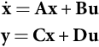 **(35.1)**

where **x** is the state vector; ; **u** is the input or control vector; **y** is the output vector; and **A**, **B**, **C**, and **D** are, respectively, the dynamics (or state), the input, the output, and the direct transmission (or feedforward) matrices.

Since the power semiconductors will be either conducting or blocking, a time-dependent switching variable *δ*(*t*) can be used to describe the allowed switch states of each structure (i.e., *δ*(*t*)=1 for the on-state circuit and *δ*(*t*)=0 for the off-state circuit). Then, two subintervals must be considered: subinterval 1 for 0≤*t*≤*δ*1*T*, when *δ*(*t*)=1, where *δ*1 is the duty ratio between the on-state and the off-state, and subinterval 2 for *δ*1*T*≤*t*≤*T* when *δ*(*t*)=0. The state equations of the circuit, in each of the circuit configurations, can be written as

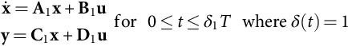 **(35.2)**

**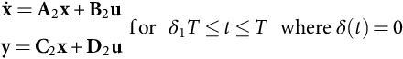** **(35.3)**

#### **35.2.2.1 Switched State-Space Model**

Given the two binary values of the switching variable *δ*(*t*), Eqs. [(35.2)](https://learning.oreilly.com/library/view/power-electronics-handbook/9780128114087/B9780128114070000398_1.xhtml#fo0015) and [(35.3)](https://learning.oreilly.com/library/view/power-electronics-handbook/9780128114087/B9780128114070000398_1.xhtml#fo0020) can be combined to obtain the nonlinear and time-variant switched state-space model of the switching converter circuit, Eq. [(35.4)](https://learning.oreilly.com/library/view/power-electronics-handbook/9780128114087/B9780128114070000398_1.xhtml#fo0025) or [(35.5)](https://learning.oreilly.com/library/view/power-electronics-handbook/9780128114087/B9780128114070000398_1.xhtml#fo0030):

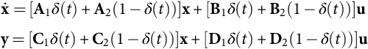 **(35.4)**

**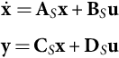** **(35.5)**

where **A**S=[**A**1*δ*(*t*)+**A**2(1−*δ*(t))], **B**S=[**B**1*δ* (*t*)+**B**2 (1−*δ* (*t*))], **C**S=[**C**1*δ* (*t*)+**C**2 (1−*δ* (*t*))], and **D**S=[**D**1*δ* (*t*)+**D**2 (1−*δ* (*t*))].

#### **35.2.2.2 State-Space Averaged Model**

Since the state variables of the **x** vector are continuous, using Eq. [(35.4)](https://learning.oreilly.com/library/view/power-electronics-handbook/9780128114087/B9780128114070000398_1.xhtml#fo0025), with the initial conditions **x**1(0)=**x**2(*T*) and **x**2(*δ*1 *T*)=**x**1(*δ*1 *T*), and considering the duty cycle *δ*1 as the average value of *δ*(*t*), the time evolution of the converter state variables can be obtained, integrating Eq. [(35.4)](https://learning.oreilly.com/library/view/power-electronics-handbook/9780128114087/B9780128114070000398_1.xhtml#fo0025) over the intervals 0≤*t*≤*δ*1 *T* and *δ*1 *T*≤*t*≤*T*, although it often requires excessive calculation effort. However, a convenient approximation can be devised, considering *λmax*, the maximum of the absolute values of all eigenvalues of **A** (usually, *λmax* is related to the cutoff frequency *fc* of an equivalent low-pass filter with *fc*≪1/*T*). For *λmax T*≪1, the exponential matrix (or state transition matrix) e**A*t***=**I**+**A***t*+**A**2*t* 2/2+…+**A***nt n*/*n*!, where **I** is the identity or unity matrix, can be approximated by e**A*t***≈**I**+**A***t*. Therefore, e**A**1*δ*1 *t*·e**A**2(1−*δ*1)*t*≈**I** + [**A**1*δ*1+**A**2(1−*δ*1)]*t*. Hence, the solution over the period *T*, for the system represented by Eq. [(35.4)](https://learning.oreilly.com/library/view/power-electronics-handbook/9780128114087/B9780128114070000398_1.xhtml#fo0025), is found to be

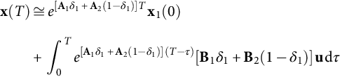 **(35.6)**

This approximate response of Eq. [(35.4)](https://learning.oreilly.com/library/view/power-electronics-handbook/9780128114087/B9780128114070000398_1.xhtml#fo0025) is identical to the exact response obtained from the nonlinear continuous time-invariant state-space model [(35.7)](https://learning.oreilly.com/library/view/power-electronics-handbook/9780128114087/B9780128114070000398_1.xhtml#fo0040), supposing that the average values of **x**, denoted , are the new state variables and considering *δ*2=1−*δ*1. Moreover, if **A**1 **A**2=**A**2 **A**1, the approximation is exact:

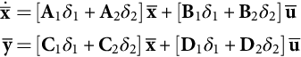 **(35.7)**

For *λmaxT*≪1, the model [(35.7)](https://learning.oreilly.com/library/view/power-electronics-handbook/9780128114087/B9780128114070000398_1.xhtml#fo0040), often referred to as the state-space averaged model, is also said to be obtained by “averaging” Eq. [(35.4)](https://learning.oreilly.com/library/view/power-electronics-handbook/9780128114087/B9780128114070000398_1.xhtml#fo0025) over one period, under small ripple and slow variations, as the average of products is approximated by products of the averages. Comparing Eq. [(35.7)](https://learning.oreilly.com/library/view/power-electronics-handbook/9780128114087/B9780128114070000398_1.xhtml#fo0040) with Eq. [(35.1)](https://learning.oreilly.com/library/view/power-electronics-handbook/9780128114087/B9780128114070000398_1.xhtml#fo0010), the relations [(35.8)](https://learning.oreilly.com/library/view/power-electronics-handbook/9780128114087/B9780128114070000398_1.xhtml#fo0045), defining the state-space averaged model, are obtained:

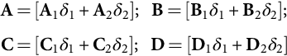 **(35.8)**

**Example 35.1**

**State-space models for the buck–boost dc/dc converter**

Consider the simplified circuitry of the buck-boost converter of [Fig. 35.1](https://learning.oreilly.com/library/view/power-electronics-handbook/9780128114087/B9780128114070000398_1.xhtml#f0010) switching at *fs*=20 kHz (*T*=50 μs) with *VDCmax*=28 V, *VDCmin*=22 V, *Vo*=24 V, *Li*=400 μH, *Co*=2700 μF, and *Ro*=2 Ω.

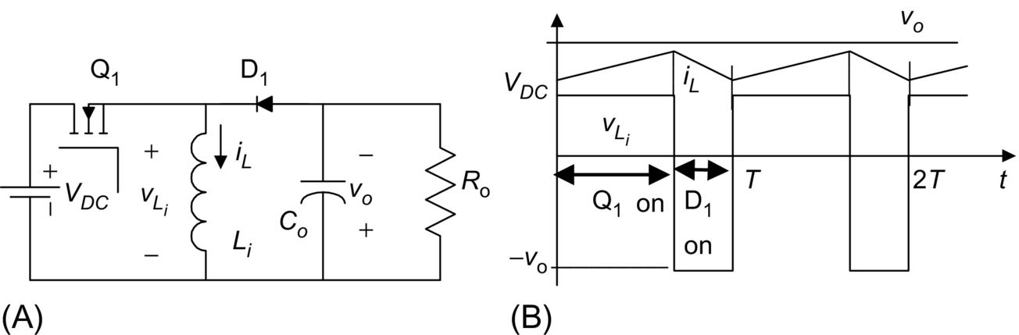

**FIG. 35.1** (A) Basic circuit of the buck-boost dc/dc converter and (B) ideal waveforms.

The differential equations governing the dynamics of the state vector **x**=[*iL*, *vo*]T (T denotes the transpose of vectors or matrices) are

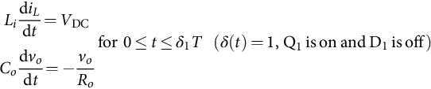 **(35.9)**

**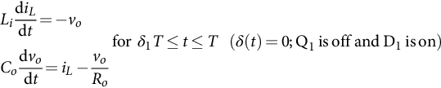** **(35.10)**

Comparing Eqs. [(35.9)](https://learning.oreilly.com/library/view/power-electronics-handbook/9780128114087/B9780128114070000398_1.xhtml#fo0050) and [(35.10)](https://learning.oreilly.com/library/view/power-electronics-handbook/9780128114087/B9780128114070000398_1.xhtml#fo0055) with Eqs. [(35.2)](https://learning.oreilly.com/library/view/power-electronics-handbook/9780128114087/B9780128114070000398_1.xhtml#fo0015) and [(35.3)](https://learning.oreilly.com/library/view/power-electronics-handbook/9780128114087/B9780128114070000398_1.xhtml#fo0020) and considering **y**=[*vo*, *iL*]*T*, the following matrices can be identified:

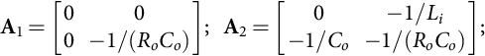



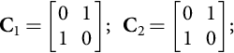



From Eqs. [(35.4)](https://learning.oreilly.com/library/view/power-electronics-handbook/9780128114087/B9780128114070000398_1.xhtml#fo0025) and [(35.5)](https://learning.oreilly.com/library/view/power-electronics-handbook/9780128114087/B9780128114070000398_1.xhtml#fo0030), the switched state-space model of this switching converter is

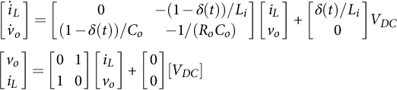 **(35.11)**

Now, applying Eq. [(35.7)](https://learning.oreilly.com/library/view/power-electronics-handbook/9780128114087/B9780128114070000398_1.xhtml#fo0040), Eqs. [(35.12)](https://learning.oreilly.com/library/view/power-electronics-handbook/9780128114087/B9780128114070000398_1.xhtml#fo0085) and [(35.13)](https://learning.oreilly.com/library/view/power-electronics-handbook/9780128114087/B9780128114070000398_1.xhtml#fo0090) can be obtained:

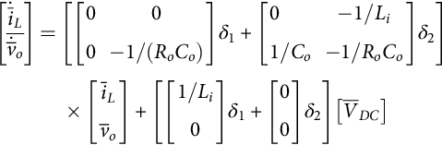 **(35.12)**

**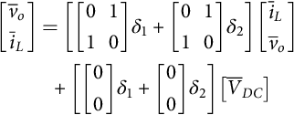** **(35.13)**

From Eqs. [(35.12)](https://learning.oreilly.com/library/view/power-electronics-handbook/9780128114087/B9780128114070000398_1.xhtml#fo0085) and [(35.13)](https://learning.oreilly.com/library/view/power-electronics-handbook/9780128114087/B9780128114070000398_1.xhtml#fo0090), the state-space averaged model, written as a function of *δ*1, is

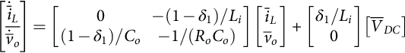 **(35.14)**

**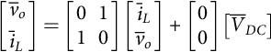** **(35.15)**

The eigenvalues  or characteristic roots of **A** are the roots of |s**I**−**A**|. Therefore,

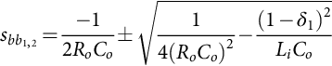 **(35.16)**

Since *λmax* is the maximum of the absolute values of all the eigenvalues of **A**, the model [(35.14)](https://learning.oreilly.com/library/view/power-electronics-handbook/9780128114087/B9780128114070000398_1.xhtml#fo0095) and [(35.15)](https://learning.oreilly.com/library/view/power-electronics-handbook/9780128114087/B9780128114070000398_1.xhtml#fo0100) is valid for switching frequencies *fs* (*fs*=1/*T*) that verify *λmaxT*≪1. Therefore, as *T*≪1/*λmax*, the values of *T* that approximately verify this restriction are *T*≪1/max(|*sbb*1,2|). Given these buck-boost converter data, *T*≪2 ms is obtained. Therefore, the converter switching frequency must obey *fs*≫max(|*sbb*1,2|), implying switching frequencies above, say, 5 kHz. Consequently, the buck-boost switching frequency, the inductor value, and the capacitor value were chosen accordingly.

This restriction can be further used to discuss the maximum frequency *ωmax* for which the state-space averaged model is still valid, given a certain switching frequency. As *λmax* can be regarded as a frequency, the preceding constraint brings *ωmax*≪2π*fs*, say *ωmax<*2π*fs*/10, which means that the state-space averaged model is a good approximation at frequencies under one-tenth of the power converter switching frequency.

The state-space averaged model [(35.14)](https://learning.oreilly.com/library/view/power-electronics-handbook/9780128114087/B9780128114070000398_1.xhtml#fo0095) and [(35.15)](https://learning.oreilly.com/library/view/power-electronics-handbook/9780128114087/B9780128114070000398_1.xhtml#fo0100) is also the state-space model of the circuit represented in [Fig. 35.2](https://learning.oreilly.com/library/view/power-electronics-handbook/9780128114087/B9780128114070000398_1.xhtml#f0015). Hence, this circuit is often named “the averaged equivalent circuit” of the buck-boost converter and allows the determination, under small ripple and slow variations, of the average equivalent circuit of the converter switching cell (power transistor plus diode).

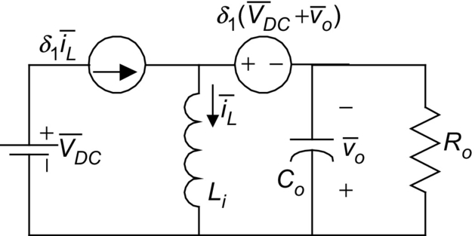

**FIG. 35.2** Equivalent circuit of the averaged state-space model of the buck-boost converter.

The average equivalent circuit of the switching cell ([Fig. 35.3A](https://learning.oreilly.com/library/view/power-electronics-handbook/9780128114087/B9780128114070000398_1.xhtml#f0020)) is represented in [Fig. 35.3B](https://learning.oreilly.com/library/view/power-electronics-handbook/9780128114087/B9780128114070000398_1.xhtml#f0020) and emerges directly from the state-space averaged model [(35.14)](https://learning.oreilly.com/library/view/power-electronics-handbook/9780128114087/B9780128114070000398_1.xhtml#fo0095) and [(35.15)](https://learning.oreilly.com/library/view/power-electronics-handbook/9780128114087/B9780128114070000398_1.xhtml#fo0100). This equivalent circuit can be viewed as the model of an “ideal transformer” ([Fig. 35.3C](https://learning.oreilly.com/library/view/power-electronics-handbook/9780128114087/B9780128114070000398_1.xhtml#f0020)), whose primary to secondary ratio (*v*1/*v*2) can be calculated applying Kirchhoff's voltage law to obtain−*v*1+*vs*−*v*2=0. As *v*2=*δ*1*vs*, it follows that *v*1=*vs*(1−*δ*1), giving (*v*1/*v*2)=(1−*δ*1)/*δ*1. The same ratio could be obtained beginning with *iL*=*i*1+*i*2 and *i*1=*δ*1*iL* ([Fig. 35.3B](https://learning.oreilly.com/library/view/power-electronics-handbook/9780128114087/B9780128114070000398_1.xhtml#f0020)), which gives *i*2=*iL*(1−*δ*1) and (*i*2/*i*1)=*δ*2/*δ*1.

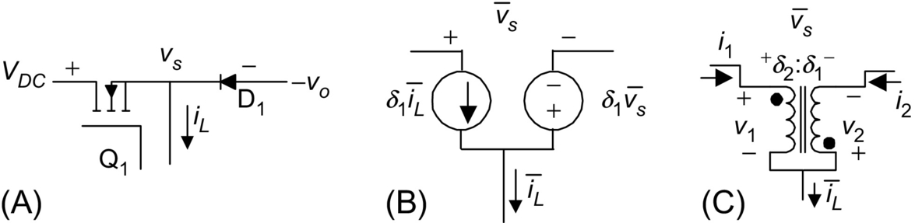

**FIG. 35.3** Average equivalent circuit of the switching cell: (A) switching cell, (B) average equivalent circuit, and (C) average equivalent circuit using an ideal transformer.

The average equivalent circuit concept, obtained from Eq. [(35.7)](https://learning.oreilly.com/library/view/power-electronics-handbook/9780128114087/B9780128114070000398_1.xhtml#fo0040) or Eqs. [(35.14)](https://learning.oreilly.com/library/view/power-electronics-handbook/9780128114087/B9780128114070000398_1.xhtml#fo0095) and [(35.15)](https://learning.oreilly.com/library/view/power-electronics-handbook/9780128114087/B9780128114070000398_1.xhtml#fo0100), can be applied to other switching converters, with or without a similar switching cell, to obtain transfer functions or to simulate the converter average behavior. The average equivalent circuit of the switching cell can be applied to converters with the same switching cell operating in the continuous conduction mode. However, note that the state variables of Eq. [(35.7)](https://learning.oreilly.com/library/view/power-electronics-handbook/9780128114087/B9780128114070000398_1.xhtml#fo0040) or Eqs. [(35.14)](https://learning.oreilly.com/library/view/power-electronics-handbook/9780128114087/B9780128114070000398_1.xhtml#fo0095) and [(35.15)](https://learning.oreilly.com/library/view/power-electronics-handbook/9780128114087/B9780128114070000398_1.xhtml#fo0100) are the mean values of the converter instantaneous variables and, therefore, do not represent their ripple components. The inputs of the state-space averaged model are the mean values of the converter inputs over one switching period.

#### **35.2.2.3 Linearized State-Space Averaged Model**

The converter outputs  must be regulated actuating on the duty cycle *δ*(*t*), and the converter inputs **ū** usually present perturbations due to the load and power supply variations. State variables are decomposed in small ac perturbations (denoted by “~”) and dc steady-state quantities (represented by uppercase letters). Therefore,

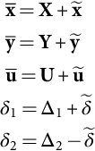 **(35.17)**

Using Eq. [(35.17)](https://learning.oreilly.com/library/view/power-electronics-handbook/9780128114087/B9780128114070000398_1.xhtml#fo0110) in Eq. [(35.7)](https://learning.oreilly.com/library/view/power-electronics-handbook/9780128114087/B9780128114070000398_1.xhtml#fo0040) and rearranging terms, it is obtained:

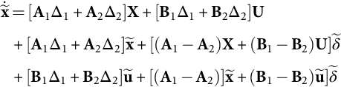 **(35.18)**

**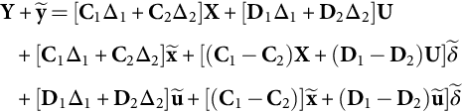** **(35.19)**

The terms [**A**1Δ1+**A**2 Δ2] **X** + [**B**1 Δ1+**B**2 Δ2] **U** and [**C**1 Δ1+**C**2 Δ2] **X** + [**D**1 Δ1+**D**2 Δ2] **U**, respectively, from Eqs. [(35.18)](https://learning.oreilly.com/library/view/power-electronics-handbook/9780128114087/B9780128114070000398_1.xhtml#fo0115) and [(35.19)](https://learning.oreilly.com/library/view/power-electronics-handbook/9780128114087/B9780128114070000398_1.xhtml#fo0120) represent the steady-state behavior of the system. As in steady-state , the following relationships hold:

 **(35.20)**

**** **(35.21)**

Neglecting higher-order terms  of Eqs. [(35.18)](https://learning.oreilly.com/library/view/power-electronics-handbook/9780128114087/B9780128114070000398_1.xhtml#fo0115) and [(35.19)](https://learning.oreilly.com/library/view/power-electronics-handbook/9780128114087/B9780128114070000398_1.xhtml#fo0120), the linearized small-signal state-space averaged model is

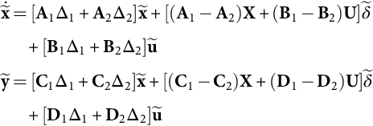 **(35.22)**

or

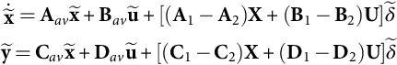 **(35.23)**

with

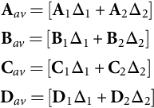 **(35.24)**

### 35.2.3 CONVERTER TRANSFER FUNCTIONS

Using Eq. [(35.20)](https://learning.oreilly.com/library/view/power-electronics-handbook/9780128114087/B9780128114070000398_1.xhtml#fo0125) in Eq. [(35.21)](https://learning.oreilly.com/library/view/power-electronics-handbook/9780128114087/B9780128114070000398_1.xhtml#fo0130), the input **U** to output **Y** steady-state relations [(35.25)](https://learning.oreilly.com/library/view/power-electronics-handbook/9780128114087/B9780128114070000398_1.xhtml#fo0150), needed for open-loop and feedforward control, can be obtained:

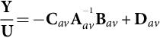 **(35.25)**

Applying Laplace transforms to Eq. [(35.23)](https://learning.oreilly.com/library/view/power-electronics-handbook/9780128114087/B9780128114070000398_1.xhtml#fo0140) with zero initial conditions and using the superposition theorem, the small-signal duty-cycle  -to-output ỹ transfer functions [(35.26)](https://learning.oreilly.com/library/view/power-electronics-handbook/9780128114087/B9780128114070000398_1.xhtml#fo0155) can be obtained considering zero line perturbations (*ũ*=0):

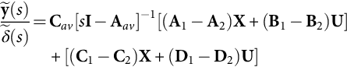 **(35.26)**

The line-to-output transfer function (or audio susceptibility transfer function) [(35.27)](https://learning.oreilly.com/library/view/power-electronics-handbook/9780128114087/B9780128114070000398_1.xhtml#fo0160) is derived using the same method, considering now zero small-signal duty-cycle perturbations 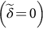:

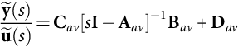 **(35.27)**

**Example 35.2**

**Buck–Boost dc/dc converter transfer functions**

From Eqs. [(35.14)](https://learning.oreilly.com/library/view/power-electronics-handbook/9780128114087/B9780128114070000398_1.xhtml#fo0095) and [(35.15)](https://learning.oreilly.com/library/view/power-electronics-handbook/9780128114087/B9780128114070000398_1.xhtml#fo0100) of [Example 35.1](https://learning.oreilly.com/library/view/power-electronics-handbook/9780128114087/B9780128114070000398_1.xhtml#en0010) and Eq. [(35.23)](https://learning.oreilly.com/library/view/power-electronics-handbook/9780128114087/B9780128114070000398_1.xhtml#fo0140), making **X**=[*IL*, *Vo*]T, **Y**=[*Vo*, *IL*]T and **U**=[*VDC*], the linearized small-signal state-space model of the buck-boost converter is

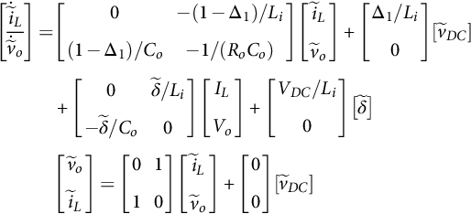 **(35.28)**

From Eqs. [(35.24)](https://learning.oreilly.com/library/view/power-electronics-handbook/9780128114087/B9780128114070000398_1.xhtml#fo0145) and [(35.28)](https://learning.oreilly.com/library/view/power-electronics-handbook/9780128114087/B9780128114070000398_1.xhtml#fo0165), the following matrices are identified:

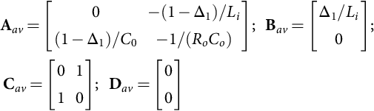 **(35.29)**

The averaged linear equivalent circuit, resulting from Eq. [(35.28)](https://learning.oreilly.com/library/view/power-electronics-handbook/9780128114087/B9780128114070000398_1.xhtml#fo0165) or from the linearization of the averaged equivalent circuit ([Fig. 35.2](https://learning.oreilly.com/library/view/power-electronics-handbook/9780128114087/B9780128114070000398_1.xhtml#f0015)) derived from Eqs. [(35.14)](https://learning.oreilly.com/library/view/power-electronics-handbook/9780128114087/B9780128114070000398_1.xhtml#fo0095) and [(35.15)](https://learning.oreilly.com/library/view/power-electronics-handbook/9780128114087/B9780128114070000398_1.xhtml#fo0100), now includes the small-signal current source  in parallel with the current source Δ1*ĩL* and the small-signal voltage source  in series with the voltage source . The supply voltage source  is replaced by the voltage source *ṽDC*.

Using Eq. [(35.29)](https://learning.oreilly.com/library/view/power-electronics-handbook/9780128114087/B9780128114070000398_1.xhtml#fo0170) in Eq. [(35.25)](https://learning.oreilly.com/library/view/power-electronics-handbook/9780128114087/B9780128114070000398_1.xhtml#fo0150), the *input U to output Y steady-state relations* are

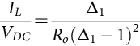 **(35.30)**

**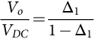** **(35.31)**

These relations are the well-known steady-state transfer relationships of the buck-boost converter [[2](https://learning.oreilly.com/library/view/power-electronics-handbook/9780128114087/B9780128114070000398_5.xhtml#bb0015),[5](https://learning.oreilly.com/library/view/power-electronics-handbook/9780128114087/B9780128114070000398_5.xhtml#bb0030),[6](https://learning.oreilly.com/library/view/power-electronics-handbook/9780128114087/B9780128114070000398_5.xhtml#bb0035)]. For open-loop control of the *Vo* output, knowing the nominal value of the power supply *VDC* and the required *Vo*, the value of Δ1 can be offline calculated from Eq. [(35.31)](https://learning.oreilly.com/library/view/power-electronics-handbook/9780128114087/B9780128114070000398_1.xhtml#fo0180) (Δ1=*Vo*/(*Vo*+*VDC*)). A modulator such as that described in [Section 35.2.4](https://learning.oreilly.com/library/view/power-electronics-handbook/9780128114087/B9780128114070000398_1.xhtml#s0050), with the modulation signal proportional to Δ1, would generate the signal *δ*(*t*). The open-loop control for fixed output voltages is possible, if the power supply *VDC* is almost constant and the converter load does not change significantly. If the *VDC* value presents disturbances, then the feedforward control can be used, calculating Δ1 online, so that its value will always be in accordance with Eq. [(35.31)](https://learning.oreilly.com/library/view/power-electronics-handbook/9780128114087/B9780128114070000398_1.xhtml#fo0180). The correct *Vo* value will be attained at steady state, despite input voltage variations. However, because of converter parasitic reactances, not modeled here (see [Example 35.3](https://learning.oreilly.com/library/view/power-electronics-handbook/9780128114087/B9780128114070000398_1.xhtml#en0020)), in practice, a steady-state error would appear. Moreover, the transient dynamics imposed by the converter would present overshoots, being often not suited for demanding applications.

From Eq. [(35.27)](https://learning.oreilly.com/library/view/power-electronics-handbook/9780128114087/B9780128114070000398_1.xhtml#fo0160), the *line*-*to*-*output transfer functions* are

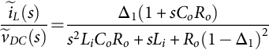 **(35.32)**

**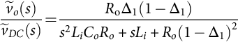** **(35.33)**

From Eq. [(35.26)](https://learning.oreilly.com/library/view/power-electronics-handbook/9780128114087/B9780128114070000398_1.xhtml#fo0155), *the small-signal duty-cycle*  -*to*-*output ỹ transfer functions are*

*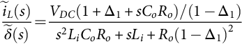* **(35.34)**

**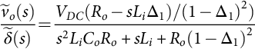** **(35.35)**

These transfer functions enable the choice and feedback loop design of the compensation network. Note the positive zero in  pointing out a nonminimum-phase system. These equations could also be obtained using the small-signal equivalent circuit derived from Eq. [(35.28)](https://learning.oreilly.com/library/view/power-electronics-handbook/9780128114087/B9780128114070000398_1.xhtml#fo0165) or from the linearized model of the switching cell ([Fig. 35.3B](https://learning.oreilly.com/library/view/power-electronics-handbook/9780128114087/B9780128114070000398_1.xhtml#f0020)), substituting the current source *δ*1*īL* by the current sources  in parallel and the voltage source  by the voltage sources  in series.

**Example 35.3**

**Transfer functions of the forward dc/dc converter**

Consider the forward (buck-derived) converter of [Fig. 35.4](https://learning.oreilly.com/library/view/power-electronics-handbook/9780128114087/B9780128114070000398_1.xhtml#f0025) switching at *fs*=100 kHz (*T*=10 μs) with *VDC*=300 V, *n*=30, *Vo*=5 V, *Li*=20 μH, *rL*=0.01 Ω, *Co*=2200 μF, *rC*=0.005 Ω, and *Ro*=0.1 Ω.

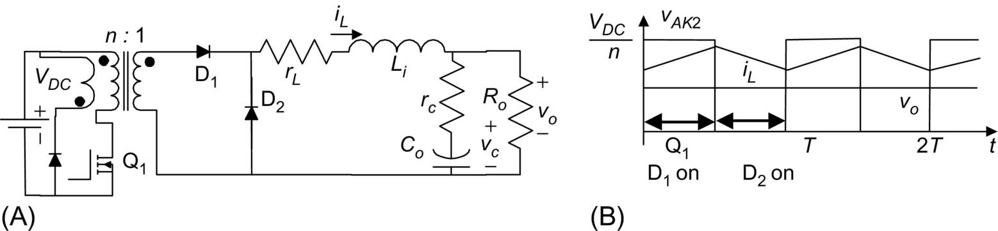

**FIG. 35.4** (A) Basic circuit of the forward dc/dc converter and (B) circuit main waveforms.

Assuming **x**=[*iL*, *vC*]*T*, *δ*(*t*)=1 when both Q1 and D1 are on and D2 is off (0≤*t*≤*δ*1 *T*), and *δ*(*t*)=0 when both Q1 and D1 are off and D2 is on (*δ*1 *T*≤*t*≤*T*), the switched state-space model of the forward converter, considering as output vector **y**=[*iL*, *vo*]*T*, is

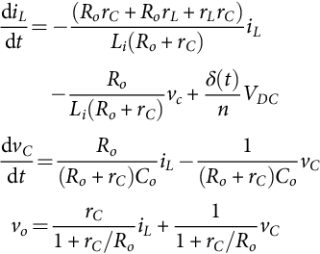 **(35.36)**

Making *rcm*=*rC*/(1+*rC*/*Ro*), *Roc*=*Ro*+*rC*, *koc*=*Ro*/*Roc*, and *rP*=*rL*+*rcm* and comparing Eq. [(35.36)](https://learning.oreilly.com/library/view/power-electronics-handbook/9780128114087/B9780128114070000398_1.xhtml#fo0205) with Eqs. [(35.2)](https://learning.oreilly.com/library/view/power-electronics-handbook/9780128114087/B9780128114070000398_1.xhtml#fo0015) and [(35.3)](https://learning.oreilly.com/library/view/power-electronics-handbook/9780128114087/B9780128114070000398_1.xhtml#fo0020), the following matrices can be identified:

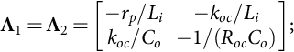



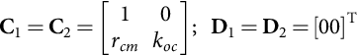

Now, applying Eq. [(35.7)](https://learning.oreilly.com/library/view/power-electronics-handbook/9780128114087/B9780128114070000398_1.xhtml#fo0040), the exact (since **A**1=**A**2) state-space averaged model [(35.37)](https://learning.oreilly.com/library/view/power-electronics-handbook/9780128114087/B9780128114070000398_1.xhtml#fo0225) and [(35.38)](https://learning.oreilly.com/library/view/power-electronics-handbook/9780128114087/B9780128114070000398_1.xhtml#fo0230) is obtained:

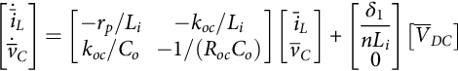 **(35.37)**

**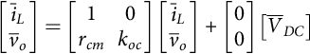** **(35.38)**

Since **A**1=**A**2, this model is valid for *ωmax<*2*πfs*. The converter eigenvalues  are

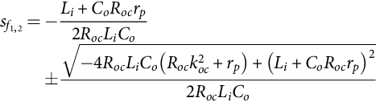 **(35.39)**

The equivalent circuit arising from Eqs. [(35.37)](https://learning.oreilly.com/library/view/power-electronics-handbook/9780128114087/B9780128114070000398_1.xhtml#fo0225) and [(35.38)](https://learning.oreilly.com/library/view/power-electronics-handbook/9780128114087/B9780128114070000398_1.xhtml#fo0230) is represented in [Fig. 35.5](https://learning.oreilly.com/library/view/power-electronics-handbook/9780128114087/B9780128114070000398_1.xhtml#f0030). It could also be obtained with the concept of the switching cell equivalent circuit [Fig. 35.3](https://learning.oreilly.com/library/view/power-electronics-handbook/9780128114087/B9780128114070000398_1.xhtml#f0020) of [Example (35.1)](https://learning.oreilly.com/library/view/power-electronics-handbook/9780128114087/B9780128114070000398_1.xhtml#fo0010).

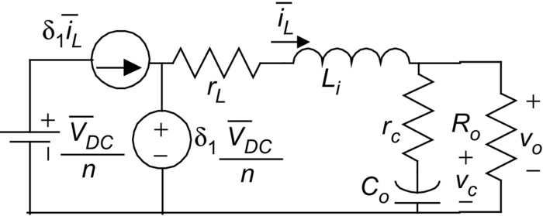

**FIG. 35.5** Equivalent circuit of the averaged state-space model of the forward converter.

Making **X**=[*IL*, *VC*]*T*, **Y**=[*IL*, *Vo*]*T* and **U**=[*VDC*], from Eq. [(35.23)](https://learning.oreilly.com/library/view/power-electronics-handbook/9780128114087/B9780128114070000398_1.xhtml#fo0140), the small-signal state-space averaged model is

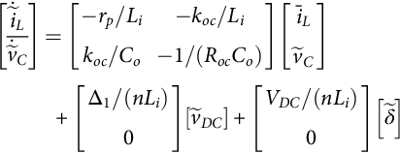 **(35.40)**

**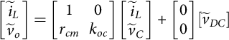** **(35.41)**

From Eq. [(35.25)](https://learning.oreilly.com/library/view/power-electronics-handbook/9780128114087/B9780128114070000398_1.xhtml#fo0150), the input **U** to output **Y** steady-state relations are

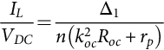 **(35.42)**

**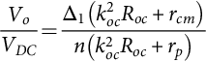** **(35.43)**

Making *rC*=0, *rL*=0, and *n*=1, the former relations give the well-known dc transfer relationships of the buck dc/dc converter. Relations [(35.42)](https://learning.oreilly.com/library/view/power-electronics-handbook/9780128114087/B9780128114070000398_1.xhtml#fo0250) and [(35.43)](https://learning.oreilly.com/library/view/power-electronics-handbook/9780128114087/B9780128114070000398_1.xhtml#fo0255) allow the open-loop and feedforward control of the converter, as discussed in [Example 35.2](https://learning.oreilly.com/library/view/power-electronics-handbook/9780128114087/B9780128114070000398_1.xhtml#en0015), provided that all the modeled parameters are time-invariant and accurate enough.

From Eq. [(35.27)](https://learning.oreilly.com/library/view/power-electronics-handbook/9780128114087/B9780128114070000398_1.xhtml#fo0160), the line-to-output transfer functions are derived:

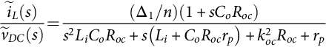 **(35.44)**

**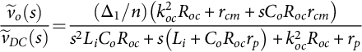** **(35.45)**

Using Eq. [(35.26)](https://learning.oreilly.com/library/view/power-electronics-handbook/9780128114087/B9780128114070000398_1.xhtml#fo0155), the small-signal duty-cycle -to-output ỹ transfer functions are

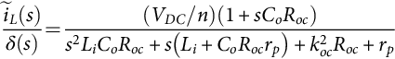 **(35.46)**

**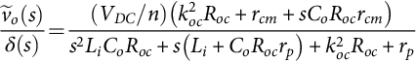** **(35.47)**

The real zero of Eq. [(35.47)](https://learning.oreilly.com/library/view/power-electronics-handbook/9780128114087/B9780128114070000398_1.xhtml#fo0275) is due to *rC*, the equivalent series resistance (ESR) of the output capacitor. A similar zero would occur in the buck-boost converter ([Example 35.2](https://learning.oreilly.com/library/view/power-electronics-handbook/9780128114087/B9780128114070000398_1.xhtml#en0015)), if the ESR of the output capacitor had been included in the modeling.

### 35.2.4 PULSE WIDTH MODULATOR TRANSFER FUNCTIONS

In what is often referred to as the pulse-width-modulation (PWM) voltage-mode control, the output voltage *uc*(*t*) of the error (between desired and actual output) amplifier plus regulator, processed if needed, is compared with a repetitive or carrier waveform *r*(*t*), to obtain the switching variable *δ*(*t*) ([Fig. 35.6A](https://learning.oreilly.com/library/view/power-electronics-handbook/9780128114087/B9780128114070000398_1.xhtml#f0035)). This function controls the power switch, turning it on at the beginning of the period and turning it off when the ramp exceeds the *uc*(*t*) voltage. In [Fig. 35.6B](https://learning.oreilly.com/library/view/power-electronics-handbook/9780128114087/B9780128114070000398_1.xhtml#f0035), the opposite occurs (turnoff at the end of the period and turn-on when the *uc*(*t*) voltage exceeds the ramp).

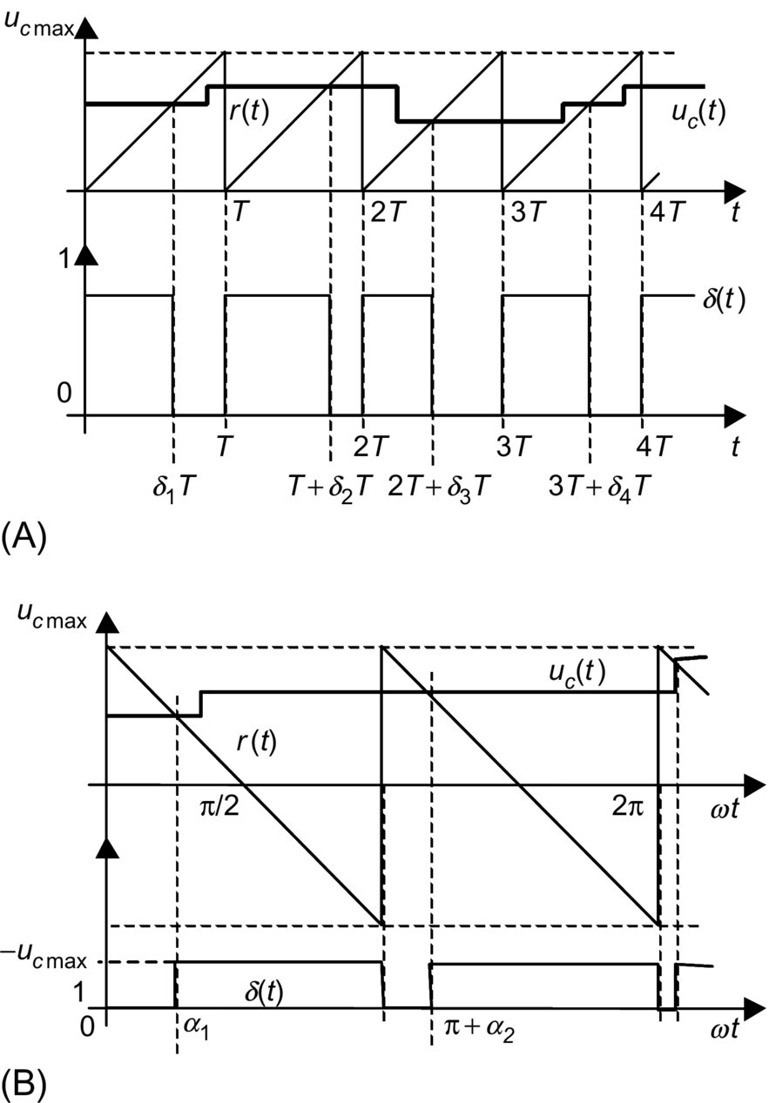

**FIG. 35.6** Waveforms of pulse-width modulators showing the variable time delays of the modulator response: (A) *r*(*t*)=*ucmax t*/*T* and (B) *r*(*t*)=*ucmax*−2*ucmax ωt*/*π*.

Considering *r*(*t*) as represented in [Fig. 35.6A](https://learning.oreilly.com/library/view/power-electronics-handbook/9780128114087/B9780128114070000398_1.xhtml#f0035) (*r*(*t*)=*ucmaxt*/*T*), *δk* is obtained equating *r*(*t*)=*uc* giving *δk*=*uc* (*t*)/*ucmax* or *δk*/*uc* (*t*)=*GM* (*GM* =1/*ucmax*). In [Fig. 35.6B](https://learning.oreilly.com/library/view/power-electronics-handbook/9780128114087/B9780128114070000398_1.xhtml#f0035), the switching-on angle *αk* is obtained from *r*(*t*)=*ucmax*−2*ucmaxωt*/*π* and *uc* (*t*)=*ucmax*−2*ucmax αk*/*π*, giving *αk*=(*π*/2)×(1−*uc*/*ucmax*) and *GM*=*∂αk*/*∂uc*=−*π*/(2*ucmax*).

Since, after turnoff or turn-on, any control action variation of *uc*(*t*) will only affect the converter duty cycle in the next period (or sample for digital hardware), a time delay is introduced in the control loop. For simplicity, with small-signal perturbations around the operating point, this delay is assumed almost constant and equal to its mean value (*T*/2). Then, the transfer function of the PWM modulator is

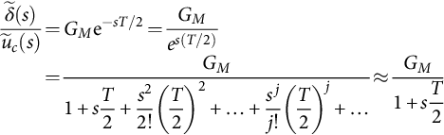 **(35.48)**

The final approximation of Eq. [(35.48)](https://learning.oreilly.com/library/view/power-electronics-handbook/9780128114087/B9780128114070000398_1.xhtml#fo0280), valid for , [[7](https://learning.oreilly.com/library/view/power-electronics-handbook/9780128114087/B9780128114070000398_5.xhtml#bb0040)] suggests that the PWM modulator can be considered as an amplifier with gain *GM* and a dominant pole. Notice that this pole occurs at a frequency doubling the switching frequency, and most state-space averaged models are valid only for frequencies below one-tenth of the switching frequency. Therefore, in most situations, this modulator pole can be neglected, being simply *δ*(*s*)=*GMuc*(*s*), as the dominant pole of Eq. [(35.48)](https://learning.oreilly.com/library/view/power-electronics-handbook/9780128114087/B9780128114070000398_1.xhtml#fo0280) stays at least one decade to the left of the dominant poles of the converter.

### 35.2.5 LINEAR FEEDBACK DESIGN ENSURING STABILITY

In the application of classical linear feedback control to switching power converters, Bode plots and root locus are, usually, suitable methods to assess system performance and stability. General rules for the design of the compensated open-loop transfer function are as follows:

The low-frequency gain should be high enough to minimize output steady-state errors.

The frequency of 0 dB gain (unity gain), *ω*0*dB*, should be placed close to the maximum allowed by the modeling approximations (*λmaxT*≪1), to allow fast response to transients. In practice, this frequency should be almost an order of magnitude lower than the switching frequency.

To ensure stability, the phase margin, defined as the additional phase shift needed to render the system unstable without gain changes (or the difference between the open-loop system phase at *ω*0*dB* and −180°), must be positive and in general greater than 30° (45−70° is desirable). In the root locus, no poles should enter the right half of the complex plane.

To increase stability, the gain should be less than −30 dB at the frequency where the phase reaches −180° (gain margin greater than 30 dB).

Transient behavior and stability margins are related: The obtained damping factor is generally 0.01 times the phase margin (in degrees), and overshoot (in percent) is given approximately by 75° minus the phase margin. The product of the rise time (in seconds) and the closed-loop bandwidth (in rad/s) is close to 2.8.

To guarantee gain and phase margins, the following series compensation transfer functions (usually implemented with operational amplifiers) are often used [[8](https://learning.oreilly.com/library/view/power-electronics-handbook/9780128114087/B9780128114070000398_5.xhtml#bb0045)]:

#### **35.2.5.1 Types of Compensation**

##### **Lag and lead compensation**

*Lag* compensation should be used in converters with good stability margin but poor steady-state accuracy. If the frequencies 1/*Tp* and 1/*Tz* of Eq. [(35.49)](https://learning.oreilly.com/library/view/power-electronics-handbook/9780128114087/B9780128114070000398_1.xhtml#fo0285) with 1/*Tp<*1/*Tz* are chosen sufficiently below the unity gain frequency, lag-lead compensation lowers the loop gain at high frequency but maintains the phase unchanged for frequencies *f*≫1/*Tz*. Then, the dc gain can be increased to reduce the steady-state error without significantly decreasing the phase margin:

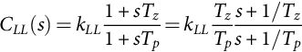 **(35.49)**

*Lead* compensation can be used in converters with good steady-state accuracy but poor stability margin. If the frequencies 1/*Tp* and 1/*Tz* of Eq. [(35.49)](https://learning.oreilly.com/library/view/power-electronics-handbook/9780128114087/B9780128114070000398_1.xhtml#fo0285) with 1/*Tp>*1/*Tz* are chosen below the unity gain frequency, lead-lag compensation increases the phase margin without significantly affecting the steady-state error. The *Tp* and *Tz* values are chosen to increase the phase margin, fastening the transient response and increasing the bandwidth.

##### **Proportional–Integral compensation**

Proportional-integral (PI) compensators [(35.50)](https://learning.oreilly.com/library/view/power-electronics-handbook/9780128114087/B9780128114070000398_1.xhtml#fo0290) are used to guarantee null steady-state error with acceptable rise times. The PI compensators are a particular case of lag-lead compensators, therefore suitable for converters with good stability margin but poor steady-state accuracy:

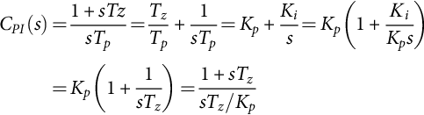 **(35.50)**

##### **Proportional–integral plus high-frequency pole compensation**

This integral plus zero-pole compensation [(35.51)](https://learning.oreilly.com/library/view/power-electronics-handbook/9780128114087/B9780128114070000398_1.xhtml#fo0295) combines the advantages of a PI with lead or lag compensation. It can be used in converters with good stability margin but poor steady-state accuracy. If the frequencies 1/*TM* and 1/*Tz* (1/*Tz<*1/*TM*) are carefully chosen, compensation lowers the loop gain at high frequency while only slightly lowering the phase to achieve the desired phase margin:

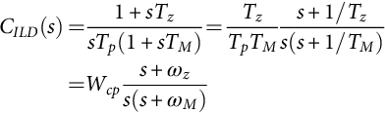 **(35.51)**

##### **Proportional-integral derivative (PID), plus high-frequency poles**

The PID notch filter type [(35.52)](https://learning.oreilly.com/library/view/power-electronics-handbook/9780128114087/B9780128114070000398_1.xhtml#fo0300) scheme is used in converters with two lightly damped complex poles, to increase the response speed, while ensuring zero steady-state error. In most switching power converters, the two complex zeros are selected to have a damping factor greater than the converter complex poles and slightly smaller oscillating frequency. The high-frequency pole is placed to achieve the needed phase margin [[9](https://learning.oreilly.com/library/view/power-electronics-handbook/9780128114087/B9780128114070000398_5.xhtml#bb0050)]. The design is correct if the complex pole loci, heading to the complex zeros in the system root locus, never enter the right half plane:

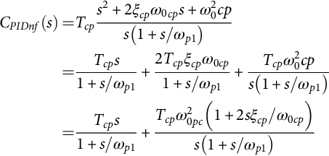 **(35.52)**

For systems with a high-frequency zero placed at least one decade above the two lightly damped complex poles, the compensator [(35.53)](https://learning.oreilly.com/library/view/power-electronics-handbook/9780128114087/B9780128114070000398_1.xhtml#fo0305), with *ωz*1≈*ωz*2*<ωp*, can be used. Usually, the two real zeros present frequencies slightly lower than the frequency of the converter complex poles. The two high-frequency poles are placed to obtain the desired phase margin [[9](https://learning.oreilly.com/library/view/power-electronics-handbook/9780128114087/B9780128114070000398_5.xhtml#bb0050)]. The obtained overall performance will often be inferior to that of the PID type notch filter:

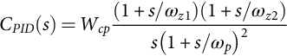 **(35.53)**

#### **35.2.5.2 Compensator Selection and Design**

The procedure to select the compensator and to design its parameters can be outlined as follows:

1. Compensator selection: In general, since *VDC* perturbations exist, null steady-state error guarantee is needed. High-frequency poles are usually necessary, if the transfer function shows a −6 dB/octave roll-off due to high-frequency left plane zeros. Therefore, in general, two types of compensation schemes with integral action [(35.51)](https://learning.oreilly.com/library/view/power-electronics-handbook/9780128114087/B9780128114070000398_1.xhtml#fo0295) or [(35.50)](https://learning.oreilly.com/library/view/power-electronics-handbook/9780128114087/B9780128114070000398_1.xhtml#fo0290) and [(35.52)](https://learning.oreilly.com/library/view/power-electronics-handbook/9780128114087/B9780128114070000398_1.xhtml#fo0300) or [(35.53)](https://learning.oreilly.com/library/view/power-electronics-handbook/9780128114087/B9780128114070000398_1.xhtml#fo0305) can be tried. Compensator [(35.52)](https://learning.oreilly.com/library/view/power-electronics-handbook/9780128114087/B9780128114070000398_1.xhtml#fo0300) is usually convenient for systems with lightly damped complex poles.

2. Unity gain frequency *ω*0*dB* choice:

• If the selected compensator has no complex zeros, it is better to be conservative, choosing *ω*0*dB* sufficiently below the frequency of the lightly damped poles of the converter (or the frequency of the right half-plane zeros if lower). However, because of the resonant peak of most converter transfer functions, the phase margin can be obtained at a frequency near the resonance. If the phase margin is not enough, the compensator gain must be lowered.

• If the selected compensator has complex zeros, *ω*0*dB* can be chosen slightly above the frequency of the lightly damped poles.

3. Desired phase margin (*φM*) specification *φM*≥30° (preferably between 45 and 70°).

4. Compensator zero-pole placement to achieve the desired phase margin:

• With the integral plus zero-pole compensation type [(35.51)](https://learning.oreilly.com/library/view/power-electronics-handbook/9780128114087/B9780128114070000398_1.xhtml#fo0295), the compensator phase *φcp*, at the maximum frequency of unity gain (often *ω*0*dB*), equals the phase margin (*φM*) minus 180° and minus the converter phase *φcv*,(*φcp*=*φM*−180°−*φcv*). The zero-pole position can be obtained calculating the factor *fct*=*tg* (*π*/2+ *φcp*/2) being *ωz*=*ω*0*dB*/*fct* and *ωM*=*ω*0*dB*fct.

• With the PID notch filter type [(35.52)](https://learning.oreilly.com/library/view/power-electronics-handbook/9780128114087/B9780128114070000398_1.xhtml#fo0300) controller, the two complex zeros are placed to have a damping factor *ξp* roughly equal to two times the damping *ξz* of the converter complex poles and oscillating frequency *ω*0*cp* 30% smaller than the complex poles frequency *ωp*. The high-frequency pole *ωp*1 is placed to achieve the needed phase margin (*ωp*1≈(*ω*0*cp*·*ω*0*dB*)1/2*fct*2 with *fct*=tg (*π*/2+*φcp*/2) and *φcp*=*φM*−180°−*φcv* [[5](https://learning.oreilly.com/library/view/power-electronics-handbook/9780128114087/B9780128114070000398_5.xhtml#bb0030)]). Alternatively, since for stability *ξz ω*0*cp*>ξ*p* ω*p* and 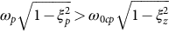, it is obtained 1>*ξz>ξp* and using the geometric mean, 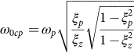.

5. Compensator gain calculation (the product of the converter and compensator gains at the *ω*0*dB* frequency must be one).

6. Stability margin verification using Bode plots and root locus.

7. Result evaluation. Restarting the compensator selection and design, if the attained results are still not good enough.

Note that several modern computer programs, such as MATLAB, provide very easy and efficient tools (such as SISOTOOL) to design these controllers, even considering that switching power converters are discrete systems. Optimum controllers such as linear-quadratic-Gaussian (LQG, LQR) controllers, whose performances might be much better than linear controllers, can also be designed using the same tools. However, in evaluating optimum controller results, care must be taken in order to guarantee that the controlled converter frequency bandwidth and gain are not beyond the validity limits of the used models.

### 35.2.6 EXAMPLES: BUCK–BOOST DC/DC CONVERTER, FORWARD DC/DC CONVERTER, 12 PULSE RECTIFIERS, BUCK–BOOST DC/DC CONVERTER IN THE DISCONTINUOUS MODE (VOLTAGE AND CURRENT MODE), THREE-PHASE PWM INVERTERS

**Example 35.4**

**Feedback design for the buck–boost dc/dc converter**

Consider the converter output voltage *vo* ([Fig. 35.1](https://learning.oreilly.com/library/view/power-electronics-handbook/9780128114087/B9780128114070000398_1.xhtml#f0010)) to be the controlled output. From [Example 35.2](https://learning.oreilly.com/library/view/power-electronics-handbook/9780128114087/B9780128114070000398_1.xhtml#en0015) and Eqs. [(35.33)](https://learning.oreilly.com/library/view/power-electronics-handbook/9780128114087/B9780128114070000398_1.xhtml#fo0190) and [(35.35)](https://learning.oreilly.com/library/view/power-electronics-handbook/9780128114087/B9780128114070000398_1.xhtml#fo0200), the block diagram of [Fig. 35.7](https://learning.oreilly.com/library/view/power-electronics-handbook/9780128114087/B9780128114070000398_1.xhtml#f0040) is obtained. The modulator transfer function is considered a pure gain (*GM*=0.1). The magnitude and phase of the open-loop transfer function *vo*/*uc* ([Fig. 35.8A](https://learning.oreilly.com/library/view/power-electronics-handbook/9780128114087/B9780128114070000398_1.xhtml#f0045) trace 1) shows a resonant peak due to the two lightly damped complex poles and the associated −12 dB/octave roll-off. The right half-plane zero changes the roll-off to −6 dB/octave and adds −90° to the converter phase (nonminimum-phase converter).

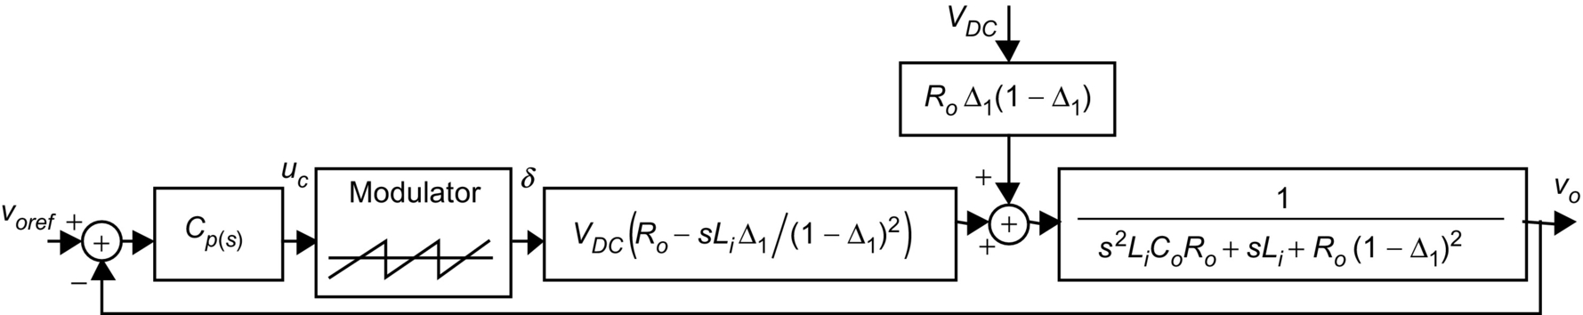

**FIG. 35.7** Block diagram of the linearized model of the closed-loop buck-boost converter.

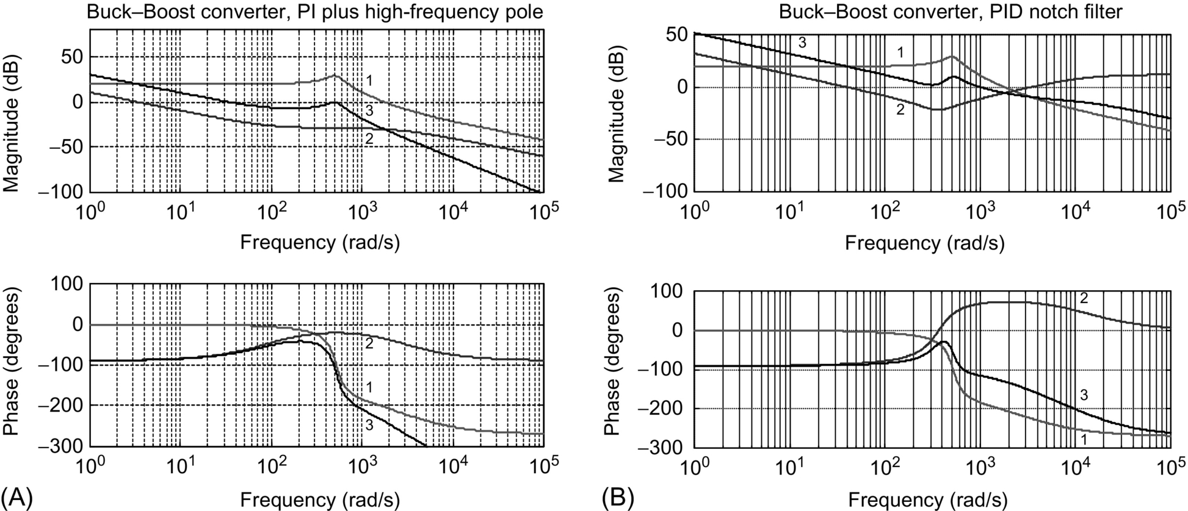

**FIG. 35.8** Bode plots for the buck-boost converter. Trace 1, switching power converter magnitude and phase; trace 2, compensator magnitude and phase; and trace 3, resulting magnitude and phase of the compensated converter: (A) PI plus high-frequency pole compensation with 60° phase margin, *ω*0*dB*=500 rad/s, and (B) PID notch filter compensation with 65° phase margin, *ω*0*dB*=1000 rad/s.

*Compensator selection*. As *VDC* perturbations exist, null steady-state error guarantee is needed. High-frequency poles are needed given the −6 dB/octave final slope of the transfer function. Therefore, two compensation [schemes (35.51)](https://learning.oreilly.com/library/view/power-electronics-handbook/9780128114087/B9780128114070000398_1.xhtml#fo0295) and [(35.52)](https://learning.oreilly.com/library/view/power-electronics-handbook/9780128114087/B9780128114070000398_1.xhtml#fo0300) with integral action are tried here. The buck-boost converter controlled with integral plus zero-pole compensation presents, in closed-loop, two complex poles closer to the imaginary axes than in open loop. These poles should not dominate the converter dynamics. Instead, the real pole resulting from the open-loop pole placed at the origin should be almost the dominant one, thus slightly lowering the calculated compensator gain. If the *ω*0*dB* frequency is chosen too low, the integral plus zero-pole compensation turns into a pure integral compensator (*ωz*=*ωM*=*ω*0*dB*). However, the obtained gains are too low, leading to very slow transient responses.

Results showing the transient responses to *voref* and *VDC* step changes, using the selected compensators and converter Bode plots ([Fig. 35.8](https://learning.oreilly.com/library/view/power-electronics-handbook/9780128114087/B9780128114070000398_1.xhtml#f0045)), are shown ([Fig. 35.9](https://learning.oreilly.com/library/view/power-electronics-handbook/9780128114087/B9780128114070000398_1.xhtml#f0050)). The compensated real converter transient behavior occurs in the buck and in the boost regions. Notice the nonminimum-phase behavior of the converter (mainly in [Fig. 35.9B](https://learning.oreilly.com/library/view/power-electronics-handbook/9780128114087/B9780128114070000398_1.xhtml#f0050)), the superior performance of the PID notch filter compensator, and the unacceptable behavior of the PI with high-frequency pole. Care should be taken with load changes, when using this compensator, since instability can easily occur.

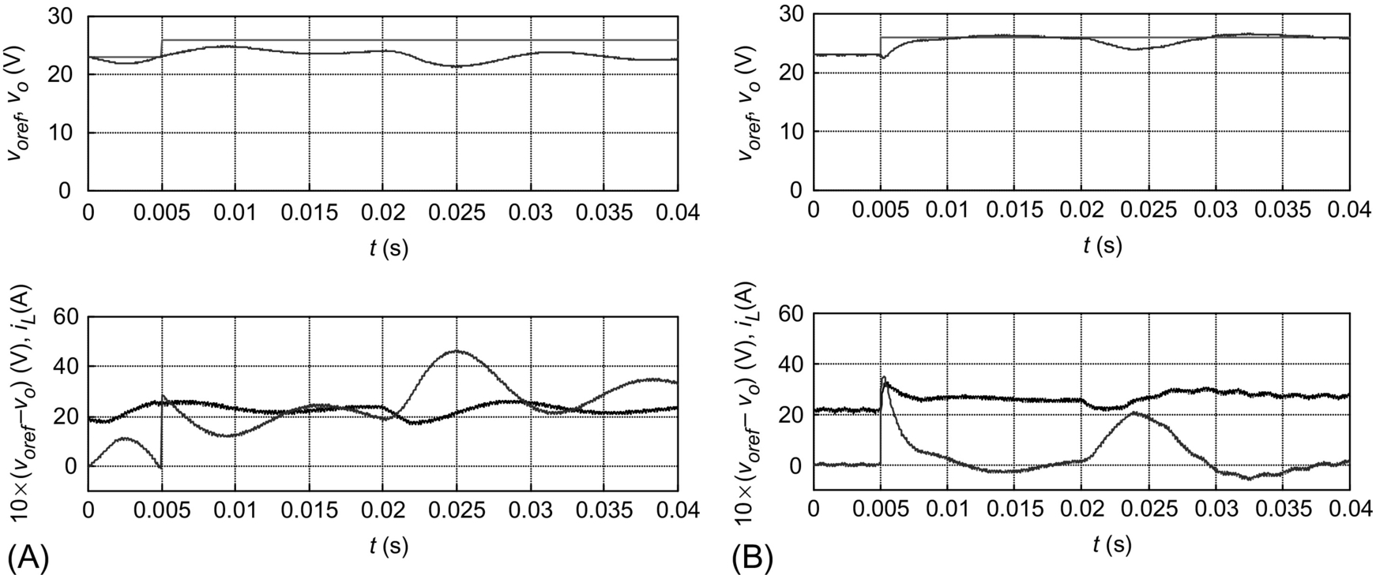

**FIG. 35.9** Transient responses of the compensated buck-boost converter. At *t*=0.00 s, *voref* step from 23 to 26 V. At *t*=0.02 s, *VDC* step from 26 to 23 V. Top graphs, step reference *voref* and output voltage *vo*. Bottom graphs, trace starting at 20 is *iL* current; trace starting at zero is 10×(*voref*−*vo*): (A) PI plus high-frequency pole compensation with 60° phase margin and *ω*0*dB*=500 rad/s and (B) PID notch filter compensation with 64° phase margin and *ω*0*dB*=1000 rad/s.

The compensator critical values, obtained with the root-locus studies, are *Wcpcrit*=700 s−1 for the integral plus zero-pole compensator, *Tcpcrit*=0.0012 s for the PID notch filter, and *WIcpcrit*=18 s−1 for the integral compensation derived from the integral plus zero-pole compensator (*ωz*=*ωM*). This confirms the Bode-plot design and allows stability estimation with changing loads and power supply.

**Example 35.5**

**Feedback design for the forward dc/dc converter**

Consider the output voltage *vo* of the forward converter ([Fig. 35.4A](https://learning.oreilly.com/library/view/power-electronics-handbook/9780128114087/B9780128114070000398_1.xhtml#f0025)) to be the controlled output. From [Example 35.3](https://learning.oreilly.com/library/view/power-electronics-handbook/9780128114087/B9780128114070000398_1.xhtml#en0020) and Eqs. [(35.45)](https://learning.oreilly.com/library/view/power-electronics-handbook/9780128114087/B9780128114070000398_1.xhtml#fo0265) and [(35.47)](https://learning.oreilly.com/library/view/power-electronics-handbook/9780128114087/B9780128114070000398_1.xhtml#fo0275), the block diagram of [Fig. 35.10](https://learning.oreilly.com/library/view/power-electronics-handbook/9780128114087/B9780128114070000398_1.xhtml#f0055) is obtained. As in [Example 35.4](https://learning.oreilly.com/library/view/power-electronics-handbook/9780128114087/B9780128114070000398_1.xhtml#en0025), the modulator transfer function is considered as a pure gain (*GM*=0.1). The magnitude and phase of the open-loop transfer function *vo*/*uc* ([Fig. 35.11A](https://learning.oreilly.com/library/view/power-electronics-handbook/9780128114087/B9780128114070000398_1.xhtml#f0060) trace 1) shows an open-loop stable system. Since integral action is needed to have some disturbance rejection of the voltage source *VDC*, the compensation schemes used in [Example 35.4](https://learning.oreilly.com/library/view/power-electronics-handbook/9780128114087/B9780128114070000398_1.xhtml#en0025), obtained using the same procedure ([Fig. 35.11](https://learning.oreilly.com/library/view/power-electronics-handbook/9780128114087/B9780128114070000398_1.xhtml#f0060)), were also tested.

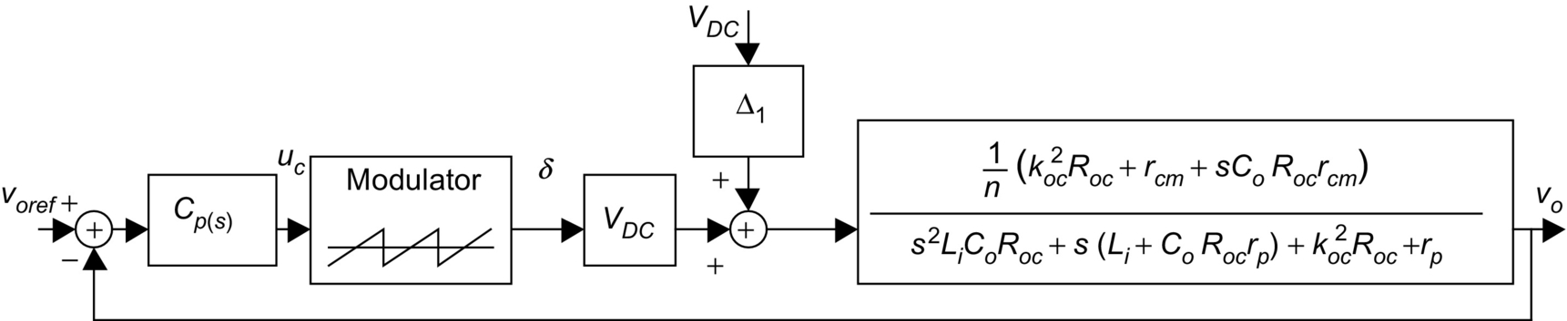

**FIG. 35.10** Block diagram of the linearized model of the closed-loop controlled forward converter.

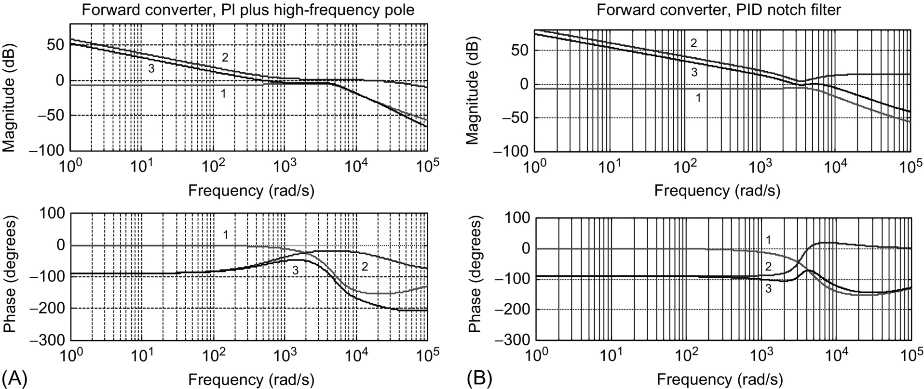

**FIG. 35.11** Bode plots for the forward converter. Trace 1, switching power converter magnitude and phase; trace 2, compensator magnitude and phase; trace 3, resulting magnitude and phase of the compensated converter: (A) PI plus high-frequency pole compensation with 115° phase margin, *ω*0*dB*=500 rad/s, and (B) PID notch filter compensation with 85° phase margin, *ω*0*dB*=6000 rad/s.

Results, showing the transient responses to *voref* and *VDC* step changes, are shown ([Fig. 35.12](https://learning.oreilly.com/library/view/power-electronics-handbook/9780128114087/B9780128114070000398_1.xhtml#f0065)). Both compensators [(35.51)](https://learning.oreilly.com/library/view/power-electronics-handbook/9780128114087/B9780128114070000398_1.xhtml#fo0295) and [(35.52)](https://learning.oreilly.com/library/view/power-electronics-handbook/9780128114087/B9780128114070000398_1.xhtml#fo0300) are easier to design than the ones for the buck-boost converter, and both have acceptable performances. Moreover, the PID notch filter presents a much faster response.

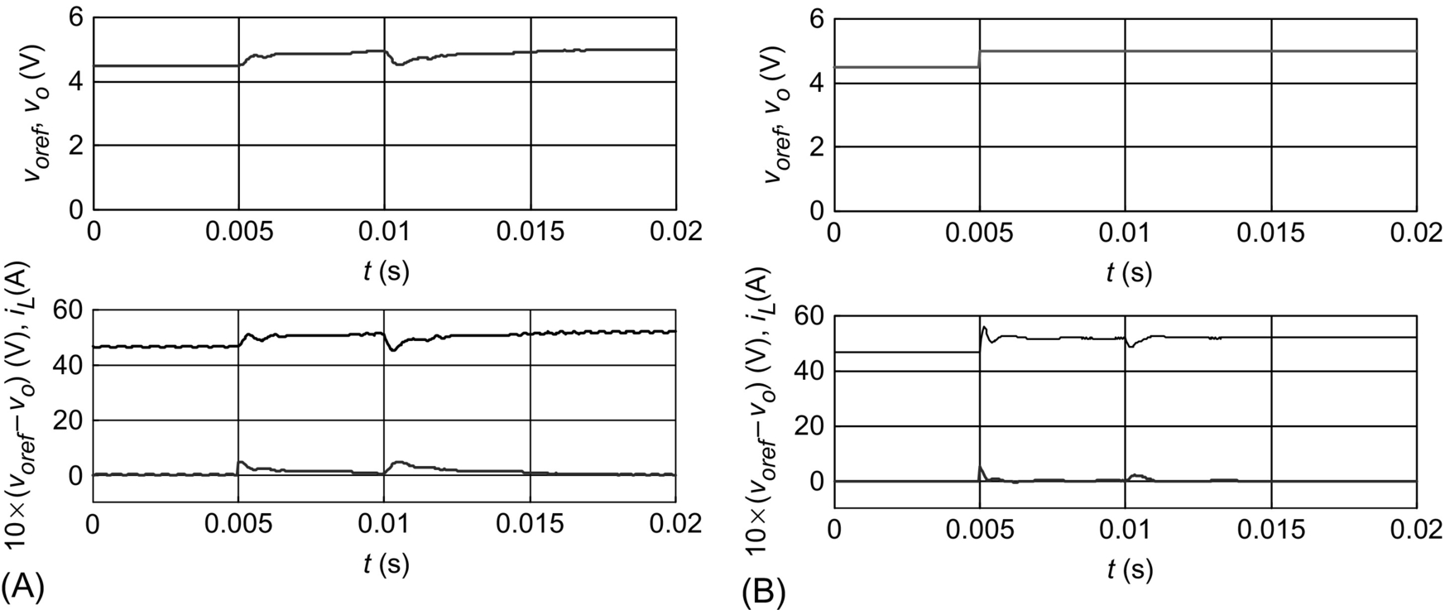

**FIG. 35.12** Transient responses of the compensated forward converter. At *t*=0.005 s, *voref* step from 4.5 to 5 V. At *t*=0.01 s, *VDC* step from 300 to 260 V. Top graphs: step reference *voref* and output voltage *vo*. Bottom graphs: top traces *iL* current and bottom traces 10×(*voref*−*vo*); (A) PI plus high-frequency pole compensation with 115° phase margin and *ω*0*dB*=500 rad/s and (B) PID notch filter compensation with 85° phase margin and *ω*0*dB*=6000 rad/s.

Alternatively, a PID feedback controller such as Eq. [(35.53)](https://learning.oreilly.com/library/view/power-electronics-handbook/9780128114087/B9780128114070000398_1.xhtml#fo0305) can be easily hand-adjusted, starting with the proportional, integral, and derivative gains all set to zero. In the first step, the proportional gain is increased until the output presents an oscillatory response with nearly 50% overshoot. Next, the derivative gain is slowly increased until the overshoot is eliminated. Finally, the integral gain is increased to eliminate the steady-state error as quickly as possible.

**Example 35.6**

**Feedback design for phase controlled rectifiers in the continuous mode**

Phase-controlled, *p* pulse (*p>*1), thyristor rectifiers ([Fig. 35.13A](https://learning.oreilly.com/library/view/power-electronics-handbook/9780128114087/B9780128114070000398_1.xhtml#f0070)), operating in the continuous mode, present an output voltage with *p* identical segments within the mains period *T*. Given this cyclic waveform, the **A**, **B**, **C**, and **D** matrices for all these *p* intervals can be written with the same form, in spite of the topological variation. Hence, the state-space averaged model is obtained simply by averaging all the variables within the period *T*/*p*. Assuming small variations, the mean value of the rectifier output voltage *UDC* can be written as [[4](https://learning.oreilly.com/library/view/power-electronics-handbook/9780128114087/B9780128114070000398_5.xhtml#bb0025)]:

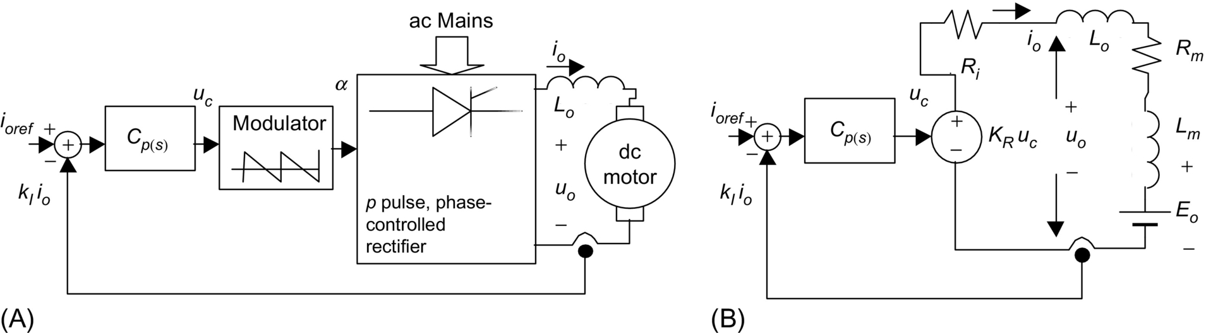

**FIG. 35.13** (A) Block diagram of a *p* pulse phase-controlled rectifier feeding a separately excited dc motor and (B) equivalent averaged circuit.

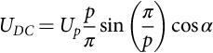 **(35.54)**

where *α* is the triggering angle of the thyristors and *Up* the maximum peak value of the rectifier output voltage, determined by the rectifier topology and the ac supply voltage. The *α* value can be obtained (*α*=(*π*/2)×(1−*uc*/*ucmax*)) using the modulator of [Fig. 35.6B](https://learning.oreilly.com/library/view/power-electronics-handbook/9780128114087/B9780128114070000398_1.xhtml#f0035), where *ω*=2*π*/*T* is the mains frequency. From Eq. [(35.54)](https://learning.oreilly.com/library/view/power-electronics-handbook/9780128114087/B9780128114070000398_1.xhtml#fo0310), the incremental gain *KR* of the modulator plus rectifier yields

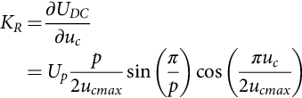 **(35.55)**

For a given rectifier, this gain depends on *uc* and should be calculated for a certain quiescent point. However, for feedback design purposes, keeping in mind that the rectifier could be required to be stable in all operating points, the maximum value of *KR*, denoted *KRM*, can be used:

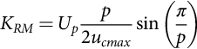 **(35.56)**

The operation of the modulator, coupled to the rectifier thyristors, introduces a nonnegligible time delay, with mean value *T*/2*p*. Therefore, from Eq. [(35.48)](https://learning.oreilly.com/library/view/power-electronics-handbook/9780128114087/B9780128114070000398_1.xhtml#fo0280), the modulator-rectifier transfer function *GR*(*s*) is

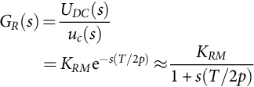 **(35.57)**

Considering zero *Up* perturbations, the rectifier equivalent averaged circuit ([Fig. 35.13B](https://learning.oreilly.com/library/view/power-electronics-handbook/9780128114087/B9780128114070000398_1.xhtml#f0070)) includes the loss-free rectifier output resistance *Ri*, due to the overlap in the commutation phenomenon caused by the mains inductance. Usually, *Ri*≈*pωl*/π where *l* is the equivalent inductance of the lines paralleled during the overlap, half of the line inductance for most rectifiers, except for single-phase bridge rectifiers where *l* is the line inductance. Here, *Lo* is the smoothing reactor, and *Rm*, *Lm*, and *Eo* are, respectively, the armature internal resistance, inductance, and back electromotive force of a separately excited dc motor (typical load). Assuming the mean value of the output current as the controlled output, making *Lt*=*Lo*+*Lm*, *Rt*=*Ri*+*Rm*, and *Tt*=*Lt*/*Rt*, and applying Laplace transforms to the differential equation obtained from the circuit of [Fig. 35.13B](https://learning.oreilly.com/library/view/power-electronics-handbook/9780128114087/B9780128114070000398_1.xhtml#f0070), the output current transfer function is

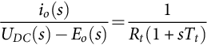 **(35.58)**

The rectifier and load are now represented by a perturbed (*Eo*) second-order system ([Fig. 35.14](https://learning.oreilly.com/library/view/power-electronics-handbook/9780128114087/B9780128114070000398_1.xhtml#f0075)). To achieve zero steady-state error, which ensures steady-state insensitivity to the perturbations, and to obtain closed-loop second-order dynamics, a PI controller [(35.50)](https://learning.oreilly.com/library/view/power-electronics-handbook/9780128114087/B9780128114070000398_1.xhtml#fo0290) was selected for *Cp*(*s*) ([Fig. 35.14](https://learning.oreilly.com/library/view/power-electronics-handbook/9780128114087/B9780128114070000398_1.xhtml#f0075)). Canceling the load pole (−1/*Tt*) with the PI zero (−1/*Tz*) yields

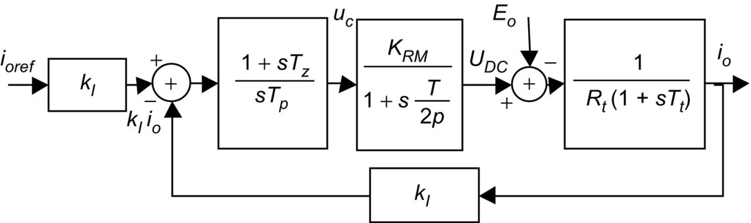

**FIG. 35.14** Block diagram of a PI-controlled *p* pulse rectifier.

 **(35.59)**

The rectifier closed-loop transfer function *io*(*s*)/*ioref* (*s*), with zero *Eo* perturbations, is

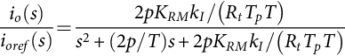 **(35.60)**

The final value theorem enables the verification of the zero steady-state error. Comparing the denominator of Eq. [(35.60)](https://learning.oreilly.com/library/view/power-electronics-handbook/9780128114087/B9780128114070000398_1.xhtml#fo0340) with the second-order polynomial  yields

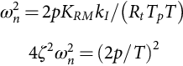 **(35.61)**

Since only one degree of freedom is available (*Tp*), the damping factor *ζ* is imposed. Usually,  is selected, since it often gives the best compromise between response speed and overshoot. Therefore, from Eq. [(35.61)](https://learning.oreilly.com/library/view/power-electronics-handbook/9780128114087/B9780128114070000398_1.xhtml#fo0345), Eq. [(35.62)](https://learning.oreilly.com/library/view/power-electronics-handbook/9780128114087/B9780128114070000398_1.xhtml#fo0350) arises:

 **(35.62)**

Note that both *Tz* [(35.59)](https://learning.oreilly.com/library/view/power-electronics-handbook/9780128114087/B9780128114070000398_1.xhtml#fo0335) and *Tp* [(35.62)](https://learning.oreilly.com/library/view/power-electronics-handbook/9780128114087/B9780128114070000398_1.xhtml#fo0350) are dependent upon circuit parameters. They will have the correct values only for dc motors with parameters closed to the nominal load value. Using Eq. [(35.62)](https://learning.oreilly.com/library/view/power-electronics-handbook/9780128114087/B9780128114070000398_1.xhtml#fo0350) in Eq. [(35.60)](https://learning.oreilly.com/library/view/power-electronics-handbook/9780128114087/B9780128114070000398_1.xhtml#fo0340) yields Eq. [(35.63)](https://learning.oreilly.com/library/view/power-electronics-handbook/9780128114087/B9780128114070000398_1.xhtml#fo0355), the second-order closed-loop transfer function of the rectifier, showing that, with loads close to the nominal value, the rectifier dynamics depend only on the mean delay time *T*/2*p*:

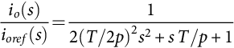 **(35.63)**

From Eq. [(35.63)](https://learning.oreilly.com/library/view/power-electronics-handbook/9780128114087/B9780128114070000398_1.xhtml#fo0355),  results, which is the maximum frequency allowed by , the validity limit of Eq. [(35.48)](https://learning.oreilly.com/library/view/power-electronics-handbook/9780128114087/B9780128114070000398_1.xhtml#fo0280). This implies that , which confirms the preceding choice. For *Up*=300 V, *p*=6, *T*=20 ms, *l*=0.8 mH, *Rm*=0.5 Ω, *Lt*=50 mH, *Eo*=−150 V, *ucmax*=10 V, and *kI*=0.1, [Fig. 35.15A](https://learning.oreilly.com/library/view/power-electronics-handbook/9780128114087/B9780128114070000398_1.xhtml#f0080) shows the rectifier output voltage *uoN* (*uoN*=*uo*/*Up*) and the step response of the output current *ioN* (*ioN*=*io*/40) in accordance with Eq. [(35.63)](https://learning.oreilly.com/library/view/power-electronics-handbook/9780128114087/B9780128114070000398_1.xhtml#fo0355). Notice that the rectifier is operating in the inverter mode. [Fig. 35.15B](https://learning.oreilly.com/library/view/power-electronics-handbook/9780128114087/B9780128114070000398_1.xhtml#f0080) shows the effect, in the *io* current, of a 50% reduction in the *Eo* value. The output current is initially disturbed, but the error vanishes rapidly with time.

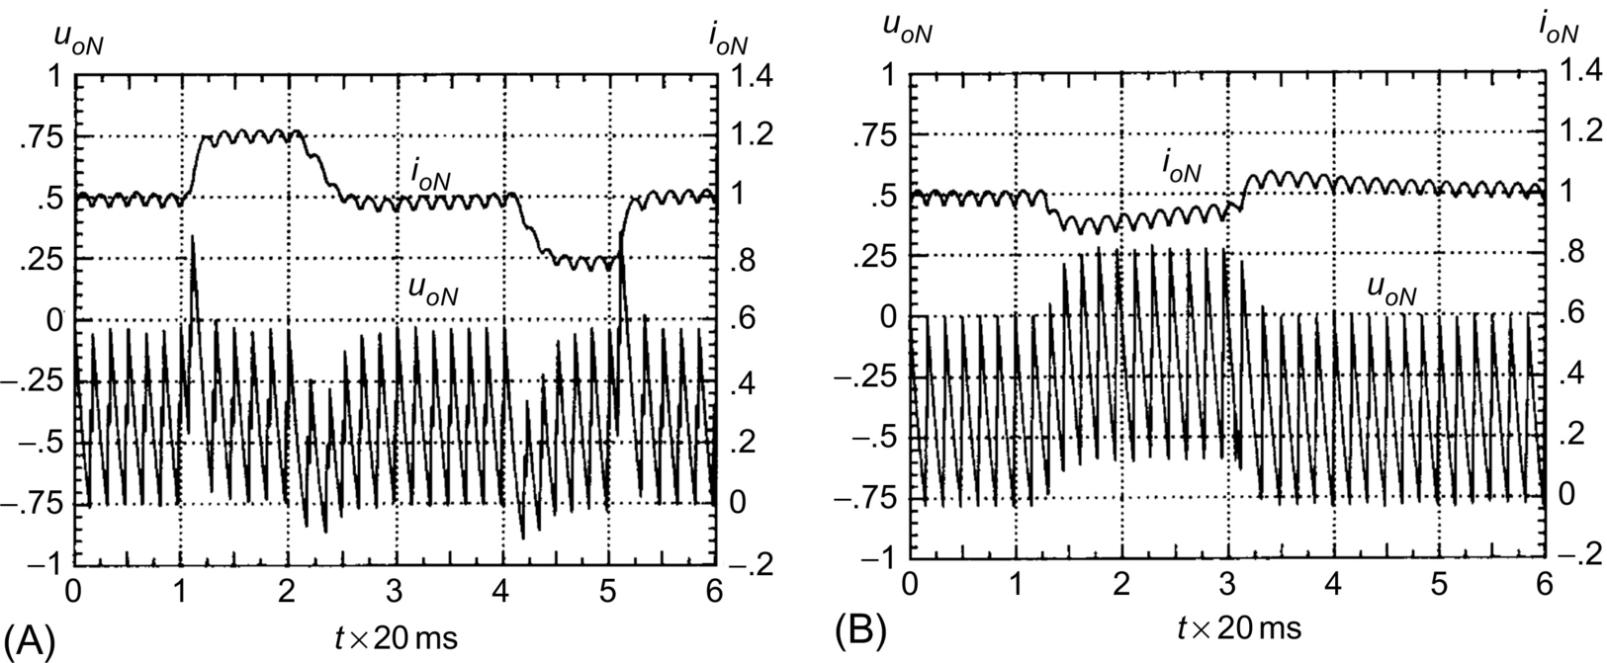

**FIG. 35.15** Transient response of the compensated rectifier: (A) step response of the controlled current *io* and (B) the current *io* response to a step chance to 50% of the *Eo* nominal value during 1.5 *T*.

These modeling and compensator design are valid for small perturbations. For large perturbations, the rectifier firing angles will either saturate at the zero value or originate large current overshoots. For large signals, antiwindup schemes ([Fig. 35.16A](https://learning.oreilly.com/library/view/power-electronics-handbook/9780128114087/B9780128114070000398_1.xhtml#f0085)) or error ramp limiters (or soft starters) and limiters of the PI integral component ([Fig. 35.16B](https://learning.oreilly.com/library/view/power-electronics-handbook/9780128114087/B9780128114070000398_1.xhtml#f0085)) must be used. These solutions will also work with other switching power converters.

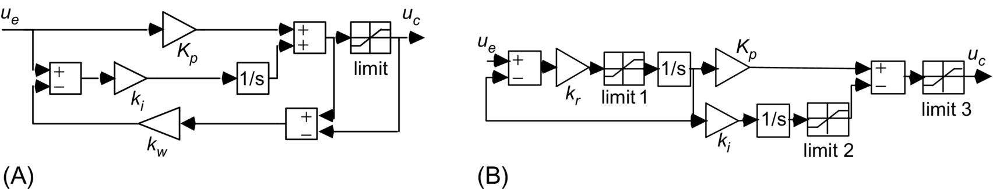

**FIG. 35.16** (A) PI implementation with antiwindup (usually 1/*Kp*≤*kw*≤*Ki*/*Kp*) to deal with rectifier saturation and (B) PI with ramp limiter/soft starter (*kr*≫*Kp*) and integral component limiter to deal with large perturbations.

To use this rectifier current controller as the inner control loop of a cascaded controller for the dc motor speed regulation, a useful first-order approximation of Eq. [(35.63)](https://learning.oreilly.com/library/view/power-electronics-handbook/9780128114087/B9780128114070000398_1.xhtml#fo0355) is *io*(*s*)/*ioref*(*s*)≈1/(*sT*/*p*+1).

Although allowing a straightforward compensator selection and precise calculation of its parameters, the rectifier modeling presented here is not suited for stability studies. The rectifier root locus will contain two complex conjugate poles in branches parallel to the imaginary axis. To study the current controller stability, at least the second-order term of Eq. [(35.48)](https://learning.oreilly.com/library/view/power-electronics-handbook/9780128114087/B9780128114070000398_1.xhtml#fo0280) in Eq. [(35.57)](https://learning.oreilly.com/library/view/power-electronics-handbook/9780128114087/B9780128114070000398_1.xhtml#fo0325) is needed. Alternative ways include the first-order Padé approximation of e−*sT*/2*p*, e−*sT*/2*p*≈(1−*sT*/4*p*)/(1+*sT*/4*p*), or the second-order approximation, e−*sT*/2*p*≈(1−*sT*/4*p*+(*sT*/2*p*)2/12)/(1+*sT*/4*p*+(*sT*/2*p*)2/12). These approaches introduce zeros in the right half-plane (nonminimum-phase systems) and/or extra poles, giving more realistic results. Taking a first-order approximation and root-locus techniques, it is found that the rectifier is stable for *Tp>KRM kI T*/(*4pRt*) (*ζ>*0.25). Another approach uses the conditions of magnitude and angle of the delay function e−*sT*/2*p* to obtain the system root locus. Also, the switching power converter can be considered as a sampled data system, at frequency *p*/*T*, and Z transform can be used to determine the critical gain and first frequency of instability *p*/(2 *T*), usually half the switching frequency of the rectifier.

**Example 35.7**

**Buck–Boost dc/dc converter feedback design in the discontinuous mode**

The methodologies just described do not apply to switching power converters operating in the discontinuous mode. However, the derived equivalent averaged circuit approach can be used, calculating the mean value of the discontinuous current supplied to the load, to obtain the equivalent circuit. Consider the buck-boost converter of [Example 35.1](https://learning.oreilly.com/library/view/power-electronics-handbook/9780128114087/B9780128114070000398_1.xhtml#en0010) ([Fig. 35.1](https://learning.oreilly.com/library/view/power-electronics-handbook/9780128114087/B9780128114070000398_1.xhtml#f0010)) with the new values *Li*=40 μH, *Co*=1000 μF, and *Ro*=15 Ω. The mean value of the current *iLo*, supplied to the output capacitor and resistor of the circuit operating in the discontinuous mode, can be calculated noting that, if the input *VDC* and output *vo* voltages are essentially constant (low ripple), the inductor current rises linearly from zero, peaking at *IP*=(*VDC*/*Li*)*δ*1 *T* ([Fig. 35.17A](https://learning.oreilly.com/library/view/power-electronics-handbook/9780128114087/B9780128114070000398_1.xhtml#f0090)). As the mean value of *iLo*, supposed linear, is *ILo*=(*IPδ*2*T*)/(2 *T*), using the steady-state input-output relation *VDCδ*1=*Voδ*2 and the above *IP* value, *ILo* can be written as

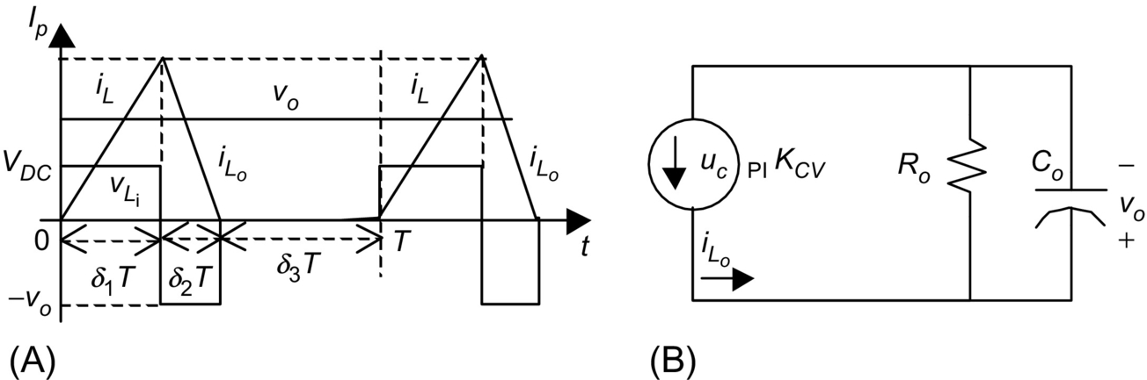

**FIG. 35.17** (A) Waveforms of the buck-boost converter in the discontinuous mode and (B) equivalent averaged circuit.

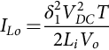 **(35.64)**

This is a nonlinear relation that could be linearized around an operating point. However, switching power converters in the discontinuous mode seldom operate just around an operating point. Therefore, using a quadratic modulator ([Fig. 35.18](https://learning.oreilly.com/library/view/power-electronics-handbook/9780128114087/B9780128114070000398_1.xhtml#f0095)), obtained integrating the ramp *r*(*t*) ([Fig. 35.6A](https://learning.oreilly.com/library/view/power-electronics-handbook/9780128114087/B9780128114070000398_1.xhtml#f0035)) and comparing the quadratic curve to the term *ucPIvo*/*VDC*2 (which is easily implemented using the Unitrode UC3854 integrated circuit), the duty cycle *δ*1 is 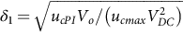, and a constant incremental factor *KCV* can be obtained:

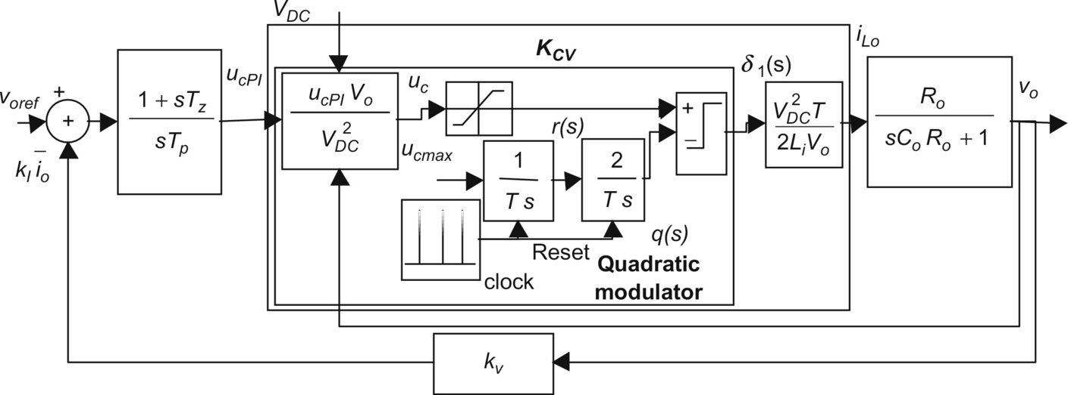

**FIG. 35.18** Block diagram of a PI-controlled (feedforward linearized) buck-boost converter operating in the discontinuous mode.

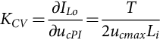 **(35.65)**

Considering zero-voltage perturbations and neglecting the modulator delay, the equivalent averaged circuit ([Fig. 35.17B](https://learning.oreilly.com/library/view/power-electronics-handbook/9780128114087/B9780128114070000398_1.xhtml#f0090)) can be used to derive the output voltage to input current transfer function *vo*(*s*)/*iLo*(*s*)=*Ro*/(*sCoRo*+1). Using a PI controller [(35.50)](https://learning.oreilly.com/library/view/power-electronics-handbook/9780128114087/B9780128114070000398_1.xhtml#fo0290), the closed-loop transfer function is

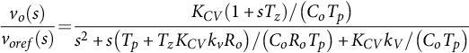 **(35.66)**

Since two degrees of freedom exist, the PI constants are derived imposing *ζ* and *ωn* for the second-order denominator of Eq. [(35.66)](https://learning.oreilly.com/library/view/power-electronics-handbook/9780128114087/B9780128114070000398_1.xhtml#fo0370), usually  and *ωn*≤2*πfs*/10. Therefore,

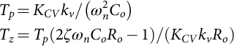 **(35.67)**

The transient behavior of this converter, with *ζ*=1 and *ωn*≈π*fs*/10, is shown in [Fig. 35.19A](https://learning.oreilly.com/library/view/power-electronics-handbook/9780128114087/B9780128114070000398_1.xhtml#f0100). Compared with [Example 35.2](https://learning.oreilly.com/library/view/power-electronics-handbook/9780128114087/B9780128114070000398_1.xhtml#en0015), the operation in the discontinuous conduction mode reduces, by 1, the order of the state-space averaged model and eliminates the zero in the right half of the complex plane. The inductor current does not behave as a true state variable, since during the interval *δ*3*T* this current is zero, and this value is always the *iLo* current initial condition. Given the differences between these two examples, care should be taken to avoid the operation in the continuous mode of converters designed and compensated for the discontinuous mode. This can happen during turn-on or step load changes, and if not prevented, the feedback design should guarantee stability in both modes ([Example 35.8](https://learning.oreilly.com/library/view/power-electronics-handbook/9780128114087/B9780128114070000398_1.xhtml#en0045) and [Fig. 35.20](https://learning.oreilly.com/library/view/power-electronics-handbook/9780128114087/B9780128114070000398_1.xhtml#f0105)).

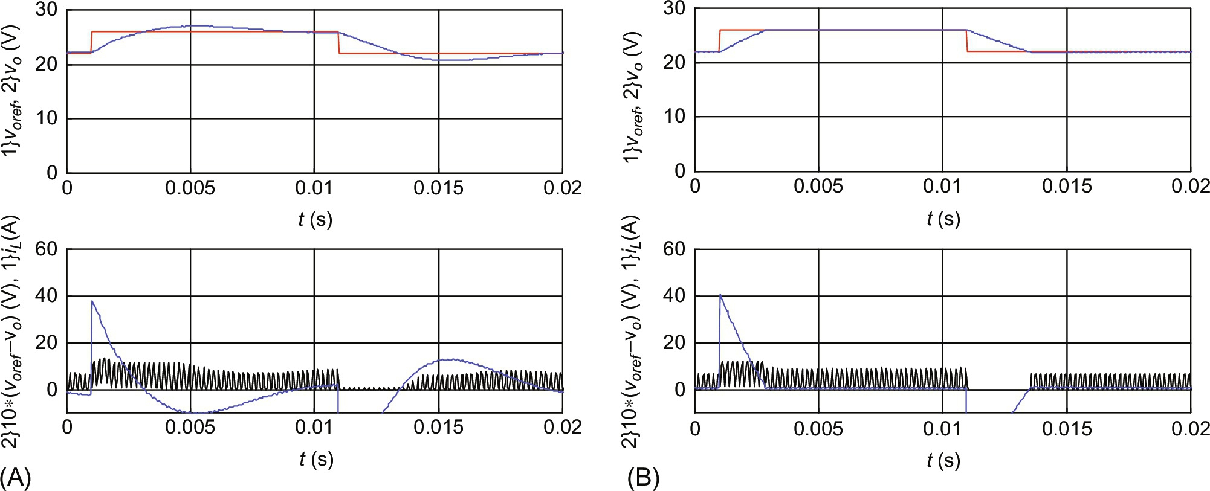

**FIG. 35.19** Transient response of the compensated buck-boost converter in the discontinuous mode. At *t*=0.001 s, *voref* step from 23 to 26 V. At *t*=0.011 s, *voref* step from 26 to 23 V. Top graphs: step reference *voref* and output voltage *vo*. Bottom graphs: pulses and *iL* current; trace peaking at 40, 10×(*voref*−*vo*): (A) PI-controlled and feedforward linearized buck-boost converter with *ζ*=1 and *ωn*≈π*fs*/10 and (B) current-mode-controlled buck-boost with *ζ*=1 and maximum value *Ipmax*=15 A.

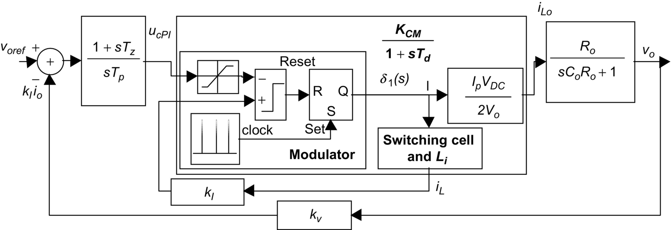

**FIG. 35.20** Block diagram of a current-mode controlled buck-boost converter operating in the discontinuous mode.

**Example 35.8**

**Feedback design for the buck–boost dc/dc converter operating in the discontinuous mode and using current-mode control**

The performances of the buck-boost converter operating in the discontinuous mode can be greatly enhanced if a *current-mode control* scheme is used, instead of the voltage-mode controller designed in [Example 35.7](https://learning.oreilly.com/library/view/power-electronics-handbook/9780128114087/B9780128114070000398_1.xhtml#en0040). Current-mode control in switching power converters is the simplest form of state feedback. Current mode needs the measurement of the current *iL* ([Fig. 35.1](https://learning.oreilly.com/library/view/power-electronics-handbook/9780128114087/B9780128114070000398_1.xhtml#f0010)) but greatly simplifies the modulator design (compare [Fig. 35.18](https://learning.oreilly.com/library/view/power-electronics-handbook/9780128114087/B9780128114070000398_1.xhtml#f0095) with [Fig. 35.20](https://learning.oreilly.com/library/view/power-electronics-handbook/9780128114087/B9780128114070000398_1.xhtml#f0105)), since no modulator linearization is used. The measured value, proportional to the current *iL*, is compared with the value *ucPI* given by the output voltage controller ([Fig. 35.20](https://learning.oreilly.com/library/view/power-electronics-handbook/9780128114087/B9780128114070000398_1.xhtml#f0105)). The modulator switches off the power semiconductor when *kIIP*=*ucPI*.

Expressed as a function of the peak *iL* current *IP*, *ILo* becomes ([Example 35.7](https://learning.oreilly.com/library/view/power-electronics-handbook/9780128114087/B9780128114070000398_1.xhtml#en0040)) *ILo*=*IPδ*1*VDC*/(2*Vo*), or considering the modulator task *ILo*=*ucPIδ*1*VDC*/(2*kIVo*). For small perturbations, the incremental gain is *KCM*=*∂ILo*/*∂ucPI*=*δ*1*VDC*/(2*kIVo*). An *ILo* current delay *Td*=1/(2*fs*), related to the switching frequency *fs*, can be assumed. The current-mode control transfer function *GCM* (*s*) is

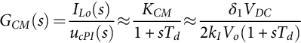 **(35.68)**

Using the approach of [Example 35.6](https://learning.oreilly.com/library/view/power-electronics-handbook/9780128114087/B9780128114070000398_1.xhtml#en0035), the values for *Tz* and *Tp* are given by Eq. [(35.69)](https://learning.oreilly.com/library/view/power-electronics-handbook/9780128114087/B9780128114070000398_1.xhtml#fo0385).

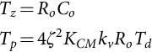 **(35.69)**

The transient behavior of this converter, with *ζ*=1 and maximum value for *Ip*, *Ipmax*=15 A, is shown in [Fig. 35.19B](https://learning.oreilly.com/library/view/power-electronics-handbook/9780128114087/B9780128114070000398_1.xhtml#f0100). The output voltage step response presents no overshoot, no steady-state error, and better dynamics, compared with the response ([Fig. 35.19A](https://learning.oreilly.com/library/view/power-electronics-handbook/9780128114087/B9780128114070000398_1.xhtml#f0100)) obtained using the quadratic modulator ([Fig. 35.18](https://learning.oreilly.com/library/view/power-electronics-handbook/9780128114087/B9780128114070000398_1.xhtml#f0095)). Notice that, with current-mode control, the converter behaves like a reduced-order system and the right half-plane zero is not present.

The current-mode control scheme can be advantageously applied to converters operating in the continuous mode, guarantying short-circuit protection, system order reduction, and better performances. However, for converters operating in the step-up (boost) regime, a stabilizing ramp with negative slope is required, to ensure stability. The stabilizing ramp will transform the signal *ucPI* in a new signal *ucPI*−rem(*ksrt*/*T*) where *ksr* is the needed amplitude for the compensation ramp and the function rem is the remainder of the division of *ksrt* by *T*. In the next section, current control of switching power converters will be detailed.

Closed-loop control of resonant converters can be achieved using the outlined approaches, if the resonant phases of operation last for small intervals compared with the fundamental period. Otherwise, the equivalent averaged circuit concept can often be used and linearized, now considering the resonant converter input-output relations, normally functions of the driving frequency and input or output voltages, to replace the *δ*1 variable.

**Example 35.9**

**Output voltage control in three-phase voltage-source inverters using sinusoidal wave PWM (SPWM) and space-vector modulation (SVM)**

**Sinusoidal wave PWM**

Voltage-source three-phase inverters ([Fig. 35.21](https://learning.oreilly.com/library/view/power-electronics-handbook/9780128114087/B9780128114070000398_2.xhtml#f0110)) are often used to drive squirrel cage induction motors (IM) in variable speed applications.

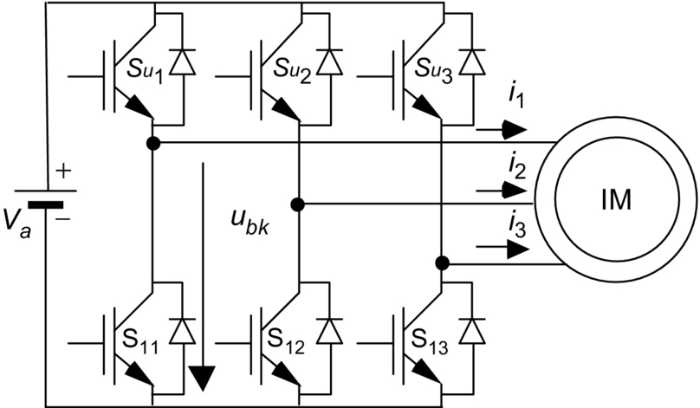

**FIG. 35.21** IGBT-based voltage-sourced three-phase inverter with induction motor.

Considering almost ideal power semiconductors, the output voltage *ubk*(*k*∈{1, 2, 3}) dynamics of the inverter is negligible as the output voltage can hardly be considered a state variable in the time scale describing the motor behavior. Therefore, the best known method to create sinusoidal output voltages uses an open-loop modulator with low-frequency sinusoidal waveforms sin(*ωt*), with the amplitude defined by the modulation index *mi* (*mi*∈[0, 1]), modulating high-frequency triangular waveforms *r*(*t*) (carriers) ([Fig. 35.22](https://learning.oreilly.com/library/view/power-electronics-handbook/9780128114087/B9780128114070000398_2.xhtml#f0115)), a process similar to the one described in [Section 35.2.4](https://learning.oreilly.com/library/view/power-electronics-handbook/9780128114087/B9780128114070000398_1.xhtml#s0050). The frequency and phase of the triangular carriers should guarantee half-wave and quarter-wave symmetry for minimum harmonic distortion.

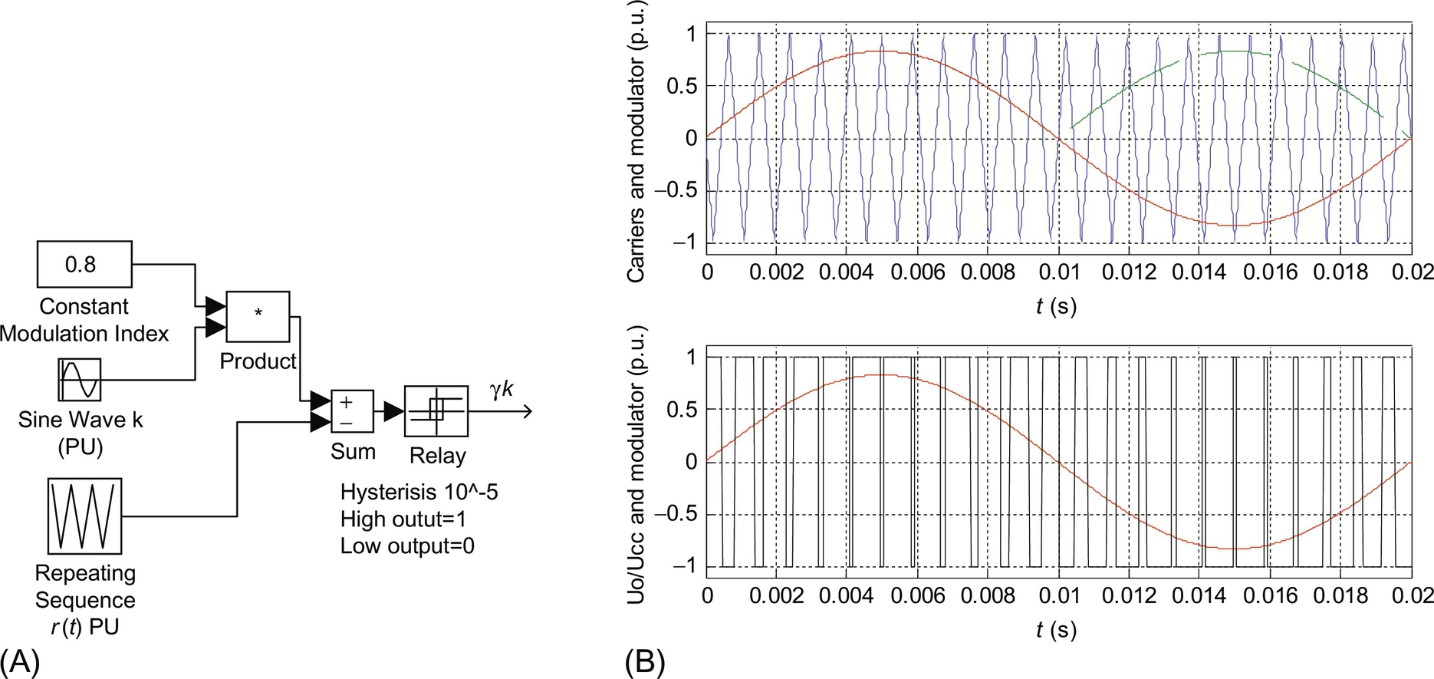

**FIG. 35.22** (A) SPWM modulator schematic and (B) main SPWM signals.

This sinusoidal wave PWM (SPWM) modulator generates the variable *γk*, represented in [Fig. 35.22](https://learning.oreilly.com/library/view/power-electronics-handbook/9780128114087/B9780128114070000398_2.xhtml#f0115) by the rectangular waveform, which describes the inverter *k* leg state:

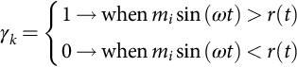 **(35.70)**

The turn-on and turn-off signals for the *k* leg inverter switches are related with the variable *γk* as follows:

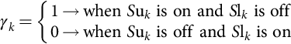 **(35.71)**

This applies constant-frequency sinusoidally weighted PWM signals to the gates of each insulated-gate bipolar transistor (IGBT). The PWM signals for all the upper IGBTs (*S*u*k*, *k*∈{1, 2, 3}) must be 120° out of phase, and the PWM signal for the lower IGBT *S*l*k* must be the complement of the *S*u*k* signal. Since transistor turn-on times are usually shorter than turn-off times, some dead time must be included between the *S*u*k* and *S*l*k* pulses to prevent internal short circuits.

Sinusoidal PWM can be easily implemented using a microprocessor or two digital counters/timers generating the addresses for two lookup tables (one for the triangular function and another for supplying the per unit basis of the sine, whose frequency can vary). Tables can be stored in read-only memories, ROM, or erasable programmable ROM, EPROM. One multiplier for the modulation index (perhaps into the digital-to-analog (D/A) converter for the sine ROM output) and one hysteresis comparator must also be included.

With SPWM, the first harmonic maximum amplitude of the obtained line-to-line voltage is only about 86% of the inverter dc supply voltage *Va*. Since it is expectable that this amplitude should be closer to *Va*, different modulating voltages (e.g., adding a third-order harmonic with one-fourth of the fundamental sine amplitude) can be used as long as the fundamental harmonic of the line-to-line voltage is kept sinusoidal. Another way is to leave SPWM and consider the eight possible inverter output voltages trying to directly use then. This will lead to space-vector modulation.

**Space vector modulation**

Space vector modulation (SVM) is based on the polar representation ([Fig. 35.23](https://learning.oreilly.com/library/view/power-electronics-handbook/9780128114087/B9780128114070000398_2.xhtml#f0120)) of the eight possible base output voltages of the three-phase inverter ([Table 35.1](https://learning.oreilly.com/library/view/power-electronics-handbook/9780128114087/B9780128114070000398_2.xhtml#t0010), where *vα* and *vβ* are the vector components of vector , obtained with Eq. [(35.72)](https://learning.oreilly.com/library/view/power-electronics-handbook/9780128114087/B9780128114070000398_2.xhtml#fo0400)). Therefore, as all the available voltages can be used, SVM does not present the voltage limitation of SPWM.

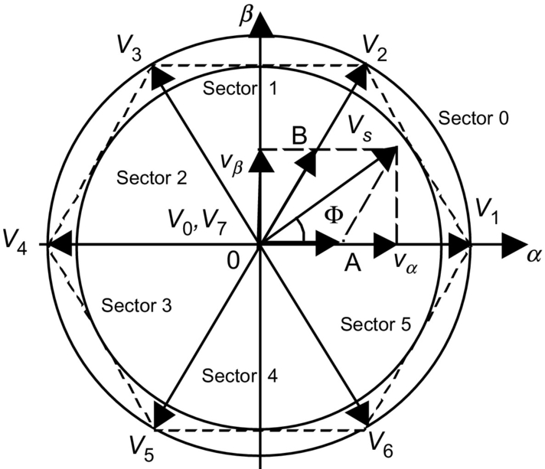

**FIG. 35.23** *α* and *β* space-vector representation of the three-phase bridge inverter leg base vectors.

**Table 35.1**

**The three-phase inverter with eight possible *γk* combinations, vector numbers, and respective *α* and *β* components**

|  |  |  |  |  |  |  |  |
| --- | --- | --- | --- | --- | --- | --- | --- |
| ***γ*1** | ***γ*2** | ***γ*3** | ***ubk*** | ***ubk*−*ubk*+1** | ***vα*** | ***vβ*** | **Vector** |
| 0 | 0 | 0 | 0 | 0 | 0 | 0 | si23_e |
| 1 | 0 | 0 | *γk Va* | (*γk*−*γk*+1)*Va* | si24_e | 0 | si25_e |
| 1 | 1 | 0 | *γk Va* | (*γk*−*γk*+1)*Va* | si26_e | si27_e | si28_e |
| 0 | 1 | 0 | *γk Va* | (*γk*−*γk*+1)*Va* | si29_e | si27_e | si31_e |
| 0 | 1 | 1 | *γk Va* | (*γk*−*γk*+1)*Va* | si32_e |  | si33_e |
| 1 | 1 | 1 | *Va* | 0 | 0 | 0 | si34_e |
| 1 | 0 | 1 | *γk Va* | (*γk*–*γk*+1)*Va* | si26_e | si36_e | si37_e |
| 0 | 0 | 1 | *γk Va* | (*γk*–*γk*+1)*Va* | si29_e | si36_e | si40_e |

Furthermore, being a vector technique, SVM fits nicely with the vector control methods often used in IM drives:

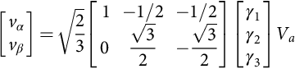 **(35.72)**

Consider that the vector  (magnitude *Vs* and angle [Fcy]) must be applied to the IM. Since there is no such vector available directly, SVM uses an averaging technique to apply the two vectors,  and , closest to . The vector  will be applied during *δATs*, while vector  will last *δBTs* (where 1/*Ts* is the inverter switching frequency and *δA* and *δB* are duty cycles, *δA* and *δB*∈[0, 1]). If there is any leftover time in the PWM period *Ts*, then the zero vector is applied during time *δ*0*Ts*=*Ts*−*δATs*−*δBTs*. Since there are two zero vectors ( and ), a symmetrical PWM can be devised, which uses both  and , as shown in [Fig. 35.24](https://learning.oreilly.com/library/view/power-electronics-handbook/9780128114087/B9780128114070000398_2.xhtml#f0125). Such a PWM arrangement minimizes the power semiconductor switching frequency and IM torque ripples



**FIG. 35.24** Symmetrical SVM.

The input to the SVM algorithm is the space vector , into the sector *sn*, with magnitude *Vs* and angle Φ*s*. This vector can be rotated to fit into sector 0 ([Fig. 35.23](https://learning.oreilly.com/library/view/power-electronics-handbook/9780128114087/B9780128114070000398_2.xhtml#f0120)) reducing Φ*s* to the first sector, Φ=Φ*s*−*sn*π/3. For any  that is not exactly along one of the six nonnull inverter base vectors ([Fig. 35.23](https://learning.oreilly.com/library/view/power-electronics-handbook/9780128114087/B9780128114070000398_2.xhtml#f0120)), SVM must generate an approximation by applying the two adjacent vectors during an appropriate amount of time. The algorithm can be devised considering that the projections of , onto the two closest base vectors, are values proportional to *δA* and *δB* duty cycles. Using simple trigonometric relations in sector 0 (0*<*Φ*<*π/3) ([Fig. 35.23](https://learning.oreilly.com/library/view/power-electronics-handbook/9780128114087/B9780128114070000398_2.xhtml#f0120)) and considering *KT* the proportional ratio, *δA* and *δB* are, respectively,  and , yielding

 **(35.73)**

The *KT* value can be found if we notice that when , *δA*=1, and *δB*=0 (or when , *δA*=0, and *δB*=1). Therefore, since when , , Φ=0, or when , , Φ=*π*/3, the *KT* constant is . Hence,

 **(35.74)**

The obtained resulting vector  cannot extend beyond the hexagon of [Fig. 35.23](https://learning.oreilly.com/library/view/power-electronics-handbook/9780128114087/B9780128114070000398_2.xhtml#f0120). This can be understood if the maximum magnitude *Vsm* of a vector with Φ=*π*/6 is calculated. For Φ=*π*/6, the maximum duty cycles are *δA*=1/2 and *δB*=1/2. Then, from Eq. (35.74,)  is obtained. This magnitude is lower than that of the vector  since the ratio between these magnitudes is . To generate sinusoidal voltages, the vector  must be inside the inner circle of [Fig. 35.23](https://learning.oreilly.com/library/view/power-electronics-handbook/9780128114087/B9780128114070000398_2.xhtml#f0120), so that it can be rotated without crossing the hexagon boundary. Vectors with tips between this circle and the hexagon are reachable but produce nonsinusoidal line-to-line voltages.

For sector 0 ([Fig. 35.23](https://learning.oreilly.com/library/view/power-electronics-handbook/9780128114087/B9780128114070000398_2.xhtml#f0120)), SVM symmetrical PWM switching variables (*γ*1, *γ*2, and *γ*3) and intervals ([Fig. 35.24](https://learning.oreilly.com/library/view/power-electronics-handbook/9780128114087/B9780128114070000398_2.xhtml#f0125)) can be obtained by comparing a triangular wave with amplitude *ucmax* ([Fig. 35.24](https://learning.oreilly.com/library/view/power-electronics-handbook/9780128114087/B9780128114070000398_2.xhtml#f0125), where *r*(*t*)=2*ucmaxt*/*Ts* and *t*∈[0, *Ts*/2]), with the following values:

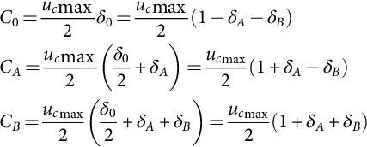 **(35.75)**

Extension of Eq. [(35.75)](https://learning.oreilly.com/library/view/power-electronics-handbook/9780128114087/B9780128114070000398_2.xhtml#fo0415) to all six sectors can be done if the sector number *sn* is considered, together with the auxiliary matrix **Ξ**:

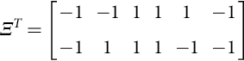 **(35.76)**

Generalization of the values *C*0, *CA*, and *CB*, denoted *C*0*sn*, *CAsn*, and *CBsn*, is written in Eq. [(35.77)](https://learning.oreilly.com/library/view/power-electronics-handbook/9780128114087/B9780128114070000398_2.xhtml#fo0425), knowing that, for example,  is the **Ξ** matrix row with number (*sn*+4)mod 6+1:

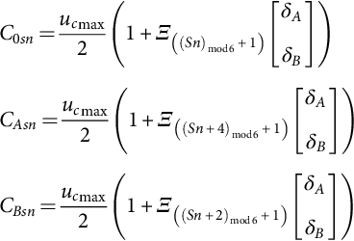 **(35.77)**

Therefore, *γ*1, *γ*2, and *γ*3 are

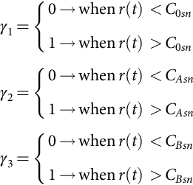 **(35.78)**

Supposing that the space vector  is now specified in the orthogonal coordinates , instead of magnitude *Vs* and angle Φ*s*, the duty cycles *δA* and *δB* can be easily calculated knowing that *vα*=*Vs* cos Φ and *vβ*=*Vs* sin Φ and using Eq. [(35.74)](https://learning.oreilly.com/library/view/power-electronics-handbook/9780128114087/B9780128114070000398_2.xhtml#fo0410):

 **(35.79)**

This equation enables the use of Eqs. [(35.77)](https://learning.oreilly.com/library/view/power-electronics-handbook/9780128114087/B9780128114070000398_2.xhtml#fo0425) and [(35.78)](https://learning.oreilly.com/library/view/power-electronics-handbook/9780128114087/B9780128114070000398_2.xhtml#fo0430) to obtain SVM in orthogonal coordinates.

Using SVM or SPWM, the closed-loop control of the inverter output currents (induction motor stator currents) can be performed using an approach similar to that outlined in [Example 35.6](https://learning.oreilly.com/library/view/power-electronics-handbook/9780128114087/B9780128114070000398_1.xhtml#en0035) and decoupling the currents expressed in a *d* and *q* rotating frame.

## 35.3 Sliding-Mode Control of Switching Power Converters

### **35.3.1 INTRODUCTION**

All the designed controllers for switching power converters are in fact variable structure controllers, in the sense that the control action changes rapidly from one to another of, usually, two possible *δ*(*t*) values, cyclically changing the converter topology. This is accomplished by the modulator ([Fig. 35.6](https://learning.oreilly.com/library/view/power-electronics-handbook/9780128114087/B9780128114070000398_1.xhtml#f0035)), which creates the switching variable *δ*(*t*) imposing *δ*(*t*)=1 or *δ*(*t*)=0, to turn on or off the power semiconductors. As a consequence of this discontinuous control action, indispensable for efficiency reasons, state trajectories move back and forth around a certain average surface in the state-space, and variables present some ripple. To avoid the effects of this ripple in the modeling and to apply linear control methodologies to time-variant systems, average values of state variables and state-space averaged models or circuits were presented ([Section 35.2](https://learning.oreilly.com/library/view/power-electronics-handbook/9780128114087/B9780128114070000398_1.xhtml#s0015)). However, a nonlinear approach to the modeling and control problem, taking advantage of the inherent ripple and variable structure behavior of switching power converters, instead of just trying to live with them, would be desirable, especially if enhanced performances could be attained.

In this approach, switching power converter topologies, as discrete nonlinear time-variant systems, are controlled to switch from one dynamics to another when just needed. If this switching occurs at a very high frequency (theoretically infinite), the state dynamics described as in Eq. [(35.4)](https://learning.oreilly.com/library/view/power-electronics-handbook/9780128114087/B9780128114070000398_1.xhtml#fo0025) can be enforced to slide along a certain prescribed state-space trajectory. The converter is said to be in sliding mode, the allowed deviations from the trajectory (the ripple) imposing the practical switching frequency.

Sliding-mode control of variable structure systems, such as switching power converters, is particularly interesting because of the inherent robustness [[10](https://learning.oreilly.com/library/view/power-electronics-handbook/9780128114087/B9780128114070000398_5.xhtml#bb0055),[11](https://learning.oreilly.com/library/view/power-electronics-handbook/9780128114087/B9780128114070000398_5.xhtml#bb0060)], capability of system order reduction, and appropriateness to the on/off switching of power semiconductors. The control action, being the control equivalent of the management paradigm “just in time” (JIT), provides timely and precise control actions, determined by the control law and the allowed ripple. Therefore, the switching frequency is not constant over all operating regions of the converter.

This section treats the derivation of the control (sliding surface) and switching laws, robustness, stability, constant-frequency operation, and steady-state error elimination necessary for sliding-mode control of switching power converters, also giving some examples.

### 35.3.2 PRINCIPLES OF SLIDING-MODE CONTROL

Consider the state-space switched model Eq. [(35.4)](https://learning.oreilly.com/library/view/power-electronics-handbook/9780128114087/B9780128114070000398_1.xhtml#fo0025) of a switching converter subsystem and input-output linearization or another technique, to obtain, from state-space equations, one Eq. [(35.80)](https://learning.oreilly.com/library/view/power-electronics-handbook/9780128114087/B9780128114070000398_2.xhtml#fo0440), for each controllable subsystem output **y**=**x**. In the controllability canonical form [[12](https://learning.oreilly.com/library/view/power-electronics-handbook/9780128114087/B9780128114070000398_5.xhtml#bb0065)] (also known as input-output decoupled or companion form), Eq. [(35.80)](https://learning.oreilly.com/library/view/power-electronics-handbook/9780128114087/B9780128114070000398_2.xhtml#fo0440) is

 **(35.80)**

where **x**=[*xh*, *…*, *xj*−1, *xj*]T is the subsystem state vector, *fh*(**x**) and *bh*(**x**) are functions of **x**, *ph*(*t*) represents the external disturbances, and *uh*(*t*) is the control input. In this special form of state-space modeling, the state variables are chosen so that the *xi*+1 variable (*i*∈{*h*, *…*, *j*−1}) is the time derivative of *xi*, that is, , where *m*=*j*−*h* [[13](https://learning.oreilly.com/library/view/power-electronics-handbook/9780128114087/B9780128114070000398_5.xhtml#bb0070)].

#### **35.3.2.1 Control Law (Sliding Surface)**

The required closed-loop dynamics for the subsystem output vector **y**=**x** can be chosen to verify Eq. [(35.81)](https://learning.oreilly.com/library/view/power-electronics-handbook/9780128114087/B9780128114070000398_2.xhtml#fo0445) with selected *ki* values. This is a model reference adaptive control approach to impose a state trajectory that advantageously reduces the system order (*j*−*h*+1):

 **(35.81)**

Effectively, in a single-input single-output (SISO) subsystem, the order is reduced by unity, applying the restriction Eq. [(35.81)](https://learning.oreilly.com/library/view/power-electronics-handbook/9780128114087/B9780128114070000398_2.xhtml#fo0445). In a multiple-input multiple-output (MIMO) system, in which *ν*-independent restrictions could be imposed (usually with *ν* degrees of freedom), the order could often be reduced in *ν* units. Indeed, from Eq. [(35.81)](https://learning.oreilly.com/library/view/power-electronics-handbook/9780128114087/B9780128114070000398_2.xhtml#fo0445), the dynamics of the *j*th term of **x** is linearly dependent from the *j*−*h* first terms:

 **(35.82)**

The controllability canonical model allows the direct calculation of the needed control input to achieve the desired dynamics Eq. [(35.81)](https://learning.oreilly.com/library/view/power-electronics-handbook/9780128114087/B9780128114070000398_2.xhtml#fo0445). In fact, as the control action should enforce the state vector **x**, to follow the reference vector , the tracking error vector will be  or . Thus, equating the subexpressions for d*xj*/d*t* of Eqs. [(35.80)](https://learning.oreilly.com/library/view/power-electronics-handbook/9780128114087/B9780128114070000398_2.xhtml#fo0440) and [(35.81)](https://learning.oreilly.com/library/view/power-electronics-handbook/9780128114087/B9780128114070000398_2.xhtml#fo0445), the necessary control input *uh*(*t*) is

 **(35.83)**

This expression is the required closed-loop control law, but unfortunately, it depends on the system parameters and on external perturbations and is difficult to compute. Moreover, for some output requirements, Eq. [(35.83)](https://learning.oreilly.com/library/view/power-electronics-handbook/9780128114087/B9780128114070000398_2.xhtml#fo0455) would give extremely high values for the control input *uh*(*t*), which would be impractical or almost impossible.

In most switching power converters, *uh*(*t*) is discontinuous. Yet, if we assume one or more discontinuity borders dividing the state-space into subspaces, the existence and uniqueness of the solution are guaranteed out of the discontinuity borders, since in each subspace the input is continuous. The discontinuity borders are subspace switching hypersurfaces, whose order is the space order minus one, along which the subsystem state slides, since its intersections with the auxiliary equations defining the discontinuity surfaces can give the needed control input.

Within the sliding-mode control (SMC) theory, assuming a certain dynamic error driven to zero, one auxiliary equation (sliding surface) and the equivalent control input *uh*(*t*) can be obtained, integrating both sides of Eq. [(35.82)](https://learning.oreilly.com/library/view/power-electronics-handbook/9780128114087/B9780128114070000398_2.xhtml#fo0450) with null initial conditions:

 **(35.84)**

This equation represents the discontinuity surface (hyperplane) and just defines the necessary sliding surface *S*(*xi*, *t*) to obtain the prescribed dynamics of Eq. [(35.81)](https://learning.oreilly.com/library/view/power-electronics-handbook/9780128114087/B9780128114070000398_2.xhtml#fo0445):

 **(35.85)**

In fact, by taking the first time derivative of *S*(*xi*, *t*), ; solving it for d*xj*/d*t*; and substituting the result in Eq. [(35.83)](https://learning.oreilly.com/library/view/power-electronics-handbook/9780128114087/B9780128114070000398_2.xhtml#fo0455), the dynamics specified by Eq. [(35.81)](https://learning.oreilly.com/library/view/power-electronics-handbook/9780128114087/B9780128114070000398_2.xhtml#fo0445) is obtained. This means that the control problem is reduced to a first-order problem, since it is only necessary to calculate the time derivative of Eq. [(35.85)](https://learning.oreilly.com/library/view/power-electronics-handbook/9780128114087/B9780128114070000398_2.xhtml#fo0465) to obtain the dynamics [(35.81)](https://learning.oreilly.com/library/view/power-electronics-handbook/9780128114087/B9780128114070000398_2.xhtml#fo0445) and the needed control input *uh*(*t*).

The sliding surface Eq. [(35.85)](https://learning.oreilly.com/library/view/power-electronics-handbook/9780128114087/B9780128114070000398_2.xhtml#fo0465), as the dynamics of the converter subsystem, must be a Routh-Hurwitz polynomial and verify the sliding manifold invariance conditions, *S*(*xi*, *t*)=0 and . Consequently, the closed-loop controlled system behaves as a stable system of order *j*−*h*, whose dynamics is imposed by the coefficients *ki*, which can be chosen by pole placement of the poles of the order *m*=*j*−*h* polynomial. Alternatively, certain kinds of polynomials can be advantageously used [[14](https://learning.oreilly.com/library/view/power-electronics-handbook/9780128114087/B9780128114070000398_5.xhtml#bb0075)]: Butterworth, Bessel, Chebyshev, elliptic (or Cauer), binomial, and minimum integral of time absolute error product (ITAE). Most useful are Bessel polynomials *BE*(*s*) (Eq. [(35.88)](https://learning.oreilly.com/library/view/power-electronics-handbook/9780128114087/B9780128114070000398_2.xhtml#fo0480)), which minimize the system response time *tr*, providing no overshoot; the polynomials *ITAE*(*s*) (Eq. [(35.87)](https://learning.oreilly.com/library/view/power-electronics-handbook/9780128114087/B9780128114070000398_2.xhtml#fo0475)) that minimize the ITAE criterion for a system with desired natural oscillating frequency *ωo*; and binomial polynomials *BI*(*s*) (Eq. [(35.86)](https://learning.oreilly.com/library/view/power-electronics-handbook/9780128114087/B9780128114070000398_2.xhtml#fo0470)). For *m>*1, ITAE polynomials give faster responses than binomial polynomials:

 **(35.86)**

**** **(35.87)**

**** **(35.88)**

These polynomials can be the reference model for this model reference adaptive control method.

#### **35.3.2.2 Closed-Loop Control Input–Output Decoupled Form**

For closed-loop control applications, instead of the state variables *xi*, it is worthy to consider, as new state variables, the errors , components of the error vector  of the state-space variables *xi*, relative to a given reference  Eq. [(35.90)](https://learning.oreilly.com/library/view/power-electronics-handbook/9780128114087/B9780128114070000398_2.xhtml#fo0490). The new controllability canonical model of the system is

 **(35.89)**

where *fe*(**e**), *pe*(*t*), and *be*(**e**) are functions of the error vector **e**.

As the transformation of variables

 **(35.90)**

is linear, the Routh-Hurwitz polynomial for the new sliding surface  is

 **(35.91)**

Since , this *control law*, from Eqs. [(35.86)](https://learning.oreilly.com/library/view/power-electronics-handbook/9780128114087/B9780128114070000398_2.xhtml#fo0470) to [(35.88)](https://learning.oreilly.com/library/view/power-electronics-handbook/9780128114087/B9780128114070000398_2.xhtml#fo0480), can be written as  and is robust as it does not depend on circuit parameters, disturbances, or operating conditions, but only on the imposed *ki* parameters and on the state variable errors , which can usually be measured or estimated. The control law Eq. [(35.91)](https://learning.oreilly.com/library/view/power-electronics-handbook/9780128114087/B9780128114070000398_2.xhtml#fo0495) enables the desired dynamics of the output variable(s), if the semiconductor switching strategy is designed to guarantee the system stability. In practice, the finite switching frequency of the semiconductors will impose a certain dynamic error *ɛ* steered to zero. The control law Eq. [(35.91)](https://learning.oreilly.com/library/view/power-electronics-handbook/9780128114087/B9780128114070000398_2.xhtml#fo0495) is the required controller for the closed-loop SISO subsystem with output **y**.

#### **35.3.2.3 Stability**

*Existence condition*. The existence of the operation in sliding mode implies . Also, to stay in this regime, the control system should guarantee . Therefore, the semiconductor switching law must ensure the stability condition for the system in sliding mode, written as

 **(35.92)**

The fulfillment of this inequality ensures the convergence of the system state trajectories to the sliding surface , since

– if  and , then  will decrease to zero,

– if  and , then  will increase toward zero.

Hence, if Eq. [(35.92)](https://learning.oreilly.com/library/view/power-electronics-handbook/9780128114087/B9780128114070000398_2.xhtml#fo0500) is verified, then  will converge to zero. The condition [(35.92)](https://learning.oreilly.com/library/view/power-electronics-handbook/9780128114087/B9780128114070000398_2.xhtml#fo0500) is the manifold  invariance condition or the sliding-mode existence condition.

Given the state-space model Eq. [(35.89)](https://learning.oreilly.com/library/view/power-electronics-handbook/9780128114087/B9780128114070000398_2.xhtml#fo0485) as a function of the error vector **e** and, from , the equivalent average control input *Ueq*(*t*) that must be applied to the system in order that the system state slides along the surface, Eq. [(35.91)](https://learning.oreilly.com/library/view/power-electronics-handbook/9780128114087/B9780128114070000398_2.xhtml#fo0495) is given by

 **(35.93)**

This control input *Ueq*(*t*) ensures the converter subsystem operation in the sliding mode.

*Reaching condition*. The fulfillment of  as  implies that the distance between the system state and the sliding surface will tend to zero, since  can be considered as a measure for this distance. This means that the system will reach sliding mode. Additionally, from Eq. [(35.89)](https://learning.oreilly.com/library/view/power-electronics-handbook/9780128114087/B9780128114070000398_2.xhtml#fo0485), it can be written as

 **(35.94)**

From Eq. [(35.91)](https://learning.oreilly.com/library/view/power-electronics-handbook/9780128114087/B9780128114070000398_2.xhtml#fo0495), Eq. [(35.95)](https://learning.oreilly.com/library/view/power-electronics-handbook/9780128114087/B9780128114070000398_2.xhtml#fo0515) is obtained:

 **(35.95)**

If , from the Routh-Hurwitz property of Eq. [(35.91)](https://learning.oreilly.com/library/view/power-electronics-handbook/9780128114087/B9780128114070000398_2.xhtml#fo0495), then . In this case, to reach , it is necessary to impose−*be*(**e**)*uh*(*t*)=−*U* in Eq. [(35.94)](https://learning.oreilly.com/library/view/power-electronics-handbook/9780128114087/B9780128114070000398_2.xhtml#fo0510), with *U* chosen to guarantee . After a certain time,  will be , implying along with Eq. [(35.95)](https://learning.oreilly.com/library/view/power-electronics-handbook/9780128114087/B9780128114070000398_2.xhtml#fo0515) that , thus verifying Eq. [(35.92)](https://learning.oreilly.com/library/view/power-electronics-handbook/9780128114087/B9780128114070000398_2.xhtml#fo0500). Therefore, every term of  will be negative, which implies, after a certain time, an error  and . Hence, the system will reach sliding mode, staying there if *U*=*Ueq*(*t*). This same reasoning can be made for ; it is now being necessary to impose−*be*(**e**)*uh*(*t*)=+*U*, with *U* high enough to guarantee .

To ensure that the system always reaches sliding-mode operation, it is necessary to calculate the maximum value of *Ueq*(*t*) and *Ueqmax* and also impose the reaching condition:

 **(35.96)**

This means that the power supply voltage values *U* should be chosen high enough to additionally account for the maximum effects of the perturbations. With step inputs, even with *U>Ueqmax*, the converter usually loses sliding mode, but it will reach it again, even if the *Ueqmax* is calculated considering only the maximum steady-state values for the perturbations.

#### **35.3.2.4 Switching Law**

From the foregoing considerations, supposing a system with two possible structures, the semiconductor switching strategy must ensure . Therefore, if , then , which implies, as seen, −*be*(**e**)*uh*(*t*)=−*U* (the sign of *be*(**e**) must be known). Also, if , then , which implies−*be*(**e**)*uh*(*t*)=+*U*. This imposes the switching between two structures at infinite frequency. Since power semiconductors can only switch at finite frequency, in practice, a small enough error for  must be allowed . Hence, the switching law between the two possible system structures might be

 **(35.97)**

The condition Eq. [(35.97)](https://learning.oreilly.com/library/view/power-electronics-handbook/9780128114087/B9780128114070000398_2.xhtml#fo0525) determines the control input to be applied and therefore represents the semiconductor switching strategy or switching function. This law determines a two-level pulse-width modulator with JIT switching (variable frequency).

#### **35.3.2.5 Robustness**

The dynamics of a system, with closed-loop control using the control law Eq. [(35.91)](https://learning.oreilly.com/library/view/power-electronics-handbook/9780128114087/B9780128114070000398_2.xhtml#fo0495) and the switching law Eq. [(35.97)](https://learning.oreilly.com/library/view/power-electronics-handbook/9780128114087/B9780128114070000398_2.xhtml#fo0525), does not depend on the system operating point, load, circuit parameters, power supply, or bounded disturbances, as long as the control input *uh*(*t*) is large enough to maintain the converter subsystem in sliding mode. Therefore, it is said that the switching power converter dynamics, operating in sliding mode, is robust against changing operating conditions, variations of circuit parameters, and external disturbances. The desired dynamics for the output variable(s) is determined only by the *ki* coefficients of the control law Eq. [(35.91)](https://learning.oreilly.com/library/view/power-electronics-handbook/9780128114087/B9780128114070000398_2.xhtml#fo0495), as long as the switching law [(35.97)](https://learning.oreilly.com/library/view/power-electronics-handbook/9780128114087/B9780128114070000398_2.xhtml#fo0525) maintains the converter in sliding mode.

### 35.3.3 CONSTANT-FREQUENCY OPERATION

Prefixed switching frequency can be achieved, even with the sliding-mode controllers, at the cost of losing the JIT action. As the sliding-mode controller changes the control input when needed and not at a certain prefixed rhythm, applications needing constant switching frequency (such as thyristor rectifiers or resonant converters) must compare *S*(*exi*, *t*) (hysteresis width 2*ι* much narrower than 2*ɛ*) with auxiliary triangular waveforms ([Fig. 35.25A](https://learning.oreilly.com/library/view/power-electronics-handbook/9780128114087/B9780128114070000398_2.xhtml#f0130)), auxiliary sawtooth functions ([Fig. 35.25B](https://learning.oreilly.com/library/view/power-electronics-handbook/9780128114087/B9780128114070000398_2.xhtml#f0130)), three-level clocks ([Fig. 35.25C](https://learning.oreilly.com/library/view/power-electronics-handbook/9780128114087/B9780128114070000398_2.xhtml#f0130)), or phase-locked loop control of the comparator hysteresis variable width 2*ɛ* [[15](https://learning.oreilly.com/library/view/power-electronics-handbook/9780128114087/B9780128114070000398_5.xhtml#bb0080)]. However, as illustrated in [Fig. 35.25D](https://learning.oreilly.com/library/view/power-electronics-handbook/9780128114087/B9780128114070000398_2.xhtml#f0130), steady-state errors do appear. Often, they should be eliminated as described in [Section 35.3.4](https://learning.oreilly.com/library/view/power-electronics-handbook/9780128114087/B9780128114070000398_2.xhtml#s0140).



**FIG. 35.25** Auxiliary functions and methods to obtain constant switching frequency with sliding-mode controllers. (A) Using a triangular carrier; (B) using a sawtooth carrier; (C) using a three-level clock; (D) generation of steady-state error.

### 35.3.4 STEADY-STATE ERROR ELIMINATION IN CONVERTERS WITH CONTINUOUS CONTROL INPUTS

In the ideal sliding mode, state trajectories are directed toward the sliding surface [(35.91)](https://learning.oreilly.com/library/view/power-electronics-handbook/9780128114087/B9780128114070000398_2.xhtml#fo0495) and move exactly along the discontinuity surface, switching between the possible system structures at infinite frequency. Practical sliding modes cannot switch at infinite frequency and therefore exhibit phase-plane trajectory oscillations inside a hysteresis band of width 2*ɛ*, centered in the discontinuity surface.

The switching law Eq. [(35.91)](https://learning.oreilly.com/library/view/power-electronics-handbook/9780128114087/B9780128114070000398_2.xhtml#fo0495) permits no steady-state errors as long as  tends to zero, which implies no restrictions on the commutation frequency. Control circuits operating at constant frequency or needed continuous inputs or particular limitations of the power semiconductors, such as minimum on or off times, can originate . The steady-state error  of the *xh* variable  can be eliminated, increasing the system order by 1. The new state-space controllability canonical form, considering the error , between the variables and their references, as the state vector, is

 **(35.98)**

The new sliding surface  written from Eq. [(35.91)](https://learning.oreilly.com/library/view/power-electronics-handbook/9780128114087/B9780128114070000398_2.xhtml#fo0495), considering the new system in Eq. [(35.98)](https://learning.oreilly.com/library/view/power-electronics-handbook/9780128114087/B9780128114070000398_2.xhtml#fo0530), is

 **(35.99)**

This sliding surface offers zero-state error, even if  due to the hardware errors or fixed (or limited) frequency switching. Indeed, at the steady state, the only nonzero term is . Also, like Eq. [(35.91)](https://learning.oreilly.com/library/view/power-electronics-handbook/9780128114087/B9780128114070000398_2.xhtml#fo0495), this closed-loop control law does not depend on system parameters or perturbations to ensure a prescribed closed-loop dynamics similar to Eq. [(35.81)](https://learning.oreilly.com/library/view/power-electronics-handbook/9780128114087/B9780128114070000398_2.xhtml#fo0445) with an error approaching zero.

The approach outlined herein precisely defines the control law (sliding surface [(35.91)](https://learning.oreilly.com/library/view/power-electronics-handbook/9780128114087/B9780128114070000398_2.xhtml#fo0495) or [(35.99)](https://learning.oreilly.com/library/view/power-electronics-handbook/9780128114087/B9780128114070000398_2.xhtml#fo0535)) needed to obtain the selected dynamics and the switching law Eq. [(35.97)](https://learning.oreilly.com/library/view/power-electronics-handbook/9780128114087/B9780128114070000398_2.xhtml#fo0525). As the control law allows the implementation of the system controller and the switching law gives the PWM modulator, there is no need to design linear or nonlinear controllers, based on linear converter models, or devise offline PWM modulators. Therefore, sliding-mode control theory, applied to switching power converters, provides a systematic method to generate both the controller(s) (usually nonlinear) and the modulator(s) that will ensure a model reference robust dynamics, solving the control problem of switching power converters.

In the next examples, it is shown that the sliding-mode controllers use (nonlinear) state feedback, therefore, needing to measure the state variables and often other variables, since they use more system information. This is a disadvantage since more sensors are needed. However, the straightforward control design and obtained performances are much better than those obtained with the averaged models, the use of more sensors being really valued. Alternatively to the extra sensors, state observers can be used [[12](https://learning.oreilly.com/library/view/power-electronics-handbook/9780128114087/B9780128114070000398_5.xhtml#bb0065),[13](https://learning.oreilly.com/library/view/power-electronics-handbook/9780128114087/B9780128114070000398_5.xhtml#bb0070)].

### 35.3.5 EXAMPLES: BUCK–BOOST DC/DC CONVERTER, HALF-BRIDGE INVERTER, 12-PULSE PARALLEL RECTIFIERS, AUDIO POWER AMPLIFIERS, NEAR UNITY POWER FACTOR RECTIFIERS, MULTILEVEL INVERTERS, MATRIX CONVERTERS

**Example 35.10**

**Sliding-mode control of the buck–boost dc/dc converter**

Consider again the buck-boost converter of [Fig. 35.1](https://learning.oreilly.com/library/view/power-electronics-handbook/9780128114087/B9780128114070000398_1.xhtml#f0010) and assume the converter output voltage *vo* to be the controlled output. From [Section 35.2](https://learning.oreilly.com/library/view/power-electronics-handbook/9780128114087/B9780128114070000398_1.xhtml#s0015), using the switched state-space model of Eq. [(35.11)](https://learning.oreilly.com/library/view/power-electronics-handbook/9780128114087/B9780128114070000398_1.xhtml#fo0080), making d*vo*/d*t*=*θ*, and calculating the first time derivative of *θ*, the controllability canonical model [(35.100)](https://learning.oreilly.com/library/view/power-electronics-handbook/9780128114087/B9780128114070000398_2.xhtml#fo0540), where *io*=*vo*/*Ro*, is obtained:

 **(35.100)**

This model, written in the form of Eq. [(35.80)](https://learning.oreilly.com/library/view/power-electronics-handbook/9780128114087/B9780128114070000398_2.xhtml#fo0440), contains two state variables, *vo* and *θ*. Therefore, from Eq. [(35.91)](https://learning.oreilly.com/library/view/power-electronics-handbook/9780128114087/B9780128114070000398_2.xhtml#fo0495) and considering , the control law (sliding surface) is

 **(35.101)**

This sliding surface depends on the variable *δ*(*t*), which should be precisely the result of the application, in Eq. [(35.101)](https://learning.oreilly.com/library/view/power-electronics-handbook/9780128114087/B9780128114070000398_2.xhtml#fo0545), of a switching law similar to Eq. [(35.97)](https://learning.oreilly.com/library/view/power-electronics-handbook/9780128114087/B9780128114070000398_2.xhtml#fo0525). Assuming an ideal up-down converter and slow variations, from Eq. [(35.31)](https://learning.oreilly.com/library/view/power-electronics-handbook/9780128114087/B9780128114070000398_1.xhtml#fo0180), the variable *δ*(*t*) can be averaged to *δ*1=*vo*/(*vo*+*VDC*). Substituting this relation in Eq. [(35.101)](https://learning.oreilly.com/library/view/power-electronics-handbook/9780128114087/B9780128114070000398_2.xhtml#fo0545) and rearranging, Eq. [(35.102)](https://learning.oreilly.com/library/view/power-electronics-handbook/9780128114087/B9780128114070000398_2.xhtml#fo0550) is derived:

 **(35.102)**

This control law shows that the power supply voltage *VDC* must be measured, as well as the output voltage *vo* and the currents *io* and *iL*.

To obtain the switching law from stability considerations [(35.92)](https://learning.oreilly.com/library/view/power-electronics-handbook/9780128114087/B9780128114070000398_2.xhtml#fo0500), the time derivative of , supposing (*vo*+*VDC*)/*vo* almost constant, is

 **(35.103)**

If , then, from Eq. [(35.92)](https://learning.oreilly.com/library/view/power-electronics-handbook/9780128114087/B9780128114070000398_2.xhtml#fo0500),  must hold. Analyzing Eq. [(35.103)](https://learning.oreilly.com/library/view/power-electronics-handbook/9780128114087/B9780128114070000398_2.xhtml#fo0555), we can conclude that, if ,  is negative if, and only if, d*iL*/d*t>*0. Therefore, for positive errors , the current *iL* must be increased, which implies *δ*(*t*)=1. Similarly, for , d*iL*/d*t*<0, and *δ*(*t*)=0. Thus, a switching law similar to Eq. [(35.97)](https://learning.oreilly.com/library/view/power-electronics-handbook/9780128114087/B9780128114070000398_2.xhtml#fo0525) is obtained:

 **(35.104)**

The same switching law could be obtained from knowing the dynamic behavior of this nonminimum-phase up-down converter: to increase (decrease) the output voltage, a previous increase (decrease) of the *iL* current is mandatory.

Eq. [(35.101)](https://learning.oreilly.com/library/view/power-electronics-handbook/9780128114087/B9780128114070000398_2.xhtml#fo0545) shows that, if the buck-boost converter is into the sliding mode , the dynamics of the output voltage error tends exponentially to zero with time constant *k*2/*k*1 (*k*2/*k*1>0). Since during step transients, the converter is in the reaching mode, the time constant *k*2/*k*1 cannot be designed to originate error variations larger than the one allowed by the self-dynamics of the converter excited by a certain maximum permissible *iL* current. Given the polynomials (35.86–35.88) with *m*=1, *k*1/*k*2=*ωo* should be much lower than the finite switching frequency (1/*T*) of the converter. Therefore, the time constant must obey *k*2/*k*1≫*T*. Then, knowing that *k*2 and *k*1 are both imposed, the control designer can tailor the time constant as needed, provided that the above restrictions are observed.

Short-circuit-proof operation for the sliding-mode-controlled buck-boost converter can be derived from Eq. [(35.102)](https://learning.oreilly.com/library/view/power-electronics-handbook/9780128114087/B9780128114070000398_2.xhtml#fo0550), noting that all the terms to the left of *iL* represent the set point for this current. Therefore, limiting these terms ([Fig. 35.26](https://learning.oreilly.com/library/view/power-electronics-handbook/9780128114087/B9780128114070000398_2.xhtml#f0135), saturation block, with *iLmax*=40 A), the switching law [(35.104)](https://learning.oreilly.com/library/view/power-electronics-handbook/9780128114087/B9780128114070000398_2.xhtml#fo0560) ensures that the output current will not rise above the maximum imposed limit. Given the converter nonminimum-phase behavior, this *iL* current limit is fundamental to reach the sliding mode of operation with step disturbances.



**FIG. 35.26** (A) Block diagram of the sliding-mode nonlinear controller for the buck-boost converter and (B) transient responses of the sliding-mode-controlled buck-boost converter. At *t*=0.005 s, *voref* step from 23 to 26 V. At *t*=0.02 s, *VDC* step from 26 to 23 V. Top graph: step reference *voref* and output voltage *vo*. Bottom graph: trace starting at 20 is *iL* current; trace starting at zero is 10×(*voref*−*vo*).

The block diagram ([Fig. 35.26A](https://learning.oreilly.com/library/view/power-electronics-handbook/9780128114087/B9780128114070000398_2.xhtml#f0135)) of the implemented control law Eq. [(35.102)](https://learning.oreilly.com/library/view/power-electronics-handbook/9780128114087/B9780128114070000398_2.xhtml#fo0550) (with *Cok*1/*k*2=4) and switching law [(35.103)](https://learning.oreilly.com/library/view/power-electronics-handbook/9780128114087/B9780128114070000398_2.xhtml#fo0555) (with *ɛ*=0.3) does not include the time derivative of the reference  since, in a dc/dc converter, its value is considered zero. The controller hardware (or software), derived using just the sliding-mode approach, operates only in a closed-loop.

The resulting performance ([Fig. 35.26B](https://learning.oreilly.com/library/view/power-electronics-handbook/9780128114087/B9780128114070000398_2.xhtml#f0135)) is much better than that obtained with the PID notch filter (compare with [Example 35.4](https://learning.oreilly.com/library/view/power-electronics-handbook/9780128114087/B9780128114070000398_1.xhtml#en0025) and [Fig. 35.9B](https://learning.oreilly.com/library/view/power-electronics-handbook/9780128114087/B9780128114070000398_1.xhtml#f0050)), with a higher response speed and robustness against power supply variations.

#### **35.3.5.1 Example 35.11: Sliding Mode Control of the Single-Phase Half-Bridge Converter**

Consider the half-bridge four-quadrant converter of [Fig. 35.27](https://learning.oreilly.com/library/view/power-electronics-handbook/9780128114087/B9780128114070000398_2.xhtml#f0140) with the output filter and the inductive load (*VDCmax*=300 V, *VDCmin*=230 V, *Ri*=0.1 Ω, *Lo*=4 mH, *Co*=470 μF, inductive load with nominal values *Ro*=7 Ω, and *Lo*=1 mH).



**FIG. 35.27** Half-bridge power inverter with insulated-gate bipolar transistors, output filter, and load.

Assuming that power switches, output filter capacitor, and power supply are all ideal and a generic load with allowed slow variations, the switched state-space model of the converter, with state variables *vo* and *iL*, is

 **(35.105)**

where *io* is the generic load current and *vPWM*=*δ*(*t*)*VDC* is the extended PWM output voltage (*δ*(*t*)=+1 when one of the upper main semiconductors of [Fig. 35.27](https://learning.oreilly.com/library/view/power-electronics-handbook/9780128114087/B9780128114070000398_2.xhtml#f0140) is conducting and *δ*(*t*)=−1 when one of the lower semiconductors is on).

##### **Output current control (current-mode control)**

To perform as a  voltage-controlled *iL* current source (or sink) with transconductance *gm* , this converter must supply a current *iL* to the output inductor, obeying . Using a bounded  voltage to provide output short-circuit protection, the reference current for a sliding-mode controller must be . Therefore, the controlled output is the *iL* current, and the controllability canonical model [(35.106)](https://learning.oreilly.com/library/view/power-electronics-handbook/9780128114087/B9780128114070000398_2.xhtml#fo0570) is obtained from the second equation of [(35.105)](https://learning.oreilly.com/library/view/power-electronics-handbook/9780128114087/B9780128114070000398_2.xhtml#fo0565), since the dynamics of this subsystem, being governed by *δ*(*t*)*VDC*, is already in the controllability canonical form for this chosen output:

 **(35.106)**

A suitable sliding surface [(35.107)](https://learning.oreilly.com/library/view/power-electronics-handbook/9780128114087/B9780128114070000398_2.xhtml#fo0575) is obtained from Eq. [(35.91)](https://learning.oreilly.com/library/view/power-electronics-handbook/9780128114087/B9780128114070000398_2.xhtml#fo0495), making :

 **(35.107)**

The switching law Eq. [(35.108)](https://learning.oreilly.com/library/view/power-electronics-handbook/9780128114087/B9780128114070000398_2.xhtml#fo0580) can be devised calculating the time derivative of Eq. [(35.107)](https://learning.oreilly.com/library/view/power-electronics-handbook/9780128114087/B9780128114070000398_2.xhtml#fo0575)  and applying Eq. [(35.92)](https://learning.oreilly.com/library/view/power-electronics-handbook/9780128114087/B9780128114070000398_2.xhtml#fo0500). If , then d*iL*/d*t>*0 must hold to obtain , implying *δ*(*t*)=1:

 **(35.108)**

The *kp* value and the allowed ripple *ɛ* define the instantaneous value of the variable switching frequency. The sliding-mode controller is represented in [Fig. 35.28A](https://learning.oreilly.com/library/view/power-electronics-handbook/9780128114087/B9780128114070000398_2.xhtml#f0145). Step response ([Fig. 35.29A](https://learning.oreilly.com/library/view/power-electronics-handbook/9780128114087/B9780128114070000398_2.xhtml#f0150)) shows the variable-frequency operation, a very short rise time (limited only by the available power supply), and confirms the expected robustness against supply variations.



**FIG. 35.28** (A) Implementation of short-circuit-proof sliding-mode current controller (variable frequency) and (B) implementation of fixed-frequency, short-circuit-proof sliding-mode current controller using a triangular waveform.



**FIG. 35.29** Performance of the transconductance amplifier; response to an *iLr* step from −20 to 20 A at *t*=0.001 s and to a *VDC* step from 300 to 230 V at *t*=0.015 s: (A) variable-frequency sliding-mode controller and (B) fixed-frequency sliding-mode controller.

For systems where fixed-frequency operation is needed, a triangular wave, with frequency (10 kHz) slightly greater than the maximum variable frequency, can be added ([Fig. 35.28B](https://learning.oreilly.com/library/view/power-electronics-handbook/9780128114087/B9780128114070000398_2.xhtml#f0145)) to the sliding-mode controller, as explained in [Section 35.3.3](https://learning.oreilly.com/library/view/power-electronics-handbook/9780128114087/B9780128114070000398_2.xhtml#s0135). Performances ([Fig. 35.29B](https://learning.oreilly.com/library/view/power-electronics-handbook/9780128114087/B9780128114070000398_2.xhtml#f0150)) are comparable with those of the variable-frequency sliding-mode controller ([Fig. 35.29A](https://learning.oreilly.com/library/view/power-electronics-handbook/9780128114087/B9780128114070000398_2.xhtml#f0150)). [Fig. 35.29B](https://learning.oreilly.com/library/view/power-electronics-handbook/9780128114087/B9780128114070000398_2.xhtml#f0150) shows not only the constant switching frequency but also a steady-state error dependent on the operating point.

To eliminate this error, a new sliding surface Eq. [(35.109)](https://learning.oreilly.com/library/view/power-electronics-handbook/9780128114087/B9780128114070000398_2.xhtml#fo0585), based on Eq. [(35.99)](https://learning.oreilly.com/library/view/power-electronics-handbook/9780128114087/B9780128114070000398_2.xhtml#fo0535), should be used. The constants *kp* and *k*0 can be calculated, as discussed in [Example 35.10](https://learning.oreilly.com/library/view/power-electronics-handbook/9780128114087/B9780128114070000398_2.xhtml#en0055):

 **(35.109)**

The new constant-frequency sliding-mode current controller ([Fig. 35.30A](https://learning.oreilly.com/library/view/power-electronics-handbook/9780128114087/B9780128114070000398_2.xhtml#f0155)), with added antiwindup techniques ([Example 35.6](https://learning.oreilly.com/library/view/power-electronics-handbook/9780128114087/B9780128114070000398_1.xhtml#en0035)), since a saturation (errMax) is needed to keep the frequency constant, now presents no steady-state error ([Fig. 35.30B](https://learning.oreilly.com/library/view/power-electronics-handbook/9780128114087/B9780128114070000398_2.xhtml#f0155)). Performances are comparable with those of the variable-frequency controller, and no robustness loss is visible. The applied sliding-mode approach led to the derivation of the known average current-mode controller.



**FIG. 35.30** (A) Block diagram of the average current-mode controller (sliding mode) and (B) performance of the fixed-frequency sliding-mode controller with removed steady-state error: response to an  step from −20 to 20 A at *t*=0.001 s and to a *VDC* step from 300 to 230 V at *t*=0.015 s.

##### **Output voltage control**

To obtain a power operational amplifier suitable for building uninterruptible power supplies, power filters, power gyrators, inductance simulators, or power factor active compensators, *vo* must be the controlled converter output. Therefore, using the input-output linearization technique, it is seen that the first time derivative of the output (d*vo*/d*t*)=(*iL*−*io*)/*Co*=*θ* does not explicitly contain the control input *δ*(*t*)*VDC*. Then, the second derivative must be calculated. Taking into account Eq. [(35.105)](https://learning.oreilly.com/library/view/power-electronics-handbook/9780128114087/B9780128114070000398_2.xhtml#fo0565), as *θ*=(*iL*−*io*)/*Co*, Eq. [(35.110)](https://learning.oreilly.com/library/view/power-electronics-handbook/9780128114087/B9780128114070000398_2.xhtml#fo0590) is derived

 **(35.110)**

This expression shows that the second derivative of the output depends on the control input *δ*(*t*)*VDC*. No further time derivative is needed, and the state-space equations of the equivalent circuit, written in the phase canonical form, are

 **(35.111)**

According to Eqs. [(35.91)](https://learning.oreilly.com/library/view/power-electronics-handbook/9780128114087/B9780128114070000398_2.xhtml#fo0495), [(35.111)](https://learning.oreilly.com/library/view/power-electronics-handbook/9780128114087/B9780128114070000398_2.xhtml#fo0595), and [(35.105)](https://learning.oreilly.com/library/view/power-electronics-handbook/9780128114087/B9780128114070000398_2.xhtml#fo0565), considering that  is the feedback error , a sliding surface  can be chosen:

 **(35.112)**

where *β* is the time constant of the desired first-order response of output voltage (*β*≫*T>*0), as the strong relative degree [[13](https://learning.oreilly.com/library/view/power-electronics-handbook/9780128114087/B9780128114070000398_5.xhtml#bb0070)] of this system is 2, and the sliding-mode operation reduces by one, the order of this system (the strong relative degree of a system is the least positive integer *r* for which the *r*th derivative of the output d*rvo*/dt*r* is an explicit function of the control input *u*, being d*ivo*/d*u*=0 for 0≤*i*≤*r*−1 and d*rvo*/d*u*≠0).

Calculating , the control strategy (switching law) Eq. [(35.113)](https://learning.oreilly.com/library/view/power-electronics-handbook/9780128114087/B9780128114070000398_2.xhtml#fo0605) can be devised since, if , then d*iL*/d*t* must be positive to obtain , implying *δ*(*t*)=1. Otherwise, *δ*(*t*)=−1:

 **(35.113)**

In the ideal sliding-mode dynamics, the filter input voltage *vPWM* switches between *VDC* and −*VDC* with the infinite frequency. This switching generates the equivalent control voltage *Veq* that must satisfy the sliding manifold invariance conditions,  and . Therefore, from , using Eqs. [(35.112)](https://learning.oreilly.com/library/view/power-electronics-handbook/9780128114087/B9780128114070000398_2.xhtml#fo0600) and [(35.105)](https://learning.oreilly.com/library/view/power-electronics-handbook/9780128114087/B9780128114070000398_2.xhtml#fo0565) (or from Eq. [(35.110)](https://learning.oreilly.com/library/view/power-electronics-handbook/9780128114087/B9780128114070000398_2.xhtml#fo0590)), *Veq* is

 **(35.114)**

This equation shows that only smooth input  signals (“smooth” functions) can be accurately reproduced at the inverter output, as it contains derivatives of the  signal. This fact is a consequence of the stored electromagnetic energy. The existence of the sliding-mode operation implies the following necessary and sufficient condition:

 **(35.115)**

Eq. [(35.115)](https://learning.oreilly.com/library/view/power-electronics-handbook/9780128114087/B9780128114070000398_2.xhtml#fo0615) enables the determination of the minimum input voltage *VDC* needed to enforce the sliding-mode operation. Moreover, even in the case of |*Veq*|*>*|*VDC*|, the system experiences only a saturation transient and eventually reaches the region of sliding-mode operation, except if the operating point and disturbances enforce |*Veq*|*>*|*VDC*| in steady state.

In the ideal sliding mode, at infinite switching frequency, state trajectories are directed toward the sliding surface and move exactly along the discontinuity surface. Practical switching power converters cannot switch at infinite frequency, so a typical implementation of Eq. [(35.112)](https://learning.oreilly.com/library/view/power-electronics-handbook/9780128114087/B9780128114070000398_2.xhtml#fo0600) ([Fig. 35.31A](https://learning.oreilly.com/library/view/power-electronics-handbook/9780128114087/B9780128114070000398_2.xhtml#f0160)) with neglected  features a comparator with hysteresis 2*ɛ*, switching occurring at  with frequency depending on the slopes of *iL*. This hysteresis causes phase-plane trajectory oscillations of width 2*ɛ* around the discontinuity surface , but the *Veq* voltage is still correctly generated, since the resulting duty cycle is a continuous variable (except for error limitations in the hardware or software, which can be corrected using the approach pointed out by Eq. [(35.98)](https://learning.oreilly.com/library/view/power-electronics-handbook/9780128114087/B9780128114070000398_2.xhtml#fo0530)).

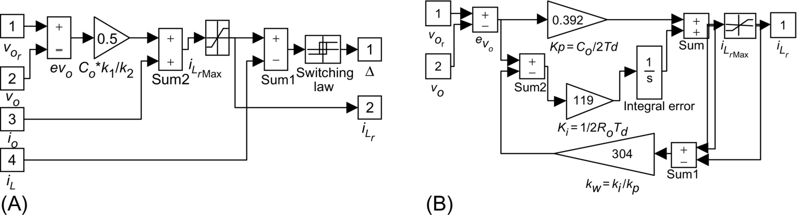

**FIG. 35.31** (A) Implementation of short-circuit-proof, sliding-mode output voltage controller (variable frequency) and (B) implementation of antiwindup PI current-mode (fixed frequency) controller.

The design of the compensator and the modulator is integrated with the same theoretical approach, since the signal  applied to a comparator generates the pulses for the power semiconductors drives. If the short-circuit-proof operation is built into the power semiconductor drives, there is the possibility to measure only the capacitor current (*iL*−*io*).

##### **Short-circuit protection and fixed-frequency operation of the power operational amplifier**

If we note that all the terms to the left of *iL* in Eq. [(35.112)](https://learning.oreilly.com/library/view/power-electronics-handbook/9780128114087/B9780128114070000398_2.xhtml#fo0600) represent the value of , a simple way to provide short-circuit protection is to bound the sum of all these terms ([Fig. 35.31A](https://learning.oreilly.com/library/view/power-electronics-handbook/9780128114087/B9780128114070000398_2.xhtml#f0160) with ). Alternatively, the output current controllers of [Fig. 35.28](https://learning.oreilly.com/library/view/power-electronics-handbook/9780128114087/B9780128114070000398_2.xhtml#f0145) can be used, comparing Eq. [(35.107)](https://learning.oreilly.com/library/view/power-electronics-handbook/9780128114087/B9780128114070000398_2.xhtml#fo0575) with Eq. [(35.112)](https://learning.oreilly.com/library/view/power-electronics-handbook/9780128114087/B9780128114070000398_2.xhtml#fo0600), to obtain . Therefore, the block diagram of [Fig. 35.31A](https://learning.oreilly.com/library/view/power-electronics-handbook/9780128114087/B9780128114070000398_2.xhtml#f0160) provides the  output (for *kp*=1) to be the input of the current controllers ([Figs. 35.28](https://learning.oreilly.com/library/view/power-electronics-handbook/9780128114087/B9780128114070000398_2.xhtml#f0145) and [35.31A](https://learning.oreilly.com/library/view/power-electronics-handbook/9780128114087/B9780128114070000398_2.xhtml#f0160)). As seen, the controllers of [Figs. 35.28B](https://learning.oreilly.com/library/view/power-electronics-handbook/9780128114087/B9780128114070000398_2.xhtml#f0145) and [35.30A](https://learning.oreilly.com/library/view/power-electronics-handbook/9780128114087/B9780128114070000398_2.xhtml#f0155) also ensure fixed-frequency operation.

For comparison purposes, a proportional-integral (PI) controller, with antiwindup ([Fig. 35.31B](https://learning.oreilly.com/library/view/power-electronics-handbook/9780128114087/B9780128114070000398_2.xhtml#f0160)) for output voltage control, was designed, supposing the current-mode control of the half bridge  considering a small delay *Td*) and a pure resistive load *Ro* and using the approach outlined in [Examples 35.6](https://learning.oreilly.com/library/view/power-electronics-handbook/9780128114087/B9780128114070000398_1.xhtml#en0035) and [35.8](https://learning.oreilly.com/library/view/power-electronics-handbook/9780128114087/B9780128114070000398_1.xhtml#en0045) (*kv*=1, *gm*=1, *ζ*2=0.5, and *Td*=600 μs). The obtained PI [(35.50)](https://learning.oreilly.com/library/view/power-electronics-handbook/9780128114087/B9780128114070000398_1.xhtml#fo0290) parameters are

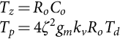 **(35.116)**

Both variable frequency ([Fig. 35.32](https://learning.oreilly.com/library/view/power-electronics-handbook/9780128114087/B9780128114070000398_2.xhtml#f0165)) and constant frequency ([Fig. 35.33](https://learning.oreilly.com/library/view/power-electronics-handbook/9780128114087/B9780128114070000398_2.xhtml#f0170)) sliding-mode output voltage controllers present excellent performance and robustness with nominal loads. With loads much higher than the nominal value ([Figs. 35.32B](https://learning.oreilly.com/library/view/power-electronics-handbook/9780128114087/B9780128114070000398_2.xhtml#f0165) and [35.33B](https://learning.oreilly.com/library/view/power-electronics-handbook/9780128114087/B9780128114070000398_2.xhtml#f0170)), the performance and robustness are also excellent. The sliding-mode constant-frequency PWM controller presents the additional advantage of injecting lower ripple in the load.



**FIG. 35.32** Performance of the power operational amplifier; response to a  step from −200 to 200 V at *t*=0.001 s and to a *VDC* step from 300 to 230 V at *t*=0.015 s: (A) variable-frequency sliding mode (nominal load) and (B) variable-frequency sliding mode (*Ro*×20).



**FIG. 35.33** Performance of the power operational amplifier; response to a  step from −200 to 200 V at *t*=0.001 s and to a *VDC* step from 300 to 230 V at *t*=0.015 s: (A) fixed-frequency sliding mode (nominal load) and (B) fixed-frequency sliding mode (*Ro*×20).

As expected, the PI regulator presents lower performance ([Fig. 35.34](https://learning.oreilly.com/library/view/power-electronics-handbook/9780128114087/B9780128114070000398_2.xhtml#f0175)). The response speed is lower, and the insensitivity to power supply and load variations ([Fig. 35.34B](https://learning.oreilly.com/library/view/power-electronics-handbook/9780128114087/B9780128114070000398_2.xhtml#f0175)) is not as high as with the sliding mode. Nevertheless, the PI performances are acceptable, since its design was carried considering a slow and fast manifold sliding-mode approach: the fixed-frequency sliding-mode current controller [(35.109)](https://learning.oreilly.com/library/view/power-electronics-handbook/9780128114087/B9780128114070000398_2.xhtml#fo0585) for the fast manifold (the *iL* current dynamics) and the antiwindup PI for the slow manifold (the *vo* voltage dynamics, usually much slower than the current dynamics).



**FIG. 35.34** Performance of the PI-controlled power operational amplifier; response to a  step from −200 to 200 V at *t*=0.001 s and to a *VDC* step from 300 to 230 V at *t*=0.015 s: (A) PI current-mode controller (nominal load) and (B) PI current-mode controller (*Ro*×20).

#### **35.3.5.2 Example 35.12: Constant-Frequency Sliding-Mode Control of *p* Pulse Parallel Rectifiers**

This example presents a new paradigm to the control of thyristor rectifiers. Since *p* pulse rectifiers are variable-structure systems, sliding-mode control is applied here to 12-pulse rectifiers, still useful for very high-power applications [[3](https://learning.oreilly.com/library/view/power-electronics-handbook/9780128114087/B9780128114070000398_5.xhtml#bb0020)]. The design determines the variables to be measured, and the controlled rectifier presents robustness and much shorter response times, even with the parameter uncertainty, perturbations, noise, and nonmodeled dynamics. These performances are not feasible using linear controllers, obtained here for comparison purposes.

##### **Modeling the 12-pulse parallel rectifier**

The 12-pulse rectifier ([Fig. 35.35A](https://learning.oreilly.com/library/view/power-electronics-handbook/9780128114087/B9780128114070000398_2.xhtml#f0180)) is built with four three-phase half-wave rectifiers, connected in parallel with current-sharing inductances *l* and *l*′ merged with capacitors *C*′ and *C*2, to obtain a second-order LC filter. This allows low-ripple output voltage and continuous mode of operation (laboratory model with *l*=44 mH, *l*′=13 mH, *C*′=*C*2=10 mF, star-delta-connected ac sources with *ERMS*≈65 V, and power rating 2.2 kW, load approximately resistive *Ro*≈3–5 Ω).



**FIG. 35.35** (A) Twelve-pulse rectifier with interphase reactors and intermediate capacitors, (B) rectifier model neglecting the half-wave rectifier dynamics, and (C) low-order averaged equivalent circuit for the 12-pulse rectifier with the resulting output double LC filter.

To control the output voltage *vc*2, given the complexity of the whole system, the best approach is to derive a low-order model. By averaging the four half-wave rectifiers, neglecting the rectifier dynamics and mutual couplings, the equivalent circuit of [Fig. 35.35B](https://learning.oreilly.com/library/view/power-electronics-handbook/9780128114087/B9780128114070000398_2.xhtml#f0180) is obtained (*l*1=*l*2=*l*3=*l*4=*l*, *l*5=*l*6=*l*′, and *C*11=*C*12=*C*′). Since the rectifiers are identical, the equivalent 12-pulse rectifier model of [Fig. 35.35C](https://learning.oreilly.com/library/view/power-electronics-handbook/9780128114087/B9780128114070000398_2.xhtml#f0180) is derived, simplifying the resulting parallel associations (*L*1=*l*/4, *L*2=*l*/2, and *C*1=2*C*′).

Considering the load current *io* as an external perturbation and *vi* the control input, the state-space model of the equivalent circuit of [Fig. 35.35C](https://learning.oreilly.com/library/view/power-electronics-handbook/9780128114087/B9780128114070000398_2.xhtml#f0180) is

 **(35.117)**

##### **Sliding-mode control of the 12-pulse parallel rectifier**

Since the output voltage  of the system must follow the reference , the system equations in the phase canonical (or controllability) form must be written, using the error  and its time derivatives as new state error variables, as done in Example 35.11:

 **(35.118)**

The sliding surface , designed to reduce the system order, is a linear combination of all the phase canonical state variables. Considering Eqs. [(35.118)](https://learning.oreilly.com/library/view/power-electronics-handbook/9780128114087/B9780128114070000398_2.xhtml#fo0630) and [(35.117)](https://learning.oreilly.com/library/view/power-electronics-handbook/9780128114087/B9780128114070000398_2.xhtml#fo0625) and the errors , *eθ*, *eγ*, and *eβ*, the sliding surface can be expressed as a combination of the rectifier currents, voltages, and their time derivatives:

 **(35.119)**

Eq. [(35.119)](https://learning.oreilly.com/library/view/power-electronics-handbook/9780128114087/B9780128114070000398_2.xhtml#fo0635) shows the variables to be measured . Therefore, it can be concluded that the output current of each three-phase half-wave rectifier must be measured.

The existence of the sliding mode implies  and . Given the state models [(35.117)](https://learning.oreilly.com/library/view/power-electronics-handbook/9780128114087/B9780128114070000398_2.xhtml#fo0625) and [(35.118)](https://learning.oreilly.com/library/view/power-electronics-handbook/9780128114087/B9780128114070000398_2.xhtml#fo0630) and from , the available voltage of the power supply *vi* must exceed the equivalent average dc input voltage *Veq* [(35.120)](https://learning.oreilly.com/library/view/power-electronics-handbook/9780128114087/B9780128114070000398_2.xhtml#fo0640), which should be applied at the filter input, in order that the system state slides along the sliding surface [(35.119)](https://learning.oreilly.com/library/view/power-electronics-handbook/9780128114087/B9780128114070000398_2.xhtml#fo0635):

 **(35.120)**

This means that the power supply root mean square (RMS) voltage values should be chosen high enough to account for the maximum effects of the perturbations. This is almost the same criterion adopted when calculating the RMS voltage values needed with linear controllers. However, as the *Veq* voltage contains the derivatives of the reference voltage, the system will not be able to stay in sliding mode with a step as the reference.

The switching law would be derived, considering that, from Eq. [(35.97)](https://learning.oreilly.com/library/view/power-electronics-handbook/9780128114087/B9780128114070000398_2.xhtml#fo0630), *be*(**e**)*>*0. Therefore, from Eq. [(35.119)](https://learning.oreilly.com/library/view/power-electronics-handbook/9780128114087/B9780128114070000398_2.xhtml#fo0525), if , then , else if , then . However, because of the lack of gate turn-off capability of the rectifier thyristors, power rectifiers cannot generate the high-frequency switching voltage *vi*(*t*), since the statistical mean delay time is *T*/2*p* (*T*=20 ms) and reaches *T*/2 when switching from  to . To control mains switched rectifiers, the described constant-frequency sliding-mode operation method is used, in which the sliding surface  instead of being compared with zero is compared with an auxiliary constant-frequency function *r*(*t*) ([Fig. 35.6B](https://learning.oreilly.com/library/view/power-electronics-handbook/9780128114087/B9780128114070000398_1.xhtml#f0035)) synchronized with the mains frequency. The new switching law is

 **(35.121)**

Since now  is not near zero, but around some value of *r*(*t*), a steady-state error  appears , as seen in Example 35.11. Increasing the value of *kp* (toward the ideal saturation control) does not overcome this drawback, since oscillations would appear even for moderate *kp* gains, because of the rectifier dynamics. Instead, the sliding surface [(35.122)](https://learning.oreilly.com/library/view/power-electronics-handbook/9780128114087/B9780128114070000398_2.xhtml#fo0650), based on Eq. [(35.99)](https://learning.oreilly.com/library/view/power-electronics-handbook/9780128114087/B9780128114070000398_2.xhtml#fo0535), should be used. It contains an integral term, which, given the canonical controllability form and the Routh-Hurwitz property, is the only nonzero term at steady state, enabling the complete elimination of the steady-state error:

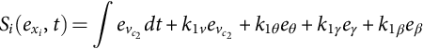 **(35.122)**

To determine the *k* constants of Eq. [(35.122)](https://learning.oreilly.com/library/view/power-electronics-handbook/9780128114087/B9780128114070000398_2.xhtml#fo0650), a pole-placement technique is selected, according to a fourth-order Bessel polynomial *BE*(*s*)*m*, *m*=4, from Eq. [(35.88)](https://learning.oreilly.com/library/view/power-electronics-handbook/9780128114087/B9780128114070000398_2.xhtml#fo0480), in order to obtain the smallest possible response time with almost no overshoot. For a delay characteristic as flat as possible, the delay *tr* is taken inversely proportional to a frequency *fci* just below the lowest cutoff frequency (*fci<*8.44 Hz) of the double LC filter. For this fourth-order filter, the delay is *tr*=2.8/(2*πfci*). By choosing *fci*=7 Hz (*tr*≈64 ms) and dividing all the Bessel polynomial terms by *str*, the characteristic polynomial [(35.123)](https://learning.oreilly.com/library/view/power-electronics-handbook/9780128114087/B9780128114070000398_2.xhtml#fo0655) is obtained:

 **(35.123)**

This polynomial must be applied to Eq. [(35.122)](https://learning.oreilly.com/library/view/power-electronics-handbook/9780128114087/B9780128114070000398_2.xhtml#fo0650) to obtain the four sliding functions needed to derive the thyristor trigger pulses of the four three-phase half-wave rectifiers. These sliding functions will enable the control of the output current  of each half-wave rectifier, improving the current sharing among them ([Fig. 35.35B](https://learning.oreilly.com/library/view/power-electronics-handbook/9780128114087/B9780128114070000398_2.xhtml#f0180)). Supposing equal current share, the relation between the  current and the output currents of each three-phase rectifier is . Therefore, for the *n*th half-wave three-phase rectifier, since, for *n*=1 and *n*=2,  and  and, for *n*=3 and *n*=4,  and , the four sliding surfaces are (*k*1*v*=1)

 **(35.124)**

If an inexpensive analog controller is desired, the successive time derivatives of the reference voltage and the output current of Eq. [(35.124)](https://learning.oreilly.com/library/view/power-electronics-handbook/9780128114087/B9780128114070000398_2.xhtml#fo0660) can be neglected (furthermore, their calculation is noise prone). Nonzero errors on the first-, second-, and third-order derivatives of the controlled variable will appear, worsening the response speed. However, the steady-state error is not affected.

To implement the four equations [(35.124)](https://learning.oreilly.com/library/view/power-electronics-handbook/9780128114087/B9780128114070000398_2.xhtml#fo0660), the variables  must be measured. Although this could be done easily, it is very convenient to further simplify the practical controller, keeping its complexity and cost at the level of linear controllers, while maintaining the advantages of sliding mode. Therefore, the voltages  are assumed almost constant over one period of the filter input current, and , meaning that . With these assumptions, valid as the values of *C*′ and *C*2 are designed to provide an output voltage with very low ripple, the new sliding-mode functions are

 **(35.125)**

These approximations disregard only the high-frequency content of  and do not affect the rectifier steady-state response, but the step response will be a little slower, although still much faster (150 ms, [Fig. 35.39](https://learning.oreilly.com/library/view/power-electronics-handbook/9780128114087/B9780128114070000398_3.xhtml#f0200)) than that obtained with linear controllers (280 ms, [Fig. 35.38](https://learning.oreilly.com/library/view/power-electronics-handbook/9780128114087/B9780128114070000398_3.xhtml#f0195)). Regardless of all the approximations, the low switching frequency of the rectifier would not allow the elimination of the dynamic errors. As a benefit of these approximations, the sliding-mode controller ([Fig. 35.36A](https://learning.oreilly.com/library/view/power-electronics-handbook/9780128114087/B9780128114070000398_2.xhtml#f0185)) will need only an extra current sensor (or a current observer) and an extra operational amplifier in comparison with linear controllers derived hereafter (which need four current sensors and six operational amplifiers). Compared with the total cost of the 12-pulse rectifier plus output filter, the control hardware cost is negligible in both cases, even for medium-power applications.



**FIG. 35.36** (A) Sliding-mode controller block diagram and (B) linear control hierarchy for the 12-pulse rectifier.

##### **Average current-mode control of the 12-pulse rectifier**

For comparison purposes, a PI-based controller structure is designed ([Fig. 35.36B](https://learning.oreilly.com/library/view/power-electronics-handbook/9780128114087/B9780128114070000398_2.xhtml#f0185)), taking into account that small mismatches of the line voltages or of the trigger angles can completely destroy the current share of the four paralleled rectifiers, in spite of the current equalizing inductances (*l* and *l*′). Output voltage control sensing only the output voltage is, therefore, not feasible. Instead, the slow and fast manifold approach is selected. For the fast manifold, four internal current control loops guarantee the same dc current level in each three-phase rectifier and limit the short-circuit currents. For the output slow dynamics, an external cascaded output voltage control loop ([Fig. 35.36B](https://learning.oreilly.com/library/view/power-electronics-handbook/9780128114087/B9780128114070000398_2.xhtml#f0185)), measuring the voltage applied to the load, is the minimum.

For a straightforward design, given the much slower dynamics of the capacitor voltages compared with the input current, the PI current controllers are calculated as shown in [Example 35.6](https://learning.oreilly.com/library/view/power-electronics-handbook/9780128114087/B9780128114070000398_1.xhtml#en0035), considering the capacitor voltage constant during a switching period and *rt*≈1 Ω the intrinsic resistance of the transformer windings, thyristor overlap, and inductor *l*. From Eq. [(35.59)](https://learning.oreilly.com/library/view/power-electronics-handbook/9780128114087/B9780128114070000398_1.xhtml#fo0335), *Tz*=*l*/*rt*≈0.044 s. From Eq. [(35.62)](https://learning.oreilly.com/library/view/power-electronics-handbook/9780128114087/B9780128114070000398_1.xhtml#fo0350), with the common assumptions, *Tp*≈0.16 *kI* s (*p*=3). These values guarantee a small overshoot (≈5%) and a current rise time of approximately *T*/3.

To design the external output voltage control loop, each current-controlled rectifier can be considered a voltage-controlled current source , since each half-wave rectifier current response will be much faster than the filter output voltage response. Therefore, in the equivalent circuit of [Fig. 35.35B](https://learning.oreilly.com/library/view/power-electronics-handbook/9780128114087/B9780128114070000398_2.xhtml#f0180), the current source  substitutes the input inductor, yielding the transfer function :

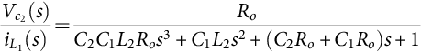 **(35.126)**

Given the real pole (*p*1=−6.7) and two complex poles (*p*2,3=−6.65±j140.9) of Eq. [(35.126)](https://learning.oreilly.com/library/view/power-electronics-handbook/9780128114087/B9780128114070000398_3.xhtml#fo0670), the PI voltage controller zero (1/*Tzv*=*p*1) can be chosen with a value equal to the transfer function real pole. The integral gain *Tpv* can be determined using a root-locus analysis to determine the maximum gain that still guarantees the stability of the closed-loop controlled system. The critical gain for the PI was found to be *Tzv*/*Tpv*≈0.4 and then *Tpv>*0.37. The value *Tpv*≈2 was selected to obtain weak oscillations, together with almost no overshoot.

The dynamic and steady-state responses of the output currents of the four rectifiers  and the output voltage  were analyzed using a step input from 2 to 2.5 A applied at *t*=1.1 s, for the currents, and from 40 to 50 V for the  voltage. The PI current controllers ([Fig. 35.37](https://learning.oreilly.com/library/view/power-electronics-handbook/9780128114087/B9780128114070000398_3.xhtml#f0190)) show good sharing of the total current, slight overshoot (*ζ*=0.7), and response time 6.6 ms (*T*/*p*).

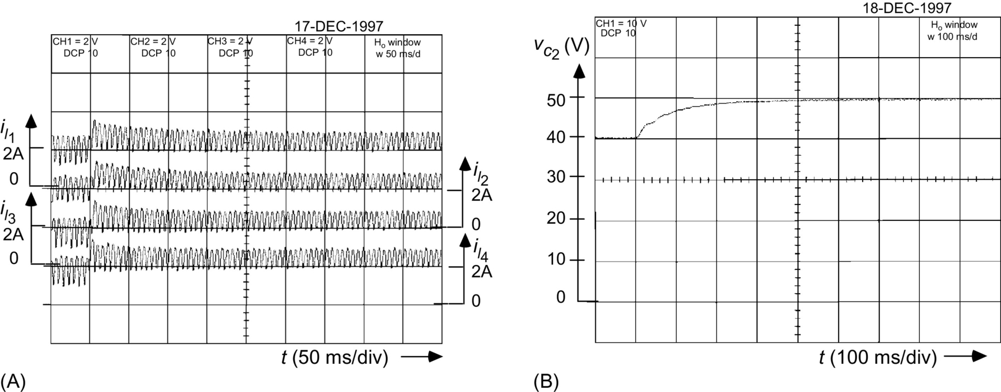

**FIG. 35.37** PI current controller performance: (A)  closed-loop currents and (B) open-loop output voltage .

The open-loop voltage  presents a rise time of 0.38 s. The PI voltage controller ([Fig. 35.38](https://learning.oreilly.com/library/view/power-electronics-handbook/9780128114087/B9780128114070000398_3.xhtml#f0195)) shows a response time of 0.4 s, no overshoot. The four three-phase half-wave rectifier output currents  present nearly the same transient and steady-state values, with no very high current peaks. These results validate the assumptions made in the PI design.

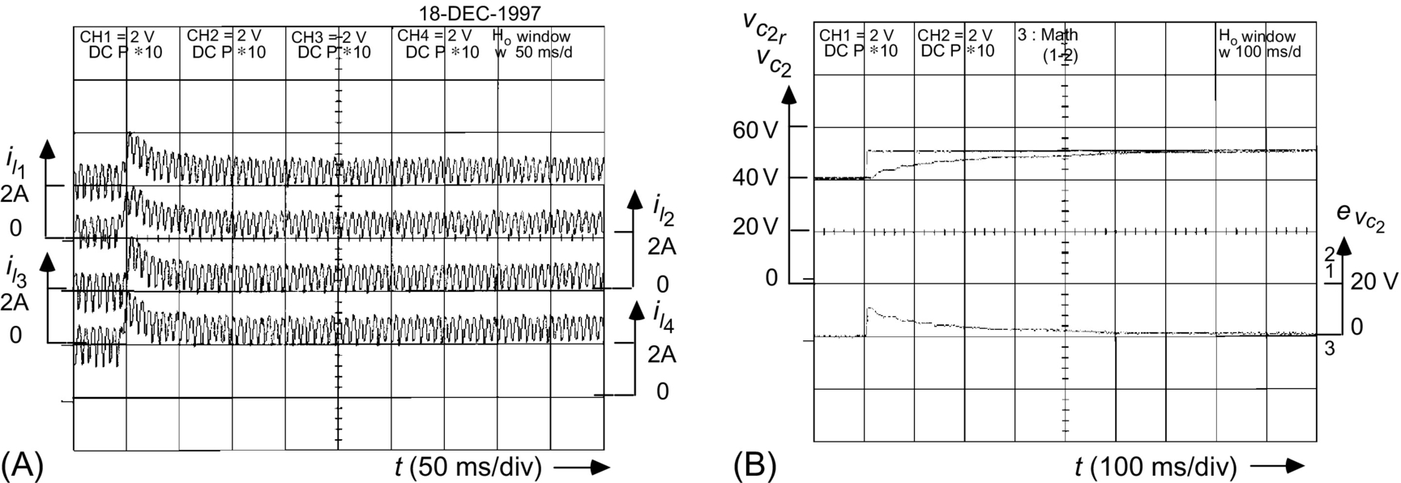

**FIG. 35.38** PI voltage controller performance: (A)  closed-loop currents and (B) closed output voltage  and  output voltage error.

The closed-loop performance of the fixed-frequency sliding-mode controller ([Fig. 35.39](https://learning.oreilly.com/library/view/power-electronics-handbook/9780128114087/B9780128114070000398_3.xhtml#f0200)) shows that all the  currents are almost equal and have peak values only slightly higher than those obtained with the PI linear controllers. The output voltage presents a much faster response time (150 ms) than the PI linear controllers, negligible or no steady-state error, and no overshoot. From these waveforms, it can be concluded that the sliding-mode controller provides a much more effective control of the rectifier, as the output voltage response time is much lower than the obtained with PI linear controllers, without significantly increasing the thyristor currents, overshoots, or costs. Furthermore, sliding mode is an elegant way to know the variables to be measured and to design all the controller and the modulator electronics.

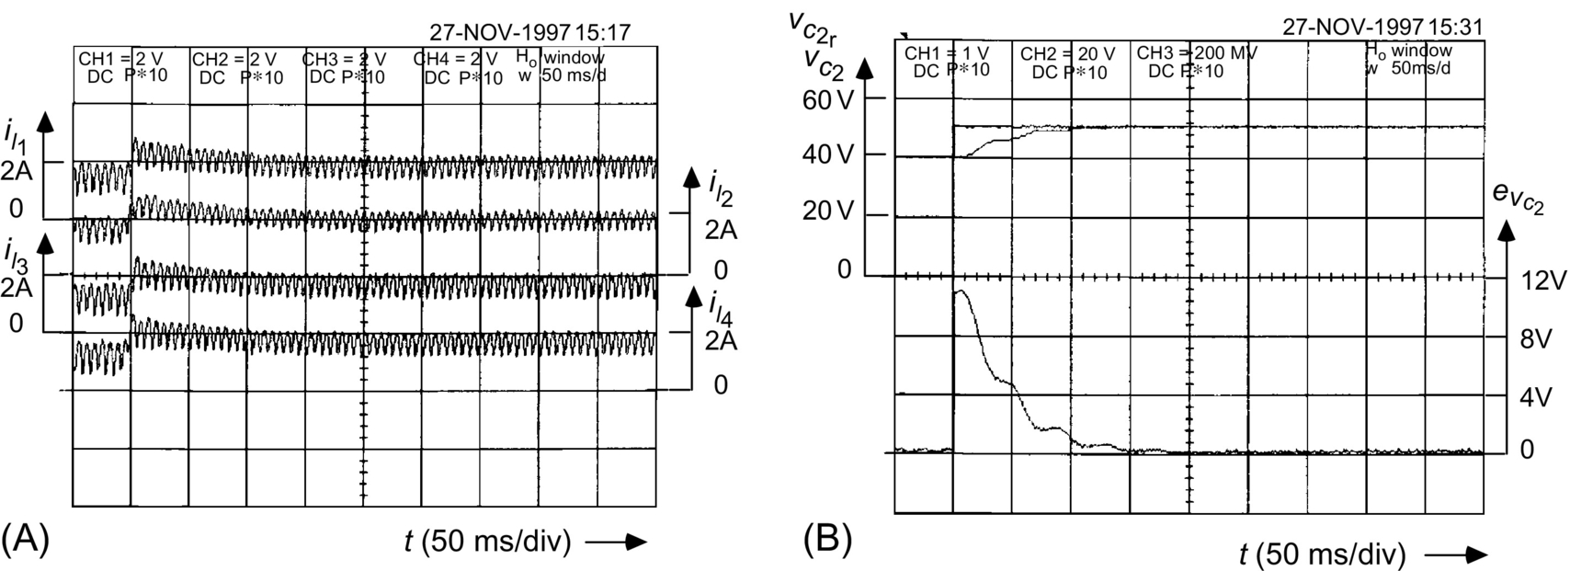

**FIG. 35.39** Closed-loop constant-frequency sliding-mode controller performance: (A)  closed-loop currents and (B) closed output voltage  and  output voltage error.

#### **35.3.5.3 Example 35.13: Sliding-Mode Control of Pulse Width Modulation Audio Power Amplifiers**

Linear audio power amplifiers can be astonishing but have efficiencies as low as 15%–20% with speech or music signals. To improve the efficiency of audio systems while preserving the quality, PWM switching power amplifiers, enabling the reduction of the power supply cost, volume, and weight and compensating the efficiency loss of modern loudspeakers, are needed. Moreover, PWM amplifiers can provide a complete digital solution for audio power processing.

For high-fidelity systems, PWM audio amplifiers must present flat passbands of at least 16–20 kHz (±0.5 dB), distortions less than 0.1% at the rated output power, fast dynamic response, and signal-to-noise ratios above 90 dB. This requires fast power semiconductors (usually metal-oxide-semiconductor field-effect transistor (MOSFET) transistors), capable of switching at frequencies near 500 kHz, and fast nonlinear controllers to provide the precise and timely control actions needed to accomplish the mentioned requirements and to eliminate the phase delays in the LC output filter and loudspeakers.

A low-cost PWM audio power amplifier, able to provide over 80 W to 8 Ω loads (*Vdd*=50 V), can be obtained using a half-bridge power inverter (switching at *fPWM*≈450 kHz), coupled to an output filter for high-frequency attenuation ([Fig. 35.40](https://learning.oreilly.com/library/view/power-electronics-handbook/9780128114087/B9780128114070000398_3.xhtml#f0205)). A low-sensitivity, doubly terminated passive ladder (double LC), low-pass filter using fourth-order Chebyshev approximation polynomials is selected, given its ability to meet, while minimizing the number of inductors, the following requirements: passband edge frequency 21 kHz, passband ripple 0.5 dB, stopband edge frequency 300 kHz, and 90 dB minimum attenuation in the stopband (*L*1=80 μH, *L*2=85 μH, *C*1=1.7 μF, *C*2=820 nF, *R*2=8 Ω, and *r*1=0.47 Ω).

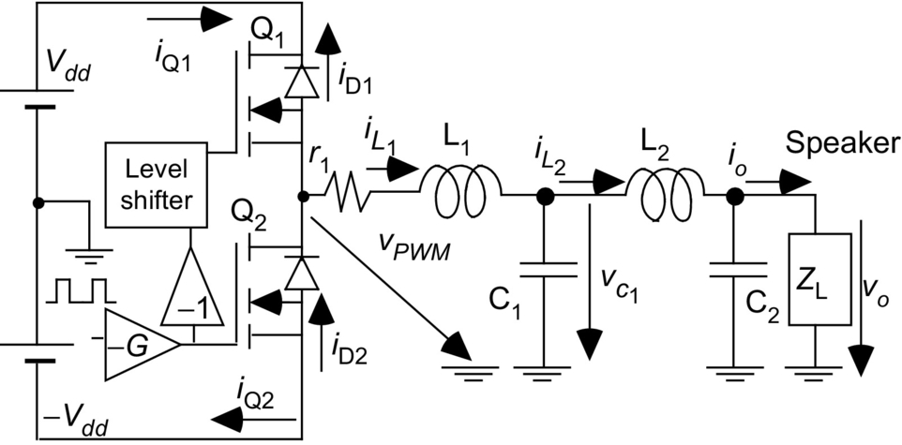

**FIG. 35.40** PWM audio amplifier with fourth-order Chebyshev low-pass output filter and loudspeaker load.

##### **Modeling the PWM audio amplifier**

The two half-bridge switches must always be in complementary states, to avoid power supply internal short circuits. Their state can be represented by the time-dependent variable *γ*, which is *γ*=1 when Q1 is on and Q2 is off, and is *γ*=−1 when Q1 is off and Q2 is on.

Neglecting switch delays, on-state semiconductor voltage drops, and auxiliary networks and supposing small dead times, the half-bridge output voltage (*vPWM*) is *vPWM*=*γVdd*. Considering the state variables and circuit components of [Fig. 35.40](https://learning.oreilly.com/library/view/power-electronics-handbook/9780128114087/B9780128114070000398_3.xhtml#f0205) and modeling the loudspeaker load as a disturbance represented by the current *io* (ensuring robustness to the frequency -dependent impedance of the speaker), the switched state-space model of the PWM audio amplifier is

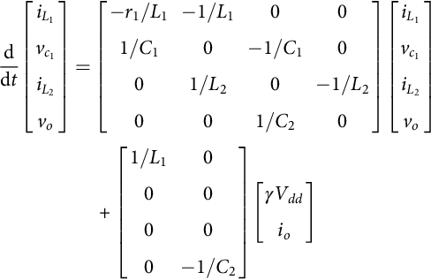 **(35.127)**

This model will be used to define the output voltage *vo* controller.

##### **Sliding-mode control of the PWM audio amplifier**

The filter output voltage *vo*, divided by the amplifier gain (1/*kv*), must follow a reference . Defining the output error as  and also using its time derivatives (*eθ*, *eγ*, and *eβ*) as a new state vector , the system equations, in the phase canonical (or controllability) form, can be written in the form

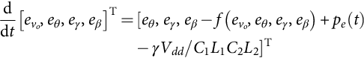 **(35.128)**

Sliding-mode control of the output voltage will enable a robust and reduced-order dynamics, independent of semiconductors, power supply, filter, and load parameters. According to Eqs. [(35.91)](https://learning.oreilly.com/library/view/power-electronics-handbook/9780128114087/B9780128114070000398_2.xhtml#fo0495) and [(35.128)](https://learning.oreilly.com/library/view/power-electronics-handbook/9780128114087/B9780128114070000398_3.xhtml#fo0680), the sliding surface is

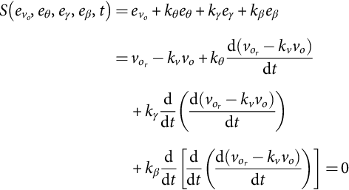 **(35.129)**

In sliding mode, Eq. [(35.129)](https://learning.oreilly.com/library/view/power-electronics-handbook/9780128114087/B9780128114070000398_3.xhtml#fo0685) confirms the amplifier gain . To obtain a stable system and the smallest possible response time *tr*, a pole placement according to a third-order Bessel polynomial is used. Taking *tr* inversely proportional to a frequency just below the lowest cutoff frequency (*ω*1) of the double LC filter (*tr*≈2.8/*ω*1≈2.8/(2*π*×21 kHz)≈20 μs) and using Eq. [(35.88)](https://learning.oreilly.com/library/view/power-electronics-handbook/9780128114087/B9780128114070000398_2.xhtml#fo0480) with *m*=3, the characteristic polynomial Eq. [(35.130)](https://learning.oreilly.com/library/view/power-electronics-handbook/9780128114087/B9780128114070000398_3.xhtml#fo0690), verifying the Routh-Hurwitz criterion, is obtained:

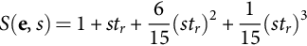 **(35.130)**

From Eq. [(35.97)](https://learning.oreilly.com/library/view/power-electronics-handbook/9780128114087/B9780128114070000398_2.xhtml#fo0525), the switching law for the control input at time *tk*, *γ*(*tk*), must be

 **(35.131)**

To ensure reaching and existence conditions, the power supply voltage *Vdd* must be greater than the maximum required mean value of the output voltage in a switching period . The sliding-mode controller ([Fig. 35.41](https://learning.oreilly.com/library/view/power-electronics-handbook/9780128114087/B9780128114070000398_3.xhtml#f0210)) is obtained from Eqs. [(35.129)](https://learning.oreilly.com/library/view/power-electronics-handbook/9780128114087/B9780128114070000398_3.xhtml#fo0685)–[(35.131)](https://learning.oreilly.com/library/view/power-electronics-handbook/9780128114087/B9780128114070000398_3.xhtml#fo0695) with *kθ*=*tr*, . The derivatives can be approximated by the block diagram of [Fig. 35.41B](https://learning.oreilly.com/library/view/power-electronics-handbook/9780128114087/B9780128114070000398_3.xhtml#f0210), where *h* is the oversampling period.

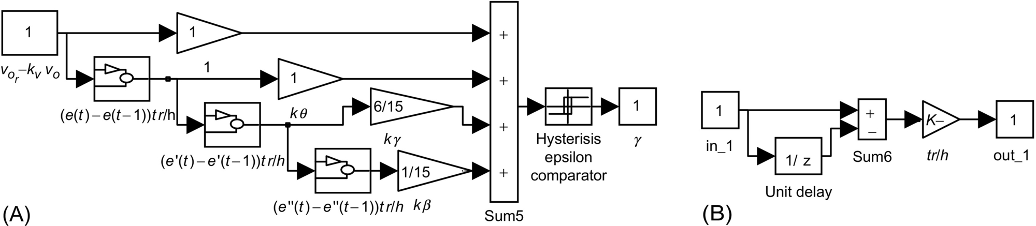

**FIG. 35.41** (A) Sliding-mode controller for the PWM audio amplifier and (B) implementation of the derivative blocks.

[Fig. 35.42A](https://learning.oreilly.com/library/view/power-electronics-handbook/9780128114087/B9780128114070000398_3.xhtml#f0215) shows the *vPWM*, , *vo*/10, and error  waveforms for a 20 kHz sine input. The overall behavior is much better than the obtained with the sigma-delta controllers ([Figs. 35.43](https://learning.oreilly.com/library/view/power-electronics-handbook/9780128114087/B9780128114070000398_3.xhtml#f0220) and [35.44](https://learning.oreilly.com/library/view/power-electronics-handbook/9780128114087/B9780128114070000398_3.xhtml#f0225)) explained below for comparison purposes. There is no 0.5 dB loss or phase delay over the entire audio band; the Chebyshev filter behaves as a maximally flat filter, with higher stopband attenuation. [Fig. 35.42B](https://learning.oreilly.com/library/view/power-electronics-handbook/9780128114087/B9780128114070000398_3.xhtml#f0215) shows *vPWM*, , and  with a 1 kHz square input. There is almost no steady-state error and almost no overshoot on the speaker voltage *vo*, attesting to the speed of response (*t*≈20 μs as designed, since, in contrast to Example 35.12, no derivatives were neglected). The stability, the system order reduction, and the sliding-mode controller usefulness for the PWM audio amplifier are also shown.

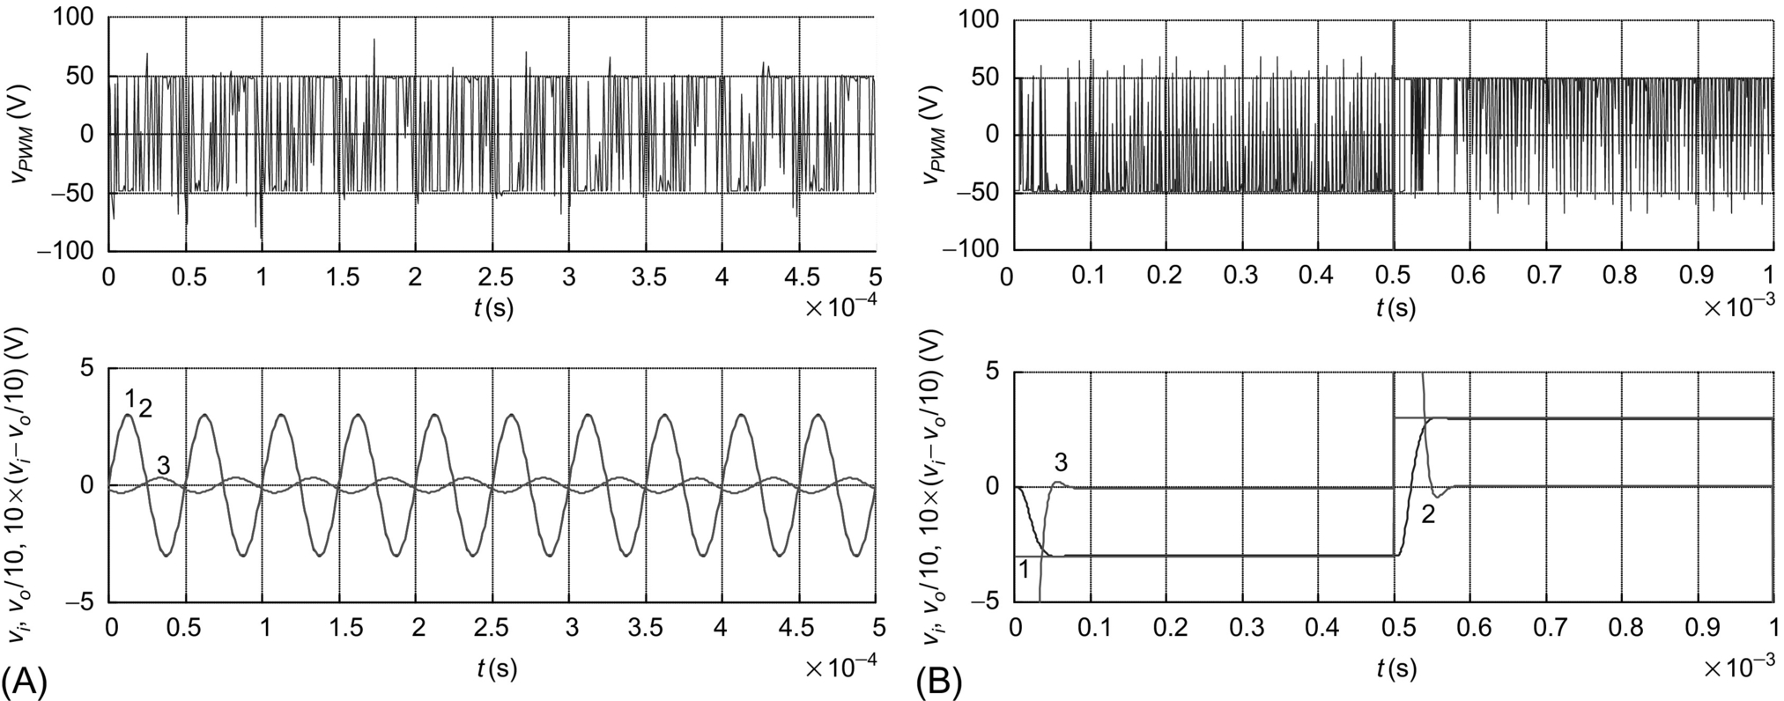

**FIG. 35.42** Sliding-mode-controlled audio power amplifier performance (upper graphs show *vPWM*, lower graphs trace 1 show , lower graphs trace 2 show *vo*/10, and lower graphs trace 3 show ): (A) response to a 20 kHz sine input, at 55 W output power, and (B) response to 1 kHz square wave input, at 100 W output power.

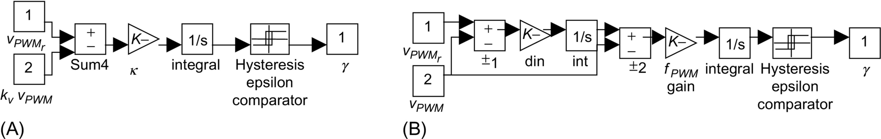

**FIG. 35.43** (A) First-order sigma-delta modulator and (B) second-order sigma-delta modulator.

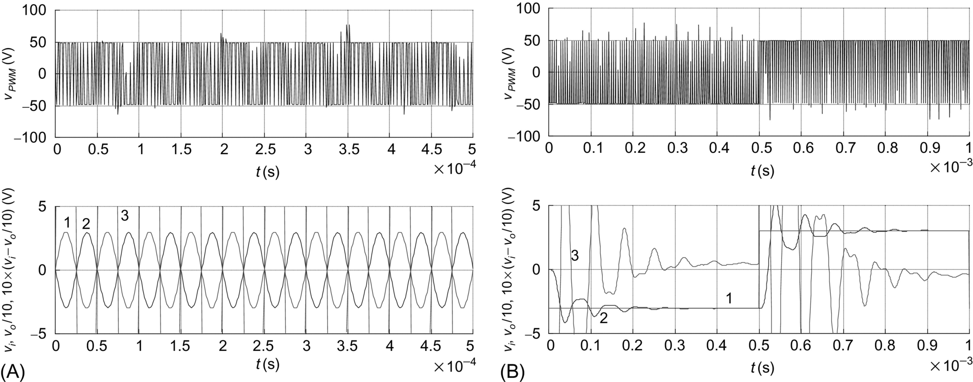

**FIG. 35.44** First-order sigma-delta audio amplifier performance (upper graphs show *vPWM*, lower graphs trace 1 show , lower graphs trace 2 shows *vo*/10, and lower graphs trace 3 show ): (A) response to a 20 kHz sine input, at 55 W output power, and (B) response to 1 kHz square wave input, at 100 W output power.

##### **Sigma delta controlled PWM audio amplifier**

Assume now the fourth-order Chebyshev low-pass filter, as an ideal filter removing the high-frequency content of the *vPWM* voltage. Then, the *vPWM* voltage can be considered as the amplifier output. However, the discontinuous voltage *vPWM*=*γVdd* is not a state variable and cannot follow the almost continuous reference . The new error variable  is always far from the zero value. Given this nonzero error, the approach outlined in [Section 35.3.4](https://learning.oreilly.com/library/view/power-electronics-handbook/9780128114087/B9780128114070000398_2.xhtml#s0140) can be used. The switching law remains Eq. [(35.131)](https://learning.oreilly.com/library/view/power-electronics-handbook/9780128114087/B9780128114070000398_3.xhtml#fo0695), but the new control law Eq. [(35.132)](https://learning.oreilly.com/library/view/power-electronics-handbook/9780128114087/B9780128114070000398_3.xhtml#fo0700) is

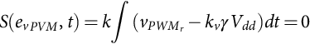 **(35.132)**

The *κ* parameter is calculated to impose the maximum switching frequency *fPWM*. Since , we obtain

 **(35.133)**

Assuming that  is nearly constant over the switching period 1/*fPWM*, Eq. [(35.132)](https://learning.oreilly.com/library/view/power-electronics-handbook/9780128114087/B9780128114070000398_3.xhtml#fo0700) confirms the amplifier gain, since .

Practical implementation of this control strategy can be done using an integrator with gain *κ* (*κ*≈1800) and a comparator with hysteresis *ɛ* (*ɛ*≈6 mV) ([Fig. 35.43A](https://learning.oreilly.com/library/view/power-electronics-handbook/9780128114087/B9780128114070000398_3.xhtml#f0220)). Such an arrangement is called a first-order sigma-delta (ΣΔ) modulator.

[Fig. 35.44A](https://learning.oreilly.com/library/view/power-electronics-handbook/9780128114087/B9780128114070000398_3.xhtml#f0225) shows the *vPWM*, *vor*, and *vo*/10 waveforms for a 20 kHz sine input. The overall behavior is as expected, because the practical filter and loudspeaker are not ideal, but notice the 0.5 dB loss and phase delay of the speaker voltage *vo*, mainly due to the output filter and speaker inductance. In [Fig. 35.44B](https://learning.oreilly.com/library/view/power-electronics-handbook/9780128114087/B9780128114070000398_3.xhtml#f0225), the *vPWM*, , *vo*/10, and error  for a 1 kHz square input are shown. Note the oscillations and steady-state error of the speaker voltage *vo*, due to the filter dynamics and double termination.

A second-order sigma-delta modulator is a better compromise between circuit complexity and signal-to-quantization noise ratio. As the switching frequency of the two power MOSFET ([Fig. 35.40](https://learning.oreilly.com/library/view/power-electronics-handbook/9780128114087/B9780128114070000398_3.xhtml#f0205)) cannot be further increased, the second-order structure named “cascaded integrators with feedback” ([Fig. 35.43B](https://learning.oreilly.com/library/view/power-electronics-handbook/9780128114087/B9780128114070000398_3.xhtml#f0220)) was selected and designed to eliminate the step response overshoot found in [Fig. 35.44B](https://learning.oreilly.com/library/view/power-electronics-handbook/9780128114087/B9780128114070000398_3.xhtml#f0225).

[Fig. 35.45A](https://learning.oreilly.com/library/view/power-electronics-handbook/9780128114087/B9780128114070000398_3.xhtml#f0230), for 1 kHz square input, shows much less overshoot and oscillations than [Fig. 35.44B](https://learning.oreilly.com/library/view/power-electronics-handbook/9780128114087/B9780128114070000398_3.xhtml#f0225). However, the *vPWM*, , and *vo*/10 waveforms, for a 20 kHz sine input presented in [Fig. 35.45B](https://learning.oreilly.com/library/view/power-electronics-handbook/9780128114087/B9780128114070000398_3.xhtml#f0230), show increased output voltage loss, compared to the first-order sigma-delta modulator, since the second-order modulator was designed to eliminate the *vo* output voltage ringing (therefore reducing the amplifier bandwidth). The obtained performances with these and other sigma-delta structures are inferior to the sliding-mode performances ([Fig. 35.42](https://learning.oreilly.com/library/view/power-electronics-handbook/9780128114087/B9780128114070000398_3.xhtml#f0215)). Sliding mode brings definite advantages as the system order is reduced, flatter passbands are obtained, power supply rejection ratio is increased, and the nonlinear effects, together with the frequency-dependent phase delays, are canceled out.

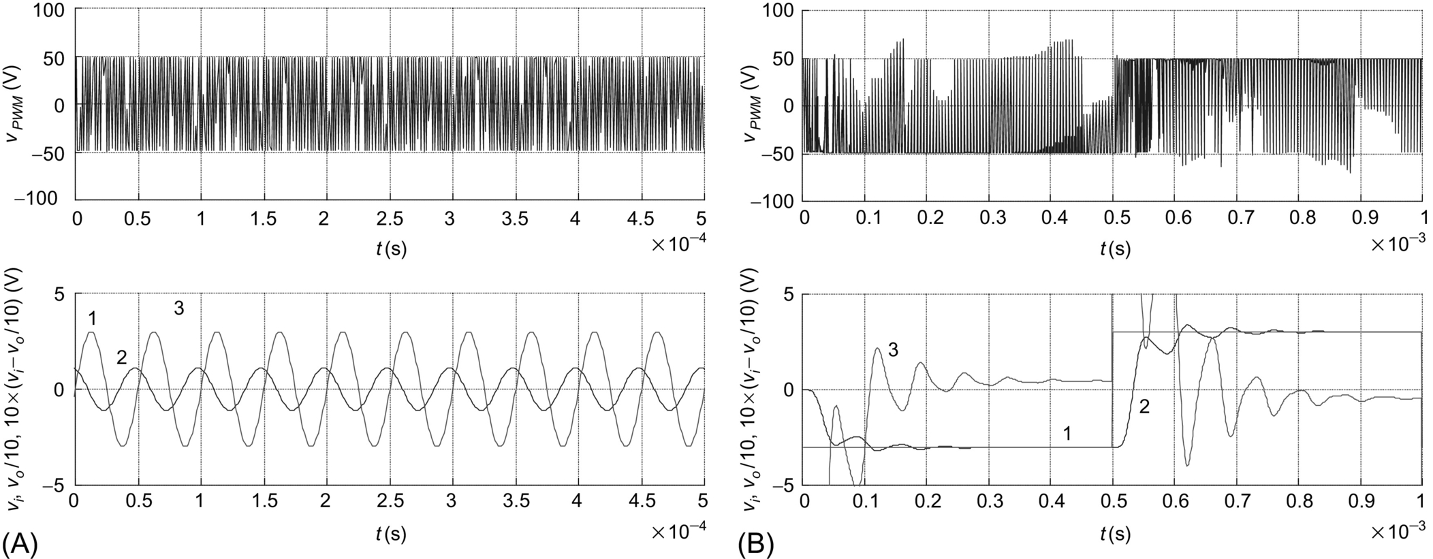

**FIG. 35.45** Second-order sigma-delta audio amplifier performance (upper graphs show *vPWM*, lower graphs trace 1 show , lower graphs trace 2 show *vo*/10, and lower graphs trace 3 show ): (A) response to 1 kHz square wave input, at 100 W output power, and (B) response to a 20 kHz sine input, at 55 W output power.

#### **35.3.5.4 Example 35.14: Sliding-Mode Control of Near Unity Power Factor PWM Three Phase Rectifiers**

Boost-type voltage-sourced three-phase rectifiers ([Fig. 35.46](https://learning.oreilly.com/library/view/power-electronics-handbook/9780128114087/B9780128114070000398_3.xhtml#f0235)) are multiple-input multiple-output (MIMO) systems capable of bidirectional power flow, near unity power factor operation, and almost sinusoidal input currents and can behave as ac/dc power supplies or power factor compensators.

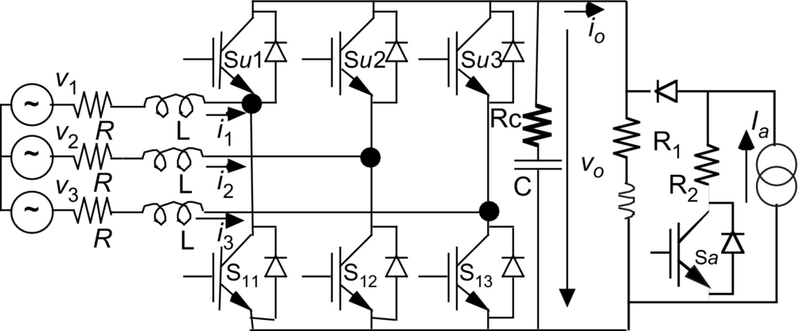

**FIG. 35.46** Voltage-sourced three-phase PWM rectifier with IGBTs and test load.

The fast power semiconductors used (usually MOSFETs or IGBTs) can switch at frequencies much higher than the mains frequency, enabling the voltage controller to provide an output voltage with fast dynamic response.

##### **Modeling the three phase PWM boost rectifier**

Neglecting switch delays and dead times, the states of the switches of the *k*th inverter leg ([Fig. 35.46](https://learning.oreilly.com/library/view/power-electronics-handbook/9780128114087/B9780128114070000398_3.xhtml#f0235)) can be represented by the time-dependent nonlinear variables *γk*, defined as

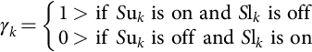 **(35.134)**

Consider the displayed variables of the circuit ([Fig. 35.46](https://learning.oreilly.com/library/view/power-electronics-handbook/9780128114087/B9780128114070000398_3.xhtml#f0235)), where *L* is the value of the boost inductors, *R* their resistance, *C* the value of the output capacitor, and *Rc* its equivalent series resistance (ESR). Neglecting semiconductor voltage drops, leakage currents, and auxiliary networks, the application of Kirchhoff laws (taking the load current *io* as a time-dependent perturbation) yields the following switched state-space model of the boost rectifier:

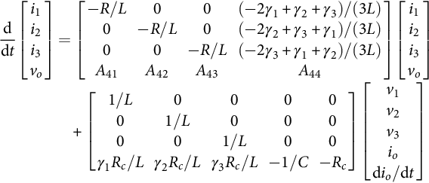 **(35.135)**

**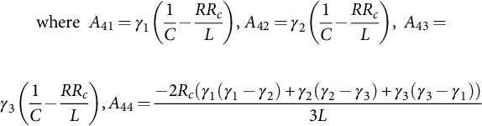**

Since the input voltage sources have no neutral connection, the preceding model can be simplified, eliminating one equation. Using the relationship [(35.136)](https://learning.oreilly.com/library/view/power-electronics-handbook/9780128114087/B9780128114070000398_3.xhtml#fo0725) between the fixed frames *x*1, 2, 3, and *xα*,*β*, in Eq. [(35.135)](https://learning.oreilly.com/library/view/power-electronics-handbook/9780128114087/B9780128114070000398_3.xhtml#fo0715), the state-space model [(35.137)](https://learning.oreilly.com/library/view/power-electronics-handbook/9780128114087/B9780128114070000398_3.xhtml#fo0730), in the *α*,*β* frame, is obtained:

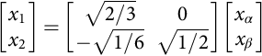 **(35.136)**

**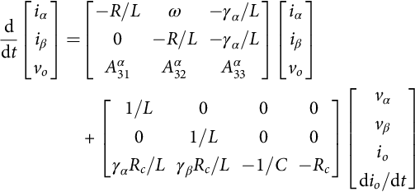** **(35.137)**

**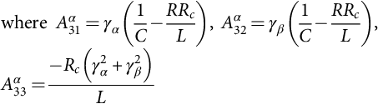**

##### **Sliding-mode control of the PWM rectifier**

The model [(35.137)](https://learning.oreilly.com/library/view/power-electronics-handbook/9780128114087/B9780128114070000398_3.xhtml#fo0730) is nonlinear and time-variant. Applying the Park transformation [(35.138)](https://learning.oreilly.com/library/view/power-electronics-handbook/9780128114087/B9780128114070000398_3.xhtml#fo0740), using a frequency *ω* rotating reference frame synchronized with the mains (with the *q* component of the supply voltages equal to zero), the nonlinear, time-invariant model [(35.139)](https://learning.oreilly.com/library/view/power-electronics-handbook/9780128114087/B9780128114070000398_3.xhtml#fo0745) is written as

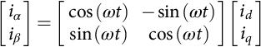 **(35.138)**

**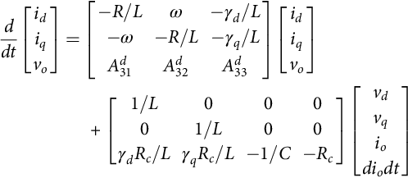** **(35.139)**

**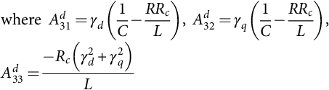**

This state-space model can be used to obtain the feedback controllers for the PWM boost rectifier. Considering the output voltage *vo* and the *iq* current as the controlled outputs and *γd* and *γq* the control inputs (MIMO system), the input-output linearization of Eq. [(35.72)](https://learning.oreilly.com/library/view/power-electronics-handbook/9780128114087/B9780128114070000398_2.xhtml#fo0400) gives the state-space equations in the controllability canonical form [(35.140)](https://learning.oreilly.com/library/view/power-electronics-handbook/9780128114087/B9780128114070000398_3.xhtml#fo0760):

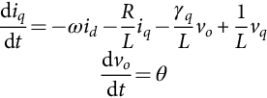

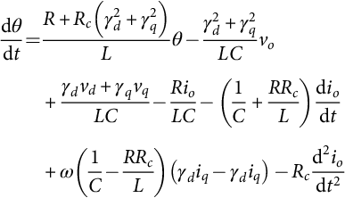 **(35.140)**

where

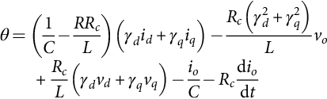

Using the rectifier overall power balance (from Tellegen's theorem, the converter is conservative, i.e., the power delivered to the load or dissipated in the converter intrinsic devices equals the input power) and neglecting the switching and output capacitor losses, . Supposing unity power factor (*iqr*≈0) and the output *vo* at steady state, 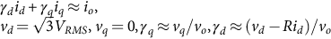. Then, from Eqs. [(35.140)](https://learning.oreilly.com/library/view/power-electronics-handbook/9780128114087/B9780128114070000398_3.xhtml#fo0760) and [(35.91)](https://learning.oreilly.com/library/view/power-electronics-handbook/9780128114087/B9780128114070000398_2.xhtml#fo0495), the following two sliding surfaces can be derived:

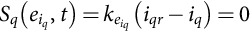 **(35.141)**

**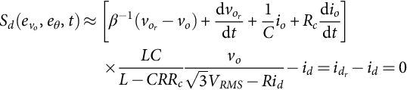** **(35.142)**

where *β*−1 is the time constant of the desired first-order response of output voltage *vo* (*β*≫*T>*0). For the synthesis of the closed-loop control system, notice that the terms of Eq. [(35.142)](https://learning.oreilly.com/library/view/power-electronics-handbook/9780128114087/B9780128114070000398_3.xhtml#fo0775) inside the square brackets can be assumed as the *id* reference current . Furthermore, from Eqs. [(35.141)](https://learning.oreilly.com/library/view/power-electronics-handbook/9780128114087/B9780128114070000398_3.xhtml#fo0770) and [(35.142)](https://learning.oreilly.com/library/view/power-electronics-handbook/9780128114087/B9780128114070000398_3.xhtml#fo0775), it is seen that the current control loops for *id* and *iq* are needed. Considering Eqs. [(35.138)](https://learning.oreilly.com/library/view/power-electronics-handbook/9780128114087/B9780128114070000398_3.xhtml#fo0740) and [(35.136)](https://learning.oreilly.com/library/view/power-electronics-handbook/9780128114087/B9780128114070000398_3.xhtml#fo0725), the two sliding surfaces can be written as

 **(35.143)**

**** **(35.144)**

The switching laws relating the sliding surfaces [(35.143)](https://learning.oreilly.com/library/view/power-electronics-handbook/9780128114087/B9780128114070000398_3.xhtml#fo0780) and [(35.144)](https://learning.oreilly.com/library/view/power-electronics-handbook/9780128114087/B9780128114070000398_3.xhtml#fo0785) with the switching variables *γk* are

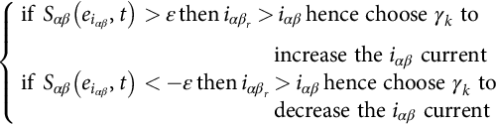 **(35.145)**

The practical implementation of this switching strategy could be accomplished using three independent two-level hysteresis comparators. However, this might introduce limit cycles as only two line currents are independent. Therefore, the control laws [(35.143)](https://learning.oreilly.com/library/view/power-electronics-handbook/9780128114087/B9780128114070000398_3.xhtml#fo0780) and [(35.144)](https://learning.oreilly.com/library/view/power-electronics-handbook/9780128114087/B9780128114070000398_3.xhtml#fo0785) can be implemented using the block diagram of [Fig. 35.47A](https://learning.oreilly.com/library/view/power-electronics-handbook/9780128114087/B9780128114070000398_3.xhtml#f0240), with *d*, *q*/*α*, and *β* (from Eq. [(35.138)](https://learning.oreilly.com/library/view/power-electronics-handbook/9780128114087/B9780128114070000398_3.xhtml#fo0740)) and 1,2,3/*α*, and *β* (from Eq. [(35.136)](https://learning.oreilly.com/library/view/power-electronics-handbook/9780128114087/B9780128114070000398_3.xhtml#fo0725)) transformations and two three-level hysteretic comparators with equivalent hysteresis *ɛ* and *ρ* to limit the maximum switching frequency. A limiter is included to bound the *id* reference current to *idmax*, keeping the input line currents within a safe value. This helps to eliminate the nonminimum-phase behavior (outside sliding mode) when large transients are present while providing short-circuit proof operation.

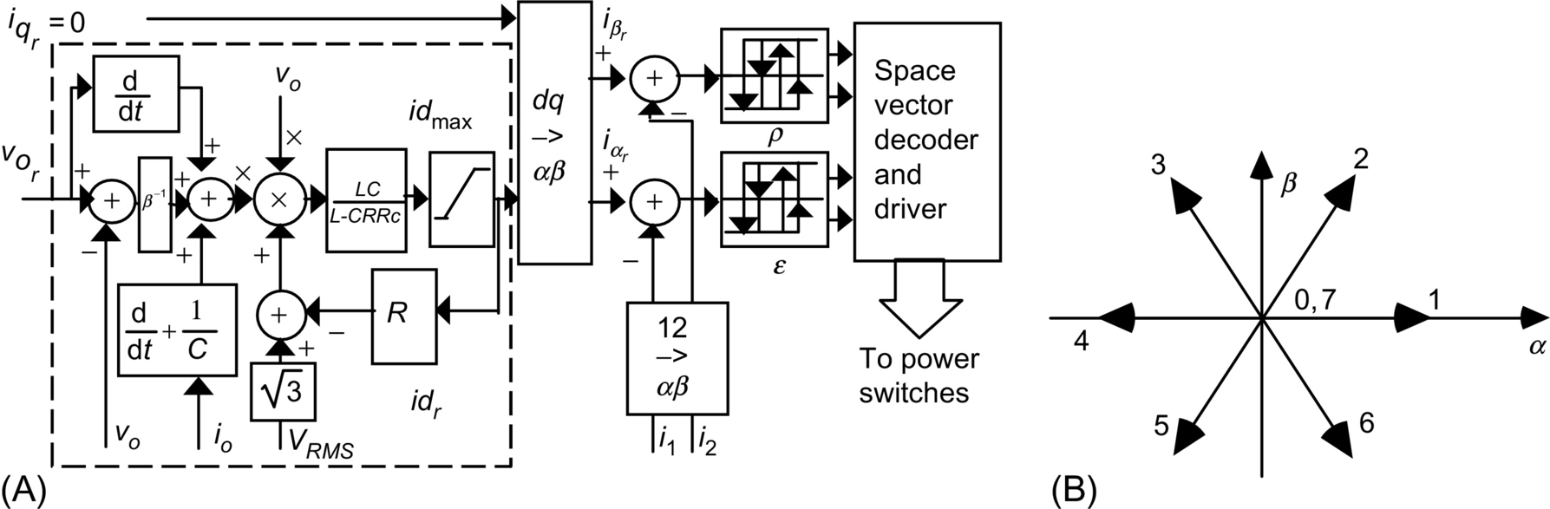

**FIG. 35.47** (A) Sliding-mode PWM controller modulator for the unity power factor three-phase PWM rectifier and (B) *α* and *β* space-vector representation of the PWM bridge rectifier leg voltages.

##### ***α*, *β* space vector current modulator**

Depending on the values of *γk*, the bridge rectifier leg output voltages can assume only eight possible distinct states represented as voltage vectors in the *α* and *β* reference frame ([Fig. 35.47B](https://learning.oreilly.com/library/view/power-electronics-handbook/9780128114087/B9780128114070000398_3.xhtml#f0240)), for sources with isolated neutral.

With only two independent currents, two three-level hysteresis comparators, for the current errors, must be used in order to accurately select all eight available voltage vectors. Each three-level comparator [[16](https://learning.oreilly.com/library/view/power-electronics-handbook/9780128114087/B9780128114070000398_5.xhtml#bb0085)] can be obtained by summing the outputs of two comparators with two levels each. One of these two comparators (*δLα* and *δLβ*) has a wide hysteresis width, and the other (*δNα* and *δNβ*) has a narrower hysteresis width. The hysteresis bands are represented by *ɛ* and *ρ*. [Table 35.1](https://learning.oreilly.com/library/view/power-electronics-handbook/9780128114087/B9780128114070000398_2.xhtml#t0010) represents all possible output combinations of the resulting four two-level comparators, their sums giving the two three-level comparators (*δα* and *δβ*), plus the voltage vector needed to accomplish the current tracking strategy  (ensuring , plus the *γk* variables and the *α* and *β* voltage components).

From the analysis of the PWM boost rectifier, it is concluded that, if, for example, the voltage vector 2 is applied (*γ*1=1, *γ*2=1, and *γ*3=0), in boost operation, the currents *iα* and *iβ* will both decrease. Oppositely, if the voltage vector 5 (*γ*1=0, *γ*2=0, and *γ*3=1) is applied, the currents *iα* and *iβ* will both increase. Therefore, vector 2 should be selected when both *iα* and *iβ* currents are above their respective references, that is, for *δα*=−1, *δβ*=−1, whereas vector 5 must be chosen when both *iα* and *iβ* currents are under their respective references or, for *δα*=1, *δβ*=1. Nearly all the outputs of [Table 35.2](https://learning.oreilly.com/library/view/power-electronics-handbook/9780128114087/B9780128114070000398_3.xhtml#t0015) can be filled using this kind of reasoning.

**Table 35.2**

**Two-level and three-level comparator results, showing corresponding vector choice, corresponding *γk* and vector *α* and *β* component voltages; vectors are mapped in** [**Fig. 35.47B**](https://learning.oreilly.com/library/view/power-electronics-handbook/9780128114087/B9780128114070000398_3.xhtml#f0240)

|  |  |  |  |  |  |  |  |  |  |  |  |
| --- | --- | --- | --- | --- | --- | --- | --- | --- | --- | --- | --- |
| ***δLα*** | ***δNα*** | ***δLβ*** | ***δNβ*** | ***δα*** | ***δβ*** | **Vector** | ***γ*1** | ***γ*2** | ***γ*3** | ***vα*** | ***vβ*** |
| −0.5 | −0.5 | −0.5 | −0.5 | −1 | −1 | **2** | 1 | 1 | 0 | si41_e | si42_e |
| 0.5 | −0.5 | −0.5 | −0.5 | 0 | −1 | **2** | 1 | 1 | 0 | si41_e | si42_e |
| 0.5 | 0.5 | −0.5 | −0.5 | 1 | −1 | **3** | 0 | 1 | 0 | si45_e | si42_e |
| −0.5 | 0.5 | −0.5 | −0.5 | 0 | −1 | **3** | 0 | 1 | 0 | si45_e | si42_e |
| −0.5 | 0.5 | 0.5 | −0.5 | 0 | 0 | **0** or **7** | 0 or 1 | 0 or 1 | 0 or 1 | 0 | 0 |
| 0.5 | 0.5 | 0.5 | −0.5 | 1 | 0 | **4** | 0 | 1 | 1 | si49_e | 0 |
| 0.5 | −0.5 | 0.5 | −0.5 | 0 | 0 | **0** or **7** | 0 or 1 | 0 or 1 | 0 or 1 | 0 | 0 |
| −0.5 | −0.5 | 0.5 | −0.5 | −1 | 0 | **1** | 1 | 0 | 0 | si50_e | 0 |
| −0.5 | −0.5 | 0.5 | 0.5 | −1 | 1 | **6** | 1 | 0 | 1 | si41_e | si52_e |
| 0.5 | −0.5 | 0.5 | 0.5 | 0 | 1 | **6** | 1 | 0 | 1 | si41_e | si52_e |
| 0.5 | 0.5 | 0.5 | 0.5 | 1 | 1 | **5** | 0 | 0 | 1 | si45_e | si52_e |
| −0.5 | 0.5 | 0.5 | 0.5 | 0 | 1 | **5** | 0 | 0 | 1 | si45_e | si52_e |
| −0.5 | 0.5 | −0.5 | 0.5 | 0 | 0 | **0** or **7** | 0 or 1 | 0 or 1 | 0 or 1 | 0 | 0 |
| 0.5 | 0.5 | −0.5 | 0.5 | 1 | 0 | **4** | 0 | 1 | 1 | si49_e | 0 |
| 0.5 | −0.5 | −0.5 | 0.5 | 0 | 0 | **0** or **7** | 0 or 1 | 0 or 1 | 0 or 1 | 0 | 0 |
| −0.5 | −0.5 | −0.5 | 0.5 | −1 | 0 | **1** | 1 | 0 | 0 | si50_e | 0 |

In the cases where *δα*=0 and *δβ*=−1, the vector is selected upon the value of the *iα* current error (if *δLα>*0 and *δNα<*0, then vector 2 and if *δLα<*0 and *δNα>*0, then vector 3). When *δα*=0 and *δβ*=1, if *δLα>*0 and *δNα<*0, then vector 6, else if *δLα<*0 and *δNα>*0, then vector 5. The vectors 0 and 7 are selected in order to minimize the switching frequency (if two of the three upper switches are on, then vector 7, otherwise vector 0). The space-vector decoder can be stored in a lookup table (or in an EPROM) whose inputs are the four two-level comparator outputs and the logic result of the operations needed to select between vectors 0 and 7.

##### **PI output voltage control of the current-mode PWM rectifier**

Using the *α* and *β* current-mode hysteresis modulators to enforce the *id* and *iq* currents to follow their reference values,  (the values of *L* and *C* are such that the *id* and *iq* currents usually exhibit a very fast dynamics compared with the slow dynamics of *vo*), a first-order model [(35.146)](https://learning.oreilly.com/library/view/power-electronics-handbook/9780128114087/B9780128114070000398_3.xhtml#fo0795) of the rectifier output voltage can be obtained from Eq. [(35.73)](https://learning.oreilly.com/library/view/power-electronics-handbook/9780128114087/B9780128114070000398_2.xhtml#fo0405):

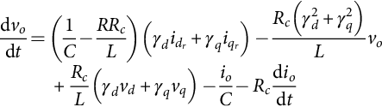 **(35.146)**

Assuming now a pure resistor load *R*1=*vo*/*io* and a mean delay *Td* between the *id* current and the reference , continuous transfer functions result for the *id* current (*id*=*idr* (1+*sT d*)−1) and for the *vo* voltage (*vo*=*kAid*/(1+*skB*) with *kA* and *kB* obtained from Eq. [(35.146)](https://learning.oreilly.com/library/view/power-electronics-handbook/9780128114087/B9780128114070000398_3.xhtml#fo0795)). Therefore, using the same approach as [Examples 35.6](https://learning.oreilly.com/library/view/power-electronics-handbook/9780128114087/B9780128114070000398_1.xhtml#en0035), [35.8](https://learning.oreilly.com/library/view/power-electronics-handbook/9780128114087/B9780128114070000398_1.xhtml#en0045), and 35.11, a linear PI regulator, with gains *Kp* and *Ki* [(35.147)](https://learning.oreilly.com/library/view/power-electronics-handbook/9780128114087/B9780128114070000398_3.xhtml#fo0800), sampling the error between the output voltage reference  and the output *vo*, can be designed to provide a voltage proportional (*kI*) to the reference current :

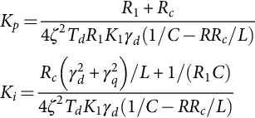 **(35.147)**

These PI regulator parameters depend on the load resistance *R*1, on the rectifier parameters (*C*, *Rc*, *L*, and *R*), on the rectifier operating point *γd*, on the mean delay time *Td*, and on the required damping factor *ζ*. Therefore, the expected response can only be obtained with the nominal load and input voltages, the line current dynamics depending on the *Kp* and *Ki* gains.

Results ([Fig. 35.48](https://learning.oreilly.com/library/view/power-electronics-handbook/9780128114087/B9780128114070000398_3.xhtml#f0245)) obtained with the values *VRMS*≈70 V, *L*≈1.1 mH, *R*≈0.1 Ω, *C*≈2000 μF with equivalent series resistance ESR≈0.1 Ω (*Rc*≈0.1 Ω), *R*1≈25 Ω, *R*2≈12 Ω, *β*=0.0012, *Kp*=1.2, *Ki*=100, and *kI*=1 show that the *α* and *β* space-vector current modulator ensures the current tracking needed ([Fig. 35.48](https://learning.oreilly.com/library/view/power-electronics-handbook/9780128114087/B9780128114070000398_3.xhtml#f0245)) [[17](https://learning.oreilly.com/library/view/power-electronics-handbook/9780128114087/B9780128114070000398_5.xhtml#bb0090)–[19](https://learning.oreilly.com/library/view/power-electronics-handbook/9780128114087/B9780128114070000398_5.xhtml#bb0100)]. The *vo* step response reveals a faster sliding-mode controller and the correct design of the current-mode/PI controller parameters. The robustness property of the sliding-mode-controlled output *vo*, compared with the current mode/PI, is shown in [Fig. 35.49](https://learning.oreilly.com/library/view/power-electronics-handbook/9780128114087/B9780128114070000398_3.xhtml#f0250).

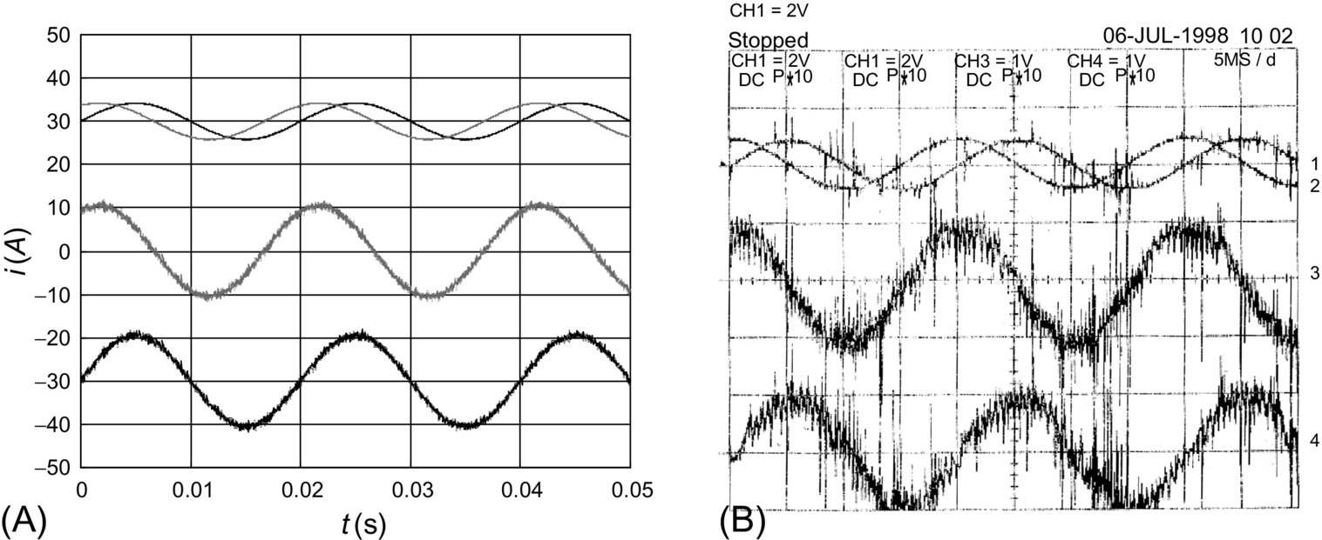

**FIG. 35.48** *α* and *β* space-vector current modulator operation at near unity power factor: (A) simulation result  and (B) experimental result (1→*i*1*r*,2→*i*2*r* (10 A/div); 3→*i*1,4→*i*2 (5 A/div)).



**FIG. 35.49** Transition from rectifier to inverter operation (*io* from 8 to −8 A) obtained by switching off IGBT Sa ([Fig. 35.46](https://learning.oreilly.com/library/view/power-electronics-handbook/9780128114087/B9780128114070000398_3.xhtml#f0235)) and using *Ia*=16 A: (A) *vo*−*vor* (v) with sliding-mode control and (B) *vo*−*vor* (v) with current-mode/PI control.

#### **35.3.5.5 Example 35.15: Sliding-Mode Controllers for Multilevel Inverters**

Diode-clamped multilevel inverters ([Fig. 35.50](https://learning.oreilly.com/library/view/power-electronics-handbook/9780128114087/B9780128114070000398_3.xhtml#f0255)) are the converters of choice for high-voltage high-power dc/ac or ac/ac (with dc link) applications, as the active semiconductors (usually gate turn-off thyristors (GTO) or IGBT transistors) of *n*-level power conversion systems, must withstand only a fraction (normally *Ucc*/(*n*−1)) of the total supply voltage *Ucc*. Moreover, the output voltage of multilevel converters, being staircase-like waveforms with *n* steps, features lower harmonic distortion compared with the two-level waveforms with the same switching frequency.



**FIG. 35.50** (A) Single-phase, neutral-point-clamped, three-level inverter with IGBTs and (B) three-phase, neutral-clamped, three-level inverter.

The advantages of multilevel converters are paid into the price of the capacitor supply voltage dividers ([Fig. 35.51](https://learning.oreilly.com/library/view/power-electronics-handbook/9780128114087/B9780128114070000398_3.xhtml#f0260)) and voltage equalization circuits, into the cost of extra power supply arrangements ([Fig. 35.51C](https://learning.oreilly.com/library/view/power-electronics-handbook/9780128114087/B9780128114070000398_3.xhtml#f0260)) and into increased control complexity. This example shows how to extend the two-level switching law [(35.97)](https://learning.oreilly.com/library/view/power-electronics-handbook/9780128114087/B9780128114070000398_2.xhtml#fo0525) to *n*-level converters and how to equalize the voltage of the capacitive dividers.

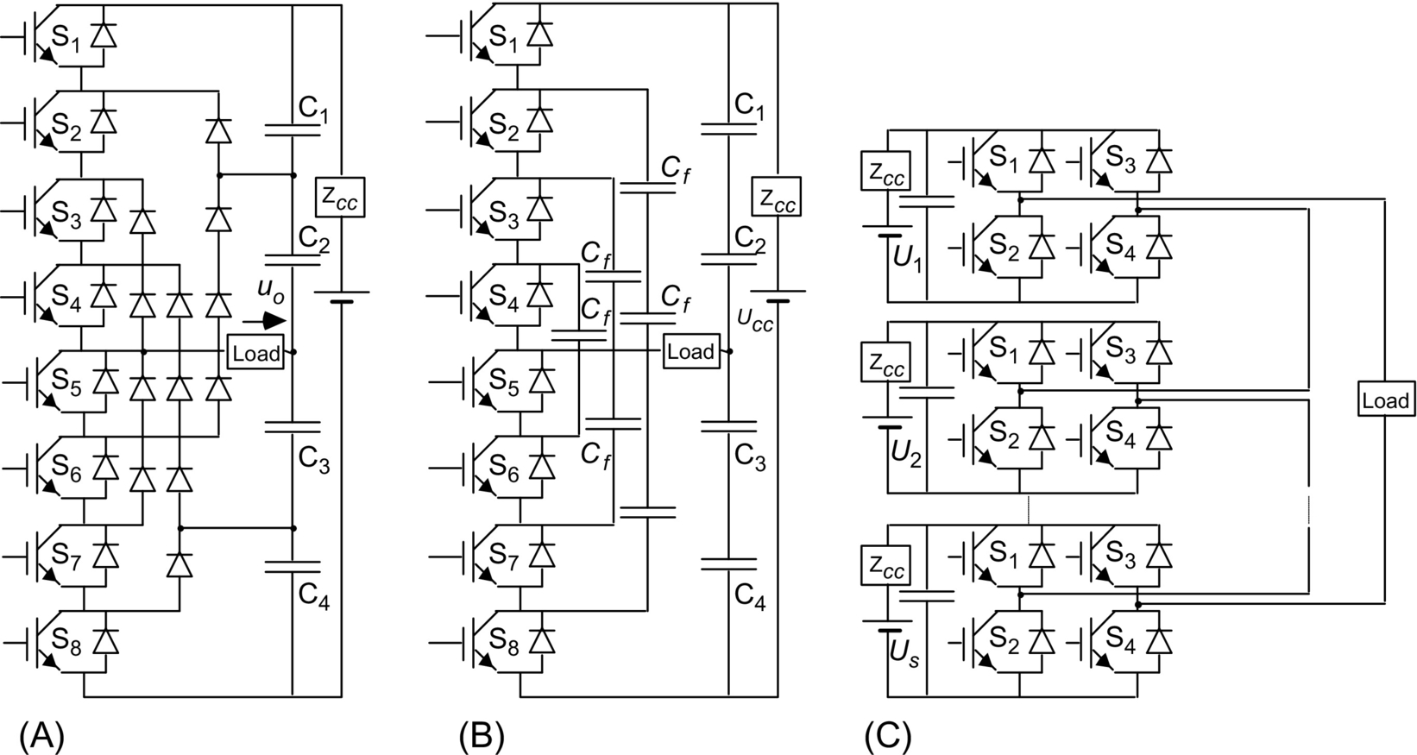

**FIG. 35.51** (A) Five-level (*n*=5) diode-clamped inverter with IGBTs, (B) five-level (*n*=5) flying capacitor converter, and (C) multilevel converter based on cascaded full-bridge inverters.

Considering single-phase three-level inverters ([Fig. 35.50A](https://learning.oreilly.com/library/view/power-electronics-handbook/9780128114087/B9780128114070000398_3.xhtml#f0255)), the open-loop control of the output voltage can be made using three-level SPWM. The two-level modulator, seen in [Example 35.9](https://learning.oreilly.com/library/view/power-electronics-handbook/9780128114087/B9780128114070000398_2.xhtml#en0050), can be easily extended ([Fig. 35.52A](https://learning.oreilly.com/library/view/power-electronics-handbook/9780128114087/B9780128114070000398_3.xhtml#f0265)) to generate the *γ*III command ([Fig. 35.52B](https://learning.oreilly.com/library/view/power-electronics-handbook/9780128114087/B9780128114070000398_3.xhtml#f0265)) to three-level inverter legs, from the two-level *γ*II signal, either with a dedicated modulator or using the following relation:



**FIG. 35.52** (A) Three-level SPWM modulator schematic and (B) main three-level SPWM signals.

 **(35.148)**

The required three-level SPWM modulators for the output voltage synthesis seldom take into account the semiconductors and the capacitor voltage divider nonideal characteristics. Consequently, the capacitor voltage divider tends to drift, one capacitor being overcharged and the other discharged, and an asymmetry appears in the currents of the power supply. A steady-state error in the output voltage can also be present. Sliding-mode control can provide the optimum switching timing between all the converter levels, together with robustness to supply voltage disturbances, semiconductor nonidealities, and load parameters.

##### **Sliding-mode surface and switching law**

For a variable-structure system where the control input *ui*(*t*) can present *n* levels, consider the *n* values of the integer variable *γ*, being−(*n*−1)/2≤*γ*≤(*n*−1)/2 and *ui*(*t*)=*γUcc*/(*n*−1), dependent on the topology and on the conducting semiconductors. To ensure the sliding-mode manifold invariance condition [(35.92)](https://learning.oreilly.com/library/view/power-electronics-handbook/9780128114087/B9780128114070000398_2.xhtml#fo0500) and the reaching mode behavior, the switching strategy *γ*(*tk*+1) for the time instant *tk*+1, considering the value of *γ*(*tk*), must be

 **(35.149)**

This switching law can be implemented as depicted in [Fig. 35.53A](https://learning.oreilly.com/library/view/power-electronics-handbook/9780128114087/B9780128114070000398_3.xhtml#f0270) and for five levels in B. An alternative is shown in [Fig. 35.53C](https://learning.oreilly.com/library/view/power-electronics-handbook/9780128114087/B9780128114070000398_3.xhtml#f0270) and named stability condition-based modulator [[20](https://learning.oreilly.com/library/view/power-electronics-handbook/9780128114087/B9780128114070000398_5.xhtml#bb0105)], where the switching law [(35.149)](https://learning.oreilly.com/library/view/power-electronics-handbook/9780128114087/B9780128114070000398_3.xhtml#fo0810) is directly used, calculating the sliding-mode surface and its time derivative, implemented as a discrete time variation. They are two-level quantized, and upon their values (obtained by half of their sum), the voltage level is increased (or decreased), until it reaches the maximum (or the minimum). Therefore, the output level is increased (or decreased) if the error and its derivative are both positive (or negative), with the upper limit *λmáx*=(*n*−1)/2 and lower limit *λmin*=−(*n*−1)/2.



**FIG. 35.53** (A) Multilevel sliding-mode PWM modulator with *n*-level hysteresis comparator with quantization interval *ɛ*, (B) four hysteresis comparator implementation of a five-level switching law, (C) stability condition-based multilevel modulator (one phase), (D) generalized sigma-delta n-level modulator.

Other implementations are possible ([Fig. 35.53D](https://learning.oreilly.com/library/view/power-electronics-handbook/9780128114087/B9780128114070000398_3.xhtml#f0270)), since in every modulation method the generated pulse levels must have the same volt-second average of the fundamental sinusoidal (i.e., the integral over time of the n-level voltage waveform minus the value of the fundamental should be zero).

##### **Control of the output voltage in single-phase multilevel converters**

To control the inverter output voltage, in closed-loop and in diode-clamped multilevel inverters with *n* levels and supply voltage *Ucc*, a control law similar to Eq. [(35.132)](https://learning.oreilly.com/library/view/power-electronics-handbook/9780128114087/B9780128114070000398_3.xhtml#fo0700), , is suitable.

[Fig. 35.54A](https://learning.oreilly.com/library/view/power-electronics-handbook/9780128114087/B9780128114070000398_3.xhtml#f0275) shows the waveforms of a five-level sliding-mode-controlled inverter, namely, the input sinus voltage, the generated output staircase wave, and the sliding-surface instantaneous error. This error is always within a band centered around the zero value and presents zero mean value, which is not the case of sigma-delta modulators followed by *n*-level quantizers, where the error presents an offset mean value in each half period.

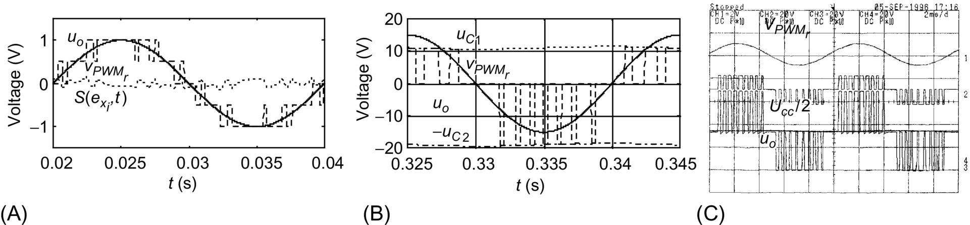

**FIG. 35.54** (A) Scaled waveforms of a five-level sliding-mode-controlled single-phase converter, showing the input sinus voltage , the generated output staircase wave *uo*, and the value of the sliding surface ; (B) scaled waveforms of a three-level neutral-point-clamped inverter showing the capacitor voltage unbalance (shown as two near-flat lines touching the tips of the PWM pulses); and (C) experimental results from a laboratory prototype of a three-level single-phase power inverter with the capacitor voltage equalization described.

Experimental multilevel converters always show capacitor voltage unbalances ([Fig. 35.54B](https://learning.oreilly.com/library/view/power-electronics-handbook/9780128114087/B9780128114070000398_3.xhtml#f0275)) due to small differences between semiconductor voltage drops and circuitry offsets. To obtain capacitor voltage equalization, the voltage error  is fed back to the controller ([Fig. 35.55A](https://learning.oreilly.com/library/view/power-electronics-handbook/9780128114087/B9780128114070000398_3.xhtml#f0280)) to counteract the circuitry offsets. Experimental results ([Fig. 35.54C](https://learning.oreilly.com/library/view/power-electronics-handbook/9780128114087/B9780128114070000398_3.xhtml#f0275)) clearly show the effectiveness of the correction made. The small steady-state error, between the voltages of the two capacitors, still present, could be eliminated using an integral regulator ([Fig. 35.55B](https://learning.oreilly.com/library/view/power-electronics-handbook/9780128114087/B9780128114070000398_3.xhtml#f0280)).



**FIG. 35.55** (A) Multilevel sliding-mode output voltage controller and PWM modulator with capacitor voltage equalization and (B) sliding-mode output current controller with capacitor voltage equalization.

[Fig. 35.56](https://learning.oreilly.com/library/view/power-electronics-handbook/9780128114087/B9780128114070000398_3.xhtml#f0285) confirms the robustness of the sliding-mode controller to power supply disturbances.



**FIG. 35.56** Simulated performance of a five-level power inverter, with a *Ucc* voltage dip (from 2 to 1.5 kV). Response to a sinusoidal wave of frequency 50 Hz: (A)  input, (B) PWM output voltage *uo*, and (C) the integral of the error voltage, which is maintained close to zero.

##### **Output current control in single-phase multilevel converters**

Considering an inductive load with current *iL*, the control law [(35.107)](https://learning.oreilly.com/library/view/power-electronics-handbook/9780128114087/B9780128114070000398_2.xhtml#fo0575) and the switching law of [(35.149)](https://learning.oreilly.com/library/view/power-electronics-handbook/9780128114087/B9780128114070000398_3.xhtml#fo0860) should be used for single-phase multilevel inverters. Results obtained using the capacitor voltage equalization principle just described are shown in [Fig. 35.57](https://learning.oreilly.com/library/view/power-electronics-handbook/9780128114087/B9780128114070000398_3.xhtml#f0290).



**FIG. 35.57** Operation of a three-level neutral-point-clamped inverter as a sinusoidal current source: Scaled waveforms of the output current sine wave reference *iLr*, the output current *iL*, showing ripple, together with the PWM-generated voltage *uo*, with nearly equal pulse heights, corresponding to the equalized dc capacitor voltages *uC*1 and *uC*2.

#### **35.3.5.6 Example 35.16: Sliding-Mode Controllers for Three-Phase Multilevel Inverters**

Three-phase *n*-level inverters ([Fig. 35.58](https://learning.oreilly.com/library/view/power-electronics-handbook/9780128114087/B9780128114070000398_3.xhtml#f0295)) are suitable for high-voltage, high-power dc/ac applications, such as modern high-speed railway traction drives, as the controlled turn-off semiconductors must block only a fraction (normally *Udc*/(*n*−1)) of the total supply voltage *Udc*.

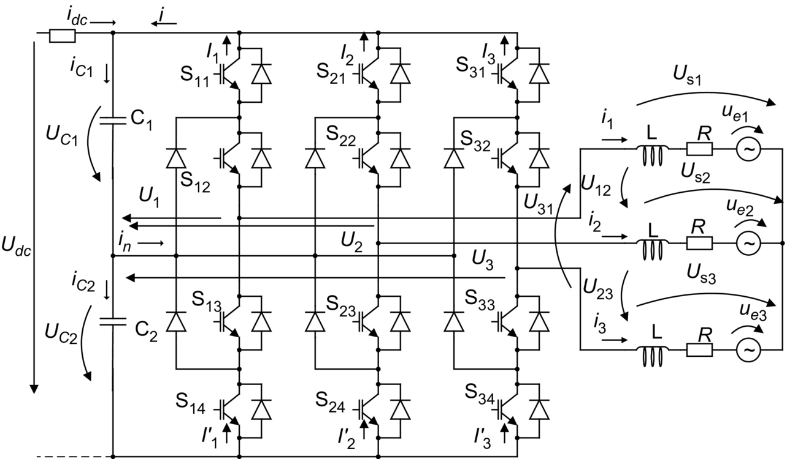

**FIG. 35.58** Three-phase, neutral-point-clamped, three-level inverter with IGBTs.

This example presents a real-time modulator for the control of the three output voltages and capacitor voltage equalization, based on the use of sliding mode and space vectors represented in the *α* and *β* frame. Capacitor voltage equalization is done with the proper selection of redundant space vectors.

##### **Output voltage control in multilevel converters**

To guarantee the topological constraints of this converter and the correct sharing of the *Udc* voltage by the semiconductors, the switching strategy for the *k* leg (*k*∈{1, 2, 3}) must ensure complementary states to switches S*k*1 and S*k*3. The same restriction applies for S*k*2 and S*k*4. Neglecting switching delays, dead times, on-state semiconductor voltage drops, snubber networks, and power supply variations; supposing small dead times and equal capacitor voltages *UC*1=*UC*2=*Udc*/2; and using the time-dependent switching variable *γk*(*t*), the leg output voltage *Uk* ([Fig. 35.58](https://learning.oreilly.com/library/view/power-electronics-handbook/9780128114087/B9780128114070000398_3.xhtml#f0295)) will be *Uk*=*γk*(*t*)*Udc*/2, with

 **(35.150)**

The converter output voltages *USk* of vector **U***S* can be expressed as

 **(35.151)**

The application of the Concordia transformation *US*1,2,3=[**C**] *USα*, *β*, *o* (Eq. [(35.152)](https://learning.oreilly.com/library/view/power-electronics-handbook/9780128114087/B9780128114070000398_3.xhtml#fo0825) to [(35.151)](https://learning.oreilly.com/library/view/power-electronics-handbook/9780128114087/B9780128114070000398_3.xhtml#fo0820))

 **(35.152)**

gives the output voltage vector in the *α* and *β* coordinates :

 **(35.153)**

where

 **(35.154)**

The output voltage vector in the *α* and *β* coordinates  is discontinuous. A suitable state variable for this output can be its average value  during one switching period:

 **(35.155)**

The controllable canonical form is

 **(35.156)**

Considering the control goal  and Eq. [(35.91)](https://learning.oreilly.com/library/view/power-electronics-handbook/9780128114087/B9780128114070000398_2.xhtml#fo0495), the sliding surface is

 **(35.157)**

To ensure reaching mode behavior and sliding-mode stability [(35.92)](https://learning.oreilly.com/library/view/power-electronics-handbook/9780128114087/B9780128114070000398_2.xhtml#fo0500), as the first derivative of Eq. [(35.157)](https://learning.oreilly.com/library/view/power-electronics-handbook/9780128114087/B9780128114070000398_3.xhtml#fo0850),  is

 **(35.158)**

The switching law is

 **(35.159)**

This switching strategy must select the proper values of  from the available outputs. As each inverter leg ([Fig. 35.58](https://learning.oreilly.com/library/view/power-electronics-handbook/9780128114087/B9780128114070000398_3.xhtml#f0295)) can deliver one of the three possible output voltages (*Udc*/2, 0, and−*Udc*/2), all the 27 possible output voltage vectors listed in [Table 35.3](https://learning.oreilly.com/library/view/power-electronics-handbook/9780128114087/B9780128114070000398_3.xhtml#t0020) can be represented in the *α* and *β* frame of [Fig. 35.59](https://learning.oreilly.com/library/view/power-electronics-handbook/9780128114087/B9780128114070000398_3.xhtml#f0300) (in per units, 1 p.u. = *Udc*). There are nine different levels for the *α* space vector component and only five for the *β* component. However, considering any particular value of *α* (or *β*) component, there are at most five levels available in the remaining orthogonal component. From the load viewpoint, the 27 space vectors of [Table 35.3](https://learning.oreilly.com/library/view/power-electronics-handbook/9780128114087/B9780128114070000398_3.xhtml#t0020) define only 19 distinct space positions ([Fig. 35.59](https://learning.oreilly.com/library/view/power-electronics-handbook/9780128114087/B9780128114070000398_3.xhtml#f0300)).



**FIG. 35.59** Output voltage vectors (1–27) of three-phase, neutral-clamped three-level inverters, in the *α* and *β* frame.

**Table 35.3**

**Vectors of the three-phase three-level converter, switching variables *γk*, switch states *skj*, and the corresponding output voltages, line to neutral point, line to line, and *α* and *β* components in per units**

|  |  |  |  |  |  |  |  |  |  |  |  |  |  |  |  |  |  |  |  |  |  |  |  |
| --- | --- | --- | --- | --- | --- | --- | --- | --- | --- | --- | --- | --- | --- | --- | --- | --- | --- | --- | --- | --- | --- | --- | --- |
| **Vector** | ***γ*1** | ***γ*2** | ***γ*3** | ***S*11** | ***S*12** | ***S*13** | ***S*14** | ***S*21** | ***S*22** | ***S*23** | ***S*24** | ***S*31** | ***S*32** | ***S*33** | ***S*34** | ***U*1** | ***U*2** | ***U*3** | ***U*12** | ***U*23** | ***U*31** | ***Usα*/*Udc*** | ***Usβ*/*Udc*** |
| **1** | 1 | 1 | 1 | 1 | 1 | 0 | 0 | 1 | 1 | 0 | 0 | 1 | 1 | 0 | 0 | *Udc*/2 | *Udc*/2 | *Udc*/2 | 0 | 0 | 0 | 0.00 | 0.00 |
| **2** | 1 | 1 | 0 | 1 | 1 | 0 | 0 | 1 | 1 | 0 | 0 | 0 | 1 | 1 | 0 | *Udc*/2 | *Udc*/2 | 0 | 0 | *Udc*/2 | −*Udc*/2 | 0.20 | 0.35 |
| **3** | 1 | 1 | −1 | 1 | 1 | 0 | 0 | 1 | 1 | 0 | 0 | 0 | 0 | 1 | 1 | *Udc*/2 | *Udc*/2 | −*Udc*/2 | 0 | *Udc* | −*Udc* | 0.41 | 0.71 |
| **4** | 1 | 0 | −1 | 1 | 1 | 0 | 0 | 0 | 1 | 1 | 0 | 0 | 0 | 1 | 1 | *Udc*/2 | 0 | −*Udc*/2 | *Udc*/2 | *Udc*/2 | −*Udc* | 0.61 | 0.35 |
| **5** | 1 | 0 | 0 | 1 | 1 | 0 | 0 | 0 | 1 | 1 | 0 | 0 | 1 | 1 | 0 | *Udc*/2 | 0 | 0 | *Udc*/2 | 0 | −*Udc*/2 | 0.41 | 0.00 |
| **6** | 1 | 0 | 1 | 1 | 1 | 0 | 0 | 0 | 1 | 1 | 0 | 1 | 1 | 0 | 0 | *Udc*/2 | 0 | *Udc*/2 | *Udc*/2 | −*Udc*/2 | 0 | 0.20 | −0.35 |
| **7** | 1 | −1 | 1 | 1 | 1 | 0 | 0 | 0 | 0 | 1 | 1 | 1 | 1 | 0 | 0 | *Udc*/2 | −*Udc*/2 | *Udc*/2 | *Udc* | −*Udc* | 0 | 0.41 | −0.71 |
| **8** | 1 | −1 | 0 | 1 | 1 | 0 | 0 | 0 | 0 | 1 | 1 | 0 | 1 | 1 | 0 | *Udc*/2 | −*Udc*/2 | 0 | *Udc* | −*Udc*/2 | −*Udc*/2 | 0.61 | −0.35 |
| **9** | 1 | −1 | −1 | 1 | 1 | 0 | 0 | 0 | 0 | 1 | 1 | 0 | 0 | 1 | 1 | *Udc*/2 | −*Udc*/2 | −*Udc*/2 | *Udc* | 0 | −*Udc* | 0.82 | 0.00 |
| **10** | 0 | −1 | −1 | 0 | 1 | 1 | 0 | 0 | 0 | 1 | 1 | 0 | 0 | 1 | 1 | 0 | −*Udc*/2 | −*Udc*/2 | *Udc*/2 | 0 | −*Udc*/2 | 0.41 | 0.00 |
| **11** | 0 | −1 | 0 | 0 | 1 | 1 | 0 | 0 | 0 | 1 | 1 | 0 | 1 | 1 | 0 | 0 | −*Udc*/2 | 0 | *Udc*/2 | −*Udc*/2 | 0 | 0.20 | −0.35 |
| **12** | 0 | −1 | 1 | 0 | 1 | 1 | 0 | 0 | 0 | 1 | 1 | 1 | 1 | 0 | 0 | 0 | −*Udc*/2 | *Udc*/2 | *Udc*/2 | −*Udc* | *Udc*/2 | 0.00 | −0.71 |
| **13** | 0 | 0 | 1 | 0 | 1 | 1 | 0 | 0 | 1 | 1 | 0 | 1 | 1 | 0 | 0 | 0 | 0 | *Udc*/2 | 0 | −*Udc*/2 | *Udc*/2 | −0.20 | −0.35 |
| **14** | 0 | 0 | 0 | 0 | 1 | 1 | 0 | 0 | 1 | 1 | 0 | 0 | 1 | 1 | 0 | 0 | 0 | 0 | 0 | 0 | 0 | 0.00 | 0.00 |
| **15** | 0 | 0 | −1 | 0 | 1 | 1 | 0 | 0 | 1 | 1 | 0 | 0 | 0 | 1 | 1 | 0 | 0 | −*Udc*/2 | 0 | *Udc*/2 | −*Udc*/2 | 0.20 | 0.35 |
| **16** | 0 | 1 | −1 | 0 | 1 | 1 | 0 | 1 | 1 | 0 | 0 | 0 | 0 | 1 | 1 | 0 | *Udc*/2 | −*Udc*/2 | −*Udc*/2 | *Udc* | −*Udc*/2 | 0.00 | 0.71 |
| **17** | 0 | 1 | 0 | 0 | 1 | 1 | 0 | 1 | 1 | 0 | 0 | 0 | 1 | 1 | 0 | 0 | *Udc*/2 | 0 | −*Udc*/2 | *Udc*/2 | 0 | −0.20 | 0.35 |
| **18** | 0 | 1 | 1 | 0 | 1 | 1 | 0 | 1 | 1 | 0 | 0 | 1 | 1 | 0 | 0 | 0 | *Udc*/2 | *Udc*/2 | −*Udc*/2 | 0 | *Udc*/2 | −0.41 | 0.00 |
| **19** | −1 | 1 | 1 | 0 | 0 | 1 | 1 | 1 | 1 | 0 | 0 | 1 | 1 | 0 | 0 | −*Udc*/2 | *Udc*/2 | *Udc*/2 | −*Udc* | 0 | *Udc* | −0.82 | 0.00 |
| **20** | −1 | 1 | 0 | 0 | 0 | 1 | 1 | 1 | 1 | 0 | 0 | 0 | 1 | 1 | 0 | −*Udc*/2 | *Udc*/2 | 0 | −*Udc* | *Udc* | *Udc*/2 | −0.61 | 0.35 |
| **21** | −1 | 1 | −1 | 0 | 0 | 1 | 1 | 1 | 1 | 0 | 0 | 0 | 0 | 1 | 1 | −*Udc*/2 | *Udc*/2 | −*Udc*/2 | −*Udc* | *Udc* | 0 | −0.41 | 0.71 |
| **22** | −1 | 0 | −1 | 0 | 0 | 1 | 1 | 0 | 1 | 1 | 0 | 0 | 0 | 1 | 1 | −*Udc*/2 | 0 | −*Udc*/2 | −*Udc*/2 | *Udc*/2 | 0 | −0.20 | 0.35 |
| **23** | −1 | 0 | 0 | 0 | 0 | 1 | 1 | 0 | 1 | 1 | 0 | 0 | 1 | 1 | 0 | −*Udc*/2 | 0 | 0 | −*Udc*/2 | 0 | *Udc*/2 | −0.41 | 0.00 |
| **24** | −1 | 0 | 1 | 0 | 0 | 1 | 1 | 0 | 1 | 1 | 0 | 1 | 1 | 0 | 0 | −*Udc*/2 | 0 | *Udc*/2 | −*Udc*/2 | −*Udc*/2 | *Udc* | −0.61 | −0.35 |
| **25** | −1 | −1 | 1 | 0 | 0 | 1 | 1 | 0 | 0 | 1 | 1 | 1 | 1 | 0 | 0 | −*Udc*/2 | −*Udc*/2 | *Udc*/2 | 0 | −*Udc*/2 | *Udc* | −0.41 | −0.71 |
| **26** | −1 | −1 | 0 | 0 | 0 | 1 | 1 | 0 | 0 | 1 | 1 | 0 | 1 | 1 | 0 | −*Udc*/2 | −*Udc*/2 | 0 | 0 | −*Udc*/2 | *Udc*/2 | −0.20 | −0.35 |
| **27** | −1 | −1 | −1 | 0 | 0 | 1 | 1 | 0 | 0 | 1 | 1 | 0 | 0 | 1 | 1 | −*Udc*/2 | −*Udc*/2 | −*Udc*/2 | 0 | 0 | 0 | 0.00 | 0.00 |

To select one of these 19 positions from the control law [(35.157)](https://learning.oreilly.com/library/view/power-electronics-handbook/9780128114087/B9780128114070000398_3.xhtml#fo0850) and the switching law of Eq. [(35.159)](https://learning.oreilly.com/library/view/power-electronics-handbook/9780128114087/B9780128114070000398_3.xhtml#fo0860), two five-level hysteretic comparators ([Fig. 35.53B](https://learning.oreilly.com/library/view/power-electronics-handbook/9780128114087/B9780128114070000398_3.xhtml#f0270)) must be used (52=25). Their outputs are the integer variables *λα* and *λβ*, denoted *λα*, *β* (*λα*, *λβ*∈{−2; −1; 0; 1; 2}) corresponding to the five selectable levels of Γ*α* and Γ*β*. Considering the sliding-mode stability, *λα*, *β*, at time step *j*+1, is given by Eq. [(35.160)](https://learning.oreilly.com/library/view/power-electronics-handbook/9780128114087/B9780128114070000398_3.xhtml#fo0865), knowing their previous values at step *j*. This means that the output level is increased (decreased) if the error and its derivative are both positive (negative), provided the maximum (minimum) output level is not exceeded:

 **(35.160)**

The available space vectors must be chosen not only to reduce the mean output voltage errors but also to guarantee transitions only between the adjacent levels, to minimize the capacitor voltage unbalance, to minimize the switching frequency, to observe minimum on or off times if applicable, and to equally stress all the semiconductors.

Using Eq. [(35.160)](https://learning.oreilly.com/library/view/power-electronics-handbook/9780128114087/B9780128114070000398_3.xhtml#fo0865) and the control laws S(**e***α*, *β*, *t*) Eq. [(35.157)](https://learning.oreilly.com/library/view/power-electronics-handbook/9780128114087/B9780128114070000398_3.xhtml#fo0850), [Tables 35.4](https://learning.oreilly.com/library/view/power-electronics-handbook/9780128114087/B9780128114070000398_3.xhtml#t0025) and [35.5](https://learning.oreilly.com/library/view/power-electronics-handbook/9780128114087/B9780128114070000398_3.xhtml#t0030) can be used to choose the correct voltage vector in order to ensure stability, output voltage tracking, and DC capacitor voltage equalization. The vector with *α* and *β* components corresponding to the levels of the pair *λβ* and *λα* is selected, provided that the adjacent transitions on inverter legs are obtained. If there is no directly corresponding vector, then the nearest vector guaranteeing adjacent transitions is selected. If a zero vector must be applied, then one of the three zero vectors (1, 14, and 27) is selected, to minimize the switching frequency. If more than one vector is the nearest, then one of them is selected to equalize the capacitor voltages, as shown next.

**Table 35.4**

**Switching table to be sed if (*UC*1–*UC*2)*>ɛeU* in the inverter mode or (*UC*1–*UC*2)*<*–*ɛeU* in the regenerative mode, showing vector selection upon the variables *λα* and *λβ***

|  |  |  |  |  |  |
| --- | --- | --- | --- | --- | --- |
| ***λβ*\*λα*** | **−2** | **−1** | **0** | **1** | **2** |
| −2 | 25 | 25 | 12 | 7 | 7 |
| −1 | 24 | 13 | 13, 6 | 6 | 8 |
| 0 | 19 | 18 | 1, 14, 27 | 5 | 9 |
| 1 | 20 | 17 | 17, 2 | 2 | 4 |
| 2 | 21 | 21 | 16 | 3 | 3 |

**Table 35.5**

**Switching table to be used if (*UC*1–*UC*2)*>ɛeU* in the regenerative mode or (*UC*1–*UC*2)*<*–*ɛeU* in the inverter mode, showing vector selection upon the variables *λα* and *λβ***

|  |  |  |  |  |  |
| --- | --- | --- | --- | --- | --- |
| ***λβ*/*λα*** | **−2** | **−1** | **0** | **1** | **2** |
| −2 | 25 | 25 | 12 | 7 | 7 |
| −1 | 24 | 26 | 26, 11 | 11 | 8 |
| 0 | 19 | 23 | 1, 14, 27 | 10 | 9 |
| 1 | 20 | 22 | 22,15 | 15 | 4 |
| 2 | 21 | 21 | 16 | 3 | 3 |

##### **DC capacitor voltage equalization**

The discrete values of *λα*, *β* allow 25 different combinations. As only 19 are distinct from the load viewpoint, the extra ones can be used to select vectors that are able to equalize the capacitor voltages (*UC*1=*UC*2=*Udc*/2).

Considering the control goal *UC*1=*UC*2, since the first derivatives of *UC*1 and *UC*2 Eq. [(35.161)](https://learning.oreilly.com/library/view/power-electronics-handbook/9780128114087/B9780128114070000398_3.xhtml#fo0870) directly depend on the *γk*(*t*) control inputs, from Eq. [(35.91)](https://learning.oreilly.com/library/view/power-electronics-handbook/9780128114087/B9780128114070000398_2.xhtml#fo0495), the sliding surface is given by Eq. [(35.162)](https://learning.oreilly.com/library/view/power-electronics-handbook/9780128114087/B9780128114070000398_3.xhtml#fo0875), where *kU* is a positive gain:

 **(35.161)**

**** **(35.162)**

The first derivative of *UC*1−*UC*2 (the sliding surface) is ([Fig. 35.58](https://learning.oreilly.com/library/view/power-electronics-handbook/9780128114087/B9780128114070000398_3.xhtml#f0295) with *C*1=*C*2=*C*)

 **(35.163)**

To ensure reaching mode behavior and sliding-mode stability, from Eq. [(35.92)](https://learning.oreilly.com/library/view/power-electronics-handbook/9780128114087/B9780128114070000398_2.xhtml#fo0500), considering a small enough *eUc* (*t*) error, *ɛeU*, the switching law is

 **(35.164)**

From circuit analysis, it can be seen that vectors (2, 5, 6, 13, 17, and 18) result in the discharge of capacitor *C*1, if the converter operates in inverter mode, or in the charge of *C*1, if the converter operates in boost rectifier (regenerative) mode. Similar reasoning can be applied for vectors (10, 11, 15, 22, 23, and 26) and capacitor *C*2, since this vector set gives *in* currents with opposite sign relatively to the set (2, 5, 6, 13, 17, and 18). Therefore, considering the vector , the switching law is the following:

If (*UC*1 *– UC*2)>ɛ*eU*,



If (*UC*1 *– UC*2)<*ɛeU*,



For example, consider the case where *UC*1*>UC*2+*ɛeU*. Then, the capacitor *C*2 must be charged, and [Table 35.4](https://learning.oreilly.com/library/view/power-electronics-handbook/9780128114087/B9780128114070000398_3.xhtml#t0025) must be used if the multilevel inverter is operating in the inverter mode or [Table 35.5](https://learning.oreilly.com/library/view/power-electronics-handbook/9780128114087/B9780128114070000398_3.xhtml#t0030) for the regenerative mode. Additionally, when using [Table 35.4](https://learning.oreilly.com/library/view/power-electronics-handbook/9780128114087/B9780128114070000398_3.xhtml#t0025), if *λα*=−1 and *λβ*=−1, then vector 13 should be used.

Experimental results shown in [Fig. 35.61](https://learning.oreilly.com/library/view/power-electronics-handbook/9780128114087/B9780128114070000398_3.xhtml#f0310) were obtained with a low-power, scaled-down laboratory prototype (150 V and 3 kW) of a three-level inverter ([Fig. 35.60](https://learning.oreilly.com/library/view/power-electronics-handbook/9780128114087/B9780128114070000398_3.xhtml#f0305)), controlled by two four-level comparators, and described capacitor voltage equalizing procedures and EPROM-based lookup [Tables 35.3](https://learning.oreilly.com/library/view/power-electronics-handbook/9780128114087/B9780128114070000398_3.xhtml#t0020)–[35.5](https://learning.oreilly.com/library/view/power-electronics-handbook/9780128114087/B9780128114070000398_3.xhtml#t0030). Transistors IGBT (MG25Q2YS40) were switched at frequencies near 4 kHz, with neutral clamp diodes 40HFL, *C*1≈*C*2≈20 mF. The load was mainly inductive (3×10 mH and 2 Ω).

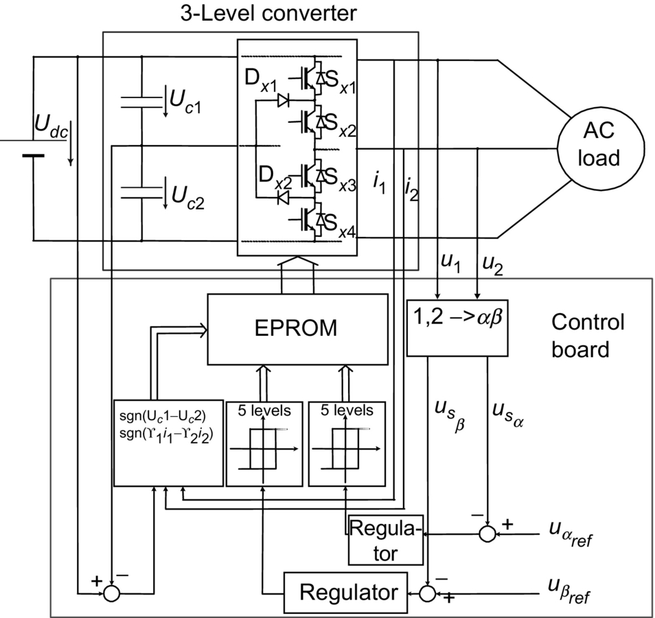

**FIG. 35.60** Block diagram of the multilevel converter and control board.

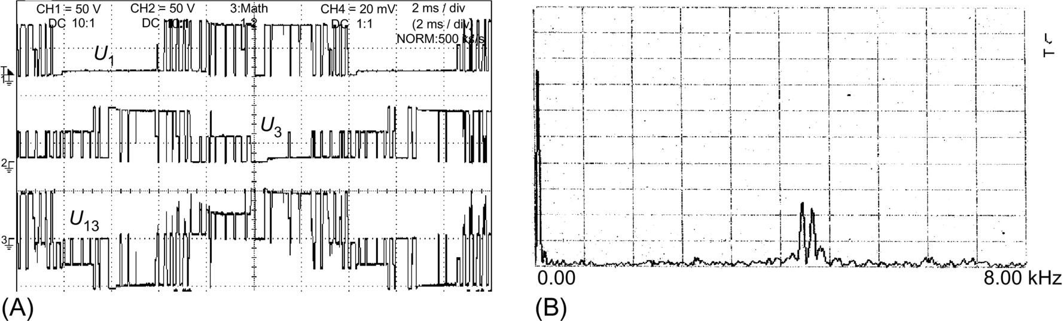

**FIG. 35.61** (A) Experimental results showing phase and line voltages and (B) harmonic spectrum of output voltages.

The inverter number of levels (three for the phase voltage and five for the line voltage), together with the adjacent transitions of inverter legs between levels, is shown in [Fig. 35.61A](https://learning.oreilly.com/library/view/power-electronics-handbook/9780128114087/B9780128114070000398_3.xhtml#f0310) and, in detail, in [Fig. 35.62A](https://learning.oreilly.com/library/view/power-electronics-handbook/9780128114087/B9780128114070000398_3.xhtml#f0315).



**FIG. 35.62** Experimental results showing (A) the transitions between adjacent voltage levels (50 V/div and time 20 μs/div) and (B) performance of the capacitor voltage equalizing strategy; from top trace to bottom, 1 is the voltage reference input; 2 is the power supply voltage; 3 is the midpoint capacitor voltage, which is maintained close to *Udc/*2; and 4 is the output current of phase 3 (2 A/div, 50 V/div, and 5 ms/div).

The performance of the capacitor voltage equalizing strategy is shown in [Fig. 35.62B](https://learning.oreilly.com/library/view/power-electronics-handbook/9780128114087/B9780128114070000398_3.xhtml#f0315), where the reference current of phase 1 and the output current of phase 3, together with the power supply voltage (*Udc*≈100 V) and the voltage of capacitor *C*2(*UC*2), can be seen. It can be noted that the *UC*2 voltage is nearly half of the supply voltage. Therefore, the capacitor voltages are nearly equal. Furthermore, it can be stated that without this voltage equalization procedure, the three-level inverter operates only during a brief transient, during which one of the capacitor voltages vanishes to nearly 0 V and the other is overcharged to the supply voltage. [Fig. 35.61B](https://learning.oreilly.com/library/view/power-electronics-handbook/9780128114087/B9780128114070000398_3.xhtml#f0310) shows the harmonic spectrum of the output voltages, where the harmonics due to the switching frequency (≈4.5 kHz) and the fundamental harmonic can be seen.

##### **On-line output current control in multilevel inverters**

Considering a standard inductive balanced load (*R* and *L*) with electromotive force (*u*) and isolated neutral, the converter output currents *ik* can be expressed:

 **(35.165)**

Now analyzing the circuit of [Fig. 35.58](https://learning.oreilly.com/library/view/power-electronics-handbook/9780128114087/B9780128114070000398_3.xhtml#f0295), the multilevel converter switched state-space model can be obtained:

 **(35.166)**

The application of the Concordia matrix Eqs. [(35.152)](https://learning.oreilly.com/library/view/power-electronics-handbook/9780128114087/B9780128114070000398_3.xhtml#fo0825)–[(35.166)](https://learning.oreilly.com/library/view/power-electronics-handbook/9780128114087/B9780128114070000398_3.xhtml#fo0905) reduces the number of the new model equations (Eq. [(35.167)](https://learning.oreilly.com/library/view/power-electronics-handbook/9780128114087/B9780128114070000398_3.xhtml#fo0910)) to two, since an isolated neutral is assumed:

 **(35.167)**

The model Eq. [(35.167)](https://learning.oreilly.com/library/view/power-electronics-handbook/9780128114087/B9780128114070000398_3.xhtml#fo0910) of this multiple-input multiple-output system (MIMO) with outputs *iα* and *iβ* reveals the control inputs *USα* and *USβ*, dependent on the control variables *γk*(*t*).

From Eqs. [(35.167)](https://learning.oreilly.com/library/view/power-electronics-handbook/9780128114087/B9780128114070000398_3.xhtml#fo0910) and [(35.91)](https://learning.oreilly.com/library/view/power-electronics-handbook/9780128114087/B9780128114070000398_2.xhtml#fo0495), the two sliding surfaces **S**(**e***α*, *β*, *t*) are

 **(35.168)**

The first derivatives of Eq. [(35.167)](https://learning.oreilly.com/library/view/power-electronics-handbook/9780128114087/B9780128114070000398_3.xhtml#fo0910), denoted , are

 **(35.169)**

Therefore, the switching law is

 **(35.170)**

These switching laws are implemented using the same *α* and *β* vector modulator described above in this example.

[Fig. 35.63A](https://learning.oreilly.com/library/view/power-electronics-handbook/9780128114087/B9780128114070000398_3.xhtml#f0320) shows the experimental results. The multilevel converter and proposed control behavior are obtained for step inputs (4–2 A) in the amplitude of the sinus references with frequency near 52 Hz (*Udc*≈150 V). Observe the tracking ability, the fast transient response, and the balanced three-phase currents. [Fig. 35.63B](https://learning.oreilly.com/library/view/power-electronics-handbook/9780128114087/B9780128114070000398_3.xhtml#f0320) shows almost the same test (step response from 2 to 4 A at the same frequency), but now, the power supply is set at 50 V, and the inductive load was unbalanced (±30% on resistor value). The response remains virtually the same, with tracking ability, almost no current distortions due to dead times or semiconductor voltage drops. These results and other works [[21](https://learning.oreilly.com/library/view/power-electronics-handbook/9780128114087/B9780128114070000398_5.xhtml#bb0110),[51](https://learning.oreilly.com/library/view/power-electronics-handbook/9780128114087/B9780128114070000398_5.xhtml#bb9005)] confirm experimentally that the designed controllers are robust concerning these nonidealities.



**FIG. 35.63** Step response of the current control method: (A) step from 4 to 2 A. Traces show the reference current for phase 1 and the three output currents with 150 V power supply (5 A/div and time scale 20 ms/div) and (B) step from 2 to 4 A in the reference amplitude at 52 Hz. Traces show the reference current for phase 1 and the three output currents with 50 V power supply.

#### **35.3.5.7 Example 35.17: Sliding-Mode Vector Controllers for Matrix Converters**

Matrix converters are all silicon ac/ac switching power converters, able to provide almost sinusoidal output voltages with adjustable amplitude and frequency, almost sinusoidal input currents, and controllable input power factor [[22](https://learning.oreilly.com/library/view/power-electronics-handbook/9780128114087/B9780128114070000398_5.xhtml#bb0115)]. They have been used in ac drive speed control and are well suited for applications related to power-quality enhancement. The lack of an intermediate energy storage link results in high power density, their main advantage, but implies an input/output coupling that increases the control complexity.

This example presents the design of sliding-mode controllers considering the switched state-space model of the matrix converter (nine bidirectional power switches), including the three-phase input filter and the output load ([Fig. 35.64](https://learning.oreilly.com/library/view/power-electronics-handbook/9780128114087/B9780128114070000398_4.xhtml#f0325)).

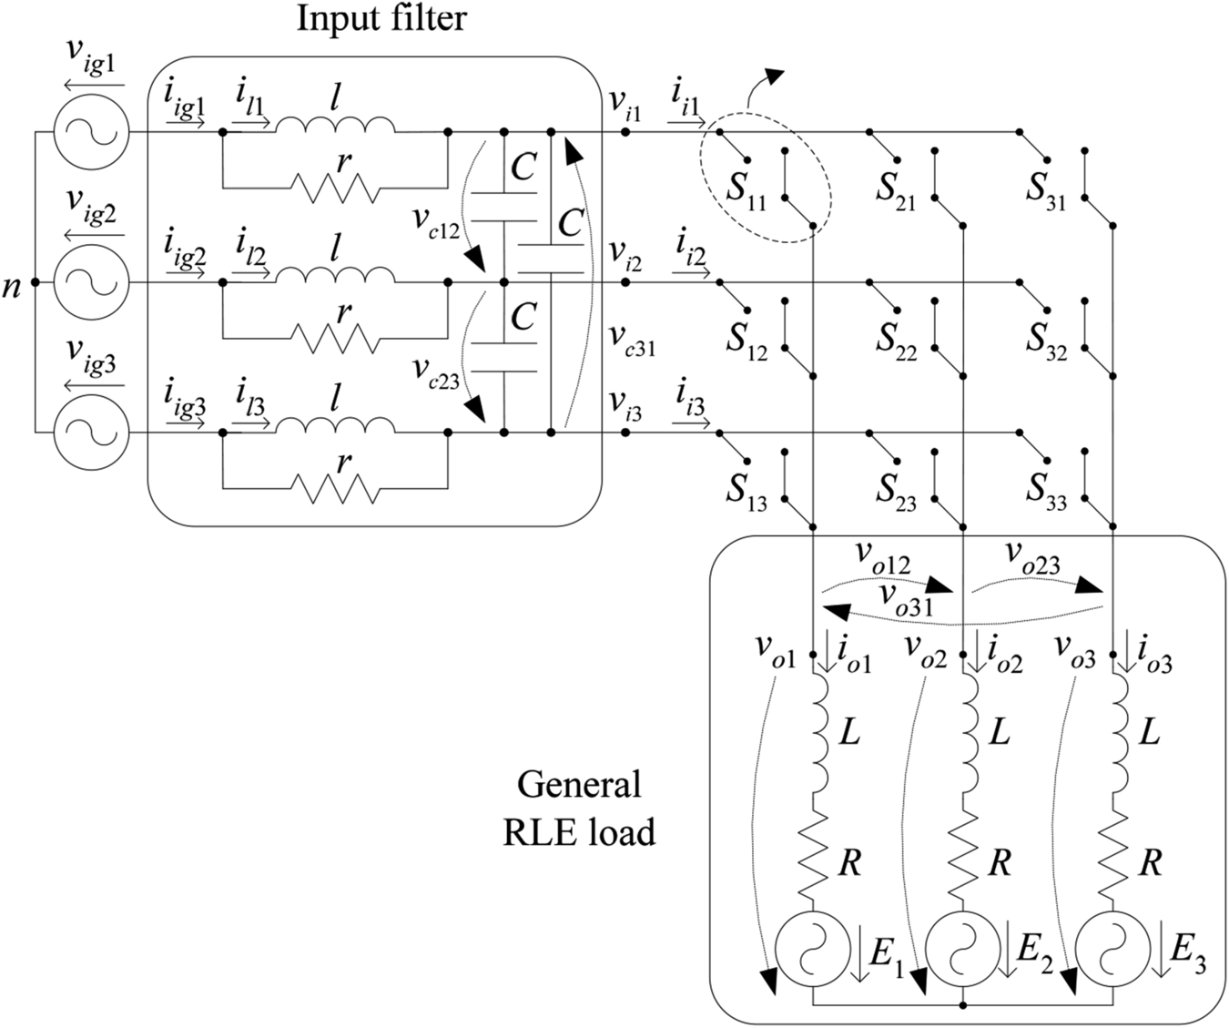

**FIG. 35.64** AC/AC matrix converter with input *lCr* filter.

##### **Output voltage control**

Ideal three-phase matrix converters are obtained by assembling nine bidirectional switches, with the turn-off capability, to allow the connection of each one of the input phases to any one of the output phases ([Fig. 35.64](https://learning.oreilly.com/library/view/power-electronics-handbook/9780128114087/B9780128114070000398_4.xhtml#f0325)). The states of these switches are usually represented as a nine-element matrix **S** (Eq. [(35.171)](https://learning.oreilly.com/library/view/power-electronics-handbook/9780128114087/B9780128114070000398_4.xhtml#fo0930)), in which each matrix element, *Skj k*, *j*∈{1, 2, 3}, has two possible states: *Skj*=1 if the switch is closed (ON) and *Skj*=0 if it is open (OFF). Only 27 switching combinations are possible ([Table 35.6](https://learning.oreilly.com/library/view/power-electronics-handbook/9780128114087/B9780128114070000398_4.xhtml#t0035)), as a result of the topological constraints (the input phases should never be short-circuited, and the output inductive currents should never be interrupted), which implies that the sum of all the *Skj* of each one of the matrix, *k* rows, must always equal to 1 (Eq. [(35.171)](https://learning.oreilly.com/library/view/power-electronics-handbook/9780128114087/B9780128114070000398_4.xhtml#fo0930)):

**Table 35.6**

**Switching combinations and output line voltage/input current state-space vectors**

|  |  |  |  |  |  |  |  |  |  |  |  |  |  |  |
| --- | --- | --- | --- | --- | --- | --- | --- | --- | --- | --- | --- | --- | --- | --- |
| **Group** | **Name** | ***von1*** | ***von2*** | ***von3*** | ***vo12*** | ***vo23*** | ***vo31*** | ***ii1*** | ***ii2*** | ***ii3*** | ***Vol*** | ***δo*** | ***Ii*** | ***μi*** |
| I | 1 g | *vi1* | *vi2* | *vi3* | *vi12* | *vi23* | *vi31* | *io1* | *io2* | *io3* | *vi* | *δi* | *io* | *μo* |
| 2 g | *vi1* | *vi3* | *vi2* | −*vi31* | −*vi23* | −*vi12* | *io1* | *io3* | *io2* | −*vi* | −*δi*+4π/3 | *io* | −*μo* |
| 3 g | *vi2* | *vi1* | *vi3* | –*vi12* | –*vi31* | –*vi23* | *io2* | *io1* | *io3* | −*vi* | −*δi* | *io* | −*μo*+2π/3 |
| 4 g | *vi2* | *vi3* | *vi1* | *vi23* | *vi31* | *vi12* | *io3* | *io1* | *io2* | *vi* | *δi*+4 π/3 | *io* | *μo*+2π/3 |
| 5 g | *vi3* | *vi1* | *vi2* | *vi31* | *vi12* | *vi23* | *io2* | *io3* | *io1* | *vi* | *δi*+2 π/3 | *io* | *μo*+4π/3 |
| 6 g | *vi3* | *vi2* | *vi1* | –*vi23* | –*vi12* | –*vi31* | *io3* | *io2* | *io1* | −*vi* | −*δi*+2 π/3 | *io* | −*μo*+4π/3 |
| II | +1 | *vi1* | *vi2* | *vi2* | *vi12* | 0 | –*vi12* | *io1* | −*io1* | 0 | si61_e *vi12* | π/6 | si61_e *io1* | −π/6 |
| –1 | *vi2* | *vi1* | *vi1* | –*vi12* | 0 | *vi12* | –*io1* | *io1* | 0 | si63_e *vi12* | π/6 | si63_e *io1* | −π/6 |
| +2 | *vi2* | *vi3* | *vi3* | *vi23* | 0 | –*vi23* | 0 | *io1* | −*io1* | si61_e *vi23* | π/6 | si61_e *io1* | π/2 |
| –2 | *vi3* | *vi2* | *vi2* | –*vi23* | 0 | *vi23* | 0 | −*io1* | *io1* | si63_e *vi23* | π/6 | si63_e *io1* | π/2 |
| +3 | *vi3* | *vi1* | *vi1* | *vi31* | 0 | –*vi31* | –*io1* | 0 | *io1* | si61_e *vi31* | π/6 | si61_e *io1* | 7π/6 |
| –3 | *vi1* | *vi3* | *vi3* | –*vi31* | 0 | *vi31* | *io1* | 0 | −*io1* | si63_e *vi31* | π/6 | si63_e *io1* | 7π/6 |
| +4 | *vi2* | *vi1* | *vi2* | –*vi12* | *vi12* | 0 | *io2* | −*io2* | 0 | si61_e *vi12* | 5π/6 | si61_e *io2* | −π/6 |
| –4 | *vi1* | *vi2* | *vi1* | *vi12* | –*vi12* | 0 | –*io2* | *io2* | 0 | si63_e *vi12* | 5π/6 | si63_e *io2* | −π/6 |
| +5 | *vi3* | *vi2* | *vi3* | –*vi23* | *vi23* | 0 | 0 | *io2* | −*io2* | si61_e *vi23* | 5π/6 | si61_e *io2* | π/2 |
| –5 | *vi2* | *vi3* | *vi2* | *vi23* | –*vi23* | 0 | 0 | −*io2* | *io2* | si63_e *vi23* | 5π/6 | si63_e *io2* | π/2 |
| +6 | *vi1* | *vi3* | *vi1* | –*vi31* | *vi31* | 0 | –*io2* | 0 | *io2* | si61_e *vi31* | 5π/6 | si61_e *io2* | 7π/6 |
| –6 | *vi3* | *vi1* | *vi3* | *vi31* | –*vi31* | 0 | *io2* | 0 | −*io2* | si63_e *vi31* | 5π/6 | si63_e *io2* | 7π/6 |
| +7 | *vi2* | *vi2* | *vi1* | 0 | *vi12* | *vi12* | *io3* | −*io3* | 0 | si61_e *vi12* | 3π/2 | si61_e *io3* | −π/6 |
| –7 | *vi1* | *vi1* | *vi2* | 0 | *vi12* | *vi12* | –*io3* | *io3* | 0 | si63_e *vi12* | 3π/2 | si63_e *io3* | −π/6 |
| +8 | *vi3* | *vi3* | *vi2* | 0 | –*vi23* | *vi23* | 0 | *io3* | −*io3* | si61_e *vi23* | 3π/2 | si61_e *io3* | π/2 |
| –8 | *vi2* | *vi2* | *vi3* | 0 | *vi23* | –*vi23* | 0 | −*io3* | *io3* | si63_e *vi23* | 3π/2 | si63_e *io3* | π/2 |
| +9 | *vi1* | *vi1* | *vi3* | 0 | –*vi31* | *vi31* | –*io3* | 0 | *io3* | si61_e *vi31* | 3π/2 | si61_e *io3* | 7π/6 |
| –9 | *vi3* | *vi3* | *vi1* | 0 | *vi31* | −*vi31* | *io3* | 0 | −*io3* | si63_e *vi31* | 3π/2 | si63_e*io3* | 7π/6 |
| III | z1 | *vi1* | *vi1* | *vi1* | 0 | 0 | 0 | 0 | 0 | 0 | 0 | – | 0 | – |
| z2 | *vi2* | *vi2* | *vi2* | 0 | 0 | 0 | 0 | 0 | 0 | 0 | – | 0 | – |
| z3 | *vi3* | *vi3* | *vi3* | 0 | 0 | 0 | 0 | 0 | 0 | 0 | – | 0 | – |

 **(35.171)**

Based on matrix **S**, output voltages related to input neutral , , and  and line voltages , , and  can be expressed in terms of matrix converter input phase voltages , , and . Input currents , , and  can be expressed as a function of output currents , , and :

 **(35.172)**

The application of Concordia transformation [*Xα,β,0*]T=**C**T [*X1*,*2*,*3*]T to the output line-to-line voltages of Eq. [(35.172)](https://learning.oreilly.com/library/view/power-electronics-handbook/9780128114087/B9780128114070000398_4.xhtml#fo0935) results in the output voltage vector:

 **(35.173)**

where *v*icαβ is the input filter capacitor voltage and , , , and  are functions of the ON/OFF state of the nine *Skj* switches:

 **(35.174)**

The average value  of the output line-to-line voltages, in *αβ* coordinates, during one switching period, is the output variable to be controlled (since *volαβ* is discontinuous) [[23](https://learning.oreilly.com/library/view/power-electronics-handbook/9780128114087/B9780128114070000398_5.xhtml#bb0120),[50](https://learning.oreilly.com/library/view/power-electronics-handbook/9780128114087/B9780128114070000398_5.xhtml#bb9000)]:

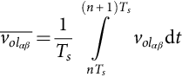 **(35.175)**

Considering the control goal , the sliding surface *S*(*eαβ*, *t*)(*kαβ>*0) is

 **(35.176)**

The first derivative of Eq. [(35.176)](https://learning.oreilly.com/library/view/power-electronics-handbook/9780128114087/B9780128114070000398_4.xhtml#fo0955) is

 **(35.177)**

As the sliding-mode stability is guaranteed if *Sαβ*(*eαβ*, *t*) , the criterion to choose the output line voltages state-space vectors is

 **(35.178)**

This implies that the sliding mode is reached only when the vector applied to the converter has the desired amplitude and phase.

According to [Table 35.6](https://learning.oreilly.com/library/view/power-electronics-handbook/9780128114087/B9780128114070000398_4.xhtml#t0035), the six vectors of group I have fixed amplitude but time-varying phase, the 18 vectors of group II have variable amplitude, and the vectors of group III are null. Therefore, from the load viewpoint, the 18 highest amplitude vectors (6 vectors from group I and 12 vectors from group II) and one null vector are suitable to guarantee the sliding-mode stability.

Therefore, if two three-level comparators (*Cαβ*∈{−1, 0, 1}) are used to quantize the deviations of Eq. [(35.178)](https://learning.oreilly.com/library/view/power-electronics-handbook/9780128114087/B9780128114070000398_4.xhtml#fo0965) from zero, the nine output voltage error combinations (33) are not enough to guarantee the choice of all the 19 available vectors. The extra vectors may be used to control the input power factor. As an example, if the output voltage error is quantized as *Cα*=1 and *Cβ*=1, at sector V*i*1 ([Fig. 35.65](https://learning.oreilly.com/library/view/power-electronics-handbook/9780128114087/B9780128114070000398_4.xhtml#f0330)), the vectors −3, +1, or 1 g might be used to control the output voltage. The final choice would depend on the input current error.



**FIG. 35.65** (A) Input voltages and their corresponding sector and (B) representation of the output voltage state-space vectors when the input voltages are located at sector V*i*1.

##### **Output current control**

For some applications, it is more useful to control the output currents, which implies some changes on the previously designed controllers. From [Fig. 35.64](https://learning.oreilly.com/library/view/power-electronics-handbook/9780128114087/B9780128114070000398_4.xhtml#f0325), the output currents can be obtained as a function of the phase voltages applied to the load:

 **(35.179)**

As the output currents are state variables, with a strong relative degree of 1, the sliding surfaces should depend directly on their errors:

 **(35.180)**

The state-space vectors should be chosen to guarantee the stability criterion , according to the following:

(a) If , then  and the output current must decrease . This means that the chosen output voltage  phase vector should be low enough to guarantee .

(b) If , then  and the output current must increase . This means that the chosen output voltage  phase vector should be high enough to guarantee .

The output voltage phase vectors can be obtained from the output voltage line vectors of [Table 35.6](https://learning.oreilly.com/library/view/power-electronics-handbook/9780128114087/B9780128114070000398_4.xhtml#t0035), using the well-known relations between three-phase line and phase voltages:

 **(35.181)**

As expected, the resultant output voltage phase vectors will have an amplitude  lower than the voltage line vectors of [Table 35.6](https://learning.oreilly.com/library/view/power-electronics-handbook/9780128114087/B9780128114070000398_4.xhtml#t0035) and a lagging phase of *π*/6. As an example, from [Fig. 35.65B](https://learning.oreilly.com/library/view/power-electronics-handbook/9780128114087/B9780128114070000398_4.xhtml#f0330), this will result in a  rotation of all the voltage vectors represented.

Therefore, if two three-level comparators (*Cαβ*∈{−1,0,1}) are used to quantize the deviations of Eq. [(35.180)](https://learning.oreilly.com/library/view/power-electronics-handbook/9780128114087/B9780128114070000398_4.xhtml#fo0975) from zero and if the output current error is quantized as *Cα*=1 and *Cβ*=1, at sector Vi1 ([Fig. 35.65](https://learning.oreilly.com/library/view/power-electronics-handbook/9780128114087/B9780128114070000398_4.xhtml#f0330)), the vectors +9 or −7 might be used to control the output current. The final choice would depend on the input current error.

##### **Input power factor control**

Assuming that the source is a balanced sinusoidal three-phase voltage supply with frequency *ωi*, the switched state-space model equations of the converter input filter are obtained in 123 coordinates:

 **(35.182)**

To control the input power factor, a reference frame synchronous with input voltage *vig1* may be used applying the Blondel-Park transformation to the matrix converter switched state-space model (Eq. [(35.183)](https://learning.oreilly.com/library/view/power-electronics-handbook/9780128114087/B9780128114070000398_4.xhtml#fo0990)), where , , , and  are functions of the on/off states of the nine *Skj* switches:

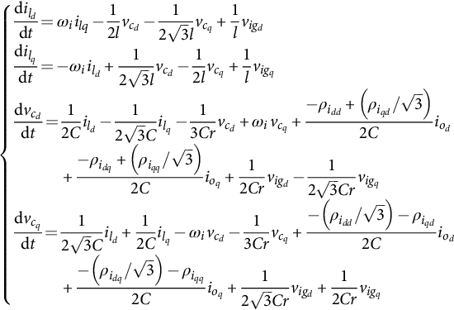 **(35.183)**

As a consequence, neglecting ripples, all the input variables become time invariant, allowing a better understanding of the sliding-mode controller design, and the choice of the most adequate state-space vector. Using this state-space model, the input *iigd* and *iigq* currents are

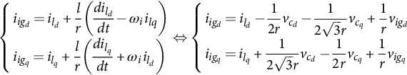 **(35.184)**

The input power factor controller should consider the input-output power constraint (Eq. [(35.185)](https://learning.oreilly.com/library/view/power-electronics-handbook/9780128114087/B9780128114070000398_4.xhtml#fo1000)) (the converter losses and ripples are neglected), obtained as a function of the input and output voltages and currents (the input voltage *vigq* is equal to zero in the chosen dq rotating frame). The choice of one output voltage vector automatically defines the instantaneous value of the input *iigd*(*t*) current:

 **(35.185)**

Therefore, only the sliding surface associated to the *iigq* current is needed, expressed as a function of the system state variables and based on the state-space model determined in Eq. [(35.183)](https://learning.oreilly.com/library/view/power-electronics-handbook/9780128114087/B9780128114070000398_4.xhtml#fo0990):

 **(35.186)**

As the derivative of the input *iigq*(*t*) current depends directly on the control variables  and , the sliding function  will depend only on the input current error :

 **(35.187)**

As the sliding-mode stability is guaranteed if , the criterion to choose the state-space vectors is [[23](https://learning.oreilly.com/library/view/power-electronics-handbook/9780128114087/B9780128114070000398_5.xhtml#bb0120)]

 **(35.188)**

Also, to choose the adequate input current vector, it is necessary (a) to know the location of the output currents, as the input currents depend on the output currents location ([Table 35.6](https://learning.oreilly.com/library/view/power-electronics-handbook/9780128114087/B9780128114070000398_4.xhtml#t0035)), and (b) to know the dq frame location. As in the chosen frame (synchronous with the *vig1* input voltage), the dq-axis location depends on the *vig1* input voltage location; the sign of the input current vector *iigq* component can be determined knowing the location of the input voltages and the location of the output currents ([Fig. 35.66](https://learning.oreilly.com/library/view/power-electronics-handbook/9780128114087/B9780128114070000398_4.xhtml#f0335)).



**FIG. 35.66** (A) Output currents and their corresponding sector and (B) representation of input current state-space vectors, when the output currents are located at sector I*o*1. The dq-axis is represented considering that the input voltages are located in zone V*i*1.

Considering the previous example, at sector V*i*1 ([Fig. 35.65](https://learning.oreilly.com/library/view/power-electronics-handbook/9780128114087/B9780128114070000398_4.xhtml#f0330)), for an error of *Cα*=1 and *Cβ*=1, vector −3, +1, or 1 g might be used to control the output voltage. When compared, at sector I*o*1 ([Fig. 35.66B](https://learning.oreilly.com/library/view/power-electronics-handbook/9780128114087/B9780128114070000398_4.xhtml#f0335)), these three vectors have positive *id* components and, as a result, will have a similar effect on the input *iigd* current. However, they have a different effect on the *iigq* current: Vector −3 has a positive *iiq* component, vector +1 has a negative *iiq* component, and vector 1 g has a nearly zero *iiq* component. As a result, if the output voltage errors are *Cα*=1 and *Cβ*=1, at sectors V*i*1 and I*o*1, vector −3 should be chosen if the input current error is quantized as *Ciq*=1 ([Fig. 35.66B](https://learning.oreilly.com/library/view/power-electronics-handbook/9780128114087/B9780128114070000398_4.xhtml#f0335)), vector +1 should be chosen if the input current error is quantized as *Ciq*=−1, and if the input current error is *Ciq*=0, vector 1 g or −3 might be used.

When the output voltage errors are quantized as zero *Cαβ*=0, the null vectors of group III should be used only if the input current error is *Ciq*=0. Otherwise (being ), the lowest amplitude voltage vectors ({+2, −8, +5, −2, +8, −5} at sector V*i*1 of [Fig. 35.65B](https://learning.oreilly.com/library/view/power-electronics-handbook/9780128114087/B9780128114070000398_4.xhtml#f0330)) that were not used to control the output voltages might be chosen to control the input *iigq* current as these vectors may have a strong influence on the input *iigq* current component ([Fig. 35.66B](https://learning.oreilly.com/library/view/power-electronics-handbook/9780128114087/B9780128114070000398_4.xhtml#f0335)).

To choose one of these six vectors, only the vectors located as near as possible to the output voltages sector ([Fig. 35.67](https://learning.oreilly.com/library/view/power-electronics-handbook/9780128114087/B9780128114070000398_4.xhtml#f0340)) are chosen (to minimize the output voltage ripple), and a five-level comparator is enough. As a result, there will be 9×5=45 error combinations to select 27 space vectors. Therefore, the same vector may have to be used for more than one error combination.



**FIG. 35.67** (A) Output voltages and their corresponding sector and (B) representation of the lowest amplitude output voltage vectors, when the input voltages are located at sector V*o*1.

With this reasoning, it is possible to obtain [Table 35.7](https://learning.oreilly.com/library/view/power-electronics-handbook/9780128114087/B9780128114070000398_4.xhtml#t0040) for sector V*i*1, I*o*1, and V*o*1 and generalize it for all the other sectors.

**Table 35.7**

**State-space vector choice at sector V*i*1, I*o*1, and V*o*1**

|  |  |  |  |  |  |  |
| --- | --- | --- | --- | --- | --- | --- |
| ***Cα*** | ***Cβ*** | ***Ciq*** | | | | |
| **−2** | **−1** | **0** | **1** | **2** |
| −**1** | −**1** | +3 | +3 | +3 | −1 | −1 |
| −**1** | **0** | 5 g | +3 | −6 | −1 | −1 |
| −**1** | **1** | −6 | −6 | −6 | +4 | 3 g |
| **0** | −**1** | 6 g | −9 | −9 | +7 | 4 g |
| **0** | **0** | +8 | +8 | 0 | −5 | +2 |
| **0** | **1** | −7 | −7 | +9 | +9 | +9 |
| **1** | −**1** | −4 | −4 | +6 | +6 | +6 |
| **1** | **0** | +1 | +1 | +6 | −3 | −3 |
| **1** | **1** | +1 | +1 | 1 g | −3 | −3 |

The experimental results shown in ([Fig. 35.68](https://learning.oreilly.com/library/view/power-electronics-handbook/9780128114087/B9780128114070000398_4.xhtml#f0345)) were obtained with a low-power prototype (1 kW), with two three-level comparators and one five-level comparator. The transistors IGBT were switched at frequencies near 10 kHz.



**FIG. 35.68** Dynamic responses obtained with a three-phase load: (A) output reference voltage step (*R*=7 Ω, *L*=15 mH, and *fo*=20 Hz): input voltage *vig1*(*t*) (CH1), input current *iig1*(*t*) (CH3), output reference voltage *vo23ref*(*t*) (CH4), and output current *io1*(*t*) (CH2) and (B) input reference current i*igqref*(*t*) step: input voltage *vig1*(*t*) (CH1), input current *iig1*(*t*) (CH3), input reference current *iigqref*(*t*) (CH2), and output current *io1*(*t*) (CH4).

The results show the response to a step on the output voltage reference ([Fig. 35.68A](https://learning.oreilly.com/library/view/power-electronics-handbook/9780128114087/B9780128114070000398_4.xhtml#f0345)) and on the input reference current ([Fig. 35.68B](https://learning.oreilly.com/library/view/power-electronics-handbook/9780128114087/B9780128114070000398_4.xhtml#f0345)), for a three-phase output load (R=7 Ω and *L*=15 mH), with *kαβ*=100 and *kiq*=2. It can be seen that the matrix converter may operate with a near unity input power factor ([Fig. 35.68A](https://learning.oreilly.com/library/view/power-electronics-handbook/9780128114087/B9780128114070000398_4.xhtml#f0345) – *fo*=20 Hz) or with lead/lag power factor ([Fig. 35.68B](https://learning.oreilly.com/library/view/power-electronics-handbook/9780128114087/B9780128114070000398_4.xhtml#f0345)), guaranteeing very low ripple on the output currents, a good tracking capability and fast transient response times.

Also, some simulation results were obtained for the output current-controlled matrix converter. The results ([Fig. 35.69A](https://learning.oreilly.com/library/view/power-electronics-handbook/9780128114087/B9780128114070000398_4.xhtml#f0350)) show the response to a step on the output current reference at *t*=0.22 s, a step of the output current frequency at *t*=0.28 s, and a step at the input  current at *t*=0.34 s, for a three-phase output load (*R*=3 Ω and *L*=30 mH), with *kioαβ*=10 and *kiq*=2. Again, these results show that matrix converter may operate with lead/lag power factor, guaranteeing very low ripple on the output currents, a good tracking capability and fast transient response times for both input and output currents.



**FIG. 35.69** Dynamic responses obtained with a three-phase load (*R*=3 Ω and *L*=30 mH) for a step in the output reference current amplitude at *t*=0.22 s, in the output reference current frequency at *t*=0.28 s and in the input i*igq*(*t*) current at *t*=0.34 s, (A) output reference current *io1ref*(*t*) and output current *io1*(*t*), (B) input grid voltage *vig1*(*t*) and input grid current *iig1*(*t*), and (C) input reference current i*igqref*(*t*) and input grid current i*igq*(*t*).

#### **35.3.5.8 Example 35.18: PI Linear Controllers for Matrix Converters**

For comparison purposes, a PI-based controller using a pulse-width-modulation (PWM) technique is designed. From Eq [(35.171)](https://learning.oreilly.com/library/view/power-electronics-handbook/9780128114087/B9780128114070000398_4.xhtml#fo0930), the modulation indexes *mij* associated to the matrix converter with nine switches are represented as a nine-element matrix **M**(*t*) (Eq. [(35.189)](https://learning.oreilly.com/library/view/power-electronics-handbook/9780128114087/B9780128114070000398_4.xhtml#fo1020)) [[24](https://learning.oreilly.com/library/view/power-electronics-handbook/9780128114087/B9780128114070000398_5.xhtml#bb0125)]:

 **(35.189)**

These modulation indexes are used to synthesize the output voltages  as a function of input voltages  Eq. [(35.190)](https://learning.oreilly.com/library/view/power-electronics-handbook/9780128114087/B9780128114070000398_4.xhtml#fo1025) and input currents  as a function of output load currents  Eq. [(35.190)](https://learning.oreilly.com/library/view/power-electronics-handbook/9780128114087/B9780128114070000398_4.xhtml#fo1025):

 **(35.190)**

However, assuming a balanced source system  with input and output neutral wires not connected , , and restriction [(35.189)](https://learning.oreilly.com/library/view/power-electronics-handbook/9780128114087/B9780128114070000398_4.xhtml#fo1020), the modulation index matrix may be reduced to a four element *akj*(*t*) (*k*, *j*={1, 2}) matrix Eq. [(35.191)](https://learning.oreilly.com/library/view/power-electronics-handbook/9780128114087/B9780128114070000398_4.xhtml#fo1030) [[25](https://learning.oreilly.com/library/view/power-electronics-handbook/9780128114087/B9780128114070000398_5.xhtml#bb0130)]:

 **(35.191)**

Based on Eq. [(35.189)](https://learning.oreilly.com/library/view/power-electronics-handbook/9780128114087/B9780128114070000398_4.xhtml#fo1020), Eq. [(35.190)](https://learning.oreilly.com/library/view/power-electronics-handbook/9780128114087/B9780128114070000398_4.xhtml#fo1025), and Eq. [(35.191)](https://learning.oreilly.com/library/view/power-electronics-handbook/9780128114087/B9780128114070000398_4.xhtml#fo1030), input currents are obtained as a function of output currents:

 **(35.192)**

From Eq. [(35.189)](https://learning.oreilly.com/library/view/power-electronics-handbook/9780128114087/B9780128114070000398_4.xhtml#fo1020) and Eq. [(35.190)](https://learning.oreilly.com/library/view/power-electronics-handbook/9780128114087/B9780128114070000398_4.xhtml#fo1025), output load phase voltages Eq. [(35.193)](https://learning.oreilly.com/library/view/power-electronics-handbook/9780128114087/B9780128114070000398_4.xhtml#fo1040) can be directly obtained from input phase voltages using a four modulation index matrix Eq. [(35.194)](https://learning.oreilly.com/library/view/power-electronics-handbook/9780128114087/B9780128114070000398_4.xhtml#fo1045) based on Eq. [(35.191)](https://learning.oreilly.com/library/view/power-electronics-handbook/9780128114087/B9780128114070000398_4.xhtml#fo1030):

 **(35.193)**

**** **(35.194)**

Assuming ideal input filtering, phase voltages Eq. [(35.195)](https://learning.oreilly.com/library/view/power-electronics-handbook/9780128114087/B9780128114070000398_4.xhtml#fo1050) applied to matrix converter should be approximately equal to grid voltages:

 **(35.195)**

Also, assuming ideal output filtering, output currents Eq. [(35.196)](https://learning.oreilly.com/library/view/power-electronics-handbook/9780128114087/B9780128114070000398_4.xhtml#fo1055) should be nearly equal to their fundamental harmonics (with frequency *ωo* and displacement factor *ϕo*):

 **(35.196)**

If switching frequencies are much higher than input and output frequencies (*fs*≫*fi* and *fs*≫*fo*), then input currents Eq. [(35.197)](https://learning.oreilly.com/library/view/power-electronics-handbook/9780128114087/B9780128114070000398_4.xhtml#fo1060) and output load voltages Eq. [(35.198)](https://learning.oreilly.com/library/view/power-electronics-handbook/9780128114087/B9780128114070000398_4.xhtml#fo1065) should be approximately equal to their references:

 **(35.197)**

**** **(35.198)**

Applying Concordia and Park transformation [[26](https://learning.oreilly.com/library/view/power-electronics-handbook/9780128114087/B9780128114070000398_5.xhtml#bb0135)] to Eq. [(35.192)](https://learning.oreilly.com/library/view/power-electronics-handbook/9780128114087/B9780128114070000398_4.xhtml#fo1035) and Eq. [(35.193)](https://learning.oreilly.com/library/view/power-electronics-handbook/9780128114087/B9780128114070000398_4.xhtml#fo1040) and choosing a reference frame synchronous with input phase voltages () for all the input variables and a reference frame synchronous with output phase voltages () for all the output variables, then, three-phase input and output variables (Eq. [(35.199)](https://learning.oreilly.com/library/view/power-electronics-handbook/9780128114087/B9780128114070000398_4.xhtml#fo1070) and Eq. [(35.200)](https://learning.oreilly.com/library/view/power-electronics-handbook/9780128114087/B9780128114070000398_4.xhtml#fo1075)) may become time invariant:

 **(35.199)**

**** **(35.200)**

From Eqs. [(35.199)](https://learning.oreilly.com/library/view/power-electronics-handbook/9780128114087/B9780128114070000398_4.xhtml#fo1070) and [(35.200)](https://learning.oreilly.com/library/view/power-electronics-handbook/9780128114087/B9780128114070000398_4.xhtml#fo1075), in the new coordinate frame, input phase voltages should be given by Eq. [(35.201)](https://learning.oreilly.com/library/view/power-electronics-handbook/9780128114087/B9780128114070000398_4.xhtml#fo1080), and target input currents should be equal to Eq. [(35.202)](https://learning.oreilly.com/library/view/power-electronics-handbook/9780128114087/B9780128114070000398_4.xhtml#fo1085):

 **(35.201)**

**** **(35.202)**

Target output load phase voltages Eq. [(35.203)](https://learning.oreilly.com/library/view/power-electronics-handbook/9780128114087/B9780128114070000398_4.xhtml#fo1090) and output currents Eq. [(35.204)](https://learning.oreilly.com/library/view/power-electronics-handbook/9780128114087/B9780128114070000398_4.xhtml#fo1095) should be

 **(35.203)**

**** **(35.204)**

From Eq. [(35.199)](https://learning.oreilly.com/library/view/power-electronics-handbook/9780128114087/B9780128114070000398_4.xhtml#fo1070), in the new coordinate frame, matrix converter modulation indexes are given by Eq. [(35.205)](https://learning.oreilly.com/library/view/power-electronics-handbook/9780128114087/B9780128114070000398_4.xhtml#fo1110):

 **(35.205)**

From Eq. [(35.199)](https://learning.oreilly.com/library/view/power-electronics-handbook/9780128114087/B9780128114070000398_4.xhtml#fo1070), using input voltages Eq. [(35.201)](https://learning.oreilly.com/library/view/power-electronics-handbook/9780128114087/B9780128114070000398_4.xhtml#fo1080), two independent control actions based on different modulation indexes, allowing the independent control of each output voltage component, are obtained:

 **(35.206)**

Solving Eq. [(35.206)](https://learning.oreilly.com/library/view/power-electronics-handbook/9780128114087/B9780128114070000398_4.xhtml#fo1105) using target output voltages Eq. [(35.203)](https://learning.oreilly.com/library/view/power-electronics-handbook/9780128114087/B9780128114070000398_4.xhtml#fo1090), it is possible to calculate *γdd* Eq. [(35.207)](https://learning.oreilly.com/library/view/power-electronics-handbook/9780128114087/B9780128114070000398_4.xhtml#fo1110) and *γqd* Eq. [(35.208)](https://learning.oreilly.com/library/view/power-electronics-handbook/9780128114087/B9780128114070000398_4.xhtml#fo1115) modulation indexes:

 **(35.207)**

**** **(35.208)**

Input/output power constraint can be verified Eq. [(35.209)](https://learning.oreilly.com/library/view/power-electronics-handbook/9780128114087/B9780128114070000398_4.xhtml#fo1120) by calculating current  from Eq. [(35.200)](https://learning.oreilly.com/library/view/power-electronics-handbook/9780128114087/B9780128114070000398_4.xhtml#fo1075) and Eq. [(35.205)](https://learning.oreilly.com/library/view/power-electronics-handbook/9780128114087/B9780128114070000398_4.xhtml#fo1100), assuming an ideal matrix converter without losses and input/output ideal filtering, using the previously calculated modulation indexes *γdd* Eq. [(35.207)](https://learning.oreilly.com/library/view/power-electronics-handbook/9780128114087/B9780128114070000398_4.xhtml#fo1110) and *γqd* Eq. [(35.208)](https://learning.oreilly.com/library/view/power-electronics-handbook/9780128114087/B9780128114070000398_4.xhtml#fo1115), input target currents Eq. [(35.202)](https://learning.oreilly.com/library/view/power-electronics-handbook/9780128114087/B9780128114070000398_4.xhtml#fo1085) and output currents Eq. [(35.204)](https://learning.oreilly.com/library/view/power-electronics-handbook/9780128114087/B9780128114070000398_4.xhtml#fo1095):

 **(35.209)**

From Eqs. [(35.209)](https://learning.oreilly.com/library/view/power-electronics-handbook/9780128114087/B9780128114070000398_4.xhtml#fo1120) and [(35.206)](https://learning.oreilly.com/library/view/power-electronics-handbook/9780128114087/B9780128114070000398_4.xhtml#fo1105), it is possible to conclude the following:

(a) Output voltages (Eq. [(35.206)](https://learning.oreilly.com/library/view/power-electronics-handbook/9780128114087/B9780128114070000398_4.xhtml#fo1105)) and input  current control depend only on *γdd* and *γqd* modulation indexes. This shows the well-known nonlinear coupling between output voltages and input currents that results from the input/output active power constraint.

(b) Output voltages and input  current are independent from input  current, which depends only on *γdq* and *γqq* modulation indexes. This shows that the input power factor is controllable and independent from output voltages control.

From Eqs. [(35.200)](https://learning.oreilly.com/library/view/power-electronics-handbook/9780128114087/B9780128114070000398_4.xhtml#fo1075) and [(35.205)](https://learning.oreilly.com/library/view/power-electronics-handbook/9780128114087/B9780128114070000398_4.xhtml#fo1100), to guarantee decoupled  and  current components, then, *γdq* and *γqq* modulation indexes should be given by Eqs. [(35.210)](https://learning.oreilly.com/library/view/power-electronics-handbook/9780128114087/B9780128114070000398_4.xhtml#fo1125) and [(35.211)](https://learning.oreilly.com/library/view/power-electronics-handbook/9780128114087/B9780128114070000398_4.xhtml#fo1130):

 **(35.210)**

**** **(35.211)**

From the previously defined modulation indexes and Eq. [(35.200)](https://learning.oreilly.com/library/view/power-electronics-handbook/9780128114087/B9780128114070000398_4.xhtml#fo1075), input  current component can be determined by Eq. [(35.212)](https://learning.oreilly.com/library/view/power-electronics-handbook/9780128114087/B9780128114070000398_4.xhtml#fo1135):

 **(35.212)**

Constant *k* (Eq. [(35.213)](https://learning.oreilly.com/library/view/power-electronics-handbook/9780128114087/B9780128114070000398_4.xhtml#fo1140)) is calculated from Eq. [(35.212)](https://learning.oreilly.com/library/view/power-electronics-handbook/9780128114087/B9780128114070000398_4.xhtml#fo1135) using output currents (Eq. [(35.204)](https://learning.oreilly.com/library/view/power-electronics-handbook/9780128114087/B9780128114070000398_4.xhtml#fo1095)), target input currents (Eq. [(35.202)](https://learning.oreilly.com/library/view/power-electronics-handbook/9780128114087/B9780128114070000398_4.xhtml#fo1085)), and input/output power constraint (Eq. [(35.209)](https://learning.oreilly.com/library/view/power-electronics-handbook/9780128114087/B9780128114070000398_4.xhtml#fo1120)):

 **(35.213)**

In the previously defined reference frame, the modulation index matrix (Eq. [(35.214)](https://learning.oreilly.com/library/view/power-electronics-handbook/9780128114087/B9780128114070000398_4.xhtml#fo1145)) is time invariant and can be obtained from Eqs. [(35.207)](https://learning.oreilly.com/library/view/power-electronics-handbook/9780128114087/B9780128114070000398_4.xhtml#fo1110), [(35.208)](https://learning.oreilly.com/library/view/power-electronics-handbook/9780128114087/B9780128114070000398_4.xhtml#fo1115), [(35.210)](https://learning.oreilly.com/library/view/power-electronics-handbook/9780128114087/B9780128114070000398_4.xhtml#fo1125), [(35.211)](https://learning.oreilly.com/library/view/power-electronics-handbook/9780128114087/B9780128114070000398_4.xhtml#fo1130), and [(35.213)](https://learning.oreilly.com/library/view/power-electronics-handbook/9780128114087/B9780128114070000398_4.xhtml#fo1140):

 **(35.214)**

As a conclusion, from Eqs. [(35.206)](https://learning.oreilly.com/library/view/power-electronics-handbook/9780128114087/B9780128114070000398_4.xhtml#fo1105) and [(35.212)](https://learning.oreilly.com/library/view/power-electronics-handbook/9780128114087/B9780128114070000398_4.xhtml#fo1135), there are three possible control actions:

(a) *γdd* and *γqd* to control output currents dq components

(b) *k* to control input currents power factor

##### **Output current controllers**

In order to design the output current controllers, it is assumed that matrix converter is feeding a three-phase general RLE load ([Fig. 35.64](https://learning.oreilly.com/library/view/power-electronics-handbook/9780128114087/B9780128114070000398_4.xhtml#f0325)). In the synchronized dq coordinate frame, output currents are given by Eq. [(35.215)](https://learning.oreilly.com/library/view/power-electronics-handbook/9780128114087/B9780128114070000398_4.xhtml#fo1150):

 **(35.215)**

From Eq. [(35.215)](https://learning.oreilly.com/library/view/power-electronics-handbook/9780128114087/B9780128114070000398_4.xhtml#fo1150), assuming nearly constant *Ed* and *Eq* voltages, *Hdq* (Eq. [(35.216)](https://learning.oreilly.com/library/view/power-electronics-handbook/9780128114087/B9780128114070000398_4.xhtml#fo1155)) command voltages will guarantee that  and  output currents follow their references:

 **(35.216)**

From Eq. [(35.206)](https://learning.oreilly.com/library/view/power-electronics-handbook/9780128114087/B9780128114070000398_4.xhtml#fo1105) and *Hdq* command variables (Eq. [(35.216)](https://learning.oreilly.com/library/view/power-electronics-handbook/9780128114087/B9780128114070000398_4.xhtml#fo1155)), matrix converter *γdd* and *γqd* modulation indexes (Eq. [(35.217)](https://learning.oreilly.com/library/view/power-electronics-handbook/9780128114087/B9780128114070000398_4.xhtml#fo1160)) are calculated as functions of *Hdq* command voltages, allowing d and q control action decoupling ([Fig. 35.70](https://learning.oreilly.com/library/view/power-electronics-handbook/9780128114087/B9780128114070000398_4.xhtml#f0355)):



**FIG. 35.70** Decoupled block diagram of the current controllers.

 **(35.217)**

Often, the crossed terms  and  do not have a significant weight and can be neglected.

Matrix converter should be defined as having a unitary gain and a dominant pole dependent on the average delay time *Td* (usually one half of the switching period) [[24](https://learning.oreilly.com/library/view/power-electronics-handbook/9780128114087/B9780128114070000398_5.xhtml#bb0125)–[27](https://learning.oreilly.com/library/view/power-electronics-handbook/9780128114087/B9780128114070000398_5.xhtml#bb0140)]

 **(35.218)**

The first-order dynamics load may be represented as in Eq. [(35.219)](https://learning.oreilly.com/library/view/power-electronics-handbook/9780128114087/B9780128114070000398_4.xhtml#fo1170), where *R* is the load resistance and *τ* is the load time constant:

 **(35.219)**

Usually, the zero of the compensator is chosen to cancel the pole introduced by the load.

 **(35.220)**

From Eqs. [(35.218)](https://learning.oreilly.com/library/view/power-electronics-handbook/9780128114087/B9780128114070000398_4.xhtml#fo1165) and [(35.219)](https://learning.oreilly.com/library/view/power-electronics-handbook/9780128114087/B9780128114070000398_4.xhtml#fo1170) and [Fig. 35.70](https://learning.oreilly.com/library/view/power-electronics-handbook/9780128114087/B9780128114070000398_4.xhtml#f0355), the closed-loop transfer function is given by

 **(35.221)**

Comparing this transfer function with a second-order system in the canonical form, then, , where ωn is the natural frequency, and , where ξ is the damping factor. Choosing  to minimize the closed-loop response overshoot and rise time, it is possible to calculate *Tp* (Eq. [(35.222)](https://learning.oreilly.com/library/view/power-electronics-handbook/9780128114087/B9780128114070000398_4.xhtml#fo1185)):

 **(35.222)**

##### **Input current controller**

Due to the input/output power constraint (Eq. [(35.209)](https://learning.oreilly.com/library/view/power-electronics-handbook/9780128114087/B9780128114070000398_4.xhtml#fo1120)), input  current depends on the same modulation indexes as output voltages. On the contrary,  is linearly independent from output voltages and  input current and depends on variable *k* (Eq. [(35.212)](https://learning.oreilly.com/library/view/power-electronics-handbook/9780128114087/B9780128114070000398_4.xhtml#fo1135)):

 **(35.223)**

Using the expected values of *γqd* (Eq. [(35.208)](https://learning.oreilly.com/library/view/power-electronics-handbook/9780128114087/B9780128114070000398_4.xhtml#fo1115)) and *γdd* (Eq. [(35.207)](https://learning.oreilly.com/library/view/power-electronics-handbook/9780128114087/B9780128114070000398_4.xhtml#fo1110)) modulation indexes and the target output currents (Eq. [(35.204)](https://learning.oreilly.com/library/view/power-electronics-handbook/9780128114087/B9780128114070000398_4.xhtml#fo1095)) in Eq. [(35.223)](https://learning.oreilly.com/library/view/power-electronics-handbook/9780128114087/B9780128114070000398_4.xhtml#fo1190), input  current is shown to depend linearly on variable *k*:

 **(35.224)**

Neglecting the input filter dynamics, a nearly unitary matrix converter input power factor is obtained for *k*=0 and, from Eq. [(35.211)](https://learning.oreilly.com/library/view/power-electronics-handbook/9780128114087/B9780128114070000398_4.xhtml#fo1130), for . However, as the input filter is not ideal, this will usually result in leading power factor on the grid side connection. To control matrix converter input power factor, a simple integral controller would be enough, as the matrix converter input currents have no associated dynamics, depending directly on the switches states. However, due to the input filter capacitive characteristic, in general, and depending on the operating power conditions, the input power factor on the grid connection will be leading when compared with the controlled matrix converter input power factor.

To consider the input filter dynamics in the controller design, it is necessary to relate the grid current  to the matrix converter input current . The resultant second-order transfer function can be further used to design an adequate higher order input current linear controller.

##### **Results**

Considering an output three-phase RL load *R*=3 Ω and *L*=30 mH, some results were obtained for a step of the output current amplitude at *t*=0.22 s, a step of the output current frequency at *t*=0.28 s, and a step of matrix converter input  current at *t*=0.34 s ([Fig. 35.71](https://learning.oreilly.com/library/view/power-electronics-handbook/9780128114087/B9780128114070000398_4.xhtml#f0360)). The input filter dynamics was not considered, and an integral controller was used to control matrix converter input power factor.



**FIG. 35.71** Dynamic responses obtained with a three-phase load (*R*=3 Ω and *L*=30 mH) for a step in the output reference current amplitude at *t*=0.22 s, in the output reference current frequency at *t*=0.28 s, and in the input i*iq*(*t*) current at *t*=0.34 s: (A) output reference current *io1ref*(*t*) and output current *io1*(*t*), (B) input grid voltage *vig1*(*t*) and input grid current *iig1*(*t*), (C) matrix converter input reference current i*iqref*(*t*) and matrix converter input filtered current i*iq*(*t*), and (D) input reference current i*igqref*(*t*) and input grid current i*igq*(*t*).

These results were obtained using the block diagram of [Fig. 35.70](https://learning.oreilly.com/library/view/power-electronics-handbook/9780128114087/B9780128114070000398_4.xhtml#f0355), assuming that matrix converter model is characterized by *Td*=1/(2 *fm*), where *fm*, the triangular modulator frequency, is *fm*=10 kHz. They show that the designed controllers guarantee a good response to step changes in the references: The output current *io1* and its reference *io1ref* are almost coincident ([Fig. 35.71A](https://learning.oreilly.com/library/view/power-electronics-handbook/9780128114087/B9780128114070000398_4.xhtml#f0360)), and the matrix converter input current *iiq* follows its reference value *iiqref*. As expected, due to the input filter, the grid current is slightly in advance when compared with the *iiqref* reference current or when compared with matrix converter input current *iiq*.

## 35.4 Predictive Optimum Control of Switching Power Converters

### **35.4.1 INTRODUCTION**

Predictive optimum controllers are based on linear optimum control systems theory and aim to solve the minimization problem of a cost functional [[13](https://learning.oreilly.com/library/view/power-electronics-handbook/9780128114087/B9780128114070000398_5.xhtml#bb0070),[28](https://learning.oreilly.com/library/view/power-electronics-handbook/9780128114087/B9780128114070000398_5.xhtml#bb0145)]. Predictive optimum controllers automatically ensure closed-loop stability and some degree of robustness concerning parameter variation and system disturbances while being easy to numerically implement [[13](https://learning.oreilly.com/library/view/power-electronics-handbook/9780128114087/B9780128114070000398_5.xhtml#bb0070),[28](https://learning.oreilly.com/library/view/power-electronics-handbook/9780128114087/B9780128114070000398_5.xhtml#bb0145)].

Predictive controllers can be designed to minimize switching power converter state output errors, together with the switching frequency, being useful to control converter state variables, such as currents, voltages, or powers, even with coupled dynamics. Several approaches to the predictive control of switching power converters are being developed, and obtained results show improvements comparatively to standard modulation techniques or to sliding-mode control [[29](https://learning.oreilly.com/library/view/power-electronics-handbook/9780128114087/B9780128114070000398_5.xhtml#bb0150)–[38](https://learning.oreilly.com/library/view/power-electronics-handbook/9780128114087/B9780128114070000398_5.xhtml#bb0195)].

### 35.4.2 PRINCIPLES OF NON-LINEAR PREDICTIVE OPTIMUM CONTROL

The first step in designing a predictive controller is to obtain a detailed nonlinear direct dynamic model (including bounds, saturations, hysteresis, or other effects) of the switching power converter. This model must contain just enough detail for the converter dynamics to allow the model to forecast, in real time and with negligible error, from initial conditions the future behavior of the converter state-space variables and load, over the next sampling steps, with the converter subjected to each possible switching state (or vector).

The next step is to define a cost functional to evaluate the error cost of the application of every vector to the converter. The cost functional contains the weighted control errors and usually is defined as a norm of the error vector and/or weight control efforts, such as the switching frequency.

Known, measured (sampled), or estimated the initial conditions of the state variables, the predictive control algorithm executes by applying every possible control vector to the model. The predicted values of the state-space variables are used to evaluate the controlled output errors corresponding to each one of the available vectors. The errors are weighted, and the value of the cost functional is calculated and stored as a vector.

After applying all the vectors to the model, the minimum of the cost functional vector indicates which switching vector must be applied to the converter in order to nearly zero the output errors in the next sampling step, that is, the next control action of the switching power converter is the vector that obtained the least value of the cost functional. Then, the algorithm is executed again in the next sampling step.

This procedure needs a powerful microprocessor to execute all the predictions in real time using fixed sampling steps (usually within 10–30 ms).

This control technology, here called nonlinear predictive optimum control, is feasible in switching power converters, as they have a reduced set of control actions: from just two in simple dc-dc converters to eight vectors in three-phase PWM inverters or 27 in three-level, three-phase multilevel or matrix converters. Therefore, for these converters, the optimization problem is reduced to the calculation and selection of the vector that generates the minimum value of the cost functional vector. However, for multilevel converters with higher number of levels, the number of vectors steeply increases (125 in five-level three-phase converters). This greatly increases the cost of the control system, since the microprocessor must execute the 125 predictions using a nonlinear model roughly within the same 10–30 ms sampling time. A faster alternative to the predictive optimum controller is also proposed.

#### **35.4.2.1 State and Output Prediction**

Consider again the state-space model [(35.1)](https://learning.oreilly.com/library/view/power-electronics-handbook/9780128114087/B9780128114070000398_1.xhtml#fo0010), where the input vector has been separated in control vector **u** and disturbance vector **v**, being **E** the disturbance matrix:

 **(35.225)**

We want to predict the operation of the switching power converter output vector at a future time *t*+*h*, **y***t*+*h*, where *h* is the predictive controller sampling step. We assume to know both the system state at step *t* and the system switching vector at step *t*+*h* (i.e., we measure the state variables at step *t*, **x***t*, and know the system matrices at step *t*+*h*, **A***t*+*h*, **B***t*+*h*, **C***t*+*h*, **D***t*+*h*, and **E***t*+*h*, since they depend on a known way from the converter switching vector or they are time invariant). To predict **y***t*+*h*, we could use the system response obtained from [(35.6)](https://learning.oreilly.com/library/view/power-electronics-handbook/9780128114087/B9780128114070000398_1.xhtml#fo0035), substituting the switching period *T*, by the time difference *h* between step *t*+*h* and step *t*. For practical converters, Eq. [(35.6)](https://learning.oreilly.com/library/view/power-electronics-handbook/9780128114087/B9780128114070000398_1.xhtml#fo0035) must be simplified to minimize calculation time, for example, making e**A*h***≈**I**+**A***h* for **A***h*≪**I**, which gives the explicit Euler forward method of integration:

 **(35.226)**

Looking carefully, this prediction method is only a rough approximation, since the switching vector to be applied at *t*+*h* is included only in **C***t*+*h* and **D***t*+*h*, but not in **A***t*+*h*, **B***t*+*h*, and **E***t*+*h*, which are usually strongly dependent on the switching vector applied to the converters. The Euler forward method of integration can be devised to be a first-order truncation of the **x***t* Taylor series expansion in the neighborhood of *t*:

 **(35.227)**

For prediction, the Euler forward is not formally adequate since the future converter switching configuration (vector) is not included explicitly in the predictive equations. Nevertheless, it has been used in predictive control, by using some equation replacement to include the needed converter matrices. Furthermore, the Euler forward method is stable only if the step *h* obeys *h*<2/*λmax*, where *λmax* is the maximum of the absolute values of all eigenvalues of **A**. This means that the sampling step must often be too small, which helps to reduce the relative step error (close to *h*2/4), but increases the needed computing power [[29](https://learning.oreilly.com/library/view/power-electronics-handbook/9780128114087/B9780128114070000398_5.xhtml#bb0150)].

The Euler backward is an implicit method derived by backward rewriting a truncated Taylor series as

 **(35.228)**

The unconditionally stable Euler backward algorithm can converge even with long sampling steps, although they are bounded by a relative step error close to−*h*2/4 [[29](https://learning.oreilly.com/library/view/power-electronics-handbook/9780128114087/B9780128114070000398_5.xhtml#bb0150)]:

 **(35.229)**

Stable and lower relative step error methods could be used, like the trapezoidal integration method [(35.230)](https://learning.oreilly.com/library/view/power-electronics-handbook/9780128114087/B9780128114070000398_4.xhtml#fo1225), but as it needs to calculate both  and , it loses the relative step error *h*3/12 advantage [[29](https://learning.oreilly.com/library/view/power-electronics-handbook/9780128114087/B9780128114070000398_5.xhtml#bb0150)] to longer computing times:

 **(35.230)**

Since we must predict the result of the application of the switching vector at *t*+*h*, we should use **A***t*+*h*, **B***t*+*h*, and **E***t*+*h*, for prediction, by selecting the Euler backward method, which gives the system time derivatives at *t*+*h*:

 **(35.231)**

Therefore, the converter state variables and outputs at *t*+*h* will be

 **(35.232)**

This equation means that to predict the converter behavior, the switching vector must define the matrices **A***t*+*h*, **B***t*+*h*, **C***t*+*h*, **D***t*+*h*, and **E***t*+*h* (or they must be time invariant) and we must measure (or estimate) the state **x***t*, the inputs **u***t*, and disturbances **v***t* to estimate **u***t*+*h* and **v***t*+*h*. If **u***t*+*h* values are based on the switching vectors times dc quantities **U**, then it might be **U***t*+*h*≈**U***t*, or **U***t*+*h* can be estimated using linear extrapolations, such as Euler backward or at least the Euler forward. If **v***t* contains ac sinusoidal voltages, then it should be for *ωh*≪1:

 **(35.233)**

The above equations can also be used to predict the future values of the output vector reference values **y***ref* at *t*+*h*, if sinusoidal references are being in use and tracking control is sought.

In predictive control, the direct dynamics equations [(35.232)](https://learning.oreilly.com/library/view/power-electronics-handbook/9780128114087/B9780128114070000398_4.xhtml#fo1235) are used to predict all the possible future values of the converter outputs, assuming open-loop stability, observability, and all state variables are accessible for measuring or estimation.

#### **35.4.2.2 Minimization of the Cost Functional in Converters with a Reduced Set of Vectors**

To solve the minimization problem of the cost functional in a system with a reduced set of *m* control vectors, consider the errors **e***j* (*j*∈{1,*m*}) between the output vector reference values **y***ref* and the output at *t*+*h* corresponding to the vector *j* of the control vector set, **y***jt*+*h*, defined as

 **(35.234)**

Define also **J***t*+*h* [(35.235)](https://learning.oreilly.com/library/view/power-electronics-handbook/9780128114087/B9780128114070000398_4.xhtml#fo1250) as an *m* components vector, the quadratic cost functional of the weighted errors **e***j*, and the weighted control action **u***j*, for each control vector *j*, with weighting matrices **ρ***e* and **ρ***u*, respectively, for the errors and control actions:

 **(35.235)**

The weighting matrices **ρ***e* and **ρ***u* are the predictive optimum controller degrees of freedom to penalize excessively high errors or high control efforts, such as high switching frequencies.

After calculating all the *m* components of the quadratic cost functional **J***t*+*h*, the last step in the design of predictive optimum controller is to select the control vector **u***j* to be applied to the converter, as the control vector *j* for which the quadratic cost functional is minimum:

 **(35.236)**

It is worth to note that the control vector **u***j* just minimizes the defined quadratic cost functional, subjected to the constraints imposed in the converter direct dynamics [(35.225)](https://learning.oreilly.com/library/view/power-electronics-handbook/9780128114087/B9780128114070000398_4.xhtml#fo1200). The usual system performance indexes (overshoot, stability margin, disturbance rejection, and robustness) can have little relation with the minimization of the defined quadratic cost functional. This must be considered when defining the cost functional and the weighting matrices of predictive optimum controllers. The designed predictive controller will only perform correctly if, while minimizing the cost functional, it also guarantees adequate steady-state and dynamic behavior. Nevertheless, predictive optimum controllers use state feedback of all the state variables to be controlled and therefore can be tailored to present optimum or near optimum dynamics, considering the physical bounds.

### 35.4.3 PRINCIPLES OF NON-LINEAR FAST PREDICTIVE OPTIMUM CONTROL

The above algorithm needs to evaluate Eqs ([35.232](https://learning.oreilly.com/library/view/power-electronics-handbook/9780128114087/B9780128114070000398_4.xhtml#fo1235))–([35.235](https://learning.oreilly.com/library/view/power-electronics-handbook/9780128114087/B9780128114070000398_4.xhtml#fo1250)) *m* times, which can be time-consuming for three-phase multilevel converters with five or more levels.

To reduce the microprocessor computational task, the use of a subset of either adjacent vectors (for minimum switching frequency) or vectors that can zero one or several harmonics, is an alternative to reduce the number of candidate vectors to be analyzed in real time.

Another possibility is to use the converter inverse dynamics to obtain a fast predictive optimum controller, which is here introduced.

From the output equation of the state-space model [(35.225)](https://learning.oreilly.com/library/view/power-electronics-handbook/9780128114087/B9780128114070000398_4.xhtml#fo1200), it can be written as

 **(35.237)**

Note also that if we suppose that the control objective is attained at sampling time *t*+*h*, then **x***t*+*h*=**x***ref*, and from [(35.229)](https://learning.oreilly.com/library/view/power-electronics-handbook/9780128114087/B9780128114070000398_4.xhtml#fo1220),

 **(35.238)**

Using [(35.237)](https://learning.oreilly.com/library/view/power-electronics-handbook/9780128114087/B9780128114070000398_4.xhtml#fo1260) in [(35.238)](https://learning.oreilly.com/library/view/power-electronics-handbook/9780128114087/B9780128114070000398_4.xhtml#fo1265) and the result in the state equation of [(35.225)](https://learning.oreilly.com/library/view/power-electronics-handbook/9780128114087/B9780128114070000398_4.xhtml#fo1200), the converter inverse dynamics, needed to estimate the necessary control vector **u***t*+*h*, can be obtained:

 **(35.239)**

This equation defines the needed components of the control vector **u***t*+*h*. An alternative way to generate the needed control vector **u***t*+*h* is to use the controllability canonical form of the converter dynamics to compute the equivalent control, similar to [(35.83)](https://learning.oreilly.com/library/view/power-electronics-handbook/9780128114087/B9780128114070000398_2.xhtml#fo0455).

Seldom, the converter will be able to replicate the vector in [(35.239)](https://learning.oreilly.com/library/view/power-electronics-handbook/9780128114087/B9780128114070000398_4.xhtml#fo1270), since it is a continuously variable equivalent control vector and the converter only outputs a reduced set of control vectors. Therefore, the control vector **u***t*+*h* might be either obtained as a kind of space-vector modulation or found by minimization of a quadratic cost functional, based on the norm of the difference vector between the needed **u***t*+*h* and the available set of vectors **u***j*:

 **(35.240)**

Then, this functional is computed for all **u***j*, to find the vector that leads to the minimum value of the cost functional [(35.240)](https://learning.oreilly.com/library/view/power-electronics-handbook/9780128114087/B9780128114070000398_4.xhtml#fo1275) accordingly to [(35.236)](https://learning.oreilly.com/library/view/power-electronics-handbook/9780128114087/B9780128114070000398_4.xhtml#fo1255).

The fast predictive optimum control needs much less computational time, as it only evaluates 35.239 one time per step and [(35.240)](https://learning.oreilly.com/library/view/power-electronics-handbook/9780128114087/B9780128114070000398_4.xhtml#fo1275) *m* times. However, preliminary inspection of Eq. [(35.239)](https://learning.oreilly.com/library/view/power-electronics-handbook/9780128114087/B9780128114070000398_4.xhtml#fo1270) indicates that it can only be directly applied to converters with input and output circuits that have time-invariant dynamic matrices.

### 35.4.4 EXAMPLES: PREDICTIVE CONTROL OF MULTILEVEL INVERTERS AND MATRIX CONVERTERS

#### **35.4.4.1 Example 35.19: Non-linear Predictive Optimum Control of Multilevel Inverters**

Consider the multilevel inverter of [Fig. 35.58](https://learning.oreilly.com/library/view/power-electronics-handbook/9780128114087/B9780128114070000398_3.xhtml#f0295), with three-phase ac current direct dynamics in the αβ plane given by [(35.167)](https://learning.oreilly.com/library/view/power-electronics-handbook/9780128114087/B9780128114070000398_3.xhtml#fo0910) and 35.161, which can be rewritten as

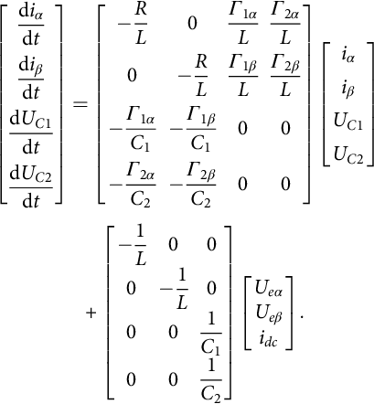 **(35.241)**

where 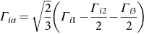, 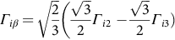, and *i*∈{1,2}.

The optimal controller is designed to choose the best output voltage vector able to minimize both the ac current, *iα* and *iβ*, errors and the input dc capacitor *UC*1 and *UC*2 voltage unbalance.

##### **Predictive equations for ac αβ currents**

To design a real-time optimal predictive controller, the obtained αβ converter model [(35.167)](https://learning.oreilly.com/library/view/power-electronics-handbook/9780128114087/B9780128114070000398_3.xhtml#fo0910) will be solved to predict the state variable values at the next sampling period, for all the 27 available vectors, assuming a sampling time *h* small enough, so that *UC*1, *UC*2, and *uep*, *p*∈{α,β}, can be considered nearly constant during step time *h*. Therefore, the simplified model is decoupled and, using [(35.229)](https://learning.oreilly.com/library/view/power-electronics-handbook/9780128114087/B9780128114070000398_4.xhtml#fo1220) in [(35.167)](https://learning.oreilly.com/library/view/power-electronics-handbook/9780128114087/B9780128114070000398_3.xhtml#fo0910), the αβ current *ipt*+*h* (*p*∈{α,β}) prediction is obtained:

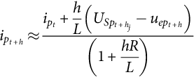 **(35.242)**

where the perturbations *uep* can be estimated using [(35.233)](https://learning.oreilly.com/library/view/power-electronics-handbook/9780128114087/B9780128114070000398_4.xhtml#fo1240).

##### **Predictive equations for dc capacitor voltage unbalance**

To predict the capacitor voltage difference or unbalance, *UC*1−*UC*2, the corresponding dynamic equations [(35.241)](https://learning.oreilly.com/library/view/power-electronics-handbook/9780128114087/B9780128114070000398_5.xhtml#fo1280) must be solved. Assuming *h* small enough, *C*1=*C*2=*C*, and small control errors, it can be assumed that the ac currents follow their references, for example, *ipt*+*h*=*ipref*. Then, from [(35.241)](https://learning.oreilly.com/library/view/power-electronics-handbook/9780128114087/B9780128114070000398_5.xhtml#fo1280) and [(35.229)](https://learning.oreilly.com/library/view/power-electronics-handbook/9780128114087/B9780128114070000398_4.xhtml#fo1220),

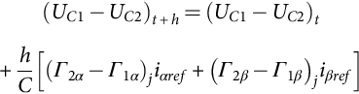 **(35.243)**

##### **Quadratic cost functional**

In NPC multilevel converters operated as ac current sources, three independent variables can be controlled, such as two ac currents *i*α(*t*) and *i*β(*t*), and the dc capacitor voltage unbalance *UC*1-*UC*2. Therefore, the tracking error vector is defined as

 **(35.244)**

The ac current references *iαref* and *iβref* are obtained one sample step forward (using [(35.233)](https://learning.oreilly.com/library/view/power-electronics-handbook/9780128114087/B9780128114070000398_4.xhtml#fo1240)) to avoid the delay time due to processor calculation time.

The main objective of the predictive optimum controller is the minimization of both the ac currents errors and the capacitor voltage difference using the following quadratic cost functional:

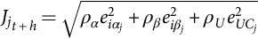 **(35.245)**

This functional is calculated for all the multilevel 27 available vectors and the resultant value stored (Eqs [35.242](https://learning.oreilly.com/library/view/power-electronics-handbook/9780128114087/B9780128114070000398_5.xhtml#fo1285)–[35.245](https://learning.oreilly.com/library/view/power-electronics-handbook/9780128114087/B9780128114070000398_5.xhtml#fo1300) are calculated 27 times). Using the procedure outlined in [(35.236)](https://learning.oreilly.com/library/view/power-electronics-handbook/9780128114087/B9780128114070000398_4.xhtml#fo1255), the vector leading to the minimum value of the cost functional is selected to be applied to the multilevel converter.

##### **Results**

The above procedure was implemented in a PowerPC-based board (DS1103) to execute in *h*=25 ms. The following parameters were used: *Udc*=300 V, *C*1=4.4 mF, *C*2=4.4 mF, *L*=15.1 mH, *R*=0.1 Ω, *iac*=7 A, *Ue* obtained from 230/400 V, 50 Hz through a 400/230 V transformer, and *ρα*=*ρβ*=11 and *ρU*=25. The ac-controlled currents and dc capacitor voltage balance are compared with the results of a sliding-mode controller. [Fig. 35.72](https://learning.oreilly.com/library/view/power-electronics-handbook/9780128114087/B9780128114070000398_5.xhtml#f0365) shows that the predictive optimum controller performance is better than the sliding-mode controller. The predictive optimum controller presents some robustness to industrial component tolerances. Results showed a tolerance from −50% to +100%.

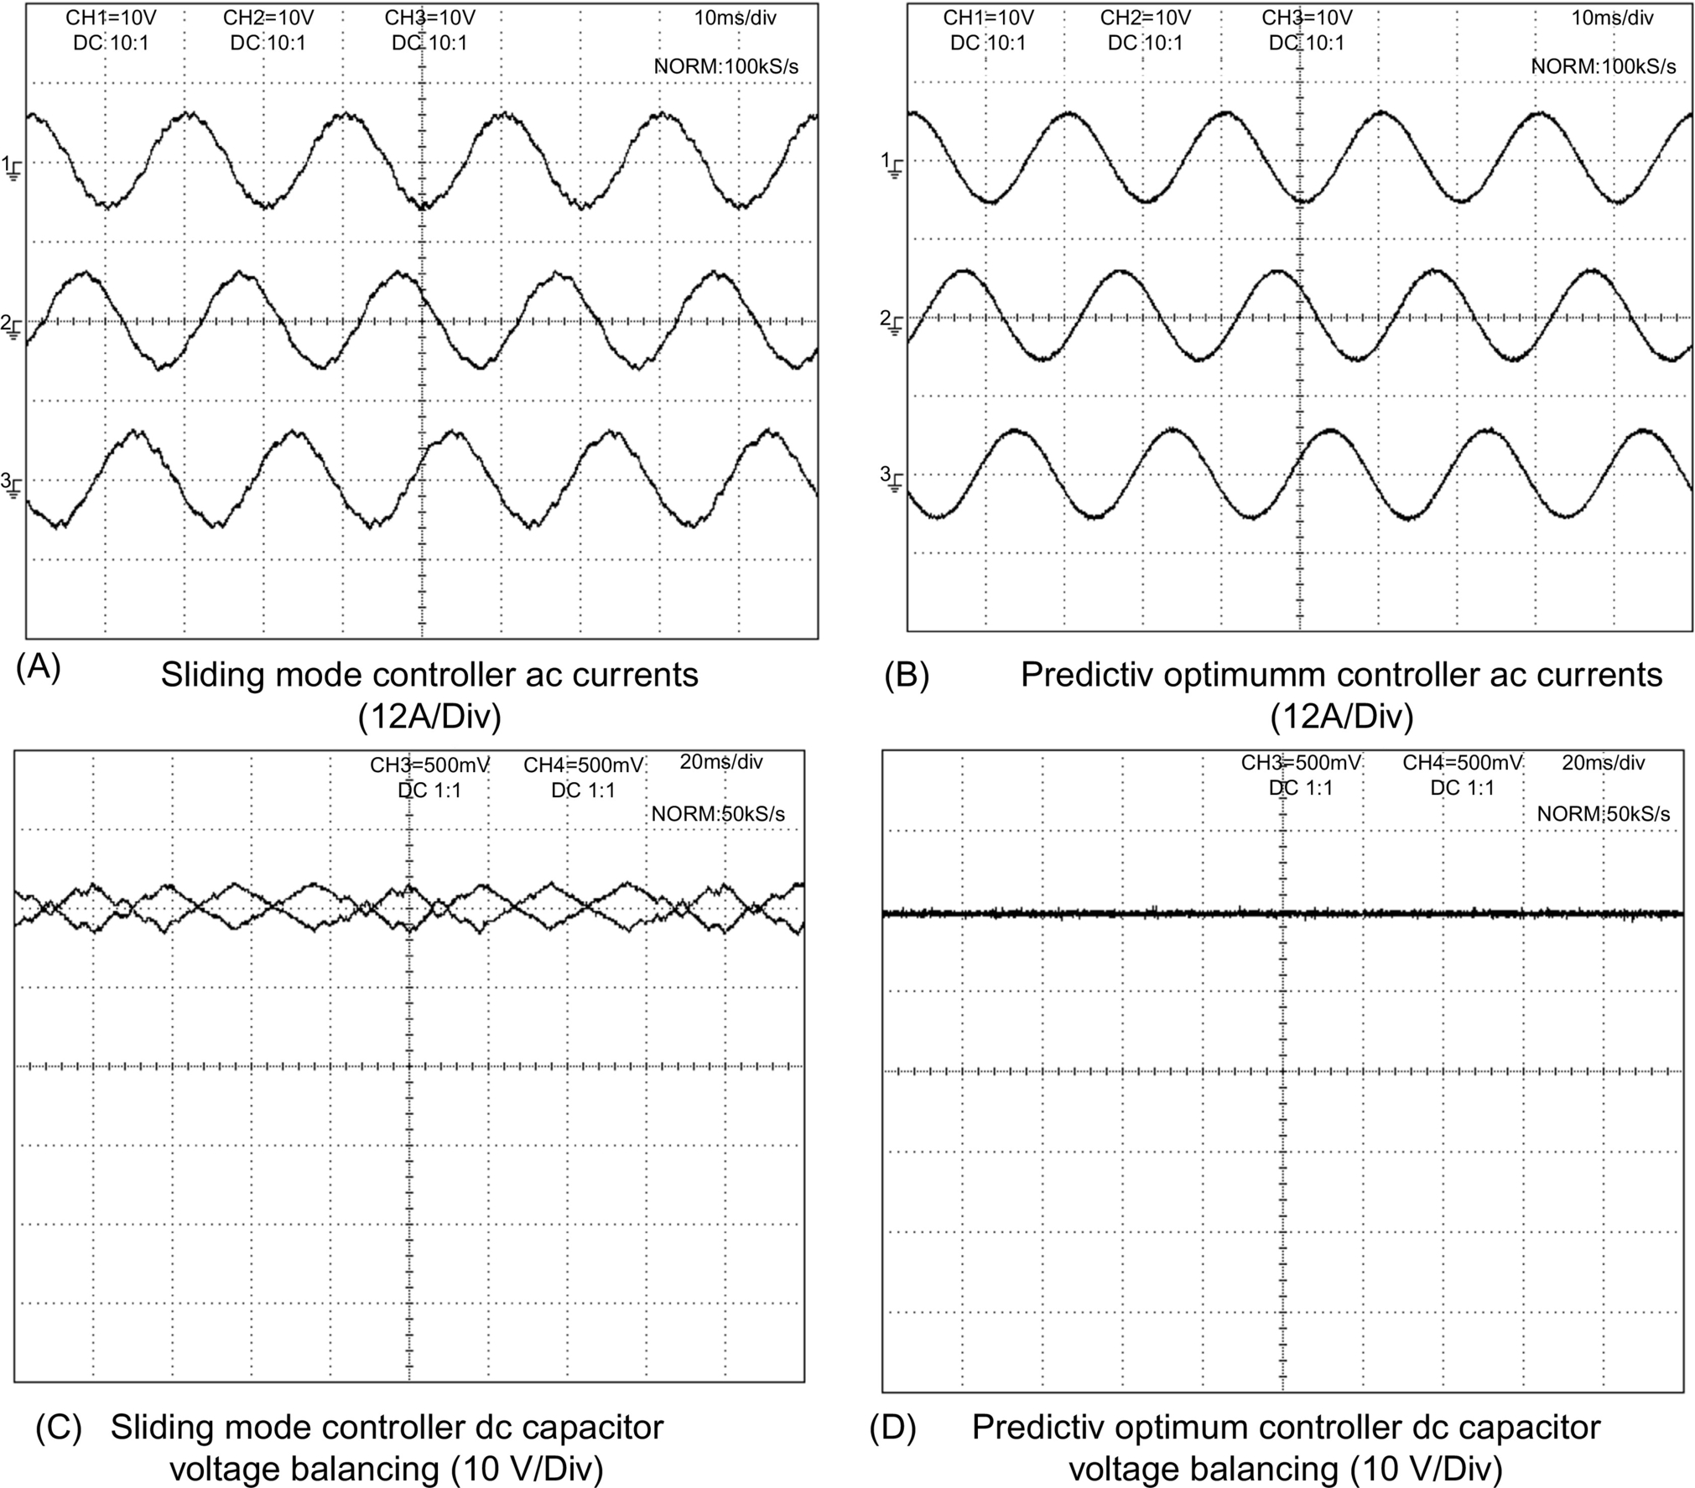

**FIG. 35.72** Multilevel converter sinusoidal ac currents, *i*1, *i*2, and *i*3, in steady-state operation and dc capacitor voltages, using sliding-mode controllers (A, C) and predictive optimum controller (B, D). (A) Sliding-mode controller ac currents (12 A/div), (B) Predictive optimum controller ac currents (12 A/div), (C) Sliding-mode controller dc capacitor voltage balancing (10 V/div), (D) Predictive optimum controller dc capacitor voltage balancing (10 V/div).

Further experiments [[37](https://learning.oreilly.com/library/view/power-electronics-handbook/9780128114087/B9780128114070000398_5.xhtml#bb0190),[38](https://learning.oreilly.com/library/view/power-electronics-handbook/9780128114087/B9780128114070000398_5.xhtml#bb0195)] revealed that harmonics of ac currents were 46 dB below the 50 Hz fundamental level, improving by 14 dB the sliding-mode controller result. The switching frequency of the predictive optimum controller spreads over the frequency spectrum below 2.5 kHz, reducing and softening the audible noise. The average switching frequency of the predictive optimum controlled multilevel converter is reduced to half of the value of a sliding-mode-controlled multilevel at the same current ripple. Further reduction could be obtained by weighting the switching frequency in the quadratic cost functional [[39](https://learning.oreilly.com/library/view/power-electronics-handbook/9780128114087/B9780128114070000398_5.xhtml#bb0200)].

#### **35.4.4.2 Example 35.20: Fast Predictive Optimum Control of Matrix Converters**

Consider the three-phase ac/ac matrix converter with input *lCr* filter of [Fig. 35.64](https://learning.oreilly.com/library/view/power-electronics-handbook/9780128114087/B9780128114070000398_4.xhtml#f0325), and suppose we want to control the output currents , , and  while guaranteeing an almost unity input power factor and near sinusoidal input currents *iig*1, *iig*2, and *iig*3.

The converter direct dynamics of the output currents in dq frame at frequency *ωo*, *iod*, *ioq* is

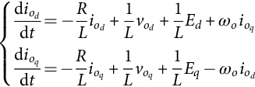 **(35.246)**

The converter direct dynamics of the input currents in dq frame at frequency *ωi*, *iigd*, *iigq* is given in [(35.183)](https://learning.oreilly.com/library/view/power-electronics-handbook/9780128114087/B9780128114070000398_4.xhtml#fo0990) and [(35.184)](https://learning.oreilly.com/library/view/power-electronics-handbook/9780128114087/B9780128114070000398_4.xhtml#fo0995). To control the matrix input power factor, the dynamics of the input dq currents, neglecting the effects of the matrix input filter damping resistor (*r*→∞), can be simplified to be

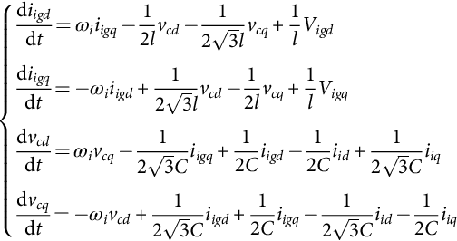 **(35.247)**

The control vector **u***t*+*h* are defined by *vodt*+*h*, *voqt*+*h*, and *iiqt+h*. From the input and output dynamics of the matrix converter, Eq. [(35.248)](https://learning.oreilly.com/library/view/power-electronics-handbook/9780128114087/B9780128114070000398_5.xhtml#fo1315) computes the necessary vector components to ensure convergence to the reference values within one sampling step *h*. Most terms of the *iiqt+h* current can be neglected for simplicity, the essential ones being the difference *iigqref−iigqt* with associated gain and the feedforward value of *iigqref*:

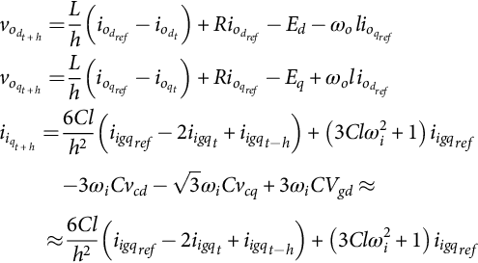 **(35.248)**

Only one calculation for the optimum vector with components [(35.247)](https://learning.oreilly.com/library/view/power-electronics-handbook/9780128114087/B9780128114070000398_5.xhtml#fo1310) is needed, avoiding the currents and the respective errors computation for all the 27 possible converter vectors, speeding the predictive method. Since the discrete time derivative and damping terms are calculated using the current future values, the Euler backward algorithm is used, ensuring convergence.

In practice, none of the available converter vectors will present exactly the necessary components. Therefore, the distance from each vector to the optimum vector (the vector error norm) must be computed, using the cost functional:

 **(35.249)**

Results using *ρvd* = *ρvq* = *ρiq* = 1 show that fast predictive optimum controllers, using the converter inverse dynamics, present better performances than state-of-art sliding-mode controllers ([Fig. 35.73](https://learning.oreilly.com/library/view/power-electronics-handbook/9780128114087/B9780128114070000398_5.xhtml#f0370)). Stability and robustness of fast predictive optimum controllers, concerning parameter variation, disturbances, and nonmodeled dynamics, must be investigated. The fast predictive methodology was successful applied to other converters [[40](https://learning.oreilly.com/library/view/power-electronics-handbook/9780128114087/B9780128114070000398_5.xhtml#bb0205)]:

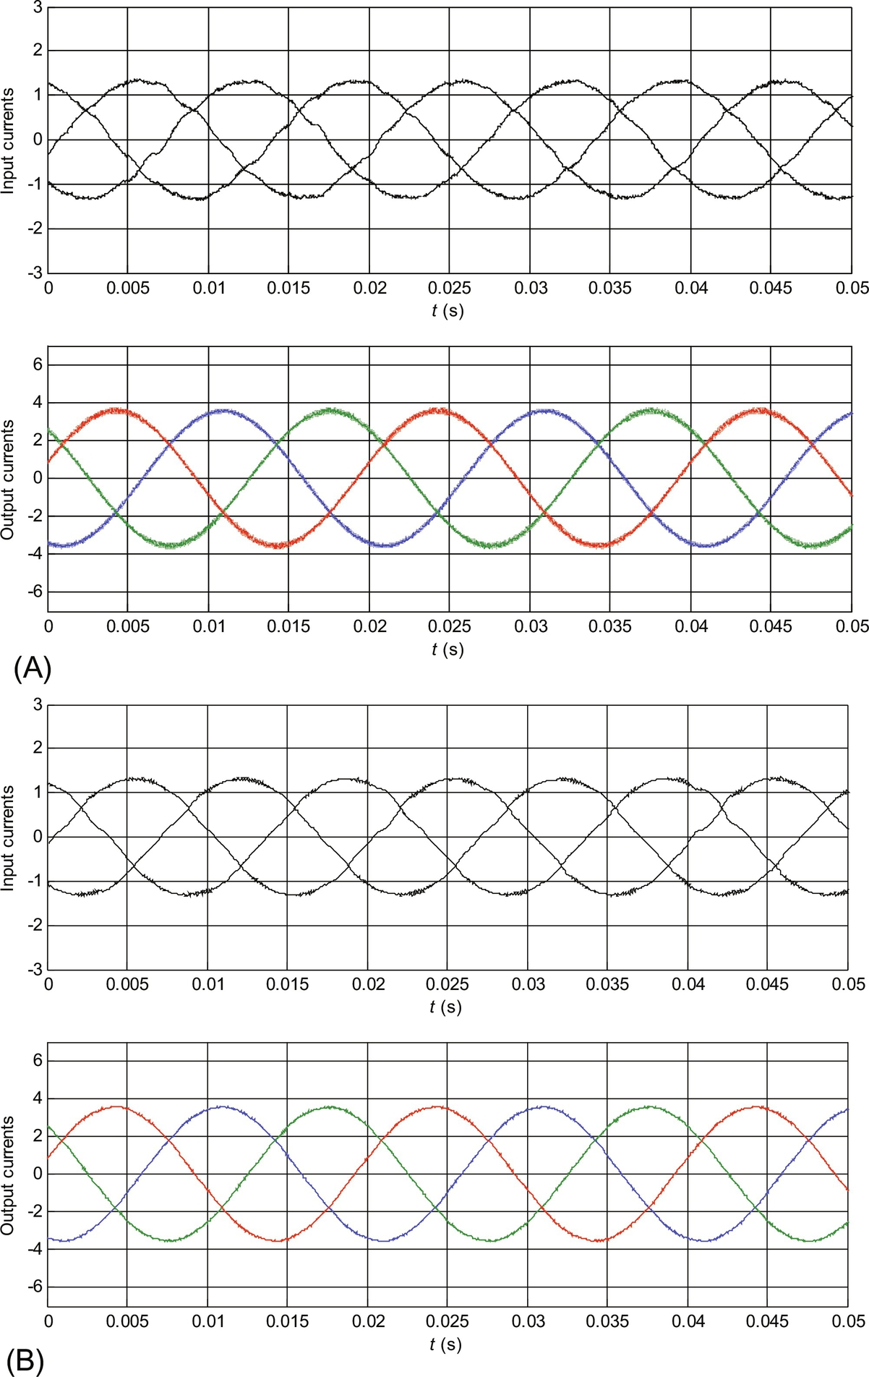

**FIG. 35.73** Matrix converter sinusoidal ac input and output currents, *i*1, *i*2, and *i*3, in steady-state operation, using sliding-mode controllers (A) and fast predictive optimum controllers (B).

## 35.5 Fuzzy Logic Control of Switching power converters

### **35.5.1 INTRODUCTION**

Fuzzy logic control is a heuristic approach that easily embeds the knowledge and key elements of human thinking in the design of nonlinear controllers [[41](https://learning.oreilly.com/library/view/power-electronics-handbook/9780128114087/B9780128114070000398_5.xhtml#bb0210)–[43](https://learning.oreilly.com/library/view/power-electronics-handbook/9780128114087/B9780128114070000398_5.xhtml#bb0220)]. Qualitative and heuristic considerations, which cannot be handled by conventional control theory, can be used for control purposes in a systematic form, applying fuzzy control concepts [[44](https://learning.oreilly.com/library/view/power-electronics-handbook/9780128114087/B9780128114070000398_5.xhtml#bb0225)]. Fuzzy logic control does not need an accurate mathematical model, can work with imprecise inputs, can handle nonlinearity, and can present disturbance insensitivity greater than the most nonlinear controllers. Fuzzy logic controllers usually outperform other controllers in complex, nonlinear, or undefined systems for which a good practical knowledge exists.

Fuzzy logic controllers are based on fuzzy sets, that is, classes of objects in which the transition from membership to nonmembership is smooth rather than abrupt. Therefore, boundaries of fuzzy sets can be vague and ambiguous, making them useful for approximation models.

The first step in the fuzzy controller synthesis procedure is to define the input and output variables of the fuzzy controller. This is done accordingly with the expected function of the controller. There are no general rules to select those variables, although typically the variables chosen are the states of the controlled system, their errors, error variation, and/or error accumulation. In switching power converters, the fuzzy controller input variables are commonly the output voltage or current error and/or the variation or accumulation of this error. The output variables *u*(*k*) of the fuzzy controller can define the converter duty cycle ([Fig. 35.74](https://learning.oreilly.com/library/view/power-electronics-handbook/9780128114087/B9780128114070000398_5.xhtml#f0375)) or a reference current to be applied in an inner current-mode PI or a sliding-mode controller.

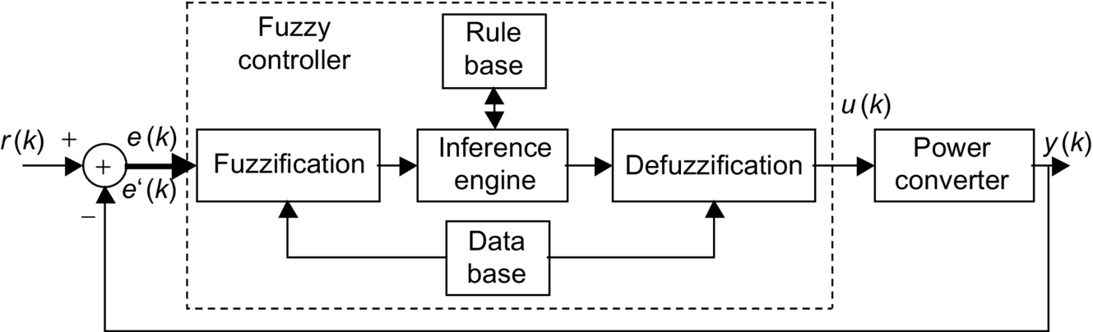

**FIG. 35.74** Structure of a fuzzy logic controller.

The fuzzy controller rules are usually formulated in linguistic terms. Thus, the use of linguistic variables and fuzzy sets implies the fuzzification procedure, that is, the mapping of the input variables into suitable linguistics values.

Rule evaluation or decision-making infers, using an inference engine, the fuzzy control action from the knowledge of the fuzzy rules and the linguistic variable definition.

The output of a fuzzy controller is a fuzzy set, and thus, it is necessary to perform a defuzzification procedure, that is, the conversion of the inferred fuzzy result to a nonfuzzy (crisp) control action, that better represents the fuzzy one. This last step obtains the crisp value for the controller output *u*(*k*) ([Fig. 35.74](https://learning.oreilly.com/library/view/power-electronics-handbook/9780128114087/B9780128114070000398_5.xhtml#f0375)).

These steps can be implemented online or offline. Online implementation, useful if an adaptive controller is intended, performs real-time inference to obtain the controller output and needs a fast enough processor. Off-line implementation employs a lookup table built according to the set of all possible combinations of input variables. To obtain this lookup table, the input values in a quantified range are converted (fuzzification) into fuzzy variables (linguistic). The fuzzy set output, obtained by the inference or decision-making engine according to linguistic control rules (designed by the knowledge expert), is then, converted into numeric controller output values (defuzzification). The table contains the output for all the combinations of quantified input entries. Off-line process can actually reduce the controller actuation time since the only effort is limited to consulting the table at each iteration.

This section presents the main steps for the implementation of a fuzzy controller suitable for switching power converter control. A meaningful example is provided.

### 35.5.2 FUZZY LOGIC CONTROLLER SYNTHESIS

Fuzzy logic controllers consider neither the parameters of the switching power converter or their fluctuations nor the operating conditions, but only the experimental knowledge of the switching power converter dynamics. In this way, such a controller can be used with a wide diversity of switching power converters implying only small modifications. The necessary fuzzy rules are simply obtained considering roughly the knowledge of the switching power converter dynamic behavior.

#### **35.5.2.1 Fuzzification**

Assume, as fuzzy controller input variables, an output voltage (or current) error and the variation of this error. For the output, assume a signal *u*(*k*), the control input of the converter.

A. Quantization Levels

Consider the reference *r*(*k*) of the converter output *k*th sample, *y*(*k*). The tracking error *e*(*k*) is *e*(*k*)=*r*(*k*)−*y*(*k*), and the output error change Δ*e*(*k*), between the samples *k* and *k*−1, is determined by Δ*e*(*k*)=*e*(*k*)−*e*(*k*−1).

These variables and the fuzzy controller output *u*(*k*), usually ranging from −10 to 10 V, can be quantified in *m* levels {− (*m*−1)/2, +(*m*−1)/2}. For offline implementation, *m* sets a compromise between the finite length of a lookup table and the required precision.

B. Linguistic Variables and Fuzzy Sets

The fuzzy sets for *xe*, the linguistic variable corresponding to the error *e*(*k*); for *x*Δ*e*, the linguistic variable corresponding to the error variation Δ*e*(*k*); and for *xu*, the linguistic variable of the fuzzy controller output *u*(*k*) are usually defined as positive big (*PB*), positive medium (*PM*), positive small (*PS*), zero (*ZE*), negative small (*NS*), negative medium (*NM*), and negative big (*NB*), instead of having numerical values.

In most cases, the use of these seven fuzzy sets is the best compromise between accuracy and computational task.

C. Membership Functions

A fuzzy subset, for example, **S***i* (**S***i*=(NB, NM, NS, ZE, PS, PM, or PB)) of a universe *E*, collection of *e*(*k*) values denoted generically by {*e*}, is characterized by a membership function *μ*Si: *E*→[0,1], associating with each element *e* of universe *E*, a number *μ*Si(*e*) in the interval [0,1], which represents the grade of membership of *e* to *E*. Therefore, each variable is assigned a membership grade to each fuzzy set, based on a corresponding membership function ([Fig. 35.75](https://learning.oreilly.com/library/view/power-electronics-handbook/9780128114087/B9780128114070000398_5.xhtml#f0380)). Considering the *m* quantization levels, the membership function *μ*Si(*e*) of the element *e* in the universe of discourse *E*, may take one of the discrete values included in *μ*Si(*e*)∈{0; 0.2; 0.4; 0.6; 0.8; 1; 0.8; 0.6; 0.4; 0.2; 0}. Membership functions are stored in the database ([Fig. 35.74](https://learning.oreilly.com/library/view/power-electronics-handbook/9780128114087/B9780128114070000398_5.xhtml#f0375)).

Considering *e*(*k*)=2 and Δ*e*(*k*)=−3, taking into account the staircase-like membership functions shown in [Fig. 35.75](https://learning.oreilly.com/library/view/power-electronics-handbook/9780128114087/B9780128114070000398_5.xhtml#f0380), it can be said that *xe* is *PS* and also *ZE*, being equally *PS* and *ZE*. Also, *x*Δ*e* is *NS* and *ZE*, being less *ZE* than *NS*.

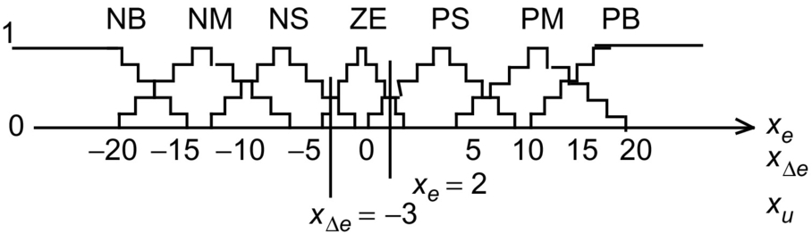

**FIG. 35.75** Membership functions in the universe of discourse.

D. Linguistic Control Rules

The generic linguistic control rule has the following form: “IF *xe*(*k*) is membership of the set **S***i*=(NB, NM, NS, ZE, PS, PM, or PB) AND *x*Δ*e*(*k*) is membership of the set **S***j*=(NB, NM, NS, ZE, PS, PM, or PB), THEN the output control variable *xu*(*k*+1) is membership of the set **S***u*=(NB, NM, NS, ZE, PS, PM, or PB).”

Usually, the rules are obtained considering the most common dynamic behavior of switching power converters, the second-order system with damped oscillating response ([Fig. 35.76](https://learning.oreilly.com/library/view/power-electronics-handbook/9780128114087/B9780128114070000398_5.xhtml#f0385)). Analyzing the error and its variation, together with the rough linguistic knowledge of the needed control input, an expert can obtain linguistic control rules such as the ones displayed in [Table 35.8](https://learning.oreilly.com/library/view/power-electronics-handbook/9780128114087/B9780128114070000398_5.xhtml#t0045). For example, at point six of [Fig. 35.76](https://learning.oreilly.com/library/view/power-electronics-handbook/9780128114087/B9780128114070000398_5.xhtml#f0385), the rule is “if *xe*(*k*) is NM AND *x*Δ*e*(*k*) is ZE, THEN *xu*(*k*+1) should be NM.”

[Table 35.8](https://learning.oreilly.com/library/view/power-electronics-handbook/9780128114087/B9780128114070000398_5.xhtml#t0045), for example, states that

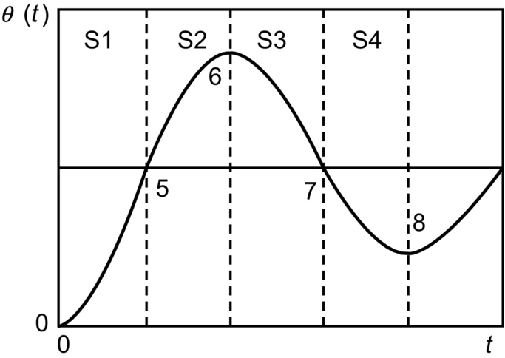

**FIG. 35.76** Reference dynamic model of switching power converters: second-order damped oscillating error response.

**Table 35.8**

**Linguistic control rules**

|  |  |  |  |  |  |  |  |
| --- | --- | --- | --- | --- | --- | --- | --- |
| ***xe*(*k*)*x*Δ*e*(*k*)** | **NB** | **NM** | **NS** | **ZE** | **PS** | **PM** | **PB** |
| NB | NB | NB | NB | NM | NM | PS | PM |
| NM | NB | NB | NM | NS | NM | PM | PB |
| NS | NB | NB | NM | NS | NS | PM | PB |
| ZE | NB | NM | NS | ZE | PS | PM | PB |
| PS | NB | NM | PS | PS | PM | PB | PB |
| PM | NB | NM | PM | PS | PM | PB | PB |
| PB | NM | NS | PM | PM | PB | PB | PB |

IF *xe* (*k*) is NB AND *x*Δ*e*(*k*) is NB, THEN *xu*(*k*+1) must be NB, or

IF *xe*(*k*) is PS AND *x*Δ*e*(*k*) is NS, THEN *xu*(*k*+1) must be NS, or

IF *xe*(*k*)is PS AND *x*Δ*e*(*k*) is ZE, THEN *xu*(*k*+1) must be PS, or

IF *xe*(*k*) is ZE AND *x*Δ*e*(*k*) is NS, THEN *xu*(*k*+1) must be NS, or

IF *xe*(*k*) is ZE AND *x*Δ*e*(*k*) is ZE, THEN *xu*(*k*+1) must be ZE, or

IF….

These rules (rule base) alone do not allow the definition of the control output, as several of them may apply at the same time.

#### **35.5.2.2 Inference Engine**

The result of a fuzzy control algorithm can be obtained using the control rules of [Table 35.8](https://learning.oreilly.com/library/view/power-electronics-handbook/9780128114087/B9780128114070000398_5.xhtml#t0045), the membership functions, and an inference engine. In fact, any quantified value for *e*(*k*) and Δ*e*(*k*) is often included into two linguistic variables. With the membership functions used and knowing that the controller considers *e*(*k*) and Δ*e*(*k*), the control decision generically must be taken according to four linguistic control rules.

To obtain the corresponding fuzzy set, the min-max inference method can be used. The minimum operator describes the “AND” present in each of the four rules, that is, it calculates the minimum between the discrete value of the membership function *μ*Si(*xe*(*k*)) and the discrete value of the membership function *μ*Sj(*x*Δ*e*(*k*)). The “THEN” statement links this minimum to the membership function of the output variable. The membership function of the output variable will therefore include trapezoids limited by the segment min(*μ*Si(*xe*(*k*)) and *μ*Sj(*x*Δ*e*(*k*))).

The OR operator linking the different rules is implemented by calculating the maximum of all the (usually four) rules. This mechanism to obtain the resulting membership function of the output variable is represented in [Fig. 35.77](https://learning.oreilly.com/library/view/power-electronics-handbook/9780128114087/B9780128114070000398_5.xhtml#f0390).

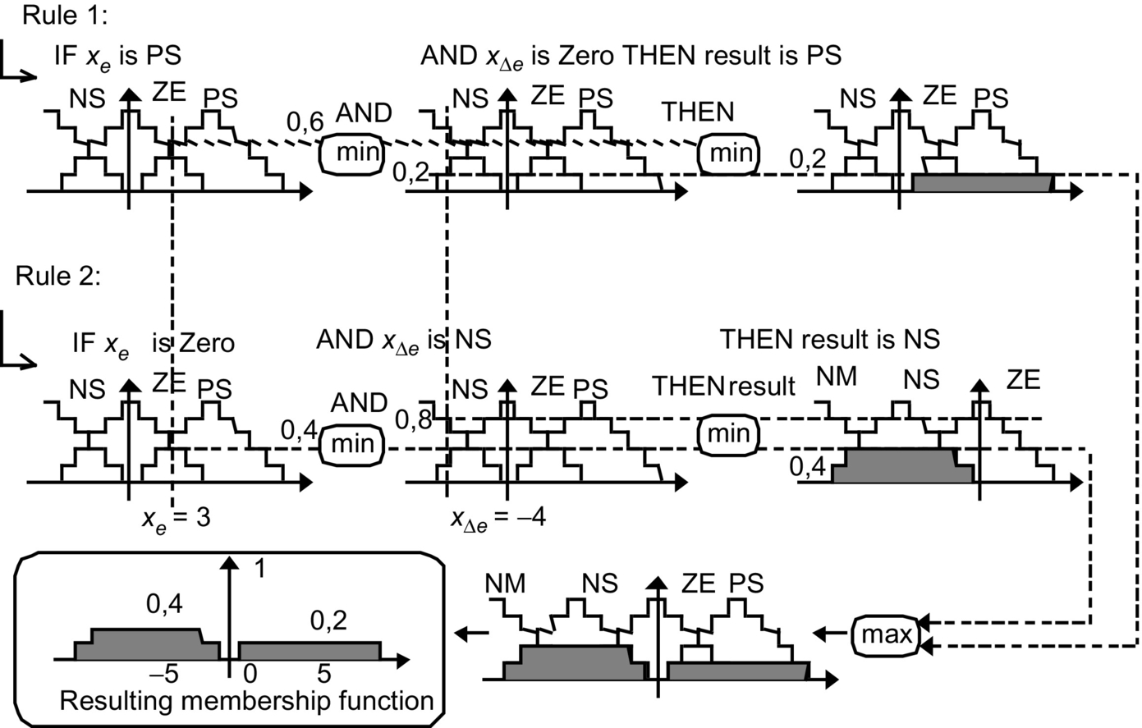

**FIG. 35.77** Application of the min-max operator to obtain the output membership function.

#### **35.5.2.3 Defuzzification**

As shown, the inference method provides a resulting membership function *μ*Sr(*xu*(*k*)), for the output fuzzy variable *xu* ([Fig. 35.77](https://learning.oreilly.com/library/view/power-electronics-handbook/9780128114087/B9780128114070000398_5.xhtml#f0390)). Using a defuzzification process, this final membership function, obtained by combining all the membership functions, as a consequence of each rule, is then converted into a numerical value, called *u*(*k*). The defuzzification strategy can be the center of area (COA) method. This method generates one output value *u*(*k*), which is the abscissa of the gravity center of the resulting membership function area, given by the following relation:

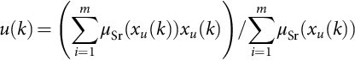 **(35.250)**

This method provides good results for output control. Indeed, for a weak variation of *e*(*k*) and Δ*e*(*k*), the center of the area will move just a little and so does the controller output value. By comparison, the alternative defuzzification method, mean of maximum strategy (MOM) is advantageous for fast response, but it causes a greater steady-state error and overshoot (considering no perturbations).

#### **35.5.2.4 Lookup Table Construction**

Using the rules given in [Table 35.8](https://learning.oreilly.com/library/view/power-electronics-handbook/9780128114087/B9780128114070000398_5.xhtml#t0045), the min-max inference procedure and COA defuzzification, all the controller output values for all quantified *e*(*k*) and Δ*e*(*k*), can be stored in an array to serve as the decision-lookup table. This lookup table usually has a three-dimensional representation similar to [Fig. 35.78](https://learning.oreilly.com/library/view/power-electronics-handbook/9780128114087/B9780128114070000398_5.xhtml#f0395). A microprocessor-based control algorithm just picks up output values from the lookup table.

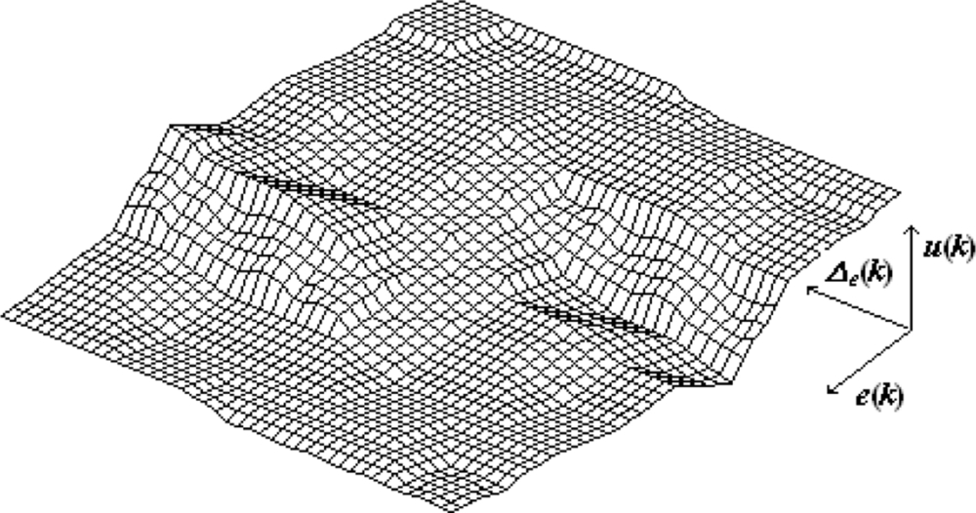

**FIG. 35.78** Three-dimensional view of the lookup table.

### 35.5.3 NEAR UNITY POWER FACTOR BUCK–BOOST PWM RECTIFIER

#### **35.5.3.1 Example 35.21: Fuzzy Logic Control of Unity Power Factor Buck–Boost Rectifiers**

Consider the near unity power factor buck-boost rectifier of [Fig. 35.79](https://learning.oreilly.com/library/view/power-electronics-handbook/9780128114087/B9780128114070000398_5.xhtml#f0400), where the diodes in series with the transistors enable them to withstand negative voltages.

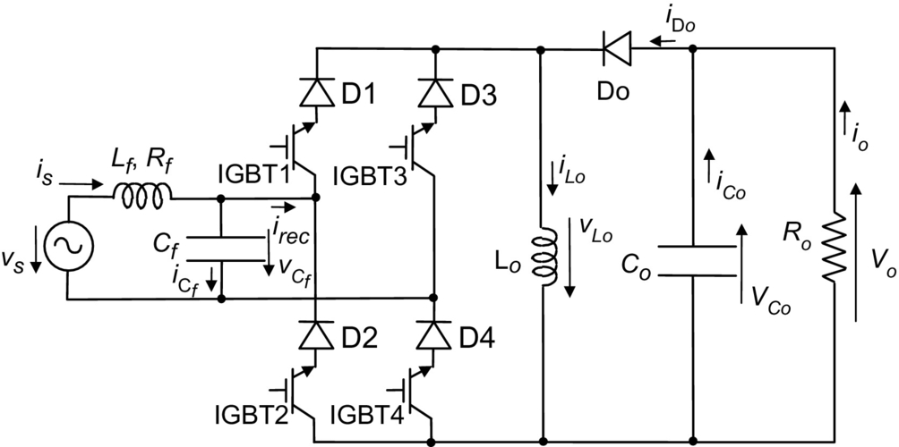

**FIG. 35.79** Power factor buck-boost rectifier with four IGBTs.

The switched state-space model of this converter can be written as

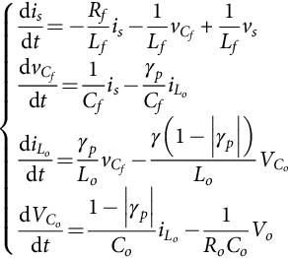 **(35.251)**

**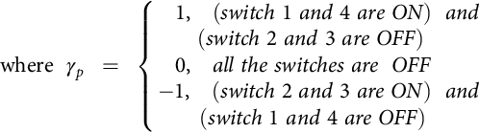**

and 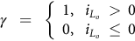.

For comparison purposes, a PI output voltage controller is designed considering that a current-mode PWM modulator enforces the reference value for the *is* current (which usually exhibits a fast dynamics compared with the dynamics of *VCo*). A first-order model, similar to Eq. [(35.146)](https://learning.oreilly.com/library/view/power-electronics-handbook/9780128114087/B9780128114070000398_3.xhtml#fo0795), is obtained. The PI gains are similar to Eq. [(35.116)](https://learning.oreilly.com/library/view/power-electronics-handbook/9780128114087/B9780128114070000398_2.xhtml#fo0620) and load-dependent (*Kp*=*Co*/(2*Td*) and *Ki*=1/(2*TdRo*)).

A fuzzy controller is obtained considering the approach outlined, with seven membership functions for the output voltage error, five for its change, and three membership functions for the output. The linguistic control rules are obtained as the ones depicted in [Table 35.8](https://learning.oreilly.com/library/view/power-electronics-handbook/9780128114087/B9780128114070000398_5.xhtml#t0045), and the lookup table gives a mapping similar to [Fig. 35.78](https://learning.oreilly.com/library/view/power-electronics-handbook/9780128114087/B9780128114070000398_5.xhtml#f0395). Performances obtained for the step response show a fuzzy controlled rectifier behavior close to the PI behavior. The advantages of the fuzzy controller emerge for perturbed loads or power supplies, where the low sensitivity of the fuzzy controller to system parameters is clearly seen ([Fig. 35.80](https://learning.oreilly.com/library/view/power-electronics-handbook/9780128114087/B9780128114070000398_5.xhtml#f0405)). Therefore, the fuzzy controllers can be advantageous for switching power converters with changing loads, power supply voltages, and other external disturbances.

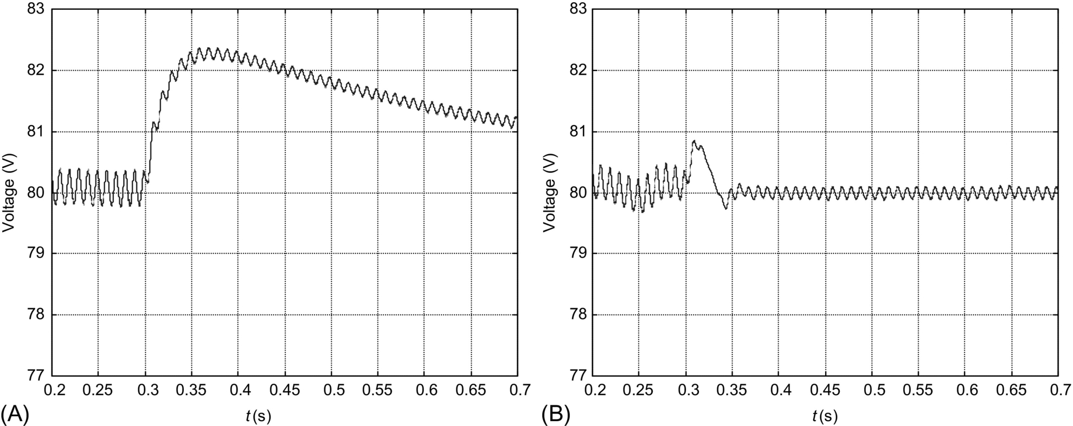

**FIG. 35.80** Simulated result of the output voltage response to load disturbances (*Ro*=50–150 Ω at time 0.3 s): (A) PI control and (B) fuzzy logic control.

## 35.6 Backstepping Control of Switching Power Converters

### **35.6.1 PRINCIPLES OF BACKSTEPPING CONTROL**

The backstepping control methodology [[45](https://learning.oreilly.com/library/view/power-electronics-handbook/9780128114087/B9780128114070000398_5.xhtml#bb0230),[46](https://learning.oreilly.com/library/view/power-electronics-handbook/9780128114087/B9780128114070000398_5.xhtml#bb0235)] may be implemented using a recursive procedure interconnecting the choice of a candidate Lyapunov function with the design of the feedback control loop using the second method of Lyapunov stability (direct method). Backstepping offers tracking ability, stability, and robust control under conditions less restrictive than other methods [[47](https://learning.oreilly.com/library/view/power-electronics-handbook/9780128114087/B9780128114070000398_5.xhtml#bb0240)]. Backstepping uses a strict-feedback form of the system model:

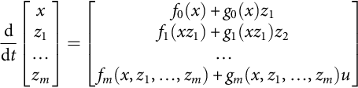 **(35.252)**

where *x*∈ℜn, *z*l–*zm* are scalar state variables, *f*0–*fm* are nonlinearities dependent only on the state variables that are fed back [*x*, *z*l,…, *zm*] (strict feedback), and *g*i≠0 is dependent on (*x*,*z*l,…,*zi*) for 1≤*i*≤*m*.

To apply the backstepping method [[47](https://learning.oreilly.com/library/view/power-electronics-handbook/9780128114087/B9780128114070000398_5.xhtml#bb0240)] and stabilize the system to the origin (zero error), the following steps can be used:

(1) The recursive procedure starts with the subsystem of [(35.252)](https://learning.oreilly.com/library/view/power-electronics-handbook/9780128114087/B9780128114070000398_5.xhtml#fo1335):

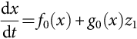 **(35.253)**

where *z*1 is a state variable, whose dynamics can be enforced, called a stabilizing control input (or virtual control input).

(2) Proceed to obtain *z*1 by defining the control objective *x=xref*, and considering the tracking error *ex*,

 **(35.254)**

Select a Lyapunov function *V*1(*x*,*t*) globally positive definite, continuously differentiable, and radially unbounded for all *ex*. Denoting *V*1(*x*,*t*) by *V*1 for simplicity, a candidate function for this case can be written as

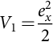 **(35.255)**

To guarantee the control solution is globally asymptotically stable, from Lyapunov's second method of stability, the time derivative of the positive-definite Lyapunov function *V*1 must be globally negative definite for all (*x*,*t*), so that  [[47](https://learning.oreilly.com/library/view/power-electronics-handbook/9780128114087/B9780128114070000398_5.xhtml#bb0240)], as in the sliding-mode stability condition [(35.92)](https://learning.oreilly.com/library/view/power-electronics-handbook/9780128114087/B9780128114070000398_2.xhtml#fo0500):

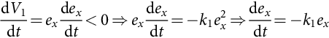 **(35.256)**

The constant *k*1 must be positive definite (for stability). The last relation implies that the tracking error will converge to zero asymptotically with time constant 1/*k*1. Eq. [(35.256)](https://learning.oreilly.com/library/view/power-electronics-handbook/9780128114087/B9780128114070000398_5.xhtml#fo1355) will be satisfied if *z1*=*z1ref*. Using [(35.254)](https://learning.oreilly.com/library/view/power-electronics-handbook/9780128114087/B9780128114070000398_5.xhtml#fo1345) and [(35.253)](https://learning.oreilly.com/library/view/power-electronics-handbook/9780128114087/B9780128114070000398_5.xhtml#fo1340) in [(35.256)](https://learning.oreilly.com/library/view/power-electronics-handbook/9780128114087/B9780128114070000398_5.xhtml#fo1355), then,

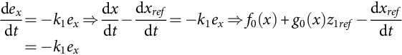 **(35.257)**

Solving for *z1ref*, (*g*0(*x*)≠0), it results

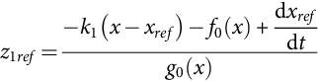 **(35.258)**

(3) Proceed to the second recursion to obtain *z*2*ref* by considering the tracking error

 **(35.259)**

and select a recursively defined composite Lyapunov function *V*2 positive definite:

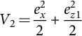 **(35.260)**

The stability condition is *dV*2/*dt*<0:

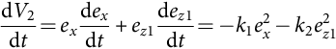 **(35.261)**

where *k*1 and *k*2 must be positive (*k*1 and *k*2>0) for asymptotic stability.

From [(35.261)](https://learning.oreilly.com/library/view/power-electronics-handbook/9780128114087/B9780128114070000398_5.xhtml#fo1380) using [(35.254)](https://learning.oreilly.com/library/view/power-electronics-handbook/9780128114087/B9780128114070000398_5.xhtml#fo1345), [(35.253)](https://learning.oreilly.com/library/view/power-electronics-handbook/9780128114087/B9780128114070000398_5.xhtml#fo1340), [(35.259)](https://learning.oreilly.com/library/view/power-electronics-handbook/9780128114087/B9780128114070000398_5.xhtml#fo1370), and the second equation of [(35.252)](https://learning.oreilly.com/library/view/power-electronics-handbook/9780128114087/B9780128114070000398_5.xhtml#fo1335), replacing *z*1*=ez*1+*z*1*ref* in [(35.257)](https://learning.oreilly.com/library/view/power-electronics-handbook/9780128114087/B9780128114070000398_5.xhtml#fo1360), and using the result of [(35.257)](https://learning.oreilly.com/library/view/power-electronics-handbook/9780128114087/B9780128114070000398_5.xhtml#fo1360), it is written as

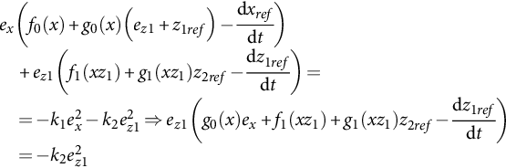 **(35.262)**

If *dz*1*ref* /*dt* is independent of *z*2, solving for *z2ref* returns,

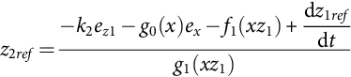 **(35.263)**

(4) Proceed recursively (return to step 1) up to the definition of the control law of *zm*, by selecting a recursively defined composite positive-definite Lyapunov function.

Alternatively, the integral action backstepping approach can be used in the first recursion.

Define a control objective *x=xref* and consider the tracking error *ex*=*x*−*xref* as in [(35.254)](https://learning.oreilly.com/library/view/power-electronics-handbook/9780128114087/B9780128114070000398_5.xhtml#fo1345). Now, add the integral of the tracking error *eI* to the control action. The integral term is useful to ensure the convergence, in steady state, of the tracking error to zero regardless of nonmodeled disturbances and parameter uncertainty:

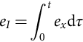 **(35.264)**

Use a positive-definite Lyapunov function *VI* that weights (with *k*0) the integral action to be added to the state feedback control law:

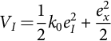 **(35.265)**

Compute the time derivative of the Lyapunov function *VI* and enforce it to be negative definite ():

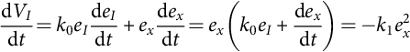 **(35.266)**

Eq. [(35.266)](https://learning.oreilly.com/library/view/power-electronics-handbook/9780128114087/B9780128114070000398_5.xhtml#fo1405) will be satisfied if *z1*=*z1ref*. Using [(35.266)](https://learning.oreilly.com/library/view/power-electronics-handbook/9780128114087/B9780128114070000398_5.xhtml#fo1405), [(35.254)](https://learning.oreilly.com/library/view/power-electronics-handbook/9780128114087/B9780128114070000398_5.xhtml#fo1345), and [(35.253)](https://learning.oreilly.com/library/view/power-electronics-handbook/9780128114087/B9780128114070000398_5.xhtml#fo1340), then,

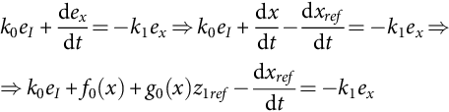 **(35.267)**

Solving for *z1ref*, being *g*0(*x*)≠0, and using [(35.264)](https://learning.oreilly.com/library/view/power-electronics-handbook/9780128114087/B9780128114070000398_5.xhtml#fo1395), then,

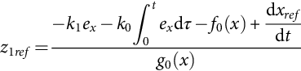 **(35.268)**

This is the backstepping equivalent of a proportional-integral (PI) linear controller. Besides the proportional *k*1 and integral *k*0 gains, it adds the influence of the plant characteristics *f*0(*x*) and *g*0(*x*) and the derivative of the reference *dxref*/*dt*, by including the correspondent feedforward terms, which are not in the linear PI.

### 35.6.2 EXAMPLE 35.22: BACKSTEPPING CONTROL OF THE BUCK–BOOST CONVERTER

Consider the buck-boost converter ([Fig. 35.81](https://learning.oreilly.com/library/view/power-electronics-handbook/9780128114087/B9780128114070000398_5.xhtml#f0410)) strict-feedback averaged subsystem model [(35.269)](https://learning.oreilly.com/library/view/power-electronics-handbook/9780128114087/B9780128114070000398_5.xhtml#fo1420), where *D* is the average value of the transistor duty-cycle *δ*(*t*):

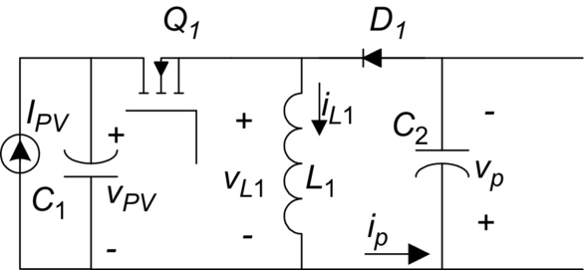

**FIG. 35.81** Buck-boost dc/dc converter feed from a current source *IPV*.

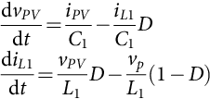 **(35.269)**

In this example, the current source *IPV* is a simple model of a photovoltaic panel and depends on *vPV*. To obtain the maximum power from the panel, the *vPV* voltage must be regulated to track the maximum power point (MPPT), defined by an MPPT algorithm [[48](https://learning.oreilly.com/library/view/power-electronics-handbook/9780128114087/B9780128114070000398_5.xhtml#bb0245),[49](https://learning.oreilly.com/library/view/power-electronics-handbook/9780128114087/B9780128114070000398_5.xhtml#bb0250)], so that the control objective is *vPV*=*vPVref*, the control input is the averaged duty-cycle *D*, and the stabilizing virtual control input is *iL1*:

(1) Consider the strict-feedback subsystem:

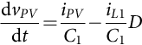 **(35.270)**

(2) Define the control objective *vPV*=*vPVref* and the tracking error:

 **(35.271)**

Define a positive-definite Lyapunov function *V*1*b*:

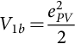 **(35.272)**

The time derivative of *V*1*b* must be negative definite for asymptotic stability. Similarly to [(35.256)](https://learning.oreilly.com/library/view/power-electronics-handbook/9780128114087/B9780128114070000398_5.xhtml#fo1355) and considering [(35.270)](https://learning.oreilly.com/library/view/power-electronics-handbook/9780128114087/B9780128114070000398_5.xhtml#fo1425),

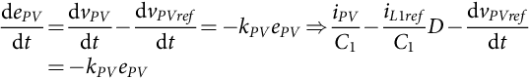 **(35.273)**

where *kPV* is a positive constant, selected to impose the time constant of the tracking error vanishing asymptotically to zero. Then, the virtual control law (stabilizing function) reference value *iL*1*ref* for the *iL*1 current (*iL*1 = *iL*1*ref*) if (*D*≠0) is

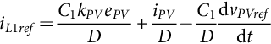 **(35.274)**

Note that this reference current might be enforced using a sliding-mode controller and *D*=*VP*/(*VPV*+*VP*). To consider parameter uncertainty and disturbances, the integral action backstepping could be used.

(3) Start the second recursion to obtain the control input averaged duty-cycle *D*, by defining the inductor current *iL*1 error *eiL*1:

 **(35.275)**

Select a suitable composite positive-definite Lyapunov function *V*2*b*:

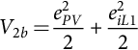 **(35.276)**

Apply the asymptotic stability condition, where *kPV* and *kiL* are positive constants:

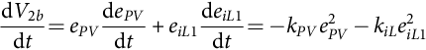 **(35.277)**

As this converter is a nonminimum-phase system, the stabilizing function reference value *iL*1*ref* in [(35.274)](https://learning.oreilly.com/library/view/power-electronics-handbook/9780128114087/B9780128114070000398_5.xhtml#fo1445) depends on the control input *D*. To evaluate *deiL*1/*dt* in [(35.277)](https://learning.oreilly.com/library/view/power-electronics-handbook/9780128114087/B9780128114070000398_5.xhtml#fo1460), first compute *diL*1*ref*/*dt* using [(35.273)](https://learning.oreilly.com/library/view/power-electronics-handbook/9780128114087/B9780128114070000398_5.xhtml#fo1440), [(35.274)](https://learning.oreilly.com/library/view/power-electronics-handbook/9780128114087/B9780128114070000398_5.xhtml#fo1445) and [(35.275)](https://learning.oreilly.com/library/view/power-electronics-handbook/9780128114087/B9780128114070000398_5.xhtml#fo1450):

 **(35.278)**

Substitute [(35.270)](https://learning.oreilly.com/library/view/power-electronics-handbook/9780128114087/B9780128114070000398_5.xhtml#fo1425) in [(35.277)](https://learning.oreilly.com/library/view/power-electronics-handbook/9780128114087/B9780128114070000398_5.xhtml#fo1460), and use the second equation of [(35.269)](https://learning.oreilly.com/library/view/power-electronics-handbook/9780128114087/B9780128114070000398_5.xhtml#fo1420) for *diL*1/*dt*, replacing *iL*1 by *eiL*1+*iL*1*ref*, and use [(35.278)](https://learning.oreilly.com/library/view/power-electronics-handbook/9780128114087/B9780128114070000398_5.xhtml#fo1465) to obtain

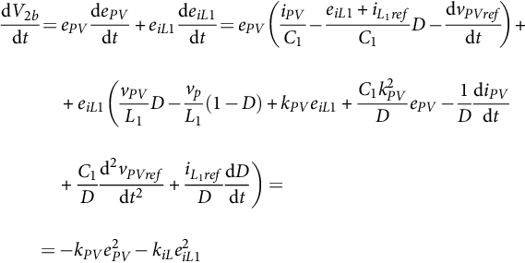 **(35.279)**

Remember [(35.273)](https://learning.oreilly.com/library/view/power-electronics-handbook/9780128114087/B9780128114070000398_5.xhtml#fo1440) to receive

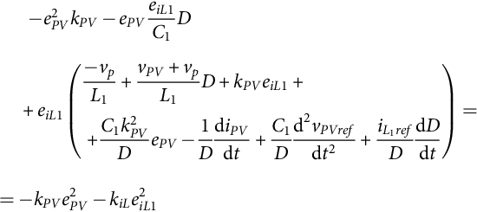 **(35.280)**

Simplify and group terms relative to *eiL*1:

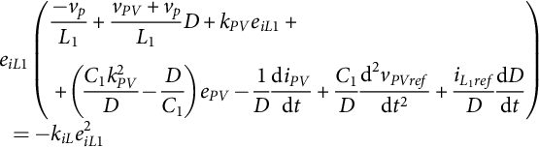 **(35.281)**

Solve for *dD*/*dt* and integrate to obtain the duty-cycle *D* controller (*iL*1*ref*≠0):

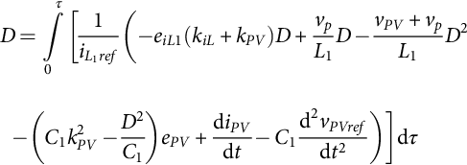 **(35.282)**

This result shows that the duty-cycle controller *D* has to go back to the input through an integrator.

Using this procedure, backstepping can stabilize nonminimum-phase systems, provided it is known how to obtain the origin stabilizing virtual control input.

[Fig. 35.82](https://learning.oreilly.com/library/view/power-electronics-handbook/9780128114087/B9780128114070000398_5.xhtml#f0415) shows the buck-boost backstepping controller [(35.282)](https://learning.oreilly.com/library/view/power-electronics-handbook/9780128114087/B9780128114070000398_5.xhtml#fo1485) transient response to a step change in *vPVref* from 18–15 V at t=0.3 s. The buck-boost switching frequency is 15 kHz, and controller gains are *kPV* = 150 and *kiL* = 1500 (*C*1=1 mF, *C*2=1 mF, *L*1=3 mH, and *IPV*≈3 A). The buck-boost load is a single-phase inverter connected to a 50 Hz grid. Voltage dynamics is nearly a first-order system response, even with a nonlinear load, whose dynamics was not included in the controller design. A small steady-state error is visible due to nonmodeled switch and inductor resistors and modulator delay. Response time is less than 5 ms.

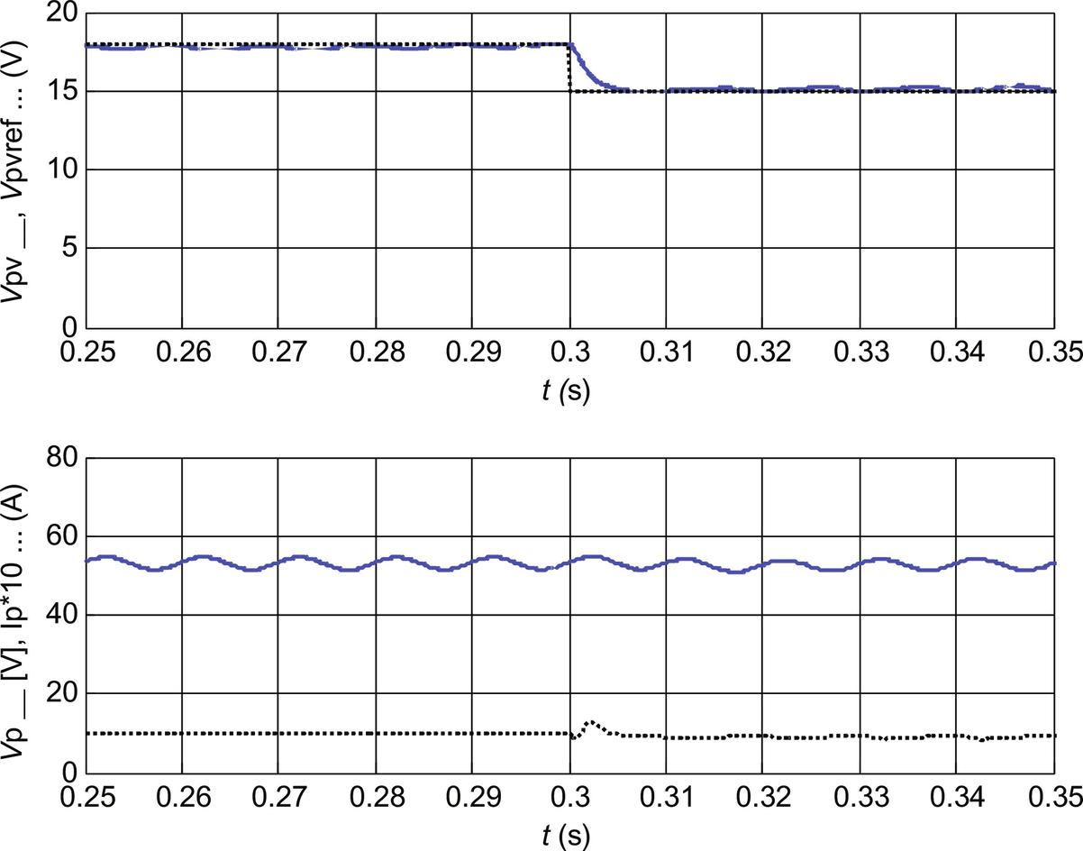

**FIG. 35.82** Upper graph, the *vPV* controlled voltage (solid gray line) and its reference (dotted line) and bottom graph, the buck-boost *vp* output voltage (solid line) and the average value of the *ip* (× 10) current (dotted line).

### 35.6.3 EXAMPLE 35.23: BACKSTEPPING CONTROL OF A SINGLE PHASE INVERTER

Consider a single-phase dc-ac inverter ([Fig. 35.83](https://learning.oreilly.com/library/view/power-electronics-handbook/9780128114087/B9780128114070000398_5.xhtml#f0420)) that enforces a dc voltage *vp* at the output capacitor of the previous buck-boost ([Fig. 35.81](https://learning.oreilly.com/library/view/power-electronics-handbook/9780128114087/B9780128114070000398_5.xhtml#f0410)), using a fixed-frequency PWM modulator to inject a sinusoidal *iL2* current into the grid, so that the power received from the buck-boost is injected in the grid *vR*.

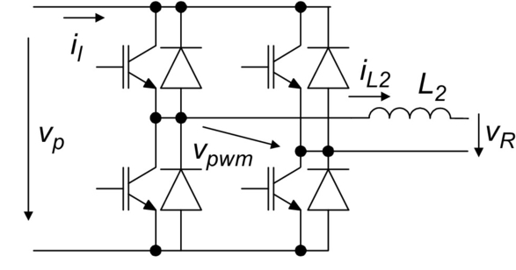

**FIG. 35.83** Single-phase inverter fed from the buck-boost.

Assuming unity power factor, unity efficiency, and the output capacitor of the buck-boost converter, the strict-feedback averaged model can be written as

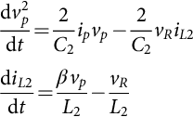 **(35.283)**

where the voltage *vpwm* is obtained from *vp* using the sinusoidal modulating waveform *β*, such as *vpwm*=*β vp*. The stabilizing virtual control input will be the root mean square value *IL*2*RMS* of the *iL*2 current. The control input is the modulation waveform *β*:

(1) Consider the strict-feedback subsystem:

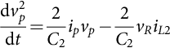 **(35.284)**

(2) Define the control objective  and the tracking error:

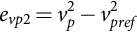 **(35.285)**

Select a suitable positive-definite Lyapunov function:

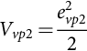 **(35.286)**

To ensure asymptotic stability, the time derivative of this Lyapunov function must be negative, which is true if

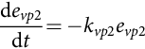 **(35.287)**

where *kvp*2 is a positive constant. The stability condition will be satisfied if the root mean square value of *iL*2 is *IL*2*RMS* in [(35.284)](https://learning.oreilly.com/library/view/power-electronics-handbook/9780128114087/B9780128114070000398_5.xhtml#fo1495), giving

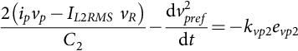 **(35.288)**

The virtual control law (stabilizing function) is *IL*2RMS (with *vR*≠0):

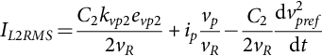 **(35.289)**

This *IL*2*RMS* value is “constant” regarding the switching period of the inverter semiconductors.

(3) Knowing that the inverter input power is a constant at the scale of the switching period whereas the inverter output power varies along the *vR* grid period (the mean value is the active power), the converter fast dynamics (*iL*2 current) and slow dynamics (DC *vp* voltage) must be separated. Otherwise, the backstepping controller would impose the energy balance during the semiconductor switching period, distorting the *iL*2 current. This sinusoidal current may be written as *iL*2*ref*=*IL*2*RMS* *vR*pu, being the tracking error:

 **(35.290)**

Select a positive-definite Lyapunov function:

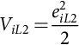 **(35.291)**

Use the stability condition, with a positive constant *kiL*2, and the second equation of [(35.283)](https://learning.oreilly.com/library/view/power-electronics-handbook/9780128114087/B9780128114070000398_5.xhtml#fo1490) to write

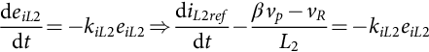 **(35.292)**

Solve to obtain the modulation waveform *β* (*vp*≠0):

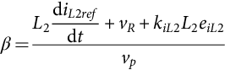 **(35.293)**

[Fig. 35.84](https://learning.oreilly.com/library/view/power-electronics-handbook/9780128114087/B9780128114070000398_5.xhtml#f0425) shows the buck-boost-fed single-phase inverter backstepping controller ([(35.293)](https://learning.oreilly.com/library/view/power-electronics-handbook/9780128114087/B9780128114070000398_5.xhtml#fo1540) and [(35.289)](https://learning.oreilly.com/library/view/power-electronics-handbook/9780128114087/B9780128114070000398_5.xhtml#fo1520)) response to the step change in *vPVref* of the buck-boost from 18–15 V at *t*=0.3 s. The PWM modulator frequency is 15 kHz, and controller gains are *kvp*2=0.05 and *kiL*2=0.025 (*L*2=10 mH, *vR*≈45 V and 50 Hz). The ac current is almost not distorted by *vPVref* step change, and its total harmonic distortion is less than 2%.

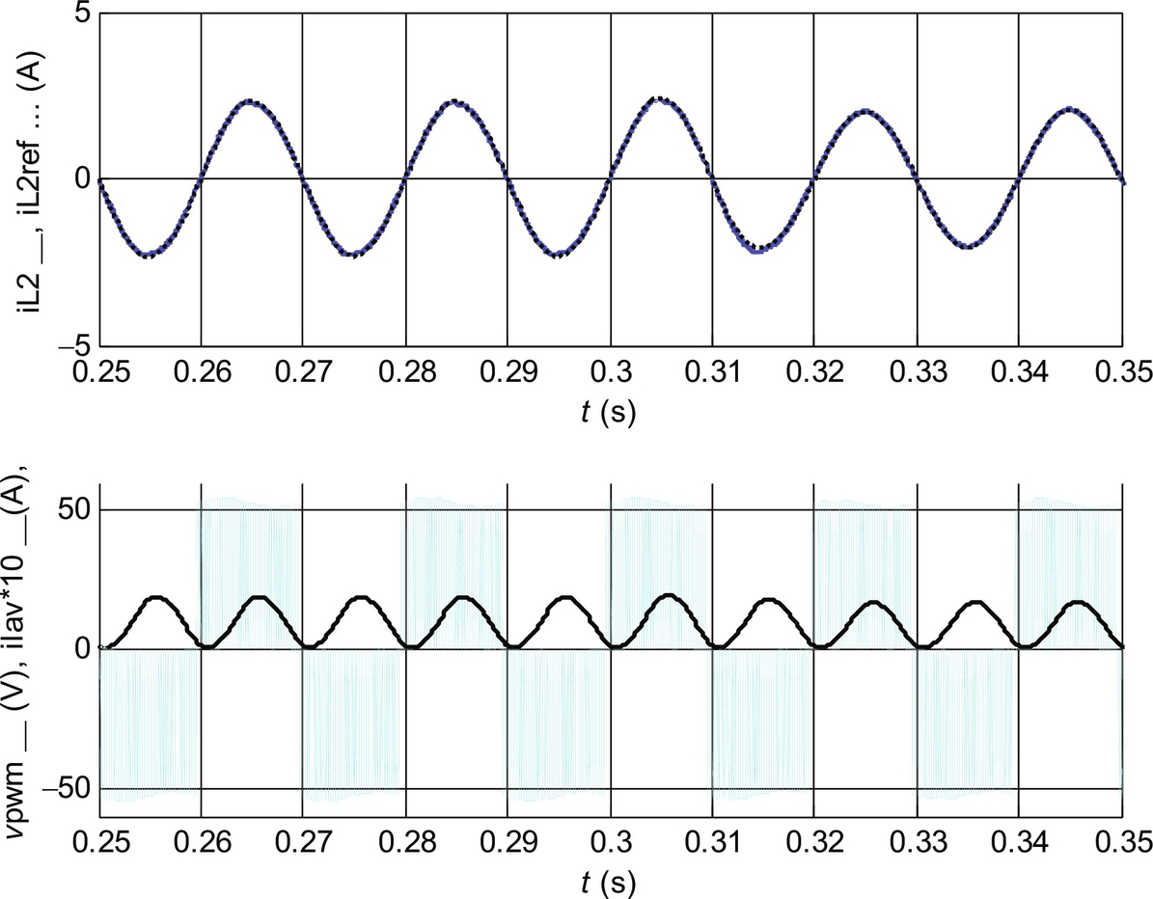

**FIG. 35.84** Upper graph, the *iL*2 ac grid current (solid line) and its reference (dotted line) and bottom graph, the inverter *vpwm* output voltage (gray line) and the average value of the *iI* (× 10) inverter input current (black solid line).

## 35.7 Conclusions

Control techniques for switching power converters were reviewed. Linear controllers based on state-space averaged models or circuits are well established and suitable for the application of linear systems control theory. Obtained linear controllers are useful, if the converter operating point is almost constant and the disturbances are not relevant. For changing operating points and strong disturbances, linear controllers can be enhanced with nonlinear, antiwindup, soft-start, or saturation techniques. Current-mode control will also help to overcome the main drawbacks of linear controllers.

Sliding mode is a nonlinear approach well adapted for the variable structure of the switching power converters. The critical problem of obtaining the correct sliding surface was highlighted, and examples were given. The sliding-mode control law allows the implementation of the switching power converter controller, and the switching law gives the PWM modulator. The system variables to be measured and fed back are identified. The obtained reduced-order dynamics is not dependent on system parameters or power supply (as long as it is high enough), presents no steady-state errors, and has a faster response speed (compared with linear controllers), as the system order is reduced and nonidealities are eliminated. Should the measure of the state variables be difficult, state observers may be used, with steady-state errors easily corrected. Sliding-mode controllers provide robustness against bounded disturbances and an elegant way to obtain the controller and modulator, using just the same theoretical approach. Fixed-frequency operation was addressed and solved, together with the short-circuit-proof operation. Presently, fixed-frequency techniques were applied to converters that can only operate with fixed frequency. Sliding-mode techniques were successfully applied to MIMO switching power converters and to multilevel converters, solving the capacitor voltage divider equalization. Sliding-mode control needs more information from the controlled system than do the linear controllers but is probably the most adequate tool to solve the control problem of switching power converters.

Predictive optimum control of power converters is based on a detailed nonlinear direct dynamics model that includes converter bounds. The predictive optimum algorithm uses the model to forecast in real time the converter future behavior, which is dependent on the applied control vector. The minimization of a suitable cost functional gives the optimum vector. Predictive optimum controllers designed to minimize converter output errors, together with the switching frequency, present better performances than sliding-mode controllers, even when controlling nonlinear outputs with cross coupled dynamics. Fast predictive controllers, using the converter inverse dynamics, designed to save computation power, also show promising results.

Fuzzy logic controller synthesis was briefly presented. Fuzzy logic controllers are based on human experience and intuition and do not depend on system parameters or operating points. Fuzzy logic controllers can be easily applied to various types of power converters having the same qualitative dynamics. Fuzzy logic controllers, like sliding-mode controllers, show robustness to load and power supply perturbations, semiconductor nonidealities (such as switch delays or uneven conduction voltage drops), and dead times. The controller implementation is simple, if based on the offline concept. Online implementation requires a fast microprocessor but can include adaptive techniques to optimize the rule base and/or the database.

Backstepping control was explained using a strict-feedback form of the converter dynamic model and a recursive approach. The procedure correctly selects positive-definite Lyapunov functions and designs the feedback control loop to ensure stability using Lyapunov's second method. Integral action control may be included to overcome nonmodeled disturbances and parameter uncertainty, ensuring convergence, in steady state, of the tracking error to zero. Backstepping control is a robust method to be used with conventional fixed-frequency duty-cycle modulators, being ideal for nonminimum-phase converters, while needing less computing power compared with predictive controllers.

## References

[1] Bose B.K. *Power Electronics and AC Drives.* New Jersey: Prentice-Hall; 1986.

[2] Kassakian J., Schlecht M., Verghese G. *Principles of Power Electronics.* Reading, MA, USA: Addison Wesley; 1992.

[3] Rashid M. *Power Electronics: Circuits, Devices and Applications.* second ed. New Jersey, USA: Prentice-Hall International; 1993.

[4] J. Fernando Silva, Electrónica Industrial: Semicondutores e Conversores de Potência, série Manuais Universitários, Fundação Calouste Gulbenkian, Lisboa, ISBN 978-972-31-1499-7, 2013, 740 pp.

[5] Mohan N., Undeland T., Robbins W. *Power Electronics: Converters, Applications, and Design.* third ed. New York, NY: John Wiley; 2002.

[6] Sum K.K. *Switched Mode Power Conversion.* New York, USA: Marcel Dekker Inc.; 1984.

[7] H. Bühler, Electronique de Réglage et de Commande, Traité D'électricité, vol. XV, éditions Georgi, 1979.

[8] Irwin J.D., ed. *The Industrial Electronics Handbook.* Boca Raton, USA: CRC/IEEE Press; 1996.

[9] Chryssis G. *High Frequency Switching Power Supplies.* USA: McGraw-Hill; 1984.

[10] Utkin V.I. *Sliding Modes and Their Application on Variable Structure Systems.* Moscow, Russia: MIR Publishers; 1978.

[11] Utkin V.I. *Sliding Modes in Control Optimization.* Berlin, Germany: Springer-Verlag; 1981.

[12] Ogata K. *Modern Control Engineering.* third ed. New Jersey, USA: Prentice-Hall International; 1997.

[13] Levine W.S., ed. *The Control Handbook.* Boca Raton, USA: CRC/IEEE Press; 1996.

[14] Fernando Silva J. *Electrónica Industrial.* Lisboa: Fundação Calouste Gulbenkian; 1998.

[15] Fernando Silva J. Sliding mode control design of control and modulator electronics for power converters, special issue on power electronics. *J. Circuit. Syst. Comp.* 1995;5(3):355–371.

[16] Martins J.F.A., Pires A.J., Silva J.F. A novel and simple current controller for three-phase PWM power inverters. *IEEE Trans. Ind. Electron.* 1998;45(5):802–805.

[17] Fernando Silva J. *Sliding mode control of voltage sourced boost-type reversible rectifiers.* In: Proc. IEEE/ISIE'97 Conference (ISBN 0-7803-3937-1), Guimarães, Portugal, Julho, vol. 2; 1997:329–334.

[18] Fernando Silva J. Sliding mode control of boost type unity power factor PWM rectifiers. Special Section on High-Power-Factor Rectifiers I *IEEE Trans. on Industrial Electronics.* 0278-00461999;46(3):594–603.

[19] Silva J., Pires V., Pinto S., Barros J. Advance control methods for power converters. *Transactions on Mathematics and Computers in Simulation, IMACS.* Elsevier; . 2003;63 3–5, pp. 281–295.

[20] Encarnação L., Silva J. Fernando. *Stability Condition Based Sliding Mode Modulators for Multilevel Power Converters.* In: 35th Annual Conference of the IEEE Industrial Electronics Society, IECON Porto, Portugal; 2009.

[21] Verveckken J., Silva J.F., Barros J.D., Driesen J. Direct power control of series converter of unified power-flow controller with three-level neutral point clamped converter. *IEEE Trans. Power Delivery.* 2012;27(4):1772–1782.

[22] Rodriguez José. Special section on matrix converters. *IEEE Trans. Ind. Electron.* 2002;49(2).

[23] Pinto S., Silva J. Sliding mode direct control of matrix converters. *IET Proc. Electric Power Applications.* May 2007;1(3):439–448.

[24] Alesina A., Venturini M. Analysis and design of optimum-amplitude nine-switch direct AC-AC converters. *IEEE Trans. Power Electron.* 1989;4(1):101–112.

[25] Pinto S., Silva J. *Matrix converters: a new approach on venturini modulation technique.* In: Proc. PEMC'04 Conference, Riga, Latvia; 2004.

[26] W. Kwon, G. Cho, Analyses of static and dynamic characteristics of practical step-up nine-switch matrix convertor, IEE Proceedings B, vol. 140, No. 2, March 1993.

[27] Pinto S., Silva J., Gambôa P. *Current Control of a Venturini Based Matrix Converter.* In: Proc. ISIE'06, Montréal, Canada; 2006.

[28] M. Athans, Lecture Notes on Design of Robust Multivariable Feedback Control System, Prof. of Electrical Engineering (emeritus), MIT, Visiting Research Prof ISR/IST, athans@isr.ist.utl.pt, Lisboa, 2004.

[29] J.F. Silva, Predictive Control of Rectifiers by Simulation with Commutation failures Elimination, Ph.D. Thesis in Electrical and Computer Enginnering, IST, TULisbon, Lisboa 1989 (in Portuguese “Controlo Preditivo por Simulação para Rectificadores com Eliminação de Falhas de Comutação”).

[30] Silva J.F., Borges B., Anunciada António A. *Improving control strategies for HF resonant link converters: the Current Mode Predictive Modulator.* In: Power Electronics Specialists Conference, IEEE PESC'91, ISSN 0275-9306, Boston, USA; 1991:268–275.

[31] J.F. Silva, Detailed Model Predictive Control for a 3 Phase Thyristor Current Source, IMACS-MCTS, Moudni, Borne, Tzafestas (Editors), ISBN 29502908-1-1, vol. I, 1991, pp. 236–241.

[32] Muller S., Ammann U., Rees S. New time-discrete modulation scheme for matrix converters. *IEEE Trans. Ind. Electron.* 2005;52(6):1607–1615.

[33] Barros D., Silva J.F. *Sliding mode assisted preditive pseudo-optimal control for three-phase three-level converters.* In: 10th International Conference on Optimization of Electrical and Electronic Equipment OPTIM2006, Vol. 2; 2006.

[34] Rodríguez J., Pontt J., Silva C.A., Correa P., Lezana P., Cortés P., Ammann U. Predictive current control of voltage source inverter. *IEEE Trans. Ind. Electron.* 2007;54(1):495–503.

[35] Barros J.D., Silva J.F. *Optimal predictive control of three-phase NPC multilevel inverter: comparison to robust sliding mode controller.* In: IEEE 38th Annual Power Electronics Specialists Conference (PESC07), Orlando, USA; 2007:2061–2067.

[36] Vargas R., Cortes P., Ammann U., Rodriguez J., Pontt J. Predictive control of a three-phase neutral-point-clamped inverter. *IEEE Trans. Ind. Electron.* October 2007;54(5):2697–2705.

[37] Barros J.D., Silva J.F. Optimal predictive control of three-phase npc multilevel converter for power quality applications. *IEEE Trans. Ind. Electron.* 2008;55(10):3670–3681.

[38] Barros J.D., Silva J.F. Multilevel optimal predictive dynamic voltage restorer. Special issue on multilevel converters *IEEE Trans. Ind. Electron.* 2010;57(8).

[39] Monteiro J., Silva J.F., Pinto S.F., Palma J. Linear and sliding mode control design for matrix converter based unified power flow controllers. *IEEE Trans. Power Electron.* 2014;29(7):3357–3367.

[40] Chaves M., Margato E., Silva J.F., Pinto S.F., Santana J. Fast optimum-predictive control and capacitor voltage balancing strategy for bipolar back-to-back NPC converters in high-voltage direct current transmission systems. *IET Gener. Transm. Distrib.* 2011;5(3):368–375.

[41] Zadeh L.A. Fuzzy Sets. *Inf. Control.* 1965;8:338–353.

[42] Zadeh L.A. Outline of a new approach to the analysis of complex systems and decision process. *IEEE Trans. Syst. Man Cybern.* 1973;SMC-3:28–44.

[43] Zimmermann H.J. *Fuzzy Sets: Theory and its Applications.* New York: Kluwer-Nijhoff; 1995.

[44] Candel A., Langholz G. *Fuzzy Control Systems.* Boca Raton, USA: CRC Press; 1994.

[45] Ezal K., Pan Z., Kokotovic P.V. Locally optimal and robust back-stepping design. *IEEE Trans. Autom. Control.* 2000;45(2):260–271.

[46] Freeman R.A., Kokotovic P.V. *Tools and procedures for robust control of nonlinear systems.* In: 33rd IEEE Conference on Decision and Control; 3458–3463. 2003;4.

[47] Khalil H.K. *Nonlinear Systems.* third ed. Upper Saddle River NJ: Prentice Hall; 2002.

[48] Martin A.D., Vazquez J.R. Backstepping controller design to track maximum power in photovoltaic systems. *Automatika.* 2014;55(1):22–31.

[49] Martin Aranzazu D., Cano J.M., Silva Fernando A., Vazquez Jesus R. Back-stepping control of smart-grid connected distributed photovoltaic power supplies for telecom equipment. *IEEE Trans. Energy Convers.* 2015;30(4):1496–1504.

[50] Pinto S., Fernando Silva J. Direct control method for matrix converters with input power factor regulation. In: *IEEE Proc. PESC'2004, CD ROM ISBN 0-7803-8400-8.* Germany: Aachen; June 2004:2366–2372.

[51] Chaves M., Margato E., Silva J.F., Pinto S.F., Santana J. HVDC transmission systems: bipolar back-to-back diode clamped multilevel converter with fast optimum-predictive control and capacitor balancing strategy, Elsevier. *Electr. Power Syst. Res.* 2011;81(7):1436–1445.

**36**

# Fuzzy-Logic Applications in Electric Drives and Power Electronics

Abdul R. Ofoli The University of Tennessee at Chattanooga, Chattanooga, TN, United States

## Abstract

The use of an extended Kalman filter to train fuzzy neural network structures for online speed trajectory tracking of a brushless drive system is illustrated as an alternative to control schemes. Also described in this chapter is an implementation of a genetic-based hybrid fuzzy-proportional-integral-derivative (PID) controller for industrial motor drives. The genetic optimization technique is used to determine the optimal values of the scaling factors of the output variables of the fuzzy-PID (FPID) controller. The objective is to utilize the best attributes of the PID and FPID controllers to produce better response under disturbance. In servomotor drive tracking applications where we need to compensate for system uncertainty and random changes, a control structure that employs a fuzzy-logic controller incorporating an H-infinity tracking controller via an acceleration feedback signal is explained. The chapter ends with the implementation of a fuzzy-logic controller structure for switch-mode power-stage DC-DC converters and evaluates experimentally its sensitivity for variable supply voltages and load resistance variations.

### KEYWORDS

Extended Kalman filter (EKF); Fuzzy neural network (FNN); Motor drives; Proportional-integral-derivative (PID) controllers; dSPACE digital signal processor (DSP); Genetic optimization; Hybrid fuzzy-PID controller; Brushless servo drives; Fuzzy-logic controller; H-infinity controller; DC-DC converter; Learning algorithm; Real-time implementation

36.1 [Introduction](https://learning.oreilly.com/library/view/power-electronics-handbook/9780128114087/B9780128114070000404.xhtml#s0010)

36.2 [PI/PD-Like Fuzzy Control Structure](https://learning.oreilly.com/library/view/power-electronics-handbook/9780128114087/B9780128114070000404.xhtml#s0015)

36.2.1 Fuzzy-Based PI Controller

36.2.2 Fuzzy-Based PD Controller

36.3 [FNN PI/PD-Like Fuzzy Control Architecture](https://learning.oreilly.com/library/view/power-electronics-handbook/9780128114087/B9780128114070000404.xhtml#s0030)

36.3.1 Input Layer

36.3.2 The Membership Layer

36.3.3 The Rule Layer

36.3.4 The Output Layer

36.4 [Learning Algorithm-Based EKF](https://learning.oreilly.com/library/view/power-electronics-handbook/9780128114087/B9780128114070000404.xhtml#s0055)

36.5 [Fuzzy PID Control Design-Based Genetic Optimization](https://learning.oreilly.com/library/view/power-electronics-handbook/9780128114087/B9780128114070000404.xhtml#s0060)

36.5.1 Fuzzy-Based Proportional Controller

36.5.2 Fuzzy-Based Integral Controller

36.5.3 Fuzzy-Based Derivative Controller

36.6 [Classical PID Versus Fuzzy-PID Controller](https://learning.oreilly.com/library/view/power-electronics-handbook/9780128114087/B9780128114070000404.xhtml#s0080)

36.7 [Genetic-Based Autotuning of Fuzzy-PID Controller](https://learning.oreilly.com/library/view/power-electronics-handbook/9780128114087/B9780128114070000404.xhtml#s0085)

36.8 [Fuzzy and  Control Design](https://learning.oreilly.com/library/view/power-electronics-handbook/9780128114087/B9780128114070000404.xhtml#s0090)

36.8.1 Brushless Servo-Motor Drive System

36.8.2 The Fuzzy  Control Structure

36.8.3  Control Design

36.8.4 Fuzzy Logic Control Design

36.8.5 Fuzzy Logic Rules

36.8.6 Defuzzification

36.8.7 On-Line Adaptation

36.9 [Fuzzy Control for DC-DC Converters](https://learning.oreilly.com/library/view/power-electronics-handbook/9780128114087/B9780128114070000404.xhtml#s0130)

36.9.1 Background

36.10 [Fuzzy Control Design for Switch-Mode Power Converters](https://learning.oreilly.com/library/view/power-electronics-handbook/9780128114087/B9780128114070000404.xhtml#s0140)

36.10.1 DC-DC Switch-Mode Power Converter

36.11 [Optimum Topology of the Fuzzy Controller](https://learning.oreilly.com/library/view/power-electronics-handbook/9780128114087/B9780128114070000404.xhtml#s0150)

36.11.1 Membership Functions and Rules Generation

36.12 [Adaptive Network-Based Fuzzy Control System for DC-DC Converters](https://learning.oreilly.com/library/view/power-electronics-handbook/9780128114087/B9780128114070000404.xhtml#s0160)

36.12.1 Topology of the Neural-Fuzzy Controller (NFC)

36.12.2 Learning Algorithm

36.13 [Summary](https://learning.oreilly.com/library/view/power-electronics-handbook/9780128114087/B9780128114070000404.xhtml#s0200)

[Acknowledgments](https://learning.oreilly.com/library/view/power-electronics-handbook/9780128114087/B9780128114070000404.xhtml#ac0010)

[References](https://learning.oreilly.com/library/view/power-electronics-handbook/9780128114087/B9780128114070000404.xhtml#bi0010)

## Acknowledgments

We will like to acknowledge Dr. Ahmed Rubaai at Howard University, Dr. Paul Young of *RadiantBlue Technologies* and Dr. Marcel J. Castro-Sitiriche at the *Electrical and Computer Engineering Department,* of the *University of Puerto Rico at Mayagüez,* for their contribution to the third edition of this chapter*.*

## 36.1 Introduction

Improving the popular proportional-integral-derivative (PID) controller using fuzzy logic (FL) is currently an important research topic. Years of various applications have shown different techniques for customizing the PID controller [[1](https://learning.oreilly.com/library/view/power-electronics-handbook/9780128114087/B9780128114070000404.xhtml#bb0010)–[7](https://learning.oreilly.com/library/view/power-electronics-handbook/9780128114087/B9780128114070000404.xhtml#bb0040)]. Recent work by Sant [[1](https://learning.oreilly.com/library/view/power-electronics-handbook/9780128114087/B9780128114070000404.xhtml#bb0010)] employs an FL controller combined with a classical PID controller with a switching function between them for speed control of a motor drive. The switching algorithm allows each controller type to perform better under different operations. In another recent example, Hohan [[2](https://learning.oreilly.com/library/view/power-electronics-handbook/9780128114087/B9780128114070000404.xhtml#bb0015)] has developed a fuzzy-PID controller based upon the error, the difference in error, and the difference to create a delta change in the control signal at each time step. Hohan includes analytic stability analysis for bounded inputs, important for fuzzy systems to gain acceptance among control engineers. The application of fuzzy reasoning to improve the PID controller is evident in the research community today to build state-of-the-art control systems. Recent work on self-tuning PID controllers demonstrates adaptive control of motor drive systems. Typically, an engineer might retune the gains of a nominal PID controller during operation, but an adaptive PID system autonomously tunes gains as performance diminishes. The work of Rubaai [[3](https://learning.oreilly.com/library/view/power-electronics-handbook/9780128114087/B9780128114070000404.xhtml#bb0020)] employs a genetic algorithm to evolve optimal scale factors of fuzzy-based PID gains for improved control of a motor drive. This genetic-based scale factor in conjunction with FL gain selection enhances the sensitivity of the PID control to error. Another class of fuzzy-PID control design mimics PID control via blending FL networks with absolute and incremental control values at a given control time step. The work of Kuo [[4](https://learning.oreilly.com/library/view/power-electronics-handbook/9780128114087/B9780128114070000404.xhtml#bb0025)] employs two FL structures to formulate a control of a suspension system. One FL mimics PD control, while the other FL generates a change in control to mimic a PI control signal. These FL structures adapt using a genetic algorithm as well. The work of Hu [[5](https://learning.oreilly.com/library/view/power-electronics-handbook/9780128114087/B9780128114070000404.xhtml#bb0030)] also employs fuzzy-PD and fuzzy-PI elements as part of a control strategy. Li [[6](https://learning.oreilly.com/library/view/power-electronics-handbook/9780128114087/B9780128114070000404.xhtml#bb0035)] designs an FL based on error and error derivative to generate an initial control estimate that then feeds a PI logic and a PD logic. This work demonstrates robustness of the control algorithm through simulations of a dynamic model. The recent work of Masiala [[7](https://learning.oreilly.com/library/view/power-electronics-handbook/9780128114087/B9780128114070000404.xhtml#bb0040)] demonstrates incremental fuzzy-PI control of an induction motor drive. For Masiala, the FL decision at each time step modifies the control current based on the error and a change in error. All these controllers use FL to generate absolute and incremental control signals to mimic control techniques seen in PID control. Kalman filter (KF) is another research topic that has been applied to a wide range of engineering disciplines. For a linear system, the KF is an established control design feature, but the improved application of variants of the KF to account for nonlinearity in systems inspires research today. Barut [[8](https://learning.oreilly.com/library/view/power-electronics-handbook/9780128114087/B9780128114070000404.xhtml#bb0045)] employs an extended Kalman filter (EKF) for a speed sensorless control of an induction motor. This work depends on high-fidelity equations of motion model and noise characteristics. Szabat [[9](https://learning.oreilly.com/library/view/power-electronics-handbook/9780128114087/B9780128114070000404.xhtml#bb0050)] demonstrates an adaptively tuned EKF for control of an industrial drive. Ahn [[10](https://learning.oreilly.com/library/view/power-electronics-handbook/9780128114087/B9780128114070000404.xhtml#bb0055)] designs an EKF algorithm to update parameters of parallel FL systems, which generate a PID gain set for control of a motor drive system. Treating the controller as a process and deriving appropriate derivatives allow for adaptive update to the FL components. So, while PID control is a commonly known algorithm, current research applications of adaptive tuning are yielding better tuned PID systems. The artificial neural network (ANN) is a computational data structure modeled after the firing of neurons in the brain. Training exercises may adjust the parameters within the ANN to improve modeling capabilities. The work of Lary [[11](https://learning.oreilly.com/library/view/power-electronics-handbook/9780128114087/B9780128114070000404.xhtml#bb0060)] details an EKF algorithm for training an ANN to model correlations between chemical compounds. Singhal [[12](https://learning.oreilly.com/library/view/power-electronics-handbook/9780128114087/B9780128114070000404.xhtml#bb0065)] shows that the EKF training algorithm treats all ANN parameters as a state vector, and thus, the ANN becomes a nonlinear stationary process. Research experience demonstrates that the EKF training compares favorably to the BP update method in terms of iterations of training epochs, but with higher computational cost per time step. The ANN is an important contribution to the control field. The fuzzy neural network (FNN) combines aspects of FL and the ANN and is at the state of the art in control research today. For example, recent work of Ho [[13](https://learning.oreilly.com/library/view/power-electronics-handbook/9780128114087/B9780128114070000404.xhtml#bb0070)] simulates PID control using an FNN structure that updates time constants in the dynamic models that generate the PID gains online. Ho compares the orthogonal simulated annealing learning technique to a genetic technique to improve performance of the FNN portion of the controller. Campo [[14](https://learning.oreilly.com/library/view/power-electronics-handbook/9780128114087/B9780128114070000404.xhtml#bb0075)] designs an embedded hardware FNN updated by the Takagi-Sugeno training method for performance improvement. Such a chip enables for a fuzzy system embedded into a hardware control loop. Uddin [[15](https://learning.oreilly.com/library/view/power-electronics-handbook/9780128114087/B9780128114070000404.xhtml#bb0080)] also developed a hybrid neuro-fuzzy-PI controller adapted by a real-coded genetic algorithm to control an IPMSM. In this case, a fuzzy basis function network similar to an FNN output PI gains sensitive to error conditions. The cutting-edge work of many researchers today relies on the FNN to improve the performance of fuzzy control systems in electric applications.

## 36.2 PI/PD-Like Fuzzy Control Structure

The FNN PI/PD-like fuzzy controller using EKF control structure presented in this chapter is an instantiation of a feedback control loop. The FNN PI/PD-like fuzzy consists of two independent fuzzy structures, namely, fuzzy-PD controller and fuzzy-PI controller. EKF technique is used to modify the weights and the membership functions of the FNN PI/PD controller to adaptively control the rotor speed of the drive system. The summation of the outputs of the two FNNs forms the control signal. [Fig. 36.1](https://learning.oreilly.com/library/view/power-electronics-handbook/9780128114087/B9780128114070000404.xhtml#f0010) shows the architecture of the neural-fuzzy PI-/PD-based EKF learning scheme. The control structure is anticipated to accommodate the robust stabilization and disturbance rejection problems. The fuzzy controller generates a control signal based upon two FL structures. The first structure is a fuzzy PD that generates a fuzzy-PD control signal. The second structure is a fuzzy PI that generates an incremental fuzzy-PI control signal.

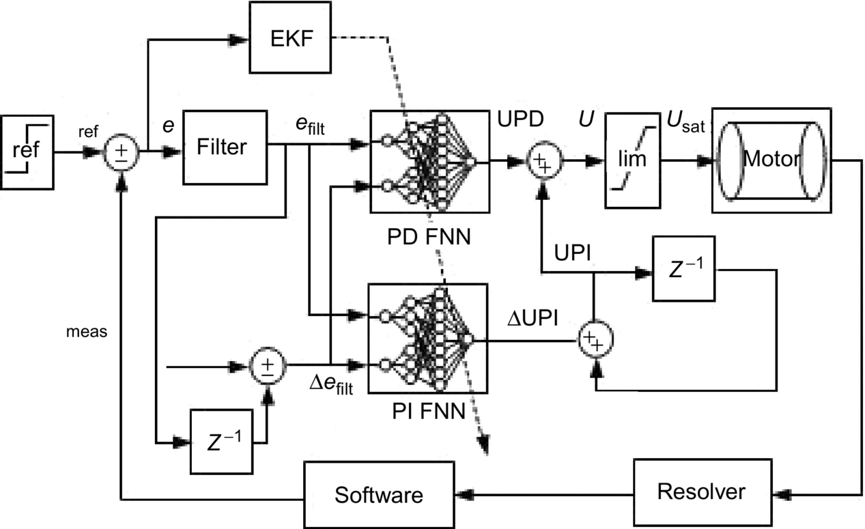

**FIG. 36.1** FNN PI/PD-like fuzzy control structure.





The incremental fuzzy-PI signal sums with the previous fuzzy-PI signal to generate the fuzzy-PI signal for the time step at hand. The fuzzy-PI/fuzzy-PD controller generates a control signal with the summation of the fuzzy-PI/fuzzy-PD control signals:



The control signal is limited by a discontinuous range-limiting saturation element. The saturation equation caps the signal between a maximum and minimum value:

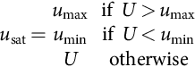

### 36.2.1 FUZZY-BASED PI CONTROLLER

The fuzzy-PI system implements an FL for the PI control signals *e*filt and Δ*e*filt, the error and the delta error, respectively, the linguistic inputs to the system. The FL output is the PI control ΔUPI signal. The error signal has three fuzzy variables: positive (P), zero (Z), and negative (N). The delta error signal has three fuzzy variables: positive (P), zero (Z), and negative (N). The membership function for each fuzzy variable is a Gaussian function. [Figs. 36.2](https://learning.oreilly.com/library/view/power-electronics-handbook/9780128114087/B9780128114070000404.xhtml#f0015) and [36.3](https://learning.oreilly.com/library/view/power-electronics-handbook/9780128114087/B9780128114070000404.xhtml#f0020) display the trained membership functions for the fuzzy inputs.

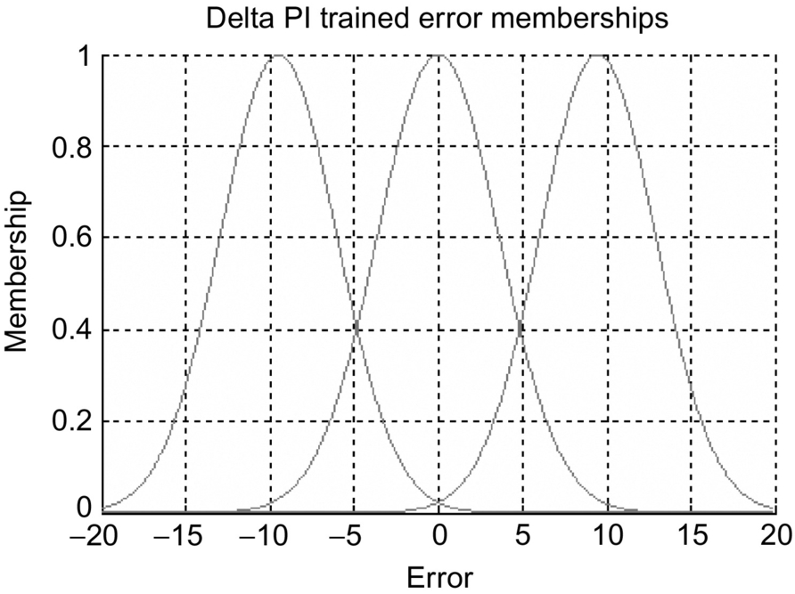

**FIG. 36.2** Trained membership function for speed error.

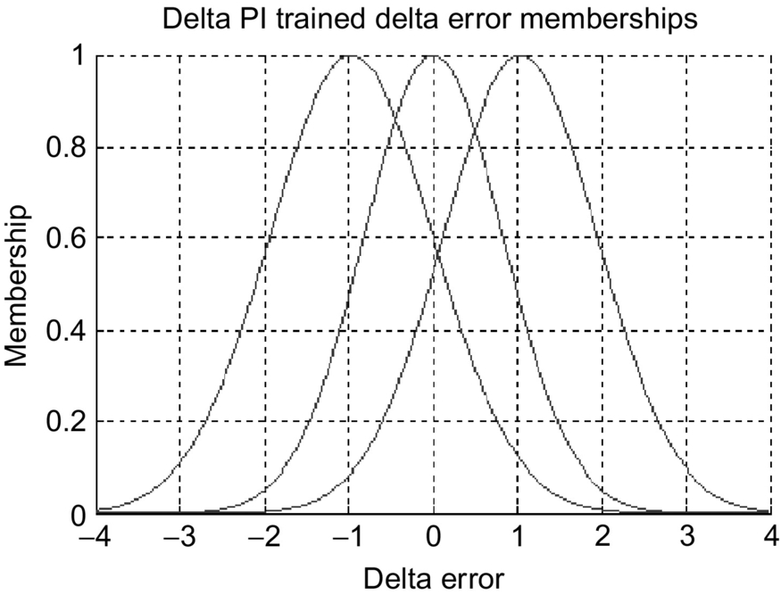

**FIG. 36.3** Trained membership functions for the delta speed error.

The linguistic control rules are established considering the dynamic behavior of the BLDC drive system and analyzing the error and its variation. The fuzzy inference system has nine rules.

*Rule 1*: IF speed error is negative (N) AND delta speed error is negative (N), THEN the fuzzy-PI control voltage (output of FL) is negative large (NL). This rule pertains to the condition that  and that the difference between them is increasing. Thus, the control action must act to change the error momentum and bring the motor rate back down to the reference rate. Therefore, a large negative change in control voltage is necessary.

*Rule 2*: IF speed error is negative (N) AND delta speed error is zero (Z), THEN the fuzzy-PI control voltage (output of FL) is negative medium (NM). This rule pertains to the condition that  and that the difference between them is steady. Thus, the control action need not change the error momentum but still bring the motor rate back down to the reference rate. Therefore, a medium negative change in control voltage is necessary.

*Rule 3*: IF speed error is zero (Z) AND delta speed error is negative (N), THEN the fuzzy-PI control voltage (output of FL) is negative small (NS). This rule pertains to the condition that  but tending toward  as the error trends more negative. Thus, the control action must act to halt the error momentum but maintain the motor rate being close to the reference rate. Therefore, a small negative change in control voltage is necessary.

*Rule 4*: IF speed error is negative (N) AND delta speed error is positive (P), THEN the fuzzy-PI control voltage (output of FL) is zero (ZE). This rule pertains to the condition that  and that the difference between them is decreasing. Thus, the control action of nothing allows the error momentum to bring the motor rate back down to the reference rate. Therefore, no change in control voltage is necessary.

*Rule 5*: IF speed error is zero (Z) AND delta speed error is zero (Z), THEN the fuzzy-PI control voltage (output of FL) is zero (ZE). This rule pertains to the condition that  and that the difference between them is steady. Thus, the control action of nothing allows the error momentum to remain negligible to leave the motor rate at the reference rate. Therefore, no change in control voltage is necessary.

*Rule 6*: IF speed error is positive (P) AND delta speed error is positive (P), THEN the fuzzy-PI control voltage (output of FL) is positive large (PL). This rule pertains to the condition that  and that the difference between them is increasing. Thus, the control action must act to change the error momentum and bring the motor rate back up to the reference rate. Therefore, a large positive change in control voltage is necessary.

*Rule 7*: IF speed error is positive (P) AND delta speed error is zero (Z), THEN the fuzzy-PI control voltage (output of FL) is negative medium (NM). This rule pertains to the condition that  and that the difference between them is steady. Thus, the control action need not change the error momentum but still bring the motor rate back down to the reference rate. Therefore, a medium positive change in control voltage is necessary.

*Rule 8*: IF speed error is zero (Z) AND delta speed error is positive (P), THEN the fuzzy-PI control voltage (output of FL) is positive small (PS). This rule pertains to the condition that  but tending toward  as the error trends more positive. Thus, the control action must act to halt the error momentum but maintain the motor rate being close to the reference rate. Therefore, a small positive change in control voltage is necessary.

*Rule 9*: IF speed error is positive (P) AND delta speed error is negative (N), THEN the fuzzy-PI control voltage (output of FL) is zero (ZE). This rule pertains to the condition that  and that the difference between them is decreasing. Thus, the control action of nothing allows the error momentum to bring the motor rate back down to the reference rate. Therefore, no change in control voltage is necessary.

Each rule is implemented via a weighted product of the membership variables. The fuzzy centroid method generates a crisp output from the nine-dimensional fuzzy rule vector. This scaled output corresponds to the control signal, ΔUPI. [Figs. 36.4](https://learning.oreilly.com/library/view/power-electronics-handbook/9780128114087/B9780128114070000404.xhtml#f0025) and [36.5](https://learning.oreilly.com/library/view/power-electronics-handbook/9780128114087/B9780128114070000404.xhtml#f0030) illustrate the initial and trained fuzzy control output ΔUPI as a function of the error and the change of error.

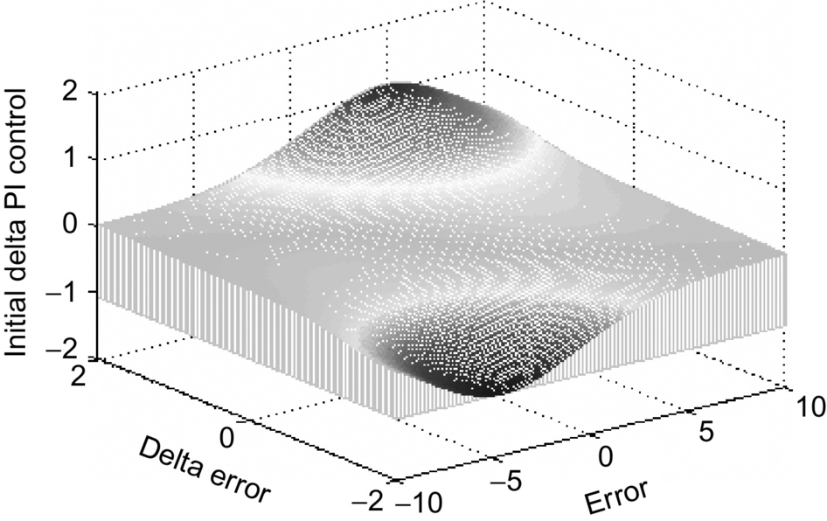

**FIG. 36.4** Initial fuzzy delta PI control surface.

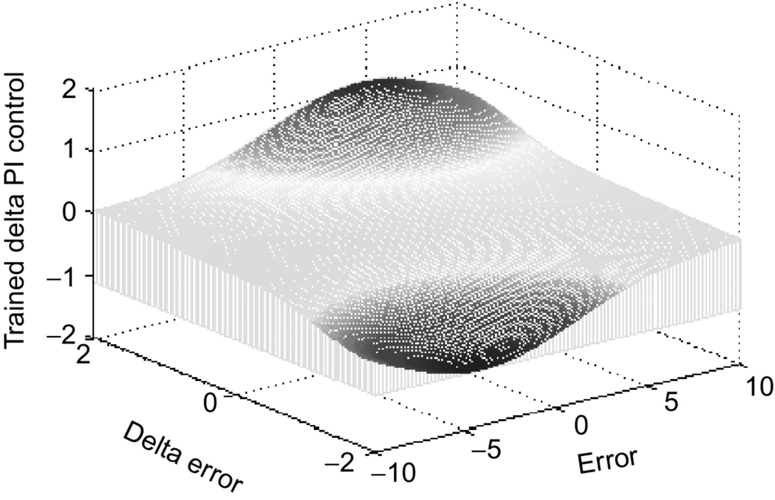

**FIG. 36.5** Trained fuzzy delta PI control surface.

### 36.2.2 FUZZY-BASED PD CONTROLLER

The same technique applied to the fuzzy-PI controller is applied to the fuzzy-PD controller. The controller has two inputs and one output. The fuzzy-PD system implements an FL for the PD control signal. The signals *e*filt and Δ*e*filt, the error and the delta error, respectively, are the linguistic inputs to the system. The FL output is the PD control signal *UPD*. The error signal has three fuzzy variables: positive (P), zero (Z), and negative (N). The delta error signal has three fuzzy variables: positive (P), zero (Z), and negative (N). The membership function for each fuzzy variable is a Gaussian function. [Figs. 36.6](https://learning.oreilly.com/library/view/power-electronics-handbook/9780128114087/B9780128114070000404.xhtml#f0035) and [36.7](https://learning.oreilly.com/library/view/power-electronics-handbook/9780128114087/B9780128114070000404.xhtml#f0040) show the trained membership functions for the PD fuzzy inputs.

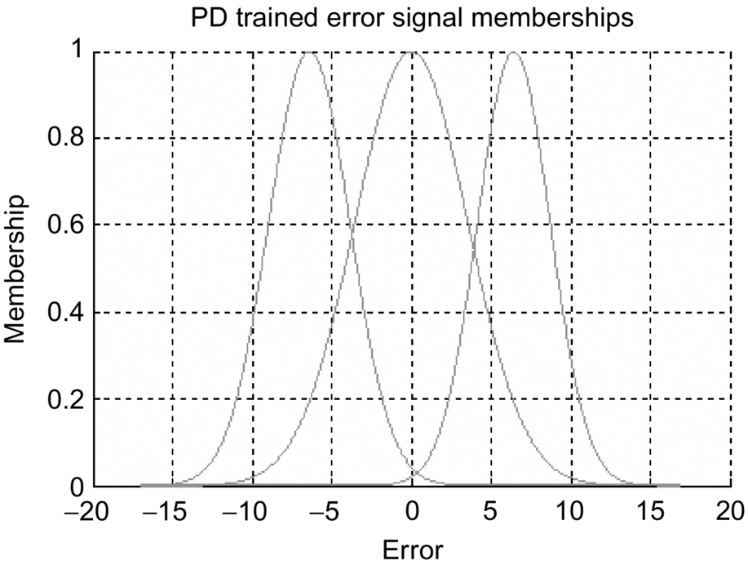

**FIG. 36.6** Trained membership functions for speed error.

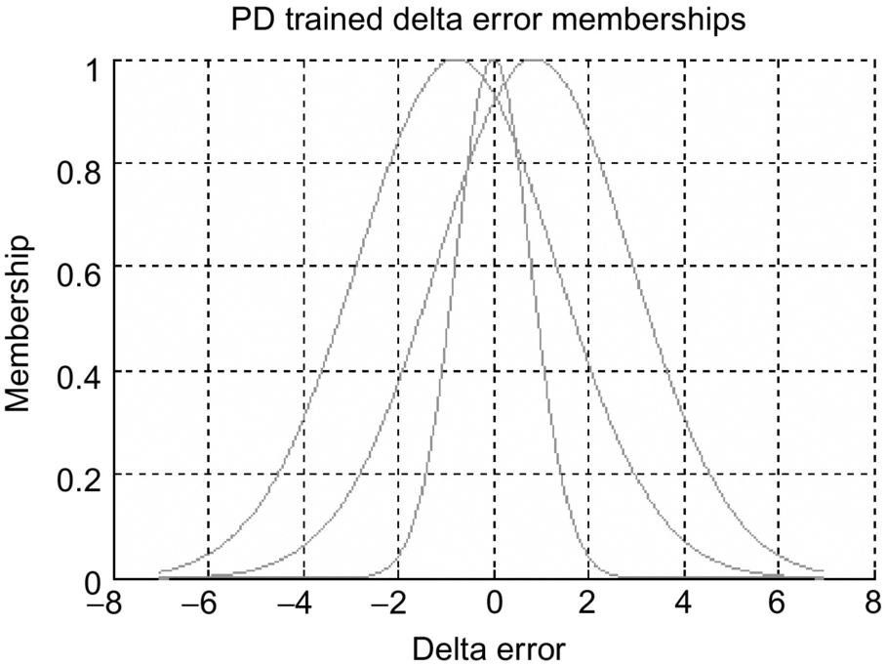

**FIG. 36.7** Trained membership functions for delta speed error.

Similarly, the number of fuzzy rules that are required is equal to the product of the number of fuzzy sets that make up each of the two fuzzy input variables. Therefore, a total of nine fuzzy rules are instituted. The nine fuzzy rules are composed of the same fuzzy rules generated for the fuzzy-PI controller and are not repeated here. Each rule is implemented via a weighted product of the membership variables. The fuzzy centroid method generates a crisp output from the nine-dimensional fuzzy rule vector. This scaled output corresponds to the control signal, UPD. [Figs. 36.8](https://learning.oreilly.com/library/view/power-electronics-handbook/9780128114087/B9780128114070000404.xhtml#f0045) and [36.9](https://learning.oreilly.com/library/view/power-electronics-handbook/9780128114087/B9780128114070000404.xhtml#f0050) demonstrate the initial and trained fuzzy control output, UPD, as a function of the error and the change of error.

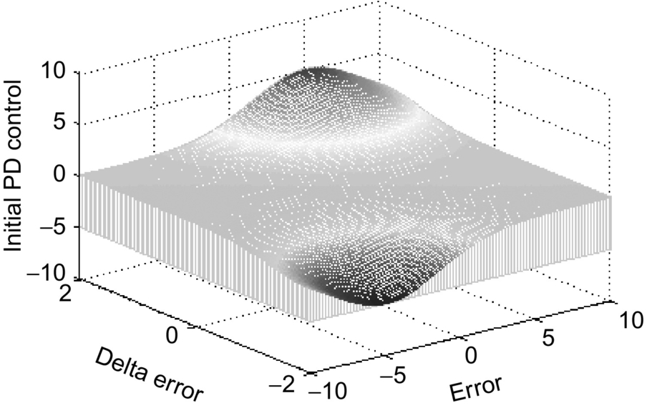

**FIG. 36.8** Initial fuzzy-PD control surface.

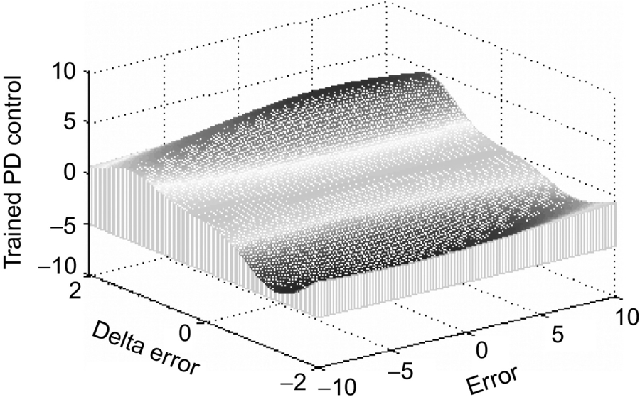

**FIG. 36.9** Trained fuzzy-PD control surface.

[Figs. 36.8](https://learning.oreilly.com/library/view/power-electronics-handbook/9780128114087/B9780128114070000404.xhtml#f0045) and [36.9](https://learning.oreilly.com/library/view/power-electronics-handbook/9780128114087/B9780128114070000404.xhtml#f0050) provide an indication of how well the EKF learning algorithm succeeds in training the output fuzzy-PD control signal. This is an indication of how well the control process is proceeding during the experimental implementation.

## 36.3 FNN PI/PD-Like Fuzzy Control Architecture

The proposed FNN has four layers: an input layer, a membership layer, a rule layer, and an output layer. The input layer is a pass-through capture of each input signal. The membership layer creates a fuzzy set for each input using Gaussian membership functions. The rule layer consists of a truth table like evaluation of the fuzzy membership sets by product pairing. The output layer consists of a weighted summation of the rules. Three numbers define the size of an FNN: the number of inputs to the logic, the number of memberships per input, and the number of outputs, respectively, that is, . The PI/PD demands two  FNNs, where *M*, the number of memberships, is customizable. A larger number of memberships enhance accuracy of the FNN for modeling; however, a smaller number of memberships yields a smaller training calculation time period per step (there are less calculations to perform) enabling a faster system rate on real-time hardware. The membership number of 3 is selected. The parameters of the FNN are the means and sigmas of the Gaussian memberships and the weights of the output layer. For a  FNN, there are (six means + six sigmas + nine weights) 21 parameters. [Figs. 36.10](https://learning.oreilly.com/library/view/power-electronics-handbook/9780128114087/B9780128114070000404.xhtml#f0055) and [36.11](https://learning.oreilly.com/library/view/power-electronics-handbook/9780128114087/B9780128114070000404.xhtml#f0060) display the structure of FNN-based PI and FNN-based PD. Below is the definition of the function of each layer.

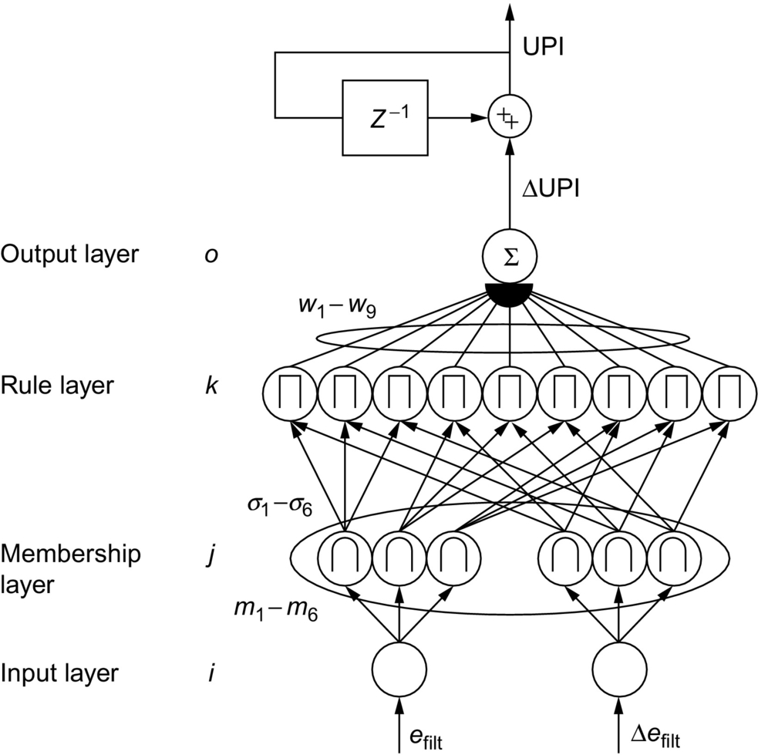

**FIG. 36.10** Proposed  FNN PI structure.

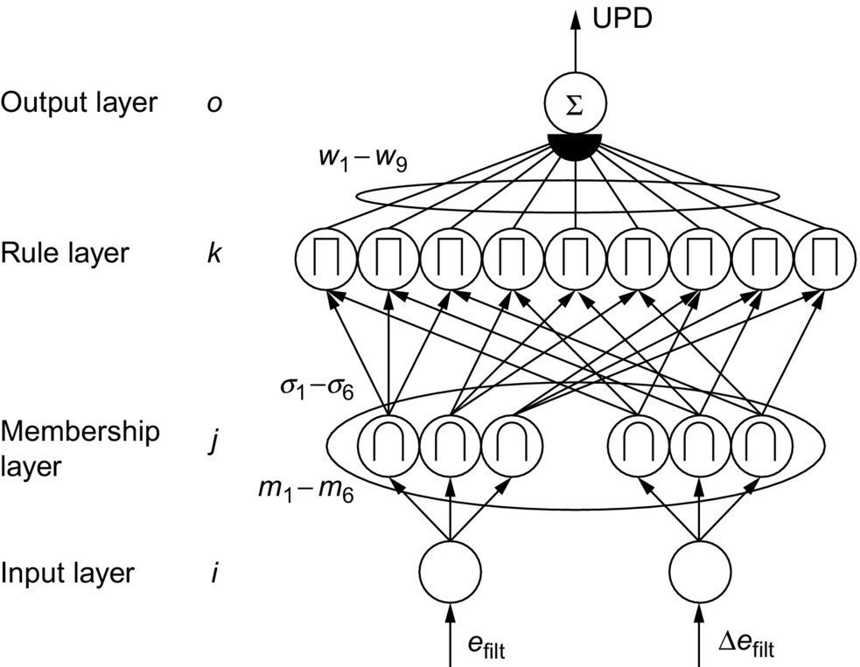

**FIG. 36.11** Proposed  FNN PD structure.

### 36.3.1 INPUT LAYER

The input layer passes the input value, assigned for each FNN as follows (let be the feedback error).

|  |  |  |
| --- | --- | --- |
| **Network\input** | ***u*1** | ***u*2** |
| PI FNN | *e*filt | Δ*e*filt |
| PD FNN | *e*filt | Δ*e*filt |

### 36.3.2 THE MEMBERSHIP LAYER

Each membership function into the fuzzy set is a Gaussian; the following evaluation occurs (note that *mij* and *σij* are parameters):

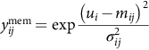 for input  and member  of that input.

For further derivations, allow the matrix *y*mem to be vectorized as follows:

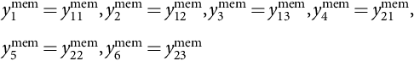

and allow the same vectorization for the means *m* matrix into a vector and sigmas *σ* matrix into a vector.

### 36.3.3 THE RULE LAYER

Each rule function is a product of two membership outputs. Refer to the table: each table cell is a rule layer output calculated by the product of the row and column label values.

|  |  |  |  |
| --- | --- | --- | --- |
| **Row\column** | ***y*21mem** | ***y*22mem** | ***y*23mem** |
| *y*11mem | *y*1rule | *y*4rule | *y*7rule |
| *y*12mem | *y*2rule | *y*5rule | *y*8rule |
| *y*13mem | *y*3rule | *y*6rule | *y*9rule |

### 36.3.4 THE OUTPUT LAYER

The weighted summation of the rules composes the output layer (note parameters *Wk*):  where .

## 36.4 Learning Algorithm-Based EKF

At each time step, for each  FNN, there is a state vector comprised of 21 elements:  (noting vector form of *m*,*σ*).

Furthermore, define the following: the reference model output *ω*ref, measured output *ω*meas, control signal *U*, PI FNN output control signal *Δ*UPI, and PD FNN output control signal UPD. Also, allow for the matrix notation of the membership outputs to be vectorized as follows:

The EKF innovation process is the difference from a reference signal to the measured output of the system . A state gradient vector *h* must be created, such that  using the chain rule backpropagation. The change in system output with respect to input (*ω*meas)/*d*(*U*) is assumed as unity. This is a dangerous assumption, and a more sophisticated control algorithm would attempt to model this scalar value, perhaps with an FNN identification structure.

The control signal is the summation . Thus, to propagate into each FNN, the following are useful:  and  and .

Within the FNN, the change in output layer calculation with respect to each weight is  for  and note  and  for each FNN.

Within the FNN, to propagate to the membership layer, the vector  is the change in the FNN output with respect to each rule.

Each rule is a product of two fuzzy set elements from the membership layer. The following matrix defines the gradient of rules to a vector form of membership outputs.

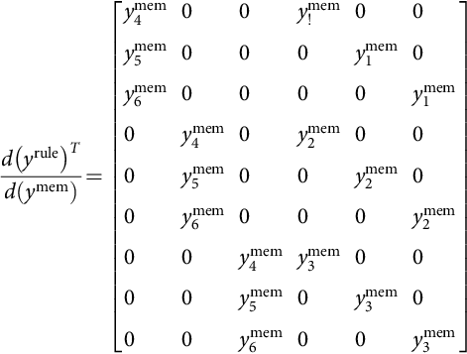

Each membership is Gaussian. The partial with respect to the mean and sigma are necessary:

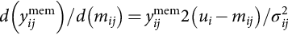

and

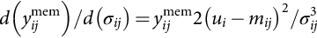

Note that the resulting matrix may be vectorized as seen previously for *y*mem.

Applying the chain rule, the following gradients for each FNN are (where  and  for each respective calculation) and  represents element-wise multiplication:

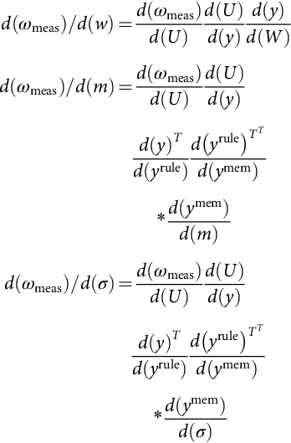

The gradient state vector is then a concatenation:

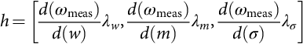

where *λw*,*λm*, and *λσ* are learning rate constants for the weights, means, and sigmas.

The EKF algorithm consists of the following recursive equations built on the state vector *x* and gradient state vector *h* (both  below) and a state covariance matrix *P* and measurement noise scalar *r* and state noise vector *q*:

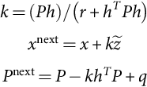

## 36.5 Fuzzy PID Control Design-Based Genetic Optimization

A genetic-based hybrid fuzzy-PID controller, which employs a fuzzy-PID controller integrating a classical PID controller, is presented in this section. The fuzzy-PID controller consists of three parallel fuzzy subcontrollers, namely, fuzzy-based proportional controller, fuzzy-based integral controller, and fuzzy-based derivative controller. A genetic optimization technique is used to determine the optimal values of the scaling factors of the output variables of these subcontrollers. These independent controllers are grouped together and integrated with an industrial PID controller to form a hybrid fuzzy-PID controller. [Fig. 36.12](https://learning.oreilly.com/library/view/power-electronics-handbook/9780128114087/B9780128114070000404.xhtml#f0065) shows the architecture of the proposed genetic-based hybrid fuzzy-PID controller. The hybrid fuzzy-PID controller is anticipated to accommodate the robust stabilization and disturbance rejection problems.

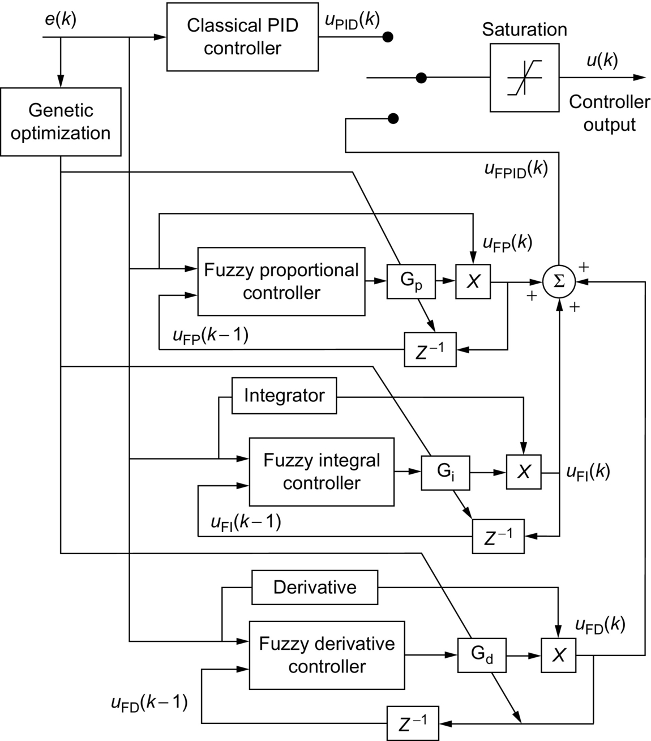

**FIG. 36.12** Block diagram of the proposed hybrid fuzzy-PID controller.

### 36.5.1 FUZZY-BASED PROPORTIONAL CONTROLLER

The first step in designing the controller is to decide which state variables of the drive system can be taken as the input signals to the controller. Both the speed error, *e*(*k*), and the delayed feedback control signal, , are used as the inputs to the speed controller. The output of the fuzzy-based proportional controllers is the gain, *FK*P. The linguistic fuzzy variable “*e*(*k*)” has three sets: positive large (PL), zero (ZE), and negative large (NL), with each set having its own membership function. Furthermore, the linguistic fuzzy variable “” also has three sets: positive large (PL), zero (ZE), and negative large (NL), with each set having its own membership function. After specifying the fuzzy sets, it is required to determine the membership functions for these sets. Typical triangular membership functions are utilized for the *e*(*k*) and . The three fuzzy sets can be symbolized by  and  Their corresponding membership functions can be symbolized by .

The next step in the design of the fuzzy subcontroller is the determination of the fuzzy IF-THEN inference rules. The number of fuzzy rules that are required is equal to the product of the number of fuzzy sets that make up each of the two fuzzy input variables. Thus, a total of nine fuzzy rules are required to relate each possible combination of the two fuzzy input variables to the output membership fuzzy sets. The fuzzy rules ensure that the output of each fuzzy controller enhances the overall speed-tracking performance. Examples of such rules are the following:

IF *e*(*k*) is positive large AND  is negative large, THEN *FK*P is positive medium (PM).

IF *e*(*k*) is zero AND  is zero, THEN *FK*P is positive small (PS).

IF *e*(*k*) is positive large AND  is zero, THEN *FK*P is positive very large (PVL).

In general, a typical fuzzy rule is of the form:

*R*(*k*): IF *e*(*k*) is *F*1*j*, and  is *F*2*l*, THEN *f*P is *C*k*l* for .

The conjunction of the rule antecedents is evaluated by the fuzzy operation intersection, which is implemented by the min operator. The rule strength represents the degree of membership of the output variable for a particular rule. Defining the rule strength, *ξi*,*j* of a particular rule as 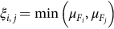 where  is associated with the fuzzy variable, *e*(*k*), and  is associated with the fuzzy variable, . The fuzzy inference engine uses the appropriately designed knowledge base to evaluate the fuzzy rules and produce an output for each rule. Subsequently, the multiple outputs are transformed to a crisp output by the defuzzification interface. Once the aggregated fuzzy set representing the fuzzy output variable has been determined, an actual crisp control decision must be made. The process of decoding the output to produce an actual value for the controller gain *FK*P is referred to as defuzzification. Thus, a fuzzy-logic controller-based center-average defuzzifier is implemented. The output of fuzzy-based proportional controller is given by , where

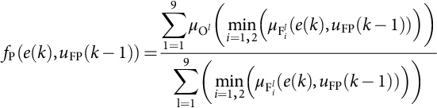

The linguistic fuzzy output variable “*FK*P” has nine sets: negative very large (NVL), negative large (NL), negative medium (NM), and negative small (NS), zero (ZE), positive small (PS), positive medium (PM), positive large (PL), and positive very large (PVL). The two fuzzy sets, namely, negative very large (NVL) and positive very large (PVL), are added to enhance the tracking performance. After specifying the fuzzy sets, it is required to determine the membership functions for these sets *μ*O*l* for . The membership function for the fuzzy set-representing zero is a fuzzy singleton. Additionally, the other membership functions are composed of fuzzy singletons within the region defined for the fuzzy output variable. Consequently, the control signal generated by the fuzzy-proportional controller can be written as , where *G*P is the scaling factor that is tuned experimentally using genetic optimization.

### 36.5.2 FUZZY-BASED INTEGRAL CONTROLLER

The same technique applied to the fuzzy-based proportional controller is applied to the fuzzy-based integral controller. The controller has two inputs and one output. The inputs to the fuzzy-based controller are (1) the angular speed error, *e*(*k*), and (2) the delayed feedback control signal, . The controller output is the gain, *FK*I, of the controller. Three fuzzy sets are defined for the fuzzy linguistic variable “*e*(*k*)” and three fuzzy sets for the fuzzy linguistic variable  After specifying the fuzzy sets of the two fuzzy variables, the membership functions for these sets are derived. The membership functions are composed of the same fuzzy triangular membership functions allocated for the fuzzy-based proportional controller. Similarly, the number of fuzzy rules that are required is equal to the product of the number of fuzzy sets that make up each of the two fuzzy input variables. Therefore, a total of nine fuzzy rules are introduced. Some of these rules and their significance are explained as follows:

*Rule 1*: IF *e*(*k*) is positive large (PL) AND  is positive large (PL), THEN *FK*I is positive large (PL). This rule implies a general condition when both input signals are positive. Consequently, the output membership function assigned to this rule is a positive value to keep the controller gain within a stable range.

*Rule 2*: IF *e*(*k*) is zero (ZE) AND  is positive large (PL), THEN *FK*I is positive very small (PVS). This rule implies a general condition when the speed error is close to zero and  is positive. Therefore, the output membership function assigned to this rule is a small positive value to reduce the control signal variations.

*Rule 3*: IF *e*(*k*) is negative large (NL) AND  is positive large (PL), THEN *FK*I is positive medium (PM). This rule usually deals with the case in which overshoots occur. A medium positive value is assigned in this case to ensure that the overshoot is decreased and prevent oscillations at the same time.

The rule strength represents the degree of membership of the output variable for a particular rule. Similarly, the rule strength, *ξn*,*m* of a particular rule is defined as



where  is associated with the fuzzy variable, *e*(*k*), and  is associated with the fuzzy variable, .

The fuzzy inference engine uses the appropriately designed knowledge base to evaluate the fuzzy rules and produce an output for each rule. Subsequently, the multiple outputs are transformed to a crisp output, by the defuzzification interface. A center-average defuzzifier method is used. Thus, the output of fuzzy-based integral controller is given by  where



After specifying the fuzzy sets for the fuzzy output variable, *FK*I, the membership functions for these sets are derived. It is important to note that the same fuzzy singleton membership functions are used here. The control signal of the fuzzy-based integral controller is given by

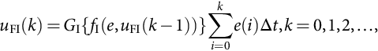

where *G*I is the scaling factor that is tuned experimentally using genetic optimization.

### 36.5.3 FUZZY-BASED DERIVATIVE CONTROLLER

The same process applied to fuzzy-based proportional controller and fuzzy-based integral controller is applied to the fuzzy-based derivative controller. The input signals (state variables) to the controller are *e*(*k*) and . The output of the controller is the gain *FK*D. After specifying the fuzzy sets and the membership functions for these sets, the triangle membership functions are also used to define the degree of membership. [Figs. 36.2](https://learning.oreilly.com/library/view/power-electronics-handbook/9780128114087/B9780128114070000404.xhtml#f0015) and [36.3](https://learning.oreilly.com/library/view/power-electronics-handbook/9780128114087/B9780128114070000404.xhtml#f0020) show the membership functions for the fuzzy sets. Similarly, the linguistic fuzzy output variable “*FK*D” has nine sets: negative very large (NVL), negative large (NL), negative medium (NM), and negative small (NS), zero (ZE), positive small (PS), positive medium (PM), positive large (PL), and positive very large (PVL). Now, it is necessary to find the final controller output. Consequently, the output of fuzzy-based derivative controller is given by , where



The control signal of the fuzzy-based derivative controller:



where *G*D is a scaling factor that tuned experimentally using genetic optimization.

Finally, the overall output of fuzzy PID was derived as follows:



Saturation is also incorporated in the hybrid fuzzy-PID controller structure. As such, the final output of proposed controller is



where *u*min and *u*max are the permitted minimum and maximum inputs to the brushless drive system.

## 36.6 Classical PID Versus Fuzzy-PID Controller

The classical linear PID controller in its discrete form can be characterized as



where *K*P,*K*I, and *K*D are constant gains.

This discrete form characterization equation provides a closed-form solution to the proposed fuzzy-PID controller. It can be rewritten as



where (*FK*P)eq,(*FK*I)eq, and (*FK*D)eq are defined to be the equivalent proportional, integral, and derivative gains to a classical linear PID controller, respectively.

## 36.7 Genetic-Based Autotuning of Fuzzy-PID Controller

Genetic optimization-based approach is used to ensure the best performance of the proposed fuzzy-PID controller. The genetic optimization imitates the natural evolution process in which the fittest survive and the best genes are propagated to the next generation. A population of chromosomes is evaluated and a fitness value is assigned to each. Each chromosome represents a possible solution for a given problem, and the ones with the higher fitness have a better chance to reproduce. One of the main features is that it could work well for nondeterministic systems, ill-defined systems, and systems that are hard to model. Furthermore, the final performance outcome of the algorithm does not depend highly on the initial choice of chromosomes. When the genetic optimization is applied to control applications, each chromosome represents the set of controller's adjustable parameters, and the fitness value is a quantitative measure of the controller performance. The autotuning consists of the automatic adjustment of these parameters to optimize the controller performance. The genetic optimization combines a stochastic exploratory search with a well-defined cost function to find the solution that fit the problem the best. The cost function that represents the fuzzy-PID controller is defined as follows:



where *G*P,*G*I,*G*D are the output scaling factors of the fuzzy-PID subcontrollers. The function *F* represents the relationship between the overall performance and the design parameters.

The optimization problem for the fuzzy-PID controller is described as



where *F* is the fitness function. There are various ways to calculate the overall performance *J* of the controller, but for simplicity reasons, the mean square error (MSE) performance index was selected.



where *N* is the length of the evaluation window and *e*(*k*) is the error between the reference speed and the actual speed. The fitness of each parameter set or chromosome can be determined as follows:

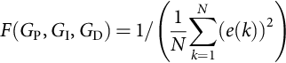

Once the fitness function is established, the genetic operators and parameters are defined. The genetic optimization consists of three basic operators: the crossover, mutation, and reproduction. The parameters are the number of generations, the population size, the probability of crossover, and mutation. In general, an initial population size is defined and evaluated with the fitness function. Once each chromosome has a fitness assigned to it, the reproduction process takes place with those that are more fit having a greater chance to be selected. Then, each of the two operators of crossover and mutation is applied to create the new pool of chromosomes to be evaluated. Crossover occurs when the chromosomes partially exchange their information by interchanging some of their genes. Mutation is the random alteration of a particular section of the chromosome by occasionally changing one or more of the genes that are part of the chromosome. For this optimization task, a crossover factor of 0.3 and a mutation factor of 0.7 were used. Another important aspect of the genetic optimization is the coding of the parameters. Binary coding has been used widely for decades; however, real-coded algorithms are proving useful for a number of applications, and it was chosen to implement the genetic optimization algorithm. One of the difficulties of the real-time implementation is in the simultaneous evaluation of the fitness for all the chromosomes in one generation as a batch data. This problem was overcome by reducing the population size to one and evaluating the fitness function of each chromosome sequentially. The mutation function is applied by increasing or decreasing the value proportional to a uniformly distributed random number between −0.9 and 1. The crossover is implemented with the chromosome that had the higher value for the fitness function and the chromosome being tested in the current generation. A Bernoulli binary set of numbers with probability of 0.5 is used to select the resulting offspring chromosome with a mix of genes from both parent chromosomes. The overall genetic-based autotuning procedure of the fuzzy-PID controller consists of the following steps:

*Step 1:* Select the control topology of the fuzzy-PID controller in which the outputs of the subcontrollers are used as the FPID gains.

*Step 2:* Define the characteristics of the fuzzy-PID subcontrollers such as the number of fuzzy sets, membership functions, fuzzy rules, and defuzzification method.

*Step 3:* Set the genetic optimization parameters, such as the number of generations, the population size, the probability of crossover, and mutation.

*Step 4:* The last step is the tuning of the parameters, *G*P,*G*I, and *G*D of the fuzzy-PID controller using the genetic optimization procedure.

## 36.8 Fuzzy and *H*∞ Control Design

### **36.8.1 BRUSHLESS SERVO-MOTOR DRIVE SYSTEM**

The brushless DC motor used in the section is excited by a three-phase sinusoidal supply and driven from a six-step inverter, which converts a constant voltage to a three-phase voltage with a frequency corresponding instantaneously to the rotor speed. The model of the drive system is used to design the  tracking controller and to simulate its dynamic behavior. However, fuzzy-logic controller does not require mathematical models and has the ability to approximate nonlinear systems. The reader is referred to [[16](https://learning.oreilly.com/library/view/power-electronics-handbook/9780128114087/B9780128114070000404.xhtml#bb0085)] for details of the dynamic model of the brushless dc motor drive system. For the purpose of discussion, the dynamics of the brushless servomotor drive system can be written in state space form as follows:



where , *d* is the external disturbance, and . Since  for , the system is controllable in the whole space *Rn*.

### 36.8.2 THE FUZZY *H*∞ CONTROL STRUCTURE

A hybrid adaptive fuzzy controller is implemented, which employs a fuzzy-logic controller integrating an  tracking controller. The  tracking controller is capable of taking care of the robust stabilization and disturbance rejection problems, while fuzzy-logic controller is used as principle components of the adaptive fuzzy controller. Actually, it is outfitted with an adaptive control law that modifies the parameters of the controller based on a Lyapunov synthesis approach. [Fig. 36.13](https://learning.oreilly.com/library/view/power-electronics-handbook/9780128114087/B9780128114070000404.xhtml#f0070) shows the block diagram of the proposed control structure.



**FIG. 36.13** Block diagram of the overall control structure.

### 36.8.3 *H*∞ CONTROL DESIGN

The controller objective is to obtain high-performance servo tracking; therefore, the control problem is to force the actual output to follow a predetermined bounded reference trajectory. The tracking performance indicates how closely the servomotor follows a desired position trajectory, velocity trajectory, or acceleration trajectory. For the purpose of discussion, we define the tracking error to be , where *ɛ* is the rotor speed error and  is the acceleration error. Consequently, the motor speed error  and the acceleration error  are used as input variables to the  controller. Here, *ω*act is the actual speed in rev/s, *ω*ref is the desired reference speed, *α*ref is the desired acceleration in rev/s2, and *α*act is the calculated acceleration. The acceleration is calculated as the difference in the speed over two successive sampling periods. A block diagram of the  tracking controller is shown in [Fig. 36.14](https://learning.oreilly.com/library/view/power-electronics-handbook/9780128114087/B9780128114070000404.xhtml#f0075). The  control law is defined as [[17](https://learning.oreilly.com/library/view/power-electronics-handbook/9780128114087/B9780128114070000404.xhtml#bb0090)]



**FIG. 36.14** Block diagram of  tracking controller.



where *r*r is a weighting factor and *P* is the solution of the simplified Riccati-like equation for 



The matrices *A* and *B* are given by



where  is chosen such that all roots of the polynomial  are in the open left-hand plane.

### 36.8.4 FUZZY LOGIC CONTROL DESIGN

The fuzzy-logic principles with center-average defuzzifier, product inference, and singleton fuzzifier are used as building blocks for the fuzzy controller. A block diagram of the fuzzy control structure is shown in [Fig. 36.15](https://learning.oreilly.com/library/view/power-electronics-handbook/9780128114087/B9780128114070000404.xhtml#f0080). The fuzzy-logic-based controller implemented in this work has two inputs and one output. The inputs are the rotor speed error and the feedback acceleration error, with each of these inputs corresponding to a fuzzy variable.



**FIG. 36.15** Block diagram of the fuzzy-logic control structure.

The output is the fuzzy control decision. The fuzzy variable associated with the rotor speed error signal consists of five fuzzy sets: positive large (PL), positive medium (PM), zero (ZE), negative large (NL), and negative medium (NM). Typical example of the fuzzy membership functions used for the speed is shown in [Fig. 36.16](https://learning.oreilly.com/library/view/power-electronics-handbook/9780128114087/B9780128114070000404.xhtml#f0085). In this way, for any given value of the rotor angle, the degree of membership *μ*, to which it belongs to each of these sets, can be determined, and a control decision based on this information can be obtained.



**FIG. 36.16** Fuzzy membership functions for the rotor speed error.

Similarly, the acceleration error can be described by a group of partially overlapping fuzzy sets as positive large (PL), positive medium (PM), zero (ZE), negative large (NL), and negative medium (NM), with each set having its own membership function. An example of typical membership functions that make up the fuzzy variable acceleration is shown in [Fig. 36.17](https://learning.oreilly.com/library/view/power-electronics-handbook/9780128114087/B9780128114070000404.xhtml#f0090).



**FIG. 36.17** Fuzzy membership functions representing the acceleration error.

The five fuzzy sets can be symbolized by  and . Their membership functions can be symbolized by  and .

### 36.8.5 FUZZY LOGIC RULES

The next step in the design of the fuzzy-logic-based controller is the determination of the fuzzy IF-THEN inference rules. The number of fuzzy rules that are required is equal to the product of the number of fuzzy sets that make up each of the two fuzzy input variables. For the fuzzy controller described here, the input variables representing the rotor speed and its acceleration consist of five fuzzy sets each. Thus, a total of 25 fuzzy rules are required. During each sampling interval that a controller is calculated, the present value of the degree of membership of the motor speed and its acceleration is calculated for each of the fuzzy sets that make up their respective fuzzy variables. This process is one of the largest computational burdens of the fuzzy-logic control algorithm if each fuzzy set is expected to have some degree of membership for the present input value of the motor speed and its acceleration. This will in addition affect the computational speed at which the fuzzy rules are processed since all the rules have to be evaluated.

Using a triangular membership function for the input variables was very desirable to reduce this computational burden and speed up the process. This ensures that only two fuzzy sets, which are overlapping, will actually have a nonzero degree of membership ([Figs. 36.16](https://learning.oreilly.com/library/view/power-electronics-handbook/9780128114087/B9780128114070000404.xhtml#f0085) and [36.17](https://learning.oreilly.com/library/view/power-electronics-handbook/9780128114087/B9780128114070000404.xhtml#f0090)). With this advantage, the evaluation of the degree of membership in each set is accelerated. This also speeds up the evaluation of the fuzzy rules since only those rules that correspond to nonzero values of membership function need to be evaluated. Hence, for this controller, only four fuzzy rules need to be evaluated during any sampling interval. The fuzzy inference rules have been determined experimentally using the measured responses of the brushless drive servo system. A typical fuzzy rule is of the form:

[*R*(1):] IF *x*1 is *F*1*j*, and *x*2 is *F*2*j*, THEN *O* is *G*1*l* for .

In general,

[*R*(*k*):] IF *x*1 is *F*1*j*, and *x*2 is *F*2*j*, THEN *O* is *G*k*l* for .

The conjunction of the rule antecedents is evaluated by the fuzzy operation *intersection,* which is implemented by the *min* operator. The rule strength represents the degree of membership of the output variable for a particular rule. Defining the rule strength, *ξi*,*j*, of a particular rule as



where  is associated with the fuzzy variable, *speed*, and  is associated with the fuzzy variable, *acceleration*. From above, it is clear that for all the rules where at least one of the degrees of membership in the corresponding fuzzy sets is zero, the output of the *min* operator will be zero, and hence, these rules do not have to be analyzed. The fuzzy inference engine uses the appropriately designed knowledge base to evaluate the fuzzy rules and produce an output for each rule. Subsequently, the multiple outputs are transformed to a crisp output by the defuzzification interface.

### 36.8.6 DEFUZZIFICATION

Once the aggregated fuzzy set representing the fuzzy output variable has been determined, an actual crisp control decision must be made. The process of decoding the output to produce an actual value for the control signal is referred to as defuzzification. Thus, a fuzzy-logic controller-based center-average defuzzifier is implemented. The control output can be written in general form:



which can be written in the form



where



 is a parameter vector representing the degree of membership of the output, which is tuned online using an adaptation law.

### 36.8.7 ON-LINE ADAPTATION

By using an adaptive law, the fuzzy parameters, *θ*, can be tuned online based on the Lyapunov synthesis approach. The feedback control law can be expressed as follows [[17](https://learning.oreilly.com/library/view/power-electronics-handbook/9780128114087/B9780128114070000404.xhtml#bb0090)]:



where *θ* is a vector denoting the parameter estimate of fuzzy-logic controller. The parameter *θ* is adjusted using the following adaptive law:



where *γ* is an adaptation gain and *g* is a constant that depends on machine parameters. A block diagram of the hybrid adaptive fuzzy controller is shown in [Fig. 36.18](https://learning.oreilly.com/library/view/power-electronics-handbook/9780128114087/B9780128114070000404.xhtml#f0095).



**FIG. 36.18** Block diagram of the overall fuzzy-  control structure.

## 36.9 Fuzzy Control for DC-DC Converters

### **36.9.1 BACKGROUND**

The DC-DC converters are generally divided into two groups: hard-switching converters and soft-switching converters. In hard-switching converters, the power switches cut off the load current within the turn-on and turn-off times under the hard-switching conditions. The output voltage is controlled by adjusting the on-time of the power switch, which in turn adjusts the width of a voltage pulse at the output. This is known as PWM control. In soft-switching converters, resonant components are used to create oscillatory voltage or current waveforms so that the zero-voltage switching or zero-current switching conditions could be created for the power switches. For many years, control design for converters has been carried out through analog circuits, which limited them to mostly PI controller structure. The PI controllers generally give overshoot in output voltage and high initial current when rise time of response is reduced. Feed-forward types of controllers have also been designed by sensing the input voltage to improve line regulation in applications with a wide range of input voltages and load currents. However, direct sensing of the input voltage through a feed-forward loop may induce large-signal disturbances that could upset the normal duty cycle of the converter. Using human linguistic terms and common sense, several fuzzy-logic controllers have been developed and implemented for the DC-DC converters [[18](https://learning.oreilly.com/library/view/power-electronics-handbook/9780128114087/B9780128114070000404.xhtml#bb0095)–[20](https://learning.oreilly.com/library/view/power-electronics-handbook/9780128114087/B9780128114070000404.xhtml#bb0105)]. These controllers have shown promise in dealing with nonlinear systems and achieving voltage regulation in buck converters. Fuzzy-logic control uses humanlike linguistic terms in the form of IF-THEN rules to capture the nonlinear system dynamics. Once in place, the fuzzy rules will not be able to adapt themselves to adequately capture the dynamics and external disturbances of the converter. Although achieving many practical successes, fuzzy control has not been viewed as a rigorous science due to a lack of formal analysis and synthesis techniques. As a result of this, a lot of work has been done to develop adaptive fuzzy controllers and automate the modeling process as much as possible. Recently, the resurgence of interest in ANN has injected a new driving force into fuzzy literature. One of the major features of ANNs is their learning capability. A learning algorithm is usually used to update the nonlinear parameters of the network architecture. A drawback in using an ANN for control is that there is so much freedom in structural implementation choice that it is often difficult to decide how complex a structure is actually necessary for the desired control. Besides, the implementation is not at all intuitive, and the inner workings of the network are very much invisible to the designer. The integration of neural network architectures with fuzzy inference system has resulted in a very powerful strategy known as adaptive network-based fuzzy inference system. Some researchers suggest that neural networks and fuzzy control are in fact special instances of adaptive networks [[21](https://learning.oreilly.com/library/view/power-electronics-handbook/9780128114087/B9780128114070000404.xhtml#bb0110),[22](https://learning.oreilly.com/library/view/power-electronics-handbook/9780128114087/B9780128114070000404.xhtml#bb0115)]. The suggested fuzzy inference system has the advantage that it can not only take linguistic information from human experts but also adapt itself using numerical data to achieve better performance.

## 36.10 Fuzzy Control Design for Switch-Mode Power Converters

The structure built-up here is a two-input single-output controller. The inputs are the variable voltage error, *e*(*k*), and the change in voltage error, Δ*e*(*k*). Consequently, the input to the DC-DC converter would be the duty cycle that is actually the output of the fuzzy controller. The operational structure of the proposed fuzzy controller is shown in [Fig. 36.19](https://learning.oreilly.com/library/view/power-electronics-handbook/9780128114087/B9780128114070000404.xhtml#f0100). It consists of three building blocks: (1) a fuzzification block that expresses quantitative action to qualitative action, (2) fuzzy inference engine that generates the fuzzy rules, and (3) a defuzzification block that articulates qualitative action to quantitative action. Fuzzification translates a numeric value for the error *e*(*k*) or change in error Δ*e*(*k*) into a linguistic value such as big or small with a membership grade. Defuzzification takes the fuzzy output of the rules and generates a “crisp” numeric value used as the control input to the DC-DC converter. The controller qualitatively captures the dynamics of the DC-DC converter and executes this qualitative idea in a real-time situation. The DC-DC converter is equipped with a feedback network that provides the error value at the output. The overall architecture of a DC-DC converter topology with the fuzzy controller structure is given in [Fig. 36.20](https://learning.oreilly.com/library/view/power-electronics-handbook/9780128114087/B9780128114070000404.xhtml#f0105). The feedback network consists of a *precision voltage reference* with a nominal voltage of 2.5 V. The 5 and 15 V output potentials are combined in a resistive sampling network in such a way that the output voltage of the network is 2.5 V when the potentials are closed to their nominal magnitudes. This output voltage is then compared internally with the reference of the *precision voltage reference*, and any error difference detected is amplified and fed back. The converter is represented by a “black box” from which we only extract the terminals corresponding to input voltage (*V*I), output voltage (*V*o), and controlled switch (S). From these measurements, the controller provides a percentage duty-cycle signal for a peripheral interface microcontroller PIC16F877, which generates the converters' actual duty cycle.



**FIG. 36.19** Fuzzy control structure.



**FIG. 36.20** Fuzzy control-based DC-DC converter topology.

### 36.10.1 DC-DC SWITCH-MODE POWER CONVERTER

The DC-DC switch-mode power converter consists of six distinct circuit networks as shown in [Fig. 36.21](https://learning.oreilly.com/library/view/power-electronics-handbook/9780128114087/B9780128114070000404.xhtml#f0110), working together to form a complete DC-to-DC dual-output switch-mode power regulator [[23](https://learning.oreilly.com/library/view/power-electronics-handbook/9780128114087/B9780128114070000404.xhtml#bb0120)]. The six distinct circuit networks are (1) the bias voltage regulator network, (2) the 100 KHZ clock, (3) the pulse-width modulator (PWM), (4) the power switch driver interface, (5) the feedback error amplifier, and (6) the integrated-magnetic (IM) power stage. In order to implement the proposed adaptive fuzzy-neural-network controller, the converter system shown in [Fig. 36.21](https://learning.oreilly.com/library/view/power-electronics-handbook/9780128114087/B9780128114070000404.xhtml#f0110) was modified by removing the *bias voltage regulator network*, the *100 KHz clock*, and the *pulse-width modulator (PWM)*, which is the core of the control system. The power-stage concept is based on that of a “dual-output forward” configuration operating in a continuous mode of energy storage. When the power MOSFET switch Q1 is turned ON, energy is transferred from the input power source (*V*IN) to the two secondary sides of the transformer. The voltage potential across the terminals of C1 will be that of the reflected line voltage, namely, . The ON time is a fraction of the clock period, and it has to be short and long enough to bring the output to a level above the desired voltage (5 and 15 V). Diodes D1 and D4 conduct allowing the energy transfer to be used to supply 5 and 15 V load power, respectively, and to replenish the energy lost in the “output” inductors during the previous OFF period of Q1. Diodes D2 and D3 do not conduct during this time, since they are reverse-biased.



**FIG. 36.21** Block diagram of switch-mode DC-DC power converter.

When Q1 turns OFF, the 5 and 15 V load power is sustained by the energies of the two “inductors” (L1 and L2). The output stored energy, located in two inductors, will then start discharging causing the voltages to drop. Diodes D2 and D3 conduct during this time with diodes D1 and D4 forced off. As soon as the voltages go below the desired values, another impulse will be applied on Q1 (Q1 ON), to bring the voltage back upward. Capacitors C2 (0.001 *μf*) and C3 (100 *μf*) serve to prevent the dynamic ripple currents in the “inductors” from appearing at the 5 and 15 V load terminals, respectively.

## 36.11 Optimum Topology of the Fuzzy Controller

The main problem with fuzzy controller generation is related to the definition of its optimum topology such as scaling factors, number of fuzzy sets, shape of the fuzzy sets, and decision-making. This section is devoted to the topology determination of the proposed fuzzy controller structure. Various test cases were performed on the DC-DC converter in order to determine the ranges of membership functions and other system-specific responses of the converter that will help in the design of the linguistic control rules of the proposed controller. The experimental tests were focused on the responses of the DC-DC converter with and without the action of the controller. One other point was to observe how the changes of the control signal and the variations of the error signal with respect to the variations of the input voltage. The various voltage ranges observed in the test cases assisted in choosing the ranges for the input and output membership set. A summary of some of these tests is shown in [Figs. 36.22](https://learning.oreilly.com/library/view/power-electronics-handbook/9780128114087/B9780128114070000404.xhtml#f0115)–[36.24](https://learning.oreilly.com/library/view/power-electronics-handbook/9780128114087/B9780128114070000404.xhtml#f0125). [Fig. 36.22](https://learning.oreilly.com/library/view/power-electronics-handbook/9780128114087/B9780128114070000404.xhtml#f0115) shows the optimum trajectories of the duty cycle, the output voltage, and the input current with variations in the input voltage. From [Fig. 36.22](https://learning.oreilly.com/library/view/power-electronics-handbook/9780128114087/B9780128114070000404.xhtml#f0115), when the input voltage increases, the control signal pulses get reduced to maintain the output voltages at their required level. The other information gives the range of the control signal (i.e., 16%–50%) required for the working range of the DC-DC converter. A similar test case was conducted while the error of the system was observed. [Fig. 36.23](https://learning.oreilly.com/library/view/power-electronics-handbook/9780128114087/B9780128114070000404.xhtml#f0120) shows four different test cases of variations of the error voltage and duty cycle with increase in the input voltage plotted together. The figure shows four variations of the error voltage with the control signal at 16%, 24%, 32%, and 40% duty cycle. For the 40% duty-cycle test case, the feedback network becomes active at an input voltage of 18 V. When the duty cycle was reduced to 32%, the feedback network becomes active at around 21 V of the input voltage. At 16% duty cycle, it was realized that the feedback network was not yet active at 36 V of the input voltage. This test case shows that when the feedback network is active, the error voltages are all below 2 V. [Fig. 36.23](https://learning.oreilly.com/library/view/power-electronics-handbook/9780128114087/B9780128114070000404.xhtml#f0120) also gives the actual values of the error voltage and the control signals needed at each stage of the input voltage variations. A general rule from [Fig. 36.23](https://learning.oreilly.com/library/view/power-electronics-handbook/9780128114087/B9780128114070000404.xhtml#f0120) will be “if the error voltage is high (i.e., max 6 V) and the change in error is zero (i.e., very small), then increase the control signal (i.e., duty cycle).” In [Fig. 36.24](https://learning.oreilly.com/library/view/power-electronics-handbook/9780128114087/B9780128114070000404.xhtml#f0125), a 5 V output voltage level was tested for different constant control signals while increasing the input voltage. Four different test cases were conducted for duty-cycle values of 16%, 24%, 32%, and 40%. From the figure, it shows the various voltage levels at which the output voltage gets to the 5 V mark for the different duty cycles. It also shows that without any control, the output voltage will continue to increase without any bound. These experimental observations were in general very helpful in the design of the fuzzy-logic controller.



**FIG. 36.22** Optimum trajectories of the percentage duty cycle, the output voltage, and the input current with variations in the input voltage.



**FIG. 36.23** Variations of the error voltage with the control signal at 16%, 24%, 32%, and 40% duty cycle.



**FIG. 36.24** 5 V output voltage level tested for different constant control signals.

### 36.11.1 MEMBERSHIP FUNCTIONS AND RULES GENERATION

The chief problem of the construction of the fuzzy controller is related to the choice of the regulator parameters. Certainly, there is no systematic procedure for the design of a fuzzy controller (membership functions and rules generation), and this section is devoted to the determination of the fuzzy sets and the linguistic rules. The number of the linguistic sets of the proposed controller has been determined using laboratory experimentation and the responses of the DC-DC converter that have been compared with different numbers of the fuzzy sets. The actual responses have been compared with three, four, five, and seven fuzzy sets. It has been found that the use of more than five linguistic sets does not improve the tracking accuracy of the DC-DC converters but in fact increases the computation time. Consequently, four linguistic sets, positive large (PL), positive small (PS), negative large (NL), and negative small (NS), have been chosen for the input variable voltage error, *e*(*k*), and three linguistic sets, positive medium (PM), zero (ZE), and negative medium (NM), have been chosen for that of the change in voltage error, Δ*e*(*k*). Additionally, five linguistic sets, positive large (PL), positive small (PS), zero, negative large (NL), and negative small (NL), have been chosen for the output variable of the fuzzy controller structure. The fuzzy controller utilizes triangular membership functions on the controller input. The triangular membership function is chosen owing to its simplicity. For the change in voltage error, Δ*e*(*k*), the initial values of the premise parameters (the corner coordinates of the triangle) are chosen so that the membership functions are equally spaced along the operating range of each input variable. The scaled input and output membership functions sets are shown in [Figs. 36.25](https://learning.oreilly.com/library/view/power-electronics-handbook/9780128114087/B9780128114070000404.xhtml#f0130) through [36.27](https://learning.oreilly.com/library/view/power-electronics-handbook/9780128114087/B9780128114070000404.xhtml#f0140). The actual error measured from the feedback network ranges from 0.8 to about 6.0 V, while the control signal ranges from 16% to 50% duty cycle. The scaling factors  and  were determined using experimental tests in such a way that the normalized inputs *e*(*k*) and Δ*e*(*k*) are well adapted to the universe of discourse  for any operating point. The linguistic control rules are established considering the dynamic behavior of the DC-DC converter and analyzing the error and its variation. To obtain control decision, the max-min inference method is used. It is based on the minimum function to describe the “AND” operator present in each control rule and the maximum function to describe the “OR” operator.



**FIG. 36.25** Input membership functions for the error, *e*(*k*).

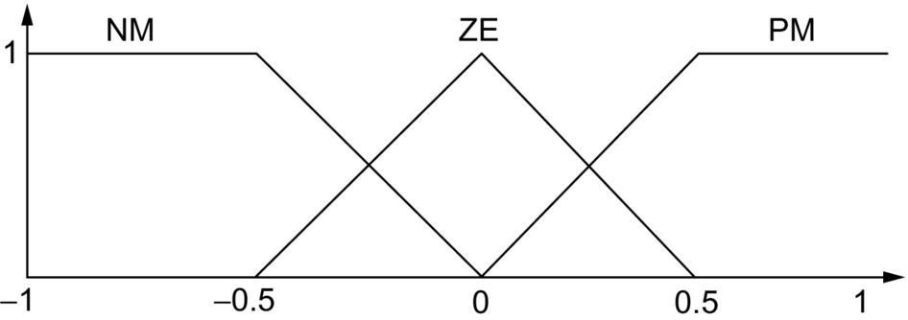

**FIG. 36.26** Input membership functions for the change in error, Δ*e*(*k*).

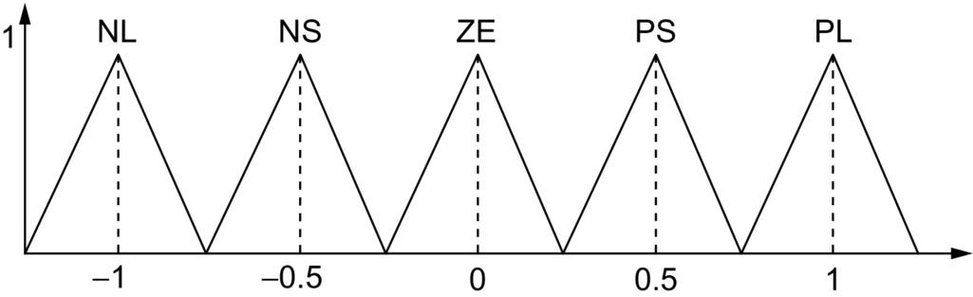

**FIG. 36.27** Output membership functions for the control signal.

The output of the fuzzy controller structure is crisp, and thus a combined output fuzzy set must be defuzzified. To express the qualitative action in a quantitative action, the sum-product composition method was used. It calculates the crisp output as the weighted average of the centroids of all output membership functions. The output of the controller can be expressed as

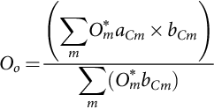

where *aCm* and *bCm* are the centers and widths of the output fuzzy sets, respectively, for . The values of the *bCm* s were chosen to be unity. This scaled output corresponds to the control signal (percent duty cycle) to be applied to maintain the output voltage at a constant value. [Fig. 36.28](https://learning.oreilly.com/library/view/power-electronics-handbook/9780128114087/B9780128114070000404.xhtml#f0145) represents the normalized output *O*o of the proposed fuzzy controller structure as a function of the error *e*(*k*) and the change of error Δ*e*(*k*). It clearly illustrates the nonlinear characteristics of the proposed fuzzy controller structure.



**FIG. 36.28** Fuzzy control surface.

## 36.12 Adaptive Network-Based Fuzzy Control System for DC-DC Converters

Adaptive network architecture, ANFIS, and a learning algorithm by which the ANFIS could construct a desired input-output mapping are proposed. The basic structure of a converter topology with adaptive network architecture is given in [Fig. 36.29](https://learning.oreilly.com/library/view/power-electronics-handbook/9780128114087/B9780128114070000404.xhtml#f0150). Both fuzzy-logic principles and learning functions of neural networks are employed together to construct the adaptive fuzzy-network inference system for the control topology. Initially, a basic fuzzy-logic controller is set up utilizing linguistic rules, and then numerical data is used for training the controller. The number of membership functions is chosen so as to cover the entire input space. The converter is represented by a “black box” from which we only extract the terminals corresponding to input voltage (*Vi*), output voltage (*Vo*), and controlled switch (S). From these measurements, the ANFIS provides a signal proportional to a percentage duty-cycle signal for a peripheral interface microcontroller, PIC16F877, which generates the converters' actual duty cycle.



**FIG. 36.29** Structure of a converter topology with adaptive network architecture.

### 36.12.1 TOPOLOGY OF THE NEURAL-FUZZY CONTROLLER (NFC)

The proposed ANFIS is a multilayer neural network-based fuzzy-logic controller. The network architecture is built, such that the designer recognizes the internal nodes as they relate to the components of fuzzy controller. The system has a total of five layers. The architecture of the network is shown in [Fig. 36.30](https://learning.oreilly.com/library/view/power-electronics-handbook/9780128114087/B9780128114070000404.xhtml#f0155). The scaled input and output membership functions sets are shown in [Figs. 36.3](https://learning.oreilly.com/library/view/power-electronics-handbook/9780128114087/B9780128114070000404.xhtml#f0020)–[36.5](https://learning.oreilly.com/library/view/power-electronics-handbook/9780128114087/B9780128114070000404.xhtml#f0030). The actual error measured from the feedback network ranges from 0.8 to about 6.0 V, while the control signal ranges from 16% to 50% duty cycle.



**FIG. 36.30** Network architecture-based topology.

#### **36.12.1.1 Layer 1: Input Layer**

Each node in this layer is an input node, which corresponds to one input variable. These nodes only bypass input signals to the next layer. The input variables are the output voltage error  and change in voltage error , respectively. The fuzzy sets proposed for the input variable voltage error, *e*(*k*), are positive large (PL), positive medium (PM), positive small (PS), and small (S) and that for the change in voltage error, Δ*e*(*k*), are positive medium (PM), zero (ZE), and negative medium (NM). The output of the neuron *i* in layer 1 is obtained as



where netI1 is the *i*th input to the node of layer 1, namely, the error and the change in the error.

#### **36.12.1.2 Layer 2: Input Membership Layer**

Each node in this layer acts as a linguistic label of one of the input variables in layer 1, that is, the membership value specifying the degree to which an input value belongs to a fuzzy set is determined in this layer. The triangular membership function is chosen owing to its simplicity. For the change in voltage error, *Δe*(*k*), the initial values of the premise parameters (the corner coordinates of the triangle) are chosen so that the membership functions are equally spaced along the operating range of each input variable. Due to the nonlinearity in the converter, the triangular membership for the error, *e*(*k*), was slightly modified. The weights between the input and membership level are assumed to be unity. The output of neuron *j* in the second layer can be obtained as follows:

when 

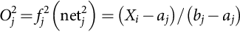

else when 



where *aj*,*bj*, and *cj* are the corners of the *j*th membership function in layer 2 shown in [Fig. 36.31](https://learning.oreilly.com/library/view/power-electronics-handbook/9780128114087/B9780128114070000404.xhtml#f0160) and *Xi* is the *i*th input variable to the node of layer 2, which could be either the value of the error or the change in error.



**FIG. 36.31** A single membership function.

#### **36.12.1.3 Layer 3: Rule Layer**

Each node in layer 3 multiplies the incoming signal and outputs the result of the product. The conjunction of the rule antecedents is evaluated by the fuzzy operation *intersection*, which is implemented by the product operator. Consequently, each node of this layer is a rule node that represents one fuzzy control rule. Each node takes two inputs: one from nodes A1–A4 and the other from nodes B1–B3 of layer 2. Nodes A1–A4 define the membership values for the voltage error, and nodes B1–B3 define the membership values for the change in voltage error. Accordingly, there are 12 nodes in layer 3 to form a fuzzy rule base for two input variables, with four linguistic variables for the input *voltage error*, *e*(*k*), and three linguistic variables for the input *change in voltage error*, Δ*e*(*k*). The input/output links of layer 3 define the preconditions and the outcome of the rule nodes, respectively. The outcome is the strength applied to the evaluation of the effect defined for each particular rule. The output of neuron *k* in layer 3 is obtained as



*yj*3 represents the *j* th input to the node of layer 3, and *wjk*3 is assumed to be unity.

#### **36.12.1.4 Layer 4: Output Membership Layer**

Neurons in this layer represent fuzzy sets used in the consequent of fuzzy rules. An output membership neuron receives inputs from the corresponding fuzzy rule neurons and combines them by using the fuzzy operation *union*. This was implemented by the *maximum* function. Layer 4 acts upon the output of layer 3 multiplied by the connecting weights. These link weights represent the output action of the rule nodes evaluated by layer 3. That output is given by



and



where the count of *k* depends on the links from layer 3 to the particular *m*th output in layer 4 and the link weight *wkm* is the output action of the *m*th output associate with the *k*th rule. This level is essential in ensuring the system's stability and allowing a smooth control action.

#### **36.12.1.5 Layer 5: Defuzzification Layer**

Layer 5 is the output layer and acts as a defuzzifier. The single node in this layer takes the output fuzzy sets clipped by the respective integrated firing strengths and combines them into a single fuzzy set. The output of the neurofuzzy system is crisp, and thus a combined output fuzzy set must be defuzzified. The sum-product composition method was used. It calculates the crisp output as the weighted average of the centroids of all output membership functions.



and

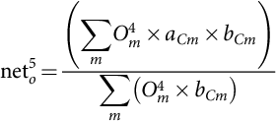

where *aCm* and *bCm* for  are the centers and widths of the output fuzzy sets, respectively. The values for the *bCm*’*s* were chosen to be unity. This scaled output corresponds to the control signal (percent duty cycle) to be applied to maintain the output voltage at a constant value.

### 36.12.2 LEARNING ALGORITHM

The only weights that are trained are those between layer 3 and layer 4 of [Fig. 36.30](https://learning.oreilly.com/library/view/power-electronics-handbook/9780128114087/B9780128114070000404.xhtml#f0155). The back-propagation network is used to train the weights of this layer. The weights of the neural network were trained offline before they were used in the experimental setup. The learning algorithm used can be described in the following steps:

*Step 1:* Calculate the error for the change in the control signal (duty cycle) based on the type of the converter.



where *E*o,*T*o, and *O*o5 are the output error, the target control signal, and the actual control signal, respectively.

*Step 2:* Calculate the error gradient.

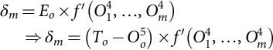

where



and the partial derivative of *f* with respect to *Om*4 is given by

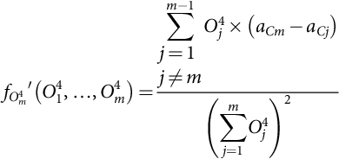

where *aCi* for  are the centers of the output fuzzy sets and *Oj*4 is the firing strength from node *j* in layer 4.

*Step 3*: Calculate the weight correction



to increase the learning rate, the Sejnowski-Rosenberg updating mechanism was used, which takes into account the effect of past weight changes on the current direction of the movement in the weight space. This is given by



where *α* is a smoothing coefficient in the range of 0–1.0 and *η* is the learning rate.

*Step 4*: Update the weights.



where *t* is the iteration number

The weights linking the rule layer (layer 3) and the output membership layer (layer 4) are trained to capture the system dynamics and therefore minimize the ripples around the operating point. The training results of the link weights are shown in [Figs. 36.32](https://learning.oreilly.com/library/view/power-electronics-handbook/9780128114087/B9780128114070000404.xhtml#f0165) and [36.33](https://learning.oreilly.com/library/view/power-electronics-handbook/9780128114087/B9780128114070000404.xhtml#f0170).

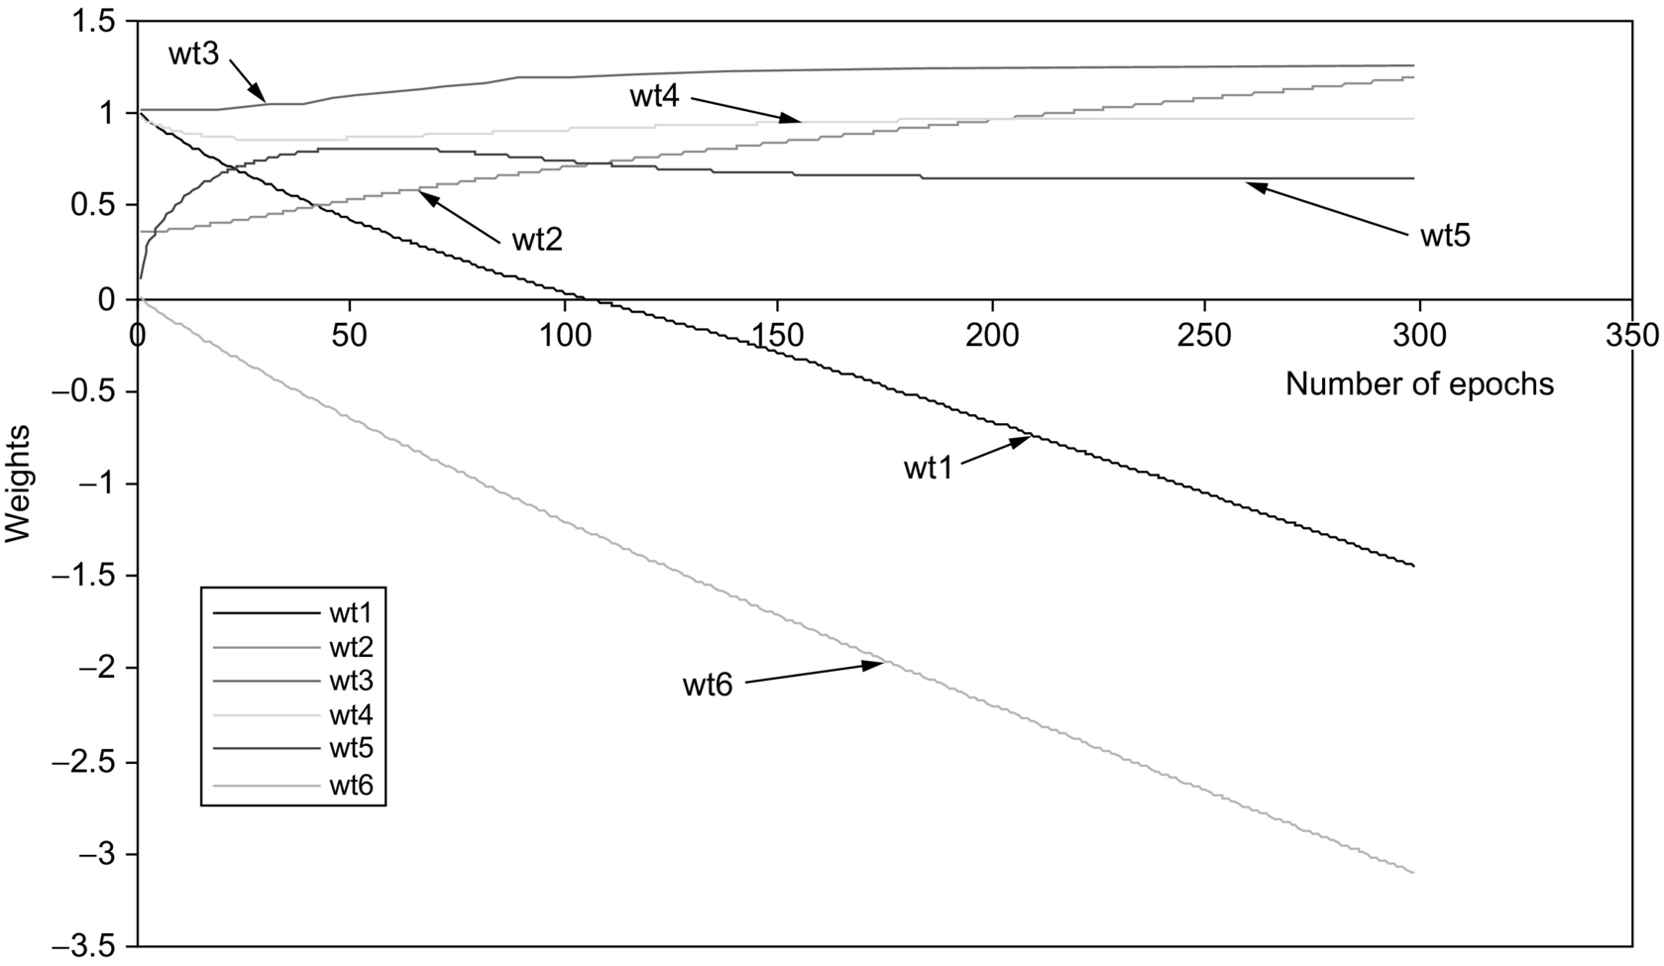

**FIG. 36.32** Weight adaptations for the first set of six weights.



**FIG. 36.33** Weight adaptations for the second set of six weights.

In the initialization of the weights, wt5 and wt6 in [Fig. 36.32](https://learning.oreilly.com/library/view/power-electronics-handbook/9780128114087/B9780128114070000404.xhtml#f0165) were set to a very small number of 0.001 with the initial assumption that those weights are almost redundant before the training begins. However, the neurofuzzy system was capable of correcting those assumptions. Weight wt5 finally converges to a positive value that indicates an excitatory rule weight, while wt6 converges to a negative number that is an inhibitory rule weight. Some of the weights change sign during the training process. Weight wt1 was initially set at a positive value but converges to a negative value that makes that rule weight inhibitory.

## 36.13 Summary

The presence of adaptive control via the EKF learning of the FNN control laws marks an improvement over the FL design. The motor drive over time is subject to experience degradation of mechanical parts or even electric characteristics, and the ability to automatically adapt the control laws to these changes is a feature that a nonadaptive fuzzy controller does not have. A genetic-based FPID controller and its integration with a classical PID in a global control scheme have been developed. Experimental results have shown excellent tracking performance of the proposed hybrid FPID controller and have convincingly demonstrated the usefulness of the FPID controller in high-performance drives with uncertainties. For the H-infinity-based controller, test results have shown that the proposed hybrid controller achieved good tracking performance and stable control, under loading conditions for a number of desired reference trajectories. The ability of the hybrid controller to achieve the tracking process with a high degree of accuracy, even in the presence of random disturbance, was also demonstrated, while the fuzzy application to the DC-DC converter topology showed considerable control performance over a wide range of operating conditions.

## References

[1] Sant A., Rajagopal K.R. PM synchronous motor speed control using hybrid fuzzy-pi with novel switching functions. *IEEE Trans. Magn.* 2009;45(10):4672–4675.

[2] Hohan B.M., Sinha A. Analytical structure and stability analysis of a fuzzy PID controller. *Appl. Soft Comput.* 2008;8:749–758.

[3] Rubaai A., Castro-Sitiriche M.J., Ofoli A.R. DSP-based laboratory implementation of hybrid fuzzy-pid controller using genetic optimization for high performance motor drives. *IEEE Trans. Ind. Appl.* 2008;44(6):1977–1986.

[4] Kuo Y.-P., Li T.-H.S. GA-based fuzzy PI/PD controller for automotive active suspension system. *IEEE Trans. Ind. Electron.* 1999;46(6):1051–1056.

[5] Hu B.-G., Mann G.K.I., Gosine R. A systematic study of fuzzy PID controllers—function-based evaluation approach. *IEEE Trans. Fuzzy Syst.* 2001;9(5):699–712.

[6] Li H.-X., Zhang L., Cai K.-Y., Chen G. An improved robust fuzzy-PID controller with optimal fuzzy reasoning. *IEEE Trans. Syst. Man Cybern.* 2005;35(6):1283–1294.

[7] Masiala M., Vafakhah B., Salmon J., Knight A.M. Fuzzy self-tuning speed control of an indirect field-oriented control induction motor drive. *IEEE Trans. Ind. Appl.* 2008;44(6):1732–1740.

[8] Barut M., Bogosyan S., Gokasan M. Speed sensorless estimation for induction motors using extended Kalman filters. *IEEE Trans. Ind. Appl.* 2007;54(1):272–280.

[9] Szabat K., Orlowska-Kowalska T. Performance improvement of industrial drives with mechanical elasticity using nonlinear adaptive Kalman filter. *IEEE Trans. Ind. Electron.* 2008;55(3):1075–1084.

[10] Ahn K.K., Truong D.Q. Online tuning fuzzy PID controller using robust extended Kalman filter. *J. Process Control.* 2009;19:1011–1023.

[11] Lary D.J., Mussa H.Y. Using an extended Kalman filter learning algorithm for feed-forward neural networks to describe tracer correlations. *Atmos. Chem. Phys. Discuss.* 2004;4:3653–3657.

[12] Singhal S., Wu L. *Training feedforward networks with extended Kalman Filter algorithm.* In: Proc. International Conf. ASSP; 1989:1187–1190.

[13] Ho S.-J., Shu L.-S., Ho S.-Y. Optimizing fuzzy neural networks for tuning PID controllers using an orthogonal simulated annealing algorithm OSA. *IEEE Trans. Fuzzy Syst.* 2006;14(3):421–434.

[14] del Campo I., Echanobe J., Bosque G., Tarela J.M. Efficient hardware/software implementation of an adaptive neuro-fuzzy system. *IEEE Trans. Fuzzy Syst.* 2008;16(3):761–778.

[15] Uddin M.N., Rahman M.A. Development and implementation of a hybrid intelligent controller for interior permanent-magnet synchronous motor drives. *IEEE Trans. Ind. Appl.* 2004;40(1):68–76.

[16] Rubaai A., Kotaru R. Neural net based robust controller design for brushless DC motor drives. *IEEE Trans. Syst. Man Cybern.* 1999;29(3):460–473.

[17] Chen B.S., Lee C.H., Chang Y.C. H ∞ tracking design of uncertain nonlinear SISO systems: adaptive fuzzy approach. *IEEE Trans. Fuzzy Syst.* 1996;4(1):32–43.

[18] Balestrino A., Landi A., Sani L. CUK converter global control via fuzzy logic and scaling factor. *IEEE Trans. Ind. Appl.* 2002;38(2):406–413.

[19] Vidal E., Martine L., Guinjoan F., Calvente J., Gomariz S. Sliding and fuzzy control of a boost converter using an 8-Bit microcontroller. *Proc. IEEE Elect. Pow. Appl.* 2004;151(1):5–11.

[20] Alvarez J., Cervantes I., Espinosa G., Maya P., Morales A. A stable design of PI control for DC-DC converters with an RHS zero. *IEEE Trans. Circuits Syst.* 2001;48(1):103–106.

[21] Principe J., Euliano N.R., Lefebvre W.C. *Neural and Adaptive Systems.* New York: John Wiley & Sons; 2000.

[22] Jang J.S.R., Sun C., Mizutani E. *Neuro-Fuzzy and Soft Computing.* Englewood Cliffs, NJ: Prentice Hall; 1997.

[23] Bloom G.E. *IMAGINE, a Converter Kit for Exploring the Fascinating World of Integrated-Magnetic Concepts.* 1991 San Rafael, **CA**.

**37**

# Artificial Neural Network Applications in Power Electronics and Electric Drives

Baburaj Karanayil The University of New South Wales, Sydney, NSW, Australia

Muhammed F. Rahman The University of New South Wales, Sydney, NSW, Australia

## Abstract

In classical control systems, knowledge of the controlled system (plant) is required in the form of a set of algebraic and differential equations, which analytically relate inputs and outputs. However, these models can become complex, rely on many assumptions, may contain parameters that are difficult to measure, or may change significantly during operation as in the case of the rotor-flux-oriented control induction motor drive. Classical control theory suffers from some limitations due to the assumptions made for the control system such as linearity, time invariance, etc. These problems can be overcome by using artificial intelligence-based control techniques, and these techniques can be used, even when the analytic models are not known. Such control systems can also be less sensitive to parameter variation than classical control systems. This chapter describes the potential of artificial neural networks to track variation parameters in parameters that are used in the rotor-flux-oriented controller of an induction motor drive.

### KEYWORDS:

Artificial neural networks; Rotor-flux-oriented controller; Fuzzy-logic systems; Neural function approximator; Induction motor drives; Speed estimator

37.1 [Introduction](https://learning.oreilly.com/library/view/power-electronics-handbook/9780128114087/B9780128114070000416.xhtml#s0010)

37.2 [Conventional and Neural Function Approximators](https://learning.oreilly.com/library/view/power-electronics-handbook/9780128114087/B9780128114070000416.xhtml#s0015)

37.2.1 Conventional Approximator

37.2.2 Neural Function Approximator

37.3 [ANN-Based Estimation in Induction Motor Drives](https://learning.oreilly.com/library/view/power-electronics-handbook/9780128114087/B9780128114070000416.xhtml#s0030)

37.3.1 Speed Estimation

37.3.2 Flux and Torque Estimation

37.3.3 Rotor Resistance Identification Using ANN

37.3.4 Stator Resistance Estimation Using ANN

37.4 [ANN-Based Controls in Motor Drives](https://learning.oreilly.com/library/view/power-electronics-handbook/9780128114087/B9780128114070000416.xhtml#s0095)

37.4.1 Induction Motor Current Control

37.4.2 Induction Motor Control

37.4.3 Efficiency Optimization in Electric Drives

37.5 [ANN-Based Controls in Power Converters](https://learning.oreilly.com/library/view/power-electronics-handbook/9780128114087/B9780128114070000416.xhtml#s0115)

[Further Reading](https://learning.oreilly.com/library/view/power-electronics-handbook/9780128114087/B9780128114070000416.xhtml#fr0010)

## 37.1 Introduction

In classical control systems, knowledge of the controlled system (plant) is required in the form of a set of algebraic and differential equations, which analytically relate inputs and outputs. However, these models can become complex, rely on many assumptions, may contain parameters that are difficult to measure, or may change significantly during operation as in the case of the rotor-flux-oriented control (RFOC) induction motor drive. Classical control theory suffers from some limitations due to the assumptions made for the control system such as linearity and time invariance. These problems can be overcome by using artificial intelligence-based control techniques, and these techniques can be used, even when the analytic models are not known. Such control systems can also be less sensitive to parameter variation than classical control systems.

The main advantages of using artificial intelligence-based controllers and estimators are the following:

• Their design does not require a mathematical model of the plant.

• They can lead to improved performance, when properly tuned.

• They can be designed exclusively on the basis of linguistic information available from experts or by using clustering or other techniques.

• They may require less tuning effort than conventional controllers.

• They may be designed on the basis of data from a real system or a plant in the absence of necessary expert knowledge.

• They can be designed using a combination of linguistic- and response-based information.

Generally, the following two types of intelligence-based systems are used for estimation and control of drives, namely:

(a) Artificial neural networks (ANNs)

(b) Fuzzy-logic systems (FLSs)

In different applications in power electronics and electric drives, there are occasions where an output *y* has to be estimated for an input *x*. This is generally accomplished with the help of mathematical equations of the system under consideration. Sometimes, it may not be possible to have an accurate mathematical model, or there is no conventional model at all that can be used. In these circumstances, model-free estimators are required that can be used either ANNs or fuzzy-logic systems. A mathematical model-based system can operate smoothly when there is no noise in the inputs, but they might fail when the input has noise or if the inputs themselves are uncertain. Also, depending on the complexity of the mathematical model, the computation times can be excessive leading to difficulties for practical implementation.

A conventional function approximator, a neural function estimator, and how these estimators are arrived at are discussed briefly in [Section 37.2](https://learning.oreilly.com/library/view/power-electronics-handbook/9780128114087/B9780128114070000416.xhtml#s0015). It will be shown how neural estimators are used in the estimation of speed, flux, torque, etc. for an induction motor. Some of these estimators are briefly reviewed in [Section 37.3](https://learning.oreilly.com/library/view/power-electronics-handbook/9780128114087/B9780128114070000416.xhtml#s0030). Also, the ANNs have been used for identification and control of stator current in induction motor drives, and these are briefly described in [Section 37.4](https://learning.oreilly.com/library/view/power-electronics-handbook/9780128114087/B9780128114070000416.xhtml#s0095). In addition to their applications to motor drives, they are also used in control of power converters. Some of these applications are discussed in [Section 37.5](https://learning.oreilly.com/library/view/power-electronics-handbook/9780128114087/B9780128114070000416.xhtml#s0115).

## 37.2 Conventional and Neural Function Approximators

### **37.2.1 CONVENTIONAL APPROXIMATOR**

A conventional function approximator should give a good prediction of output data, when a system is presented with a new input data. A conventional function approximator uses a mathematical model of the system as shown in [Fig. 37.1A](https://learning.oreilly.com/library/view/power-electronics-handbook/9780128114087/B9780128114070000416.xhtml#f0010). Sometimes, it is not possible to have an accurate mathematical model of the system, in such a case; mathematical model-free approximators are required, as shown in [Fig. 37.1B](https://learning.oreilly.com/library/view/power-electronics-handbook/9780128114087/B9780128114070000416.xhtml#f0010). A conventional function approximator can easily be replaced by a neural-network-based function approximator.

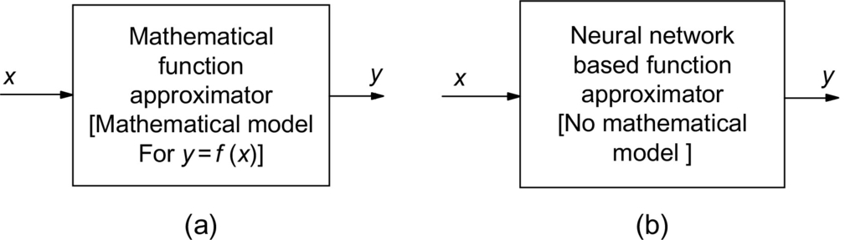

**FIG. 37.1** Conventional and neural-network-based function approximators.

### 37.2.2 NEURAL FUNCTION APPROXIMATOR

The function  is the function to be approximated, and *x*1,*x*2,*x*3,…*xn* are the *n* variables (*n* inputs), and the approximator uses the sum of nonlinear functions *g*1,*g*2,*g*3,*g*4,…,*gi*, where each of the *g* is nonlinear function of a single variable. Thus,

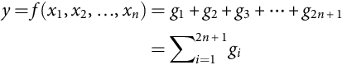 **(37.1)**

where *gi* is a real and continuous nonlinear function that depends only on a single-variable *zi*. The output *y* can also be represented as

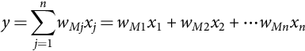 **(37.2)**

These equations can be represented by a network shown in [Fig. 37.2](https://learning.oreilly.com/library/view/power-electronics-handbook/9780128114087/B9780128114070000416.xhtml#f0015). There are *n* input nodes in the input layer and *M* hidden nodes in the hidden layer.

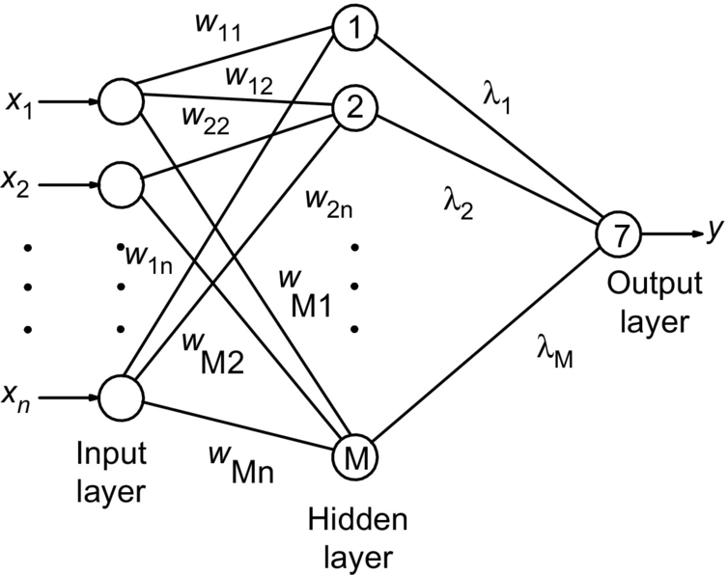

**FIG. 37.2** Artificial neural network to generate the required function.

[Fig. 37.3](https://learning.oreilly.com/library/view/power-electronics-handbook/9780128114087/B9780128114070000416.xhtml#f0020) shows the schematic diagram of a neural approximation, and [Fig. 37.4](https://learning.oreilly.com/library/view/power-electronics-handbook/9780128114087/B9780128114070000416.xhtml#f0025) shows the technique of its training. The error (*e*) between the desired nonlinear function (*y*) and the nonlinear function (*ŷ*) obtained by the neural estimator is the input to the learning algorithm for the artificial neural estimator. This type of learning is known as back propagation.

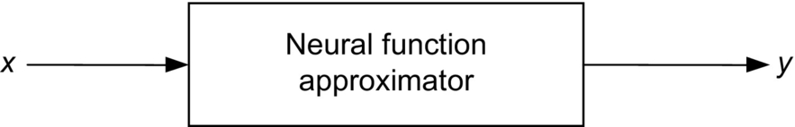

**FIG. 37.3** Schematic of a neural function approximator.

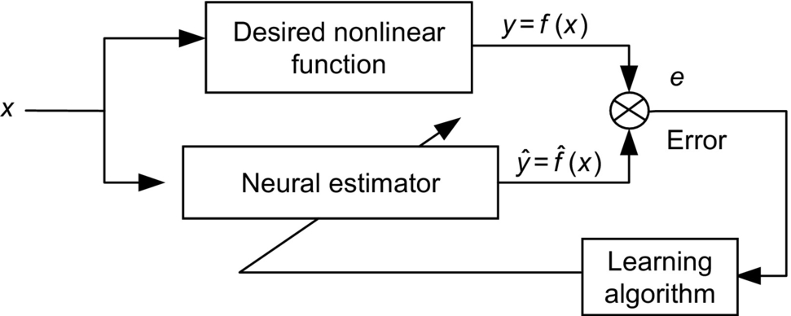

**FIG. 37.4** Training of a neural function approximator.

The output of a single neuron can be represented as

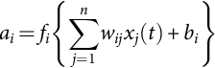 **(37.3)**

where *fi* is the activation function and *bi* is the bias. [Fig. 37.5](https://learning.oreilly.com/library/view/power-electronics-handbook/9780128114087/B9780128114070000416.xhtml#f0030) shows a number of possible activation functions in a neuron. The simplest of all is the linear activation function, where the output varies linearly with the input but saturates at  as shown with a large magnitude of the input. The most commonly used activation functions are nonlinear, continuously varying types between two asymptotic values 0 and 1 or  and . These are, respectively, the sigmoidal function also called log-sigmoid and the hyperbolic tan function also called tan-sigmoid.

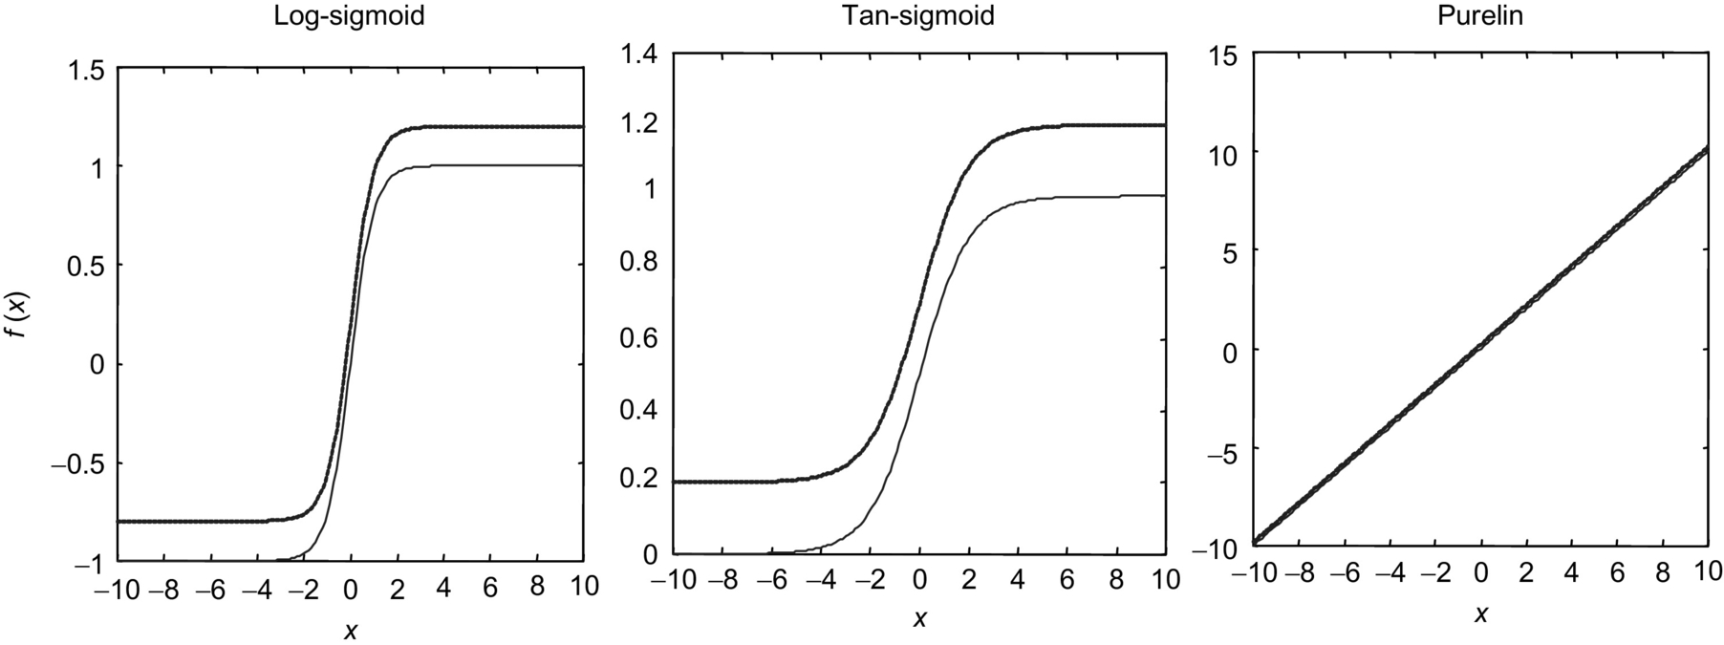

**FIG. 37.5** Log-sigmoid, tan-sigmoid, and purelin activation functions.

The learning process of an ANN is based on the training process. One of the most widely used training techniques is the error back-propagation technique, a scheme that is illustrated in [Fig. 37.4](https://learning.oreilly.com/library/view/power-electronics-handbook/9780128114087/B9780128114070000416.xhtml#f0025). When this technique is employed, the ANN is provided with input and output training data, and the ANN configures its weights. The training process is then followed by supplying with the real input data, and the ANN then produces the required output data.

The total network error (sum of squared errors) can be expressed as

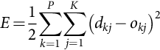 **(37.4)**

where *E* is the total error, *P* is the number of patterns in the training data, *k* is the number of outputs in the network, *dkj* is the target (desired) output for the pattern *K*, and  is the *j*th output of the *k*th pattern. The minimization of the error can be arranged with different algorithms such as the gradient descent with momentum, Levenberg-Marquardt, reduced memory Levenberg-Marquardt, and Bayesian regularization.

## 37.3 ANN-Based Estimation in Induction Motor Drives

Artificial neural networks have found widespread use in function approximation. It has been shown that, theoretically, a three-layer ANN can approximate arbitrarily closely, any nonlinear function, provided that it is nonsingular. Some of the ANN-based estimators reported in the literature for rotor flux, torque, and rotor speed of induction motor drive are discussed in the following section.

### 37.3.1 SPEED ESTIMATION

In general, steady-state and transient analysis of induction motors is done using space-vector theory, with the mathematical model having the parameters of the motor. To estimate the various machine quantities such as stator- and rotor-flux linkages, rotor speed, and electromagnetic torque, the above mathematical model is normally used. However, these machine quantities could be estimated without the mathematical model by using an ANN. Here, no assumptions have to be made about any type of nonlinearity.

As an example, the rotor speed of an induction motor can be estimated from the direct and quadrature-axis stator voltages and currents in the stationary reference frame, as shown in [Fig. 37.6](https://learning.oreilly.com/library/view/power-electronics-handbook/9780128114087/B9780128114070000416.xhtml#f0035). A three-layer feedforward neural network structure with  (eight input, seven hidden, and one output) is used in this case. The input nodes were selected as equal to the number of input signals and the output nodes as equal to the number of output signals. The number of hidden layer neurons is generally taken as the mean of the input and output nodes. In this speed estimator ANN, seven hidden neurons were selected.

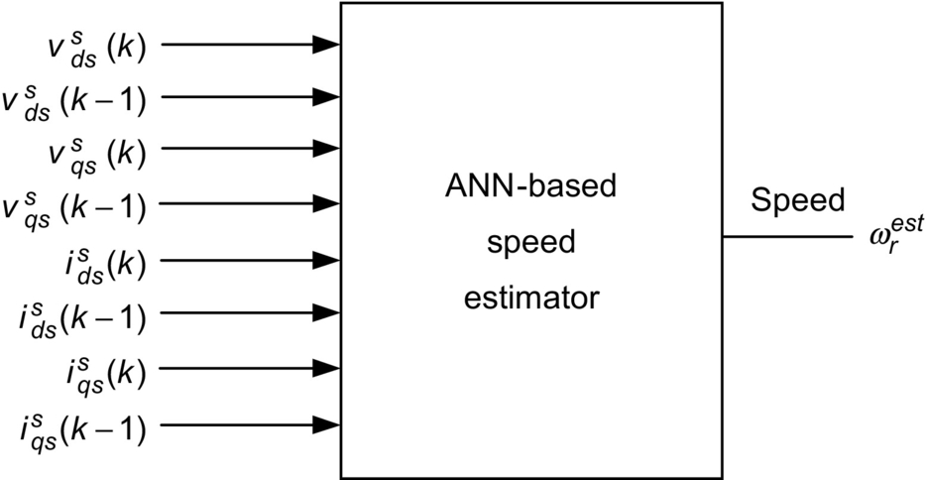

**FIG. 37.6** ANN-based speed estimator for induction motor.

The results of an experiment conducted on a 1.1 kW, 415 V, 3 phase, 4 pole, 50 Hz induction motor is explained in this section. In order to investigate the case of speed estimation using ANN, a rotor-flux-oriented induction motor drive was set up in the laboratory, where the speed reference was changed in steps of 100 rpm and reversed every time the speed reached 1000 rpm. The load torque on the motor was kept constant at its full load rating. The stator voltages, stator currents, and rotor speed were measured for 5 s, and a data file was generated. The neural network was then trained using the *trainlm* algorithm with this data file. The training of the neural network converged after 48 epochs, and the error plot for this network training is shown in [Fig. 37.7](https://learning.oreilly.com/library/view/power-electronics-handbook/9780128114087/B9780128114070000416.xhtml#f0040). The estimated speed was predicted with the trained neural network, and the result is shown in [Fig. 37.8](https://learning.oreilly.com/library/view/power-electronics-handbook/9780128114087/B9780128114070000416.xhtml#f0045).

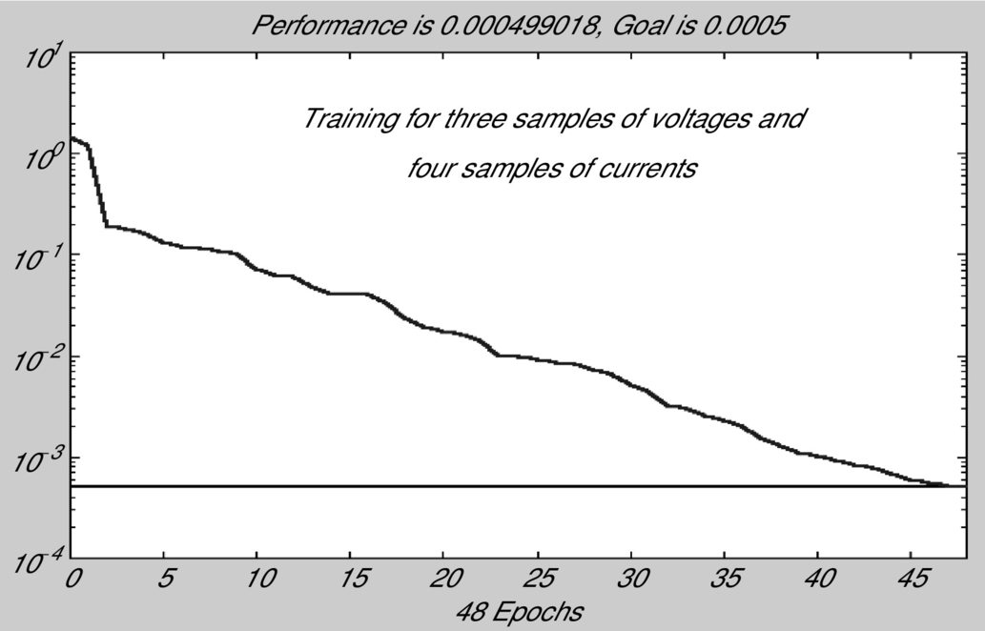

**FIG. 37.7** The error plot of  network training for speed estimation.

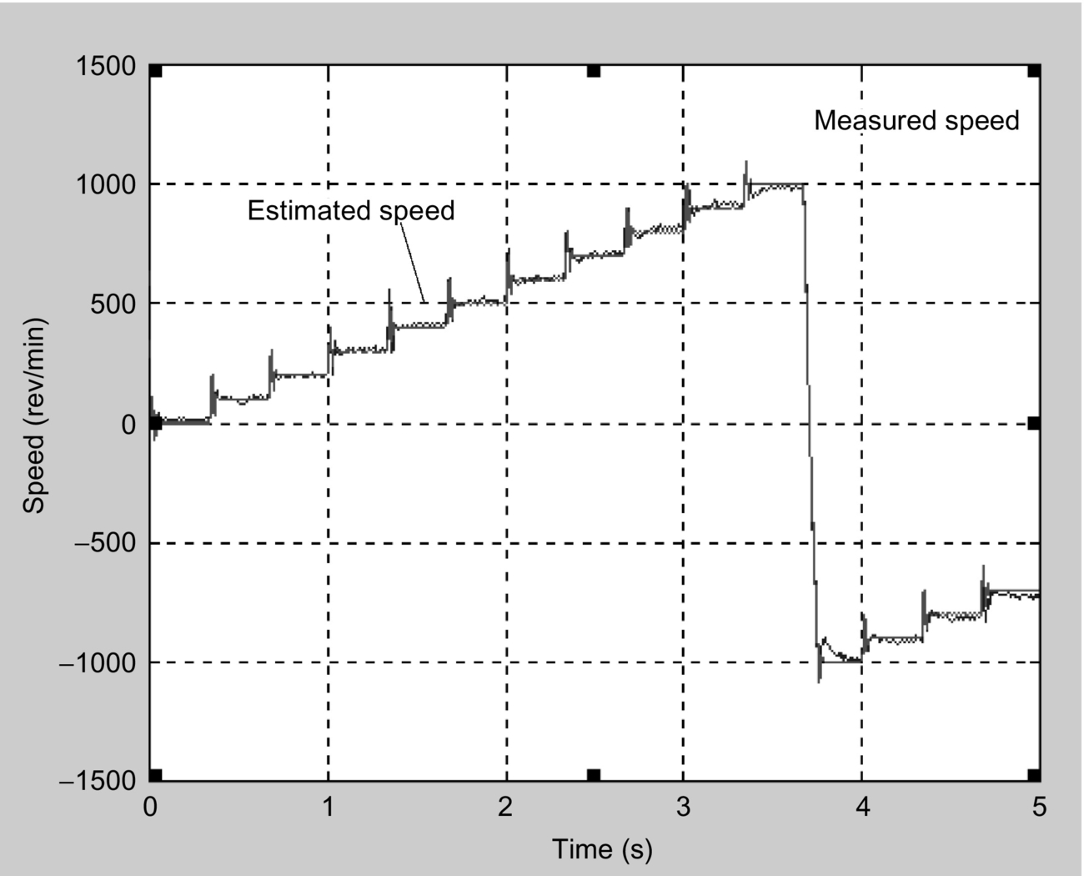

**FIG. 37.8** Measured speed versus estimated speed with ANN for induction motor.

The noisy data in the plot are the estimated speed, and the continuous line is the speed measured with the encoder. The speed estimation was found to fail for speeds <100 rpm. If the trained neural network has to predict the speed under the complete range of operation of the drive, the data for training the neural network also have to be taken for the whole range. From this example investigated, it was found that the off-line training of the neural network could not produce satisfactory results, and it can be concluded that these off-line methods are not most suitable for these applications.

Artificial neural networks were also used for the estimation of the rotor speed of an induction motor together with the help of induction motor dynamic model. Though the technique gives a fairly good estimate of the speed, this technique lies more in the adaptive control area than in neural networks. The speed is not obtained at the output of a neural network; instead, the magnitude of one of the weights corresponds to the speed. The four quadrant operation of the drive was not possible for speeds <500 rpm. The motor was not able to follow the speed reference during the reversal for speeds <500 rpm. The drive worked satisfactorily for speeds above 500 rpm. Even though this method does not fall into a true neural network estimator, the results achieved with this type of implementation were very good except for lower speeds.

Alternately, the estimated speed can be made available at the output of a neural network as shown in [Fig. 37.9](https://learning.oreilly.com/library/view/power-electronics-handbook/9780128114087/B9780128114070000416.xhtml#f0050). This speed estimator used a three-layer neural network with five input nodes, one hidden layer, and one output layer to give the estimated speed  as shown in [Fig. 37.9](https://learning.oreilly.com/library/view/power-electronics-handbook/9780128114087/B9780128114070000416.xhtml#f0050). The three inputs to the ANN are a reference model flux λ*r*⁎, an adjustable model flux , and , the time delayed estimated speed. The multilayer and recurrent structure of the network makes it robust to parameter variations and system noise. The main advantage of their ANN structure lies in the fact that they have used a recurrent structure that is robust to parameter variations and system noise. These authors were able to achieve a speed control error of 0.6% for a reference speed of 10 rpm. The speed control error dropped to 0.584% for a reference speed of 1000 rpm.

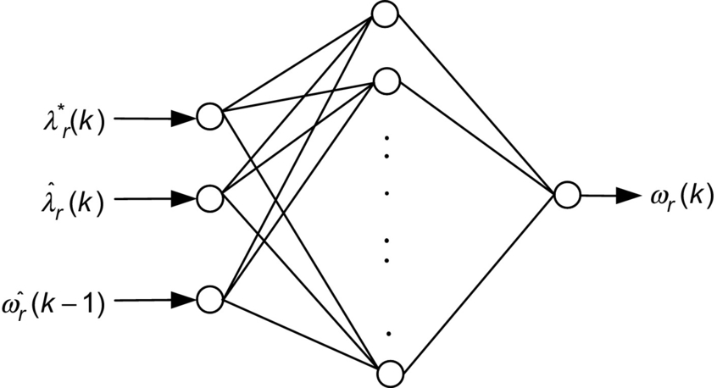

**FIG. 37.9** Structure of the neural network for the induction motor speed estimation.

### 37.3.2 FLUX AND TORQUE ESTIMATION

The same principle as described in [Section 37.3.1](https://learning.oreilly.com/library/view/power-electronics-handbook/9780128114087/B9780128114070000416.xhtml#s0035) can also be extended for simultaneous estimation of more quantities such as torque and stator flux. When more quantities or variables have to be estimated, the complex ANN has to implement a complex nonlinear mapping.

The four feedback signals required for a direct field-oriented induction motor drive can be estimated using ANNs. A  multilayer network has been used for the estimation of the rotor-flux magnitude, the electromagnetic torque, and the sine/cosine of the rotor-flux angle. It has been demonstrated both by modeling and experimental results that the above estimated quantities were almost equal to the same quantities computed by a DSP-based estimator. Both the estimated torque and rotor-flux signals using neural network were found to have higher ripple content compared with the DSP-based estimated quantities. It could be concluded that a properly trained ANN could totally eliminate the machine model equations as evident from the results reported.

In another application, an ANN with  structure has been used to estimate the stator flux using the measured induction motor stator variable quantities. After successful training, the ANN was used in a direct field-oriented controlled drive. The rotor flux is computed from the stator flux estimate provided by the ANN and the stator current. This particular implementation also included an ANN-based decoupler which was used for the indirect field-oriented (IFO) drive. An ANN with a structure of  was used for implementing the mapping between the flux and torque references and the stator current references. The estimated rotor flux using an ANN and a conventional FOC controller was shown to be equal. These authors have used experimental data for the ANN training, and thus, the effect of motor parameters was reduced. The authors were unable to use these estimated fluxes for controlling the induction motor in the experiment. The structure of the ANN used for this estimation is only that of a static ANN. It is preferable to have a dynamic neural network for this purpose.

### 37.3.3 ROTOR RESISTANCE IDENTIFICATION USING ANN

#### **37.3.3.1 Off-Line Trained ANN**

The artificial neural network can also be used for the rotor time constant adaptation in indirect field-oriented controlled drives. One of the implementation reported in the literature is shown in [Fig. 37.10](https://learning.oreilly.com/library/view/power-electronics-handbook/9780128114087/B9780128114070000416.xhtml#f0055). There are five inputs to the *Tr* estimator, namely *vdss*,*vqss*,*idss*,*iqss*,*ωr*. The training signals are generated with step variations in rotor resistance for different torque reference *Te*⁎ and flux command λ*r*⁎, and the final network is connected in the IFO controller as shown in [Fig. 37.10](https://learning.oreilly.com/library/view/power-electronics-handbook/9780128114087/B9780128114070000416.xhtml#f0055). The rotor time constant was tracked by a proportional integral (PI) regulator that corrects any errors in the slip calculator. The output of this regulator is summed with that of the slip calculator, and the result constitutes the new slip command that is required to compensate for the rotor time constant variation. The major drawback of this scheme is that the final neural network is only an off-line trained neural network with a limited data file obtained from the modeling.

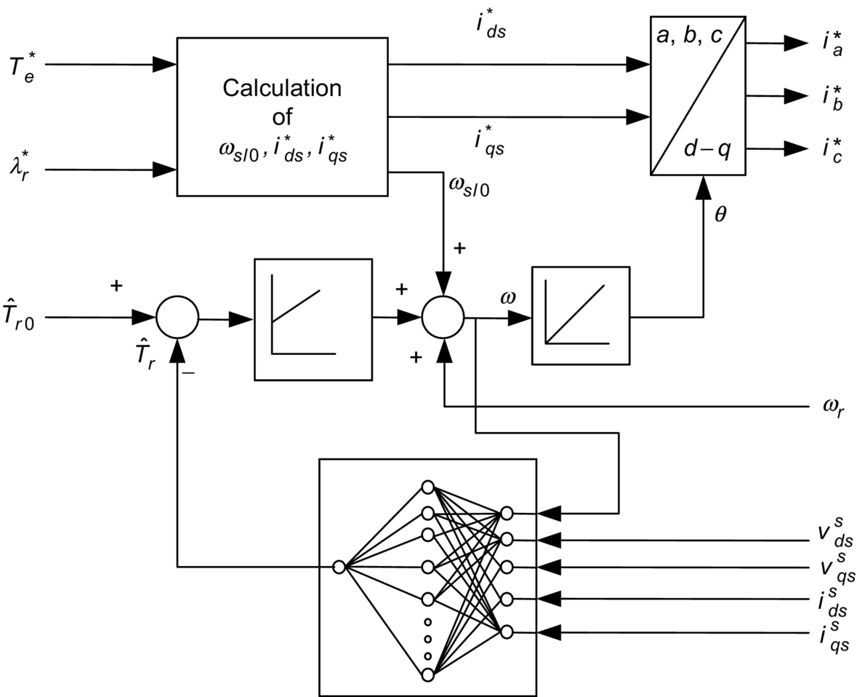

**FIG. 37.10** Principle of rotor time constant adaptation.

#### **37.3.3.2 On-Line Trained ANN**

The limitations of off-line trained ANN are overcome by using an online trained ANN configuration. The method discussed in this section has used an online trained ANN for adaptation of *Rr* of an induction motor in the RFOC induction motor drive. The error between the desired state variable of an induction motor and the actual state variable of a neural model is back propagated to adjust the weights of the neural model, so that the actual state variable tracks the desired value.

The principle of online estimation of rotor resistance (*Rr*) with multilayer feedforward artificial neural networks using online training has been described in “[Multilayer feedforward ANN](https://learning.oreilly.com/library/view/power-electronics-handbook/9780128114087/B9780128114070000416.xhtml#s0060)” section. This technique was then investigated with the help of modeling studies with a 1.1 kW squirrel-cage induction motor (SCIM), described in “[Rotor resistance estimation for RFOC using ANN](https://learning.oreilly.com/library/view/power-electronics-handbook/9780128114087/B9780128114070000416.xhtml#s0065)” section. The modeling results are presented in “[Modeling results](https://learning.oreilly.com/library/view/power-electronics-handbook/9780128114087/B9780128114070000416.xhtml#s0070)” section. In order to validate the modeling studies, modeling results were compared with those from an experimental setup with a SCIM under RFOC. These experimental results are presented in “[Experimental results](https://learning.oreilly.com/library/view/power-electronics-handbook/9780128114087/B9780128114070000416.xhtml#s0075)” section.

##### **Multilayer feedforward ANN**

Multilayer feedforward neural networks are regarded as universal approximations and have the capability to acquire nonlinear input-output relationships of a system by learning via the back-propagation algorithm. It should be possible that a simple two-layer feedforward neural network trained by the back-propagation technique can be employed in the rotor resistance identification. The modified technique using ANN proposed in this section can be implemented in real time so that the resistance updates are available instantaneously, and there is no convergence issues related to the learning algorithm. The two-layered neural network based on a back-propagation technique is used to estimate the rotor resistance. Two models of the state variable estimation are used; one provides the actual induction motor output, and the other one gives the neural model output. The total error between the desired and actual state variables is then back propagated as shown in [Fig. 37.11](https://learning.oreilly.com/library/view/power-electronics-handbook/9780128114087/B9780128114070000416.xhtml#f0060), to adjust the weights of the neural model, so that the output of this model coincides with the actual output. When the training is completed, the weights of the neural network should correspond to the parameters in the actual motor.

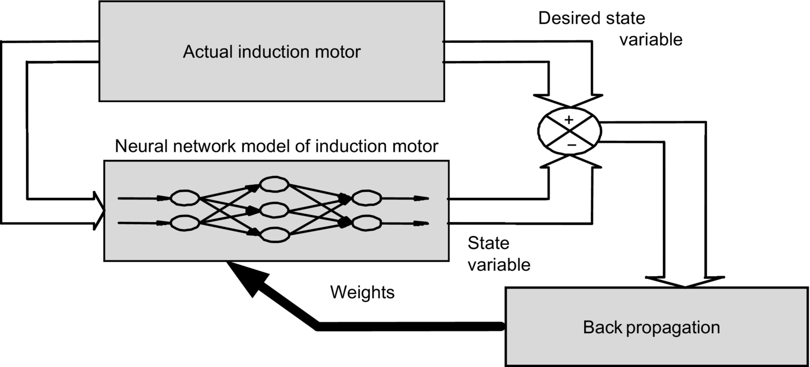

**FIG. 37.11** Block diagram of rotor resistance identification using neural networks.

##### **Rotor resistance estimation for RFOC using ANN**

The basic structure of an adaptive scheme described by [Fig. 37.11](https://learning.oreilly.com/library/view/power-electronics-handbook/9780128114087/B9780128114070000416.xhtml#f0060) is extended for rotor resistance estimation of an induction motor as illustrated in [Fig. 37.12](https://learning.oreilly.com/library/view/power-electronics-handbook/9780128114087/B9780128114070000416.xhtml#f0065). Two independent observers are used to estimate the rotor-flux vectors of the induction motor. If the rotor-flux linkages are estimated using the stator voltages and stator currents, they are referred to as *voltage model*, and if the rotor-flux linkages are estimated using the stator currents and rotor speed, they are referred to as *current model*.

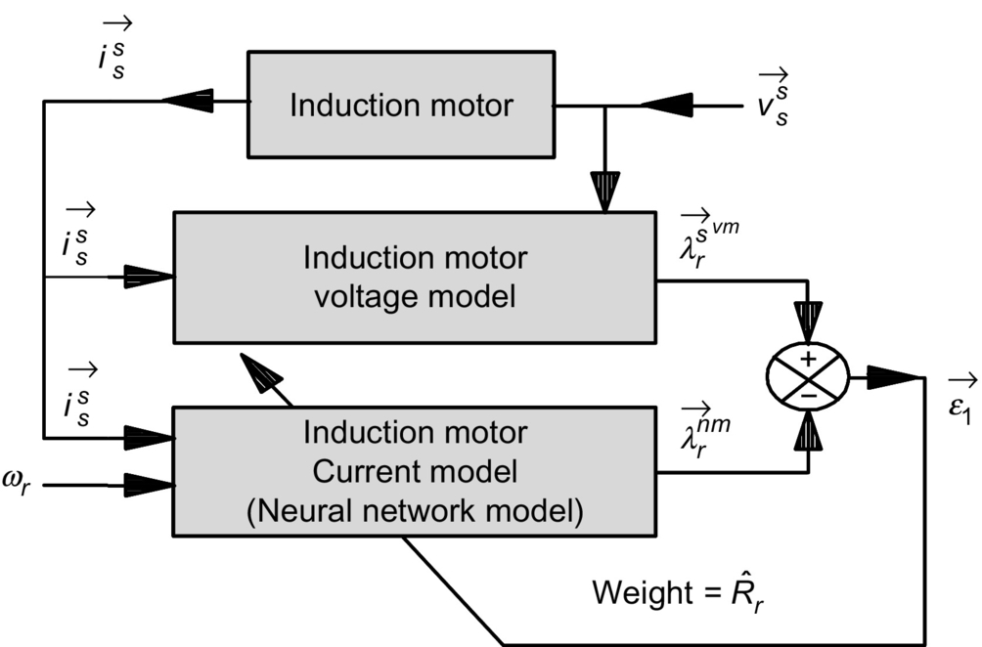

**FIG. 37.12** Structure of the neural network system for *Rr* estimation.

The stator flux linkages based on the neural network model in [Fig. 37.12](https://learning.oreilly.com/library/view/power-electronics-handbook/9780128114087/B9780128114070000416.xhtml#f0065) can be represented using Eq. [(37.5)](https://learning.oreilly.com/library/view/power-electronics-handbook/9780128114087/B9780128114070000416.xhtml#fo0030), which is derived from the sample data models of the combined voltage and current model equations of the induction motor:

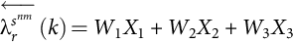 **(37.5)**

The neural network model represented by Eq. [(37.5)](https://learning.oreilly.com/library/view/power-electronics-handbook/9780128114087/B9780128114070000416.xhtml#fo0030) is shown in [Fig. 37.13](https://learning.oreilly.com/library/view/power-electronics-handbook/9780128114087/B9780128114070000416.xhtml#f0070), where *W*1, *W*2, and *W*3 represent the weights of the networks and *X*1, *X*2, and *X*3 are the three inputs to the network. If the network shown in [Fig. 37.13](https://learning.oreilly.com/library/view/power-electronics-handbook/9780128114087/B9780128114070000416.xhtml#f0070) has to be used to estimate *Rr*, where *W*2 is already known, then *W*1 and *W*3 need to be updated.

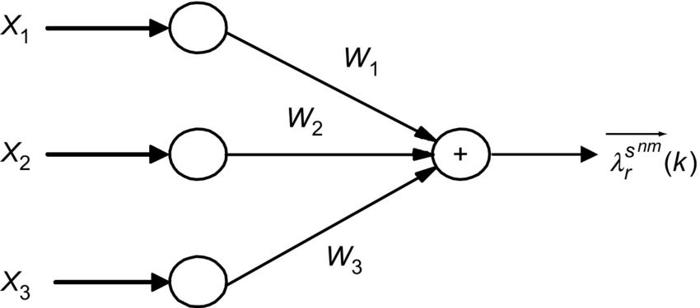

**FIG. 37.13** Two-layered neural network model for rotor-flux linkage estimation.

The weights of the network, *W*1 and *W*3, are found from training, so as to minimize the cumulative error function *E*1:

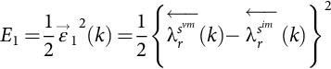 **(37.6)**

The weight of the neural network *W*1 has to be adjusted using generalized delta rule.

To accelerate the convergence of the error back-propagation learning algorithm, the current weight adjustment has to be supplemented with a fraction of the most recent weight adjustment, as indicated in Eq. [(37.7)](https://learning.oreilly.com/library/view/power-electronics-handbook/9780128114087/B9780128114070000416.xhtml#fo0040):

 **(37.7)**

where *α*1 is a user-selected positive momentum constant and *η*1 is the training coefficient.

The rotor resistance *Rr* can now be calculated from *W*3 from Eq. [(37.8)](https://learning.oreilly.com/library/view/power-electronics-handbook/9780128114087/B9780128114070000416.xhtml#fo0045) as follows:

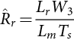 **(37.8)**

##### **Modeling results**

A schematic diagram showing the implementation of a rotor resistance estimator in RFOC controller for induction motor is shown in [Fig. 37.14](https://learning.oreilly.com/library/view/power-electronics-handbook/9780128114087/B9780128114070000416.xhtml#f0075). The stator voltages and currents are measured to estimate the rotor-flux linkages using the voltage model as shown in this figure. The inputs to the rotor resistance estimator (RRE) are the stator currents, the rotor-flux linkages , , and the rotor speed *ωr*. The estimated rotor resistance  will then be used in the RFOC controllers for the flux model. The response of the drive together with the rotor resistance estimator OFF is shown in [Fig. 37.15](https://learning.oreilly.com/library/view/power-electronics-handbook/9780128114087/B9780128114070000416.xhtml#f0080) for an abrupt change in *Rr* of motor, from 6.03 to 8.5 Ω at 0.8 s. The possible changes in the estimated motor torque *Te*, the rotor-flux linkage λ*rd* with this estimator were noted.

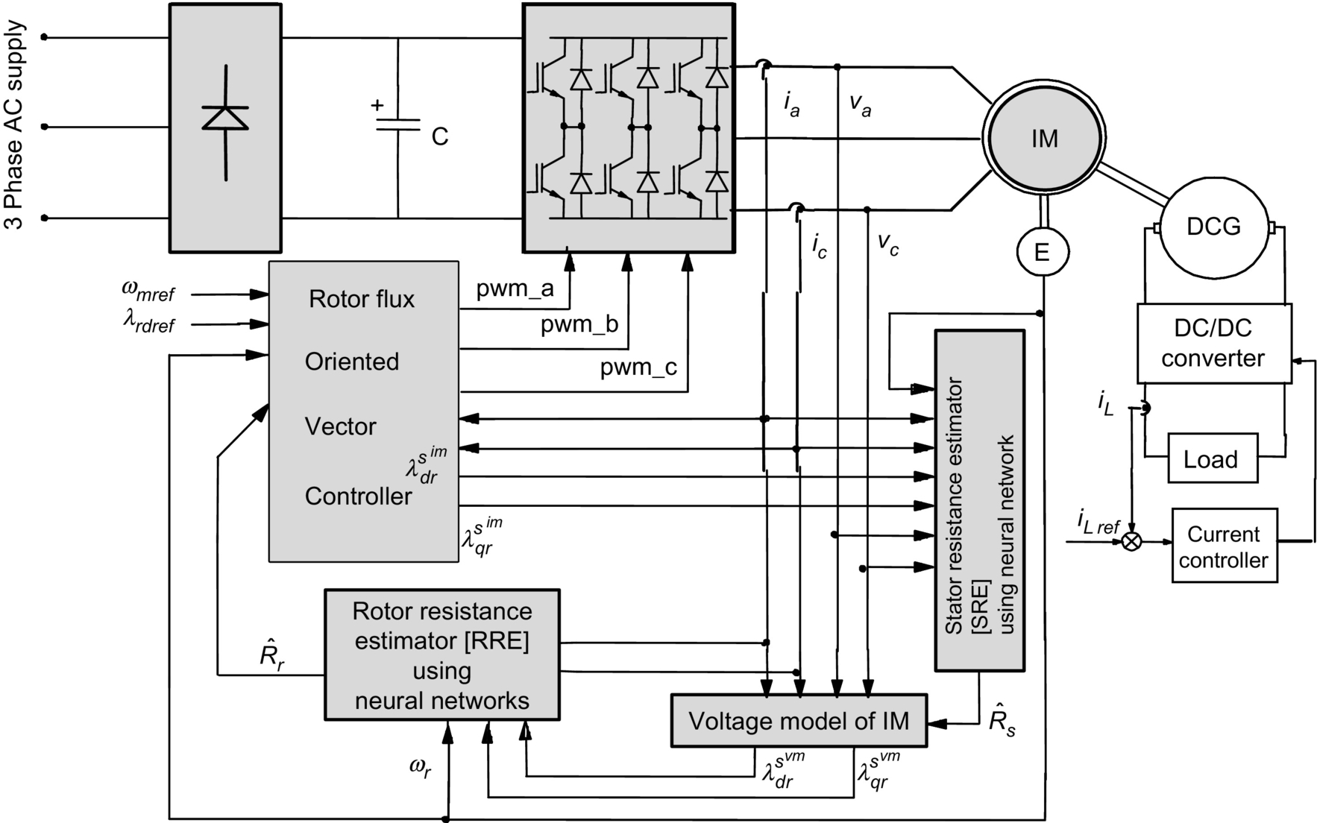

**FIG. 37.14** Block diagram of the RFOC induction motor drive with online rotor and stator resistance tracking using ANN.

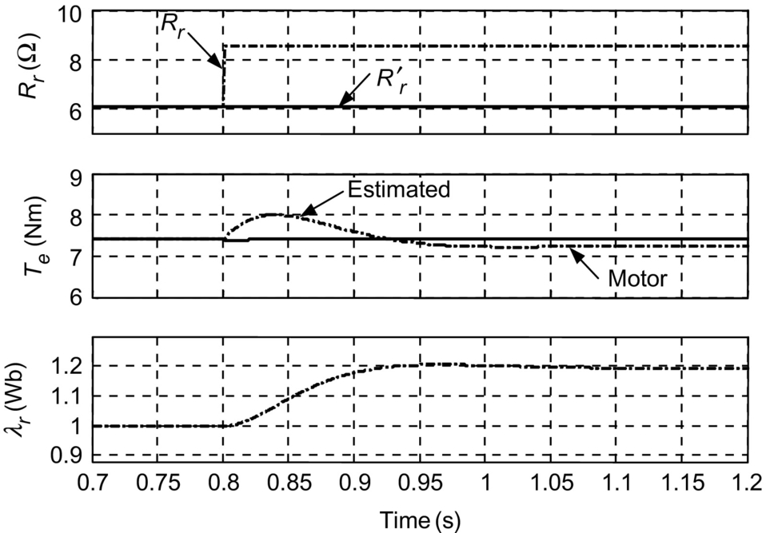

**FIG. 37.15** Effect of rotor resistance variation without rotor resistance estimator for 40% step change in *Rr* —modeling results.

Subsequently, the results of the drive were looked at with RRE ON, so that the rotor resistance in the controller *Rr*′ was updated with the estimated rotor resistance  as shown in [Fig. 37.16](https://learning.oreilly.com/library/view/power-electronics-handbook/9780128114087/B9780128114070000416.xhtml#f0085). The estimated rotor resistance  has converged to the rotor resistance of the motor *Rr* within 50 ms.

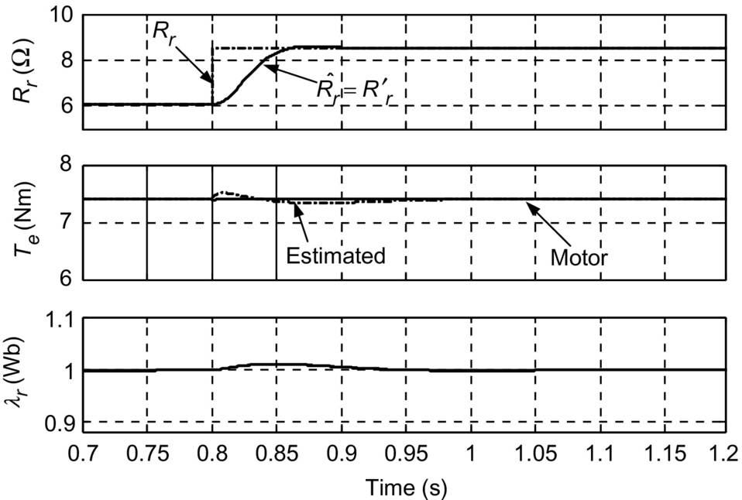

**FIG. 37.16** Effect of rotor resistance variation with rotor resistance estimator using ANN for 40% step change in *Rr* —modeling results.

The response of the drive system with the RRE using ANN is also shown for a practical profile in load torque, speed, and change in *Rr*. The *Rr* was increased from 6.03 to 8.5 Ω over a period of 8 s, and the torque and rotor-flux linkage are shown in [Fig. 37.17](https://learning.oreilly.com/library/view/power-electronics-handbook/9780128114087/B9780128114070000416.xhtml#f0090) when the RRE is OFF. For rapid reversals of the drive and variations in load torque, there are significant errors in rotor-flux linkages and thus errors in estimated torques. Subsequently, the RRE block was switched ON, and it can be observed that the rotor resistance estimator was tracking very well even during the worst dynamics in the motor speed and load torques as shown in [Fig. 37.18](https://learning.oreilly.com/library/view/power-electronics-handbook/9780128114087/B9780128114070000416.xhtml#f0095). The estimated rotor resistance  tracked the actual rotor resistance of the motor *Rr* throughout except that there was some small error during the reversal of the motor. The rotor-flux linkage λ*rd* was found to remain constant at 1.0 Wb during this transient condition. The current *iqs* also remained constant as the torque is now perfectly decoupled.

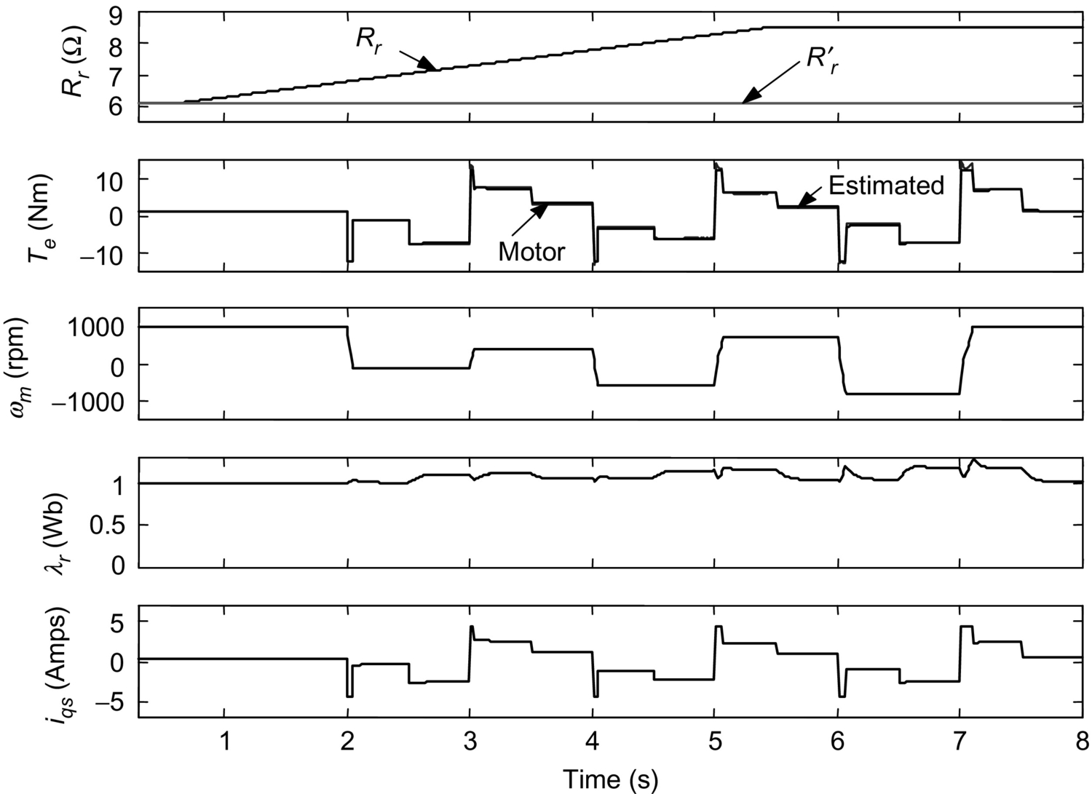

**FIG. 37.17** Effect of rotor resistance variation without rotor resistance estimator for 40% ramp change in *Rr* —modeling results.

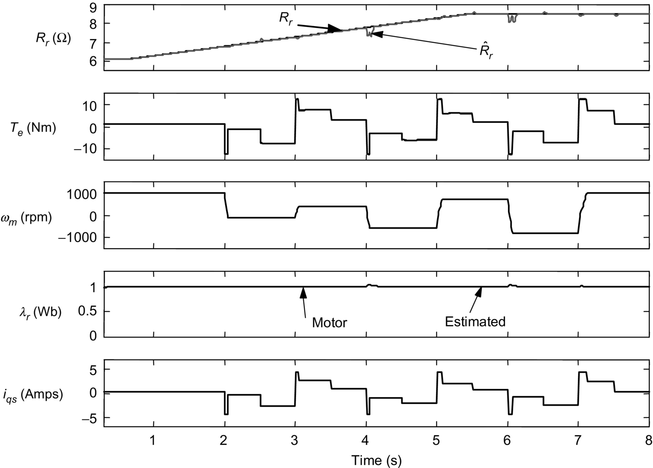

**FIG. 37.18** Effect of rotor resistance variation with rotor resistance estimator using ANN for 40% ramp change in *Rr* —modeling results.

##### **Experimental results**

The practical implementation of the above rotor resistance estimation was found functioning very well in the experimental drive setup. The results of the *Rr* estimation obtained from the experiment is shown in [Fig. 37.19](https://learning.oreilly.com/library/view/power-electronics-handbook/9780128114087/B9780128114070000416.xhtml#f0100) taken from a heat-run test conducted on an induction motor. As the RRE calculated, the rotor resistance using variables in stationary reference frame, the *d*-axis rotor-flux linkages of the current model (λ*drim*), the voltage model (λ*drvm*), and the neural model (λ*drnm*), taken at the end of heat run, is also recorded as shown in [Fig. 37.20](https://learning.oreilly.com/library/view/power-electronics-handbook/9780128114087/B9780128114070000416.xhtml#f0105).

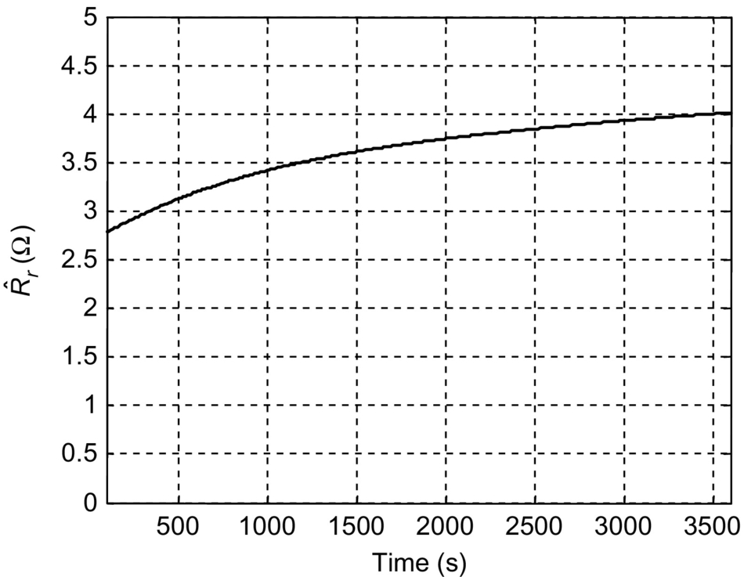

**FIG. 37.19** Estimated *Rr* using ANN—experimental results.

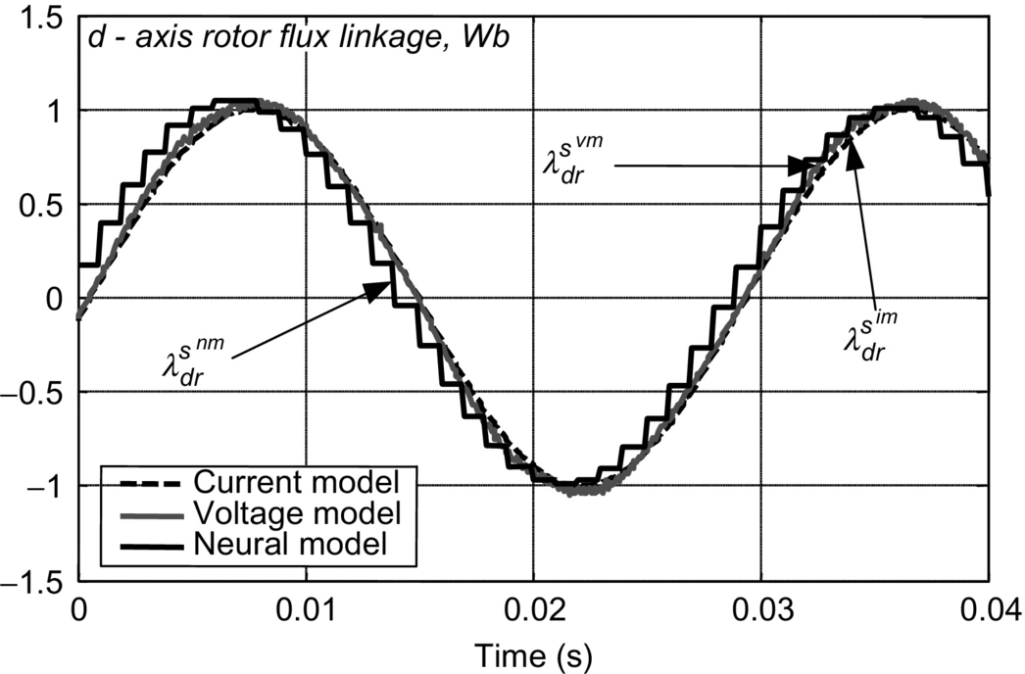

**FIG. 37.20** Rotor fluxes estimated during *Rr* estimation using ANN—experimental results.

### 37.3.4 STATOR RESISTANCE ESTIMATION USING ANN

In this section, the capability of a neural network has been deployed to have online estimator for stator resistance in an RFOC induction motor drive. The stator resistance observer was realized with a recurrent neural network with feedback loops trained using the standard back-propagation learning algorithm. Such architecture with recurrent neural network is known to be a more desirable approach, and the implementation reported in this section confirms this.

The *d*-axis stator current in the stationary reference frame in the discrete form can be represented using the voltage and current model equations of the induction motor:

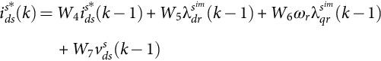 **(37.9)**

**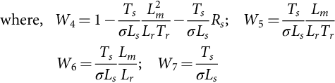**

The weights *W*5, *W*6, and *W*7 are calculated using the induction motor parameters, the rotor speed *ωr*, and the sampling interval used in the estimator *Ts*.

The relationship between stator current and stator resistance is nonlinear that could be easily mapped using a neural network.

When this Eq. [(37.9)](https://learning.oreilly.com/library/view/power-electronics-handbook/9780128114087/B9780128114070000416.xhtml#fo0050) is represented graphically, it resembles a recurrent neural network as shown in [Fig. 37.21](https://learning.oreilly.com/library/view/power-electronics-handbook/9780128114087/B9780128114070000416.xhtml#f0110). The standard back-propagation learning rule can then be employed for training this neural network. The weight *W*4 is the result of training so as to minimize the cumulative error function *E*2:

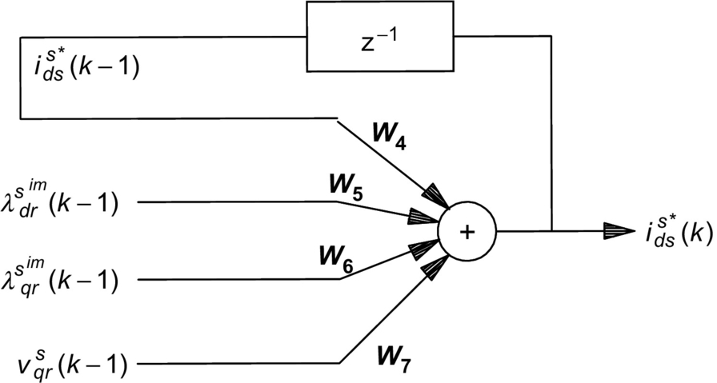

**FIG. 37.21** *d*-Axis stator current estimation using recurrent neural network based on Eq. [(37.9)](https://learning.oreilly.com/library/view/power-electronics-handbook/9780128114087/B9780128114070000416.xhtml#fo0050).

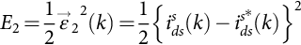 **(37.10)**

To accelerate the convergence of the error back-propagation learning algorithm, the current weight adjustment is supplemented with a fraction of the most recent weight adjustment, as indicated in Eq. [(37.11)](https://learning.oreilly.com/library/view/power-electronics-handbook/9780128114087/B9780128114070000416.xhtml#fo0065):

 **(37.11)**

where *η*2 is the training coefficient and *α*2 is a user-selected positive momentum constant.

Following a similar procedure, the *q*-axis stator current of the induction motor can be estimated using the discrete form as shown in Eq. [(37.12)](https://learning.oreilly.com/library/view/power-electronics-handbook/9780128114087/B9780128114070000416.xhtml#fo0070):

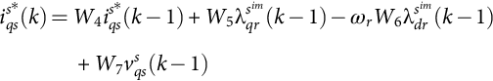 **(37.12)**

Equation [(37.12)](https://learning.oreilly.com/library/view/power-electronics-handbook/9780128114087/B9780128114070000416.xhtml#fo0070) can be represented by a neural network as shown in [Fig. 37.22](https://learning.oreilly.com/library/view/power-electronics-handbook/9780128114087/B9780128114070000416.xhtml#f0115). The weight *W*4 is updated with the training based on Eq. [(37.12)](https://learning.oreilly.com/library/view/power-electronics-handbook/9780128114087/B9780128114070000416.xhtml#fo0070).

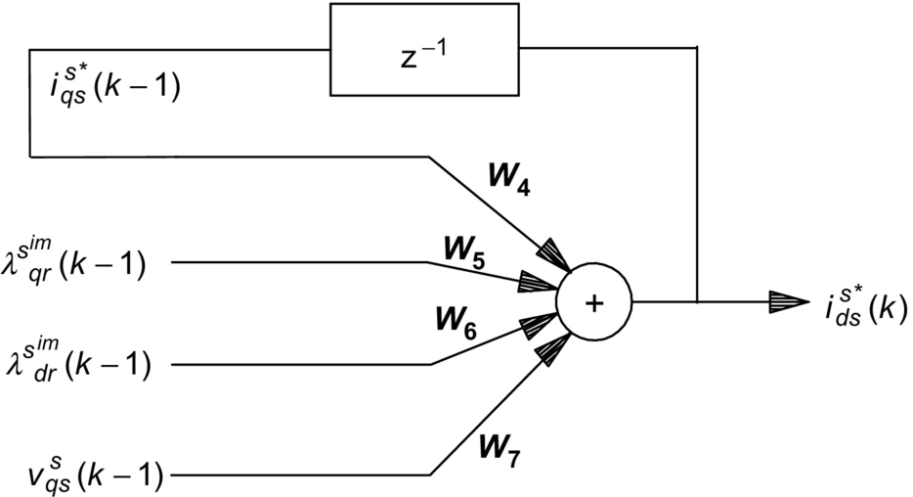

**FIG. 37.22** *q*-Axis stator current estimation using recurrent neural network based on Eq. [(37.12)](https://learning.oreilly.com/library/view/power-electronics-handbook/9780128114087/B9780128114070000416.xhtml#fo0070).

The stator resistance  of the induction motor can now be calculated using Eq. [(37.13)](https://learning.oreilly.com/library/view/power-electronics-handbook/9780128114087/B9780128114070000416.xhtml#fo0075) as follows:

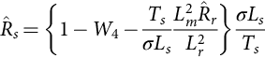 **(37.13)**

The stator resistance of an induction motor can be thus estimated from the stator current using the neural network system as indicated in [Fig. 37.23](https://learning.oreilly.com/library/view/power-electronics-handbook/9780128114087/B9780128114070000416.xhtml#f0120).

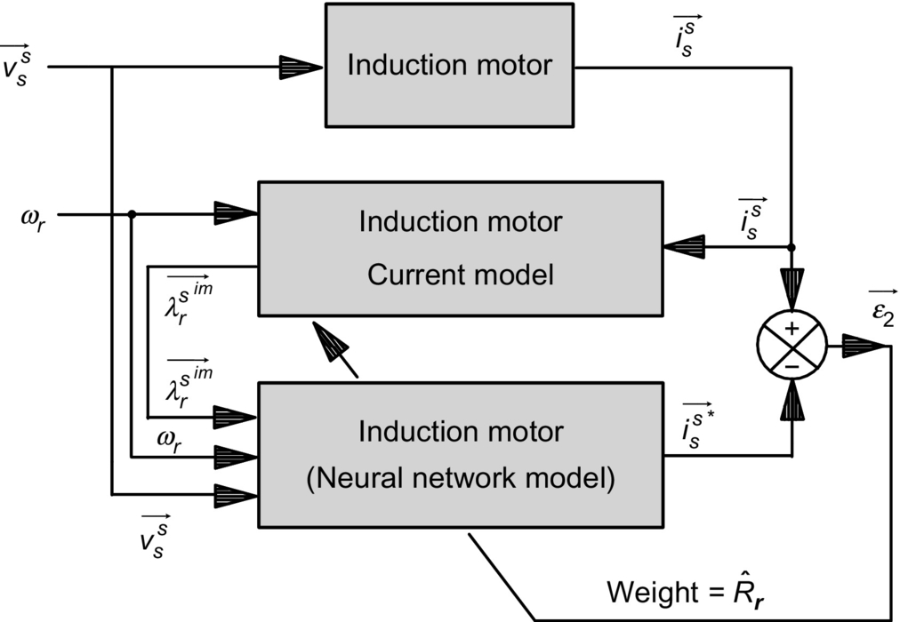

**FIG. 37.23** Block diagram of *Rs* estimation using artificial neural network.

#### **37.3.4.1 Modeling Results of Stator Resistance Estimation Using ANN**

The block diagram of a rotor-flux-oriented induction motor drive together with stator resistance identification is already shown in [Fig. 37.14](https://learning.oreilly.com/library/view/power-electronics-handbook/9780128114087/B9780128114070000416.xhtml#f0075), where the stator resistance estimation is implemented by the stator resistance estimator (SRE) block.

The stator resistance estimation results are as shown in [Fig. 37.24](https://learning.oreilly.com/library/view/power-electronics-handbook/9780128114087/B9780128114070000416.xhtml#f0125). It has three results (1) without both rotor and stator resistance estimators, (2) with only rotor resistance estimation, and (3) with both rotor and stator resistance estimations. As shown in the figure, both *Rr* and *Rs* were increased abruptly by 40% at 1.5 s. It can be seen that the estimated stator resistance  converges to  within 200 ms. It can be noted from this figure that the convergence of the stator resistance estimation is not affected by the convergence of the rotor resistance estimator.

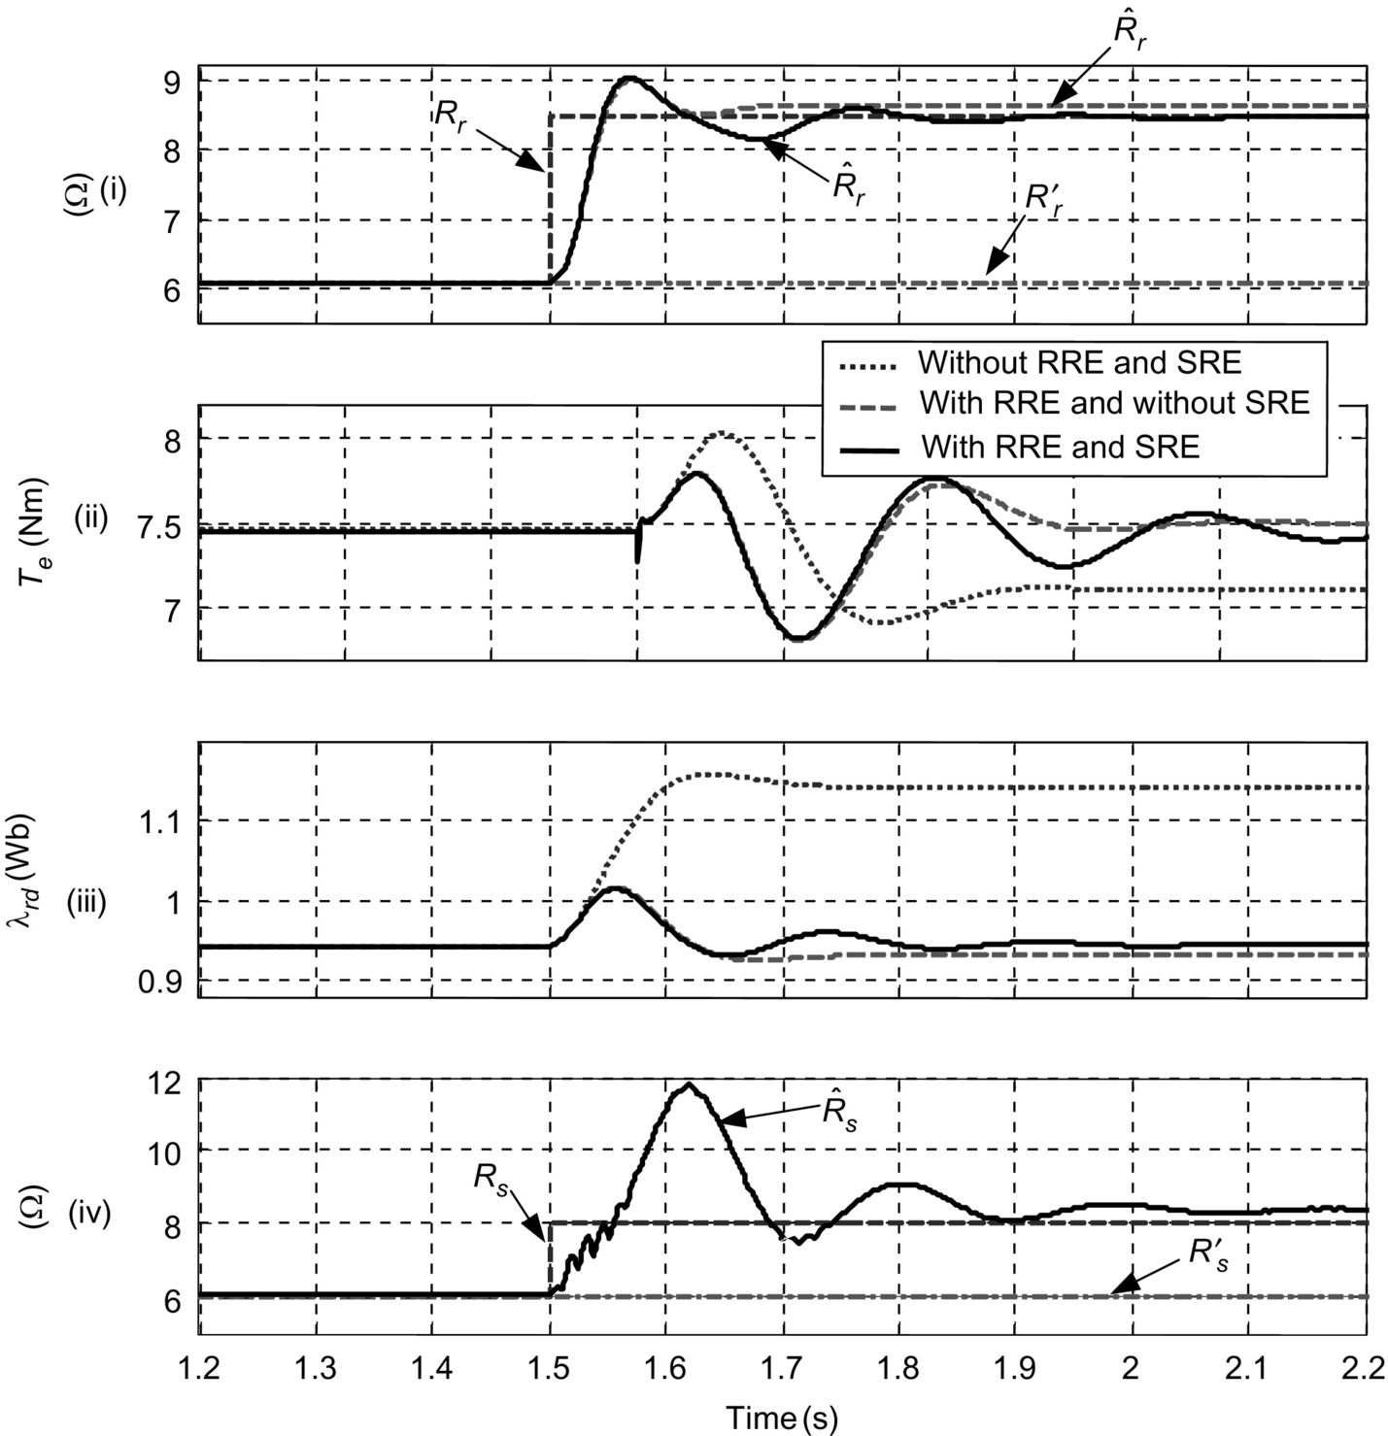

**FIG. 37.24** Performance of the drive with and without RRE and SRE using ANN for 40% step change in *Rr* and *Rs*, *Rr*′, and *Rs*′ compensated—modeling results.

#### **37.3.4.2 Experimental Results of Stator Resistance Estimation Using ANN**

The stator resistance estimation algorithm was tested together with the rotor-flux-oriented induction motor drive of [Fig. 37.14](https://learning.oreilly.com/library/view/power-electronics-handbook/9780128114087/B9780128114070000416.xhtml#f0075) implemented in the laboratory. To test the stator resistance estimation, an additional 3.4 Ω per phase was added in series with the induction motor stator, with the motor running at 1000 rev/min and with a load torque of 7.4 Nm.

The estimated stator resistance together with the actual stator resistance is shown in [Fig. 37.25](https://learning.oreilly.com/library/view/power-electronics-handbook/9780128114087/B9780128114070000416.xhtml#f0130). The estimated stator resistance converges to 9.4 Ω within <200 ms.

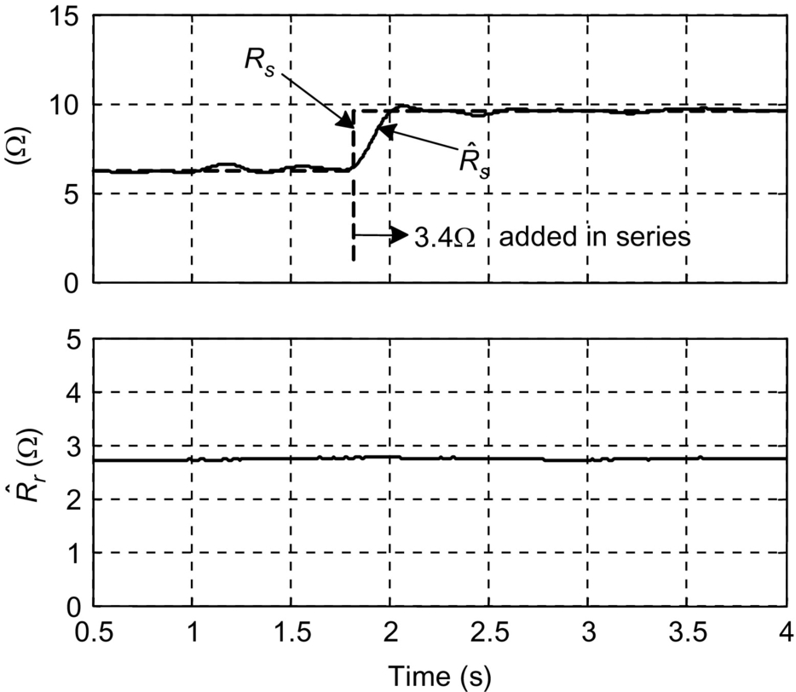

**FIG. 37.25** Estimated stator resistance *Rs* using ANN—experimental results.

[Fig. 37.26](https://learning.oreilly.com/library/view/power-electronics-handbook/9780128114087/B9780128114070000416.xhtml#f0135) shows both the measured *d*-axis stator current and the one estimated by the neural network model. The neural network model output  follows the measured values *idss*(*k*), due to the online training of the neural network.

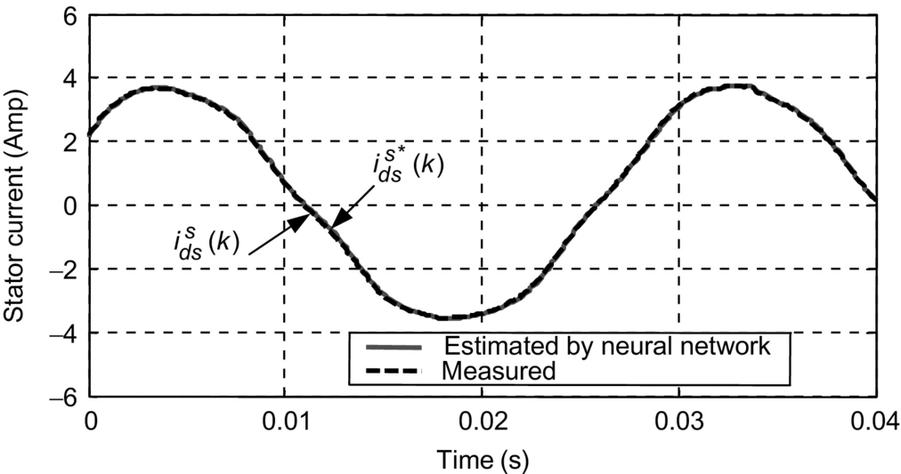

**FIG. 37.26** Stator currents in *Rs* estimation—experimental results.

## 37.4 ANN-Based Controls in Motor Drives

### **37.4.1 INDUCTION MOTOR CURRENT CONTROL**

Another application of ANN is to identify and control the stator current of an induction motor. In one study, Burton et al. have used a current control strategy outlined by Wishart and Harley to train an ANN to control the induction motor stator currents. They have used a training algorithm named random weight change (RWC) that is reported to be slightly faster than back propagation. In RWC algorithm, the weights are perturbed by a fixed step size and a random sign. This is done for fixed number of trials, and after each trial, the error with the desired output is computed. Finally, the set of weight changes that result in the least error are chosen, and the whole process is repeated until convergence is reached. The modeling results reported in this scheme was excellent. Later, Burton *et al.* presented their practical implementation of this proposed stator current controller with a transputer controller card.

### 37.4.2 INDUCTION MOTOR CONTROL

Narendra and Parthasarathy proposed methods for identification and control of dynamic systems using ANNs. Wishart and Harley used the above basic principles to identify and control induction machines. A block diagram of the control scheme is shown in [Fig. 37.27](https://learning.oreilly.com/library/view/power-electronics-handbook/9780128114087/B9780128114070000416.xhtml#f0140). For the induction motor, the nonlinear autoregressive moving average with exogenous input (NARMAX) model for the stationary frame stator current is derived and used for the identification of electromagnetic model. In its general form, the NARMAX model represents a system in terms of its delayed inputs and outputs. Random steps in the stator voltage are given for the purpose of identification. The neural network used is of the multilayer back-propagation type, and a quantity based on the rotor time constant is also computed as an extra weight. As opposed to the regular ANN architecture, this ANN has nonlinearity in the output layer, and the weighted sum of the inputs is used as the output. This gives an estimate of the rotor time constant and makes the system robust against variation of the parameters. Once, the identification is over, the ANN is used for current control. The stator currents predicted by the ANN are used to compute the input voltage for the induction motor, and the ANN output is made to track the reference currents by back propagating the error.

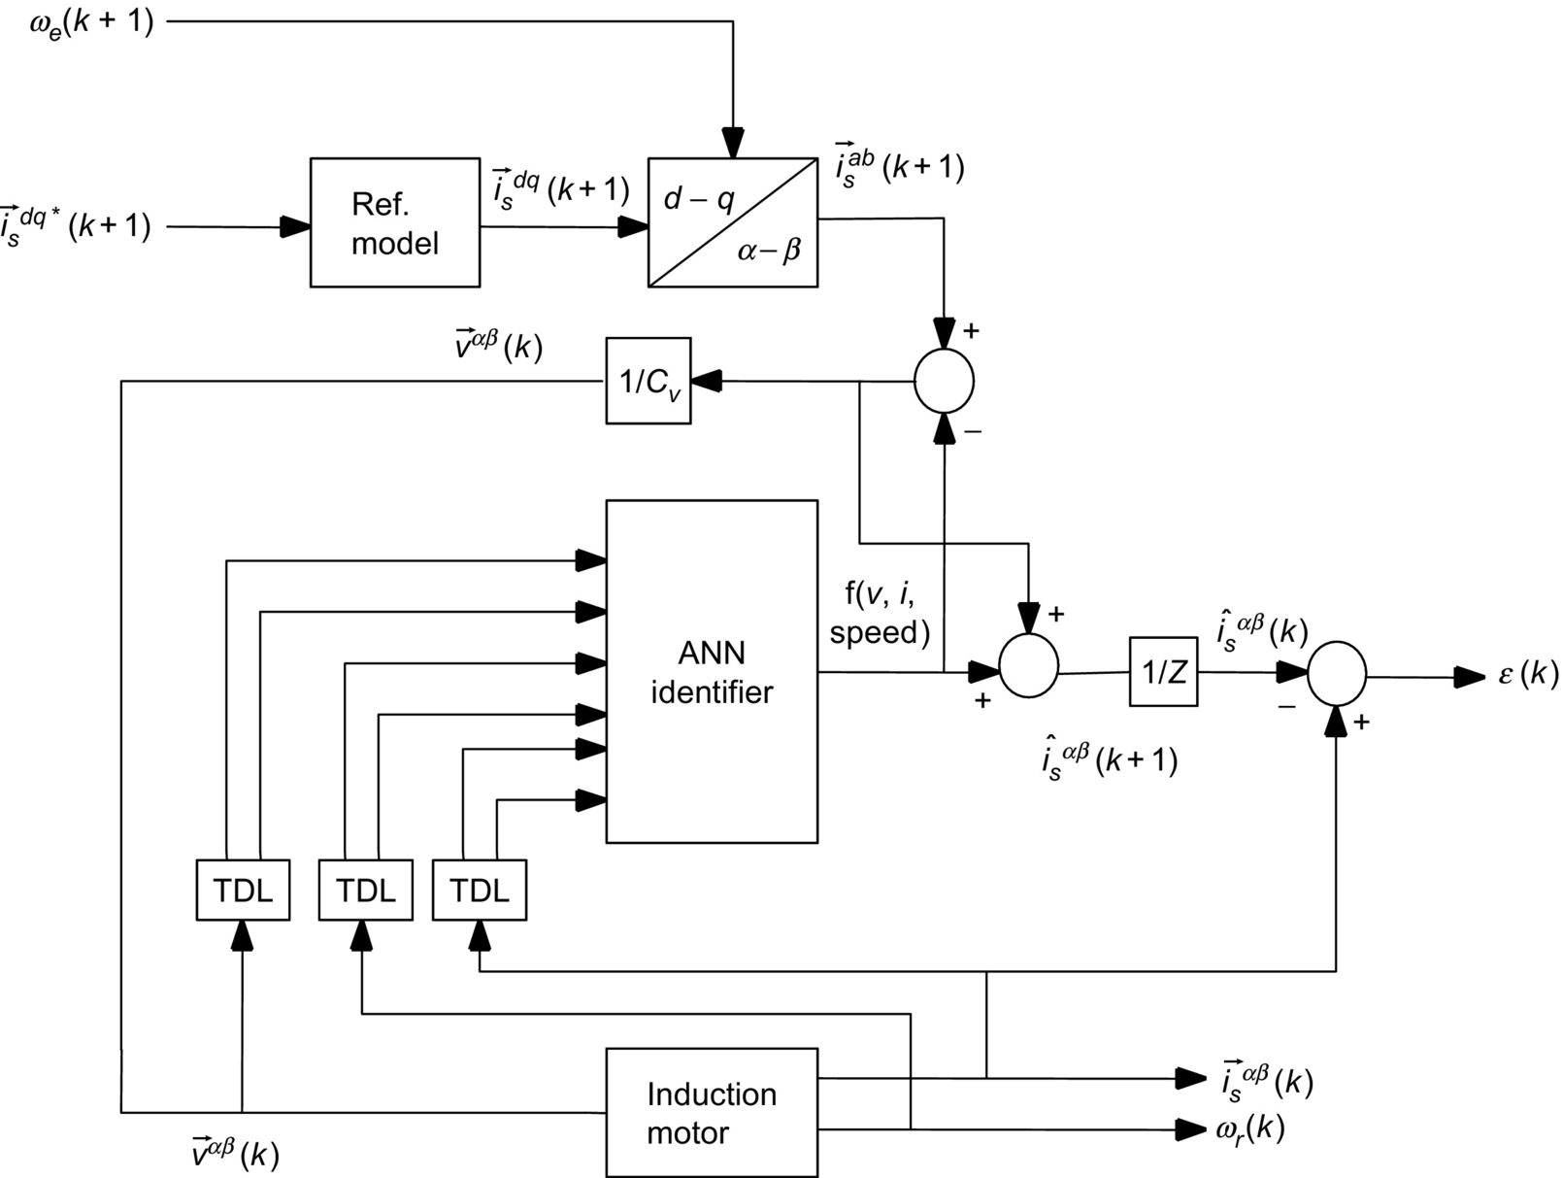

**FIG. 37.27** Adaptive current control using ANN proposed by Harley.

The rotor speed is also controlled in this system by identifying a NARMAX model for the speed increment rather than the absolute value of speed. To simplify the NARMAX model, the load torque is assumed to be a function of the motor speed, as is the case in a fan or pump type of load. For the current control case, the relationship between the control variable (voltage) and the controlled quantity (current) was linear. In the speed control case, this relationship is nonlinear, thus necessitating two ANNs, one for identification of speed and the other for control.

The identification ANN (*Ni*) predicts the value for the speed increment, which is compared with the actual speed increment, and the error (*ɛi*) is back propagated through the ANN. A PI controller is used for basic speed control, and the control ANN (*Nc*) produces the slip frequency, and the difference between the desired speed increment and actual speed increment (*ɛc*) is back propagated through the ANN. The induction motor drive therefore employs three ANNs as shown in [Fig. 37.28](https://learning.oreilly.com/library/view/power-electronics-handbook/9780128114087/B9780128114070000416.xhtml#f0145).

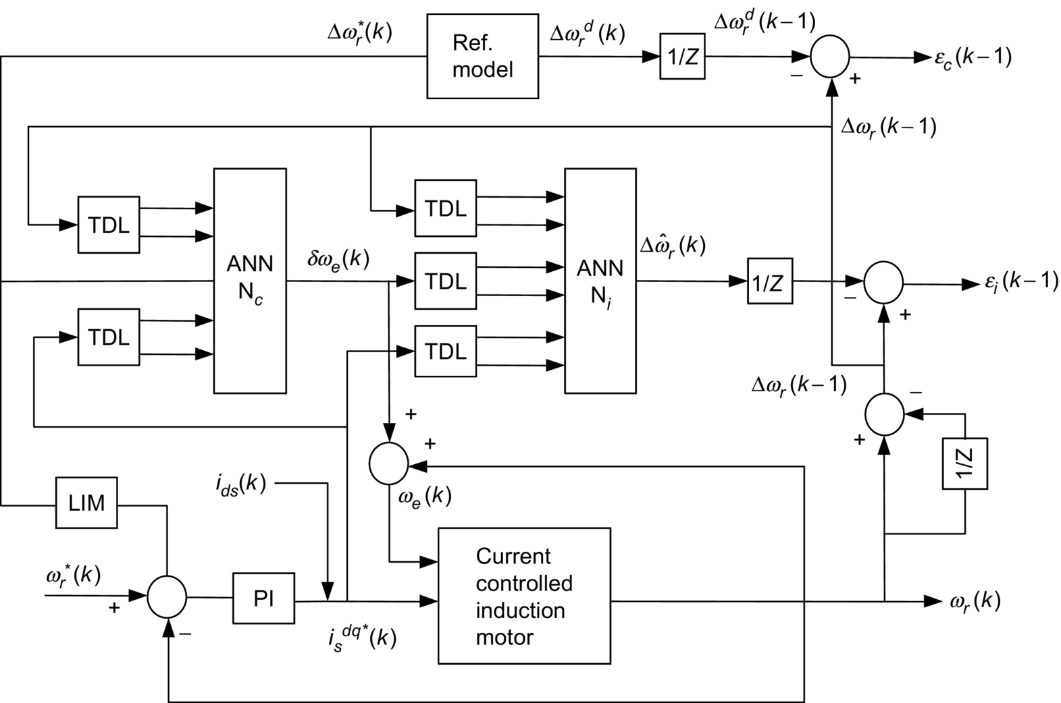

**FIG. 37.28** Adaptive speed control of the induction motor using ANN.

### 37.4.3 EFFICIENCY OPTIMIZATION IN ELECTRIC DRIVES

The efficiency improvement of induction motor drives via flux control can be classified into three groups: precomputed flux programs, real-time computation of losses, and online input-output efficiency optimization control. All of these methods target choosing a value of the motor excitation that optimizes the motor-converter losses. The main requirement of an input-output optimization is to achieve the flux optimization in a minimum number of search steps. A constant search step may take too long if the step is too small, or it may bypass the minimum power input if the step is too large. For each mechanical operating point of the motor, it is possible to find a combination of rotor-flux linkage and torque producing current *iq* at which the dc-link power *Pdc* to the drive system is minimum.

One of the possible ANN efficiency optimizers reported is shown in [Fig. 37.29](https://learning.oreilly.com/library/view/power-electronics-handbook/9780128114087/B9780128114070000416.xhtml#f0150). An ANN-based search algorithm is employed to operate as an efficiency optimizer. The inputs to the system are the dc power fed into the drive system at instant *k* and the change in the control variable at the previous instant . The only output is the actual change in control variable Δ*c*(*k*). Appropriate scaling from engineering units to the normalized interval [−1, 1] are implemented by the input and output interfaces, input scaling (IS), and output scaling (OS). The speed signal is used to generate the reference flux *C*(*k*)0 corresponding to each speed. The mechanical steady state is detected by applying a moving average filtering to the speed variation Δ*ωm*. The ANN efficiency optimizer is enabled only during the mechanical steady state.

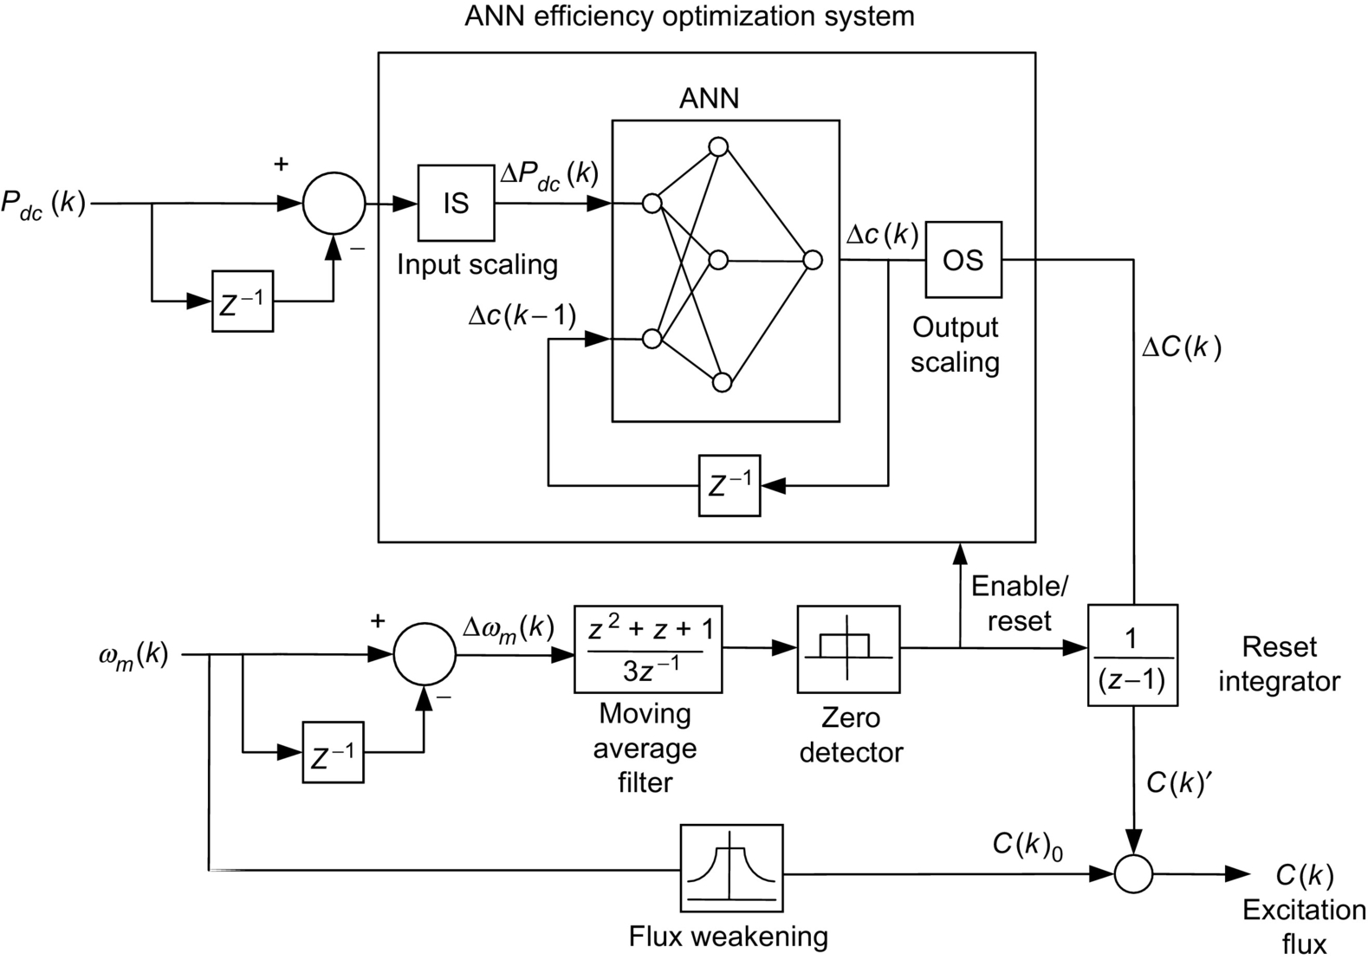

**FIG. 37.29** Induction motor efficiency optimizer using ANN.

## 37.5 ANN-Based Controls in Power Converters

A feedforward ANN can implement a nonlinear input-output mapping. A feedforward carrier-based pulse-width modulation (PWM) technique, such as space-vector modulator (SVM), can be looked at as a nonlinear mapping where the command phase voltages are sampled at the input and the corresponding pulse-width patterns are established at the output. [Fig. 37.30](https://learning.oreilly.com/library/view/power-electronics-handbook/9780128114087/B9780128114070000416.xhtml#f0155) shows the block diagram of an open-loop V/f-controlled induction motor drive incorporating the proposed ANN-based SVM controller. The command voltage  is generated from the frequency or speed command, and the angle command *θe*⁎ is obtained by integrating the frequency, as shown. The output of the modulator generates the PWM patterns for the inverter switches.



**FIG. 37.30** V/f control of induction motor using ANN-based SVM.

The ANN can be conveniently trained off-line with the data generated by calculation of the SVM algorithm. The ANN has inherent learning capability that can give improved precision by interpolation unlike the standard lookup table method. [Fig. 37.31](https://learning.oreilly.com/library/view/power-electronics-handbook/9780128114087/B9780128114070000416.xhtml#f0160) shows such an SVM that can operate during both undermodulation and overmodulation regions linearly extending smoothly up to a square wave. The SVM is implemented using two subnets: angle subnet and amplitude subnet. The subnets use a multiplayer perceptron-type network with sigmoidal-type transfer function. The bias is not shown in the figure. The composite network uses two neurons at the input, 20 neurons in the hidden layer, and four output neurons. The input signal to the angle subnet is *θe* angle that is normalized, and then pulse-width functions at unit amplitude are solved (or mapped) at the output for three phases, as indicated. The amplitude subnet implements the *f*(*V*⁎) function. The digital words corresponding to the turn-on time are generated by multiplying the angle subnet output with that of the amplitude subnet and then adding the *Ts*/4 bias signal, as shown. The PWM signals are then generated using a single timer. The angle subnet is trained with an angle interval of 2.16 degrees in the range of 0–360 degrees. Due to learning or interpolation capability, both the subnets will operate higher signal resolution. A sampling interval *Ts* of 50μs corresponds to a switching frequency of 20 kHz and a 100μs that corresponds to 10 kHz.



**FIG. 37.31** Neural network topology  for PWM wave synthesis.

## Further Reading

[1] Vas P. *Artificial Intelligence-Based Electrical Machines and Drives: Application of fuzzy, Neural, Fuzzy-Neural and Genetic-Algorithm—Based Techniques.* New York: Oxford University Press; 1999.

[2] Bose B.K. *Modern Power Electronics and AC Drives.* New Jersey: Prentice Hall; 2002.

[3] Ben-Brahim L., Tadakuma S., Akdag A. Speed control of induction motor without rotational transducers. *IEEE Trans. Ind. Appl.* 1999;35(4):844–850.

[4] Simoes M.G., Bose B.K. Neural network based estimator of feedback signals for a vector controlled induction motor drive. *IEEE Trans. Ind. Appl.* 1995;31:620–629.

[5] Funahashi K. On the approximate realization of continuous mappings by neural networks. *Neural Netw.* 1989;2:183–192.

[6] Pham D.T., Liu X. *Neural Networks for Identification, Prediction and Control.* New York: Springer–Verlag; 1995.

[7] Wishart M., Harley R.G. Identification and control of induction machines using artificial neural networks. *IEEE Trans. Ind. Appl.* 1995;31(3):612–619.

[8] Narendra K.S., Parthasarathy K. Identification and control of dynamic systems using neural networks. *IEEE Trans. Neural Netw.* 1990;1(1):4–27.

[9] Pinto J.O., Bose B.K., De Silva L.E.B., Kazmierkowski M.P. A neural-network based space-vector pwm controller for voltage-fed inverter induction motor drive. *IEEE Trans. Ind. Appl.* 2000;36(6):1628–1636.

**38**

# Novel AI-Based Soft Computing Applications in Motor Drives

Adel M. Sharaf University of Trinidad and Tobago UTT, Wallerfield, Trinidad and Tobago

Adel A.A. Elgammal University of Trinidad and Tobago UTT, Wallerfield, Trinidad and Tobago

## Abstract

The chapter introduces novel ideas in the efficient control of industrial motor drives. The use of artificial intelligence (AI) soft computing techniques is gaining acceptance in the industry to ensure efficient energy utilization, robust and accurate speed reference tracking, minimum impact on the host electric grid system, and extended life span of the motor drive system while avoiding magnetic saturation and inrush current conditions. The use of emerging soft computing random search techniques such as particle swarm optimization (PSO) and genetic algorithm (GA) is also gaining acceptance as effective tools in dynamic on line tuning, self-regulating, and adjustment of controller to ensure that specific objective functions are optimized. The use of dynamic on line self-adjusting error-driven control strategies is promising effective, robust, and efficient control strategies for DC and AC motor drives. The use of new topologies, converter architecture, and switching strategies is greatly facilitated by multiloop regulation and dynamic absolute error minimization using PSO and GA search algorithms. In this chapter, a review of PSO and GA search methods is followed by single- and multiobjective optimization search algorithms and how both soft computing AI-based technique can be applied to optimal operation of induction motor drives, hybrid photovoltaic-fuel cell-diesel-battery electric vehicle drive system, and finally, the novel self-regulating green plug-energy management energy economizer schemes developed by the first author as a number of an extended family of modulated power filters, switched capacitor compensators, and dynamic electric energy management devices and system.

### KEYWORDS

Particle swarm optimization; Genetic algorithm; Power system; Motor drives

38.1 [Introduction](https://learning.oreilly.com/library/view/power-electronics-handbook/9780128114087/B9780128114070000428.xhtml#s0010)

38.2 [Differences Between GA and PSO and Other Evolutionary Computation Techniques](https://learning.oreilly.com/library/view/power-electronics-handbook/9780128114087/B9780128114070000428.xhtml#s0015)

38.3 [Single Objective Genetic Optimization Search Algorithm (SOGA)](https://learning.oreilly.com/library/view/power-electronics-handbook/9780128114087/B9780128114070000428.xhtml#s0020)

38.4 [Single Objective Particle Swarm Optimization Search Algorithm (SOPSO)](https://learning.oreilly.com/library/view/power-electronics-handbook/9780128114087/B9780128114070000428.xhtml#s0025)

38.4.1 Structure of the PSO Particle

38.4.2 Basic Search Method

38.4.3 PSO Search Algorithm

38.5 [Multiobjective Optimization (MOO)](https://learning.oreilly.com/library/view/power-electronics-handbook/9780128114087/B9780128114070000428.xhtml#s0045)

38.6 [Multiobjective Genetic Optimization Search Algorithm (MOGA)](https://learning.oreilly.com/library/view/power-electronics-handbook/9780128114087/B9780128114070000428.xhtml#s0050)

38.7 [Multiobjective Particle Swarm Optimization Search Algorithm (MOPSO)](https://learning.oreilly.com/library/view/power-electronics-handbook/9780128114087/B9780128114070000428.xhtml#s0055)

38.8 [GA and PSO Applications in Speed Control of Motor Drives](https://learning.oreilly.com/library/view/power-electronics-handbook/9780128114087/B9780128114070000428.xhtml#s0060)

38.8.1 Efficient Operation of Induction Motor Drives

38.8.2 A Novel Self Regulating Hybrid (PV-FC-Diesel-Battery) Electric Vehicle-EV Drive System

38.8.3 Novel Self Regulating Green Plug/Energy Management/Energy Economizer GP-EM-EE Schemes for Wind Driven Induction Generation

38.9 [Conclusion](https://learning.oreilly.com/library/view/power-electronics-handbook/9780128114087/B9780128114070000428.xhtml#s0150)

[References](https://learning.oreilly.com/library/view/power-electronics-handbook/9780128114087/B9780128114070000428.xhtml#bi0010)

## 38.1 Introduction

Solving an optimization problem is one of the common scenarios that occur in most engineering applications. Classical optimization techniques such as linear programming (LP) and nonlinear programming (NLP) are efficient approaches that can be used to solve special cases of optimization problem in power system and motor drive applications. As the complexities of the problem increase, especially with the introduction of parameter uncertainties, more complicated optimization techniques, such as stochastic programming, have to be used. However, these analytic methods are not easy to implement for most of the real-world problems. As a highly nonlinear, nonstationary motor drive system with nonlinear inertia, load, noise, and uncertainties, motor drives can have a large number of operating condition states and parameters. Implementing any of the classical analytic optimization search methods may not be feasible in most of the cases. On the other hand, GA and particle swarm optimization (PSO) search techniques can be an attractive alternative and effective solutions. GA and PSO are stochastically based search techniques that have its roots in artificial life and social psychology and in engineering and computer science. In general, there are two possible optimization techniques based on GA and PSO. These two techniques are the following:

(1) Single-objective optimization (SOO)

(2) Multiobjective optimization (MOO)

The main procedure of the SOO is based on deriving a single-objective function for the optimization search problem. The single-objective function may be combined from several objective functions using weighting factors. The objective function is optimized (either minimized or maximized) using GA or PSO to obtain a single solution. On the other hand, the main objective of the multiobjective (MO) problem is finding the set of acceptable trade-off optimal solutions. This set of accepted solutions is called Pareto front. These acceptable solutions give more ability to the user to make an informed decision by seeing a wide range of solutions that are optimum from an “overall” standpoint. Single-objective (SO) optimization may ignore this trade-off viewpoint. This chapter has described the basic concepts of GA and PSO and presents a review of some of the applications of GA and PSO in motor drive-based optimization problems to give the reader some insights of how GA and PSO can serve as acceptable near-optimal solutions to some of the most complicated engineering optimization problems.

## 38.2 Differences Between GA and PSO and Other Evolutionary Computation Techniques

A comparison between conventional optimization techniques and evolutionary algorithms (like GA and PSO) is presented in [Table 38.1](https://learning.oreilly.com/library/view/power-electronics-handbook/9780128114087/B9780128114070000428.xhtml#t0010) [[1](https://learning.oreilly.com/library/view/power-electronics-handbook/9780128114087/B9780128114070000428.xhtml#bb0010)]:

**Table 38.1**

**Comparison between conventional optimization procedures and evolutionary algorithms**

|  |  |  |
| --- | --- | --- |
| **Property** | **Evolutionary** | **Traditional** |
| Search space | Population of potential solutions | Trajectory by a single point |
| Motivation | Natural selection and social adaptation | Mathematical properties (gradient, Hessian) |
| Applicability | Domain independent, applicable to variety of problems | Applicable to a specific problem domain |
| Point transition | Probabilistic | Deterministic |
| Prerequisites | An objective function to be optimized | Auxiliary knowledge such as gradient vectors |
| Initial guess | Automatically generated by the algorithm | Provided by user |
| Flow of control | Mostly parallel | Mostly serial |
| CPU time | Large | Small |
| Results | Global optimum more probable | Local optimum, dependent of initial guess |
| Advantages | Global search, parallel, speed | Convergence proof |
| Drawbacks | No general formal convergence proof | Locality, computational cost |

➢ Unlike other random search algorithms, each potential solution (called a particle) is also assigned a randomized velocity and then flown through the problem hyperspace.

➢ The most striking difference between the PSO and the other evolutionary soft computing algorithms is that PSO chooses the path of cooperation over competition. The other algorithms commonly use some form of decimation, survival of the fittest. In contrast, the PSO population is stable and individuals are not destroyed or created. Individuals are influenced by the best performance of their neighbors. Individuals eventually converge on optimal points in the problem domain.

➢ The PSO traditionally does not have any genetic operators like crossover between individuals and mutation, and other individuals never substitute particles during the run. Instead, the PSO refines its search by attracting the particles to positions with good solutions.

➢ Particles update themselves with the internal velocity.

➢ They also have memory, which is important to the algorithm.

➢ Compared with GA, the information sharing mechanism in PSO is significantly different. In GAs, chromosomes share information with each other. So the whole population moves like one group toward an optimal area. In PSO, only **gbest** or **pbest** gives out the information to others. It is a one-way information sharing mechanism. The evolution only looks for the best solution.

➢ Compared with the GA, the advantages of PSO are that PSO is easy to implement and there are few parameters to adjust.

## 38.3 Single Objective Genetic Optimization Search Algorithm (SOGA)

GAs are an evolutionary optimization approach that is an alternative to traditional optimization methods. GA is most appropriate for complex nonlinear models where location of the global optimum is a difficult task. It may be possible to use GA techniques to consider problems that may not be modeled as accurately using other approaches.

Therefore, GA appears to be a potentially useful approach. GA is particularly applicable to problems that are large, nonlinear, and possibly discrete in nature, features that traditionally add to the degree of complexity of solution. Due to the probabilistic development of the solution, GA does not guarantee optimality even when it may be reached. However, they are likely to be close to the global optimum. This probabilistic nature of the solution is also the reason they are not contained by local optima. The GA procedure is based on the Darwinian principle of survival of the fittest. An initial population is created containing a predefined number of individuals (or solutions), each represented by a genetic string (incorporating the variable information). Each individual has an associated fitness measure, typically representing an objective value. The concept that fittest (or best) individuals in a population will produce fitter offspring is then implemented in order to reproduce the next population. Selected individuals are chosen for reproduction (or crossover) at each generation, with an appropriate mutation factor to randomly modify the genes of an individual, in order to develop the new population. The result is another set of individuals based on the original subjects leading to subsequent populations with better (min or max) individual fitness. Therefore, the algorithm identifies the individuals with the optimizing fitness values, and those with lower fitness will naturally get discarded from the population [[2](https://learning.oreilly.com/library/view/power-electronics-handbook/9780128114087/B9780128114070000428.xhtml#bb0015)]. [Fig. 38.1](https://learning.oreilly.com/library/view/power-electronics-handbook/9780128114087/B9780128114070000428.xhtml#f0010) shows the general flowchart of the GA algorithm based on total error iterative minimum search. The steps of the GA are depicted as follows:

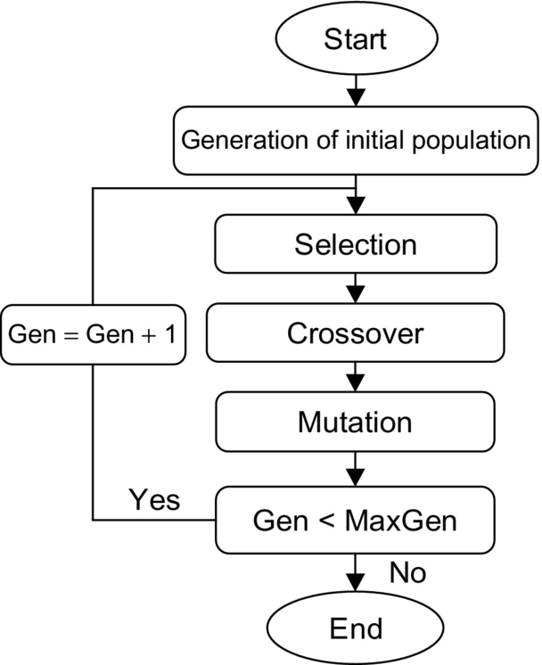

**FIG. 38.1** Flowchart for the GA minimizing search algorithm.

1. **[Start]** Generate random population of *n* chromosomes (suitable solutions for the problem).

2. **[Fitness]** Evaluate the fitness *f(x)* of each chromosome *x* in the population.

3. **[New population]** Create a new population by repeating following steps until the new population is complete:

a. **[Selection]** Select two parent chromosomes from a population according to their fitness (the better fitness, the bigger chance to be selected).

b. **[Crossover]** With a crossover probability cross over the parents to form a new offspring (children). If no crossover was performed, offspring is an exact copy of parents.

c. **[Mutation]** With a mutation probability, mutate new offspring at each locus (position in chromosome).

d. **[Accepting]** Place new offspring in a new population.

4. **[Replace]** Use new generated population for a further run of algorithm.

5. **[Test]** If the end condition is satisfied, **stop**, and return the best solution in current population.

**[Loop]** Go to step **2**.

GAs can be applied to many scientific, engineering problems, once solutions of a given problem can be encoded to chromosomes in GA and compare the relative performance (fitness) of solutions. An effective GA representation and meaningful fitness evaluation are the keys of the success in GA applications. The appeal of GAs comes from their simplicity and elegance as robust search algorithms and from their power to discover good solutions rapidly for difficult high-dimensional problems. The main advantage of GA is that models that cannot be developed using other solution methods without some form of approximation can be considered in an unapproximated form. The size of the model, that is, number of probabilistic variables, has a significant effect on the speed of solution; therefore, model specification can be crucial. Unlike other solution methods, integer variables are easier to accommodate in GA than continuous variables. This is due to the resulting restricted search space. Further, variable bound values can be applied to achieve similar results. GAs can be used for problem-solving and for modeling when the search space is large, complex, or poorly understood. Domain knowledge is scarce or expert knowledge is difficult to encode to narrow the search space. No mathematical analysis is available and traditional search methods fail.

## 38.4 Single Objective Particle Swarm Optimization Search Algorithm (SOPSO)

Particle swarm optimization (PSO) is an evolutionary computational technique (a search method based on a natural system), which was introduced by Kennedy and Eberhart in 1995 [[3](https://learning.oreilly.com/library/view/power-electronics-handbook/9780128114087/B9780128114070000428.xhtml#bb0020)]. This optimization and search technique models the natural swarm behavior seen in many species of birds returning to roost, group of fish, and swarm of bees, etc. The particle swarm optimization (PSO) may be used to find optimal (or near-optimal) solutions to numerical and qualitative problems [[4](https://learning.oreilly.com/library/view/power-electronics-handbook/9780128114087/B9780128114070000428.xhtml#bb0025)–[8](https://learning.oreilly.com/library/view/power-electronics-handbook/9780128114087/B9780128114070000428.xhtml#bb0045)]. PSO methods are inspired by particles moving around in the defined search space. The individuals in a PSO have a position and a velocity. The PSO method remembers the best position found by any particle. Additionally, each particle remembers its own previously best-found position. A particle moves through the specified solution space along a trajectory defined by its velocity, the draw to return to a previous promising search area, and an attraction toward the best location discovered by its close neighbors. Particle swarm optimization has been used for a wide range of search applications and for specific optimization tasks. PSO can be easily implemented in most programming languages and has proved to be both effective and fast when applied to a diverse set of nonlinear optimization problems. PSO has been successfully applied in many areas:

• Function optimization

• Artificial neural network training

• Proportional and integral fuzzy system control

• Other near-optimal search and optimization areas where GA can be applied

### 38.4.1 STRUCTURE OF THE PSO PARTICLE

The basic structure of any particle in a selected population consists of five components:

•  is a vector containing the current location in the solution space. The size of  is defined by the number of variables used by the problem that is being solved.

• Fitness is the quality of the solution represented by the vector , as computed by a problem-specific evaluation function.

•  is a vector containing the velocity for each dimension of . The velocity of a dimension is the step size that the corresponding  value will change into at the next iteration. Changing the  values changes the direction the particle will move through in the search space, causing the particle to make a turn. The velocity vector is used to control the range and resolution of the search.

• *Pbest* is the fitness value of the best solution yet found by a particular particle.

•  is the copy of the  for the location that generated the particle's *P*best. Jointly, *P*best and  comprise the particle's memory, which is used to control the particle to go back toward a definite search region.

• Each particle is also aware of the current best fitness in the neighborhood for any given iteration. A neighborhood may consist of some small group of particles, in which case the neighborhoods overlap and every particle is in multiple neighborhoods. Particles in a swarm are related socially; that is, each particle is a member of one or more neighborhoods. Each individual tries to emulate the behavior of the best of its neighbors. Each individual can be thought of as moving through the feature space with a velocity vector that is influenced by its neighbors.

### 38.4.2 BASIC SEARCH METHOD

The position of each particle is represented by XY-axis position, and also, the velocity is expressed by *V*x (the velocity of X-axis) and *V*y (the velocity of Y-axis). Modification of the particle position is realized by the position and velocity information. Each particle knows its best value so far **(Pbest)** and its XY position. This information represents the personal experiences of each particle. Moreover, each particle knows the best value so far in the group **(gbest)** among **Pbests**. This information represents the knowledge of how the other particles around have performed. Namely, each particle tries to modify its position using the following information:

• The current positions (*x*, *y*)

• The current velocities (*V*x, *V*y)

• The distance between the current position and **Pbest**

• The distance between the current position and **gbest**

This modification can be represented by the concept of velocity. Velocity of each particle can be modified by the following equation:

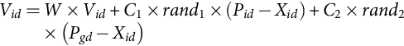 **(38.1)**

where

• *V*id is the value of dimension d in the velocity vector  for particle *i*.

• *C*1 is the cognitive learning selected rate.

• *C*2 is the social learning selected rate.

• rand1 and rand2 are random values on the range [0.1].

• *Xid* is the current position of particle i along dimension *d*.

• *W* is the selected weighting factor.

• *Pid* is the location along dimension d at which the particle previously had the best fitness measure.

• *Pgd* is the current location along dimension d of the neighborhood particle with the best fitness.

The basic concept of the PSO technique lies in accelerating each particle toward its **Pbest** and **gbest** locations, with a random weighted acceleration at each step, and this is illustrated in [Fig. 38.2](https://learning.oreilly.com/library/view/power-electronics-handbook/9780128114087/B9780128114070000428.xhtml#f0015).

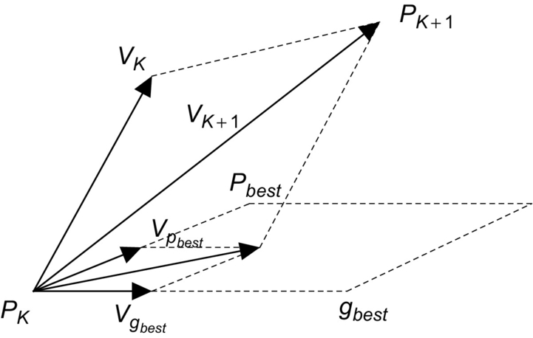

**FIG. 38.2** Concept of modification of a searching point by PSO.

where

*PK* is the current position of a particle.

*PK*+1 is its modified position.

*VK* is its initial velocity.

*VK*+1 is its modified velocity.

 is the velocity considering its pbest location.

 is the velocity considering its gbest location.

Using the above concept, a certain velocity, which gradually gets close to **Pbest** and **gbest**, can be calculated. The current position (searching point in the solution space) can be modified by the following equation:

 **(38.2)**

### 38.4.3 PSO SEARCH ALGORITHM

[Fig. 38.3](https://learning.oreilly.com/library/view/power-electronics-handbook/9780128114087/B9780128114070000428.xhtml#f0020) shows the general flowchart of the PSO algorithm. The main steps in the particle swarm optimization process are described as follows:

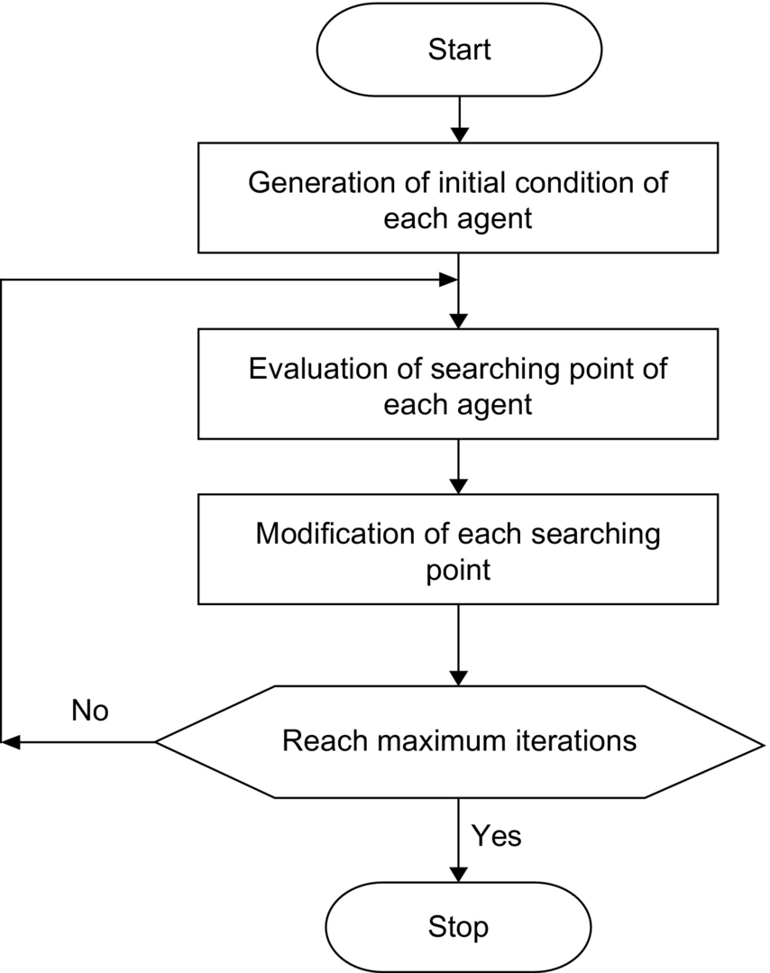

**FIG. 38.3** The general flowchart of PSO search algorithm.

1. System initialized with a population of random potential solutions. Each potential solution is assigned a random “velocity” and is called a particle. (It has position in the space, i.e., it is a point in the solution space and it has velocity.) These particles are then “flown” through the search space of potential solutions.

2. Evaluate the fitness of each particle in the swarm.

3. For every iteration, compare each particle's fitness with its previous best fitness *(Pbes*t) obtained. If the current value is better than *Pbes*t, then set *Pbest* equal to the current value and the *Pbest* location equal to the current location in the d-dimensional space.

4. Compare *Pbest* of particles with each other and update the swarm global best location with the greatest fitness (*gbest*).

5. The velocity of each particle is changed (accelerated) toward its *Pbest* and *gbest*. This acceleration is weighted by a random term. A new position in the solution space is calculated for each particle by adding the new velocity value to each component of the particle's position vector.

6. Repeat steps (2)–(5) until convergence is reached based on some desired single- or multiple-objective criteria.

## 38.5 Multiobjective Optimization (MOO)

In many real-life applications, multiple and often conflicting objectives need to be satisfied. Satisfying these conflicting objective functions is called multiobjective optimization (MO). For example, to place more functional blocks on a chip while minimizing that chip's area and/or power dissipation is a conflicting objective that needs performing a trade-off analysis [[9](https://learning.oreilly.com/library/view/power-electronics-handbook/9780128114087/B9780128114070000428.xhtml#bb0050),[10](https://learning.oreilly.com/library/view/power-electronics-handbook/9780128114087/B9780128114070000428.xhtml#bb0055)]. The objective of MO optimization is to find a set of acceptable solutions and present them to the user, who will then choose from them. Generally, there are two general approaches to solve multiobjective optimization. The first approach lies in combining the individual objective functions into a single composite function. Determination of a single objective is possible with methods, such as the weighted sum method, but the problem lies in the correct selection of the weights. In practice, it can be very difficult to accurately select these weights, even for someone very familiar with the problem domain. In addition, optimizing a particular solution with respect to a single objective can result in unacceptable results with respect to the other objectives [[11](https://learning.oreilly.com/library/view/power-electronics-handbook/9780128114087/B9780128114070000428.xhtml#bb0060),[12](https://learning.oreilly.com/library/view/power-electronics-handbook/9780128114087/B9780128114070000428.xhtml#bb0065)]. The second general approach is to obtain the optimal solution. There will be a set of optimal trade-offs between the conflicting objectives, but this optimal solution is called Pareto-optimal solution set or Pareto front [[13](https://learning.oreilly.com/library/view/power-electronics-handbook/9780128114087/B9780128114070000428.xhtml#bb0070),[14](https://learning.oreilly.com/library/view/power-electronics-handbook/9780128114087/B9780128114070000428.xhtml#bb0075)]. A Pareto-optimal set is a set of solutions that are nondominated with respect to one another. While moving from one Pareto solution to another, there is always a certain amount of importance in one objective to achieve a certain amount of gain in the other. Generating the Pareto set has several advantages. The Pareto set allows the user to make an informed decision by seeing a wide range of options. The Pareto set contains the solutions that are optimum from an “overall” standpoint. SO optimization may ignore this trade-off viewpoint. This feature is useful since it provides better understanding of this system in which all the consequences of a decision with respect to all the objectives can be explored [[9](https://learning.oreilly.com/library/view/power-electronics-handbook/9780128114087/B9780128114070000428.xhtml#bb0050)].

The following definitions are used in the proposed multiobjective optimization (MO) search algorithm:

**Definition 1**

The general MO problem requiring the optimization of N objectives may be formulated as follows:

Minimize

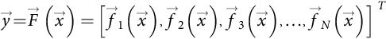 **(38.3)**

**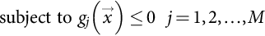** **(38.4)**

where

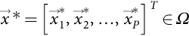 **(38.5)**

**** is the objective vector, the 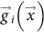 represent the constraints, and is a P-dimensional vector representing the decision variables within a parameter space *Ω*. The space spanned by the objective vectors is called the objective space. The subspace of the objective vectors satisfying the constraints is called the feasible space.

**Definition 2**

A decision vector  is said to dominate the decision vector  (denoted by ), if the decision vector  is not worse than in all objectives and strictly better than  in at least one objective.

**Definition 3**

A decision vector  is called Pareto-optimal, if there does not exist another  that dominates it. An objective vector is called Pareto-optimal, if the corresponding decision vector is Pareto-optimal.

**Definition 4**

The nondominated set of the entire feasible search space Ω is the Pareto-optimal set. The Pareto-optimal set in the objective space is called Pareto-optimal front.

## 38.6 Multiobjective Genetic Optimization Search Algorithm (MOGA)

The nondominated sorting genetic algorithm (NSGA) is a multiobjective GA that was developed by Deb et al. [[15](https://learning.oreilly.com/library/view/power-electronics-handbook/9780128114087/B9780128114070000428.xhtml#bb0080)]. This algorithm has been chosen over a conventional GA for three principal reasons: (a) no need to specify a sharing parameter, (b) a strong tendency to find a diverse set of solutions along the Pareto-optimal front, and (c) the ability to specify multiple objectives without the need to combine them using a weighted sum. The basic idea behind NSGA is the ranking process executed before the selection operation, as shown in [Fig. 38.4](https://learning.oreilly.com/library/view/power-electronics-handbook/9780128114087/B9780128114070000428.xhtml#f0025). This process identifies nondominated solutions in the population, at each generation, to form nondominated fronts [[16](https://learning.oreilly.com/library/view/power-electronics-handbook/9780128114087/B9780128114070000428.xhtml#bb0085)]; after this, the selection, crossover, and mutation usual operators are performed. In the ranking procedure, the nondominated individuals in the current population are first identified. Then, these individuals are assumed to constitute the first nondominated front with a large dummy fitness value [[16](https://learning.oreilly.com/library/view/power-electronics-handbook/9780128114087/B9780128114070000428.xhtml#bb0085)]. The same fitness value is assigned to all of them. In order to maintain diversity in the population, a sharing method is then applied. Afterward, the individuals of the first front are ignored temporarily, and the rest of population is processed in the same way to identify individuals for the second nondominated front. A dummy fitness value that is kept smaller than the minimum shared dummy fitness of the previous front is assigned to all individuals belonging to the new front. This process continues until the whole population is classified into nondominated fronts. Since the nondominated fronts are defined, the population is then reproduced according to the dummy fitness values.

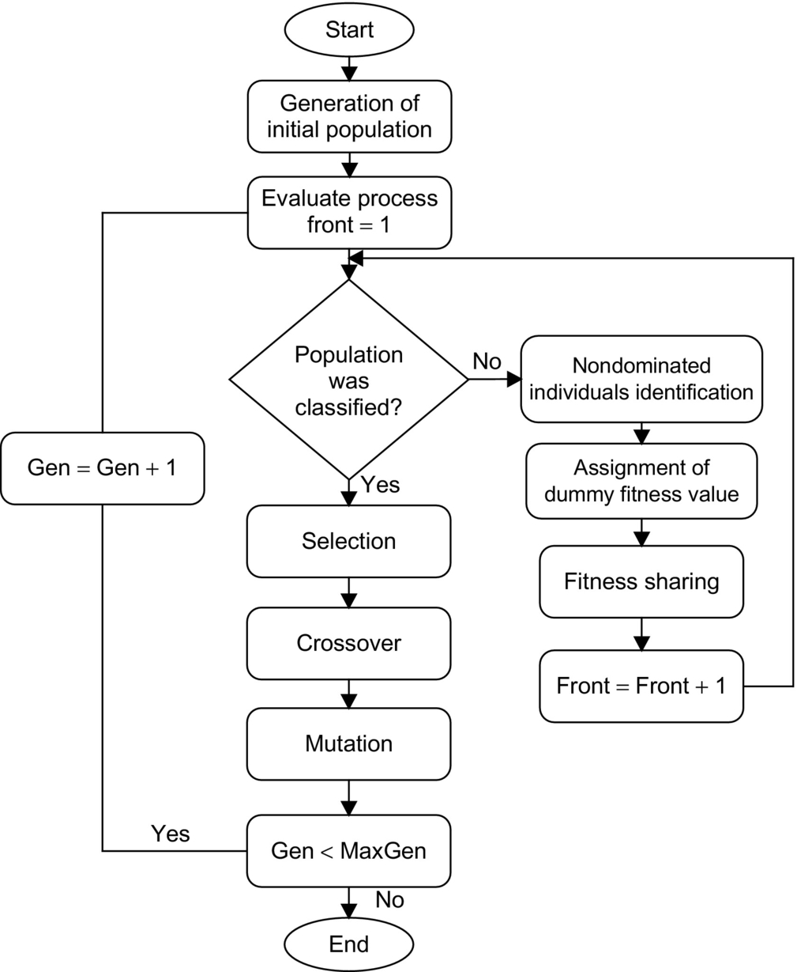

**FIG. 38.4** Flowchart of NSGA.

## 38.7 Multiobjective Particle Swarm Optimization Search Algorithm (MOPSO)

In MOPSO [[9](https://learning.oreilly.com/library/view/power-electronics-handbook/9780128114087/B9780128114070000428.xhtml#bb0050)–[14](https://learning.oreilly.com/library/view/power-electronics-handbook/9780128114087/B9780128114070000428.xhtml#bb0075)], a set of particles are initialized in the decision space at random. For each particle i, a position *x*i in the decision space and a velocity *v*i are assigned. The particles change their positions and move toward the so-far best-found solutions. The nondominated solutions from the last generations are kept in the archive. The archive is an external population, in which the so-far found nondominated solutions are kept. Moving toward the optima (maximum or minimum) is done in the calculations of the velocities as follows:

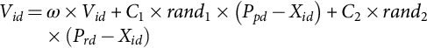 **(38.6)**

**** **(38.7)**

where *Pr,d, Pp,d* are randomly chosen from a single global Pareto archive, *ω* is the inertia factor influencing the local and global abilities of the algorithm, *Vi,d* is the velocity of the particle *i* in the *d*-th dimension, and *c*1 and *c*2 are weights affecting the cognitive and social factors, respectively. *r*1 and *r*2 are two uniform random functions in the range [0, 1]. According to Eq. [(38.7)](https://learning.oreilly.com/library/view/power-electronics-handbook/9780128114087/B9780128114070000428.xhtml#fo0040), each particle has to change its position **Xi,d** toward the position of the two guides **Pr,d, Pp,d** that must be selected from the updated set of nondominated solutions stored in the archive. The particles change their positions during generations until a termination criterion is met. Finding a relatively large set of Pareto-optimal trade-off solutions is possible by running the MOPSO for many generations. [Fig. 38.5](https://learning.oreilly.com/library/view/power-electronics-handbook/9780128114087/B9780128114070000428.xhtml#f0030) shows the flowchart of the multiobjective particle swarm optimization (MOPSO). Also, [Fig. 38.6](https://learning.oreilly.com/library/view/power-electronics-handbook/9780128114087/B9780128114070000428.xhtml#f0035) explains the procedure of the multiobjective particle swarm optimization (MOPSO) using pseudocode.

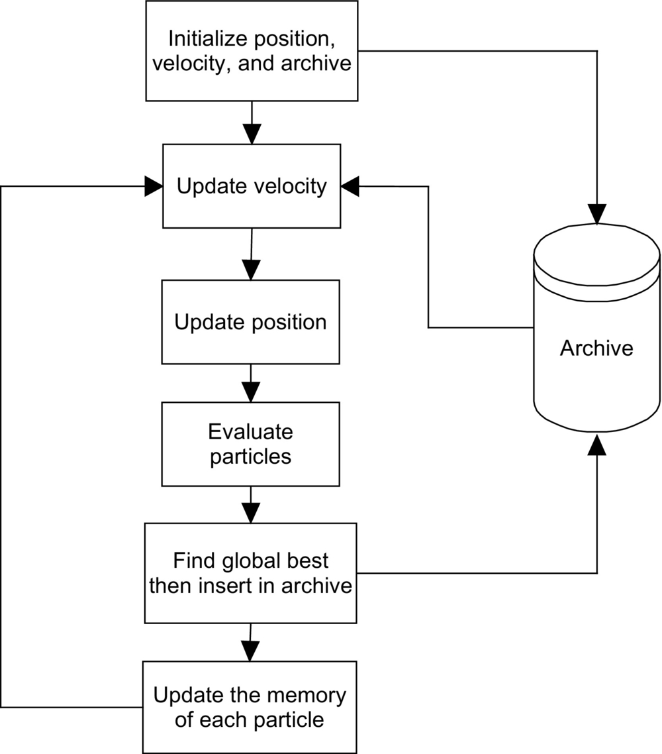

**FIG. 38.5** Flowchart of the MOPSO algorithm.

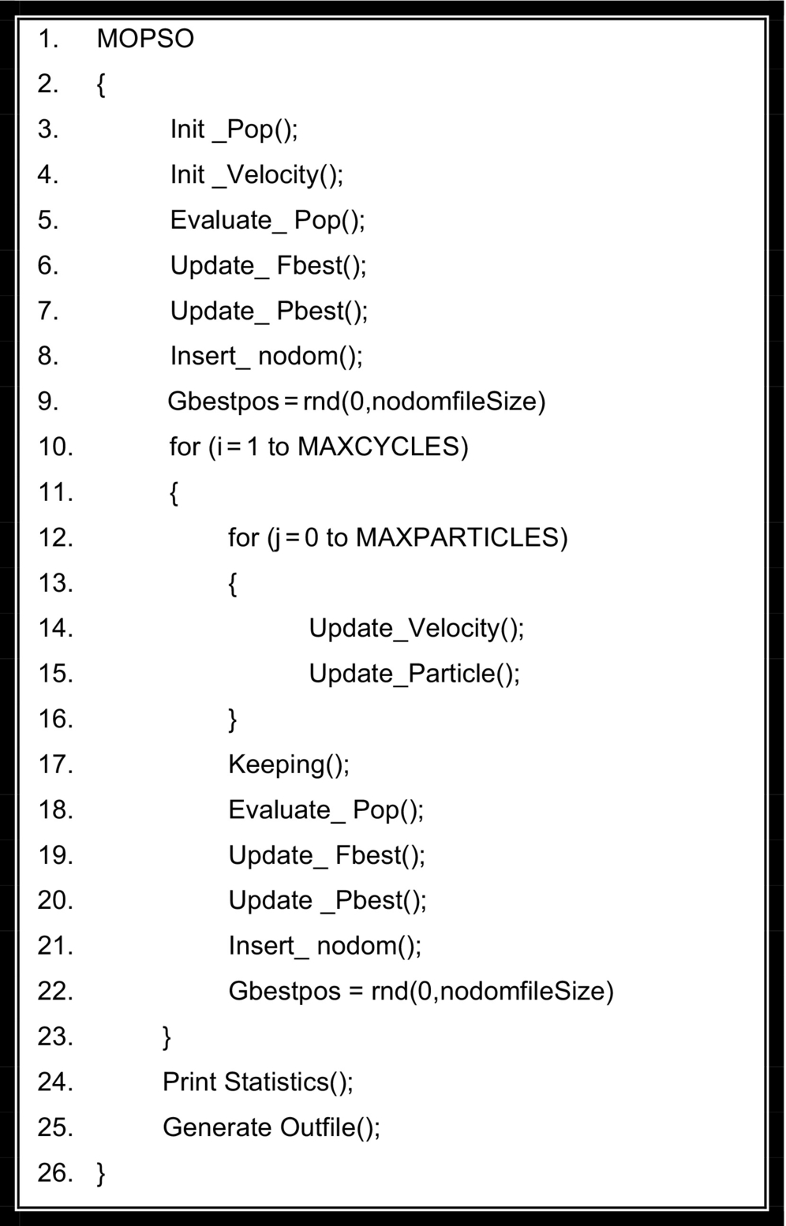

**FIG. 38.6** Pseudocode of the MOPSO.

**Init Pop();** The particle swarm is initialized with random values corresponding to the ranges of the decision variables. These values are dependent on the test functions.

**Init Velocity();** The velocities are initialized with zero values.

Check the feasibility of each particle. If the particle does not satisfy the constraints, then regenerate it.

**Evaluate Pop();** The swarm is evaluated using the corresponding objective functions.

**Update Fbest();** The fitness vectors are updated (evaluate the multiobjective fitness value of each particle and save it in vector form). As we are dealing with multiobjective optimization, these vectors store the values of each decision variable, whereby the particles obtain the best values in a Pareto sense.

At this stage of the algorithm, these vectors are filled with the results of the initial particle evaluations.

**Update Pbest();** Analogously, these values are copied in the pbest vectors.

**Insert nodom();** Calculate the multiobjective fitness values of each particle and check its Pareto optimality. Store the nondominated particles in the Pareto archive. If the specific constraint does not exist for the archive, the size of the archive will be unlimited (all nondominated particles are inserted in the grid, i.e., in the external file).

**Gbestpos=rnd (0,nodomfileSize);** The global gbest particle is randomly selected.

**//The flight cycle starts here //**

**Update Velocity();** The velocity of each particle is updated, using Eq. [(38.6)](https://learning.oreilly.com/library/view/power-electronics-handbook/9780128114087/B9780128114070000428.xhtml#fo0035). Two Pareto solutions are chosen randomly for *Pr*,*d*, *Pi*,*d* from the Pareto archive.

**Update Particle();** The position of each particle is also updated using Eq. [(38.7)](https://learning.oreilly.com/library/view/power-electronics-handbook/9780128114087/B9780128114070000428.xhtml#fo0040).

**Keeping();** The keeping operation is carried out to maintain the particles into the allowable range values. Then, the particles are mutated. If the particle does not remain within the feasible solution region, it is discarded and mutated again.

**Evaluate Pop(); Update Fbest(); Update Pbest();**

The particles are evaluated; the fitness and pbest vector are, if appropriate, updated.

**Insert nodom();** As the particles move in the search space because they have changed positions, the dominance of each particle is verified, and, if appropriate, they are inserted in the grid.

(a) Check the Pareto optimality of each particle. If the fitness value of the particle is nondominated when compared with the Pareto-optimal set in the archive, save it into the Pareto archive.

(b) In the Pareto archive, if a particle is dominated by a new one, then discard it.

**Gbestpos=rnd(0,nodomfileSize);** Then, the new gbest is randomly selected. Two Pareto solutions are chosen randomly for pp;d and pr;d from the Pareto archive.

Repeat the cycle until the number of generations reaches a given n.

**// the end of the cycles //**

**Print Statistics(); Generate Outfile();** Print the statistics and generate an output file, which contains the nondominated particles.

## 38.8 GA and PSO Applications in Speed Control of Motor Drives

Many areas in power systems require solving one or more nonlinear optimization problems. While analytic methods might suffer from slow convergence and the problem of dimensionality, GA and PSO are known to effectively solve large-scale nonlinear optimization problems [[17](https://learning.oreilly.com/library/view/power-electronics-handbook/9780128114087/B9780128114070000428.xhtml#bb0090)]. This section provides some motor drives applications that have benefited from the powerful nature of GA and PSO as an optimization techniques. For each application, technical details that are required for applying GA and PSO and the most efficient fitness functions are also discussed. In this section, online energy optimization controllers are proposed for induction motor drives and PMDC motor drives using GA and PSO. In many applications, efficiency optimization of induction motors and PMDC motors represents an important factor of control especially for autonomous electric traction. This section will present some of the applications of GA and PSO in motor drive-based optimization problems to give some insight of how GA and PSO can serve as a solution to some of the most complicated engineering optimization problems [[18](https://learning.oreilly.com/library/view/power-electronics-handbook/9780128114087/B9780128114070000428.xhtml#bb0095)–[43](https://learning.oreilly.com/library/view/power-electronics-handbook/9780128114087/B9780128114070000428.xhtml#bb0220)].

### 38.8.1 EFFICIENT OPERATION OF INDUCTION MOTOR DRIVES [[18](https://learning.oreilly.com/library/view/power-electronics-handbook/9780128114087/B9780128114070000428.xhtml#bb0095)]

Induction motor is a high-efficiency electrical machine when working close to its rated torque and speed. However, at light loads, no balance in between copper and iron losses results considerable reduction in the efficiency. The part load efficiency and power factor can be improved by making the motor excitation adjustment in accordance with load and speed. To implement the above goal, the induction motor should either be fed through an inverter or redesigned with optimization algorithms [[19](https://learning.oreilly.com/library/view/power-electronics-handbook/9780128114087/B9780128114070000428.xhtml#bb0100)]. This application presents an optimization technique for an efficient controller for the three-phase induction motors. Multiobjective particle swarm optimization (MOPSO) technique is implemented to tackle all the conflicting goals that define the search for the optimality problem. The PSO search deals with two main conflicting objective functions. These conflicting functions are maximizing the operating efficiency of the drive system for a given mechanical load and maximizing the equivalent power factor of the induction motor for start-up and steady-state operations. In addition, the optimization ensures that maximum allowable stator current constraints are not exceeded. The proposed technique are based on the principle that the flux level in a machine can be adjusted to give the required trade-off solution of maximum efficiency and maximum power factor for a given value of speed and load torque. The optimum flux levels are function of the machine load and speed requirements. Simulation results show that considerable efficiency and power factor improvements are achieved using MOPSO when compared with the field-oriented control (FOC) and constant voltage-to-frequency ratio-based control (CVFRC).

For optimal operation, three key objective functions that can affect the motor operation had been chosen. These three objective functions are based on motor efficiency, motor power factor, and motor stator current:

1. Efficiency (to maximize)

2. Power factor (to maximize)

3. Stator current (to minimize)

In addition, the optimization search ensures that all maximum stator current and inrush constraints are not exceeded. [Fig. 38.7](https://learning.oreilly.com/library/view/power-electronics-handbook/9780128114087/B9780128114070000428.xhtml#f0040) is a plot of input power versus stator current. As illustrated in this figure, the stator current and the input power are minimized almost simultaneously. Therefore, in practice, the maximum efficiency (ME) and the minimum stator current (MSC) are not conflicting objective functions. So, when the efficiency is maximized, the stator current is minimized and the torque per ampere is maximized. So, the maximum efficiency and power factor will be considered as the main conflicting objective functions. However, a good operation should represent the right compromise among different objectives, but the problem consists in searching this “compromise.” The best tool to optimally solve this problem is represented by the multiobjective approach. This approach allows us to investigate how each single-objective and multiobjective problem affects the results in terms of performance and independent variables and, above all, allows us to have a wide range of alternative solutions among which the operator can choose a better solution. The MOGA and MOPSO algorithms have been applied to optimize the operation of a three-phase, 380 V, 1 hp, 50 Hz, four-pole, squirrel cage induction motor. The block diagram of the optimization process based on PSO is shown in [Fig. 38.8](https://learning.oreilly.com/library/view/power-electronics-handbook/9780128114087/B9780128114070000428.xhtml#f0045). In the proposed controller, the PSO algorithm receives the rotor speed and load torque, and then, the PSO controller determines the slip frequency at which the optimal fitness function occurs at that rotor speed and load torque. As stated before, this part of simulation will consider the maximum efficiency and the maximum power factor (ME and MPF) problem to be solved using multiobjective particle swarm optimization. [Fig. 38.9](https://learning.oreilly.com/library/view/power-electronics-handbook/9780128114087/B9780128114070000428.xhtml#f0050) shows the solution to this problem and shows the Pareto fronts of the problem for different levels of rotor speed *ωr*=0.2, 0.4, 0.8, 1 pu and different levels of load torque *TL*=0.2 and 1 pu. [Tables 38.2](https://learning.oreilly.com/library/view/power-electronics-handbook/9780128114087/B9780128114070000428.xhtml#t0015) and [38.3](https://learning.oreilly.com/library/view/power-electronics-handbook/9780128114087/B9780128114070000428.xhtml#t0020) show the solution limits of the efficiency and the power factor for each operating point using MOGA and MOPSO. This range of solutions that is called the Pareto front enables the operator to choose the best compromise solution. [Fig. 38.10](https://learning.oreilly.com/library/view/power-electronics-handbook/9780128114087/B9780128114070000428.xhtml#f0055) shows the comparison between the constant voltage-to-frequency ratio strategy (CVFRS), the field-oriented control strategy (FOCS), and the available solutions from MOPSO at different levels of load torque and rotor speed *ωr*=0.2 and 1 pu, respectively. The solution that has maximum efficiency is selected from the Pareto front to achieve this comparison. Keep in mind that the operator can choose the compromised solution from the Pareto front depending on the desired efficiency and power factor. It is obvious from [Fig. 38.7](https://learning.oreilly.com/library/view/power-electronics-handbook/9780128114087/B9780128114070000428.xhtml#f0040) that the stator current is minimized using MOPSO. In addition, there is a great improvement in efficiency and power factor using MOPSO when compared with other strategies especially at light loads. It is noted that there is a very poor PF obtained using conventional methods (field-oriented control strategy and constant voltage-to-frequency ratio) especially at light loads. It is obvious from [Fig. 38.9](https://learning.oreilly.com/library/view/power-electronics-handbook/9780128114087/B9780128114070000428.xhtml#f0050) that the efficiency improvement has a noticeable value especially at light loads and rotor speed *ωr*=0.2 pu that can be as high as 80% using CVFRS. This difference decreases to 65% at rotor speed *ωr*=1 pu. On the other hand, the power factor improvement reaches 55% at light load and rotor speed *ωr*=0.2 pu, whereas this improvement reaches to 160% at rotor speed *ωr*=1 pu and light load. The performance difference between the field-oriented control (FOC) and the proposed control strategies MOPSO comes from the chosen value of the slip frequency and the air gap flux for each strategy. For example, at loading condition of rotor speed equal to 0.2 pu and load torques varying from 0.2 to 1 pu, the values of slip frequency based on FOCS vary from 0.01 to 0.042 pu. On the other hand, the values of slip frequency based on MOPSO vary from0.0301 to 0.0524 PU. This difference in slip frequency and air gap flux causes the difference in performance of each control strategy. The difference in the flux level of the (FOCS) controller comes from the choice of the level of the magnetization current command. The command of magnetization current is set to a constant value, which produces rated torque at rated stator flux. At light loads, the constant chosen value of magnetization current fails to choose the optimal flux level. On the other hand, this value yields the optimal flux level at rated loads. The proposed strategies overcome this problem and successfully choosing the optimal flux level especially at light loads.

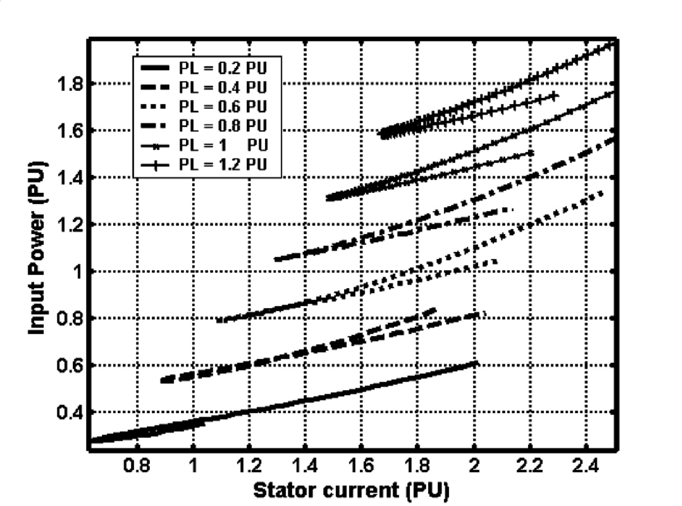

**FIG. 38.7** Input power versus stator current at rated speed and various load powers.

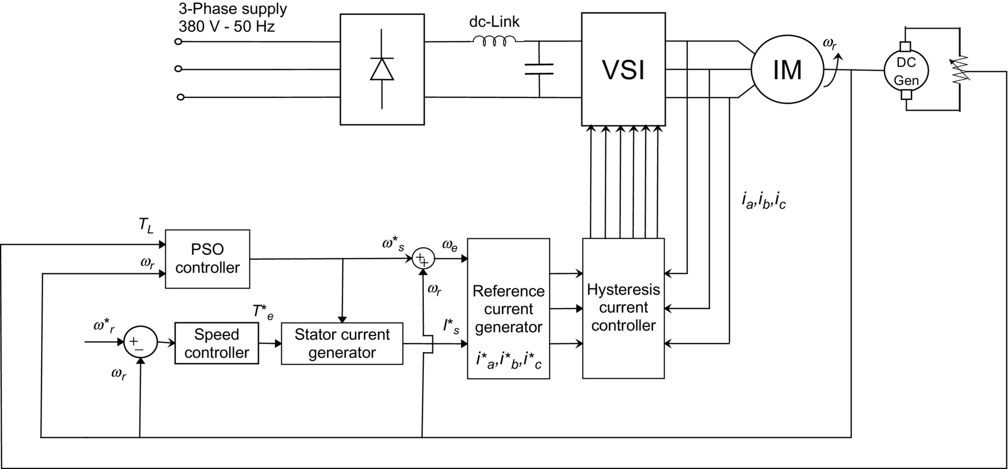

**FIG. 38.8** The proposed drive system using PSO based on the loss model controller.

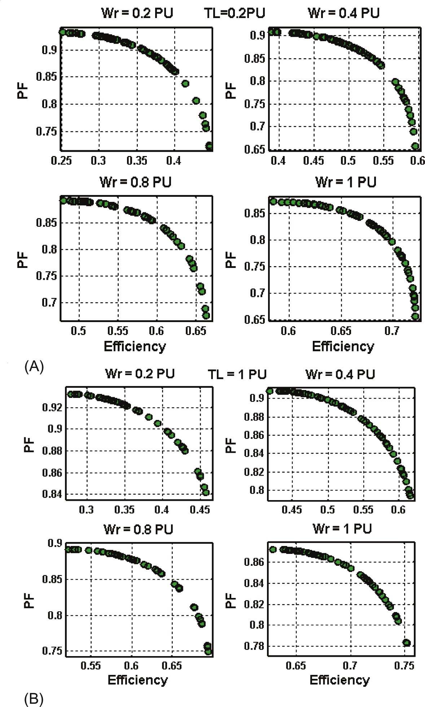

**FIG. 38.9** Pareto front of ME and MPF problem for different levels of rotor speed *ωr*=0.2, 0.4, 0.8, 1 pu and different levels of load torque: (A) *TL*=0.2 pu and (B) *TL*=1 pu.

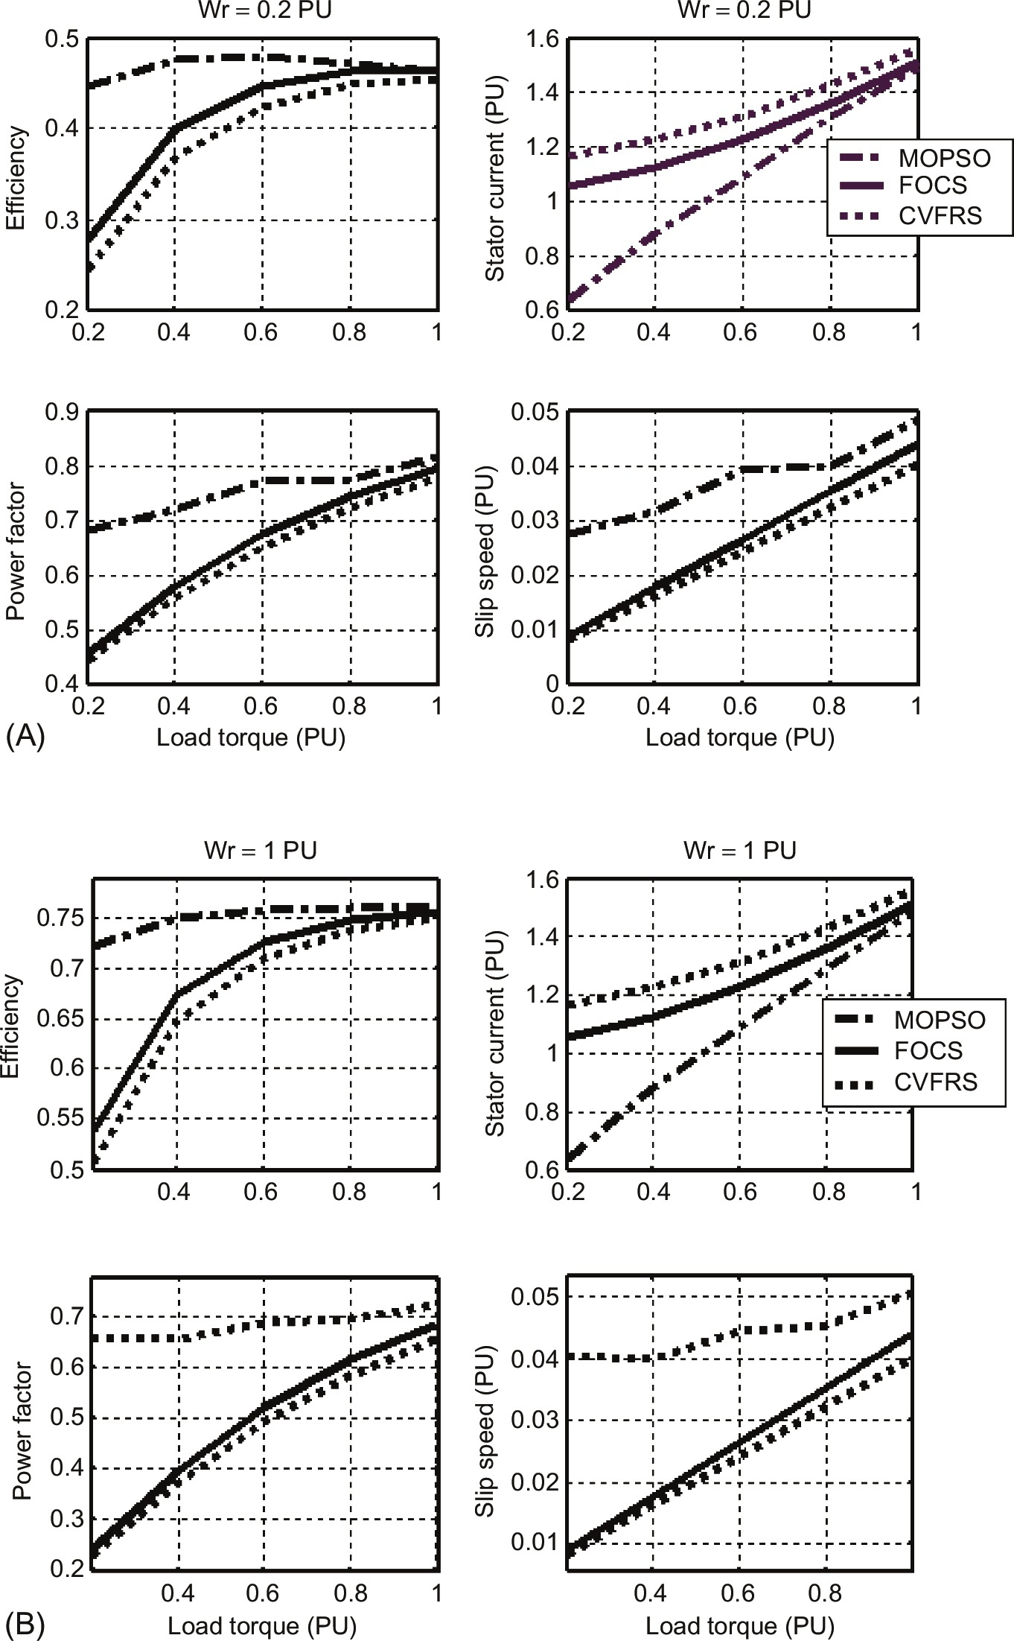

**FIG. 38.10** The comparison between CVFRS, FOCS, and MOPSO for different levels of load torque TL and different levels of rotor speed: (A) *ωr*=0.2 pu and (B) *ωr*=1 pu.

**Table 38.2**

**The limits pf the Pareto front of the two conflicting objective functions using MOGA**

|  |  |  |  |  |
| --- | --- | --- | --- | --- |
| ***TL* (pu)** | **Efficiency** | | **Power factor** | |
| **Minimum** | **Maximum** | **Maximum** | **Minimum** |
| (A) | | | | |
| *ωr*=0.2 pu | | | | |
| 0.2 | 0.2554 | 0.4665 | 0.9284 | 0.6650 |
| 0.4 | 0.2486 | 0.4544 | 0.9318 | 0.7091 |
| 0.6 | 0.2521 | 0.4371 | 0.9344 | 0.7780 |
| 0.8 | 0.2510 | 0.4688 | 0.9308 | 0.6578 |
| 1 | 0.2549 | 0.4539 | 0.9198 | 0.6771 |
| (B) | | | | |
| ωr=0.4 pu | | | | |
| 0.2 | 0.3571 | 0.5883 | 0.9010 | 0.6860 |
| 0.4 | 0.3934 | 0.6012 | 0.8862 | 0.7068 |
| 0.6 | 0.3784 | 0.5915 | 0.8963 | 0.6786 |
| 0.8 | 0.4025 | 0.5818 | 0.8871 | 0.6662 |
| 1 | 0.3794 | 0.5960 | 0.9008 | 0.6547 |
| (C) | | | | |
| ωr=0.6 pu | | | | |
| 0.2 | 0.4979 | 0.6859 | 0.8893 | 0.7015 |
| 0.4 | 0.4989 | 0.7099 | 0.8830 | 0.6641 |
| 0.6 | 0.5076 | 0.7053 | 0.8820 | 0.7114 |
| 0.8 | 0.5072 | 0.6948 | 0.8830 | 0.6872 |
| 1 | 0.4917 | 0.7051 | 0.8868 | 0.6695 |
| (D) | | | | |
| *ωr*=0.8 pu | | | | |
| 0.2 | 0.5301 | 0.7298 | 0.8753 | 0.6707 |
| 0.4 | 0.5270 | 0.7346 | 0.8744 | 0.6340 |
| 0.6 | 0.5251 | 0.7218 | 0.8738 | 0.6520 |
| 0.8 | 0.5299 | 0.7324 | 0.8722 | 0.6127 |
| 1 | 0.5285 | 0.7115 | 0.8781 | 0.7025 |
| (E) | | | | |
| *ωr*=1 pu | | | | |
| 0.2 | 0.5964 | 0.7170 | 0.8603 | 0.6899 |
| 0.4 | 0.5937 | 0.7337 | 0.8636 | 0.7032 |
| 0.6 | 0.5952 | 0.7423 | 0.8712 | 0.6599 |
| 0.8 | 0.5921 | 0.7314 | 0.8693 | 0.6919 |
| 1 | 0.5938 | 0.7366 | 0.8651 | 0.6593 |

**Table 38.3**

**The limits pf the Pareto front of the two conflicting objective functions using MOPSO**

|  |  |  |  |  |
| --- | --- | --- | --- | --- |
| **TL (pu)** | **Efficiency** | | **Power factor** | |
| **Minimum** | **Maximum** | **Maximum** | **Minimum** |
| (A) | | | | |
| *ωr*=0.2 pu | | | | |
| 0.2 | 0.2521 | 0.4463 | 0.9323 | 0.6806 |
| 0.4 | 0.2647 | 0.4768 | 0.9323 | 0.7184 |
| 0.6 | 0.2742 | 0.4792 | 0.9323 | 0.7705 |
| 0.8 | 0.2702 | 0.4725 | 0.9323 | 0.7741 |
| 1 | 0.278 | 0.4636 | 0.9323 | 0.8165 |
| (B) | | | | |
| *ωr*=0.4 pu | | | | |
| 0.2 | 0.3894 | 0.5957 | 0.9082 | 0.6328 |
| 0.4 | 0.4021 | .6257 | 0.9082 | 0.6647 |
| 0.6 | 0.4154 | 0.6309 | 0.9082 | 0.7033 |
| 0.8 | 0.4335 | 0.6271 | 0.9079 | 0.7271 |
| 1 | 0.4182 | 0.6195 | 0.9082 | 0.7532 |
| (C) | | | | |
| *ωr*=0.6 pu | | | | |
| 0.2 | 0.4804 | 0.6649 | 0.892 | 0.6342 |
| 0.4 | 0.4984 | 0.6937 | 0.892 | 0.6375 |
| 0.6 | 0.5132 | 0.7005 | 0.892 | 0.6701 |
| 0.8 | 0.5183 | 0.699 | 0.892 | 0.7224 |
| 1 | 0.523 | 0.6943 | 0.892 | 0.736 |
| (D) | | | | |
| *ωr*=0.8 pu | | | | |
| 0.2 | 0.5475 | 0.7013 | 0.8806 | 0.6221 |
| 0.4 | 0.5681 | 0.7295 | 0.8806 | 0.6676 |
| 0.6 | 0.5808 | 0.7377 | 0.8805 | 0.6542 |
| 0.8 | 0.5793 | 0.7385 | 0.8806 | 0.7124 |
| 1 | 0.5776 | 0.7353 | 0.8805 | 0.7165 |
| (E) | | | | |
| *ωr*=1 pu | | | | |
| 0.2 | 0.5846 | 0.7217 | 0.8722 | 0.6563 |
| 0.4 | 0.6093 | 0.7506 | 0.8722 | 0.6529 |
| 0.6 | 0.6221 | 0.7597 | 0.8722 | 0.6853 |
| 0.8 | 0.6277 | 0.7617 | 0.8722 | 0.6928 |
| 1 | 0.6283 | 0.7603 | 0.8722 | 0.7257 |

### 38.8.2 A NOVEL SELF REGULATING HYBRID (PV-FC-DIESEL-BATTERY) ELECTRIC VEHICLE-EV DRIVE SYSTEM [[20](https://learning.oreilly.com/library/view/power-electronics-handbook/9780128114087/B9780128114070000428.xhtml#bb0105)]

This application presents a number of novel self-regulating triloop error-driven controllers for a hybrid PV-FC-diesel-battery-powered all-wheel drive electric vehicle using four-wheel permanent magnet DC (PMDC) motors, which are modeled to include existing nonlinearities in motor plus load inertia (*J*) and viscous friction (B). A triloop dynamic error-driven scheme is proposed to regulate motor speed and current and avoid motor overloading/inrush conditions, in addition to motor speed dynamic reference tracking. The proposed triloop dynamic error-driven self-tuned control schemes are utilized to ensure dynamic energy efficiency, control loop decoupling, and grid interface stability while maintaining reference speed tracking capability. The integrated motor drive scheme is fully stabilized using novel FACTS-based green filter compensators that ensure stabilized DC bus voltage, minimal inrush current conditions, and damped load excursions. This application presents a novel comparison of multiobjective particle swarm optimization (MOPSO) and genetic search algorithms MOGA optimization and search techniques for online dynamic tuning of the different controllers under varying renewable source conditions and load excursions.

The pressing need to utilize all abundant renewable green energy sources (wind, solar, PV, wave, tidal, fuel cell, biogas, and hybrid) is currently motivated by economic and environmental concerns. The increasing reliance on costly fossil fuels with increasing rate of resource depletion is causing a shift to energy alternatives, clean fuel replacement, and energy displacement of conventional sources to new green renewable, environmentally safe, and friendly counterparts [[21](https://learning.oreilly.com/library/view/power-electronics-handbook/9780128114087/B9780128114070000428.xhtml#bb0110),[22](https://learning.oreilly.com/library/view/power-electronics-handbook/9780128114087/B9780128114070000428.xhtml#bb0115)]. Electric vehicle is one of the solutions for the reduction of the fossil fuel consumption and pollutant emissions of gas, responsible for the greenhouse effect. However, pure battery electric vehicles have shown their own range limitations; because of their size, the vehicle habitability is reduced so as its range. Adding different kinds of power supply in the same vehicle allow taking advantages from their different characteristics [[23](https://learning.oreilly.com/library/view/power-electronics-handbook/9780128114087/B9780128114070000428.xhtml#bb0120)]. Several types of electric motors may be used for EV propulsion purposes. Earlier traction motors were exclusively dc motors, either series excited or separately excited. Recently, more advanced ac drive systems have found application in EV propulsion using induction motors, permanent magnet synchronous motors, and permanent magnet brushless dc motors [[24](https://learning.oreilly.com/library/view/power-electronics-handbook/9780128114087/B9780128114070000428.xhtml#bb0125),[25](https://learning.oreilly.com/library/view/power-electronics-handbook/9780128114087/B9780128114070000428.xhtml#bb0130)]. The EV-DC motor speed or position control has been realized including conventional PI, PID, fuzzy logic based, nonlinear, adaptive variable structure, model reference adaptive control, artificial neural networks, and feedforward computed torque control strategies [[26](https://learning.oreilly.com/library/view/power-electronics-handbook/9780128114087/B9780128114070000428.xhtml#bb0135)–[28](https://learning.oreilly.com/library/view/power-electronics-handbook/9780128114087/B9780128114070000428.xhtml#bb0145)]. The need for an online gains adaptation or a “tunable” control mechanism is highly stressed in the control of any nonlinear systems with unmodeled dynamics. The PSO- and GA-based self-regulating algorithms are utilized to track any reference speed trajectory under varying parameter and load conditions. The control system comprises four different controllers used to track speed reference trajectory depicting the motor with minimum overcurrent, inrush, and ripple conditions. The proposed novel control scheme has been validated for effective dynamic speed reference trajectory tracking and enhanced power utilization.

#### **38.8.2.1 Sample Study AC-DC System**

[Figs. 38.11](https://learning.oreilly.com/library/view/power-electronics-handbook/9780128114087/B9780128114070000428.xhtml#f0060) and [38.12](https://learning.oreilly.com/library/view/power-electronics-handbook/9780128114087/B9780128114070000428.xhtml#f0065) show the proposed the four-wheel electric vehicle drive system scheme with the PV, FC sources, the diesel generator, and the backup battery. The DC compensator scheme developed by the first author is used to ensure stable, efficient, and minimal inrush operation of the hybrid renewable energy scheme. The novel PSO and GA self-tuned multiregulators and coordinated controller are used for the following purposes:

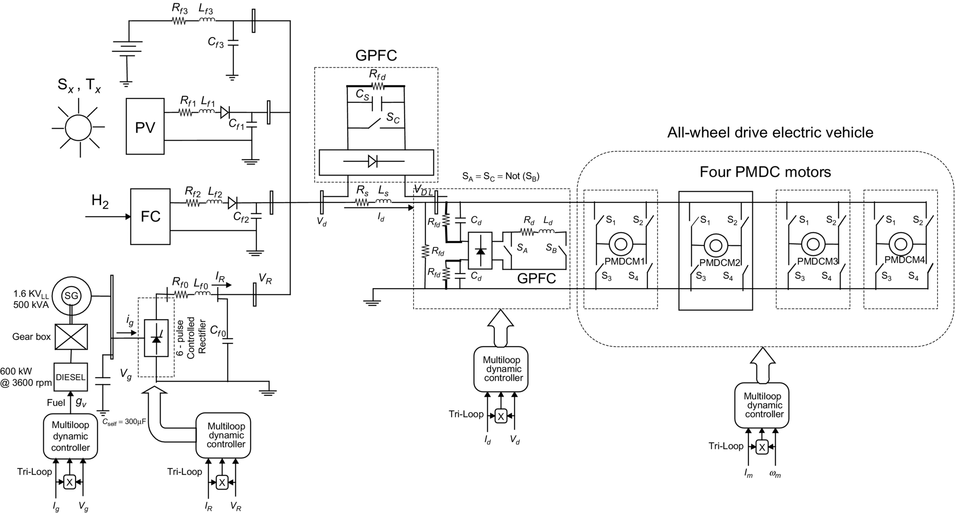

**FIG. 38.11** The proposed all-wheel electric vehicle drive system with PV-FC-diesel-battery AC/DC generation.

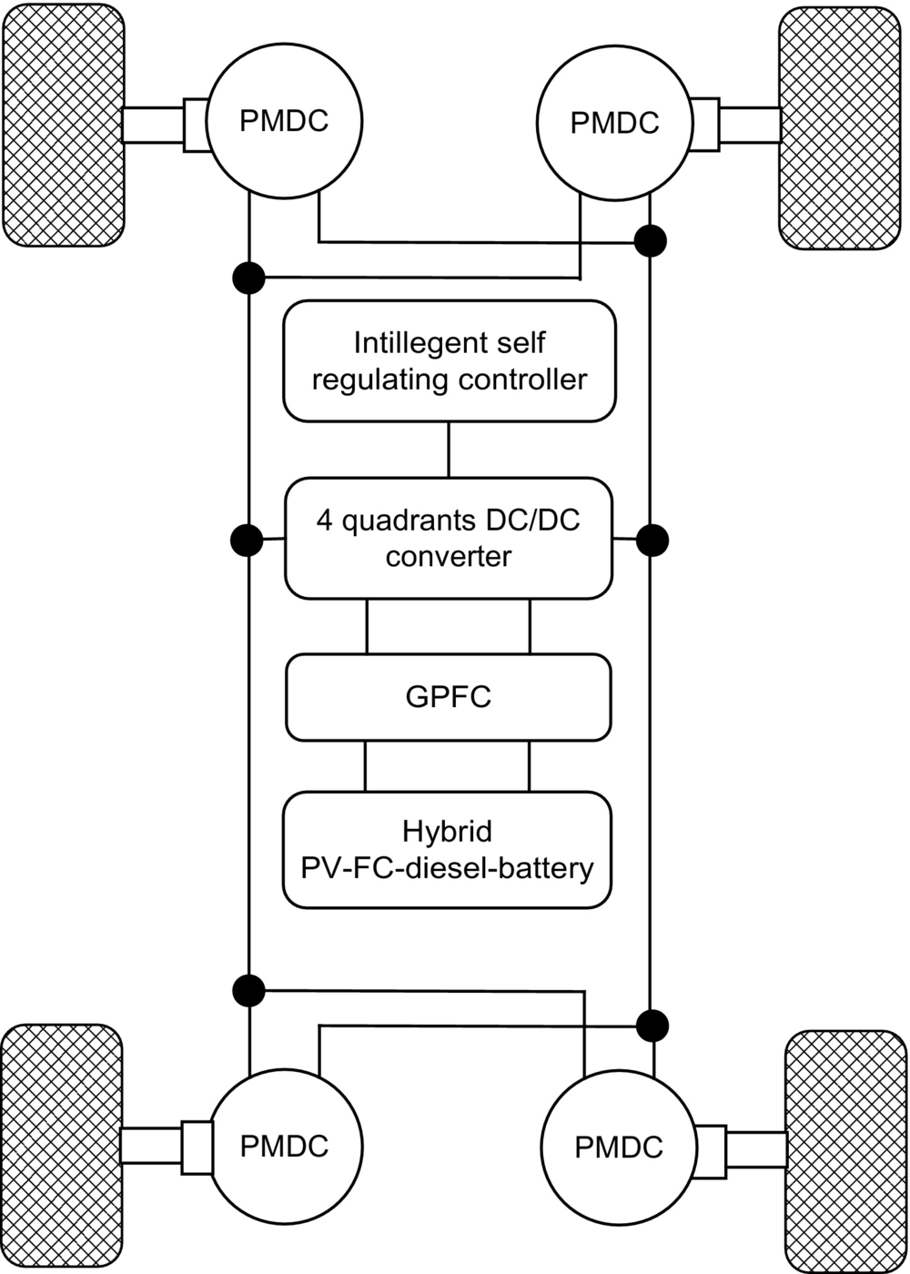

**FIG. 38.12** Schematic diagram of a prototype all-wheel drive electric vehicle using four PMDC motors.

1. Diesel AC generator set with control regulator is based on excess generation and load dynamic matching and stabilization of the common DC collection bus using six-pulse-controlled rectifier.

2. AC/DC power converter regulator to regulate the DC voltage at the diesel engine AC/DC interface and ensure limited inrush conditions and dynamic power matching to reduce current transients and improve utilization at the diesel engine interface AC-DC bus.

3. The DC side green plug filter compensator GPFC-SPWM regulator for pulse-width switching scheme to regulate the DC bus voltage and minimize inrush current transients and load excursions and/or PV and FC nonlinear volt-ampere characteristics. The GPFC device acts as a matching DC-DC interface device between the DC load dynamic characteristics and that of the hybrid main PV, FC, and backup diesel generator set.

4. The permanent magnet DC motor drive with the speed regulator that ensures speed reference tracking with minimum inrush conditions and ensures reduced voltage transients and improved energy utilization.

The unified DC-AC utilization scheme is fully validated using the Matlab/Simulink software environment under normal conditions, DC load excursion, PMDC motor torque changes and the PV, and FC source output variations due to the inherent volt-ampere nonlinear relationship. Other excursion conditions in the diesel engine generator set are also introduced to assess the control system robustness, effective energy utilization, and speed reference tracking.

##### **Diesel generator set**

From an electric system point of view, a diesel-driven AC generator can be represented as a prime mover and generator. Ideally, the prime mover has the capability to supply any power demand up to rated power at constant synchronous frequency. The synchronous generator connected to it must be able to keep the voltage constant at any load condition. The diesel engine kept the operating speed and frequency constant. When power demand fluctuates, the diesel generator could vary its power output via fuel valve regulation and governor control. The synchronous generator must control its output voltage by controlling its excitation current. Thus, the diesel generating system, as an auxiliary source, must be able to control its frequency and its output voltage. The ability of the diesel generator to respond to any frequency changes is affected by the inertia of the diesel gen set, the sensitivity of the governor, and the power capability of the diesel engine. The ability of the AC synchronous generator to control its terminal voltage can be affected by the field-winding time constant, the availability of DC excitation power to supply the field winding, and the time constant of the voltage control loop.

##### **Photo voltaic PV**

The equivalent circuit shown in [Fig. 38.13](https://learning.oreilly.com/library/view/power-electronics-handbook/9780128114087/B9780128114070000428.xhtml#f0070) is used to model the PV cells used in the proposed PV array [[29](https://learning.oreilly.com/library/view/power-electronics-handbook/9780128114087/B9780128114070000428.xhtml#bb0150)]. This model consists of a current source, a resistor, and a reverse parallel connected diode. The PVA model developed and used in Matlab/Simulink environment is based upon the circuit given in [Fig. 38.13](https://learning.oreilly.com/library/view/power-electronics-handbook/9780128114087/B9780128114070000428.xhtml#f0070), in which the current produced by the solar cell is equal to that produced by the current source, minus that which flows through the diode, minus that which flows through the shunt resistor:

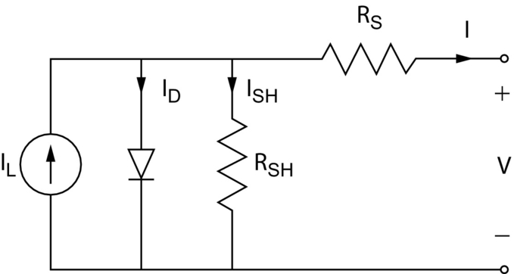

**FIG. 38.13** The equivalent circuit of a solar cell.

 **(38.8)**

where *I*=output current, *IL*=photo-generated current, *ID*=diode current, and *ISH*=shunt current. The current through these elements is governed by the voltage across them:

 **(38.9)**

where *Vj*=voltage across both diode and resistor *RSH* (volts), *V*=voltage across the output terminals (volts), *I*=output current (amperes), and *RS*=series resistance (Ω).

The current diverted through the diode is

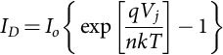 **(38.10)**

where *I0*=reverse saturation current (amperes), *n*=diode ideality factor (1 for an ideal diode), *q*=elementary charge, *k*=Boltzmann's constant, and *T*=absolute temperature.

The characteristic equation of a solar cell, which relates solar cell parameters to the output current and voltage [[30](https://learning.oreilly.com/library/view/power-electronics-handbook/9780128114087/B9780128114070000428.xhtml#bb0155)]:

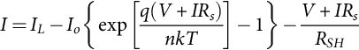 **(38.11)**

where *RSH*=shunt resistance (Ω). The *I*-*V* curve of an illuminated PV cell has the shape shown in [Fig. 38.14](https://learning.oreilly.com/library/view/power-electronics-handbook/9780128114087/B9780128114070000428.xhtml#f0075) as the voltage across the measuring load is swept from zero to *VOC*, The power produced by the cell in watts can be easily calculated along the *I*-*V* sweep by the equation *P=IV*. At the *ISC* and *VOC* points, the power will be zero, and the maximum value for power will occur between the two.

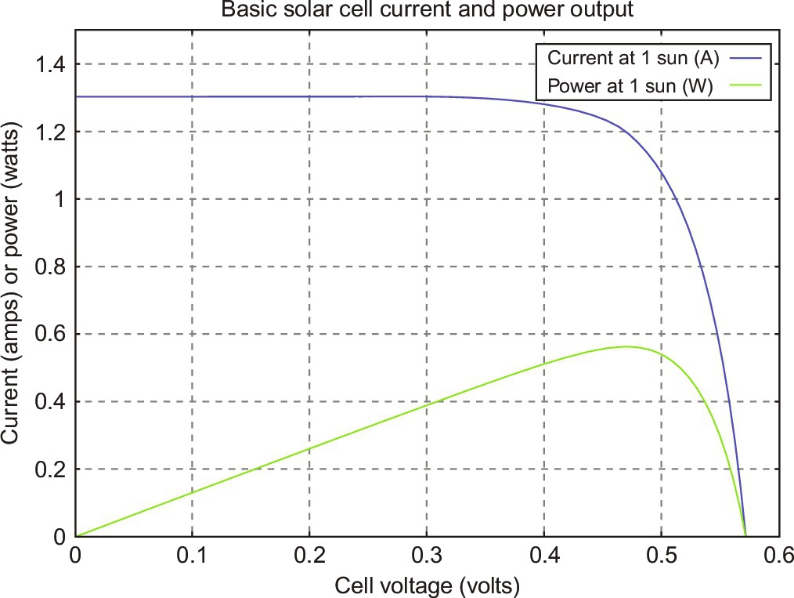

**FIG. 38.14** The behavior of a solar cell at particular intensities of solar radiation.

##### **Fuel cell energy system model**

Fuel cell stacks were connected in series/parallel combination to achieve the rating desired. [Fig. 38.15](https://learning.oreilly.com/library/view/power-electronics-handbook/9780128114087/B9780128114070000428.xhtml#f0080) shows a simplified diagram of the PEMFC system [[31](https://learning.oreilly.com/library/view/power-electronics-handbook/9780128114087/B9780128114070000428.xhtml#bb0160),[32](https://learning.oreilly.com/library/view/power-electronics-handbook/9780128114087/B9780128114070000428.xhtml#bb0165)]. The FC model here is for a type of PEM, which uses the following electrochemical reaction:

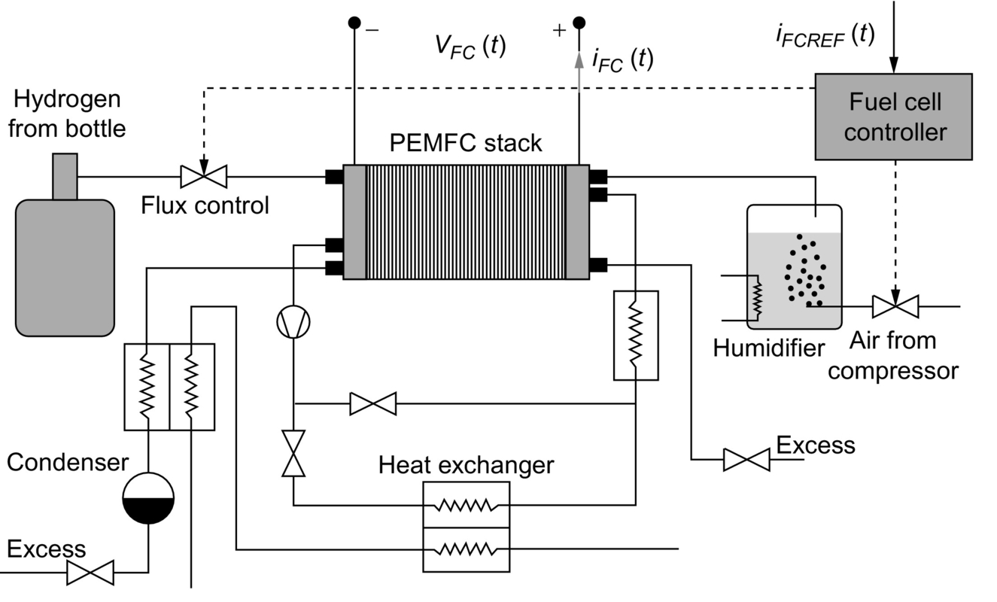

**FIG. 38.15** Simplified diagram of the fuel cell PEMFC system.

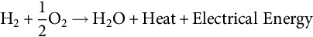 **(38.12)**

[Fig. 38.16](https://learning.oreilly.com/library/view/power-electronics-handbook/9780128114087/B9780128114070000428.xhtml#f0085) shows a simulated *V*-*I* (voltage versus current) polarization curve of a fuel cell [[31](https://learning.oreilly.com/library/view/power-electronics-handbook/9780128114087/B9780128114070000428.xhtml#bb0160),[32](https://learning.oreilly.com/library/view/power-electronics-handbook/9780128114087/B9780128114070000428.xhtml#bb0165)]. As the cell current begins to increase from zero, a sudden drop of the output voltage of the fuel cell is seen. This drop of the cell voltage is due to activation voltage loss. Then, almost a linear decrease of the cell voltage is seen as the cell current increases beyond certain values, as shown in [Fig. 38.17](https://learning.oreilly.com/library/view/power-electronics-handbook/9780128114087/B9780128114070000428.xhtml#f0090), which is a result of the ohmic loss. Finally, the cell voltage drops sharply to zero as the load current approaches the maximum current density that can be generated of the fuel cell. The sharp voltage drop is the effect of the concentration loss in the fuel cell. The fuel cell can be commonly modeled by simple equivalent first-order circuit shown in [Fig. 38.10](https://learning.oreilly.com/library/view/power-electronics-handbook/9780128114087/B9780128114070000428.xhtml#f0055). The open circuit voltage is modified as follows:

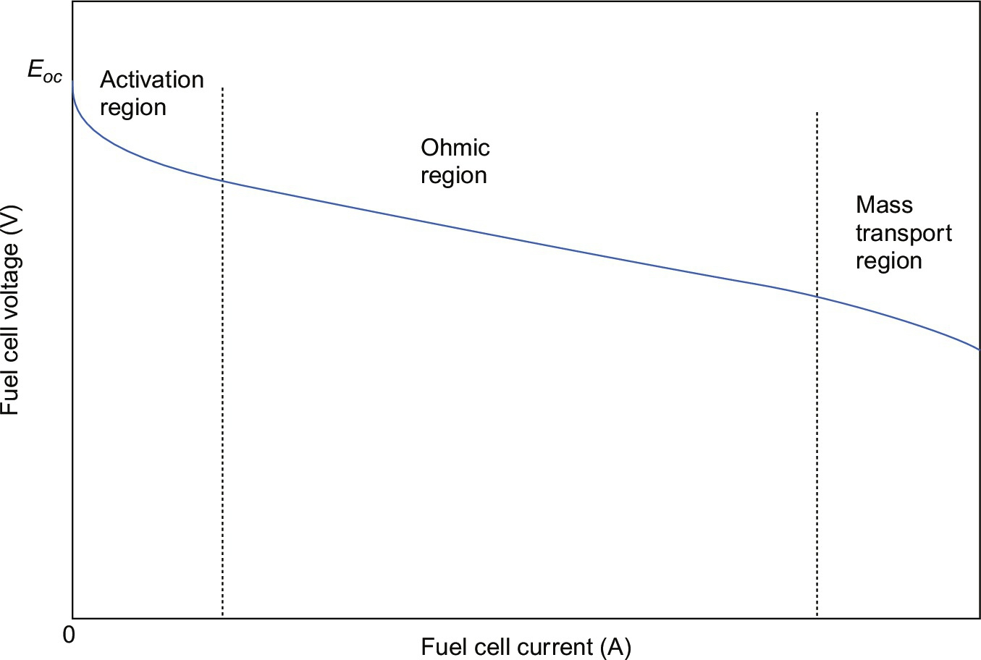

**FIG. 38.16** (*V*-*I*) polarization curve of an SOFC.

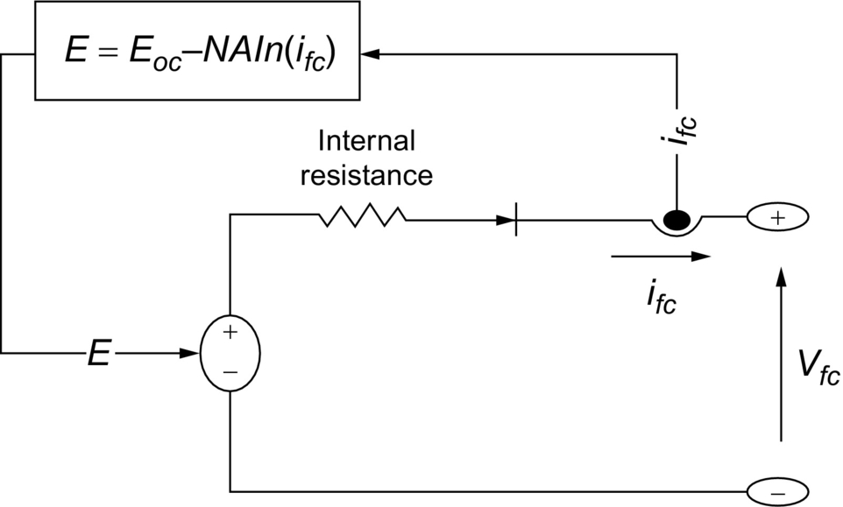

**FIG. 38.17** DC-equivalent circuit of an electrochemical fuel cell.

 **(38.13)**

where

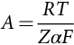 **(38.14)**

where *R*=8.3145 J/(mol K); *F*=96,485 As/mol; *z*=number of moving electrons; *En*=Nernst voltage, which is the thermodynamics voltage of the cells and depends on the temperatures and partial pressures of reactants and products inside the stack; and *i*0=exchange current, which is the current resulting from the continual backward and forward flow of electrons from and to the electrolyte at no load. It depends also on the temperatures and partial pressures of reactants inside the stack. *α* is the charge transfer coefficient, which depends on the type of electrodes and catalysts used and *T* is the temperature of operation. The fuel cell voltage *VFC* is modeled as [[31](https://learning.oreilly.com/library/view/power-electronics-handbook/9780128114087/B9780128114070000428.xhtml#bb0160),[32](https://learning.oreilly.com/library/view/power-electronics-handbook/9780128114087/B9780128114070000428.xhtml#bb0165)]

 **(38.15)**

where

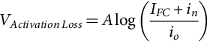 **(38.16)**

**** **(38.17)**

**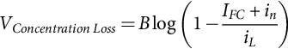** **(38.18)**

Fuel cell stacks were connected in series/parallel combination to achieve the rating desired. The output of the fuel cell array was connected to a DC bus through a DC/DC converter. The DC bus voltage was kept constant via a DC bus voltage controller.

##### **DC side green plug filter compensator GPFC**

The common concerns of power quality are the long-duration voltage variations (overvoltage, undervoltage, and sustained interruptions), short-duration voltage variations (interruption, sags, and swells), voltage imbalance (voltage unbalance), waveform distortion (DC offset, harmonics, interharmonics, notching, and noise), voltage fluctuation (voltage flicker), and power frequency variations [[33](https://learning.oreilly.com/library/view/power-electronics-handbook/9780128114087/B9780128114070000428.xhtml#bb0170)]. To prevent the undesirable states and to reduce the power consumption, a GPF scheme is used to stabilize the common DC bus.

##### **Dynamic error driven control**

The proposed control system developed by first author comprises four subregulators or controllers named as a diesel DC generator set value control regulator, DC side green plug filter compensator GPFC-SPWM regulator, the permanent magnet DC motor drive speed controller, and the AC/DC power converter regulator. [Figs. 38.12](https://learning.oreilly.com/library/view/power-electronics-handbook/9780128114087/B9780128114070000428.xhtml#f0065)–[38.15](https://learning.oreilly.com/library/view/power-electronics-handbook/9780128114087/B9780128114070000428.xhtml#f0080) depict the proposed multiloop dynamic self-regulating controllers based on multiobjective optimization search and optimization technique based on soft computing PSO and GA. The global error is the summation of the three loop individual errors including voltage stability, current limiting, and synthesis dynamic power loops. Each multiloop dynamic control scheme is used to reduce a global error based on a triloop dynamic error summation signal and to mainly track a given speed reference trajectory loop error in addition to other supplementary motor current limiting, and dynamic power loops are used as auxiliary loops to generate a dynamic global total error signal that consists of not only the main loop speed error but also the current ripple, overcurrent limit, and dynamic overload power conditions.

The global error signal is input to the self-tuned controllers shown in [Figs. 38.18](https://learning.oreilly.com/library/view/power-electronics-handbook/9780128114087/B9780128114070000428.xhtml#f0095)–[38.21](https://learning.oreilly.com/library/view/power-electronics-handbook/9780128114087/B9780128114070000428.xhtml#f0110). The (per unit) three-dimensional-error vector (*evg*, *eIg*, and *epg*) of the diesel engine controller scheme is governed by the following equations:

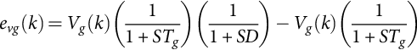 **(38.19)**

**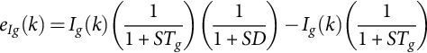** **(38.20)**

**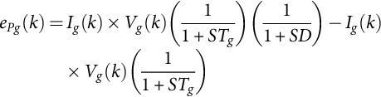** **(38.21)**

**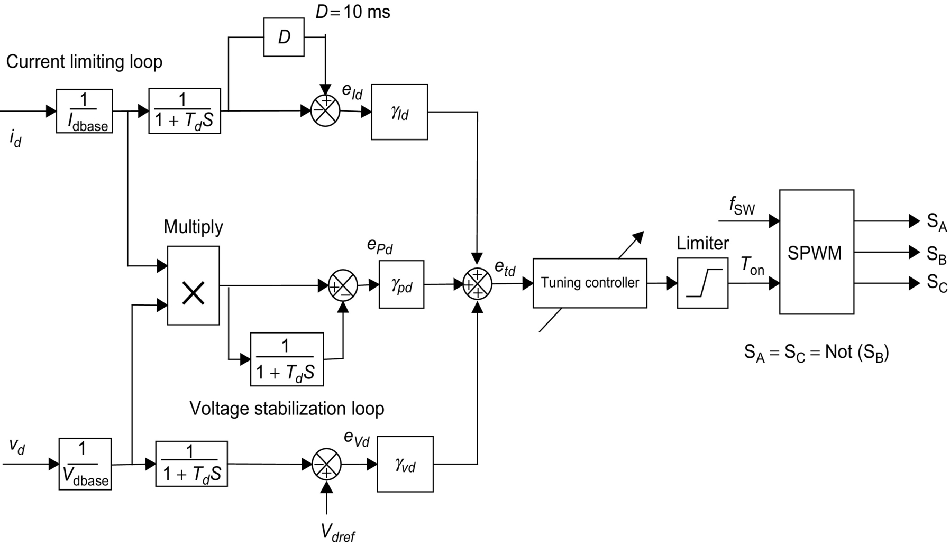**

**FIG. 38.18** Triloop error-driven self-regulating VSC/SMC/B-B controller for the common DC side GPFC scheme.

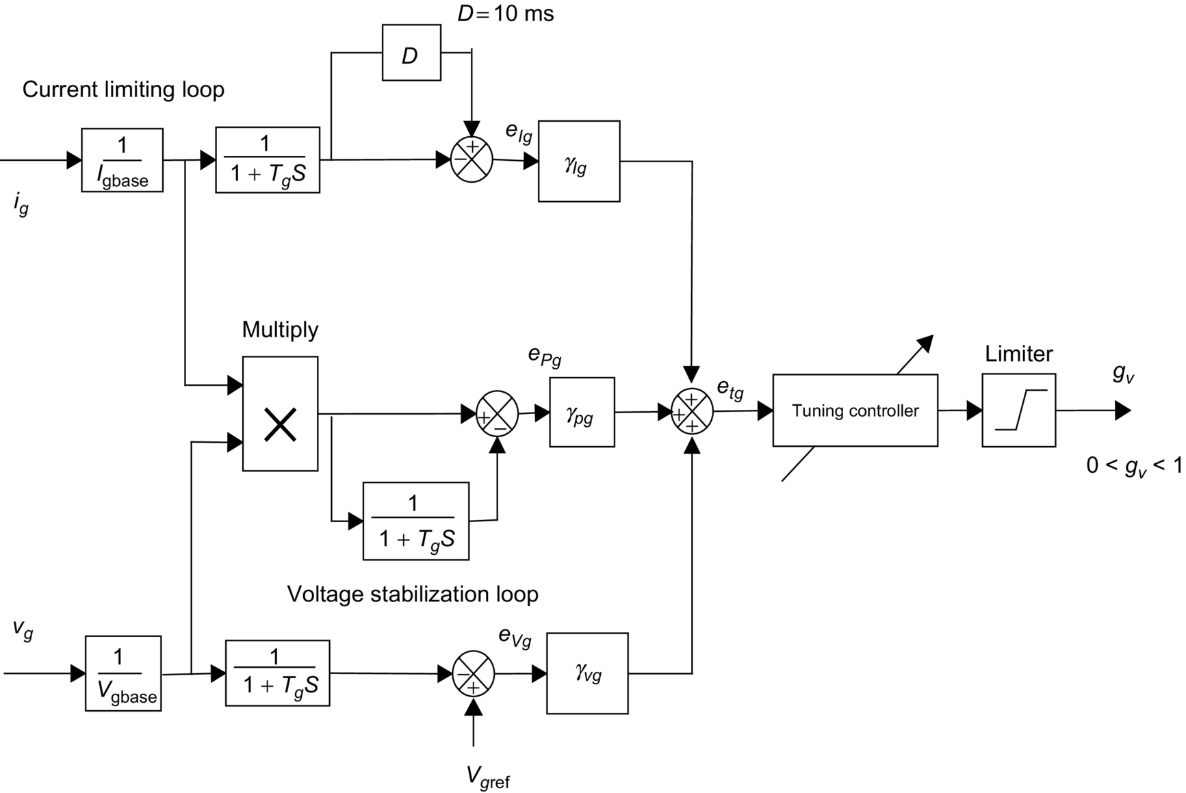

**FIG. 38.19** Triloop error-driven self-regulating VSC/SMC/B-B controller for the diesel engine generator set.

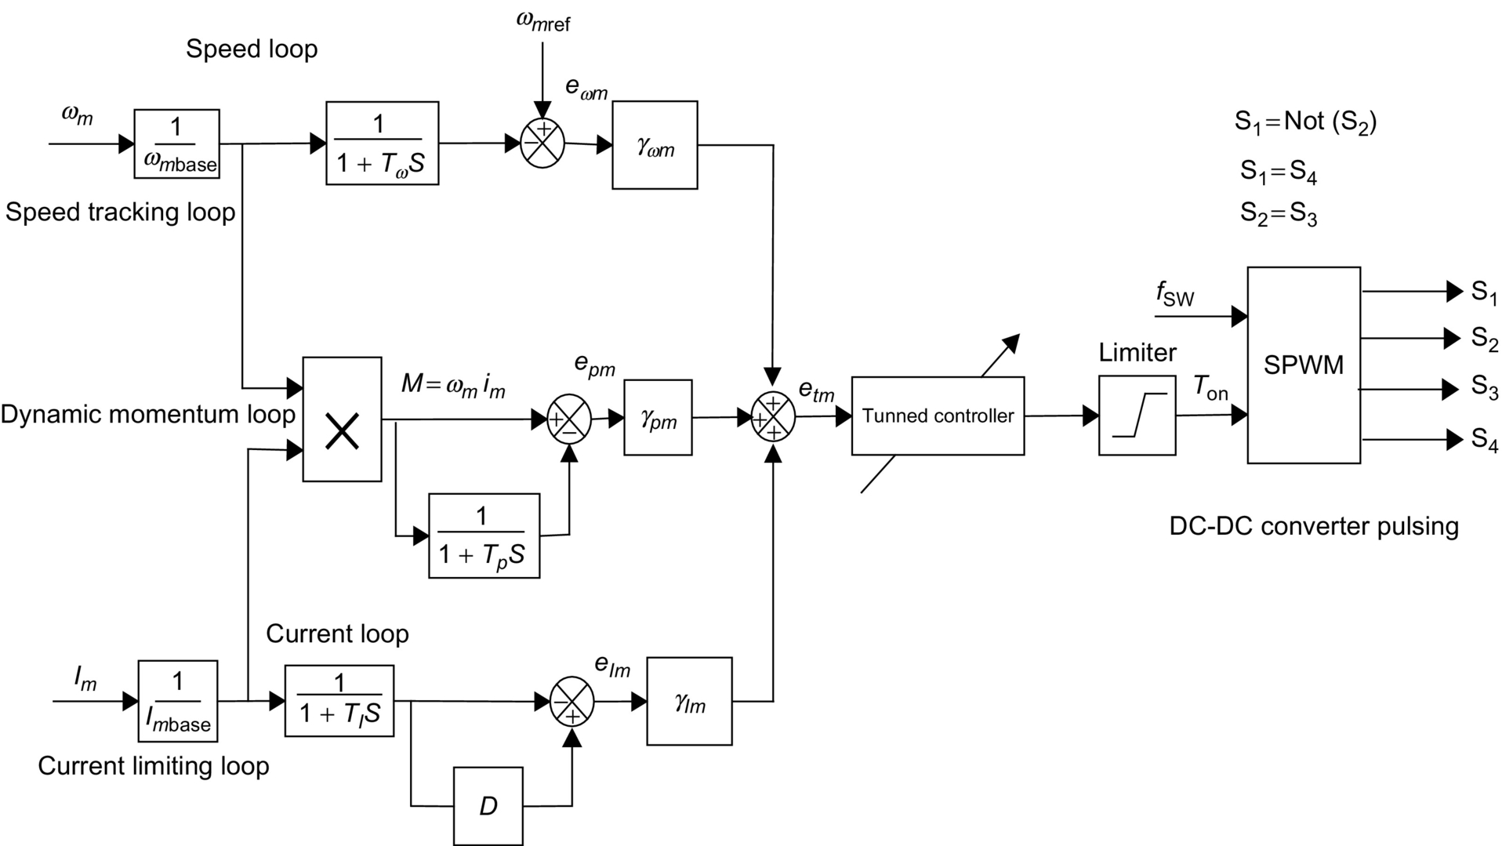

**FIG. 38.20** Triloop error-driven self-regulating VSC/SMC/B-B controller for dynamic speed control PMDC motor drive.

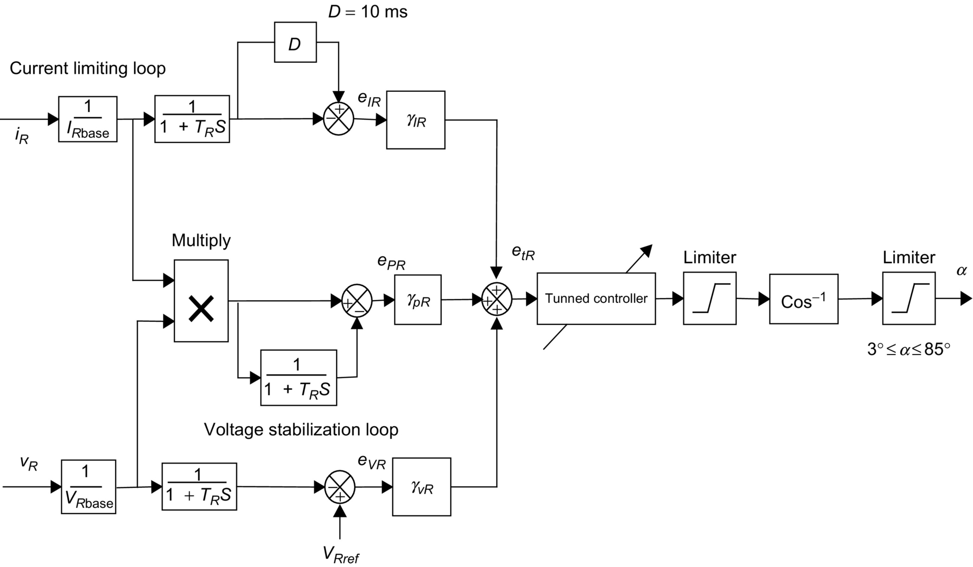

**FIG. 38.21** Triloop error-driven self-regulating VSC/SMC/B-B controller firing angle α-controller for diesel AC/DC interface rectifier scheme.

The total or global error *etg*(*k*) at the AC side scheme at a time instant

 **(38.22)**

In the same manner, the (per unit) three-dimensional-error vector (*evd*, *eId*, and *epd*) of the GPFC scheme is governed by the following equations:

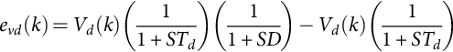 **(38.23)**

**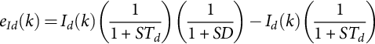** **(38.24)**

**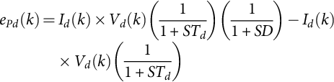** **(38.25)**

and the total or global error *etd*(*k*) for the DC side green plug filter compensator GPFC scheme at a time instant

 **(38.26)**

In addition, The (per unit) three-dimensional-error vector (*evR*, *eIR*, and *epR*) of the three-phase-controlled rectifier scheme is governed by the following equations:

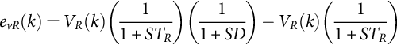 **(38.27)**

**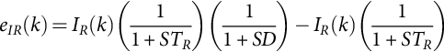** **(38.28)**

**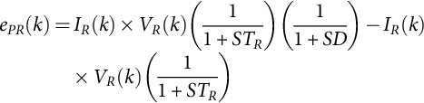** **(38.29)**

The total or global error *etR*(*k*) for the three-phase-controlled converter rectifier scheme at a time instant:

 **(38.30)**

Finally, the (per unit) three-dimensional-error vector (*eωm*, *eIm*, and *epm*) of the PMDC motor scheme is governed by the following equations:

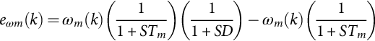 **(38.31)**

**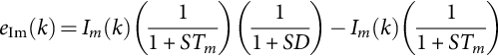** **(38.32)**

**** **(38.33)**

and the total or global error *etm*(*k*) for the MPFC scheme at a time instant

 **(38.34)**

A number of conflicting objective functions are selected to optimize using the PSO algorithm. These functions are defined by the following:

 **(38.35)**

**** **(38.36)**

**** **(38.37)**

**** **(38.38)**

**** **(38.39)**

In general, to solve this multiobjective complex optimality search problem, there are two possible optimization techniques based on particle swarm optimization (PSO): single aggregate selected objective optimization (SOO), which is explained, and multiobjective optimization (MOO). The main procedure of the SOO is based on selecting a single aggregate objective function with weighted single-objective parameters scaled by a number of weighting factors. The objective function is optimized (either minimized or maximized) using either GA or particle swarm optimization search algorithm (PSO) methods to obtain a single global or near-optimal solution. On the other hand, the main objective of the multiobjective (MO) problem is finding the set of acceptable (trade-off) optimal solutions. This set of accepted solutions is called Pareto front. These acceptable trade-off multilevel solutions give more ability to the user to make an informed decision by seeing a wide range of near-optimal selected solutions that are feasible and acceptable from an “overall” standpoint. Single-objective (SO) optimization may ignore this trade-off viewpoint, which is crucial. The main advantages of the proposed MOO method are the following: It doesn't require a priori knowledge of the relative importance of the objective functions, and it provides a set of acceptable trade-off near-optimal solutions. This set is called Pareto front or optimality trade-off surfaces. Both SOO and MOO searching algorithms are tested, validated, and compared. The dynamic error-driven controller regulates the controllers' gains using the particle swarm optimization (PSO) and GA to minimize the system total error, the settling time, the rising time, and the maximum overshoot. The proposed dynamic triloop error-driven controller, developed by the first author, is a novel advanced regulation concept that operates as an adaptive dynamic-type multipurpose controller capable of handling sudden parametric changes, load and/or DC source excursions. By using the triloop error-driven controller, it is expected to have a smoother, less dynamic overshoot and fast and more robust speed controller when compared with those of classical control schemes. The proposed general PMDC motor drive model with the novel triloop error-driven controller is fully validated in this application for effective reference speed trajectory tracking under different loading conditions and parametric variations, such as temperature changes, while driving a complex mechanical load with nonlinear parameters and/or torque-speed characteristics.

##### **Self tuned variable structure sliding mode bang-bang VSC/SMC/B-B controller**

In the variable structure sliding mode controller scheme, an optimally adaptive and self-tuned variable structure sliding mode controller for PMDC motor drive systems using particle swarm optimization technique (PSO) and GA is shown in [Fig. 38.22](https://learning.oreilly.com/library/view/power-electronics-handbook/9780128114087/B9780128114070000428.xhtml#f0115). The slope of the sliding surface is designed as

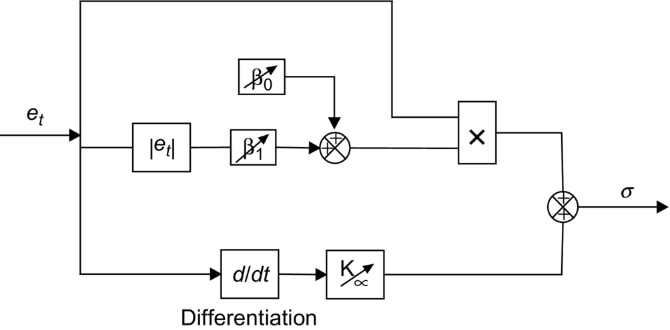

**FIG. 38.22** VSC/SMC/B-B controller block diagram.

 **(38.40)**

With adaptive adjustable error scaling gain,

 **(38.41)**

where

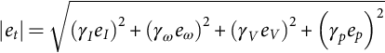 **(38.42)**

The system control voltage has the following form in the time domain [[33](https://learning.oreilly.com/library/view/power-electronics-handbook/9780128114087/B9780128114070000428.xhtml#bb0170)]: the control is an on-off logic; that is, when 

The PSO and GA search and optimization are implemented for tuning the various gains *β*0, *β*1, and *α* to minimize the selected five conflicting objective functions (*J*1−*J*5). This test is to verify that the proposed VSC/B-B with adaptive *β* can maintain the motor speed with nonlinear *J*(*ωm*) and *B*(*ωm*) even if the load changes; accordingly, the robustness can be confirmed.

##### **Self tuned artificial neural network controller ANN**

The neural network used in this application is the simplest one that uses three layers, which is widely used in the control of the electric machines. Each layer is composed of neurons. Each neuron is connected via weights to the previous layer. The first layer is connected to the input variables. The second one is connected via weights to all the neurons of the previous layer, and the last one is composed of one neuron given the output value. The weights and the biases of the ANN network's are updated to provide that the global error of the system is minimized. The proposed ANN regulator is tuned online using the back-propagation algorithm. The online ANN rule-based algorithm is used to update the ANN network weights and biases to ensure continuous effective dynamic response while keeping the motor inrush current under specified tolerable limits. The input vector with three-layer ANN as shown in [Fig. 38.23](https://learning.oreilly.com/library/view/power-electronics-handbook/9780128114087/B9780128114070000428.xhtml#f0120) is

 **(38.43)**

****

**FIG. 38.23** ANN incremental controlled controller block diagram.

##### **Self tuned fuzzy logic controller (FLC)**

As shown in [Fig. 38.24](https://learning.oreilly.com/library/view/power-electronics-handbook/9780128114087/B9780128114070000428.xhtml#f0125), the FLC system consists of three subsystems, which are the fuzzification, rule base, and defuzzification. Fuzzification subsystem converts the exact inputs to fuzzy values using five membership functions: positive big (PB), positive small (PS), zero (ZZ), negative small (NS), and negative big (NB). The rule base unit processes these fuzzy values with fuzzy rules. The defuzzification unit converts the fuzzy results to exact values. The FLC input values are the global error, *et*, and change in global error, *det*. According to these variables, a rule table is produced in the FLC rule base unit as shown in [Table 38.4](https://learning.oreilly.com/library/view/power-electronics-handbook/9780128114087/B9780128114070000428.xhtml#t0025).



**FIG. 38.24** Main structure of the FLC incremental scheme.

**Table 38.4**

**Fuzzy rule decision table**

|  |  |  |  |  |  |
| --- | --- | --- | --- | --- | --- |
| ***et*** | ***det*** | | | | |
| **NB** | **NS** | **ZZ** | **PS** | **PB** |
| NB | NB | NB | NS | NS | ZZ |
| NS | NB | NS | NS | ZZ | PS |
| ZZ | NS | NS | ZZ | PS | PS |
| PS | NS | ZZ | PS | PS | PB |
| PB | ZZ | PS | PS | PB | PB |

#### **38.8.2.2 Digital Simulation Results**

The integrated microgrid for PMDC-driven electric vehicle scheme using the photovoltaic (PV), fuel cell (FC), and backup diesel generation with battery backup renewable generation system performance is compared for two cases, with fixed and self-tuned-type controllers using either GA or PSO. The second case is to compare the performance with artificial neural network (ANN) controller and fuzzy logic controller (FLC) with the self-tuned-type controllers using either GA or PSO. The tuned variable structure sliding mode controller VSC/SMC/B-B has been applied to the speed tracking control of the same EV for performance comparison. There are three different speed references. In the first speed track, the speed increases linearly and reaches the 1 pu at the end of the first 5 s, and then, the reference speed remains speed constant during 5 s. At tenth second, the reference speed decreases with same slope as at the first 5 s. After 15 s, the motor changes the direction and EV increases its speed through the reverse direction. At twentieth second, the reference speed reaches the −1 pu and remains constant speed at the end of twenty-fifth second, and then, the reference speed decreases and becomes zero at thirtieth second. The second reference speed waveform is sinusoidal, and its magnitude is 1 pu, and the period is 12 s. The third reference track is constant speed reference starting with an exponential track. In all references, the system responses have been observed. Matlab/Simulink software was used to design, test, and validate the effectiveness of the integrated microgrid for PMDC-driven electric vehicle scheme using photovoltaic (PV), fuel cell (FC), and backup diesel generation with battery backup renewable generation system with the FACTS devices. The digital dynamic simulation model using Matlab/Simulink software environment allows for low-cost assessment and prototyping, system parameter selection, and optimization of control settings. The use of PSO search algorithm is utilized in online gain adjusting to minimize controller absolute value of total error. This is required before full-scale prototyping that is both expensive and time-consuming. The effectiveness of dynamic simulators brings on detailed submodels selections and tested submodels Matlab library of power system components already tested and validated. The common DC bus voltage reference is set at 1 pu. Digital simulations are obtained with sampling interval Ts=20 μs. Dynamic responses obtained with GA are compared with the ones resulting from the PSO for the seven proposed self-tuned controllers. The dynamic simulation conditions are identical for all tuned controllers. To compare the global performances of all controllers, the normalized mean-square-error (*NMSE*) deviations between output plant variables and desired values and is defined as

 **(38.44)**

**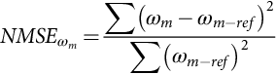** **(38.45)**

The digital simulation results validated the effectiveness of both GA- and PSO-based tuned controllers in providing effective speed tracking minimal steady-state errors. Transients are also damped with minimal overshoot, settling time, and fall time. The GA- and PSO-based self-tuned controllers are more effective and dynamically advantageous in comparison with the artificial neural network (ANN) controller, the fuzzy logic controller (FLC), and fixed-type controllers. The self-regulation is based on minimal value of absolute total/global error of each regulator shown in [Figs. 38.18](https://learning.oreilly.com/library/view/power-electronics-handbook/9780128114087/B9780128114070000428.xhtml#f0095)–[38.21](https://learning.oreilly.com/library/view/power-electronics-handbook/9780128114087/B9780128114070000428.xhtml#f0110). The control system comprising the three dynamic multiloop error-driven regulators is coordinated to minimize the selected objective functions. SOO obtains a single global or near-optimal solution based on a single-weighted objective function. The weighted single-objective function combines several objective functions using specified or selected weighting factors as follows:

 **(38.46)**

where *α*1=0.20, *α*2=0.20, *α*3=0.20, *α*4=0.20, and *α*5=0.20 are selected weighting factors. *J*1, *J*2, *J*3, *J*4, and *J*5 are the selected objective functions. On the other hand, the MO finds the set of acceptable (trade-off) optimal solutions. This set of accepted solutions is called Pareto front. These acceptable trade-off multilevel solutions give more ability to the user to make an informed decision by seeing a wide range of near-optimal selected solutions.

[Table 38.5](https://learning.oreilly.com/library/view/power-electronics-handbook/9780128114087/B9780128114070000428.xhtml#t0030) shows the optimal solutions of the main objective functions versus the tuned variable structure sliding mode controller gain-based SOGA and MOGA control schemes. On the other hand, [Table 38.6](https://learning.oreilly.com/library/view/power-electronics-handbook/9780128114087/B9780128114070000428.xhtml#t0035) shows the optimal solutions of the main objective functions versus the tuned variable structure sliding mode controller gain-based SOPSO and MOPSO control schemes. [Table 38.7](https://learning.oreilly.com/library/view/power-electronics-handbook/9780128114087/B9780128114070000428.xhtml#t0040) shows the DC bus behavior comparison using the GA-based tuned variable structure sliding mode controller for the three selected reference tracks. In addition, [Table 38.8](https://learning.oreilly.com/library/view/power-electronics-handbook/9780128114087/B9780128114070000428.xhtml#t0045) shows the system behavior using the PSO-based tuned variable structure sliding mode controller. [Figs. 38.25](https://learning.oreilly.com/library/view/power-electronics-handbook/9780128114087/B9780128114070000428.xhtml#f0130)–[38.30](https://learning.oreilly.com/library/view/power-electronics-handbook/9780128114087/B9780128114070000428.xhtml#f0155) show the effectiveness of MOPSO and MOGA search and optimized control gains in tracking the PMDC-EV motor three reference speed trajectories. Comparing the PMDC-EV dynamic response results of the two study cases, with GA and PSO tuning algorithms and traditional controllers with constant controller gain results shown in [Table 38.9](https://learning.oreilly.com/library/view/power-electronics-handbook/9780128114087/B9780128114070000428.xhtml#t0050), ANN controller in [Table 38.10](https://learning.oreilly.com/library/view/power-electronics-handbook/9780128114087/B9780128114070000428.xhtml#t0055) ([Figs. 38.31](https://learning.oreilly.com/library/view/power-electronics-handbook/9780128114087/B9780128114070000428.xhtml#f0160)–[38.33](https://learning.oreilly.com/library/view/power-electronics-handbook/9780128114087/B9780128114070000428.xhtml#f0170)) and FLC in [Table 38.11](https://learning.oreilly.com/library/view/power-electronics-handbook/9780128114087/B9780128114070000428.xhtml#t0060) ([Figs. 38.34](https://learning.oreilly.com/library/view/power-electronics-handbook/9780128114087/B9780128114070000428.xhtml#f0175)–[38.36](https://learning.oreilly.com/library/view/power-electronics-handbook/9780128114087/B9780128114070000428.xhtml#f0185)), it is quite apparent that the GA and PSO tuning algorithms highly improved the PMDC-EV system dynamic performance from a general power quality point of view. The GA and PSO tuning algorithms had a great impact on the system efficiency improving it from 0.906631 (constant gains controller), 0.928253 (ANN controller), and 0.937334 (FLC) to around 0.948156 (GA-based tuned controller) and 0.930708 (PSO-based tuned controller) that is highly desired. Moreover, the normalized mean square error (*NMSE-V*DC-Bus) of the DC bus voltage is reduced from 0.08443 (constant gains controller), 0.04827 (ANN controller), and 0.03022 (FLC) to around 0.007304 (GA-based tuned controller) and 0.005854 (PSO-based tuned controller). In addition, the normalized mean square error (*NMSE\_ωm*) of the PMDC motor is reduced from 0.053548 (constant gains controller), 0.02627 (ANN controller), and 0.02016 (FLC) to around 0.0076308 (GA-based tuned controller) and 0.006309 (PSO-based tuned controller). Maximum transient DC voltage over/undershoot (pu) is reduced from 0.054604 (constant gains controller), 0.04186 (ANN controller), and 0.03126 (FLC) to around 0.009302 (GA-based tuned controller) and 0.007259 (PSO-based tuned controller). Maximum transient DC current—over/undershoot (pu) is reduced from 0.087336 (constant gains controller), 0.07355 (ANN controller), and 0.04383 (FLC) to around 0.00292 (GA-based tuned controller) and 0.005987 (PSO-based tuned controller). DC bus voltage (pu) is improved from 0.917020 (constant gains controller), 0.932736 (ANN controller), and 0.94745 (FLC) to around 0.97417 (GA-based tuned controller) and 0.974602 (PSO-based tuned controller). DC bus current (pu) is reduced from 0.769594 (constant gains controller), 0.67464 (ANN controller), and 0.64712 (FLC) to around 0.614695 (GA-based tuned controller) and 0.607674 (PSO-based tuned controller). PMDCM total controller Error (*etm*) is reduced from 0.095145 (constant gains controller), 0.04200 (ANN controller), and 0.02154 (FLC) to around 0.009167 (GA-based tuned controller) and 0.0048638 (PSO-based tuned controller). DC side GPFC Error (*etd*) is reduced from 0.70746 (constant gains controller), 0.03416 (ANN controller), and 0.02416 (FLC) to around 0.004618 (GA-based tuned controller) and 0.0074294 (PSO-based tuned controller). The diesel engine gen set total controller error (*etg*) is reduced from 0.067513 (constant gains controller), 0.04507 (ANN controller), and 0.02964 (FLC) to around 0.005121 (GA-based tuned controller) and 0.007013 (PSO-based tuned controller). The diesel engine converter total controller error (*etR*) is reduced from 0.086233 (constant gains controller), 0.03978 (ANN controller), and 0.0260 (FLC) to around 0.003265 (GA-based tuned controller) and 0.0053836 (PSO-based tuned controller).

**Table 38.5**

**Selected objective functions versus the tuned variable structure sliding mode controller-based SOGA and MOGA control schemes**

|  |  |  |  |  |  |  |  |  |  |
| --- | --- | --- | --- | --- | --- | --- | --- | --- | --- |
|  | **The diesel generator regulator**  **si1_e** | **The GPFC-DC side regulator**  **si2_e** | **The PMDC motor regulator**  **si3_e** | **The α- controller for the converter regulator**  **si4_e** | ***J*1**  **Minimize the (total error)**  **×10−2** | ***J*2**  **Minimize the (steady-state error) (pu)**  **×10−2** | ***J*3**  **Minimize the (settling time) (pu)**  **×10−2** | ***J*4**  **Minimize the (maximum overshoot)**  **×10−2** | ***J*5**  **Minimize the (rise time)**  **×10−2** |
| SOGA | 0.4111 | 0.6814 | 0.5376 | 0.0775 | 0.4262 | 0.9659 | 0.3315 | 0.6058 | 0.4274 |
| 7.6052 | 7.2686 | 3.7351 | 2.3320 |
| 34.4595 | 18.0903 | 20.3967 | 49.4889 |
| MOGA | 0.2438 | 0.1278 | 0.5250 | 0.7085 | 0.3359 | 0.1214 | 0.1330 | 0.6465 | 0.5219 |
| 6.7638 | 9.9706 | 4.6294 | 2.0195 |
| 39.6771 | 41.6427 | 29.9333 | 31.7174 |
| 0.4171 | 0.7711 | 0.0017 | 0.8023 | 0.6439 | 0. 5840 | 0.8680 | 0.5505 | 0.4381 |
| 9.9078 | 7.3238 | 7.2307 | 6.6139 |
| 42.8415 | 30.3825 | 41.9151 | 33.9013 |
| 0.0796 | 0.5655 | 0.9480 | 0.5227 | 0.9325 | 0.7425 | 0.1286 | 0.4502 | 0.1956 |
| 4.6150 | 9.8655 | 8.5251 | 9.5619 |
| 14.8331 | 27.3988 | 20.8308 | 27.8837 |
| 0.5943 | 0.8238 | 0.8155 | 0.3747 | 0. 6220 | 0.8159 | 0.7435 | 0.3811 | 0.8706 |
| 2.5467 | 9.8989 | 2.4722 | 5.2401 |
| 14.8681 | 13.7004 | 37.7790 | 42.9201 |
| 0.8499 | 0.9512 | 0.2953 | 0.4528 | 0.8135 | 0.2985 | 0.1727 | 0.4810 | 0. 7690 |
| 5.2918 | 2.8911 | 6.2706 | 8.2844 |
| 40.0583 | 30.3251 | 45.0299 | 22.0045 |
| 0.7103 | 0.0042 | 0.3397 | 0.3788 | 0.6970 | 0.7092 | 0.4680 | 0.3245 | 0.8129 |
| 5.8841 | 9.0935 | 8.5068 | 7.4244 |
| 13.7034 | 26.9887 | 27.6030 | 33.5903 |

**Table 38.6**

**Selected objective functions versus the tuned variable structure sliding mode controller gains based SOPSO and MOPSO control schemes**

|  |  |  |  |  |  |  |  |  |  |
| --- | --- | --- | --- | --- | --- | --- | --- | --- | --- |
|  | **The Diesel generator Regulator**  **si1_e** | **The GPFC – DC side Regulator**  **si2_e** | **The PMDC motor Regulator**  **si3_e** | **the α- controller for the converter Regulator**  **si4_e** | **J1**  **Minimize the (Total Error)**  **×10−2** | **J2**  **Minimize the (Steady State Error) (PU)**  **×10−2** | **J3**  **Minimize the (Settling Time) (PU)**  **×10−2** | **J4**  **Minimize the (Maximum Overshoot)**  **×10−2** | **J5**  **Minimize the (Rise Time)**  **×10−2** |
| SOPSO | 0.6420 | 0.8224 | 0.4837 | 0.9958 | 0.6430 | 0.5063 | 0.3271 | 0.2178 | 0.1942 |
| 3.5994 | 4.5435 | 1.5718 | 4.7632 |
| 15.9501 | 45.8496 | 30.2713 | 38.4880 |
| MOPSO | 0.9180 | 0.1091 | 0.9511 | 0.2032 | 0.1188 | 0.4657 | 0.8187 | 0.7850 | 0.6490 |
| 6.8088 | 7.1060 | 5.3405 | 3.3284 |
| 41.9628 | 26.4457 | 33.8367 | 26.9778 |
| 0.7877 | 0.6885 | 0.4439 | 0.4364 | 0.6431 | 0.6374 | 0.4381 | 0.3956 | 0.1433 |
| 8.2403 | 6.4446 | 9.0896 | 5.2320 |
| 33.1334 | 45.6199 | 26.3367 | 19.1299 |
| 0.2735 | 0.5283 | 0.4714 | 0.6509 | 0.7553 | 0.1289 | 0.5451 | 0.7768 | 0.3175 |
| 8.0252 | 9.0582 | 4.1808 | 5.1085 |
| 25.5645 | 47.8210 | 19.7245 | 49.4370 |
| 0.6223 | 0.2945 | 0.0753 | 0.5513 | 0.7700 | 0.5610 | 0.5095 | 0.3739 | 0.5064 |
| 6.1631 | 3.5565 | 5.5806 | 5.3880 |
| 35.5179 | 44.9276 | 33.6105 | 40.9104 |
| 0.7421 | 0.5091 | 0.8113 | 0.5772 | 0.8056 | 0.2506 | 0.4081 | 0.7742 | 0.2081 |
| 8.5694 | 4.4184 | 3.9733 | 5.9874 |
| 17.4213 | 35.7326 | 46.4878 | 27.2446 |
| 0.8711 | 0.0135 | 0.5838 | 0.7024 | 0.5603 | 0.3070 | 0.6489 | 0.1938 | 0.3129 |
| 7.2711 | 4.0452 | 8.5443 | 1.7882 |
| 17.0029 | 26.1268 | 30.2219 | 17.1486 |

**Table 38.7**

**DC bus behavior comparison using the GA-based tuned variable structure sliding mode controller VSC/SMC/B-B**

|  |  |  |  |
| --- | --- | --- | --- |
|  | **The first speed track** | **The second speed track** | **The third speed track** |
| DC bus voltage (pu) | 0.964652 | 0.97417 | 0.964182 |
| DC bus current (pu) | 0.60878 | 0.614695 | 0.613914 |
| Maximum transient DC voltage over/undershoot (pu) | 0.0085931 | 0.009302 | 0.008437 |
| Maximum transient DC current—over/undershoot (pu) | 0.002005 | 0.00292 | 0.0028122 |
| DC system efficiency | 0.9404 | 0.948156 | 0.94302 |
| *NMSE*\_*V*DC-bus | 0.0073133 | 0.007304 | 0.008248 |
| *NMSE\_ωm* | 0.0074627 | 0.0076308 | 0.008558 |
| PMDCM total controller error *etm* | 0.008187 | 0.009167 | 0.007663 |
| DC side GPFC error *etd* | 0.003062 | 0.004618 | 0.004337 |
| The diesel engine gen set total controller error *etg* | 0.0047025 | 0.005121 | 0.004377 |
| The diesel engine converter total controller error *etR* | 0.002879 | 0.003265 | 0.002328 |

**Table 38.8**

**DC bus behavior comparison using the PSO-based tuned variable structure sliding mode controller VSC/SMC/B-B**

|  |  |  |  |
| --- | --- | --- | --- |
|  | **The first speed track** | **The second speed track** | **The third speed track** |
| DC bus voltage (pu) | 0.97347 | 0.974602 | 0.950341 |
| DC bus current (pu) | 0.604077 | 0.607674 | 0.605076 |
| Maximum transient DC voltage over/undershoot (pu) | 0.0073109 | 0.007259 | 0.008571 |
| Maximum transient DC current—over/undershoot (pu) | 0.004746 | 0.005987 | 0.0047885 |
| DC system efficiency | 0.932558 | 0.930708 | 0.9327892 |
| *NMSE\_V*DC-bus | 0.004941 | 0.005854 | 0.0052055 |
| *NMSE\_ωm* | 0.0065287 | 0.006309 | 0.007071 |
| PMDCM total controller error *etm* | 0.005095 | 0.0048638 | 0.0052238 |
| DC side GPFC error *etd* | 0.0072358 | 0.0074294 | 0.007769 |
| The diesel engine gen set total controller error *etg* | 0.0069206 | 0.007013 | 0.0071823 |
| The diesel engine converter total controller error *etR* | 0.005167 | 0.0053836 | 0.0052152 |

**Table 38.9**

**DC bus behavior comparison using the constant parameter variable structure sliding mode controller VSC/SMC/B-B**

|  |  |  |  |
| --- | --- | --- | --- |
|  | **The first speed track** | **The second speed track** | **The third speed track** |
| DC bus voltage (pu) | 0.904060 | 0.917020 | 0.895291 |
| DC bus current (pu) | 0.76545 | 0.769594 | 0.769731 |
| Maximum transient DC voltage over/undershoot (pu) | 0.052925 | 0.054604 | 0.053089 |
| Maximum transient DC current—over/undershoot (pu) | 0.09461 | 0.087336 | 0.081906 |
| DC system efficiency | 0.885737 | 0.906631 | 0.895666 |
| *NMSE\_V*DC-bus | 0.09512 | 0.08443 | 0.084672 |
| *NMSE\_ωm* | 0.05131 | 0.053548 | 0.053953 |
| PMDCM total controller error *etm* | 0.08521 | 0.095145 | 0.09422 |
| DC side GPFC error *etd* | 0.072338 | 0.70746 | 0.703462 |
| The diesel engine gen set total controller error *etg* | 0.062513 | 0.067513 | 0.069606 |
| The diesel engine converter total controller error *etR* | 0.08856 | 0.086233 | 0.085740 |

**Table 38.10**

**DC bus behavior comparison using ANN controller**

|  |  |  |  |
| --- | --- | --- | --- |
|  | **The first speed track** | **The second speed track** | **The third speed track** |
| DC bus voltage (pu) | 0.92747 | 0.932736 | 0.91131 |
| DC bus current (pu) | 0.661466 | 0.67464 | 0.64627 |
| Maximum transient DC voltage over/undershoot (pu) | 0.0372 | 0.04186 | 0.05541 |
| Maximum transient DC current—over/undershoot (pu) | 0.08575 | 0.07355 | 0.06083 |
| DC system efficiency | 0.916100 | 0.928253 | 0.926261 |
| *NMSE\_V*DC-bus | 0.03439 | 0.04827 | 0.05231 |
| *NMSE\_ω*m | 0.03793 | 0.02627 | 0.03146 |
| PMDCM total controller error *etm* | 0.04261 | 0.04200 | 0.04639 |
| DC side GPFC error *etd* | 0.02397 | 0.02416 | 0.02440 |
| The diesel engine gen set total controller error *etg* | 0.04437 | 0.04507 | 0.05522 |
| The diesel engine converter total controller error *etR* | 0.03388 | 0.03978 | 0.03463 |

**Table 38.11**

**DC bus behavior comparison using FLC controller**

|  |  |  |  |
| --- | --- | --- | --- |
|  | **The first speed track** | **The second speed track** | **The third speed track** |
| DC bus voltage (pu) | 0.943860 | 0.94745 | 0.930581 |
| DC bus current (pu) | 0.65611 | 0.64712 | 0.630216 |
| Maximum transient DC voltage over/undershoot (pu) | 0.03898 | 0.03126 | 0.02065 |
| Maximum transient DC current—over/undershoot (pu) | 0.05658 | 0.04383 | 0.05014 |
| DC system efficiency | 0.926459 | 0.92890 | 0.937334 |
| *NMSE\_V*DC-bus | 0.04193 | 0.03022 | 0.02129 |
| *NMSE\_ωm* | 0.0192 | 0.02016 | 0.02024 |
| PMDCM total controller error *etm* | 0.02956 | 0.02154 | 0.02852 |
| DC side GPFC error *etd* | 0.06562 | 0.09179 | 0.07781 |
| The diesel engine gen set total controller error *etg* | 0.0337 | 0.02964 | 0.02928 |
| The diesel engine converter total controller error *etR* | 0.02533 | 0.0260 | 0.02051 |



**FIG. 38.25** EV-PMDC motor speed response for the first speed track using GA-based tuned triloop variable structure sliding mode controller VSC/SMC/B-B.



**FIG. 38.26** EV-PMDC motor speed response for the first speed track using PSO-based tuned triloop variable structure sliding mode controller VSC/SMC/B-B.



**FIG. 38.27** EV-PMDC motor speed response for the second speed track using GA-based tuned triloop variable structure sliding mode controller VSC/SMC/B-B.



**FIG. 38.28** EV-PMDC motor speed response for the second speed track using PSO-based tuned triloop variable structure sliding mode controller VSC/SMC/B-B.



**FIG. 38.29** EV-PMDC motor speed response for the third speed track using GA-based tuned triloop variable structure sliding mode controller VSC/SMC/B-B.



**FIG. 38.30** EV-PMDC motor speed response for the third speed track using PSO-based tuned triloop variable structure sliding mode controller VSC/SMC/B-B.



**FIG. 38.31** EV-PMDC motor speed response for the first speed track using ANN-based controller.



**FIG. 38.32** EV-PMDC motor speed response for the second speed track using ANN-based controller.



**FIG. 38.33** EV-PMDC motor speed response for the third speed track using ANN-based controller.



**FIG. 38.34** EV-PMDC motor speed response for the first speed track using FLC-based controller.



**FIG. 38.35** EV-PMDC motor speed response for the second speed track using FLC-based controller.



**FIG. 38.36** EV-PMDC motor speed response for the third speed track using FLC-based controller.

### 38.8.3 NOVEL SELF REGULATING GREEN PLUG/ENERGY MANAGEMENT/ENERGY ECONOMIZER GP-EM-EE SCHEMES FOR WIND DRIVEN INDUCTION GENERATION

The application presents a novel self-adjusting wind energy utilization scheme using a modified single-phase operation of the three-phase induction generator supplemented by a voltage stabilization switched filter compensation scheme developed by the first author. The series-parallel switched capacitor filter scheme is controlled by a dynamic particle swarm optimization (PSO) and GA error-driven self-adjusting controller to ensure voltage stabilization, minimum impact of the electric load excursions, and wind variations on terminal voltage. The sinusoidal pulse-width modulation complementary switching scheme is dynamically controlled using online minimal global error search that continuously adjusts and modifies the controller gains. The application presents a family of novel switched smart filter compensated devices using green plug/energy management/energy economizer GP-EM-EE devices for small single-phase induction motors used in residential/commercial motor drives used in water pumping, ventilation, air conditioning, compressors, and refrigeration applications. The GP-EM-EE devices are equipped with a dynamic online error-driven optimally tuned controller that ensures improved power factor, reduced feeder losses, stabilized voltage, minimal current ripples, and efficient energy utilization/conservation with minimal impact on the host electric grid security and reliability. The proposed schemes can enhance the power quality and extend induction motor life span by reducing overheating due to inrush currents and harmonics. They prevent overheating and possible motor damage. The scheme is suitable for small-scale applications of wind energy utilization in the range from 5 to 25 kVA.

Wind energy conversion systems (WECS) are increasing their number as an environmentally friendly power generation system. Small-sized wind turbine systems in the output power range of 5–25 kVA to be used for the residential houses or small-sized business complex are extending their application fields. There are various advantages of the small-sized wind turbine system. The rotational speed of the smaller sized wind turbines can more rapidly follow the change of the wind speed than the large-scale wind turbines system due to their smaller inertia. This feature contributes higher power generation efficiency of the wind turbines in the case that the wind speed frequently changes [[34](https://learning.oreilly.com/library/view/power-electronics-handbook/9780128114087/B9780128114070000428.xhtml#bb0175)]. Induction generators are being increasingly utilized in a WECS since they are relatively inexpensive, rigid, and require low maintenance [[35](https://learning.oreilly.com/library/view/power-electronics-handbook/9780128114087/B9780128114070000428.xhtml#bb0180)]. Small-scale induction motor drives consume over 50% of the total electric energy generated in the developed countries [[36](https://learning.oreilly.com/library/view/power-electronics-handbook/9780128114087/B9780128114070000428.xhtml#bb0185)]. The electric utility industry and consumers of electric energy around the world are facing new challenges for cutting electric energy cost, improving energy utilization, enhancing energy efficiency, demand-side management, improving supply waveform power quality, reducing safety hazards to personnel, and protecting sensitive computer and automatic data processing networks [[37](https://learning.oreilly.com/library/view/power-electronics-handbook/9780128114087/B9780128114070000428.xhtml#bb0190)]. There is a mushrooming use of nonlinear electric loads especially in large motor drives, arc furnaces, and power electronic converter loads. All these nonlinear loads are by-products of analog (saturation or limiter-type) or digital (converter, solid-state switching-type) nonlinearities [[38](https://learning.oreilly.com/library/view/power-electronics-handbook/9780128114087/B9780128114070000428.xhtml#bb0195)]. Nonlinear-type loads cause severe waveform distortion, power quality problem interference, and extra feeder losses due to excessive inrush currents and severe voltage sags. The extended use of power electronic switching conveners and devices in motor drives and process industries such as mining, oil, and gas industries and industrial DC and AC arc-type furnaces has resulted in a polluted grid and unreliable radial distribution/utilization system with serious inherent voltage and power quality problems [[39](https://learning.oreilly.com/library/view/power-electronics-handbook/9780128114087/B9780128114070000428.xhtml#bb0200)]. These nonlinear-type electric loads are used with ventilation, air conditioning, water pumping, and low-power factor industries such as sewing, printing, shear and press machinery, and food processing plants. These nonlinear loads also fall in the category of inrush or arc-type motorized loads and combined with fluorescent lighting can cause waveform distortion, harmonic interference, and voltage flickering [[40](https://learning.oreilly.com/library/view/power-electronics-handbook/9780128114087/B9780128114070000428.xhtml#bb0205)–[42](https://learning.oreilly.com/library/view/power-electronics-handbook/9780128114087/B9780128114070000428.xhtml#bb0215)]. Generally, direct online motor starting is an economic method for starting induction motors. But direct starting will result in severe voltage sags and extra heating. When starting large induction motors, excessive voltage dips result in overheating and loss of motor life expectancy [[43](https://learning.oreilly.com/library/view/power-electronics-handbook/9780128114087/B9780128114070000428.xhtml#bb0220)].

#### **38.8.3.1 Sample Study Motorized System**

[Fig. 38.37](https://learning.oreilly.com/library/view/power-electronics-handbook/9780128114087/B9780128114070000428.xhtml#f0190) depicts the block diagram of the utilization (single-phase induction motor SPIM) and the connection of switched smart filter compensated device using green plug/energy management/energy economizer GP-EM-EE devices and the speed control drive system to the SPIM load. [Figs. 38.38](https://learning.oreilly.com/library/view/power-electronics-handbook/9780128114087/B9780128114070000428.xhtml#f0195) and [38.39](https://learning.oreilly.com/library/view/power-electronics-handbook/9780128114087/B9780128114070000428.xhtml#f0200) show the proposed triloop dynamic tracking controller to ensure both objectives of (energy/power) saving and power quality enhancement of the supply system current and load bus voltage. The novel PSO and GA self-tuned multiregulators and coordinated controller are used for the following purposes: (1) green plug filter compensator GPFC-SPWM regulator for pulse-width switching scheme to regulate the DC bus voltage and minimize inrush current transients and load excursions and (2) the SPIM drive with the speed regulator that ensures speed reference tracking with minimum inrush conditions and ensure reduced voltage transients and improved energy utilization. [Figs. 38.40](https://learning.oreilly.com/library/view/power-electronics-handbook/9780128114087/B9780128114070000428.xhtml#f0205)–[38.44](https://learning.oreilly.com/library/view/power-electronics-handbook/9780128114087/B9780128114070000428.xhtml#f0225) depict the proposed family of switched smart filter compensated devices using green plug/energy management/energy economizer GP-EM-EE devices. All filters objectives can be either (a) harmonic reduction and power quality (PQ) enhancement or (b) electric power/energy savings and dynamic reactive compensation for the single-phase induction motor loads. The proposed utilization scheme is fully validated using the Matlab/Simulink software environment under normal conditions, load excursion, SPIM motor torque changes to assess the control system robustness, effective energy utilization, and speed reference tracking.



**FIG. 38.37** The proposed switched smart filter compensated devices using green plug/energy management/energy economizer GP-EM-EE devices for single-phase induction motor SPIM drive system.



**FIG. 38.38** Triloop error-driven self-regulating dynamic controller for control of single-phase induction motor SPIM drive.



**FIG. 38.39** Triloop error-driven self-regulating dynamic controller for the GP-EM-EE scheme.



**FIG. 38.40** Low-cost switched power filter compensator Scheme A.



**FIG. 38.41** Low-cost switched power filter compensator Scheme B.



**FIG. 38.42** Low-cost switched power filter compensator Scheme C.



**FIG. 38.43** Low-cost switched power filter compensator Scheme D.



**FIG. 38.44** Low-cost switched power filter compensator Scheme E.

The common concerns of power quality are the long-duration voltage variations (overvoltage, undervoltage, and sustained interruptions), short-duration voltage variations (interruption, sags, and swells), voltage imbalance (voltage unbalance), waveform distortion (DC offset, harmonics, interharmonics, notching, and noise), voltage fluctuation (voltage flicker), and power frequency variations. To prevent the undesirable states and to reduce the power consumption, a GPF scheme is used to stabilize the system.

##### **Dynamic error driven control**

The proposed control system comprises two subregulators or controllers named as DC side green plug filter compensator GPFC-SPWM regulator and the SPIM drive speed controller. [Figs. 38.38](https://learning.oreilly.com/library/view/power-electronics-handbook/9780128114087/B9780128114070000428.xhtml#f0195) and [38.39](https://learning.oreilly.com/library/view/power-electronics-handbook/9780128114087/B9780128114070000428.xhtml#f0200) depict the proposed multiloop dynamic self-regulating controllers based on multiobjective optimization search and optimization technique based on soft computing PSO and GA. The global error is the summation of the three loop individual errors including voltage stability, current limiting, and synthesize dynamic power loops. Each multiloop dynamic control scheme is used to reduce a global error based on a triloop dynamic error summation signal and to mainly track a given speed reference trajectory loop error in addition to other supplementary motor current limiting, and dynamic power loops are used as auxiliary loops to generate a dynamic global total error signal that consists of not only the main loop speed error but also the current ripple, overcurrent limit, and dynamic over load power conditions.

The global error signal is input to the self-tuned controllers shown in [Fig. 38.38](https://learning.oreilly.com/library/view/power-electronics-handbook/9780128114087/B9780128114070000428.xhtml#f0195). The (per unit) three-dimensional-error vector (*evs*, *eIs*, and *eps*) of the diesel engine controller scheme is governed by the following equations:

 **(38.47)**

**** **(38.48)**

**** **(38.49)**

The total or global error *ets*(*k*) for the GP-EM-EE side scheme at a time instant

 **(38.50)**

In the same manner, the (per unit) three-dimensional-error vector (*eωm*, *eIm*, and *epm*) of the SPIM motor scheme is governed by the following equations:

 **(38.51)**

**** **(38.52)**

**** **(38.53)**

and the total or global error *etm*(*k*) for the MPFC scheme at a time instant

 **(38.54)**

A number of conflicting objective functions are selected to optimize using the PSO algorithm. These functions are defined by the following:

 **(38.55)**

**** **(38.56)**

**** **(38.57)**

**** **(38.58)**

**** **(38.59)**

In general, to solve this complex optimality search problem, there are two possible optimization techniques based on particle swarm optimization (PSO): single aggregate selected objective optimization (SOO), which is explained, and multiobjective optimization (MOO). The main procedure of the SOO is based on selecting a single aggregate objective function with weighted single-objective parameters scaled by a number of weighting factors. The objective function is optimized (either minimized or maximized) using either GA or particle swarm optimization search algorithm (PSO) methods to obtain a single global or near-optimal solution. On the other hand, the main objective of the multiobjective (MO) problem is finding the set of acceptable (trade-off) optimal solutions. This set of accepted solutions is called Pareto front. These acceptable trade-off multilevel solutions give more ability to the user to make an informed decision by seeing a wide range of near-optimal selected solutions that are feasible and acceptable from an “overall” standpoint. Single-objective (SO) optimization may ignore this trade-off viewpoint, which is crucial. The main advantages of the proposed MOO method are the following: It doesn't require a priori knowledge of the relative importance of the objective functions, and it provides a set of acceptable trade-off near-optimal solutions. This set is called Pareto front or optimality trade-off surfaces. Both SOO and MOO searching algorithms are tested, validated, and compared.

The dynamic error-driven controller regulates the controllers' gains using the particle swarm optimization (PSO) and GA to minimize the system total error and the selected objective functions. The proposed dynamic triloop error-driven controller, developed by the first author, is a novel advanced regulation concept that operates as an adaptive dynamic-type multipurpose controller capable of handling sudden parametric changes, load and/or source excursions. By using the triloop error-driven controller, it is expected to have a smoother, less dynamic overshoot and fast and more robust controller when compared with those of classical control schemes.

##### **Self tuned conventional PID controller**

Fundamentally, the conventional PID controller comprises three basic control actions. They are simple to implement and they provide good performance. The tuning process of the gains of PID controllers can be complex because it is iterative: first, it is necessary to tune the “proportional” mode, then the “integral,” and then add the “derivative” mode to stabilize the overshoot, then add more “proportional,” and so on. The PID controller has the following form in the time domain as shown in [Fig. 38.45](https://learning.oreilly.com/library/view/power-electronics-handbook/9780128114087/B9780128114070000428.xhtml#f0230):



**FIG. 38.45** Optimally tuned conventional PID controller block diagram.

 **(38.60)**

where *e*(*t*) is the selected system error, *u*(*t*) the control variable, *Kp* the proportional gain, *Ki* the integral gain, and *Kd* is the derivative gain. Each coefficient of the PID controller adds some special characteristics to the output response of the system. Because of this, choosing the right parameters becomes a crucial decision. In this scheme, the triloop error-driven controller is utilized with traditional PID controller. PID controller gains (*KP*, *KI*, and *KD*) are dynamically self-tuned using the PSO and GA dynamic search and optimization criterion based on total error minimization, steady-state error, maximum overshoot, and settling time and rising time.

#### **38.8.3.2 Digital Simulation Results**

The family of (GP-EM-EE) devices system performance is compared for two cases; with (as shown in [Table 38.12](https://learning.oreilly.com/library/view/power-electronics-handbook/9780128114087/B9780128114070000428.xhtml#t0065)) and without the (GP-EM-EE) devices, the second case is studied with fixed (as shown in [Table 38.13](https://learning.oreilly.com/library/view/power-electronics-handbook/9780128114087/B9780128114070000428.xhtml#t0070)) and self-tuned-type controllers using either GA or PSO. In addition, the second case is studied to compare the performance with artificial neural network (ANN) controller (as shown in [Table 38.14](https://learning.oreilly.com/library/view/power-electronics-handbook/9780128114087/B9780128114070000428.xhtml#t0075)) and fuzzy logic controller (FLC) (as shown in [Table 38.15](https://learning.oreilly.com/library/view/power-electronics-handbook/9780128114087/B9780128114070000428.xhtml#t0080)) with the self-tuned-type controllers using either GA or PSO. The self-tuned-type controllers based either GA or PSO is tuned conventional PID controller and has been applied to the speed tracking control of the same system parameters for performance comparison. Matlab/Simulink software was used to design, test, and validate the effectiveness of the (GP-EM-EE) devices for small motors used in household appliances, washers, dryers, fans, water pumps, ventilation systems, air conditions, and other applications in dispersing machines, actuators, and small converters with induction motor size from 5 to 25 kVA. The digital dynamic simulation model using Matlab/Simulink software environment allows for low-cost assessment and prototyping, system parameter selection, and optimization of control settings. The use of GA and PSO search algorithms is utilized in online gain adjusting to minimize controller absolute value of total error. This is required before full-scale prototyping that is both expensive and time-consuming. The effectiveness of dynamic simulators brings on detailed submodels selections and tested submodels Matlab library of power system components already tested and validated. The dynamic simulation conditions are identical for all tuned controllers. To compare the global performances of tuned conventional PID controller, the normalized mean-square-error (*NMSE*) deviations between output plant variables and desired values and is defined as

**Table 38.12**

**System behavior without (GP-EM-EE) schemes**

|  |  |
| --- | --- |
|  | **Without (GP-EM-EE)** |
| RMS motor voltage (pu) | 0.8578 |
| RMS motor current (pu) | 0.8724 |
| Maximum transient voltage over/undershoot (pu) | 0.1797 |
| Maximum transient current—over/undershoot (pu) | 0.1875 |
| System efficiency | 0.7853 |
| *NMSE\_V* | 0.4672 |
| *NMSE\_ωm* | 0.6476 |
| *NMSE\_I* | 0.4238 |
| THDv\_Bus L (%) | 19.647 |
| THDi\_Bus L (%) | 20.346 |
| THDv\_Bus M (%) | 21.675 |
| THDi\_Bus M (%) | 19.564 |
| Motor power factor | 0.7167 |

**Table 38.13**

**System dynamic behavior comparison using the constant parameters conventional PID controller**

|  |  |  |  |  |  |
| --- | --- | --- | --- | --- | --- |
|  | **GP-EM-EE scheme A** | **GP-EM-EE scheme B** | **GP-EM-EE scheme C** | **GP-EM-EE scheme D** | **GP-EM-EE scheme E** |
| RMS motor voltage (pu) | 0.9762 | 0.9609 | 0.9575 | 0.9735 | 0.9690 |
| RMS Motor current (pu) | 0.7029 | 0.7008 | 0.6743 | 0.7032 | 0.6821 |
| Maximum transient voltage over/undershoot (pu) | 0.0905 | 0.0734 | 0.0729 | 0.0880 | 0.0846 |
| Maximum transient current—over/undershoot (pu) | 0.0701 | 0.0671 | 0.0884 | 0.0716 | 0.0740 |
| *NMSE\_V* | 0.0828 | 0.0737 | 0.0781 | 0.0683 | 0.0907 |
| *NMSE\_ωm* | 0.0809 | 0.0770 | 0.0793 | 0.0749 | 0.0773 |
| *NMSE\_I* | 0.0722 | 0.0808 | 0.0852 | 0.0796 | 0.0823 |
| THDv\_Bus L (%) | 7.8228 | 9.0412 | 8.7138 | 8.9321 | 9.5253 |
| THDi\_Bus L (%) | 7.3532 | 8.3315 | 9.5150 | 7.7711 | 9.5659 |
| THDv\_Bus M (%) | 8.0566 | 9.4304 | 9.1032 | 8.9371 | 9.2456 |
| THDi\_Bus M (%) | 10.8589 | 8.4421 | 8.6837 | 8.3050 | 8.7230 |
| System efficiency | 0.8577 | 0.8749 | 0.9080 | 0.9186 | 0.8579 |
| Motor power factor | 0.9082 | 0.8957 | 0.8919 | 0.8721 | 0.9083 |
| Reduction in kWh consumption (%) | 14.4937 | 14.6854 | 12.2181 | 12.6337 | 12.7710 |

**Table 38.14**

**System dynamic behavior comparison using ANN controller**

|  |  |  |  |  |  |
| --- | --- | --- | --- | --- | --- |
|  | **GP-EM-EE Scheme A** | **GP-EM-EE Scheme B** | **GP-EM-EE Scheme C** | **GP-EM-EE Scheme D** | **GP-EM-EE Scheme E** |
| RMS motor voltage (pu) | 0.9790 | 0.9713 | 0.9620 | 0.9723 | 0.9719 |
| RMS motor current (pu) | 0.6837 | 0.6944 | 0.6839 | 0.6887 | 0.7077 |
| Maximum transient voltage over/undershoot (pu) | 0.0769 | 0.0873 | 0.0795 | 0.0717 | 0.0830 |
| Maximum transient current—over/undershoot (pu) | 0.0871 | 0.0673 | 0.0833 | 0.0760 | 0.0869 |
| *NMSE\_V* | 0.0790 | 0.0840 | 0.0772 | 0.0742 | 0.0714 |
| *NMSE\_ωm* | 0.0715 | 0.0833 | 0.0741 | 0.0799 | 0.0704 |
| *NMSE\_I* | 0.0837 | 0.0759 | 0.0876 | 0.0874 | 0.0811 |
| THDv\_Bus L (%) | 10.4023 | 7.7359 | 8.6519 | 9.1624 | 9.9567 |
| THDi\_Bus L (%) | 9.3573 | 8.9212 | 8.8588 | 7.4199 | 8.8514 |
| THDv\_Bus M (%) | 8.5408 | 8.2842 | 10.4948 | 10.1231 | 10.8888 |
| THDi\_Bus M (%) | 9.3120 | 7.1241 | 9.4659 | 10.3514 | 10.9988 |
| System efficiency | 0.8943 | 0.9163 | 0.8749 | 0.9125 | 0.8632 |
| Motor power factor | 0.8609 | 0.8715 | 0.9153 | 0.8607 | 0.8734 |
| Reduction in kWh consumption (%) | 12.3129 | 12.0158 | 14.3858 | 13.4017 | 11.8366 |

**Table 38.15**

**System dynamic behavior comparison using the FLC controller**

|  |  |  |  |  |  |
| --- | --- | --- | --- | --- | --- |
|  | **GP-EM-EE scheme A** | **GP-EM-EE scheme B** | **GP-EM-EE scheme C** | **GP-EM-EE scheme D** | **GP-EM-EE scheme E** |
| RMS motor voltage (pu) | 0.9598 | 0.9573 | 0.9627 | 0.9594 | 0.9584 |
| RMS motor current (pu) | 0.6863 | 0.6893 | 0.6917 | 0.6893 | 0.6929 |
| Maximum transient voltage over/under shoot (pu) | 0.0788 | 0.0886 | 0.0867 | 0.0824 | 0.0866 |
| Maximum transient current—over/undershoot (pu) | 0.0828 | 0.0751 | 0.0738 | 0.0750 | 0.0797 |
| *NMSE\_V* | 0.0844 | 0.0743 | 0.0871 | 0.0805 | 0.0757 |
| *NMSE\_ωm* | 0.0838 | 0.0800 | 0.0775 | 0.0836 | 0.0818 |
| *NMSE\_I* | 0.0860 | 0.0899 | 0.0794 | 0.0881 | 0.0710 |
| THDv\_Bus L (%) | 8.2175 | 8.6528 | 9.0910 | 9.9722 | 8.2990 |
| THDi\_Bus L (%) | 7.5181 | 8.8507 | 8.9451 | 7.1258 | 9.7391 |
| THDv\_Bus M (%) | 9.9806 | 8.2001 | 8.1204 | 9.9178 | 10.2212 |
| THDi\_Bus M (%) | 11.0353 | 8.9716 | 10.6999 | 8.8819 | 10.3043 |
| System efficiency | 0.9195 | 0.8701 | 0.8880 | 0.8750 | 0.8990 |
| Motor power factor | 0.9169 | 0.9049 | 0.8986 | 0.8650 | 0.8628 |
| Reduction in kWh consumption (%) | 11.4634 | 11.4088 | 13.0202 | 13.8055 | 12.4766 |

 **(38.34)**

**** **(38.35)**

**** **(38.36)**

The control system comprises the three dynamic multiloop error-driven regulator is coordinated to minimize the selected objective functions. SOO obtains a single global or near-optimal solution based on a single-weighted-objective function. The weighted single-objective function combines several objective functions using specified or selected weighting factors as follows:

 **(38.37)**

where *α*1=0.20, *α*2=0.20, *α*3=0.20, *α*4=0.20, and *α*5=0.20 are selected weighting factors. *J*1, *J*2, *J*3, *J*4, and *J*5 are the selected objective functions. On the other hand, the MO finds the set of acceptable (trade-off) optimal solutions. This set of accepted solutions is called Pareto front. These acceptable trade-off multilevel solutions give more ability to the user to make an informed decision by seeing a wide range of near-optimal selected solutions. [Table 38.16](https://learning.oreilly.com/library/view/power-electronics-handbook/9780128114087/B9780128114070000428.xhtml#t0085) shows the system behavior using traditional controllers with constant controller gains for the (GP-EM-EE) schemes. In addition, [Table 38.10](https://learning.oreilly.com/library/view/power-electronics-handbook/9780128114087/B9780128114070000428.xhtml#t0055) shows system behavior comparison using the SOGA-based tuned conventional PID controller, and [Table 38.17](https://learning.oreilly.com/library/view/power-electronics-handbook/9780128114087/B9780128114070000428.xhtml#t0090) shows the system behavior comparison using the MOGA-based tuned conventional PID controller. Finally, [Tables 38.18](https://learning.oreilly.com/library/view/power-electronics-handbook/9780128114087/B9780128114070000428.xhtml#t0095) and [38.19](https://learning.oreilly.com/library/view/power-electronics-handbook/9780128114087/B9780128114070000428.xhtml#t0100)) show system behavior comparison using the SOPSO- and MOPSO-based tuned conventional PID controller, respectively. Comparing the system dynamic response results of the two study cases, with GA and PSO tuning algorithms and traditional controllers with constant controller gain results, ANN controller and FLC, it is quite apparent that the GA and PSO tuning algorithms highly improved the system dynamic performance from a general power quality point of view. The GA and PSO tuning algorithms had a great impact on motor RMS voltage (pu) improving it from 0.8578 (without the (GP-EM-EE) device), 0.9762 (constant gains controller), 0.9790 (ANN controller), and 0.9598 (FLC) to around 0.9804 (SOGA-based tuned controller), 0.9865 (MOGA-based tuned controller), 0.9887 (SOPSO)-based tuned controller, and 0.9852 (MOPSO-based tuned controller). Motor RMS current (pu) is reduced from 0.8724 (without the (GP-EM-EE) device), 0.7029 (constant gains controller), 0.6837 (ANN controller), and 0.6863 (FLC) to around 0.6247 (SOGA-based tuned controller), 0.6304 (MOGA-based tuned controller), 0.6358 (SOPSO)-based tuned controller, and 0.6471 (MOPSO-based tuned controller). Maximum transient motor voltage over/undershoot (pu) is reduced from 0.1797 (without the (GP-EM-EE) device), 0.0905 (constant gains controller), 0.0769 (ANN controller), and 0.0788 (FLC) to around 0.0472 (SOGA-based tuned controller), 0.0394 (MOGA-based tuned controller), 0.0441 (SOPSO)-based tuned controller, and 0.0365 (MOPSO-based tuned controller). Maximum transient motor current – over/undershoot (pu) is reduced from 0.1875 (without the (GP-EM-EE) device), 0.0701 (constant gains controller), 0.0871 (ANN controller), and 0.0828 (FLC) to around 0.0431 (SOGA-based tuned controller), 0.0533 (MOGA-based tuned controller), 0.0412 (SOPSO)-based tuned controller, and 0.0563 (MOPSO-based tuned controller). Moreover, the normalized mean square error (*NMSE\_V*) of the motor voltage is reduced from 0.4672 (without the (GP-EM-EE) device), 0.0828 (constant gains controller), 0.0790 (ANN controller), and 0.0844 (FLC) to around 0.00396 (SOGA-based tuned controller), 0.00429 (MOGA-based tuned controller), 0.00489 (SOPSO)-based tuned controller, and 0.00440 (MOPSO-based tuned controller). In addition, the (*NMSE*\_*ωm*) of the SPIM motor is reduced from 0.6476 (without the (GP-EM-EE) device), 0.0809 (constant gains controller), 0.0715 (ANN controller), and 0.0838 (FLC) to around 0.00458 (SOGA-based tuned controller), 0.00608 (MOGA-based tuned controller), 0.00608 (SOPSO)-based tuned controller, and 0.00513 (MOPSO-based tuned controller). The (*NMSE\_I*) of the motor current is reduced from 0.4238 (without the (GP-EM-EE) device), 0.0722 (constant gains controller), 0.0837 (ANN controller), and 0.0860 (FLC) to around 0.00361 (SOGA-based tuned controller), 0.00499 (MOGA-based tuned controller), 0.00602 (SOPSO)-based tuned controller, and 0.00465 (MOPSO-based tuned controller). Total harmonic distortion (THD) (%) of the supply voltage is reduced from 19.647 (without the (GP-EM-EE) device), 7.8228 (constant gains controller), 10.4023 (ANN controller), and 8.2175 (FLC) to around 6.2535 (SOGA-based tuned controller), 4.8408 (MOGA-based tuned controller), 4.2581 (SOPSO)-based tuned controller, and 4.1081 (MOPSO-based tuned controller). THD (%) of the supply current is reduced from 20.346 (without the (GP-EM-EE) device), 7.3532 (constant gains controller), 9.3573 (ANN controller), and 7.5181 (FLC) to around 4.1530 (SOGA-based tuned controller), 4.0103 (MOGA-based tuned controller), 5.2433 (SOPSO)-based tuned controller, and 5.1378 (MOPSO-based tuned controller). THD (%) of the motor voltage is reduced from 21.675 (without the (GP-EM-EE) device), 8.0566 (constant gains controller), 8.5408 (ANN controller), and 9.9806 (FLC) to around 5.7887 (SOGA-based tuned controller), 4.9313 (MOGA-based tuned controller), 4.5873 (SOPSO)-based tuned controller, and 4.3629 (MOPSO-based tuned controller). THD (%) of the motor current is reduced from 21.675 (without the (GP-EM-EE) device), 10.8589 (constant gains controller), 9.3120 (ANN controller), and 11.0353 (FLC) to around 3.9572 (SOGA-based tuned controller), 3.9998 (MOGA-based tuned controller), 5.1673 (SOPSO)-based tuned controller, and 5.1216 (MOPSO-based tuned controller). The system efficiency is improved from 0.7853 (without the (GP-EM-EE) device), 0.8577 (constant gains controller), 0.8943 (ANN controller), and 0.9195 (FLC) to around 95.4132 (SOGA-based tuned controller), 95.4882 (MOGA-based tuned controller), 95.4999 (SOPSO)-based tuned controller, and 90.7467 (MOPSO-based tuned controller). Motor power factor is improved from 0.7167 (without the (GP-EM-EE) device), 0.9082 (constant gains controller), 0.8609 (ANN controller), and 0.9169 (FLC) to around 95.1040 (SOGA-based tuned controller), 90.8137 (MOGA-based tuned controller), 91.7450 (SOPSO)-based tuned controller, and 91.4433 (MOPSO-based tuned controller). Reduction in kWh consumption (%) is reduced from 0.000 (without the (GP-EM-EE) device), 14.4937 (constant gains controller), 12.3129 (ANN controller), and 11.4634 (FLC) to around 18.3913 (SOGA-based tuned controller), 16.5388 (MOGA-based tuned controller), 15.9691 (SOPSO)-based tuned controller, and 16.5328 (MOPSO-based tuned controller).

**Table 38.16**

**System dynamic behavior comparison using the SOGA-based tuned conventional PID controller**

|  |  |  |  |  |  |
| --- | --- | --- | --- | --- | --- |
|  | **GP-EM-EE scheme A** | **GP-EM-EE scheme B** | **GP-EM-EE scheme C** | **GP-EM-EE scheme D** | **GP-EM-EE scheme E** |
| RMS motor voltage (pu) | 0.9804 | 0.9810 | 0.9944 | 0.9922 | 0.9799 |
| RMS motor current (pu) | 0.6247 | 0.6237 | 0.6448 | 0.6473 | 0.6428 |
| Maximum transient voltage over/undershoot (pu) | 0.0472 | 0.0569 | 0.0565 | 0.0494 | 0.0380 |
| Maximum transient current—over/undershoot (pu) | 0.0431 | 0.0509 | 0.0403 | 0.0542 | 0.0495 |
| *NMSE\_V*×10−1 | 0.0396 | 0.0591 | 0.0408 | 0.0359 | 0.0531 |
| *NMSE\_ωm*×10−1 | 0.0458 | 0.0453 | 0.0585 | 0.0595 | 0.0477 |
| *NMSE\_I*×10−1 | 0.0361 | 0.0564 | 0.0371 | 0.0380 | 0.0533 |
| THDv\_Bus L (%) | 6.2535 | 5.8337 | 3.9023 | 6.1560 | 4.7221 |
| THDi\_Bus L (%) | 4.1530 | 5.3045 | 6.4754 | 4.9912 | 5.3056 |
| THDv\_Bus M (%) | 5.7887 | 3.6631 | 6.2107 | 6.3719 | 3.7171 |
| THDi\_Bus M (%) | 3.9572 | 4.7990 | 6.6102 | 5.5482 | 5.7022 |
| System efficiency | 95.4132 | 92.3235 | 94.2164 | 95.4236 | 93.5954 |
| Motor power factor | 95.1040 | 94.4444 | 92.5749 | 94.3228 | 91.4794 |
| Reduction in kWh consumption (%) | 18.3913 | 16.2849 | 15.9924 | 18.9718 | 17.9797 |

**Table 38.17**

**System dynamic behavior comparison using a selected solution from the MOGA Pareto front-based tuned conventional PID controller**

|  |  |  |  |  |  |
| --- | --- | --- | --- | --- | --- |
|  | **GP-EM-EE scheme A** | **GP-EM-EE scheme B** | **GP-EM-EE scheme C** | **GP-EM-EE scheme D** | **GP-EM-EE scheme E** |
| RMS motor voltage (pu) | 0.9865 | 0.9775 | 0.9790 | 0.9767 | 0.9939 |
| RMS motor current (pu) | 0.6304 | 0.6289 | 0.6477 | 0.6338 | 0.6252 |
| Maximum transient voltage over/undershoot (pu) | 0.0394 | 0.0371 | 0.0373 | 0.0539 | 0.0365 |
| Maximum transient current—over/undershoot (pu) | 0.0533 | 0.0413 | 0.0515 | 0.0486 | 0.0502 |
| *NMSE\_V*×10−1 | 0.0429 | 0.0582 | 0.0380 | 0.0431 | 0.0564 |
| *NMSE\_ωm*×10−1 | 0.0608 | 0.0374 | 0.0603 | 0.0590 | 0.0599 |
| *NMSE\_I*×10−1 | 0.0499 | 0.0597 | 0.0437 | 0.0424 | 0.0372 |
| THDv\_Bus L (%) | 4.8408 | 6.6094 | 3.8605 | 4.6237 | 4.0436 |
| THDi\_Bus L (%) | 4.0103 | 4.1585 | 3.9436 | 5.2812 | 5.9842 |
| THDv\_Bus M (%) | 4.9313 | 6.2074 | 6.1134 | 3.6848 | 5.6249 |
| THDi\_Bus M (%) | 3.9998 | 4.3153 | 6.4326 | 4.0984 | 4.2902 |
| System efficiency | 95.4882 | 91.6483 | 94.5787 | 93.7556 | 91.4767 |
| Motor power factor | 90.8137 | 92.1151 | 95.5633 | 95.4594 | 91.8090 |
| Reduction in kWh consumption (%) | 16.5388 | 16.5127 | 19.0189 | 20.4335 | 15.4505 |

**Table 38.18**

**System dynamic behavior comparison using the SOPSO-based tuned conventional PID controller**

|  |  |  |  |  |  |
| --- | --- | --- | --- | --- | --- |
|  | **GP-EM-EE scheme A** | **GP-EM-EE scheme B** | **GP-EM-EE scheme C** | **GP-EM-EE Scheme D** | **GP-EM-EE scheme E** |
| RMS motor voltage (pu) | 0.9887 | 0.9831 | 0.9901 | 0.9806 | 0.9809 |
| RMS motor current (pu) | 0.6358 | 0.6449 | 0.6456 | 0.6486 | 0.6446 |
| Maximum transient voltage over/undershoot (pu) | 0.0441 | 0.0431 | 0.0458 | 0.0365 | 0.0429 |
| Maximum transient current—over/undershoot (pu) | 0.0412 | 0.0500 | 0.0577 | 0.0421 | 0.0506 |
| *NMSE\_V*×10−1 | 0.0489 | 0.0389 | 0.0358 | 0.0439 | 0.0448 |
| *NMSE\_ωm*×10−1 | 0.0608 | 0.0594 | 0.0466 | 0.0593 | 0.0482 |
| *NMSE\_I*×10−1 | 0.0602 | 0.0599 | 0.0539 | 0.0521 | 0.0575 |
| THDv\_Bus L (%) | 4.2581 | 5.2727 | 5.1959 | 5.1325 | 4.8095 |
| THDi\_Bus L (%) | 5.2433 | 6.1471 | 4.2937 | 4.8437 | 3.7976 |
| THDv\_Bus M (%) | 4.5873 | 6.1412 | 5.7390 | 6.3506 | 3.9065 |
| THDi\_Bus M (%) | 5.1673 | 4.9705 | 4.7114 | 6.4459 | 4.1457 |
| System efficiency | 95.4999 | 94.0919 | 90.9345 | 93.6876 | 92.6432 |
| Motor power factor | 91.7450 | 91.5784 | 91.0446 | 90.6943 | 94.6423 |
| Reduction in kWh consumption (%) | 15.9691 | 18.6019 | 14.9762 | 16.0446 | 18.6966 |

**Table 38.19**

**System dynamic behavior comparison using a selected solution from the MOPSO Pareto front-based tuned conventional PID controller**

|  |  |  |  |  |  |
| --- | --- | --- | --- | --- | --- |
|  | **GP-EM-EE Scheme A** | **GP-EM-EE Scheme B** | **GP-EM-EE Scheme C** | **GP-EM-EE Scheme D** | **GP-EM-EE Scheme E** |
| RMS motor voltage (pu) | 0.9852 | 0.9830 | 0.9816 | 0.9915 | 0.9847 |
| RMS motor current (pu) | 0.6471 | 0.6407 | 0.6249 | 0.6353 | 0.6278 |
| Maximum transient voltage over/undershoot (pu) | 0.0365 | 0.0449 | 0.0380 | 0.0441 | 0.0359 |
| Maximum transient current—over/undershoot (pu) | 0.0563 | 0.0363 | 0.0464 | 0.0365 | 0.0528 |
| *NMSE\_V*×10−1 | 0.0440 | 0.0498 | 0.0464 | 0.0395 | 0.0373 |
| *NMSE\_ωm*×10−1 | 0.0513 | 0.0516 | 0.0401 | 0.0460 | 0.0535 |
| *NMSE\_I*×10−1 | 0.0465 | 0.0410 | 0.0506 | 0.0568 | 0.0581 |
| THDv\_Bus L (%) | 4.1081 | 4.1093 | 5.6076 | 3.9418 | 6.4921 |
| THDi\_Bus L (%) | 5.1378 | 4.1551 | 4.5004 | 4.0566 | 3.7277 |
| THDv\_Bus M (%) | 4.3629 | 6.2371 | 5.8741 | 5.7775 | 4.8263 |
| THDi\_Bus M (%) | 5.1216 | 6.6090 | 6.0487 | 4.9076 | 6.5793 |
| System efficiency | 90.7467 | 95.0928 | 92.4381 | 94.3056 | 95.5501 |
| Motor power factor | 91.4433 | 91.4801 | 92.2403 | 90.8052 | 92.4638 |
| Reduction in kWh consumption (%) | 16.5328 | 16.2839 | 17.9038 | 15.6451 | 15.9338 |

The application validated the operation of a novel wind-driven squirrel cage induction generator fed from single-phase supply. The scheme utilizes a simple but effective series-parallel switched capacitor filter to ensure dynamic terminal voltage stabilization, effective energy utilization, and minimal impact of electric load switching and dynamic excursions and wind velocity changes. The novel error-driven self-regulating multiloop dynamic controller utilizes random search optimization algorithms using particle swarm optimization (PSO) and GA to continuously search for effective and optimized controllers gains that can cope with specified objective function restrictions of minimum voltage deviations, limited generated current and power excursions due to terminal load changes, and wind velocity excursions and gusting. The application presents a family of novel low-cost green plug electricity saving devices/energy management/energy economizer (GP-EM-EE) devices equipped with a dynamic online error-driven optimally tuned controller. The (GP-EM-EE) are small low-cost energy conservation devices in the form add-on dynamic switched capacitor filter compensator schemes for low horsepower motors used in household appliances, washers, dryers, fans, water pumps, ventilation systems, air conditioners, and other cyclic motorized loads used in dispersing machines, actuators, and small converters with induction motor size from 5 to 25 kVA. The (GP-EM-EE) devices family can be used with all types of small horsepower motors with billions of small motors used in multitude of applications that consumes over 50%–60% of total electric energy generated in the world. The (GP-EM-EE) device can save 10–20% of the electricity cost of operating the small motor over the estimated motor life span of 7–10 years. This translates into millions of dollars in daily electricity savings, reduced electric utility overloading conditions, blackouts, brownouts, and enhanced, secure, and reliable operation with additional sizable power capacity release due to reduced electric demand and feeder losses.

## 38.9 Conclusion

The chapter covers novel techniques for the dynamic control of industrial motor drives. The use of AI soft computing PSO and GA random search techniques is presented. The specific use of PSO and GA single-objective and multiobjective controller optimization and dynamic gains adjusting is illustrated using three key applications of optimal operation of induction motor drives, hybrid photovoltaic-fuel cell-diesel-battery electric vehicle drive system, and finally, the novel self-regulating green plug-energy management energy economizer schemes developed by the first author as a number of an extended family of modulated power filters, switched capacitor compensators, and dynamic electric energy management devices and system. The control strategies are all based on multiloop error-driven regulation with online dynamic gain adjusting based on PSO and GA search algorithm. The use of AI self-regulating dynamic controllers based on AI soft computing allows meeting a multitude of conflicting objective functions of effective speed reference tracking, minimal losses, efficient utilization, limited inrush currents under parametric variations, supply source excursions, inertia, and mechanical load nonlinear loads. The other added benefit is targeting the use of power electronic devices and switched capacitor compensator/filters in ensuring efficient operation of motors and motor drives especially in future applications using renewable and green energy system.

## References

[1] Gudise V.G., Venayagamoorthy G.K. Evolving digital circuits using particle swarm. *Proceedings of the International Joint Conference on Neural Networks, vol. 1, 20–24 July.* 2003;1:468–472.

[2] Davis L. *Handbooks of Genetic Algorithm.* New York: Van Nostrand, Reinhold; 1991.

[3] Kennedy J., Eberhart R. Particle swarm optimization. In: *Proceedings, IEEE International Conf. on Neural Networks.* 1942–1948. 1995;vol. 4.

[4] Shi Y., Eberhart R. *Empirical study of particle swarm optimization.* In: Proceedings of the 1999 Congress on Evolutionary Computation, vol. 3; 1999.

[5] Shi Y., Eberhart R. *A modified particle swarm optimizer.* In: IEEE International Conference on Evolutionary Computation; 1998:69–73.

[6] Eberhart R., Shi Y. *Particle swarm optimization: developments, applications and resources.* In: Proceedings of the 2001 Congress on Evolutionary Computation, vol. 1; 2001:81–86.

[7] Shi Y., Eberhart R. *Parameter selection in particle swarm optimization.* In: Proceedings of Seventh Annual Conference on Evolutionary Programming; 1998:591–601.

[8] Fukuyama Y., et al. A particle swarm optimization for reactive power and voltage control considering voltage security assessment. *IEEE Trans. Power Syst.* 2000;15(4):1–11.

[9] Ngatchou P., Zarei A., El-Sharkawi A. Pareto multi objective optimization. In: *Intelligent Systems Application to Power Systems.* Proceedings of the 13th International Conference on 6–10 Nov. 2005; 2005:84–89.

[10] Berizzi A., Innorta M., Marannino P. *Multiobjective optimization techniques applied to modern power systems.* In: IEEE Power Engineering Society Winter Meeting, Jan 28-Feb 1 2001; 2001.

[11] Coello Coello C.A., Lechuga Mopso M.S. *A proposal for multiple objective particle swarm optimization.* In: IEEE Proceedings World Congress on Computational Intelligence; 2003:1051–1056.

[12] Fieldsend J.E., Singh S. *A multi-objective algorithm based upon particle swarm optimisation, an efficient data structure and turbulence.* In: The 2002 U.K. Workshop on Computational Intelligence; 2002:34–44.

[13] Hu X., Eberhart R., Shi Y. *Particle swarm with extended memory for multiobjective optimization.* In: IEEE Swarm Intelligence Symposium; 2003:193–198.

[14] Mostaghim S., Teich J. *Strategies for finding good local guides in multi-objective particle swarm optimization.* In: IEEE Swarm Intelligence Symposium; 2003:26–33.

[15] Deb K., Paratap A., Agarwal S., Meyarivan T. A fast and elitist multi-objective genetic algorithm: NSGA-II. *IEEE Trans. Evolut. Comput.* 2002;2:182–197.

[16] Srinivas N., Deb K. *Multiobjective optimization using nondominated sorting in genetic algorithms.* Tech. Rep. Kanpur, India: Dept. Mechanical Engineering; 1993.

[17] del Valle Y., Kumar Venayagamoorthy G., Mohagheghi S., Hernandez J.-C., Harley R.G. Particle swarm optimization: basic concepts, variants and applications in power systems. *IEEE Trans. Evol. Comput.* 2008;12(2):171–191.

[18] Abdel Hamid R.H., Amin A.M.A., Ahmed R.S., Elgammal A.A.A. *Optimal operation of induction motors based on multi-objective particle swarm optimization (MOPSO).* In: The 33rd Annual Conference of the IEEE Industrial Electronics Society November 5–8, 2007, Taipei, Taiwan; 2007.

[19] Thanga Raj C., Srivastava S.P., Agarwal P. Energy efficient control of three-phase induction motor—a review. *Int. J. Comput. Electr. Eng.* 2009;1(1):61–70.

[20] El-Gammal A.A.A., Sharaf A.M. A self regulating particle swarm optimized controller for (PV-FC) battery charging of hybrid electric vehicles. *IET Elec. Sys. Transport.* 2012;2(2):77–89.

[21] Billinton R., Gao Y. Multistate wind energy conversion system models for adequacy assessment of generating systems incorporating wind energy. *IEEE Trans. Energy Convers.* 2008;23(1):163–170.

[22] Hu Weihao, Wang Yue, Yao Weizheng, Wu Jinlong, Zhang Hailong, Wang Zhaoan. *An efficient experimental method for high power direct drive wind energy conversion systems.* In: Power Electronics Specialists Conference, PESC 2008. IEEE, 15-19 June; 2008:3955–3959.

[23] Pera M.C., Hissel D., Kauffmann J.M. *Fuel cell systems for electrical vehicles.* In: Vehicular Technology Conference, VTC Spring, IEEE 55th, vol. 4; 2002:2097–2102.

[24] Parspour N. *Novel drive for use in electrical vehicles.* In: Vehicular Technology Conference, VTC-Spring, IEEE, 1st, vol. 5; 2005:2930–2933.

[25] Sharaf A.M., Ozkop E., Altas I.H. *A hybrid photovoltaic PV array-battery powered EV-PMDC drive scheme.* In: Electrical Power Conference, EPC, IEEE Canada; 2007:37–43.

[26] Zhu Z.Q., Chan C.C. *Electrical machine topologies and technologies for electric, hybrid, and fuel cell vehicles.* In: Vehicle Power and Propulsion Conference, VPPC '08. IEEE; 2008:1–6.

[27] Vas J.V., Venugopal S., Nair V.G. *Control scheme for electrical drive of solar powered vehicles.* In: India Conference, INDICON Annual IEEE, vol. 1; 2008:75–80.

[28] Zhu Z.Q., Howe D. Electrical machines and drives for electric, hybrid, and fuel cell vehicles. *Proc. IEEE.* 2007;95(4):746–765.

[29] Luque A., Hegedus S. *Handbook of Photovoltaic Science and Engineering.* John Wiley and Sons; 2003.0471491969.

[30] Nelson J. *The Physics of Solar Cells.* Imperial College Press; 2003.978-1-86094-340-9.

[31] Thounthong P., Rael S., Davat B. Analysis of supercapacitor as second source based on fuel cell power generation. *IEEE Trans. Energy Convers.* 2009;24(1):247–255.

[32] Gebregergis A., Pillay P., Bhattacharyya D., Rengaswemy R. Solid oxide fuel cell modeling. *IEEE Trans. Ind. Electron.* 2009;56(1):139–148.

[33] Altas I.H., kop E.O., Sharaf A.M. *A novel PV-powered standalone village electricity utilization fuzzy logic dynamic controller strategy.* In: INISTA 2009, International Symposium on INnovations in Intelligent SysTems and Applications, June 29-July 1, 2009, TRABZON, TURKEY; 2009.

[34] Fujinami K., Takahashi K., Kondo K., Sato Y. *A restarting method of an induction motor speed-sensorless vector control system for a small-sized wind turbine power generator system.* In: ICEMS 2009. International Conference on Electrical Machines and Systems; 2009:1–5.

[35] Chen W.-L., Hsu Y.-Y. Controller design for an induction generator driven by a variable-speed wind turbine. *IEEE Trans. Energy Convers.* 2006;21(3):625–635.

[36] Zahedi B., Vaez-Zadeh S. Efficiency optimization control of single-phase induction motor drives. *IEEE Trans. Power Electron.* 2009;24(4):1062–1070.

[37] Mademlis C., Kioskeridis I., Theodoulidis T. Optimization of single-phase induction Motors-part I: maximum energy efficiency control. *IEEE Trans. Energy Convers.* 2005;20(1):187–195.

[38] de Rossiter Correa M.B., Jacobina C.B., da Silva E.R.C., Lima A.M.N. Vector control strategies for single-phase induction motor drive systems. *IEEE Trans. Ind. Electron.* 2004;51(5):1073–1080.

[39] Sharaf A.M., Ciaxia C., Huang H. *A smart PWM-modulated power filter for single phase motorized loads.* In: IEEE Canadian Conference on Electrical and Computer Engineering, vol. 2; 1998:778–781.

[40] Sharaf A.M., Kreidi P. *Dynamic compensation using switched/modulated power filters.* In: Canadian Conference on Electrical and Computer Engineering, 2002. IEEE CCECE, vol. 1; 2002:230–235.

[41] Sharaf A.M., Chalet R. *A low cost on-off modulated power filter for single phase motorized loads.* In: IEEE Canadian Conference on Electrical and Computer Engineering, vol. 2; 1998:862–865.

[42] Sharaf A.M., Aljankawey A. *Voltage stabilization using a facts modulated power filter.* In: IEEE International Symposium on Industrial Electronics, vol. 3; 2006:1937–1942.

[43] Yang L., Yang G.Y., Xu Z., Dong Z.Y., Wong K.P., Ma X. Optimal controller design of a doubly-fed induction generator wind turbine system for small signal stability enhancement. *IET Gener. Transm. Distrib.* 2010;4(5):579–597.



Dr. **Adel M. Sharaf** obtained his BSc degree in electrical engineering from Cairo University in 1971. He completed a MSc degree in electrical engineering in 1976 and PhD degree in 1979 from the University of Manitoba, Canada. He joined the University of New Brunswick in 1981 to start a tenure-track academic career as an assistant professor and was promoted to associate professor in 1983, awarded tenure in 1986, and the full professorship in 1987. Dr. Sharaf has extensive industrial and consulting experience with electric utilities in Canada and abroad. He is currently the vice provost of graduate studies and research and professor of energy systems at the University of Trinidad and Tobago, West Indies. He authored and coauthored over 580 scholarly technical journal, refereed conference applications, and engineering reports. Dr. Sharaf holds a number of US and international patents (pending) in electric energy and environmental devices. He supervised over (50) graduate student (37 MSc and 13 PhD) since joining the academia in July 1981. His current research areas include power systems and electrotechnology, motor drives, FACTS technology, renewable/alternate energy systems, and harmonics and power quality.



Dr. **Adel A. A.** is currently an associate professor at the University of Trinidad and Tobago (UTT), Centre for Energy Studies. He received his BSc degree in electrical power engineering from Helwan University, Egypt, in 1996. He completed his MSc degree in electric drives and machines engineering in 2002 and PhD degree in January 2007 from the faculty of engineering (Helwan University, Egypt). He joined the University of Helwan, Egypt, in January 2007 as an assistant professor. He authored and coauthored over 12 scholarly technical journal and over 37 refereed conference publications and one engineering chapter. In May 2008, Dr. El-Gammal joined UTT as assistant professor at Center of Energy Studies, and he was promoted to associate professor in May 2010 at the Centre of Energy Studies, the University of Trinidad and Tobago (UTT). His current research areas include power systems and electrotechnology, motor drives, FACTS technology, renewable/alternate energy systems, harmonics and power quality, application of intelligent systems (particle swarm optimization (PSO), fuzzy logic, neutral networks, and genetic algorithms) to power systems, renewable/green energy systems and electric drives, application of power electronics to power systems, and computer-based controllers. Dr. El-Gammal has gained industrial and academic experience and participated in several technical consultations and professional experience in Egypt.

**40**

# Predictive Control of Power Electronic Converters

Sertac Bayhan Texas A&M University at Qatar, Doha, Qatar

Gazi University, Ankara, Turkey

Haitham Abu-Rub Texas A&M University at Qatar, Doha, Qatar

## Abstract

The importance of advanced control techniques in the power electronics is increasing day by day due to the requirement of the new developed standards and regulations. Model predictive control (MPC), one of the most advanced control techniques, has been at the forefront in the control of power electronic converters in recent years because of its significant advantages over the linear control techniques. In this chapter, the use of model predictive control in power electronic converters is elaborated. Firstly, the theory and operational principle of predictive control are presented. After that, predictive control types including deadbeat control, hysteresis based, trajectory based, and model predictive control are summarized. Then, the implementation of MPC for power electronic converters is explained step by step. Traditional three-phase voltage source inverter is tackled to explain the MPC idea for power converters. Furthermore, two case studies are presented in order to verify MPC technique for different power converter topologies.

### KEYWORDS

Digital control; Model predictive control; Cost function; Multivariable control systems; Power converters

40.1 [Introduction](https://learning.oreilly.com/library/view/power-electronics-handbook/9780128114087/B9780128114070000441.xhtml#s0010)

40.2 [Theory of Predictive Control](https://learning.oreilly.com/library/view/power-electronics-handbook/9780128114087/B9780128114070000441.xhtml#s0015)

40.3 [Types of Predictive Control](https://learning.oreilly.com/library/view/power-electronics-handbook/9780128114087/B9780128114070000441.xhtml#s0020)

40.4 [Model Predictive Control for Power Electronics](https://learning.oreilly.com/library/view/power-electronics-handbook/9780128114087/B9780128114070000441.xhtml#s0025)

40.4.1 Converter Model

40.4.2 Discrete-Time Model of Load for Prediction

40.4.3 Cost Function Optimization

40.4.4 Control Algorithm

40.5 [MPC Applications in Power Electronic](https://learning.oreilly.com/library/view/power-electronics-handbook/9780128114087/B9780128114070000441.xhtml#s0050)

40.5.1 Three-Level Neutral-Point-Clamped Inverter

40.5.2 33-Level Input Switched Inverter

[Acknowledgment](https://learning.oreilly.com/library/view/power-electronics-handbook/9780128114087/B9780128114070000441.xhtml#ac0010)

[References](https://learning.oreilly.com/library/view/power-electronics-handbook/9780128114087/B9780128114070000441.xhtml#bi0010)

[Further Reading](https://learning.oreilly.com/library/view/power-electronics-handbook/9780128114087/B9780128114070000441.xhtml#st0090)

## Acknowledgment

This chapter was made possible by NPRP grant No. NPRP-EP X-033-2-007 from the Qatar National Research Fund (a member of Qatar Foundation). The statements made herein are solely the responsibility of the authors.

## 40.1 Introduction

In recent years, power electronic converters have been involved in many applications from industrial level (motor drives, renewable energy technologies, etc.) to home level (PCs, home appliances, etc.). Therefore, the widespread use of power electronic converters puts their control requirements at the forefront. Traditionally, the control techniques in such converters are supposed to have good dynamic response and high reference tracking accuracy. In addition to these requirements, modern control methods should take into account some technical specifications and constraints to meet national and international standards and grid codes. Although these requirements often can be met with the hardware modifications, this results in extra cost. Thus, this shift in trend has driven the development of more advanced control methods, which should fulfill many control objectives at the same time [[1](https://learning.oreilly.com/library/view/power-electronics-handbook/9780128114087/B9780128114070000441.xhtml#bb0010)].

One of these control methods is predictive control that has appeared as an attractive solution for the control of power converters due to its fast dynamic response and increased control accuracy [[1](https://learning.oreilly.com/library/view/power-electronics-handbook/9780128114087/B9780128114070000441.xhtml#bb0010)–[3](https://learning.oreilly.com/library/view/power-electronics-handbook/9780128114087/B9780128114070000441.xhtml#bb0020)]. Originally, this method was introduced in the process industry, but a very innovative and early paper applied predictive control for power electronics [[4](https://learning.oreilly.com/library/view/power-electronics-handbook/9780128114087/B9780128114070000441.xhtml#bb0025)]. The main approach is based on the computation of the future system dynamic to calculate optimal actuation variables. Therefore, this technique requires a high amount of calculations, compared with classic control schemes; fortunately, parallel computational capable microprocessors are available in the current market to make possible the implementation of predictive control [[5](https://learning.oreilly.com/library/view/power-electronics-handbook/9780128114087/B9780128114070000441.xhtml#bb0030)].

Furthermore, predictive control brings considerable benefits to power electronics systems. First of all, concepts are intuitive and easy to understand and implement, it can be applied to a variety of systems, it allows for nonlinearities and constraints to be incorporated into the control law in a straightforward manner, a multivariable case can be considered, and the resulting controller is easy to implement. However, the method requires a high amount of calculations, compared with a classic control scheme; however, the fast microprocessors available today make possible the implementation of predictive control. Generally, the quality of the controller depends on the quality of the model [[6](https://learning.oreilly.com/library/view/power-electronics-handbook/9780128114087/B9780128114070000441.xhtml#bb0035)].

The aim of this chapter is to provide a comprehensive overview of predictive control and to illustrate its use in power electronic converters. It starts with an overview of predictive control theory. Then, predictive control types are presented along with a description of advantages and disadvantages of each type of predictive control. After that, implementation of MPC for power electronic converters is described. Finally, two case studies are given with simulation and experimental results.

## 40.2 Theory of Predictive Control

The main idea of the predictive control can be roughly explained as follows: it uses a discrete-time model of the system to forecast the future behavior of the controlled parameters during a certain time window called a receding horizon. A basic block diagram of this control technique is given in [Fig. 40.1](https://learning.oreilly.com/library/view/power-electronics-handbook/9780128114087/B9780128114070000441.xhtml#f0010) [[7](https://learning.oreilly.com/library/view/power-electronics-handbook/9780128114087/B9780128114070000441.xhtml#bb0040)]. It can be seen that predictive control consists of two main blocks: model and optimizer. To predict behavior of the system at the next sampling time, the system discrete-time model is used. Then, the future error between predicted output and the reference value is minimized by using predefined cost function in the optimizer. To sum up briefly, the basic idea of MPC can be explained as follows:

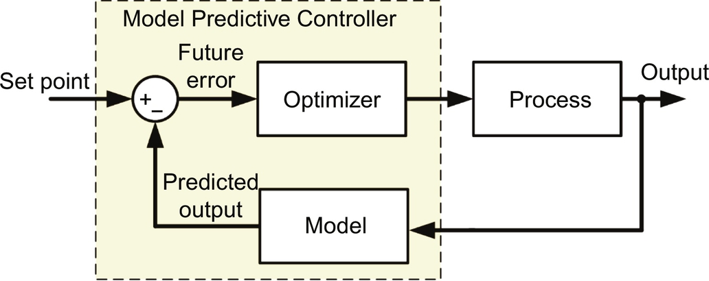

**FIG. 40.1** A principle block diagram of predictive control.

• A discrete-time model of the system should be obtained in order to predict system output at the next sampling instant.

• To obtain the optimal actuation, the cost function is used in the optimizer block.

The system prediction model can be defined as state space model as follows:

 **(40.1)**

**** **(40.2)**

where *x*(*k*+1), *u*(*k*), and *y*(k) are the state variable vector, the input vector, and the output vector, respectively. Furthermore, *A* is the system matrix, *B* is the control matrix, *C* is the output matrix, and *D* is the feedthrough matrix. The prediction model can be obtained by combining *N* equations at *k*+1th through *k*+*N*th instants as follows [[8](https://learning.oreilly.com/library/view/power-electronics-handbook/9780128114087/B9780128114070000441.xhtml#bb0045)]:

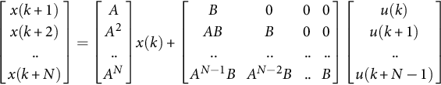 **(40.3)**

This prediction model can be expressed as

 **(40.4)**

**** **(40.5)**

A cost function (*g*) is needed to be determined to select an optimal actuation in the next sampling time. Since the objective of the controller is to guide the system state toward zero from any given initial conditions, the cost function can be defined as follows:

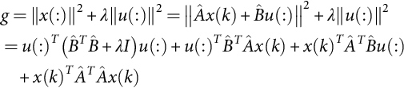 **(40.6)**

where *λ* is a weighting factor. Taking the derivative of the cost function with respect to *u*(:) and setting it to zero, one obtains

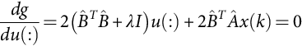 **(40.7)**

whose solution is

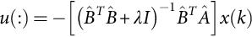 **(40.8)**

Following the fundamental concept behind predictive control, only the first vector from the array of the optimally predicted future control inputs in Eq. [(40.8)](https://learning.oreilly.com/library/view/power-electronics-handbook/9780128114087/B9780128114070000441.xhtml#fo0045) is utilized. Hence, the control input vector at the *k*th time instant can be found to be

 **(40.9)**

[Fig. 40.2](https://learning.oreilly.com/library/view/power-electronics-handbook/9780128114087/B9780128114070000441.xhtml#f0015) illustrates the working principle of predictive control. The future values of the system states are predicted until a predefined horizon in time *k*+N using the system model and the available measured data until time *k*. The sequence of the optimal actuation is calculated by minimizing the cost function. This process is repeated taking into account the new measured data for each sampling time [[9](https://learning.oreilly.com/library/view/power-electronics-handbook/9780128114087/B9780128114070000441.xhtml#bb0050)].

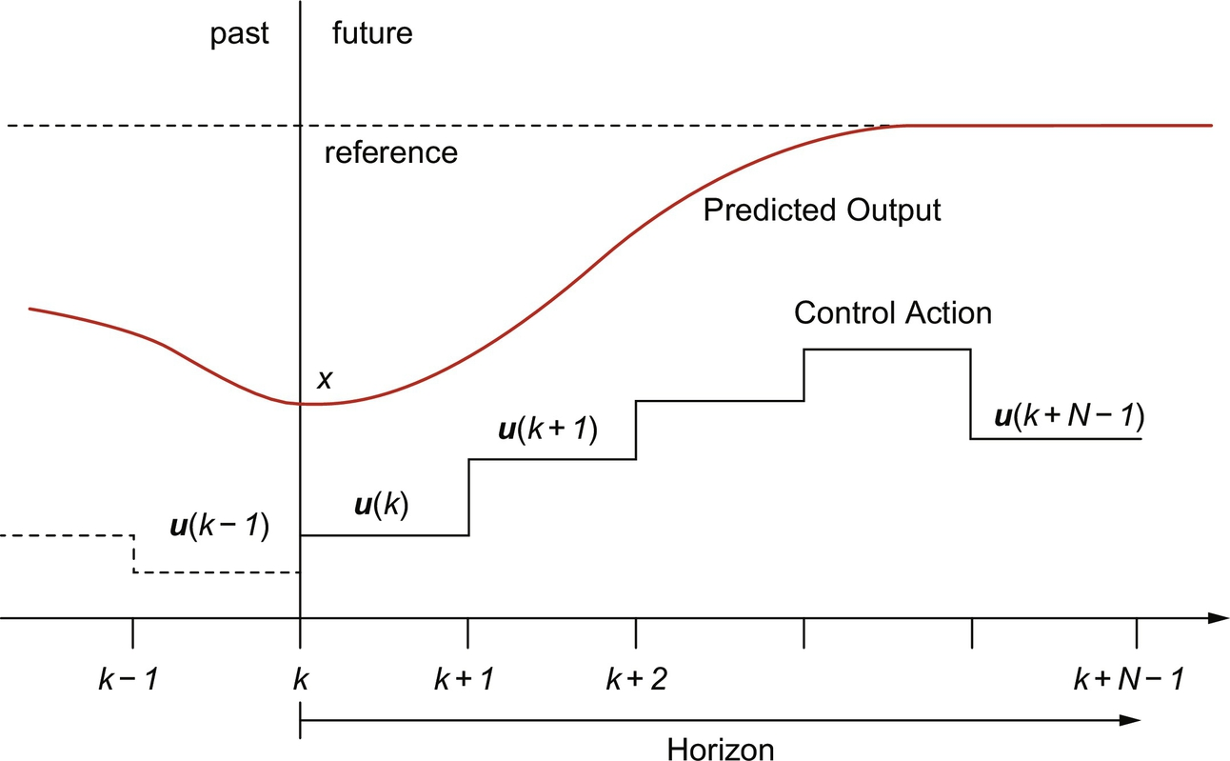

**FIG. 40.2** Working principle of predictive control.

## 40.3 Types of Predictive Control

The classification of predictive control in power electronic converters can be divided into four main categories, as shown in [Fig. 40.3](https://learning.oreilly.com/library/view/power-electronics-handbook/9780128114087/B9780128114070000441.xhtml#f0020) [[10](https://learning.oreilly.com/library/view/power-electronics-handbook/9780128114087/B9780128114070000441.xhtml#bb0055)]. The deadbeat control consists of determining which input signal must be applied to the system to ensure the output reaches steady state in the smallest number of time steps. Although deadbeat control requires a modulator, it provides constant switching frequency and requires low computation burden to be implemented in digital platforms. The optimization criterion in the hysteresis-based predictive control is to keep the controlled variable within the boundaries of a hysteresis area, while in the trajectory based, the variables are forced to follow a predefined trajectory. Furthermore, hysteresis-based and trajectory-based predictive controls can be accepted as direct control technique, which means that it doesn’t need modulator stage; however, switching frequency is variable. Model predictive control (MPC), which is the most significant predictive control technique for power electronic converters among the others, can be classified in two categories: continuous control set MPC (CCS-MPC) and finite control set MPC (FCS-MPC). CCS-MPC requires a modulator to generate the switching states, while in FCS-MPC, the switching state can be generated without modulator stage. In FCS-MPC approach, to solve the optimization problem, the power converters' finite number of switching states is used. To do that, a discrete-time model of the system should be employed to predict the future behavior of the system. Then, an optimal control actuation is selected by the predefined cost function. Although FCS-MPC can generate switching signals without a modulator, switching frequency is variable.

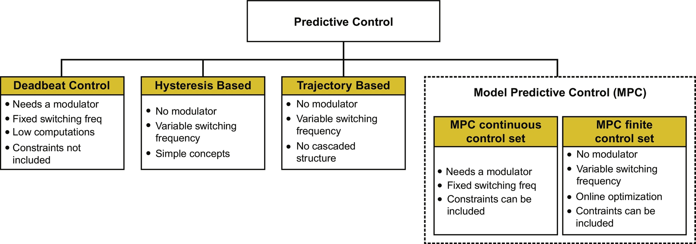

**FIG. 40.3** The classification of predictive control techniques.

Simplicity and easy implementation concept are the most important advantages of predictive control. Using predictive control technique also allows avoiding the cascaded control structure, which results in fast dynamic response in control. Furthermore, some constraints can be included in the control in order to improve the system performance. Although these advantages can be easily implemented in some predictive control techniques such as MPC, but it is very difficult to add in deadbeat control.

## 40.4 Model Predictive Control for Power Electronics

In this subsection, the implementation of MPC for power electronic converters will be explained step by step. Although this technique is suitable for all power electronic converters, traditional three-phase three-leg voltage source inverter (VSI) will be taken as an example to explain the MPC idea for power converters.

The block diagram of the MPC for three-phase VSI is shown in [Fig. 40.4](https://learning.oreilly.com/library/view/power-electronics-handbook/9780128114087/B9780128114070000441.xhtml#f0025). This control technique can be summarized by the following steps:

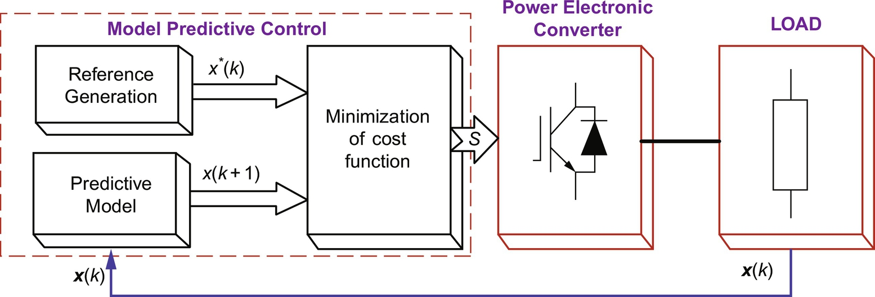

**FIG. 40.4** Model predictive control block diagram for three-phase VSI.

• Build a model of the converter and determine the possible switching states.

• Build a model of the load for the predictive model.

• Define a cost function to minimize the error.

### 40.4.1 CONVERTER MODEL

The traditional three-phase VSI with *RL* load and VSI equivalent circuits are shown in [Fig. 40.5](https://learning.oreilly.com/library/view/power-electronics-handbook/9780128114087/B9780128114070000441.xhtml#f0030) [[11](https://learning.oreilly.com/library/view/power-electronics-handbook/9780128114087/B9780128114070000441.xhtml#bb0060)]. As shown, each leg can be represented as a dual-way switch, so only one switch can be active simultaneously in the same leg in order to avoid short circuit. The switching states *Sa*, *Sb*, *Sc* are controlled as follows:

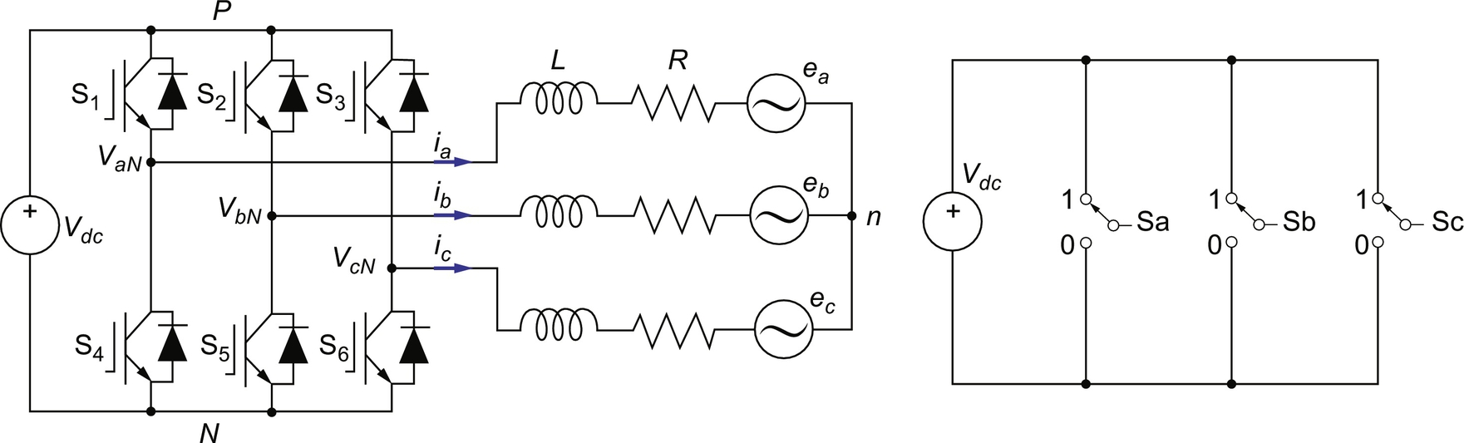

**FIG. 40.5** Three-phase three-leg voltage source inverter circuit with *RL* load and its equivalent circuit.

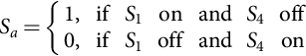 **(40.10)**

**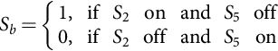** **(40.11)**

**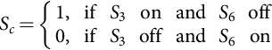** **(40.12)**

These switching states can be expressed as

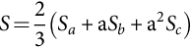 **(40.13)**

where **a** is called as a unitary vector and is equal to e*j*2*π*/3. Finally, the inverter output voltage vector can be defined as a function of the switching state vector ***S*** by

 **(40.14)**

where *Vdc* is the dc-link voltage.

Considering all the possible combinations of the switches (Sa, Sb, Sc), eight switching states and consequently eight voltage vectors can be obtained, as shown in [Fig. 40.6](https://learning.oreilly.com/library/view/power-electronics-handbook/9780128114087/B9780128114070000441.xhtml#f0035). Six of these vectors (v1–*v*6) are defined as active vectors, while the other two (*v*0, *v*7) are defined as zero vector. Consequently, seven different voltage vectors are obtained as shown in [Fig. 40.6](https://learning.oreilly.com/library/view/power-electronics-handbook/9780128114087/B9780128114070000441.xhtml#f0035).

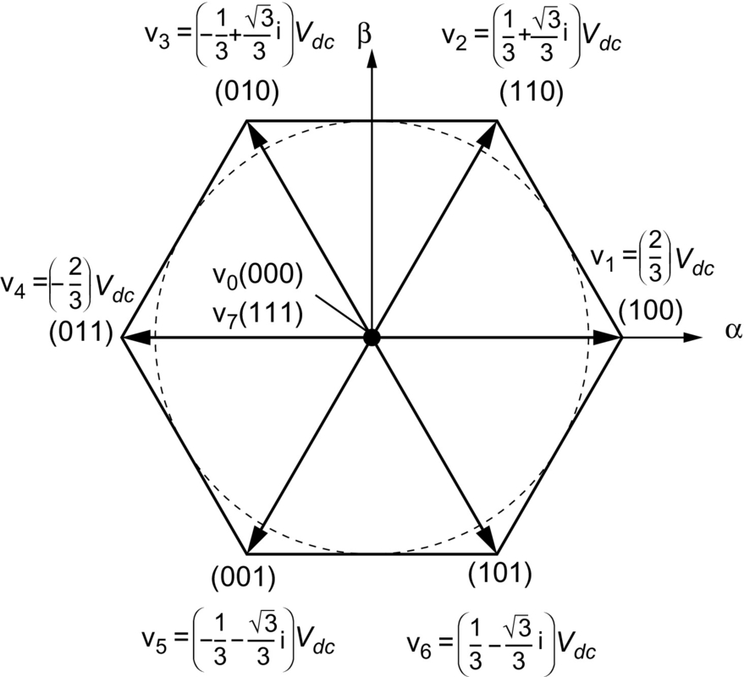

**FIG. 40.6** Voltage vectors of the three-phase three-leg inverter.

### 40.4.2 DISCRETE-TIME MODEL OF LOAD FOR PREDICTION

The equivalent circuit of the three-phase VSI with *RL* load is shown in [Fig. 40.7](https://learning.oreilly.com/library/view/power-electronics-handbook/9780128114087/B9780128114070000441.xhtml#f0040). The continuous-time model of the system can be expressed as

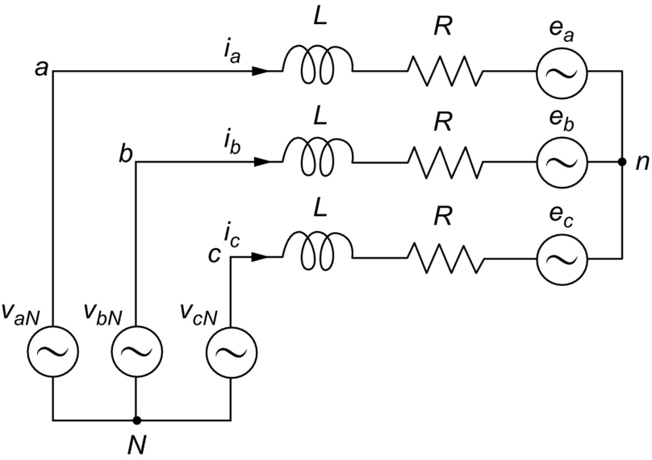

**FIG. 40.7** Equivalent circuit of the three-phase VSI with *RL* load.

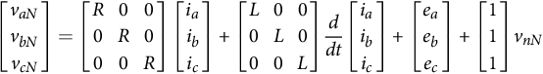 **(40.15)**

where *R* and *L* are the load resistance and the load inductance, respectively. This equation can be simplified as

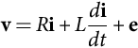 **(40.16)**

where **v** is inverter output voltage vector, **i** is the load current vector, and **e** the load back-emf vector. The derivative of the output current vector can be obtained from

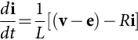 **(40.17)**

To use mathematical equations in the prediction model, discrete-time equations of the system must be obtained from continuous-time equations. To do that, the general structure of forward-difference Euler equation [(40.18)](https://learning.oreilly.com/library/view/power-electronics-handbook/9780128114087/B9780128114070000441.xhtml#fo0095) can be used in order to compute the differential equations of the output current [[12](https://learning.oreilly.com/library/view/power-electronics-handbook/9780128114087/B9780128114070000441.xhtml#bb0065),[13](https://learning.oreilly.com/library/view/power-electronics-handbook/9780128114087/B9780128114070000441.xhtml#bb0070)]:

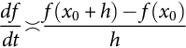 **(40.18)**

To estimate these variables in the next sampling time, the discretization equation can be defined as

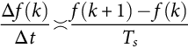 **(40.19)**

The continuous-time expression for the *iabc* is given in [(40.17)](https://learning.oreilly.com/library/view/power-electronics-handbook/9780128114087/B9780128114070000441.xhtml#fo0090). By substituting [(40.19)](https://learning.oreilly.com/library/view/power-electronics-handbook/9780128114087/B9780128114070000441.xhtml#fo0100) into [(40.17)](https://learning.oreilly.com/library/view/power-electronics-handbook/9780128114087/B9780128114070000441.xhtml#fo0090), the discrete-time model of the *iabc* can be obtained as

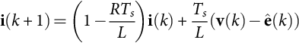 **(40.20)**

where **i**(*k+*1) is the predicted output current vector at the next sampling time and *ê*(*k*) denotes the estimated back emf that can be calculated from [(40.16)](https://learning.oreilly.com/library/view/power-electronics-handbook/9780128114087/B9780128114070000441.xhtml#fo0085) considering the measurements of the load voltage and current with the following expression;

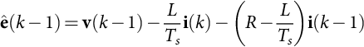 **(40.21)**

where  is the estimated value of .

### 40.4.3 COST FUNCTION OPTIMIZATION

The objective of the cost function is to minimize the error between the reference currents (*iabc*\*(*k*)) and the predicted output currents () at the next sampling time. The cost function can be expressed in orthogonal coordinates as

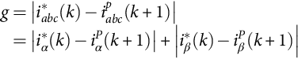 **(40.22)**

where  and  are the real and imaginary parts of the predicted load current vector, while  and  are the real and imaginary parts of the reference load current. To simplify the analysis, it is assumed that the reference current does not change immediately in one sampling time. Thus,  can be considered. On the other hand, this may introduce a one sample delay in the reference tracking, which can be neglected in high sampling frequency conditions. In general, the reference current is generated from an external control loop, for example, maximum power point tracking control loop.

The sketch map of the reference and predicted rotor currents is shown in [Fig. 40.8](https://learning.oreilly.com/library/view/power-electronics-handbook/9780128114087/B9780128114070000441.xhtml#f0045) to illustrate how the proposed MPC strategy works. Here, the measured output current *ia*(k) and voltage vectors **v0-7**, which are given in [Table 40.1](https://learning.oreilly.com/library/view/power-electronics-handbook/9780128114087/B9780128114070000441.xhtml#t0010), have been evaluated together to estimate the future output current *ia*(*k+*1) values. As shown in [Fig. 40.8](https://learning.oreilly.com/library/view/power-electronics-handbook/9780128114087/B9780128114070000441.xhtml#f0045), there are eight different predicted rotor current values at time *k*+1 and *k*+2. However, it can be seen from the figure that only v2 and v3 voltage vectors minimize the error of the output current at *k*+1 and *k*+2 instants, respectively. Thus, voltage vectors that minimize the cost function *g* are v2 at *k*+1 and v3 at *k*+2 are selected. In other words, corresponding voltage vector at each sample time is determined by the cost function according to the minimum error or distance between reference and predicted currents. As a result, it can be shown that v2 and v3 voltage vectors produce the lowest value of the cost function at *k*+1 and *k*+2 instants, respectively.

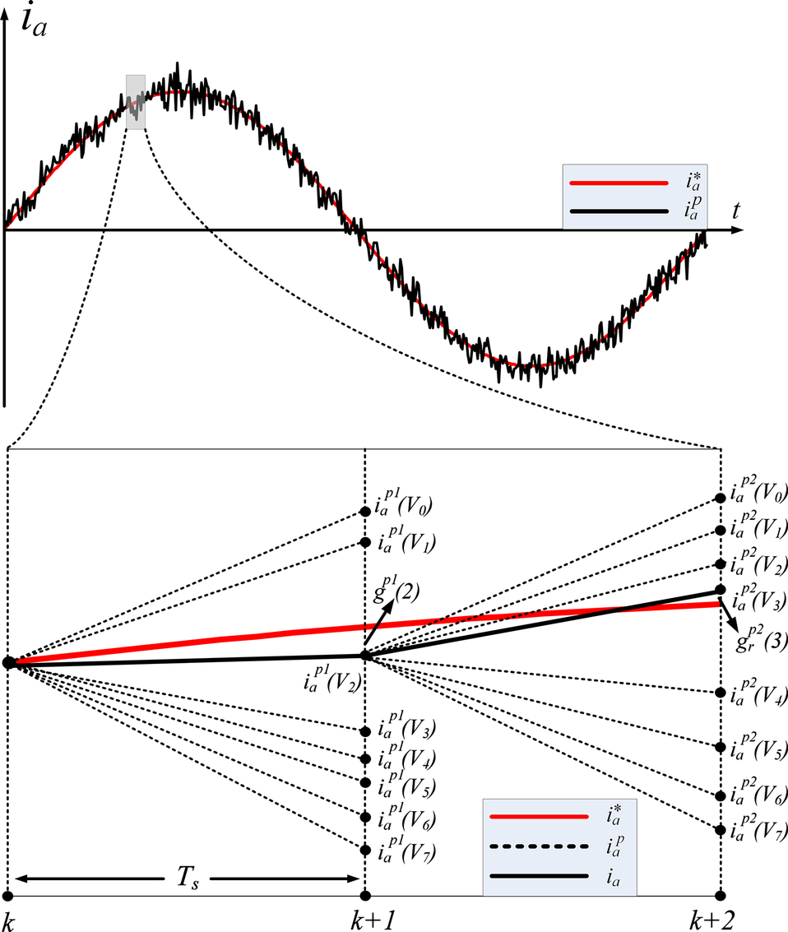

**FIG. 40.8** The sketch map of the reference and predicted currents.

**Table 40.1**

**Switching states and voltage vectors of three-phase VSI**

|  |  |  |  |  |
| --- | --- | --- | --- | --- |
| **Switching state** | **Sa** | **Sb** | **Sc** | **Voltage vector V** |
| **0** | 0 | 0 | 0 | si1_e |
| **1** | 1 | 0 | 0 | si2_e |
| **2** | 1 | 1 | 0 | si3_e |
| **3** | 0 | 1 | 0 | si4_e |
| **4** | 0 | 1 | 1 | si5_e |
| **5** | 0 | 0 | 1 | si6_e |
| **6** | 1 | 0 | 1 | si7_e |
| **7** | 1 | 1 | 1 | si8_e |

### 40.4.4 CONTROL ALGORITHM

The MPC algorithm can be implemented as a “*for*” loop to predict future behavior of the system output, minimize the error between the reference and predicted output using predefined cost function, and store the index value of the corresponding switching state [[14](https://learning.oreilly.com/library/view/power-electronics-handbook/9780128114087/B9780128114070000441.xhtml#bb0075),[15](https://learning.oreilly.com/library/view/power-electronics-handbook/9780128114087/B9780128114070000441.xhtml#bb0080)]. The flowchart of the MPC algorithm is given in [Fig. 40.9](https://learning.oreilly.com/library/view/power-electronics-handbook/9780128114087/B9780128114070000441.xhtml#f0050). The control algorithm can be summarized by the following steps:

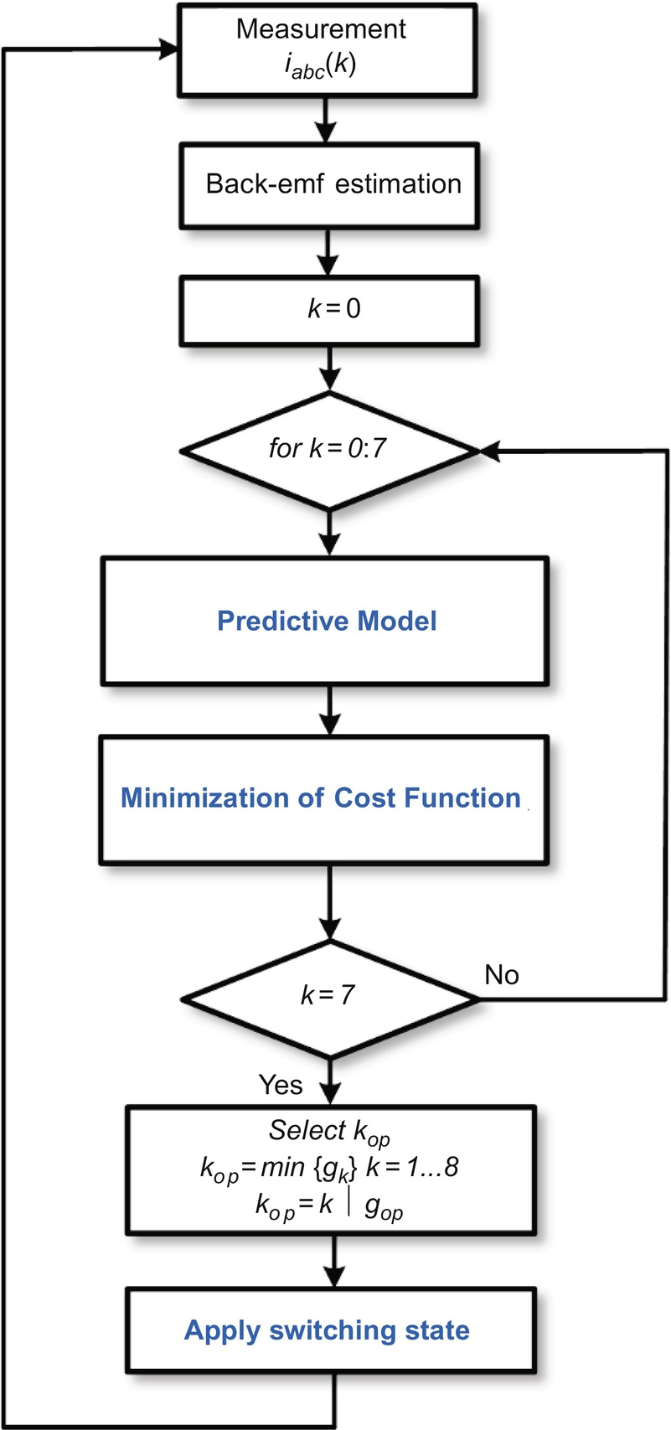

**FIG. 40.9** Flowchart of the model predictive control of three-phase VSI.

• Measure the output currents (*iabc*).

• Estimate the back emf using Eq. [(40.21)](https://learning.oreilly.com/library/view/power-electronics-handbook/9780128114087/B9780128114070000441.xhtml#fo0110).

• These measured and estimated values are used to predict output currents using the predictive model in Eq.[(40.20)](https://learning.oreilly.com/library/view/power-electronics-handbook/9780128114087/B9780128114070000441.xhtml#fo0105).

• All predictions are evaluated using the predefined cost function.

• The optimal switching state that corresponds to the optimal voltage vector that minimizes the cost function is selected to be applied at the next sampling time.

## 40.5 MPC Applications in Power Electronic

### **40.5.1 THREE-LEVEL NEUTRAL-POINT-CLAMPED INVERTER**

Motivated by the aforementioned advantages of MPC and considering the multiobjective control requirements of neutral-point-clamped (NPC) inverter, in this subsection, MPC-based control technique for three-phase NPC inverter is presented. Here, two parameters, the output current and the capacitor voltages, are controlled by the MPC technique. Thus, multiobjective control requirement is solved with simple technique.

A. System Model

The used three-phase NPC inverter topology is illustrated in [Fig. 40.10](https://learning.oreilly.com/library/view/power-electronics-handbook/9780128114087/B9780128114070000441.xhtml#f0055). Each leg of the inverter consists of four power switches with two diodes that allow the output terminal to be connected to the middle point of the split dc-link capacitors. This circuit configuration allows to generate three voltage levels at the output of the inverter according to the neutral point. The switching combinations are given in [Table 40.2](https://learning.oreilly.com/library/view/power-electronics-handbook/9780128114087/B9780128114070000441.xhtml#t0015) [[16](https://learning.oreilly.com/library/view/power-electronics-handbook/9780128114087/B9780128114070000441.xhtml#bb0085)]. Switching state variable Sx represents the switching state of phase *x*, with *x*=*a*, *b*, *c*, and it has three possible values denoted by positive, zero, and negative that represent the switching combinations that generate *Vdc*/2, 0, and*−Vdc*/2, respectively, at the output of the inverter phase.

The NPC inverter applies to the load 19 voltage vectors, which are generated from 27 switching states, as shown in [Fig. 40.11](https://learning.oreilly.com/library/view/power-electronics-handbook/9780128114087/B9780128114070000441.xhtml#f0060) [[16](https://learning.oreilly.com/library/view/power-electronics-handbook/9780128114087/B9780128114070000441.xhtml#bb0085)]. In addition to these switching states, for this application, one extra switching state is required to ensure shoot-through state. During this state, dc link must be short-circuited by single or multiple inverter legs.

The continuous-time expression for the output current (*io*) can be described by the following equation:

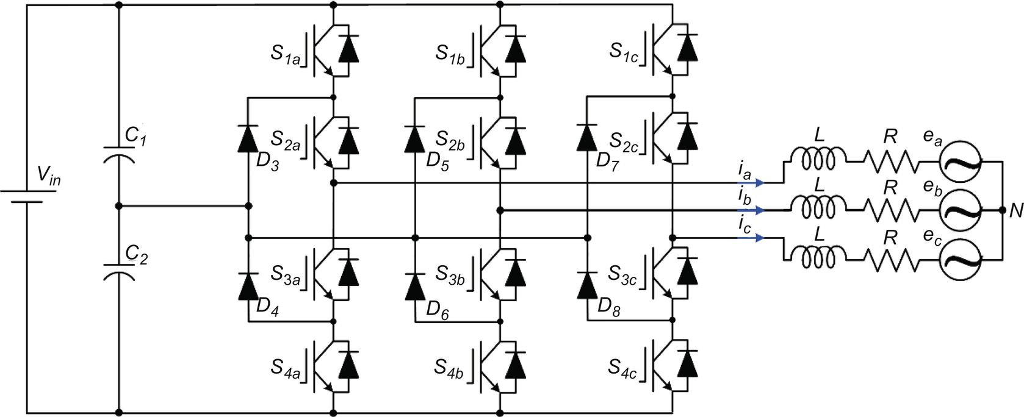

**FIG. 40.10** Three-phase three-level NPC inverter topology.

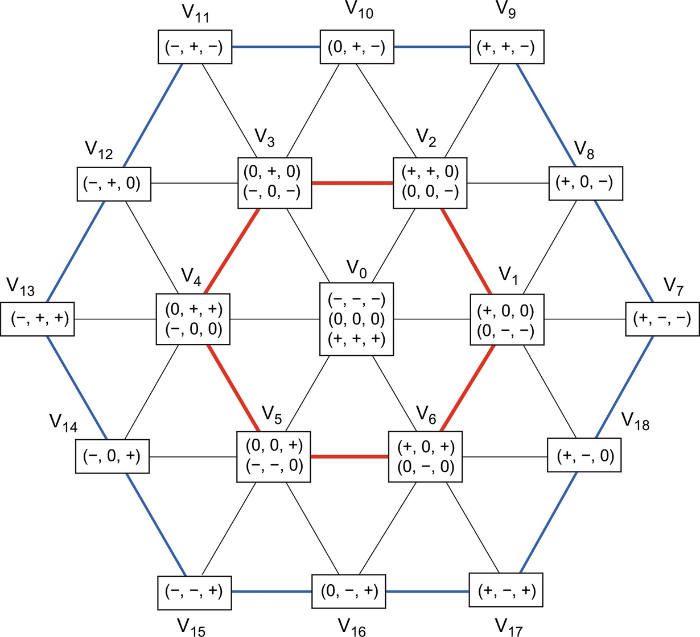

**FIG. 40.11** Possible voltage vectors and switching states generated by a three-level NPC inverter.

**Table 40.2**

**Switching states for one phase of the NPC inverter**

|  |  |  |  |  |  |
| --- | --- | --- | --- | --- | --- |
| ***Sx*** | ***Sx*1** | ***Sx*2** | ***Sx*3** | ***Sx*4** | ***vx*0** |
| + | 1 | 1 | 0 | 0 | *Vdc*/2 |
| 0 | 0 | 1 | 1 | 0 | 0 |
| − | 0 | 0 | 1 | 1 | *Vdc*/2 |

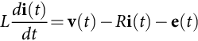 **(40.23)**

where *R* and *L* are the load resistance and inductance, respectively, **v** is the voltage vector generated by the inverter, **e** is the electromotive force of the load, and **i** is the load current vector. These vectors are defined as

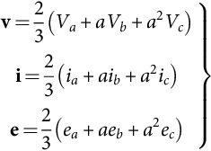 **(40.24)**

where .

B. MPC-based control algorithm

The proposed MPC algorithm applied to the three-level NPC inverter is shown in [Fig. 40.12](https://learning.oreilly.com/library/view/power-electronics-handbook/9780128114087/B9780128114070000441.xhtml#f0065). To predict the output current (**i**o) and the capacitor voltages (v*C*1 and v*C*2) at the next sampling time, discrete-time model of the inverter must be defined. One way to obtain discrete-time models is to use the forward-difference Euler equation due to its simplicity. The derivative form *dx*(*t*)/*dt* is approximated by

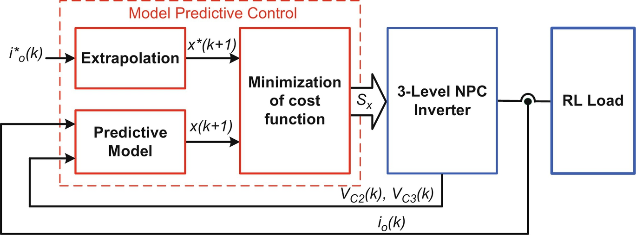

**FIG. 40.12** Block diagram of the proposed MPC technique.

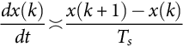 **(40.25)**

where *Ts* is the sampling time and *x* is one of the control parameters such as **i** and *vc*12.

By substituting [(40.23)](https://learning.oreilly.com/library/view/power-electronics-handbook/9780128114087/B9780128114070000441.xhtml#fo0120) into [(40.25)](https://learning.oreilly.com/library/view/power-electronics-handbook/9780128114087/B9780128114070000441.xhtml#fo0130), the discrete-time model of the output current vector is

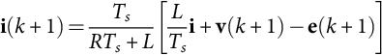 **(40.26)**

where **i** (*k*+1) is the predicted output current vector at the next sampling time.

The current prediction in [(40.26)](https://learning.oreilly.com/library/view/power-electronics-handbook/9780128114087/B9780128114070000441.xhtml#fo0135) also requires an estimation of the future load back EMF **e** (k+1). It can be estimated by using a second-order extrapolation from present and past values. From [(40.25)](https://learning.oreilly.com/library/view/power-electronics-handbook/9780128114087/B9780128114070000441.xhtml#fo0130) and the output voltage and current, resulting in the following expression:

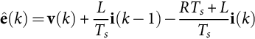 **(40.27)**

where **ê**(*k*) is the estimated value of **e**(*k*).

Furthermore, the discrete-time equations of the capacitor voltage can be expressed by using [(40.25)](https://learning.oreilly.com/library/view/power-electronics-handbook/9780128114087/B9780128114070000441.xhtml#fo0130):

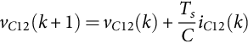 **(40.28)**

where v*C*12(k+1) is the predicted capacitor voltages, at the next sampling time.

To use reference value in the cost function, this value must be extrapolated to *k*+1 instant. To do that, Lagrange's extrapolation can be used [[17](https://learning.oreilly.com/library/view/power-electronics-handbook/9780128114087/B9780128114070000441.xhtml#bb0090)]. Once the extrapolated reference values obtained, they are applied in the cost function optimization block as can be seen in [Fig. 40.12](https://learning.oreilly.com/library/view/power-electronics-handbook/9780128114087/B9780128114070000441.xhtml#f0065). To handle the desired control objectives, two terms are required to be defined in the cost function. The terms are responsible for minimizing the error between the reference and predicted values. The defined cost function is

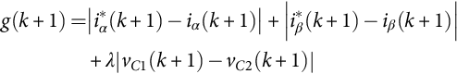 **(40.29)**

where λ is the weighting factor.

C. Simulation Results

The simulation of the proposed system was performed using Matlab/Simulink environment. The NPC inverter topology, shown in [Fig. 40.10](https://learning.oreilly.com/library/view/power-electronics-handbook/9780128114087/B9780128114070000441.xhtml#f0055), is used in the simulation. The parameters used in the simulation are summarized in [Table 40.3](https://learning.oreilly.com/library/view/power-electronics-handbook/9780128114087/B9780128114070000441.xhtml#t0020).

The simulation result of steady-state analysis is shown in [Fig. 40.13](https://learning.oreilly.com/library/view/power-electronics-handbook/9780128114087/B9780128114070000441.xhtml#f0070). The reference output currents track their references with high accuracy, while the dc-link voltage is kept balanced by the MPC. [Fig. 40.14](https://learning.oreilly.com/library/view/power-electronics-handbook/9780128114087/B9780128114070000441.xhtml#f0075) shows the simulation result of the transient response of the proposed control technique. The output reference current is step changed from 10 to 15 A. It can be seen that the dc-link voltage remains balanced at 150 V, with small deviations during the transient.

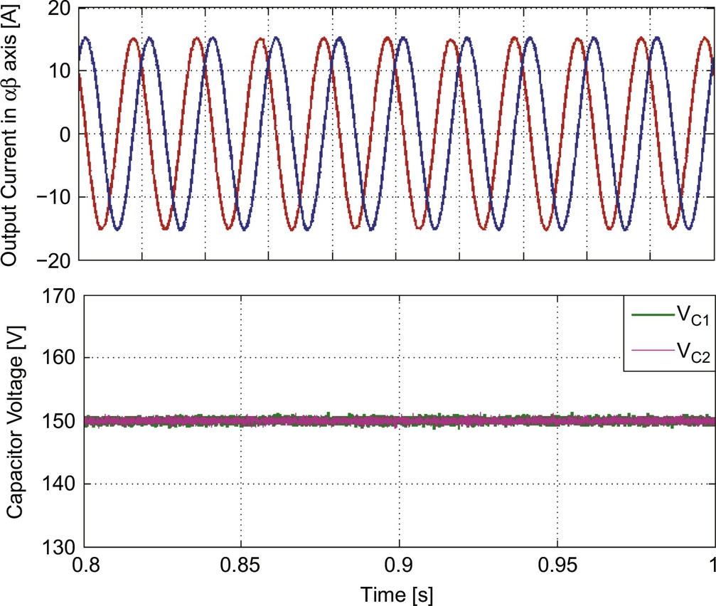

**FIG. 40.13** Simulation results of steady-state operation.

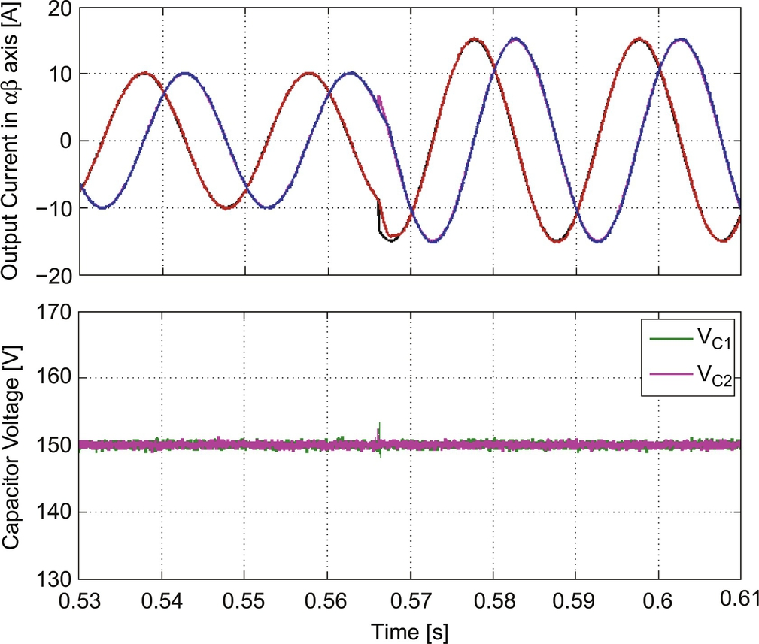

**FIG. 40.14** Simulation results of transient response.

**Table 40.3**

**System parameters**

|  |  |
| --- | --- |
| **Parameters** | **Values** |
| Input DC voltage, *VDC* | 300 V |
| qZS Network inductance, *L*1 and *L*2 | 1 mH |
| qZS Network capacitance, *C*1 and *C*2 | 470 μF |
| Load resistance, *R* | 10 Ω |
| Load inductance, *L* | 10 mH |
| Sampling time, *Ts* | 100 μs |

### 40.5.2 33-LEVEL INPUT SWITCHED INVERTER

The control of multilevel inverters (MIs) is quite challenging and requires a flexible approach to success multiple control objectives. The MPC technique is extremely effective to control MIs due to its considerable advantages over the traditional linear controller. This subsection presents MPC technique for 33-level input switched multilevel inverter (ISMI) to verify MPC's effectiveness in the high-level MI topologies.

A. Overview of the ISMI

The circuit diagram of the single-phase 33-level ISMI with PV generation system is shown in [Fig. 40.15](https://learning.oreilly.com/library/view/power-electronics-handbook/9780128114087/B9780128114070000441.xhtml#f0080) [[18](https://learning.oreilly.com/library/view/power-electronics-handbook/9780128114087/B9780128114070000441.xhtml#bb0095)]. The ISMI topology has two stages, consisting of the multilevel module and H-bridge inverter. Output voltage level of this topology is given by *Nlevel=*2*n+*1, where n represents the number of power legs. In order to obtain 33 voltage level, *n* should be 16 for this application.

In the first stage, each leg includes two power switches that allow bidirectional current flow. Sixteen capacitors are also employed to divide the dc-link voltage equally to *Vdc*/16, as seen in [Fig. 40.15](https://learning.oreilly.com/library/view/power-electronics-handbook/9780128114087/B9780128114070000441.xhtml#f0080). The bidirectional power switches of each leg should be gated on sequentially to obtain desired voltage level. It is noticeable that more than one leg switches cannot be turned on at the same time because input dc source would be short circuit. Moreover, the switching state of the multilevel module is determined by the output current direction and the voltage level of the multilevel module. For example, when the first leg (S1ab) is turned on and other legs are turned off, the output voltage (*vx*) of the multilevel module is *Vdc*, the current flows through S1a and D1b. The proposed ISMI has 64 switching states that produce thirty-three voltage levels. However, it should be noted that the voltage level of the multilevel module is only 16 positive levels. Therefore, to obtain positive and negative levels, the traditional H-bridge inverter is employed in the second stage of this topology, as seen in [Fig. 40.15](https://learning.oreilly.com/library/view/power-electronics-handbook/9780128114087/B9780128114070000441.xhtml#f0080). The H-bridge inverter provides voltage gains, which are +1, 0, −1, to ensure positive, zero, and negative voltage on the output. The switching states of 33-level ISMI are given in [Table 40.4](https://learning.oreilly.com/library/view/power-electronics-handbook/9780128114087/B9780128114070000441.xhtml#t0025).

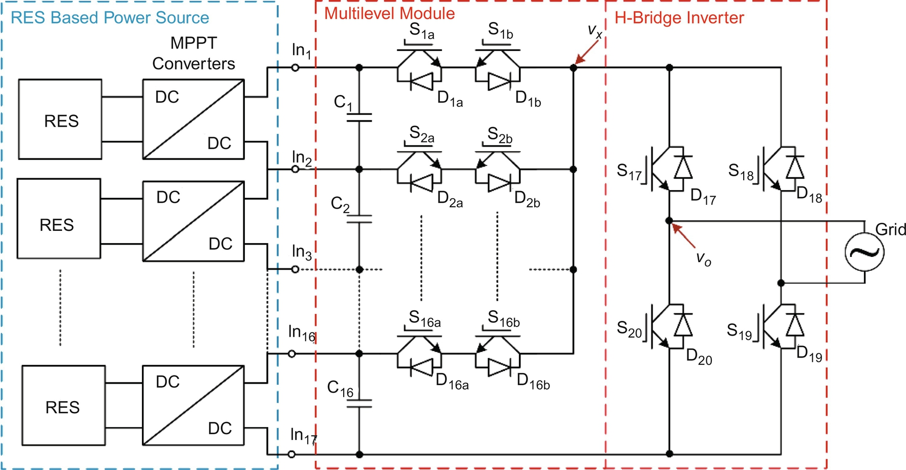

**FIG. 40.15** The block diagram of single-phase 33-level ISMI in PV generation system.

**Table 40.4**

**Switching states of 33-level ISMI**

|  |  |  |  |  |  |  |  |  |  |  |  |  |  |  |  |  |  |  |  |  |  |
| --- | --- | --- | --- | --- | --- | --- | --- | --- | --- | --- | --- | --- | --- | --- | --- | --- | --- | --- | --- | --- | --- |
|  | ***S*1** | ***S*2** | ***S*3** | ***S*4** | ***S*5** | ***S*6** | ***S*7** | ***S*8** | ***S*9** | ***S*10** | ***S*11** | ***S*12** | ***S*13** | ***S*14** | ***S*15** | ***S*16** | ***S*17** | ***S*18** | ***S*19** | ***S*20** | ***Vo*** |
| 0 | 1 | 0 | 0 | 0 | 0 | 0 | 0 | 0 | 0 | 0 | 0 | 0 | 0 | 0 | 0 | 0 | 1 | 0 | 1 | 0 | *Vdc* |
| 1 | 0 | 1 | 0 | 1 | *Vdc* |
| *2* | 0 | 0 | 1 | 1 | 0 |
| *3* | 1 | 1 | 0 | 0 | 0 |
| *4* | 0 | 1 | 0 | 0 | 0 | 0 | 0 | 0 | 0 | 0 | 0 | 0 | 0 | 0 | 0 | 0 | 1 | 0 | 1 | 0 | 15*Vdc/*16 |
| *5* | 0 | 1 | 0 | 1 | 15*Vdc/*16 |
| *6* | 0 | 0 | 1 | 1 | 0 |
| 7 | 1 | 1 | 0 | 0 | 0 |
| **.** |  |  |  |  |  |  |  |  |  | **.** |  |  |  |  |  |  |  |  |  |  | **.** |
| **.** |  |  |  |  |  |  |  |  |  | **.** |  |  |  |  |  |  |  |  |  |  | **.** |
| **.** |  |  |  |  |  |  |  |  |  | **.** |  |  |  |  |  |  |  |  |  |  | **.** |
| **.** |  |  |  |  |  |  |  |  |  | **.** |  |  |  |  |  |  |  |  |  |  | **.** |
| *60* | 0 | 0 | 0 | 0 | 0 | 0 | 0 | 0 | 0 | 0 | 0 | 0 | 0 | 0 | 0 | 1 | 1 | 0 | 1 | 0 | *Vdc/*16 |
| *61*  *62* | 0  0 | 1  0 | 0  1 | 1  1 | −*Vdc/*16  0 |
| *63* | 1 | 1 | 0 | 0 | 0 |

B. MPC-based control algorithm for 33-level ISMI

The block diagram of the MPC strategy applied to the current control for the 33-level grid-connected ISMI is shown in [Fig. 40.16](https://learning.oreilly.com/library/view/power-electronics-handbook/9780128114087/B9780128114070000441.xhtml#f0085). The predictive model of the system needs output current information in order to generate reference current. Grid phase angle information is also required to generate reference current in same phase with the grid voltage. In this case, the output current *io*(k) and the grid voltage *vg*(k) need to be measured. The phase angle (*θe*) of the reference current is obtained from PLL block. Thus, generated reference current will be in same phase and frequency with the grid voltage.

To control the output current (*io*) of the ISMI, a discrete-time model of the *io* must be defined. To do that, the averaged model of the system, which is defined in [(40.30)](https://learning.oreilly.com/library/view/power-electronics-handbook/9780128114087/B9780128114070000441.xhtml#fo0155), can be used:

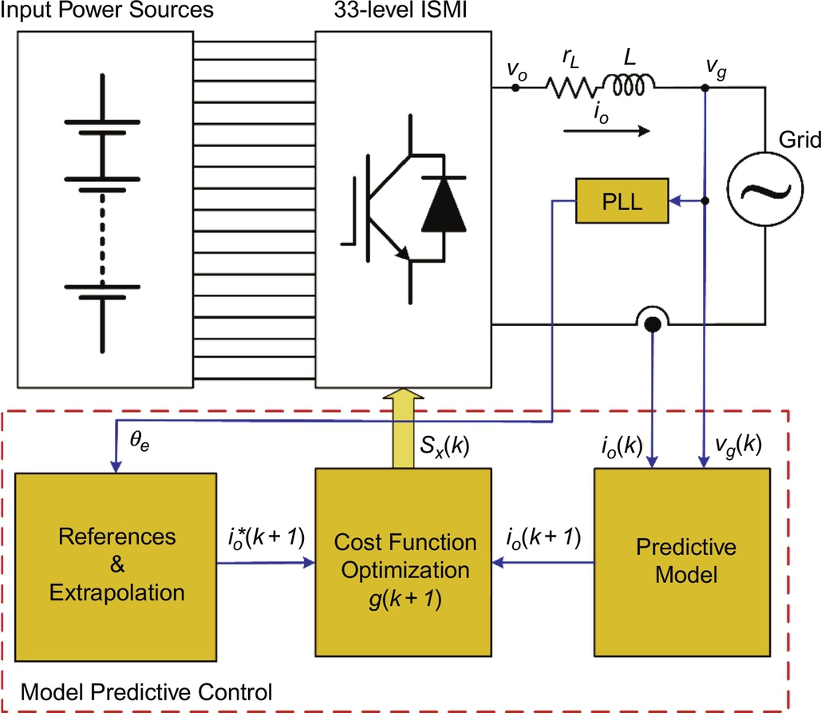

**FIG. 40.16** Block diagram of the proposed model predictive control scheme.

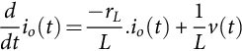 **(40.30)**

where *rL* and *L* are the resistance and inductance of the filter inductor, respectively, *io*(*t*) is the average inverter output current, and *v*(*t*) is the voltage, averaged in a switching period and applied to the inductor. The voltage on the inductor can be written as *v*(*t*)=*vo*(*t*)−*vg*(*t*), where *vg*(*t*) is the grid voltage and *vo*(*t*) is the averaged value of the inverter voltage.

The general solution of the differential equation is

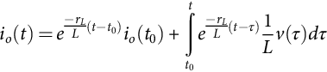 **(40.31)**

where lower (*t*0) and upper (*t*) limits of integration can be defined as k*Ts* and (k+1)*Ts*, respectively, to obtain discrete-time model with sampling period Ts.

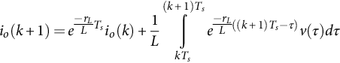 **(40.32)**

where *io*(k)≡*io*(k*Ts*). *Ts* is usually small enough to satisfy (*rLTs/L*) <<l; thus, [(40.32)](https://learning.oreilly.com/library/view/power-electronics-handbook/9780128114087/B9780128114070000441.xhtml#fo0165) can be approximated as

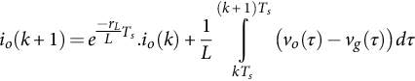 **(40.33)**

Since *d*(*t*) is actualized every sampling period, we can assume that *vo*(*t*) is constant between two sampling instants:

 **(40.34)**

if *t*  [ k*Ts*,(*k*+1)*Ts*]. On the other hand, as the sampling frequency is much higher than the grid frequency, we can approximate *vg*(*t*) linearly between two sampling instants:

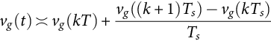 **(40.35)**

if *t ϵ*[k*Ts*,(*k*+1)*Ts*]. Discrete-time model of the output current can be obtained from substituting [(40.34)](https://learning.oreilly.com/library/view/power-electronics-handbook/9780128114087/B9780128114070000441.xhtml#fo0175) and [(40.35)](https://learning.oreilly.com/library/view/power-electronics-handbook/9780128114087/B9780128114070000441.xhtml#fo0180) into [(40.33)](https://learning.oreilly.com/library/view/power-electronics-handbook/9780128114087/B9780128114070000441.xhtml#fo0170):

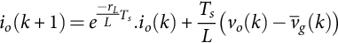 **(40.36)**

where  is the averaged value of the grid voltage between two samples.

The cost function is an important stage of the MPC technique. To minimize the error between the reference and the predicted values in the next sampling time, the cost function must be selected according to specific design criteria. In this study, in order to control the output current, the cost function is defined as

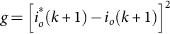 **(40.37)**

where *io*\*(*k+*1) is the reference output current and *io*(*k+*1) is the predicted output current in the next sampling time.

C. Implantation results

To verify the proposed MPC scheme for 33-level ISMI, experimental studies have been carried out for different operating conditions. The parameters of the system are summarized in [Table 40.5](https://learning.oreilly.com/library/view/power-electronics-handbook/9780128114087/B9780128114070000441.xhtml#t0030).

[Fig. 40.17A and B](https://learning.oreilly.com/library/view/power-electronics-handbook/9780128114087/B9780128114070000441.xhtml#f0090) shows the experimental results of steady-state performance of the MPC-based current controller under normal and poor grid conditions. The results show that even with poor grid condition, the MPC-based current controller has an excellent steady-state performance.

[Fig. 40.18](https://learning.oreilly.com/library/view/power-electronics-handbook/9780128114087/B9780128114070000441.xhtml#f0095) shows the transient response results of the proposed MPC. The reference current is changed from 30 to 10 A and vice versa in order to observe the response of the proposed control technique. It can be seen that the transient time is very short, controller response is very fast, and the output current tracks its reference with high accuracy.

As the proposed control method is based on the system model, the algorithm is also tested to verify the robustness against the mismatch with filter parameter. To do that, the filter inductance (*Lf*) is consecutively set at 0.5\**L*, *L*, and 1.5⁎*L*, which is the typical case in distributed generation systems where the power system impedance changes randomly. It is remarkable that the new filter inductance value is not entered to the controller. The control algorithm uses a rated filter inductance value (*L*=10 mH). Results are shown in [Fig. 40.19A–C](https://learning.oreilly.com/library/view/power-electronics-handbook/9780128114087/B9780128114070000441.xhtml#f0100). It is clear that, when the modeled inductance value is smaller than selected value (0.5\**L*), the mismatch causes steady-state errors, and when the modeled inductance value is bigger than selected value (1.5\**L*), the mismatch causes current oscillation. However, it can be observed from results that the mismatch of the filter model slightly affects the system performance.

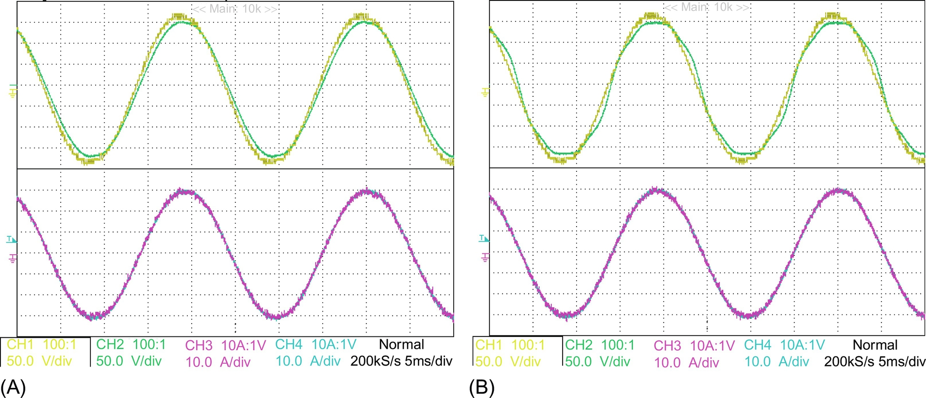

**FIG. 40.17** Steady-state results of the proposed algorithm. (A) Normal grid condition. (B) Poor grid condition. CH1, inverter output voltage; CH2, grid voltage; CH3, output current; CH4, reference current.

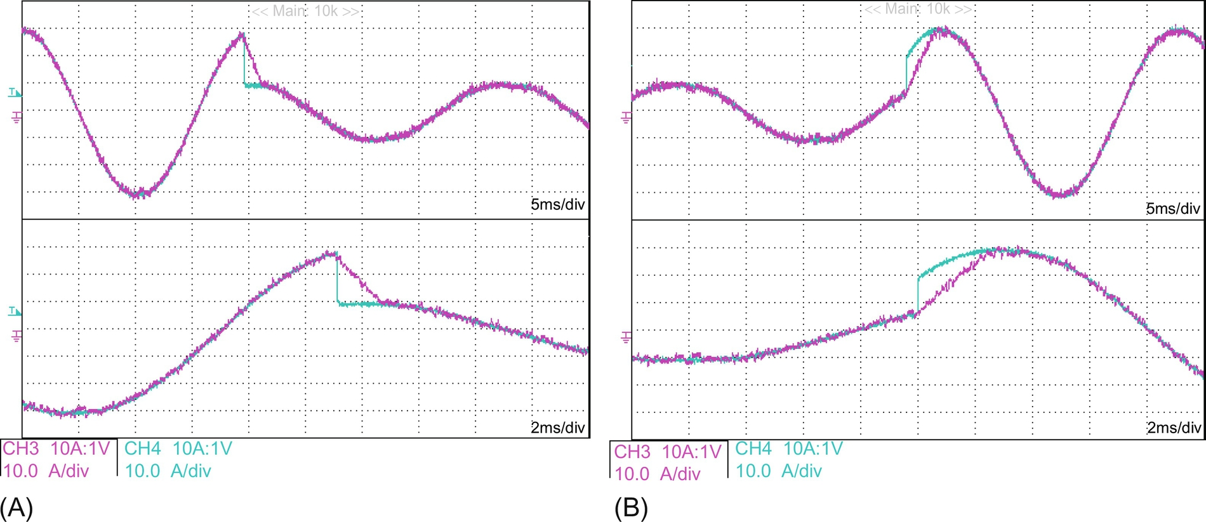

**FIG. 40.18** Transient response of the proposed algorithm. (A) Step changes from 30 to 10 A. (B) Step changes from 10 to 30 A. CH3, output current; CH4, reference current.

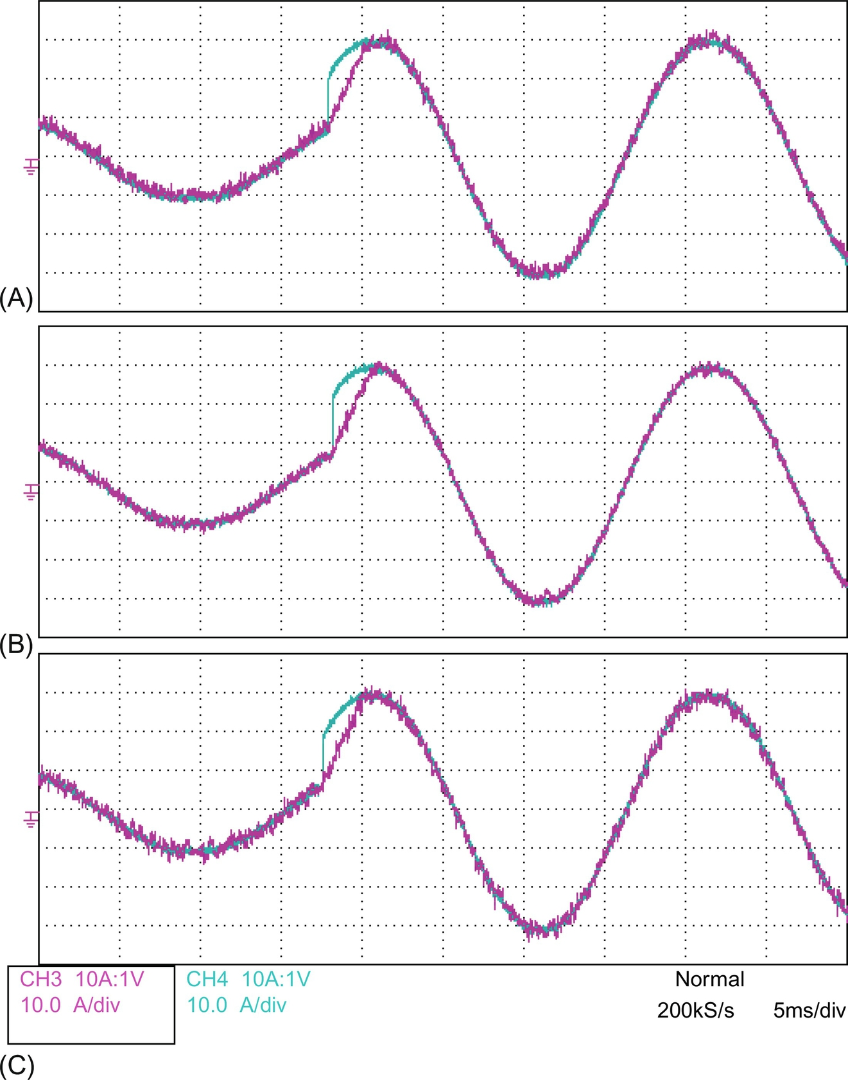

**FIG. 40.19** Effect of mismatch filter inductance errors. (A) −50% error *L*=0.5⁎*L*, (B) no error *L*=*L*, (C) +50% error *L*=1.5⁎*L*. CH3, output current; CH4, reference current.

**Table 40.5**

**System parameters**

|  |  |
| --- | --- |
| **Parameters** | **Values** |
| Input DC voltage, *Vin* | 16⁎62.5=1000 V |
| dc-link capacitor, *Cn* | 470 μF (each) |
| Filter inductance, *Lf* | 10 mH |
| Filter resistance, *Rf* | 0.02 Ω |
| Nominal output voltage, *vln* | 800 V max |
| Sampling time, *Ts* | 50 μs |

## References

[1] Liuping W., Shan C., Dae Y., Lu G., Ki N. *PID and Predictive Control of Electrical Drives and Power Converters Using Matlab/Simulink.* Wiley & IEEE Press; 2015 ISBN 97811118339442.

[2] Trabelsi M., Bayhan S., Refaat S.S., Abu-Rub H., Ben-Brahim L. *Multi-objective model predictive control for grid-tied 15-level packed U cells inverter.* In: 18th European Conference on Power Electronics and Applications (EPE'16 ECCE Europe), Karlsruhe, Germany; 2016:1–7.

[3] Bayhan S., Abu-Rub H. *Model predictive sensorless control of standalone doubly fed induction generator.* In: 40th Annual Conference of the IEEE Industrial Electronics Society, IECON 2014; 2014:2166–2172.

[4] Holtz J., Stadtfeld S. *A predictive controller for the stator current vector of ac machines fed from a switched voltage source.* In: IEEE International Power Electronics Conference, Tokyo; 1983:1665–1675.

[5] Trabelsi M., Bayhan S., Abu-Rub H., Ben-Brahim L., Zanchetta P. *Finite control set model predictive control for Grid-Tie Quasi-Z-source based multilevel inverter.* In: IEEE International Conference on Industrial Technology, ICIT 2016, Taipei, Taiwan, 14–17 March; 2016.

[6] Rodriguez J., Kazmierkowski M., Espinoza J.R., Zanchetta P., Abu-Rub H., Young H.A., Rojas C.A. State of the art of finite control set model predictive control in power electronics. *IEEE Trans. Ind. Inform.* 2013;9(2):1003–1016.

[7] Cortes P., Kazmierkowski M.P., Kennel R.M., Quevedo D.E., Rodriguez J. Predictive control in power electronics and drives. *IEEE Trans. Ind. Electron.* 2008;55(12):4312–4324.

[8] Kim B., Washington N., Yoon H. Hysteresis-reduced dynamic displacement control of piezoceramic stack actuators using model predictive sliding mode control. *Smart Mater. Struct.* 2012;21(5):55–68.

[9] Bayhan S., Mosa M., Abu-Rub H. *Model Predictive Control of Impedance Source Inverter.* John Wiley & Sons Ltd; 2016 pp. 329–361.

[10] Rodriguez J., Cortes P. *Predictive Control of Power Converters and Electrical Drives.* Wiley & IEEE Press; 2012.

[11] Abu-Rub H., Guzinski J., Krzeminski Z., Toliyat H.A. Predictive current control of voltage-source inverters. *IEEE Trans. Ind. Electron.* 2004;51(3):585–593.

[12] Rodriguez J., Pontt J., Silva C.A., Correa P., Lezana P., Cortes P., Ammann U. Predictive current control of a voltage source inverter. *IEEE Trans. Ind. Electron.* 2007;54(1):495–503.

[13] Bayhan S., Abu-Rub H., Ellabban O. Sensorless model predictive control of wind-driven DFIG in DC microgrid system. *IET Renaw. Power Gen.* 2016;10(4):514–521.

[14] Yaramasu V., Rivera M., Narimani M., Wu B., Rodriguez J. Model predictive approach for a simple and effective load voltage control of four-leg inverter with an output RL filter. *IEEE Trans. Ind. Electron.* 2014;61(10):5259–5270.

[15] Bayhan S., Abu-Rub H. *Model predictive control of Quasi-Z source three-phase four-leg inverter.* In: 41st Annual Conference of the IEEE Industrial Electronics Society, Yokohama, Japan; 2015.

[16] Bayhan S., Trabelsi M., Abu-Rub H. *Model predictive control of three-phase three-level neutral-point-clamped qZS inverter.* In: 6th International Conference on Power Engineering, Energy and Electrical Drives, Bydgoszcz, Poland, 29 June-01 July; 2016.

[17] S. Bayhan, M. Trabelsi, H. Abu-Rub, M. Malinowski, Finite control set model predictive control for a quasi-Z-source four-leg inverter under unbalanced load condition. IEEE Trans. Ind. Electron. 64 (4) (2017) 2560–2569.

[18] Bayhan S., Abu-Rub H., Rivera M., Demirbas S. *Model predictive control of 33-level input switched multilevel inverter for grid-connected PV systems.* In: IV. European Conference on Renewable Energy Systems, 28-31 August, Istanbul, Turkey; 2016.

## Further Reading

[19] Bayhan S., Trabelsi M., Abu-Rub H. *Model Predictive Control of Z-Source Four-Leg Inverter for Standalone Photovoltaic System with Unbalanced Load.* In: The Applied Power Electronics Conference & Exposition, Long Beach, US; 2016.

[20] Bayhan S., Abu-Rub H., Robert B. Model predictive control of quasi-Z source four-leg inverter for distributed power generation. *IEEE Trans. Ind. Electron.* 2016;63(7):4506–4516.

[21] Rivera M., Yaramasu V., Llor A., Rodriguez J., Wu B., Fadel M. Digital predictive current control of a three-phase four-leg inverter. *IEEE Trans. Ind. Electron.* 2013;60(11):4903–4912.

[22] Bayhan S., Kakosimos P., Abu-Rub H., Rodriguez J. *Model Predictive Control of Five-Level Neutral-Point-Clamped/H-Bridge Quasi-Impedance Source Inverter.* In: 41st Annual Conference of the IEEE Industrial Electronics Society, October 23–27, Florence, Italy; 2016.

[23] Trabelsi M., Bayhan S., Abu-Rub H., Ben-Brahim L., Marcos M., Robert B. *An effective model predictive control for grid connected packed U cells multilevel inverter.* In: Annual IEEE Power and Energy Conference at Illinois, US, PECI 2016, 19–20 February; 2016.

[24] Trabelsi M., Bayhan S., Ghazi K.A., Abu-Rub H., Ben-Brahim L. Finite-control-set model predictive control for grid-connected packed-U-cells multilevel inverter. *IEEE Trans. Ind. Electron.* 2016;63(11):7286–7295.

[25] Metry M., Bayhan S., Balog R., Abu-Rub H. *Model predictive control for maximum power point tracking of single-phase submultilevel inverter for photovoltaic systems.* In: Annual IEEE Power and Energy Conference at Illinois, US, PECI 2016, 19–20 February; 2016.

**SECTION VII**

Power Quality and EMI Issues